Name of Journal: World Journal of Gastrointestinal Oncology
ESPS Manuscript NO: 22707
Manuscript Type: Original Article

Basic Study
Expression of p-STAT3 and vascular endothelial growth factor in MNNG-induced precancerous lesions and gastric tumor in rats

Wang XY et al. P-STAT3 and VEGF in expression of p-STAT3 and VEGF

Xiao-Yan Wang, Lou-Lei Wang, Xuan Zheng, Li-Na Meng, Bin Lyu, Hai-Feng Jin

Xiao-Yan Wang, Lou-Lei Wang, The First Affiliated Hospital of Zhejiang University, Hangzhou 310003, Zhejiang Province, China

Xuan Zheng, Li-Na Meng, Bin Lyu, Hai-Feng Jin, The First Affiliated Hospital of Zhejiang Chinese Medicine University, Hangzhou 310006, Zhejiang Province, China

Author contributions: Wang XY and Wang LL are co-first authors; they contributed equally to the work; Zheng X, Meng LN, Lyu B, Jin HF contributed to the conception and design of the study, acquisition, analysis and interpretation of data; all authors drafted the article and made critical revisions related to the intellectual content of the manuscript, and approved the final version of the article to be published.

Institutional animal care and use committee statement: The Animal Care and Use Committee of the First Affiliated Hospital of Zhejiang Chinese Medicine University approved the protocol.

Conflict-of-interest statement: To the best of our knowledge, no conflict of interest exists.

Data sharing statement: No additional data are available.

Open-Access: This article is an open-access article which was selected by an in-house editor and fully peer-reviewed by external reviewers. It is distributed in accordance with the Creative Commons Attribution Non Commercial (CC BY-NC 4.0) license, which permits others to distribute, remix, adapt, build upon this work non-commercially, and license their derivative works on different terms, provided the original work is properly cited and the use is non-commercial. See: http://creativecommons.org/licenses/by-nc/4.0/

Correspondence to: Hai-Feng Jin, MD, Resident Physician of Gastroenterology, The First Affiliated Hospital of Zhejiang Chinese Medicine University, Youdian Rd. 54, Hangzhou 310006, Zhejiang Province, China. jinhaifeng0908@163.com
Telephone: +86-571-87077785
Fax: +86-571-87077785

Received: June 16, 2015
Peer-review started: June 19, 2015
First decision: October 21, 2015
Revised: November 14, 2015
Accepted: January 21, 2016
Article in press:
Published online:

Abstract
AIM: To investigate the dynamic expression of p-signal transducer and activator of transcription 3 (STAT3) and vascular endothelial growth factor (VEGF) in formation of gastric tumor induced by drinking water with N-methyl-N'-nitro-N-nitrosoguanidine (MNNG) in Wistar rat.

METHODS: One hundred and twenty Wistar rats were randomly divided into two groups (each of 60): Control group and Model group. The sixty rats in each group were randowly divided into three groups (each of 20): C/M15, C/M25 and C/M40 (15, 25 and 40 digital represent the number of feeding weeks from termination). Rats in control group drank normal drinking water freely, rats in model group drank drinking water with 100 ug/mL MNNG freely. Stomach tissues were collected respectively in the end of 15th, 25th and 40th week for microscopic measurement using hematoxylin and eosin staining. The expression of p-STAT3 and VEGF in different pathological types of gastric tissue, such as normal, inflammation, atrophy, hyperplasia and gastric stromal tumor, was observed by immunohistochemistry and Western blot, and analyzed the corelation between the p-STAT3 and VEGF.

RESULTS: (1) The expression of p-STAT3 in stomach tissue with gastritis, atrophy, dysplasia and gastric stromal tumor were significantly increased in model group compared with control group (2.5 ± 1.0, 2.75 ± 0.36, 6.2 ± 0.45, 5.67 ± 0.55 vs 0.75 ± 0.36, P = 0.026, 0.035, 0.001, 0.002, respectively); The expression of p-STAT3 in gastric tissue with dysplasia was higher than its expression in sample with gastritis or atrophy (6.2 ± 0.45 vs 2.5 ± 1.0, P = 0.006; 6.2 ± 0.45 vs 2.75 ± 0.36, P = 0.005, respectively); but the expression of p-STAT3 between gastritis and atrophy has no significant difference (P > 0.05); (2) the expression of VEGF in stomach tissue with gastritis, atrophy, dysplasia and gastric stromal tumor were significantly increased in model group compared with normal gastric mucosa; and the expression VEGF in gastric tissue with dysplasia was higher than in tissue with inflammation and atrophy (10.8 ± 1.96 vs 7.62 ± 0.25, P = 0.029; 10.8 ± 1.96 vs 6.26 ± 0.76, P=0.033, respectively); similarly, expression of VEGF in gastric tissue with gastritis and atrophy has no significant difference (P > 0.05); and 3) the expression of VEGF had positive correlation with p-STAT3.

CONCLUSION: p-STAT3 plays an important role in gastric cancer formation via regulating expression of VEGF to promote the progress of gastric tumor from gastritis.

Key words: N-methyl-N'-nitro-N-nitrosoguanidine; Precancerous of gastric cancer; Gastric tumor; p-Signal transducer and activator of transcription 3; Vascular endothelial growth factor; Wistar rat

© The Author(s) 2016. Published by Baishideng Publishing Group Inc. All rights reserved.

Core tip: The results show that signal transducer and activator of transcription 3 (STAT3) is partially responsible for the process from chronic gastritis to gastric carcinoma induced by N-methyl-N'-nitro-N-nitrosoguanidine (MNNG) and is significantly related the expression of vascular endothelial growth factor (VEGF) in the process, which is considered that STAT3 can induce the abnormal level expression of the VEGF to promote the formation of gastric carcinoma. To the best of our knowledge, this is the first time to report that p-STAT3 is also persistently activated from chronic gastritis to gastritis carcinoma induced by administration of MNNG in rats, which is positively associated with the expression of VEGF.

Wang XY, Wang LL, Zheng X, Meng LN, Lyu B, Jin HF. Expression of p-STAT3 and vascular endothelial growth factor in MNNG-induced precancerous lesions and gastric tumor in rats. World J Gastrointest Oncol 2016; In press

INTRODUCTION
Gastric cancer is the second cause of cancer related death worldwide, and its prevalence rate and mortality are still very high, especially in some developing countries; the high incidence of gastric cancer is a major public health problem in worldwide^{[1]}. Formation and development of gastric cancer are a complex condition associated with multifactorial etiology^{[2]}. Helicobacter pylori, high-salt diet, smoking, obesity and Epstein-Barr virus are relative factors which increase gastric cancer risk^{[3-7]}. In addition, environmental factors have a considerable amount of contribution in etiology of cancer^{[2]}. N-methyl-N'-nitro-N-nitrosoguanidine (MNNG) was used commonly to induce gastric tumor in basic research^{[8,9]}, so we also chose MNNG to induce gastric precancerous leision and gastric tumor in this study. Consistent with other tumors, so far, the pathogenesis of gastric tumor is also still not very clear.
Signal transducer and activator of transcription 3 (STAT3), a key transcription factor^{[10]} was showed that plays a vital role in human gastric cancer angiogenesis^{[11]}. It have been reported that activation of STAT3 and the microbial environment were important for gastric tumor initiation and development in the gp130 (757F/F) mouse^{[11]}, and it is believed by some investigators that STAT is as a fuel to the fire for the gastric tumorigenesis^{[12]}.
Vascular endothelial growth factor (VEGF) plays a very critical role in cancer metastasis because of its function in vascular generation^{[13,14]}. Recently, it was reported to be closely associated with gastric cancer, which may provide additional prognostic information for preoperative evaluation of gastric cancer invasion and tumor type^{[15]}, so anti-VEGF was treated as a targeted therapy for treatment of gastric cancer^{[16]}. Several researchers demonstrated the expression of the STAT3 was potentially associated with the expression of VEGF-C in various malignant diseases^{[17,18]}, Judd LM et al^{[11]} reported that constitutive STAT3 activation promoted VEGF expression and stimulates tumor angiogenesis. But, to our best of knowledge, the roles of STAT3 and VEGF in formation of gastric precancerous lesion and gastric cancer that were induced by MNNG are still unknown.
The aim of this study was to investigat the dynamic expression of p-STAT3 and VEGF as well as the relationship between them in formation of gastric tumor from gastritis induced by MNNG in male Wistar rats.

MATERIALS AND METHODS
Animal preparation
One hundred and twenty male Sprague-Dawley (SD) rats with 4 weeks old weighing 125-150g were provided by Animal Center of Zheng jiang Chinese medical University. The animals were housed in groups of five per cage under controlled illumination (12:12 h light/dark cycle, lights on/off: 6 h/18 h), humidity (60%) and temperature (22 ± 2℃) for one week to accommodate to the environment. Then the animals were randomly divided into two groups (eath of 60 rats): control group (the rats were able to eat regular food, drink drinking water) and model group (the rats were able to eat regular food, drink drinking water with 100 ug/mL MNNG); each group was randomly divided into other three groups (each of 20 rats): C/M15, C/M25 and C/M40 (15, 25 and 40 digital represent the number of feeding weeks from termination). The Animal Care and Use Committee of the Zhejiang Chinese Medical University approved the protocol.

Experimental protocols
Rats were fed by normal food and drinking water or drinking water with MNNG. Rats in C/M15 were sacrified in the end of 15th week in both control group (C15) and model group (M15) and the gastric tissue was collected immediately and stored in -80℃ freeze or was perfused with cold PBS above ice and then was put into a tube with 4% paraformaldehyde for different measurements as described as follows. Similarly, rats in C/M25 or C/M40 were sacrified in the end of 25th week or 40th week and gastric tissue was collected. The whole experimental protocol was described as in Figure 1.

Measurement of morphological changes
The rats were terminated respectively in the end of 15th week, 25th week and 40th week. Stomaches were separeated immediately and were opened along long axis on ice to record the conditions as follows: edema, hyperemia, erosion, ulcer or mass, and took photoes by two pathologies who were unaware of the groupings of animals. Then the stomoach tissue was divided into two parts, one was stored in -80℃ low temperature refrigerator and another was put into tubes with 4% paraformaldehyde (PFA).

Measurement of histology
Gastric tissue was perfused with PBS followed by 4% PFA in 0.1 M phosphate buffer and cryoprotected in 30% sucrose in PBS overnight at 4°C. Samples were embedded in paraffin wax, and 5 μm specimens were stained with hematoxylin and eosin. The results of histology were divided into four types according the features of histology: chronic superficial gastritis, chronic atrophy gastritis, dysplasia and tumor.
Gastritis is defined by inflammation of the stomach lining associated with mucosal injury. Atrophy gastritis is characterized by chronic inflammatory processes of gastric mucosa that leads to the loss of appropriate glands^{[19]} and gasctric dysplasia is diagonosed according the classification of epithelial neoplasia of the gastrointestinal tract was drafted on the occasion of the World Congress of Gastroenterology in Vienna in 1998^{[20]}; gastric tumor is diagonosed by presence of tumor cell.

Tissue collection and immunohistochemical processing
The expression of p-STAT3 and VEGF in gastric mucosa of different groups was evaluated using immunohistochemistry. Specimens were segmented into 1-cm blocks transversely oriented to the hippocampal long axis. Blocks were placed in buffered paraformaldehyde (Sigma, St Louis, MO, USA). After 48 h, specimens were paraffin embedded for immunohistochemistry descriped as Jung HY et al and Meng XM et al^{[21,22]}. Briefly, endogenous peroxidase activity was blocked using 3% H₂O₂ in methanol for 15 min. Sections were washed, and stained with a rabbit polyclonal antibody against p-STAT3 and VEGF (Santa Cruz Biotechnology, TX, USA) diluted 1:50. Primary antibody binding was detected using Bond Polymer Refine Detection Kit (Leica, Wetzlar, Germany). The sections were counterstained with hematoxylin, dehydrated and mounted.

Evaluation of immunohistochemical staining
Scoring of immunohistochemical results was performed according to the semi-quantitative method. The method was descriped as Meng XM, et al^{[22]}. Briefly, the percentage of immunopositive cells was scored using a four-point system: 0 point, < 5% of positive cells; 1 point, 5%-25% of positive cells; 2 points, 26%-50% of positive cells; 3 points, 51%-75% of positive cells; 4 points, > 75% of positive cells. The staining intensity was scored similarly, with 0 point for negative staining, 1 point for weak staining (light yellow), 2 points for moderate staining (brown), and 3 points for strong staining (dark brown). Immunoreactivity score for each lesion was calculated as (the score for the percentage of immunopositivity cells + the score for the staining intensity)/2. Based on immunoreactivity scores, immunohistochemical staining was considered negative (< 0.5), weakly positive (0.5-1.5), or strongly positive (> 1.5).

Extraction of proteins for Western blot analysis
Fozen gastric tissue samples (whole layer) were homogenized in homogenization buffer (50mM Tris-HCl, pH 7.2) containing Na3VO4 and a proteaseinhibitor cocktail (Sigma-Aldrich) using an OmniTH homogenizer (OmniInternational, Marietta, GA). After sonication, the homogenate was centrifuged at 2000 rpm for 5 min. The resulting supernatants were collected as total proteins and protein concentrations were measured using the Bio-Rad Protein Assay (Bio-Rad Inc., Hercules, CA)^{[23]}.

SDS-PAGE and Western blot analysis
Western blots were performed as previously described with minor modifications by Li X et al^{[24]}. Briefly, proteins were separated on 12.5 % SDS polyacrylamide gels and blotted onto nitrocellulose membranes. Nitrocellulose membranes were incubated in PBST-milk (0.1 % Tween-20 and 5 % milk), and followed by primary antibodies (2 h) for p-STAT3 and VEGF and β-actin (Santa Cruz Biotechnology, Inc. Texas, USA). Then blots were washed with PBST 3 times, and subsequently incubated for 1h with corresponding fluorescently labeled secondary antibodies (Rockland Immunochemicals, Inc., Gilbertsville, PA) diluted in PBST-milk. The blots were washed 3 times again and the fluorescence intensity of detected protein bands was quantified by the Quantity One system (Bio-Rad Inc., Hercules, CA).

Statistical analysis
Statistical analyses were performed using SigmaStat17.0 (SPSS, Chicago, IL, USA). Data was reported as means ± SE. Student’s t-test was used to analyze the difference in measurements between the ES group and sham-ES group. Analysis of variance (ANOVA) was applied for multiple comparisons. A P value of < 0.05 was considered statistically significant.

RESULTS
Macroscopic and microscopic changes in differen groups
Administration of MNNG induced significant changes of macroscopy and microscopy in model groups compared with control group. There were little hyperemia and sporadic erosion observed in gastric tissue at the end of 15th week (A15 group); and retuse ulcer, reduction of mucosal folds, gray mucosa and even some mucosal hyperplasias besides hyperemia and erosion were observed at the end of 25th week (A25 group); and the obvious masses could be observed at the end of 40th week (A40 group) (Figure 2A). The respective changes of microscopy were observed in respective groups. There were inflammatory cell observed in samples with gastritis in A15 group, loss of appropriate glands in some samples in A25 group and A40 group and tumour cell in some samples in A40 group (Figure 2B), while those changes were not observed in control group.

Histological changes in differen groups
There were only 20% rats with gastritis (4/20) in C15 group, while 42.1% rats with gastritis (8/19), 10.53% rats with atrophy gastritis (2/19) and 5.3% rat with dysplasia (1/19) in M15 group (Table 1). In C25 group, there were 30% rats with gastritis (6/20), 10% rats with atrophy gastritis (2/20) and no rat with dysplasia or tumour; but in M25 group, there were 31.58% rats with gastritis (6/19), 26.32% rats with atrophy gastritis (5/19) and 15.79% rats with dysplasia (3/19) although there was no rat with tumour (Table 1). In the end of study, there were 16.67% rats with gastritis (3/18) in M40 group (vs 35% in C40 group, 7/20), 27.78% rats with atrophy gastritis (5/18) (vs 20% in C40 group, 4/20) and 27.78% rats with dysplasia (5/18) (vs 5% in C40 group, 1/20), the point was that there were 27.78% rats with tumour (5/18) in M40 group (vs 0% in C40 group, 0/20) (Table 1).

Expressions of p-STAT3、VEGF in different pathological type stomach tissue measured by immunohistochemistry
Expressions of p-STAT3, VEGF in model groups measured by immunohistochemistry were increased significantly compared with control groups. The expressions of p-STAT3 in gastro tissue expressing mainly in the nucleus were showed in Figure 3A, and we found that immunochemistric score of p-STAT3 in tissues with gastritis, tissues with atrophy and tissues with dysplasia were significantly higher than control group (all P value less than 0.05) and the expression of p-STAT3 in tissue with dysplasia was higher than in tissue with gastritis and tissue with atrophy (P < 0.001, P < 0.001, respectively) and the expression of p-STAT3 in tissue with tumor was substantially higher than tissue in control group (P < 0.001); but the difference of expression of p-STAT3 between tissue with gastritis and tissue with atrophy was not significant (P > 0.05) (Figure 4A).
Similarly, for the expression of VEGF, mainly in the cytoplasm (Figure 3B), was higher in precancerous lesions than control group (P < 0.05) showed in Figure 4B. Consistent with p-STAT3, the expression of VEGF in tissue with dysplasia was higher than in tissue with gastritis, tissue with atrophy or control group (P < 0.001, P < 0.001, respectively); the expression of VEGF in tissue with stromal tumor was substantially higher than tissue in control group (P < 0.001) (Figure 4B), but the difference between tissue with gastritis and tissue with atrophy was not significant (P > 0.05).

Expressions of p-STAT3, VEGF in different pathological type stomach tissue measured by Western blot
To further determine whether the observed p-STAT3 and VEGF consistented with that of changes seen by immunohistochemistry, proteins were extracted from tissue that was scraped from freshly excised stomach, and samples were analyzed with SDS-PAGE Western-blots using primary antibodies for p-STAT3 and VEGF. As shown in Figure 5: (a) both p-STAT3 and VEGF protein expression were significantly higher in tissue with gastritis or atrophy or dysplasis or tumor than control group (P < 0.05); (b) both p-STAT3 and VEGF protein expression were significantly higher in tissue with dysplasis or tumor compared with that of tissue with gastritis or atrophy (P < 0.05); and (c) there was no significant difference of p-STAT3 and VEGF protein expression between dysplasis and tumor (P > 0.05).

The relationship between expression of p-STAT3 and VEGF
There was a strong correlation between expression of p-STAT3 and VEGF both in result of immunohistochemistry and Western Blot. In order to further explore the relationship between expression of p-STAT3 and VEGF, we did a reletivitied analysis and found that there was a strong positive correlation of immunohistochemistrical score between expression of p-STAT3 and VEGF (R²=0.86, P < 0.001) as well as in protein expression measured by Western Blot (R²=0.90, P < 0.001), suggesting that p-STAT3 may regulate VEGF to promote the formation and development of gastric cancer (Figure 6).

DISCUSSION
We performed this study to examine the significance of p-STAT3 and VEGF expression in the process of gastric cancer from gastritis, atrophy gastritis and dysplasia induced by administration of MNNG in rats. The results from this study showed that STAT3 is partially responsible for the process from chronic gastritis to gastric carcinoma induced by MNNG and is significantly related the expression of VEGF in the process. Although overexpression of p-STAT3 in primary tumor sites has been recognized as a predictor of poorer survival in many malignancies, including gastric cancer^{[25, 26]}, to best of our knowledge, this is the first time to report that p-STAT3 is also persistently activated from chronic gastritis to gastritis carcinoma induced by administration of MNNG in rats, which is positively associated with the expression of VEGF.
STAT3, plays important roles in the process of inflammation and carcinogenesis as well as tumor metastasis^{[27, 28]}. Normally, STAT3 is activated for a short time and then is deactivated to maintain homeostasis; however, under abnormal conditions, STAT3 activation continues, which triggers oncogene transcription^{[29]}. Only few studies reported the difference of expression of p-STAT3 between normal gastric mucoso and precancerous of gastric cancer. In a clinic study^{[30]}, it has been reported that p-STAT3 expression was significantly higher in chronic atrophy gastritis (60.0%), in intestinal metaplasia (77.1%), in dysplasia (68%) and gastric cancer (60.1%) than in normal gastric mucosa (41.1%, P < 0.05), consistent with those findings, in our study, we found that p-STAT3 expression in samples with chronic gastritis or atrophy gastritis was significantly higher than that in normal mucosa and was substantially increased in samples with dysplasia or tumor compared with normal mucosa, even higher than that of samples with chronic gastritis or atrophy gastritis, further indicating the potential role of p-STAT3 not only in invasion and metastasis of gastric cancer, but also in the process from chronic gastritis to gastric cancer. However, the interesting thing is that there was no significant difference of expression of p-STAT3 between samples with chronic gastritis and samples with atrophy gastritis, the similar result was observed between samples with dysplasia and samples with tumor, indicating that important effect of p-STAT3 on the progress from atrophy gastritis to gastrical carcinoma.
Vascular endothelial growth factors (VEGFs) are glycoproteins secreted by tumor cells that are the most important factors in angiogenesis and tumor metastasis^{[31]}. The VEGF family includes VEGF-A to F and placental growth factor. It has been reported that VEGF-A and B play a key role in blood vessel growth, whereas VEGF-C and D are important for the growth of lymphatic vessels^{[32, 33]}. The role of VEGFs, particularly VEGF-A, C, and D promote angiogenesis and metastasis of many cancers including gastric cancer (GC)^{[34]}.
Some clinic researchs have showed the protential effects of VEGF inhibitor in treatment of multiple cancers including GC^{[35]}. Raica M et al^{[36]} investigated the immunohistochemical expression of VEGF on 80 patients with intestinal type gastric carcinoma and found that the reaction for VEGF was positive in 52 from 80 cases (70%), indicating that the expression of VEGF could signify an early angiogenic switch during tumorigenesis. Consistent with the finding, in our study, we also found that the expression of VEGF in samples with dysplasia or tumor was higher than that of samples with chronic gastritis or astrophy gastritis. However, consistent with expression of p-STAT3, both the difference of expression of VEGF between samples with chronic gastritis and samples with atrophy gastritis and the difference between samples with dysplasia and samples with tumor were not significant. According to those results, we analyzed a correlationship between the expression of p-STAT3 and VEGF and found that the expression of VEGF was a significantly positive related with p-STAT3. To our best of knowledge, it is the first time to report the positive relationship between p-STAT3 and VEGF in precancerous leision of gastric cancer induced by MNNG.
Some published papers supported the finding in our study about the relationship between the expression of p-STAT3 and VEGF in gastric cancer. Deng et al^{[37]} reported that the STAT3, p-STAT3, and VEGF-D expression in GC tissue was significantly higher than those in adjacent non-tumor tissue, and both STAT3 and VEGF-D mRNA expression was much higher in many GC cell lines than those in GES-1 cell line. With STAT3 siRNA transfection, they found that VEGF-D expression significantly decreased in HGC-27 cell, representing STAT3 potential regulation for the VEGF-D expression^{[37]}. The similar result was observed by Zhu et al^{[38]} that (-)-Epigallocatechin-3-gallate could inhibite IL-6-induced VEGF expression and angiogenesis via suppressing STAT3 activity in human gastric cancer cell. But the relationship between p-STAT3 and VEGF in precancerous lesion of gastric cancer is still not very clear. In this current study, we found that even in samples with chronic gastritis and atrophy gastritis, both expression of p-STAT3 and VEGF were higher than that of normal mucosa and showed a positive relationship, suggesting that VEGF may be activiated in the beginning of damage of gastric mucosa via p-STAT3 pathway induced by MNNG and contribute to the development and progression of GC, highlighting the potential for anti-p-STAT3 as a therapeutic target for prevention of gastric cancer.
In conclusion, STAT3 activation plays an important role in the process of changes in gastric mucosa from chronic gastritis to gastric tumor via STAT/VEGF pathway, confirming the potential value of targeted therapy focusing on STAT/VEGF in pretecting precancerous lesion from gastric cancer in clinic applications.

COMMENTS
Background
Signal transducer and activator of transcription 3 (STAT3) was showed that plays a vital role in human gastric cancer angiogenesis. Vascular endothelial growth factor (VEGF) plays a very critical role in cancer metastasis because of its function in vascular generation. Several researchers demonstrated the expression of the STAT3 was potentially associated with the expression of VEGF-C in various malignant diseases; Judd LM et al reported that constitutive STAT3 activation promoted VEGF expression and stimulates tumor angiogenesis. But, to our best of knowledge, the role of STAT3 and VEGF in formation of gastric precancerous lesion and gastric cancer that was induced by MNNG is still unknown.

Research frontiers
STAT3 and VEGF have been reported about their some effects on gastric cancer, in this study showed that STAT3 activation plays an important role in the process of changes in gastric mucosa from chronic gastritis to gastric tumor via STAT/VEGF pathway.

Innovations and breakthroughs
To the best of our knowledge, this is the first time to report that p-STAT3 is also persistently activated from chronic gastritis to gastritis carcinoma induced by administration of MNNG in rats, which is positively associated with the expression of VEGF.

Applications
It was showed in this study that STAT3 is partially responsible for the process from chronic gastritis to gastric carcinoma induced by MNNG and is significantly related the expression of VEGF in the process, which is considered that STAT3 can induce the abnormal level expression of the VEGF to promote the formation of gastric carcinoma.

Peer-review
Previous studies have established that STAT3 has close relationship with VEGF in cancers. However, this is the first time to report that p-STAT3 is also persistently activated from chronic gastritis to gastritis carcinoma induced by administration of MNNG in rats, which is positively associated with the expression of VEGF.

REFERENCES
1 Chan AO, Wong BC, Lam SK. Gastric cancer: past, present and future. Can J Gastroenterol 2001; 15: 469-474 [PMID: 11493951]
2 Crew KD, Neugut AI. Epidemiology of gastric cancer. World J Gastroenterol 2006; 12: 354-362 [PMID: 16489633 DOI: 10.3748/wjg.v12.i3.354]
3 Houghton J, Wang TC. Helicobacter pylori and gastric cancer: a new paradigm for inflammation-associated epithelial cancers. Gastroenterology 2005; 128: 1567-1578 [PMID: 15887152 DOI: 10.1053/j.gastro.2005.03.037]
4 Alemán JO, Eusebi LH, Ricciardiello L, Patidar K, Sanyal AJ, Holt PR. Mechanisms of obesity-induced gastrointestinal neoplasia. Gastroenterology 2014; 146: 357-373 [PMID: 24315827 DOI: 10.1053/j.gastro.2013.11.051]
5 Abnet CC, Corley DA, Freedman ND, Kamangar F. Diet and upper gastrointestinal malignancies. Gastroenterology 2015; 148: 1234-1243.e4 [PMID: 25680671 DOI: 10.1053/j.gastro.2015.02.007]
6 Hishida A, Matsuo K, Goto Y, Naito M, Wakai K, Tajima K, Hamajima N. Smoking behavior and risk of Helicobacter pylori infection, gastric atrophy and gastric cancer in Japanese. Asian Pac J Cancer Prev 2010; 11: 669-673 [PMID: 21039034]
7 Wu MS, Shun CT, Wu CC, Hsu TY, Lin MT, Chang MC, Wang HP, Lin JT. Epstein-Barr virus-associated gastric carcinomas: relation to H. pylori infection and genetic alterations. Gastroenterology 2000; 118: 1031-1038 [PMID: 10833477 DOI: 10.1016/S0016-5085(00)70355-6]
8 Hu PJ, Yu J, Zeng ZR, Leung WK, Lin HL, Tang BD, Bai AH, Sung JJ. Chemoprevention of gastric cancer by celecoxib in rats. Gut 2004; 53: 195-200 [PMID: 14724149 DOI: 10.1136/gut.2003.021477]
9 Livingstone JI, Filipe MI, Wastell C. Expression of transforming growth factor alpha in experimental gastric carcinogenesis. Gut 1994; 35: 604-607 [PMID: 8200550 DOI: 10.1136/gut.35.5.604]
10 Giraud AS, Menheniott TR, Judd LM. Targeting STAT3 in gastric cancer. Expert Opin Ther Targets 2012; 16: 889-901 [PMID: 22834702 DOI: 10.1517/14728222.2012.709238]
11 Judd LM, Bredin K, Kalantzis A, Jenkins BJ, Ernst M, Giraud AS. STAT3 activation regulates growth, inflammation, and vascularization in a mouse model of gastric tumorigenesis. Gastroenterology 2006; 131: 1073-1085 [PMID: 17030178 DOI: 10.1053/j.gastro.2006.07.018]
12 Denson LA. Adding fuel to the fire: STAT3 priming of gastric tumorigenesis. Gastroenterology 2006; 131: 1342-1344 [PMID: 17030202 DOI: 10.1053/j.gastro.2006.08.049]
13 Wang CA, Tsai SJ. The non-canonical role of vascular endothelial growth factor-C axis in cancer progression. Exp Biol Med (Maywood) 2015; 240: 718-724 [PMID: 25888649]
14 Ramchandani D, Weber GF. Interactions between osteopontin and vascular endothelial growth factor: Implications for cancer. Biochim Biophys Acta 2015; 1855: 202-222 [PMID: 25732057]
15 Bilgiç CI, Tez M. Serum VEGF levels in gastric cancer patients: correlation with clinicopathological parameters. Turk J Med Sci 2015; 45: 112-117 [PMID: 25790539 DOI: 10.3906/sag-1401-154]
16 Thiel A, Ristimäki A. Targeted therapy in gastric cancer. APMIS 2015; 123: 365-372 [PMID: 25706252 DOI: 10.1111/apm.12359]
17 Huang C, Huang R, Chang W, Jiang T, Huang K, Cao J, Sun X, Qiu Z. The expression and clinical significance of pSTAT3, VEGF and VEGF-C in pancreatic adenocarcinoma. Neoplasma 2012; 59: 52-61 [PMID: 22082308 DOI: 10.4149/neo_2012_007]
18 Jin C, Wang A, Chen J, Liu X, Wang G. Relationship between expression and prognostic ability of PTEN, STAT3 and VEGF-C in colorectal cancer. Exp Ther Med 2012; 4: 633-639 [PMID: 23170117]
19 Dixon MF, Genta RM, Yardley JH, Correa P. Classification and grading of gastritis. The updated Sydney System. International Workshop on the Histopathology of Gastritis, Houston 1994. Am J Surg Pathol 1996; 20: 1161-1181 [PMID: 8827022 DOI: 10.1097/00000478-199610000-00001]
20 Schlemper RJ, Riddell RH, Kato Y, Borchard F, Cooper HS, Dawsey SM, Dixon MF, Fenoglio-Preiser CM, Fléjou JF, Geboes K, Hattori T, Hirota T, Itabashi M, Iwafuchi M, Iwashita A, Kim YI, Kirchner T, Klimpfinger M, Koike M, Lauwers GY, Lewin KJ, Oberhuber G, Offner F, Price AB, Rubio CA, Shimizu M, Shimoda T, Sipponen P, Solcia E, Stolte M, Watanabe H, Yamabe H. The Vienna classification of gastrointestinal epithelial neoplasia. Gut 2000; 47: 251-255 [PMID: 10896917 DOI: 10.1136/gut.47.2.251]
21 Jung HY, Cho H, Oh MH, Lee JH, Lee HJ, Jang SH, Lee MS. Loss of FAT Atypical Cadherin 4 Expression Is Associated with High Pathologic T Stage in Radically Resected Gastric Cancer. J Gastric Cancer 2015; 15: 39-45 [PMID: 25861521 DOI: 10.5230/jgc.2015.15.1.39]
22 Meng XM, Zhou Y, Dang T, Tian XY, Kong J. Magnifying chromoendoscopy combined with immunohistochemical staining for early diagnosis of gastric cancer. World J Gastroenterol 2013; 19: 404-410 [PMID: 23372365]
23 Alex P, Zachos NC, Nguyen T, Gonzales L, Chen TE, Conklin LS, Centola M, Li X. Distinct cytokine patterns identified from multiplex profiles of murine DSS and TNBS-induced colitis. Inflamm Bowel Dis 2009; 15: 341-352 [PMID: 18942757 DOI: 10.1002/ibd.20753]
24 Li X, Galli T, Leu S, Wade JB, Weinman EJ, Leung G, Cheong A, Louvard D, Donowitz M. Na -H exchanger 3 (NHE3) is present in lipid rafts in the rabbit ileal brush border: a role for rafts in trafficking and rapid stimulation of NHE3. J Physiol 2001; 537: 537–552 [PMID: 11731584 DOI: 10.1111/j.1469-7793.2001.00537.x]
25 Kim DY, Cha ST, Ahn DH, Kang HY, Kwon CI, Ko KH, Hwang SG, Park PW, Rim KS, Hong SP. STAT3 expression in gastric cancer indicates a poor prognosis. J Gastroenterol Hepatol 2009; 24: 646-651 [PMID: 19175826 DOI: 10.1111/j.1440-1746.2008.05671.x]
26 Yakata Y, Nakayama T, Yoshizaki A, Kusaba T, Inoue K, Sekine I. Expression of p-STAT3 in human gastric carcinoma: significant correlation in tumour invasion and prognosis. Int J Oncol 2007; 30: 437-442 [PMID: 17203226]
27 Hodge DR, Hurt EM, Farrar WL. The role of IL-6 and STAT3 in inflammation and cancer. Eur J Cancer 2005; 41: 2502-2512 [PMID: 16199153 DOI: 10.1016/j.ejca.2005.08.016]
28 Lee H, Herrmann A, Deng JH, Kujawski M, Niu G, Li Z, Forman S, Jove R, Pardoll DM, Yu H. Persistently activated Stat3 maintains constitutive NF-kappaB activity in tumors. Cancer Cell 2009; 15: 283-293 [PMID: 19345327 DOI: 10.1016/j.ccr.2009.02.015]
29 Yu H, Jove R. The STATs of cancer--new molecular targets come of age. Nat Rev Cancer 2004; 4: 97-105 [PMID: 14964307 DOI: 10.1038/nrc1275]
30 Zhang JG, Zhao J, Xin Y. Significance and relationship between Cripto-1 and p-STAT3 expression in gastric cancer and precancerous lesions. World J Gastroenterol 2010; 16: 571-577 [PMID: 20128024 DOI: 10.3748/wjg.v16.i5.571]
31 McColm JR, Geisen P, Hartnett ME. VEGF isoforms and their expression after a single episode of hypoxia or repeated fluctuations between hyperoxia and hypoxia: relevance to clinical ROP. Mol Vis 2004; 10: 512-520 [PMID: 15303088]
32 Hoeben A, Landuyt B, Highley MS, Wildiers H, Van Oosterom AT, De Bruijn EA. Vascular endothelial growth factor and angiogenesis. Pharmacol Rev 2004; 56: 549-580 [PMID: 15602010 DOI: 10.1124/pr.56.4.3]
33 Yuanming L, Feng G, Lei T, Ying W. Quantitative analysis of lymphangiogenic markers in human gastroenteric tumor. Arch Med Res 2007; 38: 106-112 [PMID: 17174733 DOI: 10.1016/j.arcmed.2006.08.009]
34 Liu XE, Sun XD, Wu JM. Expression and significance of VEGF-C and FLT-4 in gastric cancer. World J Gastroenterol 2004; 10: 352-355 [PMID: 14760756]
35 Fontanella C, Ongaro E, Bolzonello S, Guardascione M, Fasola G, Aprile G. Clinical advances in the development of novel VEGFR2 inhibitors. Ann Transl Med 2014; 2: 123 [PMID: 25568876]
36 Raica M, Mogoantă L, Cîmpean AM, Alexa A, Ioanovici S, Mărgăritescu C, Lazăr D, Izvernariu D. Immunohistochemical expression of vascular endothelial growth factor (VEGF) in intestinal type gastric carcinoma. Rom J Morphol Embryol 2008; 49: 37-42 [PMID: 18273500]
37 Deng J, Cui J, Jiang N, Zhang R, Zhang L, Hao X, Liang H. STAT3 regulation the expression of VEGF-D in HGC-27 gastric cancer cell. Am J Transl Res 2014; 6: 756-767 [PMID: 25628786]
38 Zhu BH, Chen HY, Zhan WH, Wang CY, Cai SR, Wang Z, Zhang CH, He YL. (-)-Epigallocatechin-3-gallate inhibits VEGF expression induced by IL-6 via Stat3 in gastric cancer. World J Gastroenterol 2011; 17: 2315-2325 [PMID: 21633597 DOI: 10.3748/wjg.v17.i18.2315]
P-Reviewer: Slomiany BL S-Editor: Wang JL
L-Editor: E-Editor:

Table 1 A the histological result
Group | N | Pathological type
 |  | Normal | Gastritis | Atrophy gastritis | Dysplasia | Tumour
A15 group
Control  A15 group | 20  19 | 80.00%(16/20)  42.11%(8/19) | 20.00%(4/20)  42.11%(8/19) | 0  10.53%(2/19) | 0  5.26%(1/19) | 0  0
A25 group
Control  A25 group | 20  19 | 60.00% (12/20)  26.32% (5/19) | 30.00%(6/20)  31.58%(6/19) | 10.0%(2/20)  26.32%(5/19) | 0  15.79%(3/19) | 0  0
A40 group
Control  A40 group | 20  18 | 40.00%(8/20)  0 | 35.00%(7/20)  16.67%(3/18) | 20.00%(4/20)  27.78%(5/18) | 5.00%(1/20)  27.78%(5/18) | 0  27.78%(5/18)

Figure 1 The experimental protocol. VEGF: Vascular endothelial growth factor; STAT3: Signal transducer and activator of transcription 3.

Figure 2 Administration of N-methyl-N'-nitro-N-nitrosoguanidine could induce macroscopic changes: gastritis, atrophy gastritis, dysplasia and gastric tumor in rats (A) and respective microscopic changes were observed in hematoxylin and eosin staining (B).

Figure 3 Expressions of p-signal transducer and activator of transcription 3, vascular endothelial growth factor in model groups. A: The expression of p-signal transducer and activator of transcription 3 (STAT3) measured by immunohistochemistry. From normal sample to samples with tumor induced by administration of N-methyl-N'-nitro-N-nitrosoguanidine, the expression of p-STAT3 became more obvious; B: The similiar result was found in the expression of vascular endothelial growth factor.

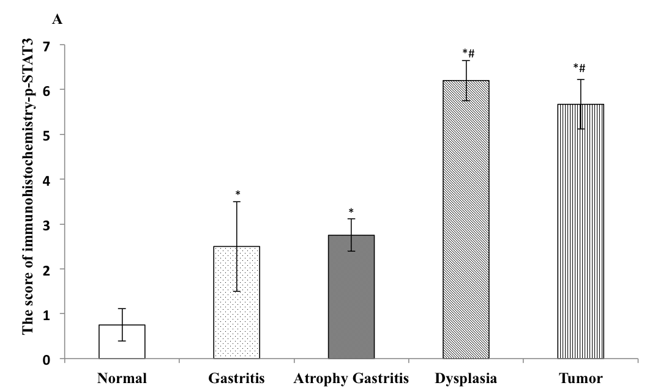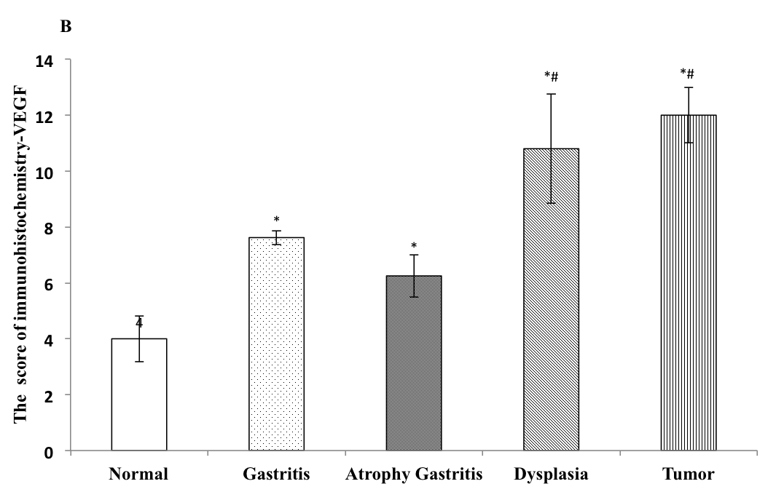
a
a
a,c
a,c
a,c
a,c
a
a

Figure 4 Immunohistochemistrical score of p-signal transducer and activator of transcription 3 and vascular endothelial growth factor. A: The immunohistochemistrical score of p-signal transducer and activator of transcription (STAT3) was significantly increased by N-methyl-N'-nitro-N-nitrosoguanidine with the progress from gastritis to gastric tumor. The score of p-STAT3 in samples with precancerous lesion or samples with tumor was significant higher than that of normal sample; and the score of p-STATS in samples with dysplasia was significantly higher than that of samples with gastritis or atrophy gastritis, which was comparable with that of samples with tumor; B: The similiar results were found in the score of vascular endothelial growth factor (ªP < 0.05, vs normal group; ^{c}P < 0.05, vs Gastritis or Atrophy Gastritis).

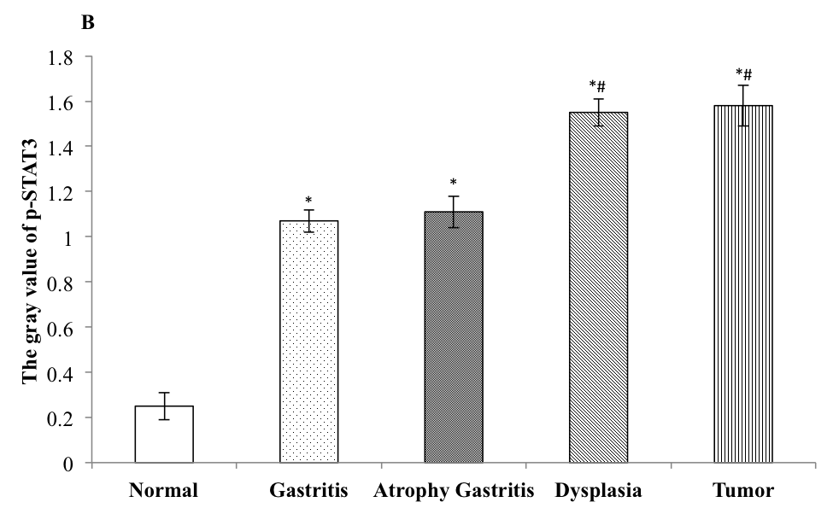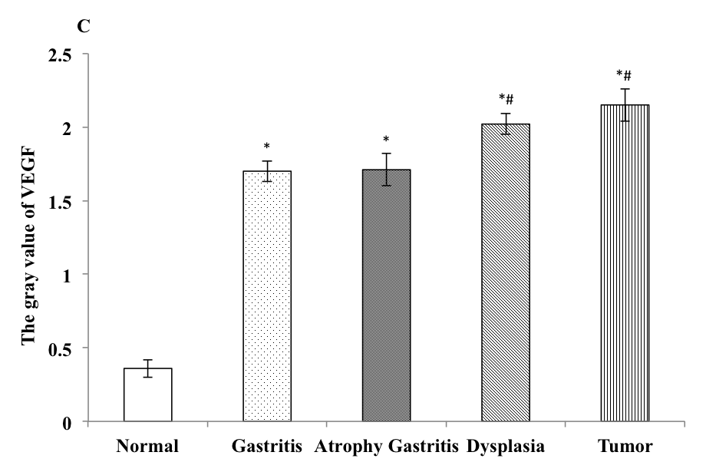
a,c
a,c
a,c
a,c
a
a
a
a

Figure 5 Protein expression of p-signal transducer and activator of transcription 3 and vascular endothelial growth factor. A: The protein expression of p-signal transducer and activator of transcription (STAT3) in samples with dysplasia or tumor was more obvious than others; B: the protein expression of p-STATS in samples with dysplasia or tumor was significantly higher than that of samples with gastritis or atrophy gastritis, but the difference between samples with dysplasia and tumor was not significant, the same result was observed between samples with gastritis and samples with atrophy gastritis; C: The consistent results were found in the protein expression of vascular endothelial growth factor in samples (ªP < 0.05, vs normal group; ^{c}P < 0.05, vs gastritis or atrophy gastritis). AG: Atrophy gastritis.

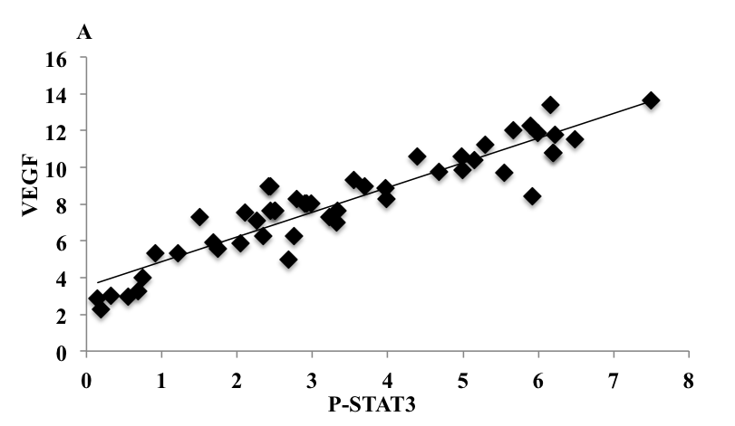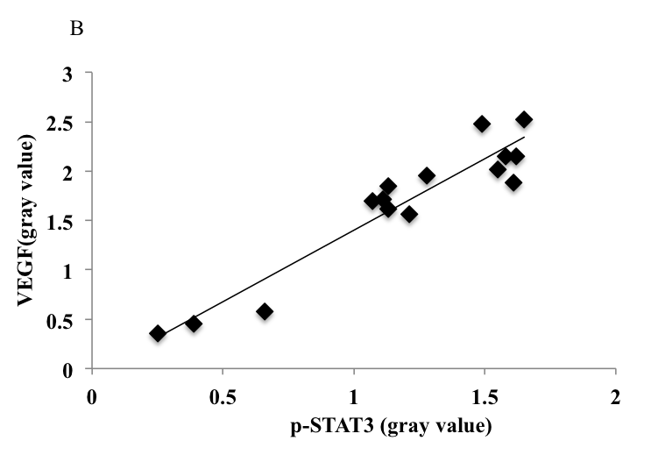
Figure 6 Correlation of immunochemistric score between p-signal transducer and activator of transcription 3 and vascular endothelial growth factor. A: There was a strong correlation of immunochemistric score between p-signal transducer and activator of transcription (STAT3) and vascular endothelial growth factor (VEGF). The immunochemistric score of p-STAT3 was positively related with that of VEGF (R²=0.86, P < 0.001); B: The similar result was observed in protein expression of p-STAT3 and VEGF (R²=0.90, P < 0.001).

