Name of Journal: World Journal of Clinical Cases
Manuscript NO: 86629
Manuscript Type: CASE REPORT

Transverse mesocolic hernia with intestinal obstruction a rare cause of acute abdomen in adults: A case report

Zhang C et al. Transverse mesocolic hernia with intestinal obstruction

Chun Zhang, Deng-Fang Guo, Feng Lin, Wen-Feng Zhan, Jian-Yuan Lin, Gui-Fang Lv

Chun Zhang, Deng-Fang Guo, Feng Lin, Wen-Feng Zhan, Jian-Yuan Lin, General Surgery Department, Mindong Hospital Affiliated to Fujian Medical University, Fu’an 355000, Fujian Province, China

Gui-Fang Lv, Medical Laboratory, Mindong Hospital Affiliated to Fujian Medical University, Fu’an 355000, Fujian Province, China

Author contributions: Zhang C drafted and edited the manuscript; Guo DF and Lin F treated the patient; Zhan WF and Lin JY contributed to the literature review; Zhang C and Lin JY performed the operation; Lv GF contributed to the final approval.

Corresponding author: Gui-Fang Lv, MD, PhD, Doctor, Medical Laboratory, Mindong Hospital Affiliated to Fujian Medical University, No. 89 Heshan Road, Fu’an 355000, Fujian Province, China. zc715866@163.com

Received: June 28, 2023
Revised: August 9, 2023
Accepted: August 17, 2023
Published online: September 26, 2023

Abstract
BACKGROUND
Internal hernia is a rare cause of acute abdomen and intestinal obstruction in adults. Internal abdominal hernias include paraduodenal, perigastric, foramen of Winslow, intersigmoid, and post-anastomotic hernias and can be congenital or acquired. Internal hernias occur in 1%-2% of patients, and transmesocolic hernias are extremely rare. This report presents a patient with a transverse mesocolic hernia with a preoperative diagnosis of small intestinal obstruction.

CASE SUMMARY
A 45-year-old Chinese woman was admitted to the hospital with middle and upper abdominal pain for 2 d, abdominal distension, and vomiting. After abdominal computed tomography, she was diagnosed with an internal abdominal hernia complicated by small intestinal obstruction and underwent emergency laparoscopic surgery. The patient recovered well and was discharged 6 d postoperatively.

CONCLUSION
Transmesocolic hernias must be considered in adult patients with signs and symptoms of intestinal obstruction, even without a history of abdominal trauma or surgery.

Key Words: Internal hernia; Transmesocolic hernias; Abdominal computed tomography; Small bowel obstruction; Laparoscopic surgery; Case report

©The Author(s) 2023. Published by Baishideng Publishing Group Inc. All rights reserved.

Citation: Zhang C, Guo DF, Lin F, Zhan WF, Lin JY, Lv GF. Transverse mesocolic hernia with intestinal obstruction a rare cause of acute abdomen in adults: A case report. World J Clin Cases 2023; 11(27): 6613-6617
URL: https://www.wjgnet.com/2307-8960/full/v11/i27/6613.htm
DOI: https://dx.doi.org/10.12998/wjcc.v11.i27.6613

Core Tip: Transverse mesocolic hernia with intestinal obstruction is a rare cause of acute abdomen in adults. This case emphasizes the importance of considering a diagnosis of transmesocolic hernia in adult patients with intestinal obstruction, even in the absence of a history of abdominal trauma or surgery. Intraoperative images and video included with this case report highlight the surgical procedures required to treat these rare hernias.

INTRODUCTION
Transmesenteric hernias are extremely rare. Approximately 0.6%-5.8% of all small intestinal obstructions are due to internal abdominal hernias^{[1]}, and transmesocolic hernias account for approximately 5%-10% of all internal abdominal hernias^{[2]}. The overall mortality rate of strangulated small intestinal obstruction is over 50%. In adults, transmesocolic hernias are usually caused by previous abdominal surgery, abdominal trauma, or intraperitoneal inflammation. It is extremely rare for a patient with no history of abdominal surgery to develop a transmesocolic hernia^{[3]}. This report presents the case of a patient with a transmesocolic hernia accompanied by an incarcerated small intestine.

CASE PRESENTATION
Chief complaints
Middle and upper abdominal pain for 2 d.

History of present illness
A 45-year-old Chinese woman with no history of abdominal surgery was admitted to the hospital with middle and upper abdominal pain for 2 d, abdominal distension, and vomiting.

Physical examination
Upon admission, her blood pressure was 137/82 mmHg, heart rate was 87 beats/min, and body temperature was 36.7 °C. A physical examination of the abdomen revealed tenderness in the middle and upper abdomen without rebound pain.

Laboratory examinations
Upon admission, laboratory assessments revealed a white blood cell count of 10.6 × 10⁹/L (NEUT%, 84.4%); haemoglobin concentration of 121 g/L; platelet count of 10.6 × 10⁹/L; C-reactive protein of 15 mg/dL; sodium of 134 mmol/L; potassium of 3.7 mmol/L; aspartate aminotransferase of 39 U/L; alanine aminotransferase of 51 U/L; alkaline phosphatase of 86 U/L; lactate dehydrogenase of 195 U/L; blood urea nitrogen of 5.97 mmol/L; and creatinine of 62 umol/L.

Imaging examinations
Abdominal computed tomography (CT) revealed local intestinal dilation in the abdominal cavity, thickening of the intestinal tube wall, an abnormal location and disordered arrangement of the small intestine, and partial thickening and edema of the intestinal wall and mesangium above the transverse colon near the hepatoduodenal ligament and gallbladder (Figure 1).

FINAL DIAGNOSIS
An internal abdominal hernia with small intestinal obstruction was suspected.

TREATMENT
The patient underwent emergency laparoscopic surgical exploration. Intraoperatively, the small intestine was discovered to be herniated from the mesocolon defect below the transverse colon to the lower part of the liver and gallbladder and was trapped by an adhesive band between the liver and duodenum. The entrapment intestinal obstruction involved a trapped small intestine and mesocolon, a loosened adhesive band, and the entrapment of the small intestine because of the mesocolon defect below the transverse colon. The defect area of the transverse mesocolon was approximately 25 cm². The blood flow within the small intestine recovered well, and no intestinal resection or anastomosis was required (Figure 2). The small intestinal obstruction in this patient was closely related to adhesive tape entrapment. An intraoperative evaluation revealed that the mesocolic defect in this patient was large and that the possibility of recurrence of small intestinal obstruction was minimal, so the decision was made not to repair the mesocolic defect during the operation.

OUTCOME AND FOLLOW-UP
The patient was discharged on postoperative day 6 with a favourable outpatient follow-up at 6 mo postoperatively (Figure 3).

DISCUSSION
An internal abdominal hernia involves the protrusion of an abdominal organ through a normal or abnormal mesentery or peritoneal pore^{[4]}. Internal hernias may occur because of trauma, surgical procedures, or other reasons related to congenital peritoneal defects. Internal hernias with unique clinical and imaging features are classified according to their anatomical regions: Paraduodenal (left or right) (53%), foramen of Winslow (8%), cecum (13%), sigmoid colon (6%), intestinal membrane (8%), interventricular (1%-4%), and anastomotic, bladder, and pelvic (6%) hernias^{[5]}. Transmesenteric hernias are difficult to diagnose preoperatively and typically require the removal of the affected intestinal area during surgery^{[6]}. Few mesocolic hernias have been reported. Congenital mesocolic hernias have three types. The first two are the right and left types, comprising 25% and 75% of all cases, respectively. The third type is extremely rare and known as a transverse mesocolic hernia^{[7]}.
Congenital mesocolic defects are extremely rare, and previous studies have proposed theories regarding their congenital causes. Because mesenteric perforations and associated hernias are often found in infants with closed intestinal segments, they may be related to prenatal intestinal ischaemic accidents. In adults, mesenteric defects are caused mostly by previous gastrointestinal surgery, abdominal trauma, or intraperitoneal inflammation^{[8,9]}. The presentation of a transverse mesocolic hernia in an adult with no history of trauma or prior abdominal surgery, as in this report, is rare.
A clear preoperative diagnosis is difficult in most patients with internal abdominal hernias because they have no obvious symptoms or signs. These hernias manifest mostly as abdominal pain, abdominal distension, and vomiting and cannot be distinguished from other acute abdominal diseases. Abdominal CT is a useful auxiliary diagnostic technique. With the patient presented in this report, CT revealed local intestinal dilation in the abdominal cavity, intestinal tube wall thickening, an abnormal location and disordered arrangement of the small intestine, intestinal wall thickening, edema, and mesangium above the transverse colon near the hepatoduodenal ligament and gallbladder. The small intestine is not typically located in this region. Therefore, this patient underwent an emergency laparoscopic operation to investigate an intraperitoneal hernia with small intestinal obstruction. For intraperitoneal hernias with mesocolic defects, most surgeons will choose to close the defect^{[10]}. However, the small intestinal obstruction was closely related to adhesive tape entrapment in this patient. An intraoperative evaluation revealed that the mesocolic defect in this patient was large, and the possibility of recurrence of small intestinal obstruction was minimal, so a decision was made not to repair the mesocolic defect during the operation.
Transmesocolic hernias, especially transverse mesocolic hernias, are rare. Most previous reports of mesocolic hernias are case reports and involve open surgery. The surgical images provided in this report reflect the incarceration caused by the internal abdominal hernia. The patient had no history of abdominal trauma or surgery, and the laparoscopic emergency operation was successful. The surgical pictures (Figure 2) and videos (Video) provided in this report highlight the incarceration of the internal abdominal hernia, allowing readers to gain a better understanding of this condition and the required surgical treatment.

CONCLUSION
In conclusion, the preoperative diagnosis of intestinal obstruction caused by internal hernias, especially mesocolic hernias, remains difficult. Therefore, considering the possibility of transmesocolic hernias in adult patients with signs and symptoms of intestinal obstruction is important, even when the patient has no history of abdominal trauma or surgery.

REFERENCES
1 Newsom BD, Kukora JS. Congenital and acquired internal hernias: unusual causes of small bowel obstruction. Am J Surg 1986; 152: 279-285 [PMID: 3752377 DOI: 10.1016/0002-9610(86)90258-8]
2 Agresta F, Mazzarolo G, Bedin N. Incarcerated internal hernia of the small intestine through a re-approximated peritoneum after a trans-abdominal pre-peritoneal procedure--apropos of two cases: review of the literature. Hernia 2011; 15: 347-350 [PMID: 20354744 DOI: 10.1007/s10029-010-0656-1]
3 Jung P, Kim MD, Ryu TH, Choi SH, Kim HS, Lee KH, Park JH. Transmesocolic hernia with strangulation in a patient without surgical history: case report. World J Gastroenterol 2013; 19: 1997-1999 [PMID: 23569347 DOI: 10.3748/wjg.v19.i12.1997]
4 Mathieu D, Luciani A; GERMAD Group. Internal abdominal herniations. AJR Am J Roentgenol 2004; 183: 397-404 [PMID: 15269032 DOI: 10.2214/ajr.183.2.1830397]
5 Gomes R, Rodrigues J. Spontaneous adult transmesentric hernia with bowel gangrene. Hernia 2011; 15: 343-345 [PMID: 20336475 DOI: 10.1007/s10029-010-0652-5]
6 Murphy DA. Internal hernias in infancy and childhood. Surgery 1964; 55: 311-316 [PMID: 14121782]
7 Deger KC. Laparoscopic Reduction and Repair of a Mesocolic Hernia Causing Small Bowel Obstruction: A Case Report and Review of Literature. Cureus 2023; 15: e37421 [PMID: 37182032 DOI: 10.7759/cureus.37421]
8 Shaffner Lde S, Pennell TC. Congenital internal hernia. Surg Clin North Am 1971; 51: 1355-1359 [PMID: 5129913 DOI: 10.1016/s0039-6109(16)39590-1]
9 Mock CJ, Mock HE Jr. Strangulated internal hernia associated with trauma. AMA Arch Surg 1958; 77: 881-886 [PMID: 13593984 DOI: 10.1001/archsurg.1958.01290050051010]
10 Montovano M, Chernock B, Merchant AM, Shapiro M, Oliver JB. The Rare Middle Mesocolic Hernia. Am Surg 2022; 88: 1346-1348 [PMID: 32856934 DOI: 10.1177/0003134820945278]

Footnotes
Informed consent statement: Informed written consent was obtained from the patients for the publication of this report and any accompanying images.

Conflict-of-interest statement: The authors declare that they have no conflicts of interest.

CARE Checklist (2016) statement: The authors have read the CARE Checklist (2016), and the manuscript was prepared and revised according to the CARE Checklist (2016).

Open-Access: This article is an open-access article that was selected by an in-house editor and fully peer-reviewed by external reviewers. It is distributed in accordance with the Creative Commons Attribution NonCommercial (CC BY-NC 4.0) license, which permits others to distribute, remix, adapt, build upon this work non-commercially, and license their derivative works on different terms, provided the original work is properly cited and the use is non-commercial. See: https://creativecommons.org/Licenses/by-nc/4.0/

Provenance and peer review: Unsolicited article; Externally peer reviewed.
Peer-review model: Single blind

Peer-review started: June 28, 2023
First decision: August 5, 2023
Article in press: August 17, 2023

Specialty type: Surgery
Country/Territory of origin: China
Peer-review report’s scientific quality classification
Grade A (Excellent): 0
Grade B (Very good): 0
Grade C (Good): C
Grade D (Fair): D
Grade E (Poor): 0

P-Reviewer: Seretis C, Greece; Viswanath YK, United Kingdom S-Editor: Chen YL L-Editor: Filipodia P-Editor: Chen YL

Figure Legends
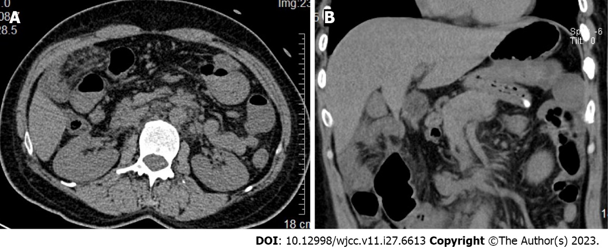
Figure 1 Abdominal computed tomography findings. A: Transverse view; B: Sagittal view. The small intestine was locally dilated in the abdominal cavity and the intestinal tube wall was thickened. Above the transverse colon, the small intestine and mesangium were partially thickened, and edema of the tube wall was found around the gallbladder.

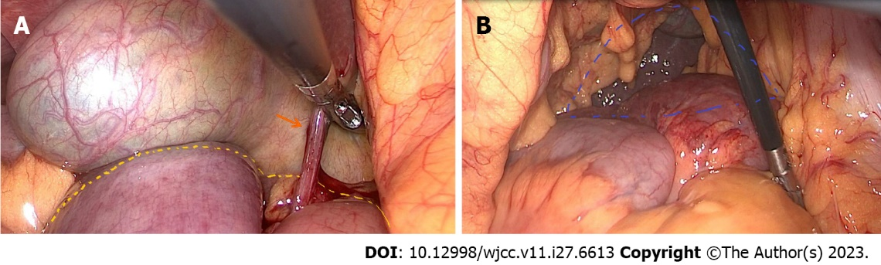
Figure 2 Intraoperative findings. A: The yellow dotted line shows herniation into the incarcerated small intestine. The black arrow shows the hepatoduodenal adhesions; B: The blue dotted line shows the transverse mesocolic defect.

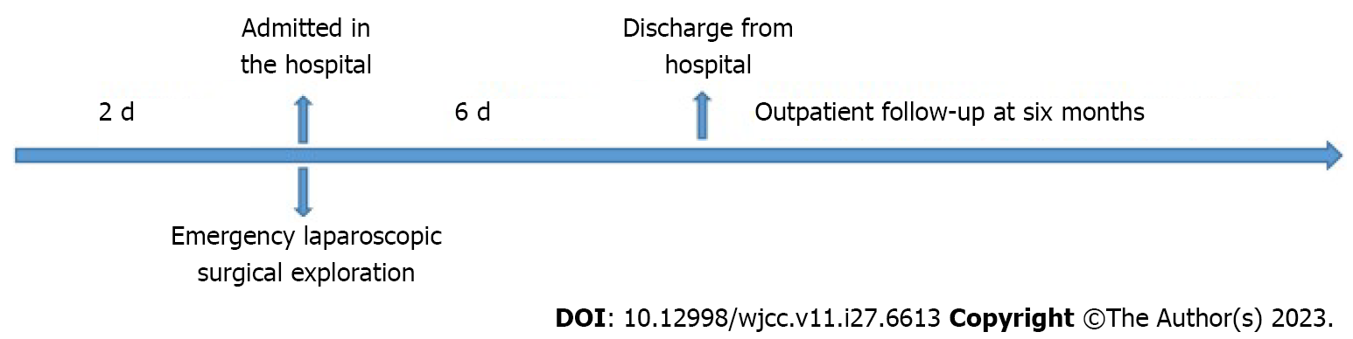
Figure 3 Timeline.

Published by Baishideng Publishing Group Inc
7041 Koll Center Parkway, Suite 160, Pleasanton, CA 94566, USA
Telephone: +1-925-3991568
E-mail: bpgoffice@wjgnet.com
Help Desk: https://www.f6publishing.com/helpdesk
https://www.wjgnet.com

© 2023 Baishideng Publishing Group Inc. All rights reserved.

