Name of Journal: World Journal of Gastroenterology
Manuscript NO: 85822
Manuscript Type: ORIGINAL ARTICLE

Basic Study
Effect of exogenous hydrogen sulfide in the nucleus tractus solitarius on gastric motility in rats

Sun HZ et al. H₂S within NTS and gastric motility

Hong-Zhao Sun, Chen-Yu Li, Yuan Shi, Jin-Jin Li, Yi-Ya Wang, Li-Na Han, Lu-Jie Zhu, Ya-Fei Zhang

Hong-Zhao Sun, Chen-Yu Li, Yuan Shi, Jin-Jin Li, Yi-Ya Wang, Li-Na Han, Lu-Jie Zhu, Ya-Fei Zhang, College of Life Science, Qi Lu Normal University, Zhangqiu 250200, Shandong Province, China

Author contributions: Sun HZ and Li CY contributed equally to this work; Sun HZ conceived and designed the experiments; Li CY, Shi Y, Li JJ, Wang YY, Han LN, Zhu LJ, and Zhang YF performed the experiments; Sun HZ and Li CY analyzed the data; Sun HZ provided reagents/materials/analysis tools; Li CY authored the paper; all authors have read and approved the final manuscript.

Supported by the Natural Science Foundation of Shandong Province, No. ZR2019MC020.

Corresponding author: Hong-Zhao Sun, PhD, Professor, College of Life Science, Qi Lu Normal University, No. 2 Wenbo Road, Zhangqiu 250200, Shandong Province, China. sunhongzhao18@126.com

Received: May 18, 2023
Revised: June 29, 2023
Accepted: July 19, 2023
Published online: August 7, 2023

Abstract
BACKGROUND
Hydrogen sulfide (H₂S) is a recently discovered gaseous neurotransmitter in the nervous and gastrointestinal systems. It exerts its effects through multiple signaling pathways, impacting various physiological activities. The nucleus tractus solitarius (NTS), a vital nucleus involved in visceral sensation, was investigated in this study to understand the role of H₂S in regulating gastric function in rats.

AIM
To examine whether H₂S affects the nuclear factor kappa-B (NF-κB) and transient receptor potential vanilloid 1 pathways and the neurokinin 1 (NK1) receptor in the NTS.

METHODS
Immunohistochemical and fluorescent double-labeling techniques were employed to identify cystathionine beta-synthase (CBS) and c-Fos co-expressed positive neurons in the NTS during rat stress. Gastric motility curves were recorded by inserting a pressure-sensing balloon into the pylorus through the stomach fundus. Changes in gastric motility were observed before and after injecting different doses of NaHS (4 nmol and 8 nmol), physiological saline, Capsazepine (4 nmol) + NaHS (4 nmol), pyrrolidine dithiocarbamate (PDTC, 4 nmol) + NaHS (4 nmol), and L703606 (4 nmol) + NaHS (4 nmol).

RESULTS
We identified a significant increase in the co-expression of c-Fos and CBS positive neurons in the NTS after 1 h and 3 h of restraint water-immersion stress compared to the expressions observed in the control group. Intra-NTS injection of NaHS at different doses significantly inhibited gastric motility in rats (P < 0.01). However, injection of saline, first injection NF-κB inhibitor PDTC or transient receptor potential vanilloid 1 (TRPV1) antagonist Capsazepine or NK1 receptor blockers L703606 and then injection NaHS did not produce significant changes (P > 0.05).

CONCLUSION
NTS contains neurons co-expressing CBS and c-Fos, and the injection of NaHS into the NTS can suppress gastric motility in rats. This effect may be mediated by activating TRPV1 and NK1 receptors via the NF-κB channel.

Key Words: Nucleus tractus solitarius; Hydrogen sulfide; Gastric motility; Nuclear factor kappa-B; Transient receptor potential vanilloid 1

©The Author(s) 2023. Published by Baishideng Publishing Group Inc. All rights reserved.

Citation: Sun HZ, Li CY, Shi Y, Li JJ, Wang YY, Han LN, Zhu LJ, Zhang YF. Effect of exogenous hydrogen sulfide in the nucleus tractus solitarius on gastric motility in rats. World J Gastroenterol 2023; 29(29): 4557-4570
URL: https://www.wjgnet.com/1007-9327/full/v29/i29/4557.htm
DOI: https://dx.doi.org/10.3748/wjg.v29.i29.4557

Core Tip: This study revealed a significant inhibitory effect of exogenous hydrogen sulfide on gastric motility in rats. This effect appeared to involve the release of substance P, potentially activating the transient receptor potential vanilloid 1 pathway mediated by nuclear factor kappa-B channels.

INTRODUCTION
The number of patients with stress-induced gastric ulcers has increased dramatically^{[1]}, and stress is highly associated with several functional gastrointestinal disorders, such as functional dyspepsia and irritable bowel syndrome^{[2]}. The nucleus tractus solitarius (NTS) is a relay nucleus for visceral primary afferent neural signaling. It receives sensory afferents from visceral organs and projects to the spinal cord to regulate respiratory and cardiovascular activity. The NTS is also closely connected with various brain nuclei^{[3]}. Recent studies have demonstrated the role of the NTS in cardiovascular and respiratory regulation and the reflex regulation of intragastric pressure. Synapses mediate the vagal-dependent gastric reflex between vagal afferent fibers and NTS neurons, and through the vagal preganglionic parasympathetic neurons in the dorsal vagal complex^{[4]}. Neuronal firing studies in the NTS have shown that H₂S increases NTS-evoked postsynaptic currents by enhancing presynaptic glutamate release and affects the membrane potential of NTS neurons in a concentration-dependent manner^{[5]}.
Vagal afferent transmission primarily terminates in the NTS^{[6]}, which may act as a relay activator to inhibit spinal neuronal activity. Vagal-mediated glutamate release can regulate homeostasis by activating NTS neurons and metabotropic glutamate receptors, contributing to homeostatic regulation. Injection of oxytocin in the NTS has been observed to inhibit gastric smooth muscle diastole in rats, possibly through the cAMP-PKA signaling pathway^{[7]}. The microinjection of monosodium glutamate in the NTS and the activation of NTS opioid receptors inhibit gastric motility and significant c-Fos expression in the dorsal motor nucleus of the vagus (DMV) neurons^{[8]}.
However, hydrogen sulfide (H₂S) is a recently discovered gas transmitter endogenously produced in the human and animal brain and organ tissues. Cystathionine beta-synthase (CBS) mainly synthesizes H₂S in the central nervous system and plays a significant physiological role^{[9]} and has a protective role in neurodegenerative diseases such as Parkinson’s disease^{[10]} and Alzheimer’s disease^{[11]}. CBS is present in neurons and glial cells of the NTS, exerting excitatory effects and modulating synaptic neuronal activity^{[12]}. Blocking CBS attenuates synaptic transmission in NTS neurons. Applying the H₂S donor NaHS also enhances synaptic transmission in NTS neurons. H₂S in the NTS plays an equally important role as a gaseous neuromodulator in maintaining or modulating autonomicand other systems^{[13]}. In vitro experiments have shown that H₂S relaxes gastrointestinal smooth muscles, inhibiting spontaneous movements and responses to chemical or electrical stimuli^{[14]}. H₂S also plays a role in other types of smooth muscle relaxation via K⁺-ATP channels^{[15]}, suggesting that endogenous H₂S has a regulatory role in the gastrointestinal tract’s motor function.
The nuclear factor kappa-B (NF-κB) pathway is activated by various factors and plays a crucial role in the immune response and inflammation. A study found that NaHS administration in the rat intraperitoneal via sulfhydration caused NF-κB activation and lung inflammation, a significant increase in p65 protein levels, vascular congestion, and neutrophil infiltration. Also, slight neuronal degeneration was observed in the rat heart, liver, and brain, suggesting that H₂S acts on NF-κB channels for messaging^{[16]}. H₂S also interacts with nitric oxide to cause vasodilation, down-regulates NF-kB pathway-induced inflammation, fibrosis and damage from prolonged or intense oxidative stress; protects tissues from ischemia- and reperfusion-induced injury; and reduces immune rejection by reducing oxygen free radicals produced in vivo^{[17]}. Additionally, H₂S demonstrates antioxidant and anti-apoptotic effects on neurons and glial cells^{[18]}.
Transient receptor potential vanilloid type 1 (TRPV1) is a non-selective calcium channel associated with nociceptive sensations in peripheral nerves. Its activation can lead to neurokinin 1 (NK1) receptor activation, pain, local neurogenic inflammation, and systemic anti-inflammatory/analgesic effects, and enhanced transmitter release in the NTS. TRPV1 involves various physiological and pathological processes^{[19,20]}. Electrophysiological studies have shown that the activation of TRPV1 by capsaicin enhances glutamate release to visceral sensory neurons, affecting NTS preganglionic neurons^{[21]}. H₂S can cause peripheral inflammation and synaptic enhancement of glutamatergic signaling in the spinal cord by activating TRPV1 channels, thus stimulating other receptors at the terminals of capsaicin-sensitive neurons^{[22]}. TRPV1 activation also leads to the release of substance P (SP), while NK1 receptors are responsible for neurally mediated digestive secretion and contributes to brain homeostasis and sensory neuronal transmission associated with depression, stress, anxiety and vomiting^{[23]}. H₂S causes gastric juice secretion by stimulating TRPV1 receptors on primary afferent nerve fibers and modulates cholinergic neurons by releasing SP to act on NK1, NK2, or NK3 receptors^{[24]}. Therefore, we speculate that TRPV1 channels may be involved in the effect of H₂S donors on gastric emptying.
SP is a neuroactive peptide involved in pain and inflammation^{[25]}. It is widely present in the mammalian organism in the central, peripheral, and gastrointestinal nervous systems^{[26]} and other tissues, participating in various physiopathological processes, including stress, emotional anxiety, and immune regulation. NK1 receptors are the primary receptors for SP and are widely expressed in the brain, contributing to stress and emotional anxiety^{[27]}. SP is widely expressed in the NTS, mainly in the primary sensory neurons in the peripheral nervous system, and intrinsic neurons of the gastrointestinal tract. It has been shown to have neurotransmitter effects in the central and peripheral nervous systems and is associated with immune and inflammatory diseases of the respiratory and gastrointestinal systems^{[28]}.
Herein, we investigated the regulatory effects of H₂S in the NTS on rat gastric function and explore whether these effects were mediated by SP release via NF-κB channel-dependent activation of the TRPV1 pathway.

MATERIALS AND METHODS
Animal
The animals used in this experiment were 240-280 g adult male Wistar rats purchased from Jinan Panyue Experimental Animal Breeding Co and housed in separate cages at a constant temperature (22 °C ± 2 °C) given appropriate food and water based on their body weight. To allow them to acclimate to their surroundings, the rats were exposed to natural rhythmic light for one week before the start of the experiment.
Before the experiment, the rats underwent a 24-h fasting period, during which they were allowed to freely drink. The other environmental conditions remained consistent throughout the experiment. The Experimental Animal Ethics Committee of Qilu Normal University approved the experiment. All experiments complied with internationally accepted ethical standards. The study also adhered to the guidelines set by the International Association for the Study of Pain^{[29]}.

Chemicals
NaHS, L703606, PDTC, Capsazepine, and protamine sky blue were purchased from Sigma-Aldrich (St. Louis, MO, United States). NaHS was dissolved in 0.9% saline, while the other chemicals were dissolved in dimethyl sulfoxide and reconstituted in saline. For the immunohistochemical fluorescence double labeling, the following reagents were purchased from Servicebio (Wuhan, China): Goat serum, anti-CBS rabbit pAb, FITC-conjugated goat anti-rabbit IgG, Cy3-conjugated goat anti-mouse IgG, and anti-c-Fos mouse pAb.

Immunohistochemical fluorescence double labeling
We used the restraint water immersion stress model to investigate acute stress-induced gastric mucosal injury in rats. This acute compound stress model causes changes in gastric function in rats under stress through enhanced parasympathetic activity in the innervated stomach^{[30]}. Once anesthetized, the rats were swiftly removed from the bottle and secured to a wooden board using medical tape to immobilize their limbs and teeth. When awake, the rats were then immersed in cold water (21 °C ± 1 °C) with the sternal process aligned with the water level. To minimize experimental error, consistent time points were selected for each experiment.
The rats were randomly divided into three groups (n = 6) based on the duration of restraint water-immersion stress (RWIS) (0 h, 1 h, or 3 h). Cardiac perfusion was performed using 500 mL of prepared 0.01 mol/L phosphate-buffered saline (PBS) followed by 500 mL of 4% 0.1 mol/L paraformaldehyde (PFA). After administering an overdose of isoflurane to sacrifice the rat, the thoracic cavity was opened along the sternal process, and the heart was exposed. The infuser needle was inserted into the heart’s left ventricle, securing the heart, while the right auricle was incised to allow blood to drain. The rat’s liver was flushed with 0.01 mol/L PBS buffer until it turned white, followed by perfusion with 4% PFA solution using a “fast and then slow” principle, gradually reducing the flow rate when the rat’s limbs twitched.
Upon completion of perfusion, the rat’s head was severed, and the brain was extracted. The brain was placed in a small wide-mouth flask containing 4% PFA and kept at 4 °C for 24 h. Subsequently, the fixed rat brain was transferred to a 0.1 mol/L 30% sucrose solution for dehydration. The frozen target nuclei region was then sectioned into 30 μm thick coronal sections using a sectioning machine and stored in 0.01 mol/L PBS.
Next, each well of a multi-well plate was filled with 500 μL of 0.01 mol/L PBS buffer to clean the brain slices and remove impurities. A methanolic solution of 3% H₂O₂ was added to block endogenous peroxidase activity. The wells were then incubated with a goat serum closure solution for 1 h to enhance cell membrane permeability. Subsequently, 500 μL of each primary antibody working solution was added, consisting of mouse anti-c-Fos (diluted at 1:500) and rabbit anti-CBS (diluted at 1:500), and incubated overnight at 4 °C.
Finally, 500 μL of each fluorescent secondary antibody working solution was added for 1 h. Any residual fluorescent secondary antibody was washed off with PBST. Previously treated with chromium-vanadium gelatin, the brain slides were placed on glass slides and allowed to dry naturally. The slides were sealed with an anti-fluorescence quencher, ensuring the removal of air bubbles using a vacuum. Finally, the sealed fluorescent glass slide was placed under an Olympus Fluorescence confocal microscopy to observe and compare the brain atlas to determine the position of the NTS, observe the CBS and c-Fos-positive neurons number, and take pictures. The expression of c-Fos and CBS in the NTS was counted using Image Pro-Plus 6.0 software (Number/0.01 mm²).

Experimental grouping
We evaluated the following subgroups to investigate the regulatory effects of NaHS in the NTS on gastric function and its underlying mechanisms. The chosen doses were based on pre-experiments and relevant literature^{[31]}: (1) The effect of microinjection of NaHS (0.1 µL, 4 nmol; n = 6) in NTS on gastric motility; (2) the effect of microinjection of NaHS (0.1 µL, 8 nmol; n = 6) in NTS on gastric motility; (3) the effect of microinjection of saline (0.1 µL; n = 6) in NTS on gastric motility as a control group; (4) the effect of microinjection of NaHS (0.1 µL, 4 nmol) + PDTC (0.1 µL; n = 6) in NTS on gastric motility; (5) microinjection of NaHS (0.1 µL, 4 nmol) + Capsazepine (0.1 µL, 4 nmol; n = 6) in NTS on gastric motility; and (6) microinjection of NaHS (0.1 µL, 4 nmol) + L703606 (0.1 µL, 4 nmol; n = 6) in NTS on gastric motility.

Microinjection
Before conducting the experiments, the rats were anesthetized with 4% chloral hydrate at (400 mg/kg body weight) by intraperitoneal injection until the eyelids and corneal reflexes disappeared, the muscles were relaxed, and the breathing was uniform. The anesthetized rat head was fixed on a brain stereotaxic apparatus (Stoelting 68002, Shenzhen Ruiwode Company, China).
Next, the animal was fixed according to the rat brain stereotaxic atlas (Paxinos and Watson, 2007) using the three points of the animal’s bilateral inner ear holes and incisors. With the left and right ear rods reading the same, fontanelle and bregma were kept at the same level with an error of no more than 0.3 mm.
The head hair was removed with hair clippers to expose the scalp and disinfected with 75% alcohol. Then, the scalp was cut along the sagittal suture of the skull with ophthalmic clippers to expose the skull, the excess connective tissue around the skull was cut away, and the surface of the skull was gently wiped with saline until the fontanelle and herringbone suture were exposed. The three-dimensional coordinates of fontanelle were used as the zero point. A small hole of approximately 2 mm in diameter was drilled in the skull ipsilateral to the coordinates of the NTS center point (13.3 mm posterior to fontanelle, 0.8 mm paracentral opening, 7.9 mm subdural) in the atlas using an electric cranial drill. A glass microelectrode with a tip of approximately 30 μm was placed into the brain at the depth of the coordinates.

Recording gastric motility
The anesthetized rats were placed abdomen side up, and a small incision was made in the fundus of the stomach to clean the gastric residue. A 5 mm diameter balloon filled with warm water was inserted into the pylorus of the gastric sinus and kept at a constant baseline pressure. The balloon inserted into the rat’s stomach was connected to the pressure transducer and BL-420 (Biological Function Experimental System; Chengdu Taimeng Company, China) via a polyethylene plastic tube. The stimulation parameters of the transducer were adjusted to 25 mm/min speed, 0.5 mV/cm sensitivity, and 10 Hz filter. Once the gastric motility curve was stabilized, the drug’s microinjections and contaminate sky blue were administered. A heat lamp was used throughout the experiment to maintain a constant ambient temperature, and gastric motility was recorded.

Histological identification of the microinjection site
After gastric motility recording, 2% pontamine sky blue (0.1 µL) was injected into the NTS, the rats were executed with an excess of sodium pentobarbital, and the thorax was opened for cardiac perfusion. After perfusion, the heads of the rats were cut off, and the brain tissues were removed and placed in a 4% formaldehyde solution for fixation.
Subsequently, the brain tissues were frozen at -16 °C for 30 min and sectioned into successive coronal sections with a thickness of 16 μm. The brainstem sections were stained, allowing for the identification of injection sites. The brain slices on slides were treated with a neutral red stain and dehydrated to achieve transparency. The sections were observed and photographed using a microscope (Nikon Optiphot, Nikon, Shanghai, China) and photographed with a digital camera (Magnafire; Optronics, Goleta, CA, United States) connected to a computer. The blue dot marking the precise location of the NTS was identified for further statistical analysis.

Data analysis and statistics
The gastric motility of the rats was assessed by counting the number of contractions before and 5 min after injection were counted respectively. The total duration of contraction waves (T.D.C.W) within 5 min, the total amplitude of contraction waves (T.A.C.W) within 5 min and the gastric motility index (the product of amplitude and duration) before and after the 5-min microinjection were evaluated statistically. To calculate the inhibition rate of gastric motility, the following formula was used: Inhibition rate (%) = (pre-injection value-post-injection value) × 100%/pre-injection value. The height between the highest point of the contraction curve and the baseline is the amplitude of the contraction wave. The time duration between the starting point and the ending point of the contraction wave is the time duration of the contraction wave.
Statistical analysis was performed using SPSS v25.0 (IBM SPSS Inc., Chicago, IL, United States) using Student’s t-test or one-way ANOVA, followed by a posthoc test using the Student-Newman-Keuls test. All data are presented as mean ± SE. A P value less than 0.05 was considered statistically significant.

RESULTS
Observation of c-Fos and CBS expression in NTS at different times in RWIS
In this experiment, the number of CBS and c-Fos co-expressing neurons in the NTS (Figure 1, n = 6) was revealed by immunohistochemical fluorescence double-labeling. The expression of c-Fos protein in the NTS showed varying degrees of increase at 1 h (7.00 ± 0.37) and 3 h (4.83 ± 0.31) after RWIS compared to the control group at 0 h (1.83 ± 0.30) (P < 0.01). This finding indicates that CBS neurons in the NTS of rats were activated during the RWIS procedure.

NTS injection site identification
Following neutral red staining, the brain slices were examined under a light microscope to determine the localization of the injected blue spots and drugs within the NTS. The observed data regarding the gastric motility of rats in the correct position were analyzed. Figure 2 presents the diagram for identifying the degree of tissue localization.

NaHS inhibits gastrointestinal motility within NTS
The microinjection of physiological saline (PS) (0.1 µL, n = 6) under the same conditions did not produce a significant change in gastric motility (Figure 3A). In contrast, the microinjection of NaHS at different concentrations (4 nmol and 8 nmol, 0.1 µL, n = 6) into the rat NTS resulted in significant inhibition of gastric motility (Figure 3B and C).
We compared gastric motility curves measured before and 5 min after the drug injection and after 4 nmol NaHS injection in the NTS. The T.A.C.W. decreased from 553.08 mm 5 min⁻¹ ± 9.59 mm 5 min⁻¹ to 421.30 mm 5 min⁻¹ ± 10.58 mm 5 min⁻¹ (P < 0.01). The T.D.C.W. decreased from 179.79 s 5 min⁻¹ ± 13.33 s 5 min⁻¹ to 132.56 s 5 min⁻¹ ± 6.67 s 5 min⁻¹ (P < 0.01), and the gastric motility index (G.M.I.) decreased from 5219.88 ± 182.11 to 4250.28 ± 159.03 (P < 0.01). At a NTS microinjection dose of 8 nmol NaHS, the T.A.C.W. decreased from 587.62 mm 5 min⁻¹ ± 9.58 mm 5 min⁻¹ to 407.44 mm 5 min⁻¹ ± 10.61 mm 5 min⁻¹ (P < 0.01) and the T.D.C.W. decreased from 234.11 s 5 min⁻¹ ± 11.74 s 5 min⁻¹ to 145.13 s 5 min⁻¹ ± 3.93 s 5 min⁻¹ (P < 0.01) and the G.M.I. decreased from 5906.07 ± 181.71 to 4105.60 ± 49.35. After PS injection in the NTS, the T.A.C.W. decreased from 468.72 mm 5 min⁻¹ ± 6.42 mm 5 min⁻¹ to 467.34 mm 5 min⁻¹ ± 5.04 mm 5 min⁻¹ (P > 0.05), the T.D.C.W. from 236.96 s 5 min⁻¹ ± 8.51 s 5 min⁻¹ to 232.38 s 5 min⁻¹ ± 16.31 s 5 min⁻¹ (P > 0.05), and the G.M.I. from 5797.17 ± 141.87 to 5778.08 ± 125.32 (P > 0.05) (Figure 4A-C).
The inhibition rates of the T.A.C.W. in the 4 nmol NaHS, 8 nmol NaHS, and saline groups were 23.83%, 30.69%, and 0.27%, respectively. The inhibition rates of T.D.C.W. in the 4 nmol NaHS, 8 nmol NaHS, and saline groups were 26.21%, 37.43%, and 2.06%, respectively. The inhibition rates of G.M.I. in the 4 nmol NaHS, 8 nmol NaHS, and saline groups were 18.55%, 30.17%, and 0.30%, respectively (Figure 4D). The data indicated that the inhibition rates of T.A.C.W., T.D.C.W., and G.M.I. were significantly higher in the 8 nmol NaHS group compared to the 4 nmol NaHS group. These findings suggest a dose-dependent inhibitory effect of NTS injection of NaHS on gastric motility.

PDTC eliminates the inhibitory effect of NaHS on gastric motility
Injection of PDTC followed by NaHS into the NTS eliminated the inhibitory effect of NaHS on gastric motility (Figure 5A, n = 6). The T.A.C.W. changed from 500.15 mm 5 min⁻¹ ± 7.56 mm 5 min⁻¹ to 491.06 mm 5 min⁻¹ ± 17.19 mm 5 min⁻¹ (P > 0.05), the T.D.C.W. changed from 169.84 s 5 min⁻¹ ± 3.40 s 5 min⁻¹ (P > 0.05), and the G.M.I. changed from 5494.78 ± 140.32 to 5490.60 ± 88.80 after PDTC followed by NaHS injection (P > 0.05) (Figure 5B-D). These data suggest that NaHS can regulate gastric motility through the NF-κB signaling pathway.

Capsazepine eliminates the inhibitory effect of NaHS on gastric motility
Injection of Capsazepine followed by NaHS into the NTS eliminated the inhibitory effect of NaHS on gastric motility (Figure 6A, n = 6). As a result, the T.A.C.W. changed from 514.46 mm 5 min⁻¹ ± 6.56 mm 5 min⁻¹ to 523.87 mm 5 min⁻¹ ± 9.21 mm 5 min⁻¹ (P > 0.05), the T.D.C.W. changed from 175.90 s 5 min⁻¹ ± 4.22 s 5 min⁻¹ to 172.13 s 5 min⁻¹ ± 4.68 s 5 min⁻¹ (P > 0.05), and the G.M.I. changed from 5932.97 ± 104.93 to 5946.45 ± 184.14 (P > 0.05) (Figure 6B-D). These data suggest that NaHS can regulate gastric motility through TRPV1 channels.

L703606 eliminates the inhibitory effect of NaHS on gastric motility
Injection of L703606 followed by NaHS into the NTS eliminated the inhibitory effect of NaHS on gastric motility (Figure 7A, n = 6). The T.A.C.W. changed from 494.46 mm 5 min⁻¹ ± 11.86 mm 5 min⁻¹ to 490.53 mm 5 min⁻¹ ± 14.00 mm 5 min⁻¹ (P > 0.05), the T.D.C.W. changed from 164.10 s 5 min⁻¹ ± 5.53 s 5 min⁻¹ to 158.39 s 5 min⁻¹ ± 10.64 s 5 min⁻¹ (P > 0.05), and the G.M.I. changed from 5827.59 ± 133.74 to 5762.80 ± 114.34 (P > 0.05) (Figure 7B-D). These data suggest that NaHS can act on NK1 receptors to regulate gastric motility.

DISCUSSION
Endogenous H₂S concentrations in the brain range between 10 nM and 160 nM^{[32]}, and approximately 33% of H₂S is produced by volatilization in NaHS solutions when measurements are made in a closed environment. H₂S (10 mmol/L) in NTS neurons can maintain excitatory postsynaptic potential excitation for 10 minutes, which is equivalent to the time it takes for a microinjection NaHS to work^{[33]}. Moreover, H₂S can cross the cell membrane by free diffusion to modulate cellular properties^{[34]}. We selected NaHS as an exogenous H₂S rapid drug-delivery donor.
H₂S, an emerging gaseous signaling molecule, plays an important role in regulating digestion and the nervous system^{[35]}. Placing coronal NTS slices into NaHS solution was found to cause rapid concentration-dependent depolarization of neurons at NTS sites, with H₂S increasing the postsynaptic currents in NTS neurons by promoting presynaptic glutamate release^{[36]}. Herein, we observed a significant increase in the co-expression of neurons between CBS and c-Fos in rat NTS after RWIS, indicating that H₂S in the NTS is involved in gastrointestinal regulation and stress.
In this experiment, we found that the amplitude and duration of gastric motility and the index of gastric motility were significantly lower in the NTS than in the control group, in a dose-dependent manner, after the injection of different concentrations of NaHS in rats. Sensory information from the upper gastrointestinal tract is transmitted to the NTS via vagal afferent fibers, and c-Fos-positive neurons are significantly increased in the NTS following stressful processes. Glutamate release from vagal afferent fibers activates NTS neurons, which can regulate gastrointestinal activity by inhibiting the vagal excitatory cholinergic efferent pathway via the inhibitory neurotransmitter GABA or by exciting the vagal inhibitory non-adrenergic non-cholinergic (NANC) efferent pathway^{[37]}. In addition, vagal afferent nerves from the gastrointestinal tract can activate the NANC efferent pathway leading to gastric smooth muscle relaxation. Vagal efferent fibers activate the noradrenergic neurons in the NTS, which in turn activate the NANC pathway neurons in the DMV. These NANC-DMV neurons transmit to the gastrointestinal plexus to activate postganglionic cholinergic neurons, thus causing gastric relaxation^{[38]}.
In vivo studies found that the microinjection of D-glucose into the NTS resulted in decreased gastric motility and increased intragastric pressure in rats via K⁺-ATP channel relaxation of the smooth muscles and increased firing of GABAergic neurons^{[39]}. Injection of cholecystokinin in the rat NTS modulates the gastrointestinal motility and secretory function in the upper gastrointestinal tract by activating postganglionic cholinergic excitatory or NANC inhibitory pathways^{[40]}. Increased glutamate content within the NTS directly activates excitatory postsynaptic potentials in NTS neurons, which in turn stimulates local circuit GABAergic and glutamatergic neurons. GABAergic signals at the NTS determine the state of the gastric tone and contraction and mediate changes in gastric mechanical function at the onset of the vagal-vagal reflex^{[41,42]}. The intra-NTS injection of GLP-1 reduces the gastric tone by activating NANC and delays gastric emptying in a dose-dependent manner^{[43]}. Therefore, NaHS injection in the rat NTS may inhibit gastric motility by releasing inhibitory neurotransmitters such as GABA from preganglionic cholinergic neurons.
The activation of TRPV1 leads to the release of various pro-inflammatory cytokines, which can activate NF-kB translocation to the nucleus. Our experiments revealed that the injection of the NF-κB pathway blocker PDTC followed by NaHS eliminated the modulation of gastric function by NaHS. H₂S is mainly synthesized in the brain by the CBS enzyme, andwe found that NaHS injection in both the ambiguous and paraventricular nuclei inhibited gastric motility in rats via the NF-κB pathway^{[44,45]}, that the injection of NaHS to the brain blocked inflammation-associated apoptosis, and that treatment with NaHS reduced the expression of inflammatory factors in astrocytes and microglia due to Alzheimer’s disease^{[46]}. H₂S reduces the levels of phosphorylated p38 MAPK and phosphorylated p65 NF-κB in vivo. NaHS also reduces LPS-induced inflammation by inhibiting p38 MAPK and p65 NF-κB in rat cells^{[47]}. SP is the main presynaptically released excitatory transmitter from injured primary afferent fibers. It binds to NK1 receptors on the postsynaptic membrane to activate NF-kB-induced inflammatory factor synthesis. NF-κB is reportedly involved in the transcriptional regulation of various response-related genes, including gastrointestinal mucosal damage, and that the downregulation of NF-κB signaling can inhibit stress-induced local inflammatory responses in the gastric mucosa and can repair local lesions in the gastric mucosa^{[48,49]}. Therefore, physiological concentrations of H₂S can modulate the inflammatory process and regulate gastric dysfunction by down-regulating the inflammatory response.
To investigate the signaling pathways involved in H₂S regulation, we focused on the TRPV1-SP-NF-kB pathway^{[50]}. TRPV1 activation, enhanced pro-inflammatory cytokine expression, and oxidative stress via the NF-kB pathway led to reduced phosphorylation of the ERK signaling pathway, activation of PAG involved in the ERK-NF-kB pathway, and production of SP, which in turn regulated TRPV1-mediated neurogenic inflammation^{[51]}. Our experiments showed that the administration of the TRPV1 blocker Capsazepine followed by NaHS eliminated the modulation of gastric function by NaHS. TRPV1 is widely expressed in spinal and vagal afferent neurons. It innervates the gastrointestinal tract, and its upregulated sensitivity may be associated with the pathophysiological functions of diseases such as visceral pain, irritable bowel syndrome, inflammatory bowel disease and pancreatitis^{[52]}. TRPV1 presents two sides to inflammation. There are even studies showing the alternating effects of TRPV1 on inflammation^{[53]}. Capsaicin induces inflammation in the stomach by activating TRPV1, damages the gastrointestinal mucosa, causes structural changes in the intestinal barrier and further leads to other gastrointestinal symptoms^{[54-56]}. It also decreases the expression of anti-inflammatory cytokines in the stomach and intestine and promotes the release of gastrointestinal neuropeptide SP, which is closely associated with gastrointestinal visceral pain^{[57]}. The findings suggest that the TRPV1 receptor antagonist caspofungin abrogates H₂S donor-induced enhancement of gastric emptying and that TRPV1-dependent pathways have been shown to produce modulation of vagally mediated muscle contractions in the gastrointestinal tract^{[58]}. Capsaicin also activates the enterocholinergic neurons in guinea pig’s small intestine and induces contractile effects and inhibition of gastric emptying, thus inducing the relaxation of smooth muscles of the fundus^{[59]}. Capsazepine was also found to inhibit NaHS-induced pyloric smooth muscle relaxation, indicating that the effect of H₂S donors on enhancing gastric emptying and inducing pyloric sphincter relaxation is mediated by the activation of TRPV1 receptors. Although there are many mechanisms by which this effect can be manifested, our data support the theory of smooth muscle relaxation induced by afferent neuronal TRPV1 receptor activation^{[45,60]}.
TRPV1 receptors may act as molecular sensors involved in processing cardiac injury information in spinal neurons. Harmful environmental stimuli can activate TRPV1 to produce pro-inflammatory mediators in the epithelial cells, thus triggering neurogenic inflammatory responses. TRPV1 antagonists reportedly inhibited H₂S-induced neuropeptide release and bronchoconstriction in vitro, whereas H₂S induced the release of an endogenous tachykinin, SP, by stimulating sensory nerve endings, and that NaHS-induced SP release is significantly reduced when the TRPV1 blocker Capsazepine is applied^{[61]}. Capsaicin also slows down gastric motility through TRPV1-induced excitation of gastric sensory nerve fibers^{[62]}. A possible role of capsaicin-sensitive vagal afferent nerves in gastric mucosal injury and prevention has been demonstrated and is associated with the release of SP^{[31]}.
We eliminated the inhibitory effect of NaHS on gastric motility in our experiments by injecting the NK1 receptor blocker L703606 followed by NaHS. SP is a brain-gut peptide abundant in mammals that acts as a neurotransmitter for specific receptors to mediate NANC expression in the autonomic nervous system. Numerous studies have shown its role in stress and nociceptive transmission^{[63]}. Injection of exogenous SP into the NTS resulted in the reduction of gastric motility. In contrast, injection of NK1 blockers enhanced the gastric motility. Therefore, SP in the NTS may play a predominantly inhibitory role in gastrointestinal regulation. Administration of NK1 receptor antagonists also prevented H₂S-induced contractile responses, indicating that SP released from sensory nerve endings is the ultimate mediator of H₂S-induced excitation of smooth muscle in rats, possibly leading to altered gastric motility and the formation of gastric ulcers^{[64]}. Injection of glutamate and SP in the NTS modulates gastric motility and emptying, and leads to a dose-dependent decrease in tonic gastric pressure and inhibition of gastric motility^{[65,66]}. It has been shown that glutamate, acting through N-methyl-D-aspartic acid receptors with glutamate ion channels, and tachykinin, acting through NK1 and NK2 receptors, act synergistically in the transmission of acid stimuli from the gastric mucosa to the NTS^{[67]}. SP regulates gastric smooth muscle contraction by both inhibition and enhancement mechanisms. Studies have found that SP microinjections in the brain have inhibitory effects on gastric motility. Furthermore, microinjections of SP in the rat DMV inhibited gastric EMG fast waves and gastric motility. These effects could be abolished by SP receptor antagonists and by severing the vagus nerve, respectively^{[68]}. SP in the brain plays a role in stress-induced physiological and behavioral activity. The effects of NK1 can be blocked using injectable drugs or knockout methods^{[69-71]}. Moreover, c-Fos expression can be downregulated, with the nucleus involved in stress in the brain and pain, causing pain through increased SP release in the hypothalamic and spinal cord tissue. This results in a sterile inflammatory response, with persistent pain leading to increased levels of SP receptors in the posterior horn of the spinal cord^{[72]}. SP also plays a role in transmitting injurious information, with low doses given ventrally to produce analgesia, acting in a neuroendocrine manner on various immune cells involved in immune regulation and enhancing immune function^{[73]}. We, therefore, consider that H₂S enhances the inhibitory effect of SP on gastric motility by excitation of NTS neurons which are then transmitted to the DMV.

CONCLUSION
Our experiments revealed that CBSergic neurons affecting gastric function were present in the NTS and were activated by stress. Furthermore, exogenous H₂S in the NTS significantly inhibited gastric motility in rats, possibly by activating the TRPV1 pathway through NF-κB channels to release SP. This is the first study to report that H₂S in the NTS may regulate gastric function. It provides an important experimental basis for the clinical prevention and treatment of gastric ulcers.

ARTICLE HIGHLIGHTS
Research background
Recent studies have revealed that hydrogen sulfide is the third class of gas signaling molecules after nitric oxide (NO) and carbon monoxide (CO). The high level of endogenous hydrogen sulfide found in the brain, which is mainly produced by cystathionine beta-synthase, suggests that it may have a physiological function, and the nucleus tractus solitarius is important nucleus that regulates the function of internal organs, so we want to elucidate the role of hydrogen sulfide in the NTS in regulating gastric function in rats.

Research motivation
To investigate whether hydrogen sulfide in the nucleus tractus solitarius is involved in the regulation of gastric dysfunction by restraint water-immersion stress, this study will examine the role of hydrogen sulfide in the nucleus tractus solitarius in the regulation of gastric motility.

Research objectives
It is the first time to propose that hydrogen sulfide in the nucleus tractus solitarius has a regulatory effect on the gastric motility caused by restraint water-immersion stress, and to investigate its mechanism of action, which can not only elucidate the mechanism of regulation of gastric dysfunction by hydrogen sulfide in the nucleus tractus solitarius, and also provide an important experimental basis for the prevention and treatment of stress gastric ulcer from the central aspect in clinical practice.

Research methods
We used immunohistochemical, fluorescent double-labeling technique and restraint water-immersion stress model to confirm the involvement of hydrogen sulfide-producing cystathionine beta-synthase neurons in the nucleus tractus solitarius in the regulation of gastric function, and physiological methods to record changes in gastric motility before and after their brain injection.

Research results
After restraint water-immersion stress, cystathionine beta-synthase neurons containing c-Fos were significantly increased and gastric motility was inhibited in rats after nucleus tractus solitarius injection of NaHS, and this inhibitory effect was eliminated after pre-injection of transient receptor potential vanilloid 1 channels, NF-κB channel blockers, and NK1 receptor antagonists followed by NaHS injection.

Research conclusions
Injection NaHS into the nucleus tractus solitarius can inhibit gastric motility in rats and this effect may be mediated by TRPV1 and NK1 receptors via NF-κB channel-dependent activation.

Research perspectives
Our next step will be to continue our work on the effects of endogenous hydrogen sulfide in the nucleus tractus solitarius on gastric function.

REFERENCES
1 Gong SN, Zhu JP, Ma YJ, Zhao DQ. Proteomics of the mediodorsal thalamic nucleus of rats with stress-induced gastric ulcer. World J Gastroenterol 2019; 25: 2911-2923 [PMID: 31249449 DOI: 10.3748/wjg.v25.i23.2911]
2 Travagli RA, Anselmi L. Vagal neurocircuitry and its influence on gastric motility. Nat Rev Gastroenterol Hepatol 2016; 13: 389-401 [PMID: 27251213 DOI: 10.1038/nrgastro.2016.76]
3 Hyde TM, Miselis RR. Subnuclear organization of the human caudal nucleus of the solitary tract. Brain Res Bull 1992; 29: 95-109 [PMID: 1504855 DOI: 10.1016/0361-9230(92)90013-n]
4 Zhang X, Fogel R, Renehan WE. Relationships between the morphology and function of gastric- and intestine-sensitive neurons in the nucleus of the solitary tract. J Comp Neurol 1995; 363: 37-52 [PMID: 8682936 DOI: 10.1002/cne.903630105]
5 Qiao W, Yang L, Li XY, Cao N, Wang WZ, Chai C, Lu Y. The cardiovascular inhibition functions of hydrogen sulfide within the nucleus tractus solitarii are mediated by the activation of KATP channels and glutamate receptors mechanisms. Pharmazie 2011; 66: 287-292 [PMID: 21612157]
6 Cao J, Wang X, Powley TL, Liu Z. Gastric neurons in the nucleus tractus solitarius are selective to the orientation of gastric electrical stimulation. J Neural Eng 2021; 18 [PMID: 34634781 DOI: 10.1088/1741-2552/ac2ec6]
7 Holmes GM, Browning KN, Babic T, Fortna SR, Coleman FH, Travagli RA. Vagal afferent fibres determine the oxytocin-induced modulation of gastric tone. J Physiol 2013; 591: 3081-3100 [PMID: 23587885 DOI: 10.1113/jphysiol.2013.253732]
8 Gillis RA, Dezfuli G, Bellusci L, Vicini S, Sahibzada N. Brainstem Neuronal Circuitries Controlling Gastric Tonic and Phasic Contractions: A Review. Cell Mol Neurobiol 2022; 42: 333-360 [PMID: 33813668 DOI: 10.1007/s10571-021-01084-5]
9 Jimenez M. Hydrogen sulfide as a signaling molecule in the enteric nervous system. Neurogastroenterol Motil 2010; 22: 1149-1153 [PMID: 21069935 DOI: 10.1111/j.1365-2982.2010.01600.x]
10 Hacioglu G, Cirrik S, Tezcan Yavuz B, Tomruk C, Keskin A, Uzunoglu E, Takir S. The BDNF-TrkB signaling pathway is partially involved in the neuroprotective effects of hydrogen sulfide in Parkinson's disease. Eur J Pharmacol 2023; 944: 175595 [PMID: 36804547 DOI: 10.1016/j.ejphar.2023.175595]
11 Paul BD, Pieper AA. Protective Roles of Hydrogen Sulfide in Alzheimer's Disease and Traumatic Brain Injury. Antioxidants (Basel) 2023; 12 [PMID: 37237961 DOI: 10.3390/antiox12051095]
12 Wang S, Paton JF, Kasparov S. Differential sensitivity of excitatory and inhibitory synaptic transmission to modulation by nitric oxide in rat nucleus tractus solitarii. Exp Physiol 2007; 92: 371-382 [PMID: 17138620 DOI: 10.1113/expphysiol.2006.036103]
13 Li Q, Sun B, Wang X, Jin Z, Zhou Y, Dong L, Jiang LH, Rong W. A crucial role for hydrogen sulfide in oxygen sensing via modulating large conductance calcium-activated potassium channels. Antioxid Redox Signal 2010; 12: 1179-1189 [PMID: 19803741 DOI: 10.1089/ars.2009.2926]
14 Gallego D, Clavé P, Donovan J, Rahmati R, Grundy D, Jiménez M, Beyak MJ. The gaseous mediator, hydrogen sulphide, inhibits in vitro motor patterns in the human, rat and mouse colon and jejunum. Neurogastroenterol Motil 2008; 20: 1306-1316 [PMID: 19019033 DOI: 10.1111/j.1365-2982.2008.01201.x]
15 Fernandes VS, Ribeiro AS, Barahona MV, Orensanz LM, Martínez-Sáenz A, Recio P, Martínez AC, Bustamante S, Carballido J, García-Sacristán A, Prieto D, Hernández M. Hydrogen sulfide mediated inhibitory neurotransmission to the pig bladder neck: role of KATP channels, sensory nerves and calcium signaling. J Urol 2013; 190: 746-756 [PMID: 23454157 DOI: 10.1016/j.juro.2013.02.103]
16 Unuma K, Aki T, Yamashita A, Yoshikawa A, Uemura K. Hydrogen sulfide donor NaHS causes bronchitis with enhanced respiratory secretion in rats. J Toxicol Sci 2019; 44: 107-112 [PMID: 30726810 DOI: 10.2131/jts.44.107]
17 Scammahorn JJ, Nguyen ITN, Bos EM, Van Goor H, Joles JA. Fighting Oxidative Stress with Sulfur: Hydrogen Sulfide in the Renal and Cardiovascular Systems. Antioxidants (Basel) 2021; 10 [PMID: 33801446 DOI: 10.3390/antiox10030373]
18 Kimura Y, Shibuya N, Kimura H. Sulfite protects neurons from oxidative stress. Br J Pharmacol 2019; 176: 571-582 [PMID: 29808913 DOI: 10.1111/bph.14373]
19 Derbenev AV, Monroe MJ, Glatzer NR, Smith BN. Vanilloid-mediated heterosynaptic facilitation of inhibitory synaptic input to neurons of the rat dorsal motor nucleus of the vagus. J Neurosci 2006; 26: 9666-9672 [PMID: 16988037 DOI: 10.1523/JNEUROSCI.1591-06.2006]
20 Peters JH, McDougall SJ, Fawley JA, Smith SM, Andresen MC. Primary afferent activation of thermosensitive TRPV1 triggers asynchronous glutamate release at central neurons. Neuron 2010; 65: 657-669 [PMID: 20223201 DOI: 10.1016/j.neuron.2010.02.017]
21 Jin YH, Bailey TW, Andresen MC. Cranial afferent glutamate heterosynaptically modulates GABA release onto second-order neurons via distinctly segregated metabotropic glutamate receptors. J Neurosci 2004; 24: 9332-9340 [PMID: 15496669 DOI: 10.1523/JNEUROSCI.1991-04.2004]
22 Lappin SC, Randall AD, Gunthorpe MJ, Morisset V. TRPV1 antagonist, SB-366791, inhibits glutamatergic synaptic transmission in rat spinal dorsal horn following peripheral inflammation. Eur J Pharmacol 2006; 540: 73-81 [PMID: 16737693 DOI: 10.1016/j.ejphar.2006.04.046]
23 Garcia-Recio S, Gascón P. Biological and Pharmacological Aspects of the NK1-Receptor. Biomed Res Int 2015; 2015: 495704 [PMID: 26421291 DOI: 10.1155/2015/495704]
24 Krueger D, Foerster M, Mueller K, Zeller F, Slotta-Huspenina J, Donovan J, Grundy D, Schemann M. Signaling mechanisms involved in the intestinal pro-secretory actions of hydrogen sulfide. Neurogastroenterol Motil 2010; 22: 1224-1231, e319-e320 [PMID: 20659296 DOI: 10.1111/j.1365-2982.2010.01571.x]
25 Couture R, Harrisson M, Vianna RM, Cloutier F. Kinin receptors in pain and inflammation. Eur J Pharmacol 2001; 429: 161-176 [PMID: 11698039 DOI: 10.1016/S0014-2999(01)01318-8]
26 Severini C, Improta G, Falconieri-Erspamer G, Salvadori S, Erspamer V. The tachykinin peptide family. Pharmacol Rev 2002; 54: 285-322 [PMID: 12037144 DOI: 10.1124/pr.54.2.285]
27 Nakaya Y, Kaneko T, Shigemoto R, Nakanishi S, Mizuno N. Immunohistochemical localization of substance P receptor in the central nervous system of the adult rat. J Comp Neurol 1994; 347: 249-274 [PMID: 7814667 DOI: 10.1002/cne.903470208]
28 Mashaghi A, Marmalidou A, Tehrani M, Grace PM, Pothoulakis C, Dana R. Neuropeptide substance P and the immune response. Cell Mol Life Sci 2016; 73: 4249-4264 [PMID: 27314883 DOI: 10.1007/s00018-016-2293-z]
29 Zimmermann M. Ethical considerations in relation to pain in animal experimentation. Acta Physiol Scand Suppl 1986; 554: 221-233 [PMID: 3469880]
30 Murison R, Overmier JB. Some psychosomatic causal factors of restraint-in-water stress ulcers. Physiol Behav 1993; 53: 577-581 [PMID: 8451325 DOI: 10.1016/0031-9384(93)90155-9]
31 Sun H, Yang J, Shi Y, Wang Y, Li C, Zhu M. Hydrogen sulfide in the nucleus tractus solitarii regulates gastric acid secretion in rats. J Physiol Pharmacol 2020; 71 [PMID: 33214338 DOI: 10.26402/jpp.2020.4.05]
32 Mancuso C, Navarra P, Preziosi P. Roles of nitric oxide, carbon monoxide, and hydrogen sulfide in the regulation of the hypothalamic-pituitary-adrenal axis. J Neurochem 2010; 113: 563-575 [PMID: 20089135 DOI: 10.1111/j.1471-4159.2010.06606.x]
33 Levitt MD, Abdel-Rehim MS, Furne J. Free and acid-labile hydrogen sulfide concentrations in mouse tissues: anomalously high free hydrogen sulfide in aortic tissue. Antioxid Redox Signal 2011; 15: 373-378 [PMID: 20812866 DOI: 10.1089/ars.2010.3525]
34 Ritter JM. Human pharmacology of hydrogen sulfide, putative gaseous mediator. Br J Clin Pharmacol 2010; 69: 573-575 [PMID: 20565447 DOI: 10.1111/j.1365-2125.2010.03690.x]
35 Fiorucci S, Antonelli E, Distrutti E, Rizzo G, Mencarelli A, Orlandi S, Zanardo R, Renga B, Di Sante M, Morelli A, Cirino G, Wallace JL. Inhibition of hydrogen sulfide generation contributes to gastric injury caused by anti-inflammatory nonsteroidal drugs. Gastroenterology 2005; 129: 1210-1224 [PMID: 16230075 DOI: 10.1053/j.gastro.2005.07.060]
36 Malik R, Ferguson AV. Hydrogen sulfide depolarizes neurons in the nucleus of the solitary tract of the rat. Brain Res 2016; 1633: 1-9 [PMID: 26721687 DOI: 10.1016/j.brainres.2015.12.029]
37 Bellusci L, Kim E, Garcia DuBar S, Gillis RA, Vicini S, Sahibzada N. Brainstem activation of GABA(B) receptors in the nucleus tractus solitarius increases gastric motility. Front Neurosci 2022; 16: 961042 [PMID: 35983226 DOI: 10.3389/fnins.2022.961042]
38 McDougal DH, Viard E, Hermann GE, Rogers RC. Astrocytes in the hindbrain detect glucoprivation and regulate gastric motility. Auton Neurosci 2013; 175: 61-69 [PMID: 23313342 DOI: 10.1016/j.autneu.2012.12.006]
39 Ferreira M Jr, Browning KN, Sahibzada N, Verbalis JG, Gillis RA, Travagli RA. Glucose effects on gastric motility and tone evoked from the rat dorsal vagal complex. J Physiol 2001; 536: 141-152 [PMID: 11579164 DOI: 10.1111/j.1469-7793.2001.t01-1-00141.x]
40 Talman WT, Andreasen K, Calvin J, Eversmann-Johanns S. Cholecystokinin in nucleus tractus solitarii modulates tonic and phasic gastric pressure. Am J Physiol 1991; 261: R217-R222 [PMID: 1858949 DOI: 10.1152/ajpregu.1991.261.1.R217]
41 Cruz MT, Dezfuli G, Murphy EC, Vicini S, Sahibzada N, Gillis RA. GABA(B) Receptor Signaling in the Dorsal Motor Nucleus of the Vagus Stimulates Gastric Motility via a Cholinergic Pathway. Front Neurosci 2019; 13: 967 [PMID: 31572117 DOI: 10.3389/fnins.2019.00967]
42 Herman MA, Cruz MT, Sahibzada N, Verbalis J, Gillis RA. GABA signaling in the nucleus tractus solitarius sets the level of activity in dorsal motor nucleus of the vagus cholinergic neurons in the vagovagal circuit. Am J Physiol Gastrointest Liver Physiol 2009; 296: G101-G111 [PMID: 19008339 DOI: 10.1152/ajpgi.90504.2008]
43 Holmes GM, Browning KN, Tong M, Qualls-Creekmore E, Travagli RA. Vagally mediated effects of glucagon-like peptide 1: in vitro and in vivo gastric actions. J Physiol 2009; 587: 4749-4759 [PMID: 19675064 DOI: 10.1113/jphysiol.2009.175067]
44 Li C, Sun H, Shi Y, Yu Y, Ji X, Li E, Zhou X, Liu X, Xue X, Sun H. Effects of Exogenous Hydrogen Sulfide in the Hypothalamic Paraventricular Nucleus on Gastric Function in Rats. Front Pharmacol 2021; 12: 806012 [PMID: 35095514 DOI: 10.3389/fphar.2021.806012]
45 Sun H, Ding H, Shi Y, Li C, Jin H, Yang X, Chen Z, Tian P, Zhu J, Sun H. Exogenous Hydrogen Sulfide Within the Nucleus Ambiguus Inhibits Gastrointestinal Motility in Rats. Front Physiol 2020; 11: 545184 [PMID: 33013478 DOI: 10.3389/fphys.2020.545184]
46 Xuan A, Long D, Li J, Ji W, Zhang M, Hong L, Liu J. Hydrogen sulfide attenuates spatial memory impairment and hippocampal neuroinflammation in β-amyloid rat model of Alzheimer's disease. J Neuroinflammation 2012; 9: 202 [PMID: 22898621 DOI: 10.1186/1742-2094-9-202]
47 Hu LF, Wong PT, Moore PK, Bian JS. Hydrogen sulfide attenuates lipopolysaccharide-induced inflammation by inhibition of p38 mitogen-activated protein kinase in microglia. J Neurochem 2007; 100: 1121-1128 [PMID: 17212697 DOI: 10.1111/j.1471-4159.2006.04283.x]
48 Sun HZ, Zheng S, Lu K, Hou FT, Bi JX, Liu XL, Wang SS. Hydrogen sulfide attenuates gastric mucosal injury induced by restraint water-immersion stress via activation of K(ATP) channel and NF-κB dependent pathway. World J Gastroenterol 2017; 23: 87-92 [PMID: 28104983 DOI: 10.3748/wjg.v23.i1.87]
49 Guo C, Liang F, Shah Masood W, Yan X. Hydrogen sulfide protected gastric epithelial cell from ischemia/reperfusion injury by Keap1 s-sulfhydration, MAPK dependent anti-apoptosis and NF-κB dependent anti-inflammation pathway. Eur J Pharmacol 2014; 725: 70-78 [PMID: 24444438 DOI: 10.1016/j.ejphar.2014.01.009]
50 Bhatia M. H₂S and substance P in inflammation. Methods Enzymol 2015; 555: 195-205 [PMID: 25747481 DOI: 10.1016/bs.mie.2014.11.024]
51 Ang SF, Moochhala SM, MacAry PA, Bhatia M. Hydrogen sulfide and neurogenic inflammation in polymicrobial sepsis: involvement of substance P and ERK-NF-κB signaling. PLoS One 2011; 6: e24535 [PMID: 21931742 DOI: 10.1371/journal.pone.0024535]
52 Holzer P. TRPV1 and the gut: from a tasty receptor for a painful vanilloid to a key player in hyperalgesia. Eur J Pharmacol 2004; 500: 231-241 [PMID: 15464036 DOI: 10.1016/j.ejphar.2004.07.028]
53 Wang Y, Cui L, Xu H, Liu S, Zhu F, Yan F, Shen S, Zhu M. TRPV1 agonism inhibits endothelial cell inflammation via activation of eNOS/NO pathway. Atherosclerosis 2017; 260: 13-19 [PMID: 28324760 DOI: 10.1016/j.atherosclerosis.2017.03.016]
54 Han J, Zhang S, Liu X, Xiao C. Fabrication of capsaicin emulsions: improving the stability of the system and relieving the irritation to the gastrointestinal tract of rats. J Sci Food Agric 2020; 100: 129-138 [PMID: 31452202 DOI: 10.1002/jsfa.10002]
55 Lu M, Cao Y, Ho CT, Huang Q. The enhanced anti-obesity effect and reduced gastric mucosa irritation of capsaicin-loaded nanoemulsions. Food Funct 2017; 8: 1803-1809 [PMID: 28443906 DOI: 10.1039/c7fo00173h]
56 van Wanrooij SJ, Wouters MM, Van Oudenhove L, Vanbrabant W, Mondelaers S, Kollmann P, Kreutz F, Schemann M, Boeckxstaens GE. Sensitivity testing in irritable bowel syndrome with rectal capsaicin stimulations: role of TRPV1 upregulation and sensitization in visceral hypersensitivity? Am J Gastroenterol 2014; 109: 99-109 [PMID: 24189713 DOI: 10.1038/ajg.2013.371]
57 Xiang Q, Tang X, Cui S, Zhang Q, Liu X, Zhao J, Zhang H, Mao B, Chen W. Capsaicin, the Spicy Ingredient of Chili Peppers: Effects on Gastrointestinal Tract and Composition of Gut Microbiota at Various Dosages. Foods 2022; 11 [PMID: 35267319 DOI: 10.3390/foods11050686]
58 Boudaka A, Wörl J, Shiina T, Neuhuber WL, Kobayashi H, Shimizu Y, Takewaki T. Involvement of TRPV1-dependent and -independent components in the regulation of vagally induced contractions in the mouse esophagus. Eur J Pharmacol 2007; 556: 157-165 [PMID: 17156774 DOI: 10.1016/j.ejphar.2006.11.005]
59 Benko R, Lazar Z, Undi S, Illenyi L, Antal A, Horvath OP, Rumbus Z, Wolf M, Maggi CA, Bartho L. Inhibition of nitric oxide synthesis blocks the inhibitory response to capsaicin in intestinal circular muscle preparations from different species. Life Sci 2005; 76: 2773-2782 [PMID: 15808879 DOI: 10.1016/j.lfs.2004.07.033]
60 Medeiros JV, Bezerra VH, Lucetti LT, Lima-Júnior RC, Barbosa AL, Tavares BM, Magalhães PJ, Santos AA, Cunha FQ, Soares PM, Souza MH. Role of KATP channels and TRPV1 receptors in hydrogen sulfide-enhanced gastric emptying of liquid in awake mice. Eur J Pharmacol 2012; 693: 57-63 [PMID: 22884438 DOI: 10.1016/j.ejphar.2012.07.004]
61 Trevisani M, Patacchini R, Nicoletti P, Gatti R, Gazzieri D, Lissi N, Zagli G, Creminon C, Geppetti P, Harrison S. Hydrogen sulfide causes vanilloid receptor 1-mediated neurogenic inflammation in the airways. Br J Pharmacol 2005; 145: 1123-1131 [PMID: 15937520 DOI: 10.1038/sj.bjp.0706277]
62 Holzer P. Efferent-like roles of afferent neurons in the gut: Blood flow regulation and tissue protection. Auton Neurosci 2006; 125: 70-75 [PMID: 16542883 DOI: 10.1016/j.autneu.2006.01.004]
63 Zieglgänsberger W. Substance P and pain chronicity. Cell Tissue Res 2019; 375: 227-241 [PMID: 30284083 DOI: 10.1007/s00441-018-2922-y]
64 Patacchini R, Santicioli P, Giuliani S, Maggi CA. Hydrogen sulfide (H2S) stimulates capsaicin-sensitive primary afferent neurons in the rat urinary bladder. Br J Pharmacol 2004; 142: 31-34 [PMID: 15051627 DOI: 10.1038/sj.bjp.0705764]
65 Spencer SE, Talman WT. Central modulation of gastric pressure by substance P: a comparison with glutamate and acetylcholine. Brain Res 1986; 385: 371-374 [PMID: 2430670 DOI: 10.1016/0006-8993(86)91085-1]
66 Clyburn C, Browning KN. Glutamatergic plasticity within neurocircuits of the dorsal vagal complex and the regulation of gastric functions. Am J Physiol Gastrointest Liver Physiol 2021; 320: G880-G887 [PMID: 33730858 DOI: 10.1152/ajpgi.00014.2021]
67 Jocic M, Schuligoi R, Schöninkle E, Pabst MA, Holzer P. Cooperation of NMDA and tachykinin NK(1) and NK(2) receptors in the medullary transmission of vagal afferent input from the acid-threatened rat stomach. Pain 2001; 89: 147-157 [PMID: 11166470 DOI: 10.1016/s0304-3959(00)00357-2]
68 Krowicki ZK, Hornby PJ. Substance P in the dorsal motor nucleus of the vagus evokes gastric motor inhibition via neurokinin 1 receptor in rat. J Pharmacol Exp Ther 2000; 293: 214-221 [PMID: 10734172]
69 Hahn MK, Bannon MJ. Stress-induced C-fos expression in the rat locus coeruleus is dependent on neurokinin 1 receptor activation. Neuroscience 1999; 94: 1183-1188 [PMID: 10625057 DOI: 10.1016/s0306-4522(99)00319-x]
70 Santarelli L, Gobbi G, Blier P, Hen R. Behavioral and physiologic effects of genetic or pharmacologic inactivation of the substance P receptor (NK1). J Clin Psychiatry 2002; 63 Suppl 11: 11-17 [PMID: 12562138]
71 Singewald N, Chicchi GG, Thurner CC, Tsao KL, Spetea M, Schmidhammer H, Sreepathi HK, Ferraguti F, Singewald GM, Ebner K. Modulation of basal and stress-induced amygdaloid substance P release by the potent and selective NK1 receptor antagonist L-822429. J Neurochem 2008; 106: 2476-2488 [PMID: 18673452 DOI: 10.1111/j.1471-4159.2008.05596.x]
72 Abbadie C, Brown JL, Mantyh PW, Basbaum AI. Spinal cord substance P receptor immunoreactivity increases in both inflammatory and nerve injury models of persistent pain. Neuroscience 1996; 70: 201-209 [PMID: 8848125 DOI: 10.1016/0306-4522(95)00343-h]
73 Souza-Moreira L, Campos-Salinas J, Caro M, Gonzalez-Rey E. Neuropeptides as pleiotropic modulators of the immune response. Neuroendocrinology 2011; 94: 89-100 [PMID: 21734355 DOI: 10.1159/000328636]

Footnotes
Institutional animal care and use committee statement: All animal procedures were reviewed and approved by the Institutional Animal Care and Use Committee (IACUC) of Qi Lu Normal University (Approval No. 14276).

Conflict-of-interest statement: The authors declare no conflicts of interest.

Data sharing statement: No additional data are available.

ARRIVE guidelines statement: The authors have read the ARRIVE Guidelines, and the manuscript was prepared and revised according to the ARRIVE Guidelines.

Open-Access: This article is an open-access article that was selected by an in-house editor and fully peer-reviewed by external reviewers. It is distributed in accordance with the Creative Commons Attribution NonCommercial (CC BY-NC 4.0) license, which permits others to distribute, remix, adapt, build upon this work non-commercially, and license their derivative works on different terms, provided the original work is properly cited and the use is non-commercial. See: https://creativecommons.org/Licenses/by-nc/4.0/

Provenance and peer review: Unsolicited article; Externally peer reviewed.
Peer-review model: Single blind

Peer-review started: May 18, 2023
First decision: June 20, 2023
Article in press: July 19, 2023

Specialty type: Gastroenterology and hepatology
Country/Territory of origin: China
Peer-review report’s scientific quality classification
Grade A (Excellent): 0
Grade B (Very good): 0
Grade C (Good): C, C
Grade D (Fair): 0
Grade E (Poor): 0

P-Reviewer: Sato T, Japan; Zayachkivska O, Ukraine S-Editor: Chen YL L-Editor: A P-Editor: Cai YX

Figure Legends
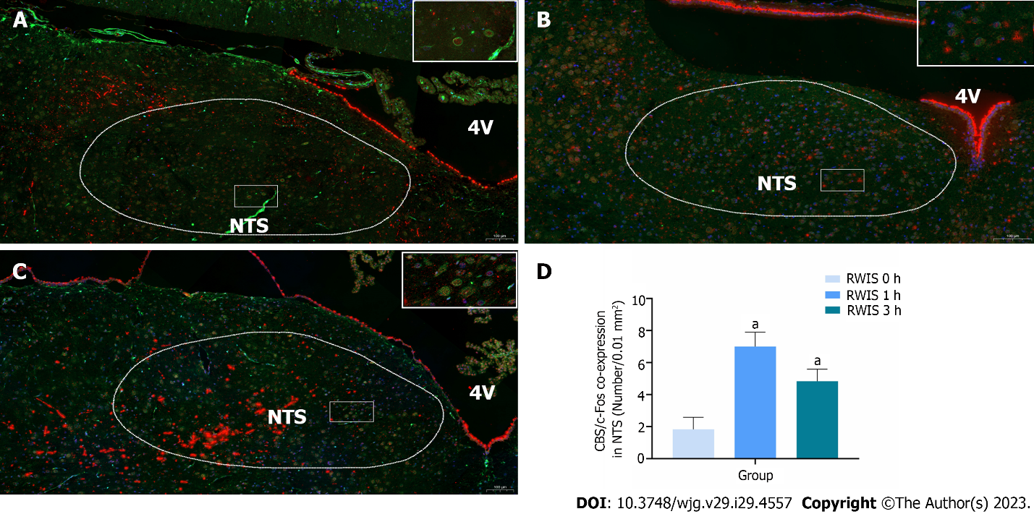
Figure 1 Co-expression of cystathionine beta-synthase (green) and c-Fos (red) neurons in the nucleus tractus solitarius at different times of restraint water-immersion stress. A: Expression of cystathionine beta-synthase (CBS) and c-Fos in restraint water-immersion stress (RWIS) at 0 h; B: Expressions of CBS and c-Fos in RWIS at 1 h; C: Expression of CBS and c-Fos in RWIS at 3 h; D: Quantification of neurons co-expressing CBS and c-Fos in the nucleus tractus solitarius (n = 6). ªP < 0.01 vs RWIS 0 h group. NTS: Nucleus tractus solitarius; RWIS: Restraint water-immersion stress; CBS: Cystathionine beta-synthase.

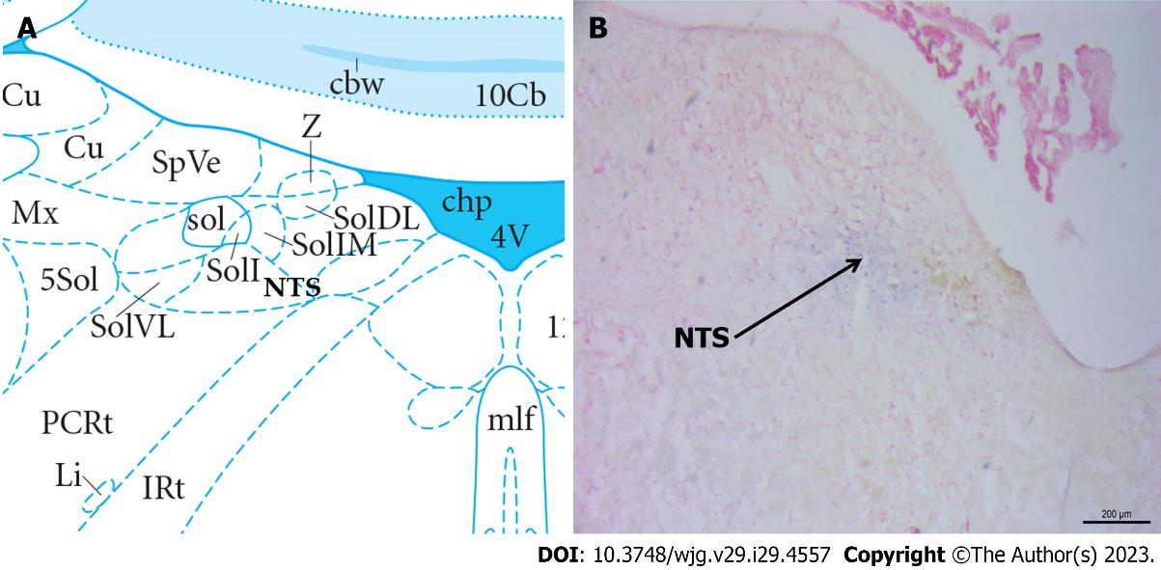
Figure 2 Histological identification of microinjections located at the nucleus tractus solitarius in the brain. A: Location of the nucleus tractus solitarius (NTS) in the brain atlas; B: Neutral red stained brain section with blue dot sites representing injection into the NTS. NTS: Nucleus tractus solitarius.

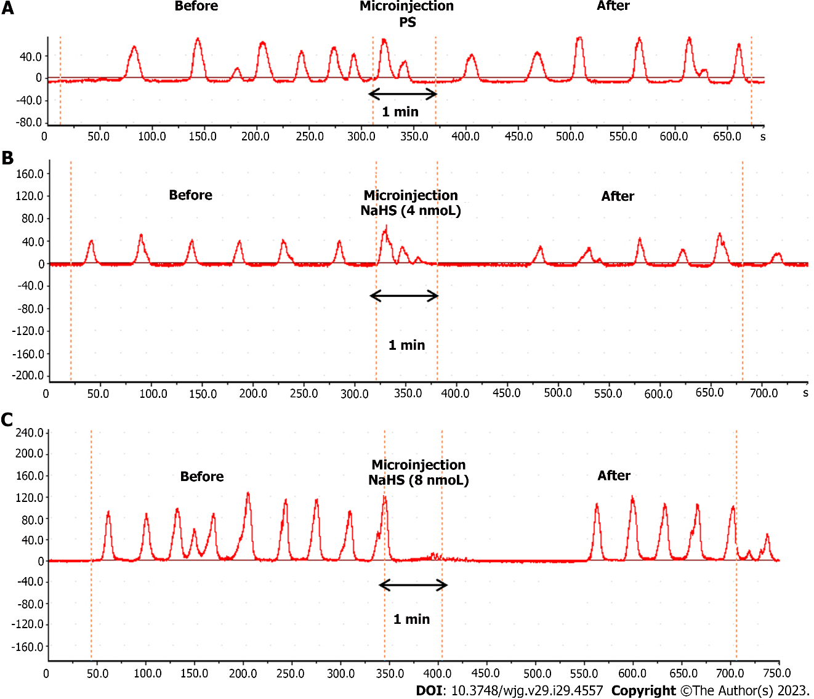
Figure 3 Effect of microinjection of drugs in the nucleus tractus solitarius on gastric motility in rats. A: Gastric motility curves were recorded in rats microinjected with saline at the nucleus tractus solitarius (NTS); B: Gastric motility curves were recorded in rats microinjected with 4 nmol NaHS in the NTS; C: Gastric motility curves were recorded in rats microinjected with 8 nmol NaHS in the NTS. PS: Physiological saline.

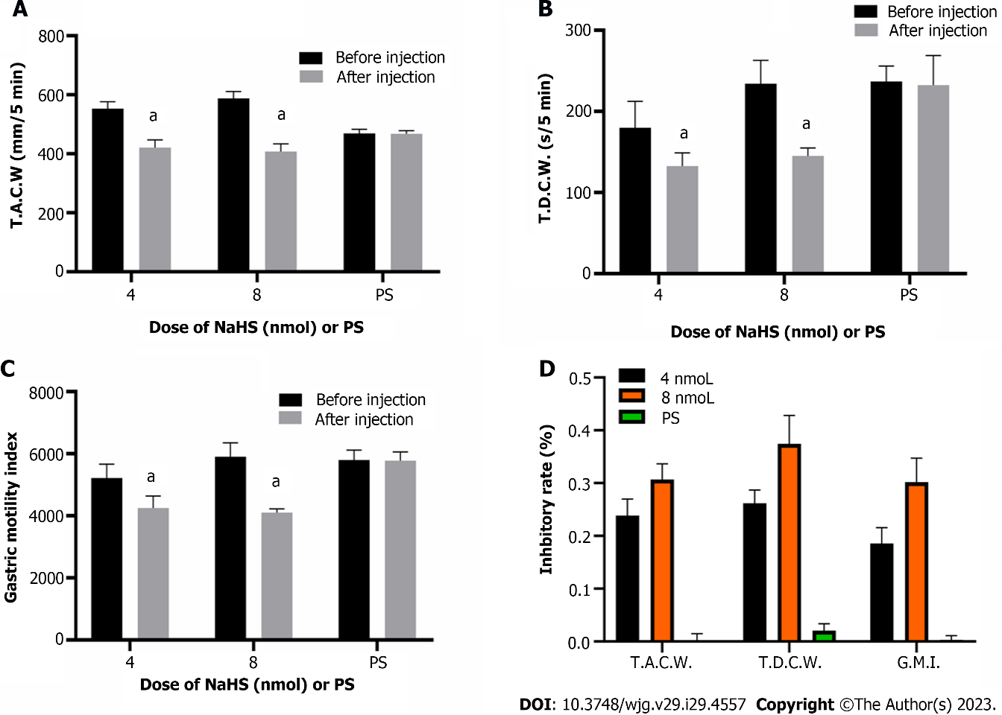
Figure 4 Effects of the microinjection of NaHS (4 nmol and 8 nmol) and physiological saline into the nucleus tractus solitarius before and after the gastric motility data. A: Total amplitude of the contraction wave (T.A.C.W.); B: Total duration of the contraction wave (T.D.C.W.); C: Gastric motility index (G.M.I.); D: Inhibition rates of T.A.C.W., T.D.C.W., and G.M.I. ªP < 0.01 vs before injection. PS: Physiological saline; T.A.C.W.: Total amplitude of the contraction wave; T.D.C.W.: Total duration of the contraction wave; G.M.I.: Gastric motility index.

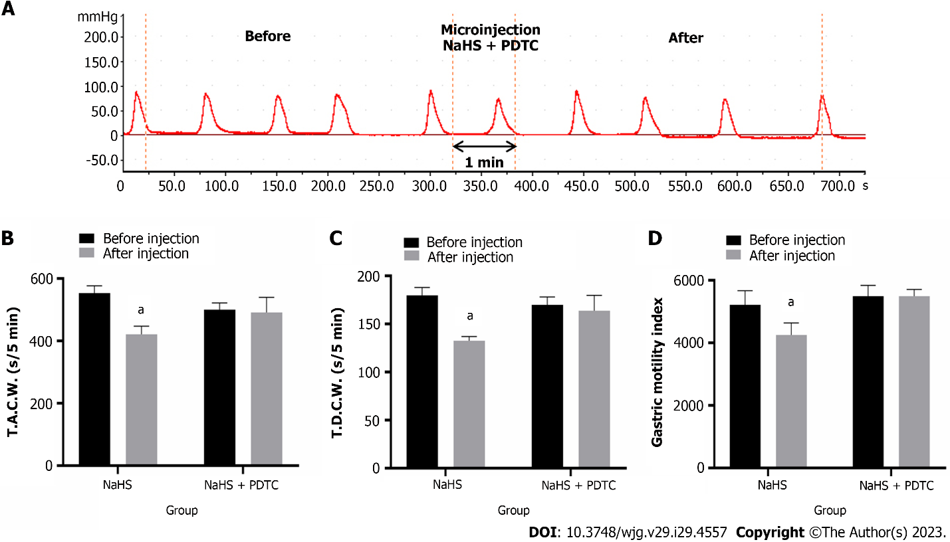

Figure 5 Effect of microinjection of 4 nmol NaHS and 4 nmol NaHS + pyrrolidine dithiocarbamate into the nucleus tractus solitarius on gastric motility in rats. A: Gastric motility curve recorded in rats with 4 nmol NaHS + pyrrolidine dithiocarbamate microinjection in nucleus tractus solitarius; B: Data of total amplitude of the contraction wave; C: Data of total duration of the contraction wave; D: Data of gastric motility index. ªP < 0.01 vs before injection. PDTC: Pyrrolidine dithiocarbamate; T.A.C.W.: Total amplitude of the contraction wave; T.D.C.W.: Total duration of the contraction wave.

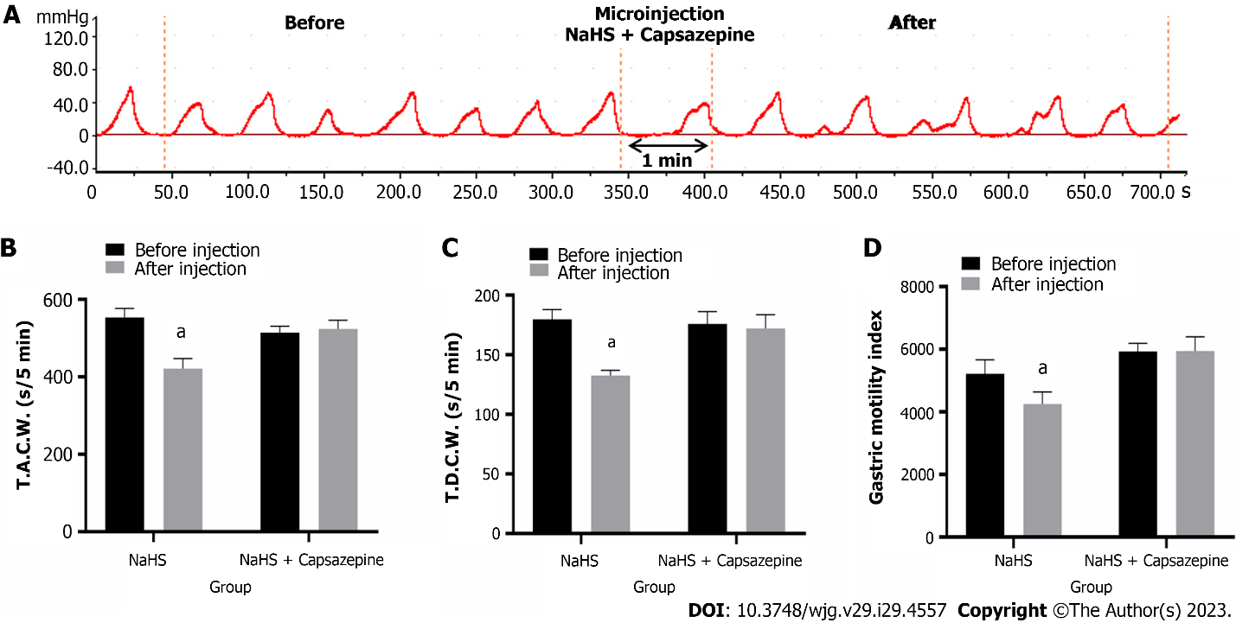
Figure 6 Effects of microinjection of 4 nmol NaHS and 4 nmol NaHS + Capsazepine into the nucleus tractus solitarius on gastric motility in rats. A: Gastric motility curve recorded in rats with 4 nmol NaHS + Capsazepine microinjection in nucleus tractus solitarius; B: Data of total amplitude of the contraction wave; C: Data of total duration of the contraction wave; D: Data of gastric motility index. ªP < 0.01 vs before injection. T.A.C.W.: Total amplitude of the contraction wave; T.D.C.W.: Total duration of the contraction wave.

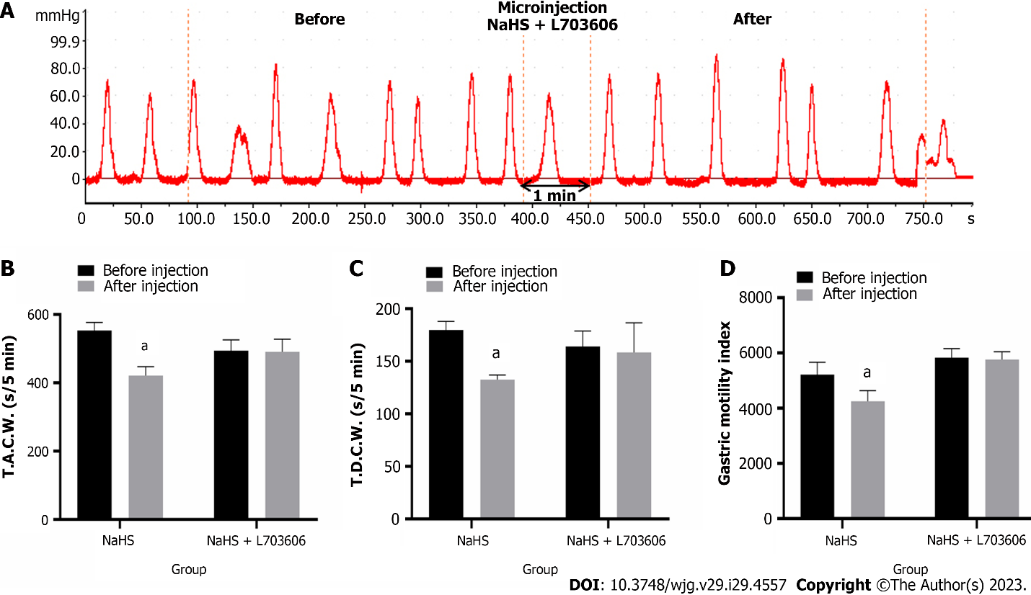
Figure 7 Effects of microinjection of 4 nmol NaHS and 4 nmol NaHS + L703606 into the nucleus tractus solitarius on gastric motility in rats. A: Gastric motility curve recorded in rats with 4 nmol NaHS + L703606 microinjection in nucleus tractus solitarius; B: Data of total amplitude of the contraction wave; C: Data of total duration of the contraction wave; D: Data of gastric motility index. ªP < 0.01 vs before injection. T.A.C.W.: Total amplitude of the contraction wave; T.D.C.W.: Total duration of the contraction wave.

Published by Baishideng Publishing Group Inc
7041 Koll Center Parkway, Suite 160, Pleasanton, CA 94566, USA
Telephone: +1-925-3991568
E-mail: bpgoffice@wjgnet.com
Help Desk: https://www.f6publishing.com/helpdesk
https://www.wjgnet.com

© 2023 Baishideng Publishing Group Inc. All rights reserved.

