Name of Journal: World Journal of Clinical Cases
Manuscript NO: 72096
Manuscript Type: META-ANALYSIS

Prognostic value of neutrophil/lymphocyte, platelet/lymphocyte, lymphocyte/monocyte ratios and Glasgow prognostic score in osteosarcoma: A meta-analysis

Peng LP et al. NLR and GPS in osteosarcoma

Li-Peng Peng, Jie Li, Xian-Feng Li

Li-Peng Peng, Jie Li, Xian-Feng Li, Department of Orthopedic, The Second People's Hospital of Yibin, Yibin 644000, Sichuan Province, China

Author contributions: Li XF made the substantial contributions to the conception and design of the work; Peng LP and Li J searched, selected materials and extracted data; Peng LP wrote this manuscript; Li J and Li XF revised the paper carefully and also contributed to the statistical analysis; all authors have read and approved the final manuscript.

Corresponding author: Xian-Feng Li, MD, Surgeon, Department of Orthopedic, The Second People's Hospital of Yibin, No. 96 North Street, Cuiping District, Yibin 64000, Sichuan Province, China. 2396806953@qq.com

Received: October 4, 2021
Revised: November 19, 2021
Accepted: January 17, 2022
Published online:

Abstract
BACKGROUND
Some studies investigated the prognostic role of several blood biomarkers, including the neutrophil/lymphocyte ratio (NLR), platelet/lymphocyte ratio (PLR), lymphocyte/monocyte ratio (LMR) and Glasgow prognostic score (GPS), in osteosarcoma, but their results were inconsistent with each other.

AIM
To identify the prognostic value of NLR, PLR, LMR and GPS in osteosarcoma patients through reviewing relevant studies.

METHODS
The PubMed, EMBASE, Web of Science and CNKI databases were searched up to October 2, 2021. The primary and second outcomes were overall survival (OS) and disease-free survival (DFS), respectively. The hazard ratios (HRs) with 95% confidence intervals (CIs) were combined to assess the association between these indicators and prognosis of osteosarcoma patients.

RESULTS
A total of 13 studies involving 2087 patients were eventually included. The pooled results demonstrated that higher NLR and GPS were significantly associated with poorer OS (HR = 1.88, 95%CI: 1.38-2.55, P < 0.001; HR = 2.19, 95%CI: 1.64-2.94, P < 0.001) and DFS (HR = 1.67, 95%CI: 1.37-2.04, P < 0.001; HR = 2.50, 95%CI: 1.39-4.48, P < 0.001). However, no significant relationship of PLR and LMR and OS (P = 0.085; P = 0.338) and DFS (P = 0.396; P = 0.124) was observed.

CONCLUSION
Higher NLR and GPS were related with worse prognosis and might serve as novel prognostic indicators for osteosarcoma patients.

Key Words: Neutrophil/lymphocyte; Platelet/lymphocyte; Lymphocyte/monocyte ratios; Glasgow prognostic score; Osteosarcoma; Prognosis; Meta-analysis

Peng LP, Li J, Li XF. Prognostic value of neutrophil/lymphocyte, platelet/lymphocyte, lymphocyte/monocyte ratios and Glasgow prognostic score in osteosarcoma patients: A meta-analysis. World J Clin Cases 2022; In press

Core Tip: Higher neutrophil/lymphocyte ratio (NLR) and Glasgow prognostic score (GPS) were significantly associated with poorer overall survival (OS) (P < 0.001; P < 0.001) and disease-free survival (DFS) (P < 0.001; P < 0.001). However, no significant relationship of platelet/lymphocyte ratio and lymphocyte/monocyte ratio and OS (P = 0.085; P = 0.338) and DFS (P = 0.396; P = 0.124) was observed. Higher NLR and GPS were related with worse prognosis in osteosarcoma and might serve as reliable and valuable prognostic indicators for osteosarcoma patients.

INTRODUCTION
Osteosarcoma is a malignant bone tumor that seriously affects the health of children and adolescents with annual incidence of 2-3/1 million, accounting for about 20%-30% of all primary bone tumors^{[1]}. It has the characteristics of high malignant degree, early metastasis and high mortality. Before the 1070s, the treatment of osteosarcoma was mainly based on the surgical resection with the five-year survival rate of 10%-20%^{[2,3]}. In recent years. Through the combination of preoperative neoadjuvant chemotherapy, surgical resection, postoperative adjuvant chemotherapy and other important therapies, the five-year survival rate of osteosarcoma patients has increased to 60%-70%^{[4,5]}.
However, osteosarcoma tends to metastasize to the lungs and nearly half of osteosarcoma cases have pulmonary metastases, which is the main cause of death in patients with osteosarcoma^{[6]}. Nevertheless, less than 20% of patients showed metastases at the time of diagnosis and the five-year survival rate of patients with pulmonary metastases is less than 30%^{[6,7]}. Thus, some reliable and valuable prognostic indicators are still clinically needed to accurately predict the survival of osteosarcoma patients and contribute to the formulation of appropriate treatment strategies.
In recent years, many haematological indexes have been reported to show high prognostic value in cancer patients, including the neutrophil to lymphocyte ratio (NLR)^{[8,9]}, platelet to lymphocyte ratio (PLR)^{[10,11]}, lymphocyte to monocyte ratio (LMR)^{[10]} and Glasgow prognostic score (GPS)^{[12-14]}. Besides, the NLR has been also reported to play a role in predicting postoperative complications like the anastomoticleakage^{[15]}Some investigators explored the prognostic value of these indicators in osteosarcoma^{[16-28]}, but inconsistent results were reported in their studies. Whether they could be used to predict prognosis of osteosarcoma patients in clinics remains unclear.
Thus, the aim of this study was to identify the prognostic role of NLR, PLR, LMR and GPS in osteosarcoma, which might help formulate the appropriate treatment strategies for osteosarcoma patients.

MATERIALS AND METHODS
This systematic review and meta-analysis were conducted according to the Preferred Reporting Items for Systematic Reviews and Meta-Analyses guidelines^{[29]}.

Literature search
The PubMed, EMBASE, Web of Science and CNKI electronic databases were searched up to October 2, 2021. The following key works were used during the literature search: neutrophil/lymphocyte ratio, neutrophil to lymphocyte ratio, NLR, platelet/lymphocyte ratio; platelet to lymphocyte ratio, PLR, lymphocyte/monocyte ratio, lymphocyte to monocyte ratio, LMR, Glasgow prognostic score, GPS, osteosarcoma, osteogenic sarcoma, prognostic, prognosis and survival. Besides, the references cited in the included studies were also evaluated for availability.

Inclusion and exclusion criteria
The following inclusion criteria were applied: (1) Patients were pathologically diagnosed with osteosarcoma; (2) Patients were divided into two groups according to the NLR, PLR, LMR or GPS and the long-term survival of patients between the two groups were compared; and (3) Hazard ratios (HRs) with corresponding 95% confidence intervals (CIs) of overall survival (OS) or disease-free survival (DFS) were reported in the articles directly.
The following exclusion criteria were applied: (1) None of the prognostic value of NLR, PLR, LMR or GPS were investigated; (2) Duplicated or overlapped data; and (3) Conference abstracts, animal trials, case reports or reviews.

Data extraction and quality assessment
The following information were collected from included studies: the name of first author, publication year, country, sample size, indicators (NLR, PLR, LMR or GPS), cutoff values of NLR, PLR or LMR, endpoints and corresponding HRs with 95%CIs.
The Newcastle-Ottawa scale (NOS) was used for the quality assessment of included studies and high-quality studies were defined as a NOS of 6 or higher^{[30]}.
In the current meta-analysis, the literature search, selection, data extraction and quality assessment were all performed by two authors independently and any disagreement was resolved by team discussion.

Statistical analysis
The HRs with 95%CIs were combined to assess the relationship between NLR, PLR, LMR and GPS and prognosis of osteosarcoma patients. The heterogeneity among included studies was evaluated by I² statistics and Q test. When obvious heterogeneity was observed presenting as the I² > 50% or (and) P < 0.1, the random effect model was used; otherwise, the fix effect model was used^{[31]}. Considering the similarity, we combined the cancer-specific survival, event-free and progression-free as DFS. The sensitivity analysis was performed to detect the source of heterogeneity and evaluated the stability of pooled results. Besides, the Begg’s funnel plot and Egger’s test were conducted to detect publication bias^{[32]}. If significant publication bias was observed presenting as a P < 0.05, then the nonparametric trim-and-fill method was used to re-estimate a corrective effect size after publication bias was adjusted^{[33]}. All statistical analyses were conducted by STATA 15.0 software.

RESULTS
Literature selection process
Ninety-one records were initially identified and 21 duplicated records were removed. Then 28 potentially relevant publications were assessed and 10 of them were excluded because of meeting abstract, case reports and reviews. Eighteen full texts were reviewed and a total of 13 studies were included eventually^{[16-28]}. The detailed selection process was presented in Figure 1.

Basic characteristics of included studies
All include studies were retrospective. Most of them were from China and a total of 2087 patients were enrolled, with the sample size ranging from 55 to 327. All of them were high-quality studies with a NOS of 6 or higher. The specific information was presented in Table 1.

Association between NLR and prognosis of osteosarcoma patients
Eleven studies involving 1623 patients investigated the prognostic role of NLR in osteosarcoma^{[17-24,26-28]}. The pooled results indicated that higher NLR was significantly associated with poor OS (HR = 1.88, 95%CI: 1.38-2.55, P < 0.001; I² = 80.2%, P < 0.001) (Figure 2A) and DFS (HR = 1.67, 95%CI: 1.37-2.04, P < 0.001; I² = 35.4%, P = 0.186) (Figure 2B). NLR was demonstrated to be a prognostic indicator for osteosarcoma patients (Table 2).

Association between PLR and prognosis of osteosarcoma patients
Eight studies involving 1215 patients explored the prognostic value of PLR in osteosarcoma patients^{[17,19-21,23,24,27,28]}. However, no significant relationship of PLR with OS (HR = 1.29, 95%CI: 0.97-1.72, P = 0.085; I² = 77.4%, P < 0.001) (Figure 3A) and DFS (HR = 1.12, 95%CI: 0.87-1.44, P < 0.001; I² =0.0%, P = 0.465) (Figure 3B) was observed (Table 2).

Association between LMR and prognosis of osteosarcoma patients
Six studies involving 906 participants were included to identify the association of LMR with prognosis of osteosarcoma patients^{[16,17,25-28]}. The pooled results manifested that LMR was not related with OS (HR = 0.82, 95%CI: 0.54-1.23, P = 0.338; I² = 70.8%, P = 0.004) (Figure 4A) or DFS (HR = 0.68, 95%CI: 0.41-1.11, P = 0.124; I² = 76.1%, P = 0.041) (Figure 4B) of osteosarcoma patients (Table 2).

Association between GPS and prognosis of osteosarcoma patients
Only four studies investigate the relationship of GPS with survival of osteosarcoma patients^{[17,18,20,22]}. The pooled results certified that GPS was a novel predictor for OS (HR = 2.19, 95%CI: 1.64-2.94, P < 0.001; I² = 0.0%, P = 0.602) (Figure 5A) and DFS (HR = 2.50, 95%CI: 1.39-4.48, P < 0.001; I² = 0.0%, P = 0.342) (Figure 5B) of osteosarcoma patients (Table 2).

Sensitivity analysis and publication bias analysis
The sensitivity analysis and publication bias analysis for the association between NLR and OS of osteosarcoma patients were performed. The sensitivity analysis indicated that the pooled results were stable and reliable (Figure 6). Furthermore, the Begg’s funnel plot was asymmetric (Figure 7A) and the P value of Egger’s test was < 0.001, which indicated significant publication bias. Then the nonparametric trim-and-fill method was used and six potentially unpublished papers were found (Figure 7B). After combining these six publications, the pooled HRs for the fixed effect model and random effect model were 1.137 (95%CI: 1.036-1.247, P = 0.007) and 1.255 (95%CI: 0.952-1.654, P = 0.107), which indicated that the potentially unpublished studies might have a significant impact on the pooled results. Thus, more prospective studies with high-quality are still needed to verify our findings.

DISCUSSION
The current study demonstrated that higher NLR and GPS were independent prognostic risk factors for poorer OS and DFS of osteosarcoma patients, but no significant association of PLR and LMR with prognosis in osteosarcoma was identified. However, obvious publication bias was observed in this meta-analysis and more prospective high-quality studies are still needed to verify above findings.
It has been widely known that the systematic inflammation response is closely related with the occurrence and development of tumors. The detailed internal mechanisms have been deeply explored and introduced in previous literatures^{[8,33-35]}. The neutrophils, lymphocytes, platelets, monocytes and C-reactive protein are all common inflammatory biomarkers and a great number of studies have revealed the prognostic role of NLR, PLR, LMR and GPS in tumors. Several met-analyses demonstrated that elevated pretreatment NLR was a prognostic risk factor in colorectal cancer (HR = 1.57, 95%CI: 1.39-1.78, P < 0.001)^{[36]}, gastric cancer (HR = 1.78, 95%CI: 1.59-1.99, P < 0.001)^{[37]}, laryngeal cancer (HR = 1.76, 95%CI: 1.53-2.03, P < 0.001)^{[38]} and non-small cell lung cancer patients (HR = 2.86, 95%CI: 2.11-3.87, P < 0.001)^{[39]}. Furthermore, the prognostic value of GPS has been verified in ovarian cancer (HR = 1.62, 95%CI: 1.38-1.91, P < 0.001), esophageal squamous cell cancer (HR = 1.66, 95%CI: 1.14-2.41, P = 0.008), colorectal cancer (HR = 2.20, 95%CI: 1.88-2.57, P < 0.001) and lung cancer patients (HR = 2.058, 95%CI: 1.51-2.80, P < 0.05) by several meta-analyses^{[14,40-42]}. Similarly, the PLR and LMR have also been reported to show high prognostic value in cancer patients by some studies with high-quality evidence^{[33,43-47]}. However, whether the NLR, PLR, LMR and GPS could serve as valuable predictors for long-term survival in osteosarcoma remained unclear. Thus, we conducted the current meta-analysis and revealed the high prognostic value of NLR and GPS in osteosarcoma patients.
In our study, the LMR was not statistically related with prognosis of osteosarcoma patients. However, among the six included studies, two of them reported significantly positive association of lower LMR with poorer OS^{[16,28]}. Remarkably, Yang et al^{[27]} seemed to report conflicting results. According to the Kaplan-Meier survival curve, patients with lower LMR had poorer OS than patients with higher LMR did; however, the univariate analysis indicated that higher LMR was a risk factor for worse OS^{[27]}. After excluding this study, the pooled HR was 0.69 (95%CI: 0.55-0.87, P = 0.002) by combining the remaining studies. Thus, we deem that LMR is also a valuable prognostic indicator in osteosarcoma patients, but more relevant studies are needed to further verify this.
Actually, we suppose that there are still some fields worth further investigation. Although we identified the prognostic role of these indexes, a comparison of their prognostic values was not conducted and it is not clear whether a combination of them would show higher predictive role for prognosis in osteosarcoma patients. Whether these indicators could predict the therapeutic effects of neoadjuvant or adjuvant chemotherapy is unclear. Besides, we deem that these blood parameters might play a role in the diagnosis of osteosarcoma or its recurrence. Based on our findings, we suggested that the NLR and GPS should be considered for the assessment of disease status and formulation of therapy strategies and osteosarcoma patients with higher pretreatment NLR or GPS might receive more aggressive treatment and follow-up. Besides, it is worth exploring whether anti-inflammation treatment, reducing the NLR and GPS, is beneficial for osteosarcoma patients with high NLR or GPS.
There are several limitations in this meta-analysis. First, all included studies are retrospective with relatively small sample size, which might cause some bias. Second, most studies are from China, which limits the application of our results in other regions or countries. Third, subgroup analyses based on some important parameters such as the disease stage, age and treatment were not able to performed due to lack of relevant data.

CONCLUSION
In overall, higher NLR and GPS were related with worse prognosis and might serve as valuable prognostic indicators for osteosarcoma patients. However, more prospective high-quality studies are still needed to verify our findings.

ARTICLE HIGHLIGHTS
Research background
Previous researches explored the prognostic role of the neutrophil/lymphocyte ratio (NLR), platelet/lymphocyte ratio (PLR), lymphocyte/monocyte ratio (LMR) and Glasgow prognostic score (GPS) in osteosarcoma, but their results were inconsistent with each other.

Research motivation
To verify the prognostic value of these blood indexes in osteosarcoma patients.

Research objectives
To verify the prognostic value of these blood indexes in osteosarcoma patients.

Research methods
Several electronic databases were searched to identify relevant articles. The hazard ratio (HR) with 95% confidence interval (CI) was combined to the evaluate the association between these indicators and overall survival (OS) and disease-free survival (DFS).

Research results
Higher NLR and GPS were significantly associated with poorer OS (P < 0.001; P < 0.001) and DFS (P < 0.001; P < 0.001). However, no significant relationship of PLR and LMR and OS (P = 0.085; P = 0.338) and DFS (P = 0.396; P = 0.124) was observed.

Research conclusions
Higher NLR and GPS were related with worse prognosis in osteosarcoma.

Research perspectives
The NLR and GPS might serve as reliable and valuable prognostic indicators for osteosarcoma patients.

REFERENCES
1 Smeland S, Bielack SS, Whelan J, Bernstein M, Hogendoorn P, Krailo MD, Gorlick R, Janeway KA, Ingleby FC, Anninga J, Antal I, Arndt C, Brown KLB, Butterfass-Bahloul T, Calaminus G, Capra M, Dhooge C, Eriksson M, Flanagan AM, Friedel G, Gebhardt MC, Gelderblom H, Goldsby R, Grier HE, Grimer R, Hawkins DS, Hecker-Nolting S, Sundby Hall K, Isakoff MS, Jovic G, Kühne T, Kager L, von Kalle T, Kabickova E, Lang S, Lau CC, Leavey PJ, Lessnick SL, Mascarenhas L, Mayer-Steinacker R, Meyers PA, Nagarajan R, Randall RL, Reichardt P, Renard M, Rechnitzer C, Schwartz CL, Strauss S, Teot L, Timmermann B, Sydes MR, Marina N. Survival and prognosis with osteosarcoma: outcomes in more than 2000 patients in the EURAMOS-1 (European and American Osteosarcoma Study) cohort. Eur J Cancer 2019; 109: 36-50 [PMID: 30685685 DOI: 10.1016/j.ejca.2018.11.027]
2 American Cancer Society Cancer Statistics 2021 Report. J Nucl Med 2021; 62: 12N [PMID: 33622967]
3 Ferlay J, Colombet M, Soerjomataram I, Parkin DM, Piñeros M, Znaor A, Bray F. Cancer statistics for the year 2020: An overview. Int J Cancer 2021 [PMID: 33818764 DOI: 10.1002/ijc.33588]
4 Isakoff MS, Bielack SS, Meltzer P, Gorlick R. Osteosarcoma: Current Treatment and a Collaborative Pathway to Success. J Clin Oncol 2015; 33: 3029-3035 [PMID: 26304877 DOI: 10.1200/JCO.2014.59.4895]
5 Pruksakorn D, Teeyakasem P, Klangjorhor J, Chaiyawat P, Settakorn J, Diskul-Na-Ayudthaya P, Chokchaichamnankit D, Pothacharoen P, Srisomsap C. Overexpression of KH-type splicing regulatory protein regulates proliferation, migration, and implantation ability of osteosarcoma. Int J Oncol 2016; 49: 903-912 [PMID: 27573585 DOI: 10.3892/ijo.2016.3601]
6 Kager L, Zoubek A, Pötschger U, Kastner U, Flege S, Kempf-Bielack B, Branscheid D, Kotz R, Salzer-Kuntschik M, Winkelmann W, Jundt G, Kabisch H, Reichardt P, Jürgens H, Gadner H, Bielack SS; Cooperative German-Austrian-Swiss Osteosarcoma Study Group. Primary metastatic osteosarcoma: presentation and outcome of patients treated on neoadjuvant Cooperative Osteosarcoma Study Group protocols. J Clin Oncol 2003; 21: 2011-2018 [PMID: 12743156 DOI: 10.1200/jco.2003.08.132]
7 Chou AJ, Geller DS, Gorlick R. Therapy for osteosarcoma: where do we go from here? Paediatr Drugs 2008; 10: 315-327 [PMID: 18754698 DOI: 10.2165/00148581-200810050-00005]
8 Jiang Y, Xu D, Song H, Qiu B, Tian D, Li Z, Ji Y, Wang J. Inflammation and nutrition-based biomarkers in the prognosis of oesophageal cancer: a systematic review and meta-analysis. BMJ Open 2021; 11: e048324 [PMID: 34593492 DOI: 10.1136/bmjopen-2020-048324]
9 Zhou Q, Dong J, Sun Q, Lu N, Pan Y, Han X. Role of neutrophil-to-lymphocyte ratio as a prognostic biomarker in patients with breast cancer receiving neoadjuvant chemotherapy: a meta-analysis. BMJ Open 2021; 11: e047957 [PMID: 34561257 DOI: 10.1136/bmjopen-2020-047957]
10 Kumarasamy C, Tiwary V, Sunil K, Suresh D, Shetty S, Muthukaliannan GK, Baxi S, Jayaraj R. Prognostic Utility of Platelet-Lymphocyte Ratio, Neutrophil-Lymphocyte Ratio and Monocyte-Lymphocyte Ratio in Head and Neck Cancers: A Detailed PRISMA Compliant Systematic Review and Meta-Analysis. Cancers (Basel) 2021; 13 [PMID: 34439320 DOI: 10.3390/cancers13164166]
11 Wang E, Huang H, Tang L, Tian L, Yang L, Wang S, Ma H. Prognostic significance of platelet lymphocyte ratio in patients with melanoma: A meta-analysis. Medicine (Baltimore) 2021; 100: e27223 [PMID: 34559114 DOI: 10.1097/MD.0000000000027223]
12 Hu X, Wang Y, Yang WX, Dou WC, Shao YX, Li X. Modified Glasgow prognostic score as a prognostic factor for renal cell carcinomas: a systematic review and meta-analysis. Cancer Manag Res 2019; 11: 6163-6173 [PMID: 31308752 DOI: 10.2147/CMAR.S208839]
13 Wang Y, Li P, Li J, Lai Y, Zhou K, Wang X, Che G. The prognostic value of pretreatment Glasgow Prognostic Score in patients with esophageal cancer: a meta-analysis. Cancer Manag Res 2019; 11: 8181-8190 [PMID: 31564977 DOI: 10.2147/CMAR.S203425]
14 Wang Y, Chen L, Wu Y, Li P, Che G. The prognostic value of modified Glasgow prognostic score in patients with esophageal squamous cell cancer: a Meta-analysis. Nutr Cancer 2020; 72: 1146-1154 [PMID: 31617767 DOI: 10.1080/01635581.2019.1677925]
15 Radulescu D, Baleanu VD, Padureanu V, Radulescu PM, Bordu S, Patrascu S, Socea B, Bacalbasa N, Surlin MV, Georgescu I, Georgescu EF. Neutrophil/Lymphocyte Ratio as Predictor of Anastomotic Leak after Gastric Cancer Surgery. Diagnostics (Basel) 2020; 10 [PMID: 33050137 DOI: 10.3390/diagnostics10100799]
16 Liu T, Fang XC, Ding Z, Sun ZG, Sun LM, Wang YL. Pre-operative lymphocyte-to-monocyte ratio as a predictor of overall survival in patients suffering from osteosarcoma. FEBS Open Bio 2015; 5: 682-687 [PMID: 26380812 DOI: 10.1016/j.fob.2015.08.002]
17 Liu B, Huang Y, Sun Y, Zhang J, Yao Y, Shen Z, Xiang D, He A. Prognostic value of inflammation-based scores in patients with osteosarcoma. Sci Rep 2016; 6 [PMID: 28008988 DOI: 10.1038/srep39862]
18 Aggerholm-Pedersen N, Maretty-Kongstad K, Keller J, Baerentzen S, Safwat A. The Prognostic Value of Serum Biomarkers in Localized Bone Sarcoma. Transl Oncol 2016; 9(4): 322-328 [PMID: 27567955 DOI: 10.1016/j.tranon.2016.05.006]
19 Xia WK, Liu ZL, Shen D, Lin QF, Su J, Mao WD. Prognostic performance of pre-treatment NLR and PLR in patients suffering from osteosarcoma. World J Surg Oncol 2016; 14 [PMID: 27125872 DOI: 10.1186/s12957-016-0889-2]
20 Li YJ, Yao K, Lu MX, Zhang WB, Xiao C, Tu CQ. Prognostic value of the C-reactive protein to albumin ratio: a novel inflammation-based prognostic indicator in osteosarcoma. Onco Targets Ther 2017; 10: 5255-5261 [PMID: 29138578 DOI: 10.2147/OTT.S140560]
21 Vasquez L, León E, Beltran B, Maza I, Oscanoa M, Geronimo J. Pretreatment Neutrophil-to-Lymphocyte Ratio and Lymphocyte Recovery: Independent Prognostic Factors for Survival in Pediatric Sarcomas. J Pediatr Hematol Oncol 2017; 39: 538-546 [PMID: 28697168 DOI: 10.1097/MPH.0000000000000911]
22 Huang Z, Yang C, Luo Y, Deng Q, Rong X. Role of systemic inflammatory response in evaluating the prognosis of patients with osteosarcoma. J Pract Med 2018; 34: 3410-3414
23 Huang X, Hu H, Zhang W, Shao Z. Prognostic value of prognostic nutritional index and systemic immune-inflammation index in patients with osteosarcoma. J Cell Physiol 2019; 234(10): 18408-18414 [PMID: 30891768 DOI: 10.1002/jcp.28476]
24 Xu K, Li B, Huang Q, Jiang D, Sun H, Zhong N, Wan W, Wei H, Xiao J. Clinical significance of traditional clinical parameters and inflammatory biomarkers for the prognosis of patients with spinal chondrosarcoma: a retrospective study of 150 patients in a single center. Eur Spine J 2019; 28(6): 1468-1479 [PMID: 31055664 DOI: 10.1007/s00586-019-05993-4]
25 Hu H, Deng X, Song Q, Lv H, Chen W, Xing X, Zhu J, Tan Z, Cheng X, Wang B, Shao Z, Zhang Y. Prognostic Value of the Preoperative Lymphocyte-to-C-Reactive Protein Ratio and Albumin-to-Globulin Ratio in Patients with Osteosarcoma. Onco Targets Ther 2020; 13: 12673-12681 [PMID: 33328739 DOI: 10.2147/OTT.S287192]
26 Yang Q, Chen T, Yao Z, Zhang X. Prognostic value of pre-treatment Naples prognostic score (NPS) in patients with osteosarcoma. World J Surg Oncol 2020; 18(1) : 24 [PMID: 32000789 DOI: 10.1186/s12957-020-1789-z]
27 Yang S, Wu C, Wang L, Shan D, Chen B. Pretreatment inflammatory indexes as prognostic predictors for survival in osteosarcoma patients. Int J Clin Exp Pathol 2020; 13(3): 515-524 [PMID: 32269690]
28 Yeerhanati H, Aerhengbieke T, Aikebaier Y. Relation Between NLR, LMR, PLR and Prognosis of Osteosarcoma. Cancer Res Prev Treat 2021; 48: 381-386
29 Zhang X, Tan R, Lam WC, Yao L, Wang X, Cheng CW, Liu F, Chan JC, Aixinjueluo Q, Lau CT, Chen Y, Yang K, Wu T, Lyu A, Bian Z. PRISMA (Preferred Reporting Items for Systematic Reviews and Meta-Analyses) Extension for Chinese Herbal Medicines 2020 (PRISMA-CHM 2020). Am J Chin Med 2020; 48: 1279-1313 [PMID: 32907365 DOI: 10.1142/S0192415X20500639]
30 Stang A. Critical evaluation of the Newcastle-Ottawa scale for the assessment of the quality of nonrandomized studies in meta-analyses. Eur J Epidemiol 2010; 25: 603-605 [PMID: 20652370 DOI: 10.1007/s10654-010-9491-z]
31 Higgins JP, Thompson SG, Deeks JJ, Altman DG. Measuring inconsistency in meta-analyses. BMJ 2003; 327: 557-560 [PMID: 12958120 DOI: 10.1136/bmj.327.7414.557]
32 Wang Y, Li J, Chang S, Dong Y, Che G. Risk and Influencing Factors for Subsequent Primary Lung Cancer After Treatment of Breast Cancer: A Systematic Review and Two Meta-Analyses Based on Four Million Cases. J Thorac Oncol 2021; 16: 1893-1908 [PMID: 34256110 DOI: 10.1016/j.jtho.2021.07.001]
33 Wang Y, Huang D, Xu WY, Wang YW, Che GW. Prognostic Value of Pretreatment Lymphocyte-to-Monocyte Ratio in Non-Small Cell Lung Cancer: A Meta-Analysis. Oncol Res Treat 2019; 42: 523-531 [PMID: 31319409 DOI: 10.1159/000501726]
34 Candido S, Tomasello BMR, Lavoro A, Falzone L, Gattuso G, Libra M. Novel Insights into Epigenetic Regulation of IL6 Pathway: In Silico Perspective on Inflammation and Cancer Relationship. Int J Mol Sci 2021; 22 [PMID: 34576335 DOI: 10.3390/ijms221810172]
35 Wiedlocha A, Haugsten EM, Zakrzewska M. Roles of the FGF-FGFR Signaling System in Cancer Development and Inflammation. Cells 2021; 10 [PMID: 34571880 DOI: 10.3390/cells10092231]
36 Naszai M, Kurjan A, Maughan TS. The prognostic utility of pre-treatment neutrophil-to-lymphocyte-ratio (NLR) in colorectal cancer: A systematic review and meta-analysis. Cancer Med 2021; 10: 5983-5997 [PMID: 34308567 DOI: 10.1002/cam4.4143]
37 Du S, Fang Z, Ye L, Sun H, Deng G, Wu W, Zeng F. Pretreatment neutrophil-to-lymphocyte ratio predicts the benefit of gastric cancer patients with systemic therapy. Aging (Albany NY) 2021; 13: 17638-17654 [PMID: 34245559 DOI: 10.18632/aging.203256]
38 Yang F, Huang Q, Guan Z, Diao Q. Prognostic significance of pretreatment neutrophil-to-lymphocyte ratio in patients with laryngeal cancer: a systematic review and meta-analysis. Eur Arch Otorhinolaryngol 2021; 278: 417-425 [PMID: 32886184 DOI: 10.1007/s00405-020-06337-5]
39 Li Y, Zhang Z, Hu Y, Yan X, Song Q, Wang G, Chen R, Jiao S, Wang J. Pretreatment Neutrophil-to-Lymphocyte Ratio (NLR) May Predict the Outcomes of Advanced Non-small-cell Lung Cancer (NSCLC) Patients Treated With Immune Checkpoint Inhibitors (ICIs). Front Oncol 2020; 10: 654 [PMID: 32656072 DOI: 10.3389/fonc.2020.00654]
40 Jin J, Hu K, Zhou Y, Li W. Prognostic value of the Glasgow prognostic score in lung cancer: evidence from 10 studies. Int J Biol Markers 2018; 33: 201-207 [PMID: 29076522 DOI: 10.5301/ijbm.5000308]
41 Lu X, Guo W, Xu W, Zhang X, Shi Z, Zheng L, Zhao W. Prognostic value of the Glasgow prognostic score in colorectal cancer: a meta-analysis of 9,839 patients. Cancer Manag Res 2019; 11: 229-249 [PMID: 30636896 DOI: 10.2147/CMAR.S185350]
42 Xu S, Song L, Liu X. Prognostic Value of Pretreatment Glasgow Prognostic Score/Modified Glasgow Prognostic Score in Ovarian Cancer: A Systematic Review and Meta-Analysis. Nutr Cancer 2021: 1-8 [PMID: 34549675 DOI: 10.1080/01635581.2021.1980591]
43 Ding N, Pang Z, Shen H, Ni Y, Du J, Liu Q. The Prognostic Value of PLR in Lung Cancer, a Meta-analysis Based on Results from a Large Consecutive Cohort. Sci Rep 2016; 6: 34823 [PMID: 27703265 DOI: 10.1038/srep34823]
44 Zhang J, Zhang HY, Li J, Shao XY, Zhang CX. The elevated NLR, PLR and PLT may predict the prognosis of patients with colorectal cancer: a systematic review and meta-analysis. Oncotarget 2017; 8: 68837-68846 [PMID: 28978160 DOI: 10.18632/oncotarget.18575]
45 Jiang S, Liu J, Chen X, Zheng X, Ruan J, Ye A, Zhang S, Zhang L, Kuang Z, Liu R. Platelet-lymphocyte ratio as a potential prognostic factor in gynecologic cancers: a meta-analysis. Arch Gynecol Obstet 2019; 300(4): 829-839 [PMID: 31385023 DOI: 10.1007/s00404-019-05257-y]
46 Jin J, Yang L, Liu D, Li WM. Prognostic Value of Pretreatment Lymphocyte-to-Monocyte Ratio in Lung Cancer: A Systematic Review and Meta-Analysis. Technol Cancer Res Treat 2021; 20: 1533033820983085 [PMID: 33576324 DOI: 10.1177/1533033820983085]
47 Hu RJ, Ma JY, Hu G. Lymphocyte-to-monocyte ratio in pancreatic cancer: Prognostic significance and meta-analysis. Clin Chim Acta 2018; 481: 142-146 [PMID: 29544747 DOI: 10.1016/j.cca.2018.03.008]

Footnotes
Conflict-of-interest statement: The authors declared no potential conflicts of interest with respect to the research, authorship, and/or publication of this article.

PRISMA 2009 Checklist statement: This systematic review and meta-analysis were conducted according to the Preferred Reporting Items for Systematic Reviews and Meta-Analyses guidelines.

Open-Access: This article is an open-access article that was selected by an in-house editor and fully peer-reviewed by external reviewers. It is distributed in accordance with the Creative Commons Attribution NonCommercial (CC BY-NC 4.0) license, which permits others to distribute, remix, adapt, build upon this work non-commercially, and license their derivative works on different terms, provided the original work is properly cited and the use is non-commercial. See: https://creativecommons.org/Licenses/by-nc/4.0/

Provenance and peer review: Unsolicited article; Externally peer reviewed.
Peer-review model: Single blind

Peer-review started: October 4, 2021
First decision: November 11, 2021
Article in press:

Specialty type: Oncology
Country/Territory of origin: China
Peer-review report’s scientific quality classification
Grade A (Excellent): 0
Grade B (Very good): 0
Grade C (Good): C, C
Grade D (Fair): 0
Grade E (Poor): 0

P-Reviewer: Arigami T, Socea B S-Editor: Ma YJ L-Editor: A P-Editor: Ma YJ
Figure Legends
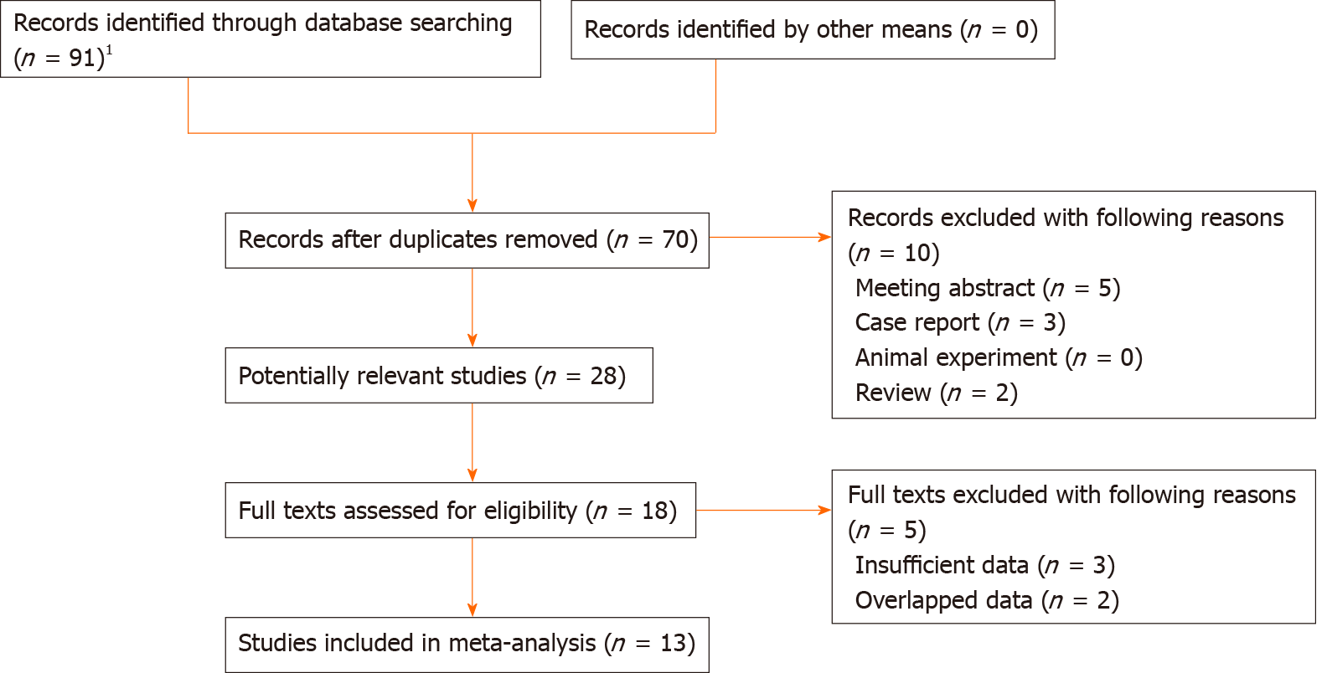
Figure 1 The flow diagram of this meta-analysis.
¹PubMed (n = 22), EMBASE (n = 26), Web of Science (n = 30), CNKI (n = 13).

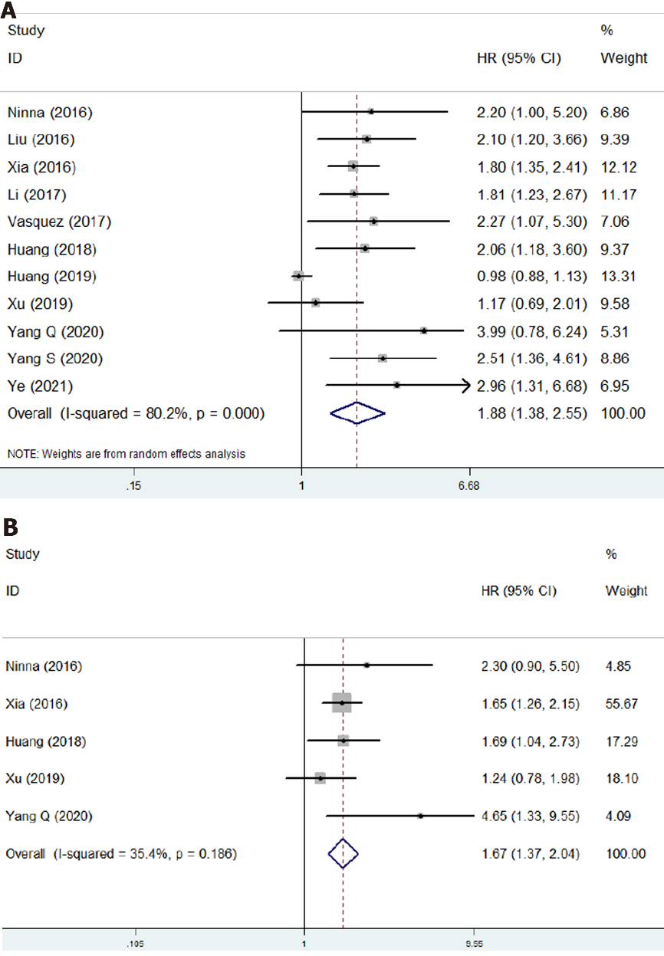
Figure 2 The association of neutrophil to lymphocyte ratio with prognosis of osteosarcoma patients. A: The association of neutrophil to lymphocyte ratio with overall survival of osteosarcoma patients; B: The association of neutrophil to lymphocyte ratio with disease-free survival of osteosarcoma patients. CI: Confidence interval; HR: Hazard ratio.

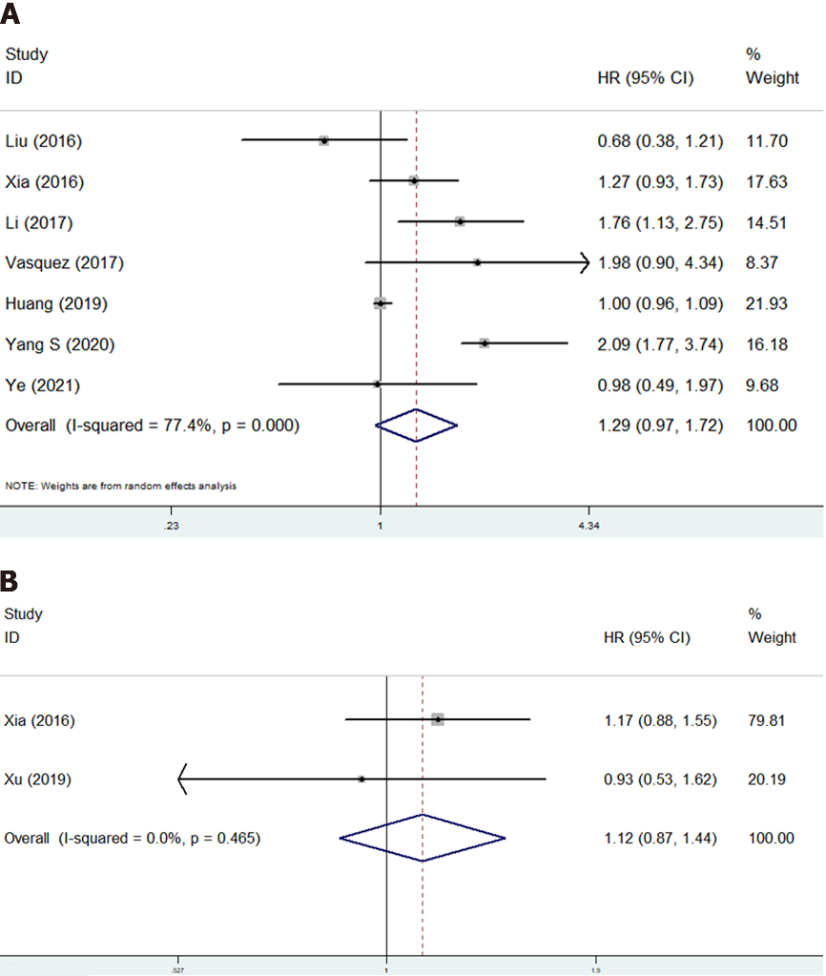
Figure 3 The association of platelet to lymphocyte ratio with prognosis of osteosarcoma patients. A: Overall survival; B: Disease-free survival. CI: Confidence interval; HR: Hazard ratio.

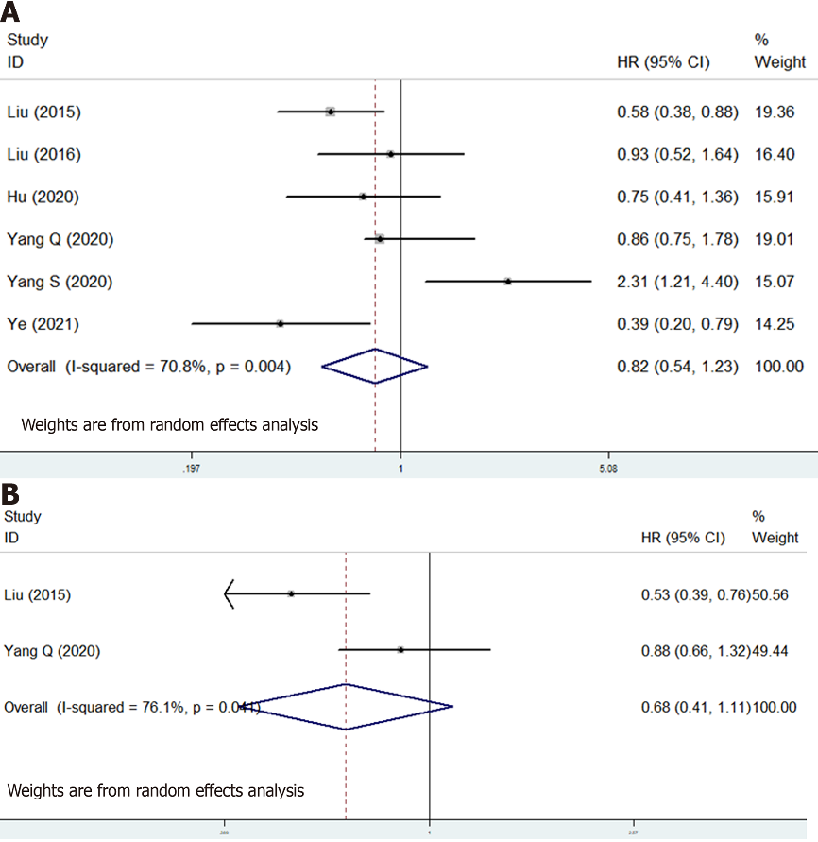
Figure 4 The association of lymphocyte to monocyte ratio with prognosis of osteosarcoma patients. A: The association of lymphocyte to monocyte ratio with overall survival of osteosarcoma patients; B: The association of lymphocyte to monocyte ratio with disease-free survival of osteosarcoma patients. CI: Confidence interval; HR: Hazard ratio.

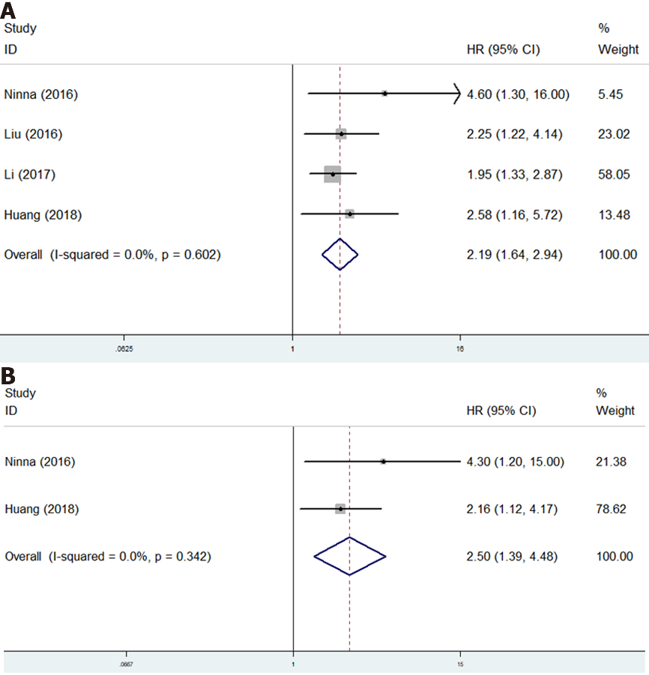

Figure 5 The association of Glasgow prognostic score with prognosis of osteosarcoma patients. A: The association of Glasgow prognostic score with overall survival of osteosarcoma patients; B: The association of Glasgow prognostic score with disease-free survival of osteosarcoma patients. CI: Confidence interval; HR: Hazard ratio.

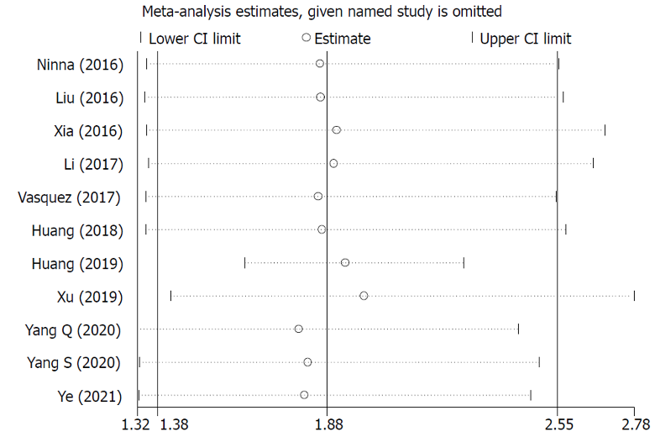
Figure 6 Sensitivity analysis about the association of neutrophil to lymphocyte ratio with overall survival of osteosarcoma patients. CI: Confidence interval.
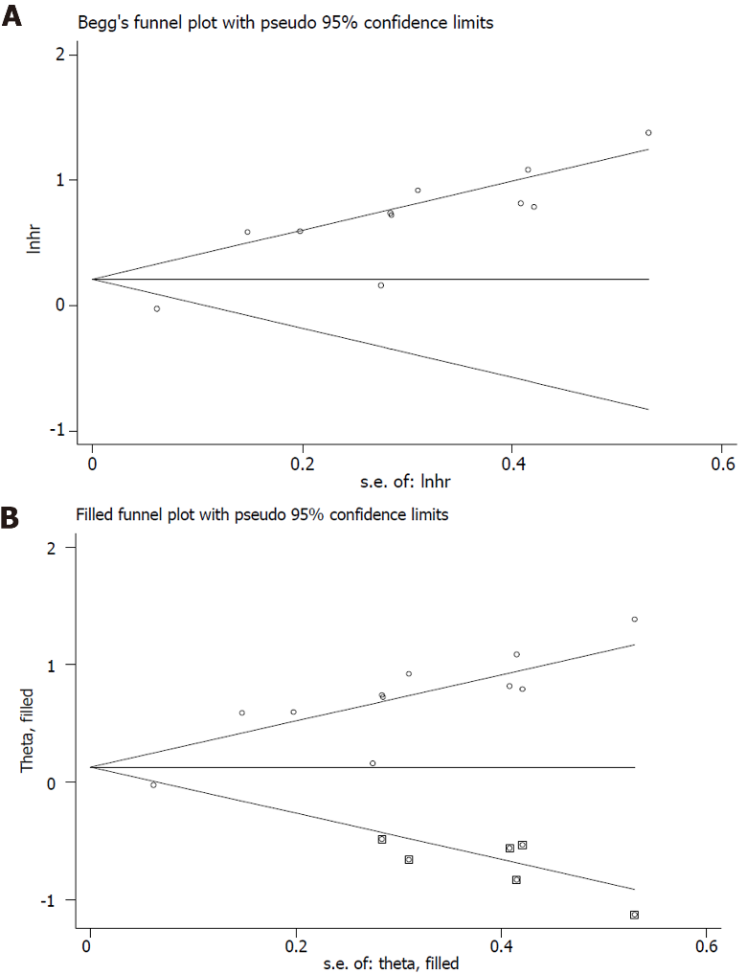
Figure 7 Begg’s analysis. A: Begg’s funnel plot; B: Trimed Begg’s funnel plot.

Table 1 Basic characteristics of included studies
Ref. | Year | Country | Sample size | Indicators | Thresholds | Endpoints | NOS
Liu et al^{[16]} | 2015 | China | 327 | LMR | 3.43 | OS, EFS | 7
Aggerholm-Pedersen et al^{[18]} | 2016 | Denmark | 172 | NLR, GPS | 5.3 | OS, CSS | 7
Liu et al^{[17]} | 2016 | China | 162 | NLR, PLR, LMR, GPS | 2.57, 123.5, 4.73 | OS | 6
Xia et al^{[19]} | 2016 | China | 359 | NLR, PLR | 3.43, 122 | OS, PFS | 7
Li et al^{[20]} | 2017 | China | 216 | NLR, PLR, GPS | 2.65, 118 | OS | 6
Vasquez et al^{[21]} | 2017 | Peru | 55 | NLR, PLR | 2, 150 | OS | 6
Huang et al^{[22]} | 2018 | China | 103 | NLR, mGPS | 2.70 | OS, EFS | 7
Huang et al^{[23]} | 2019 | China | 126 | NLR, PLR | 2.1, 163.2 | OS | 7
Xu et al^{[24]} | 2019 | China | 150 | NLR, PLR, LMR | 2.7, 200, 3.0 | OS, DFS | 6
Hu et al^{[25]} | 2020 | China | 137 | LMR | 3.05 | OS | 7
Yang et al^{[26]} | 2020 | China | 133 | NLR, LMR | 2.96, 4.44 | OS, PFS | 6
Yang et al^{[27]} | 2020 | China | 77 | NLR, PLR, LMR | 2.65, 125.0, 5.16 | OS | 7
Ye et al^{[28]} | 2021 | China | 70 | NLR, PLR, LMR | 3.025, 111.5, 4.82 | OS | 7
NLR: Neutrophil/lymphocyte ratio; PLR: Platelet/lymphocyte ratio; LMR: Lymphocyte/monocyte ratio; GPS: Glasgow prognostic score; mGPS: Modified Glasgow prognostic score; OS: Overall survival; CSS: Cancer-specific survival; EFS: Event-free survival; DFS: Disease-free survival; NOS: Newcastle-Ottawa quality assessment scale.
Table 2 Results of meta-analysis
 | No. of studies | HR | 95%CI | P value | I²(%) | P value
Neutrophil/lymphocyte ratio
Overall survival | 11 | 1.88 | 1.38-2.55 | < 0.001 | 80.2 | < 0.001
Disease-free survival | 5 | 1.67 | 1.37-2.04 | < 0.001 | 35.4 | 0.186
Platelet/lymphocyte ratio
Overall survival | 7 | 1.29 | 0.97-1.72 | 0.085 | 77.4 | < 0.000
Disease-free survival | 2 | 1.12 | 0.87-1.44 | 0.396 | 0.0 | 0.465
Lymphocyte/monocyte ratio
Overall survival | 6 | 0.82 | 0.54-1.23 | 0.338 | 70.8 | 0.004
Disease-free survival | 2 | 0.68 | 0.41-1.11 | 0.124 | 76.1 | 0.041
Glasgow prognostic score
Overall survival | 4 | 2.19 | 1.64-2.94 | < 0.001 | 0.0 | 0.602
Disease-free survival | 2 | 2.50 | 1.39-4.48 | < 0.001 | 0.0 | 0.342
HR: Hazard ratio; CI: Confidence interval.

