Name of Journal: World Journal of Clinical Cases
Manuscript NO: 55361
Manuscript Type: CASE REPORT

First branchial cleft cyst accompanied by external auditory canal atresia and middle ear malformation: A case report

Zhang C et al. Malformation of first branchial cleft cyst

Chun-Lin Zhang, Chun-Lei Li, Hang-Qi Chen, Qiang Sun, Zhao-Hui Liu

Chun-Lin Zhang, Chun-Lei Li, Hang-Qi Chen, Qiang Sun, Zhao-Hui Liu, Department of Otorhinolaryngology, Head and Neck Surgery, Affiliated Hospital of Zunyi Medical University, Zunyi 563000, Guizhou Province, China

Hang-Qi Chen, Qiang Sun, Postgraduate College of Zunyi Medical University, Zunyi 563000, Guizhou Province, China

Author contributions: Zhang CL, Li CL, Chen HQ and Sun Q contributed surgical treatment and collected follow-up data; Zhang CL wrote the paper; Liu ZH designed the study; Liu ZH revised the manuscript; all authors read and approved the final manuscript.

Corresponding author: Zhao-Hui Liu, MD, Chairman, Chief Doctor, Full Professor, Senior Lecturer, Department of Otolaryngology Head and Neck Surgery, Affiliated Hospital of Zunyi Medical University, No. 149, Dalian Road, Huichuan District, Zunyi 563000, Guizhou Province, China. rzent@163.com

Received: March 21, 2020
Revised: May 6, 2020
Accepted: July 17, 2020
Published online: August 26, 2020
Abstract
BACKGROUND
We report a rare case of first branchial cleft anomaly (FBCA) accompanied by bony atresia of the external auditory canal, middle ear malformation, and location malformation of the facial nerve according to the intraoperative findings.

CASE SUMMARY
A 19-year-old male patient presented to our department with a mass behind the right earlobe and recurrent postauricular swelling and pain since childhood, he also had severe hearing loss in the right ear since birth. The patient underwent surgery including mass removal, mastoidectomy, and simultaneous meatoplasty and ossiculoplasty under microscopy. No facial palsy or recurrence was noted during postoperative follow-up.

CONCLUSION
FBCAs are rare, and to our knowledge, this is the first report of FBCA accompanied by external auditory canal bony atresia, middle ear malformation, and location malformation of the facial nerve. An effective postauricular approach under microscopy facilitated complete lesion removal and simultaneous otologic reconstruction.

Key words: First branchial cleft anomaly; External auditory canal atresia; Middle ear malformation; Case report

Citation: Zhang CL, Li CL, Chen HQ, Sun Q, Li ZH. First branchial cleft cyst accompanied by external auditory canal atresia and middle ear malformation: A case report. World J Clin Cases 2020; 8(16): 3616-3620
URL: https://www.wjgnet.com/2307-8960/full/v8/i16/3616.htm
DOI: https://dx.doi.org/10.12998/wjcc.v8.i16.3616

Core tip: We report a rare case of first branchial cleft anomaly accompanied by bony atresia of the external auditory canal, middle ear malformation, and location malformation of the facial nerve according to the intraoperative findings. An effective treatment strategy including lesion excision, mastoidectomy, and simultaneous meatoplasty and ossiculoplasty was undertaken, which achieved a satisfactory outcome.
INTRODUCTION
First branchial cleft anomalies (FBCAs) are rare, accounting for less than 8% of all branchial anomalies in the head and neck. FBCAs are usually classified as cysts, sinuses, and fistulas according to the clinical features^{[1,2]}. In a few cases, FBCAs are accompanied by microtia, stenosis or atresia of the external auditory canal (EAC), and cholesteatoma^{[3-6]}. In this study, we report a case of FBCA accompanied by bony atresia of the EAC, middle ear malformation, as well as location malformation of the facial nerve (FN) according to the intraoperative findings. To our knowledge, this is the first report of such a complex case. An effective treatment strategy including lesion excision, mastoidectomy, and simultaneous meatoplasty and ossiculoplasty under microscopy was undertaken, which achieved a satisfactory outcome. As the cyst was closely related to the FN, we performed the cystectomy with complete preservation of the parotid gland under the microscope to better protect the FN.

CASE PRESENTATION
Chief complaints
A 19-year-old male patient presented to our department in June 2019, with a mass behind the right earlobe and recurrent postauricular swelling and pain since childhood. He received abscess incision drainage three times in a local hospital. The patient also had severe hearing loss in the right ear since birth.

History of present illness
The patient had a mass behind the right earlobe and recurrent postauricular swelling and pain since childhood.

History of past illness
The patient had no other previous medical history.

Physical examination
A 2 cm × 3 cm fluctuant and tender mass in the postauricular area, and bony atresia of the EAC were observed.

Laboratory examinations
A computed tomography (CT) scan of the temporal bone showed a hypointense cystic mass protruding into the area of the atretic EAC (Figure 1). Color Doppler ultrasound showed a mucocele-like lesion with inhomogenous internal echoes. Pure-tone audiometry showed severe conductive hearing loss with an air-bone conduction gap of 56 decibels (dB).

FINAL DIAGNOSIS
The final diagnosis in this patient was FBCA accompanied by EAC atresia and middle ear malformation.

TREATMENT
Under general anesthesia, mass excision, mastoidectomy, and simultaneous meatoplasty and tympanoplasty were performed under microscopy. A postauricular incision was performed, which showed that the mass originated from the stylomastoid foramen and adhered to the posterior surface of the parotid gland, invading the temporal bone. The lesion which tightly adhered to the stylomastoid foramen segment and the vertical segment of the FN was carefully removed with complete preservation of the parotid gland. Location malformation of the FN was observed, and the vertical segment was shifted to the anteposition and embedded in the lateral atresia bony plank of the tympanic cavity. We removed the bony structure to assess the tympanic cavity, and found that the ossicular chain was fused to the bony atresia plank, the malleus and incus were fused and fixed, and the stapes was normal with a mobile footplate. Tympanoplasty was performed with the tragus cartilage and a partial ossicular replacement prosthesis. A posterior occipital tissue flap and skin flap were used for meatoplasty (Figure 2).

OUTCOME AND FOLLOW-UP
The patient recovered well with an open EAC and improved hearing. The postoperative air-bone conduction gap was 21 dB, and the pure-tone average gain was 35 dB (Figure 3). No evidence of recurrence was found during follow-up at 6 mo postoperatively. No major complications, such as facial palsy and significant sensorineural hearing loss, occurred.

DISCUSSION
Generally, FBCAs are classified into Work I and Work II types according to the anatomical and histological features^{[7]}, Type I lesions are always present as soft cysts lined by squamous epithelium, and usually protrude into the EAC. Type II lesions usually present as a cyst, sinus, or fistula and are of ectodermal and mesodermal origin, containing either skin appendages or cartilage^{[6,8]}. The histopathological examination of our case showed a soft cyst lined by squamous epithelium, the lesion was classified as Type 1, as previously reported^{[6]}, the soft mass also protruded into the bony atresia plank.
Most structures of the head and neck originate from the differentiation of branchial arches. The first arch develops into the EAC and tympanic membrane, and abnormal differentiation can induce FBCAs and aberrations of the EAC. Generally, EAC bony atresia means that the bony atresia plank has occupied the normal structure of the EAC. FBCA accompanied by external ear diseases are rare, and to date, only a few FBCA cases accompanied by congenital EAC stenosis or atresia, and cholesteatoma have been reported^{[4,9-11]}. Banakis et al^{[4]} reported a case of bilateral ear canal cholesteatomas in the setting of underlying FBCA. Hinson et al^{[10]} reported the case of a 15-year-old female with a Type II first branchial cleft cyst presenting as a right neck mass and two main facial nerve trunks were found during surgery. However, to the best of our knowledge, this is the first report of a FBCA accompanied by EAC bony atresia, middle ear malformation and FN location malformation. The maldevelopment of the first and second branchial arches and the first gill ditch may cause malformation of the external and middle ear.
The diverse presentations and duplicated anomalies of FBCA pose a challenge for surgeons. As the lesions are usually very deep and often involved with the FN and parotid gland, especially in the condition of FBCA accompanied by aural stenosis or atresia, clinicians should be familiar with the otological and head and neck clinical features; surgical expertise must be available to remove the lesion completely, preserve FN function, and perform otologic reconstruction if necessary^{[12]}. Traditionally, surgical removal of a FBCA involves either superficial or total parotidectomy for exposure^{[13]}, which might cause unnecessary trauma and the risk of FN injury^{[6,10]}. Jang et al^{[11]} reported a recurrent FBCA case, in which canal wall-up mastoidectomy and lesion removal under microscopy, with an effective postauricular approach, were performed.

CONCLUSION
In the present case, for EAC bony atresia, a postauricular approach was chosen for mastoidectomy. During the operation, the cyst was tightly adhered to the FN and parotid gland, lesion excision under microscopy reduced the risk of FN injury with preservation of the parotid gland. Interestingly, we found that the FN vertical segment was embedded outside the atretic bony plate of the tympanic cavity, we thus performed canaloplasty and ossiculoplasty at the same time. The patient had hearing improvement after surgery. To our knowledge, this is the first report of a FBCA accompanied by EAC bony atresia, middle ear malformation and FN location malformation, which were successfully treated with FBCA lesion removal, and simultaneous meatoplasty and tympanoplasty.

REFERENCES
1 LaRiviere CA, Waldhausen JH. Congenital cervical cysts, sinuses, and fistulae in pediatric surgery. Surg Clin North Am 2012; 92: 583-597, viii [PMID: 22595710 DOI: 10.1016/j.suc.2012.03.015]
2 Maithani T, Pandey A, Dey D, Bhardwaj A, Singh VP. First branchial cleft anomaly: clinical insight into its relevance in otolaryngology with pediatric considerations. Indian J Otolaryngol Head Neck Surg 2014; 66: 271-276 [PMID: 24533397 DOI: 10.1007/s12070-012-0482-0]
3 Abdollahi Fakhim S, Naderpoor M, Mousaviagdas M. First branchial cleft fistula associated with external auditory canal stenosis and middle ear cholesteatoma. Iran J Otorhinolaryngol 2014; 26: 263-266 [PMID: 25320705]
4 Banakis Hartl RM, Said S, Mann SE. Bilateral Ear Canal Cholesteatoma with Underlying Type I First Branchial Cleft Anomalies. Ann Otol Rhinol Laryngol 2019; 128: 360-364 [PMID: 30607978 DOI: 10.1177/0003489418821700]
5 Yalçin S, Karlidağ T, Kaygusuz I, Demirbağ E. First branchial cleft sinus presenting with cholesteatoma and external auditory canal atresia. Int J Pediatr Otorhinolaryngol 2003; 67: 811-814 [PMID: 12791459 DOI: 10.1016/s0165-5876(03)00074-0]
6 Magdy EA, Ashram YA. First branchial cleft anomalies: presentation, variability and safe surgical management. Eur Arch Otorhinolaryngol 2013; 270: 1917-1925 [PMID: 23192665 DOI: 10.1007/s00405-012-2287-x]
7 Work WP. Newer concepts of first branchial cleft defects. Laryngoscope 1972; 82: 1581-1593 [PMID: 5079586 DOI: 10.1288/00005537-197209000-00001]
8 D'Souza AR, Uppal HS, De R, Zeitoun H. Updating concepts of first branchial cleft defects: a literature review. Int J Pediatr Otorhinolaryngol 2002; 62: 103-109 [PMID: 11788142 DOI: 10.1016/s0165-5876(01)00612-7]
9 Ohki M, Baba Y, Ohata A. Temporal bone histopathology case of the month. First branchial cleft anomaly with an orifice in the bony external auditory canal accompanied by contralateral middle ear cholesteatoma. Otol Neurotol 2015; 36: e70-e72 [PMID: 24770409 DOI: 10.1097/MAO.0000000000000411]
10 Hinson D, Poteet P, Bower C. Duplicated facial nerve trunk with a first branchial cleft cyst. Laryngoscope 2014; 124: 662-664 [PMID: 23946158 DOI: 10.1002/lary.24365]
11 Jang M, Dai C. An Effective Surgical Approach for the Management of Recurrent First Branchial Cleft Fistula with Cysts: A Case Report. J Int Adv Otol 2017; 13: 419-421 [PMID: 29092806 DOI: 10.5152/iao.2017.3781]
12 Chan KC, Chao WC, Wu CM. Surgical management of first branchial cleft anomaly presenting as infected retroauricular mass using a microscopic dissection technique. Am J Otolaryngol 2012; 33: 20-25 [PMID: 21353723 DOI: 10.1016/j.amjoto.2010.12.003]
13 Guo YX, Guo CB. Relation between a first branchial cleft anomaly and the facial nerve. Br J Oral Maxillofac Surg 2012; 50: 259-263 [PMID: 21514984 DOI: 10.1016/j.bjoms.2011.03.002]
Footnotes
Informed consent statement: The patient gave informed consent. Consent was obtained from the patient for publication of this report and any accompanying images.

Conflict-of-interest statement: The authors have no conflicts of interest to declare. None of the authors have received funding from any organization with a real or potential interest in the subject matter, materials, equipment, software, or devices discussed.

CARE Checklist (2016) statement: The authors have read the CARE Checklist (2016), and the manuscript was prepared and revised according to the CARE Checklist (2016).

Open-Access: This article is an open-access article that was selected by an in-house editor and fully peer-reviewed by external reviewers. It is distributed in accordance with the Creative Commons Attribution NonCommercial (CC BY-NC 4.0) license, which permits others to distribute, remix, adapt, build upon this work non-commercially, and license their derivative works on different terms, provided the original work is properly cited and the use is non-commercial. See: http://creativecommons.org/licenses/by-nc/4.0/

Manuscript source: Unsolicited manuscript

Peer-review started: March 21, 2020
First decision: April 22, 2020
Article in press: July 17, 2020

Specialty type: Medicine, research and experimental
Country/Territory of origin: China
Peer-review report’s scientific quality classification
Grade A (Excellent): 0
Grade B (Very good): 0
Grade C (Good): C
Grade D (Fair): 0
Grade E (Poor): 0

P-Reviewer: Mehrzad R S-Editor: Zhang L L-Editor: Webster JR E-Editor: Li JH
Figure Legends
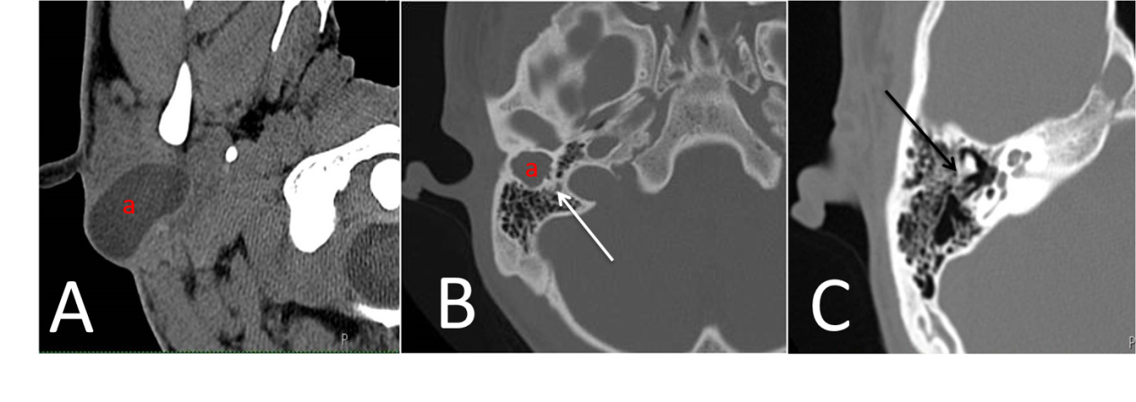
Figure 1 Temporal bone computed tomography findings. A: The first branchial cleft cyst; B: The white arrow indicates the lesion tightly adhered to the facial nerve; C: The black arrow indicates that the incus is fused with the lateral bony plank.
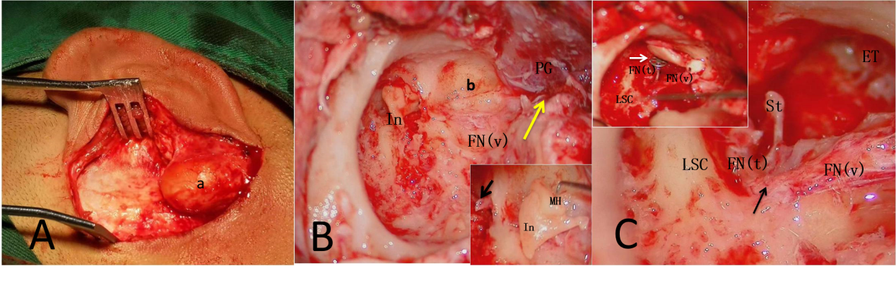
Figure 2 Intraoperative findings and surgical strategy. A: The lesion; B: The white arrow indicates the fusion of the malleus head and incus body, the black arrow indicates that the malleus handle was fused to the lateral bony plank, the yellow arrow shows the origin of the lesion; C: The white arrow indicates the hearing reconstruction with a partial ossicular replacement prosthesis and tragus cartilage graft, the black arrow shows the location variation of the facial nerve, which migrated to the anteposition. a: The lesion; b: The atretic bony plank outside the closed tympanic cavity. In: Incus; MH: Malleus head; PG: Parotid gland; FN (t): Tympanic segment of the facial nerve; FN (v): Vertical segment of the facial nerve; LSC: Lateral semicircular canal; St: Stapes; ET: Eustachian tube.
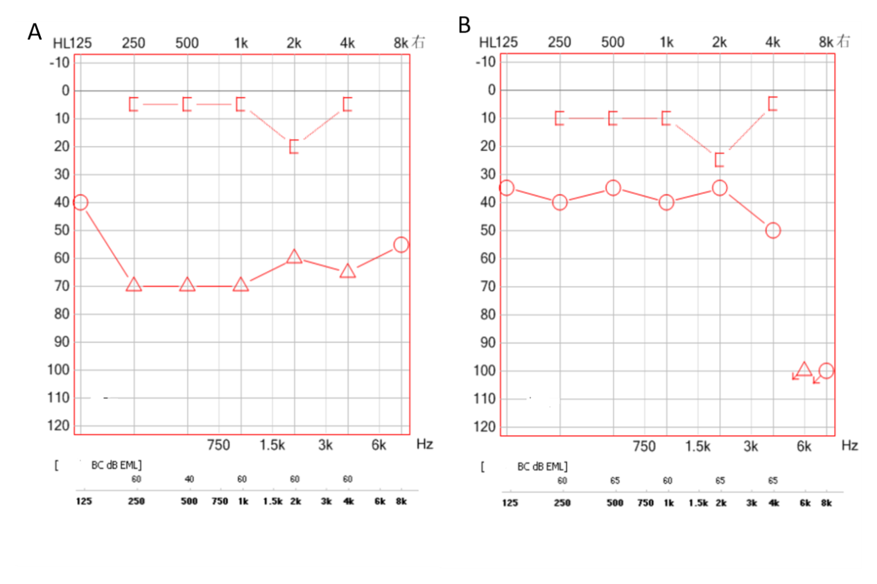
Figure 3 Comparison of preoperative and postoperative pure tone audiometry in the right ear. A: Shows the preoperative pure tone audiometry, the preoperative air-bone conduction gap was 56 decibels; B: Shows postoperative pure tone audiometry, the postoperative air-bone gap was 21 decibels, and the pure-tone average gain was 35 decibels.

