Informed consent statement

All study participants, or their legal guardian, provided informed written consent prior to study enrollment.

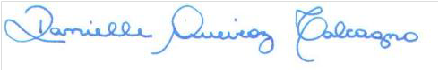
Danielle Queiroz Calcagno, Ph.D.
Núcleo de Pesquisas em Oncologia
Universidade Federal do Pará
e-mail: danicalcagno@gmail.com

