Name of Journal: World Journal of Clinical Cases
Manuscript NO: 52972
Manuscript Type: CASE REPORT

Extrapontine myelinolysis caused by rapid correction of pituitrin-induced severe hyponatremia: A case report

Fang LJ et al. EPM caused by rapid correction of pituitrin-induced severe hyponatremia

Liang-Jie Fang, Ming-Wei Xu, Jian-Ying Zhou, Zhi-Jie Pan

Liang-Jie Fang, Jian-Ying Zhou, Zhi-Jie Pan, Department of Respiratory Medicine, First Affiliated Hospital, School of Medicine, Zhejiang University, Hangzhou 310009, Zhejiang Province, China

Ming-Wei Xu, Department of Neurology, First Affiliated Hospital, School of Medicine, Zhejiang University, Hangzhou 310009, Zhejiang Province, China

Author contributions: Fang LJ collected the case data and drafted the article; Fang LJ and Xu MW consulted literature material; Zhou JY and Pan ZJ revised the manuscript; all authors read and approved the final manuscript.

Supported by the Department of Health of Zhejiang Province, China, No. 2016RCA013.

Corresponding author: Zhi-Jie Pan, MD, Chief Doctor, Professor, Department of Respiratory Medicine, First Affiliated Hospital, School of Medicine, Zhejiang University, No. 79, Qingchun Road, Hangzhou 310009, Zhejiang Province, China. panzj200709@zju.edu.cn

Received: November 29, 2019
Revised: January 6, 2020
Accepted: February 12, 2020
Published online: March 6, 2020

Abstract
Background
Severe hyponatremia is considered a rare complication of pituitrin, which is widely used for the treatment of pulmonary hemorrhage. However, the management of pituitrin-associated hyponatremia can be challenging because a rapid correction of hyponatremia may cause the development of osmotic demyelination syndrome, resulting in life-threatening neurological injuries.

Case summary
A 20-year-old Chinese man with massive hemoptysis developed symptomatic hyponatremia (116 mmol/L) after therapy by a continuous intravenous drip of pituitrin. To normalize his serum sodium, a hypertonic saline infusion was applied for 3 d, and the pituitrin administration was stopped concurrently. Then, an overly rapid increase in serum sodium level (18 mmol/L in 24 h) was detected after treatment. One day later, the patient experienced a sudden onset of generalized tonic-clonic seizures, as well as subsequent dysarthria and dystonia. Magnetic resonance imaging revealed increased signal intensity in the bilateral symmetric basal ganglia on the T2-weighted images, compatible with a diagnosis of extrapontine myelinolysis. The patient received an intravenous administration of high-dose corticosteroids, rehabilitation, and neurotrophic therapy. Finally, his clinical abnormalities were vastly improved, and he was discharged with few residual symptoms.

Conclusion
Physicians should be fully aware that pituitrin can cause profound hyponatremia and its correction must be performed at a controlled rate to prevent the development of osmotic demyelination syndrome.

Key words: Pituitrin; Hyponatremia; Extrapontine myelinolysis; Case report

Fang LJ, Xu MW, Zhou JY, Pan ZJ, Extrapontine myelinolysis caused by rapid correction of pituitrin-induced severe hyponatremia: A case report. World J Clin Cases 2020; 8(5): 946-953 URL: https://www.wjgnet.com/2307-8960/full/v8/i5/946.htm DOI: https://dx.doi.org/10.12998/wjcc.v8.i5.946

Core tip: Osmotic demyelination syndrome (ODS) is a devastating neurologic disorder often associated with a precipitous rise in serum sodium. Here we describe a rare case of extrapontine myelinolysis that developed after a rapid correction of symptomatic hyponatremia induced by pituitrin to treat a patient with massive hemoptysis. Because ODS is mainly an iatrogenic disease, effective prevention is mandatory. Through an analysis of the previous literature, the risk factors, clinical characteristics, and outcomes of vasopressin (pituitrin)-associated ODS are discussed in this article.

Introduction
Massive hemoptysis, representing a life-threatening condition of pulmonary hemorrhage, always needs urgent management. Pituitrin^{[1,2]}, extracted from the posterior pituitary, comprises vasopressin and oxytocin and is widely used to treat massive hemoptysis since vasopressin possesses a strong vasoconstriction ability. In addition, vasopressin, also called antidiuretic hormone, has been shown to reduce renal free water excretion, leading to dilutional hyponatremia.
The treatment of pituitrin-induced hyponatremia is quite challenging. On the one hand, severe hyponatremia is often associated with cerebral edema, which causes neurological symptoms ranging from nausea to seizures and even death; on the other hand, an overly rapid correction of hyponatremia may cause abrupt osmotic fluctuations and pose a high risk for osmotic demyelination syndrome (ODS). ODS, first reported in alcoholic patients with malnutrition in 1959^{[3]}, comprises central pontine myelinolysis (CPM) and extrapontine myelinolysis (EPM) and is a noninflammatory demyelinating disorder affecting the pons and other regions of the central nervous system; it is characterized clinically by severe and often irreversible neurological deterioration. To date, the underlying mechanism is not fully understood, and the rapid correction of hyponatremia remains the most documented etiologic factor for ODS. It has been suggested that rapid osmotic fluctuations and osmotic-induced fluid shifts may cause cell shrinkage and apoptosis, disruption of the blood-brain barrier, and injury to the myelin sheath, resulting in demyelination^{[4,5]}. Additionally, chronic alcoholism, malnutrition, liver transplantation, and other chronic diseases have also been regarded as risk factors according to recent studies^{[6]}.
Here, we report a case of EPM following a rapid correction of pituitrin-induced hyponatremia when treating a patient with massive hemoptysis. We review similar cases reported in the PubMed database and summarize the clinical characteristics and the underlying mechanism in this paper.

CASE PRESENTATION
Chief complaints
A 20-year-old Chinese man was initially admitted to the pulmonary department complaining of repeated hemoptysis for more than one week. During hospitalization, he developed symptomatic hyponatremia and experienced a generalized tonic-clonic seizure, dysarthria, and dystonia after hyponatremia correction.

History of present illness
The patient’s hemoptysis started one week ago but worsened, and he coughed up large amounts of bright red blood (approximately 150-200 mL) in the last 24 h. At the local hospital, he received conventional therapy with aminomethylbenzoic acid and antibiotics, which was ineffective. Then, he was transferred to our hospital for further treatment. He was diagnosed with bronchiectasis 2 years ago, and he had similar episodes in the past.
To treat the massive hemoptysis, pituitrin (24 U in 40 mL saline) was administered by intravenous drip continuously at a rate of 3-4 mL/h via a pump for a total of 5 d. In addition, he was given oxygen and empirical antibiotic therapy. Electrolyte disorders and his urine output were intensively monitored accordingly (Table 1). The hemoptysis gradually decreased, but he exhibited severe nausea and vomiting after 3 d of pituitrin infusion. A biochemical assessment revealed significant hyponatremia with a sodium level of 116 mmol/L, as well as a low serum osmolality of 248 mOsm/kg. We prescribed a daily infusion of 1.5% hypertonic saline (500-750 mL per day) from day 3 to day 5. However, it failed to normalize the serum sodium level, and the symptomatic hyponatremia sustained for more than 48 h. Meanwhile, his urine output declined to 0.9 L per day.
On day 5, his serum sodium was 119 mmol/L. Then, we stopped pituitrin therapy since we considered pituitrin to be the main cause of his severe hyponatremia. On day 6, the serum sodium level rose to 137 mmol/L [Δ(Na⁺) 18 mmol/L], accompanied by an obviously elevated urine output from 0.9 L to 2.1 L. Unfortunately, on day 7, the patient developed sudden-onset generalized tonic-clonic seizures. After the seizures were controlled by intravenous diazepam, the neurological symptoms worsened over the following days, presenting as severe dysarthria and movement disorders. He was unable to speak, write, and walk. The changes of the patient’s serum sodium during pituitrin treatment and correction of hyponatremia are shown in Figure 1.

History of past illness
The patient had a history of bronchiectasis for 2 years but had no other comorbid conditions, such as alcoholism, malnutrition, hepatic cirrhosis, or renal insufficiency.

Personal and family history
The family history was unremarkable.

Physical examination
The vital signs after seizure cessation included a temperature of 37.2 °C, blood pressure of 116/63 mmHg, heart rate of 85 beats per minute, respiratory rate of 20 breaths per minute, and oxygen saturation of 97% in room air. The neurological examination revealed mildly disturbed consciousness and severe dysarthria, as well as exaggerated muscular tone. The cranial nerve functions, muscle strength, and sensation were all intact.

Laboratory examinations
A routine blood test revealed a white blood cell count of 11.3 × 10⁹/L with 67.4% of neutrophils. The red blood cell and platelet counts were normal. The serum C-reactive protein was slightly elevated at 1.0 mg/dL (normal range: <0.8 mg/dL). The cerebral spinal fluid test was normal. The electroencephalogram suggested medium, nonspecific neurological dysfunction. Other laboratory data such as biochemistry, electrolytes, thyroid function, tumor markers, and autoimmune profiles were within the normal range. The electrocardiogram and transthoracic cardiac ultrasound were within normal limits.

Imaging examinations
An initial imaging evaluation by head computed tomography presented normal results. Magnetic resonance imaging (MRI) of the brain revealed increased signal intensity in the bilateral symmetric basal ganglia on T2-weighted images and low signal intensity on T1-weighted images (Figure 2).

FINAL DIAGNOSIS
After expert consultation by neurologists, the patient was diagnosed with EPM caused by the rapid correction of pituitrin-induced severe hyponatremia.

TREATMENT
The patient was transferred to the neurology department and was mainly treated with high-dose intravenous methylprednisolone, starting from 240 mg daily for 5 days, tapering off slowly, and finally shifting to oral glucocorticoids. In addition, rehabilitation and neurotrophic therapy were also introduced to treat EPM.

OUTCOME AND FOLLOW-UP
Approximately one week later, the patient began to speak and write simple words; then, progressively, he was able to construct sentences. One month later, his speech vastly improved, but his fluency was still slightly affected. Finally, this patient was discharged with few residual symptoms. Follow-up brain MRI showed reduced signal intensity in the affected regions, which correlated with clinical improvement.

DISCUSSION
Hyponatremia, defined as a plasma sodium level of less than 135 mmol/L, is the most common electrolyte abnormality encountered in hospitalized patients, resulting from a varied spectrum of conditions^{[7]}. In this case, significant hyponatremia was detected after an intravenous infusion of pituitrin to treat pulmonary hemorrhage. As there was no history of syndromes that caused inappropriate antidiuretic hormone secretion or adrenal insufficiency in this patient, we considered pituitrin to be involved.
Arginine vasopressin in pituitrin is the main active component for the treatment of various bleeding disorders^{[1]}. Vasopressin activates V1a receptors on vascular smooth muscle to contribute to a strong contraction of the arterioles and capillaries. However, its interaction with V2 receptors on renal collecting duct cells can exert antidiuretic effects by stimulating the cyclic adenosine monophosphate signaling cascade, leading to an increase in free water reabsorption and secondary dilutional hyponatremia^{[2]}. As shown in our case, after pituitrin therapy, the patient's daily urine output declined gradually, and his serum sodium fell to a low level of 116 mmol/L, accompanied by severe nausea and vomiting.
The incidence of hyponatremia associated with vasopressin or its analogs (such as terlipressin and desmopressin) varies greatly according to the type of patients studied, ranging from less than 1% to more than 50%. In a retrospective study of 102 adult patients with septic shock who were given vasopressin therapy, only one patient developed hyponatremia^{[8]}. Yim et al^{[9]} reported a hyponatremia rate as high as 67% when terlipressin was used to treat variceal bleeding. Choi et al^{[10]} analyzed 172 nocturnal polyuria patients treated with desmopressin and revealed that 14% of the patients developed hyponatremia, of whom 10% and 4% had mild (126-134 mmol/L) and severe (≤125 mmol/L) hyponatremia, respectively.
Although generally safe, it has been reported that in some severe cases, vasopressin or its analogs can reduce serum sodium to a much greater degree, resulting in cerebral edema, seizures, and death^{[11,12]}. The management of severe hyponatremia is complex. Because, for severe patients (<120 mmol/L), a sodium supplement is always needed to avoid the onset of hyponatremic encephalopathy, but active correction of hyponatremia may increase the risk for developing ODS.
ODS is a devastating neurologic disorder often associated with a precipitous rise in serum sodium. CPM mainly involves the central pontine, and EPM classically affects the thalamus, basal ganglia, or subcortical white matter. The difference in the location of the lesions results in different clinical presentations that are commonly delayed for 2-7 d after rapid elevations in the serum sodium level, including dysarthria, dystonia, behavioral disturbances, confusion, coma, and even death^{[6,13]}. Brain MRI has been considered the gold standard imaging technique to reveal ODS lesions, which typically present with hypointense T1-weighted and hyperintense T2-weighted signals.
Recommendations suggest that ideally, hyponatremia should be corrected by limiting the sodium increase to no more than 8-10 mmol/L every 24 h^{[7]}. In this case, progressive neurological injury occurred after a rapid increase in serum sodium from 119 to 137 mmol/L in 24 h. The imaging features of the brain MRI revealed a hyperintense T2-weighted signal in the bilateral symmetric basal ganglia and were in agreement with the diagnosis of EPM. We summarized several probable causes for a significant increase in serum sodium in this patient. First, an excess of hypertonic saline was transfused. Second, frequent electrolyte monitoring was absent during restoration. Third, pituitrin was withheld abruptly rather than reduced gradually.
According to the guidelines, 100 mL of 3% saline infusion is suggested for severe symptoms and can be repeated two or three times if needed^{[7,14]}. Accordingly, the serum sodium should be checked at least every 2 h to prevent vast fluctuations in serum osmolality. In addition, care must be taken to avoid water diuresis by pituitrin withdrawal that can cause overcorrection. Because the impaired free water excretion was transitory, once the medication stopped, free water excretion could occur unabatedly, and hyponatremia could resolve spontaneously. If the drug was stopped abruptly, a rapid decline in the circulating exogenous antidiuretic hormone levels could lead to the excretion of copious amounts of free water and put the patient at a high risk of overly increasing serum sodium. In particular, when hypertonic saline was also applied, the excessive supplementation of sodium could aggravate the rapid correction of hyponatremia to a dangerous level.
Through a search of the literature, seven cases of ODS associated with vasopressin or its analogs were found in the PubMed database^{[15-21]}. We review the reported cases and summarize the clinical characteristics in Table 2. Briefly, including our case, the mean age of these eight patients was 29.1 years (ranging from 13 to 69 years), with five adolescents younger than 25 years. Pituitrin was prescribed in two patients with massive hemoptysis, and terlipressin was prescribed in one patient with gastrointestinal bleeding. Desmopressin was used in four patients who had central diabetes insipidus. An increase in serum sodium of more than 10 mmol/L in 24 h was observed in seven (87.5%) patients. Only one patient who had a steady decline in his serum sodium level (less than 8 mmol/L per day) developed CPM 25 d after admission^{[21]}. Six (75%) patients had a definite history of drug discontinuation and administration of hypertonic saline. This result suggested that young patients who were provided with hypertonic saline and rapid drug discontinuation were particularly predisposed to an overly rapid correction of their serum sodium levels. Additionally, another study that included 15 patients with desmopressin-associated hyponatremia showed that 13 patients with an average age of 32.5 years who were treated with hypertonic saline and discontinued desmopressin during hyponatremia correction developed significant morbidity (77%) and mortality (23%) compared to the control group^{[22]}. This finding also indicated that cessation in a gradual manner may prevent fatal neurological injury when symptomatic patients were administered hypertonic saline.
Concerning the treatment for ODS, supportive therapy should be provided to all patients. Some animal studies and limited case reports have shown that re-lowering the sodium at an early stage may help prevent ODS^{[23,24]}. Chang et al^{[25]} applied plasma exchange to successfully treat a case of CPM caused by acute hypernatremia. Glucocorticoid treatment is also suggested. In animal experiments, early dexamethasone treatment can exert a preventive effect on ODS by reducing the disruption of the blood-brain barrier^{[26]}. High-dose intravenous methylprednisolone achieved success in the current case. In these seven reported cases, five patients recovered after treatment, and two patients died. Nevertheless, there are still no proven definite and effective therapies for ODS, so its prevention is quite essential.

CONCLUSION
We report a rare case of EPM following the rapid correction of pituitrin-induced hyponatremia. Physicians should be fully aware that the correction of hyponatremia must be performed at a controlled rate. In addition, this case provides a strong warning that hypertonic saline might be a high-risk medication and may require additional precautions when applied to treat pituitrin-induced severe hyponatremia.

ReferenceS
1 Trimble HG, Wood JR. Control of pulmonary hemorrhage by intravenous use of pituitrin. Calif Med 1952; 76: 155-157 [PMID: 14905298 DOI: 10.1378/chest.18.4.345]
2 Maybauer MO, Maybauer DM, Enkhbaatar P, Traber DL. Physiology of the vasopressin receptors. Best Pract Res Clin Anaesthesiol 2008; 22: 253-263 [PMID: 18683472 DOI: 10.1016/j.bpa.2008.03.003]
3 Adams RD, Victor M, Mancall EL. Central pontine myelinolysis: a hitherto undescribed disease occurring in alcoholic and malnourished patients. AMA Arch Neurol Psychiatry 1959; 81: 154-172 [PMID: 13616772 DOI: 10.1001/archneurpsyc.1959.02340140020004]
4 Baker EA, Tian Y, Adler S, Verbalis JG. Blood-brain barrier disruption and complement activation in the brain following rapid correction of chronic hyponatremia. Exp Neurol 2000; 165: 221-230 [PMID: 10993682 DOI: 10.1006/exnr.2000.7474]
5 Adler S, Martinez J, Williams DS, Verbalis JG. Positive association between blood brain barrier disruption and osmotically-induced demyelination. Mult Scler 2000; 6: 24-31 [PMID: 10694842 DOI: 10.1177/135245850000600106]
6 Brown WD. Osmotic demyelination disorders: central pontine and extrapontine myelinolysis. Curr Opin Neurol 2000; 13: 691-697 [PMID: 11148672 DOI: 10.1097/00019052-200012000-00014]
7 Spasovski G, Vanholder R, Allolio B, Annane D, Ball S, Bichet D, Decaux G, Fenske W, Hoorn EJ, Ichai C, Joannidis M, Soupart A, Zietse R, Haller M, van der Veer S, Van Biesen W, Nagler E; Hyponatraemia Guideline Development Group. Clinical practice guideline on diagnosis and treatment of hyponatraemia. Eur J Endocrinol 2014; 170: G1-47 [PMID: 24569125 DOI: 10.1530/EJE-13-1020]
8 Obritsch MD, Jung R, Fish DN, MacLaren R. Effects of continuous vasopressin infusion in patients with septic shock. Ann Pharmacother 2004; 38: 1117-1122 [PMID: 15178740 DOI: 10.1345/aph.1D513]
9 Yim SY, Seo YS, Jung CH, Kim TH, Kim ES, Keum B, Kim JH, An H, Yim HJ, Yeon JE, Jeen YT, Lee HS, Chun HJ, Byun KS, Um SH, Kim CD, Ryu HS. Risk Factors for Developing Hyponatremia during Terlipressin Treatment: A Retrospective Analyses in Variceal Bleeding. J Clin Gastroenterol 2015; 49: 607-612 [PMID: 25216384 DOI: 10.1097/MCG.0000000000000217]
10 Choi EY, Park JS, Kim YT, Park SY, Kim GH. The risk of hyponatremia with desmopressin use for nocturnal polyuria. Am J Nephrol 2015; 41: 183-190 [PMID: 25871541 DOI: 10.1159/000381562]
11 Guo J, Wang D, Zeng K, Xu G, Zhao Y. Generalized tonic-clonic seizures in adult patients following intravenous administration of desmopressin. Aging Clin Exp Res 2013; 25: 479-481 [PMID: 23780691 DOI: 10.1007/s40520-013-0064-3]
12 Lucchini B, Simonetti GD, Ceschi A, Lava SA, Faré PB, Bianchetti MG. Severe signs of hyponatremia secondary to desmopressin treatment for enuresis: a systematic review. J Pediatr Urol 2013; 9: 1049-1053 [PMID: 23619353 DOI: 10.1016/j.jpurol.2013.02.012]
13 Gocht A, Colmant HJ. Central pontine and extrapontine myelinolysis: a report of 58 cases. Clin Neuropathol 1987; 6: 262-270 [PMID: 3322623 DOI: 10.1002/ana.410220528]
14 Verbalis JG, Goldsmith SR, Greenberg A, Korzelius C, Schrier RW, Sterns RH, Thompson CJ. Diagnosis, evaluation, and treatment of hyponatremia: expert panel recommendations. Am J Med 2013; 126: S1-42 [PMID: 24074529 DOI: 10.1016/j.amjmed.2013.07.006]
15 Niehaus L, Kulozik A, Lehmann R. Reversible central pontine and extrapontine myelinolysis in a 16-year-old girl. Childs Nerv Syst 2001; 17: 294-296 [PMID: 11398953 DOI: 10.1007/pl00013730]
16 Gutenstein M. Osmotic myelinolysis syndrome after treatment of severe deamino arginine vasopressin-associated hyponatraemia: pitfalls in emergency medicine. Emerg Med Australas 2007; 19: 68-70 [PMID: 17305665 DOI: 10.1111/j.1742-6723.2007.00931.x]
17 Ranger A, Szymczak A, Levin S, Salvadori M, Fraser DD. Osmotic myelinolysis with malignant cerebellar edema occurring after DDAVP-induced hyponatremia in a child. Pediatr Neurosurg 2010; 46: 318-323 [PMID: 21196800 DOI: 10.1159/000320146]
18 Solà E, Lens S, Guevara M, Martín-Llahí M, Fagundes C, Pereira G, Pavesi M, Fernández J, González-Abraldes J, Escorsell A, Mas A, Bosch J, Arroyo V, Ginès P. Hyponatremia in patients treated with terlipressin for severe gastrointestinal bleeding due to portal hypertension. Hepatology 2010; 52: 1783-1790 [PMID: 20931555 DOI: 10.1002/hep.23893]
19 Zhuang L, Xu Z, Li Y, Luo B. Extrapontine myelinolysis associated with pituitrin: case report and literature review. BMC Neurol 2014; 14: 189 [PMID: 25294308 DOI: 10.1186/s12883-014-0189-9]
20 Nabaei G, Abdi S, Fatehi F. Demyelination syndrome due to rapid correction of desmopressin-associated hyponatremia in a known case of central diabetes insipidus: a case report. Acta Neurol Belg 2015; 115: 819-821 [PMID: 25777520 DOI: 10.1007/s13760-015-0450-z]
21 Hossain T, Ghazipura M, Reddy V, Rivera PJ, Mukherjee V. Desmopressin-Induced Severe Hyponatremia with Central Pontine Myelinolysis: A Case Report. Drug Saf Case Rep 2018; 5: 19 [PMID: 29696555 DOI: 10.1007/s40800-018-0084-1]
22 Achinger SG, Arieff AI, Kalantar-Zadeh K, Ayus JC. Desmopressin acetate (DDAVP)-associated hyponatremia and brain damage: a case series. Nephrol Dial Transplant 2014; 29: 2310-2315 [PMID: 25107337 DOI: 10.1093/ndt/gfu263]
23 Ochiai H, Uenishi E. Early Relowering of Serum Sodium Concentration Overcomes Disturbances in Consciousness during Hyponatremia Overcorrection and Prevents Osmotic Demyelination Syndrome. Intern Med 2018; 57: 2353-2357 [PMID: 30111674 DOI: 10.2169/internalmedicine.0299-17]
24 Soupart A, Penninckx R, Stenuit A, Perier O, Decaux G. Reinduction of hyponatremia improves survival in rats with myelinolysis-related neurologic symptoms. J Neuropathol Exp Neurol 1996; 55: 594-601 [PMID: 8627349 DOI: 10.1097/00005072-199605000-00011]
25 Chang KY, Lee IH, Kim GJ, Cho K, Park HS, Kim HW. Plasma exchange successfully treats central pontine myelinolysis after acute hypernatremia from intravenous sodium bicarbonate therapy. BMC Nephrol 2014; 15: 56 [PMID: 24708786 DOI: 10.1186/1471-2369-15-56]
26 Sugimura Y, Murase T, Takefuji S, Hayasaka S, Takagishi Y, Oiso Y, Murata Y. Protective effect of dexamethasone on osmotic-induced demyelination in rats. Exp Neurol 2005; 192: 178-183 [PMID: 15698632 DOI: 10.1016/j.expneurol.2004.10.018]

Footnotes
Informed consent statement: Written informed consent was obtained from the patient for publication of this report and any accompanying images.

Conflict-of-interest statement: The authors declare that they have no conflict of interest.

CARE Checklist (2016) statement: The authors have read the CARE Checklist (2016), and the manuscript was prepared and revised according to the CARE Checklist (2016).

Open-Access: This article is an open-access article that was selected by an in-house editor and fully peer-reviewed by external reviewers. It is distributed in accordance with the Creative Commons Attribution NonCommercial (CC BY-NC 4.0) license, which permits others to distribute, remix, adapt, build upon this work non-commercially, and license their derivative works on different terms, provided the original work is properly cited and the use is non-commercial. See: http://creativecommons.org/licenses/by-nc/4.0/

Manuscript source: Unsolicited manuscript

Peer-review started: November 29, 2019
First decision: December 30, 2019
Article in press: February 12, 2020

Specialty type: Medicine, research and experimental
Country of origin: China
Peer-review report classification
Grade A (Excellent): 0
Grade B (Very good): 0
Grade C (Good): C
Grade D (Fair): 0
Grade E (Poor): 0

P-Reviewer: Vyshka G S-Editor: Zhang L L-Editor: Wang TQ E-Editor: Xing YX
Figure Legends

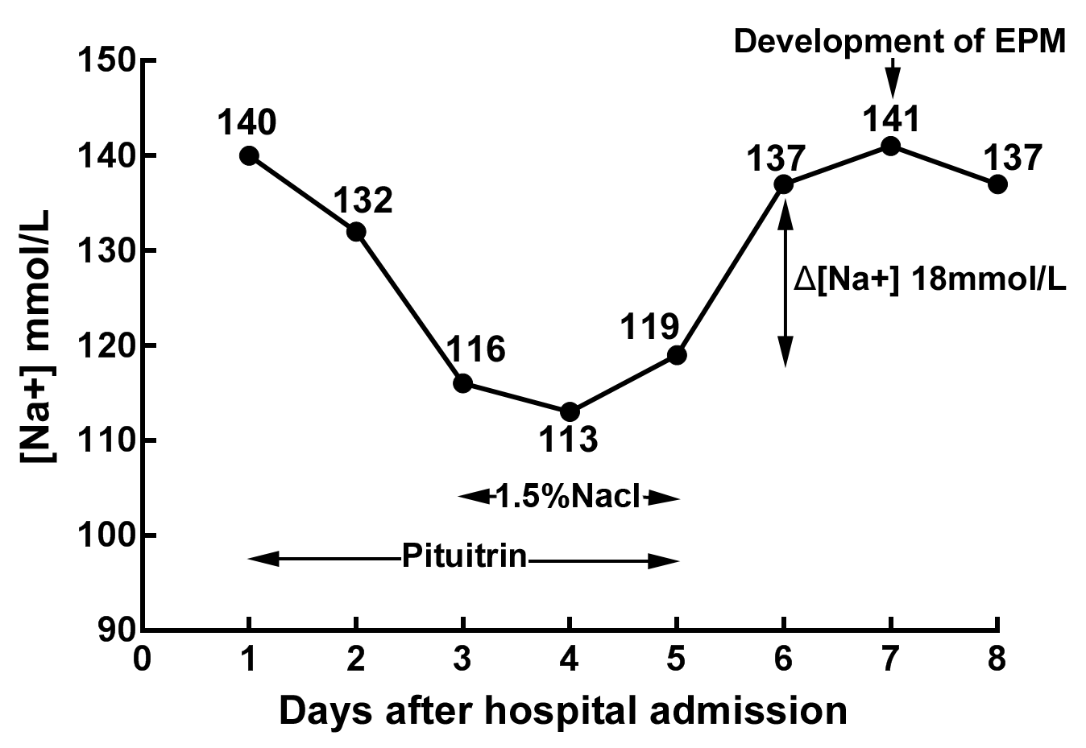

Figure 1 Serum sodium levels of the patient after admission. The serum sodium gradually declined after the use of pituitrin. Hypertonic saline was administered on day 3 until day 5. Pituitrin therapy was stopped on day 5, then a sharp increase in serum sodium level was detected on day 6, and neurological symptoms appeared on the seventh day after admission.
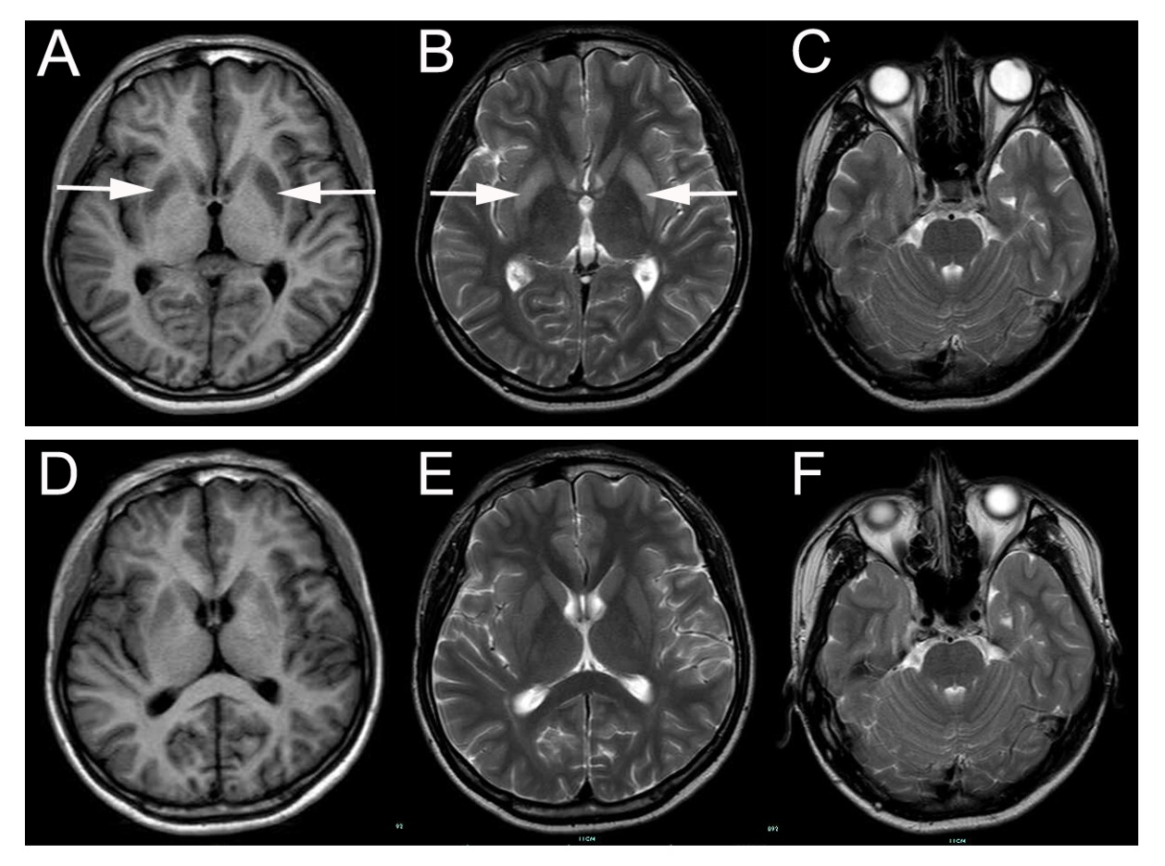
Figure 2 Brain magnetic resonance imaging during hospitalization. A: Initial brain magnetic resonance imaging (MRI) obtained 3 d after neurological deterioration displayed low signal intensity in the bilateral symmetric basal ganglia (the white arrows) on the axial T1-weighted MRI; B: High signal intensity (the white arrows) on the axial T2-weighted images; C: No lesion in the pons; D-F: Follow-up brain MRI performed one month after treatment. E: Compared to the previous brain MRI, a markedly decreased signal was observed on the T2-weighted image, indicating a significant improvement.
Table 1 Trends of the patient's clinical and laboratory data
Day | Serum K⁺ (mmol/L) | Serum Na⁺ (mmol/L) | Serum osmolality (mOsm/kg) | 1.5% NaCl (mL) | Urine output (L)
1 | 4.12 | 140 | 298 | _ | 2.1
2 | 4.10 | 132 | 284 | _ | 1.8
3 | 3.63 | 116 | 248 | 500 | 1.6
4 | 3.29 | 113 | 240 | 750 | 1.1
5 | 3.35 | 119 | 251 | 750 | 0.9
6 | 4.07 | 137 | 288 | _ | 2.1
7 | 3.80 | 141 | 299 | _ | 2.2
8 | 4.52 | 137 | 292 | _ | 1.6
Serum osmolality = 2 (Na⁺ + K⁺) + Glucose (mmol/L) + Blood urea nitrogen (mmol/L).
Table 2 Clinical characteristics of central pontine myelinolysis and/or extrapontine myelinolysis associated with vasopressin or its analogs
Ref. | Age/sex | Drug | Original disease | Treatment of hyponatremia | Hyponatremia improvement (mmol/L) | Lesions | Neurological presentation | Therapy for ODS | Outcome
Niehaus et al^{[15]}, 2001 | 16/F | Antidiuretic hormone | Nocturnal enuresis | Discontinued drug + hypertonic saline | 10 in 24 h (128 to 138) | EPM, CPM | Conscious disturbance | Prednisolone | Recovery
Gutenstein^{[16]}, 2007 | 39/F | Desmopressin | Hypopituitary | Saline | 38 in 48 h (103 to 141) | EPM, CPM | Dysarthria, hemiplegia, seizures | NA | Death
Ranger et al^{[17]}, 2010 | 13/M | Desmopressin | Central DI | NA | 60 in 48 h (116 to 176) | EPM, CPM | Coma | NA | Death
Solà et al^{[18]}, 2010 | NA | Terlipressin | Gastrointestinal bleeding | Discontinued drug + hypertonic saline | 19 in 24 h (109 to 128) | ODS, | Seizures, coma | NA | Recovery
Zhuang et al^{[19]}, 2014 | 24/F | Pituitrin | Hemoptysis | Discontinued drug + hypertonic saline | 16 in 24 h (118 to 134) | EPM | Dysarthria, quadriparesis, dystonia | Corticosteroid | Recovery
Nabaei et al^{[20]}, 2015 | 23/F | Desmopressin | Central DI | Discontinued drug + hypertonic saline | 40 in 24 h (126 to166) | EPM, CPM | Quadriparesis, dysarthria, dysphagia | NA | Severe brain damage
Hossain et al^{[21]}, 2018 | 69/M | Desmopressin | Central DI | Discontinued drug + hypertonic saline | Less than 8 in 24 h | CPM | NA | NA | Recovery
DI: Diabetes insipidus; M: Male; F: Female; NA: Not available; CPM: Central pontine myelinolysis; EPM: Extrapontine myelinolysis; ODS: Osmotic demyelination syndrome.

