Name of Journal: World Journal of Clinical Cases
Manuscript NO: 53268
Manuscript Type: CASE REPORT

Hemophagocytic syndrome as a complication of acute pancreatitis: A case report

Han CQ et al. HPS as a complication of AP

Chao-Qun Han, Xin-Ru Xie, Qin Zhang, Zhen Ding, Xiao-Hua Hou

Chao-Qun Han, Xin-Ru Xie, Zhen Ding, Xiao-Hua Hou, Division of Gastroenterology, Union Hospital, Tongji Medical College, Huazhong University of Science and Technology, Wuhan 430022, China

Qin Zhang, Division of Pathology, Union Hospital, Tongji Medical College, Huazhong University of Science and Technology, Wuhan 430022, China

Author contributions: Han CQ performed the literature search and data extraction and drafted the manuscript; Xie XR collected the data; Zhang Q provided pathology results; Hou XH revised the manuscript for important intellectual content; Ding Z designed the study and edited the manuscript as corresponding author.

Supported by the National Natural Science Foundation of China, No. 81800467, No. 81974062, and No. 81770637.

Corresponding author: Zhen Ding, MD, PhD, Doctor, Professor, Teacher, Chief Physician, Division of Gastroenterology, Union Hospital, Tongji Medical College, Huazhong University of Science and Technology, No. 1277, Jiefang Avenue, Wuhan 430022, Hubei Province, China. 2007xh0814@hust.edu.cn

Received: January 21, 2020
Revised: April 17, 2020
Accepted: May 13, 2020
Published online: June 6, 2020

Abstract
BACKGROUND
Haemophagocytic syndrome (HPS) is rarely seen in patients with acute pancreatitis (AP). HPS as a complication of AP in patients without any previous history has not been elucidated.

CASE SUMMARY
A 46-year-old man was admitted for symptom of persistent abdominal pain, nausea, and vomiting for 2 d after heavy drinking. During hospital stay, he suddenly developed skin rash and a secondary fever. The laboratory findings revealed progressive pancytopenia, abnormal hepatic tests, and elevation of serum triglyceride, ferritin, and lactate dehydrogenase levels. However, apparent bacterial or viral infections were not detected. He was also possibly related to autoimmune diseases because of positive expression of various autoimmune antibodies and no remarkable past history. Finally, the bone marrow examination showed a histiocytic reactive growth and prominent hemophagocytosis, which resulted in a diagnosis of HPS. Unexpectedly, the patient responded well to the immunosuppressive therapy.

CONCLUSION
HPS is a very rare extrapancreatic manifestation of AP. The diagnosis relies on bone marrow examination and immunosuppressive therapy is effective. For AP with skin changes, the possibility of HPS should be considered during clinical work.

Key words: Haemophagocytic syndrome; Acute pancreatitis; Immunosuppressive therapy

Han CQ, Xie XR, Zhang Q, Ding Z, Hou XH. Hemophagocytic syndrome as a complication of acute pancreatitis: A case report. World J Clin Cases 2020; 8(11): 2364-2373 URL: https://www.wjgnet.com/2307-8960/full/v8/i11/2364.htm DOI: https://dx.doi.org/10.12998/wjcc.v8.i11.2364

Core tip: Haemophagocytic syndrome is a rare extrapancreatic manifestation of acute pancreatitis. We herein report the first such case to share our experience with its diagnosis and treatment. The patient responded well to the immunosuppressive therapy. Early diagnosis and treatment are crucial.

INTRODUCTION
Haemophagocytic syndrome (HPS) is an uncommon disorder that may be characterized by fever, peripheral blood pancytopenia, liver dysfunction, coagulation abnormalities, and hepatosplenomegaly^{[1, 2]}. It may be triggered by genetic disorders, malignant neoplasms, viral infections, and autoimmune disorders^{[3-5]}. Acute pancreatitis (AP) and HPS are sporadically observed in the course of systemic lupus erythematosus (SLE) or fulminant ulcerative colitis secondary to autoimmune diseases^{[2, 6, 7]}. We herein report such a case to share our experience with its diagnosis and treatment.

CASE PRESENTATION
Chief complaints
A 46-year-old man was admitted for symptom of persistent abdominal pain, nausea, and vomiting for 2 d after heavy drinking and then transferred to our hospital.

History of present illness
The patient’s symptoms started with mild abdominal pain, which had worsened in the last 2 h.

History of past illness
He had no previous history except for smoking.

Physical examination
The physical examination on admission revealed a discontinuous fever (38 ℃) (Figure 1B) and upper abdomen tenderness. His skin was normal.

Laboratory examinations
The laboratory data showed significantly increased serum levels of amylase (1454.9 U/L), lipase (1705.28 U/L), white blood cell count (17 G/L), positive C-reactive protein (4.8 mg/mL), and erythrocyte sedimentation rate (58 mm/h) (Figure 1D-F), slightly elevated glucose (7.71 mmol/L) and D-dimer (1.63 mg/L), slightly reduced calcium (1.88 mmol/L), and hypoalbuminemia (31.0 g/L). The coagulation, hepatic, and renal functions were all within normal limits. The detailed laboratory values are described in Table 1.

Imaging examinations
Pancreatic enlargement and peripancreatic seepage on computerized tomography confirmed the diagnosis of AP (Figure 2). Then, the patient was given enteral nutrition via a jejunal nutrition tube (Figure 1C) and treated with pantoprazole sodium (40 mg per 8 h), octreotide aetate (0.6 mg/q12h), and anti-inflammatory drugs (ornidazole 0.5 g/q8h, meropenem 0.5 g/q8h, etc.). Traditional Chinese medicine catharsis was performed for the prevention of intestinal function failure (Figure 1A). The symptoms of the patient gradually disappeared. He had no febrile and each index was close to the baseline level (Figure 1D-F). Bilateral pleural effusion was absorbed better than before (Figure 3). Surprisingly, from the hospital days 11 to 17, the patient suddenly developed a secondary fever and the highest temperature reached 39.7 ℃ (Figure 1B). We strengthened the antibiotic treatment, including antifungal therapy, although blood culture did not find any evidence of bacterial or fungal infection. Unfortunately, although the temperature was controlled, his general condition deteriorated. On day 16 after hospitalization, he developed a rash on the trunk, upper limbs, and cruses (Figure 4F), then the indexes of autoimmune disease (e.g., SLE), such as anti-ANA (1:1000), anti-SSA (+), Ro-52-Ab (+), IgG (15.80 g/L), and IgE (471.1 IU/mL), were evaluated. Additionally, he also developed pancytopenia (3.18 g/L of white blood cells, 109 g/L of hemoglobin, and 88 g/L of platelets), hepatic dysfunction (alanine aminotransferase [ALT], 390 U/L; aspartate amino transferase [AST], 172 U/L), and a marked elevation of triglyceride (3.51 mmol/L), ferritin (5850 μg/L), and serum lactic acid dehydrogenase (LDH, 396 U/L) (Figure 4A-E), but his coagulation function was normal without significant abdominal ultrasonography findings.

FINAL DIAGNOSIS
Based on the above findings, a diagnosis of HPS was highly suspected and a peripheral blood smear and bone marrow examination were planned due to the complicated symptoms. Hemophagocytic cells were found in peripheral blood smears (Figure 4G) and the bone marrow examination showed a histiocytic reactive growth and prominent hemophagocytosis (Figure 4H). Thus, HPS as a complication of AP was finally diagnosed.

TREATMENT
The patient was then treated with liver-protecting drugs, antiallergic drugs, and hexadecadrol 5 mg/d for 4 consecutive days. By day 20, his symptoms of pancytopenia, liver function, and LDH and ferritin elevations were improved. On the day that the patient left the hospital (day 26), the laboratory parameters were largely close to the baseline levels again.

OUTCOME AND FOLLOW-UP
At the 1-mo follow-up visit after discharge, the patient did not take any drugs and had no symptoms or signs without any recurrence.

DISCUSSION
Other abnormal clinical and laboratory findings consistent with the diagnosis of HPS include cerebromeningeal symptoms, jaundice, edema, lymph node enlargement, skin rash, hepatic enzyme abnormalities, hypoproteinemia, and hyponatremia^{[8]}. In the present case, the symptoms of patient gradually recovered after effective treatment. However, the results of laboratory re-examination were incomprehensibly deteriorative. He developed a secondary fever, rash, pancytopenia, hepatic dysfunction, hyperferritinemia, and elevation of serum triglyceride and LDH levels. The bone marrow examination proved that he had concurrent HPS^{[9]}.
He had no remarkable past medical history, therefore we first considered if HPS was bacteria or virus-associated or malignancy-associated. However, no active infections with viruses as coxsackievirus, enterovirus, cytomegalovirus, hepatitis B virus, Epstein-Barr virus and other respiratory tract infective viruses were observed. Neither prominent hemophagocytosis nor hematological malignancies were detected. There were also no abnormal findings on abdominal CT and tumor markers analysis except slightly elevated CA125. We also suspected concurrent autoimmune diseases because HPS was reported more commonly in patients with pre-existing SLE. However, besides some autoimmune antibodies showing positive expression, no evidence suggested an underlying autoimmune disease.
There was another possibility that HPS was the side effect of pharmaceutical treatment. We indeed used some drugs that could cause rash, pancytopenia, and hepatorenal dysfunction, e.g., antibiotics such as cefoperazone sodium, fluconazole, or teicoplanin and other acid suppression drugs such as pantoprazole sodium. However, all of these are generally well tolerated and therapeutic measures were appropriate^{[10-13]}. Additionally, some common adverse reactions of these drugs, such as headache, nausea, vomiting, diarrhea, and pruritus did not occur^{[14-17]}. Therefore, the possibility that it was the side effect of pharmaceutical treatment was ruled out.
HPS is a rare extrapancreatic manifestation of AP. A ambiguous association between AP and HPS was first mentioned in 1998 by Kanaji et al^{[2]}, who found HPS associated with fulminant ulcerative colitis and concurrent AP. So far, there have been just two reports about HPS associated with AP in patients with SLE disease.

CONCLUSION
We have described the first case of HPS as a complication of AP, which was successfully treated with immunosuppressive therapy. HPS is a severe condition which requires both early diagnosis and treatment, and HPS as one of the extrapancreatic manifestations of AP should be considered in the future.

ACKNOWLEDGEMENTS
The authors are grateful to the patient for participating in the study.

REFERENCES
1 Reiner AP, Spivak JL. Hematophagic histiocytosis. A report of 23 new patients and a review of the literature. Medicine (Baltimore) 1988; 67: 369-388 [PMID: 3054418 DOI: 10.1097/00005792-198811000-00002]
2 Kanaji S, Okuma K, Tokumitsu Y, Yoshizawa S, Nakamura M, Niho Y. Hemophagocytic syndrome associated with fulminant ulcerative colitis and presumed acute pancreatitis. Am J Gastroenterol 1998; 93: 1956-1959 [PMID: 9772064 DOI: 10.1111/j.1572-0241.1998.00554.x]
3 Ishii E, Ohga S, Imashuku S, Kimura N, Ueda I, Morimoto A, Yamamoto K, Yasukawa M. Review of hemophagocytic lymphohistiocytosis (HLH) in children with focus on Japanese experiences. Crit Rev Oncol Hematol 2005; 53: 209-223 [PMID: 15718147 DOI: 10.1016/j.critrevonc.2004.11.002]
4 Haque WM, Shuvo ME, Rahim MA, Mitra P, Samad T, Haque JA. Haemophagocytic syndrome in an adult suffering from pyrexia of unknown origin: an uncommon presentation of tuberculosis: a case report. BMC Res Notes 2017; 10: 110 [PMID: 28241857 DOI: 10.1186/s13104-017-2434-y]
5 Janka GE, Lehmberg K. Hemophagocytic syndromes--an update. Blood Rev 2014; 28: 135-142 [PMID: 24792320 DOI: 10.1016/j.blre.2014.03.002]
6 Abdallah M, B'Chir Hamzaoui S, Bouslama K, Mestiri H, Harmel A, Ennafaa M, M'Rad S, Ben Dridi M. [Acute pancreatitis associated with hemophagocytic syndrome in systemic lupus erythematous: a case report]. Gastroenterol Clin Biol 2005; 29: 1054-1056 [PMID: 16435516 DOI: 10.1016/s0399-8320(05)88191-6]
7 Elqatni M, Mekouar F, Sekkach Y, Elomri N, Fatihi J, Amezyane T, Abouzahir A, Ghafir D. [Haemophagocytic syndrome as a complication of acute pancreatitis during systemic lupus erythematosus]. Ann Dermatol Venereol 2012; 139: 46-49 [PMID: 22225742 DOI: 10.1016/j.annder.2011.10.398]
8 Henter JI, Horne A, Aricó M, Egeler RM, Filipovich AH, Imashuku S, Ladisch S, McClain K, Webb D, Winiarski J, Janka G. HLH-2004: Diagnostic and therapeutic guidelines for hemophagocytic lymphohistiocytosis. Pediatr Blood Cancer 2007; 48: 124-131 [PMID: 16937360 DOI: 10.1002/pbc.21039]
9 Oh HS, Kim M, Lee JO, Kim H, Kim ES, Park KU, Kim HB, Song KH. Hemophagocytic lymphohistiocytosis associated with SFTS virus infection: A case report with literature review. Medicine (Baltimore) 2016; 95: e4476 [PMID: 27495089 DOI: 10.1097/MD.0000000000004476]
10 Baltatzis M, Jegatheeswaran S, O'Reilly DA, Siriwardena AK. Antibiotic use in acute pancreatitis: Global overview of compliance with international guidelines. Pancreatology 2016; 16: 189-193 [PMID: 26804006 DOI: 10.1016/j.pan.2015.12.179]
11 Mourad MM, Evans R, Kalidindi V, Navaratnam R, Dvorkin L, Bramhall SR. Prophylactic antibiotics in acute pancreatitis: endless debate. Ann R Coll Surg Engl 2017; 99: 107-112 [PMID: 27917667 DOI: 10.1308/rcsann.2016.0355]
12 Rada G, Peña J. Is antibiotic prophylaxis beneficial in acute pancreatitis?--First update. Medwave 2015; 15: e6125 [PMID: 25938428 DOI: 10.5867/medwave.2015.03.6125]
13 Choi HM, Choi MH, Yang YW. A Case of Teicoplanin-Induced Pancytopenia Caused by Excessive Dosing. Am J Ther 2016; 23: e307-e310 [PMID: 24263159 DOI: 10.1097/MJT.0000000000000008]
14 Ren X, Liu D, Ding N, Huang K, Xiong Y, Du G, Zeng F. Safety evaluation of cephalosporins based on utilization and adverse drug events: analysis of two databases in China. Expert Opin Drug Saf 2012; 11: 689-697 [PMID: 22708900 DOI: 10.1517/14740338.2012.699037]
15 Xie JX, Wei JF, Meng L. Teicoplanin-induced hepatocellular liver injury: a case report and literature review of 17 cases in mainland China. Int J Clin Pharmacol Ther 2014; 52: 525-529 [PMID: 24691063 DOI: 10.5414/CP202060]
16 Holloway WJ, Palmer D. Clinical applications of a new parenteral antibiotic in the treatment of severe bacterial infections. Am J Med 1996; 100: 52S-59S [PMID: 8678098 DOI: 10.1016/s0002-9343(96)00108-8]
17 Schiller D, Maieron A, Schöfl R, Donnerer J. Drug fever due to a single dose of pantoprazole. Pharmacology 2014; 94: 78-79 [PMID: 25228460 DOI: 10.1159/000364781]

Footnotes
Informed consent statement: Informed written consent was obtained from the patient for publication of this report and any accompanying images.

Conflict-of-interest statement: The authors declare that they have no conflict of interest.

CARE Checklist (2016) statement: The authors have read the CARE Checklist (2016), and the manuscript was prepared and revised according to the CARE Checklist (2016).

Open-Access: This article is an open-access article that was selected by an in-house editor and fully peer-reviewed by external reviewers. It is distributed in accordance with the Creative Commons Attribution NonCommercial (CC BY-NC 4.0) license, which permits others to distribute, remix, adapt, build upon this work non-commercially, and license their derivative works on different terms, provided the original work is properly cited and the use is non-commercial. See: http://creativecommons.org/licenses/by-nc/4.0/

Manuscript source: Unsolicited manuscript

Peer-review started: February 14, 2020
First decision: April 9, 2020
Article in press: May 13, 2020

Specialty type: Medicine, research and experimental
Country/Territory of origin: China
Peer-review report’s scientific quality classification
Grade A (Excellent): 0
Grade B (Very good): B
Grade C (Good): C
Grade D (Fair): 0
Grade E (Poor): 0

P-Reviewer: Can G, Schietroma M S-Editor: Tang JZ L-Editor: Wang TQ E-Editor: Qi LL

Figure Legends
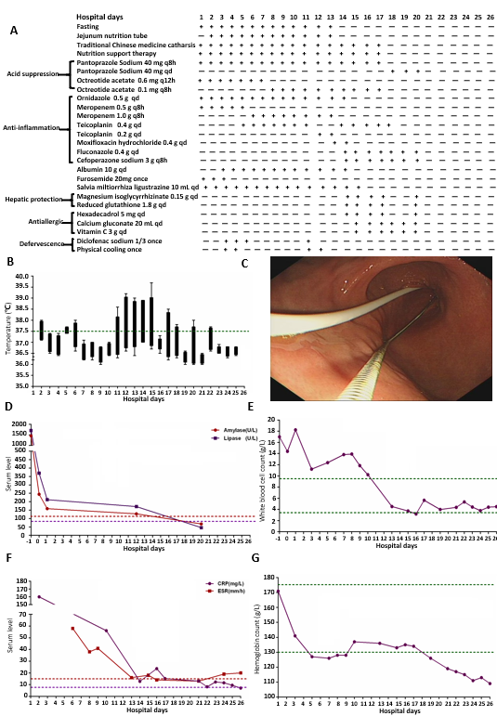
Figure 1 Results of examinations. A: Detailed therapeutic measures taken for the patient with acute pancreatitis during the time of hospitalization. Nutrition support therapy included 5% glucose, compound sodium chloride, hetastarch, mix sugar electrolyte, fructose, compound amino acid peptide, glutamine dipeptide, multi-vitamin, and fish oil fat emulsion; B: Temperature change curve of the patient. The measuring frequency was four times a day; C: Jejunum nutrition tube was placed by gastroscopy; D-G: Changes of amylase, lipase, white blood cell count, C-reactive protein, erythrocyte sedimentation rate, and hemoglobin during hospitalization.
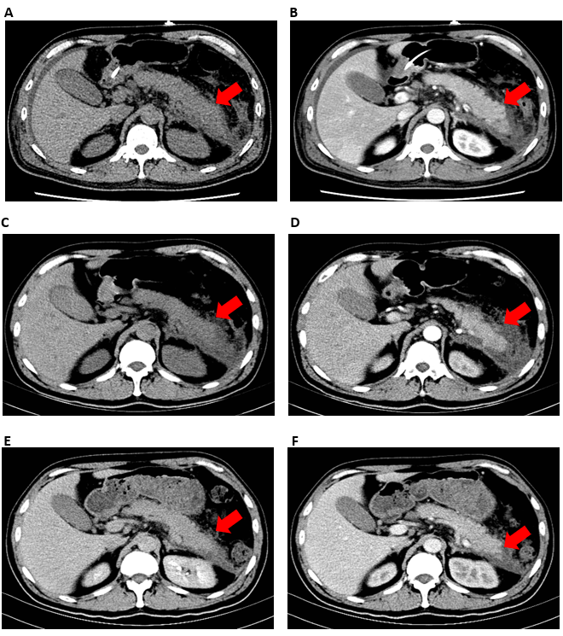
Figure 2 Images of abdominal computed tomography. A and B: Contrast-enhanced computed tomography imaging of the pancreas showed pancreatic swelling, peripancreatic infiltration, and bilateral fascia thickening on the fourth day of hospitalization; C and D: The pancreatic swelling and peripancreatic fluid collections were meliorated on day 13; E and F: The peripancreatic seepage almost recovered on day 23.

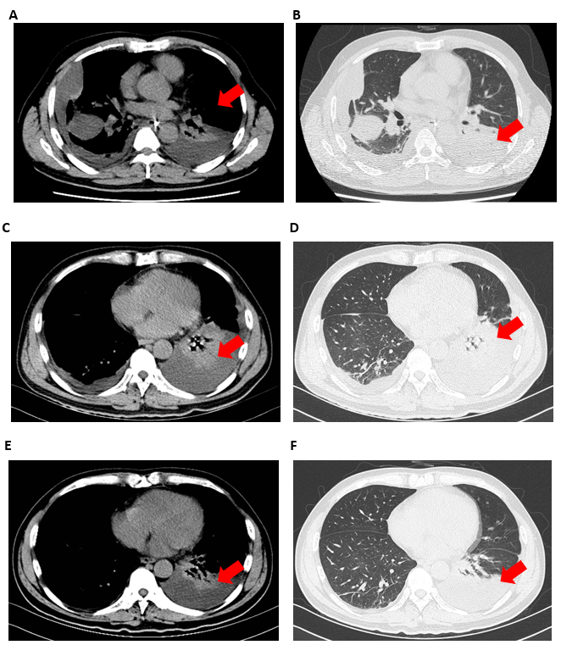
Figure 3 Images of thoracic computed tomography. A and B: On the fourth day, thoracic computed tomography showed bilateral pleural effusion with partially encapsulated effusion. The lungs also showed scattered linear and lamellar high-density shadows, which were considered to be due to an infectious disease; C and D: Thoracic computed tomography indicated that encapsulated effusion was gradually absorbed but the left lung showed segmental atelectasis on day 13; E and F: Bilateral pleural effusion completely disappeared and segmental atelectasis was recovered on day 23.

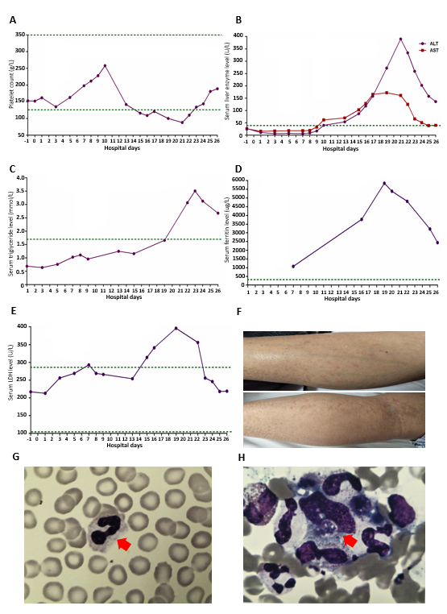
Figure 4 Changes of indexes after effective treatment. A-E: Changes of platelets and serum levels of alanine aminotransferase, aspartate amino transferase, triglyceride, ferritin, and lactic acid dehydrogenase during hospitalization; F: The patient suddenly developed skin rash; G: No obvious abnormality was found in the peripheral blood smear (original magnification, 1 × 10³); H: Overactive macrophage phagocytosis, erythrocytes, leucocytes, platelets, and their precursors were also not found in the bone marrow aspiration specimen (original magnification, 1 × 10³). ALT: Alanine aminotransferase; AST: Aspartate amino transferase.

Table 1 Laboratory findings for the patient with acute pancreatitis during hospitalization
Day | Index | Value | Range | P/N
1 | Calcium | 1.88 | 2.03-2.54 mmol/L
1 | Glucose | 7.71 | 3.9-6.1 mmol/L
1 | Albumin | 31.0 | 35-55 g/L
1 | Creatinine | 86.6 | 44.0-133.0 μmol/L
1 | D-Dimer | 1.63 | < 0.5 mg/L
6 | PCT | 0.28 | < 0.5 ng/mL
7 | CA125 | 320.0 | < 35.0 U/mL
7 | CA153 | 8.2 | < 31.3 U/mL
7 | CA199 | 6.5 | < 37.0 U/mL
14 | Anti-ANA | 1:1000 | < 1:100
14 | IgG | 15.80 | 7.51-15.60 g/L
14 | IgA | 2.93 | 0.82-4.53 g/L
14 | IgM | 0.634 | 0.46-3.04 g/L
15 | Anti-TPO | 384.63 | < 5.61 IU/mL
15 | Anti-TG | 427.53 | < 4.11 IU/mL
15 | FT3 | 2.0 | 2.63-5.7 pmol/L
16 | C3 | 0.395 | 0.79-1.52 g/L
16 | C4 | 0.052 | 0.16-0.38 g/L
16 | ASO | 49.7 | < 200.0 IU/mL
16 | IgG4 | 0.892 | 0.03-2.01 g/L
19 | IgE | 471.17 | 1-190 IU/mL
8 | T-SPOT.TB |  |  | +
14 | Anti-nRNP |  |  | -
14 | Anti-SSA |  |  | +
14 | Anti-SSB |  |  | -
14 | ADA |  |  | -
14 | DE |  |  | -
14 | RA-54 |  |  | -
14 | ACA |  |  | -
14 | AHA |  |  | -
14 | Ro-52-Ab |  |  | +
15 | CoxB3-IgM |  |  | -
15 | CoxB5-IgM |  |  | -
15 | Evs-RNA |  |  | -
15 | CMV-IgM |  |  | -
15 | pANCA |  |  | -
15 | cANCA |  |  | -
15 | GBM-Ab |  |  | -
15 | EB-DNA |  |  | -
17 | HBV |  |  | -
17 | HCV |  |  | -
17 | HIV |  |  | -
20 | Type A influenza virus |  |  | -
20 | Type B influenza virus |  |  | -
20 | Respiratory syncytial virus |  |  | -
20 | Adenovirus |  |  | -
20 | Type 1 parainfluenza virus |  |  | -
20 | Type 2 parainfluenza virus |  |  | -
20 | Type 3 parainfluenza virus |  |  | -
P/N: Positive/negative; PCT: Procalcitonin; Anti-ANA : Anti-nuclear antibody; Anti-TPO: Anti-thyroid peroxidase antibody; Anti-TG: Anti-thyroglobulin antibody; FT3: Free triiodothyronine; C3: Complement 3; ASO: Antistreptolysin; T-SPOT.TB: Tuberculosis T cell spot test; Anti-nRNP: Anti-nuclear ribonucleoprotein; Anti-SSA: Anti-Sj gren syndrome A antibody; Anti-SSB: Anti-Sj gren syndrome B antibody; ADA: Anti-dsDNA antibody; DE: Anti-ribosomal P protein antibody; RA-54: Anti-nucleosome antibody; ACA: Anti-cardiolipin antibody; AHA: Anti-histone antibody; Ro-52-Ab: Ro-52 antibody; Cox: Coxsackievirus; Evs: Enterovirus; CMV: Cytomegalovirus; pANCA: Anti-antineutrophilic perinuclear antibody; cANCA: Anti-antineutrophilic cytoplasmic antibody; GBM-Ab: Glomerular basement membrane antibody; EB: Epstein-Barr virus; HBV: Hepatitis B virus; HCV: Hepatitis C virus; HIV: Human immunodeficiency virus.

