Name of Journal: World Journal of Clinical Cases
Manuscript NO: 83807
Manuscript Type: CASE REPORT

Severe liver trauma with complex portal and common bile duct avulsion: A case report and review of the literature

Mitricof B et al. RPV and CBD avulsion liver trauma

Bianca Mitricof, Alin Kraft, Florentina Anton, Alexandru Barcu, Darina Barzan, Carmen Haiducu, Vladislav Brasoveanu, Irinel Popescu, Cosmin Alec Moldovan, Florin Botea

Bianca Mitricof, Alexandru Barcu, Medicine Doctoral School, Titu Maiorescu University of Bucharest, Bucharest 040441, Romania

Alin Kraft, Department of General Surgery, Regina Maria Military Emergency Hospital, Brasov 500007, Romania

Florentina Anton, Faculty of Medicine, Carol Davila University of Medicine and Pharmacy, Bucharest 050474, Romania

Darina Barzan, Carmen Haiducu, Vladislav Brasoveanu, Irinel Popescu, Florin Botea, Dan Setlacec Center for General Surgery and Liver Transplant, Fundeni Clinical Institute, Bucharest 022328, Romania

Vladislav Brasoveanu, Irinel Popescu, Cosmin Alec Moldovan, Florin Botea, Department of Medical-Surgical and Prophylactic Disciplines, Faculty of Medicine, Titu Maiorescu University of Bucharest, Bucharest 031593, Romania

Cosmin Alec Moldovan, Department of General Surgery, Witting Clinical Hospital, Bucharest 010243, Romania

Author contributions: Mitricof B, Kraft A, Botea F, Moldovan C and Popescu I provided conceptualization; Botea F, Moldovan C and Popescu I designed the methodology and performed validation; Kraft A, Botea F, Moldovan C and Popescu I provided formal analysis; Mitricof B, Kraft A, Anton F, Bârcu A, Bârzan D, Haiducu C and Brașoveanu V were responsible for investigation; Mitricof B, Kraft A, Anton F, Bârcu A, Bârzan D, Haiducu C, Brașoveanu V and Popescu I performed data curation; Mitricof B, Kraft A, Anton F, Bârcu A and Haiducu C provided writing and original draft preparation; Brașoveanu V, Popescu I, Botea F and Moldovan C performed final review and editing; Popescu I and Brașoveanu V were in charge of supervision; Botea F and Moldovan C were responsible for project administration; All authors have read and agreed to the published version of the manuscript.

Corresponding author: Cosmin Alec Moldovan, MD, PhD, Associate Professor, Department of Medical-Surgical and Prophylactic Disciplines, Faculty of Medicine, Titu Maiorescu University of Bucharest, 67A Gheorghe Pătrașcu Street, 031593 Bucharest, Romania. cosmin.moldovan@prof.utm.ro

Received: February 9, 2023
Revised: April 2, 2023
Accepted: April 12, 2023
Published online: June 6, 2023

Abstract
BACKGROUND
Given its size and location, the liver is the third most injured organ by abdominal trauma. Thanks to recent advances, it is unanimously accepted that the non-operative management is the current mainstay of treatment for hemodynamically stable patients. However, those patients with hemodynamic instability that generally present with severe liver trauma associated with major vascular lesions will require surgical management. Moreover, an associated injury of the main bile ducts makes surgery compulsory even in the case of hemodynamic stability, thereby imposing therapeutic challenges in the tertiary referral hepato-bilio-pancreatic centers’ setting.

CASE SUMMARY
We present the case of a 38-year-old male patient with The American Association for the Surgery of Trauma grade V liver injury and an associated right branch of portal vein and common bile duct avulsion, due to a crush polytrauma. The patient was referred to the nearest emergency hospital and because of the hemorrhagic shock, damage control surgery was performed by means of ligation of the right portal vein branch and right hepatic artery, and hemostatic packing. Afterwards, the patient was referred immediately to our tertiary hepato-bilio-pancreatic center. We performed depacking, a right hepatectomy and Roux-en-Y hepaticojejunostomy. On the 9th postoperative day, the patient developed a high output anastomotic bile leak that required a redo of the cholangiojejunostomy. The postoperative period was marked by a surgical incision site of incomplete evisceration that was managed non-operatively by negative wound pressure. The follow-up was optimal, with no complications at 55 mo.

CONCLUSION
In conclusion, the current case clearly supports that a favorable outcome in severe liver trauma with associated vascular and biliary injuries is achieved thru proper therapeutic management, conducted in a tertiary referral hepato-bilio-pancreatic center, where a stepwise and complex surgical approach is mandatory.

Key Words: Severe; Liver; Trauma; Avulsion; Right portal vein; Common bile duct; Case report

©The Author(s) 2023. Published by Baishideng Publishing Group Inc. All rights reserved.

Citation: Mitricof B, Kraft A, Anton F, Barcu A, Barzan D, Haiducu C, Brasoveanu V, Popescu I, Moldovan CA, Botea F. Severe liver trauma with complex portal and common bile duct avulsion: A case report and review of the literature. World J Clin Cases 2023; 11(16): 3837-3846
URL: https://www.wjgnet.com/2307-8960/full/v11/i16/3837.htm
DOI: https://dx.doi.org/10.12998/wjcc.v11.i16.3837

Core Tip: This paper analyzes a rare and difficult case of a 38-year-old male patient that presented to the nearest emergency hospital for polytrauma secondary to a crush injury, which mainly resulted in a severe liver trauma associated with vascular and biliary injury (grade V liver trauma with severe laceration involving more than 75% of the right hemiliver with injury of the right portal vein and common bile duct). Its management consisted in emergency damage control surgery for hemostasis by vascular ligation and packing in a primary trauma center. This was followed by a major liver resection (right hepatectomy) and biliary reconstruction in a tertiary hepato-bilio-pancreatic (HBP) center. The patient recovered well with no long-term complications and had a follow-up ultrasound that showed no issues. Currently, the overall survival is 55 mo. In conclusion, the current case clearly supports that a favorable outcome in severe liver trauma with associated vascular and biliary injuries is achieved thru proper therapeutic management, conducted in a tertiary referral HBP center, where stepwise and complex surgical approach is mandatory.

INTRODUCTION
The general term “liver trauma” covers blunt or penetrating abdominal trauma that causes parenchymal hepatic injury and could involve a wide spectrum of intra and/or extra-parenchymal vascular structures and bile ducts^{[1]}; the liver is the third most injured organ, given its size and anterior location^{[2]}. Other associated organ lesions are found in up to 30% of the cases, usually involving the spleen, the pancreas or the kidneys^{[3,4]}.
The American Association for the Surgery of Trauma (AAST) classification, based on morphologic and imaging criteria, is scaled from I to VI, from the least injury to the most severe, and according to the anatomic disruption characteristics of the liver lesions. Grades from I to V are compatible with survival and represent increasingly complex injuries. Grade VI consists of a destructive lesion, usually incompatible with survival. This classification facilitates the comparison of an equivalent injury that is manageable by several therapeutic conducts^{[3]}. The consecutive severity is based on the potential threat to the patient's life. In clinical practice, 80%-90% of the encountered liver lesions are minor and moderate^{[5]}. Advances of the last decades have shifted the mainstay of treatment from exploratory laparotomy to non-operative management (NOM) by multidisciplinary teams in experienced centers^{[6,7]}.
The hemodynamic status, anatomic lesion, as well as associated injuries must be analyzed when deciding upon the optimal management plan^{[3]}. NOM is the first choice of treatment in all hemodynamically stable patients with AAST grade I-V injuries, showing no sign of peritonitis or other lesions requiring surgery^{[8,9]}.
However, in clinical practice it is generally admitted that patients with severe liver trauma graded ≥ III who present hemodynamic instability after initial fluid resuscitation must undergo an emergency laparotomy aimed at prompt bleeding control^{[10]}. Thus, hemodynamically unstable patients should undergo operative management (OM), with major resections only to be considered in subsequent surgical interventions, and not upon the primary surgery setting – that should solely control the hemorrhage and restrict the bile leak^{[3]}.
AAST grade V-VI injuries are associated with vascular avulsion and higher mortality rates^{[11]}. Vascular avulsion secondary to trauma is very rare and represents a challenge for surgeons who need to perform damage control surgery and can include the ligation of the injured vessels^{[12]}. Post-traumatic bile duct injuries represent another entity that poses a high risk to major complications such as choleperitoneum and biliary fistulas^{[10]}.
The computed tomography (CT) scan is the gold standard investigation for diagnosing post-traumatic abdominal lesions and has a key role in selecting the treatment strategy^{[13]}. However, bile duct lesions pose great diagnostic issues in the post-traumatic setting; literature data suggest that the clinical diagnosis is extremely difficult and stand-alone CT scanning does not hold an adequate sensitivity for detecting biliary leaks^{[14]}; moreover, high morbidity rates are related to a delayed diagnosis thereby making the early diagnosis crucial^{[10]}.
The existing literature offers few studies that report the association between severe liver trauma, right portal vein branch, and common bile duct avulsion, and therefore the present paper is aimed at filling the gaps of knowledge by presenting the management of such a challenging injury.

CASE PRESENTATION
Chief complaints
We present the case of a 38-year-old male patient who was taken to the nearest emergency room with polytrauma due to a crush injury which presented with hemorrhagic shock due to a grade V liver trauma with severe laceration involving more than 75% of the right hemiliver, avulsion of the right portal vein and common bile duct, with massive hemoperitoneum, right hemopneumothorax, pulmonary contusions, right renal hematoma, II-X rib fractures and a left clavicle fracture.

History of present illness
Emergency laparotomy was performed, consisting with ligation and suture of the right portal vein, intentional ligation of the right hepatic artery for hemostasis, drainage of the total biliary fistula (the biliary reconstruction was not considered at this time), and perihepatic packing. Right pleurostomy and closed reduction and immobilization of the left clavicle were also performed. The pulmonary contusions and the right renal hematoma were treated conservatively.

History of past illness
The patient had no significant medical history.

Personal and family history
The patient had no significant personal or family medical history.

Physical examination
The patient was then referred 24 h later to our tertiary hepato-bilio-pancreatic (HBP) center for subsequent treatment.

Laboratory examinations
A high-output biliary fistula which drained externally was recorded.

Imaging examinations
The CT scan showed no contrast uptake of the right hemiliver in the portal phase, no intrahepatic bile ducts dilatation, no peritoneal liquid and a mild right renal contusion (Figure 1). A high-output biliary fistula which drained externally was recorded.

FINAL DIAGNOSIS
Grade V liver trauma with severe laceration involving more than 75% of the right hemiliver, avulsion of the right portal vein and common bile duct, with massive hemoperitoneum, right hemopneumothorax, pulmonary contusions, right renal hematoma, II-X rib fractures and left clavicle fracture.

TREATMENT
One day after the primary surgical intervention the second operation was performed, consisting of depacking, a right hepatectomy and Roux-en-Y hepatico-jejunostomy (using the stump of the common hepatic duct) protected by Wietzel external biliary drainage (Figures 2 and 3). The postoperative CT scan performed in postoperative day (POD) 6 showed the normal aspect of the remnant liver (Figure 4).
On POD 4, the onset of bile output through the subhepatic surgical drain was recorded and had increased progressively to 700 mL/d in POD 9. On POD 10, surgical reintervention was urged for high output anastomotic leakage. Intraoperatively, we diagnosed an anastomotic leakage and dubious vitality of the common bile duct stump. Therefore, we performed a redo cholangio-jejunostomy (using the left bile duct), protected by Wietzel external biliary drainage.
The intensive care unit stay had a total length of 4 d, as follows: 1 d in the emergency trauma center and 3 d in our center (2 d following the operation for right hemihepatectomy, 1 d following the intervention for biliary leakage). The patient was administered Piperacillin/tazobactam and Colistin. Blood products were used prior to and during the first operation performed in the primary emergency trauma center because the patient was admitted in hemorrhagic shock. Only 1 unit of blood was used in our tertiary referral center during the operation for right hemihepatectomy, and no blood products were used during the operation for biliary leakage.
The postoperative period was marked by a surgical incisional site incomplete evisceration that was managed non-operatively by means of negative pressure wound therapy (NPWT). The patient was discharged on POD 30, after a remaining uneventful course, with outcare NPWT, until the complete healing of the surgical wound after 4 mo postoperatively (Figure 5).

OUTCOME AND FOLLOW-UP
A follow-up ultrasound was performed at 1, 3, and 6 mo, showing no complications; the external biliary drainage was removed after 6 mo prior to cholangiography control. The patient fully recovered, as there were no other long-term complications encountered; currently the overall survival is 55 mo.

DISCUSSION
Although most liver traumas are successfully treated by NOM, which reduced the morbidity and mortality rates of these patients, interventional therapy still has a role in the management of complex liver injuries.
However, cases of severe blunt liver injury that associate hemodynamic instability after initial fluid resuscitation carry a high risk of hypovolemic shock and death, especially when other abdominal or thoracic lesions coexist; therefore, the current therapeutic conduct in such cases is the OM^{[3,5,10]}. In this regard, the main goal of the primary surgery conducted in an emergency setting should be to secure efficient hemostasis by damage control surgery^{[15]}. In the absence of major bleeding sites, it is usually suitable to employ techniques such as: compression, electrocautery, bipolar devices or suturing the liver parenchyma^{[16,17]}. Major hemorrhage, however, may impose techniques such as: hepatic packing, direct vessel repair under vascular control, vessel ligation, shunting maneuvers, balloon tamponade or hepatic vascular isolation or exclusion^{[18]}. Literature data clearly emphasizes that major resections should be avoided whenever possible upon this primary surgical intervention^{[4]}.
Studies that have investigated the outcomes of damage control surgery came to the conclusion that the packing procedure is part of a whole “damage control” strategy^{[19]}. Even after a well conducted perihepatic packing procedure, some patients present active hemorrhage generated from deep injured vessels. In such cases, these patients are managed in the multidisciplinary setting, by selective angioembolization techniques performed by the interventional radiologists^{[3]}. Some severe patients that still present with active bleeding following the aforementioned procedures are quickly subjected to a second packing procedure, because time is of essence in order to avoid the onset of the mortality associated “lethal triad” (i.e. acidosis, hypothermia and coagulopathy)^{[19]}. The efficient perihepatic packing cannot be defined using an optimal number of gauzes^{[20]}; it is important to avoid excessive packing in order to prevent abdominal compartment syndrome^{[19]}. It is generally considered that packing is best removed after 48 h^{[21]}.
When vascular avulsion is present, it is vital to identify the injured vessels. In the case of hepatic artery injury, selective ligation is suitable whenever the repair of the vessel is not feasible. If the right hepatic artery needs to be ligated, cholecystectomy is recommended in order to avoid necrosis of the gallbladder^{[22,23]}; this was not the case with our patient, as he had previously undergone cholecystectomy prior to trauma. When there are injuries of the portal vein, packing or liver resection are preferred to ligation when only segmental branches are affected^{[17]}. In our case, the right portal vein was severely injured, imposing its ligation in the setting of damage control surgery, followed by right hepatectomy in the referral HBP center, leaving a sufficient functional liver remnant.
In the case of extensive parenchymal damage with insufficient liver remnant, liver transplant is to be considered^{[23]}. Liver transplantation completes the therapeutic armamentum, and should be considered the last therapeutic alternative when the previously mentioned procedures prove unsuccessful in achieving hemodynamic stability, and complete hepatectomy is the last resort in bleeding control^{[1]}. Literature data on this topic are very scarce^{[24]}; nonetheless, the generally accepted indications are: uncontrollable hemorrhage following damage control surgery, extensive and complex hepatic injuries not correctable by surgical procedures, unrepairable injuries of the portal vein, hepatic veins or bile ducts, trauma related acute liver failure due to trauma, and hepatic necrosis^{[25]}. The liver transplantation decision should be thoroughly evaluated and implies the identification of those patients unfit for transplant, that present severe sepsis, multiple system organ failure, or associated severe organ injuries^{[24,25]}.
Liver trauma leads to a great variety of intra- and/or extrahepatic bile duct injuries; unfortunately, few studies have evaluated the management of bile leakage according to the location of the injured bile duct; therefore, the therapeutic management is controversial^{[10]}. Literature states that the moment of detection raises issues of great importance. Because of the vague symptoms at presentation, delayed diagnosis can often occur, leading to high mortality and morbidity rates, through bacterial or fungal peritonitis, intractable bile leakage, haemobilia, pseudoaneurysms, or biliocutaneous fistula, and septic shock^{[10,14]}. Thus, great importance must be given to early detection and proper management of bile leakage following liver trauma^{[14]}.
As stated earlier, due to the patient’s hemodynamic instability, the goal of the above mentioned primary emergency damage control surgery is to rapidly control the hemorrhage. Studies show that if a bile duct injury is diagnosed upon this primary procedure, the risks of performing extensive procedures such as liver resection and/or bile duct reconstruction are greater than the provided benefits, therefore it is generally accepted that the management of the injured bile ducts will be postponed and conducted at a later time^{[10]}.
Recent literature data consider applying adequate therapeutic management according to the extent of the injury and to the bile duct’s location. Certain studies have reported promising results following the nonoperative management of peripheral bile duct injuries by using percutaneous drainage procedures and early endoscopic biliary stenting, thus providing a safe alternative and avoiding open surgery^{[10,14,26,27]}. Some of the major drawbacks are: the difficulty in performing early Endoscopic retrograde cholangiopancreatography (ERCP) and internal stenting in hemodynamically unstable patients, and post-ERCP cholangitis, resulting in hepatic abscess and consecutive liver rupture^{[28]}. In an attempt to overcome these shortcomings, some centers avoided ERCP stenting and stent removal procedures, and adopted first-line percutaneous intraperitoneal drainage; their updated experience shows comparable outcomes^{[10,14]}. Previous studies reporting the setting of severe liver trauma show that peripheral bile duct injuries can be managed by the above mentioned nonoperative treatments. However, the appropriate timing and the choice of therapeutic management are still subject of debate^{[10,26,29,30]}.
Recent studies also show that post-traumatic sections of a central bile duct are rare and often difficult to diagnose preoperatively^{[30]}. The attempt to determine the degree of the bile duct injury with massive fluid collection by means of preoperative CT or magnetic resonance cholangiopancreatography (MRCP) scan is close to impossible^{[10]}; therefore, as a diagnostic alternative, some authors promote the use of technetium-99 m trimethylbromoimino‐diacetic acid scan for early detection on post-traumatic days 5 to 7^{[14]}. Nonetheless, some studies suggest that a preoperative CT exam shows a strong correlation between the minimal distance measured from the portal pedicle to the parenchymal traumatic injury and the existence of a bile duct injury^{[14]}.
Given the emergency setting scenario of the case under discussion, the MPCR exam was not taken into consideration due to long delays in both waiting list times and performance of examination. In addition, properly conducted perihepatic packing can cause artefacts and major anatomic distortions that render the MRCP exam inconclusive. We considered that intraoperative exploration of the bile ducts combined with intraoperative cholangiography, whenever deemed necessary, is optimal for this type of case with severe hepato-biliary trauma managed with emergency packing as a first step of the surgical treatment. For example, we did not perform intraoperative cholangiography, as the surgical exploration of the bile ducts with a malleable metal probe was considered enough.
On the other hand, a central bile duct injury will require aggressive surgical treatment, performed once the patient’s condition is stable; however, currently, there is no consensual therapeutic conduct available in the literature regarding central bile duct injuries; consequently, the management of such an injury must be tailored^{[10]}. Literature data report successful outcomes after techniques, such as, liver resection, reconstruction of the injured bile ducts by Roux-en-Y hepaticojejunostomy^{[31]}, and /or primary repair of the injured duct with T-tube insertion^{[32]}. Biliary leakage by anastomotic fistula is a possible complication, as shown by the current case – i.e. the hepaticojejunostomy was redone in a subsequent intervention. There are also reports available on central bile duct injuries repaired by primary suture and complemented by ERCP and internal stenting as an option for biliary decompression. Due to the extent of the bile duct injury, the concepts of NOM were not applicable in the case in question. In addition, even if in retrospect a hepatico-jejunostomy would have been a better therapeutic option, there was no way of knowing this in advance, because the stump of the common bile duct seemed properly vascularized at the time of the first surgical intervention performed in our tertiary referral center. Therefore, at that time, an anastomosis performed on the left hepatic duct seemed like an excessive treatment measure.
Given the complexity of the encountered lesions, we did not consider it appropriate to adopt any other therapeutic approach. A reconstruction of the right portal vein and right hepatic artery was not considered feasible, because a significant portion of the right portal vein was missing (due to associated trauma and to surgical hemostasis during the damage control surgery), because of the long ischemic time of the right hemiliver, and finally because the parenchyma of the right hemiliver was almost completely damaged by trauma.
Of note, the ligation of the right hepatic artery performed upon the damage control laparotomy was considered mandatory due to remanent significant parenchymal bleeding despite right portal vein ligation. Moreover, the right hemiliver was already compromised by the laceration and associated right portal vein avulsion. Therefore, right hepatectomy would have been needed even in the absence of the right hepatic artery ligation.
NPWT facilitates healing by reducing edema, draining excess fluids, and eliminating barriers to cellular proliferation^{[33,34]}. NPWT can successfully promote the healing of infected wounds, diabetic foot wounds, laparotomy incisions, as well as other chronic conditions^{[35,36]}. In our case, it successfully facilitated the closure of the surgical incisional site evisceration allowing for complete healing, thus avoiding the need for additional surgery and exposing the patient to fewer risks.

CONCLUSION
This case clearly supports that a favorable outcome in severe liver trauma with associated vascular and biliary injuries is achieved thru proper therapeutic management, conducted in a tertiary referral HBP center, where stepwise and complex surgical approach is mandatory.

ACKNOWLEDGEMENTS
The present study is included in a wider retrospective research entitled “Liver Trauma”, as part of a doctoral dissertation, developed by Bianca Mitricof, Ph D student at “Titu Maiorescu” Doctoral School of Medicine, Bucharest, Romania with Irinel Popescu as thesis coordinator. The authors would like to thank Luiza-Anca Kraft, Associate Professor in “Carol I” National Defense University, Bucharest, Romania, for the language editing work.

REFERENCES
1 Krawczyk M, Grąt M, Adam R, Polak WG, Klempnauer J, Pinna A, Di Benedetto F, Filipponi F, Senninger N, Foss A, Rufián-Peña S, Bennet W, Pratschke J, Paul A, Settmacher U, Rossi G, Salizzoni M, Fernandez-Selles C, Martínez de Rituerto ST, Gómez-Bravo MA, Pirenne J, Detry O, Majno PE, Nemec P, Bechstein WO, Bartels M, Nadalin S, Pruvot FR, Mirza DF, Lupo L, Colledan M, Tisone G, Ringers J, Daniel J, Charco Torra R, Moreno González E, Bañares Cañizares R, Cuervas-Mons Martinez V, San Juan Rodríguez F, Yilmaz S, Remiszewski P; European Liver and Intestine Transplant Association (ELITA). Liver Transplantation for Hepatic Trauma: A Study From the European Liver Transplant Registry. Transplantation 2016; 100: 2372-2381 [PMID: 27780185 DOI: 10.1097/TP.0000000000001398]
2 Matthes G, Stengel D, Seifert J, Rademacher G, Mutze S, Ekkernkamp A. Blunt liver injuries in polytrauma: results from a cohort study with the regular use of whole-body helical computed tomography. World J Surg 2003; 27: 1124-1130 [PMID: 12917767 DOI: 10.1007/s00268-003-6981-0]
3 Coccolini F, Coimbra R, Ordonez C, Kluger Y, Vega F, Moore EE, Biffl W, Peitzman A, Horer T, Abu-Zidan FM, Sartelli M, Fraga GP, Cicuttin E, Ansaloni L, Parra MW, Millán M, DeAngelis N, Inaba K, Velmahos G, Maier R, Khokha V, Sakakushev B, Augustin G, di Saverio S, Pikoulis E, Chirica M, Reva V, Leppaniemi A, Manchev V, Chiarugi M, Damaskos D, Weber D, Parry N, Demetrashvili Z, Civil I, Napolitano L, Corbella D, Catena F; WSES expert panel. Liver trauma: WSES 2020 guidelines. World J Emerg Surg 2020; 15: 24 [PMID: 32228707 DOI: 10.1186/s13017-020-00302-7]
4 Barcu A, Mitricof B, Verdea C, Bălănescu L, Tomescu D, Droc G, Lupescu I, Hrehoreţ D, Braşoveanu V, Popescu I, Botea F. Definitive Surgery for Liver Trauma in a Tertiary HPB Center (with video). Chirurgia (Bucur) 2021; 116: 678-688 [PMID: 34967713 DOI: 10.21614/chirurgia.116.6.678]
5 Saviano A, Ojetti V, Zanza C, Franceschi F, Longhitano Y, Martuscelli E, Maiese A, Volonnino G, Bertozzi G, Ferrara M, La Russa R. Liver Trauma: Management in the Emergency Setting and Medico-Legal Implications. Diagnostics (Basel) 2022; 12 [PMID: 35741266 DOI: 10.3390/diagnostics12061456]
6 García IC, Villalba JS, Iovino D, Franchi C, Iori V, Pettinato G, Inversini D, Amico F, Ietto G. Liver Trauma: Until When We Have to Delay Surgery? A Review. Life (Basel) 2022; 12 [PMID: 35629360 DOI: 10.3390/life12050694]
7 Mitricof B, Brasoveanu V, Hrehoret D, Barcu A, Picu N, Flutur E, Tomescu D, Droc G, Lupescu I, Popescu I, Botea F. Surgical treatment for severe liver injuries: a single-center experience. Minerva Chir 2020; 75: 92-103 [PMID: 32009332 DOI: 10.23736/S0026-4733.20.08193-6]
8 Hommes M, Navsaria PH, Schipper IB, Krige JE, Kahn D, Nicol AJ. Management of blunt liver trauma in 134 severely injured patients. Injury 2015; 46: 837-842 [PMID: 25496854 DOI: 10.1016/j.injury.2014.11.019]
9 Kozar RA, Moore FA, Moore EE, West M, Cocanour CS, Davis J, Biffl WL, McIntyre RC Jr. Western Trauma Association critical decisions in trauma: nonoperative management of adult blunt hepatic trauma. J Trauma 2009; 67: 1144-8; discussion 1148-9 [PMID: 20009658 DOI: 10.1097/TA.0b013e3181ba361f]
10 Kagoura M, Monden K, Sadamori H, Hioki M, Ohno S, Takakura N. Outcomes and management of delayed complication after severe blunt liver injury. BMC Surg 2022; 22: 241 [PMID: 35733106 DOI: 10.1186/s12893-022-01691-z]
11 Oniscu GC, Parks RW, Garden OJ. Classification of liver and pancreatic trauma. HPB (Oxford) 2006; 8: 4-9 [PMID: 18333232 DOI: 10.1080/13651820500465881]
12 Melloul E, Denys A, Demartines N. Management of severe blunt hepatic injury in the era of computed tomography and transarterial embolization: A systematic review and critical appraisal of the literature. J Trauma Acute Care Surg 2015; 79: 468-474 [PMID: 26307882 DOI: 10.1097/TA.0000000000000724]
13 Fodor M, Primavesi F, Morell-Hofert D, Haselbacher M, Braunwarth E, Cardini B, Gassner E, Öfner D, Stättner S. Non-operative management of blunt hepatic and splenic injuries-practical aspects and value of radiological scoring systems. Eur Surg 2018; 50: 285-298 [PMID: 30546386 DOI: 10.1007/s10353-018-0545-x]
14 Stonelake S, Ali S, Pinkey B, Ong E, Anbarasan R, McGuirk S, Perera T, Mirza D, Muiesan P, Sharif K. Fifteen-Year Single-Center Experience of Biliary Complications in Liver Trauma Patients: Changes in the Management of Posttraumatic Bile Leak. Eur J Pediatr Surg 2021; 31: 245-251 [PMID: 32422676 DOI: 10.1055/s-0040-1710391]
15 Küçükaslan H, Tayar S, Oğuz Ş, Topaloglu S, Geze Saatci S, Şenel AC, Calik A. The role of liver resection in the management of severe blunt liver trauma. Ulus Travma Acil Cerrahi Derg 2022; 29: 122-129 [PMID: 36588513 DOI: 10.14744/tjtes.2021.89678]
16 Letoublon C, Reche F, Abba J, Arvieux C. Damage control laparotomy. J Visc Surg 2011; 148: e366-e370 [PMID: 22075562 DOI: 10.1016/j.jviscsurg.2011.09.010]
17 Coccolini F, Montori G, Catena F, Di Saverio S, Biffl W, Moore EE, Peitzman AB, Rizoli S, Tugnoli G, Sartelli M, Manfredi R, Ansaloni L. Liver trauma: WSES position paper. World J Emerg Surg 2015; 10: 39 [PMID: 26309445 DOI: 10.1186/s13017-015-0030-9]
18 Kodadek LM, Efron DT, Haut ER. Intrahepatic Balloon Tamponade for Penetrating Liver Injury: Rarely Needed but Highly Effective. World J Surg 2019; 43: 486-489 [PMID: 30280221 DOI: 10.1007/s00268-018-4812-6]
19 Martellotto S, Melot C, Raux M, Chereau N, Menegaux F. Depacked patients who underwent a shortened perihepatic packing for severe blunt liver trauma have a high survival rate: 20 years of experience in a level I trauma center. Surgeon 2022; 20: e20-e25 [PMID: 34154925 DOI: 10.1016/j.surge.2021.04.012]
20 Baldoni F, Di Saverio S, Antonacci N, Coniglio C, Giugni A, Montanari N, Biscardi A, Villani S, Gordini G, Tugnoli G. Refinement in the technique of perihepatic packing: a safe and effective surgical hemostasis and multidisciplinary approach can improve the outcome in severe liver trauma. Am J Surg 2011; 201: e5-e14 [PMID: 21167358 DOI: 10.1016/j.amjsurg.2010.05.015]
21 Ordoñez C, Pino L, Badiel M, Sanchez A, Loaiza J, Ramirez O, Rosso F, García A, Granados M, Ospina G, Peitzman A, Puyana JC, Parra MW. The 1-2-3 approach to abdominal packing. World J Surg 2012; 36: 2761-2766 [PMID: 22955950 DOI: 10.1007/s00268-012-1745-3]
22 David Richardson J, Franklin GA, Lukan JK, Carrillo EH, Spain DA, Miller FB, Wilson MA, Polk HC Jr, Flint LM. Evolution in the management of hepatic trauma: a 25-year perspective. Ann Surg 2000; 232: 324-330 [PMID: 10973382 DOI: 10.1097/00000658-200009000-00004]
23 Peitzman AB, Marsh JW. Advanced operative techniques in the management of complex liver injury. J Trauma Acute Care Surg 2012; 73: 765-770 [PMID: 22929505 DOI: 10.1097/TA.0b013e318265cef5]
24 Patrono D, Brunati A, Romagnoli R, Salizzoni M. Liver transplantation after severe hepatic trauma: a sustainable practice. A single-center experience and review of the literature. Clin Transplant 2013; 27: E528-E537 [PMID: 23923975 DOI: 10.1111/ctr.12192]
25 Ribeiro MA Jr, Medrado MB, Rosa OM, Silva AJ, Fontana MP, Cruvinel-Neto J, Fonseca AZ. LIVER TRANSPLANTATION AFTER SEVERE HEPATIC TRAUMA: CURRENT INDICATIONS AND RESULTS. Arq Bras Cir Dig 2015; 28: 286-289 [PMID: 26734803 DOI: 10.1590/S0102-6720201500040017]
26 Tamura N, Ishihara S, Kuriyama A, Watanabe S, Suzuki K. Long-term follow-up after non-operative management of biloma due to blunt liver injury. World J Surg 2015; 39: 179-183 [PMID: 25205342 DOI: 10.1007/s00268-014-2780-z]
27 Kulaylat AN, Stokes AL, Engbrecht BW, McIntyre JS, Rzucidlo SE, Cilley RE. Traumatic bile leaks from blunt liver injury in children: a multidisciplinary and minimally invasive approach to management. J Pediatr Surg 2014; 49: 424-427 [PMID: 24650470 DOI: 10.1016/j.jpedsurg.2013.07.015]
28 Hommes M, Kazemier G, Schep NW, Kuipers EJ, Schipper IB. Management of biliary complications following damage control surgery for liver trauma. Eur J Trauma Emerg Surg 2013; 39: 511-516 [PMID: 26815449 DOI: 10.1007/s00068-013-0304-4]
29 Paffrath T, Lefering R, Flohé S; TraumaRegister DGU. How to define severely injured patients? -- an Injury Severity Score (ISS) based approach alone is not sufficient. Injury 2014; 45 Suppl 3: S64-S69 [PMID: 25284238 DOI: 10.1016/j.injury.2014.08.020]
30 Oo J, Smith M, Ban EJ, Clements W, Tagkalidis P, Fitzgerald M, Pilgrim CHC. Management of bile leak following blunt liver injury: a proposed guideline. ANZ J Surg 2021; 91: 1164-1169 [PMID: 33459492 DOI: 10.1111/ans.16552]
31 Rodriguez-Montes JA, Rojo E, Martín LG. Complications following repair of extrahepatic bile duct injuries after blunt abdominal trauma. World J Surg 2001; 25: 1313-1316 [PMID: 11596896 DOI: 10.1007/s00268-001-0116-2]
32 Zago TM, Pereira BM, Calderan TR, Hirano ES, Fraga GP. Extrahepatic duct injury in blunt trauma: two case reports and a literature review. Indian J Surg 2014; 76: 303-307 [PMID: 25278655 DOI: 10.1007/s12262-013-0885-5]
33 Bellot GL, Dong X, Lahiri A, Sebastin SJ, Batinic-Haberle I, Pervaiz S, Puhaindran ME. MnSOD is implicated in accelerated wound healing upon Negative Pressure Wound Therapy (NPWT): A case in point for MnSOD mimetics as adjuvants for wound management. Redox Biol 2019; 20: 307-320 [PMID: 30390545 DOI: 10.1016/j.redox.2018.10.014]
34 Song YP, Wang L, Yuan BF, Shen HW, Du L, Cai JY, Chen HL. Negative-pressure wound therapy for III/IV pressure injuries: A meta-analysis. Wound Repair Regen 2021; 29: 20-33 [PMID: 32989919 DOI: 10.1111/wrr.12863]
35 Cirocchi R, Birindelli A, Biffl WL, Mutafchiyski V, Popivanov G, Chiara O, Tugnoli G, Di Saverio S. What is the effectiveness of the negative pressure wound therapy (NPWT) in patients treated with open abdomen technique? A systematic review and meta-analysis. J Trauma Acute Care Surg 2016; 81: 575-584 [PMID: 27257705 DOI: 10.1097/TA.0000000000001126]
36 Sahebally SM, McKevitt K, Stephens I, Fitzpatrick F, Deasy J, Burke JP, McNamara D. Negative Pressure Wound Therapy for Closed Laparotomy Incisions in General and Colorectal Surgery: A Systematic Review and Meta-analysis. JAMA Surg 2018; 153: e183467 [PMID: 30267040 DOI: 10.1001/jamasurg.2018.3467]

Footnotes
Informed consent statement: Informed consent was obtained from the subject involved in the study.

Conflict-of-interest statement: All the authors report having no relevant conflicts of interest for this article.

CARE Checklist (2016) statement: The authors have read the CARE Checklist (2016), and the manuscript was prepared and revised according to the CARE Checklist (2016).

Open-Access: This article is an open-access article that was selected by an in-house editor and fully peer-reviewed by external reviewers. It is distributed in accordance with the Creative Commons Attribution NonCommercial (CC BY-NC 4.0) license, which permits others to distribute, remix, adapt, build upon this work non-commercially, and license their derivative works on different terms, provided the original work is properly cited and the use is non-commercial. See: https://creativecommons.org/Licenses/by-nc/4.0/

Provenance and peer review: Unsolicited article; Externally peer reviewed.
Peer-review model: Single blind

Peer-review started: February 9, 2023
First decision: March 28, 2023
Article in press: April 12, 2023

Specialty type: Medicine, research and experimental
Country/Territory of origin: Romania
Peer-review report’s scientific quality classification
Grade A (Excellent): 0
Grade B (Very good): B
Grade C (Good): C, C, C
Grade D (Fair): 0
Grade E (Poor): 0

P-Reviewer: Ghimire R, Nepal; Govindarajan KK, India; He YH, China S-Editor: Liu XF L-Editor: Filipodia P-Editor: Zhang YL

Figure Legends
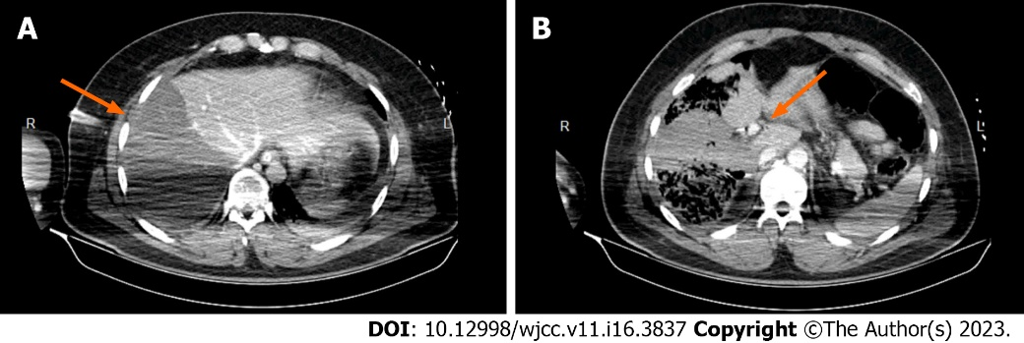
Figure 1 Preoperative computed tomography scan image performed upon admission in our tertiary hepato-bilio-pancreatic referral center. A: Ischemic right hemiliver post-right hepatic pedicle ligation upon damage control surgery; B: Right hepatic pedicle ligated proximally.
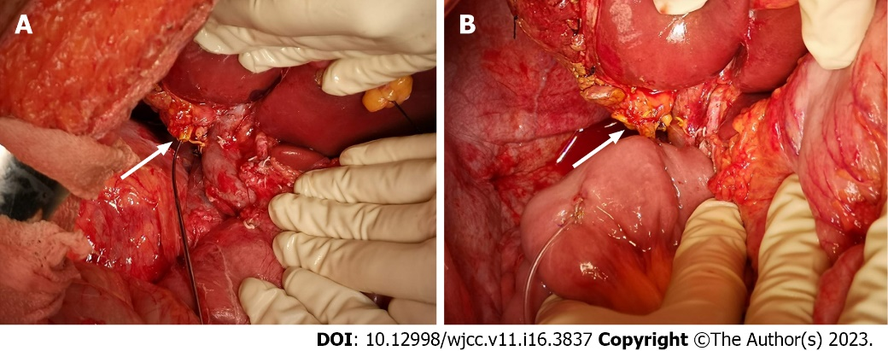
Figure 2 Intraoperative aspect. A: Sectioned common hepatic duct, prepared for the hepaticojejunostomy; B: Finished hepaticojejunostomy.
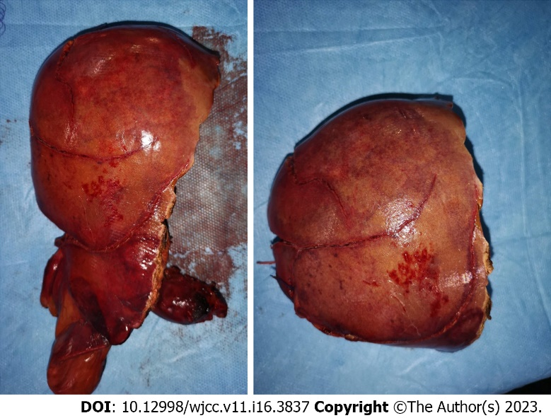
Figure 3 Gross pathology of the resected right hemiliver.
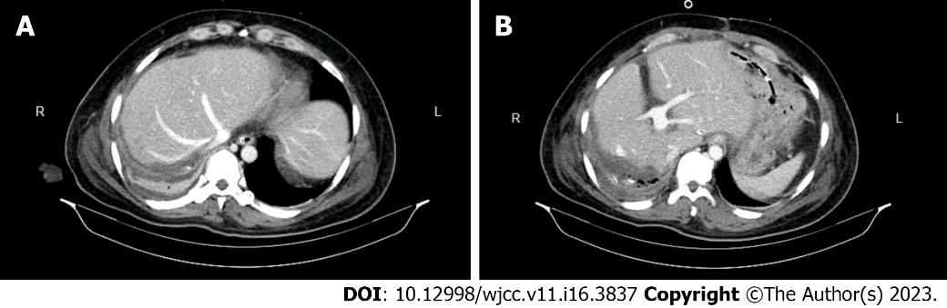
Figure 4 Postresection computed tomography scan image. A: Remnant left hemiliver showing no ischemic regions; B: Image showing the left portal vein branches.
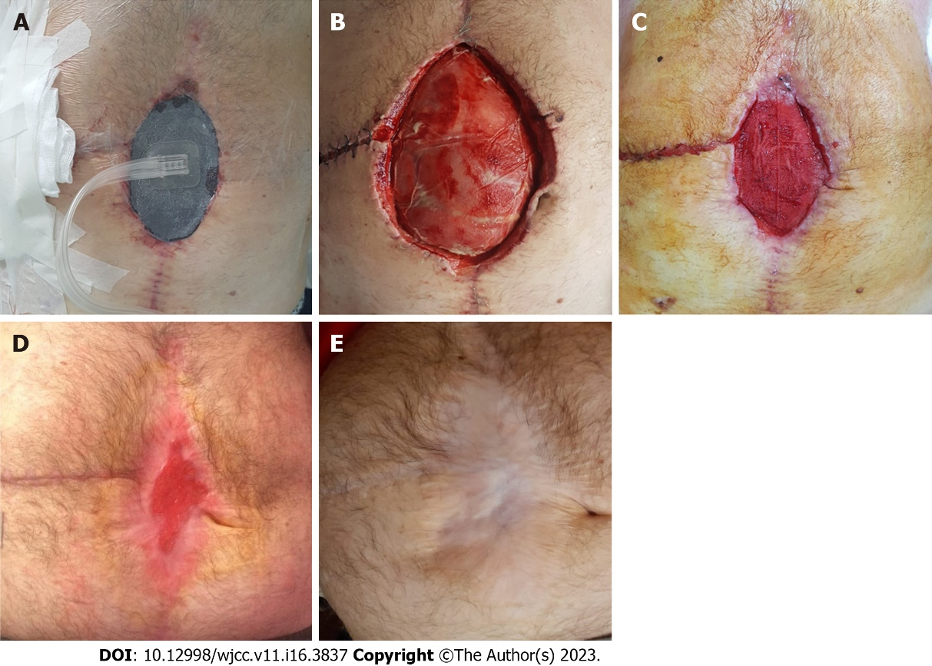
Figure 5 Postoperative aspect. A: The surgical incisional site evisceration managed by negative-pressure wound therapy on the 48th postoperative day (POD); B: 18th POD aspect showing the surgical incisional site evisceration; C: 48th POD aspect showing the surgical incisional site evisceration managed by negative-pressure wound therapy; D: 4 mo postoperative aspect showing the chronological evolution of the surgical incisional site evisceration managed by negative-pressure wound therapy; E: 55 mo postoperative aspect showing the chronological evolution of the surgical incisional site evisceration following negative-pressure wound therapy.

Published by Baishideng Publishing Group Inc
7041 Koll Center Parkway, Suite 160, Pleasanton, CA 94566, USA
Telephone: +1-925-3991568
E-mail: bpgoffice@wjgnet.com
Help Desk: https://www.f6publishing.com/helpdesk
https://www.wjgnet.com

© 2023 Baishideng Publishing Group Inc. All rights reserved.

