Name of journal: World Journal of Clinical Cases

ESPS Manuscript NO: 17497

Columns: CASE REPORT

Transhepatic venous approach to permanent pacemaker placement in a patient with limited central venous access

Siddiqui AM et al. Transhepatic approach to PPM with limited access

Adeel M Siddiqui, Gregory S Harris, Assad Movahed, Karl S Chiang, Mihail G Chelu, Rajasekhar Nekkanti

Adeel M Siddiqui, Department of Internal Medicine, East Carolina School of Medicine, Greenville, NC 27834, United States
Gregory S Harris, Assad Movahed, Mihail G Chelu, Rajasekhar Nekkanti, Department of Cardiovascular Sciences, East Carolina Brody School of Medicine, Greenville, NC 27834, United States
Karl S Chiang, Vascular Interventional Radiology, Vidant Medical Center, Greenville, NC 27834, United States

Author contributions: Siddiqui AM, Harris GS, Movahed A designed the report; Chelu MG, Nekkanti R, Chiang KS performed the procedure.

Ethics approval: Please note that case reports consisting of less than three cases are not required to undergo the IRB approval process at our institution (East Carolina University).
Informed consent: Please note that case reports consisting of one case are not required to undergo the informed consent statement process at our institution (East Carolina University).
Conflict-of-interest: None of the authors have any disclosures.

Open-Access: This article is an open-access article which was selected by an in-house editor and fully peer-reviewed by external reviewers. It is distributed in accordance with the Creative Commons Attribution Non Commercial (CC BY-NC 4.0) license, which permits others to distribute, remix, adapt, build upon this work non-commercially, and license their derivative works on different terms, provided the original work is properly cited and the use is non-commercial. See: http://creativecommons.org/licenses/by-nc/4.0/

Correspondance to: Adeel M Siddiqui, MD, Department of Internal Medicine, East Carolina School of Medicine, 115 Heart Drive, Greenville, NC 27834, United States. siddiquia@ecu.edu
Telephone: +1-252-7443597
Fax: +1-252-7443987

Received: March 10, 2015
Peer-review started: March 12, 2015
First decision: April 27, 2015
Revised: May 15, 2015
Accepted: June 15, 2015
Article in press:
Published online:

Abstract
The end-stage renal disease population poses a challenge for obtaining venous access required for life-saving invasive cardiac procedures. In this case report, we describe an adult patient with end-stage renal disease in whom the hepatic vein was the only available access to implant a single-lead permanent cardiac pacemaker. A 63 year-old male with end-stage renal disease on maintenance hemodialysis and permanent atrial fibrillation/atrial flutter presented with symptomatic bradycardia. Imaging studies revealed all traditional central venous access sites to be occluded/non-accessible. With the assistance of vascular interventional radiology, a trans-hepatic venous catheter was placed. This was then used to place a right ventricular pacing lead with close attention to numerous technical aspects. The procedure was completed successfully with placement of a single-lead permanent cardiac pacemaker.

Key words: Trans-hepatic venous access; Permanent cardiac pacemaker; End-stage renal disease

© The Author(s) 2015. Published by Baishideng Publishing Group Inc. All rights reserved.

Core tip: End-stage renal disease patients pose a great challenge to establish central venous access. In situations when life-saving cardiac procedures are required in such patients, the clinician must use non-traditional venous access sites to perform these procedures. In our case report, we illustrate the novel use of the trans-hepatic venous access route to implant a single-lead permanent cardiac pacemaker in a patient with bradycardia and hypotension. Additionally, we describe the technical challenges associated with this procedure.

Siddiqui AM, Harris GS, Movahed A, Chiang KS, Chelu MG, Nekkanti R. Transhepatic venous approach to permanent pacemaker placement in a patient with limited central venous access. World J Clin Cases 2015; In press

INTRODUCTION
The end-stage renal disease population poses a challenge for obtaining venous access required for invasive cardiac procedures due to placement of multiple arteriovenous fistulas for hemodialysis access or venous thrombus formation. The left subclavian vein is the preferred venous access for implantation of a pacing lead, but in patients with limited access alternative approaches include the right subclavian vein^{[1]} and iliac veins^{[2]}. In this case report, we describe an adult patient with end-stage renal disease in whom the hepatic vein was the only available access to implant a single-lead permanent cardiac pacemaker.

CASE REPORT
A 63-year-old African American male with end-stage renal disease on maintenance hemodialysis for 10 years and permanent atrial fibrillation/atrial flutter presented with symptoms of bradycardia including lightheadedness and dizziness. Ventricular rate was between 30 to 40 beats per minute. Hypotension was noted during dialysis sessions with a lack of positive dromotropic response due to atrioventricular node dysfunction. Non-functioning arteriovenous fistulas were present in the left upper and left lower extremities. A right lower extremity arteriovenous fistula was being used for hemodialysis access. Contrast venography of the right chest revealed an occluded right innominate vein (Figure 1A). Vascular interventional radiology placed a 6 French/45 cm Berenstein catheter (Boston Scientific, Inc., Marlborough, MA, United States) via the right peripheral hepatic vein terminating in the right atrium (RA). In the cardiac electrophysiology lab this catheter was exchanged over a 0.81 mm wire with placement of a 7 French/25 cm peel away introducer sheath into the RA, Figure 1B. The right ventricular pacing electrode with a soft curved (hockey stick curve) stylet was advanced through the sheath into the right ventricular apex. The stylet was withdrawn and the lead was advanced to provide redundancy in the RA. Sensing and pacing threshold parameters were optimal. The suture sleeve was advanced and 2 sutures were applied around the suture sleeve incorporating the indwelling muscle tissue. A subcutaneous pocket was made at the insertion point of the pacing lead. The procedure was successfully completed with no complications. A final fluoroscopic image is shown in Figure 1C.

DISCUSSION
Our main challenge was to implant a pacing lead in a symptomatic patient with no central venous access in the right and left upper extremities or right and left lower extremities. The trans-hepatic approach has been used in a variety of clinical situations where traditional central access was not possible, such as exhausted hemodialysis options^{[3]}. Current literature states complication rates are < 5% and include line sepsis, catheter migration, thrombosis, and bleeding^{[4]}. However, as the patient population described is so unique, the incidence rate of patients with no central venous access requiring trans-hepatic access is unknown.
One limitation of this approach is the technical aspect of inserting the lead into the right ventricle via the inferior vena cava. Additionally, the pacing lead traverses the substance of the liver, and therefore is subject to respirophasic diaphragmatic excursions potentially leading to loss of redundancy and dislodgement. Consequently, it is important to provide more than the usual redundancy in the RA to minimize dislodgement of the lead (Figure 1D).
The trans-hepatic venous approach is feasible for a single-lead permanent pacemaker implantation when all other central venous access options are exhausted.

COMMENTS

Case characteristics
A 63-year-old African American male with a history of end-stage renal disease on renal replacement therapy and permanent atrial fibrillation/flutter.

Clinical diagnosis
Symptomatic bradycardia with hypotension.

Differential diagnosis
Lack of positive dromotropic response due to atrioventricular node dysfunction.

Imaging diagnosis
Contrast venography of the right chest revealed an occluded right innominate vein.

Treatment
A single-lead permanent cardiac pacemaker was placed into the right ventricle.

Related reports
The percentage of patients with end-stage renal disease with limited central venous access requiring trans-hepatic access is unknown.

Experiences and lessons
This case represents demonstrates the challenge of establishing central venous access via the trans-hepatic route in a patient with no other access sites. Additionally, we highlight the technical challenges associated with undertaking this procedure.

Peer-review
The authors have performed a good study, the manuscript is interesting.

REFERENCES
1 Jović Z, Mijailović Z, Obradović S, Tavciovski D, Matunović R, Rusović S, Djurić P. Successful implantation of a permanent pacemaker through a persistent left superior vena cava by using a right subclavian approach. Vojnosanit Pregl 2011; 68: 792-794 [PMID: 22046886 DOI: 10.2298/VSP1109792J]
2 Erdogan O, Augostini R, Saliba W, Juratli N, Wilkoff BL. Transiliac permanent pacemaker implantation after extraction of infected pectoral pacemaker systems. Am J Cardiol 1999; 84: 474-475, A9-A10 [PMID: 10468093]
3 Po CL, Koolpe HA, Allen S, Alvez LD, Raja RM. Transhepatic PermCath for hemodialysis. Am J Kidney Dis 1994; 24: 590-591 [PMID: 7942816 DOI: 10.1016/S0272-6386(12)80218-6]
4 Stavropoulos SW, Pan JJ, Clark TW, Soulen MC, Shlansky-Goldberg RD, Itkin M, Trerotola SO. Percutaneous transhepatic venous access for hemodialysis. J Vasc Interv Radiol 2003; 14: 1187-1190 [PMID: 14514812 DOI: 10.1097/01.RVI.0000085770.63355.F2]
P-Reviewer: Kim ST, Rehman HU, Virk JS S-Editor: Tian YL
L-Editor: E-Editor:

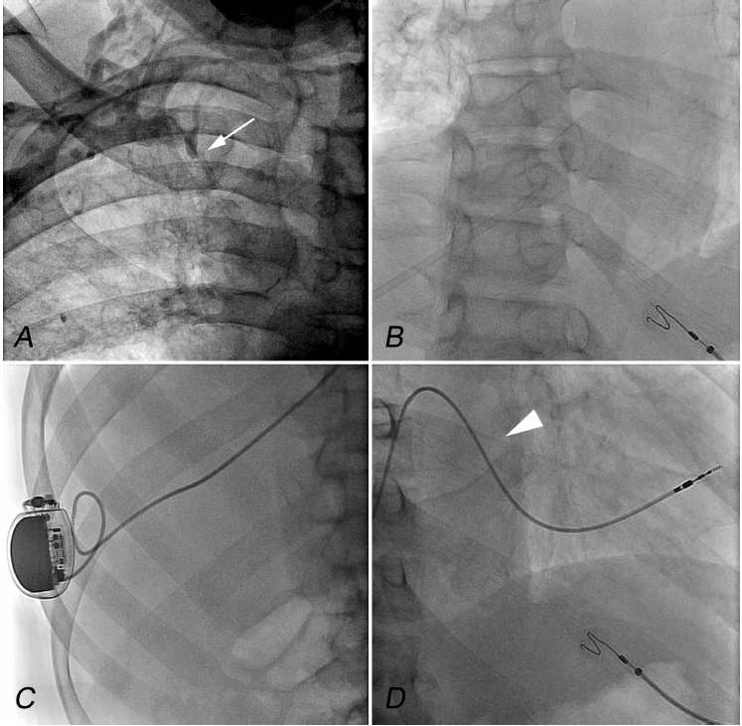
Figure 1 Transhepatic venous approach to single-lead permanent cardiac pacemaker in a 63 year-old male with bradycardia and hypotension. A: Right upper extremity venogram demonstrating total occlusion of the right innominate vein (arrow); B: Transhepatic catheter placement terminating in the right atrium; C: Placement of the pulse generator on the lateral aspect of the thoracic wall with attached right ventricular lead; D: Adequate redundancy provided to the right ventricular lead in the right atrium (arrowhead).

