Name of the Journal: World Journal of Radiology
ESPS Manuscript NO: 27470
Manuscript Type: Original Article

Retrospective Study
Value of serial magnetic resonance imaging in the assessment of brain metastases volume control during stereotactic radiosurgery

Sparacia G et al. Imaging of brain metastases volume changes during SRS

Gianvincenzo Sparacia, Francesco Agnello, Aurelia Banco, Francesco Bencivinni, Andrea Anastasi, Giovanna Giordano, Adele Taibbi, Massimo Galia, Tommaso Vincenzo Bartolotta

Gianvincenzo Sparacia, Francesco Agnello, Aurelia Banco, Francesco Bencivinni, Andrea Anastasi, Giovanna Giordano, Adele Taibbi, Massimo Galia, Tommaso Vincenzo Bartolotta, Department of Radiology, University of Palermo, 90127 Palermo, Italy

Author contributions: Sparacia G is the guarantor of integrity of entire study, study design, statistical analysis, analysis and interpretation of data, text editing, and literature research; Agnello F contributed to imaging data collecting, drafting the article, and literature research; Banco A and Bencivinni F contributed to MR images evaluation; Anastasi A, Girodano G, Taibbi A and Galia M contributed to clinical data collecting; Bartolotta TV contributed to text editing and critical revisions.

Institutional review board statement: This was a retrospective study approved by the Institutional Review Board of the University of Palermo, Department of Radiology - Palermo, Italy.

Informed consent statement: All patients had given written consent for this retrospective study.

Conflict-of-interest statement: All authors have no conflict-of-interest.

Data sharing statement: Participants gave informed consent for data sharing and the presented data are anonymized to avoid the risk of identification. No additional data are available.

Open-Access: This article is an open-access article which was selected by an in-house editor and fully peer-reviewed by external reviewers. It is distributed in accordance with the Creative Commons Attribution Non Commercial (CC BY-NC 4.0) license, which permits others to distribute, remix, adapt, build upon this work non-commercially, and license their derivative works on different terms, provided the original work is properly cited and the use is non-commercial. See: http://creativecommons.org/licenses/by-nc/4.0/

Manuscript source: Invited manuscript

Correspondence to: Gianvincenzo Sparacia, MD, Department of Radiology, University of Palermo, Via del Vespro, 127, 90127 Palermo, Italy. sparacia@yahoo.com
Telephone: +39-091-6552385
Fax: +39-091-6552302

Received: May 30, 2016
Peer-review started: June 3, 2016
First decision: July 5, 2016
Revised: August 7, 2016
Revised: September 29, 2016
Accepted: October 17, 2016
Article in press:
Published online:

Abstract
AIM
To evaluate brain metastases volume control capabilities of stereotactic radiosurgery (SRS) through serial magnetic resonance (MR) imaging follow-up.

METHODS
MR examinations of 54 brain metastases in 31 patients before and after SRS were reviewed. Patients were included in this study if they had a pre-treatment MR examination and serial follow-up MR examinations at 6 wk, 9 wk, 12 wk, and 12 mo after SRS. The metastasis volume change was categorized at each follow-up as increased (> 20% of the initial volume), stable (± 20% of the initial volume) or decreased (< 20% of the initial volume).

RESULTS
A local tumor control with a significant (P < 0.05) volume decrease was observed in 25 metastases at 6-wk follow-up. Not significant volume change was observed in 23 metastases and a significant volume increase was observed in 6 metastases. At 9-wk follow-up, 15 out of 25 metastases that decreased in size at 6 wk had a transient tumor volume increase, followed by tumor regression at 12 wk. At 12-wk follow-up there was a significant reduction in volume in 45 metastases, and a significant volume increase in 4 metastases. At 12-mo follow-up, 19 metastases increased significantly in size (up to 41% of the initial volume). Volume tumor reduction was correlated to histopathologic subtype.

CONCLUSION
SRS provided an effective local brain metastases volume control that was demonstrated at follow-up MR imaging.

Key words: Brain metastases; Stereotactic radiosurgery; Magnetic resonance imaging; Pseudo-progression; Radiation therapy

© The Author(s) 2016. Published by Baishideng Publishing Group Inc. All rights reserved.

Core tip: Stereotactic radiosurgery (SRS) provided an effective long-term local volume control of brain metastases during 12-mo magnetic resonance (MR) imaging follow-up. A significant reduction of the tumor volume by 6 wk post-SRS was associated with long-term volume control suggesting that the timing for MR imaging follow-up at 6, 9, 12 wk and 12 mo after SRS, could be considered the most effective to provide useful information to make the best treatment decisions.

Sparacia G, Agnello F, Banco A, Bencivinni F, Anastasi A, Giordano G, Taibbi A, Galia M, Bartolotta TV. Value of serial magnetic resonance imaging in the assessment of brain metastases volume control during stereotactic radiosurgery. World J Radiol 2016; In press

INTRODUCTION
Brain metastases account for 20%-40% of adult cancer and affect survival and quality of life^{[1]}. The two most commonly used treatments for brain metastases are whole-brain radiation therapy and stereotactic radiosurgery (SRS), which extend survival from 3 mo to 5 mo and from 7 mo to 13 mo, respectively, depending on tumor type. Surgical resection remains a valuable approach for patients with larger symptomatic metastatic tumors^{[2]}.
SRS is an increasingly used procedure for the treatment of primary and metastatic intracranial brain tumors. Indications include patients with few, well-defined, and small intracranial brain tumors. In SRS, radiations are directly delivered into a brain tumor, thus reducing radiation dose of surrounding normal brain tissue and side effects such as neurotoxicity, skin damage, nausea and vomiting^{[3-5]}. The damage to the peritumoral brain is further reduced by a step dose gradient at the target periphery of the tumor^{[3]}.
The objectives of SRS include local tumor control, defined as the absence of a substantial (< 25%) increase in tumor volume at follow-up magnetic resonance (MR) imaging, improved quality of life, and prolonged survival^{[6,8]}. Metastatic lesions are particularly well-suited for the treatment with SRS because they are usually small (< 3 cm), well-circumscribed, and have well-defined margins^{[6]}.
Studies have demonstrated that SRS is an effective alternative to traditional surgical resection and whole brain radiotherapy in patients with single or few well-defined brain metastases ^{[1,7-9]}.
Knowledge of natural history of brain metastases treated with SRS is crucial to prevent management dilemmas, and reduce patient anxiety. For instance, radiation toxicity can sometimes cause a pseudo-progression of brain metastases, which usually resolves with time^{[1,7,9,10]}.
The purpose of this study is to evaluate volume tumor control capabilities of SRS in the treatment of brain metastases trough serial MR imaging follow-up.

MATERIALS AND METHODS
Patient population
This was a retrospective study approved by the Institutional Review Board of our institution. All patients were referenced with the diagnosis of brain metastases and were treated with Gamma Knife-SRS (Leksell Gamma Knife, model 4C, GammaPlan 5.3; Elekta Instruments, Stockholm, Sweden) at a single academic medical center from January 2015 to January 2016. All patients had given written consent for this retrospective study. Patients were included in this study if they had a pre-treatment MR examination and serial follow-up MR examinations within 6 wk, 9 wk, 12 wk, and 12 mo post-SRS.
Patients were excluded if SRS was performed for consolidation to a surgical resection bed only. Additionally, patients in whom lesions required salvage surgery due to symptomatic local failure, were excluded.
The SRS dose delivered to the tumor margins ranged from 18 to 24 Gy prescribed to the 40%-70% isodose surface. Radioresistant tumors (melanoma, renal cancer) received a median marginal dose of 23.7 Gy (range, 20-24 Gy), and radiosensitive tumors (lung and, breast cancer) received a median marginal dose of 21.3 Gy (range, 18-24 Gy).
There was a total of 31 patients (14 men, 17 women; age: 32-77 years; mean age, 51, 5 years) that underwent serial MR imaging examinations at 6 wk, 9 wk, 12 wk, and 12 mo after SRS.
Brain metastases were confirmed by pathology. There were 54 brain metastases: non-small cell lung carcinoma n = 19 (36%), breast carcinoma n = 16 (29%), renal cell carcinoma n = 9 (16%), and melanoma n = 10 (19%). Patient population and primary cancer types are summarized in Table 1.

MR imaging
All MR examinations were performed with a 1.5T MR scanner (Signa Excite, GE Medical Systems, Milwaukee, USA). MR imaging protocol included axial and sagittal fast spin-echo (FSE) T2W (5100/110 [TR/TE]) images, axial fluid-attenuated inversion-recovery (FLAIR) (8000/140/2400 [TR/TE/TI]) images, along with axial, sagittal, and coronal non-enhanced and contrast-enhanced (0.1 mmol/Kg gadobutrol - Gadovist, Bayer, Germany) FSE T1W (650/15 [TR/TE]) images with a FOV of 22 cm, matrix 512 × 512, slice thickness 5 mm, intersection gap 1 mm, number of excitations 2. Follow-up MR examinations were performed at 6 wk, 9 wk, 12 wk, and 12 mo post-SRS.

Volume change analysis
Two experienced neuroradiologists evaluated in consensus the maximum enhancing metastasis volume measured in 3 orthogonal planes at initial MR examinations and at each follow-up. Tumor volume was calculated according to the following formula: volume = length × width × height / 2 as reported in other studies^{[7]}. Metastases of at least 0.5 cm³ were included. Metastasis volume change was categorized at each follow-up as increased (> 20% of the initial volume), stable (± 20% of the initial volume) or decreased (< 20% of the initial volume). This criteria was chosen taking in account a measurement error of 20%, as there are no validated categorization schemes for tumor response.

Statistical analysis
Statistical analysis was performed using the statistical software package SPSS (SPSS, Chicago, Ill). The Wilcoxon signed-rank test for continuous variables was used to evaluate the significance of volume change. A multivariate logistic regression analysis was used to determine the correlation between histopathology and volume changes. A P value of < 0.05 was considered statistically significant.

RESULTS
Primary cancer types and effective time point for MR imaging follow-up to identify significant phases of the response to the SRS therapy are summarized in Table 2. At 6-wk follow-up, a local tumor control with a significant volume decrease up of 63% was observed in 25 brain metastases (46%) (12 non-small cell lung carcinoma, 11 breast carcinoma, 1 renal cell carcinoma, 1 melanoma). No significant volume change was observed in 23 metastases (43%) (6 non-small cell lung carcinoma, 5 breast carcinoma, 7 renal cell carcinoma, 5 melanoma), and a significant volume increase was observed in 6 metastases (11%) (1 non-small cell lung carcinoma, 1 renal cell carcinoma, 4 melanoma).
At 9-wk follow-up, 15 out of 25 radiosensitive brain metastases (28% of the total lesions) (8 non-small cell lung cancer, 7 breast metastases) that decreased in size at 6 wk had a transient tumor volume increase, followed by tumor regression at 12 wk with no clinical symptoms (pseudo-progression) (Figure 1).
At 12-wk follow-up, there was a significant reduction in volume in 45 metastases (18 non-small cell lung carcinoma, 14 breast carcinoma, 7 renal cell carcinoma, 6 melanoma), no significant volume change in 5 metastases (1 non-small cell lung carcinoma, 1 breast carcinoma, 1 renal cell carcinoma, 2 melanoma), and a significant volume increase in 4 metastases (1 breast carcinoma, 1 renal cell carcinoma, 2 melanoma).
At 12-mo follow-up, 19 (35%) metastases increased (true-progression) significantly in size (up to 41% of the initial volume) (1 non-small cell lung cancer, 4 breast cancer, 6 renal cell carcinoma, 8 melanoma) (Figure 2).
The logistic regression analysis showed that volume tumor reduction correlates to histopathologic subtype: non-small cell lung carcinoma had a significant reduction of 38% of its initial volume; breast carcinoma had a significant reduction of 41% of its initial volume; renal cell carcinoma had a significant reduction of 14% of its initial volume; melanoma had a significant reduction of 8% of its initial volume. Thus, higher tumor reduction was observed in the radiation sensitive carcinomas (breast and non-small cell lung carcinomas).
Moreover, we evaluated the volume tumor variation of breast, non-small cell lung cancer, melanoma, and renal cell carcinoma metastases at 6 wk, 9 wk, 12 wk, and 12 mo post-SRS. Our results show that response categorization differences among these 4 primary types were not statistically significant, however melanoma and renal cell carcinoma metastases had less robust volume reduction than non-small cell lung cancer or breast metastases.
Temporary or permanent clinical complications were evaluated during 12 mo follow-up of these patients. Transient headache related to intracranial edema was noted in 10 patients, with nausea (5 patients) and arm or leg weakness (2 patients). Permanent neurologic deficits were noted in 6 patients.

DISCUSSION
Our results suggest that a significant early reduction of tumor volume is associated with a good long-term volume tumor control as reported in previous studies^{[6,7,14]}. Conversely, increased tumor volume at 6-wk follow-up has a higher probability of a final increase in lesion size, thus in a poor tumor volume control.
Transient volume growth at 9-wk follow-up occurred in 15 radiosensitive brain metastases (8 non-small cell lung cancer, 7 breast metastases) (28% of the total lesions), followed by tumor regression at 12 wk with no clinical symptoms (Figure 1, Table 2). This transient growth must be careful interpreted as it could be misinterpreted as tumor recurrence, whereas it should be interpreted as a pseudo-progression ^{[7]}.
The histopathology of pseudo-progression is probably related to treatment-induced tumor inflammation and necrosis^{[7,10-13]}. Tumor volume variation trend in our series demonstrates that melanoma and renal cell carcinoma metastases showed less volume reduction than non-small cell lung cancer or breast metastases.
However, response categorization differences among these 4 primary types were not statistically significant, thus suggesting that the most effective timing for MR imaging follow-up, regardless the type of primary tumor, could be considered at 6, 9, 12 wk and 12 mo after SRS.
The observation that a small percentage of lesions may undergo a transient volume increase indicate that initial lesion growth does not necessary preclude local volume control. Conversely, there were a low number of metastases that exhibited initial volume growth and continued to grow with no volume control during SRS (Figure 2).
SRS has become the standard procedure for the treatment of brain metastases as it allows a longer survival and higher local control rates compared to whole-brain radiation therapy^{[6,7,9,14]}. Compared to surgical resection, SRS is associated to lower morbidity and decrease cost^{[1]}.
To summarize, SRS is effective in treating brain metastases regardless of their histology, including those that are radio-resistant to conventional whole-brain radiation therapy, such as metastases that originates from melanoma and renal cell carcinoma.
Although initial consistent tumor volume reduction after SRS is predictive of long term volume control, initial tumor growth does not necessarily indicate tumor progression but radiation-induced inflammation and necrosis (pseudo-progression) and it should be taken into account to avoid to be misinterpreted as a recurrence.

Limitations
This study was a retrospective, single-institution study with a relative small size population and these factors could be considered limitations.
To prevent potential inaccuracies in the volume measurement of the intracranial lesion, we excluded lesions with an initial tumor volume of less than 0.5 cm³ and a 20% cutoff for volume response categorization was chosen.
In conclusion, effective long-term SRS local volume control of brain metastases can be demonstrated at 12 mo follow-up. Significant tumor volume reduction by 6 wk post-SRS was associated with long-term volume control suggesting that the timing for MR imaging follow-up at 6, 9, 12 wk and 12 mo after SRS, could be considered the most effective to provide useful information to make the best treatment decisions. Although it is necessary to validate these results in a larger, prospective series, the results are encouraging that an early local volume reduction after SRS is associated with significant local control for metastatic brain lesions.

COMMENTS
Background
Brain metastases account for 20% to 40% of adult cancer and affect both survival and quality of life. Brain metastases volume reduction is associated with significant local control of the lesions and prolongation of patient’s survival. Stereotactic radiosurgery (SRS) is an increasingly used procedure for the treatment of primary and metastatic intracranial brain tumors to achieve local volume reduction.

Research frontiers
Volume tumor control capabilities of SRS in the treatment of brain metastases is an important factor for post-treatment decision making and delivery salvage therapy.

Innovations and breakthroughs
Volume tumor control capabilities of SRS could be demonstrated trough serial magnetic resonance (MR) imaging follow-up. Accurate determination of the timing for MR imaging follow-up is crucial for decision making and delivery timely salvage therapy.

Applications
Serial MR imaging follow-up at 6 wk, 9 wk, 12 wk, and 12 mo is the most effective timing to demonstrate volume reduction of brain metastases after SRS. The information derived from serial MR imaging follow-up could affect clinical management and improve survival of these patients.

Terminology
Stereotactic radiosurgery (SRS) is a procedure for the treatment of primary and metastatic intracranial brain tumors. Indications include patients with few, well-defined, and small intracranial brain tumors. In SRS, radiations are directly delivered into a brain tumor, thus reducing radiation dose of surrounding normal brain tissue and side effects such as neurotoxicity, skin damage, nausea and vomiting. The damage to the peritumoral brain is further reduced by a step dose gradient at the target periphery of the tumor. The objectives of SRS include local tumor control, defined as the absence of a substantial (< 25%) increase in tumor volume at follow-up MR imaging, improved quality of life, and prolonged survival.

Peer-review
This study is interesting. However the manuscript would be of higher value to the reader if the manuscript focuses on the pseudo-progression period, that period is confusing for the practicing physician and can lead to misinterpretation and additional or changes in treatment strategies.

REFERENCES
- Stafinski T, Jhangri GS, Yan E, Menon D. Effectiveness of stereotactic radiosurgery alone or in combination with whole brain radiotherapy compared to conventional surgery and/or whole brain radiotherapy for the treatment of one or more brain metastases: A systematic review and meta-analysis. Cancer Treat Rev 2006; 32: 203-213 [PMID: 16472924 DOI: 10.1016/j.ctrv.2005.12.009]
- Sharpton SR, Oermann EK, Moore DT, Schreiber E, Hoffman R, Morris DE, Ewend MG. The volumetric response of brain metastases after stereotactic radiosurgery and its post-treatment implications. Neurosurgery 2014; 74: 9-15; discussion 16; quiz 16 [PMID: 24077581 DOI: 10.1227/NEU.0000000000000190]
- Young RF. Radiosurgery for the treatment of brain metastases. Semin Surg Oncol 1998; 14: 70-78 [PMID: 9407633]
- Kaal EC, Niël CG, Vecht CJ. Therapeutic management of brain metastasis. Lancet Neurol 2005; 4: 289-298 [PMID: 15847842 DOI: 10.1016/S1474-4422(05)70072-7]
- Suh JH. Stereotactic radiosurgery for the management of brain metastases. N Engl J Med 2010; 362: 1119-1127 [PMID: 20335588 DOI: 10.1056/NEJMct0806951]
- Peterson AM, Meltzer CC, Evanson EJ, Flickinger JC, Kondziolka D. MR imaging response of brain metastases after gamma knife sterotactic radiosurgery. Radiology 1999; 211: 807-814 [PMID: 10352610 DOI: 10.1148/radiology.211.3.r99jn48807]
- Patel TR, McHugh BJ, Bi WL, Minja FJ, Knisely JP, Chiang VL. A comprehensive review of MR imaging changes following radiosurgery to 500 brain metastases. AJNR Am J Neuroradiol 2011; 32: 1885-1892 [PMID: 21920854 DOI: 10.3174/ajnr.A2668]
- Chang WS, Kim HY, Chang JW, Park YG, Chang JH. Analysis of radiosurgical results in patients with brain metastases according to the number of brain lesions: is stereotactic radiosurgery effective for multiple brain metastases? J Neurosurg 2010; 113 Suppl: 73-78 [PMID: 21121789 DOI: 10.3171/2010.8.GKS10994]
- Kondziolka D, Martin JJ, Flickinger JC, Friedland DM, Brufsky AM, Baar J, Agarwala S, Kirkwood JM, Lunsford LD. Long-term survivors after gamma knife radiosurgery for brain metastases. Cancer 2005; 104: 2784-2791 [PMID: 16288488 DOI: 10.1002/cncr.21545]
- Shah R, Vattoth S, Jacob R, Manzil FF, O’Malley JP, Borghei P, Patel BN, Curé JK. Radiation necrosis in the brain: imaging features and differentiation from tumor recurrence. Radiographics 2012; 32: 1343-1359 [PMID: 22977022 DOI: 10.1148/rg.325125002]
- Dequesada IM, Quisling RG, Yachnis A, Friedman WA. Can standard magnetic resonance imaging reliably distinguish recurrent tumor from radiation necrosis after radiosurgery for brain metastases? A radiographic-pathological study. Neurosurgery 2008; 63: 898-903; discussion 904 [PMID: 19005380 DOI: 10.1227/01.NEU.0000333263.31870.31]
- Ruzevick J, Kleinberg L, Rigamonti D. Imaging changes following stereotactic radiosurgery for metastatic intracranial tumors: differentiating pseudoprogression from tumor progression and its effect on clinical practice. Neurosurg Rev 2014; 37: 193-201; discussion 201 [PMID: 24233257 DOI: 10.1007/s10143-013-0504-8]
- Wang LL, Leach JL, Breneman JC, McPherson CM, Gaskill-Shipley MF. Critical role of imaging in the neurosurgical and radiotherapeutic management of brain tumors. Radiographics 2014; 34: 702-721 [PMID: 24819790 DOI: 10.1148/rg.343130156]
- Linskey ME, Andrews DW, Asher AL, Burri SH, Kondziolka D, Robinson PD, Ammirati M, Cobbs CS, Gaspar LE, Loeffler JS, McDermott M, Mehta MP, Mikkelsen T, Olson JJ, Paleologos NA, Patchell RA, Ryken TC, Kalkanis SN. The role of stereotactic radiosurgery in the management of patients with newly diagnosed brain metastases: a systematic review and evidence-based clinical practice guideline. J Neurooncol 2010; 96: 45-68 [PMID: 19960227 DOI: 10.1007/s11060-009-0073-4]

P-Reviewer: Fatterpekar GM, Rodriguez GJ S-Editor: Kong JX L-Editor: E-Editor:
Table 1 Patient population and primary cancer types
Number of patients | Gender | Age (yr) | Primary cancer type | Number of lesions, (%)
11 | 7 men - 4 women | 50-70 | Non-small cell lung carcinoma | 19 (36%)
9 | 1 men - 8 women | 32-60 | Breast carcinoma | 16 (29$)
7 | 5 men - 2 women | 55-77 | Renal cell carcinoma | 9 (16%)
4 | 1 men - 3 women | 32-65 | Melanoma | 10 (19%)

Table 2 Primary cancer types and effective time point for magnetic resonance imaging follow-up to provide useful information for the treatment decision
Primary cancer type | n of lesions | %⁴ | Reduced in size at 6 wk¹ | %⁴ | Pseudo-progression (9 wk)² | %⁴ | True-progression (12 mo)³ |  | %⁴
Non-small cell lung carcinoma | 19 | 36 | 12 | 22 | 8 | 15 | 1 | 2
Breast carcinoma | 16 | 29 | 11 | 20 | 7 | 13 | 4 | 7
Renal cell carcinoma | 9 | 16 | 1 | 2 | 0 | 0 | 6 | 11
Melanoma | 10 | 19 | 1 | 2 | 0 | 0 | 8 | 15
Total | 54 | 100 | 25 | 46 | 15 | 28 | 19 | 35

¹Number of lesions reduced in size at 6-wk follow-up; ²Number of lesions that presented a transient volume growth (pseudo-progression) at 9-wk follow-up; ³Number of lesions that presented final volume growth (true-progression) at 12-mo follow-up; ⁴Percentage of lesions computed over the total number of lesions (n = 54).

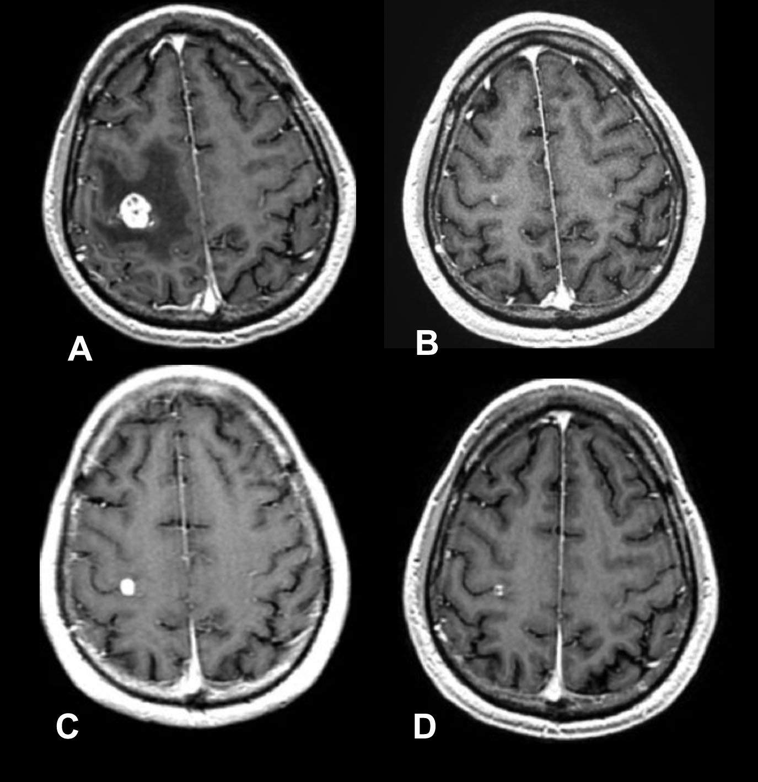
Figure 1 Follow-up axial enhanced T1-weighted magnetic resonance images of a brain metastasis from breast carcinoma treated with stereotactic radiosurgery in a 60-years old woman. A: Pre stereotactic radiosurgery (SRS) magnetic resonance (MR) image; B: Initial follow-up MR image at 6 wk after SRS demonstrating an initial volume reduction; C: Follow-up MR image at 9 wk after SRS demonstrating a transient volume increase (pseudo-progression); D: Follow-up MR image at 12 wk demonstrating a final volume reduction.
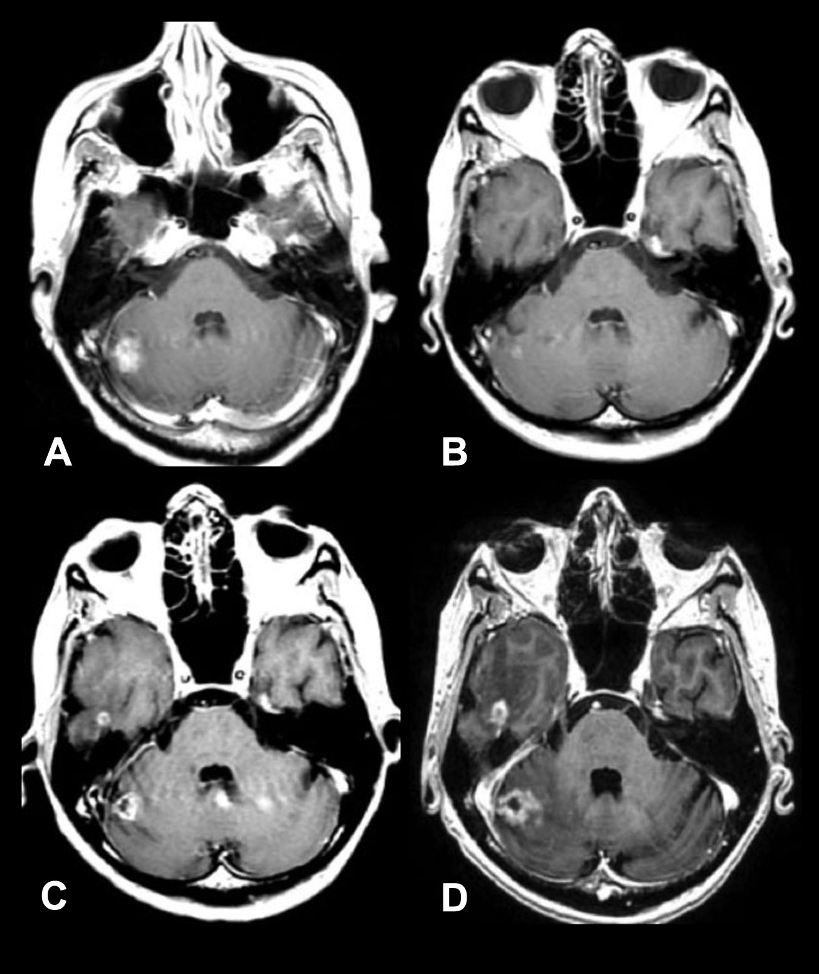
Figure 2 Follow-up axial enhanced T1-weighted magnetic resonance images of a lung carcinoma metastatic to the right cerebellum treated with stereotactic radiosurgery. A: Pre stereotactic radiosurgery (SRS) magnetic resonance (MR) image; B: Initial follow-up MR image at 6 wk after SRS demonstrating an initial volume reduction; C: Follow-up MR image at 9 wk demonstrating volume increase (true-progression); D: Follow-up MR image at 12 wk with final volume increase.

