Name of Journal: World Journal of Clinical Cases
Manuscript NO: 78835
Manuscript Type: CASE REPORT

Congenital dysfibrinogenemia misdiagnosed and inappropriately treated as acute fatty liver in pregnancy: A case report and review of literature

Jia Y et al. CD misdiagnosed as acute fatty liver

Yan Jia, Xi-Wen Zhang, Yi-Shi Wu, Qing-Yu Wang, Shu-Li Yang

Yan Jia, Xi-Wen Zhang, Yi-Shi Wu, Shu-Li Yang, Department of Obstetrics and Gynecology, The Second Hospital of Jilin University, Changchun 130000, Jilin Province, China

Qing-Yu Wang, Department of Orthopedic Medical Center, The Second Hospital of Jilin University, Changchun 130000, Jilin Province, China

Author contributions: Jia Y and Zhang XW participated in manuscript writing, editing, and in the literature search; Zhang XW, Wu YS and Wang QY performed data collection under the supervision of Yang SL; the manuscript was drafted by Jia Y, reviewed by all authors, and revised with contributions from all authors under the supervision and final revision of Yang SL; Yang SL was responsible for the integrity of the work from inception to the finished article; all authors read and approved the final manuscript and contributed to the review and interpretation of data.

Supported by Natural Science Fund of Jilin Province, No. YDZJ202201ZYTS278.

Corresponding author: Shu-Li Yang, MD, Chief Doctor, Department of Obstetrics and Gynecology, The Second Hospital of Jilin University, No. 128 Ziqiang Street, Changchun 130000, Jilin Province, China. yangsl@jlu.edu.cn

Received: July 18, 2022
Revised: October 24, 2022
Accepted: November 28, 2022
Published online:

Abstract
BACKGROUND
The purpose of this study was to report the rare case of a pregnant woman with congenital dysfibrinogenemia (CD) misdiagnosed as acute fatty liver. She was treated according to the principles of acute fatty liver but achieved good clinical results.

CASE SUMMARY
A 30-year-old woman presented with 39 (6/7) wk of menopause and 6 h of irregular abdominal pain and attended our hospital. Emergency surgery was performed due to fetal distress. Postoperative management followed the treatment principle of acute fatty liver. DNA sequencing was carried out on the pregnant woman and her pedigree. Coagulation values of the patient on admission were prothrombin time 33.7 s, activated partial thromboplastin time 60.4 s, thrombin time 45.2 s, and fibrinogen 0.60 g/L. DNA sequencing results showed that the woman carried a pathogenic heterozygous variation of the fibrinogen alpha chain gene (FGA), which is closely related to hereditary fibrinogen abnormality, and the mutation site was located in p.R350H. After a follow-up period of 12 mo, the mother and her newborn had a good prognosis without bleeding or thrombosis.

CONCLUSION
Pregnant women with CD may have atypical symptoms, which can easily lead to misdiagnosis. In addition, treatment can be attempted according to the principles of acute fatty liver management. This rare pregnant patient with CD was caused by a novel FGA (p.R350H) gene mutation.

Key Words: Gene mutation; Fibrinogen; Congenital dysfibrinogenemia; Pregnancy; Case report

Jia Y, Zhang XW, Wu YS, Wang QY, Yang SL. Congenital dysfibrinogenemia misdiagnosed and inappropriately treated as acute fatty liver in pregnancy: A case report and review of literature. World J Clin Cases 2022; In press

Core Tip: Pregnant women with congenital dysfibrinogenemia (CD) may have atypical symptoms, which can easily lead to misdiagnosis. The purpose of this study was to report the rare case of a pregnant woman with CD who was misdiagnosed with acute fatty liver. She was treated according to the principles of acute fatty liver but achieved good clinical results. DNA sequencing was carried out on the pregnant woman and her pedigree. The DNA sequencing results showed that the woman carried a pathogenic heterozygous variation of the fibrinogen alpha chain gene closely related to hereditary fibrinogen abnormality, and the mutation site was located in p.R350H.

INTRODUCTION
Congenital dysfibrinogenemia (CD) is an uncommon inherited coagulation disorder^{[1]}. It is usually autosomal dominant and can be caused by liver disease, diffuse intravascular coagulation, primary fibrinolytic abnormalities, or certain drugs^{[2]}. CD is a disease characterized by a dysfunctional fibrinogen molecule resulting in abnormal blood coagulation. The presentation of dysfibrinogenemia varies widely, ranging from asymptomatic (55% of patients) to hemorrhagic (25%) to thrombotic (20%). It can be quantitative or qualitative, congenital or acquired^{[3]}. More than 400 families have been affected by this disorder^{[4]}. However, fewer than 20 pregnant women with CD have been reported worldwide^{[5]}.
CD is difficult to diagnose due to the broad spectrum of clinical symptoms, and even after the diagnosis, treatment is selected based on symptoms. Commonly used methods include fibrinogen replacement therapy, anticoagulation, thromboprophylaxis, and a multidisciplinary team approach^{[6]}. However, no unified standard CD treatment has been established, especially for pregnant women. Several adverse pregnancy outcomes have been associated with fibrinogen abnormalities, including post-partum hemorrhage or thrombosis, spontaneous abortion, recurrent miscarriage^{[7,8]}, and placental abruption^{[9,10]}.
We present the rare case of a pregnant woman with CD who was initially misdiagnosed with acute fatty liver. As a result, the patient was hospitalized and treated for “acute fatty liver” until discharge. Fortunately, the mother delivered a healthy newborn by cesarean section, and neither had clinical symptoms of severe hemorrhage or thrombosis. We then analyzed the diagnosis and treatment process of this rare pregnant woman. In addition, we performed sequence analysis of the amplified DNA for the proband and her pedigree. We also reviewed the literature of the last 30 years on clinical symptoms, coagulation function, DNA sequencing, treatments, and clinical outcomes of CD during pregnancy.

CASE PRESENTATION
Chief complaints
A 30-year-old female presented with “39 (6/7) wk of menopause and 6 h of irregular abdominal pain”.

History of present illness
Her abdominal pain occurred at intervals of 15 to 30 min and lasted for 30 s. She was admitted to the obstetric department of our hospital as an emergency case.

History of past illness
The patient denied a history of other diseases.

Personal and family history
The pregnant woman was previously healthy and denied a family history of hereditary diseases.

Physical examination
Measurements of fundal height, abdominal circumference, fetal heart rate, and external pelvis were normal. The position of the fetus was Left Occiput Anterior (LOA). No dystocia of the head was noted. An internal examination revealed no abnormalities.

Laboratory examinations
The pregnant woman was admitted to the operating room as an emergency due to intrauterine distress before her laboratory results were available. Intraoperatively, laboratory tests showed that the white blood cell count was 11.3 × 10⁹/L ↑, the prothrombin time (PT) was 33.7 s ↑, the international prothrombin standard was 2.79 ↑, partial thromboplastin time was 60.4 s ↑, partial thromboplastin ratio was 2.06 ↑, PT was 45.2 s ↑, prothrombin activity was 22% ↓ and antithrombin was 17% ↓, fibrinogen assay was 0.6 g/L ↓, fibrin (pro) degradation product was 116.4 μg/mL ↑, uric acid was 615 μmol/L ↑, creatinine was 172 μmol/L ↑, glutathione aminotransferase was 705 U/L ↑, glutathione aminotransferase was 323 U/L ↑, total bilirubin was 89.51 μmol/L ↑, direct bilirubin was 70.25 μmol/L ↑ and indirect bilirubin was 19.26 μmol/L ↑.

Imaging examinations
Ultrasound examination showed ascites and bright liver. Obstetric three-dimensional color ultrasound showed the following: The fetal position was cephalic, the fetal heart rate was 171 bpm, fetal movements were palpable, the biparietal diameter was 9.1 cm, the head circumference was 32.0 cm, the abdominal circumference was 33.1 cm, femoral length was 6.8 cm, the placenta was in the fundus with a maturity of II, the amniotic index was 17.41 cm, umbilical artery S/D was 2.4, placental entrance and the inferior border was indistinct. The results of the non-stress test after admission showed a non-responsive type, a flat baseline, no fetal movements, and no fetal heart fluctuations.

Genetic tests on the pedigree
We analyzed genomic DNA obtained from the blood sample to check for mutations in the fibrinogen gene. Both the mother and the newborn had abnormal coagulation values, indicating that the disease was inherited in the family. Genotype analysis confirmed the diagnosis of hypofibrinogenemia by identifying a homozygous mutation in fibrinogen alpha chain gene (FGA) (p.R350H). In addition, genetic testing was performed on the patient’s parents and daughter, and the results confirmed that both the father and daughter were disease-causing gene carriers (Figure 1). We have studied the clinical symptoms, fibrinogen results, genetic analysis, treatment, and clinical outcomes of pregnant women with CD over the past 30 years (Table 1). In addition, we reviewed the CD-related gene mutation sites mentioned above (Table 2).

FINAL DIAGNOSIS
CD.

TREATMENT
A cesarean section of the lower uterine segment was performed under emergency lumbar epidural anesthesia. When the membrane was punctured during the procedure, brown-yellow amniotic fluid was seen overflowing, and a live female baby weighing 3090 g was delivered at LOA. The Apgar score was one point at one minute after birth and improved to four points at five minutes after birth. The neonatal medical staff was present to assist with the resuscitation and transfer of the newborn to neonatology. Fortunately, there were no surgical complications during the operation, such as severe bleeding.
Intraoperatively, laboratory tests showed that the patient had leukocytosis, elevated transaminases, elevated bilirubin, elevated urate, coagulopathy and renal impairment. After intraoperative multidisciplinary consultation, the clinical diagnosis of acute fatty liver during pregnancy was made according to the Swansea criteria and NHS guidelines^{[11]}. She was then transferred to the intensive care unit (ICU). In the ICU, glucose supplementation, monitoring of coagulation function, oxygen inhalation, infection control, blood transfusion, fluid infusion, multifunctional monitoring, and other general treatments were given to stabilize her vital signs.
Postoperative treatment included benzalkonium chloride solution (0.05%, 0.25 g/500 mL × 1 bottle, Guangdong Lorst Pharmaceutical Co., Ltd.) 0.25 g for infection prevention, oxytocin injection (5 U/mL × 1 piece, Anhui Hongye Pharmaceutical Co., Ltd.) 20 U for contraction promotion, sodium chloride injection (0.90%, 500 mL × 1 bag, Anhui Fengyuan Pharmaceutical Co., Ltd.) 500 mL for fluid infusion, Yigong Granules (CO 10 g × 9 sachets, Shaanxi Jianmin Pharmaceutical Co., Ltd.) 3 boxes for strengthening qi and enriching blood, Compound Ferrous Sulfate and Folic Acid Tablets (CO 50 mg × 36 tablets, Jilin Province West point Pharmaceutical Science and Technology Development Co., Ltd.) 3 boxes for prevention of iron deficiency anemia, and Vitamin D2 Calcium Hydrogen Phosphate and Calcium Gluconate Tablets (60 tablets, China Resources Double Crane Pharmaceutical Co., Ltd.) for supplementation of calcium for symptomatic treatment. The patient’s vital signs were monitored closely, and uterine involution and vaginal bleeding were observed.

OUTCOME AND FOLLOW-UP
Eight days after surgery, the patient’s condition had improved significantly, and her vital signs were stable, but her liver function was still abnormal, so she was transferred to the department of hepatobiliary and pancreatic medicine for treatment. Laboratory examination revealed abnormal liver function, abnormal renal function, blood tests, and coagulation tests. Abdominal ultrasound revealed fatty liver. The patient was then treated with anti-infectives, liver protection, and coagulation improvement.
Twenty-one days after surgery, liver function improved significantly, and coagulation function returned to normal. The patient was subsequently discharged.
During hospitalization, the patient’s fibrinogen fell below the critical level several times. The doctors immediately injected fresh frozen plasma or cryoprecipitate and took blood samples every other day to monitor the coagulation function. The coagulation routine was performed 15 times before and after treatment, and the results are shown in Figure 2A.
The newborn was transferred to the neonatal unit for treatment after birth. The initial diagnosis was neonatal meconium aspiration syndrome, neonatal asphyxia, metabolic acidosis, hyperlactatemia combined with abnormal coagulation function, and fibrinogen fell below the critical level several times. After active symptomatic treatment, the child’s general condition and response were acceptable, and nutrition was tolerated. There were no obvious abnormalities on physical examination, and the child was discharged from the hospital. The infant’s coagulation profiles are shown in Figure 2B.
After a follow-up period of 12 mo, the mother and her newborn had a good prognosis without bleeding or thrombosis. The diagnosis and treatment of this patient are summarized in Figure 3.

DISCUSSION
Of the various cases of dysfibrinogenemia reported previously, 16 pregnant women with CD were reviewed (Table 1). The most important finding is that a new, previously unreported heterozygosity of the FGA (p.R350H) gene mutation was found in one pregnant woman, leading to CD in this patient. Another important finding is that the treatment strategy for acute fatty liver could have a therapeutic effect in the treatment of CD in pregnant women. Therefore, we have shared our experience on the diagnosis and treatment methods in this rare case.
CD can be easily misdiagnosed for the following two reasons: First, the clinical symptoms of CD are characterized by high heterogeneity and low specificity. They usually present as asymptomatic, thrombosis, chronic thromboembolic pulmonary hypertension, or renal amyloidosis, suggesting that CD is likely to be initially diagnosed as a respiratory, digestive, or urinary tract disease, making accurate diagnosis difficult. Secondly, the diagnosis of CD in clinical practice relies mainly on laboratory tests. However, the most commonly used methods for detecting fibrinogen, such as the PT algorithm or the Clauss method, have serious shortcomings. The PT algorithm can easily lead to a misdiagnosis of CD. Yan et al^{[12]} found that the Clauss method can easily misdiagnose CD as hypofibrinogenemia. Recently, Xiang et al^{[13]} reported that the combined use of the Clauss and PT-derived method can improve the accuracy of CD diagnosis. Values of the PT algorithm/Clauss method > 1.43 indicated a diagnosis of CD, with a sensitivity and specificity of about 100%. In this study, the pregnant woman with CD was misdiagnosed with acute fatty liver due to atypical clinical symptoms and incomplete laboratory results. The absence of laboratory examinations can lead to the misdiagnosis or missed diagnosis of CD^{[14]}. In clinical practice, we recommend combining the PT-derived method and the Clauss method when CD is suspected to improve the accuracy of the diagnosis. Our opinion was supported by Yan et al^{[15]}, who reported that simultaneous determination of fibrinogen concentrations utilizing the Clauss method, the PT-derived method and immunoturbidimetry, as well as measurement of PT, reptilase time, thrombin time (TT) and activated partial thromboplastin time, can effectively distinguish dysfibrinogenemia from other diseases.

Treatment of CD in pregnancy
Treatment of CD during pregnancy or surgery should be individualized^{[15]}. The optimal concentration and function of fibrinogen are crucial to the success of a pregnancy.
With regard to pregnant women with asymptomatic CD, special treatment of asymptomatic dysfibrinogenemia is not needed during pregnancy or surgery in the absence of bleeding or thrombotic events in the patient’s personal or family history^{[15]}. The authors reported that using fibrinogen replacement therapy and prophylactic anticoagulation starting in the third trimester could achieve a successful clinical outcome for CD pregnant women without bleeding symptoms^{[6]}.
Concerning hemorrhage in pregnant women with CD, if CD pregnant women or their family members have a history of bleeding symptoms, it is recommended that the patient be referred to a hemophilia center for prenatal care. Bleeding and spontaneous abortion must be prevented if the fibrinogen level is below 0.5 g/L. In patients with vaginal delivery or cesarean section, the fibrinogen level should be raised to 1.5 g/L or more^{[2]}.
Regarding thrombosis in pregnant women with CD, low-molecular-weight heparin can be used during pregnancy for thromboprophylaxis in CD pregnant women or their family members who have a history of symptoms of thrombosis. These patients are at increased risk of thrombosis, so anticoagulants and fibrinogen should be used simultaneously. Optimizing treatment in different groups of patients under different clinical conditions and improving our knowledge of thrombotic events requires further study.
In this study, we report a pregnant patient with CD who underwent an emergency cesarean section due to intrauterine stress. Intraoperative laboratory examination revealed PT 33.7 s, activated partial thromboplastin time (APTT) 60.4 s, TT 45.2 s, and fibrinogen 0.60 g/L. After multidisciplinary consultation, the clinical diagnosis was “acute fatty liver in pregnancy”. After surgery, the patient was transferred to the ICU. Her condition improved after general and symptomatic treatment. However, her liver function remained abnormal. She was then transferred to the hepatobiliary and pancreatic medicine department. The results of additional examinations showed that the patient had liver damage and cholestatic hepatitis. Following treatment according to the principles of acute fatty liver, her coagulation gradually improved to normal values, and she was discharged. During the 12 mo follow-up, the patient achieved a good clinical outcome. This effective treatment has not been mentioned in previous studies. In our opinion, in pregnant women with CD special attention should be paid to the following during pregnancy: (1) Their general health during pregnancy; (2) The frequency of prenatal examinations; (3) The number of coagulation function tests, including PT, APTT, TT, and fibrinogen; and (4) A comprehensive evaluation of the risk of bleeding or thrombosis under the guidance of the obstetrician. We believe that this effective treatment regimen will help provide an alternative for other pregnant women with CD.
As CD is inherited in families, we advocate that other family members should also have a blood coagulation test. Furthermore, the entire family should be subjected to genetic sequencing, and this view is consistent with Yan et al^{[12]}. In this study, a new heterozygous FGA mutant (p.R350H) was found by gene analysis. The pedigree map showed that the proband’s heterozygous FGA (p.R350H) mutation was inherited from her father, which was consistent with the autosomal dominant inheritance reported by progenitors^{[12,16]}. In addition, genetic analysis revealed that the proband’s daughter also carried the disease-causing gene. Therefore, we performed comprehensive genetic counselling for the proband’s family members and informed the patient’s daughter that she should pay special attention to the risk of bleeding and thrombosis during pregnancy and that she should check her coagulation function regularly.
Although the patient was misdiagnosed and inappropriately treated, she eventually achieved a satisfactory treatment outcome. However, the study still has some shortcomings: First, due to the misdiagnosis of acute fatty liver during hospitalization, the patient did not have fibrinogen detected by the Clauss method; second, this treatment method needs to be verified by multicenter studies with large samples and randomized controlled trials.

CONCLUSION
Pregnant women with CD may have atypical symptoms, which can easily lead to misdiagnosis. In addition, a treatment approach can be attempted according to the principles of acute fatty liver. This rare pregnant woman with CD was caused by a novel FGA (p.R350H) gene mutation.

REFERENCES
1 Bouvier S, Chea M, Ripart S, Hanss M, de Mazancourt P, Gris JC. Successful Pregnancy under Fibrinogen Substitution with Heparin and Aspirin in a Woman with Dysfibrinogenemia Revealed by Placental Abruption. Thromb Haemost 2018; 118: 2006-2008 [PMID: 30296816 DOI: 10.1055/s-0038-1673615]
2 Casini A, Neerman-Arbez M, Ariëns RA, de Moerloose P. Dysfibrinogenemia: from molecular anomalies to clinical manifestations and management. J Thromb Haemost 2015; 13: 909-919 [PMID: 25816717 DOI: 10.1111/jth.12916]
3 Edwards RZ, Rijhsinghani A. Dysfibrinogenemia and placental abruption. Obstet Gynecol 2000; 95: 1043 [PMID: 10808030 DOI: 10.1016/s0029-7844(00)00867-x]
4 Cunningham MT, Brandt JT, Laposata M, Olson JD. Laboratory diagnosis of dysfibrinogenemia. Arch Pathol Lab Med 2002; 126: 499-505 [PMID: 11900586 DOI: 10.5858/2002-126-0499-LDOD]
5 Yoshida S, Kibe T, Matsubara R, Koizumi SI, Nara K, Amano K, Okumura N. Congenital dysfibrinogenemia in a Japanese family with fibrinogen Naples (BβAla68Thr) manifesting as superior sagittal sinus thrombosis. Blood Coagul Fibrinolysis 2017; 28: 580-584 [PMID: 28537987 DOI: 10.1097/MBC.0000000000000641]
6 Langer M, Manire M, Clarkson M, Samhouri Y, Shah D, Bhagavatula R. Management of congenital dysfibrinogenemia in pregnancy: A challenging patient case. Res Pract Thromb Haemost 2021; 5: e12619 [PMID: 34816075 DOI: 10.1002/rth2.12619]
7 Casini A, de Moerloose P, Neerman-Arbez M. Clinical Features and Management of Congenital Fibrinogen Deficiencies. Semin Thromb Hemost 2016; 42: 366-374 [PMID: 27019462 DOI: 10.1055/s-0036-1571339]
8 Shapiro SE, Phillips E, Manning RA, Morse CV, Murden SL, Laffan MA, Mumford AD. Clinical phenotype, laboratory features and genotype of 35 patients with heritable dysfibrinogenaemia. Br J Haematol 2013; 160: 220-227 [PMID: 23061815 DOI: 10.1111/bjh.12085]
9 Deering SH, Landy HJ, Tchabo N, Kessler C. Hypodysfibrinogenemia during pregnancy, labor, and delivery. Obstet Gynecol 2003; 101: 1092-1094 [PMID: 12738112 DOI: 10.1016/s0029-7844(02)02269-x]
10 Casini A, Blondon M, Lebreton A, Koegel J, Tintillier V, de Maistre E, Gautier P, Biron C, Neerman-Arbez M, de Moerloose P. Natural history of patients with congenital dysfibrinogenemia. Blood 2015; 125: 553-561 [PMID: 25320241 DOI: 10.1182/blood-2014-06-582866]
11 Ch'ng CL, Morgan M, Hainsworth I, Kingham JG. Prospective study of liver dysfunction in pregnancy in Southwest Wales. Gut 2002; 51: 876-880 [PMID: 12427793 DOI: 10.1136/gut.51.6.876]
12 Yan J, Luo M, Xiang L, Wu Y, Lin F. Congenital dysfibrinogenemia in major surgery: A description of four cases and review of the literature. Clin Chim Acta 2022; 528: 1-5 [PMID: 35063457 DOI: 10.1016/j.cca.2022.01.009]
13 Xiang L, Luo M, Yan J, Liao L, Zhou W, Deng X, Deng D, Cheng P, Lin F. Combined use of Clauss and prothrombin time-derived methods for determining fibrinogen concentrations: Screening for congenital dysfibrinogenemia. J Clin Lab Anal 2018; 32: e22322 [PMID: 28922493 DOI: 10.1002/jcla.22322]
14 Li CQ, Wang DX, Wei XY. [Perioperative management of pregnant women combined with congenital fibrinogen deficiency: four cases report and literature review]. Beijing Da Xue Xue Bao Yi Xue Ban 2018; 50: 932-936 [PMID: 30337762]
15 Yan J, Deng D, Luo M, Cheng P, Chi B, Yuan Y, Liao L, Lin F. Dysfibrinogenemia in a patient undergoing artificial abortion after misdiagnosis and review of the literature. Clin Chim Acta 2015; 447: 86-89 [PMID: 26057201 DOI: 10.1016/j.cca.2015.06.002]
16 Qiao Y, Zhang Q, Xu P, Deng Y. A family study of congenital dysfibrinogenemia caused by a novel mutation in the FGA gene: A case report. Open Med (Wars) 2020; 15: 769-773 [PMID: 33336034 DOI: 10.1515/med-2020-0214]
17 Takala T, Oksa H, Rasi V, Tuimala R. Dysfibrinogenemia associated with thrombosis and third-trimester fetal loss. A case report. J Reprod Med 1991; 36: 410-412 [PMID: 2061889]
18 Yamanaka Y, Takeuchi K, Sugimoto M, Sato A, Nakago S, Maruo T. Dysfibrinogenemia during pregnancy treated successfully with fibrinogen. Acta Obstet Gynecol Scand 2003; 82: 972-973 [PMID: 12956852 DOI: 10.1034/j.1600-0412.2003.00211.x]
19 Franchini M, Raffaelli R, Musola M, Memmo A, Poli G, Franchi M, Pizzolo G, Veneri D. Management of inherited dysfibrinogenemia during pregnancy: a description of four consecutive cases. Ann Hematol 2007; 86: 693-694 [PMID: 17492257 DOI: 10.1007/s00277-007-0307-5]
20 Kotlín R, Zichová K, Suttnar J, Reicheltová Z, Salaj P, Hrachovinová I, Dyr JE. Congenital dysfibrinogenemia Aα Gly13Glu associated with bleeding during pregnancy. Thromb Res 2011; 127: 277-278 [PMID: 21112076 DOI: 10.1016/j.thromres.2010.11.003]
21 Yan J, Deng D, Cheng P, Liao L, Luo M, Lin F. Management of dysfibrinogenemia in pregnancy: A case report. J Clin Lab Anal 2018; 32 [PMID: 28948631 DOI: 10.1002/jcla.22319]
22 Kotlín R, Suttnar J, Cápová I, Hrachovinová I, Urbánková M, Dyr JE. Fibrinogen Šumperk II: dysfibrinogenemia in an individual with two coding mutations. Am J Hematol 2012; 87: 555-557 [PMID: 22407772 DOI: 10.1002/ajh.23162]
23 Luo M, Deng D, Xiang L, Cheng P, Liao L, Deng X, Yan J, Lin F. Three cases of congenital dysfibrinogenemia in unrelated Chinese families: heterozygous missense mutation in fibrinogen alpha chain Argl6His. Medicine (Baltimore) 2016; 95: e4864 [PMID: 27684817 DOI: 10.1097/MD.0000000000004864]
24 Cai R, Li Y, Wang W, Gao X, Liu M, Diao Y, Tang Y, Feng Q. A novel fibrinogen variant in a Chinese pedigree with congenital dysfibrinogenemia caused by FGA P. Arg38Thr mutation: A case report. Medicine (Baltimore) 2018; 97: e12697 [PMID: 30290666 DOI: 10.1097/MD.0000000000012697]
25 Shlebak AA, Katsarou AD, Adams G, Fernando F. A novel mutation in exon 2 of FGB caused by c.221G>T (†) substitution, predicting the replacement of the native Arginine at position 74 with a Leucine (p.Arg74Leu (†) ) in a proband from a Kurdish family with dysfibrinogenaemia and familial venous and arterial thrombosis. J Thromb Thrombolysis 2017; 43: 263-270 [PMID: 27812779 DOI: 10.1007/s11239-016-1439-z]
26 Casini A, Brungs T, Lavenu-Bombled C, Vilar R, Neerman-Arbez M, de Moerloose P. Genetics, diagnosis and clinical features of congenital hypodysfibrinogenemia: a systematic literature review and report of a novel mutation. J Thromb Haemost 2017; 15: 876-888 [PMID: 28211264 DOI: 10.1111/jth.13655]
27 Undas A, Zdziarska J, Iwaniec T, Stepien E, Skotnicki AB, de Moerloose P, Neerman-Arbez M. Fibrinogen Krakow: a novel hypo/dysfibrinogenemia mutation in fibrinogen gamma chain (Asn325Ile) affecting fibrin clot structure and function. Thromb Haemost 2009; 101: 975-976 [PMID: 19404553]
28 Luo S, Xu Q, Xie Y, Li X, Jin Y, Yang L, Liu S, Wang M. A novel heterozygous mutation (γIIe367Thr) causes congenital dysfibrinogenemia in a Chinese family. Blood Coagul Fibrinolysis 2020; 31: 569-574 [PMID: 32833807 DOI: 10.1097/MBC.0000000000000948]
29 Yan J, Deng D, Deng X, Luo M, Cheng P, Liao L, Lin F. [Analysis of a family with congenital dysfibrinogenemia caused by an Arg275His mutation in the gamma chain of fibrinogen]. Zhonghua Yi Xue Yi Chuan Xue Za Zhi 2016; 33: 160-163 [PMID: 27060305 DOI: 10.3760/cma.j.issn.1003-9406.2016.02.007]
30 Imafuku Y, Tanaka K, Takahashi K, Ogawa K, Sanpei M, Yamada H, Sato A, Yoshida H. Identification of a dysfibrinogenemia of gammaR275C (Fibrinogen Fukushima). Clin Chim Acta 2002; 325: 151-156 [PMID: 12367780 DOI: 10.1016/s0009-8981(02)00293-0]

Footnotes
Informed consent statement: Informed written consent was obtained from the patient for publication of this report and any accompanying images.

Conflict-of-interest statement: All the authors report no relevant conflicts of interest for this article.

CARE Checklist (2016) statement: The authors have read the CARE Checklist (2016), and the manuscript was prepared and revised according to the CARE Checklist (2016).

Open-Access: This article is an open-access article that was selected by an in-house editor and fully peer-reviewed by external reviewers. It is distributed in accordance with the Creative Commons Attribution NonCommercial (CC BY-NC 4.0) license, which permits others to distribute, remix, adapt, build upon this work non-commercially, and license their derivative works on different terms, provided the original work is properly cited and the use is non-commercial. See: https://creativecommons.org/Licenses/by-nc/4.0/

Provenance and peer review: Unsolicited article; Externally peer reviewed.

Peer-review model: Single blind

Peer-review started: July 18, 2022
First decision: October 13, 2022
Article in press:

Specialty type: Medicine, research and experimental
Country/Territory of origin: China
Peer-review report’s scientific quality classification
Grade A (Excellent): 0
Grade B (Very good): B
Grade C (Good): 0
Grade D (Fair): D
Grade E (Poor): 0

P-Reviewer: Dhaliwal A, United States; Tolunay HE, Turkey S-Editor: Wei ZH L-Editor: Webster JR P-Editor: Fan JR

Figure Legends
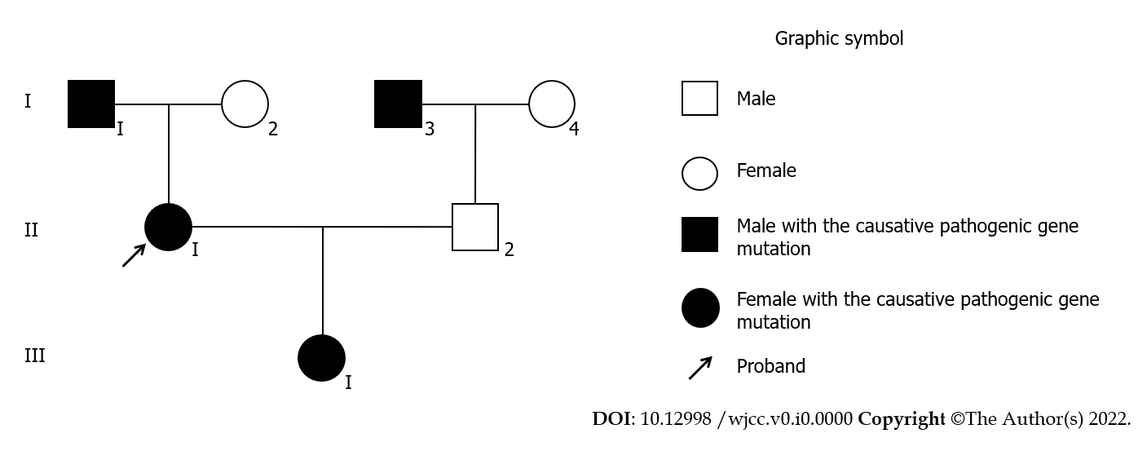
Figure 1 Pedigree. Affected II1 (proband) had congenital dysfibrinogenemia and carried the genetic mutation in the fibrinogen alpha chain gene (p.R350H). I1, I3, II1, and III1 carry the causative pathogenic gene.

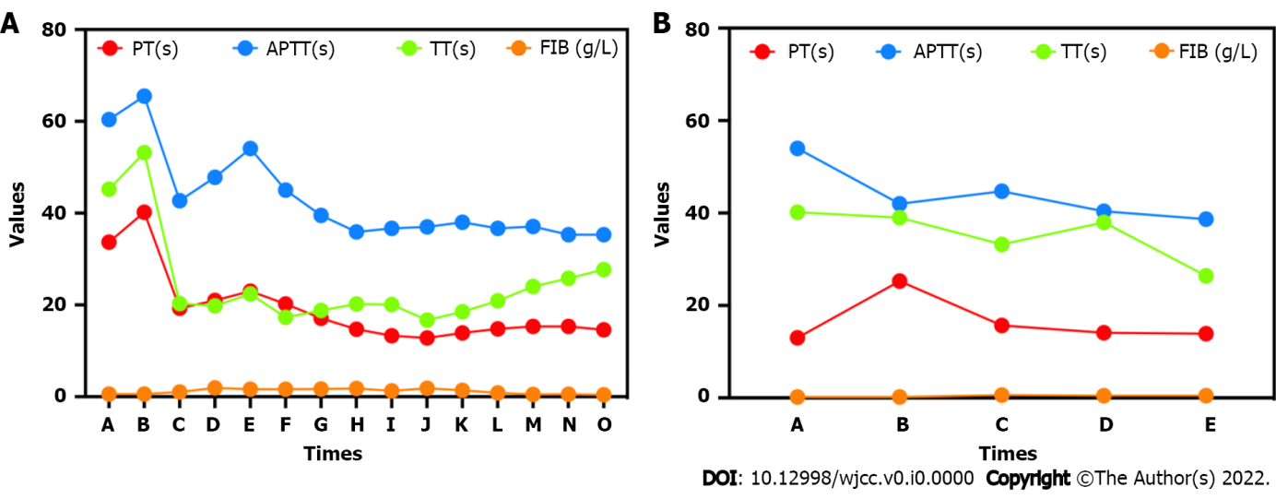
Figure 2 Coagulation results. A: The pregnant patient during hospitalization. Fibrinogen dropped below the critical value several times, and fresh frozen plasma or cryoprecipitate was injected immediately; B: The newborn during hospitalization. PT: Prothrombin time; APTT: Activated partial thromboplastin time; TT: Thrombin time; FIB: Fibrinogen.

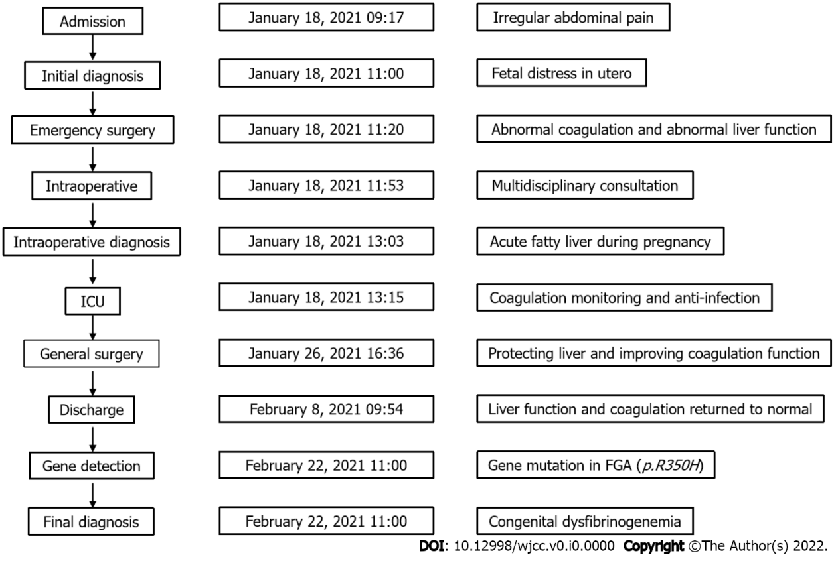
Figure 3 The process of patient admission, diagnosis, and treatment. ICU: Intensive care unit; FGA: Fibrinogen alpha chain gene.

Table 1 Review of congenital dysfibrinogenemia in pregnancy
Ref. | Age (yr) | Symptoms | BCF | GT | Treatments | Clinical outcomes
Bouvier et al^{[1]}, 2018 | 21 | Placental abruption | 1. Fibrinogen plasma level (Clauss): 0.6 g/L ↓; 2. A normal immunological level: 1.91 g/L | FGA exon 5: c.1415_1416 ins C | Fibrinogen substitution with heparin and aspirin | (1) First pregnancy: A low-birth-weight baby by cesarean delivery followed by postpartum hemorrhage; (2) Second pregnancy: Cesarean delivery due to decreased fetal movements; (3) Third pregnancy: Fetal death; and (4) Fourth pregnancy: Pregnancy was normal with a programmed cesarean delivery
Edwards and Rijhsinghani^{[3]}, 2000 | 24 | (1) Vaginal bleeding; and (2) Placental abruption | Fibrinogen level: 84 mg/dL ↓; thrombin time: 67 s ↑ | - | Operation | -
Langer et al^{[6]}, 2021 | 28 | Heavy vaginal bleeding after her first sexual intercourse | Fibrinogen activity level: < 60 mg/dL ↓ | - | (1) Fibrinogen replacement therapy; and (2) Prophylactic anticoagulation | Uneventful delivery
Takala et al^{[17]}, 1991 | - | Thrombotic | - | - | Heparin | Fetal loss
Yamanaka et al^{[18]}, 2003 | 38 | (1) Vaginal bleeding; and (2) Three times repeated abortions due to placental abruption | (1) Clottable fibrinogen: 66 mg/dL↓; and (2) Immunologic fibrinogen: 225 mg/dL (normal) | - | (1) Cesarean section; and (2) Before and during the operation 6 g of fibrinogen was infused | (1) No findings of placental abruption at the time of surgery; and (2) The newborn developed normally
Franchini et al^{[19]}, 2007 | 30 | Miscarriage at 9 wk of gestation 2 yr previously | (1) Functional fibrinogen: 161 mg/dL ↓; and (2) Immunologic fibrinogen: 466 mg/dL | Prothrombin G20210A mutation | LMWH | The woman delivered a healthy female baby
Franchini et al^{[19]}, 2007 | 36 | Idiopathic thrombocytopenic purpura | (1) Functional fibrinogen: 85 mg/dL ↓; and (2) Immunologic fibrinogen: 221 mg/dL | - | - | The woman delivered a healthy male baby
Franchini et al^{[19]}, 2007 | 25 | No | (1) Functional fibrinogen: 56 mg/dL ↓; and (2) Immunologic fibrinogen: 268 mg/dL | - | LMWH | The woman delivered a male baby
Franchini et al^{[19]}, 2007 | 33 | No | (1) Functional fibrinogen: 63 mg/dL ↓; and (2) Immunologic fibrinogen:180 mg/dL | - | LMWH | A normal male baby was delivered
Kotlín et al^{[20]}, 2011 | 36 | (1) Bleeding; and (2) Spontaneous abortions | (1) Functional fibrinogen level: 0.85 g/L ↓; and (2) Thrombin time: 39.3 s ↑ | A heterozygous G4864A transition in exon 2 of the FGA (GenBank  access number M64982) | Curettage | -
Yan et al^{[15]}, 2015 | 26 | (1) Viral cold and Mycoplasma genitalium  infection; and (2) No other clinical signs. | (1) Fibrinogen concentration: 0.56 g/L ↓; and (2) Immunoturbidimetry: 3.82 g/L | - | Operation | Artificial abortion
Yan et al^{[21]}, 2018 | 30 | No | Function fibrinogen level: 0.55 g/L ↓ | FGA exon 2: 1233C→A | No specific intervention in this case because the patient had no previous episodes of abnormal bleeding or thrombosis | Uneventful delivery
The normal level of functional fibrinogen (Clauss) was 150-450 mg/dL; the normal thrombin time was 12.5-16.5 s; the normal reptilase time was 12–22 s. BCF: Blood coagulation function; GT: Genetic testing; LMWH: Low-molecular-heparin; FGA: Fibrinogen alpha chain gene; ↓: Decreased values; ↑: Prolonged values.
Table 2 Review of gene mutation sites
Ref. | cDNA | Gene | Exon | CM | Clinical symptoms
Yoshida et al^{[5]}, 2017 | - | FGB | - | Ala68Thr | Superior sagittal sinus thrombosis, pulmonary embolism, DVT
Qiao et al^{[16]}, 2020 | c.92G>A | FGA | - | p.Gly31Glu | No symptoms so far
Kotlín et al^{[22]}, 2012 | - | FGA | - | Gly13Glu and Ser314Cys | Easy bruising, excessive bleeding during pregnancy and delivery, menorrhagia
Kotlín et al^{[22]}, 2022 | - | FGA | - | Gly13Glu | Epistaxis, bleeding from gums, prolonged bleeding after venipuncture
Luo et al^{[23]}, 2016 | c.104G>A | FGA | 2 | Arg16His | Mostly asymptomatic, sometimes severe bleeding and postpartum DIC
Cai et al^{[24]}, 2018 | c.103C>A | FGA | 2 | Arg38Thr | No symptoms so far
Shlebak et al^{[25]}, 2017 | c.221G> T | FGB | 2 | p.Arg74Leu | Venous and arterial thrombosis
Casini et al^{[26]}, 2017 | c.284 G>C | FGB | 2 | p.Cys95Ser | One miscarriage followed by metrorrhagia lasting nearly 2 mo
Undas et al^{[27]}, 2009 | c.1052A>T | FGG | 8 | Asn325Ile | DVT after appendectomy
Luo et al^{[28]}, 2020 | c.1178T>C | FGG | 9 | p.IIe367Thr | Menorrhagia
Yan et al^{[29]}, 2016 | g.5877G>A | FGG | 8 | Arg275His | No symptoms so far
Imafuku et al^{[30]}, 2002 | γ chain from Arg 275 to Cys (gR275C) | FGG | 8 | γ R275C | No symptoms so far
CM: Causative mutations; cDNA: Complementary DNA; FGA: Fibrinogen alpha chain; FGB: Fibrinogen beta chain; FGG: Fibrinogen gamma chain; DIC: Disseminated intravascular coagulation; DVT: Deep venous thrombosis.

