Name of journal: World Journal of Clinical Cases
Manuscript NO: 55672
Manuscript type: Minireviews

Clinical applicability of gastroscopy with narrow-band imaging for the diagnosis of Helicobacter pylori gastritis, precancerous gastric lesion, and neoplasia

Cho JH et al. Narrow-band imaging for gastric lesions

Jun-Hyung Cho, Seong Ran Jeon, So-Young Jin

Jun-Hyung Cho, Seong Ran Jeon, Digestive Disease Center, Soonchunhyang University Hospital, Seoul 04401, South Korea

So-Young Jin, Department of Pathology, Soonchunhyang University Hospital, Seoul 04401, South Korea

Author contributions: Cho JH designed research and wrote the paper; Cho JH, Jeon SR and Jin SY performed research; Cho JH and Jeon SR performed literature review; Cho JH and Jin SY analyzed data; Cho JH, Jeon SR and Jin SY contributed critical revision and editing.

supported by the Soonchunhyang University Research Fund, No. 20200004.

Corresponding author: Jun-Hyung Cho, MD, PhD, Associate Professor, Digestive Disease Center, Soonchunhyang University Hospital, No. 59, Daesagwan-ro, Yongsan-gu, Seoul 04401, South Korea. chojhmd@naver.com

Received: March 28, 2020
Revised: May 1, 2020
Accepted: July 14, 2020
Published online: July 26, 2020

Abstract
Premalignant gastric lesions such as atrophic gastritis and intestinal metaplasia frequently occur in subjects with long-term Helicobacter pylori (H. pylori) infection. The regular arrangement of collecting venules (RAC) is seen in the normal gastric corpus, whereas mucosal swelling and redness without RAC are observed in H. pylori-infected mucosa. Despite successful H. pylori eradication, the presence of atrophic gastritis and/or gastric intestinal metaplasia (GIM) is a risk factor for gastric cancer. With the development of advanced imaging technologies, recent studies have reported the usefulness of narrow-band imaging (NBI) for endoscopic diagnosis of atrophic gastritis and GIM. Using NBI endoscopy with magnification (M-NBI), atrophic gastritis is presented as irregular coiled microvessels and loss of gastric pits. Typical M-NBI endoscopic findings of GIM are a light blue crest and a white opaque substance. Based on the microvascular patterns, fine network, core vascular, and unclear patterns are useful for predicting gastric dysplasia in polypoid lesions. For diagnosis of early gastric cancer (EGC), a systematic classification using M-NBI endoscopy has been proposed on the basis of the presence of a demarcation line and an irregular microvascular/microsurface pattern. Furthermore, M-NBI endoscopy has been found to be more accurate for determining the horizontal margin of EGC compared to conventional endoscopy. In this review, we present up-to-date results on the clinical usefulness of gastroscopy with NBI for the diagnosis of H. pylori gastritis, precancerous gastric lesion, and neoplasia.

Key words: Gastroscopy; Narrow-band imaging; Magnification; Helicobacter pylori; Atrophic gastritis; Intestinal metaplasia; Dysplasia; Cancer

Cho JH, Jeon SR, Jin SY. Clinical applicability of gastroscopy with narrow-band imaging for the diagnosis of Helicobacter pylori gastritis, precancerous gastric lesion, and neoplasia. World J Clin Cases 2020; 8(14): 2902-2916 URL: https://www.wjgnet.com/2307-8960/full/v8/i14/2902.htm DOI: https://dx.doi.org/10.12998/wjcc.v8.i14.2902

Core tip: Image-enhanced endoscopy techniques such as narrow-band imaging (NBI) improve the diagnosis of Helicobacter pylori infection, atrophic gastritis, and gastric intestinal metaplasia (GIM). When NBI is combined with magnifying endoscopy, typical endoscopic findings can clearly be observed. Thus, the extent and severity of GIM can be endoscopically evaluated by close mucosal observation. Based on the microvascular patterns, fine network, core vascular, and unclear patterns are useful for predicting gastric dysplasia in polypoid lesions. When the endoscopists find a small flat or depressed lesion, magnifying NBI endoscopy is helpful for differentiating between cancer and gastritis. The presence of a demarcation line and an irregular microvascular/microsurface pattern are highly suspicious for high grade dysplasia and cancer. For endoscopic treatment of early gastric cancer, the horizontal tumor margin can be assessed by magnifying NBI endoscopy.

INTRODUCTION
Gastric cancer is the third most common cause of cancer-related mortality worldwide^{[1]}. Long-term Helicobacter pylori (H. pylori) infection causes premalignant gastric conditions, such as atrophic gastritis and intestinal metaplasia^{[2]}. In particular, gastric intestinal metaplasia (GIM) is a risk factor for gastric cancer development^{[3]}. Although GIM is reportedly improved after H. pylori eradication, complete elimination of the gastric cancer risk cannot be guaranteed^{[4]}. Thus, surveillance endoscopy is recommended in subjects with precancerous lesions at the time of eradication^{[5]}. The diagnostic accuracy for precancerous lesions and gastric neoplasia of image-enhanced endoscopy has been increased by the advent of narrow-band imaging (NBI) endoscopy^{[6,7]}. Before endoscopic submucosal dissection, NBI endoscopy can determine the margin of gastric dysplasia and cancer to promote complete removal^{[8]}. Although pathologic diagnosis is the gold standard, accurate endoscopic prediction is important to minimize the number of biopsies and prevent post-biopsy bleeding. Herein, we present up-to-date results on the clinical usefulness of NBI endoscopy for the diagnosis of H. pylori gastritis, precancerous gastric lesion, and neoplasia. This review consists of the following: (1) H. pylori gastritis; (2) atrophic gastritis and GIM; (3) gastric dysplasia; and (4) early gastric cancer (EGC).

PRINCIPLE OF NARROW-BAND IMAGING WITH MAGNIFICATION
In 2005, technological advances resulted in the advent of NBI. NBI is an innovative optical method that modifies the wavelengths and bandwidths of the light into narrow bands of 415 ± 30 nm and 540 ± 30 nm^{[9]}. In this endoscopy system, which uses a red (R), green (G), and blue (B) sequential imaging system, the gastrointestinal mucosa is illuminated sequentially with R, G, and B light through a rotating RGB filter wheel^{[10]}. When the endoscopist presses the button on the handle, a narrow-band filter is inserted between the lamp and the RGB filter. Red light (long wavelength) diffuses widely and deeply, whereas blue light (short wavelength) diffuses within a smaller range and less deeply. Because short-wavelength light strongly reflects from the epithelial surface, it is suitable for visualizing its morphology. Therefore, NBI improves upon the detailed visualization possible by magnifying endoscopy (Figure 1).
Magnifying endoscopy enables examination of the microanatomy of the gastric mucosa^{[11]}. When a soft black cap is fixed to the tip of the endoscope, it is possible to maintain a distance of approximately 2 mm, at which up to 100-fold magnification is feasible. This system produces sharp images of microvascular architecture and microsurface structure. In the upper gastrointestinal tract, the line of sight may be disrupted by respiration movement and great vessel pulsation. To climb the learning curve of magnifying endoscopy, a proper training system under an experienced supervisor is required.

H. pylori GASTRITIS
Initially, the main tests for H. pylori infection were the rapid urease test and pathologic examination, both of which require a biopsy specimen^{[12]}. The development of endoscopy techniques enabled detection in real time, earlier than possible using these biopsy-based tests. In 2005, a regular arrangement of collecting venules (RAC) was suggested as the normal pattern in gastric mucosa without H. pylori infection^{[13]}. When the gastric corpus was examined by magnifying endoscopy, H. pylori-infected mucosa showed dilation of gastric pits and disappearance of RAC^{[14]}. For predicting histological chronic gastritis, Tahara et al^{[15]} observed the gastric corpus using magnifying NBI (M-NBI) endoscopy, which enabled visualization of the micromucosal pattern. The normal pattern was defined as a honeycomb-like subepithelial capillary network (SECN) and the presence of RAC (Figure 1A). The abnormal pattern of H. pylori-induced gastritis is typically polygonal swollen mucosa with enlarged crypt openings (Figure 1B). The sensitivities and specificities of magnifying endoscopy for H. pylori infection are 93.8% to 100% and 82.2% to 96.2%, respectively^{[13-15]}.
Recently, endoscopists have attempted to diagnose H. pylori infection by white-light imaging (WLI) or non-magnifying endoscopy with other image-enhanced techniques^{[16,17]}. The typical endoscopic findings of H. pylori-induced gastritis are mucosal swelling and redness with disappearance of RAC at the gastric corpus^{[18]}. Although M-NBI has good diagnostic accuracy, non-magnifying endoscopy is also useful for detecting H. pylori gastritis by close observation of the greater curvature side of the corpus^{[19]}. Furthermore, the rapid urease test from the corpus mucosa had a faster positive reaction, compared to the antrum^{[20]}. However, an endoscopic classification based on WLI has not yet been established. Furthermore, a comparison study between M-NBI and WLI endoscopy for H. pylori diagnosis is needed.

ATROPHIC GASTRITIS
In the H. pylori-infected stomach, chronic active inflammation becomes persistent, leading to mucosal atrophy with destruction of gastric glands. In Japan, atrophic gastritis is often evaluated according to the endoscopic Kimura-Takemoto classification^{[21]}. This classification has showed the good agreement with the histological assessment of atrophic gastritis^{[22,23]}. Because of high risk for gastric cancer development, surveillance endoscopy is required in subjects with severe atrophic gastritis^{[24]}. Compared to conventional WLI endoscopy, M-NBI enables a reliable diagnosis for the degree of atrophic gastritis.
Before the NBI system was introduced, Yagi et al^{[13]} classified magnified endoscopic findings of the H. pylori-infected corpus mucosa into three types (Z-1 to Z-3). Of these, type Z-3 mucosal pattern corresponded to histological features of marked atrophy of the gastric glands. Recent studies have reported the typical endoscopic findings using M-NBI in diagnosing atrophic gastritis^{[25,26]}. Ridged surface structures encasing dilated coiled subepithelial capillaries indicates the presence of atrophic gastritis (Figure 2C). With progression to severe mucosal atrophy, irregular coiled microvessels and loss of gastric pits are observed by M-NBI endoscopy (Figure 2D). The sensitivities and specificities of M-NBI endoscopy for atrophic gastritis are 50.0% to 90.0% and 96.0% to 96.3%, respectively^{[14,15]}.

GASTRIC INTESTINAL METAPLASIA
All subjects with intestinal metaplasia are at risk for gastric cancer development. Whether the gastric cancer risk is low or high depends on the extent and severity of intestinal metaplasia^{[27]}. Since the advent of endoscopy, pathologic examination by forceps biopsy has been the gold standard for diagnosis of GIM. In the updated Sydney System, multiple mucosal biopsies from the gastric corpus and antrum are required to obtain the specimens^{[28]}. The diagnostic criteria of the operative link for gastritis assessment (OLGA) and operative link for gastric intestinal metaplasia assessment (OLGIM) enable more reliable risk stratification of gastric cancer and identification of patients at high risk who need endoscopic surveillance^{[29,30]}. However, OLGA and OLGIM staging are based on pathologic analyses of gastric biopsies from five sites. In clinical practice, elderly patients taking antiplatelets or anticoagulants are at risk for post-biopsy bleeding. Furthermore, biopsy-based methods can considerably increase the medical costs and procedure time.
Based on WLI, the presence of light gray granular patches is the only endoscopic finding of GIM^{[31]}. However, endoscopic diagnosis using only WLI is limited by its low sensitivity. Several investigators have proposed NBI endoscopic criteria for diagnosis of GIM (Table 1). In 2006, Uedo et al^{[32]} suggested a light blue crest (LBC) as a new diagnostic criterion for GIM. In M-NBI endoscopy, LBC was observed as a fine, blue line on the crests of the epithelial surface (Figure 3). The presence of LBC was correlated with histological GIM (sensitivity 89% and specificity 93%). Savarino et al^{[33]} reported that LBC was a good indicator of GIM (sensitivity 80%, specificity 96%, and accuracy 93%). For diagnosing GIM, An et al^{[34]} suggested the marginal turbid band (MTB), which was defined as an enclosed, white turbid band on the epithelial surface. The presence of both MTB and LBC is more frequent in moderate to severe GIM. The presence of MTB without LBC is considered indicative of early-stage GIM. LBC may be present in subjects who progress to severe GIM. In Japan, Kanemitsu et al^{[35]} reported that a white opaque substance (WOS) was a marker for M-NBI diagnosis of GIM. The sensitivity of LBC for histological GIM was 62.5%. When the presence of WOS was added to the criteria, the sensitivity increased to 87.5%. The specificity and accuracy of WOS and/or LBC were 93.8% and 90.0%, respectively. Saka et al^{[36]} performed M-NBI endoscopic staging of gastritis using the diagnostic criteria of a tubular/granular mucosal pattern plus LBC or WOS. The accuracy for assessing OLGA and OLGIM was 69.1% for the antrum and 72.7% for the corpus. The degree of gastritis was classified as low or high risk by summing the scores of the corpus and antrum. The concordance of M-NBI endoscopy with histologic severity for differentiating the low- and high-risk groups was 89.1%.
In 2012, Pimentel-Nunes et al^{[37]} performed a validation study for endoscopic classification of premalignant gastric lesions and dysplasia. Using NBI endoscopy without magnification, they defined a regular tubulovillous or ridge glandular pattern as intestinal metaplasia. This mucosal pattern showed 90% sensitivity, 81% specificity, and 84% accuracy for diagnosing GIM. They used a web-based video system to address the learning curve of this classification by endoscopists^{[38]}. The sensitivity and specificity for GIM reached 73% and 81% by the trainees, respectively. An NBI classification seemed to be easily learned for the identification of precancerous gastric lesions. A multicenter prospective study evaluated endoscopic grading of GIM using the same NBI classification^{[39]}. Five different areas (each of the lesser and greater curvature of the corpus and antrum, and the gastric angle) were closely observed by NBI endoscopy. The endoscopic grades of GIM were evaluated on a three-point scale [no = 0, focal (≤ 30%) = 1, and extensive (> 30%) = 2] according to the extent of metaplastic mucosa. Compared to WLI, NBI had a higher diagnostic accuracy for GIM (83% vs 94%). NBI increased the sensitivity for GIM from 53% to 87%. The endoscopic grading was concordant with an extensive degree of histological GIM (OLGIM III/IV). If the cutoff value was > 4 (total score = 5–10), the sensitivity and specificity for OLGIM III/IV were 94.2% and 95.2%, respectively. The area under the receiver operating characteristic curve was 0.98. Esposito et al^{[40]} suggested that NBI endoscopy for diagnosing GIM is useful for evaluating the risk for OLGIM without performing mucosal biopsy. By contrast, another study reported that the diagnostic yield for GIM using NBI endoscopy was 53% to 65%^{[41]}. NBI-targeted biopsy is still recommended for detection of GIM. A further large-scale study is required to standardize the diagnosis of GIM using NBI endoscopy.

GASTRIC DYSPLASIA
Gastric dysplasia is the precursor lesion of gastric adenocarcinoma, particularly of the intestinal type^{[42]}. The World Health Organization (WHO) defines dysplasia in the gastrointestinal tract as the presence of histologically unequivocal neoplastic epithelium without evidence of tissue invasion^{[43]}. According to the revised Vienne classification, low and high grade dysplasia (category 3 and 4.1) is classified as non-invasive gastric neoplasia^{[44]}. Endoscopic resection is recommended for the management of gastric dysplasia due to the possibility of malignant transformation^{[45]}. Indefinite pathology for neoplasia on forceps biopsy specimens (category 2 of the revised Vienne classification) is often observed in clinical practice. Although endoscopic biopsy is essential before planning an endoscopic resection, there are reportedly histological discrepancies between forceps biopsy and post-resection specimen^{[46]}. In a study by Lee et al^{[47]}, up to 64.5% of gastric lesions with indefinite pathology were upgraded to dysplasia and cancer after endoscopic submucosal dissection (ESD). Endoscopic biopsy may not be representative of the entire lesion due to its superficiality and sampling errors^{[48]}. Repeated biopsy can make the subsequent endoscopic treatment to be difficult due to submucosal fibrosis. Therefore, advanced endoscopic imaging such as M-NBI is required for the management of gastric dysplasia.
Using M-NBI endoscopy, Omori et al^{[49]} suggested the characteristics of fine mucosal structures and microvascular pattern for diagnosing the gastric polypoid lesions. Most reliable microvascular patterns were honeycomb for fundic gland polyp (sensitivity 94.7%, specificity 97.4%) and dense vascular patterns for hyperplastic polyp (sensitivity 93.6%, specificity 91.6%). For predicting gastric neoplasia, fine network, core vascular, and unclear patterns showed the high specificity of 97%, 100%, and 100%, respectively (Figure 4). Hwang et al^{[50]} reported the association between the M-NBI findings and upgraded histology in biopsy-proven low grade dysplasia. Positive M-NBI findings were defined as the irregularity of microvascular and/or microsurface patterns within the lesion (Figure 5). In cases with positive M-NBI findings, 76.6% (n = 59/77) was diagnosed as high grade dysplasia and cancer in post-resection pathology. If either an irregular microvascular or microsurface pattern is present, the gastric lesion can be diagnosed as high grade dysplasia or EGC^{[51]}. In addition, M-NBI endoscopy is useful for determining the horizontal margin of gastric dysplasia before ESD (Figure 6).

EARLY GASTRIC CANCER
Differential diagnosis between focal gastritis and small depressed cancer
During endoscopy, EGCs are recognized based on a color or morphological change. Particularly in small (≤ 10 mm) gastric cancer, pathologic examination may be misdiagnosed due to targeted biopsy failure. If the opportunity for treatment by endoscopic resection is missed, false negativity based on the pathologic result alone is of great concern. Because conventional WLI endoscopy cannot be used to examine the gastric micromucosal pattern in detail, its utility for real-time endoscopic diagnosis is limited. To overcome this, the diagnostic efficacy of magnifying endoscopy has been investigated (Table 2).
In 2007, Yao et al^{[52]} reported that cancerous lesions can be diagnosed by close observation using magnifying endoscopy. They defined the characteristics of EGC as a demarcation line (DL) between the lesion and the background mucosa, and an irregular microvascular pattern within the lesion. When these criteria were used, the sensitivity, specificity, and accuracy for distinguishing cancerous from benign lesions were 92.9%, 99.3%, and 98.7%, respectively. Ezoe et al^{[53]} performed a prospective comparative study of magnifying NBI and magnifying WLI for diagnosing cancer in small depressed lesions. The NBI mode enabled the gastric micromucosal patterns around the lesion to be more clearly visualized, increasing the diagnostic performance (sensitivity of 70.0% vs 33.3%, specificity of 88.8% vs 66.6%, and accuracy of 78.9% vs 43.8%). Yamada et al^{[54]} compared WLI alone and M-NBI after WLI for the diagnosis of small, depressed EGC. When WLI endoscopy alone was performed according to criteria including irregular margin and spiny depressed area, the sensitivity was 40%, specificity was 68%, and accuracy was 65%. Remarkably, M-NBI after WLI showed improved sensitivity of 95%, specificity of 97%, and accuracy of 97%.
Systematic classification using M-NBI endoscopy based on microvascular and microsurface pattern (the VS classification) has been proposed^{[55]}. When a suspicious mucosal lesion with color or morphological change is detected, the first step is to identify the presence of DL, which separates the lesion from the background mucosa. A lesion without DL is unlikely to be cancer. If a DL is seen, the diagnosis of gastric cancer can be determined by the presence of an irregular microvascular and/or microsurface pattern within the DL (Figure 7). In a prospective multicenter study, the sensitivity, specificity, and accuracy of M-NBI for diagnosis of EGC were 85.7%, 99.4%, and 98.1%, respectively^{[56]}. However, there were false-negative cases of signet ring cell carcinoma despite the diagnosis being performed by well-trained endoscopists. Pale-colored lesions suspicious of undifferentiated-type carcinoma are indications not for M-NBI endoscopy but rather for pathologic study by targeted biopsy. Fugiwara et al^{[57]} evaluated M-NBI diagnosis of minute gastric cancer (≤ 5 mm) compared to chromoendoscopy using indigo carmine. The sensitivity and diagnostic accuracy were significantly higher for M-NBI endoscopy than chromoendoscopy (78.0% vs 43.7% and 88.3% vs 69.9%, respectively).
Kato et al^{[58]} suggested a diagnostic triad for gastric cancer by M-NBI endoscopy: Disappearance of fine mucosal structure, microvascular dilation, and heterogeneous shape. The sensitivity and specificity were significantly higher than those of conventional WLI endoscopy (92.9% vs 42.9% and 94.7% vs 61.0%, respectively). Kanesaka et al^{[59]} categorized the microvascular patterns of small depressed lesions as microvascular dilation, microvascular tortuosity, difference in caliber, and variation in shape. Among these microvascular findings by M-NBI endoscopy, variation in shape was the most significant feature, with a diagnostic accuracy of 92%.

Determination of the horizontal extent of early gastric cancer before endoscopic submucosal dissection
ESD is curative in selected patients with EGC^{[60]}. For a successful outcome of ESD, the tumor margin should be clearly examined. In M-NBI endoscopy, EGC margin delineation can be achieved by close-up observation of DL (Table 3). In 2010, Kiyotoki et al^{[61]} evaluated the usefulness of M-NBI endoscopy for determining the gastric tumor margin compared to conventional chromoendoscopy using indigo carmine. Before ESD, marking dots were made at the tumor margin using M-NBI or chromoendoscopy. If the distance was less than 1 mm between the endoscopic marking dot and pathologically confirmed margin, the diagnosis was defined to be accurate. The diagnostic accuracy was significantly higher for M-NBI endoscopy than chromoendoscopy (97.4% vs 77.8%, P = 0.009). In another comparison study, there was a significant difference in delineating the margin of EGC between M-NBI endoscopy and chromoendoscopy (89.4% vs 75.9%, P = 0.007)^{[62]}. Similarly, several studies have demonstrated that M-NBI endoscopy improves the determination of horizontal extent before ESD in patients with an unclear margin of EGC^{[63,64]}. Horii et al^{[65]} showed that diagnostic accuracy using M-NBI was 96.7% when the successful demarcation of EGC was evaluated on the basis of the biopsy-negative rate outside the tumor. Complete resection of EGC with a tumor-negative horizontal margin was achieved in 97.9% (n = 323/330). However, Nagahama et al^{[66]} reported that the diagnostic accuracy for EGC margin delineation of M-NBI endoscopy was not superior to that of chromoendoscopy using indigo carmine. Indeed, M-NBI endoscopy does not need a dye solution and so is less time consuming.

CONCLUSION
In an era of high imaging quality in medical devices, magnifying endoscopy and NBI have enabled H. pylori diagnosis, endoscopic grading of GIM, and detailed characterization of small gastric cancer. Previously, the pathological report was the absolute authority for diagnosis of gastrointestinal tract diseases. Henceforth, image-enhanced endoscopy can make a big step to optical biopsy, which is a real-time diagnosis during gastrointestinal endoscopy. Furthermore, confocal laser endomicroscopy and endocytoscopy may become available in the future^{[67]}. If endoscopists are well-trained in advanced endoscopic imaging, they may evolve into endo-pathologists^{[68]}.

REFERENCES
1 Bray F, Ferlay J, Soerjomataram I, Siegel RL, Torre LA, Jemal A. Global cancer statistics 2018: GLOBOCAN estimates of incidence and mortality worldwide for 36 cancers in 185 countries. CA Cancer J Clin 2018; 68: 394-424 [PMID: 30207593 DOI: 10.3322/caac.21492]
2 Kuipers EJ, Uyterlinde AM, Peña AS, Roosendaal R, Pals G, Nelis GF, Festen HP, Meuwissen SG. Long-term sequelae of Helicobacter pylori gastritis. Lancet 1995; 345: 1525-1528 [PMID: 7791437 DOI: 10.1016/s0140-6736(95)91084-0]
3 Li D, Bautista MC, Jiang SF, Daryani P, Brackett M, Armstrong MA, Hung YY, Postlethwaite D, Ladabaum U. Risks and Predictors of Gastric Adenocarcinoma in Patients with Gastric Intestinal Metaplasia and Dysplasia: A Population-Based Study. Am J Gastroenterol 2016; 111: 1104-1113 [PMID: 27185078 DOI: 10.1038/ajg.2016.188]
4 Hwang YJ, Kim N, Lee HS, Lee JB, Choi YJ, Yoon H, Shin CM, Park YS, Lee DH. Reversibility of atrophic gastritis and intestinal metaplasia after Helicobacter pylori eradication - a prospective study for up to 10 years. Aliment Pharmacol Ther 2018; 47: 380-390 [PMID: 29193217 DOI: 10.1111/apt.14424]
5 Wong BC, Lam SK, Wong WM, Chen JS, Zheng TT, Feng RE, Lai KC, Hu WH, Yuen ST, Leung SY, Fong DY, Ho J, Ching CK, Chen JS; China Gastric Cancer Study Group. Helicobacter pylori eradication to prevent gastric cancer in a high-risk region of China: a randomized controlled trial. JAMA 2004; 291: 187-194 [PMID: 14722144 DOI: 10.1001/jama.291.2.187]
6 Song J, Zhang J, Wang J, Guo X, Wang J, Liu Y, Dong W. Meta-analysis: narrow band imaging for diagnosis of gastric intestinal metaplasia. PLoS One 2014; 9: e94869 [PMID: 24743566 DOI: 10.1371/journal.pone.0094869]
7 Hu YY, Lian QW, Lin ZH, Zhong J, Xue M, Wang LJ. Diagnostic performance of magnifying narrow-band imaging for early gastric cancer: A meta-analysis. World J Gastroenterol 2015; 21: 7884-7894 [PMID: 26167089 DOI: 10.3748/wjg.v21.i25.7884]
8 Yao K, Nagahama T, Matsui T, Iwashita A. Detection and characterization of early gastric cancer for curative endoscopic submucosal dissection. Dig Endosc 2013; 25 Suppl 1: 44-54 [PMID: 23362939 DOI: 10.1111/den.12004]
9 Gono K. Narrow Band Imaging: Technology Basis and Research and Development History. Clin Endosc 2015; 48: 476-480 [PMID: 26668792 DOI: 10.5946/ce.2015.48.6.476]
10 Yao K, Takaki Y, Matsui T, Iwashita A, Anagnostopoulos GK, Kaye P, Ragunath K. Clinical application of magnification endoscopy and narrow-band imaging in the upper gastrointestinal tract: new imaging techniques for detecting and characterizing gastrointestinal neoplasia. Gastrointest Endosc Clin N Am 2008; 18: 415-433, vii-viii [PMID: 18674694 DOI: 10.1016/j.giec.2008.05.011]
11 Yao K. Clinical Application of Magnifying Endoscopy with Narrow-Band Imaging in the Stomach. Clin Endosc 2015; 48: 481-490 [PMID: 26668793 DOI: 10.5946/ce.2015.48.6.481]
12 Cohen H, Laine L. Endoscopic methods for the diagnosis of Helicobacter pylori. Aliment Pharmacol Ther 1997; 11 Suppl 1: 3-9 [PMID: 9146785 DOI: 10.1046/j.1365-2036.11.s1.2.x]
13 Yagi K, Honda H, Yang JM, Nakagawa S. Magnifying endoscopy in gastritis of the corpus. Endoscopy 2005; 37: 660-666 [PMID: 16010611 DOI: 10.1055/s-2005-861423]
14 Anagnostopoulos GK, Yao K, Kaye P, Fogden E, Fortun P, Shonde A, Foley S, Sunil S, Atherton JJ, Hawkey C, Ragunath K. High-resolution magnification endoscopy can reliably identify normal gastric mucosa, Helicobacter pylori-associated gastritis, and gastric atrophy. Endoscopy 2007; 39: 202-207 [PMID: 17273960 DOI: 10.1055/s-2006-945056]
15 Tahara T, Shibata T, Nakamura M, Yoshioka D, Okubo M, Arisawa T, Hirata I. Gastric mucosal pattern by using magnifying narrow-band imaging endoscopy clearly distinguishes histological and serological severity of chronic gastritis. Gastrointest Endosc 2009; 70: 246-253 [PMID: 19386303 DOI: 10.1016/j.gie.2008.11.046]
16 Glover B, Teare J, Patel N. A systematic review of the role of non-magnified endoscopy for the assessment of H. pylori infection. Endosc Int Open 2020; 8: E105-E114 [PMID: 32010741 DOI: 10.1055/a-0999-5252]
17 Cho JH. Advanced Imaging Technology Other than Narrow Band Imaging. Clin Endosc 2015; 48: 503-510 [PMID: 26668796 DOI: 10.5946/ce.2015.48.6.503]
18 Kato T, Yagi N, Kamada T, Shimbo T, Watanabe H, Ida K; Study Group for Establishing Endoscopic Diagnosis of Chronic Gastritis. Diagnosis of Helicobacter pylori infection in gastric mucosa by endoscopic features: a multicenter prospective study. Dig Endosc 2013; 25: 508-518 [PMID: 23369058 DOI: 10.1111/den.12031]
19 Cho JH, Chang YW, Jang JY, Shim JJ, Lee CK, Dong SH, Kim HJ, Kim BH, Lee TH, Cho JY. Close observation of gastric mucosal pattern by standard endoscopy can predict Helicobacter pylori infection status. J Gastroenterol Hepatol 2013; 28: 279-284 [PMID: 23189930 DOI: 10.1111/jgh.12046]
20 Cho JH, Jeon SR, Kim HG, Jin SY, Park S. Factors for improving the diagnostic efficiency of the rapid urease test from the gastric corpus. Scand J Gastroenterol 2017; 52: 1320-1325 [PMID: 28927301 DOI: 10.1080/00365521.2017.1378712]
21 Kimura K, Satoh K, Ido K, Taniguchi Y, Takimoto T, Takemoto T. Gastritis in the Japanese stomach. Scand J Gastroenterol Suppl 1996; 214: 17-20; discussion 21-3 [PMID: 8722400 DOI: 10.3109/00365529609094509]
22 Liu Y, Uemura N, Xiao SD, Tytgat GN, Kate FJ. Agreement between endoscopic and histological gastric atrophy scores. J Gastroenterol 2005; 40: 123-127 [PMID: 15770394 DOI: 10.1007/s00535-004-1511-x]
23 Quach DT, Le HM, Nguyen OT, Nguyen TS, Uemura N. The severity of endoscopic gastric atrophy could help to predict Operative Link on Gastritis Assessment gastritis stage. J Gastroenterol Hepatol 2011; 26: 281-285 [PMID: 21261717 DOI: 10.1111/j.1440-1746.2010.06474.x]
24 Kaji K, Hashiba A, Uotani C, Yamaguchi Y, Ueno T, Ohno K, Takabatake I, Wakabayashi T, Doyama H, Ninomiya I, Kiriyama M, Ohyama S, Yoneshima M, Koyama N, Takeda Y, Yasuda K. Grading of Atrophic Gastritis is Useful for Risk Stratification in Endoscopic Screening for Gastric Cancer. Am J Gastroenterol 2019; 114: 71-79 [PMID: 30315306 DOI: 10.1038/s41395-018-0259-5]
25 Kawamura M, Abe S, Oikawa K, Terai S, Saito M, Shibuya D, Kato K, Shimada T, Uedo N, Masuda T. Topographic differences in gastric micromucosal patterns observed by magnifying endoscopy with narrow band imaging. J Gastroenterol Hepatol 2011; 26: 477-483 [PMID: 21155881 DOI: 10.1111/j.1440-1746.2010.06527.x]
26 Kanzaki H, Uedo N, Ishihara R, Nagai K, Matsui F, Ohta T, Hanafusa M, Hanaoka N, Takeuchi Y, Higashino K, Iishi H, Tomita Y, Tatsuta M, Yamamoto K. Comprehensive investigation of areae gastricae pattern in gastric corpus using magnifying narrow band imaging endoscopy in patients with chronic atrophic fundic gastritis. Helicobacter 2012; 17: 224-231 [PMID: 22515361 DOI: 10.1111/j.1523-5378.2012.00938.x]
27 Shichijo S, Endo Y, Aoyama K, Takeuchi Y, Ozawa T, Takiyama H, Matsuo K, Fujishiro M, Ishihara S, Ishihara R, Tada T. Application of convolutional neural networks for evaluating Helicobacter pylori infection status on the basis of endoscopic images. Scand J Gastroenterol 2019; 54: 158-163 [PMID: 30879352 DOI: 10.1080/00365521.2019.1577486]
28 Dixon MF, Genta RM, Yardley JH, Correa P. Classification and grading of gastritis. The updated Sydney System. International Workshop on the Histopathology of Gastritis, Houston 1994. Am J Surg Pathol 1996; 20: 1161-1181 [PMID: 8827022 DOI: 10.1097/00000478-199610000-00001]
29 Rugge M, Correa P, Di Mario F, El-Omar E, Fiocca R, Geboes K, Genta RM, Graham DY, Hattori T, Malfertheiner P, Nakajima S, Sipponen P, Sung J, Weinstein W, Vieth M. OLGA staging for gastritis: a tutorial. Dig Liver Dis 2008; 40: 650-658 [PMID: 18424244 DOI: 10.1016/j.dld.2008.02.030]
30 Capelle LG, de Vries AC, Haringsma J, Ter Borg F, de Vries RA, Bruno MJ, van Dekken H, Meijer J, van Grieken NC, Kuipers EJ. The staging of gastritis with the OLGA system by using intestinal metaplasia as an accurate alternative for atrophic gastritis. Gastrointest Endosc 2010; 71: 1150-1158 [PMID: 20381801 DOI: 10.1016/j.gie.2009.12.029]
31 Sauerbruch T, Schreiber MA, Schüssler P, Permanetter W. Endoscopy in the diagnosis of gastritis. Diagnostic value of endoscopic criteria in relation to histological diagnosis. Endoscopy 1984; 16: 101-104 [PMID: 6734532 DOI: 10.1055/s-2007-1018546]
32 Uedo N, Ishihara R, Iishi H, Yamamoto S, Yamamoto S, Yamada T, Imanaka K, Takeuchi Y, Higashino K, Ishiguro S, Tatsuta M. A new method of diagnosing gastric intestinal metaplasia: narrow-band imaging with magnifying endoscopy. Endoscopy 2006; 38: 819-824 [PMID: 17001572 DOI: 10.1055/s-2006-944632]
33 Savarino E, Corbo M, Dulbecco P, Gemignani L, Giambruno E, Mastracci L, Grillo F, Savarino V. Narrow-band imaging with magnifying endoscopy is accurate for detecting gastric intestinal metaplasia. World J Gastroenterol 2013; 19: 2668-2675 [PMID: 23674874 DOI: 10.3748/wjg.v19.i17.2668]
34 An JK, Song GA, Kim GH, Park DY, Shin NR, Lee BE, Woo HY, Ryu DY, Kim DU, Heo J. Marginal turbid band and light blue crest, signs observed in magnifying narrow-band imaging endoscopy, are indicative of gastric intestinal metaplasia. BMC Gastroenterol 2012; 12: 169 [PMID: 23185997 DOI: 10.1186/1471-230X-12-169]
35 Kanemitsu T, Yao K, Nagahama T, Imamura K, Fujiwara S, Ueki T, Chuman K, Tanabe H, Atsuko O, Iwashita A, Shimokawa T, Uchita K, Kanesaka T. Extending magnifying NBI diagnosis of intestinal metaplasia in the stomach: the white opaque substance marker. Endoscopy 2017; 49: 529-535 [PMID: 28395383 DOI: 10.1055/s-0043-103409]
36 Saka A, Yagi K, Nimura S. OLGA- and OLGIM-based staging of gastritis using narrow-band imaging magnifying endoscopy. Dig Endosc 2015; 27: 734-741 [PMID: 25923666 DOI: 10.1111/den.12483]
37 Pimentel-Nunes P, Dinis-Ribeiro M, Soares JB, Marcos-Pinto R, Santos C, Rolanda C, Bastos RP, Areia M, Afonso L, Bergman J, Sharma P, Gotoda T, Henrique R, Moreira-Dias L. A multicenter validation of an endoscopic classification with narrow band imaging for gastric precancerous and cancerous lesions. Endoscopy 2012; 44: 236-246 [PMID: 22294194 DOI: 10.1055/s-0031-1291537]
38 Dias-Silva D, Pimentel-Nunes P, Magalhães J, Magalhães R, Veloso N, Ferreira C, Figueiredo P, Moutinho P, Dinis-Ribeiro M. The learning curve for narrow-band imaging in the diagnosis of precancerous gastric lesions by using Web-based video. Gastrointest Endosc 2014; 79: 910-20; quiz 983-e1, 983.e4 [PMID: 24287281 DOI: 10.1016/j.gie.2013.10.020]
39 Pimentel-Nunes P, Libânio D, Lage J, Abrantes D, Coimbra M, Esposito G, Hormozdi D, Pepper M, Drasovean S, White JR, Dobru D, Buxbaum J, Ragunath K, Annibale B, Dinis-Ribeiro M. A multicenter prospective study of the real-time use of narrow-band imaging in the diagnosis of premalignant gastric conditions and lesions. Endoscopy 2016; 48: 723-730 [PMID: 27280384 DOI: 10.1055/s-0042-108435]
40 Esposito G, Pimentel-Nunes P, Angeletti S, Castro R, Libânio D, Galli G, Lahner E, Di Giulio E, Annibale B, Dinis-Ribeiro M. Endoscopic grading of gastric intestinal metaplasia (EGGIM): a multicenter validation study. Endoscopy 2019; 51: 515-521 [PMID: 30577062 DOI: 10.1055/a-0808-3186]
41 Buxbaum JL, Hormozdi D, Dinis-Ribeiro M, Lane C, Dias-Silva D, Sahakian A, Jayaram P, Pimentel-Nunes P, Shue D, Pepper M, Cho D, Laine L. Narrow-band imaging versus white light versus mapping biopsy for gastric intestinal metaplasia: a prospective blinded trial. Gastrointest Endosc 2017; 86: 857-865 [PMID: 28366441 DOI: 10.1016/j.gie.2017.03.1528]
42 Misdraji J, Lauwers GY. Gastric epithelial dysplasia. Semin Diagn Pathol 2002; 19: 20-30 [PMID: 11936263 DOI: 10.1053/sdia.2002.31546]
43 Morson BC, Sobin LH, Grundmann E, Johansen A, Nagayo T, Serck-Hanssen A. Precancerous conditions and epithelial dysplasia in the stomach. J Clin Pathol 1980; 33: 711-721 [PMID: 7430384 DOI: 10.1136/jcp.33.8.711]
44 Dixon MF. Gastrointestinal epithelial neoplasia: Vienna revisited. Gut 2002; 51: 130-131 [PMID: 12077106 DOI: 10.1136/gut.51.1.130]
45 Goddard AF, Badreldin R, Pritchard DM, Walker MM, Warren B; British Society of Gastroenterology. The management of gastric polyps. Gut 2010; 59: 1270-1276 [PMID: 20675692 DOI: 10.1136/gut.2009.182089]
46 Cho SJ, Choi IJ, Kim CG, Lee JY, Kook MC, Park S, Ryu KW, Lee JH, Kim YW. Risk of high-grade dysplasia or carcinoma in gastric biopsy-proven low-grade dysplasia: an analysis using the Vienna classification. Endoscopy 2011; 43: 465-471 [PMID: 21425043 DOI: 10.1055/s-0030-1256236]
47 Lee H, Kim H, Shin SK, Park JC, Lee SK, Lee YC, Kim H, Noh SH. The diagnostic role of endoscopic submucosal dissection for gastric lesions with indefinite pathology. Scand J Gastroenterol 2012; 47: 1101-1107 [PMID: 22793876 DOI: 10.3109/00365521.2012.704939]
48 Kim CG. Tissue acquisition in gastric epithelial tumor prior to endoscopic resection. Clin Endosc 2013; 46: 436-440 [PMID: 24143298 DOI: 10.5946/ce.2013.46.5.436]
49 Omori T, Kamiya Y, Tahara T, Shibata T, Nakamura M, Yonemura J, Okubo M, Yoshioka D, Ishizuka T, Maruyama N, Kamano T, Fujita H, Nakagawa Y, Nagasaka M, Iwata M, Arisawa T, Hirata I. Correlation between magnifying narrow band imaging and histopathology in gastric protruding/or polypoid lesions: a pilot feasibility trial. BMC Gastroenterol 2012; 12: 17 [PMID: 22356674 DOI: 10.1186/1471-230X-12-17]
50 Hwang JW, Bae YS, Kang MS, Kim JH, Jee SR, Lee SH, An MS, Kim KH, Bae KB, Kim B, Seol SY. Predicting pre- and post-resectional histologic discrepancies in gastric low-grade dysplasia: A comparison of white-light and magnifying endoscopy. J Gastroenterol Hepatol 2016; 31: 394-402 [PMID: 26474082 DOI: 10.1111/jgh.13195]
51 Yao K. How is the VS (vessel plus surface) classification system applicable to magnifying narrow-band imaging examinations of gastric neoplasias initially diagnosed as low-grade adenomas? Gastric Cancer 2012; 15: 118-120 [PMID: 22407063 DOI: 10.1007/s10120-011-0132-3]
52 Yao K, Iwashita A, Tanabe H, Nagahama T, Matsui T, Ueki T, Sou S, Kikuchi Y, Yorioka M. Novel zoom endoscopy technique for diagnosis of small flat gastric cancer: a prospective, blind study. Clin Gastroenterol Hepatol 2007; 5: 869-878 [PMID: 17544872 DOI: 10.1016/j.cgh.2007.02.034]
53 Ezoe Y, Muto M, Uedo N, Doyama H, Yao K, Oda I, Kaneko K, Kawahara Y, Yokoi C, Sugiura Y, Ishikawa H, Takeuchi Y, Kaneko Y, Saito Y. Magnifying narrowband imaging is more accurate than conventional white-light imaging in diagnosis of gastric mucosal cancer. Gastroenterology 2011; 141: 2017-2025.e3 [PMID: 21856268 DOI: 10.1053/j.gastro.2011.08.007]
54 Yamada S, Doyama H, Yao K, Uedo N, Ezoe Y, Oda I, Kaneko K, Kawahara Y, Yokoi C, Sugiura Y, Ishikawa H, Takeuchi Y, Saito Y, Muto M. An efficient diagnostic strategy for small, depressed early gastric cancer with magnifying narrow-band imaging: a post-hoc analysis of a prospective randomized controlled trial. Gastrointest Endosc 2014; 79: 55-63 [PMID: 23932092 DOI: 10.1016/j.gie.2013.07.008]
55 Yao K, Anagnostopoulos GK, Ragunath K. Magnifying endoscopy for diagnosing and delineating early gastric cancer. Endoscopy 2009; 41: 462-467 [PMID: 19418401 DOI: 10.1055/s-0029-1214594]
56 Yao K, Doyama H, Gotoda T, Ishikawa H, Nagahama T, Yokoi C, Oda I, Machida H, Uchita K, Tabuchi M. Diagnostic performance and limitations of magnifying narrow-band imaging in screening endoscopy of early gastric cancer: a prospective multicenter feasibility study. Gastric Cancer 2014; 17: 669-679 [PMID: 24407989 DOI: 10.1007/s10120-013-0332-0]
57 Fujiwara S, Yao K, Nagahama T, Uchita K, Kanemitsu T, Tsurumi K, Takatsu N, Hisabe T, Tanabe H, Iwashita A, Matsui T. Can we accurately diagnose minute gastric cancers (≤5 mm)? Chromoendoscopy (CE) vs magnifying endoscopy with narrow band imaging (M-NBI). Gastric Cancer 2015; 18: 590-596 [PMID: 25005559 DOI: 10.1007/s10120-014-0399-2]
58 Kato M, Kaise M, Yonezawa J, Toyoizumi H, Yoshimura N, Yoshida Y, Kawamura M, Tajiri H. Magnifying endoscopy with narrow-band imaging achieves superior accuracy in the differential diagnosis of superficial gastric lesions identified with white-light endoscopy: a prospective study. Gastrointest Endosc 2010; 72: 523-529 [PMID: 20598685 DOI: 10.1016/j.gie.2010.04.041]
59 Kanesaka T, Uedo N, Yao K, Ezoe Y, Doyama H, Oda I, Kaneko K, Kawahara Y, Yokoi C, Sugiura Y, Ishikawa H, Kato M, Takeuchi Y, Muto M, Saito Y. A significant feature of microvessels in magnifying narrow-band imaging for diagnosis of early gastric cancer. Endosc Int Open 2015; 3: E590-E596 [PMID: 26716118 DOI: 10.1055/s-0034-1392608]
60 Cho JH, Cha SW, Kim HG, Lee TH, Cho JY, Ko WJ, Jin SY, Park S. Long-term outcomes of endoscopic submucosal dissection for early gastric cancer: a comparison study to surgery using propensity score-matched analysis. Surg Endosc 2016; 30: 3762-3773 [PMID: 26659226 DOI: 10.1007/s00464-015-4672-1]
61 Kiyotoki S, Nishikawa J, Satake M, Fukagawa Y, Shirai Y, Hamabe K, Saito M, Okamoto T, Sakaida I. Usefulness of magnifying endoscopy with narrow-band imaging for determining gastric tumor margin. J Gastroenterol Hepatol 2010; 25: 1636-1641 [PMID: 20880172 DOI: 10.1111/j.1440-1746.2010.06379.x]
62 Asada-Hirayama I, Kodashima S, Sakaguchi Y, Ono S, Niimi K, Mochizuki S, Tsuji Y, Minatsuki C, Shichijo S, Matsuzaka K, Ushiku T, Fukayama M, Yamamichi N, Fujishiro M, Koike K. Magnifying endoscopy with narrow-band imaging is more accurate for determination of horizontal extent of early gastric cancers than chromoendoscopy. Endosc Int Open 2016; 4: E690-E698 [PMID: 27556080 DOI: 10.1055/s-0042-107068]
63 Nagahama T, Yao K, Maki S, Yasaka M, Takaki Y, Matsui T, Tanabe H, Iwashita A, Ota A. Usefulness of magnifying endoscopy with narrow-band imaging for determining the horizontal extent of early gastric cancer when there is an unclear margin by chromoendoscopy (with video). Gastrointest Endosc 2011; 74: 1259-1267 [PMID: 22136775 DOI: 10.1016/j.gie.2011.09.005]
64 Uchita K, Yao K, Uedo N, Shimokawa T, Iwasaki T, Kojima K, Kawada A, Nakayama M, Okazaki M, Iwamura S. Highest power magnification with narrow-band imaging is useful for improving diagnostic performance for endoscopic delineation of early gastric cancers. BMC Gastroenterol 2015; 15: 155 [PMID: 26526857 DOI: 10.1186/s12876-015-0385-0]
65 Horii Y, Dohi O, Naito Y, Takayama S, Ogita K, Terasaki K, Nakano T, Majima A, Yoshida N, Kamada K, Uchiyama K, Ishikawa T, Takagi T, Handa O, Konishi H, Yagi N, Yanagisawa A, Itoh Y. Efficacy of Magnifying Narrow Band Imaging for Delineating Horizontal Margins of Early Gastric Cancer. Digestion 2019; 100: 93-99 [PMID: 30423568 DOI: 10.1159/000494053]
66 Nagahama T, Yao K, Uedo N, Doyama H, Ueo T, Uchita K, Ishikawa H, Kanesaka T, Takeda Y, Wada K, Imamura K, Arima H, Shimokawa T. Delineation of the extent of early gastric cancer by magnifying narrow-band imaging and chromoendoscopy: a multicenter randomized controlled trial. Endoscopy 2018; 50: 566-576 [PMID: 29439278 DOI: 10.1055/s-0044-100790]
67 Goetz M, Malek NP, Kiesslich R. Microscopic imaging in endoscopy: endomicroscopy and endocytoscopy. Nat Rev Gastroenterol Hepatol 2014; 11: 11-18 [PMID: 23897286 DOI: 10.1038/nrgastro.2013.134]
68 Wallace M. Leeuwenhoek meets Kussmaul: the evolution of endoscopist to endo-pathologist. Gastroenterology 2006; 131: 347-349 [PMID: 16890588 DOI: 10.1053/j.gastro.2006.06.051]
Footnotes
Conflict-of-interest statement: The authors declare that they have no conflict of interests.

Open-Access: This article is an open-access article that was selected by an in-house editor and fully peer-reviewed by external reviewers. It is distributed in accordance with the Creative Commons Attribution NonCommercial (CC BY-NC 4.0) license, which permits others to distribute, remix, adapt, build upon this work non-commercially, and license their derivative works on different terms, provided the original work is properly cited and the use is non-commercial. See: http://creativecommons.org/licenses/by-nc/4.0/

Manuscript source: Invited manuscript

Corresponding Author's Membership(s) in Professional Societies: The Korean Society of Gastroenterology.

Peer-review started: March 28, 2020
First decision: April 24, 2020
Article in press: July 14, 2020

Specialty type: Medicine, research and experimental
Country/Territory of origin: South Korea
Peer-review report’s scientific quality classification
Grade A (Excellent): 0
Grade B (Very good): 0
Grade C (Good): C
Grade D (Fair): 0
Grade E (Poor): 0

P-Reviewer: Yeoh SW S-Editor: Gong ZM L-Editor: A E-Editor: Wang LL
Figure legends
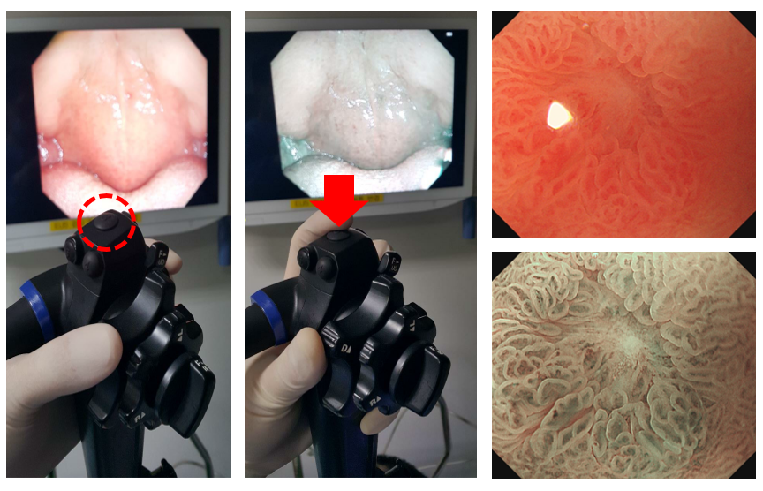
Figure 1 Narrow-band imaging system. When the button is pressed by the endoscopist, the endoscopy monitor changes from white-light imaging to narrow-band imaging (NBI) mode. Compared to the magnification mode without NBI (upper-right panel), NBI enables examination of the mucosal surface and microvessels around the erosion (lower-right panel).
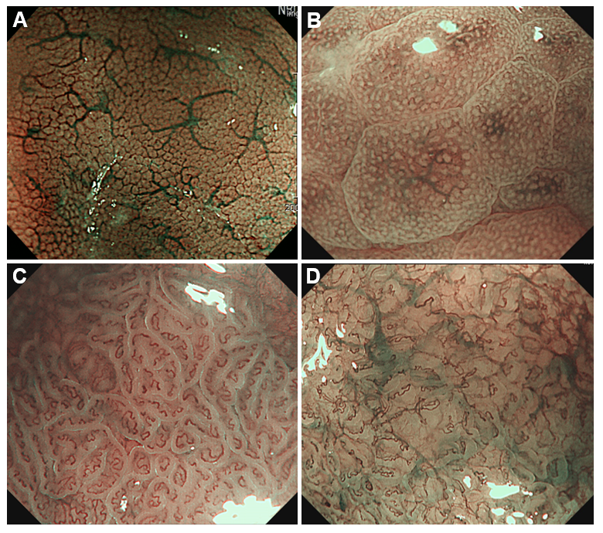
Figure 2 Magnifying narrow-band imaging endoscopy images of Helicobacter pylori-positive corpus mucosa and atrophic gastritis. A: Normal mucosal pattern showing a honeycomb-like subepithelial capillary network and regular arrangement of collecting venules; B: Helicobacter pylori-infected status presenting as polygonal swollen mucosa with dilated round crypt opening; C: Ridged surface structures encasing dilated coiled subepithelial capillaries indicate the presence of atrophic gastritis; D: Severe mucosal atrophy characterized by irregular coiled microvessels, loss of gastric pits, and greenish submucosal vessels.
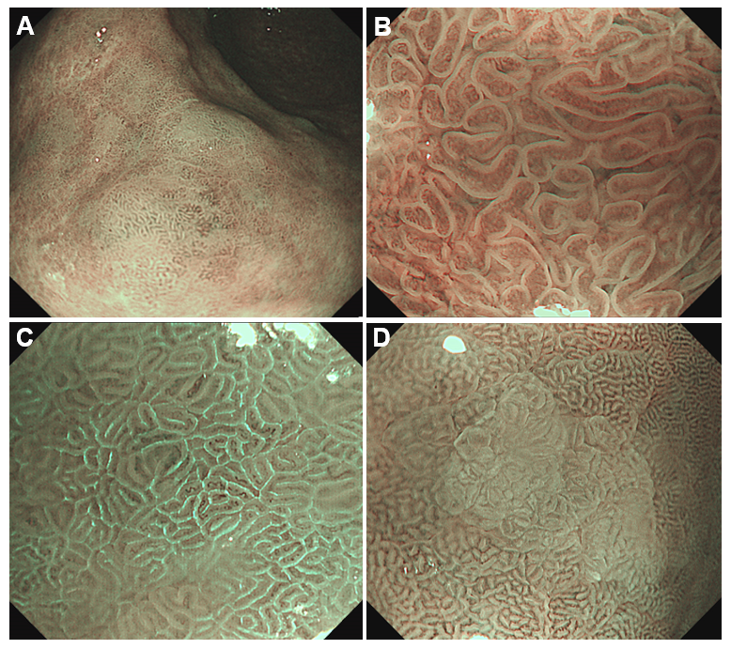
Figure 3 narrow-band imaging endoscopy images of intestinal metaplastic mucosa. A: Gastric mucosa covered with multiple whitish green-colored patches; B: Thick borders enclosing a tubulovillous mucosal pattern, the so-called marginal turbid band (MTB); C: Thin fluorescent lines along the MTB, the so-called light blue crest; D: White opaque substance obscuring the mucosa surface.
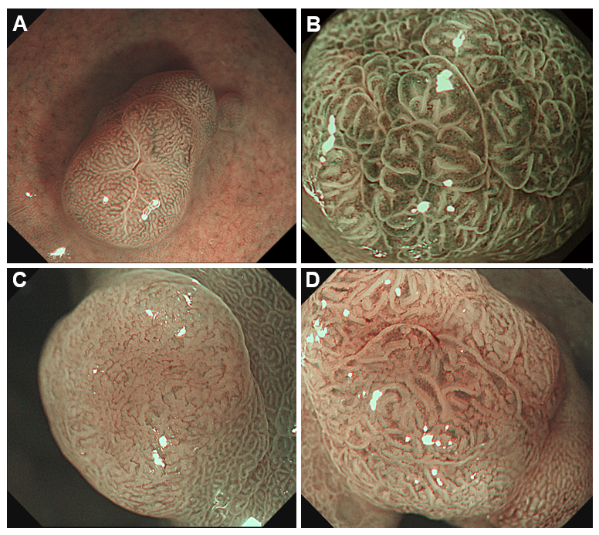
Figure 4 Magnifying narrow-band imaging findings of microvascular patterns for diagnosing the gastric polypoid lesions. A: Honeycomb-like pattern (fundic gland polyp); B: Dense vascular pattern (hyperplastic polyp); C: Fine network within a light brown area (low grade dysplasia); D: Core vascular pattern (low grade dysplasia).
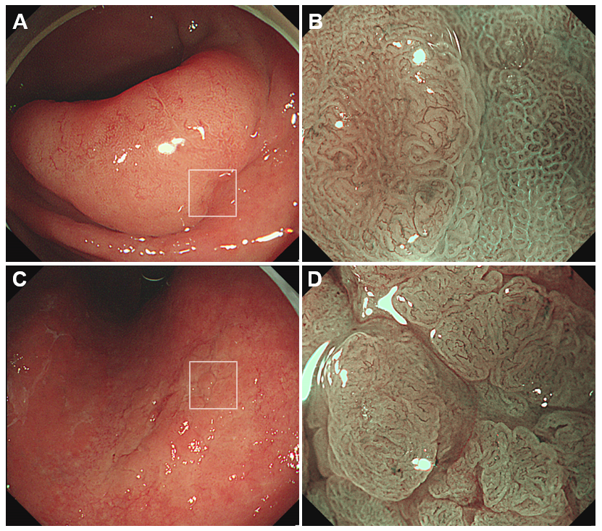
Figure 5 White-light endoscopy and magnifying narrow-band imaging images of high grade dysplasia. A: An elevated lesion (40 mm × 30 mm) at the gastric antrum; B: Brownish area showing an irregular mucosal surface and a microvascular pattern (left side), indicating a high grade dysplasia. The demarcation line is evident between the dysplasia and background mucosa with intestinal metaplasia (also see white box in A); C: A slightly elevated lesion (35 mm × 20 mm) at the lesser curvature of the gastric corpus; D: The microvessels within irregular, nodular lesion show tortuosity and variation in shape. This magnifying narrow-band imaging endoscopic finding indicates high grade dysplasia (also see white box in C).
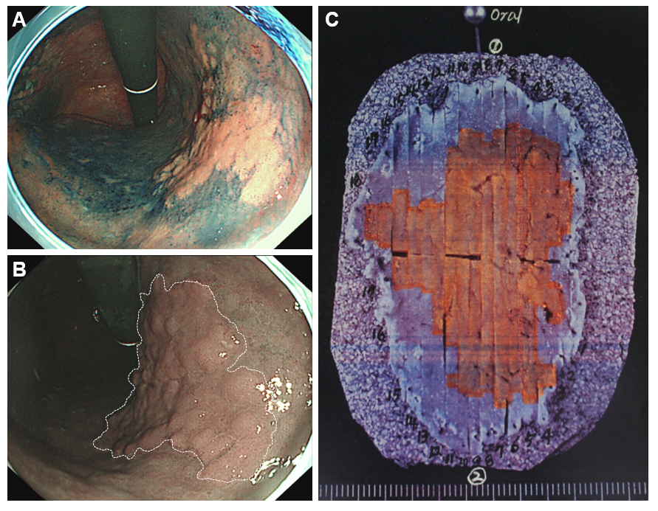
Figure 6 Narrow-band imaging endoscopy for determining the horizontal margin of gastric dysplasia before endoscopic submucosal dissection. A: Conventional chromoendoscopy using indigo carmine is useful for determining the horizontal margin of gastric neoplasia. However, this procedure requires a dye solution and is time-consuming; B: When the endoscopist presses the button, narrow-band imaging (NBI) endoscopy can be easily performed as a virtual chromoendoscopy. The tumor margin is evident between the large brownish lesion and greenish background mucosa (dotted white line); C: An en bloc-resected specimen by endoscopic submucosal dissection. The orange-colored area indicates a tubulovillous adenoma of 46 mm × 36 mm size, corresponding to the tumor extent determined by NBI endoscopy.
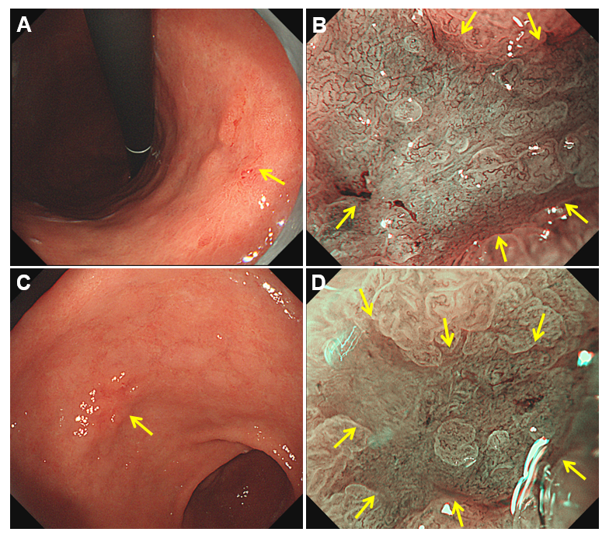
Figure 7 Magnifying narrow-band imaging endoscopic findings of early gastric cancers. A: Conventional white-light endoscopy shows a slightly elevated and depressed lesion at the gastric corpus; B: Magnifying narrow-band imaging (NBI) endoscopy demonstrates an irregular microvascular and microsurface pattern with a demarcation line (yellow arrows); C: Conventional white-light endoscopy shows a reddish depressed lesion at the gastric antrum; D: By magnifying NBI endoscopy, an irregular microsurface pattern is identified within the demarcation line (yellow arrows).
Table 1 Endoscopic criteria using narrow-band imaging for diagnosis of gastric intestinal metaplasia
Ref. | Year | Endoscopy mode | Diagnostic criteria | Concordance with histopathology
 |  |  |  | Sensitivity | Specificity | Accuracy
Pimentel-Nunes et al^{[37]} | 2012 | NBI | Regular tubulovillous/ridge glandular pattern | 90% | 81% | 84%
Saka et al^{[36]} | 2015 | M-NBI | Tubular/granular mucosa with LBC or WOS | N/A | N/A | 69.1-72.7%¹
Pimentel-Nunes et al^{[39]} | 2016 | NBI | Regular tubulovillous/ridge glandular pattern | 87% | 97% | 94%
Buxbaum et al^{[41]} | 2017 | NBI | Tubulovillous/ridge pattern and/or LBC | N/A | N/A | 53-65%²
Esposito et al^{[40]} | 2019 | NBI | Regular tubulovillous/ridge glandular pattern | 89.4% | 94.6% | N/A
An et al^{[34]} | 2012 | M-NBI | MTB and/or LBC | 72.1-100%³ | 66.0-96.0%³ | 81.7-84.9%³
Savarino et al^{[33]} | 2013 | M-NBI | LBC | 80% | 96% | 93%
Kanemitsu et al^{[35]} | 2017 | M-NBI | WOS and/or LBC | 87.5% | 93.8% | 90.0%
¹Concordance rate between the M-NBI and histopathology was 69.1% for the antrum and 72.7% for the corpus. ²Diagnostic yield per-patient and per-site was 65% and 53%, respectively. ³MTB and LBC had sensitivities, specificities, and accuracy of 100/72.1%, 66.0/96.0%, and 81.7/84.9%, respectively. NBI: Narrow-band imaging; M-NBI: magnifying narrow-band imaging; LBC: light blue crest; WOS: white opaque substance; MTB: marginal turbid band; N/A: not applicable.
Table 2 Diagnostic performance of narrow-band imaging with magnification for early gastric cancer
Ref. | Year | Endoscopic criteria of NBI with magnification | NBI with magnification (vs white light imaging)
 |  |  | Sensitivity | Specificity | Accuracy
Yao et al^{[52]} | 2007 | Irregular microvascular pattern | 92.9% | 99.3% | 98.7%
Ezoe et al^{[53]} | 2010 | Demarcation line | 70.0% (33.3%¹) | 88.8% (66.6%¹) | 78.9% (43.8%¹)
 |  | Irregular microvascular pattern
Kato et al^{[58]} | 2010 | Disappearance of fine mucosal structure | 92.9% (42.9%) | 94.7% (61.0%) | N/A
 |  | Microvascular dilation
 |  | Microvascular heterogeneity in shape
Yamada et al^{[54]} | 2014 | Demarcation line | 95% (40%²) | 97% (68%²) | 97% (65%²)
 |  | Irregular microvascular pattern
Yao et al^{[56]} | 2014 | VS classification | 85.7% | 99.4% | 98.1%
Fugiwara et al^{[57]} | 2015 | VS classification | 78.0% (43.7%³) | 92.9% (81.6%³) | 88.3% (69.9%³)
Kanesaka et al^{[59]} | 2015 | Microvascular dilation | 25% | 90% | 83%
 |  | Microvascular tortuosity | 55% | 24% | 28%
 |  | Difference in caliber | 13% | 99% | 89%
 |  | Variation in shape | 70% | 95% | 92%
¹Diagnostic sensitivity, specificity, and accuracy using white-light endoscopy with magnification. ²Endoscopic criteria of white-light endoscopy for gastric cancer were an irregular margin and a spiny depressed area. ³Diagnostic sensitivity, specificity, and accuracy using chromoendoscopy with indigo carmine. NBI: Narrow-band imaging; VS: Vessel plus surface; N/A: not applicable.
Table 3 Determination of the horizontal extent of early gastric cancer by magnifying narrow-band imaging
Ref. | Study design | Lesion (n) | Pathology | Diagnostic accuracy | P value
Kiyotoki et al^{[61]} | Comparative study between CE and M-NBI | EGC (70), adenoma (13) | ESD | 77.8% vs 97.4% | 0.009
 | Marking dots were placed on the tumor margins
Nagahama et al^{[63]} | M-NBI for unclear margins by CE | EGC (350) | ESD | 81.1% → 94.8% | < 0.001
Uchita et al^{[64]} | Combination of CE and M-NBI | EGC (161) | ESD | 72.7% → 98.1% | < 0.001
Asada-Hirayama et al^{[62]} | Comparative study between CE and M-NBI | EGC (109) | ESD | 75.9% vs 89.4% | 0.007
 | Oral and anal tumor margins of the same lesion
Nagahama et al^{[66]} | Comparative study between CE and M-NBI | EGC (343) | Biopsy | 85.7% vs 88.0% | 0.63
 | Biopsies outside and inside the tumor margins
Horii et al^{[65]} | Non-comparative study using M-NBI only | EGC (330) | Biopsy, ESD | 96.7%-97.9% | N/A
CE: Chromoendoscopy; M-NBI: magnifying narrow-band imaging; EGC: early gastric cancer; ESD: endoscopic submucosal dissection; N/A: not applicable.

