Name of journal: World Journal of Hepatology
ESPS Manuscript NO: 16623
Columns: Editorial
Changing common sense: Anti-platelet/coagulation therapy against cirrhosis

Ikura Y et al. Anti-platelet/coagulation therapy against cirrhosis

Yoshihiro Ikura, Tatsuya Osuga

Yoshihiro Ikura, Department of Pathology, Takatsuki General Hospital, Takatsuki 569-1192, Japan

Tatsuya Osuga, Department of Gastroenterology, Takatsuki General Hospital, Takatsuki 569-1192, Japan

Author contributions: Ikura Y designed the concept and wrote the manuscript; Osuga T designed the concept, prepared the figures and checked the manuscript.

Conflict-of-interest: None.

Open-Access: This article is an open-access article which was selected by an in-house editor and fully peer-reviewed by external reviewers. It is distributed in accordance with the Creative Commons Attribution Non Commercial (CC BY-NC 4.0) license, which permits others to distribute, remix, adapt, build upon this work non-commercially, and license their derivative works on different terms, provided the original work is properly cited and the use is non-commercial. See: http://creativecommons.org/licenses/by-nc/4.0/

Correspondence to: Yoshihiro Ikura, MD, Department of Pathology, Takatsuki General Hospital, 1-3-13, Kosobecho, Takatsuki 569-1192, Japan. ikura@ajk.takatsuki-hp.or.jp

Telephone: +81-72-6813801
Fax: +81-72-6823834

Received: January 25, 2015
Peer-review started: January 27, 2015
First decision: March 20, 2015
Revised: March 29, 2015
Accepted: April 28, 2015
Article in press:
Published online:

Abstract
Until recently, anti-platelet/coagulation therapy had not been recommended for patients with cirrhosis. Although venous thrombosis is one of the representative complications of cirrhosis and ischemic disorders associated with atherosclerosis are not infrequent in cirrhotic patients, many clinicians have tended to hesitate to introduce anti-platelet/coagulation therapy to their patients. Undoubtedly, this is due to the increased risk of hemorrhagic diathesis in cirrhotic patients. However, accumulating evidence has revealed the benefits of anti-platelet/coagulation therapy for cirrhotic patients. In addition to the safety of the therapy carried out against cardiovascular diseases in cirrhotic patients, some clinical data have indicated its preventive effect on venous thrombosis. Moreover, the efficacy of anti-platelet/coagulation therapy against cirrhosis itself has been demonstrated both clinically and experimentally. The conceptual basis for application of anti-platelet/coagulation therapy against cirrhosis was constructed through two pathologic studies on intrahepatic thrombosis in cirrhotic livers. It may be better to use thrombopoietin-receptor agonists, which have been tested as a treatment for cirrhosis-related thrombocytopenia, in combination with anti-platelet drugs to reduce the risk of venous thrombosis. During the last decade, the World Journal of Gastroenterology, a sister journal of World Journal of Hepatology, has been one of the main platforms of active discussion of this theme.

Key words: Anti-platelet/coagulation therapy; Cirrhosis; Hemorrhagic diathesis; Thrombosis; Thrombocytopenia

© The Author(s) 2015. Published by Baishideng Publishing Group Inc. All rights reserved.

Core tip: Recognition concerning anti-platelet/coagulation therapy for cirrhotic patients has been changing from relative contraindication to recommendable. Administration of this type of drugs is expected to not only prevent cirrhosis-related thrombotic disorders but also slow down the progression of liver disease itself.

Ikura Y, Osuga T. Changing common sense: Anti-platelet/coagulation therapy against cirrhosis. World J Hepatol 2015; In press

PROLOGUE: CONTRAINDICATION?
Until recently, it was thought that a balance between the necessity and risks of anti-platelet/coagulation therapy for patients with cirrhosis had to be carefully considered. This therapy was believed to be rather a relative contraindication for cirrhotic patients. Even currently, no one can dispute that this therapy increases the risk of gastrointestinal bleeding in patients with advanced decompensated cirrhosis^{[1,2]}. In contrast, venous thrombosis is one of important complications of cirrhosis^{[1-7]}. In addition, cirrhotic patients who suffer from atherosclerotic cardiovascular and cerebrovascular diseases have been increasing in number with the prevalence of metabolic syndrome. As a result, a certain number of cirrhotic patients need anti-platelet/coagulation therapy. Many physicians seem to administer a minimum amount of anti-platelet/coagulation drugs to such cirrhotic patients very carefully but timidly.
The coagulation status of cirrhotic patients is certainly delicate and is placed on a very sensitive balance. Importantly, the balance easily leans towards coagulable as well as hemorrhagic^{[8-11]}.

DISCUSSIONS IN THE WORLD JOURNAL OF GASTROENTEROLOGY AND THE COAGULATION IN LIVER DISEASE STUDY GROUP
The accumulation of recent evidence through clinical observations and experimental investigations has been upsetting the hitherto common sense about anti-platelet/coagulation therapy for cirrhotic patients. Previous reports in this research field were mostly negative ones, which emphasized the risks and potential side effects of this therapy^{[12-14]}. In 2003, however, a revolutionary research paper by Shi et al^{[15]} published in the World Journal of Gastroenterology (WJG), a sister journal of the World Journal of Hepatology (WJH), reported the efficacy of heparin administration to cirrhotic patients. Thereafter, papers suggesting the safety and benefits of anti-platelet/coagulation therapy for cirrhotic patients have been published^{[6-8,16-30]}.
An international workshop of the Coagulation in Liver Disease Study Group (CLDSG) established by Professor Caldwell at the University of Virginia, has been promoting this movement. Since 2005, every other year this group has held a symposium with heated discussions to form a consensus for the best management of liver-related coagulation disorders^{[9,20,21]}. Their latest conclusion states that anti-platelet/coagulation therapy is applicable as a treatment and preventive tool for cirrhotic patients although sufficient prophylactic means against gastrointestinal bleeding are required.
After the article of Shi et al^{[15]}, WJG has steadily published further articles suggesting the benefits of this therapy^{[2,5-8,16,17,22,31,32]}. Some papers in WJG have discussed the efficacy of this therapy not only for thrombotic complications but also for the diseased liver itself^{[3,6,17]}. The journal and its contributors possessed amazing prospective insight; they were approximately 4 years ahead of analogous publications in other journals^{[18-20]}.

THE SOURCE OF THE IDEA
Undoubtedly, two papers written by Wanless et al^{[33,34]} and published in 1995 are the source of the present idea that anti-platelet/coagulation therapy may be beneficial for cirrhotic patients. They demonstrated both macroscopically and histologically the presence of intrahepatic thrombi in cirrhotic livers, and suggested that the thrombi potentially contribute to further liver damage (i.e., parenchymal extinction) and to the development and progression of portal hypertension. Subsequently, relevant data indicating abnormal intrahepatic platelet aggregation in cirrhotic patients have been published^{[20,35,36]}. These papers disclose a part of the mechanisms of cirrhosis-related thrombocytopenia, and prove the usefulness of anti-platelet/coagulation therapy for cirrhotic patients.

THROMBOPOIETIN RECEPTOR AGONISTS
As the latest subject in this research field, we refer to clinical trials of administration of thrombopoietin receptor agonists (eltrombopag and avatrombopag) to cirrhotic patients with thrombocytopenia^{[37-40]}. The aim of the interventional trials is to expand the indication of antiviral therapies and invasive procedures for cirrhotic patients^{[39,40]}. These agents obviously increase the circulating platelet count through direct stimulation of thrombopoiesis. Similar to splenectomy for cirrhotic patients, the theoretical background seems to be simple and to make sense. However, since the projects lacked enough insight into coagulation abnormalities of cirrhotic patients, many patients developed portal vein thrombosis^{[40]}. A member of the CLDSG immediately pointed out the significant risk of hypercoagulable complications introduced by non-selective administration of thrombopoietin receptor agonists^{[41]}. A similar discussion was presented in the recent issue of WJG^{[42]}.
Because the etiology of cirrhosis-related thrombocytopenia is quite diverse^{[32,36,43,44]}, forcible normalization of the platelet count targeting only one factor may be either ineffective or even risky. Our recent data^{[44]} suggest that at least three major factors, including decreased thrombopoiesis, hypersplenism and excessive platelet aggregation, contribute to the development of cirrhosis-related thrombocytopenia (Figure 1). Hence, normalization of the platelet count is thought to require a correct diagnosis of each patient’s background conditions leading to thrombocytopenia and strict selection of the appropriate method for each case. In some cases, a combination of multiple methods may lead to a favorable outcome (Figure 1). To construct such a combination therapy, anti-platelet/coagulation therapy is a key element, and needs an approval to the extended application against cirrhosis.

EPILOGUE: TO BE APPROVED AS AN ALTERNATIVE THERAPY
Because platelets are very small blood cells without nuclei and are hardly detected by an ordinary histological examination (Figure 2), their pathological significance in diseases other than vascular disorders has seldom been considered. They play an important role in many inflammatory disorders as a mediator of both inflammatory reactions and fibroproliferative reactions. If hepatologists can correctly understand the robust pathobiological faculties of platelets, a dramatic paradigm shift will be approaching. Anti-platelet/coagulation therapy is not a novel medical tool, and past clinical research suggested the ineffectiveness of this therapy for cirrhosis^{[45]}. However, it should be considered as one of the treatment options for cirrhosis again in this era in which antiviral therapies have sufficiently been developed.
We strongly hope and expect that WJH and its sister journal WJG will continue to be a discussion platform for and a witness of this changing common sense concerning anti-platelet/coagulation therapy against cirrhosis.

REFERENCES
1 Crawford JM. Vascular disorders of the liver. Clin Liver Dis 2010; 14: 635-650 [PMID: 21055687 DOI: 10.1016/j.cld.2010.08.002]
2 Ponziani FR, Zocco MA, Campanale C, Rinninella E, Tortora A, Di Maurizio L, Bombardieri G, De Cristofaro R, De Gaetano AM, Landolfi R, Gasbarrini A. Portal vein thrombosis: insight into physiopathology, diagnosis, and treatment. World J Gastroenterol 2010; 16: 143-155 [PMID: 20066733]
3 Janssen HL. Changing perspectives in portal vein thrombosis. Scand J Gastroenterol Suppl 2000; 232: 69-73 [PMID: 11232496]
4 Valla DC. Thrombosis and anticoagulation in liver disease. Hepatology 2008; 47: 1384-1393 [PMID: 18318436 DOI: 10.1002/hep.22192]
5 Nusrat S, Khan MS, Fazili J, Madhoun MF. Cirrhosis and its complications: evidence based treatment. World J Gastroenterol 2014; 20: 5442-5460 [PMID: 24833875 DOI: 10.3748/wjg.v20.i18.5442]
6 Ponziani FR, Zocco MA, Garcovich M, D'Aversa F, Roccarina D, Gasbarrini A. What we should know about portal vein thrombosis in cirrhotic patients: a changing perspective. World J Gastroenterol 2012; 18: 5014-5020 [PMID: 23049208 DOI: 10.3748/wjg.v18.i36.5014]
7 Aggarwal A, Puri K, Liangpunsakul S. Deep vein thrombosis and pulmonary embolism in cirrhotic patients: systematic review. World J Gastroenterol 2014; 20: 5737-5745 [PMID: 24914335 DOI: 10.3748/wjg.v20.i19.5737]
8 Senzolo M, Burra P, Cholongitas E, Burroughs AK. New insights into the coagulopathy of liver disease and liver transplantation. World J Gastroenterol 2006; 12: 7725-7736 [PMID: 17203512]
9 Caldwell SH, Hoffman M, Lisman T, Macik BG, Northup PG, Reddy KR, Tripodi A, Sanyal AJ. Coagulation disorders and hemostasis in liver disease: pathophysiology and critical assessment of current management. Hepatology 2006; 44: 1039-1046 [PMID: 17006940]
10 Tripodi A, Primignani M, Chantarangkul V, Dell'Era A, Clerici M, de Franchis R, Colombo M, Mannucci PM. An imbalance of pro- vs anti-coagulation factors in plasma from patients with cirrhosis. Gastroenterology 2009; 137: 2105-2111 [PMID: 19706293 DOI: 10.1053/j.gastro.2009.08.045]
11 Bianchini M, De Pietri L, Villa E. Coagulopathy in liver diseases: complication or therapy? Dig Dis 2014; 32: 609-614 [PMID: 25034295 DOI: 10.1159/000360514]
12 de Lédinghen V, Mannant PR, Foucher J, Perault MC, Barrioz T, Ingrand P, Vandel B, Silvain C, Beauchant M. Non-steroidal anti-inflammatory drugs and variceal bleeding: a case-control study. J Hepatol 1996; 24: 570-573 [PMID: 8773912]
13 De Lédinghen V, Heresbach D, Fourdan O, Bernard P, Liebaert-Bories MP, Nousbaum JB, Gourlaouen A, Becker MC, Ribard D, Ingrand P, Silvain C, Beauchant M. Anti-inflammatory drugs and variceal bleeding: a case-control study. Gut 1999; 44: 270-273 [PMID: 9895389]
14 Riley TR, Smith JP. Preventive care in chronic liver disease. J Gen Intern Med 1999; 14: 699-704 [PMID: 10571719]
15 Shi J, Hao JH, Ren WH, Zhu JR. Effects of heparin on liver fibrosis in patients with chronic hepatitis B. World J Gastroenterol 2003; 9: 1611-1614 [PMID: 12854176]
16 Maksan SM, Ryschich E, Ulger Z, Gebhard MM, Schmidt J. Disturbance of hepatic and intestinal microcirculation in experimental liver cirrhosis. World J Gastroenterol 2005; 11: 846-849 [PMID: 15682478]
17 Maksan SM, Ulger Z, Gebhard MM, Schmidt J. Impact of antithrombin III on hepatic and intestinal microcirculation in experimental liver cirrhosis and bowel inflammation: an in vivo analysis. World J Gastroenterol 2005; 11: 4997-5001 [PMID: 16124052]
18 Assy N, Hussein O, Khalil A, Luder A, Szvalb S, Paizi M, Spira G. The beneficial effect of aspirin and enoxaparin on fibrosis progression and regenerative activity in a rat model of cirrhosis. Dig Dis Sci 2007; 52: 1187-1193 [PMID: 17372820]
19 Anstee QM, Goldin RD, Wright M, Martinelli A, Cox R, Thursz MR. Coagulation status modulates murine hepatic fibrogenesis: implications for the development of novel therapies. J Thromb Haemost 2008; 6: 1336-1343 [PMID: 18485088 DOI: 10.1111/j.1538-7836.2008.03015.x]
20 Northup PG, Sundaram V, Fallon MB, Reddy KR, Balogun RA, Sanyal AJ, Anstee QM, Hoffman MR, Ikura Y, Caldwell SH. Hypercoagulation and thrombophilia in liver disease. J Thromb Haemost 2008; 6: 2-9 [PMID: 17892532]
21 Lisman T, Caldwell SH, Burroughs AK, Northup PG, Senzolo M, Stravitz RT, Tripodi A, Trotter JF, Valla DC, Porte RJ. Hemostasis and thrombosis in patients with liver disease: the ups and downs. J Hepatol 2010; 53: 362-371 [PMID: 20546962 DOI: 10.1016/j.jhep.2010.01.042]
22 Lai W, Lu SC, Li GY, Li CY, Wu JS, Guo QL, Wang ML, Li N. Anticoagulation therapy prevents portal-splenic vein thrombosis after splenectomy with gastroesophageal devascularization. World J Gastroenterol 2012; 18: 3443-3450 [PMID: 22807615 DOI: 10.3748/wjg.v18.i26.3443]
23 Villa E, Cammà C, Marietta M, Luongo M, Critelli R, Colopi S, Tata C, Zecchini R, Gitto S, Petta S, Lei B, Bernabucci V, Vukotic R, De Maria N, Schepis F, Karampatou A, Caporali C, Simoni L, Del Buono M, Zambotto B, Turola E, Fornaciari G, Schianchi S, Ferrari A, Valla D. Enoxaparin prevents portal vein thrombosis and liver decompensation in patients with advanced cirrhosis. Gastroenterology 2012; 143: 1253-60.e1-4 [PMID: 22819864 DOI: 10.1053/j.gastro.2012.07.018]
24 Delgado MG, Seijo S, Yepes I, Achécar L, Catalina MV, García-Criado A, Abraldes JG, de la Peña J, Bañares R, Albillos A, Bosch J, García-Pagán JC. Efficacy and safety of anticoagulation on patients with cirrhosis and portal vein thrombosis. Clin Gastroenterol Hepatol 2012; 10: 776-783 [PMID: 22289875 DOI: 10.1016/j.cgh.2012.01.012]
25 Russo MW, Pierson J, Narang T, Montegudo A, Eskind L, Gulati S. Coronary artery stents and antiplatelet therapy in patients with cirrhosis. J Clin Gastroenterol 2012; 46: 339-344 [PMID: 22105182 DOI: 10.1097/MCG.0b013e3182371258]
26 Lisman T, Kamphuisen PW, Northup PG, Porte RJ. Established and new-generation antithrombotic drugs in patients with cirrhosis - possibilities and caveats. J Hepatol 2013; 59: 358-366 [PMID: 23548197 DOI: 10.1016/j.jhep.2013.03.027]
27 Sitia G, Iannacone M, Guidotti LG. Anti-platelet therapy in the prevention of hepatitis B virus-associated hepatocellular carcinoma. J Hepatol 2013; 59: 1135-1138 [PMID: 23742914 DOI: 10.1016/j.jhep.2013.05.040]
28 Lisman T. Platelets and fibrin in progression of liver disease: friends or foes? J Thromb Haemost 2015; 13: 54-56 [PMID: 25393399 DOI: 10.1111/jth.12783]
29 Martinez M, Tandra A, Vuppalanchi R. Treatment of acute portal vein thrombosis by nontraditional anticoagulation. Hepatology 2014; 60: 425-426 [PMID: 24395623 DOI: 10.1002/hep.26998]
30 Poujol-Robert A, Boëlle PY, Conti F, Durand F, Duvoux C, Wendum D, Paradis V, Mackiewicz V, Chazouillères O, Corpechot C, Poupon R. aspirin may reduce liver fibrosis progression: Evidence from a multicenter retrospective study of recurrent hepatitis C after liver transplantation. Clin Res Hepatol Gastroenterol 2014; 38: 570-576 [PMID: 25130796 DOI: 10.1016/j.clinre.2014.07.004]
31 He XF, Wen ZB, Liu MJ, Zhang H, Li Q, He SL. Levels of plasma des-gamma-carboxy protein C and prothrombin in patients with liver diseases. World J Gastroenterol 2004; 10: 3073-3075 [PMID: 15378798]
32 Panasiuk A, Zak J, Kasprzycka E, Janicka K, Prokopowicz D. Blood platelet and monocyte activations and relation to stages of liver cirrhosis. World J Gastroenterol 2005; 11: 2754-2758 [PMID: 15884116]
33 Wanless IR, Liu JJ, Butany J. Role of thrombosis in the pathogenesis of congestive hepatic fibrosis (cardiac cirrhosis). Hepatology 1995; 21: 1232-1237 [PMID: 7737628]
34 Wanless IR, Wong F, Blendis LM, Greig P, Heathcote EJ, Levy G. Hepatic and portal vein thrombosis in cirrhosis: possible role in development of parenchymal extinction and portal hypertension. Hepatology 1995; 21: 1238-1247 [PMID: 7737629]
35 Ikura Y, Nakamichi T, Matsumoto S, Wada S, Tachibana M, Iwasa Y, Naruko T, Caldwell SH, Ueda M. Hepatic aggregation of activated platelets contributes to the development of thrombocytopenia in cirrhosis. Hepatology 2010; 52: 895A
36 Kondo R, Yano H, Nakashima O, Tanikawa K, Nomura Y, Kage M. Accumulation of platelets in the liver may be an important contributory factor to thrombocytopenia and liver fibrosis in chronic hepatitis C. J Gastroenterol 2013; 48: 526-534 [PMID: 22911171 DOI: 10.1007/s00535-012-0656-2]
37 McHutchison JG, Dusheiko G, Shiffman ML, Rodriguez-Torres M, Sigal S, Bourliere M, Berg T, Gordon SC, Campbell FM, Theodore D, Blackman N, Jenkins J, Afdhal NH. Eltrombopag for thrombocytopenia in patients with cirrhosis associated with hepatitis C. N Engl J Med 2007; 357: 2227-2236 [PMID: 18046027]
38 Terrault NA, Hassanein T, Howell CD, Joshi S, Lake J, Sher L, Vargas H, McIntosh J, Tang S, Jenkins TM. Phase II study of avatrombopag in thrombocytopenic patients with cirrhosis undergoing an elective procedure. J Hepatol 2014; 61: 1253-1259 [PMID: 25048952 DOI: 10.1016/j.jhep.2014.07.007]
39 Afdhal NH, Dusheiko GM, Giannini EG, Chen PJ, Han KH, Mohsin A, Rodriguez-Torres M, Rugina S, Bakulin I, Lawitz E, Shiffman ML, Tayyab GU, Poordad F, Kamel YM, Brainsky A, Geib J, Vasey SY, Patwardhan R, Campbell FM, Theodore D. Eltrombopag increases platelet numbers in thrombocytopenic patients with HCV infection and cirrhosis, allowing for effective antiviral therapy. Gastroenterology 2014; 146: 442-52.e1 [PMID: 24126097 DOI: 10.1053/j.gastro.2013.10.012]
40 Afdhal NH, Giannini EG, Tayyab G, Mohsin A, Lee JW, Andriulli A, Jeffers L, McHutchison J, Chen PJ, Han KH, Campbell F, Hyde D, Brainsky A, Theodore D. Eltrombopag before procedures in patients with cirrhosis and thrombocytopenia. N Engl J Med 2012; 367: 716-724 [PMID: 22913681 DOI: 10.1056/NEJMoa1110709]
41 Lisman T, Porte RJ. Eltrombopag before procedures in patients with cirrhosis and thrombocytopenia. N Engl J Med 2012; 367: 2055-2056 [PMID: 23171114 DOI: 10.1056/NEJMc1211471#SA1]
42 Mihăilă RG, Cipăian RC. Eltrombopag in chronic hepatitis C. World J Gastroenterol 2014; 20: 12517-12521 [PMID: 25253952 DOI: 10.3748/wjg.v20.i35.12517]
43 Pradella P, Bonetto S, Turchetto S, Uxa L, Comar C, Zorat F, De Angelis V, Pozzato G. Platelet production and destruction in liver cirrhosis. J Hepatol 2011; 54: 894-900 [PMID: 21145808 DOI: 10.1016/j.jhep.2010.08.018]
44 Ikura Y, Ohsawa M, Okada M, Iwai Y, Wakasa K. The significance of platelet consumption in the development of thrombocytopenia in patients with cirrhosis. Am J Med Sci 2013; 346: 199-203 [PMID: 23979210 DOI: 10.1097/MAJ.0b013e31826e364d]
45 Luzzatto G, Fabris F, Gerunda GE, Zangrandi F, Girolami A. Failure of two anti-platelet drugs (indobufen and dipyridamole) to improve thrombocytopenia in liver cirrhosis. Acta Haematol 1987; 77: 101-106 [PMID: 2955629]

P-Reviewer: Li YM S-Editor: Ji FF L-Editor: E-Editor:
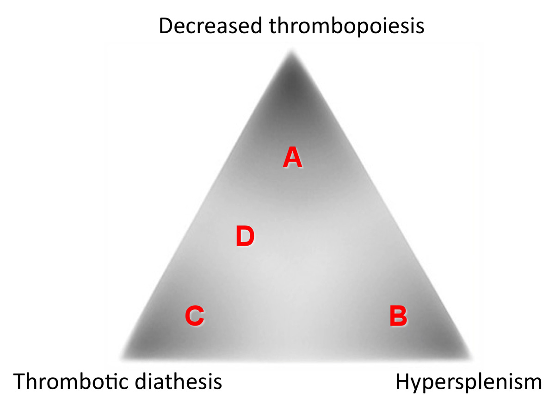

Figure 1 Theoretically ideal therapies against cirrhosis-related thrombocytopenia depending on the etiology. The platelet count in cirrhotics is determined mainly by three major factors, including (A) a rate of thrombopoiesis, (B) the presence/abscence of hypersplenism, and (C) the presence/abscence of thrombotic diathesis, which differently affect each case. Patients with thrombocytopenic conditions A, B, or C are considered to respond well to thrombopoietin receptor agonists, splenectomy, and anti-platelet/coagulation drugs, respectively. In patients with condition D, a combination of thrombopoietin receptor agonists and anti-platelet/coagulation drugs is thought to be necessary.

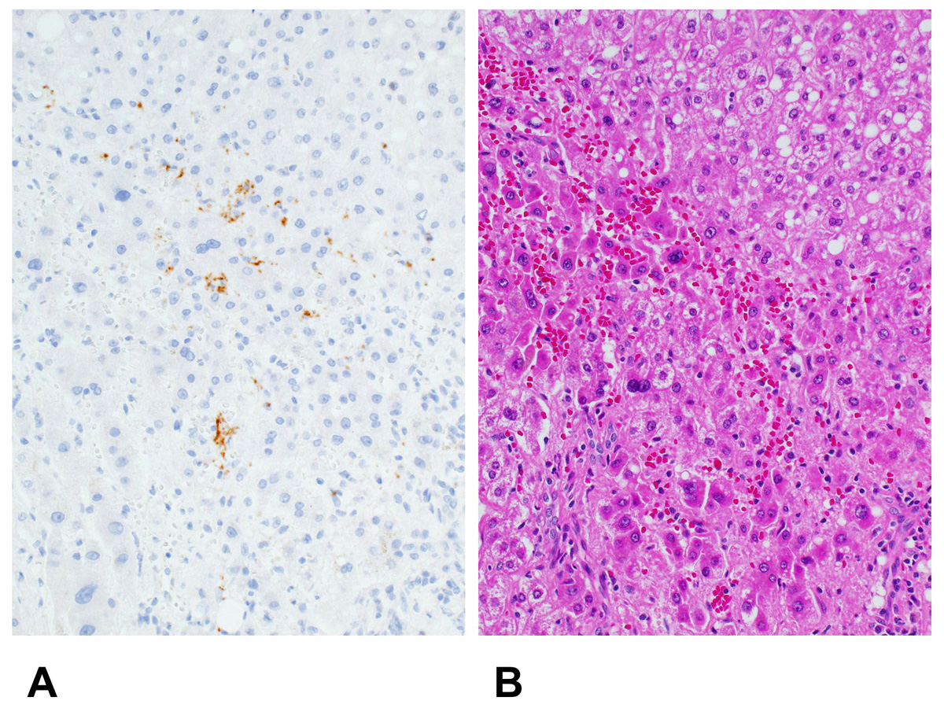

Figure 2 Platelet aggregation in a cirrhotic liver. A: Immunohistochemical findings. Platelets are stained in brown. (Immunoperoxidase for CD41; original magnification, × 400); B: The corresponding histological findings. Platelets cannot be identified in this photomicrograph. (Hematoxylin-eosin; original magnification, × 400).

