Name of Journal: World Journal of Gastrointestinal Endoscopy
Manuscript NO: 39566
Manuscript Type: REVIEW

Introduction of endoscopic submucosal dissection in the West

Friedel D et al. Introduction of ESD in the West

David Friedel, Stavros Nicholas Stavropoulos

David Friedel, Stavros Nicholas Stavropoulos, Gastroenterology, NYU Winthrop Hospital, Mineola, NY 11501, United States

ORCID number: David Friedel (0000-0001-8051-7410); Stavros Nicholas Stavropoulos (0000-0003-1410-2684).

Author contributions: Stavropoulos SN is the source of material for this manuscript; Friedel D formulated it into this manuscript.

Conflict-of-interest statement: Dr. Friedel and Dr. Stavropoulos have nothing to disclose.

Open-Access: This article is an open-access article which was selected by an in-house editor and fully peer-reviewed by external reviewers. It is distributed in accordance with the Creative Commons Attribution Non Commercial (CC BY-NC 4.0) license, which permits others to distribute, remix, adapt, build upon this work non-commercially, and license their derivative works on different terms, provided the original work is properly cited and the use is non-commercial. See: http://creativecommons.org/licenses/by-nc/4.0/

Manuscript source: Invited manuscript

Correspondence to: David Friedel, MD, Associate Professor, Gastroenterology, NYU Winthrop Hospital, 222 Station Plaza North, Suite 428, Mineola, NY 11501, United States. dfriedel@winthrop.org
Telephone: +1-516-6634623
Fax: +1-516-6634617

Received: April 27, 2018
Peer-review started: April 27, 2018
First decision: May 16, 2018
Revised: July 21, 2018
Accepted: August 1, 2018
Article in press:
Published online:

Abstract
Endoscopic submucosal dissection (ESD) is well established in Asia as a modality for selected advanced lesions of both the upper and lower gastrointestinal tract, but ESD has not attained the same niche in the West due to a variety of reasons. These include competition from traditional surgery, minimally invasive surgery and endoscopic mucosal resection. Other obstacles to ESD introduction in the West include time commitment for learning and doing procedures, a steep learning curve, special equipment, lack of mentors, cost issues, interdisciplinary conflicts, concern regarding complications and lack of support from institutions and interfacing departments. There are intrinsic differences in pathology prevalence (e.g., early gastric cancer) between the two regions that are less conducive for ESD implementation in the West. We will elaborate on these issues and suggest measures as well as a protocol to overcome these obstacles and hopefully allow introduction of ESD as a tenable option for appropriate patients.

Key words: Endoscopic submucosal dissection; Barrett’s esophagus; Gastric cancer; Colon cancer; Rectal cancer; Endoscopy training

© The Author(s) 2018. Published by Baishideng Publishing Group Inc. All rights reserved.

Core tip: Endoscopic submucosal dissection (ESD) is a well-accepted and widely employed modality in Asia for resection of advanced mucosa-derived lesions of the gastrointestinal tract including early cancer However ESD is not widely utilized in the West for a variety of reasons including lack of mentors, steep learning curve, cost issues and concern for complications. The authors describe these obstacles to the implementation of ESD in the West and measures to overcome them and begin an ESD program. We give a Western perspective on the current status of ESD for lesions of the esophagus, stomach and colorectum.

Friedel D, Stavropoulos SN. Introduction of endoscopic submucosal dissection in the West. World J Gastrointest Endosc 2018; In press

INTRODUCTION
Endoscopic submucosal dissection (ESD) has enabled resection of larger and more histologically advanced epithelial - based lesions including early cancer of the upper and lower gastrointestinal tract as well as a broad array of submucosal lesions, that previously had necessitated surgical removal. ESD allows en-bloc resection with precise pathological staging and potential cure. It was invented in Japan where now it is well-established and subsequently permeated into the other East Asian areas^{[1]}. ESD has been slow to be adopted in the West, and its penetration in the United States is especially poor. This disparity regarding ESD availability and implementation respectively in the East and West has had extensive examination with perspective from both areas^{[2,3]}. However, ESD may have finally arrived in the West as it is now critically reviewed in mainstay American gastroenterology journals^{[4,5]}.
ESD is a minimally invasive endoscopic/surgical procedure technique for curative resection of advanced lesions including early gastrointestinal (GI) cancer. If curative, it can obviate surgery (laparoscopic or open) that otherwise would be needed for resection. This essence of the value of ESD is less obvious when comparisons are made to EMR rather than to surgery. The value of ESD is more enhanced when early GI cancer is readily identified at endoscopy. This is arguably done better in the East (especially Japan) where the endoscopist is more apt to spend more time examining the entire gastric mucosal surface, employ magnification, chromoendoscopy and light filtering technique such as NBI and generally better appreciate the appearance of early GI cancer. The accepted classification systems for early GI cancer emanate predominantly from the East. There are mass screening programs for gastric cancer in Japan (not in the West) with both the endoscopist and pathologist vigilant for EGC.
The ESGE consensus guidelines on the role of ESD in the resection of more common mucosal - derived lesions of the GI tract reflect a relatively limited niche^{[6]}. This panel concluded that most rectal and colonic superficial lesions can be effectively removed with traditional snare polypectomy and/or endoscopic mucosal resection (EMR). ESD is considered for colorectal lesions with a significant suspicion of limited submucosal invasion based on an irregular (non-granular) surface or depressed morphology that are not amenable to snare removal. EMR is the preferred approach for removal for Barrett’s lesions with curative intent in that ESD has not been demonstrated to be superior. ESD, however, may be considered for Barrett’s lesions larger than 15 mm, poorly lifting lesions and lesions with a concern for submucosal invasion. The panel did recommend ESD to achieve endoscopic en-bloc resection of superficial esophageal squamous cell cancers with the exclusion of those with obvious submucosal invasion. EMR may be considered for SCC’s < 10 mm. ESD, though, was acknowledged as the first option to provide complete resection and accurate pathological staging. Also, ESD was recommended as the treatment of choice for most gastric superficial lesions. EMR may be an acceptable option for lesions < 10-15 mm and low probability of advanced pathology (Paris 0-IIA)^{[6]}. Thus ESD is the accepted standard for early gastric cancer (EGC) if tumor size < 2 cm, intramucosal, intestinal gastric cancer histology and no ulceration.

BARRETT’S ESOPHAGUS AND CANCER
The 2015 ESGE guidelines favor EMR over ESD for Barrett’s esophagus and early cancer except for larger and more advanced lesions^{[6]}. The two modalities were comparable in terms of recurrence and complication rate with ESD more time consuming^{[7]} (Table 1). In a small randomized controlled trial (20 subjects each group) comparing ESD to EMR for Barrett’s high-grade dysplasia or early cancer (< 3 cm), the two groups were comparable again in terms of remission, occurrence and need for surgery^{[8]}. Complete resection was five times more likely in the ESD group, though the two severe adverse events was seen in the ESD group as well. Their compilation of ESD data reflects success with en-bloc resection though some series had significant complication rate (Table 2). Some ESD groups had no strictures but others had a stricture rate up to 50%^{[9-11]}! More recent comparative studies and commentary reinforced the feasibility and safety of ESD in the West for BE and EAC with better R0 resection rates than EMR and the de facto choice for larger (> 3 cm), nodular, scarred and ulcerated lesions^{[12-14]}.
The Western centers foray into ESD for early esophageal cancer reflects mixed results and a fairly steep learning curve. A multicenter ESD study with resection of HGD or EAC had a R0 resection, curative and stricture rate of 76%, 70% and 15%^{[12]}. Our center’s resection experience with resection of cancer (EAC and SCC) and HGD yielded an en-bloc, R0, curative and stricture rate of 98%, 83%, 74% and 10% respectively (Figure 1). There was a significant decrease in procedure time with experience^{[15]}.
ESD in the esophagogastric junction is technically difficult and should be restricted only to higher volume specialized centers. Barrett’s is less frequent in Japan where is more overall ESD expertise and this may hinder ESD in its comparison with EMR for BE resection results.

ESD
Early gastric cancer
Five pioneering Western ESD centers detailed their results for resection of gastric cancer^{[16-20]} (Table 3). En-bloc resection was obtained in over 80% of subjects with 64%-92% achieving cure. However, there was a 10%-20% complication rate with no mortality in 4/5 series and 3% mortality in one series.
The Japanese suggested expanded criteria for ESD in EGC to include larger lesions (> 3 cm), ulcerated lesions of smaller size (< 3 m), superficial submucosal lesions < 500 micrometers and possibly diffuse histology EGC if < 20 mm and consistent with absolute criteria above^{[21]} (Table 4). Long-term outcomes of patients with expanded criteria including larger lesions (> 3 cm), ulcerated lesions of smaller size (< 3 cm) have excellent reported results in a Japanese multi-center prospective study^{[22]}. However, enthusiasm in the West for ESD in EGC was tempered by a study demonstrating increased tendency for lymph node metastases in EGC for non-Asian subjects matched to Asian subjects with similar histopathological findings^{[23]}. A German study of EGC subjects having surgery demonstrated a lymph node metastases rate of 21%/16%/40% respectively for sm₁/sm₂/sm₃ tumor extension^{[24]}. Thus, there is debate among European medical societies about extrapolation of the Japanese expanded criteria to European subjects.
A more recent European study validated the success of ESD in EGC even with expanded criteria subjects as well showing improved technical performance with greater speed and better clinical results^{[25]} (Table 5). However, the racial/regional differences issue in EGC still somewhat lingers in that complete resection rates were less than most Asian studies and there was a 1% mortality compared to a negligible rate in Asia. There was a non-statistical superiority of survival of subjects with guideline entry criteria compared to those with expanded criteria but this appeared at 7 years with a 13.2% mortality with guideline criteria and 18.4% with expanded criteria (Figure 2).

Colorectal ESD
The predominance of colon polyps and cancer relative to early gastric cancer in the West would theoretically allow Western physicians to garner needed ESD experience, but unfortunately, Western societal guidelines and thought leaders are not encouraging in this regard. As mentioned, the 2015 ESGE guidelines relegates ESD for colorectal lesions that are larger, likely more invasive or clearly not amenable to EMR^{[6]}. In the United States, Dr. Ginsburg stated: “ESD over EMR for the vast majority of colorectal neoplasms (i.e., adenomas) cannot be reconciled with the increased risk and procedure duration”^{[26]}. Dr Rex stated: “Colorectal ESD, and en-bloc resection in general, are powerful concepts that currently come with a high price tag for most American colonoscopists. However, we acknowledge that as with many evolving technologies, deciding whether to learn colorectal ESD is “gray” not “black and white”^{[27]}. Rex’s group calculated the NNT for ESD to obviate surgery is 7 which was characterized as “a lot of work” but arguably individual patients may disagree! Moreover, this calculation may be flawed in that they only consider lesions with superficial SM invasion. However, there are two other scenarios where ESD can spare patients from colectomy: Aborted EMR due to fibrosis/non-lifting/difficulty in snare positioning-approximately 5% in Moss^{[28]}) and intractable recurrences after EMR (approximately 2%) Including these scenarios, the NNT may be as low as approximately 5! A cogent argument favoring ESD over EMR is the high relative en-bloc resection and potential curative rates. A recent meta-analysis comparing the two modalities favored ESD with pooled odds ratio (OR) for en-bloc resection, cure and recurrence respectively of 6.8, 4.3 and 0.08 respectively^{[29]}. “Enhanced” EMR with cold snare and water immersion minimally lessened this relative disparity with the cold snare group showing 18% recurrence at 5 mo for lesion > 2 cm^{[30]} and the water immersion group had a 10% recurrence rate for these lesions at 6 mo^{[31]}.
Cost analysis comparisons of colon EMR vs ESD would favor the former in the short run because of longer procedure time and associated anesthesia as well as need for more expensive equipment with ESD, but ESD is more cost-effective in the long term because of its significantly better curative resection rate with less incumbent need for subsequent surveillance colonoscopy^{[32]}. Another group compared various strategies for sessile lesions and lateral spreading colorectal lesions > 2 cm including wide field EMR (WF-EMR), selective ESD (S-ESD) and universal ESD^{[33]} (Table 6). Selective ESD was performed when there was concern for submucosal invasion including lesions that were non-lifting, Paris 2C in appearance or with Kudo V pit pattern. S-ESD was preferred for all but rectal lesions. However, the study design favored EMR by including 18% rectal lesions, and in earlier work by the same group, there was 16% recurrence after EMR at 4 mo with an additional 4% new recurrences in those patients at 16 mo for a total of 20% cumulative recurrence by 16 mo^{[28]}. For ESD, recurrence rate in a meta-analysis of 104 colorectal ESD studies^{[34]}: 1% at 19 mo and 0.04% if R0 resection! In another meta-analysis^{[35]} comparing colon EMR vs ESD, recurrence was 0.9% for ESD.

Starting an ESD program
The Western ESD pioneers will likely have their R₀ resection rates and significant complications closely scrutinized by their gastroenterology colleagues, surgeons, tumor boards and administration (Table 7). Cost-effectiveness will be an ongoing debate at most institutions but, if curative resection and significant AE rate are satisfactory, one can effectively advocate for ESD by emphasizing the benefits having an ESD program (Table 8). Enhanced EMR methods such as circumferential mucosal incision (CMI) or circumferential submucosal incision (CSI) followed by snare removal have not shown R₀ or curative resection rates comparable to traditional ESD but can help build ESD skills^{[36,37]}. The performance of ESD is often a multi-hour endeavor and anesthesia, nursing and ancillary personnel should be aware of their roles. Ergonomic consideration should be given to both the operator and the patient-two deaths in a European study may have related to thrombosis^{[6,38,39]}. In addition, both the patient and pathology should be appropriately triaged (Table 7). Appropriate medical or other discipline clearance should be obtained beforehand. Endoscopic and pathologic data should be evaluated with caution. Concordance of biopsy and resected specimen pathologic diagnosis of gastric polyps > 5 mm is only 55%-77%^{[40,41]}. Concordance of biopsy and resected specimen pathologic diagnosis of colon polyps in one study was only 60%^{[42]}.
There are progressive phases or stages typically necessary for development of ESD skills. Initially, one acquires basic knowledge via texts, reviews and courses. Lesions should be properly assessed including use of enhanced imaging. Knowledge of electrosurgical generators and their appropriate settings for the various ESD stages as well as familiarity with the common electrosurgical knives. Overall, one should develop an understanding of ESD techniques, indications, limitations, risks and expected outcomes. Subsequently, training can be obtained in ex vivo animal models including pig esophagus/stomach and bovine rectum. Expenses may be possibly defrayed by industry support in anticipation of equipment necessary for an ESD program. Before embarking on ESD cases in humans, one should observe live ESD cases by experts; probably a minimum of 20 cases. Trainees can likely assist in ESD cases by their mentor experts. A trip to Japan with concentrated exposure and ideally hands-on experience can also be useful^{[43]}. These experts may also travel to regional meetings. Experts may also view a video of your technique with suggestions^{[44]}. The 2010 ESGE White Paper suggested performance of 30 ESDs reaching speed of 30 min/5 cm lesion in live animals as well as management of simulated complications such as bleeding and perforation prior to clinical ESD^{[45,46]}.
Once the operator begins to perform clinical ESD, there must be a sufficient volume of cases to maintain and improve techniques. This would be a minimum of two cases per month but preferably at least a case weekly^{[2,47]}. In the “step-up” approach of transitioning from clinical training to competence, one would do 20-30 supervised cases-optimally in the antrum or rectum where management of complications is easiest with a subsequent 20-30 cases in more challenging areas with the goal of achieving > 80% en-bloc resection and < 10% complications in 20 consecutive cases^{[45]}. The next phase is the transition from competence to proficiency-usually > 80 cases. This is mostly a result of self- training to attain proficiency with an en-bloc resection rate ≥ 90% and dissection speed ≥ 9 cm²/h. “Master classes” and/or additional observation of live cases by experts may help at this stage (refine skills and acquire more advanced tips and tricks). The next and last phase is mastery after hundreds of cases with a curative rate > 80% and teaching of other physicians. The difficulty of ESD varies by location with the proximal stomach, colon flexures and ileocecal valve/appendiceal areas and ESD in the small intestine including the duodenum reserved for true experts (Figures 3 and 4).

CHALLENEGES FOR WESTERN ESD OPERATOR
The Western ESD operator is at a distinct disadvantage compared to his Asian counterpart with the latter having widespread acceptance, existent infrastructure, choices of mentors and ample pathology. In the West, the relative paucity of early gastric cancer cases relative to colon and esophageal pathology is a particular challenge. As mentioned, the Western endoscopist may be less attuned to the appearance of EGC. There are about eight times more cases of gastric cancer in Japan than in the United States^{[48]}. SEER database analysis over a recent decade in the United States noted 43769 cases of gastric adenocarcinoma of which 1826 were early gastric cancer (EGC)-only 203 cases yearly^{[49]}! Absence of suitable lesions was the main perceived obstacle to ESD implementation in the West as per a survey of 40 ESD trainees at a conference^{[50]}. There are different approaches in the West to this obstacle of too few EGC cases. The “step-up” approach for “untutored learning” in the West recommends starting with UGI lesions where ESD is easier and most beneficial (resecting early cancers). But this approach is problematic for several reasons. UGI lesions are rare (unlike colon lesions) and would make it difficult to achieve the 2 lesions/mo requirement. An R1/Rx resection (a common error during ESD learning) is much more detrimental in the UGI tract than in the colon; especially if high risk colon lesions are avoided during learning. For UGI lesions (often carcinomas) patient would be subjected to highly morbid surgery (esophagectomy/gastrectomy) whereas for colon adenomas/HGIEN careful follow-up/further endoscopic treatment is sufficient for most R1 resections^{[51]}.
Another approach to the relative paucity of early gastric cancer in the West for the ESD operator is to have a prevalence based or ad hoc strategy^{[51]}. Berr described this relatively untutored ad hoc strategy where 80% of his first 50 cases were in the colorectum, and he clearly documented improved rates of en-blo and R₀ resection as well as a lower perforation rate and increased speed of dissection with increasing experience^{[51]}. A South Korean study of colorectal ESD without prior gastric ESD experience noted the same positive trends as the Berr group with more cases and the performance > 100 ESDs, rectal ESD and lack of submucosal fibrosis were independent predictors of success^{[52]}. Competence was defined as 80% en-bloc resection rate AND statistically significant decrease in operative time^{[53]}. An Italian endoscopist with prior EMR experience did not transition to colon ESD until ESD competence was demonstrated in the rectum^{[54]}. All lesions were > 2 cm, and again increased en-bloc resection rates were noted with increased experience as well as decreased operative time, but defined competence was noted after only five cases in the rectum but required 20 cases in the colon^{[54]}.

NYU Winthrop ESD experience
The NYU Winthrop ESD experience was also untutored with gradual progression of skills (Figure 5). There was progression from ESD to natural orifice transluminal endoscopic surgery (NOTES) including POEM, submucosal tunnel endoscopic resection (STER) and endoscopic full-thickness resection (EFTR)^{[55]}. The initial four year experience reflected the learning curve with 53% and 75% en-bloc resection rates respectively for early mucosal neoplasms and submucosal tumors^{[56]} (Table 9). We studied the relative utility of various electrosurgical devices during this period^{[57]}. We have performed over 500 ESD’s with progressively faster dissection rate and presently an en-bloc resection > 90% (Figure 6). We have resected early mucosal neoplasms and submucosal lesions from the esophagus, stomach, duodenum and colorectum as well as ileocecal valve polyps that extended into the ileum^{[55,56]}.

ESD complications
The significant adverse events of hemorrhage and perforation are more common in ESD then with EMR, and a major concern for the fledgling ESD operator, though, as mentioned, the complication rate diminishes usually with experience and likely is better managed by the more seasoned operator^{[46,50]}. The ESD resection bed should be copiously irrigated to assess for vessels that may cause subsequent post - resection bleeding. The main complications (perforation and bleeding) can almost always be managed (or even prevented in the case of bleeding) by skillful application of clips and coagulation Experience with endoscopic clip placement and coagulation grasper application is essential (experience with endoscopic suturing is highly desirable) (Table 7). There is controversy as to the necessity of closing the ESD post-resection defect. Proponents of closure cite less delayed bleeding and perforation as well as earlier discharge with associated decreased cost, but the data is limited to date^{[58]}. Opponents argue that closure may complicate subsequent surveillance or further resection at the ESD site by creating artificial nodules or other “lesions” and/or burying residual neoplastic tissue and questionable cost-effectiveness^{[59]}. Use of an omental patch may help in perforation closure either with clips or endoscopic sutures. Berr noted the relatively low rate of colonic ESD complications in early operators reported in the Japanese literature (< 12.5%) may not extrapolate to the Western experience^{[51]}. The Japanese trainees were tutored by experts and reportedly completed less than half of their initial procedures. A more “real-life “elaboration of the initial ESD French experience noted 11% and 18% hemorrhage and perforation rate respectively with en-bloc and R₀ resection rates of 77%/73% respectively^{[60]}. Berr^{[51]} had suggestions for the “colon heavy-untutored/prevalence based” ESD learners based on his retrospective video analysis of his own work including avoiding: (1) wide SM injection around the lesion (which forces a “perpendicular” instead of “tangential approach”); (2) injection deep to muscle layer (lack of submucosal fluid cushion); (3) disruption of vessels leading to hematoma and loss of transparency of submucosa; (4) dissection without direct vision of the tip of the knife; (5) contact coagulation of small vessel directly on colonic proper muscle layer; and (6) mucosal incision using knife in “pullback fashion” across a haustral fold^{[51]}.
Another peril of over-extrapolating ESD results from Japan to the West concerns pathology. One should be cautious concerning extended Japanese indications for gastric ESD (particularly SM1 invasion) (Table 4). The local pathologist may not be as accurate and experienced as expert Japanese pathologists (all SM1 invasion is not created equal (extensive vs focal, tumor budding, etc.) As reviewed, some surgical studies purport to show that early gastric cancer in the West may behave more aggressively^{[23,24]}. One must discuss risk of metastatic cancer (even after “curative ESD”) and metachronous cancers and need for surveillance as even intramucosal carcinoma has a low but not negligible rate of metastasis (e.g., 1%-2% for Barrett’s intramucosal carcinoma or HGD^{[61]}). The recurrence rate of T1b carcinoma in the rectum (4.2%-4.5%) is higher than in the colon (1.5%-1.9%)^{[4-6]}. Follow-up colonoscopy as well as periodic CEA, abdominal ultrasonography, and thoracic and abdominal CT should be performed. However, no clear consensus was reached regarding the particular method and time of surveillance^{[62]}. Metachronous lesions occur in 10%-30% in early 3-5 years follow-up post gastric, esophageal, colon resection^{[4,5]}. Endoscopic surveillance is important.

Rectal ESD
Rectal ESD merits specific mention as it is in fierce competition with burgeoning techniques of trans-anal surgery including trans-anal endoscopic microsurgery (TEMS), trans-anal minimally invasive surgery (TAMIS) and a host of other platforms. Surgeons have the apparent advantage of better and innovative equipment including robotic devices as surgical resection via endoscopy is a natural extension for this discipline. A provocative meta-analysis compared ESD and TEM for rectal lesions demonstrated a relative procedure time, en-bloc resection rates, R₀ resection rates, recurrence rates for ESD/TEM of 96/67 min, 88%/99%, 75%/88%, 2.6%/5.2% respectively^{[63]}. The overall complication and emergency surgery rates were about the same (8%, 1.5%). The ESD group had a perforation/hemorrhage rate of 3.7%3.5%, but the surgery group had the more troubling and durable complications of suture leak and fistula (3.2%/0.5%). The surgery group had the distinct advantage in terms of less needed abdominal surgery for oncologic indications or recurrence (8.4% vs 2.9%). However, closer scrutiny determines that the ESD group had much more advanced pathology with almost 90% of pathology showing cancer vs 10% in the TEM group. Thus, rectal ESD is currently holding its own against these innovative surgical procedures.

Traction
The ESD operator should be aware of gravity during the performance of the section in terms of endogenous fluid and expected blood with consideration of patient repositioning. A practical way to facilitate resection is to employ traction (Figure 7). Traction is the equivalent of a second operator and examples in ESD ranges from simply having a forceps or snare outside the scope channel to setups employing endo-clips, endo-loops, suture thread or floss to create spring or pulley effect. More sophisticated methods employ a second scope, percutaneous access or magnets^{[64]}. Traction may improve performance; especially in trainees and those with modest experience^{[65]}.

ESD technology
As mentioned, acquiring skills in ESD is a gateway to innovative resection methods such as STER and EFTR. Technological innovations are inevitable with many past and future innovations coming from the West. Some of these innovations will make it easier for physicians with a background in EMR to begin ESD, while others will allow experienced ESD operators to perform more challenging cases and to do so more quickly. The already crowded arena of electrosurgical devices and injection solutions will expand. Novel scissors-type knives were invented to facilitate ESD and increase trainee completion rates^{[66,67]}. There is an array of devices being developed as adjuncts to ESD performance. This includes platform devices to allow a variety of instruments to be used synergistically similar to the operating room setup^{[68]}. Balloon devices can allow stabilization of the colonoscope during ESD, and this includes the traditional double balloon endoscope and the DiLumen device (expressively developed for ESD)^{[69]}. Thullim laser is an alternative to the electrosurgical knives powered by monopolar electrosurgical units^{[70]}.

CONCLUSION
ESD originated in Japan and is a well-accepted modality in Asia for larger and advanced epithelial-derived neoplasms of the upper and lower gastrointestinal tract. In the West, there is evident interest in ESD as demonstrated by the content of the main gastroenterology and endoscopy journals and national meetings of the related societies. However, ESD has clearly not become part of mainstream endoscopy practice. This is due to multiple factors including the relatively steep learning curve, relative lack of resources for learning ESD including few potential mentors, cost issues, longer procedural time and concern for complications. In addition, societal thought leaders have generally not supported ESD development. Despite this, the consensus (even in the West) is that ESD is the premier modality for resection of early gastric cancer and squamous cell esophageal cancer with the exception of small non-advanced lesions. ESD has a more modest niche for Barrett’s lesions compared to EMR and surgery though this is still debated. A prime obstacle to ESD implementation in the West is the relative lack of early gastric cancer compared to Asia. The irony is that there is ample colorectal pathology in the West amenable to ESD, but this colon ESD implementation is discouraged by the thought leaders; perhaps because of the relative success of wide-field EMR and the usual relative indolent nature of colon adenoma recurrence. Nonetheless, ESD has clear advantages in the colon and elsewhere in terms of superior en-bloc and curative resection rates with associated low recurrence rates. Some ESD “pioneers” have essentially self-tutored themselves in ESD with the more prevalent colorectal lesions. Those embarking on an ESD program should do appropriate preparatory work and avail themselves of international mentors and animal labs before doing clinical work as their resection results and complications will be closely scrutinized. They should also be conservative initially with their choice of potential lesions-especially in the stomach- as there may be biological differences in EGC between the West and the East. We feel that it is inevitable that ESD will eventually be ingrained in mainstream endoscopy practice in the West. This will occur as a result of burgeoning ESD data from the West supporting its validity and utility in this population as well as more potential ESD tutors and perhaps formal society-sanctioned traineeships. The growing demand for basic and adjunctive ESD equipment will spur new devices likely largely derived from the West.

REFERENCES
1 Kakushima N, Yahagi N, Fujishiro M, Kodashima S, Nakamura M, Omata M. Efficacy and safety of endoscopic submucosal dissection for tumors of the esophagogastric junction. Endoscopy 2006; 38: 170-174 [PMID: 16479425 DOI: 10.1055/s-2005-921039]
2 Oyama T, Yahagi N, Ponchon T, Kiesslich T, Berr F. How to establish endoscopic submucosal dissection in Western countries. World J Gastroenterol 2015; 21: 11209-11220 [PMID: 26523097 DOI: 10.3748/wjg.v21.i40.11209]
3 Draganov PV, Coman RM, Gotoda T. Training for complex endoscopic procedures: how to incorporate endoscopic submucosal dissection skills in the West? Expert Rev Gastroenterol Hepatol 2014; 8: 119-121 [PMID: 24308749 DOI: 10.1586/17474124.2014.864552]
4 ASGE Technology Committee., Maple JT, Abu Dayyeh BK, Chauhan SS, Hwang JH, Komanduri S, Manfredi M, Konda V, Murad FM, Siddiqui UD, Banerjee S. Endoscopic submucosal dissection. Gastrointest Endosc 2015; 81: 1311-1325 [PMID: 25796422 DOI: 10.1016/j.gie.2014.12.010]
5 Bourke MJ, Neuhaus H, Bergman JJ. Endoscopic Submucosal Dissection: Indications and Application in Western Endoscopy Practice. Gastroenterology 2018; 154: 1887-1900.e5 [PMID: 29486200 DOI: 10.1053/j.gastro.2018.01.068]
6 Pimentel-Nunes P, Dinis-Ribeiro M, Ponchon T, Repici A, Vieth M, De Ceglie A, Amato A, Berr F, Bhandari P, Bialek A, Conio M, Haringsma J, Langner C, Meisner S, Messmann H, Morino M, Neuhaus H, Piessevaux H, Rugge M, Saunders BP, Robaszkiewicz M, Seewald S, Kashin S, Dumonceau JM, Hassan C, Deprez PH. Endoscopic submucosal dissection: European Society of Gastrointestinal Endoscopy (ESGE) Guideline. Endoscopy 2015; 47: 829-854 [PMID: 26317585 DOI: 10.1055/s-0034-1392882]
7 Komeda Y, Bruno M, Koch A. EMR is not inferior to ESD for early Barrett's and EGJ neoplasia: An extensive review on outcome, recurrence and complication rates. Endosc Int Open 2014; 2: E58-E64 [PMID: 26135261 DOI: 10.1055/s-0034-1365528]
8 Terheggen G, Horn EM, Vieth M, Gabbert H, Enderle M, Neugebauer A, Schumacher B, Neuhaus H. A randomised trial of endoscopic submucosal dissection versus endoscopic mucosal resection for early Barrett's neoplasia. Gut 2017; 66: 783-793 [PMID: 26801885 DOI: 10.1136/gutjnl-2015-310126]
9 Chevaux JB, Piessevaux H, Jouret-Mourin A, Yeung R, Danse E, Deprez PH. Clinical outcome in patients treated with endoscopic submucosal dissection for superficial Barrett's neoplasia. Endoscopy 2015; 47: 103-112 [PMID: 25412090 DOI: 10.1055/s-0034-1390982]
10 Kagemoto K, Oka S, Tanaka S, Miwata T, Urabe Y, Sanomura Y, Yoshida S, Hiyama T, Arihiro K, Chayama K. Clinical outcomes of endoscopic submucosal dissection for superficial Barrett's adenocarcinoma. Gastrointest Endosc 2014; 80: 239-245 [PMID: 24565073 DOI: 10.1016/j.gie.2014.01.022]
11 Höbel S, Dautel P, Baumbach R, Oldhafer KJ, Stang A, Feyerabend B, Yahagi N, Schrader C, Faiss S. Single center experience of endoscopic submucosal dissection (ESD) in early Barrett's adenocarcinoma. Surg Endosc 2015; 29: 1591-1597 [PMID: 25294533 DOI: 10.1007/s00464-014-3847-5]
12 Yang D, Coman RM, Kahaleh M, Waxman I, Wang AY, Sethi A, Shah AR, Draganov PV. Endoscopic submucosal dissection for Barrett's early neoplasia: a multicenter study in the United States. Gastrointest Endosc 2017; 86: 600-607 [PMID: 27688205 DOI: 10.1016/j.gie.2016.09.023]
13 Subramaniam S, Chedgy F, Longcroft-Wheaton G, Kandiah K, Maselli R, Seewald S, Repici A, Bhandari P. Complex early Barrett's neoplasia at 3 Western centers: European Barrett's Endoscopic Submucosal Dissection Trial (E-BEST). Gastrointest Endosc 2017; 86: 608-618 [PMID: 28159540 DOI: 10.1016/j.gie.2017.01.027]
14 Siddiki H, Fukami N. Endoscopic submucosal dissection for Barrett's neoplasia: decade of experience, little progress. Is ESD thE-BEST for complex Barrett's neoplasia? Gastrointest Endosc 2017; 86: 619-622 [PMID: 28917341 DOI: 10.1016/j.gie.2017.06.001]
15 Stavropoulos SS, Gurram KC, Bhumi S, Ly EK, Modayil RJ, Munigala S, Peller A, Friedel D. Tu1259 ESD for early eosophageal cancer; practice makes perfect. Gastrointest Endosc 2017; 85 (5S): AB605 [DOI: 10.1016/j.gie.2017.03.1397]
16 Cardoso DM, Campoli PM, Yokoi C, Ejima FH, Barreto PA, de Brito AM, Mota ED, de Fraga Júnior AC, da Mota OM. Initial experience in Brazil with endoscopic submucosal dissection for early gastric cancer using insulation-tipped knife: a safety and feasibility study. Gastric Cancer 2008; 11: 226-232 [PMID: 19132485 DOI: 10.1007/s10120-008-0489-0]
17 Catalano F, Trecca A, Rodella L, Lombardo F, Tomezzoli A, Battista S, Silano M, Gaj F, de Manzoni G. The modern treatment of early gastric cancer: our experience in an Italian cohort. Surg Endosc 2009; 23: 1581-1586 [PMID: 19263148 DOI: 10.1007/s00464-009-0350-5]
18 Probst A, Pommer B, Golger D, Anthuber M, Arnholdt H, Messmann H. Endoscopic submucosal dissection in gastric neoplasia - experience from a European center. Endoscopy 2010; 42: 1037-1044 [PMID: 20972955 DOI: 10.1055/s-0030-1255668]
19 Schumacher B, Charton JP, Nordmann T, Vieth M, Enderle M, Neuhaus H. Endoscopic submucosal dissection of early gastric neoplasia with a water jet-assisted knife: a Western, single-center experience. Gastrointest Endosc 2012; 75: 1166-1174 [PMID: 22482915 DOI: 10.1016/j.gie.2012.02.027]
20 Pimentel-Nunes P, Mourão F, Veloso N, Afonso LP, Jácome M, Moreira-Dias L, Dinis-Ribeiro M. Long-term follow-up after endoscopic resection of gastric superficial neoplastic lesions in Portugal. Endoscopy 2014; 46: 933-940 [PMID: 25019970 DOI: 10.1055/s-0034-1377348]
21 Ono H, Yao K, Fujishiro M, Oda I, Nimura S, Yahagi N, Iishi H, Oka M, Ajioka Y, Ichinose M, Matsui T. Guidelines for endoscopic submucosal dissection and endoscopic mucosal resection for early gastric cancer. Dig Endosc 2016; 28: 3-15 [PMID: 26234303 DOI: 10.1111/den.12518]
22 Hasuike N, Ono H, Boku N, Mizusawa J, Takizawa K, Fukuda H, Oda I, Doyama H, Kaneko K, Hori S, Iishi H, Kurokawa Y, Muto M; Gastrointestinal Endoscopy Group of Japan Clinical Oncology Group (JCOG-GIESG). A non-randomized confirmatory trial of an expanded indication for endoscopic submucosal dissection for intestinal-type gastric cancer (cT1a): the Japan Clinical Oncology Group study (JCOG0607). Gastric Cancer 2018; 21: 114-123 [PMID: 28224238 DOI: 10.1007/s10120-017-0704-y]
23 Fukuhara S, Yabe M, Montgomery MM, Itagaki S, Brower ST, Karpeh MS Jr. Race/Ethnicity is predictive of lymph node status in patients with early gastric cancer. J Gastrointest Surg 2014; 18: 1744-1751 [PMID: 25060552 DOI: 10.1007/s11605-014-2590-5]
24 Hölscher AH, Drebber U, Mönig SP, Schulte C, Vallböhmer D, Bollschweiler E. Early gastric cancer: lymph node metastasis starts with deep mucosal infiltration. Ann Surg 2009; 250: 791-797 [PMID: 19809298 DOI: 10.1097/SLA.0b013e3181bdd3e4]
25 Probst A, Schneider A, Schaller T, Anthuber M, Ebigbo A, Messmann H. Endoscopic submucosal dissection for early gastric cancer: are expanded resection criteria safe for Western patients? Endoscopy 2017; 49: 855-865 [PMID: 28564714 DOI: 10.1055/s-0043-110672]
26 Chandrasekhara V, Ginsberg GG. ESD for colorectal neoplasms: dissecting value from virtue. Gastrointest Endosc 2011; 74: 1084-1086 [PMID: 22032318 DOI: 10.1016/j.gie.2011.07.005]
27 Rex DK, Hassan C, Dewitt JM. Colorectal endoscopic submucosal dissection in the United States: Why do we hear so much about it and do so little of it? Gastrointest Endosc 2017; 85: 554-558 [PMID: 28215767 DOI: 10.1016/j.gie.2016.09.015]
28 Moss A, Williams SJ, Hourigan LF, Brown G, Tam W, Singh R, Zanati S, Burgess NG, Sonson R, Byth K, Bourke MJ. Long-term adenoma recurrence following wide-field endoscopic mucosal resection (WF-EMR) for advanced colonic mucosal neoplasia is infrequent: results and risk factors in 1000 cases from the Australian Colonic EMR (ACE) study. Gut 2015; 64: 57-65 [PMID: 24986245 DOI: 10.1136/gutjnl-2013-305516]
29 Fujiya M, Tanaka K, Dokoshi T, Tominaga M, Ueno N, Inaba Y, Ito T, Moriichi K, Kohgo Y. Efficacy and adverse events of EMR and endoscopic submucosal dissection for the treatment of colon neoplasms: a meta-analysis of studies comparing EMR and endoscopic submucosal dissection. Gastrointest Endosc 2015; 81: 583-595 [PMID: 25592748 DOI: 10.1016/j.gie.2014.07.034]
30 Piraka C, Saeed A, Waljee AK, Pillai A, Stidham R, Elmunzer BJ. Cold snare polypectomy for non-pedunculated colon polyps greater than 1 cm. Endosc Int Open 2017; 5: E184-E189 [PMID: 28331902 DOI: 10.1055/s-0043-101696]
31 Schenck RJ, Jahann DA, Patrie JT, Stelow EB, Cox DG, Uppal DS, Sauer BG, Shami VM, Strand DS, Wang AY. Underwater endoscopic mucosal resection is associated with fewer recurrences and earlier curative resections compared to conventional endoscopic mucosal resection for large colorectal polyps. Surg Endosc 2017; 31: 4174-4183 [PMID: 28342125 DOI: 10.1007/s00464-017-5474-4]
32 Backes Y, Moons LM, van Bergeijk JD, Berk L, Ter Borg F, Ter Borg PC, Elias SG, Geesing JM, Groen JN, Hadithi M, Hardwick JC, Kerkhof M, Mangen MJ, Straathof JW, Schröder R, Schwartz MP, Spanier BW, de Vos Tot Nederveen Cappel WH, Wolfhagen FH, Koch AD. Endoscopic mucosal resection (EMR) versus endoscopic submucosal dissection (ESD) for resection of large distal non-pedunculated colorectal adenomas (MATILDA-trial): rationale and design of a multicenter randomized clinical trial. BMC Gastroenterol 2016; 16: 56 [PMID: 27229709 DOI: 10.1186/s12876-016-0468-6]
33 Bahin FF, Heitman SJ, Rasouli KN, Mahajan H, McLeod D, Lee EYT, Williams SJ, Bourke MJ. Wide-field endoscopic mucosal resection versus endoscopic submucosal dissection for laterally spreading colorectal lesions: a cost-effectiveness analysis. Gut 2017; pii: gutjnl-2017-313823 [PMID: 28988198 DOI: 10.1136/gutjnl-2017-313823]
34 Akintoye E, Kumar N, Aihara H, Nas H, Thompson CC. Colorectal endoscopic submucosal dissection: a systematic review and meta-analysis. Endosc Int Open 2016; 4: E1030-E1044 [PMID: 27747275 DOI: 10.1055/s-0042-114774]
35 Fujiya M, Kashima S, Ikuta K, Dokoshi T, Sakatani A, Tanaka K, Ando K, Ueno N, Tominaga M, Inaba Y, Ito T, Moriichi K, Tanabe H, Saitoh Y, Kohgo Y. Decreased numbers of vascular networks and irregular vessels on narrow-band imaging are useful findings for distinguishing intestinal lymphoma from lymphoid hyperplasia. Gastrointest Endosc 2014; 80: 1064-1071 [PMID: 24830575 DOI: 10.1016/j.gie.2014.03.030]
36 Yang DH, Kwak MS, Park SH, Ye BD, Byeon JS, Myung SJ, Yang SK, Kim HG, Friedland S. Endoscopic Mucosal Resection with Circumferential Mucosal Incision for Colorectal Neoplasms: Comparison with Endoscopic Submucosal Dissection and between Two Endoscopists with Different Experiences. Clin Endosc 2017; 50: 379-387 [PMID: 28264251 DOI: 10.5946/ce.2016.058]
37 Moss A, Bourke MJ, Tran K, Godfrey C, McKay G, Chandra AP, Sharma S. Lesion isolation by circumferential submucosal incision prior to endoscopic mucosal resection (CSI-EMR) substantially improves en bloc resection rates for 40-mm colonic lesions. Endoscopy 2010; 42: 400-404 [PMID: 20213591 DOI: 10.1055/s-0029-1243990]
38 Kusunoki M, Miyake K, Shindo T, Ueki N, Kawagoe T, Gudis K, Futagami S, Tsukui T, Takagi I, Hosaka J, Sakamoto C. The incidence of deep vein thrombosis in Japanese patients undergoing endoscopic submucosal dissection. Gastrointest Endosc 2011; 74: 798-804 [PMID: 21855867 DOI: 10.1016/j.gie.2011.06.015]
39 Janki S, Mulder EEAP, IJzermans JNM, Tran TCK. Ergonomics in the operating room. Surg Endosc 2017; 31: 2457-2466 [PMID: 27752811 DOI: 10.1007/s00464-016-5247-5]
40 Szalóki T, Tóth V, Tiszlavicz L, Czakó L. Flat gastric polyps: results of forceps biopsy, endoscopic mucosal resection, and long-term follow-up. Scand J Gastroenterol 2006; 41: 1105-1109 [PMID: 16938725 DOI: 10.1080/00365520600615880]
41 Szalóki T, Tóth V, Németh I, Tiszlavicz L, Lonovics J, Czakó L. Endoscopic mucosal resection: not only therapeutic, but a diagnostic procedure for sessile gastric polyps. J Gastroenterol Hepatol 2008; 23: 551-555 [PMID: 18070010 DOI: 10.1111/j.1440-1746.2007.05247.x]
42 Sung HY, Cheung DY, Cho SH, Kim JI, Park SH, Han JY, Park GS, Kim JK, Chung IS. Polyps in the gastrointestinal tract: discrepancy between endoscopic forceps biopsies and resected specimens. Eur J Gastroenterol Hepatol 2009; 21: 190-195 [PMID: 19092673 DOI: 10.1097/MEG.0b013e3283140ebd]
43 Draganov PV, Chang M, Coman RM, Wagh MS, An Q, Gotoda T. Role of observation of live cases done by Japanese experts in the acquisition of ESD skills by a western endoscopist. World J Gastroenterol 2014; 20: 4675-4680 [PMID: 24782619 DOI: 10.3748/wjg.v20.i16.4675]
44 Bhatt A, Abe S, Kumaravel A, Parsi MA, Stevens T, Jang S, Lopez R, Oda I, Vargo JJ, Saito Y. Video-based supervision for training of endoscopic submucosal dissection. Endoscopy 2016; 48: 711-716 [PMID: 27129136 DOI: 10.1055/s-0042-106722]
45 Deprez PH, Bergman JJ, Meisner S, Ponchon T, Repici A, Dinis-Ribeiro M, Haringsma J. Current practice with endoscopic submucosal dissection in Europe: position statement from a panel of experts. Endoscopy 2010; 42: 853-858 [PMID: 20623442 DOI: 10.1055/s-0030-1255563]
46 Kim SH, Moon JS, Youn YH, Lee KM, Lee SJ. Management of the complications of endoscopic submucosal dissection. World J Gastroenterol 2011; 17: 3575-3579 [PMID: 21987602 DOI: 10.3748/wjg.v17.i31.3575]
47 Ebigbo A, Messmann H. How can we make the learning curve of endoscopic submucosal dissection for (Western) endoscopists less steep? Endoscopy 2016; 48: 697-698 [PMID: 27459211 DOI: 10.1055/s-0042-110399]
48 Yamaoka Y, Kato M, Asaka M. Geographic differences in gastric cancer incidence can be explained by differences between Helicobacter pylori strains. Intern Med 2008; 47: 1077-1083 [PMID: 18552463 DOI: 10.2169/internalmedicine.47.0975]
49 Pokala SK, Chen Z, Mekaroonkamol P, Gamboa A, Keillen S, Cai Q, Willingham FF. Predictors of Lymph Node Involvement in Early Stage Gastric Adenocarcinoma in the United States. Gastrointest Endosc 2017; 85: AB73-AB74 [DOI: 10.1016/j.gie.2017.03.093]
50 Schlachterman A, Yang D, Goddard A, Gotoda T, Draganov PV. Perspectives on endoscopic submucosal dissection training in the United States: a survey analysis. Endosc Int Open 2018; 6: E399-E409 [PMID: 29607391 DOI: 10.1055/s-0044-101452]
51 Berr F, Wagner A, Kiesslich T, Friesenbichler P, Neureiter D. Untutored learning curve to establish endoscopic submucosal dissection on competence level. Digestion 2014; 89: 184-193 [PMID: 24714421 DOI: 10.1159/000357805]
52 Yang DH, Jeong GH, Song Y, Park SH, Park SK, Kim JW, Jung KW, Kim KJ, Ye BD, Myung SJ, Yang SK, Kim JH, Park YS, Byeon JS. The Feasibility of Performing Colorectal Endoscopic Submucosal Dissection Without Previous Experience in Performing Gastric Endoscopic Submucosal Dissection. Dig Dis Sci 2015; 60: 3431-3441 [PMID: 26088371 DOI: 10.1007/s10620-015-3755-0]
53 Hotta K, Oyama T, Shinohara T, Miyata Y, Takahashi A, Kitamura Y, Tomori A. Learning curve for endoscopic submucosal dissection of large colorectal tumors. Dig Endosc 2010; 22: 302-306 [PMID: 21175483 DOI: 10.1111/j.1443-1661.2010.01005.x]
54 Iacopini F, Bella A, Costamagna G, Gotoda T, Saito Y, Elisei W, Grossi C, Rigato P, Scozzarro A. Stepwise training in rectal and colonic endoscopic submucosal dissection with differentiated learning curves. Gastrointest Endosc 2012; 76: 1188-1196 [PMID: 23062760 DOI: 10.1016/j.gie.2012.08.024]
55 Modayil R, Stavropoulos SN. A Western Perspective on "New NOTES" from POEM to Full-thickness Resection and Beyond. Gastrointest Endosc Clin N Am 2016; 26: 413-432 [PMID: 27036906 DOI: 10.1016/j.giec.2015.12.014]
56 Stavropoulos SN, Widmer J, Kwan A, Grendell J. Early experience with endoscopic submucosal dissection (ESD) for early mucosal neoplasms (EMNs) and sub epithelial tumors (SETs) at an US center. Gastrointest Endosc 2013; 77: AB465 [DOI: 10.1016/j.gie.2013.03.416]
57 Stavropoulos SN, Ghevariya V, DeJesus D, Gupta M, Katsogridakis l, Rodriguez K, Barkan A, Angelos G, Iqbal S, Grendell J. Prospective, randomized comparison of three endoscopic submucosal dissection (ESD) knives in an acute porcine model: results from a U.S. Center. Am J Gastroenterol 2012; 107 (Suppl 1s): S781
58 Kantsevoy SV, Bitner M, Mitrakov AA, Thuluvath PJ. Endoscopic suturing closure of large mucosal defects after endoscopic submucosal dissection is technically feasible, fast, and eliminates the need for hospitalization (with videos). Gastrointest Endosc 2014; 79: 503-507 [PMID: 24332082 DOI: 10.1016/j.gie.2013.10.051]
59 Burgess NG, Bourke MJ. Mucosal colonic defect post EMR or ESD: to close or not? Endosc Int Open 2016; 4: E1073-E1074 [PMID: 27747280 DOI: 10.1055/s-0042-117220]
60 Farhat S, Chaussade S, Ponchon T, Coumaros D, Charachon A, Barrioz T, Koch S, Houcke P, Cellier C, Heresbach D, Lepilliez V, Napoleon B, Bauret P, Coron E, Le Rhun M, Bichard P, Vaillant E, Calazel A, Bensoussan E, Bellon S, Mangialavori L, Robin F, Prat F; SFED ESD study group. Endoscopic submucosal dissection in a European setting. A multi-institutional report of a technique in development. Endoscopy 2011; 43: 664-670 [PMID: 21623560 DOI: 10.1055/s-0030-1256413]
61 Dunbar KB, Spechler SJ. The risk of lymph-node metastases in patients with high-grade dysplasia or intramucosal carcinoma in Barrett's esophagus: a systematic review. Am J Gastroenterol 2012; 107: 850-62; quiz 863 [PMID: 22488081 DOI: 10.1038/ajg.2012.78]
62 Oka S, Tanaka S, Saito Y, Iishi H, Kudo SE, Ikematsu H, Igarashi M, Saitoh Y, Inoue Y, Kobayashi K, Hisabe T, Tsuruta O, Sano Y, Yamano H, Shimizu S, Yahagi N, Watanabe T, Nakamura H, Fujii T, Ishikawa H, Sugihara K; Colorectal Endoscopic Resection Standardization Implementation Working Group of the Japanese Society for Cancer of the Colon and Rectum, Tokyo, Japan. Local recurrence after endoscopic resection for large colorectal neoplasia: a multicenter prospective study in Japan. Am J Gastroenterol 2015; 110: 697-707 [PMID: 25848926 DOI: 10.1038/ajg.2015.96]
63 Arezzo A, Passera R, Saito Y, Sakamoto T, Kobayashi N, Sakamoto N, Yoshida N, Naito Y, Fujishiro M, Niimi K, Ohya T, Ohata K, Okamura S, Iizuka S, Takeuchi Y, Uedo N, Fusaroli P, Bonino MA, Verra M, Morino M. Systematic review and meta-analysis of endoscopic submucosal dissection versus transanal endoscopic microsurgery for large noninvasive rectal lesions. Surg Endosc 2014; 28: 427-438 [PMID: 24149849 DOI: 10.1007/s00464-013-3238-3]
64 Tsuji K, Yoshida N, Nakanishi H, Takemura K, Yamada S, Doyama H. Recent traction methods for endoscopic submucosal dissection. World J Gastroenterol 2016; 22: 5917-5926 [PMID: 27468186 DOI: 10.3748/wjg.v22.i26.5917]
65 Yamasaki Y, Takeuchi Y, Uedo N, Kanesaka T, Kato M, Hamada K, Tonai Y, Matsuura N, Akasaka T, Hanaoka N, Higashino K, Ishihara R, Okada H, Iishi H. Efficacy of traction-assisted colorectal endoscopic submucosal dissection using a clip-and-thread technique: A prospective randomized study. Dig Endosc 2018; 30: 467-476 [PMID: 29424030 DOI: 10.1111/den.13036]
66 Yamashina T, Takeuchi Y, Nagai K, Matsuura N, Ito T, Fujii M, Hanaoka N, Higashino K, Uedo N, Ishihara R, Iishi H. Scissor-type knife significantly improves self-completion rate of colorectal endoscopic submucosal dissection: Single-center prospective randomized trial. Dig Endosc 2017; 29: 322-329 [PMID: 27977890 DOI: 10.1111/den.12784]
67 Akahoshi K, Akahane H. A new breakthrough: ESD using a newly developed grasping type scissor forceps for early gastrointestinal tract neoplasms. World J Gastrointest Endosc 2010; 2: 90-96 [PMID: 21160708 DOI: 10.4253/wjge.v2.i3.90]
68 Kantsevoy SV, Bitner M, Piskun G. New endoscopic platform for endoluminal en bloc tissue resection in the gastrointestinal tract (with videos). Surg Endosc 2016; 30: 3145-3151 [PMID: 26514139 DOI: 10.1007/s00464-015-4544-8]
69 Yamashina T, Hayashi Y, Sakamoto H, Yano T, Miura Y, Shinozaki S, Sunada K, Kawarai Lefor A, Yamamoto H. Balloon-assisted endoscopy facilitates endoscopic submucosal dissection of difficult superficial proximal colon tumors. Endoscopy 2018 [PMID: 29433147 DOI: 10.1055/s-0044-100720]
70 Cho JH, Cho JY, Kim MY, Jeon SR, Lee TH, Kim HG, Jin SY, Hong SJ. Endoscopic submucosal dissection using a thulium laser: preliminary results of a new method for treatment of gastric epithelial neoplasia. Endoscopy 2013; 45: 725-728 [PMID: 23884792 DOI: 10.1055/s-0033-1344215]

P-Reviewer: Akiho H, Eleftheriadis NP, Kim GHH S-Editor: Ji FF L-Editor: E-Editor:

Specialty type: Gastroenterology and hepatology
Country of origin: United States
Peer-review report classification
Grade A (Excellent): A
Grade B (Very good): B, B
Grade C (Good): 0
Grade D (Fair): 0
Grade E (Poor): 0

Table 1 Endoscopic mucosal resection vs endoscopic submucosal dissection for early Barrett’s and esophagogastric junction neoplasia

 | ESD-6 Asian studies |  | EMR-10 Western studies |  | Odds ratio | P-value
Outcome | No. of studies | n (%) | No. of studies | n (%) | (95%CI)
Recurrence rate | 6 | 1/333 (0.3%) | 5 | 10/380 (2.6%) | 8.55 (0.91, 80.0) | 0.06
Perforation | 6 | 5/335 (1.5%) | 9 | 8/686 (1.2%) | 1.07 (0.20, 5.62) | 0.94
Delayed bleeding | 6 | 7/335 (2.1%) | 9 | 8/686 (1.2%) | 0.46 (0.12, 1.75) | 0.26
Stricture | 5 | 7/207 (3.4%) | 7 | 3/456 (0.7%) | 0.21 (0.03, 1.41) | 0.11
Method | No. of studies |  | Pooled procedure time (95%CI)
EMR | 2 |  | 36.7 (34.5, 38.9)
ESD | 5 |  | 83.3 (57.4, 109.2)
Modified from Komeda et al^{[7]}. EMR: Endoscopic mucosal resection; ESD: Endoscopic submucosal dissection.

Table 2 Endoscopic submucosal dissection for Barrett’s high-grade intraepithelial neoplasia and early adenocarcinoma

Reference | Chevaux et al^{[9]} | Kagemento et al^{[10]} | Hobel et al^{[11]} | Tergheggen et al^{[8]}
Subjects | 75 | 19 | 22 | 17
Study design | Retrospective | Retrospective | Retrospective | Prospective
Rates of resection
En-bloc | 90% | 100% | 96% | 100%
R0 resection rate | 64% | 85% | 82% | 59%
Curative rate | 64% | 65% | 77% | 93%
Adverse events
Bleeding | 3% | 4% | 9% | 0%
Perforation | 4% | 0% | 5% | 12%
Stricture | 60% | 15% | 14% | 0%

Modified from Terheggen et al^{[7]}.

Table 3 Endoscopic submucosal dissection for early gastric cancer in the West

Reference | N | Follow-up  (yr) | Mortality (%) | En-bloc resection (%) | Curative resection (%) | Surgery (%) | Recurrence (%)
Cardoso et al^{[16]} | 15 | 1 | 0 | 80 | 74 | 8 | 8
Catalano et al^{[17]} | 12 | 2.5 | 0 | 92 | 92 | 8 | 8
Probst et al^{[18]} | 91 | 2.3 | 0 | 87 | 72 | 12 | 5.6
Schumacher et al^{[19]} | 28 | 2 | 3.4 | 90 | 64 | 7 | 11
Pimental-Nunez et al^{[20]} | 136 | 2.2 | 0 | 94 | 82 | 7 | 7

Modified from Oyama et al^{[2]}.

Table 4 Endoscopic submucosal dissection for early gastric cancer

Histology | Depth
 | Mucosal cancer |  |  |  | Submucosal cancer
 | No ulceration |  | Ulcerated |  | SM1 | SM2
 | ≤ 20 | > 20 | ≤ 30 | > 30 | ≤ 30 | Any size
Intestinal | ¹ | ³ | ³ | ⁴ | ³ | ⁴
Diffuse | ² | ⁴ | ⁴ | ⁴ | ⁴ | ⁴

¹Guideline criteria for ESD; ²Consider surgery; ³Expanded criteria for ESD; ⁴Surgery (gastrectomy + lymph node dissection). ESD: Endoscopic submucosal dissection.

Table 5 Major Western endoscopic submucosal dissection series for early gastric cancer

 | Guideline criteria | Expanded criteria | Out of indication | P-value
179 subjects | 53 subjects | 87 subjects | 30 subjects
Post ESD endoscopic follow-up n (%) | 53/53 (100) | 84/87 (97) | 27/39 (69) | < 0.001
Follow-up median (mo) | 51 | 56 | 36 | NS
Curative resection n (%) | 47/53 (89) | 65/87 (75) | 0 | 0.07
Local recurrence n (%) | 0 | 4/84 (5) | 3/27 (11) | 0.06
Post ESD surgery n (%) | 0 | 3/87 (3) | 12/39 (31) | < 0.001
Metastases n (%) | 0 | 1/84 (1) | 3/27 (11) | 0.005
Gastric cancer mortality n (%) | 0 | 0 | 3 (8) | 0.004
All-cause mortality n (%) | 7 (13) | 16 (18) | 11 (28) | 0.19

One hundred and seventy-nine ESD procedures for EGC over 12 years-about 15/year (modest compared to Asian centers). This Western center’s learning curve: 1st block of ESD’s (1-96) compared to 2nd block (97-191). R0 resection increased from 60% (57/96) to 93% (88/95) (P < 0.001). Median procedure time decreased from 148 to 110 min (P < 0.001). Modified from Probst et al^{[25]}. ESD: Endoscopic submucosal dissection; NS: Not significant; EGC: Early gastric cancer.

Table 6 Cost Analysis-endoscopic submucosal dissection vs endoscopic mucosal resection for colorectal lesions
ESD vs Wide-field EMR for large sessile and lateral spreading lesions > 2 cm: Cost analysis
Selective ESD prevented 19 additional surgeries per 1000 cases at slightly lower cost compared with WF-EMR
U-ESD could prevent an additional 13 surgeries per 1000 cases compared with S-ESD but at substantially increased cost of > 21000 dollars (Australian) per surgery avoided
Expanded ESD criteria (Japanese Gastrointestinal Endoscopy Society) adding mainly granular lesions > 4 cm added little additional benefit
Authors stated U-ESD is “unjustified” given WF-EMR effectiveness for benign lesions of LR-SMIC
Subgroup analysis of only rectal lesions concluded WF-EMR including trans-anal resection was as effective as S-ESD and still less costly
Because of the higher prevalence of SMIC in the rectum, the incremental cost per surgery avoided by U-ESD decrased to $87066 and dropped to $32132 among non-granular rectal lesions. U-ESD became the least costly and most effective strategy among higher risk non-granular Paris 0-is rectal lateral spreading lesions
Study design: Selective ESD strategy was employed for lesions suspicious for SMIC-all others had WF-EMR. Pathology after ESD revealing high – risk SMIC necessitated surgery. LR-SMIC on pathology at the ESD were considered cured
After Behin. Gut 2017. U-ESD: Universal ESD; ESD: Endoscopic submucosal dissection; EMR: Endoscopic mucosal resection; LR-SMIC: Low prevalence of low risk submucosal invasive cancer.

Table 7 Caveats for the endoscopic submucosal dissection pioneer

Start clinical ESD only after extensive pre-clinical training
Start with easier lesions
Avoid “unprincipled ESD”
Record and monitor closely outcomes and complications- consider registry and videos
Be familiar with techniques for endoscopic management of complications
The main complications (perforation and bleeding) can almost always be managed (or even prevented in the case of bleeding) by skillful application of clips and coagulation
Experience with endoscopic clip placement and coagulation grasper application is essential (experience with endoscopic suturing is highly desirable)
Avoid mistakes in selecting and scheduling cases-many referral reports lack detailed information on morphology, size, location, prior manipulation
Morphology (e.g., Paris classification) may suggest a more advanced lesions that was appreciated on the index endoscopy and biopsy that may require expedited scheduling
Index biopsies may be misleading (obtained from the periphery rather than depressed areas of 2c or 1s lesions missing a carcinoma)
Biopsies yielding only dysplasia may result in a publicly delayed resection of cancer
Concordance of biopsy results and ultimate post-resection pathology is fair at best
EDUCATE your referring physicians-AVOID inappropriate India ink tattooing and “partial snare resections”/hot forceps/jumbo forceps for “diagnosis or “attempted” hasty resections (tackling lesions where probability of complete EMR is low)
Lack of experience in delineating early G.I. cancer main lead to excessive sampling biopsies
DISCOURAGE APC to” vaporize “grossly” evident residual tumor or aggressive/many biopsies of delicate flat lesions (SSA’s)
ENCOURAGE: (1) detailed descriptions: size, morphology; (2) lots of pictures; (3) giving print out with color pictures to the patient and d) having referring physicians transit “money” shots of lesion to you
Put post - resection specimens on corkboard and educate pathologist about specifics of resection
Pathologists should properly orient specimens with ≤ 2 mm slices
Pathology report should comment on adequacy of resection including deep and lateral margins with measurement of submucosal invasion with micrometer measurements as well as the differentiation (G1-G3)
Optimally there should be desmin staining of the muscularis mucosa noting the pattern of SM invasion, e.g., budding
Comment should be made regarding lympovascular invasion with elastin Van Gieson stain to delineate venules and the D2 – 40 immunostain for lymphatics (important)
Multidisciplinary input and communication including nursing, technicians, anesthesiologists, surgeons and oncologists
The patient should be evaluated as dictated by medical history by internists, cardiology and pulmonary medicine with particular attention to anticoagulants and antiplatelet drugs
Ergonomic considerations are given to both ESD operator and patient

ESD: Endoscopic submucosal dissection.

Table 8 Benefits of institution endoscopic submucosal dissection program
- Potential benefit in avoiding surgery/organ resection
- “Downstream revenue “from increased services and subsequent referral to surgery/oncology of patients (possibly up to 20% of ESD’s performed)
- Enhancement of overall institutional prestige
- ESD is a necessity for any institution purporting to be a tertiary referral center for luminal GI tract
- Enhanced recruitment of trainees and faculty after establishment of ESD program

ESD: Endoscopic submucosal dissection; GI: Gastrointestinal.

Table 9 Western Center initial endoscopic submucosal dissection series
EMNS |  | SETs
Total Lesions n (%) | 38 (43) | Total lesions | 51 (57)
Size, mean millimeters (range) | 26 (5-90) | Size, mean millimeters (range) | 18 (8-55)
Complete en-bloc resection (R0 deep + lateral margins) n (%) | 20 (53) | Complete en-bloc resection (completeness assessed endoscopically) | 38 (75)
 |  | Complete 2-piece resection | 5 (10)
 |  | incomplete resection | 8 (15)
Histologic diagnosis n (%) |  | Histologic diagnosis n (%)
T1 carcinomas/adenomas with  HGD | 16 (42) | GIST | 12 (23)
Adenomas w/o HGD | 10 (26) | Pancreatic rests | 11 (21)
No residual adenoma  granulation tissue | 11 (29) | Lipomas | 8 (16)
Unclassified | 1 (3) | Carcinoids | 6 (12)
 |  | Granular cell tumors | 3 (6)
 |  | Leiomyomas | 8 (16)
 |  | Other | 3 (6)

SETs: Subepithelial tumors; EMNS: Early mucosal neoplasm; GIST: Gastrointestinal stromal tumors; HGD: High grade dysplasia.

A
ESD characteristics n = 41
En-bloc resection, n (%) | 40 (97.5)
Procedure time (min), median (range) | 92 (10-291)
Lesion size (cm), mean diameter (range) | 1.9 (0.5-3.9)
Total AEs n (%) | 8 (20%)
Early AEs (within 24 h)
Self-limited bleeding (no endoscopy) | 1 patient
Prophylactic stent at time of ESD | 1 patient
Transient self-limited pain and fever | 1 patient
Glue to cover deep mp defect | 1 patient
Late AEs (beyond the first 24 h)
Strictures [all successfully dilated over a median of 3 sessions (1-4)] | 4 patients
Histopathology n = 41
RO resection, n (%) | 7 (17)
+ at lateral margin | 4 (57.1)
+ at deep margin | 1 (14.2)
+ at both margins | 2 (28.5)
Depth of invasion of carcinomas | 34 cancers
Adenocarcinoma
Pt1a | 17 (63%)
Pt1b | 9 (33%)
pT2 (R0 including superficial muscularis) | 1 (4%)
Squamous cell carcinoma
Pt1a | 5 (71%)
Pt1b | 2 (29%)

B

C

D

Figure 1 NYU Winthrop esophageal endoscopic submucosal dissection experience. A: ESD characteristics and histopathology; B: Histology of lesions; C: Learning effect on procedure time; D: Learning effect on R0 resection rate. AEs: Adverse events; ESD: Endoscopic submucosal dissection.
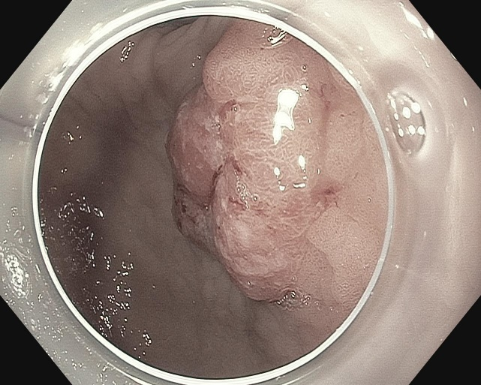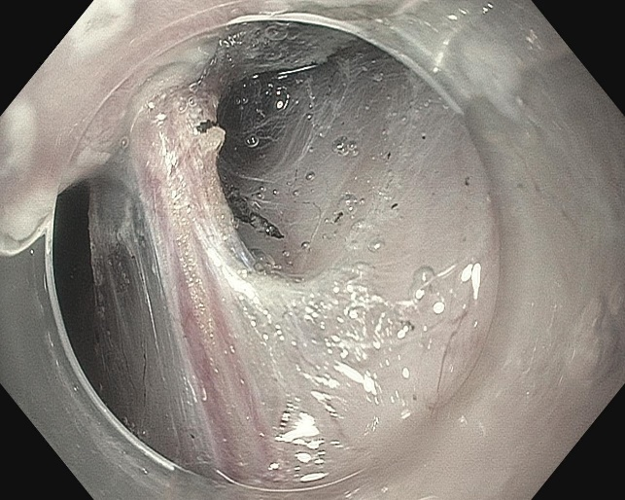
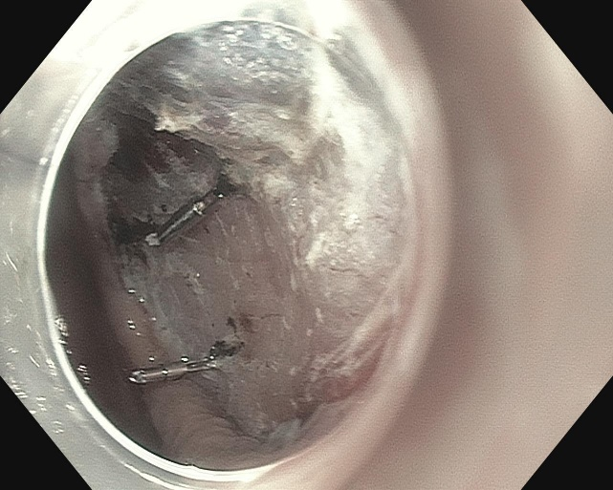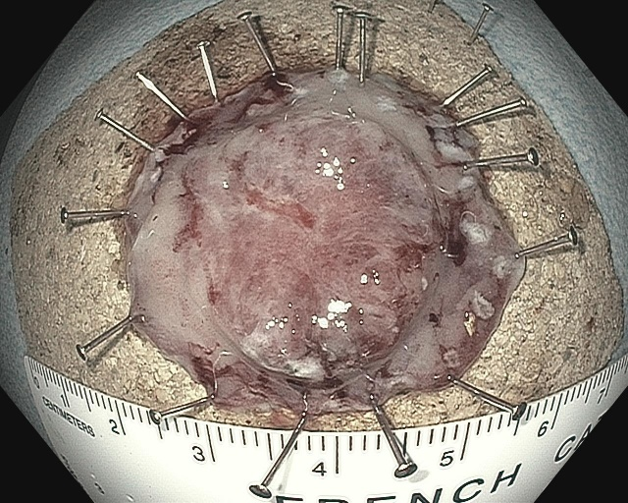
Figure 2 Endoscopic submucosal dissection of early gastric cancer (NYU-Winthrop).

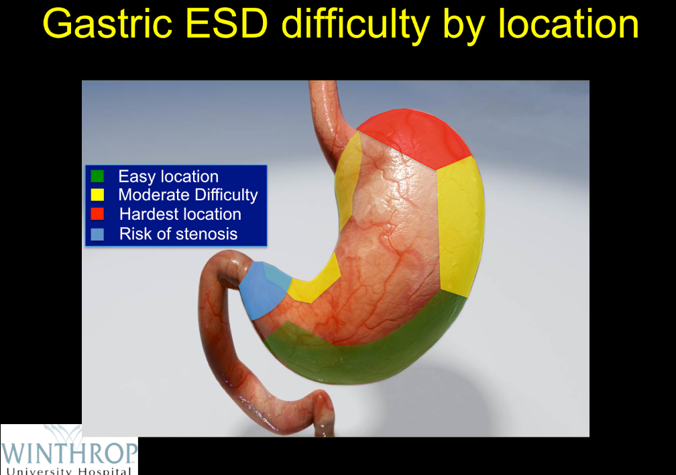
Figure 3 Gastric endoscopic submucosal dissection difficulty by location. ESD: Endoscopic submucosal dissection.

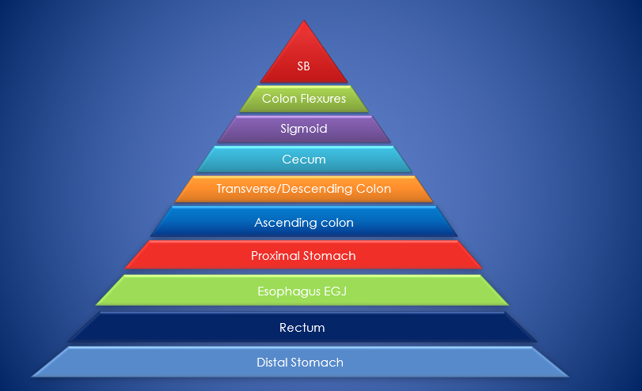
Figure 4 Relative endoscopic submucosal dissection difficulty by location. ESD: Endoscopic submucosal dissection; EGJ: Esophagogastric junction.

Figure 5 Chronology of endoscopic submucosal dissection development in a Western Center. ESD: Endoscopic submucosal dissection.

A

B

C

Figure 6 NYU-Winthrop endoscopic submucosal dissection experiences. A: ESD pathology; B: ESD R0 rates; C: UGI ESD dissection speed. ESD: Endoscopic submucosal dissection.

A B
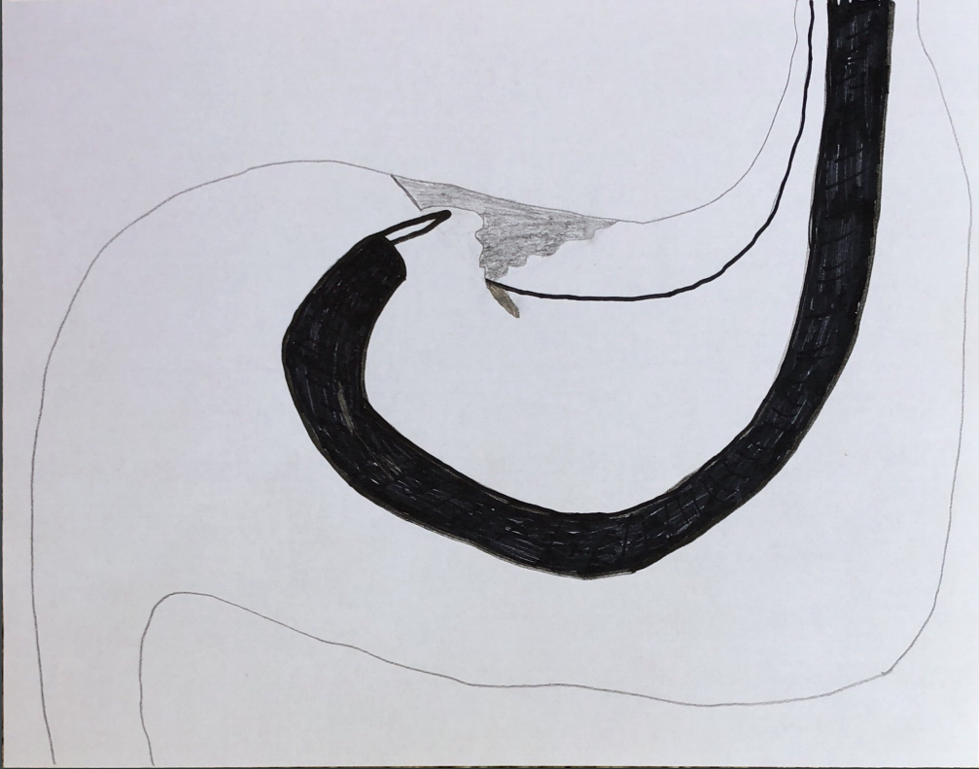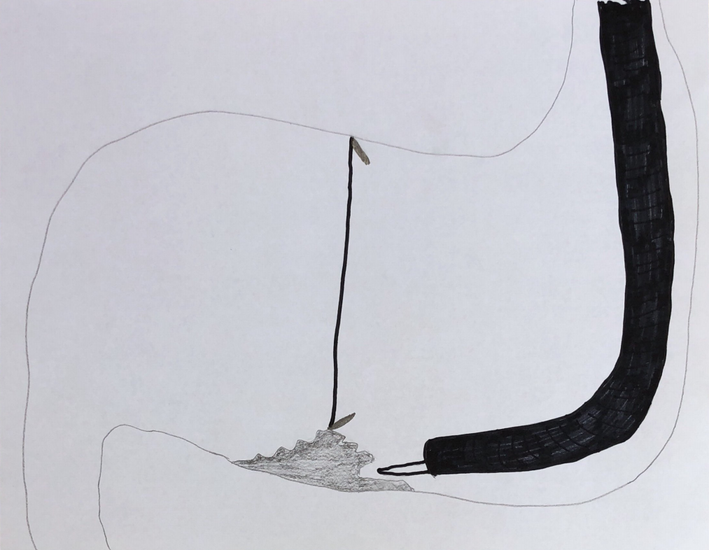
Figure 7 Traction in endoscopic submucosal dissection. A: Traction via clip on string; B: Traction via pulley effect with two clips.

