Name of Journal: World Journal of Clinical Cases
Manuscript NO: 79720
Manuscript Type: CASE REPORT

Genetic changes in refractory relapsed acute myeloid leukemia with NPM1 mutation: A case report

Wang SL. Genetic changes in R/R AML

Shuang-Ling Wang

Shuang-Ling Wang, Department of Hematology and Oncology, The Second Affiliated Hospital of Medical College of Shantou University, Shantou 515041, Guangdong Province, China

Author contributions: Wang SL reviewed the literature and contributed to manuscript drafting.

Supported by the Shantou Science and Technology Planning Project of Guangdong Province, No. SFK [2019] 79.

Corresponding author: Shuang-Ling Wang, MMed, Deputy Chief Physician, Department of Hematology and Oncology, The Second Affiliated Hospital of Medical College of Shantou University, No. 69 Dongxia North Road, Shantou 515041, Guangdong Province, China. slwang_2006@126.com

Received: September 5, 2022
Revised: November 4, 2022
Accepted: November 18, 2022
Published online: December 16, 2022

Abstract
BACKGROUND
Acute myeloid leukemia is often associated with gene mutation or chromosome abnormality, which is an important factor affecting prognosis. The 5-year survival rate of patients with acute myeloid leukemia without hematopoietic stem cell transplantation is low. For patients who only received chemotherapy and whose first remission lasted > 5 years, there are few reports of gene spectrum changes between relapse and initial diagnosis.

CASE SUMMARY
We report a 41-year-old woman who presented to our hospital with complaints of dizziness, poor appetite and wasting. She was diagnosed with acute myelomonocytic leukemia (M4b) with NPM1 mutation and only received chemotherapy. Her first remission lasted > 5 years. New genetic variants were detected upon relapse that may have been related to relapse and chemotherapy resistance.

CONCLUSION
Mutations in WT1 (R394fs/A387fs)/PTPN11 T73I/ETV6 S350P and JAK2 W659R may be related to relapse and chemotherapy resistance in acute myeloid leukemia.

Key Words: Acute myeloid leukemia; NPM1 mutation; Genetic variants; WT1; Case report

©The Author(s) 2022. Published by Baishideng Publishing Group Inc. All rights reserved.

Citation: Wang SL. Genetic changes in refractory relapsed acute myeloid leukemia with NPM1 mutation: A case report. World J Clin Cases 2022; 10(35): 13058-13063
URL: https://www.wjgnet.com/2307-8960/full/v10/i35/13058.htm
DOI: https://dx.doi.org/10.12998/wjcc.v10.i35.13058

Core Tip: We report a patient with relapsed refractory acute myelomonocytic leukemia. Compared with the gene spectrum at initial diagnosis, new genetic variants were detected. We speculate that mutations in WT1 (R394fs/A387fs)/PTPN11 T73I/ETV6 S350P and JAK2 W659R may be related to relapse and chemotherapy resistance.

INTRODUCTION
Chemotherapy is the main treatment for acute myeloid leukemia (AML) patients who cannot undergo hematopoietic stem cell transplantation, but 5-year overall survival is < 40%^{[1,2]}. It is known that some genetic variation or cytogenetic abnormalities are important factors affecting the prognosis of AML^{[3,4]}. Here, we report a case of acute monocytic leukemia with normal karyotype and NPM1 mutation. The patient had complete remission with chemotherapy but relapsed 5 years later. New genetic variants and chromosomal abnormalities were detected when she relapsed. We found new gene mutations that may be related to chemoresistance of AML.

CASE PRESENTATION
Chief complaints
A 41-year-old woman presented to our hospital in July 2016 to address a 2-mo history of dizziness, poor appetite and wasting.

History of present illness
At admission, the patient was actively suffering from dizziness, headache, poor appetite, gum pain and unintentional weight loss (approximately 10 kg in the 2 mo prior).

History of past illness
In 2011, the patient had undergone hysterectomy for cervical cancer. Since it was early-stage cancer, no chemotherapy or radiotherapy was performed after the operation.

Personal and family history
The patient’s personal and family histories were unremarkable.

Physical examination
The patient had moderate anemia and slightly swollen gums. There was no sternal tenderness or superficial lymphadenopathy. Her liver and spleen were not palpable under the ribs.

Laboratory examinations
On July 16, 2019, bone marrow showed that the proportion of naive monocytes was 53%, and the proportion of promyelocytes was 18% (Figure 1A). A routine blood test indicated a white blood cell count of 19.4 × 10⁹/L (normal range: 4-10 × 10⁹/L), hemoglobin level of 87 g/L (normal range: 110-150 g/L) and platelet count of 113 × 10⁹/L (normal range: 100-300 × 10⁹/L).

Imaging examinations
Imaging examination showed no obvious abnormality.

Further diagnostic work-up
Karyotype analysis showed 46, XX [14]. The following 11 common genes showed mutations: NPM1 exon 12; DNMT3A exon 2 c.27C>T, p.P9P; TET2 exon 3 c.652G>A, p.V218M, c.3117G>A, p.S1039S; TET2 exon 9 c.4140T>C, p.H1380H; and ASXL1 exon 12 c.3759T>C, p.S1253S (Table 1).

FINAL DIAGNOSIS
Acute myelomonocytic leukemia (M4b) with NPM1 mutation.

TREATMENT
On July 19, 2016, the “idarubicin - cytarabine (IA)” regimen was administered, consisting of idarubicin at 10 mg for days 1-3 plus cytarabine at 0.1 g q12h on days 1-7. On August 3, 2016, bone examination showed complete remission (Figure 1B). On August 25, 2016, the IA regimen was given again. On September 18, 2016, the patient was treated with lumbar puncture and intrathecal injection of cytarabine plus dexamethasone. No abnormality was found in the cerebrospinal fluid examination. However, the patient refused hematopoietic stem cell transplantation for economic reasons. We chose high-dose cytarabine (3.0 g q12h on days 1, 3 and 5 q4w) as consolidation therapy, and four cycles of cytarabine were given starting on September 28, 2016. The minimal residual leukemia cell count was 5.23 × 10⁻² after consolidation treatment. Due to minimal residual leukemia, two courses of the “MA” regimen (mitoxantrone 10 mg days 1-3 + cytarabine 75 mg q12h days 1-7 q12w) and the “DA” regimen (daunorubicin 40 mg days 1-3 + cytarabine 75 mg q12h days 1-7 q12w) were given, starting on September 8, 2017. After the last chemotherapy treatment, bone marrow examination showed complete remission (Figure 1C). Routine blood tests were conducted every 3-6 mo.
In August 2021, the patient was re-hospitalized in our department due to recurrent leukemia (Figure 1D). The karyotype analysis of bone marrow cells showed: 46, X, t (X; 3) (p11.2; P13) [6]/46, XX [14]. Molecular pathological gene mutation reports showed mutations of the following genes: NPM1 exon 11 NM_002520:c.863_864insCCAG (p.W288fs); TET2 exon 3 NM_001127208: c.1588C>T(p.Q530*); WT1 exon 7 NM_024426:c.1180_1186delins8 (p.R394fs), NM_024426:c.1157dupC (p.A387fs); PTPN11 exon 3 NM_002834:c.218C>T (p.T73I); ETV6 exon 6 NM_001987:c.1048T>C (p.S350P); and JAK2 exon 15 NM_004972:c.1975T>C (p.W659R) (Table 2).
IA chemotherapy was given on September 27, 2021. On November 1, 2021, we observed 8% naive cells in the peripheral blood. A regimen of azacytidine at 100 mg on days 1-7 and venetoclax at 400 mg on days 1-28 was given on November 5, 2021. The minimal residual leukemia cell count was 5.9 × 10⁻³ after the first cycle of treatment and 8.6 × 10⁻³ after four cycles of treatment (Figure 1E). After seven cycles of treatment, naive cells reappeared in the peripheral blood.

OUTCOME AND FOLLOW-UP
The patient was subsequently treated with the “HA” regimen (cytarabine 0.15 g q12h days 1-7 + homoharringtonine 3.5 mg days 1-7) and the “CV” regimen (cytarabine 15 mg q12h days 1-10 + venetoclax 400 mg days 1-28) on June 10, 2022. Unfortunately, remission was not achieved (Figure 1F). At the last follow-up, the patient had pancytopenia, and the proportion of naive cells was 70%. Blood transfusion was administered.

DISCUSSION
AML is a highly heterogeneous hematological tumor, often accompanied by gene mutations and chromosomal abnormalities. According to the European LeukemiaNet, AML can be divided into low, medium and high risk^{[5,6]}. It is known that AML with normal karyotype and NPM1 mutation without FLT3-ITD mutation has a better prognosis, but our patient also had mutations in DNMT3A, TET2 and ASXL1. According to the European LeukemiaNet risk classification (2017), this patient was classified as high risk due to the ASXL1 mutation.
After induction of remission, bone marrow transplantation was the best treatment, but the patient refused the recommendation. She relapsed 5 years later, and the gene spectrum and chromosome examination were performed again. Compared with the gene spectrum at diagnosis, WT1 (R394fs/A387fs), PTPN11 T73I, ETV6 S350P and JAK2 W659R mutations replaced the ASXL1 and DNMT3A mutations. This is the first report of mutations in WT1 (R394fs/A387fs), PTPN11 T73I, ETV6 S350P and JAK2 W659R in a patient with relapsed refractory AML. Eisfeld et al^{[7]} reported that the combination of NPM1 and WT1 mutations is an adverse prognostic combination. Krauth et al^{[8]} confirmed that WT1 mutations are independent adverse factors for event-free survival in AML patients.
TET2 mutation is an early event in the stepwise progression from hematopoietic stem cells to myeloid malignancy, but there is still controversy over the prognostic impact of TET2 mutation in AML. TET2 mutation might be correlated with relapse of leukemia^{[9-11]}. JAK2 mutation has not been observed in the absence of TET2 mutations^{[12]}. JAK2 V617F is the most common type of JAK2 mutation but occurs rarely in ML^{[13]}. Currently, there are no reports of the JAK2 W659R mutation in AML. Alfayez et al^{[14]} concluded that mutations in PTPN11 had deleterious effects on survival. ETV6 rearrangements often accompany other molecular mutations^{[15]}.
Routine chemotherapy was ineffective for this patient. However, azacytidine and venetoclax treatment achieved morphological remission and progression-free survival for 6 mo. We speculate that mutations in WT1 (R394fs/A387fs), PTPN11 T73I, ETV6 S350P and JAK2 W659R may be related to relapse and chemotherapy resistance.

CONCLUSION
We report a patient with relapsed refractory AML. Compared with the gene spectrum at diagnosis, new mutations were detected. We speculate that mutations in WT1 (R394fs/A387fs), PTPN11 T73I, ETV6 S350P and JAK2 W659R may be related to relapse and chemotherapy resistance. Larger studies are warranted to confirm this.

REFERENCES
1 Alsobhi E, Farahat F, Daghistani M, Awad K, Al-Zahran O, Al-Saiari A, Koshak F. Overall survival of adult acute myeloid leukemia based on cytogenetic and molecular abnormalities during 5 years in a single center study. Saudi Med J 2019; 40: 1171-1176 [PMID: 31707416 DOI: 10.15537/smj.2019.11.24584]
2 Dohner H, Estey EH, Amadori S, Appelbaum FR, Buchner T, Burnett AK. Diagnosis and management of acute myeloid leukemia in adults: recommendations from an international expert panel, on behalf of the European LeukemiaNet. Blood 2010; 115: 453-474 [DOI: 10.1182/blood-2009-07-235358]
3 Papaemmanuil E, Gerstung M, Bullinger L, Gaidzik VI, Paschka P, Roberts ND, Potter NE, Heuser M, Thol F, Bolli N, Gundem G, Van Loo P, Martincorena I, Ganly P, Mudie L, McLaren S, O'Meara S, Raine K, Jones DR, Teague JW, Butler AP, Greaves MF, Ganser A, Döhner K, Schlenk RF, Döhner H, Campbell PJ. Genomic Classification and Prognosis in Acute Myeloid Leukemia. N Engl J Med 2016; 374: 2209-2221 [PMID: 27276561 DOI: 10.1056/NEJMoa1516192]
4 Nakajima H. Genetic abnormalities in AML. Rinsho Ketsueki 2019; 60: 584-593 [PMID: 31281149 DOI: 10.11406/rinketsu.60.584]
5 Döhner H, Estey E, Grimwade D, Amadori S, Appelbaum FR, Büchner T, Dombret H, Ebert BL, Fenaux P, Larson RA, Levine RL, Lo-Coco F, Naoe T, Niederwieser D, Ossenkoppele GJ, Sanz M, Sierra J, Tallman MS, Tien HF, Wei AH, Löwenberg B, Bloomfield CD. Diagnosis and management of AML in adults: 2017 ELN recommendations from an international expert panel. Blood 2017; 129: 424-447 [PMID: 27895058 DOI: 10.1182/blood-2016-08-733196]
6 Pastore F, Dufour A, Benthaus T, Metzeler KH, Maharry KS, Schneider S, Ksienzyk B, Mellert G, Zellmeier E, Kakadia PM, Unterhalt M, Feuring-Buske M, Buske C, Braess J, Sauerland MC, Heinecke A, Krug U, Berdel WE, Buechner T, Woermann B, Hiddemann W, Bohlander SK, Marcucci G, Spiekermann K, Bloomfield CD, Hoster E. Combined molecular and clinical prognostic index for relapse and survival in cytogenetically normal acute myeloid leukemia. J Clin Oncol 2014; 32: 1586-1594 [PMID: 24711548 DOI: 10.1200/JCO.2013.52.3480]
7 Eisfeld AK, Kohlschmidt J, Mims A, Nicolet D, Walker CJ, Blachly JS, Carroll AJ, Papaioannou D, Kolitz JE, Powell BE, Stone RM, de la Chapelle A, Byrd JC, Mrózek K, Bloomfield CD. Additional gene mutations may refine the 2017 European LeukemiaNet classification in adult patients with de novo acute myeloid leukemia aged <60 years. Leukemia 2020; 34: 3215-3227 [PMID: 32461631 DOI: 10.1038/s41375-020-0872-3]
8 Krauth MT, Alpermann T, Bacher U, Eder C, Dicker F, Ulke M, Kuznia S, Nadarajah N, Kern W, Haferlach C, Haferlach T, Schnittger S. WT1 mutations are secondary events in AML, show varying frequencies and impact on prognosis between genetic subgroups. Leukemia 2015; 29: 660-667 [DOI: 10.1038/leu.2014.243]
9 Moran-Crusio K, Reavie L, Shih A, Abdel-Wahab O, Ndiaye-Lobry D, Lobry C, Figueroa ME, Vasanthakumar A, Patel J, Zhao X, Perna F, Pandey S, Madzo J, Song C, Dai Q, He C, Ibrahim S, Beran M, Zavadil J, Nimer SD, Melnick A, Godley LA, Aifantis I, Levine RL. Tet2 loss leads to increased hematopoietic stem cell self-renewal and myeloid transformation. Cancer Cell 2011; 20: 11-24 [PMID: 21723200 DOI: 10.1016/j.ccr.2011.06.001]
10 Chan SM, Majeti R. Role of DNMT3A, TET2, and IDH1/2 mutations in pre‐leukemic stem cells in acute myeloid leukemia. Int J Hematol 2013; 98: 648-657 [DOI: 10.1007/s12185-013-1407-8]
11 Wang RQ, Chen CJ, Jing Y, Qin JY, Li Y, Chen GF, Zhou W, Li YH, Wang J, Li DW, Zhao HM, Wang BH, Wang LL, Wang H, Wang MZ, Gao XN, Yu L. Characteristics and prognostic significance of genetic mutations in acute myeloid leukemia based on a targeted next-generation sequencing technique. Cancer Med 2020; 9: 8457-8467 [PMID: 32970934 DOI: 10.1002/cam4.3467]
12 Sasaki K, Kanagal-Shamanna R, Montalban-Bravo G, Assi R, Jabbour E, Ravandi F, Kadia T, Pierce S, Takahashi K, Nogueras Gonzalez G, Patel K, Soltysiak KA, Cortes J, Kantarjian HM, Garcia-Manero G. Impact of the variant allele frequency of ASXL1, DNMT3A, JAK2, TET2, TP53, and NPM1 on the outcomes of patients with newly diagnosed acute myeloid leukemia. Cancer 2020; 126: 765-774 [PMID: 31742675 DOI: 10.1002/cncr.32566]
13 Aynardi J, Manur R, Hess PR, Chekol S, Morrissette JJD, Babushok D, Hexner E, Rogers HJ, Hsi ED, Margolskee E, Orazi A, Hasserjian R, Bagg A. JAK2 V617F-positive acute myeloid leukaemia (AML): a comparison between de novo AML and secondary AML transformed from an underlying myeloproliferative neoplasm. A study from the Bone Marrow Pathology Group. Br J Haematol 2018; 182: 78-85 [PMID: 29767839 DOI: 10.1111/bjh.15276]
14 Alfayez M, Issa GC, Patel KP, Wang F, Wang X, Short NJ, Cortes JE, Kadia T, Ravandi F, Pierce S, Assi R, Garcia-Manero G, DiNardo CD, Daver N, Pemmaraju N, Kantarjian H, Borthakur G. The Clinical impact of PTPN11 mutations in adults with acute myeloid leukemia. Leukemia 2021; 35: 691-700 [PMID: 32561839 DOI: 10.1038/s41375-020-0920-z]
15 Zhou F, Chen B. Acute myeloid leukemia carrying ETV6 mutations: biologic and clinical features. Hematology 2018; 23: 608-612 [PMID: 29894279 DOI: 10.1080/10245332.2018.1482051]

Footnotes
Informed consent statement: Before treatment, patients and their families have signed informed consent for treatment.

Conflict-of-interest statement: There is no conflict of interest.

CARE Checklist (2016) statement: This manuscript was checked according to the checklist (2016) state.

Open-Access: This article is an open-access article that was selected by an in-house editor and fully peer-reviewed by external reviewers. It is distributed in accordance with the Creative Commons Attribution NonCommercial (CC BY-NC 4.0) license, which permits others to distribute, remix, adapt, build upon this work non-commercially, and license their derivative works on different terms, provided the original work is properly cited and the use is non-commercial. See: https://creativecommons.org/Licenses/by-nc/4.0/

Provenance and peer review: Unsolicited article; Externally peer reviewed.
Peer-review model: Single blind

Peer-review started: September 5, 2022
First decision: October 27, 2022
Article in press: November 18, 2022

Specialty type: Medicine, research and experimental
Country/Territory of origin: China
Peer-review report’s scientific quality classification
Grade A (Excellent): 0
Grade B (Very good): 0
Grade C (Good): C, C
Grade D (Fair): 0
Grade E (Poor): 0

P-Reviewer: Diamantidis MD, Greece; Sultana N, Bangladesh S-Editor: Wang LL L-Editor: A P-Editor: Wang LL

Figure Legends
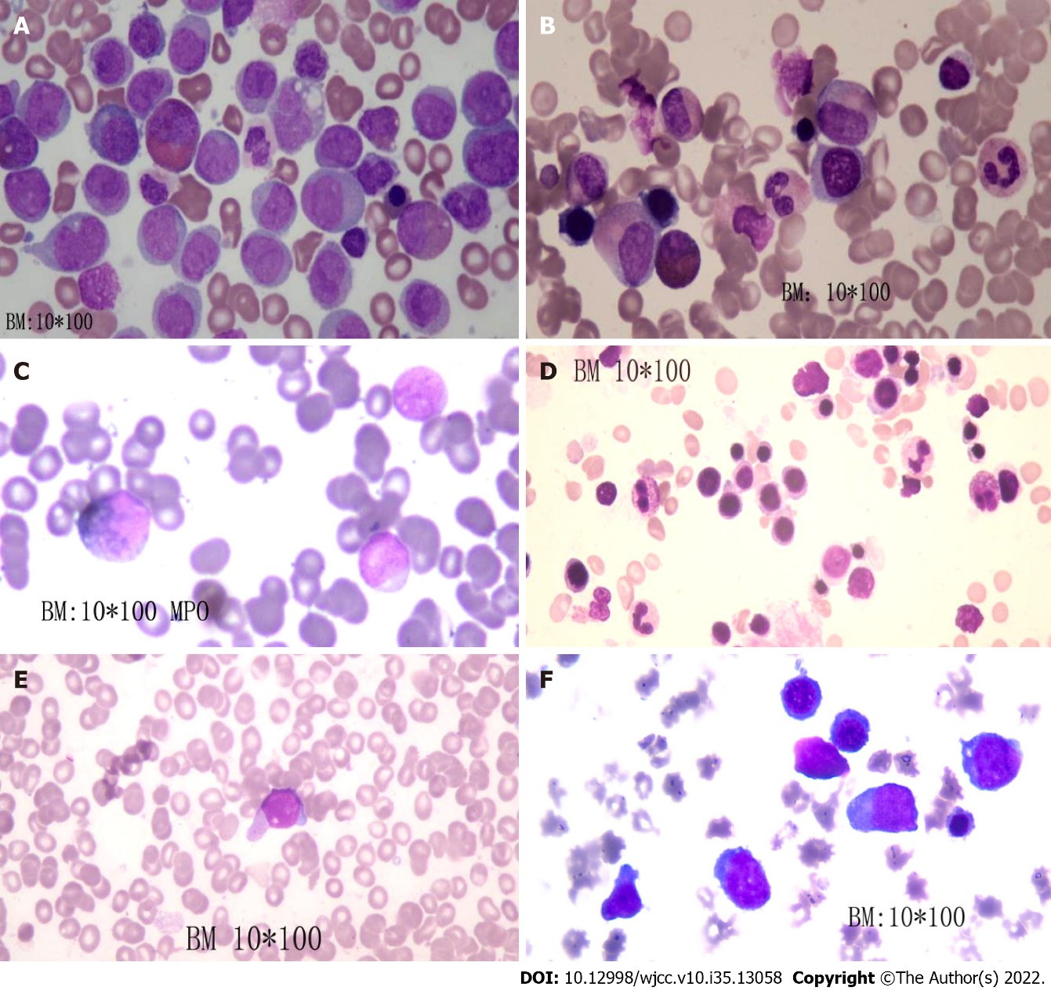
Figure 1 Morphological observation of bone marrow cells (hematoxylin-eosin staining, magnification × 100). A: Before chemotherapy; B: After induction therapy; C: After maintenance treatment; D: At first recurrence; E: After one cycle of venetoclax and azacytidine therapy; F: After one cycle of cytarabine, homoharringtonine and venetoclax therapy.

Table 1 Gene testing before chemotherapy
Gene | Variation content
NPM1 | Exon 12
ASXL1 | Exon 12 c.3759T>C; p.S1253S
DNMT3A | Exon 2 c.27C>T; p.P9P
TET2 | Exon 9 c.4140T>C; p.H1380H
 | Exon 3 c.652G>A; p.V218M c.3117G>A; p.S1039S
FLT3-ITD | No gene mutation was detected

Table 2 Gene testing after the first recurrence
Gene | Variation content | Variation ratio
NPM1 | Exon 11 NM_002520:c.863_864insCCAG (p.W288fs) | 11.8% (1276X)
TET2 | Exon 3 NM_001127208:c.1588C>T (p.Q530*) | 6.6% (2572X)
PTPN11 | Exon 3 NM_002834:c.218C>T (p.T73I) | 16.2% (2056X)
ETV6 | Exon 6 NM_001987:c.1048T>C (p.S350P) | 6.9% (1822X)
JAK2 | Exon 15 NM_004972:c.1975T>C (p.W659R) | 40.2% (1044X)
WT1 | Exon 7 NM_024426:c.1157dupC (p.A387fs) | 14.0% (1826X)
 | Exon 7 NM_024426:c.1180_1186delins8 p.R394fs) | 10.1% (1926X)

Published by Baishideng Publishing Group Inc
7041 Koll Center Parkway, Suite 160, Pleasanton, CA 94566, USA
Telephone: +1-925-3991568
E-mail: bpgoffice@wjgnet.com
Help Desk: https://www.f6publishing.com/helpdesk
https://www.wjgnet.com

© 2022 Baishideng Publishing Group Inc. All rights reserved.

