Name of Journal: World Journal of Cardiology
ESPS Manuscript NO: 27047
Manuscript Type: Case Report

Interventional treatment of the left subclavian in 2 patients with coronary steal syndrome

Heid J et al. Coronary steal syndrome

Julia Heid, Britta Vogel, Arnd Kristen, Wanda Kloos, Benedikt Kohler, Hugo A Katus, Grigorios Korosoglou
Julia Heid, Britta Vogel, Arnd Kristen, Wanda Kloos, Benedikt Kohler, Hugo A Katus, Grigorios Korosoglou, Department of Internal Medicine III, University Hospital Heidelberg, 69120 Heidelberg, Germany

Author contributions: All authors contributed to the acquisition of data, writing, and revision of this manuscript.

Institutional review board statement: This case report was exempt from the Institutional Review Board standards at University Hospital Heidelberg, Heidelberg, Germany.

Informed consent statement: The patients involved in this study gave their written informed consent authorizing use and disclosure of her protected health information.

Conflict-of-interest statement: All the authors have no conflicts of interests to declare.

Open-Access: This article is an open-access article which was selected by an in-house editor and fully peer-reviewed by external reviewers. It is distributed in accordance with the Creative Commons Attribution Non Commercial (CC BY-NC 4.0) license, which permits others to distribute, remix, adapt, build upon this work non-commercially, and license their derivative works on different terms, provided the original work is properly cited and the use is non-commercial. See: http://creativecommons.org/licenses/by-nc/4.0/

Manuscript source: Unsolicited manuscript

Correspondence to: Grigorios Korosoglou, MD, Professor of Medicine, Department of Internal Medicine III, University Hospital Heidelberg, Im Neuenheimer Feld 410, 69120 Heidelberg, Germany. gkorosoglou@hotmail.com
Telephone: +49-6221-564130
Fax: +49-6221-565516

Received: May 6, 2016
Peer-review started: May 9, 2016
First decision: June 13, 2016
Revised: July 23, 2016
Accepted: September 21, 2016
Article in press:
Published online:

Abstract
In patients with history of coronary artery disease angina pectoris is usually attributed to the progression of atherosclerotic lesions. However, in patients with previous coronary artery bypass graft operation (CABG) using internal mammary artery grafts, great vessel disease should also be considered. Herein we present two patients with history of CABG whose symptoms were suspicious for coronary ischemia. During cardiac catheterization reverse blood flow was observed from the left artery disease to the left internal mammary artery (LIMA) graft in both cases. After angioplasty and stent implantation of the left subclavian artery antegrade flow was restored in the LIMA grafts and both patients had complete resolution of symptoms.

Key words: Coronary steal syndrome; Coronary artery bypass graft; Left subclavian artery; Reverse blood flow; Cardiac catheterization

© The Author(s) 2016. Published by Baishideng Publishing Group Inc. All rights reserved.

Core tip: Both coronary and peripheral artery diseases are comorbidities with increasing morbidity and mortality. In patients with history of coronary artery disease and previous coronary revascularization, angina pectoris is usually attributed to the progression of atherosclerotic lesions. However, in patients who previously underwent coronary artery bypass graft operation (CABG) using internal mammary artery grafts, subclavian artery disease should also be considered. Herein we present 2 patients who previously underwent CABG with symptoms of myocardial ischemia due to subclavian artery stenosis.

Heid J, Vogel B, Kristen A, Kloos W, Kohler B, Katus HA, Korosoglou G. Interventional treatment of the left subclavian in 2 patients with coronary steal syndrome. World J Cardiol 2016; In press

INTRODUCTION
Coronary and peripheral artery disease (CAD and PAD) are both comorbidities which exhibit a high prevalence and increasing morbidity and mortality in the western world^{[1]}. Especially PAD is estimated to affect over 200 million people worldwide, and around 30% of primary care individuals over 70 years old^{[2,3]}. Patients with symptomatic PAD exhibit a life expectancy of 80% at 5 years of follow-up, whereas 20% of such patients experience non-fatal cardiovascular complications^{[4,5]}. Interestingly, PAD patients have significantly less chance of receiving appropriate risk factor modification (e.g., statin therapy) and antithrombotic treatment compared to patients with CAD^{[1]}. In addition, the prevalence of unrecognised PAD is extremely high (68%) in patients referred for coronary angiography for suspected CAD, especially in individuals with low socioeconomic status^{[6]}.
In patients with history of CAD and previous coronary revascularization, angina pectoris is usually attributed to the progression of atherosclerotic lesions. However, in patients who previously underwent coronary artery bypass graft operation (CABG) using internal mammary artery (IMA) grafts, great vessel disease, for example of the subclavian artery, should also be considered. In this regard, the coronary subclavian steal syndrome is a rare complication after CABG when the left internal mammary artery (LIMA) graft is used. This disease is characterized by retrograde flow from the LIMA graft to the distal post-stenotic part of the subclavian artery during muscle work and increased oxygen and blood demand of the arm in order to maintain adequate perfusion of the left hand. As a result, patients with such a condition may develop typical symptoms of myocardial ischemia despite patency of the grafted vessels.

CASE REPORT
Herein we present a mini series of two patients (Patient A, Patient B) with suspected progress of the known multi-vessel CAD. Both patients had history of previous CABG including a LIMA graft to the left artery disease (LAD). Baseline characteristics of our patients are provided in Table 1.
Patient A was referred to our department for an elective coronary angiography due to typical angina symptoms (CCS class III) during exertion since 4 wk. He had a history of multi vessel disease with prior CABG 14 years ago.
The initial coronary angiography revealed a 75% ostial stenosis of the left main coronary artery. Despite the presence of significant left main stenosis, reverse blood flow was observed from the LAD to the LIMA graft. Thus, contrast opacification could be followed up to the insertion of the graft at the subclavian artery (Figure 1). Both the 2 vein grafts to the left circumflex (LCX) and the right coronary artery (RCA) were patent. In addition, angiography of the subclavian artery revealed high grade lesions in the subclavian and the origin of the left vertebral artery (Figure 1). Hereby, con-current retrograde flow from the LAD was observed during contrast agent injection.
Due to typical angina and significant left main disease, PCI of left main artery and stent placement (Promus Element 4.0 mm × 20 mm, Boston Scientific) was performed in patient A with a good angiographic result (Figure 2). However, retrograde flow from the LAD to the LIMA graft remained after percutaneous coronary intervention (PCI), and sparse flow was seen in the distal LAD despite successful left main PCI (orange and blue arrows in Figure 2, respectively). After 4 wk the patient was scheduled for PCI of his left subclavian artery due to suspected LIMA steal syndrome. Interestingly, at that time he reported on persistence of CCS class III anginal symptoms. Angioplasty could be performed successfully, followed by bifurcation stent implantation of the stenotic subclavian and vertebral arteries (balloon expandable Visi-Pro 8.0 mm × 27 mm, Covidien for the subclavian and Taxus Element 4.5 mm × 12 mm, Boston Scientific for the vertebral artery) and final kissing balloon inflation. Subsequently, a good angiographic result was observed with restored antegrade flow indicated in the LIMA graft (Figure 2).
For patient B, the initial cause for admission to our hospital was a presyncopal episode and atypical angina. Cardiac catheterization was performed due to the high risk profile of the patient, including known multi-vessel disease and CABG 9 years ago. After selection of a left radial access for coronary angiography and wire insertion into the subclavian artery, we proceeded with selective contrast injection into the LIMA graft to the LAD. Surprisingly, contrast opacification was not possible despite selective contrast injection into the presumably patent vessel (Figure 3). Subsequently, angiography of the left subclavian artery was performed, confirming high grade stenosis of the left subclavian artery (Figure 3), which was already accidentally diagnosed one year earlier during a computed tomography scan. Consistently an interarm blood pressure difference of 20 mmHg (left < right) could be measured with this patient. The subclavian stenosis was located proximally to the origin of the LIMA graft, thus possibly causing a coronary steal syndrome. Coronary angiography confirmed this diagnosis demonstrating retrograde flow from the LAD up to the insertion of the LIMA graft into the subclavian artery (Figure 3) despite the presence of significant left main disease (Figure 3). On the following day, stress echocardiography was performed, demonstrating an inducible hypokinesia in the anterior LV-wall by arm exertion (“hand grip method”), compatible with inducible ischemia in the LAD territory. Subsequently, balloon angioplasty and stent placement of the left subclavian artery was performed using an Armada 6.0 mm × 20 mm balloon and an 8.0 mm × 27 mm VisiPro-Stent with good angiographic result (Figure 3). Importantly, antegrade flow could be reestablished in the subclavian artery after interventional treatment (Figure 3).
Both patients were discharged the day after the procedure. During clinical follow-up patient A showed complete resolution auf his angina symptoms, whereas repeated stress echocardiography showed no signs of inducible ischemia in patient B.

DISCUSSION
Subclavian artery stenosis is a relatively frequent disease, which is more commonly described in patients with diabetes mellitus and was shown to be predictive of poor cardiovascular outcomes^{[7]}. Known PAD accompanied by a interarm blood pressure difference greater than 10% has been suggested as a specific, but unfortunately less sensitive indicator for a subclavian stenosis^{[8]}. The presence of subclavian artery stenosis in patients with previous CABG, who have received a LIMA graft can lead to angina symptoms independent of atherosclerosis progression in native coronary arteries and bypass grafts. Although several cases of subclavian artery causing a so-called LIMA steal syndrome have been reported in the literature, this syndrome is still considered as relatively uncommon in patients after myocardial revascularization. However, in light of the greater number of LIMA grafts currently used and their long life expectancy its incidence may be higher than expected. In a retrospective study including 226 patients scheduled for CABG, 6 (3%) patients had significant left subclavian artery stenosis, which was successfully treated by angioplasty and stent placement in all cases before bypass surgery^{[9]}. In our case the presence of subclavian artery stenosis was not investigated prior to CABG in our 2 cases. However, due to the long time duration between CABG and angina symptoms of the patient (A: 14 years, B: 9 years) it is more likely that subclavian stenosis developed after CABG. Thus, pre-CABG angiography would probably not have been helpful in our cases.
In the past years, significant technical developments have occurred with endovascular therapy, which offer several distinct advantages over open surgical revascularization techniques in selected lesions^{[10]}. Although no head-to-head trials comparing interventional versus surgical treatment of the proximal subclavian artery stenosis are present so far, the effectiveness of percutaneous revascularization seems to be at least equivalent to surgery and that PCI and stent placement may be associated with fewer procedure-related serious complications^{[11]}. In our patients subclavian (in both patients) and vertrebral artery stenosis (in patient B) could be successfully treated by balloon angioplasty and stent placement. This caused restoration of the antegrade flow into the LIMA graft, resulting in resolution of anginal symptoms with patient A and restoration of the inducible wall motion abnormality by echocardiography in patient B. In patient A treatment of the subclavian artery stenosis may have been enough to restore antegrade perfusion of the LAD territory via the anatomically patent LIMA graft, without requiring PCI of the left main. However, PCI of the left main had already been performed in the initial session during diagnostic coronary angiography. Due to the fact that symptoms remained, we decided to perform stenting of the subclavian artery stenosis in a second session.
In patients with previous myocardial revascularization apart from CAD, great vessel disease resulting to coronary steal syndromes needs to be considered as a rare but important alternative diagnosis. In such cases, interventional treatment by angioplasty and stent placement may lead to complete resolution of symptoms and possible prevention of ischemic complications.

COMMENTS
Case characteristics
A 75- and 78-year-old male patient, both with known coronary artery disease, peripheral artery disease and prior coronary artery bypass graft who presented with symptoms of myocardial ischemia

Clinical diagnosis
Peripheral artery disease with subclavian artery stenosis causing coronary steal syndrome.

Differential diagnosis
Progression of coronary artery disease.

Laboratory diagnosis
All labs were within normal limits.

Imaging diagnosis
Peripheral artery disease was diagnosed in both patients by digital subtraction angiography.

Pathological diagnosis
Coronary steal syndrome due to subclavian artery disease.

Treatment
Percutaneous balloon angioplasty and stent placement in the left subclavian artery.

Related reports
Coronary steal syndrome is a pathologic entity, which has been previously reported quite rarely so far in the current literature. This disease can sometimes be confused with coronary artery disease due to typical symptoms of myocardial ischemia in such patients.

Term explanation
Coronary steal syndrome is a relatively rare condition, where subclavian artery stenosis causes myocardial ischemia due to reduced blood flow to the left internal mammary artery coronary graft after coronary artery bypass graft operation.

Experiences and lessons
In patients with previous myocardial revascularization apart from coronary artery disease, great vessel disease resulting to coronary steal syndromes needs to be considered as a rare but important alternative diagnosis.

Peer-review
The authors present 2 rare case reports of coronary subclavian steal syndrome after coronary artery bypass graft. The authors have demonstrated that interventional treatment may lead to complete resolution of symptoms and possible prevention of ischemic complications. This manuscript is nicely structured and well written.

REFERENCES
1 Gallino A, Aboyans V, Diehm C, Cosentino F, Stricker H, Falk E, Schouten O, Lekakis J, Amann-Vesti B, Siclari F, Poredos P, Novo S, Brodmann M, Schulte KL, Vlachopoulos C, De Caterina R, Libby P, Baumgartner I. Non-coronary atherosclerosis. Eur Heart J 2014; 35: 1112-1119 [PMID: 24595865 DOI: 10.1093/eurheartj/ehu071]
2 Fowkes FG, Rudan D, Rudan I, Aboyans V, Denenberg JO, McDermott MM, Norman PE, Sampson UK, Williams LJ, Mensah GA, Criqui MH. Comparison of global estimates of prevalence and risk factors for peripheral artery disease in 2000 and 2010: a systematic review and analysis. Lancet 2013; 382: 1329-1340 [PMID: 23915883 DOI: 10.1016/S0140-6736(13)61249-0]
3 Hirsch AT, Criqui MH, Treat-Jacobson D, Regensteiner JG, Creager MA, Olin JW, Krook SH, Hunninghake DB, Comerota AJ, Walsh ME, McDermott MM, Hiatt WR. Peripheral arterial disease detection, awareness, and treatment in primary care. JAMA 2001; 286: 1317-1324 [PMID: 11560536 DOI: 10.1001/jama.286.11.1317]
4 Norgren L, Hiatt WR, Dormandy JA, Nehler MR, Harris KA, Fowkes FG. Inter-Society Consensus for the Management of Peripheral Arterial Disease (TASC II). J Vasc Surg 2007; 45 Suppl S: S5-67 [PMID: 17223489 DOI: 10.1016/j.jvs.2006.12.037]
5 Rothwell PM, Coull AJ, Silver LE, Fairhead JF, Giles MF, Lovelock CE, Redgrave JN, Bull LM, Welch SJ, Cuthbertson FC, Binney LE, Gutnikov SA, Anslow P, Banning AP, Mant D, Mehta Z. Population-based study of event-rate, incidence, case fatality, and mortality for all acute vascular events in all arterial territories (Oxford Vascular Study). Lancet 2005; 366: 1773-1783 [PMID: 16298214 DOI: 10.1016/S0140-6736(05)67702-1]
6 Chang P, Nead KT, Olin JW, Cooke JP, Leeper NJ. Clinical and socioeconomic factors associated with unrecognized peripheral artery disease. Vasc Med 2014; 19: 289-296 [PMID: 24872403 DOI: 10.1177/1358863X14535475]
7 Aboyans V, Criqui MH, McDermott MM, Allison MA, Denenberg JO, Shadman R, Fronek A. The vital prognosis of subclavian stenosis. J Am Coll Cardiol 2007; 49: 1540-1545 [PMID: 17418292 DOI: 10.1016/j.jacc.2006.09.055]
8 Osborn LA, Vernon SM, Reynolds B, Timm TC, Allen K. Screening for subclavian artery stenosis in patients: who are candidates for coronary bypass surgery. Catheter Cardiovasc Interv 2002; 56: 162-165 [PMID: 12112906 DOI: 10.1002/ccd.10198]
9 Prasad A, Prasad A, Varghese I, Roesle M, Banerjee S, Brilakis ES. Prevalence and treatment of proximal left subclavian artery stenosis in patients referred for coronary artery bypass surgery. Int J Cardiol 2009; 133: 109-111 [PMID: 18158191 DOI: 10.1016/j.ijcard.2007.08.108]
10 White CJ, Gray WA. Endovascular therapies for peripheral arterial disease: an evidence-based review. Circulation 2007; 116: 2203-2215 [PMID: 17984390 DOI: 10.1161/CIRCULATIONAHA.106.621391]
11 Eisenhauer AC. Subclavian and Innominate Revascularization: Surgical Therapy Versus Catheter-Based Intervention. Curr Interv Cardiol Rep 2000; 2: 101-110 [PMID: 11096657]

P-Reviewer: Peteiro J, Sabate M, Ueda H S-Editor: Qiu S L-Editor: E-Editor:

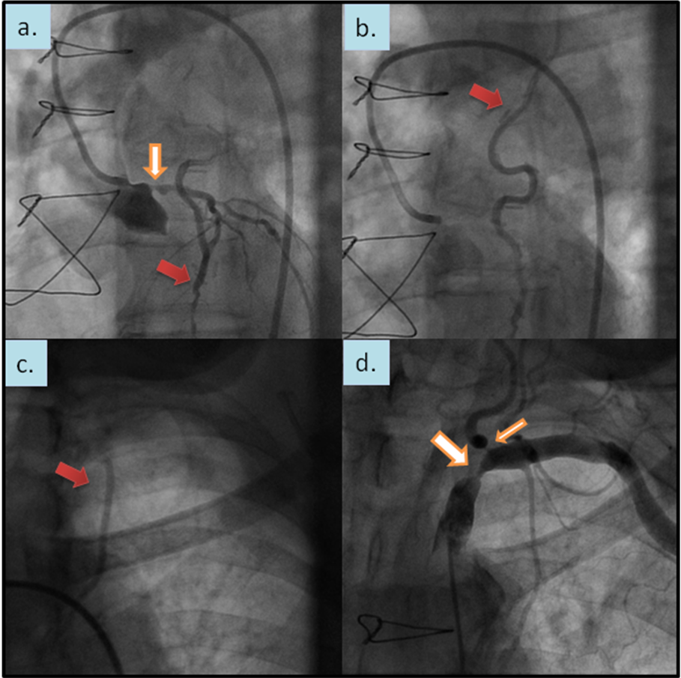
Figure 1 Reverse blood flow was observed from the left artery disease to the left internal mammary artery graft. During coronary angiography (red arrows in A and B) despite 75% stenosis of the left main coronary artery (orange arrow in A), contrast injection could be followed up to the insertion of the graft in the subclavian artery (red arrow in C). Angiography of the subclavian artery revealed high grade lesions in the subclavian and left vertebral artery (orange arrows in D).
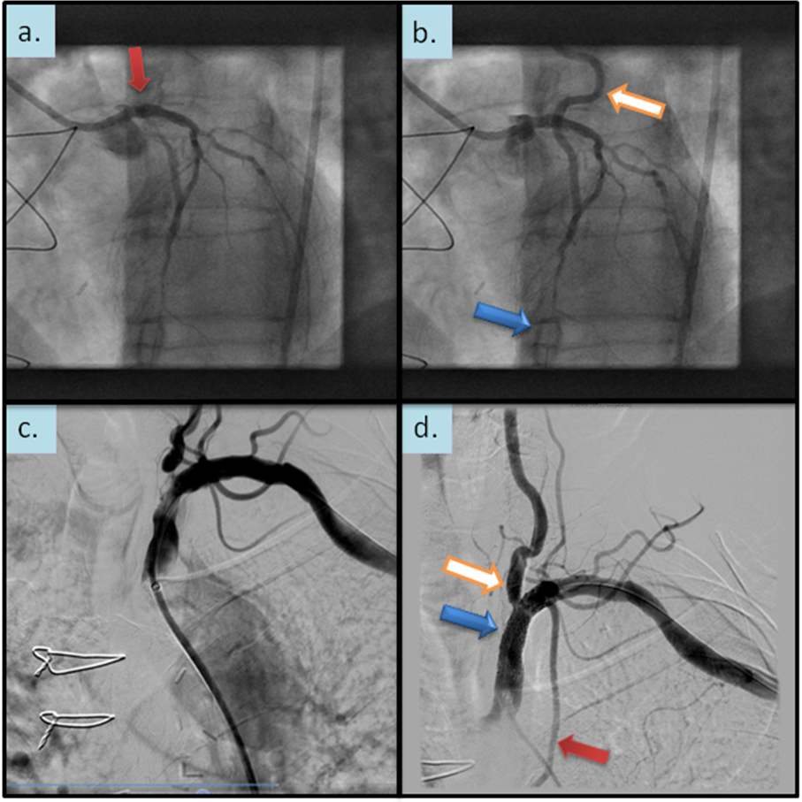
Figure 2 Percutaneous coronary intervention of left main artery and stent placement. It was performed with a good angiographic result (red arrow in A) However, retrograde flow from the left artery disease LAD to the LIMA graft remained after PCI, and sparse flow was seen in the distal LAD (orange and blue arrows in B, respectively). DSA confirmed the presence of high grades stenosis of the left subclavian and vertrebral artery (C). After angioplasty and bifurcation stent implantation a good angiographic result can be appreciated (orange and blue arrows in d) with normal opacification of the LIMA graft (red arrow in d). PCI: Percutaneous coronary intervention; LAD: Left artery disease; LIMA: Left internal mammary artery; DSA: Digital subtraction angiography.

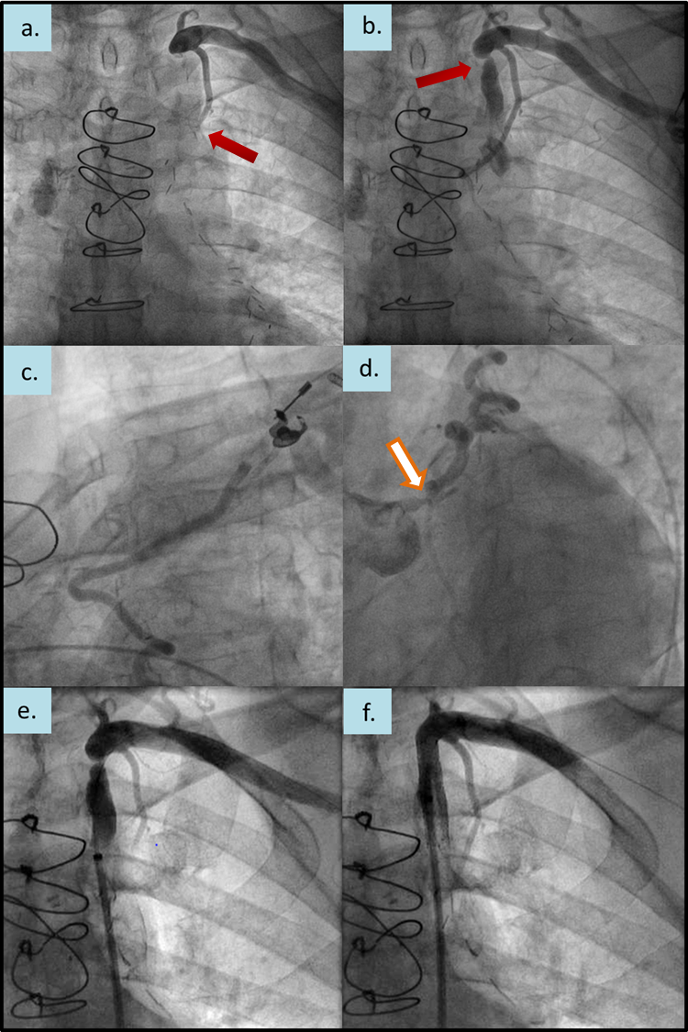
Figure 3 After selective contrast injection into the left internal mammary artery graft no contrast opafication. It was shown in the left artery disease (red arrow in A). Subsequently, a high grade stenosis of the left subclavian artery was observed (red arrow in B). During coronary angiography retrograde flow from the left artery disease up to the origin of the LIMA graft could be demonstrated (C), despite left main stenosis (orange arrow in D). After angioplasty and stent placement (E) antegrade flow could be re-established in the subclavian artery (F). LIMA: Left internal mammary artery.

Table 1 Baseline characteristics of our 2 patients: Typical angina symptoms indicate Canadian Cardiovascular Society

 | Patient A | Patient B
Sex | Male | Male
Age (yr) | 75 | 78
Cardiovascular risk factors | Arterial hypertension  Hyperlipidemia  Adipositas | Arterial hypertension  Hyperlipidemia  Previous smoker
CAD | Known 3-vessel-disease | Known 2-vessel disease
CABG | 14 yr ago  LIMA graft to the LAD  Venous grafts to the right coronary  (RCA) and the left circumflex artery (LCX) | 9 yr ago  LIMA graft to the LAD  Venous graft to the first marginal branch
Left ventricular function | Mildly impaired | Mildly impaired
PAD history | Previous recanalization of left (2009) and right (2010) superficial femoral artery | Surgical endatherectomy of the left internal carotid artery 2013  High grade lesions in the left vertebral artery and left subclavian artery (accidental finding in a computed tomography performed one year earlier)
Initial symptoms | Typical angina symptoms (CCS III) | Presyncope and atypical angina
Baseline medication | Aspirin  ß-blocker  Angiotensin converting enzyme inhibitor  Statin | Aspirin  ß-blocker  Angiotensin converting enzyme inhibitor  Statin  Calcium antagonist  Diuretics

LAD: Left anterior descending.

