Name of Journal: World Journal of Clinical Cases
Manuscript NO: 77378
Manuscript Type: CASE REPORT

Idiopathic cholesterol crystal embolism with atheroembolic renal disease and blue toes syndrome: A case report

Cheng DJ et al. Idiopathic cholesterol crystal embolism with atheroembolic renal disease

De-Jin Cheng, Lin Li, Xiang-Yue Zheng, Shui-Fu Tang

De-Jin Cheng, Shui-Fu Tang, Division of Nephrology, The First Affiliated Hospital of Guangzhou University of Chinese Medicine, Guangzhou 510405, Guangdong Province, China

Lin Li, Division of Nephrology, Hua Du hospitals of Traditional Chinese and Western Medicine, Guangzhou 510800, Guangdong Province, China

Xiang-Yue Zheng, Division of Ophthalmology, The First Affiliated Hospital of Guangzhou University of Chinese Medicine, Guangzhou 510405, Guangdong Province, China

Author contributions: Tang SF decided the patient’s treatment plan; Cheng DJ wrote the paper; and Li L and Zheng XY collected the clinical data.

Corresponding author: Shui-Fu Tang, PhD, Academic Fellow, Division of Nephrology, The First Affiliated Hospital of Guangzhou University of Chinese Medicine, No. 16 Jichang Road, Baiyun District, Guangzhou 510405, Guangdong Province, China. tsf0838@126.com

Received: April 27, 2022
Revised: June 28, 2022
Accepted: July 25, 2022
Published online:

Abstract
BACKGROUND
Cholesterol crystal embolization (CCE) is a multisystemic and fatal disease with multiple clinical manifestations; however, there are few cases of idiopathic CCE. Here we report a patient with idiopathic CCE accompanied by atheroembolic renal disease and blue toes who had a relatively good prognosis in the short-term due to early treatment with corticosteroids and statins.

CASE SUMMARY
A 76-year-old man complained of coldness, numbness and purple color change in his left foot for 7 d. He had a feeling of fatigue, constipation, foamy urine, poor appetite and sleep. He had a lacunar infarction for 5 years and hypertension for 9 mo. Laboratory results showed elevated eosinophils, cholesterol, uric acid, serum creatinine, urea and 24 h urine analysis revealed proteinuria. A renal biopsy revealed atheroembolic renal disease. Taken together, these findings strongly supported the diagnosis of idiopathic CCE and atheroembolic renal disease.

CONCLUSION
Atheroembolic renal disease and blue toes syndrome can be caused by idiopathic CCE, and early treatment with corticosteroids is effective but requires further investigation.

Key Words: Idiopathic cholesterol crystal embolism; Atheroembolic renal disease; Blue toes syndrome; Corticosteroids; Case report; Prognosis

Cheng DJ, Li L, Zheng XY, Tang SF. Idiopathic cholesterol crystal embolism with atheroembolic renal disease and blue toes syndrome: A case report. World J Clin Cases 2022; In press

Core Tip: Idiopathic cholesterol crystal embolization can induce atheroembolic renal disease and blue toes syndrome, and the early corticosteroids treatment is effective.

INTRODUCTION
Cholesterol crystal embolization (CCE) is caused by diffusion of cholesterol atheroma debris and can be triggered by intraarterial interventions and anticoagulant therapy, leading to both ischemic and inflammatory damage to the target organ^{[1]}. However, there are only a few reports of patients with idiopathic CCE who did not receive medication or arterial intervention^{[2,3]}. As cholesterol atheroma can occlude all types of small arteries, the disease has various clinical manifestations involving organs such as the brain, eye, kidney, gastrointestinal system and skin, which makes CCE a fatal disease with poor prognosis^{[4]}. In a review of 221 cases of histologically proven CCE, the mortality rate was as high as 80%^{[5]}. Here we report a patient with idiopathic CCE accompanied by atheroembolic renal disease and blue toes who had a relatively good prognosis in the short-term due to early treatment with corticosteroids and statins.

CASE PRESENTATION
Chief complaints
A 76-year-old man complained of coldness, numbness and purple color change (Figure 1A) in his left foot for 7 d. He had a feeling of fatigue, constipation, foamy urine, poor appetite and sleep, but no fever, headache or abdominal pain. His urine output was normal.

History of present illness
A 76-year-old man complained of coldness, numbness and purple color change in his left foot for 7 d. And he came to our hospital for treatments.

History of past illness
The patient had a lacunar infarction for five years and took three Fufang Xueshuantong capsules three times daily. He also had hypertension (maximum blood pressure: 189/102 mmHg) for 9 mo and took one tablet of amlodipine, atorvastatin calcium and fosinopril sodium tablets 10 mg once daily. There was no history of surgery.

Physical examination
Physical examination upon admission showed no abnormalities.

Laboratory examinations
Laboratory findings (Table 1) showed elevated eosinophils, triglycerides, serum creatinine and urea. The 24 h urine analysis showed increased proteinuria.

Imaging examinations
Doppler ultrasonography showed carotid atherosclerosis with carotid plaque formation (Figure 2A) and both kidneys were of normal size; however, kidney parenchymal thickness (approximately 13 mm) was slightly thinner (Figure 2b). Liver, spleen and pancreas were normal. A renal biopsy (Figure 3) showed glomerulus ischemic globular sclerosis in all 41 glomerulus; and mesangial cells and stroma showed slight hyperplasia in the rest of the glomerulus, one small cell fibrous crescent, and some of the glomerular capillaries were ischemic and wrinkled. With regard to the renal tubules, epithelial cells showed cavitation and granular degeneration, crystal nucleation within some renal tubules, a few renal tubules demonstrated cavity expansion, disappearance of brush border, multifocal and atrophy (shrinkage area of approximately 60%); diffuse and patchy infiltration of the kidney interstitium by lymphocytes, plasma cells and a few eosinophils; small artery wall thickening with a narrow lumen, endometrial hyperplasia, and cholesterol embolism filling several small arteries. Congo and oxidized Congo red were negative. Immunofluorescence showed no deposition of immune complexes.

FINAL DIAGNOSIS
The patient was diagnosed with idiopathic cholesterol crystal embolization and atheroembolic renal disease.

TREATMENT
He was treated with 30 mg of prednisone acetate tablets once daily during hospitalization and the dosage was gradually tapered after discharge. The patient also received a 20 mg tablet of atorvastatin calcium, 50 mg tablet of clopidogrel bisulfate, 10 mg tablet of fosinopril sodium and 10 mg of amlodipine once a day, respectively.

OUTCOME AND FOLLOW-UP
During the 12-mo follow-up period, the color of his left foot gradually returned to normal (Figure 1b). The gradual reduction in prednisone acetate is shown in Figure 4. Following treatment with prednisone, eosinophils and serum creatine gradually decreased after discharge (Figure 4).

DISCUSSION
CCE is a multisystemic disease with various clinical manifestations induced by atherosclerotic plaques, and these plaques are composed of platelets, fibrin, necrotic cell debris, and cholesterol crystals (CCs)^{[6]}. Hemodynamic changes, intraplaque hemorrhage, and inflammation, which may occur spontaneously (namely idiopathic CCE) or due to invasive procedures, can induce plaque erosion and rupture that expose the plaque components to the systemic circulation. Initially, CCs only cause ischemic injury; but the subsequent inflammatory reaction aggravates end-organ injury. Endothelial injury, oxidative stress, activation of the renin-angiotensin-aldosterone system, leukocyte aggregation, complement activation, and release of leukocyte enzymes are all considered responsible for end-organ injury^{[1,7]}. Approximately 80% of cases of CCE have been reported to be due to anticoagulation therapy and catheter manipulation, and there are few cases of idiopathic CCE^{[8]}. The patient with definite pathological findings in this report had no history of surgery or anticoagulation therapy, which supported the diagnosis of idiopathic CCE. Male and older patients with atherosclerotic cardiovascular risk factors are more susceptible to CCE than other patients, and the overall in-hospital mortality among patients with CCE was 11%^{[9]}. Older age, hypertension and lacunar infarction in this patient were high risk factors.
With regard to treatment, secondary prevention of cardiovascular disease is of utmost importance in these patients, such as statins, antiplatelet therapy, cessation of smoking, and control of blood pressure, weight, and glycemia. Furthermore, anti-inflammatory treatment such as corticosteroids and cyclophosphamide are alternative choices but these drugs have not been evaluated in randomized controlled trials^{[7]}. Some studies demonstrated improved renal function with high-dose corticosteroid treatment in patients with CCE^{[10,11]}. One patient with leg ulceration caused by CCE was reported to improve with colchicine and corticosteroids^{[12]}. However, several studies have shown that corticosteroid therapy results in good renal outcome in CCE patients in the short-term, but does not have a favorable effect on long-term renal outcome^{[13]}. Statins, prednisone, clopidogrel and antihypertensive agents were administered to our patient. In the 12 mo follow-up period, his renal function gradually improved and the level of eosinophils gradually decreased, which demonstrated that prednisone treatment was effective. However, the long-term effect of corticosteroid treatment and the dose reduction regimen require further investigation in randomized controlled trials.

CONCLUSION
Atheroembolic renal disease and blue toes syndrome can be caused by idiopathic CCE, and early treatment with corticosteroids is effective but requires further study.

REFERENCES
1 Saric M, Kronzon I. Cholesterol embolization syndrome. Curr Opin Cardiol 2011; 26: 472-479 [PMID: 21993354 DOI: 10.1097/HCO.0b013e32834b7fdd]
2 Higo S, Hirama A, Ueda K, Mii A, Kaneko T, Utsumi K, Iino Y, Katayama Y. A patient with idiopathic cholesterol crystal embolization: effectiveness of early detection and treatment. J Nippon Med Sch 2011; 78: 252-256 [PMID: 21869560 DOI: 10.1272/jnms.78.252]
3 Tashiro M, Ito K, Saito T. An autopsy case of idiopathic cholesterol embolism. Clin Exp Nephrol 2013; 17: 142-143 [PMID: 23224026 DOI: 10.1007/s10157-012-0747-7]
4 Kuwatani M, Sakamoto N. Angiogenic Dreaded Killer: Cholesterol Crystal Embolization. Intern Med 2021; 60: 825-826 [PMID: 33055490 DOI: 10.2169/internalmedicine.6100-20]
5 Fine MJ, Kapoor W, Falanga V. Cholesterol crystal embolization: a review of 221 cases in the English literature. Angiology 1987; 38: 769-784 [PMID: 3310742 DOI: 10.1177/000331978703801007]
6 Kronzon I, Saric M. Cholesterol embolization syndrome. Circulation 2010; 122: 631-641 [PMID: 20697039 DOI: 10.1161/CIRCULATIONAHA.109.886465]
7 Ozkok A. Cholesterol-embolization syndrome: current perspectives. Vasc Health Risk Manag 2019; 15: 209-220 [PMID: 31371977 DOI: 10.2147/VHRM.S175150]
8 Scolari F, Tardanico R, Zani R, Pola A, Viola BF, Movilli E, Maiorca R. Cholesterol crystal embolism: A recognizable cause of renal disease. Am J Kidney Dis 2000; 36: 1089-1109 [PMID: 11096032 DOI: 10.1053/ajkd.2000.19809]
9 Tanaka H, Yamana H, Matsui H, Fushimi K, Yasunaga H. Proportion and risk factors of cholesterol crystal embolization after cardiovascular procedures: a retrospective national database study. Heart Vessels 2020; 35: 1250-1255 [PMID: 32277287 DOI: 10.1007/s00380-020-01593-1]
10 Fabbian F, Catalano C, Lambertini D, Bordin V, Di Landro D. A possible role of corticosteroids in cholesterol crystal embolization. Nephron 1999; 83: 189-190 [PMID: 10516511 DOI: 10.1159/000045509]
11 Desai M, Ram R, Prayaga A, Dakshinamurty KV. Cholesterol crystal embolization (CCE): Improvement of renal function with high-dose corticosteroid treatment. Saudi J Kidney Dis Transpl 2011; 22: 327-330 [PMID: 21422636 DOI: 10.4103/1319-2442.256860]
12 Verneuil L, Ze Bekolo R, Dompmartin A, Comoz F, Marcelli C, Leroy D. Efficiency of colchicine and corticosteroids in a leg ulceration with cholesterol embolism in a woman with rheumatoid arthritis. Rheumatology (Oxford) 2003; 42: 1014-1016 [PMID: 12869676 DOI: 10.1093/rheumatology/keg252]
13 Nakayama M, Izumaru K, Nagata M, Ikeda H, Nishida K, Hasegawa E, Ohta Y, Tsuchihashi T, Urabe K. The effect of low-dose corticosteroids on short- and long-term renal outcome in patients with cholesterol crystal embolism. Ren Fail 2011; 33: 298-306 [PMID: 21401354 DOI: 10.3109/0886022X.2011.560403]

Footnotes
Informed consent statement: The patient provided written informed consent.

Conflict-of-interest statement: All authors report no relevant conflicts of interest for this article.

CARE Checklist (2016) statement: The authors wrote the manuscript according to the requirements of the CARE Checklist.

Open-Access: This article is an open-access article that was selected by an in-house editor and fully peer-reviewed by external reviewers. It is distributed in accordance with the Creative Commons Attribution NonCommercial (CC BY-NC 4.0) license, which permits others to distribute, remix, adapt, build upon this work non-commercially, and license their derivative works on different terms, provided the original work is properly cited and the use is non-commercial. See: https://creativecommons.org/Licenses/by-nc/4.0/

Provenance and peer review: Unsolicited article; Externally peer reviewed.
Peer-review model: Single blind

Peer-review started: April 27, 2022
First decision: June 16, 2022
Article in press:

Specialty type: Urology and nephrology
Country/Territory of origin: China
Peer-review report’s scientific quality classification
Grade A (Excellent): 0
Grade B (Very good): 0
Grade C (Good): C, C, C
Grade D (Fair): 0
Grade E (Poor): 0

P-Reviewer: Corso G, Italy; Esposito P, Italy; Moreno-Gómez-Toledano R, Spain S-Editor: Ma YJ L-Editor: A P-Editor: Ma YJ

Figure Legends
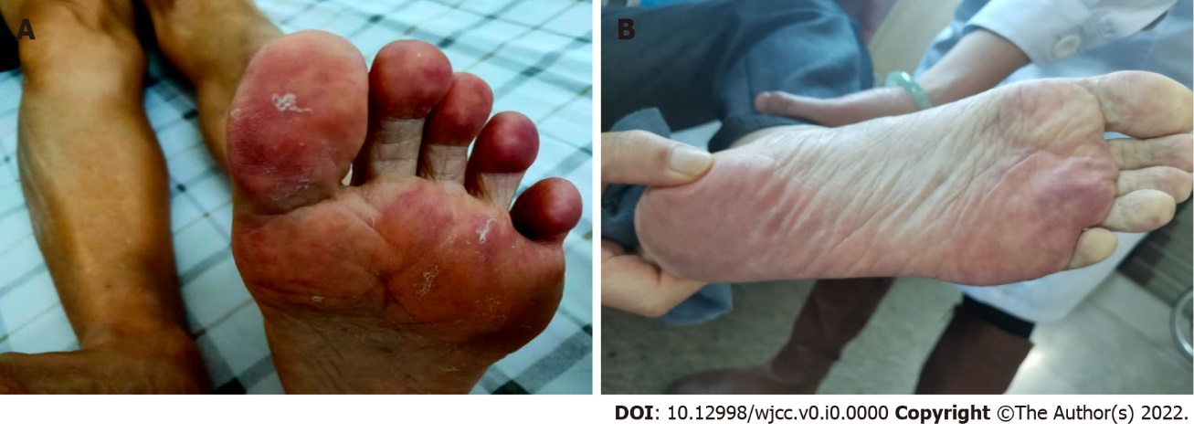
Figure 1 Blue toes on the left foot. A: on admission; B: 8 mo after discharge.
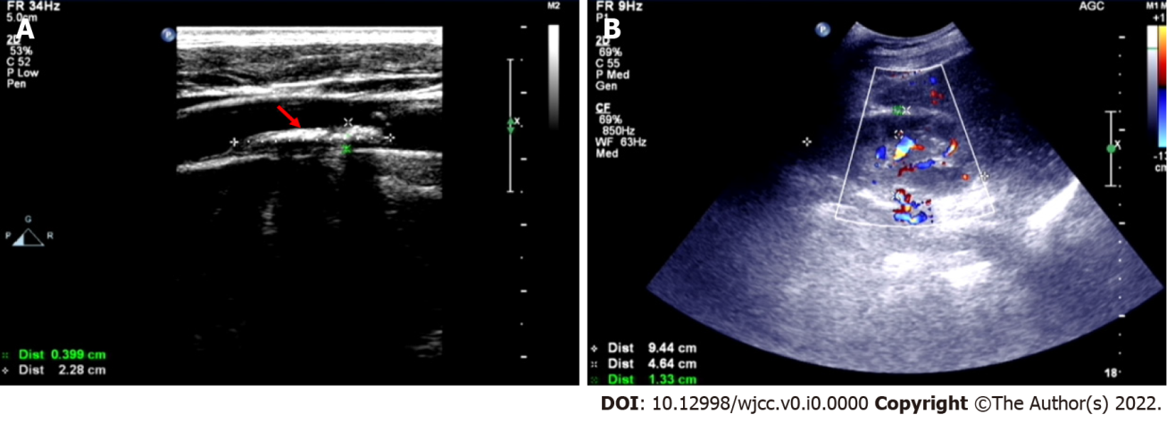
Figure 2 Doppler ultrasonography. A: The red arrow shows carotid plaque formation; B: Kidney parenchymal thickness was approximately 13.3 mm.
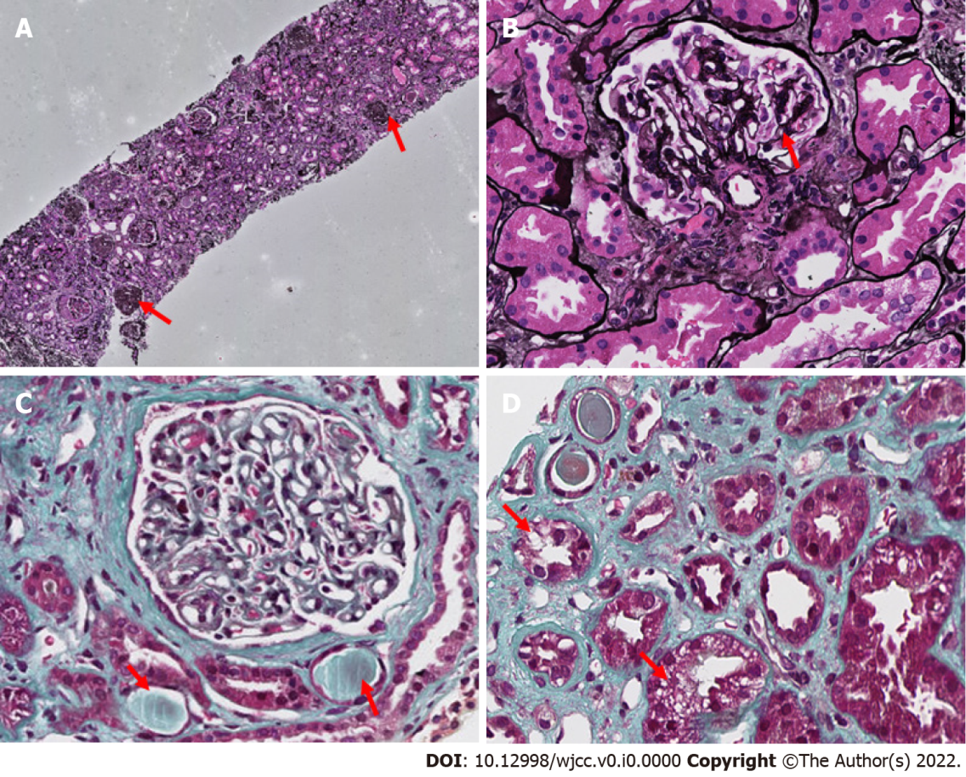
Figure 3 Renal biopsy. A: Red arrow: glomerulus ischemic globular sclerosis (x 100); B: Red arrow: glomerulus ischemic globular sclerosis (x 400); C: Red arrow: cholesterol embolism filling the arteries (x 400); D: Red arrow: epithelial cell cavitation and granular degeneration (x 400).
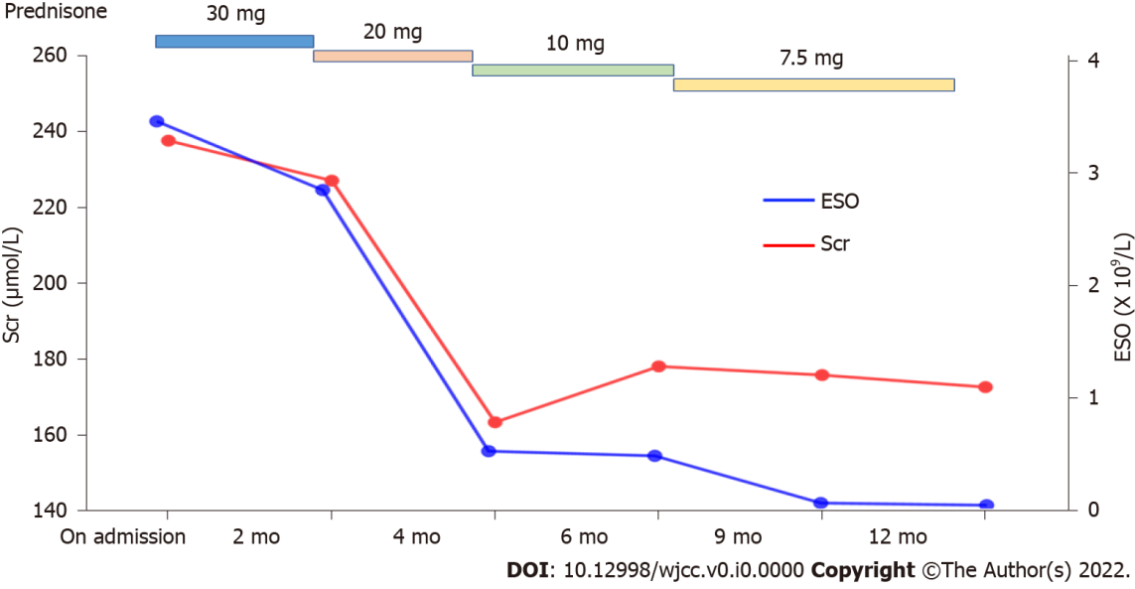
Figure 4 Follow-up period over 12 mo. The reduced regimen of prednisone and the level of serum creatine and eosinophil count are shown. Scr: serum creatine; ESO: eosinophil count.
Table 1 Laboratory results
Items | Reference value | Results
Eosinophil count (x 10⁹/L) | 0.05-0.3 | 3.46
Serum creatinine (mmol/L) | 57-97 | 239
Serum urea (mmol/L) | 3.6-9.5 | 23.32
Cholesterol (mmol/L) | 2.6-5.2 | 3.90
Triglycerides (mmol/L) | 0.34-1.60 | 1.63
HDL-C (mmol/L) | > 1.04 | 1.43
LDL-C (mmol/L) | ≤ 3.37 | 2.19
Urinary protein (g/24 h) | ≤ 0.15 | 0.89
HDL-C: High-density lipoprotein cholesterol; LDL-C: Low-density lipoprotein cholesterol.

