Name of Journal: World Journal of Gastroenterology
ESPS Manuscript NO: 32585
Manuscript Type: ORIGINAL ARTICLE

Clinical Trials Study
Phase I study of personalized peptide vaccination combined with radiotherapy for advanced hepatocellular carcinoma patients

Shen J et al. personalized peptide vaccination in HCC

Jie Shen, Li-Feng Wang, Zheng-Yun Zou, Wei-Wei Kong, Jing Yan, Fan-Yan Meng, Fang-Jun Chen, Juan Du, Jie Shao, Qiu-Ping Xu, Hao-Zhen Ren, Ru-Tian Li, Jia Wei, Xiao-Ping Qian, Bao-Rui Liu

Jie Shen, Li-Feng Wang, Zheng-Yun Zou, Wei-Wei Kong, Jing Yan, Fan-Yan Meng, Fang-Jun Chen, Juan Du, Jie Shao, Qiu-Ping Xu, Ru-Tian Li, Jia Wei, Xiao-Ping Qian, Bao-Rui Liu, the Comprehensive Cancer Centre of Drum Tower Hospital, Medical School of Nanjing University, Clinical Cancer Institute of Nanjing University, Nanjing 210008, Jiangsu Province, China

Hao-Zhen Ren, Department of Hepatobiliary Surgery, Drum Tower Hospital, Medical School of Nanjing University, Nanjing 210008, Jiangsu Province, China

Author contributions: Shen J, Wang LF and Zou ZY were equally contributed to this work; Shen J, Liu BR, Wang LF and Chen FJ are responsible for the study designing and experiment adjustment; Shen J, Zou ZY, Du J and Xu QP and Meng FY performed the experiments involved, draft the manuscript, and conducted statistical analysis; Li RT, Wang LF, Qian XP and Wei J collected the blood sample and clinical information of patients; All authors read and approved the final manuscript.

Support by National Natural Science Foundation of China, No. 81401969; Jiangsu Provincial Medical Youth Talent, No. QNRC2016043; and the Key Medical Science and Technology Development Project of Nanjing, No. ZKX16032.

Institutional review board statement: The study was reviewed and approved by the board of Comprehensive Cancer Centre of Drum Tower Hospital and by the Drum Tower Hospital ethic review board.

Clinical trial registration statement: This registration policy applies to phase I clinical study. This study is registered at http://www.chictr.org.cn/edit.aspx?pid=16964&htm=4. The registration identification number is ChiCTR-OIC-16010025.

Informed consent statement: All study participants, or their legal guardian, provided informed written consent prior to study enrollment.

Conflict-of-interest statement: Not declared.

Data sharing statement: No additional data are available.

Open-Access: This article is an open-access article which selected by an inhouse editor and fully peer-reviewed by external reviewers. It distributed in accordance with the Creative Commons Attribution Non Commercial (CC BY-NC 4.0) license, which permits others to distribute, remix, adapt, build upon this work non-commercially, and license their derivative works on different terms, provided the original work is properly cited and the use is non-commercial. See: http://creativecommons.org/licenses/by-nc/4.0/

Manuscript source: Unsolicited manuscript

Correspondence to: Bao-rui Liu, MD, PhD, Comprehensive Cancer Centre of Drum Tower Hospital, Medical School of Nanjing University, Clinical Cancer Institute of Nanjing University, 321 Zhongshan Rd, Nanjing 210008, Jiangsu Province, China. baoruiliu@nju.edu.cn
Telephone: +86-25-83106666-61331
Fax: +86-25-83105082

Received: January 15, 2016
Peer-review started: January 16, 2016
First decision: February 9, 2017
Revised: February 25, 2017
Accepted: March 4, 2017
Article in press:
Published online:

Abstract
AIM
To conduct a new treatment modality, meaning a cellular immune therapy based on personalized peptide vaccination (PPV-DC-CTL) combined with radiotherapy, to treat advanced hepatocellular carcinoma (HCC).

Methods
A total of 9 patients with advanced HCC were admitted. Multidisciplinary consultation confirmed that all the patients were clearly no surgical opportunity. 4 patients with multiple liver metastases (liver lesions > 3 pieces), 1 patient with liver metastases and portal vein tumor thrombosis, 1 patient with lung and bone metastasis, 2 patients with liver and lung metastasis, and 1 patients with liver metastases and peritoneal metastasis. Patients with metastasis were treated with precise radiotherapy combined with PPV-DC-CTL.

Results
After radiotherapy and 1-3 cycles of PPV-DC-CTL treatment, AFP levels were significantly decreased in 6 patients, of which, imaging assessment of lesions researched PR for 3 patients and SD for another 3 patients. Response rate (RR) was 33%, and disease control rate (DCR) was 66%. This scheme is safe and well tolerated. None of the patients had side effects on liver and kidney function. Only one patient had Grade2 of bone marrow suppression, and the rest had no significant side effects on hemogram.

Conclusion
Radiotherapy combined with PPV-DC-CTL provides a new therapeutic strategy for patients with advanced HCC, which is well tolerated, safe, feasible, and effective.

Key words: Personalized peptide vaccination; TOMO radiotherapy; Cytotoxic lymphocyte; Hepatocellular carcinoma

© The Author(s) 2017. Published by Baishideng Publishing Group Inc. All rights reserved.

Core tip: Advanced hepatocellular carcinoma (HCC) is a challenging disease to treat because of its late stage, rapid progression. We conducted a new treatment modality, meaning a cellular immune therapy based on personalized peptide vaccination (PPV-DC-CTL) combined with radiotherapy, to treat advanced HCC. It integrates personalized peptide vaccination in tumor immunotherapy, takes full advantages of the immune modulation of radiotherapy, promotes tumor cells releasing antigens and results in more effective therapeutic strategy in local control and system treatment.

Shen J, Wang LF, Zou ZY, Kong WW, Yan J, Meng FY, Chen FJ, Du J, Shao J, Xu QP, Ren HZ, Li RT, Wei J, Qian XP, Liu BR. Phase I study of personalized peptide vaccination combined with radiotherapy for advanced hepatocellular carcinoma patients. World J Gastroenterol 2017; In press

Introduction
Hepatocellular carcinoma (HCC) is the top fifth common cancer and the top third leading cause of cancer death all over the world^{[1]}. The resection rate is approximately 10%–30% for HCC and the overall prognosis is very poor with a 5-year survival rate of 5%–6%^{[2]}. There was a high recurrence rate after radical resection. Besides surgery, radiofrequency ablation, transcatheter arterial chemoembolization (TACE), microwave ablation, cryoablation, radioactive seeds implantation, high-intensity–focused ultrasound, radiation therapy, chemotherapy and targeted drug are available for those un-respectable patients; however, the efficacy rate and long-term prognosis is quite limited^{[3]}. Moreover, because the serious side effect of treatment, such as TACE, chemotherapy and targeted drug, it may be impossible for patient to keep receiving.
Because of the latest progress in other tumors especially melanoma, immunotherapy carries high expectation for decades in HCC treatment^{[4]}. Liver as metabolizing organ and immune organ has unique characteristics, and patients with HCC present with special anti- and pro-tumor responseduring the development of tumor^{[4-6]}. Currently, many cancer vaccination strategies, which is on the basis of the TAA (tumor-associated antigens) identified in different tumors, have been investigated^{[7,8]}. However, it is disappointing that therapeutic vaccines for HCC are still inaccessible, though the application of prophylactic vaccine, including HBV vaccine, has been reported to decrease the prevalence of HCC patients . Numerous factors constraint the tumor vaccine researches which are concerned with the way to stimulate the immune system of the host to kill the cancer cell. Among these reasons shortageof TAA or tumor specific antigens is the most important one^{[9]}.
Recently, “personalized peptide vaccination’’,also named PPV, a novel immunotherapeutic approach based on a specific pool of peptides, were produced. The pool of peptides included all information about the personal human leukocyte antigen class 1A type (HLA class 1A) and the preexisting immunity of the host before vaccination. So, selected from this pool, maximum of four HLA class 1A-matched peptides would be used for the PPV^{[7]}. Compared with other immunotherapy, there were several advantages in the PPV. Firstly, it could increase the possibility of avoiding both tumor heterogeneity and immunological diversity. Secondly, vaccination used ‘‘personalized’’ antigen with pre-existing immunity could trigger antigenspecific memory T cell to produce secondary immune responses in more rapid and stronger way. Moreover, one of the important characteristics of PPVs is that they could activate Cytotoxic lymphocyte(CTL) cells, which have stronger antitumor cytotoxicity, higher proliferative ability and more cytolytic activity than lymphokineactivated killer cell in vitro and in vivo. Recent studies suggest immunotherapy of cytotoxic lymphocytes cells play an important role in preventing HCC recurrence and metastasis^{[4-6]}.
In order to improve efficacy rate and reduce side effect of treatment, we start a clinical trial (phase I) to treat un-respectable HCC patients with radiation therapy combined with immunotherapy of PPV-DC-CTL. We successfullydeveloped a new PPV-based immunotherapeutic approach by using a maximum of four HLA class 1A-matched peptides selected from the pooled peptides of the host.

MATERIALS AND METHODS
Patients
This study was approved by the Drum Tower Hospital ethic review board. A total of 9 patients with advanced HCC were admitted. Multidisciplinary consultation confirmed that all the patients were clearly no surgical opportunity. 4 patients with multiple liver metastases (liver lesions > 3 pieces), 1 patient with liver metastases and portal vein tumor thrombosis, 1 patient with lung and bone metastasis, 2 patients with liver and lung metastasis, and 1 patients with liver metastases and peritoneal metastasis (Table 1).

Treatment schedule
Radiotherapy: Patients with liver metastasis, portal vein tumor thrombus and pulmonary metastasis were treated with precise radiotherapy (PGTV 5Gy*10f; PTV 2.5Gy*10f) combined with PPV-DC-CTL; patients with bone metastasis cancer were treated with precise radiotherapy of bone (PGTV 4Gy*10f; PTV 3Gy*10f) combined with PPV-DC-CTL; patients with peritoneal metastasis were treated with precise TOMO radiotherapy of peritoneum (PTV 0.5Gy bid *2f) combined with PPV-DC-CTL.

Selection for PPV: First, peptide candidate library, including mutation peptides and high expression peptides, were established according to gene mutation spectrum of hepatocarcinoma and previous researches about personalized peptide vaccination. Peptides for vaccination of everyspecific patient were selected from the peptide candidate library with the consideration of the preexisting immunity of the host before vaccination. The detailed procedure was described in reference^{[7,9]} and the personalized peptides for these nine patients are as follows:
P1：CORE-18, MUC-12, KRAS-A02-G13D1, PSCA-76
P2：PI3KCA-A02-H1047L-1, CORE-35, WTP53-149, AFP-137
P3：EGFR-800, KRAS-A11-G13D, CYPB-84, CTNNB1-A11-S45F
P4：KRAS11-12C, EGFR-54, AFP-403, Survivin28-80
P5：AFP-357, VEGFR2-169, KRAS-A11-12C, MRP3-1293
P6：KRAS-A11-12D, CTNNB1-A11-41A, CTNNB1-A11-S45F, KRAS-A11-12R
P7:SART3-109, CORE-18, PSCA-7, hTERT-540
P8：AFP-357, KRAS-A11-12D, VEGFR2-169, PSCA-776
P9：CTNNB1-A11-S45F, CTNNB11-41A, CTNNB11-45P, EGFR-54

Collection of peripheral blood mononuclear cells and transfusion of DC-CTL: PPV were load in DC (D0), which was sorted from peripheral blood mononuclear cells (PBMC), and then these DC were infused back to patients after cultured for 7 d in vitro (D7). To get the CTL, we used PPV and PPV-DC to stimulate the T cells. In 12 to 15 d, these CTL were transfused to patients (D12-15). The steps above defined as one cycle and it was repeated every 21 d.

Main outcome measures
To assess the immune responses and other effects to PPV, the level of CD3+, CD8+, CD4+, NK and B lymphocyte was examined prior to blood collection and after CTL transfusion. AFP test was performed once a cycle after vaccinations. Tests of blood routine, liver and kidney function were also carried on once a cycle. Monitor of other side effects of patients include rash, fever, and diarrhea.

Radiological evaluation
The clinical response is evaluated by CT(computed tomography ) scan and abdominal MRI(magnetic resonance imaging) prior to vaccination and once two cycles therapy. The RESIST-based clinical responses levels were assessed by PR, SD and PD. The percentage of RR refers to the effectiveness rate of treatment while PR and SD refer to disease control rate (DCR).

Ethical permission
Thisclinical trial was approved by the Drum Tower Hospital ethic review board. Every patient has been informed of the protocolof the study and signed an informed consent form.

Statistical analyses
Paired-samples t test was used to compare the levels of CD3+, CD8+, CD4+, NK and B lymphocyte between prior to blood collection and after CTL transfusions. Statistical significance was set at P < 0.05. Statistical analyses were finished by using SPSS, version 19.0.

Results
After radiotherapy and 1-3 cycles of PPV-DC-CTL treatment, AFP levels were significantly decreased in 6 patients, of which, imaging assessment of lesions researched PR for 3 patients and SD for another 3 patients. Response rate (RR) was 33%, and disease control rate (DCR) was 66% (Table 2). This scheme is safe and well tolerated. None of the patients had side effects on liver and kidney function. Only one patient had Grade 2 of bone marrow suppression, and the rest had no significant side effects on hemogram. Only two patients had Grade1 of rash, and the rest had no side effects on skin and other system. Six patents had low-grade fever (37-38 ℃), and none of the patients had diarrhea (Table 3).
As indicated in Figure 3, the levels of AFP were significantly decreased in Patients 1 to 6. At the same time, the degrees of their radiological evaluation performed PR or SD. Radiation treatment can have partial effect for Patient 1 on certain tumor lesion. However, because of its large size, radiation may not cover all the tumor metastasis on liver. Fortunately, with a combination of radiotherapy and PPV-DC-CTL, the liver mass within and without radiation field were both significantly decreased in size after treated (Figure 4). This result suggested that the vaccine and CTL-based immune therapy and radiotherapy work together to reduce the progress of tumor cells even for those didn’t receive radiation. Patient 4 was a case with tumor metastasis in T4 vertebra and lung. After treated with a combination of radiotherapy and PPV-DC-CTL, AFP had a significant decline as well as chest pain released. This provided further evidence that a synergistic combination of radiotherapy and PPV-DC-CTL effectively controlled the tumor lesions, in this case was in lung, which didn’t receive radiation (Figure 5).
Four of nine patients finished three cycles of PPV-DC-CTL treatment, four patients finished two cycles and the remained one patient only received one cycle of treatment. Patient 3 didn’t continue the 3rd cycle of PPV-DC-CTL treatment due to the state of carcinoma emboli in the portal veins had been controlled after treatment. He felt better than before and took sorafenib instead. This patient was diagnosed in 2015-04 with the last follow-up in 2016-06. Compared with the average overall survival time of carcinoma emboli in the portal veins reported in previous studies, his was much longer (14 mo vs 3 mo).Because of the decrease of tumor makers, patient 5 and patient 6 both finished their combination treatment in the end of the 2ndcycle. Patient 5 took sorafenib instead and patient 6 took Chinese Medicine. Up to now, these two patients are still alive and their OS has been over 10 months. Patient 8 quit this clinical trial according to the rise of tumor markers after the 1st cycle. Patient 9 didn’t continue treatment because of rash. However, compared with pretreatment, patient 8 and patient 9 had better condition after PPV-DC-CTL treatment.
In addition, cellular immune responses specific to the treatment, including the levels of CD3+, CD8+, CD4+, NK and B lymphocyte, were analyzed in blood samples prior to blood collection and after CTL transfusion in every cycles. It found that CD3+, CD8+ cytotoxic T lymphocytes and NK lymphocyte were all increased after CTL transfusion(paired-samples t test, P < 0.05), suggesting the possibility of immune activation (Table 4, Figure 6). However, B lymphocyte was decreased, while CD4+ cytotoxic T lymphocytes had no significant trends of changes.

Discussion
As far as we know, this is the first report of the application and value of radiotherapy combined with PPV-DC-CTL in the treatment of advanced HCC. In the treatment of 9 patients, the program has no obvious side effects, but good tolerance, and well disease control with disease response rate of 33% and disease control rate of 66%, significantly better than TACE, sorafenib and chemotherapy^{[10]}.
It is hypothesized that, in some cases, radiotherapy may successfully immunize the patient against the cancer, converting the irradiated tissue into an in situ vaccine and endowing the host with a set of new and powerful tools to master systemic disease^{[11]}. Radiotherapy can be applied as a more general “immune response modifier”, a novel tool to add to the arsenal of immunotherapy agents, but the response varies with the size of dose per fraction^{[12-16]}. It is still unclear how the host-tumor relationship is affected by radiation, but it has been proved that when moving away from the 2 Gy/fraction, 5-fractions-a-week conventional schedule to 5 Gy/fraction-10 Gy/fraction schedule, the immune effect will be more significant^{[17]}. The potential exists for higher peak integrated “danger” signals as a result of more rapid cell kill, more vascular damage, and inflammatory cytokine induction at higher radiation doses. Therefore, in this context, the radiotherapy dose we choose for liver and lung metastasis were 5 Gy/fraction, 5-fractions-a-week schedule. For one thing, it can improve the local control, for the other thing, this schedule can increase immune effect. But we chose 4 Gy/fraction, 5-fractions-a-week schedule for bone metastasis in order to protect the spinal cord. For peritoneal metastasis, we chose 0.5 Gy/fraction BID, 2-fractions schedule with the purpose to deduce the side effect on colon and increase the effect of immune.
Based on preexisting host immunity,quite a lot of peptide antigens selectedand screened from vaccine candidates are appropriate for this treatment formula. In the earlierstudies of PPV, the assayof peptidespecific IFN-γ production with an average cut-off level of 1 in 10000 cells was used to define the preexisting immunity. Because it isdiscovered that the enlargement and magnitude of CTL activation will depend on the frequency of peptidespecific CTL precursor fromPBMC partly^{[7,18]}. Actually, when CTL precursors aretested in PBMCbefore vaccination and then followed by the administration of specific peptides, strong and rapid stimulation of CTL withpotent clinical benefitwill be induced in specific patients as reported in some clinical trials of advanced cancer^{[19,20]}.
Until now, a quite number of phase I and II clinical trials with PPV has been carried out^{[7]}. All the trials mentioned above indicate that PPVs arewell tolerated and safe immunotherapy without seriousadverse effects and they can stimulatemuch stronger immune response in certain patients. Evaluated by the criteria of response evaluation, some patients received PPV exhibited objective clinical responses with boosted immune responses^{[20]}. According to the current study, we also have designed and conducted a phase I clinical trial for advanced HCC patients. Firstly, we developed a new immunotherapeuticstrategy of personalized peptide vaccination, according to the mutation spectrum of liver cancer and the previous literature on vaccine peptides; and then, we stimulated a group of strong activation of CTL with PPV loaded DC cell, and transfusion into patients to increase the effect of immunotherapy. At the same time, radiation is combined to help release vaccine in situ and to control the disease in time. It is no doubt that PPV-DV-CTL and radiation were synergetic, especially for Patient1 and 4, the tumor within and without radiation field were both decreased in size or keep stable after treated. Another advantage of this combined treatment schedule is to avoid the side effect of chemotherapy and the embraces of the limitation of radiation therapy for wide metastasis.
In the current study, we have shown the potential of PPVs as novel treatment strategyfor advanced liver cancerpatients. Randomized clinical trials will be essential tofurtherverifythe clinical benefit of PPVs in liver cancer patients. At the same time, accurate biomarkersofpredicting patients who could get benefits most from the PPV-based treatment remain to be discovered and identified.

COMMENTS
Background
Advanced hepatocellular carcinoma (HCC) is a challenging disease to treat because of its late stage, rapid progression. The resection rate is only 10%–30% for HCC and the overall prognosis is very poor with a dismal 5-year survival rate of approximately 5%–6%. There was a high recurrence rate after radical resection. Besides surgery, radiofrequency ablation, transcatheter arterial chemoembolization, microwave ablation, cryoablation, radioactive seeds implantation, high-intensity–focused ultrasound, radiation therapy, chemotherapy and targeted drug are available for those un-respectable patients; however, the efficacy rate and long-term prognosis is quite limited. The authors conducted a new treatment modality, meaning a cellular immune therapy based on personalized peptide vaccination (PPV-DC-CTL) combined with radiotherapy, to treat advanced HCC. It integrates personalized peptide vaccination in tumor immunotherapy, takes full advantages of the immune modulation of radiotherapy, promotes tumor cells releasing antigens and results in more effective therapeutic strategy in local control and system treatment.

Research frontiers
Immunotherapy which is explored in HCC for decades carries high expectations. Liver which differs from other organs shows its distinguished characteristics, such as an “immune organ”, and patients with HCC present with unique anti- or pro-tumor responses during the development and progression of HCC. Currently, many cancer vaccination strategies, which is on the basis of the tumor-associated antigens (TAA) identified in different tumor histological types, have been investigated. However, it is disappointing that a therapeutic vaccine for HCC is still inaccessible, though the application of prophylactic vaccines for HCC, like HBV vaccine, has been reported to decrease the prevalence of HCC patients. Numerous factors constraint the tumor vaccine researches which are concerned with the way to trigger the host immune system to remove cancer cells. In the current study, the authors conducted a new treatment modality, meaning a cellular immune therapy based on personalized peptide vaccination (PPV-DC-CTL) combined with radiotherapy, to treat advanced HCC. It integrates personalized peptide vaccination in tumor immunotherapy, takes full advantages of the immune modulation of radiotherapy, promotes tumor cells releasing antigens and results in more effective therapeutic strategy in local control and system treatment.

Innovations and breakthroughs
As far as we know, this is the first report of the application and value of radiotherapy combined with PPV-DC-CTL in the treatment of advanced HCC. In the current study, the authors have shown promising results of PPV as a new treatment modality for patients with advanced liver cancer. Further randomized phase II clinical trials are essential to prove the clinical benefits of PPV in liver cancer patients. In addition, novel biomarkers for selecting patients who would benefit most from PPV remain to be identified.

Applications
Radiotherapy combined with PPV-DC-CTL provides a new therapeutic strategy for patients with advanced HCC, which is well tolerated, safe, feasible, and effective.

Terminology
PPV-DC-CTL refers to personalized peptide vaccination. It is a novel immunotherapeutic approach based on a specific pool of peptides. The pool of peptides included all information about the personal human leukocyte antigen (HLA) class IA type and the preexisting host immunity before vaccination. So, selected from this pool, maximum of four HLA class IA-matched peptides would be used for the PPV. Compared with other immunotherapy, there were several advantages in the PPV. Firstly, it could increase the possibility of bypassing both immunological diversity and tumor heterogeneity. Secondly, vaccination used ‘‘personalized’’ antigens with preexisting immunity could stimulate antigen-specific memory T cells to produce secondary immune responses in more rapid and stronger way. Moreover, one of the notable characteristics of PPV is to activate Cytotoxic lymphocyte(CTL) cells, which have stronger antitumor cytotoxicity, higher proliferative and more cytolytic activity than lymphokine-activated killer cells in vitro and in vivo.

Peer–review
In this paper, the issue proposed by the authors is an important and potential method in the future but some methodological shortcoming and the design should be clearly exposed. The present study includes a total of nine patients. Usually, the phase I study includes a small sample size (20 to 100, typically around 20). Despite the small number of patients included in the present study (nine patients with advanced hepatocellular carcinoma), it is interesting. The title reflects the contents of the manuscript. The structure is good and concise.

References
1 Siegel RL, Miller KD, Jemal A. Cancer Statistics, 2017. CA Cancer J Clin 2017; 67: 7-30 [PMID: 28055103 DOI: 10.3322/caac.21387]
2 Buonaguro L, Petrizzo A, Tagliamonte M, Tornesello ML, Buonaguro FM. Challenges in cancer vaccine development for hepatocellular carcinoma. J Hepatol 2013; 59: 897-903 [PMID: 23714157 DOI: 10.1016/j.jhep.2013.05.031]
3 Dhir M, Melin AA, Douaiher J, Lin C, Zhen WK, Hussain SM, Geschwind JF, Doyle MB, Abou-Alfa GK, Are C. A Review and Update of Treatment Options and Controversies in the Management of Hepatocellular Carcinoma. Ann Surg 2016; 263: 1112-1125 [PMID: 26813914 DOI: 10.1097/SLA.0000000000001556]
4 Prieto J, Melero I, Sangro B. Immunological landscape and immunotherapy of hepatocellular carcinoma. Nat Rev Gastroenterol Hepatol 2015; 12: 681-700 [PMID: 26484443 DOI: 10.1038/nrgastro.2015.173]
5 Lee JH, Lee JH, Lim YS, Yeon JE, Song TJ, Yu SJ, Gwak GY, Kim KM, Kim YJ, Lee JW, Yoon JH. Adjuvant immunotherapy with autologous cytokine-induced killer cells for hepatocellular carcinoma. Gastroenterology 2015; 148: 1383-91.e6 [PMID: 25747273 DOI: 10.1053/j.gastro.2015.02.055]
6 Hong YP, Li ZD, Prasoon P, Zhang Q. Immunotherapy for hepatocellular carcinoma: From basic research to clinical use. World J Hepatol 2015; 7: 980-992 [PMID: 25954480 DOI: 10.4254/wjh.v7.i7.980]
7 Noguchi M, Sasada T, Itoh K. Personalized peptide vaccination: a new approach for advanced cancer as therapeutic cancer vaccine. Cancer Immunol Immunother 2013; 62: 919-929 [PMID: 23197273 DOI: 10.1007/s00262-012-1379-1]
8 Yamada A, Sasada T, Noguchi M, Itoh K. Next-generation peptide vaccines for advanced cancer. Cancer Sci 2013; 104: 15-21 [PMID: 23107418 DOI: 10.1111/cas.12050]
9 Yamada T, Terazaki Y, Sakamoto S, Yoshiyama K, Matsueda S, Komatsu N, Waki K, Yamada A, Kawahara A, Kage M, Sugawara S, Yamashita Y, Sasada T, Takamori S, Itoh K. Feasibility study of personalized peptide vaccination for advanced non-small cell lung cancer patients who failed two or more treatment regimens. Int J Oncol 2015; 46: 55-62 [PMID: 25310280 DOI: 10.3892/ijo.2014.2699]
10 Qin S, Bai Y, Lim HY, Thongprasert S, Chao Y, Fan J, Yang TS, Bhudhisawasdi V, Kang WK, Zhou Y, Lee JH, Sun Y. Randomized, multicenter, open-label study of oxaliplatin plus fluorouracil/leucovorin versus doxorubicin as palliative chemotherapy in patients with advanced hepatocellular carcinoma from Asia. J Clin Oncol 2013; 31: 3501-3508 [PMID: 23980077 DOI: 10.1200/JCO.2012.44.5643]
11 Formenti SC, Demaria S. Radiation therapy to convert the tumor into an in situ vaccine. Int J Radiat Oncol Biol Phys 2012; 84: 879-880 [PMID: 23078897 DOI: 10.1016/j.ijrobp.2012.06.020]
12 Formenti SC, Demaria S. Combining radiotherapy and cancer immunotherapy: a paradigm shift. J Natl Cancer Inst 2013; 105: 256-265 [PMID: 23291374 DOI: 10.1093/jnci/djs629]
13 Matsumura S, Wang B, Kawashima N, Braunstein S, Badura M, Cameron TO, Babb JS, Schneider RJ, Formenti SC, Dustin ML, Demaria S. Radiation-induced CXCL16 release by breast cancer cells attracts effector T cells. J Immunol 2008; 181: 3099-3107 [PMID: 18713980]
14 Golden EB, Chhabra A, Chachoua A, Adams S, Donach M, Fenton-Kerimian M, Friedman K, Ponzo F, Babb JS, Goldberg J, Demaria S, Formenti SC. Local radiotherapy and granulocyte-macrophage colony-stimulating factor to generate abscopal responses in patients with metastatic solid tumours: a proof-of-principle trial. Lancet Oncol 2015; 16: 795-803 [PMID: 26095785 DOI: 10.1016/S1470-2045(15)00054-6]
15 Klug F, Prakash H, Huber PE, Seibel T, Bender N, Halama N, Pfirschke C, Voss RH, Timke C, Umansky L, Klapproth K, Schäkel K, Garbi N, Jäger D, Weitz J, Schmitz-Winnenthal H, Hämmerling GJ, Beckhove P. Low-dose irradiation programs macrophage differentiation to an iNOS⁺/M1 phenotype that orchestrates effective T cell immunotherapy. Cancer Cell 2013; 24: 589-602 [PMID: 24209604 DOI: 10.1016/j.ccr.2013.09.014]
16 Yang G, Kong Q, Wang G, Jin H, Zhou L, Yu D, Niu C, Han W, Li W, Cui J. Low-dose ionizing radiation induces direct activation of natural killer cells and provides a novel approach for adoptive cellular immunotherapy. Cancer Biother Radiopharm 2014; 29: 428-434 [PMID: 25402754 DOI: 10.1089/cbr.2014.1702]
17 Schaue D, Ratikan JA, Iwamoto KS, McBride WH. Maximizing tumor immunity with fractionated radiation. Int J Radiat Oncol Biol Phys 2012; 83: 1306-1310 [PMID: 22208977 DOI: 10.1016/j.ijrobp.2011.09.049]
18 Hida N, Maeda Y, Katagiri K, Takasu H, Harada M, Itoh K. A simple culture protocol to detect peptide-specific cytotoxic T lymphocyte precursors in the circulation. Cancer Immunol Immunother 2002; 51: 219-228 [PMID: 12012109 DOI: 10.1007/s00262-002-0273-7]
19 Mine T, Gouhara R, Hida N, Imai N, Azuma K, Rikimaru T, Katagiri K, Nishikori M, Sukehiro A, Nakagawa M, Yamada A, Aizawa H, Shirouzu K, Itoh K, Yamana H. Immunological evaluation of CTL precursor-oriented vaccines for advanced lung cancer patients. Cancer Sci 2003; 94: 548-556 [PMID: 12824881]
20 Tsuda N, Mochizuki K, Harada M, Sukehiro A, Kawano K, Yamada A, Ushijima K, Sugiyama T, Nishida T, Yamana H, Itoh K, Kamura T. Vaccination with predesignated or evidence-based peptides for patients with recurrent gynecologic cancers. J Immunother 2004; 27: 60-72 [PMID: 14676634]

P-Reviewer: Facciorusso A, Kao JT, Streba LAM S-Editor: Ma YJ L-Editor: E-Editor:

Specialty type: Gastroenterology and hepatology
Country of origin: China
Peer-review report classification
Grade A (Excellent): 0
Grade B (Very good): 0
Grade C (Good): C, C, C
Grade D (Fair): 0
Grade E (Poor): 0

Table 1 characteristics of all the patients
Patients | Age | Sex | BCLC | HK | Tumor sites | Tumor of radiotherpy | Dose of radiotherpy | Cycle of PPV-DC-CTL
P1 | 66 | Male | B | IIIB | Liver | Partial liver mass | PGTV 5Gy*10fPTV2.5Gy*10f | 3
P2 | 56 | Female | B | IIIB | Liver | Partial liver mass | PGTV 5Gy*10f PTV2.5Gy*10f | 3
P3 | 54 | Male | C | IVa | Liver and portal vein tumor thrombosis | Portal vein tumor thrombosis | PGTV 5Gy*10fPTV2.5Gy*10f | 2
P4 | 37 | Male | C | IVa | Bone and lung | Bonemetastasis | PGTV 4Gy*10f PTV3Gy*10f | 3
P5 | 56 | Male | C | IVa | Liver and peritoneal metastasis | Peritoneal metastasis | PTV0.5Gy BID *2f | 2
P6 | 45 | Male | B | IIIB | Liver | — | — | 2
P7 | 43 | Male | B | IIIB | Liver | Partial liver mass | PGTV 5Gy*10f PTV2.5Gy*10f | 3
P8 | 59 | Male | C | IVa | Liver and lung | Partiallung mass | PGTV 5Gy*10f PTV2.5Gy*10f | 1
P9 | 72 | Male | C | IVa | Lung | — | — | 2

Table 2 clinical outcome of the nine patients received the radiotherapy combined with PPV-DC-CTL immunotherapy
Patient | Change of AFP | AFP before treatment | AFP after first cycle | AFP after second cycle | AFP after third cycle | Radiological evaluation
P1 | ↓ | 168.5 | 118.0 | 29.7 | 27.3 | PR
P2 | ↓ | 94.9 | 53.8 | 59.8 | 50.2 | PR
P3 | ↓ | 4942.3 | 3297.1 | 3180.0 | — | PR
P4 | ↓ | 1691.6 | 619.7 | 312.2 | 302.0 | SD
P5 | ↓ | 45.7 | 25.9 | 24.1 | — | SD
P6 | ↓ | 11.6 | 1.7 | 2.9 | — | SD
P7 | ↑ | 1029.7 | 1700.0 | 3800.0 | 3818.3 | PD
P8 | ↑ | 737.8 | 2005.6 | — | — | PD
P9 | ↑ | 157.5 | 294.1 | 248.0 | — | PD

Table 3 side effect of the nine patients received the radiotherapy combined with PPV-DC-CTL immunotherapy
 | Grade 1 | Grade 2 | Grade 3 | Grade 4
Constitutional symptom
Fever | 6 | 0 | 0 | 0
Tumor pain | 0 | 0 | 0 | 0
Rash | 2 | 0 | 0 | 0
Diarrhea | 0 | 0 | 0 | 0
Respiratory
Dyspnea | 0 | 0 | 0 | 0
Hypoxia | 0 | 0 | 0 | 0
Neurological
CNS cerebrovascular ischemia | 0 | 0 | 0 | 0
Blood/bone marrow
Anemia | 2 | 0 | 0 | 0
Neutropenia | 0 | 1 | 0 | 0
Lymphocytopenia | 0 | 0 | 0 | 0
Thrombocytopenia | 3 | 0 | 0 | 0
Metabolic and laboratory
AST increased | 0 | 0 | 0 | 0
ALT increased | 0 | 0 | 0 | 0
Scr increased | 0 | 0 | 0 | 0
BUN increased | 0 | 0 | 0 | 0

Table 4 change of lymphocytes before and after treatment
 | CD3⁺ | CD4⁺ | CD8⁺ | NK | B
Before treatment | 54.7%±18.5% | 32.3%±11.9% | 15.4%±7.0% | 16.0%±9.3% | 8.5%±5.3%
After treatment | 76.9%±16.1% | 37.9%±11.0% | 32.0%±14.8% | 23.8%±14.8% | 2.8%±3.1%

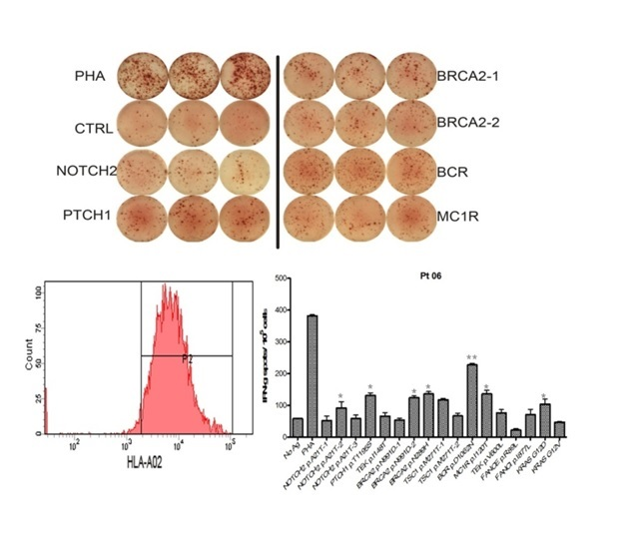
Figure 1 Selection for personalized peptide vaccination from the peptide candidate library in consideration of the pre-existing host immunity by the peptide-specific IFN-γ production assay.

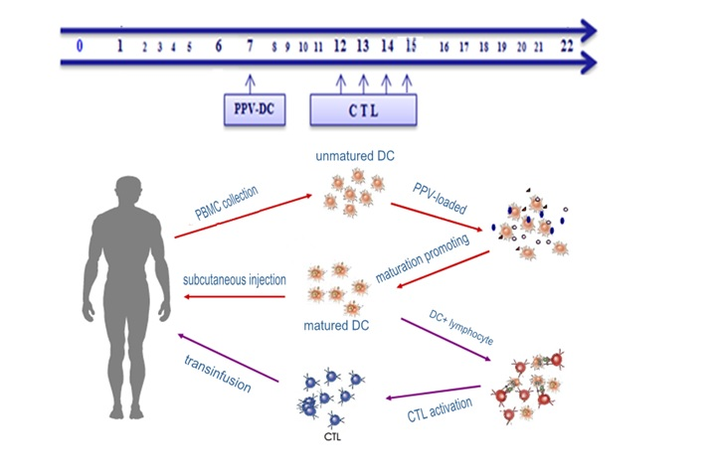
Figure 2 time schedule of collection of peripheral blood mononuclear cells and transfusion of DC-CTL. PPV: personalized peptide vaccination; CTL: Cytotoxic lymphocyte; PBMC: peripheral blood mononuclear cells.

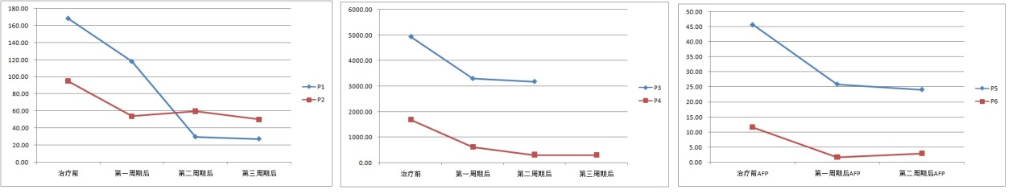
a b c
Figure 3 change of AFP levels of Patients 1-6 before and after treament. A: AFP levels of Patents 1-2; B: AFP levels of Patents 3-4; C: AFP levels of Patents 5-6.

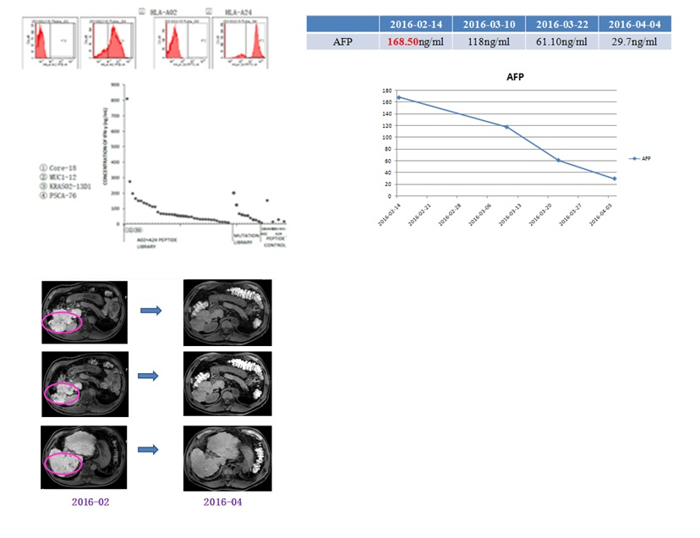
Figure 4 treatment outcome of Patient 1. The liver mass within and without radiation field were both significantly decreased in size after treated with a combination of radiotherapy and PPV-DC-CTL. AFP had a significant decline as well.

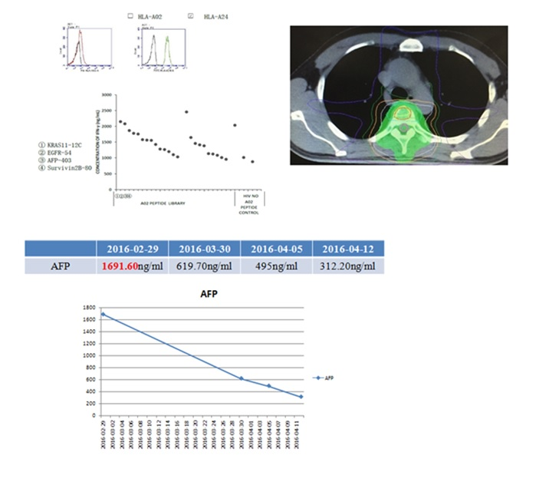
Figure 5 Patient 4 was a case with tumor metastasis in T4 vertebra and lung. After treated with a combination of radiotherapy and PPV-DC-CTL, AFP had a significant decline as well as chest pain released.

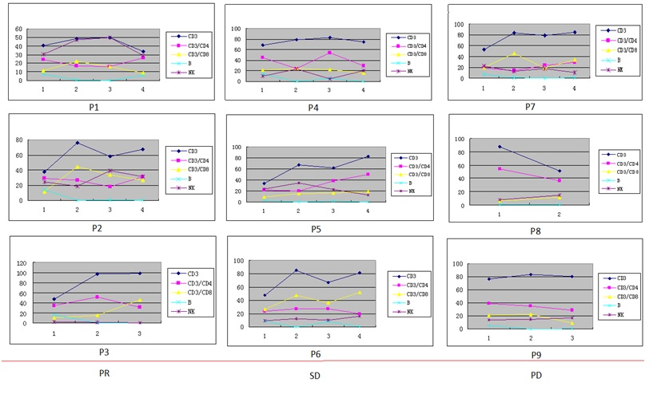
Figure 6 After treatments of PPV-DC-CTL, CD3+, CD8+ cytotoxic T lymphocytes and NK lymphocyte were increased after CTL transfusion in most cases, suggesting the possibility of immune activation. Other lymphocytes had no significant trends of changes.

