Name of Journal: World Journal of Gastrointestinal Endoscopy

ESPS Manuscript NO: 19911

Manuscript Type: MINIREVIEWS

Advanced endoscopic imaging of indeterminate biliary strictures

Tabibian JH et al. Endoscopy for indeterminate biliary strictures

James H Tabibian, Kavel H Visrodia, Michael D Levy, Christopher J Gostout

James H Tabibian, Michael D Levy, Christopher J Gostout, Division of Gastroenterology and Hepatology, Mayo Clinic, Rochester, MN 55905, United States

James H Tabibian, Division of Gastroenterology, Wilmott Center for Endoscopic Innovation, Research, and Training, University of Pennsylvania, Philadelphia, PA 19104, United States

Kavel H Visrodia, Department of Internal Medicine, Mayo Clinic, Rochester, MN 55905, United States

Author contributions: Tabibian JH and Visrodia KH contributed equally to this work; Tabibian JH and Visrodia KH performed the literature review for relevant content; Tabibian JH and Visrodia KH composed a first draft; Levy MD and Gostout CJ provided supervision and critical revisions of the manuscript; all authors approved of the manuscript.

Open-Access: This article is an open-access article which was selected by an in-house editor and fully peer-reviewed by external reviewers. It is distributed in accordance with the Creative Commons Attribution Non Commercial (CC BY-NC 4.0) license, which permits others to distribute, remix, adapt, build upon this work non-commercially, and license their derivative works on different terms, provided the original work is properly cited and the use is non-commercial. See: http://creativecommons.org/licenses/by-nc/4.0/

Correspondence to: Dr. Christopher J Gostout, Division of Gastroenterology and Hepatology, Mayo Clinic, 200 First St. SW, Rochester, MN 55905, United States. gostout.christopher@mayo.edu
Telephone: +1-507-2841649

Received: May 25, 2015
Peer-review started: May 26, 2015
First decision: July 3, 2015
Revised: August 26, 2015
Accepted: October 20, 2015
Article in press:
Published online:

Abstract
Endoscopic evaluation of indeterminate biliary strictures (IDBSs) has evolved considerably since the development of flexible fiberoptic endoscopes over 50 years ago. Endoscopic retrograde cholangiography pancreatography (ERCP) was introduced nearly a decade later and has since become the mainstay of therapy for relieving obstruction of the biliary tract. However, longstanding methods of ERCP-guided tissue acquisition (i.e., biliary brushings for cytology and intraductal forceps biopsy for histology) have demonstrated disappointing performance characteristics in distinguishing malignant from benign etiologies of IDBSs. The limitations of current technologies have thus helped drive the search for novel techniques to enhance the evaluation of IDBSs to improve diagnosis and clinical care. These modalities include, but are not limited to, endoscopic ultrasound, intraductal ultrasound, cholangioscopy, confocal microendoscopy, and optical coherence tomography. In this review, we discuss the established and newer options in the evaluation of IDBSs.

Key words: Gastrointestinal endoscopy; Cholangiocarcinoma; Pancreatic adenocarcinoma; Bile duct diseases; Cholangiopathies

© The Author(s) 2015. Published by Baishideng Publishing Group Inc. All rights reserved.

Core tip: Indeterminate biliary strictures (IDBSs) remain a considerable challenge for endoscopists, clinicians, surgeons, and other medical professionals as well as patients. The limitations of current technologies have helped drive the search for novel techniques aimed to enhance the evaluation of IDBSs and thereby improve diagnosis and clinical care. Here we review existing and emerging techniques and provide a synopsis of current understanding of their strengths, limitations, and role in the evaluation of IDBSs.

Tabibian JH, Visrodia KV, Levy MD, Gostout CJ. Advanced endoscopic imaging of indeterminate biliary strictures. World J Gastrointest Endosc 2015; In press
INTRODUCTION
A substantial proportion of biliary strictures cannot be classified as benign or malignant on the basis of non-invasive imaging, endoscopic retrograde cholangiography (ERCP), and/or routine tissue sampling methods (i.e., biliary brushing, intraductal forceps biopsy)^{[1]}. Although the addition of fluorescence in situ hybridization (FISH) to conventional biliary cytology has been useful in targeting strictures with a higher suspicion for malignancy which may benefit from closer follow-up, sensitivity remains low. As a result, these “indeterminate biliary strictures” (IDBSs) remain a clinical challenge , especially when considering the resulting delayed diagnosis, deferred implementation of care, economic impact from repeated evaluations, and resulting angst among patients, clinicians, and endoscopists.
IDBSs may arise de novo or in patients with known chronic biliary disease. They typically manifest with (abrupt onset or slowly progressive) jaundice, pruritus, right upper quadrant pain, and/or cholangitis. IDBSs may also be incidentally discovered, often following abdominal computed tomography or magnetic resonance imaging (MRI) performed for other indications. The differential diagnosis of IDBSs is broad (Table 1), and determination of the underlying pathobiology is often challenging. Endoscopic evaluation of IDBSs has traditionally consisted of ERCP, but several other ancillary techniques have been developed to help address this common diagnostic challenge.
In this article, we review these ancillary techniques, providing our current understanding of their strengths, limitations, and role in the evaluation of IDBSs.

ENDOSCOPIC RETROGRADE CHOLANGIOPANCREATOGRAPHY
ERCP provides fluoroscopic images of the biliary tree and provides the primary portal for diagnosis and intervention. Cholangiographic features suggestive of a malignan stricture include length (> 14 mm), irregularity, abrupt shelf-like borders, presence of intraductal polypoid or nodular areas, and the presence of simultaneous common bile duct (CBD) and pancreatic duct dilation (i.e., double duct sign)^{[2,3]}. Efforts to improve the sensitivity of cholangiography have led to methods for tissue acquisition; however, conventional methods such as biliary brush cytology, intraductal biopsy, and fine needle aspiration (FNA) have yielded disappointingly low sensitivity for detecting malignancy. For example, a recent review of the literature that identified 16 studies reported an overall biliary brush cytology sensitivity of 42% with a negative predictive value (NPV) of 58%^{[4]}. The poor sensitivity was attributed to sampling error, inadequate specimen (e.g., due to desmoplastic reaction or biliary fibrosis), and/or difficult cytopathologic distinction of subtle differences between malignant and nonmalignant cells^{[5,6]}. Biliary cytopathology interpretation is often challenging, even within high-volume centers. A recent meta-analysis by Navaneethan et al^{[7]} compared the effectiveness of brush cytology and intraductal biopsy for evaluating biliary strictures; nine studies were included, and the pooled sensitivity and specificity for brushings was 45% and 99%, respectively, compared to 48% and 99% for intraductal biopsies, respectively. When the two modalities were combined, there was some incremental yield, with sensitivity improving to 59%^{[7]}. Methods tested to potentially further increase the diagnostic sensitivity have included use of longer brush length, initial stricture dilation, and repeated brushing, with repeat brushing appearing to be most effective, albeit still with suboptimal results^{[8,9]}. Intraductal FNA has also been associated with disappointing results, as data from five series (220 patients) demonstrated a sensitivity of 34%, in part perhaps due to technical challenges with performing intraductal FNA^{[10]}. The suboptimal diagnostic performance of conventional tissue sampling techniques has provided the impetus for developing advanced cytologic methods such as FISH, digital image analysis (DIA), and flow cytometry, which are described further in a subsequent section.
A “dominant stricture” is a subtype of IDBS that arises in the setting of underlying primary sclerosing cholangitis (PSC) or other fibrosing cholangiopathies and may be loosely defined as a CBD stenosis of ≤ 1.5 mm or hepatic duct stenosis ≤ 1 mm in diameter^{[11]}. Accurately detecting malignancy in the setting of PSC is especially critical given the 1560-fold increased risk of developing cholangiocarcinoma (CCA) in this cohort compared to the general population^{[12]}. However, this imposes an even greater diagnostic challenge, as ERCP-guided approaches to tissue acquisition have performed poorly in this disease, with sensitivity ranging from 18%-40%^{[11,13,14]}. Reasons for low sensitivity include but are not limited to periductal (or submucosal) as opposed to radial growth of some CCAs, desmoplastic reaction, and inadequate access of endoscopic devices and sampling under indirect visualization (chiefly due to the stenotic nature of the disease)^{[15]}. Adjunctive modalities for endoscopic evaluation of IDBSs in this high-risk subset of patients may provide improved diagnostic value and are discussed below in their respective sections.

ADVANCED CYTOLOGIC TECHNIQUES FOR ERCP-ACQUIRED BILIARY BRUSHING SPECIMENS
Fluorescence in situ hybridization
FISH is a cytogenic technique that employs fluorescently labeled DNA probes to chromosomal loci of interest and thereby reveals losses or gains in these specific loci (i.e., aneuploidy). Fluorescence microscopy is then used to quantify cells containing nuclei with abnormal probe signal numbers (Figure 1). The presence of ≥ 5 such cells showing gains of ≥ 2 of the (currently four) probes on FISH analysis, i.e., polysomy, has been found to provide improved sensitivity compared to cytology while maintaining comparable specificity^{[16-20]}. Recent studies have reported that incorporating 9p21 (i.e., CDKN2A locus, critical in cell cycle progression and senescence^{[21,22]}) deletion into the diagnostic criteria further improves the sensitivity to 76%-89%^{[23,24]}. In individuals with PSC, detection of polysomy during subsequent ERCPs (i.e., serial polysomy) or detection of polysomy in multiple segments of the biliary tree (i.e., multifocal polysomy) appears to denote even greater risk of CCA^{[25,26]}.

Digital image analysis
DIA incorporates digital conversion and computer analysis to quantify nuclear DNA content and evaluate nuclear features; when compared to conventional cytology, it has been shown to have a higher sensitivity (39% vs 18%) but at the expense of lower specificity (77% vs 98%)^{[27]}. In two studies comparing DIA with FISH, DIA appeared to have slightly lower sensitivity (38%-43% vs 44%-45%) and specificity (92%-95% vs 98%-100%). In one of the studies, routine cytology had a sensitivity of 15% and specificity of 100%, whereas in the other, DIA and FISH were performed only after negative cytology and histology^{[16,18]}. Moreover, multivariable analysis of advanced cytologic methods in the evaluation of IDBSs showed FISH polysomy to be an independent predictor of malignancy, whereas DIA was not^{[19]}. Despite the somewhat enhanced diagnostic sensitivity, the associated decrement in specificity has eliminated the use of DIA in many centers.

Flow cytometry
Flow cytometry relies on the detection of hyperploidy to identify malignant cells; it has similar sensitivity to routine cytology (42%) but has inferior specificity (77% vs 92%)^{[28]}. It is not routinely used in the clinical evaluation of IDBSs.

ENDOSCOPIC ULTRASOUND
EUS is increasingly being utilized in the evaluation of biliary strictures since reports of its first application in the mid-1980s^{[29,30]}. Most of the hepatobiliary system can be examined with curvilinear echoendoscopy (EUS) from the gastric antrum (for visualization of the gallbladder), duodenal bulb (for visualization of the mid-CBD up to the confluence of the left and right hepatic ducts), or second portion of the duodenum (for visualization of the periampullary region)^{[31,32]}. In addition, EUS provides other key information, including lymph node (Figure 2A), portal vein, and hepatic artery status for staging and through the detection of malignant ascites, omental deposits, and hepatic metastasis. Furthermore, EUS-guided FNA (Figure 2B) offers a minimally-invasive means for diagnostic tissue sampling (Table 2).
EUS with or without FNA may be useful in distinguishing malignant from benign biliary strictures. EUS findings of a pancreatic head mass (causing a biliary stricture secondary to extrinsic compression), an irregular outer edge of the bile duct wall, or bile duct wall thickness > 3 mm have been associated with malignancy when evaluating IDBSs^{[33]}. In a meta-analysis of nine studies including 555 patients, EUS without FNA was found to diagnose a malignant biliary stricture with a sensitivity and specificity of 78% and 84%, respectively^{[34]}. The addition of FNA provides even more encouraging results, as a separate meta-analysis of 9 studies including 284 patients undergoing EUS-FNA demonstrated a sensitivity and specificity of 84% and 100%, respectively^{[35]}. Many of these studies were performed following unsuccessful ERCP diagnosis, thus suggesting the value of EUS-FNA even among this more difficult-to-diagnose cohort.
A factor that appears to influence the sensitivity of EUS-FNA is the location of the stricture: proximal (intrahepatic or hilar) vs distal (extrahepatic). In one study, the sensitivity for distal CCA was significantly higher than that for proximal CCA (81% vs 59%)^{[36]}. This is perhaps explained by the greater ease of imaging and sampling of distal lesions as compared to proximal, which may be an important consideration when comparing EUS-FNA to ERCP data. Rosche et al^{[37]} found EUS-FNA to be inferior to ERCP in patients with hilar biliary tumors (25% vs 75%) but superior for distal malignant strictures (60% vs 38%). Another variable that may impact performance of EUS-FNA is the presence of a bile duct stent, which results in acoustic shadowing and may occasionally interfere with sonographic imaging and FNA^{[38]}. However, published data have not found the presence of plastic bile duct stents to lower the yield of EUS-FNA in the evaluation of IDBSs or suspected CCA^{[39]}.
A major limitation of EUS-FNA remains the concern for potential seeding of malignant cells along the needle track. This is less problematic for pancreatic head lesions, as the path of trans-duodenal sampling would be resected during potential subsequent pancreatoduodenectomy. The concern is predominantly for proximal bile duct lesions, which require traversal of the hepatoduodenal ligament portion of the lesser omentum, which may not be resected during potential subsequent surgical intervention. In a series of 191 patients with hilar CCA receiving neoadjuvant chemoradiation followed by liver transplantation, 16 underwent transperitoneal FNA, and of the six (38%) that were positive for malignancy, five (86%) were later found to have peritoneal metastasis at operative staging vs 14/175 (8%) who did not undergo transperitoneal biopsy (P < 0.01)^{[40]}. While nearly all patients in this study underwent FNA via a percutaneous route, the same concerns exists for EUS-guided FNA. Due to the potential for needle tract seeding, EUS-FNA of a primary bile duct tumor is considered a contraindication to liver transplantation; however, a recent retrospective study showed that preoperative EUS-FNA in patients with CCA did not affect overall or progression-free survival^{[41]}. Until additional studies have further explored this area of uncertainty, biliary specimens to rule out CCA should be acquired intraductally rather than transmurally (e.g., percutaneous or trans-duodenal) if liver transplantation is a consideration.

INTRADUCTAL ULTRASOUND
Intraductal ultrasound (IDUS) employs a thin (2.0-3.1 mm), high frequency (12-30 MHz) wire-guided radial ultrasound probe that is passed through the working channel of a duodenoscope and into the pancreatobiliary system during ERCP. With a radial penetration of 2 cm, IDUS allows for high-resolution characterization of IDBSs. Two to three mural layers are visualized during IDUS: (1) an inner hypoechoic layer representing mucosa, muscularis propria, and the fibrous layer of serosa; (2) an outer hyperechoic layer representing subserosal adipose tissue and serosa; and (3) sometimes an interface layer between bile and the inner hypoechoic layer^{[42]}.
IDUS features that have been associated with malignant rather than benign biliary strictures include sonographic disruption of the choledochal wall layers, wall thickening or irregularity, a hypoechoic mass with irregular margins, sessile tumor, infiltration of adjacent tissue or vasculature, or the presence of enlarged lymph nodes^{[43-45]}.
The published literature suggests that IDUS, although not often used in routine clinical practice, can be a useful ancillary technique in the evaluation of IDBSs. A retrospective review by Meister et al^{[46]} of patients undergoing ERCP with IDUS demonstrated sensitivity as well as specificity of 98%, and a meta-analysis of 5 other studies found that IDUS accuracy for malignancy ranged from 84%-95%. Studies have also demonstrated that adding IDUS to ERCP-guided tissue acquisition improved sensitivity from 41%-68% to 90%-93%^{[47-49]}. Domagk et al^{[50]} found a combination of ERCP and IDUS to correctly diagnose malignancy in 88% of patients vs 76% and 58% of patients by ERCP alone and MRCP, respectively. Compared to EUS, IDUS has been shown to have greater sensitivity (91% vs 76%) and accuracy (89% vs 76%) in differentiating a malignant from a benign stricture^{[51]}. IDUS was also found to have superior sensitivity (88% vs 63%) and specificity (91% vs 53%) in patients with PSC compared to ERCP alone^{[52]}.
IDUS, in a single experience reported cancer staging of T1, T2, T3/T4, N0 and N1 to be 84%, 73%, 71%, 69% and 69% accurate, respectively^{[46]}. These results are intriguing; the low accuracy with N staging may be attributable to the limited depth of ultrasonic penetration, which limits IDUS largely to characterizing the mural features of the IDBS^{[51]}.

CHOLANGIOSCOPY
Cholangioscopy involves the use of a small-caliber, flexible endoscope to directly inspect the biliary epithelium and facilitate targeted sampling. The cholangioscope (daughter scope) is typically passed either through the working channel of a therapeutic (mother) scope during ERCP (Figures 3A-C) or via direct peroral cholangioscopy following endoscopic papillotomy and percutaneous transhepatic cholangioscopy. Early cholangioscopy typically required two skilled endoscopists; this has since evolved to a single endoscopist effort with as-needed nurse assistance. In the last decade, a single-operator cholangioscopy system (SpyGlass Direct Visualization System, Boston Scientific Endoscopy, Marlboro, MA) with capability for 4-way tip deflection, a channel for insertion of a reusable fiberoptic probe, and irrigation and working channels, has been introduced. This system was severely hampered by poor image quality, but recent modifications, including the use of a video chip, has markedly improved image quality. Other cholangioscope options also exist, as alluded to above, but are currently not utilized clinically in the United States^{[53,54]}.
Cholangioscopy can help distinguish malignant from benign strictures, particularly via examination of epithelial vascular pattern (e.g., irregularly dilated tortuous vessels, i.e., “tumor vessels”), which is 100% specific and 96% sensitive when combined with targeted biopsies^{[55,56]}. The presence of nodules, ulceration, or papillary or villous mucosal projections also suggest malignancy and warrant targeted biopsies^{[57]}.
Studies examining direct peroral or percutaneous cholangioscopy with or without biliary mucosal biopsies have demonstrated a sensitivity of 77%-100% and specificity of 79%-100%, with tissue adequacy achieved in 82%-97% of patients^{[58-63]}. Addition of cholangioscopy to ERCP-guided tissue sampling enhances sensitivity for the diagnosis of biliary malignancy. For example, Fukuda et al^{[58]} reported the sensitivity and accuracy of ERCP guided cytology and/or forceps biopsy improved from 58% and 78% to 100% and 93%, respectively. In a study by Draganov et al^{[63]}, sensitivity and accuracy of cytology, forceps biopsy, and cholangioscopy-guided mini-forceps biopsy were as follows: 5.8% and 39%, 29% and 54%, and 77% and 85%, respectively; mini-forceps biopsy was significantly more sensitive and accurate than cytology (P = 0.0001) or forceps biopsy (P = 0.0215) alone. Chen et al^{[64]} reported the sensitivity and specificity of ERCP, cholangioscopy, and cholangioscopy-directed tissue biopsies to be 51% and 54%, 78% and 82%, and 49% and 98%, respectively, thus demonstrating much greater sensitivity and specificity for cholangioscopy with or without biopsy compared to ERCP alone.
The benefit of cholangioscopy over ERCP in patients with PSC and for distinguishing malignant from benign dominant strictures has also been demonstrated. In a study of 53 patients with PSC and dominant stricture, Tischendorf et al^{[52]} used cholangioscopic findings of a polypoid or villous mass or irregularly shaped ulcer to classify malignancy before confirmation with standard tissue acquisition. This cholangioscopic finding provided greater sensitivity (92% vs 66%) and specificity (93% vs 51%) with a better NPV (97% vs 84%) than ERCP alone^{[52]}. Cholangioscopy in the setting of PSC is often severely hampered by the number and severity of biliary stenosis. Cholangioscopy is performed predominantly under water immersion; alternatively, carbon dioxide gas insufflation can be used (predominantly during direct peroral cholangioscopy) and provides a distinctly different appearance to the biliary mucosa. Differences between the two imaging approaches may have individual value, e.g., interpreting subtle surface mucosal change vs mucosal surface vascular pattern changes.
Video chip-based cholangioscopes are also equipped with narrow band imaging (NBI) (Figure 3C). NBI is based on the observation that the depth of light penetration depends on wavelength; the longer the wavelength, the deeper the penetration. Standard color video chips provide images based on sequential red-green- and blue (RGB) illumination. The image is passed directly through selective band filters which highlight the red and blue bands. Blue light penetrates only superficially, whereas red light penetrates into deeper layers. The selective color imaging enhancement highlights mucosal surface detail and more so, mucosal vascular patterns^{[65-67]}. An initial feasibility study involving 21 patients with biliary lesions found visualization of 57% of lesions to be “excellent” using NBI vs 9.5% using conventional white-light imaging^{[68]}. A recent, small series of patients with PSC also led to the conclusion that NBI allowed better determination of tumor margins and increased detection of suspicious lesions compared to white-light imaging; the authors could not demonstrate an improved dysplasia detection rate, but this may have been consequent to methodological issues^{[69]}.
Relatively few studies have compared the diagnostic yield of cholangioscopy vs EUS. In one retrospective series of 66 patients undergoing evaluation of IDBSs with cholangioscopy combined with EUS, sensitivity and specificity for combined modalities was greater than for either modality alone^{[70]}. In another study, 39 patients with negative brush cytology underwent EUS-FNA first and only proceeded to cholangioscopy if EUS was negative; EUS-FNA was diagnostic in 23 patients (58%), and the remainder of the patients required cholangioscopy, thus leading the authors to conclude that cholangioscopy could be reserved for cases where EUS-FNA is nondiagnostic^{[71]}.
Potential adverse events of cholangioscopy include pancreatitis, cholangitis, perforation, hemobilia, and sphincterotomy bleeding. A recent retrospective study found that patients undergoing ERCP with cholangioscopy had significantly higher rates of pancreatitis (2.2% vs 1.3%), cholangitis (1.0% vs 0.2%), and perforation (1.0% vs 0.3%) than ERCP alone^{[72]}. However, multivariable analysis did not find cholangioscopy to be associated with an increased rate of adverse events compared to ERCP^{[73]}.

CONFOCAL LASER ENDOMICROSCOPY
Confocal laser endomicroscopy (CLE) is an emerging imaging modality that permits high-resolution, in vivo assessment of the biliary epithelium. It provides real-time contact imaging at a cellular and sub-cellular level, offering a lateral resolution of 3.5 μm, optical slice thickness of 30 μm, and optical penetration of 40-70 μm. CLE is based upon the principle of illuminating a tissue with a low-power laser and then detecting reflected fluorescent light. The laser is focused at a specific depth, and only light which is reflected back from that plane is refocused and able to pass through the pinhole confocal aperture; the term “confocal” hence refers to the fact that the reflected light is refocused onto the detection system by the same lens through which the laser light was initially emitted. As a result, scattered light from above and below the plane of interest is not detected, thereby increasing spatial resolution. A focused, scanning light source (i.e., laser) and processor then generate reconstructed grayscale images of the target area, enabling epithelial and subepithelial visualization. Notably, CLE requires administration of intravenous or topical contrast (typically fluorescein) to highlight tissue features and better differentiate normal architecture or inflammatory changes from neoplastic tissue.
A CLE imaging probe (pCLE) can be passed through various ERCP catheters or through the working channel of a cholangioscope. In the first study of pCLE for the evaluation of IDBSs, Meining et al^{[74]} reported that the visualization of irregular, dilated (“angiogenic”) vessels predicted malignancy with a sensitivity of 83% (compared to 50% for standard histopathology), specificity of 88%, and accuracy of 86% among 14 patients. A subsequent study with 37 patients revealed similar findings^{[75]}. In an effort to more uniformly identify pCLE imaging findings associated with malignancy, a standardized classification system (i.e., Miami classification) was proposed consisting of: (1) the presence of thick, white bands (> 20 pm); (2) thick dark bands (> 40 μm); (3) dark clumps; (4) epithelial structures; and (5) fluorescein leakage^{[76]}. Suggested criteria for benign strictures were: (1) thin, dark (branching) bands; and (2) thin, white bands. In a blinded consensus review that validated this classification schema, combining two or more of the criteria suggestive for malignancy (except fluorescein leakage) provided a sensitivity, specificity, positive predictive value (PPV), and NPV of 97%, 33%, 80%, and 80%, respectively, compared with 48%, 100%, 100%, and 41% for standard tissue acquisition^{[77]}. Interobserver variability was moderate for most of the criteria. A prospective, multicenter study assessing the role of pCLE in the evaluation of 89 patients with IDBSs reported a sensitivity, specificity , PPV, and NPV of 98%, 67%, 71%, and 97% for the detection of malignancy, respectively, compared with 45%, 100%, 100%, and 69% for index pathology^{[78]}. Moreover, when combined with ERCP, pCLE was significantly more accurate than ERCP with tissue acquisition (90% vs 73%). Among the subset of patients with PSC, a small retrospective study found that pCLE detected malignancy with a sensitivity, specificity, PPV, and NPV of 100%, 61%, 22.2%, and 100%, respectively, compared to 0%, 94.4%, 0%, and 89% with standard tissue sampling^{[79]}. Given its high sensitivity and NPV, pCLE may ideally be used to exclude malignancy in this high-risk population. The technique is limited by the need for point contact and by movement. Additional study is needed to optimize image interpretation and to determine the cost benefit.
A limitation of the Miami classification is the suboptimal interobserver agreement. In contrast to the initially reported moderate interobserver variability with most criteria, a subsequent study among 6 experienced endoscopists from 5 institutions reviewed 25 de-identified pCLE video clips of IDBSs and found interobserver agreement for individual criteria to range from poor to fair and for final diagnosis to be slight^{[80]}. Further training and standardization is needed to improve interobserver reliability, as may be expected with most evolving techniques^{[81]}.
In an effort to improve the low specificity of pCLE, which has been attributed to inflammatory changes (e.g., chronic inflammation, stent-related changes, previous endoscopic procedures), descriptive criteria (i.e., Paris classification) have recently been proposed^{[82]}. These criteria aim to distinguish benign inflammatory strictures by assessing for vascular congestion, dark glandular patterns, increased interglandular space, and thickened reticular structures, and reportedly have increased the specificity from 64% to 76%^{[82]}. A prospective, multicenter study evaluating 112 patients with IDBSs incorporating the Paris classification found pCLE to be 89% sensitive, 71% specific, and 82% accurate compared with 56%, 100%, and 72% with standard tissue sampling alone^{[83]}.

OPTICAL COHERENCE TOMOGRAPHY
Optical coherence tomography (OCT) is analogous to ultrasound but relies on low-intensity infrared light (700 to 1500 nm wavelength range) instead of sound to generate high-resolution, cross-sectional tissue imaging. The delay in time of light back-scattered by the various tissues is measured using a technique known as low coherence interferometry, which has a depth of penetration of 1-3 mm and lateral and axial resolution down to 10 μm. This technology provides much greater spatial resolution than IDUS and, unlike endomicroscopy, does not require contrast administration. OCT achieves visualization of layer architecture similar to histologic sections^{[84,85]}. In doing so, OCT allows visualization of microscopic structures such as blood vessels, lymphoid aggregates, crypts, and submucosal glands and can aid in differentiating malignant from benign tissue in real-time^{[86-88]}. Miniaturization of early OCT probes has enabled insertion into a transparent biliary catheter that can be passed through the working channel of an ERCP scope for biliary cannulation and in vivo imaging^{[89]}.
OCT has been shown to increase the sensitivity for detecting malignant biliary strictures as compared to biliary brushing cytology alone. Arvanitakis et al^{[90]} evaluated 2 OCT criteria, namely unrecognizable layer architecture and presence of large nonreflective areas compatible with tumor vessels, for diagnosing malignant strictures when compared to the gold standard of tissue acquisition in 35 patients undergoing ERCP for evaluation of IDBSs. Nineteen patients ultimately had malignant strictures, and these 2 OCT criteria were associated with a sensitivity, specificity, PPV, NPV and accuracy of 53%, 100%, 100%, 64%, and 74%, respectively. The sensitivity of biliary mucosal brushings and/or biopsy improved from 67% to 84% when at least 1 criterion was added. In another study, the diagnostic utilities of OCT and ERCP-guided brush cytology were compared while evaluating 12 patients with main pancreatic duct stricture. Six patients ultimately had malignancy and OCT demonstrated greater sensitivity (100% vs 67%) than cytology while maintaining equal specificity (100%)^{[91]}. OCT, unlike confocal imaging, permits larger surfaces areas to be examined. Improved resolution is paramount. The limited existing data are encouraging, but additional studies are awaited to better define the potential role of OCT in evaluating IBDSs, particularly among patients with high-risk conditions such as PSC.

FUTURE DIRECTIONS
Other technologies may be amenable to use in the evaluation of IDBSs. These include high-resolution microendoscopy, Raman spectroscopy, EUS elastography, and CLE with chromocholangioscopy or autofluorescence. Each will be challenged by the need for miniaturization and must satisfy value in the face of added cost.

CONCLUSION
IDBSs pose a diagnostic challenge for which more accurate diagnostic tests are critically needed. Although ERCP offers therapeutic options for biliary obstruction, conventional methods of tissue acquisition remain generally insensitive, albeit to a lesser degree with use of advanced cytologic techniques such as FISH. EUS can be of additional benefit in evaluating distal strictures and staging, though concerns remain regarding tumor seeding. IDUS may supplement ERCP and EUS and aid in local staging but, despite its longstanding availability, is seldom employed. Cholangioscopy permits direct visualization and directed sampling; design enhancements may simplify its use and improve performance. Emerging techniques such as pCLE and OCT enable real–time, in vivo, endohistologic assessment, but additional study is needed to standardize interpretation, improve inter-rater reliability, and validate performance. The challenges in diagnosis often result in multimodal testing that marginally enhances diagnosis but substantially increases cost. While application of new and innovative technologies is of interest to endoscopists, their use must be tempered by the realization of only marginal improvements in diagnostic sensitivity and frequent decrement in specificity, their potential for adverse events, associated cost, and often limited availability to a small number of diagnostic centers. In addition, more research is needed to determine how to best guide important clinical decisions using these and other established and emerging modalities.
REFERENCES
1 Papachristou GI, Smyrk TC, Baron TH. Endoscopic retrograde cholangiopancreatography tissue sampling: when and how? Clin Gastroenterol Hepatol 2007; 5: 783-790 [PMID: 17628333 DOI: 10.1016/j.cgh.2007.04.017]
2 Bain VG, Abraham N, Jhangri GS, Alexander TW, Henning RC, Hoskinson ME, Maguire CG, Lalor EA, Sadowski DC. Prospective study of biliary strictures to determine the predictors of malignancy. Can J Gastroenterol 2000; 14: 397-402 [PMID: 10851279]
3 Krishna N, Tummala P, Reddy AV, Mehra M, Agarwal B. Dilation of both pancreatic duct and the common bile duct on computed tomography and magnetic resonance imaging scans in patients with or without obstructive jaundice. Pancreas 2012; 41: 767-772 [PMID: 22450366 DOI: 10.1097/MPA.0b013e31823ba536]
4 Burnett AS, Calvert TJ, Chokshi RJ. Sensitivity of endoscopic retrograde cholangiopancreatography standard cytology: 10-y review of the literature. J Surg Res 2013; 184: 304-311 [PMID: 23866788 DOI: 10.1016/j.jss.2013.06.028]
5 Kocjan G, Smith AN. Bile duct brushings cytology: potential pitfalls in diagnosis. Diagn Cytopathol 1997; 16: 358-363 [PMID: 9143832 DOI: 3.0.CO; 2-J']
6 Logrono R, Kurtycz DF, Molina CP, Trivedi VA, Wong JY, Block KP. Analysis of false-negative diagnoses on endoscopic brush cytology of biliary and pancreatic duct strictures: the experience at 2 university hospitals. Arch Pathol Lab Med 2000; 124: 387-392 [PMID: 10705391 DOI: 10.1043/0003-9985(2000)124<0387: AOFNDO>2.0.CO; 2]
7 Navaneethan U, Njei B, Lourdusamy V, Konjeti R, Vargo JJ, Parsi MA. Comparative effectiveness of biliary brush cytology and intraductal biopsy for detection of malignant biliary strictures: a systematic review and meta-analysis. Gastrointest Endosc 2015; 81: 168-176 [PMID: 25440678 DOI: 10.1016/j.gie.2014.09.017]
8 de Bellis M, Fogel EL, Sherman S, Watkins JL, Chappo J, Younger C, Cramer H, Lehman GA. Influence of stricture dilation and repeat brushing on the cancer detection rate of brush cytology in the evaluation of malignant biliary obstruction. Gastrointest Endosc 2003; 58: 176-182 [PMID: 12872082 DOI: 10.1067/mge.2003.345]
9 Fogel EL, deBellis M, McHenry L, Watkins JL, Chappo J, Cramer H, Schmidt S, Lazzell-Pannell L, Sherman S, Lehman GA. Effectiveness of a new long cytology brush in the evaluation of malignant biliary obstruction: a prospective study. Gastrointest Endosc 2006; 63: 71-77 [PMID: 16377319 DOI: 10.1016/j.gie.2005.08.039]
10 De Bellis M, Sherman S, Fogel EL, Cramer H, Chappo J, McHenry L, Watkins JL, Lehman GA. Tissue sampling at ERCP in suspected malignant biliary strictures (Part 1). Gastrointest Endosc 2002; 56: 552-561 [PMID: 12297773 DOI: 10.1067/mge.2002.128132]
11 Chapman R, Fevery J, Kalloo A, Nagorney DM, Boberg KM, Shneider B, Gores GJ. Diagnosis and management of primary sclerosing cholangitis. Hepatology 2010; 51: 660-678 [PMID: 20101749 DOI: 10.1002/hep.23294]
12 Burak K, Angulo P, Pasha TM, Egan K, Petz J, Lindor KD. Incidence and risk factors for cholangiocarcinoma in primary sclerosing cholangitis. Am J Gastroenterol 2004; 99: 523-526 [PMID: 15056096 DOI: 10.1111/j.1572-0241.2004.04067.x]
13 Siqueira E, Schoen RE, Silverman W, Martin J, Rabinovitz M, Weissfeld JL, Abu-Elmaagd K, Madariaga JR, Slivka A. Detecting cholangiocarcinoma in patients with primary sclerosing cholangitis. Gastrointest Endosc 2002; 56: 40-47 [PMID: 12085033 DOI: 10.1067/mge.2002.125105]
14 Charatcharoenwitthaya P, Enders FB, Halling KC, Lindor KD. Utility of serum tumor markers, imaging, and biliary cytology for detecting cholangiocarcinoma in primary sclerosing cholangitis. Hepatology 2008; 48: 1106-1117 [PMID: 18785620 DOI: 10.1002/hep.22441]
15 Coté GA, Sherman S. Biliary stricture and negative cytology: what next? Clin Gastroenterol Hepatol 2011; 9: 739-743 [PMID: 21554986 DOI: 10.1016/j.cgh.2011.04.011]
16 Barr Fritcher EG, Kipp BR, Slezak JM, Moreno-Luna LE, Gores GJ, Levy MJ, Roberts LR, Halling KC, Sebo TJ. Correlating routine cytology, quantitative nuclear morphometry by digital image analysis, and genetic alterations by fluorescence in situ hybridization to assess the sensitivity of cytology for detecting pancreatobiliary tract malignancy. Am J Clin Pathol 2007; 128: 272-279 [PMID: 17638662 DOI: 10.1309/BC6DY755Q3T5W9EE]
17 Kipp BR, Stadheim LM, Halling SA, Pochron NL, Harmsen S, Nagorney DM, Sebo TJ, Therneau TM, Gores GJ, de Groen PC, Baron TH, Levy MJ, Halling KC, Roberts LR. A comparison of routine cytology and fluorescence in situ hybridization for the detection of malignant bile duct strictures. Am J Gastroenterol 2004; 99: 1675-1681 [PMID: 15330900 DOI: 10.1111/j.1572-0241.2004.30281.x]
18 Levy MJ, Baron TH, Clayton AC, Enders FB, Gostout CJ, Halling KC, Kipp BR, Petersen BT, Roberts LR, Rumalla A, Sebo TJ, Topazian MD, Wiersema MJ, Gores GJ. Prospective evaluation of advanced molecular markers and imaging techniques in patients with indeterminate bile duct strictures. Am J Gastroenterol 2008; 103: 1263-1273 [PMID: 18477350 DOI: 10.1111/j.1572-0241.2007.01776.x]
19 Fritcher EG, Kipp BR, Halling KC, Oberg TN, Bryant SC, Tarrell RF, Gores GJ, Levy MJ, Clayton AC, Sebo TJ, Roberts LR. A multivariable model using advanced cytologic methods for the evaluation of indeterminate pancreatobiliary strictures. Gastroenterology 2009; 136: 2180-2186 [PMID: 19232347 DOI: 10.1053/j.gastro.2009.02.040]
20 Moreno Luna LE, Kipp B, Halling KC, Sebo TJ, Kremers WK, Roberts LR, Barr Fritcher EG, Levy MJ, Gores GJ. Advanced cytologic techniques for the detection of malignant pancreatobiliary strictures. Gastroenterology 2006; 131: 1064-1072 [PMID: 17030177 DOI: 10.1053/j.gastro.2006.08.021]
21 Tabibian JH, O'Hara SP, Splinter PL, Trussoni CE, LaRusso NF. Cholangiocyte senescence by way of N-ras activation is a characteristic of primary sclerosing cholangitis. Hepatology 2014; 59: 2263-2275 [PMID: 24390753 DOI: 10.1002/hep.26993]
22 O'Hara SP, Gradilone SA, Masyuk TV, Tabibian JH, LaRusso NF. MicroRNAs in Cholangiopathies. Curr Pathobiol Rep 2014; 2: 133-142 [PMID: 25097819 DOI: 10.1007/s40139-014-0048-9]
23 Gonda TA, Glick MP, Sethi A, Poneros JM, Palmas W, Iqbal S, Gonzalez S, Nandula SV, Emond JC, Brown RS, Murty VV, Stevens PD. Polysomy and p16 deletion by fluorescence in situ hybridization in the diagnosis of indeterminate biliary strictures. Gastrointest Endosc 2012; 75: 74-79 [PMID: 22100297 DOI: 10.1016/j.gie.2011.08.022]
24 Boldorini R, Paganotti A, Andorno S, Orlando S, Mercalli F, Orsello M, Ballarè M, Magnani C, Sartori M. A multistep cytological approach for patients with jaundice and biliary strictures of indeterminate origin. J Clin Pathol 2015; 68: 283-287 [PMID: 25681513 DOI: 10.1136/jclinpath-2014-202731]
25 Eaton JE, Barr Fritcher EG, Gores GJ, Atkinson EJ, Tabibian JH, Topazian MD, Gossard AA, Halling KC, Kipp BR, Lazaridis KN. Biliary multifocal chromosomal polysomy and cholangiocarcinoma in primary sclerosing cholangitis. Am J Gastroenterol 2015; 110: 299-309 [PMID: 25623660 DOI: 10.1038/ajg.2014.433]
26 Barr Fritcher EG, Kipp BR, Voss JS, Clayton AC, Lindor KD, Halling KC, Gores GJ. Primary sclerosing cholangitis patients with serial polysomy fluorescence in situ hybridization results are at increased risk of cholangiocarcinoma. Am J Gastroenterol 2011; 106: 2023-2028 [PMID: 21844920 DOI: 10.1038/ajg.2011.272]
27 Baron TH, Harewood GC, Rumalla A, Pochron NL, Stadheim LM, Gores GJ, Therneau TM, De Groen PC, Sebo TJ, Salomao DR, Kipp BR. A prospective comparison of digital image analysis and routine cytology for the identification of malignancy in biliary tract strictures. Clin Gastroenterol Hepatol 2004; 2: 214-219 [PMID: 15017605 DOI: 10.1016/S1542-3565(04)00006-0]
28 Ryan ME, Baldauf MC. Comparison of flow cytometry for DNA content and brush cytology for detection of malignancy in pancreaticobiliary strictures. Gastrointest Endosc 1994; 40: 133-139 [PMID: 8013809 DOI: 10.1016/S0016-5107(94)70154-7]
29 Yasuda K, Nakajima M, Kawai K. Technical aspects of endoscopic ultrasonography of the biliary system. Scand J Gastroenterol Suppl 1986; 123: 143-150 [PMID: 3535031 DOI: 10.3109/00365528609091876]
30 Tio TL, Tytgat GN. Endoscopic ultrasonography of bile duct malignancy and the preoperative assessment of local resectability. Scand J Gastroenterol Suppl 1986; 123: 151-157 [PMID: 3022371 DOI: 10.3109/00365528609091877]
31 Topazian M. Endoscopic ultrasonography in the evaluation of indeterminate biliary strictures. Clin Endosc 2012; 45: 328-330 [PMID: 22977829 DOI: 10.5946/ce.2012.45.3.328]
32 Gupta K. Bile Duct: Radial and Linear. In: Gress FG, Savides TJ, Bounds BC, Deutsch AC. Atlas of Endoscopic Ultrasonography Oxford: Wiley-Blackwell, 2011 [DOI: 10.1002/9781444346305.ch5]
33 Lee JH, Salem R, Aslanian H, Chacho M, Topazian M. Endoscopic ultrasound and fine-needle aspiration of unexplained bile duct strictures. Am J Gastroenterol 2004; 99: 1069-1073 [PMID: 15180727 DOI: 10.1111/j.1572-0241.2004.30223.x]
34 Garrow D, Miller S, Sinha D, Conway J, Hoffman BJ, Hawes RH, Romagnuolo J. Endoscopic ultrasound: a meta-analysis of test performance in suspected biliary obstruction. Clin Gastroenterol Hepatol 2007; 5: 616-623 [PMID: 17478348 DOI: 10.1016/j.cgh.2007.02.027]
35 Wu LM, Jiang XX, Gu HY, Xu X, Zhang W, Lin LH, Deng X, Yin Y, Xu JR. Endoscopic ultrasound-guided fine-needle aspiration biopsy in the evaluation of bile duct strictures and gallbladder masses: a systematic review and meta-analysis. Eur J Gastroenterol Hepatol 2011; 23: 113-120 [PMID: 21183858 DOI: 10.1097/MEG.0b013e3283426313]
36 Mohamadnejad M, DeWitt JM, Sherman S, LeBlanc JK, Pitt HA, House MG, Jones KJ, Fogel EL, McHenry L, Watkins JL, Cote GA, Lehman GA, Al-Haddad MA. Role of EUS for preoperative evaluation of cholangiocarcinoma: a large single-center experience. Gastrointest Endosc 2011; 73: 71-78 [PMID: 21067747 DOI: 10.1016/j.gie.2010.08.050]
37 Rösch T, Hofrichter K, Frimberger E, Meining A, Born P, Weigert N, Allescher HD, Classen M, Barbur M, Schenck U, Werner M. ERCP or EUS for tissue diagnosis of biliary strictures? A prospective comparative study. Gastrointest Endosc 2004; 60: 390-396 [PMID: 15332029 DOI: 10.1016/S0016-5107(04)01732-8]
38 Khashab MA, Fockens P, Al-Haddad MA. Utility of EUS in patients with indeterminate biliary strictures and suspected extrahepatic cholangiocarcinoma (with videos). Gastrointest Endosc 2012; 76: 1024-1033 [PMID: 22749367 DOI: 10.1016/j.gie.2012.04.451]
39 Eloubeidi MA, Chen VK, Jhala NC, Eltoum IE, Jhala D, Chhieng DC, Syed SA, Vickers SM, Mel Wilcox C. Endoscopic ultrasound-guided fine needle aspiration biopsy of suspected cholangiocarcinoma. Clin Gastroenterol Hepatol 2004; 2: 209-213 [PMID: 15017604 DOI: 10.1016/S1542-3565(04)00005-9]
40 Heimbach JK, Sanchez W, Rosen CB, Gores GJ. Trans-peritoneal fine needle aspiration biopsy of hilar cholangiocarcinoma is associated with disease dissemination. HPB (Oxford) 2011; 13: 356-360 [PMID: 21492336 DOI: 10.1111/j.1477-2574.2011.00298.x]
41 El Chafic AH, Dewitt J, Leblanc JK, El Hajj II, Cote G, House MG, Sherman S, McHenry L, Pitt HA, Johnson C, Mohamadnejad M, Al-Haddad M. Impact of preoperative endoscopic ultrasound-guided fine needle aspiration on postoperative recurrence and survival in cholangiocarcinoma patients. Endoscopy 2013; 45: 883-889 [PMID: 24165813 DOI: 10.1055/s-0033-1344760]
42 Fujita N, Noda Y, Kobayashi G, Ito K, Horaguchi J, Koshita S, Kanno Y. Intraductal ultrasonography (IDUS) for the diagnosis of biliopancreatic diseases. Best Pract Res Clin Gastroenterol 2009; 23: 729-742 [PMID: 19744636 DOI: 10.1016/j.bpg.2009.05.007]
43 Tamada K, Ueno N, Tomiyama T, Oohashi A, Wada S, Nishizono T, Tano S, Aizawa T, Ido K, Kimura K. Characterization of biliary strictures using intraductal ultrasonography: comparison with percutaneous cholangioscopic biopsy. Gastrointest Endosc 1998; 47: 341-349 [PMID: 9609424 DOI: 10.1016/S0016-5107(98)70216-0]
44 Pavey DA, Gress FG. The role of EUS-guided FNA for the evaluation of biliary strictures. Gastrointest Endosc 2006; 64: 334-337 [PMID: 16923478 DOI: 10.1016/j.gie.2006.03.005]
45 Krishna NB, Saripalli S, Safdar R, Agarwal B. Intraductal US in evaluation of biliary strictures without a mass lesion on CT scan or magnetic resonance imaging: significance of focal wall thickening and extrinsic compression at the stricture site. Gastrointest Endosc 2007; 66: 90-96 [PMID: 17451708 DOI: 10.1016/j.gie.2006.10.020]
46 Meister T, Heinzow HS, Woestmeyer C, Lenz P, Menzel J, Kucharzik T, Domschke W, Domagk D. Intraductal ultrasound substantiates diagnostics of bile duct strictures of uncertain etiology. World J Gastroenterol 2013; 19: 874-881 [PMID: 23430958 DOI: 10.3748/wjg.v19.i6.874]
47 Vazquez-Sequeiros E, Baron TH, Clain JE, Gostout CJ, Norton ID, Petersen BT, Levy MJ, Jondal ML, Wiersema MJ. Evaluation of indeterminate bile duct strictures by intraductal US. Gastrointest Endosc 2002; 56: 372-379 [PMID: 12196775]
48 Farrell RJ, Agarwal B, Brandwein SL, Underhill J, Chuttani R, Pleskow DK. Intraductal US is a useful adjunct to ERCP for distinguishing malignant from benign biliary strictures. Gastrointest Endosc 2002; 56: 681-687 [PMID: 12397276 DOI: 10.1067/mge.2002.128918]
49 Stavropoulos S, Larghi A, Verna E, Battezzati P, Stevens P. Intraductal ultrasound for the evaluation of patients with biliary strictures and no abdominal mass on computed tomography. Endoscopy 2005; 37: 715-721 [PMID: 16032489 DOI: 10.1055/s-2005-870132]
50 Domagk D, Wessling J, Reimer P, Hertel L, Poremba C, Senninger N, Heinecke A, Domschke W, Menzel J. Endoscopic retrograde cholangiopancreatography, intraductal ultrasonography, and magnetic resonance cholangiopancreatography in bile duct strictures: a prospective comparison of imaging diagnostics with histopathological correlation. Am J Gastroenterol 2004; 99: 1684-1689 [PMID: 15330902 DOI: 10.1111/j.1572-0241.2004.30347.x]
51 Menzel J, Poremba C, Dietl KH, Domschke W. Preoperative diagnosis of bile duct strictures--comparison of intraductal ultrasonography with conventional endosonography. Scand J Gastroenterol 2000; 35: 77-82 [PMID: 10672839]
52 Tischendorf JJ, Krüger M, Trautwein C, Duckstein N, Schneider A, Manns MP, Meier PN. Cholangioscopic characterization of dominant bile duct stenoses in patients with primary sclerosing cholangitis. Endoscopy 2006; 38: 665-669 [PMID: 16673310 DOI: 10.1055/s-2006-925257]
53 Itoi T, Nageshwar Reddy D, Sofuni A, Ramchandani M, Itokawa F, Gupta R, Kurihara T, Tsuchiya T, Ishii K, Ikeuchi N, Moriyasu F, Moon JH. Clinical evaluation of a prototype multi-bending peroral direct cholangioscope. Dig Endosc 2014; 26: 100-107 [PMID: 23560942 DOI: 10.1111/den.12082]
54 Moon JH, Choi HJ. The role of direct peroral cholangioscopy using an ultraslim endoscope for biliary lesions: indications, limitations, and complications. Clin Endosc 2013; 46: 537-539 [PMID: 24143317 DOI: 10.5946/ce.2013.46.5.537]
55 Kim HJ, Kim MH, Lee SK, Yoo KS, Seo DW, Min YI. Tumor vessel: a valuable cholangioscopic clue of malignant biliary stricture. Gastrointest Endosc 2000; 52: 635-638 [PMID: 11060188 DOI: 10.1067/mge.2000.108969]
56 Itoi T, Osanai M, Igarashi Y, Tanaka K, Kida M, Maguchi H, Yasuda K, Okano N, Imaizumi H, Yokoyama T, Itokawa F. Diagnostic peroral video cholangioscopy is an accurate diagnostic tool for patients with bile duct lesions. Clin Gastroenterol Hepatol 2010; 8: 934-938 [PMID: 20655394 DOI: 10.1016/j.cgh.2010.06.029]
57 Seo DW, Lee SK, Yoo KS, Kang GH, Kim MH, Suh DJ, Min YI. Cholangioscopic findings in bile duct tumors. Gastrointest Endosc 2000; 52: 630-634 [PMID: 11060187 DOI: 10.1067/mge.2000.108667]
58 Fukuda Y, Tsuyuguchi T, Sakai Y, Tsuchiya S, Saisyo H. Diagnostic utility of peroral cholangioscopy for various bile-duct lesions. Gastrointest Endosc 2005; 62: 374-382 [PMID: 16111955 DOI: 10.1016/j.gie.2005.04.032]
59 Shah RJ, Langer DA, Antillon MR, Chen YK. Cholangioscopy and cholangioscopic forceps biopsy in patients with indeterminate pancreaticobiliary pathology. Clin Gastroenterol Hepatol 2006; 4: 219-225 [PMID: 16469683]
60 Ramchandani M, Reddy DN, Gupta R, Lakhtakia S, Tandan M, Darisetty S, Sekaran A, Rao GV. Role of single-operator peroral cholangioscopy in the diagnosis of indeterminate biliary lesions: a single-center, prospective study. Gastrointest Endosc 2011; 74: 511-519 [PMID: 21737076 DOI: 10.1016/j.gie.2011.04.034]
61 Osanai M, Itoi T, Igarashi Y, Tanaka K, Kida M, Maguchi H, Yasuda K, Okano N, Imaizumi H, Itokawa F. Peroral video cholangioscopy to evaluate indeterminate bile duct lesions and preoperative mucosal cancerous extension: a prospective multicenter study. Endoscopy 2013; 45: 635-642 [PMID: 23807803 DOI: 10.1055/s-0032-1326631]
62 Manta R, Frazzoni M, Conigliaro R, Maccio L, Melotti G, Dabizzi E, Bertani H, Manno M, Castellani D, Villanacci V, Bassotti G. SpyGlass single-operator peroral cholangioscopy in the evaluation of indeterminate biliary lesions: a single-center, prospective, cohort study. Surg Endosc 2013; 27: 1569-1572 [PMID: 23233008 DOI: 10.1007/s00464-012-2628-2]
63 Draganov PV, Chauhan S, Wagh MS, Gupte AR, Lin T, Hou W, Forsmark CE. Diagnostic accuracy of conventional and cholangioscopy-guided sampling of indeterminate biliary lesions at the time of ERCP: a prospective, long-term follow-up study. Gastrointest Endosc 2012; 75: 347-353 [PMID: 22248602 DOI: 10.1016/j.gie.2011.09.020]
64 Chen YK, Parsi MA, Binmoeller KF, Hawes RH, Pleskow DK, Slivka A, Haluszka O, Petersen BT, Sherman S, Devière J, Meisner S, Stevens PD, Costamagna G, Ponchon T, Peetermans JA, Neuhaus H. Single-operator cholangioscopy in patients requiring evaluation of bile duct disease or therapy of biliary stones (with videos). Gastrointest Endosc 2011; 74: 805-814 [PMID: 21762903 DOI: 10.1016/j.gie.2011.04.016]
65 Gono K, Obi T, Yamaguchi M, Ohyama N, Machida H, Sano Y, Yoshida S, Hamamoto Y, Endo T. Appearance of enhanced tissue features in narrow-band endoscopic imaging. J Biomed Opt 2004; 9: 568-577 [PMID: 15189095 DOI: 10.1117/1.1695563]
66 Singh R, Nind G, Tucker G, Nguyen N, Holloway R, Bate J, Shetti M, George B, Tam W. Narrow-band imaging in the evaluation of villous morphology: a feasibility study assessing a simplified classification and observer agreement. Endoscopy 2010; 42: 889-894 [PMID: 21072704 DOI: 10.1055/s-0030-1255708]
67 Higashi R, Uraoka T, Kato J, Kuwaki K, Ishikawa S, Saito Y, Matsuda T, Ikematsu H, Sano Y, Suzuki S, Murakami Y, Yamamoto K. Diagnostic accuracy of narrow-band imaging and pit pattern analysis significantly improved for less-experienced endoscopists after an expanded training program. Gastrointest Endosc 2010; 72: 127-135 [PMID: 20493482 DOI: 10.1016/j.gie.2010.01.054]
68 Itoi T, Sofuni A, Itokawa F, Tsuchiya T, Kurihara T, Ishii K, Tsuji S, Moriyasu F, Gotoda T. Peroral cholangioscopic diagnosis of biliary-tract diseases by using narrow-band imaging (with videos). Gastrointest Endosc 2007; 66: 730-736 [PMID: 17905015 DOI: 10.1016/j.gie.2007.02.056]
69 Azeem N, Gostout CJ, Knipschield M, Baron TH. Cholangioscopy with narrow-band imaging in patients with primary sclerosing cholangitis undergoing ERCP. Gastrointest Endosc 2014; 79: 773-779.e2 [PMID: 24206748 DOI: 10.1016/j.gie.2013.09.017]
70 Khan AH, Austin GL, Fukami N, Sethi A, Brauer BC, Shah RJ. Cholangiopancreatoscopy and endoscopic ultrasound for indeterminate pancreaticobiliary pathology. Dig Dis Sci 2013; 58: 1110-1115 [PMID: 23161267 DOI: 10.1007/s10620-012-2471-2]
71 Nguyen NQ, Schoeman MN, Ruszkiewicz A. Clinical utility of EUS before cholangioscopy in the evaluation of difficult biliary strictures. Gastrointest Endosc 2013; 78: 868-874 [PMID: 23800700 DOI: 10.1016/j.gie.2013.05.020]
72 Sethi A, Chen YK, Austin GL, Brown WR, Brauer BC, Fukami NN, Khan AH, Shah RJ. ERCP with cholangiopancreatoscopy may be associated with higher rates of complications than ERCP alone: a single-center experience. Gastrointest Endosc 2011; 73: 251-256 [PMID: 21106195 DOI: 10.1016/j.gie.2010.08.058]
73 Hammerle CW, Haider S, Chung M, Pandey A, Smith I, Kahaleh M, Sauer BG. Endoscopic retrograde cholangiopancreatography complications in the era of cholangioscopy: is there an increased risk? Dig Liver Dis 2012; 44: 754-758 [PMID: 22727634 DOI: 10.1016/j.dld.2012.04.024]
74 Meining A, Frimberger E, Becker V, Von Delius S, Von Weyhern CH, Schmid RM, Prinz C. Detection of cholangiocarcinoma in vivo using miniprobe-based confocal fluorescence microscopy. Clin Gastroenterol Hepatol 2008; 6: 1057-1060 [PMID: 18639496 DOI: 10.1016/j.cgh.2008.04.014]
75 Giovannini M, Bories E, Monges G, Pesenti C, Caillol F, Delpero JR. Results of a phase I-II study on intraductal confocal microscopy (IDCM) in patients with common bile duct (CBD) stenosis. Surg Endosc 2011; 25: 2247-2253 [PMID: 21424206 DOI: 10.1007/s00464-010-1542-8]
76 Chen YK, Shah RJ, Pleskow DK, Chuttani R, Slivka A, Stevens PD, Giovannini M, Meining A. Miami Classification (MC) of Probe-Based Confocal Laser Endomicroscopy (pCLE) Findings in the Pancreaticobiliary (PB) System for Evaluation of Indeterminate Strictures: Interim Results From an International Multicenter Registry. Gastrointest Endosc 2010; 71: AB134
77 Meining A, Shah RJ, Slivka A, Pleskow D, Chuttani R, Stevens PD, Becker V, Chen YK. Classification of probe-based confocal laser endomicroscopy findings in pancreaticobiliary strictures. Endoscopy 2012; 44: 251-257 [PMID: 22261749 DOI: 10.1055/s-0031-1291545]
78 Meining A, Chen YK, Pleskow D, Stevens P, Shah RJ, Chuttani R, Michalek J, Slivka A. Direct visualization of indeterminate pancreaticobiliary strictures with probe-based confocal laser endomicroscopy: a multicenter experience. Gastrointest Endosc 2011; 74: 961-968 [PMID: 21802675 DOI: 10.1016/j.gie.2011.05.009]
79 Heif M, Yen RD, Shah RJ. ERCP with probe-based confocal laser endomicroscopy for the evaluation of dominant biliary stenoses in primary sclerosing cholangitis patients. Dig Dis Sci 2013; 58: 2068-2074 [PMID: 23475187 DOI: 10.1007/s10620-013-2608-y]
80 Talreja JP, Sethi A, Jamidar PA, Singh SK, Kwon RS, Siddiqui UD, Sawhney M, Bakhru MR, Gaidhane M, Kline P, Sauer BG, Kahaleh M. Interpretation of probe-based confocal laser endomicroscopy of indeterminate biliary strictures: is there any interobserver agreement? Dig Dis Sci 2012; 57: 3299-3302 [PMID: 22875310 DOI: 10.1007/s10620-012-2338-6]
81 Talreja JP, Turner BG, Gress FG, Ho S, Sarkaria S, Paddu N, Natov N, Bharmal S, Gaidhane M, Sethi A, Kahaleh M. Pre- and post-training session evaluation for interobserver agreement and diagnostic accuracy of probe-based confocal laser endomicroscopy for biliary strictures. Dig Endosc 2014; 26: 577-580 [PMID: 24344750 DOI: 10.1111/den.12214]
82 Caillol F, Filoche B, Gaidhane M, Kahaleh M. Refined probe-based confocal laser endomicroscopy classification for biliary strictures: the Paris Classification. Dig Dis Sci 2013; 58: 1784-1789 [PMID: 23314855 DOI: 10.1007/s10620-012-2533-5]
83 Slivka A, Gan I, Jamidar P, Costamagna G, Cesaro P, Giovannini M, Caillol F, Kahaleh M. Validation of the diagnostic accuracy of probe-based confocal laser endomicroscopy for the characterization of indeterminate biliary strictures: results of a prospective multicenter international study. Gastrointest Endosc 2015; 81: 282-290 [PMID: 25616752 DOI: 10.1016/j.gie.2014.10.009]
84 Testoni PA, Mangiavillano B. Optical coherence tomography for bile and pancreatic duct imaging. Gastrointest Endosc Clin N Am 2009; 19: 637-653 [PMID: 19917469 DOI: 10.1016/j.giec.2009.06.006]
85 Mahmud MS, May GR, Kamal MM, Khwaja AS, Sun C, Vitkin A, Yang VX. Imaging pancreatobiliary ductal system with optical coherence tomography: A review. World J Gastrointest Endosc 2013; 5: 540-550 [PMID: 24255746 DOI: 10.4253/wjge.v5.i11.540]
86 Tearney GJ, Brezinski ME, Bouma BE, Boppart SA, Pitris C, Southern JF, Fujimoto JG. In vivo endoscopic optical biopsy with optical coherence tomography. Science 1997; 276: 2037-2039 [PMID: 9197265]
87 Pfau PR, Sivak MV, Chak A, Kinnard M, Wong RC, Isenberg GA, Izatt JA, Rollins A, Westphal V. Criteria for the diagnosis of dysplasia by endoscopic optical coherence tomography. Gastrointest Endosc 2003; 58: 196-202 [PMID: 12872085 DOI: 10.1067/mge.2003.344]
88 Isenberg G, Sivak MV, Chak A, Wong RC, Willis JE, Wolf B, Rowland DY, Das A, Rollins A. Accuracy of endoscopic optical coherence tomography in the detection of dysplasia in Barrett's esophagus: a prospective, double-blinded study. Gastrointest Endosc 2005; 62: 825-831 [PMID: 16301020 DOI: 10.1016/j.gie.2005.07.048]
89 Seitz U, Freund J, Jaeckle S, Feldchtein F, Bohnacker S, Thonke F, Gladkova N, Brand B, Schröder S, Soehendra N. First in vivo optical coherence tomography in the human bile duct. Endoscopy 2001; 33: 1018-1021 [PMID: 11740643 DOI: 10.1055/s-2001-18934]
90 Arvanitakis M, Hookey L, Tessier G, Demetter P, Nagy N, Stellke A, De Maertelaer V, Devière J, Le Moine O. Intraductal optical coherence tomography during endoscopic retrograde cholangiopancreatography for investigation of biliary strictures. Endoscopy 2009; 41: 696-701 [PMID: 19618343 DOI: 10.1055/s-0029-1214950]
91 Testoni PA, Mariani A, Mangiavillano B, Arcidiacono PG, Di Pietro S, Masci E. Intraductal optical coherence tomography for investigating main pancreatic duct strictures. Am J Gastroenterol 2007; 102: 269-274 [PMID: 17100970 DOI: 10.1111/j.1572-0241.2006.00940.x]
P-Reviewer: Lee CL, Skok P, Wang HP S-Editor: Tian YL
L-Editor: E-Editor:

Figure 1 Representative fluorescence in situ hybridization (FISH) microscopic image. Shown above are individual cells from biliary brushings showing distinct FISH results (arranged from lowest to highest risk of malignancy) using centromere enumeration probes (CEPs) to chromosomes 3 (red), 7 (green), 17 (aqua) and the 9p21 locus (gold). Potential FISH results include negative (two copies of each probe), trisomy 7 (≥ 10 cells with ≥ 3 CEP 7 signals and ≤ 2 signals for the other probes), tetrasomy (≥ 10 cells with four signals for all four probes), and polysomy (≥ 5 cells with ≥ 3 signals for ≥ 2 of the four probes).

Negative Trisomy Tetrasomy Polysomy
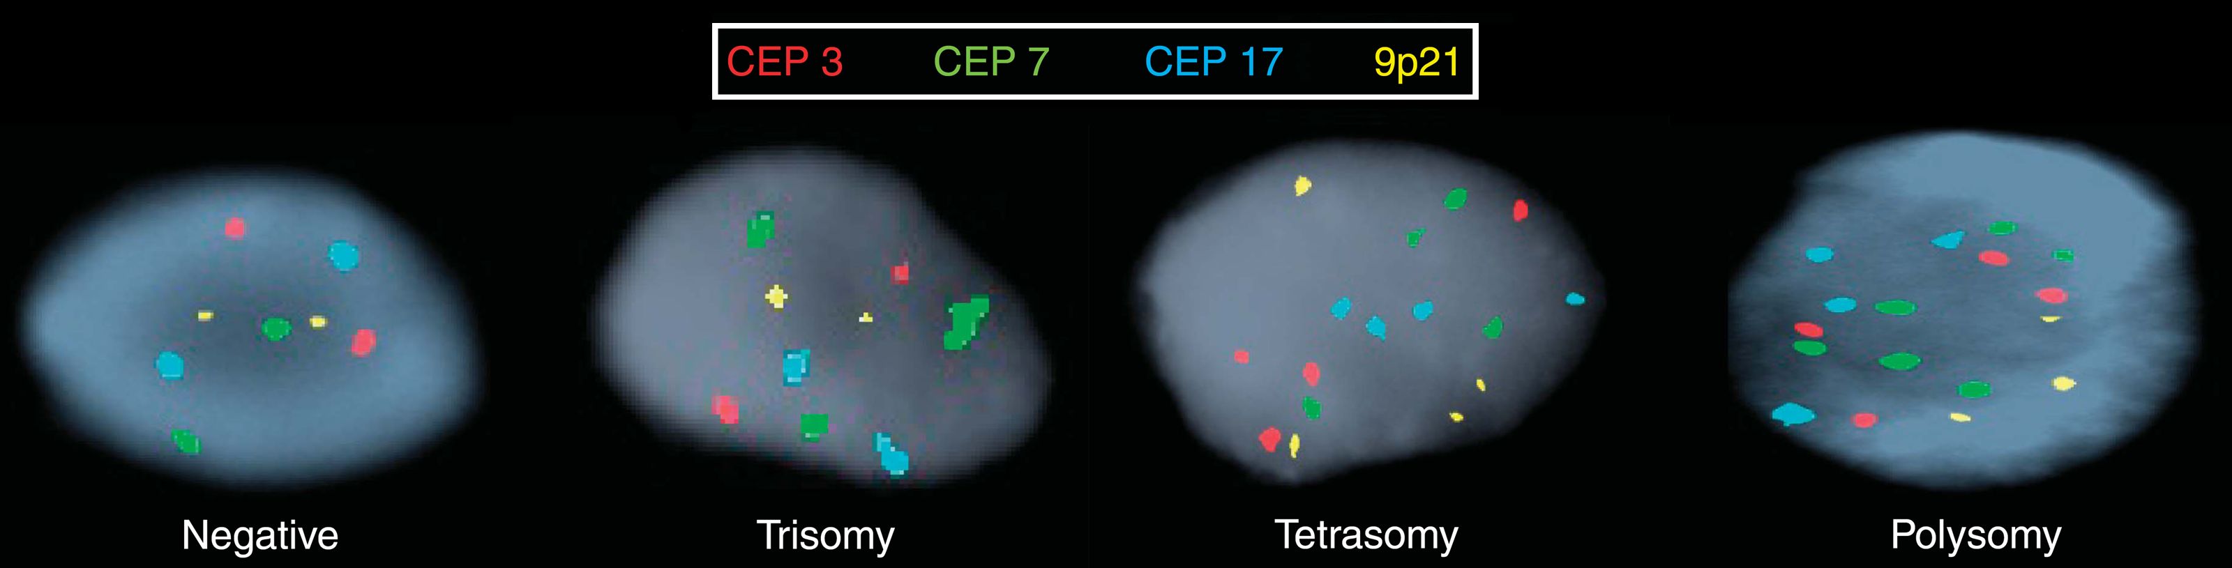

Figure 2 Endoscopic ultrasonographic findings in a patient found to have locally-advanced cholangiocarcinoma. A: Malignant lymphadenopathy; B: Endoscopic ultrasound-guided fine needle aspiration of primary cholangiocarcinoma.
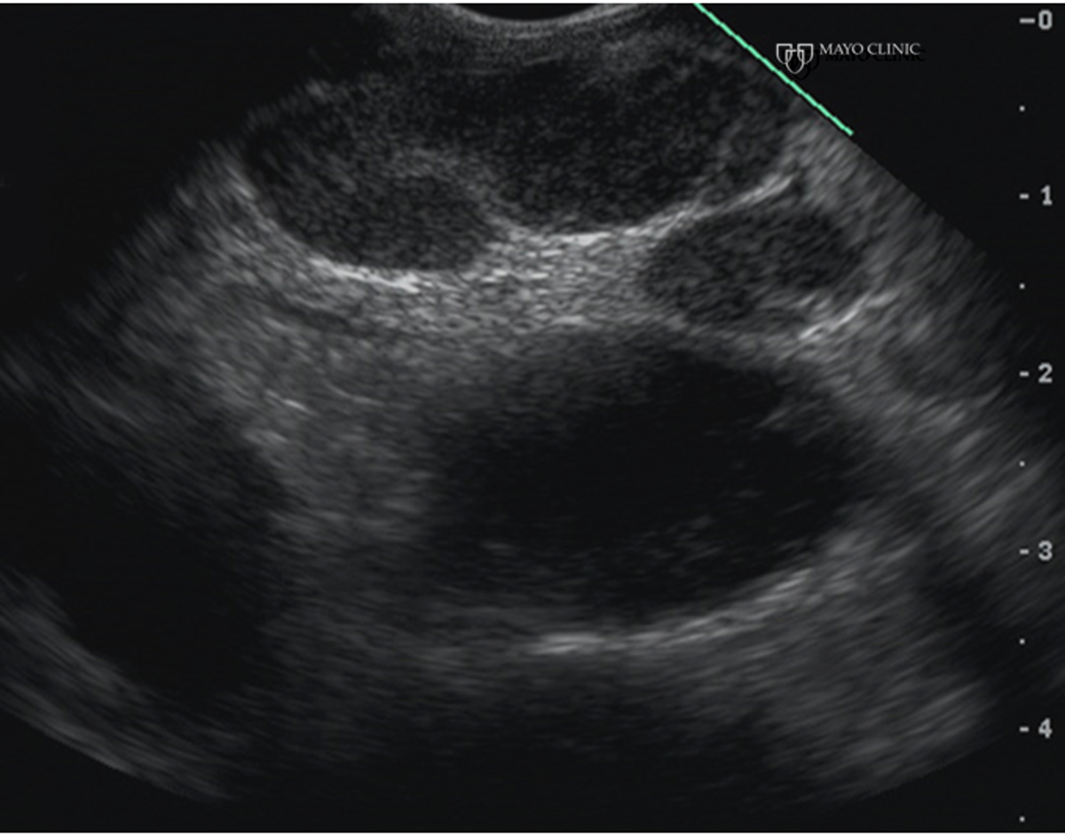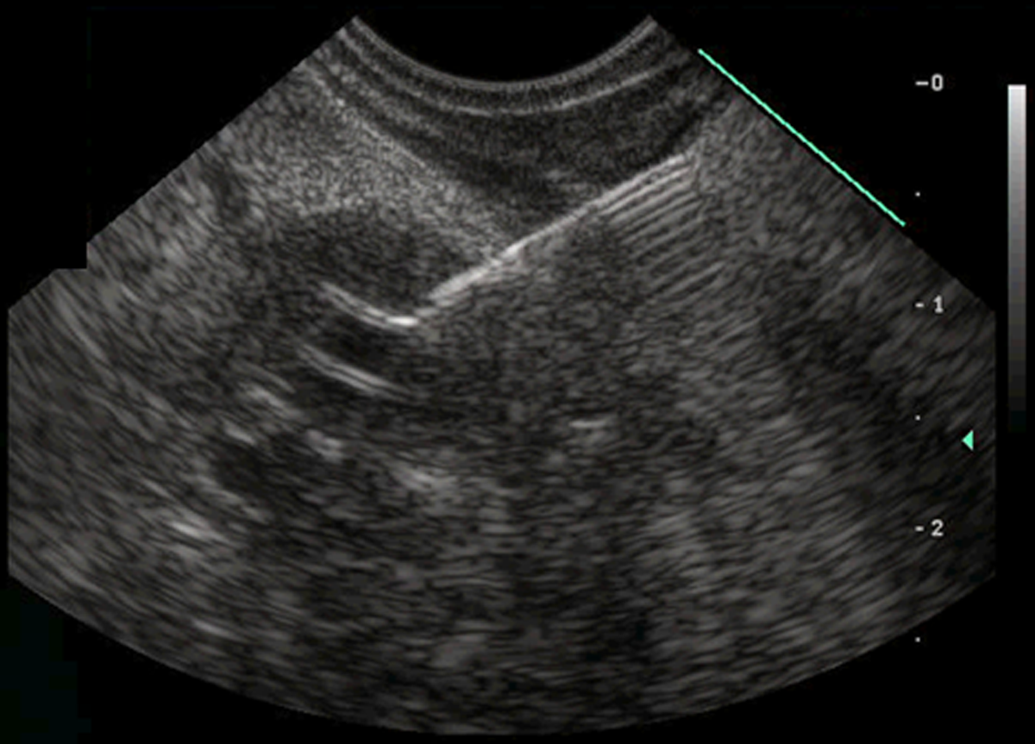

Figure 3 Passage of a SypGlass cholangioscope through a therapeutic duodenoscope to better evaluate hilar strictures and filling defects. A: Hilar (primarily anterior right hepatic duct) stricture and filling defects seen during endoscopic retrograde cholangiography pancreatography; B: SypGlass cholangioscope being passed through the working channel of therapeutic duodenoscope to better assess biliary stricturing and filling defects; C: SpyGlass cholangioscopy with narrow band imaging revealing villiform biliary mucosal changes; targeted biopsies were obtained and revealed low grade dysplasia concerning for early cholangiocarcinoma.
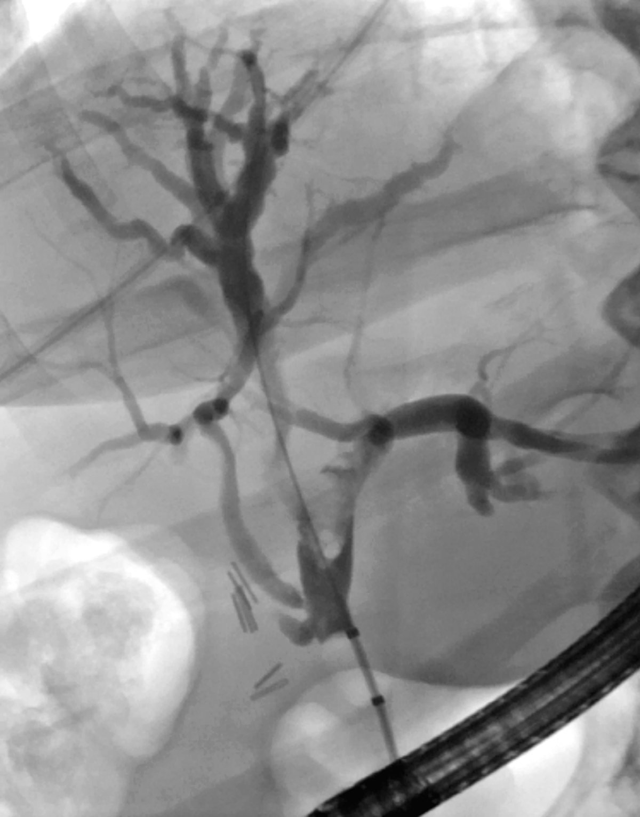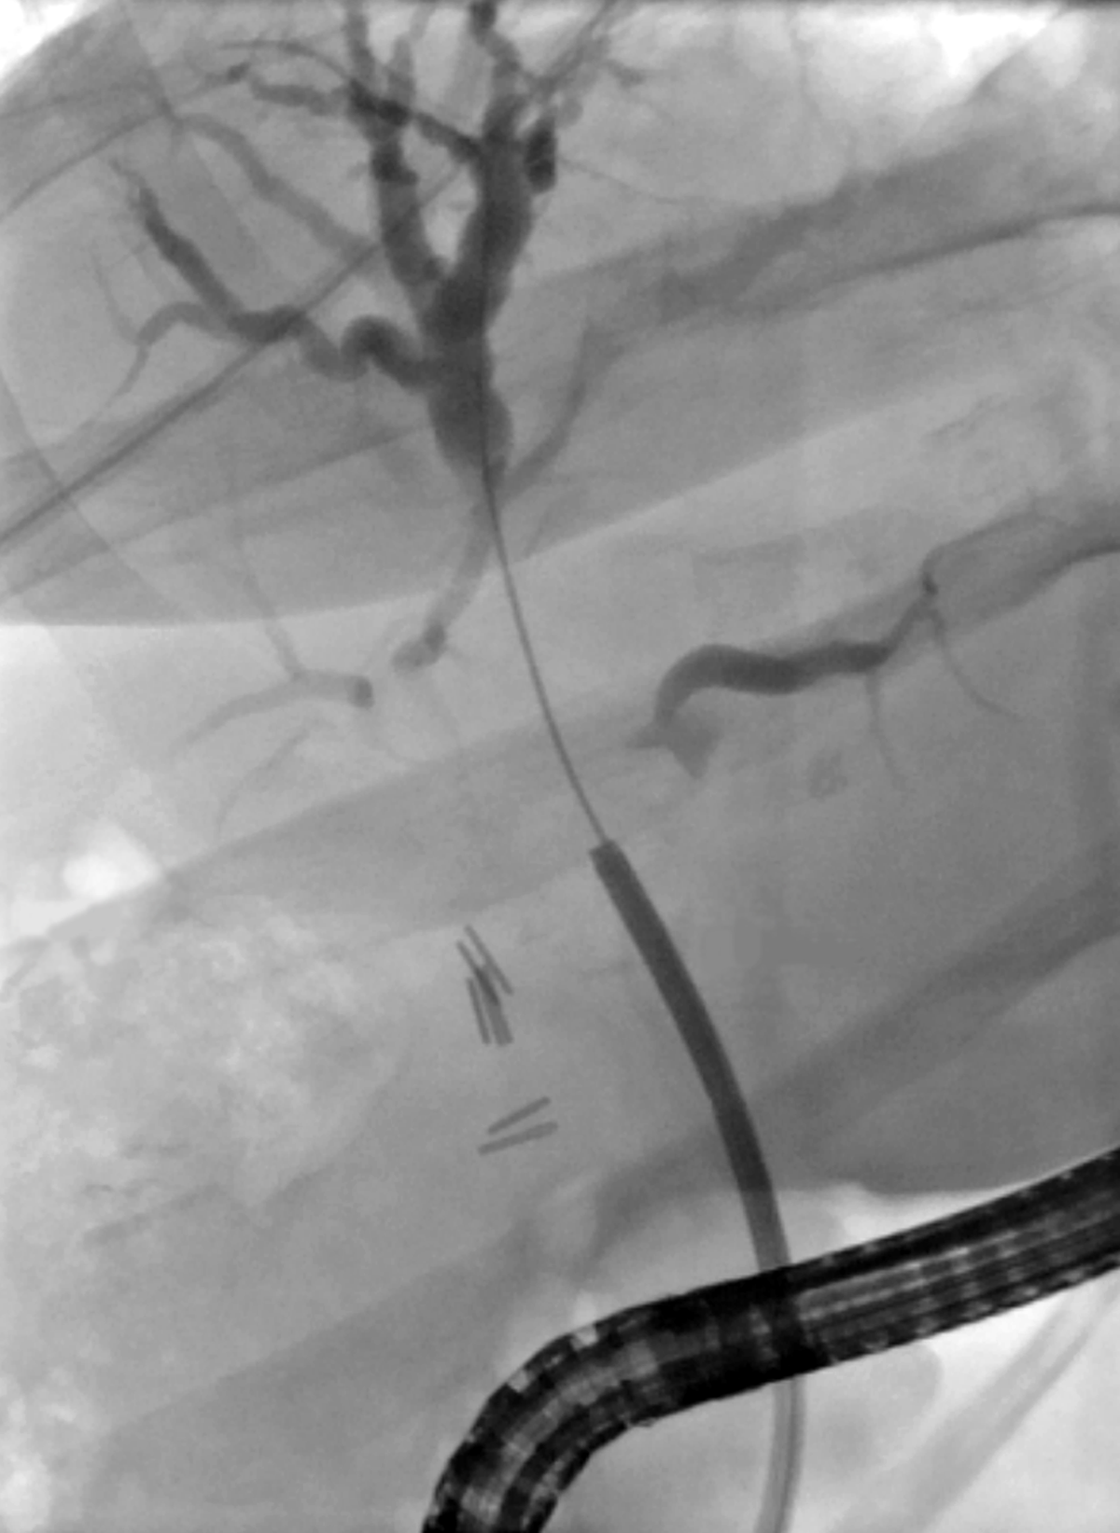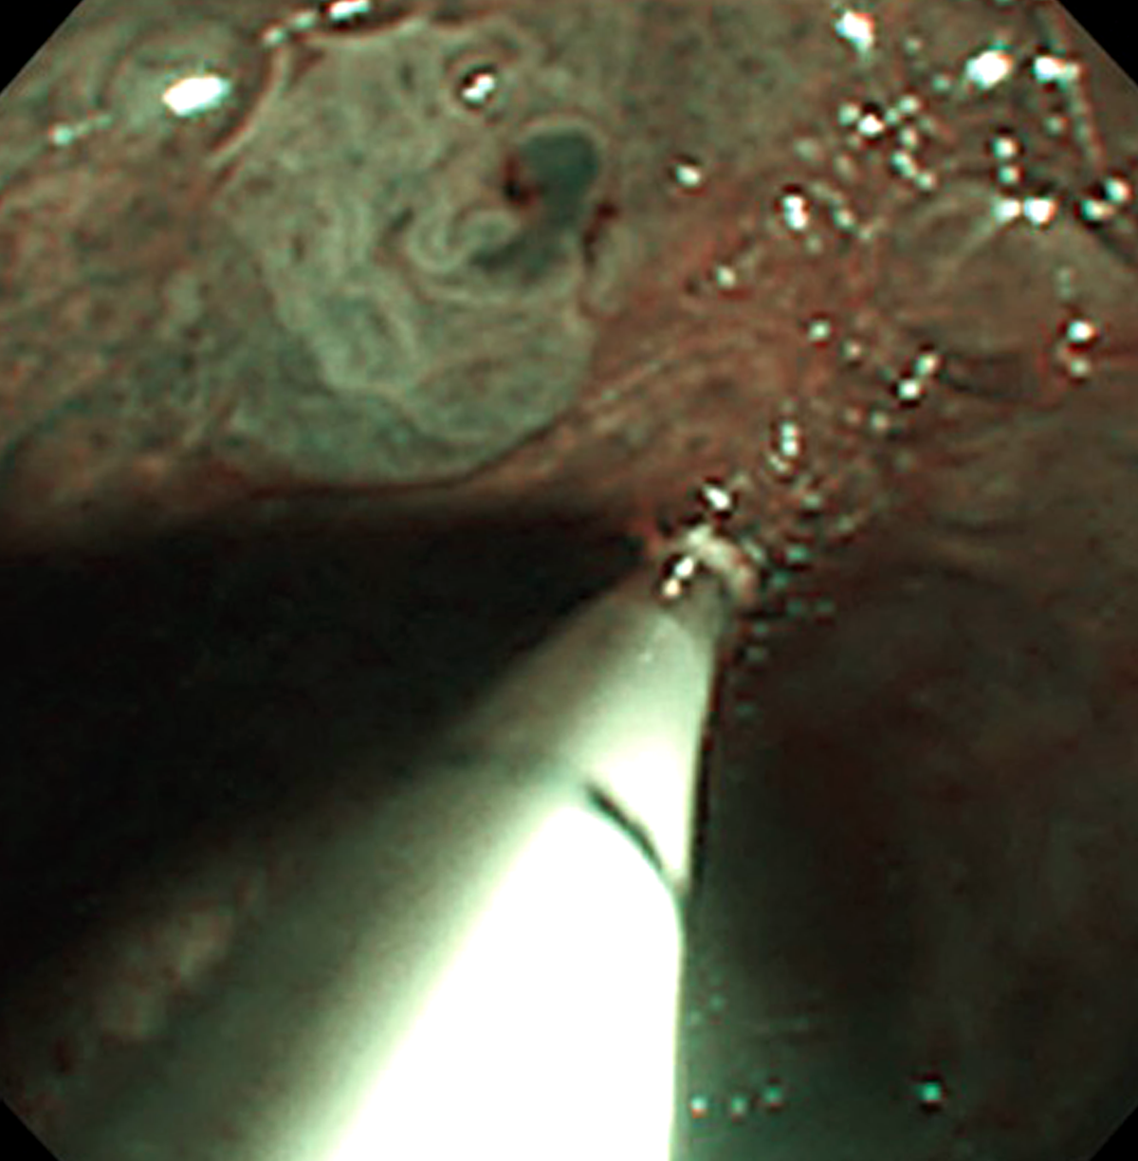

Table 1 Potential etiologies of indeterminate biliary stricture
Benign
Primary sclerosing cholangitis
IgG4-associated cholangiopathy
Postoperative stricture (anastomotic, ischemic, cholecystectomy-related)
Ischemia (e.g., hepatic artery thrombosis)
Infections (HIV cholangiopathy, parasites)
Pancreatitis (acute, , chronic, autoimmune)
Choledocholithiasis
Mirizzi syndrome
Eosinophilic cholangitis
Vasculitis
Radiation
Portal biliopathy
Malignant
Pancreatic adenocarcinoma
Cholangiocarcinoma
Hepatocellular carcinoma
Lymphoma
Metastatic adenocarcinoma (e.g., compressive lymphadenopathy)

Table 2 Comparison of advanced endoscopic imaging modalities
 | Advantages | Disadvantages
ERCP | Widely available.  Workhorse technique with numerous accessories  Facilitates other diagnostic modalities (e.g., biliary brushing, biopsy, endomicroscopy) as well as therapy | Procedural risks.  Fluoroscopic (and endoscopic) images only.  Low sensitivity of conventional cytology and intraductal biopsies)
EUS | Provides staging information.  Permits FNA.  Can facilitate difficult biliary cannulation | Limited views of the intrahepatic biliary tree (and non-visualization of the right intrahepatic ductal system)  Generally nondiagnostic in and of itself without FNA.  Risk of tumor seeding if FNA primary tumor
IDUS | Can help direct ERCP-guided tissue acquisition. | Limited depth of imaging.  Infrequently used in routine practice
Cholangioscopy | Excellent visualization of the biliary mucosa (with digital cholangioscopes).  May improve sensitivity, specificity, and overall accuracy compared to ERCP alone | High cost (disposable system $2000 per case).  Likely higher rates of pancreatitis, cholangitis, and perforation compared to ERCP alone  Time-consuming.  Not widely available.
CLE | Excellent sensitivity and negative predictive value.  Provides imaging at a cellular and sub-cellular level (lateral resolution of 3.5 μm) | Marginal interobserver agreement  Contact imaging of a very limited regional surface.  Time-consuming  Not widely available
Optical coherence tomography (OCT) | High resolution.  Improved sensitivity compared to ERCP-guided tissue acquisition.  Highly specific.  Permits larger surfaces areas to be examined compared to CLE | Suboptimal sensitivity  Resolution not as high as CLE  Not widely available  Not well-validated
ERCP: Endoscopic retrograde cholangiopancreatography; EUS: Endoscopic ultrasound; IDUS: Intraductal ultrasound; CLE: Confocal laser endomicroscopy; OCT: Optical coherence tomography.

