Name of journal: World Journal of Gastroenterology
ESPS Manuscript NO: 3748
Columns: MINIREVIEW

Endoscopic papillectomy: Indications, techniques, and results

De Palma GD. Endoscopic papillectomy

Giovanni D De Palma

Giovanni D De Palma, Center of Excellence for Technical Innovation in Surgery, Department of Clinical Medicine and Surgery, University of Naples Federico II School of Medicine, 80131 Naples, Italy

Author contributions: De Palma GD solely contributed to this paper.

Correspondence to: Giovanni D De Palma, MD, Director of Center of Excellence for Technical Innovation in Surgery, Department of Clinical Medicine and Surgery, University of Naples Federico II School of Medicine, Via Pansini 5, 80131 Naples, Italy. giovanni.depalma@unina.it

Telephone: +39-81-7462773 Fax: +39-81-7462752
Received: May 25, 2013 Revised: October 17, 2013
Accepted: December 12, 2013

Published online:

Abstract
Currently, endoscopic papillectomy (EP) has been accepted as a viable alternative therapy to surgery in sporadic ampullary adenoma and has been reported with high success and low recurrence rates. At present, indications for EP are not yet fully established. The accepted criteria of EP included size (up to 5 cm), no evidence of intraductal growth, and no evidence of malignancy by endoscopic findings (ulceration, friability, and spontaneous bleeding). Endoscopic ultrasound (EUS) is the imaging modality of choice for local T staging in ampullary neoplasms. The data reported in the literature have revealed that linear EUS is superior to helical computed tomography in the preoperative assessment of tumor size, detection of regional nodal metastases and detection of major vascular invasion. Endoscopic ampullectomy is performed with a standard duodenoscope in a similar manner to snare polypectomy of a mucosal lesion. There is no standardization of equipment or technique and methods of EP are described broad. Endoscopic ampullectomy is considered a ‘‘high-risk’’ procedure for complications. Complications of endoscopic papillectomy can be classified as early (pancreatitis, bleeding, perforation, and cholangitis) and late (papillary stenosis) complications. The appropriate use of stenting after ampullectomy may prevent post-procedural pancreatitis and papillary stenosis. Tumor recurrence for benign lesion occurs in up to 20% of patients and depends on tumor size, final histology, presence of intraductal tumor, coexisting familial adenomatous polyposis, and the expertise of the endoscopist. Recurrent lesions are usually benign and most can be retreated endoscopically.

© 2013 Baishideng Publishing Group Co., Limited. All rights reserved.

Key words: Endoscopic papillectomy; Papillary neoplasms; Major duodenal papilla; Endoscopic retrograde cholangiopancreatography; Endoscopic sphincterotomy

Core tip: Endoscopic papillectomy is a relatively safe and effective therapy and should be established as a first-line therapy for adenomas of the major duodenal papilla. Accurate staging of tumor is important in the selection of patients. Performed by experienced endoscopists leads to successful tumor eradication in over 85% of patients with ampullary adenomas.

De Palma GD. Endoscopic papillectomy: Indications, techniques, and results. World J Gastroenterol 2013;
Available from: URL: http://www.wjgnet.com/esps/
DOI: http://dx.doi:10.3748/wjg.v19.i0.0000

INTRODUCTION
Endoscopic papillectomy (EP) was first reported by Suzuki et al^{[1]}. Currently, endoscopic papillectomy has been accepted as a viable alternative therapy to surgery in sporadic ampullary adenoma and has been reported with high success and low recurrence rates.
In the present report, several issues were assessed: indications, optimal papillectomy technique, complications, and results.

DEFINITION
The term ‘‘endoscopic “papillectomy’’ refers to the resection of the mucosa and submucosa of the duodenal wall, in the area of the anatomical attachments of the ampulla of Vater, including the tissue around the bile duct and the pancreatic-duct orifices.
Endoscopic papillectomy differs from surgical “ampullectomy” that consists of resection of the ampulla of Vater, via a duodenotomy, including resection of pancreatic-head tissue, followed by separate reinsertion of the common bile duct and main pancreatic into the duodenal wall.

INDICATIONS
The most critical point in EP is the assessment of its indication. At present, indications for EP are not yet fully established. These could be dictate by the collection of features that can predict complete removal of lesion, while minimizing procedure-related morbidities.
The accepted criteria of EP included size (up to 5 cm), no evidence of intraductal growth, and no evidence of malignancy by endoscopic findings (ulceration, friability, and spontaneous bleeding)^{[2-9]} .
Actually, indications for EP are evolving^{[10-16]}. Application of piecemeal resection when appropriate, resulted in a gradual increase in the size of the tumor resected^{[17]}. Intraductal extension less than 1 cm does not seem to be an absolute contraindication for EP, because the tumor can be exposed to the luminal side with balloon sweeping and, thus, resected completely^{[18-20]}. Cancer in adenoma without invasion of the muscularis propria of the duodenum, pancreas, or extension along the bile or pancreatic duct is also a possible candidate for this treatment^{[21-25]}.
Is important to note that, on some occasions, EP may be indicated as a total biopsy^{[26]}.

PRE-OPERATIVE ASSESSMENT
A common problem is to achieve a reliable pretreatment distinction between benign and malignant papillary tumors.
On the basis of endoscopic appearance alone, ampullary adenomas cannot always be distinguished from ampullary carcinomas or non-adenomatous polyps (carcinoid tumors, gangliocytic paragangliomas, etc.)^{[27-29]}. Ulceration, friability, and spontaneous bleeding are generally related to malignant lesion. An increased application of magnifying endoscopy and narrow-band imaging can assist in selecting candidates for endoscopic therapy^{[30,31]}.
A definitive tissue diagnosis is a prerequisite for appropriate management, but malignancy may be missed in up to 30% of tumors of the major duodenal papilla when forceps biopsy specimens are obtained^{[32-34]}. Moreover, the coexistence of carcinoma within adenoma cannot be excluded by pre-procedural biopsy. Some authors advocate deeper biopsy after sphincterotomy for accurate diagnosis of endoscopic biopsy^{[35]}. A prospective study, however, reported that sensitivity was found to be 21% before and 37% after sphincterotomy, concluding that endoscopic forceps biopsies do not allow for reliable preoperative diagnosis of ampullary tumors^{[36]}. Thus, in some cases, endoscopic papillectomy can be recommended as a diagnostic tool prior to surgery, because of high false-negative rate of biopsy^{[26]}.

STAGING
Endoscopic ultrasound (EUS) is the imaging modality of choice for local T staging. The data reported in the literature have revealed that linear EUS is superior to helical Computed tomography (CT) in the preoperative assessment of tumor size, detection of regional nodal metastases and detection of major vascular invasion in patients with periampullary malignancies^{[37-43]}.
Many experts agree that lesions less than 1 cm in diameter without suspicious signs of malignancy (ulceration, induration, bleeding and or biopsies showing high-grade dysplasia or carcinoma), do not require EUS but this needs further prospective study and validation^{[9]}. Intraductal ultrasound (IDUS) using a 20 MHz frequency probe may be more accurate in visualizing the mucosal layers compared with standard echoendoscopes^{[44-47]}.
EUS/IDUS are able to accurately detect involvement of the bile and pancreatic ducts. Tumor extension into either ductal system can also be assessed by endoscopic retrograde cholangiopancreatography (ERCP). This should be performed before ampullectomy if EUS is not available or the findings on EUS are equivocal. Although the presence of intraductal extension of tumor generally indicates the need for surgery, it has been shown that tumor extension of ± 1 cm into the common bile duct or pancreatic duct can be further resected and ablated endoscopically^{[18-20]}.
CT scan, magnetic resonance imaging (MRI), and positron emission tomographic scans are highly sensitive for the detection of distant metastases. In the assessment of nodal involvement, MRI has been found to be superior to both CT and endoscopic ultrasound^{[38]}.

TECHNIQUE
Endoscopic ampullectomy is performed with a standard duodenoscope in a similar manner to snare polypectomy of a mucosal lesion. There is no standardization of equipment or technique and methods of EP are described broad. There are also no guidelines regarding the power output and the mode of electrosurgical current (cutting or coagulation), the use of adjunctive interventions, such as submucosal injection, post-ampullectomy ablative therapy, and prophylactic stent placement. The need for prophylactic antibiotics prior to ampullectomy has not been established^{[48]}.
The procedure starts with cannulation of both the bile duct and pancreatic duct and partially fill the ducts with contrast so they can be easily recannulated after the major papilla is resected. To preserve access to the pancreatic duct, some experts have placed methylene blue in contrast injected into the pancreatic duct to assist in identifying the pancreatic orifice.
Once the delineation of the biliary and the pancreatic ducts has been made a standard polypectomy snare and blended electrosurgical current (50-60 J) are generally used. The papillary tumor is snared at the base, and constant tension is applied to the snare loop during electrosurgery until the lesion is transected. Aggressive efforts to retrieve all resected tissue in all patients for histopathologic evaluation are mandatory (Figure 1).
Balloon-catheter-assisted papillectomy has also been advocated to facilitate en bloc resection mainly of flat papillary tumors^{[18,19]}.
For lesions not resectable “en bloc”, piecemeal polypectomy is recommended. However, en bloc resection is fundamental to the treatment of neoplastic lesions, because this allows more precise histopathologic evaluation of the resection specimen^{[19,49]}.
Submucosal injection of dilute epinephrine is suggested as a means of lifting the tumor from the wall; this also may decrease the risk of bleeding. It is uncertain, however, whether epinephrine injection reduces the risk of bleeding and perforation^{[11,20,50]}.
If residual neoplastic tissue remains after snare excision this should be destroyed. Argon plasma coagulation is the most frequently used modality due to the non-contact approach that limits the depth of tissue injury^{[9,48,50,51]}.
Many authorities suggest that placement of a pancreatic stent reduces the risk of papillectomy-related pancreatitis minimizing, moreover, the risk of stenosis of the pancreatic duct orifice and also allowing safer use of adjunctive coagulative therapies, but this theory is unproven. Others advocate pancreatic stent placement only if the pancreatic duct does not drain after papillectomy^{[52-55]}. The only prospective, randomized, controlled trial to evaluate the role of prophylactic pancreatic duct stenting for the reduction of post-ERCP pancreatitis after endoscopic papillectomy showed a statistically significant decrease in the rate of post-procedure pancreatitis in the stent group^{[56]}. There is no data as to how long the duct should be stented. Most pancreatic stents will migrate spontaneously out of the pancreatic duct within 2 wk of insertion. This is confirmed with an abdominal x-ray at 2 wk. A stent that remains in situ is removed endoscopically.
Prophylactic biliary stenting to reduce the risk of post-procedural cholangitis has not been widely performed and cannot be uniformly recommended at this time unless there is concern about inadequate biliary drainage after a papillectomy^{[2,8,50,57]}.

COMPLICATIONS
Endoscopic amoullectomy is considered a ‘‘high-risk’’ procedure for complications. Complications of endoscopic papillectomy can be classified as early (pancreatitis, bleeding, perforation, and cholangitis) and late (papillary stenosis) complications.
The overall rate of complications after ampullectomy reported from large, tertiary care referral centers varies between 8% and 35%, with the most common complication being pancreatitis (5%-15%) and bleeding (2%-16%)^{[14,17,51,58-61]}. Most bleeding can be controlled by conservative management and endoscopic hemostasis. Most post-procedural pancreatitis was mild and resolved with conservative management only. Late complications include the development of pancreatic or biliary stenosis (0%-8%) and can be treated with sphincterotomy, stents, and balloon dilation. The appropriate use of stenting after ampullectomy may prevent post-procedural pancreatitis and papillary stenosis^{[52-57]}. As evidenced by a recent randomized trial, prophylactic rectal indomethacin significantly reduces the incidence and severity of post-ERCP pancreatitis providing an incremental benefit over temporary pancreatic stents^{[62]}.
Mortality after endoscopic ampullectomy is rare, but has been reported on average in 0.4% (range 0%-7%)^{[63]}.

OUTCOMES
Results of endoscopic treatment of ampulla tumors reported in the literature are shown in Table 1. Outcomes data of endoscopic ampullectomy are based on retrospective, heterogeneous case series. Because there is no consensus on the definition of ‘‘success’’ after endoscopic papillectomy, it is difficult to compare the outcome of the reported studies. Conventionally, ‘‘success’’ may be defined as complete resection of the tumor with endoscopic papillectomy (as the absence of endoscopically visible and histologically proven residual adenoma for a follow-up of 3 to 6 mo.
Tumor recurrence for benign lesion occurs in up to 20% of patients and depends on tumor size, final histology, presence of intraductal tumor, coexisting FAP, and the expertise of the endoscopist^{[14,63-71]}. Recurrent lesions are usually benign and most can be retreated endoscopically.

CONCLUSION
Endoscopic papillectomy is a relatively safe and effective therapy and should be established as a first-line therapy for adenomas of the major duodenal papilla. Accurate staging of ampullary tumors is important in the selection of appropriate candidates for endoscopic or surgical therapy. Compared with surgery, endoscopic ampullectomy is associated with lower morbidity and mortality, and appears to be a preferred treatment modality for small benign ampullary tumors that have no intraductal ductal extension. Endoscopic ampullectomy performed by experienced endoscopists leads to successful tumor eradication in over 85% of patients with ampullary adenomas.

REFERENCES
1 Suzuki K, Kantou U, Murakami Y. Two cases with ampullary cancer who underwent endoscopic excision. Prog Dig Endosc 1983; 23: 236-239
2 Binmoeller KF, Boaventura S, Ramsperger K, Soehendra N. Endoscopic snare excision of benign adenomas of the papilla of Vater. Gastrointest Endosc 1993; 39: 127-131 [PMID: 8495831 DOI: 10.1016/S0016-5107(93)70051-6]
3 Silvis SE. Endoscopic snare papillectomy. Gastrointest Endosc 1993; 39: 205-207 [PMID: 8495850 DOI: 10.1016/S0016-5107(93)70074-7]
4 El Hajj II, Coté GA. Endoscopic diagnosis and management of ampullary lesions. Gastrointest Endosc Clin N Am 2013; 23: 95-109 [PMID: 23168121 DOI: 10.1016/j.giec.2012.10.004]
5 Zádorová Z, Dvofák M, Hajer J. Endoscopic therapy of benign tumors of the papilla of Vater. Endoscopy 2001; 33: 345-347 [PMID: 11315897 DOI: 10.1055/s-2001-13693]
6 Wong RF, DiSario JA. Approaches to endoscopic ampullectomy. Curr Opin Gastroenterol 2004; 20: 460-467 [PMID: 15689680 DOI: 10.1097/00001574-200409000-00008]
7 Catalano MF, Linder JD, Chak A, Sivak MV, Raijman I, Geenen JE, Howell DA. Endoscopic management of adenoma of the major duodenal papilla. Gastrointest Endosc 2004; 59: 225-232 [PMID: 14745396 DOI: 10.1016/S0016-5107(03)02366-6]
8 Cheng CL, Sherman S, Fogel EL, McHenry L, Watkins JL, Fukushima T, Howard TJ, Lazzell-Pannell L, Lehman GA. Endoscopic snare papillectomy for tumors of the duodenal papillae. Gastrointest Endosc 2004; 60: 757-764 [PMID: 15557951 DOI: 10.1016/S0016-5107(04)02029-2]
9 Baillie J. Endoscopic ampullectomy. Am J Gastroenterol 2005; 100: 2379-2381 [PMID: 16279887 DOI: 10.1111/j.1572-0241.2005.00332.x]
10 Han J, Kim MH. Endoscopic papillectomy for adenomas of the major duodenal papilla (with video). Gastrointest Endosc 2006; 63: 292-301 [PMID: 16427938 DOI: 10.1016/j.gie.2005.07.022]
11 Bohnacker S, Soehendra N, Maguchi H, Chung JB, Howell DA. Endoscopic resection of benign tumors of the papilla of vater. Endoscopy 2006; 38: 521-525 [PMID: 16767591 DOI: 10.1055/s-2006-925263]
12 Hernandez LV, Catalano MF. Endoscopic papillectomy. Curr Opin Gastroenterol 2008; 24: 617-622 [PMID: 19122504 DOI: 10.1097/MOG.0b013e3283088e12]
13 Ito K, Fujita N, Noda Y. Endoscopic diagnosis and treatment of ampullary neoplasm (with video). Dig Endosc 2011; 23: 113-117 [PMID: 21429014 DOI: 10.1111/j.1443-1661.2010.01101.x]
14 Patel R, Varadarajulu S, Wilcox CM. Endoscopic ampullectomy: techniques and outcomes. J Clin Gastroenterol 2012; 46: 8-15 [PMID: 22064552 DOI: 10.1097/MCG.0b013e318233a844]
15 Rattner DW, Fernandez-del Castillo C, Brugge WR, Warshaw AL. Defining the criteria for local resection of ampullary neoplasms. Arch Surg 1996; 131: 366-371 [PMID: 8615720 DOI: 10.1001/archsurg.1996.01430160024003]
16 Bassan M, Bourke M. Endoscopic ampullectomy: a practical guide. J Interv Gastroenterol 2012; 2: 23-30 [PMID: 22586547 DOI: 10.4161/jig.20131]
17 Ito K, Fujita N, Noda Y, Kobayashi G, Obana T, Horaguchi J, Koshita S, Kanno Y, Ogawa T, Kato Y, Yamashita Y. Impact of technical modification of endoscopic papillectomy for ampullary neoplasm on the occurrence of complications. Dig Endosc 2012; 24: 30-35 [PMID: 22211409 DOI: 10.1111/j.1443-1661.2011.01161.x]
18 Kim JH, Moon JH, Choi HJ, Lee HS, Kim HK, Cheon YK, Cho YD, Lee JS, Lee MS, Shim CS. Endoscopic snare papillectomy by using a balloon catheter for an unexposed ampullary adenoma with intraductal extension (with videos). Gastrointest Endosc 2009; 69: 1404-1406 [PMID: 19152886 DOI: 10.1016/j.gie.2008.07.049]
19 Aiura K, Imaeda H, Kitajima M, Kumai K. Balloon-catheter-assisted endoscopic snare papillectomy for benign tumors of the major duodenal papilla. Gastrointest Endosc 2003; 57: 743-747 [PMID: 12709713 DOI: 10.1067/mge.2003.213]
20 Bohnacker S, Seitz U, Nguyen D, Thonke F, Seewald S, deWeerth A, Ponnudurai R, Omar S, Soehendra N. Endoscopic resection of benign tumors of the duodenal papilla without and with intraductal growth. Gastrointest Endosc 2005; 62: 551-560 [PMID: 16185970 DOI: 10.1016/j.gie.2005.04.053]
21 Yoon SM, Kim MH, Kim MJ, Jang SJ, Lee TY, Kwon S, Oh HC, Lee SS, Seo DW, Lee SK. Focal early stage cancer in ampullary adenoma: surgery or endoscopic papillectomy? Gastrointest Endosc 2007; 66: 701-707 [PMID: 17905011 DOI: 0.1016/j.gie.2007.02.049]
22 Woo SM, Ryu JK, Lee SH, Lee WJ, Hwang JH, Yoo JW, Park JK, Kang GH, Kim YT, Yoon YB. Feasibility of endoscopic papillectomy in early stage ampulla of Vater cancer. J Gastroenterol Hepatol 2009; 24: 120-124 [PMID: 19032444 DOI: 10.1111/j.1440-1746.2008.05578.x]
23 Salmi S, Ezzedine S, Vitton V, Ménard C, Gonzales JM, Desjeux A, Grimaud JC, Barthet M. Can papillary carcinomas be treated by endoscopic ampullectomy? Surg Endosc 2012; 26: 920-925 [PMID: 22011948 DOI: 10.1007/s00464-011-1968-7]
24 Kim HK, Lo SK. Endoscopic approach to the patient with benign or malignant ampullary lesions. Gastrointest Endosc Clin N Am 2013; 23: 347-383 [PMID: 23540965 DOI: 10.1016/j.giec.2013.01.003]
25 Petrone G, Ricci R, Familiari P, Inzani F, Matsuoka M, Mutignani M, Delle Fave G, Costamagna G, Rindi G. Endoscopic snare papillectomy: a possible radical treatment for a subgroup of T1 ampullary adenocarcinomas. Endoscopy 2013; 45: 401-404 [PMID: 23616129 DOI: 10.1055/s-0032-1326213]
26 Ogawa T, Ito K, Fujita N, Noda Y, Kobayashi G, Horaguchi J, Koshita S, Kanno Y, Masu K, Ishii S. Endoscopic papillectomy as a method of total biopsy for possible early ampullary cancer. Dig Endosc 2012; 24: 291 [PMID: 22725127 DOI: 10.1111/j.1443-1661.2011.01214.x]
27 Niido T, Itoi T, Harada Y, Haruyama K, Ebihara Y, Tsuchida A, Kasuya K. Carcinoid of major duodenal papilla. Gastrointest Endosc 2005; 61: 106-107 [PMID: 15672069 DOI: 10.1016/S0016-5107(04)02384-3]
28 Kwon J, Lee SE, Kang MJ, Jang JY, Kim SW. A case of gangliocytic paraganglioma in the ampulla of Vater. World J Surg Oncol 2010; 8: 42 [PMID: 20497533 DOI: 10.1186/1477-7819-8-42]
29 De Palma GD, Masone S, Siciliano S, Maione F, Falleti J, Mansueto G, De Rosa G, Persico G. Endocrine carcinoma of the major papilla: report of two cases and review of the literature. Surg Oncol 2010; 19: 235-242 [PMID: 19586767 DOI: 10.1016/j.suronc.2009.06.003]
30 Uchiyama Y, Imazu H, Kakutani H, Hino S, Sumiyama K, Kuramochi A, Tsukinaga S, Matsunaga K, Nakayoshi T, Goda K, Saito S, Kaise M, Kawamuara M, Omar S, Tajiri H. New approach to diagnosing ampullary tumors by magnifying endoscopy combined with a narrow-band imaging system. J Gastroenterol 2006; 41: 483-490 [PMID: 16799891 DOI: 10.1007/s00535-006-1800-7]
31 Itoi T, Tsuji S, Sofuni A, Itokawa F, Kurihara T, Tsuchiya T, Ishii K, Ikeuchi N, Igarashi M, Gotoda T, Moriyasu F. A novel approach emphasizing preoperative margin enhancement of tumor of the major duodenal papilla with narrow-band imaging in comparison to indigo carmine chromoendoscopy (with videos). Gastrointest Endosc 2009; 69: 136-141 [PMID: 19026411 DOI: 10.1016/j.gie.2008.07.036]
32 Yamaguchi K, Enjoji M, Kitamura K. Endoscopic biopsy has limited accuracy in diagnosis of ampullary tumors. Gastrointest Endosc 1990; 36: 588-592 [PMID: 2279648 DOI: 10.1016/S0016-5107(90)71170-4]
33 Elek G, Gyôri S, Tóth B, Pap A. Histological evaluation of preoperative biopsies from ampulla vateri. Pathol Oncol Res 2003; 9: 32-41 [PMID: 12704445 DOI: 10.1007/BF03033712]
34 Bellizzi AM, Kahaleh M, Stelow EB. The assessment of specimens procured by endoscopic ampullectomy. Am J Clin Pathol 2009; 132: 506-513 [PMID: 19762527 DOI: 10.1309/AJCPUZWJ8WA2IHBG]
35 Bourgeois N, Dunham F, Verhest A, Cremer M. Endoscopic biopsies of the papilla of Vater at the time of endoscopic sphincterotomy: difficulties in interpretation. Gastrointest Endosc 1984; 30: 163-166 [PMID: 6735092 DOI: 10.1016/S0016-5107(84)72357-1]
36 Menzel J, Poremba C, Dietl KH, Böcker W, Domschke W. Tumors of the papilla of Vater--inadequate diagnostic impact of endoscopic forceps biopsies taken prior to and following sphincterotomy. Ann Oncol 1999; 10: 1227-1231 [PMID: 10586341 DOI: 10.1023/A: 1008368807817]
37 Rivadeneira DE, Pochapin M, Grobmyer SR, Lieberman MD, Christos PJ, Jacobson I, Daly JM. Comparison of linear array endoscopic ultrasound and helical computed tomography for the staging of periampullary malignancies. Ann Surg Oncol 2003; 10: 890-897 [PMID: 14527907 DOI: 10.1245/ASO.2003.03.555]
38 Cannon ME, Carpenter SL, Elta GH, Nostrant TT, Kochman ML, Ginsberg GG, Stotland B, Rosato EF, Morris JB, Eckhauser F, Scheiman JM. EUS compared with CT, magnetic resonance imaging, and angiography and the influence of biliary stenting on staging accuracy of ampullary neoplasms. Gastrointest Endosc 1999; 50: 27-33 [PMID: 10385718 DOI: 10.1016/S0016-5107(99)70340-8]
39 Rösch T, Lorenz R, Braig C, Feuerbach S, Siewert JR, Schusdziarra V, Classen M. Endoscopic ultrasound in pancreatic tumor diagnosis. Gastrointest Endosc 1991; 37: 347-352 [PMID: 2070987 DOI: 10.1016/S0016-5107(91)70729-3]
40 Azih LC, Broussard BL, Phadnis MA, Heslin MJ, Eloubeidi MA, Varadarajulu S, Arnoletti JP. Endoscopic ultrasound evaluation in the surgical treatment of duodenal and peri-ampullary adenomas. World J Gastroenterol 2013; 19: 511-515 [PMID: 23382629 DOI: 10.3748/wjg.v19.i4.511]
41 Ito K, Fujita N, Noda Y, Kobayashi G, Horaguchi J, Takasawa O, Obana T. Preoperative evaluation of ampullary neoplasm with EUS and transpapillary intraductal US: a prospective and histopathologically controlled study. Gastrointest Endosc 2007; 66: 740-747 [PMID: 17905017 DOI: 10.1016/j.gie.2007.03.1081]
42 Will U, Bosseckert H, Meyer F. Correlation of endoscopic ultrasonography (EUS) for differential diagnostics between inflammatory and neoplastic lesions of the papilla of Vater and the peripapillary region with results of histologic investigation. Ultraschall Med 2008; 29: 275-280 [PMID: 18491258 DOI: 10.1055/s-2008-1027327]
43 Cote GA, Edmundowicz SA. The Role of Endoscopic Ultrasonography (EUS) and Endoscopic Retrograde Cholangiopancreatography (ERCP) in the Evaluation and Management of Ampullary Adenomas. Tech Gastrointest Endosc 2009; 11: 49-57 [DOI: 10.1016/j.tgie.2009.03.004]
44 Menzel J, Hoepffner N, Sulkowski U, Reimer P, Heinecke A, Poremba C, Domschke W. Polypoid tumors of the major duodenal papilla: preoperative staging with intraductal US, EUS, and CT--a prospective, histopathologically controlled study. Gastrointest Endosc 1999; 49: 349-357 [PMID: 10049419 DOI: 10.1016/S0016-5107(99)70012-X]
45 Itoh A, Goto H, Naitoh Y, Hirooka Y, Furukawa T, Hayakawa T. Intraductal ultrasonography in diagnosing tumor extension of cancer of the papilla of Vater. Gastrointest Endosc 1997; 45: 251-260 [PMID: 9087831 DOI: 10.1016/S0016-5107(97)70267-0]
46 Menzel J, Domschke W. Gastrointestinal miniprobe sonography: the current status. Am J Gastroenterol 2000; 95: 605-616 [PMID: 10710047 DOI: 10.1111/j.1572-0241.2000.01832.x]
47 Ito K, Fujita N, Noda Y, Kobayashi G, Horaguchi J. Diagnosis of ampullary cancer. Dig Surg 2010; 27: 115-118 [PMID: 20551654 DOI: 10.1159/000286607]
48 Menees SB, Schoenfeld P, Kim HM, Elta GH. A survey of ampullectomy practices. World J Gastroenterol 2009; 15: 3486-3492 [PMID: 19630102 DOI: 10.3748/wjg.15.3486]
49 Charton JP, Deinert K, Schumacher B, Neuhaus H. Endoscopic resection for neoplastic diseases of the papilla of Vater. J Hepatobiliary Pancreat Surg 2004; 11: 245-251 [PMID: 15368108 DOI: 10.1007/s00534-004-0897-4]
50 Desilets DJ, Dy RM, Ku PM, Hanson BL, Elton E, Mattia A, Howell DA. Endoscopic management of tumors of the major duodenal papilla: Refined techniques to improve outcome and avoid complications. Gastrointest Endosc 2001; 54: 202-208 [PMID: 11474391 DOI: 10.1067/mge.2001.116564]
51 Norton ID, Gostout CJ, Baron TH, Geller A, Petersen BT, Wiersema MJ. Safety and outcome of endoscopic snare excision of the major duodenal papilla. Gastrointest Endosc 2002; 56: 239-243 [PMID: 12145603 DOI: 10.1016/S0016-5107(02)70184-3]
52 Lee SK, Kim MH, Seo DW, Lee SS, Park JS. Endoscopic sphincterotomy and pancreatic duct stent placement before endoscopic papillectomy: are they necessary and safe procedures? Gastrointest Endosc 2002; 55: 302-304 [PMID: 11818948 DOI: 10.1067/mge.2002.120885]
53 Baillie J. Endoscopic ampullectomy: does pancreatic stent placement make it safer? Gastrointest Endosc 2005; 62: 371-373 [PMID: 16111954 DOI: 10.1016/j.gie.2005.04.021]
54 Yamao T, Isomoto H, Kohno S, Mizuta Y, Yamakawa M, Nakao K, Irie J. Endoscopic snare papillectomy with biliary and pancreatic stent placement for tumors of the major duodenal papilla. Surg Endosc 2010; 24: 119-124 [PMID: 19517183 DOI: 10.1007/s00464-009-0538-8]
55 Napoléon B, Alvarez-Sanchez MV, Leclercq P, Mion F, Pialat J, Gincul R, Ribeiro D, Cambou M, Lefort C, Rodríguez-Girondo M, Scoazec JY. Systematic pancreatic stenting after endoscopic snare papillectomy may reduce the risk of postinterventional pancreatitis. Surg Endosc 2013; 27: 3377-3387 [PMID: 23549765 DOI: 10.1007/s00464-013-2920-9]
56 Harewood GC, Pochron NL, Gostout CJ. Prospective, randomized, controlled trial of prophylactic pancreatic stent placement for endoscopic snare excision of the duodenal ampulla. Gastrointest Endosc 2005; 62: 367-370 [PMID: 16111953 DOI: 10.1016/j.gie.2005.04.020]
57 Adler DG, Qureshi W, Davila R, Gan SI, Lichtenstein D, Rajan E, Shen B, Zuckerman MJ, Fanelli RD, Van Guilder T, Baron TH. The role of endoscopy in ampullary and duodenal adenomas. Gastrointest Endosc 2006; 64: 849-854 [PMID: 17140885 DOI: 10.1016/j.gie.2006.08.044]
58 Jun DW, Choi HS. [Is the endoscopic papillectomy safe procedure in periampullary tumors?]. Korean J Gastroenterol 2005; 46: 247-250 [PMID: 16179847]
59 Lee SY, Jang KT, Lee KT, Lee JK, Choi SH, Heo JS, Paik SW, Rhee JC. Can endoscopic resection be applied for early stage ampulla of Vater cancer? Gastrointest Endosc 2006; 63: 783-788 [PMID: 16650538]
60 Katsinelos P, Paroutoglou G, Kountouras J, Beltsis A, Papaziogas B, Mimidis K, Zavos C, Dimiropoulos S. Safety and long-term follow-up of endoscopic snare excision of ampullary adenomas. Surg Endosc 2006; 20: 608-613 [PMID: 16508819 DOI: 10.1007/s00464-004-2278-0]
61 Pandolfi M, Martino M, Gabbrielli A. Endoscopic treatment of ampullary adenomas. JOP 2008; 9: 1-8 [PMID: 18182736]
62 Elmunzer BJ, Scheiman JM, Lehman GA, Chak A, Mosler P, Higgins PD, Hayward RA, Romagnuolo J, Elta GH, Sherman S, Waljee AK, Repaka A, Atkinson MR, Cote GA, Kwon RS, McHenry L, Piraka CR, Wamsteker EJ, Watkins JL, Korsnes SJ, Schmidt SE, Turner SM, Nicholson S, Fogel EL. A randomized trial of rectal indomethacin to prevent post-ERCP pancreatitis. N Engl J Med 2012; 366: 1414-1422 [PMID: 22494121 DOI: 10.1056/NEJMoa1111103]
63 Heinzow HS, Lenz P, Lenze F, Domagk D, Domschke W, Meister T. Feasibility of snare papillectomy in ampulla of Vater tumors: meta-analysis and study results from a tertiary referral center. Hepatogastroenterology 2012; 59: 332-335 [PMID: 21940377 DOI: 10.5754/hge11414]
64 Han J, Lee SK, Park DH, Choi JS, Lee SS, Seo DW, Kim MH. [Treatment outcome after endoscopic papillectomy of tumors of the major duodenal papilla]. Korean J Gastroenterol 2005; 46: 110-119 [PMID: 16118521]
65 Dittrick GW, Mallat DB, Lamont JP. Management of ampullary lesions. Curr Treat Options Gastroenterol 2006; 9: 371-376 [PMID: 16942661 DOI: 10.1007/BF02738525]
66 Boix J, Lorenzo-Zúñiga V, Moreno de Vega V, Domènech E, Gassull MA. Endoscopic resection of ampullary tumors: 12-year review of 21 cases. Surg Endosc 2009; 23: 45-49 [PMID: 18398649 DOI: 10.1007/s00464-008-9866-3]
67 Jung MK, Cho CM, Park SY, Jeon SW, Tak WY, Kweon YO, Kim SK, Choi YH. Endoscopic resection of ampullary neoplasms: a single-center experience. Surg Endosc 2009; 23: 2568-2574 [PMID: 19360365 DOI: 10.1007/s00464-009-0464-9]
68 Irani S, Arai A, Ayub K, Biehl T, Brandabur JJ, Dorer R, Gluck M, Jiranek G, Patterson D, Schembre D, Traverso LW, Kozarek RA. Papillectomy for ampullary neoplasm: results of a single referral center over a 10-year period. Gastrointest Endosc 2009; 70: 923-932 [PMID: 19608181 DOI: 10.1016/j.gie.2009.04.015]
69 Jeanniard-Malet O, Caillol F, Pesenti C, Bories E, Monges G, Giovannini M. Short-term results of 42 endoscopic ampullectomies: a single-center experience. Scand J Gastroenterol 2011; 46: 1014-1019 [PMID: 21492053 DOI: 10.3109/00365521.2011.571711]
70 Kim JH, Kim JH, Hwang JC, Yoo BM, Moon JH, Lee3 DK, Kim HG, Cho YD, Lee DH, Park SH. Management after Endoscopic Snare Papillectomy for Ampullary Adenomas. Hepatogastroenterology 2013; 60: [PMID: 23492013 DOI: 10.5754/hge11604]
71 Ahn DW, Ryu JK, Kim J, Yoon WJ, Lee SH, Kim YT, Yoon YB. Endoscopic papillectomy for benign ampullary neoplasms: how can treatment outcome be predicted? Gut Liver 2013; 7: 239-245 [PMID: 23560162]
72 Vogt M, Jakobs R, Benz C, Arnold JC, Adamek HE, Riemann JF. Endoscopic therapy of adenomas of the papilla of Vater. A retrospective analysis with long-term follow-up. Dig Liver Dis 2000; 32: 339-345 [PMID: 11515633 DOI: 10.1016/S1590-8658(00)80028-6]

P-Reviewer Meister T S-Editor Gou SX L-Editor E-Editor
A B
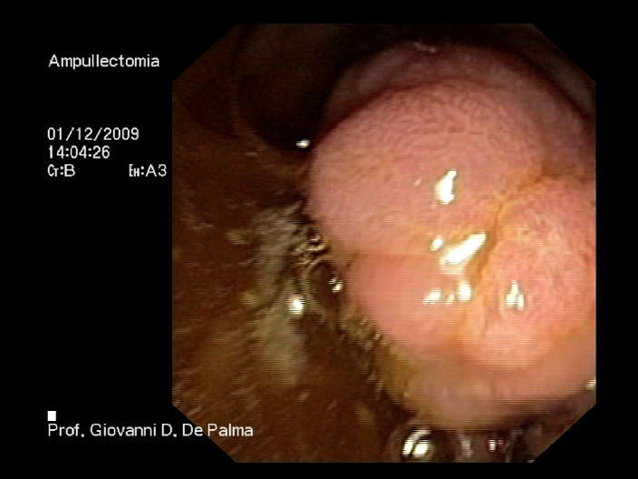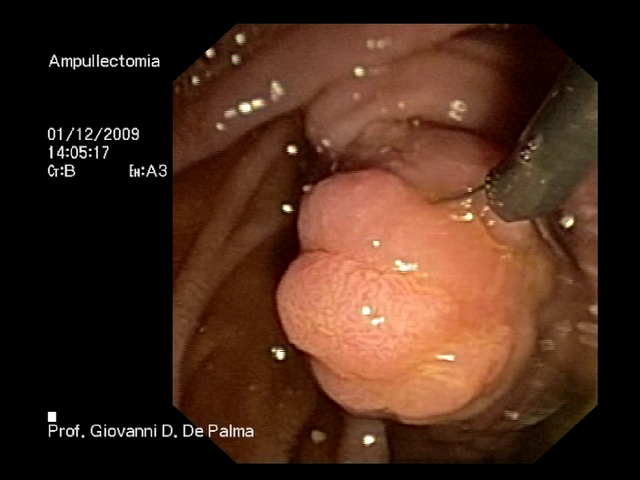
C D
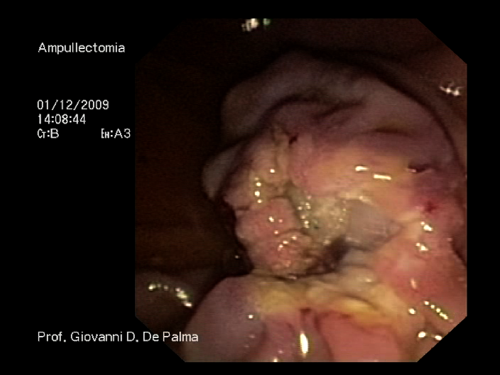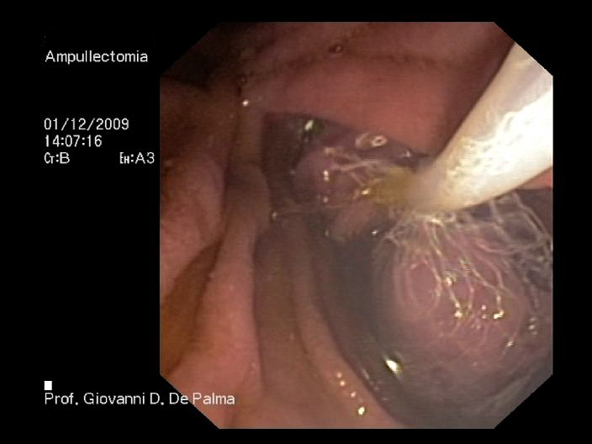
E F
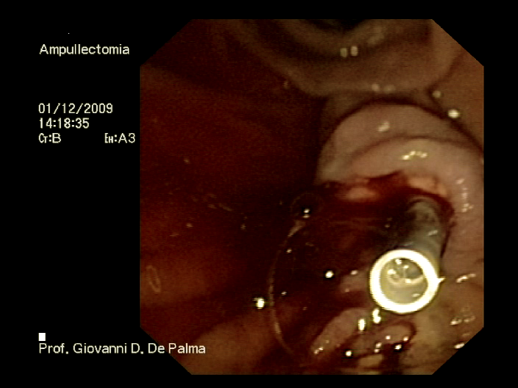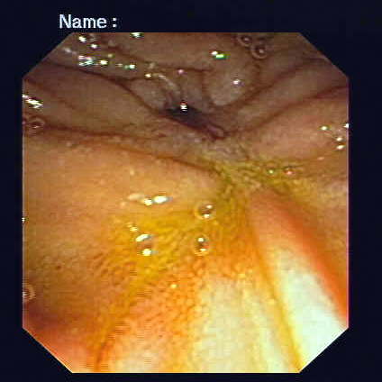
Figure 1 Aggressive efforts to retrieve all resected tissue in all patients for histopathologic evaluation are mandatory. A: Endoscopic view of a 3 cm’s neoplastic lesion of the major papilla; B: The lesion is entirely entrapped by endoscopic snare; C: The lesion is completely resected (en-bloc resection); D: The resected specimen is retrieved by a Roth Net© device (US Endoscopy, Mentor, OH, United States); E: A plastic stent is implanted into the main pancreatic duct to prevent post-papillectomy pancreatitis; F: Duodenal view 6 mo after papillectomy. No evidence of recurrent disease is observed.

Table 1 Outcomes after endoscopic papillectomy
Ref. | Patients | Successful resection | Complications | Mortality | Recurrence | Need for surgery
Binmoeller et al^{[2]} | 25 | 23 | 5 | 0 | 6 | 3
Vogt et al^{[72]} | 18 | 12 | 4 | 0 | 6 | NA
Zadorova et al^{[5]} | 16 | 13 | 4 | 0 | 3 | 1
Desilets et al^{[50]} | 13 | 12 | 1 | 0 | 0 | 1
Norton et al^{[51]} | 26 | 12 | 5 | 0 | 2 | 1
Bohnacker et al^{[20]} | 87 | 74 | 29 | 0 | 15 | 17
Catalano et al^{[7]} | 103 | 83 | 10 | 0 | 10 | 16
Cheng et al^{[8]} | 55 | 39 | 12 | 0 | 9 | 4
Han et al^{[10]} | 33 | 20 | 11 | 0 | 2 | 2
NA: Not available.

