Name of journal: World Journal of Gastroenterology

Manuscript NO: 40527

Manuscript type: ORIGINAL ARTICLE

Basic Study
Zinc finger E-box-binding homeobox 1 mediates aerobic glycolysis via suppression of sirtuin 3 in pancreatic cancer

Xu WY et al. ZEB1 regulates glycolysis in pancreatic cancer

Wen-Yan Xu, Qiang-Sheng Hu, Yi Qin, Bo Zhang, Wen-Sheng Liu, Quan-Xing Ni, Jin Xu, Xian-Jun Yu

Wen-Yan Xu, Qiang-Sheng Hu, Bo Zhang, Wen-Sheng Liu, Quan-Xing Ni, Xian-Jun Yu, Department of Pancreatic Surgery, Fudan University Shanghai Cancer Center, Shanghai 200032, China

Yi Qin, Jin Xu, Department of Oncology, Shanghai Medical College, Fudan University, Shanghai 200032, China

Yi Qin, Bo Zhang, Jin Xu, Pancreatic Cancer Institute, Fudan University, Shanghai Pancreatic Cancer Institute, Shanghai 200032, China

ORCID number: Wen-Yan Xu (0000-0003-1855-6245); Qiang-Sheng Hu (0000-0001-7469-1359); Yi Qin (0000-0001-9804-202X); Bo Zhang (0000-0002-2808-2242); Wen-Sheng Liu (0000-0003-4357-1893); Quan-Xing Ni (0000-0003-1877-8067); Jin Xu (0000-0002-2942-8604); Xian-Jun Yu (0000-0002-6697-7143).

Author contributions: Yu XJ designed and supervised the study; Xu WY performed biochemical assays and wrote the manuscript; Hu QS and Qin Y performed metabolism assays, collected and analyzed the biochemistry and cell biology data; Zhang B and Liu WS helped in the The Cancer Genome Atlas (TCGA) dataset analysis and analysis of clinical data; Ni QX and Xu J supervised the organization and editing of the manuscript.

Supported by the National Science Fund for Distinguished Young Scholars of China, No. 81625016; the National Science Foundation of China, No. 81502031 and No. 81772555; Shanghai Municipal Commission of Health and Family Planning Grant, No. 20154Y0090; and Youth Research Foundation of Shanghai Municipal Commission of Health and Family Planning, No. Z0124Y074.

Conflict-of-interest statement: The authors have declared no conflicts of interest.

Open-Access: This is an open-access article that was selected by an in-house editor and fully peer-reviewed by external reviewers. It is distributed in accordance with the Creative Commons Attribution Non Commercial (CC BY-NC 4.0) license, which permits others to distribute, remix, adapt, build upon this work non-commercially, and license their derivative works on different terms, provided the original work is properly cited and the use is non-commercial. See: http://creativecommons.org/licenses/by-nc/4.0/

Manuscript source: Invited manuscript

Correspondence to: Xian-Jun Yu, MD, PhD, Professor, Surgeon, Surgical Oncologist, Department of Pancreatic Surgery, Fudan University Shanghai Cancer Center, No. 270 DongAn Road, Xuhui District, Shanghai 200032, China.yuxianjun@fudanpci.org
Telephone: +86-021-64175590
Fax: +86-021-64031446

Received: July 7, 2018

Peer-review started: July 9, 2018

First decision: August 30, 2018
Revised: September 27, 2018

Accepted: October 16, 2018

Article in press:

Published online:

Abstract

AIM
To uncover the roles of tumor-promoting gene ZEB1 in aerobic glycolysis regulation and shed light on the underlying molecular mechanism.

METHODS
Endogenous zinc finger E-box binding homeobox-1 (ZEB1) was silenced using a lentivirus-mediated method, and the impact of ZEB1 and methyl-CpG binding domain protein 1 (MBD1) on aerobic glycolysis was measured using seahorse cellular flux analyzers, reactive oxygen species (ROS) quantification, and mitochondrial membrane potential measurement. The interaction between ZEB1 and MBD1 was assessed by coimmunoprecipitation (Co-IP) and immunofluorescence assays. The impact of ZEB1 and MBD1 interaction on sirtuin 3 (SIRT3) expression was confirmed by quantitative polymerase chain reaction, western blotting, and dual-luciferase and chromatin-immunoprecipitation assays.

RESULTS
ZEB1 was a positive regulator of aerobic glycolysis in pancreatic cancer. ZEB1 transcriptionally silenced expression of SIRT3, a mitochondrial-localized tumor suppressor through interaction with MBD1.

CONCLUSION
ZEB1 silenced SIRT3 expression via interaction with MBD1 to promote aerobic glycolysis in pancreatic cancer.

Key words: Pancreatic cancer; Zinc finger E-box binding homeobox-1; Sirtuin 3; Methyl-CpG binding domain protein 1; Glycolysis

© The Author(s) 2018. Published by Baishideng Publishing Group Inc. All rights reserved.

Core tip: Recent studies have demonstrated the impact of aerobic glycolysis on oncogenesis, proliferation, progression, and metastasis of cancer cells. Zinc finger E-box binding homeobox-1 (ZEB1) is an important regulator of metastasis and progression of pancreatic cancer, but its role in aerobic glycolysis has seldom been discussed. Our results demonstrated that ZEB1 is an important regulator of aerobic glycolysis. It has been demonstrated that ZEB1 regulates aerobic glycolysis by suppression of sirtuin 3 (SIRT3) via interaction with methyl-CpG binding domain protein 1 (MBD1). Our results shed light on novel aspects and targets for treatment pancreatic cancer.

Xu WY, Hu QS, Qin Y, Zhang B, Liu WS, Ni QX, Xu J, Yu XJ. Zinc finger E-box-binding homeobox 1 mediates aerobic glycolysis via suppression of sirtuin 3 in pancreatic cancer. World J Gastroenterol 2018; In press

INTRODUCTION
Pancreatic cancer is an aggressive and lethal cancer, and its incidence is equal to its mortality rate. Although significant progress has been made in the diagnosis and treatment of pancreatic cancer, the overall 5-year survival rate of the disease remains unchanged at about 6%^{[1]}. One critical reason for the high fatality rate of pancreatic cancer is that pancreatic cancer cells have already metastasized to local and distant organs at the time of diagnosis. Furthermore, resistance to chemotherapy and radiotherapy have made traditional treatment strategies futile^{[2]}. Thus, there is an urgent need for a better understanding of the biological aspects of pancreatic cancer.
Epithelial–mesenchymal transition (EMT) is a morphological cellular program that is defined as the phenotypic transition from an epithelial to mesenchymal state. The epithelial state is considered to be stable and capable of colonization, while the mesenchymal phenotype is regarded as metastable. EMT has long been regarded as an important contributor to cancer metastasis^{[3]}. EMT is regulated by a complex of regulatory networks that involve epigenetic modification and transcription control^{[4]}. Zinc finger E-box-binding homeobox 1 (ZEB1) is an important regulator of EMT and plays vital roles in regulating metastasis to exert a negative impact on malignancy^{[5].} ZEB1 also participates in the regulation of stroma-related properties of pancreatic cancer^{[6]}. Furthermore, ZEB1 has been reported to regulate genotoxic response and drug resistance in pancreatic cancer and is an important target for improving chemotherapy resistance^{[7-9]}. ZEB1 is an important factor in maintaining malignant properties of pancreatic cancer cells.
The functions of aberrant cancer cell metabolism in the oncogenesis and progression of cancer has received increasing attention in recent years^{[10]}. Solid tumor cells reside in a microenvironment that is characterized by dense stroma and limited vascular system, leading to severe hypoxic conditions. To survive under such a hostile environment, cancer cells must shift their metabolic pattern^{[11]}. By shifting their metabolic program, cancer cells use limited oxygen and nutrient supply to meet the demands for uncontrolled proliferation and metastasis. The best-characterized metabolism reprogramming is for glucose metabolism. Cancer cells utilize glucose by glycolysis instead of mitochondrial oxidative phosphorylation. From the adenosine triphosphate (ATP) generation aspect, this seems less efficient, but through glycolysis, cancer cells break down glucose into small molecules for the synthesis of other macromolecules^{[12]}. Furthermore, lactate produced by glycolysis creates an acidic microenvironment, leading to destruction of extracellular matrix and providing metastatic advantage^{[13]}. Glycolysis is catalyzed by a series of enzymatic reactions, and some glycolytic enzymes like lactate dehydrogenase and pyruvate kinase play vital roles in metastasis and EMT^{[14,15]}. However, the impact of EMT process regulators on glycolysis has seldom been reported.
In the present study, we demonstrated that EMT regulator ZEB1 played positive roles in maintaining glycolysis. ZEB1 mediated glycolysis by suppression of sirtuin 3 (SIRT3), a mitochondrial localized tumor suppressor and negative regulator of glycolysis. Our present study sheds light on the novel functions of ZEB1 in regulating glycolysis and metastasis and provides insights into the crosstalk between EMT and glycolysis, and indicates possibilities for reversing metastasis by cutting the fuel supply of pancreatic cancer.

MATERIALS AND METHODS

Cell culture
The human pancreatic cancer cell lines PANC-1 and MIA PaCa-2 were obtained from American Type Culture Collection. PANC-1 cells were cultured in Dulbecco’s modified Eagle’s medium (DMEM), containing fetal bovine serum (FBS) at a final concentration of 10%. MIA PaCa-2 cells were cultured in DMEM, with 10% FBS and 2.5% horse serum.

Generation of stable knockdown cell lines
To silence ZEB1 expression in pancreatic cancer cells, pLKO.1 TRC cloning vector (Addgene plasmid 10878) was used^{[16]}. Targets (21 bp) against ZEB1 were CCTCTCTGAAAGAACACATTA and GCTGTTGTTCTGCCAACAGTT. Lentiviral particles were generated by transfection of pLKO.1-ZEB1 constructs collectively with lentiviral packaging vector psPAX2 and pMD2.G in a ratio of 4:3:1. Stable cell lines were generated by infecting targeted cells with lentivirus followed by puromycin selection. The silencing knockdown efficiency was confirmed by quantitative real-time polymerase chain reaction (PCR) and western blotting.

RNA isolation and quantitative real-time PCR
RNA was extracted by using TRIzol reagent (Invitrogen, Carlsbad, CA, United States) and cDNA was obtained by reverse transcription with PrimeScript RT Reagent Kit (TaKaRa, Dalian, China). Expression status of designated genes and control β-actin gene was determined by quantitative real-time PCR. All reactions were run in triplicate. Primers sequences are listed in Table 1.

Protein extraction and western blotting
Pancreatic cancer cells were washed twice with ice-cold phosphate buffer solution (PBS) and lysed in RIPA buffer for 10 min, followed by sonication to ensure complete lysis. Cell debris was removed by centrifugation at 10000 g for 20 min at 4 °C. Whole cell lysates (20 μg) were denatured in sodium dodecyl sulfate (SDS) loading buffer and subjected to denaturing 10% SDS-PAGE. The samples were transferred to a membrane for subsequent blotting with specific antibodies. ZEB1, SIRT3 and β-actin antibodies were purchased from Proteintech (Rosemont, IL 60018, United States).

Extracellular acidification rate and oxygen consumption rate
To assess the impact of ZEB1 on glycolytic capacity and mitochondrial respiration of pancreatic cancer cells, Seahorse Bioscience XF96 Extracellular Flux Analyzer was used according to the manufacturer’s instructions for Seahorse XF Glycolysis Stress Test Kit and Cell Mito Stress Test Kit, as described previously^{[17]}.

ROS generation analysis
To assess the impact of ZEB1 and SIRT3 on reactive oxygen species (ROS) generation in pancreatic cancer cells, we used the Beyotime Reactive Oxygen Species Assay Kit (Nantong, China). ROS within a living cell were labeled using the cell-permeable fluorogenic probe 2’,7’-dichlorodihydrofluorescein diacetate (DCF-DA). Once DCF-DA had diffused into cells it was deacetylated by cellular esterases to a nonfluorescent compound and rapidly oxidized by ROS into DCF. DCF was highly fluorescent and could be detected by cytometry. The fluorescence intensity was proportional to the ROS levels within the cell.

Mitochondrial membrane potential measurement
Cell membrane potential was measured using the Beyotime Mitochondrial Membrane Potential Assay Kit with JC-1 dye. JC-1 showed potential-dependent accumulation in mitochondria, indicated by a fluorescence emission shift from green (approximately 529 nm) to red (approximately 590 nm). Consequently, mitochondrial depolarization was indicated by a decrease in the red/green fluorescence intensity ratio, which could be measured by cytometry.

Dual-luciferase assay
To assess the impact of ZEB1 on promoter activity of SIRT3, we used the Promega Dual-Luciferase Assay Kit (Madison, WI, United States). SIRT3 promoter was amplified from genomic DNA of PANC-1 cells and ligated into pGL3-Basic vector to generate pGL3-SIRT3 construct. pGL3-SIRT3 was transfected with Renilla luciferase vector into pancreatic cancer cells. The impact of ZEB1 on SIRT3 promoter activity was assessed by Dual-Luciferase Assay Kit.

ChIP assay
To test whether ZEB1 occupied the SIRT3 promoter region, we performed chromatin immunoprecipitation (ChIP) assay. Cells were fixed with formaldehyde and harvested. ChIP assay was carried out by using Millipore’s EZ ChIP kit (Massachusetts, United States) with ZEB1 antibody (Cell Signaling Technologies, 3396). The primer sequences to detect ZEB1-bound SIRT3 promoter were forward: 5’-AGTAGCAGGGATTACAGGCATGAG-3’ and reverse: 5’-TGCCTTCCCTGAGATACTCAGCT-3’.

IHC
Expression of ZEB1 and SIRT3 in pancreatic cancer patients’ samples were assessed by immunohistochemistry (IHC) staining. Paraffin sections were incubated for 1 h at 70 °C, deparaffinized in xylene, and rehydrated in graded ethanol. The slides were neutralized with 3% H₂O₂ for 30 min. The antigen retrieval was processed with citrate buffer (pH = 6.0) in an incubator at 95 ℃. After antigen retrieval, the slides were incubated with primary and secondary antibodies. ZEB1 antibody (ab181451; Abcam, Cambridge, MA, United States) was used at a dilution of 1:100. SIRT3 antibody (ab217319; Abcam) was used at a dilution of 1:50. The sections were stained with 3,3-diaminobenzidine, terminated in PBS, and counterstained with hematoxylin.

TCGA dataset analysis
The Cancer Genome Atlas - pancreatic adenocarcinoma (TCGA-PAAD) on RNA expression (Level 3) of pancreatic cancer patients in terms of RNA-seq by Expectation–Maximization was downloaded from the Cancer Genomics Brower of the University of California, Santa Cruz (https://genome-cancer.ucsc.edu/). In total, 160 primary pancreatic cancer samples from patients with detailed expression data were chosen from the updated TCGA database according to the parameters mentioned. Detailed demographics of these patients were characterized by the TCGA consortium.

Statistical analysis
Statistical analysis was performed by SPSS version 17.0 (IBM Corp., Armonk, NY, United States) using independent Student’s t test (two-tailed) or one-way analysis of variance. Logistic regression was used to determine the correlation between ZEB1 and SIRT3 expression level in the TCGA cohorts. Statistical significance was based on two-sided P values < 0.05.

RESULTS

ZEB1 mediates aerobic glycolysis in pancreatic cancer
ZEB1 is an important regulator of EMT and stem cell properties, but its roles in aerobic glycolysis and mitochondrion-related properties have seldom been discussed in pancreatic cancer. To explore these, we first silenced ZEB1 expression in pancreatic cancer cell lines PANC-1 and MIA PaCa-2. The silencing effect was validated by quantitative real-time PCR and western blotting (Figure 1A and B). Aerobic glycolysis was assessed by extracellular acidification rate (ECAR) measurement. In ZEB1-silenced PANC-1 and MIA PaCa-2 cells, we observed a decrease in ECAR rates that indicated that ZEB1 was a negative regulator of glycolysis (Figure 1C). In the process of metabolism reprogramming from mitochondria to glycolysis, mitochondrial respiration was impaired and could be tested by oxygen consumption rate (OCR) measurement. In ZEB1 knockdown PANC-1 and MIA PaCa-2 cells, the OCR levels increased, which reflected that ZEB1 was a negative regulator of mitochondrial respiration (Figure 1D). Collectively, these results suggested that ZEB1 was a positive regulator of aerobic glycolysis in pancreatic cancer.

ZEB1 maintains ROS generation and mitochondrial membrane potentials
The production of ROS was a net result of glycolysis, which in turn exerted a positive impact on aerobic glycolysis. When ZEB1 expression was silenced, the production of ROS decreased, suggesting that ZEB1 functioned as a positive regulator in generation of ROS in pancreatic cancer cells (Figure 2A and B). Cancer cells utilized glucose by aerobic glycolysis, and in this process, the mitochondrial membrane potential decreased. When ZEB1 was silenced, the mitochondrial membrane potential increased (Figure 2C and D). Thus, ZEB1 could maintain ROS generation and regulate mitochondria membrane in pancreatic cancer cells.

ZEB1 negatively correlates with SIRT3 expression in pancreatic cancer
Sirtuin family members, including SIRT1–7, are deacetylases and regulate metabolism, aging, energy and redox homeostasis in cells. Among them, SIRT3, SIRT4 and SIRT5 localize in mitochondria and negatively regulate glycolysis. Thus, we examined the impact of ZEB1 on the expression of SIRT3, SIRT4 and SIRT5 in PANC-1 and MIA PaCa-2 cells. SIRT3 mRNA and protein levels increased significantly in ZEB1-silenced PANC-1 and MIA PaCa-2 cells in (Figure 3A and B). To explore further the correlation between ZEB1 and SIRT3, we analyzed the expression of ZEB1 and SIRT3 in TCGA-included pancreatic cancer patients. As shown, ZEB1 negatively and significantly correlated with SIRT3 expression in pancreatic cancer patients (Figure 3C). We performed IHC staining to examine the expressional correlation between ZEB1 and SIRT3. Pancreatic cancer patients that displayed higher expression of ZEB1 exhibited lower SIRT3 expression (Figure 3D). Furthermore, the negative correlation was of statistical significance (Figure 3E).

SIRT3 is a transcriptional target of ZEB1
To confirm the negative correlation between ZEB1 and SIRT3, we asked whether SIRT3 was a downstream target of ZEB1 in pancreatic cancer cells. ZEB1 bound specifically to E-box (CANNTG) or Z-box (CAGGTA) sequences in the promoter region of its downstream transcription targets. First, we analyzed the promoter region of SIRT3 that covered from −2500 to +200 and identified a potential Z box in the promoter region of SIRT3 (Figure 4A). We performed a dual-luciferase assay to examine the impact of ZEB1 on SIRT3 promoter luciferase activity. ZEB1 inhibited the promoter activity of SIRT3 in a dose-dependent manner (Figure 4B). To confirm the impact of ZEB1 on SIRT3 promoter activity, we mutated Z-box in the promoter region of SIRT3 from CAGGTA to GTGGTA(pGL3-SIRT3^{Mut}) (Figure 4C). Subsequent promoter activity indicated that ZEB1 had an impact on pGL3-SIRT^{Mut} activity. Collectively, these results suggested that SIRT3 is a downstream transcription target of ZEB1.

Epigenetic factor MBD1 could interact with ZEB1 in pancreatic cancer cells
Our previous studies demonstrated that epigenetic factor methyl-CpG binding domain protein 1 (MBD1) interacts with TWIST in pancreatic cancer cells to induce EMT. ZEB1 and TWIST share common downstream targets in promoting metastasis. Thus, we asked whether ZEB1 could interact with MBD1 in pancreatic cancer patients. First, we performed a coimmunoprecipitation (Co-IP) assay to check whether these two nuclear proteins interacted with each other. As demonstrated by Co-IP assay, we observed that ZEB1 interacted with MBD1 (Figure 5A and B). Then, we performed an immunofluorescence assay using ZEB1 and MBD1 antibody to examine the localization status of these two proteins. As shown, ZEB1 colocalized with MBD1 in the nucleus in PANC-1 and MIA PaCa-2 cells (Figure 5C).

MBD1 positively regulates aerobic glycolysis and ROS production in pancreatic cancer cells
We then asked whether MBD1 could regulate aerobic glycolysis like its interaction partner ZEB1. First, we generated stable MBD1-silenced PANC-1 and MIA PaCa-2 cell lines. The knockdown effect was validated by quantitative PCR and western blotting (Figure 6A and B). Next, using Seahorse energy flux analyzer, we tested the impact of MBD1 on glycolysis. Silencing MBD1 expression inhibited ECAR values in PANC-1 and MIA PaCa-2 cells, indicating that MBD1 functioned as a positive regulator of glycolysis (Figure 6C). Next, by measuring OCR values, we observed an increase in OCR values in MBD1 knockdown cell lines, suggesting that MBD1 negatively as a mitochondrial respiration regulator (Figure 6D). In the end, we examined the influence of MBD1 on ROS generation in PANC-1 and MIA PaCa-2 cells. Silencing MBD1 expression decreased ROS production in pancreatic cancer cells (Figure 6E). These results confirm that MBD1 positively regulate aerobic glycolysis and ROS generation in pancreatic cancer cells.

ZEB1 interacts with MBD1 to suppress SIRT3 expression in pancreatic cancer cells
As demonstrated above, ZEB1 negatively regulated SIRT3 expression in pancreatic cancer cells, thus, we asked whether MBD1 functioned as a cofactor in ZEB1-mediated repression of SIRT3. First, we performed a dual luciferase assay, which showed that MBD1 repressed SIRT3 promoter activity, and co-transfection of ZEB1 with MBD1 repressed SIRT3 promoter activity to a more decreased state (Figure 7A). Then, we performed a ChIP assay to validate that MBD1 and ZEB1 occupied the Z-box region in SIRT3 promoter. ZEB1 and MBD1 were enriched in the SIRT3 promoter region (Figure 7B and C). Subsequently, we performed a reChIP assay to examine whether ZEB1 and MBD1 jointly occupied the Z-box in SIRT3 promoter. As shown by ChIP and reChIP assay, ZEB1 and MBD1 simultaneously occupied the same region in SIRT3 promoter (Figure 7D). In conclusion, the present study demonstrated that ZEB1 and MBD1 interacted with each other to suppress SIRT3 expression to induce aerobic glycolysis in pancreatic cancer (Figure 7E).

DISCUSSION
In the present study, we demonstrated that EMT regulator ZEB1 could positively regulate aerobic glycolysis in pancreatic cancer. Mechanistic studies uncovered that ZEB1 interacted with epigenetic factor MBD1 to suppress SIRT3 expression. The present study shed light on a novel link between EMT and glycolysis in cancer.
Accumulating evidence suggests that EMT plays important roles in tumor progression^{[18]}. In pancreatic cancer, EMT also plays pivotal roles in tumorigenesis^{[19]}. ZEB1 plays an important role in inducing and maintaining EMT and is regarded as a gatekeeper of the EMT process and maintenance of cancer malignancy^{[20]}. ZEB1 expression is increased in poorly differentiated pancreatic cancer samples and in invasive cells derived from differentiated pancreatic cancer tumors, and could be used as a prognostic marker for overall survival^{[21]}. ZEB1 is also reported to regulate drug resistance, and pancreatic cancer cells that develop resistance to gemcitabine have shown increased ZEB1 expression. However, the impact of ZEB1 on pancreatic cancer cell metabolism has seldom been reported. Recent years have witnessed the impact of cancer cell metabolism on maintaining malignant properties of cancer cells, and this is regarded as one of the hallmarks of cancer. However, the impact of ZEB1 on cancer cell metabolism has seldom been discussed. In breast cancer, the EMT regulator SNAIL is reported to play a positive role in inducing aerobic glycolysis by suppression of fructose-bisphosphatase 1 (FBP1). FBP1 is a negative regulator of glycolysis and catalyzes gluconeogenesis. In breast cancer, clear renal cell carcinoma and gastric cancer, FBP1 acts a tumor suppressor. Thus, SNAIL-mediated repression of FBP1 renders a metabolic advantage to invasive cancer cells^{[22]}. In line with studies in breast cancer, our present study also indicated a novel function of ZEB1 in regulating glycolysis. Mechanistic studies have demonstrated that ZEB1 represses SIRT3 expression. SIRT3 is a mitochondrial tumor suppressor gene and negatively regulates glycolysis^{[23]}. For example, SIRT3 opposes metabolic reprogramming by destabilizing hypoxia-inducible factor 1α (HIF1α)^{[24]}. Beyond its role in regulating glucose metabolism, SIRT3 has also been reported to regulate EMT and metastasis in cancer cells. For example, as a deacetylase, SIRT3 can deacetylate S-phase kinase-associated protein 2 (SKP2). Deacetylated SKP2 exhibits decreased ligase activity, and stabilizes its substrate E-cadherin, thus reversing EMT^{[25]}. Thus, SIRT3 functions as a negative regulator of EMT. Based on these observations, we put forward the hypothesis that ZEB1-mediated repression of SIRT3 renders a metabolic advantage to highly metastatic pancreatic cancer cells.
SIRT3 is a tumor suppressor and negatively regulates glycolysis and EMT. However, the regulatory mechanism for SIRT3 dysregulation in cancer has seldom been discussed. The peroxisome proliferator-activated receptor γ co-activator-1α, a transcription factor that regulates mitochondrial biogenesis, also regulates SIRT3 expression via estrogen-related receptor-α (ERRα), and there exists a putative ERRα biding element in the promoter region of SIRT3^{[26]}. Another observation is that SIRT3 is specifically upregulated in response to increased ROS production^{[27]}. This upregulation could be controlled by an oxygen-sensing mechanism involving transcription factors like HIF1α or antioxidant response factor nuclear factor E2-related factor 2 (Nrf2)^{[28,29]}. In the process, variations in ROS levels are also observed, thus, it is natural to conceive that the EMT regulator could exert some effect on SIRT3 expression. Consistent with this hypothesis, we validated EMT regulator ZEB1 as a transcription factor for SIRT3 in pancreatic cancer, and there is a specific ZEB1-binding element CAGGTA in the SIRT3 promoter region. In Alzheimer’s disease, DNA methylation in the promoter region of SIRT3 was observed, suggesting that SIRT3 expression is under epigenetic control^{[30]}. MBD1, an epigenetic factor that could specifically binding to methylated CpG island, is reported to be upregulated in pancreatic cancer and to regulate EMT and chemotherapy and radiotherapy resistance^{[31,32]}. In the present study, we demonstrated that ZEB1 interacted with MBD1, and these two proteins jointly occupied the SIRT3 promoter region, indicating that the ZEB1/MBD1 complex regulates SIRT3 expression. However, there remain further investigations. For example, whether SIRT3 expression changes in the process of EMT, and whether interrupting SIRT3 expression or SIRT3 activity could improve glycolysis in the process of EMT. Another indication that needs to be confirmed is whether DNA methylation regulates SIRT3 expression in pancreatic cancer and treating pancreatic cancer cells with DNA methyltransferase inhibitors reverses SIRT3 expression.
In conclusion, we demonstrated that ZEB1 interacted with MBD1 to suppress SIRT3 expression in pancreatic cancer, which might provide metabolic advantages to highly metastatic pancreatic cancer cells. We shed light on the possibility of inhibiting metastasis of pancreatic cancer by cutting the fuel supply and inhibiting glycolysis. Collectively, the present study uncovered a novel link between EMT and glycolysis and provided potential therapeutic targets for pancreatic cancer.

ARTICLE HIGHLIGHTS

Research background
Pancreatic cancer is a highly lethal disease that is characterized by metastasis. Uncovering novel functions of metastasis regulators might provide novel predictive and treatment targets.

Research motivation
Aerobic glycolysis has been implicated in multiple processes of cancer progression. However, the impact of cancer metastasis gene zinc finger E-box-binding homeobox 1 (ZEB1) on aerobic glycolysis has seldom been discussed and the molecular link is lacking.

Research objectives
To uncover the roles of ZEB1 in aerobic glycolysis regulation and establish the molecular mechanism.

Research methods
ZEB1 was silenced in pancreatic cancer cells to examine its impact on aerobic glycolysis. The impact of ZEB1 on mitochondrion-localized tumor suppressors sirtuin 3 (SIRT3), 4 and 5 was assessed by real-time polymerase chain reaction and western blotting. The transcriptional regulation of ZEB1 on SIRT3 expression was assayed by dual-luciferase and chromatin immunoprecipitation (ChIP) assays. The underlying molecular mechanism that governs the effect of ZEB1 on SIRT3 expression was confirmed by protein interaction, promoter luciferase and ChIP assay.

Research results
ZEB1 positively regulated aerobic glycolysis. Mechanistically, ZEB1 regulated aerobic glycolysis by suppression of SIRT3 via interaction with methyl-CpG binding domain protein 1.

Research conclusions
Metastasis gene ZEB1 is an important regulator of aerobic glycolysis.

Research perspectives
The impact of ZEB1 and SIRT3 on prediction of prognosis and the prospect for targeting metastasis by regulation of glycolysis should be investigated in future.

REFERENCES

1 Muñoz AR, Chakravarthy D, Gong J, Halff GA, Ghosh R, Kumar AP. Pancreatic cancer: Current status and Challenges. Curr Pharmacol Rep 2017; 3: 396-408 [PMID: 29404265 DOI: 10.1007/s40495-017-0112-3]

2 Narayanan V, Weekes CD. Molecular therapeutics in pancreas cancer. World J Gastrointest Oncol 2016; 8: 366-379 [PMID: 27096032 DOI: 10.4251/wjgo.v8.i4.366]

3 Mittal V. Epithelial Mesenchymal Transition in Tumor Metastasis. Annu Rev Pathol 2018; 13: 395-412 [PMID: 29414248 DOI: 10.1146/annurev-pathol-020117-043854]

4 Jiang JH, Liu C, Cheng H, Lu Y, Qin Y, Xu YF, Xu J, Long J, Liu L, Ni QX, Yu XJ. Epithelial-mesenchymal transition in pancreatic cancer: Is it a clinically significant factor? Biochim Biophys Acta 2015; 1855: 43-49 [PMID: 25432020]

5 Krebs AM, Mitschke J, Lasierra Losada M, Schmalhofer O, Boerries M, Busch H, Boettcher M, Mougiakakos D, Reichardt W, Bronsert P, Brunton VG, Pilarsky C, Winkler TH, Brabletz S, Stemmler MP, Brabletz T. The EMT-activator Zeb1 is a key factor for cell plasticity and promotes metastasis in pancreatic cancer. Nat Cell Biol 2017; 19: 518-529 [PMID: 28414315 DOI: 10.1038/ncb3513]

6 Sangrador I, Molero X, Campbell F, Franch-Expósito S, Rovira-Rigau M, Samper E, Domínguez-Fraile M, Fillat C, Castells A, Vaquero EC. Zeb1 in Stromal Myofibroblasts Promotes Kras-Driven Development of Pancreatic Cancer. Cancer Res 2018; 78: 2624-2637 [PMID: 29490942 DOI: 10.1158/0008-5472.CAN-17-1882]

7 Passacantilli I, Panzeri V, Bielli P, Farini D, Pilozzi E, Fave GD, Capurso G, Sette C. Alternative polyadenylation of ZEB1 promotes its translation during genotoxic stress in pancreatic cancer cells. Cell Death Dis 2017; 8: e3168 [PMID: 29120411 DOI: 10.1038/cddis.2017.562]

8 Zheng X, Carstens JL, Kim J, Scheible M, Kaye J, Sugimoto H, Wu CC, LeBleu VS, Kalluri R. Epithelial-to-mesenchymal transition is dispensable for metastasis but induces chemoresistance in pancreatic cancer. Nature 2015; 527: 525-530 [PMID: 26560028 DOI: 10.1038/nature16064]

9 Meidhof S, Brabletz S, Lehmann W, Preca BT, Mock K, Ruh M, Schüler J, Berthold M, Weber A, Burk U, Lübbert M, Puhr M, Culig Z, Wellner U, Keck T, Bronsert P, Küsters S, Hopt UT, Stemmler MP, Brabletz T. ZEB1-associated drug resistance in cancer cells is reversed by the class I HDAC inhibitor mocetinostat. EMBO Mol Med 2015; 7: 831-847 [PMID: 25872941 DOI: 10.15252/emmm.201404396]

10 Koppenol WH, Bounds PL, Dang CV. Otto Warburg's contributions to current concepts of cancer metabolism. Nat Rev Cancer 2011; 11: 325-337 [PMID: 21508971 DOI: 10.1038/nrc3038]

11 Tennant DA, Durán RV, Gottlieb E. Targeting metabolic transformation for cancer therapy. Nat Rev Cancer 2010; 10: 267-277 [PMID: 20300106 DOI: 10.1038/nrc2817]

12 Hamanaka RB, Chandel NS. Targeting glucose metabolism for cancer therapy. J Exp Med 2012; 209: 211-215 [PMID: 22330683 DOI: 10.1084/jem.20120162]

13 Sun S, Li H, Chen J, Qian Q. Lactic Acid: No Longer an Inert and End-Product of Glycolysis. Physiology (Bethesda) 2017; 32: 453-463 [PMID: 29021365 DOI: 10.1152/physiol.00016.2017]

14 Zhao J, Huang X, Xu Z, Dai J, He H, Zhu Y, Wang H. LDHA promotes tumor metastasis by facilitating epithelial-mesenchymal transition in renal cell carcinoma. Mol Med Rep 2017; 16: 8335-8344 [PMID: 28983605 DOI: 10.3892/mmr.2017.7637]

15 Fan FT, Shen CS, Tao L, Tian C, Liu ZG, Zhu ZJ, Liu YP, Pei CS, Wu HY, Zhang L, Wang AY, Zheng SZ, Huang SL, Lu Y. PKM2 regulates hepatocellular carcinoma cell epithelial-mesenchymal transition and migration upon EGFR activation. Asian Pac J Cancer Prev 2014; 15: 1961-1970 [PMID: 24716919 DOI: 10.7314/APJCP.2014.15.5.1961]

16 Moffat J, Grueneberg DA, Yang X, Kim SY, Kloepfer AM, Hinkle G, Piqani B, Eisenhaure TM, Luo B, Grenier JK, Carpenter AE, Foo SY, Stewart SA, Stockwell BR, Hacohen N, Hahn WC, Lander ES, Sabatini DM, Root DE. A lentiviral RNAi library for human and mouse genes applied to an arrayed viral high-content screen. Cell 2006; 124: 1283-1298 [PMID: 16564017 DOI: 10.1016/j.cell.2006.01.040]

17 Ji S, Qin Y, Liang C, Huang R, Shi S, Liu J, Jin K, Liang D, Xu W, Zhang B, Liu L, Liu C, Xu J, Ni Q, Chiao PJ, Li M, Yu X. FBW7 (F-box and WD Repeat Domain-Containing 7) Negatively Regulates Glucose Metabolism by Targeting the c-Myc/TXNIP (Thioredoxin-Binding Protein) Axis in Pancreatic Cancer. Clin Cancer Res 2016; 22: 3950-3960 [PMID: 26983463 DOI: 10.1158/1078-0432.CCR-15-2380]

18 Brabletz T, Kalluri R, Nieto MA, Weinberg RA. EMT in cancer. Nat Rev Cancer 2018; 18: 128-134 [PMID: 29326430 DOI: 10.1038/nrc.2017.118]

19 Beuran M, Negoi I, Paun S, Ion AD, Bleotu C, Negoi RI, Hostiuc S. The epithelial to mesenchymal transition in pancreatic cancer: A systematic review. Pancreatology 2015; 15: 217-225 [PMID: 25794655 DOI: 10.1016/j.pan.2015.02.011]

20 Caramel J, Ligier M, Puisieux A. Pleiotropic Roles for ZEB1 in Cancer. Cancer Res 2018; 78: 30-35 [PMID: 29254997 DOI: 10.1158/0008-5472.CAN-17-2476]

21 Bronsert P, Kohler I, Timme S, Kiefer S, Werner M, Schilling O, Vashist Y, Makowiec F, Brabletz T, Hopt UT, Bausch D, Kulemann B, Keck T, Wellner UF. Prognostic significance of Zinc finger E-box binding homeobox 1 (ZEB1) expression in cancer cells and cancer-associated fibroblasts in pancreatic head cancer. Surgery 2014; 156: 97-108 [PMID: 24929761 DOI: 10.1016/j.surg.2014.02.018]

22 Dong C, Yuan T, Wu Y, Wang Y, Fan TW, Miriyala S, Lin Y, Yao J, Shi J, Kang T, Lorkiewicz P, St Clair D, Hung MC, Evers BM, Zhou BP. Loss of FBP1 by Snail-mediated repression provides metabolic advantages in basal-like breast cancer. Cancer Cell 2013; 23: 316-331 [PMID: 23453623 DOI: 10.1016/j.ccr.2013.01.022]

23 Haigis MC, Deng CX, Finley LW, Kim HS, Gius D. SIRT3 is a mitochondrial tumor suppressor: a scientific tale that connects aberrant cellular ROS, the Warburg effect, and carcinogenesis. Cancer Res 2012; 72: 2468-2472 [PMID: 22589271 DOI: 10.1158/0008-5472.CAN-11-3633]

24 Finley LW, Carracedo A, Lee J, Souza A, Egia A, Zhang J, Teruya-Feldstein J, Moreira PI, Cardoso SM, Clish CB, Pandolfi PP, Haigis MC. SIRT3 opposes reprogramming of cancer cell metabolism through HIF1α destabilization. Cancer Cell 2011; 19: 416-428 [PMID: 21397863 DOI: 10.1016/j.ccr.2011.02.014]

25 Inuzuka H, Gao D, Finley LW, Yang W, Wan L, Fukushima H, Chin YR, Zhai B, Shaik S, Lau AW, Wang Z, Gygi SP, Nakayama K, Teruya-Feldstein J, Toker A, Haigis MC, Pandolfi PP, Wei W. Acetylation-dependent regulation of Skp2 function. Cell 2012; 150: 179-193 [PMID: 22770219 DOI: 10.1016/j.cell.2012.05.038]

26 Giralt A, Hondares E, Villena JA, Ribas F, Díaz-Delfín J, Giralt M, Iglesias R, Villarroya F. Peroxisome proliferator-activated receptor-gamma coactivator-1alpha controls transcription of the Sirt3 gene, an essential component of the thermogenic brown adipocyte phenotype. J Biol Chem 2011; 286: 16958-16966 [PMID: 21454513 DOI: 10.1074/jbc.M110.202390]

27 Kong X, Wang R, Xue Y, Liu X, Zhang H, Chen Y, Fang F, Chang Y. Sirtuin 3, a new target of PGC-1alpha, plays an important role in the suppression of ROS and mitochondrial biogenesis. PLoS One 2010; 5: e11707 [PMID: 20661474 DOI: 10.1371/journal.pone.0011707]

28 Hervouet E, Cízková A, Demont J, Vojtísková A, Pecina P, Franssen-van Hal NL, Keijer J, Simonnet H, Ivánek R, Kmoch S, Godinot C, Houstek J. HIF and reactive oxygen species regulate oxidative phosphorylation in cancer. Carcinogenesis 2008; 29: 1528-1537 [PMID: 18515279 DOI: 10.1093/carcin/bgn125]

29 Sporn MB, Liby KT. NRF2 and cancer: the good, the bad and the importance of context. Nat Rev Cancer 2012; 12: 564-571 [PMID: 22810811 DOI: 10.1038/nrc3278]

30 Silva PN, Gigek CO, Leal MF, Bertolucci PH, de Labio RW, Payão SL, Smith Mde A. Promoter methylation analysis of SIRT3, SMARCA5, HTERT and CDH1 genes in aging and Alzheimer's disease. J Alzheimers Dis 2008; 13: 173-176 [PMID: 18376059 DOI: 10.3233/JAD-2008-13207]

31 Xu J, Zhu W, Xu W, Yao W, Zhang B, Xu Y, Ji S, Liu C, Long J, Ni Q, Yu X. Up-regulation of MBD1 promotes pancreatic cancer cell epithelial-mesenchymal transition and invasion by epigenetic down-regulation of E-cadherin. Curr Mol Med 2013; 13: 387-400 [PMID: 23331011]

32 Xu J, Zhu W, Xu W, Cui X, Chen L, Ji S, Qin Y, Yao W, Liu L, Liu C, Long J, Li M, Yu X. Silencing of MBD1 reverses pancreatic cancer therapy resistance through inhibition of DNA damage repair. Int J Oncol 2013; 42: 2046-2052 [PMID: 23588667 DOI: 10.3892/ijo.2013.1901]

P-Reviewer: Chowdhury P
S-Editor: Ma RY L-Editor: E-Editor:
Specialty type: Gastroenterology and hepatology
Country of origin: China
Peer-review report classification
Grade A (Excellent): 0
Grade B (Very good): B
Grade C (Good): 0
Grade D (Fair): 0
Grade E (Poor): 0

Table 1 Primers sequences used in the text
ZEB1 forward | 5’- CTGCAGTCCAAGAACCACCCTTG-3’
ZEB1 reverse | 5’- CCACACTCATGAGGTCTTTTACC -3’
SIRT3 forward | 5‘-AGCCCTCTTCATGTTCCGAAGTGT-3’
SIRT3 reverse | 5‘-TCATGTCAACACCTGCAGTCCCTT-3’
SIRT4 forward | 5’- ATGTGGATGCTTTGCACACCAAGG-3’
SIRT4 reverse | 5’- TTCAGGACTTGGAAACGCTCTTGC-3’
SIRT5 forward | 5’- AGAGAGCTCGCCCACTGTGATTTA-3’
SIRT5 reverse | 5’- AGGGTCCCTGGAAATGAAACCTGA-3’
β-actin forward | 5’- CTACGTCGCCCTGGACTTCGAGC-3’
β-actin reverse | 5’- GATGGAGCCGCCGATCCACACGG-3’

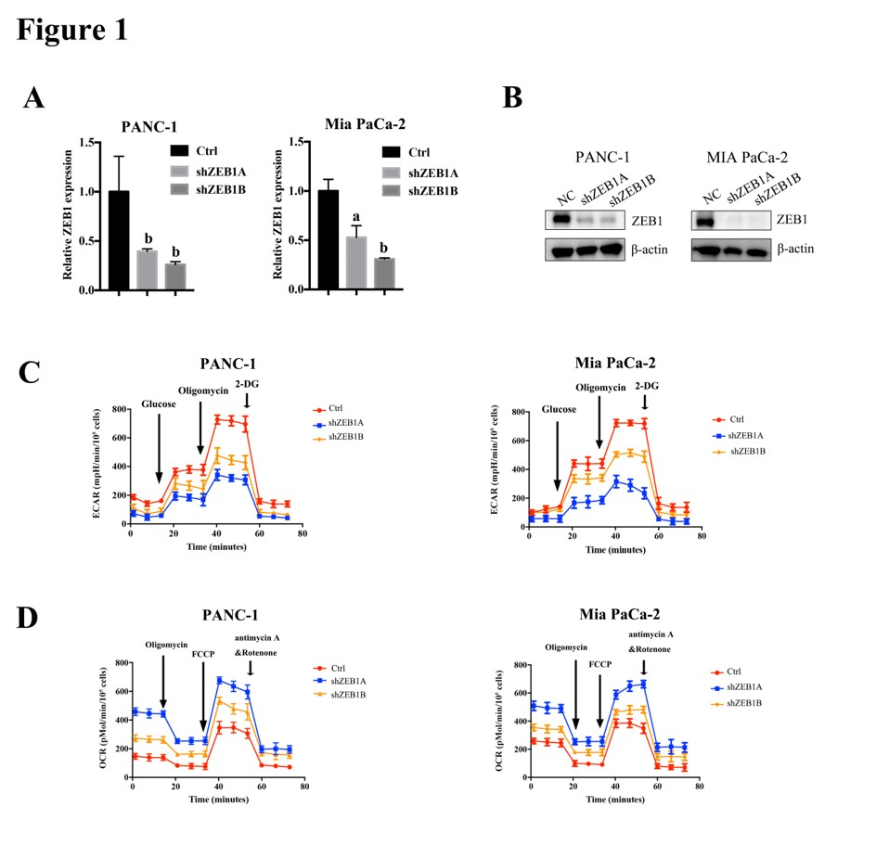
Figure 1 Zinc finger E-box binding homeobox-1 mediates aerobic glycolysis in pancreatic cancer. A: Zinc finger E-box binding homeobox-1 (ZEB1) silencing effect was assessed by quantitative real-time PCR in PANC-1 and MiaPaCa-2 cells. B: Immunoblot with ZEB1 antibody confirmed that ZEB1 was effectively downregulated in PANC-1 and MiaPaCa-2 cells. C: ZEB1 knockdown decreased glycolysis, as reflected by extracellular acidification rate measurement. D: Silencing ZEB1 expression increased mitochondrial respiration, measured by oxygen consumption rate. E and F: Decreased ZEB1 expression in PANC-1 and MiaPaCa-2 cells lowered reactive oxygen species generation. G and H: Downregulation of ZEB1 increased mitochondrial membrane potential in PANC-1 and MiaPaCa-2 cells. ZEB1: Zinc finger E-box binding homeobox-1; ECAR: Extracellular acidification rate; OCR: Oxygen consumption rate. ªP < 0.05, and ^{b}P < 0.01 vs NC or mock group. Error bars indicate mean ± SD.

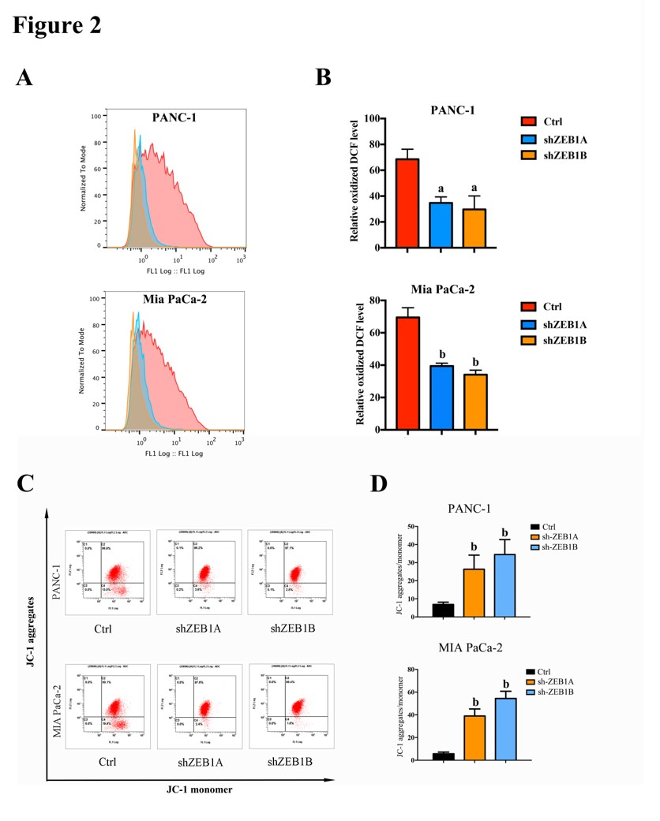

Figure 2 Zinc finger E-box binding homeobox-1 maintains reactive oxygen species generation and mitochondrial membrane potentials. A and B: Decreased zinc finger E-box binding homeobox-1 (ZEB1) expression in PANC-1 and MiaPaCa-2 cells lowered reactive oxygen species (ROS) generation, as demonstrated by using ROS assay kit ananlysis. C and D: Downregulation of ZEB1 increased mitochondrial membrane potential in PANC-1 and MiaPaCa-2 cells, which were confirmed by membrane potential probe JC-1 measurement. ZEB1: Zinc finger E-box binding homeobox-1. ªP < 0.05, and ^{b}P < 0.01 vs NC or mock group. Error bars indicate mean ± SD.

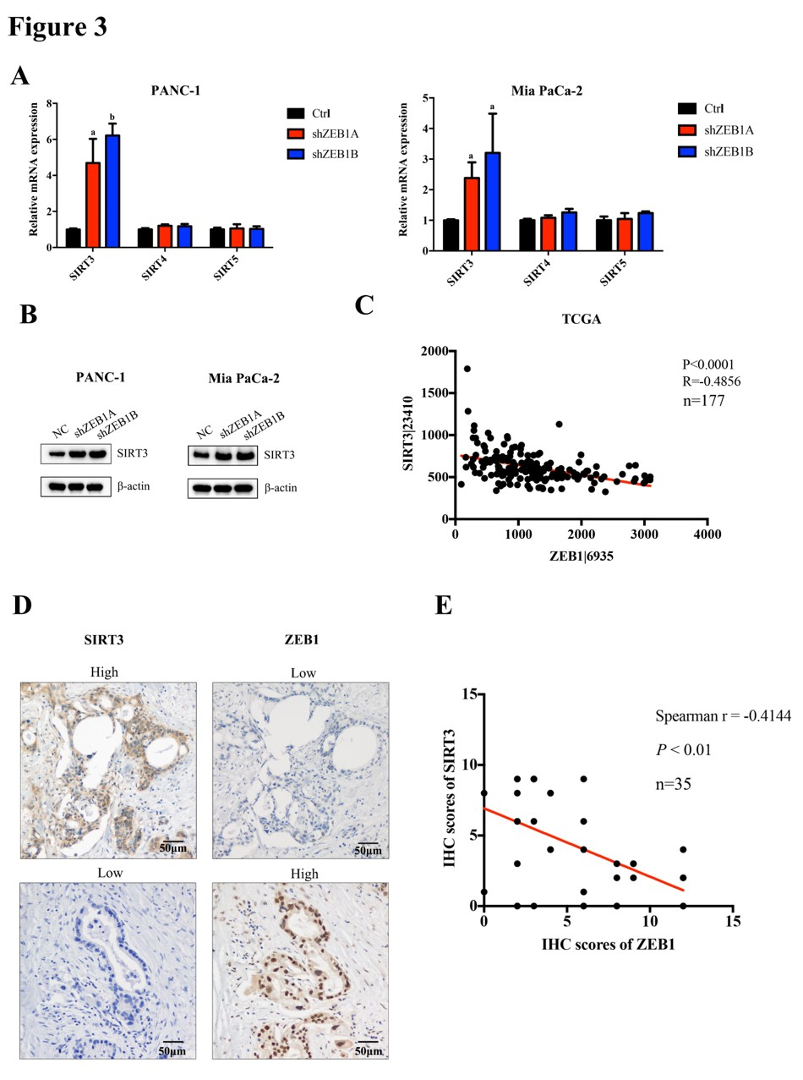

Figure 3 Zinc finger E-box binding homeobox-1 negatively correlated with sirtuin 3 expression in pancreatic cancer. A: Zinc finger E-box binding homeobox-1 (ZEB1) knockdown increased sirtuin 3 (SIRT3) mRNA levels in PANC-1 and MiaPaCa-2 cells, but had only a small impact on SIRT4 and SIRT5 expression. B: Protein levels of SIRT3 increased in ZEB1-silenced PANC-1 and MiaPaCa-2 cells. C: SIRT3 expression negatively and significantly correlated with ZEB1 expression in the TCGA cohort pancreatic cancer patients (P < 0.0001, R = −0.4856). D: SIRT3 expression was lower in patients with higher ZEB1 expression, as suggested by IHC staining. E: SIRT3 expression was negatively and significantly correlated with ZEB1 expression as demonstrated by IHC staining in pancreatic cancer patients (P = 0.0078, r = −0.4144). ZEB1: Zinc finger E-box binding homeobox-1; SIRT3: Sirtuin 3; TCGA: The Cancer Genome Atlas; IHC: Immunohistochemistry. ªP < 0.05, and ^{b}P < 0.01 vs NC or mock group. Error bars indicate mean ± SD.

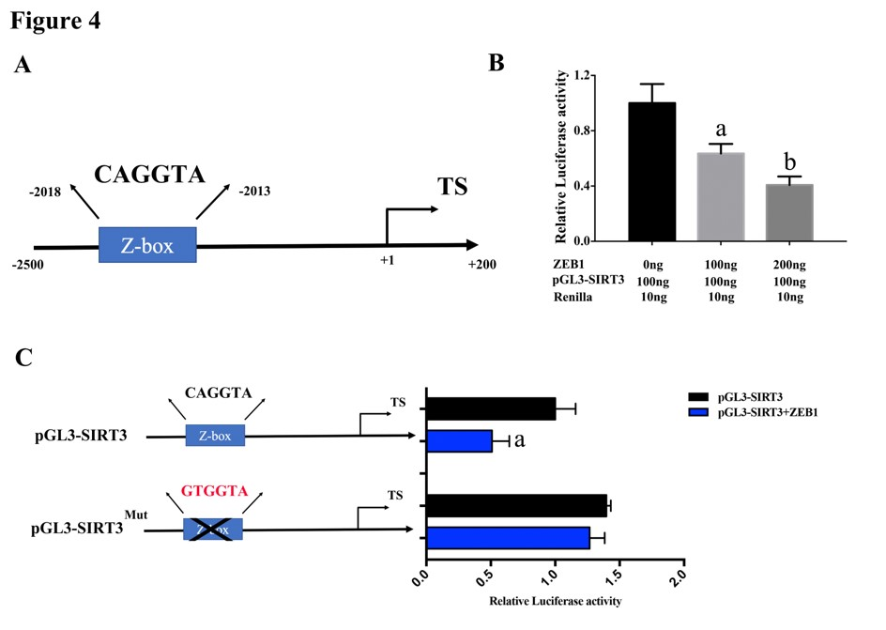
Figure 4 Sirtuin 3 was a transcriptional target of zinc finger E-box binding homeobox-1. A: There is a specific zinc finger E-box binding homeobox-1 (ZEB1) binding element (Z-box: CAGGTA) in the promoter region of sirtuin 3 (SIRT3). B: ZEB1 suppressed SIRT3 promoter luciferase activity in a dose-dependent manner. C: The Z-box in SIRT3 promoter was mutated from CAGGTA to GTGGTA to confirm that ZEB1 regulated SIRT3 promoter activity specifically. D: ZEB1 had a slight impact on mutated SIRT3 promoter luciferase activity, suggesting that ZEB1 regulated SIRT3 expression by Z-box specific binding. ZEB1: Zinc finger E-box binding homeobox-1; SIRT3: Sirtuin 3. ªP < 0.05, and ^{b}P < 0.01 vs NC or mock group.
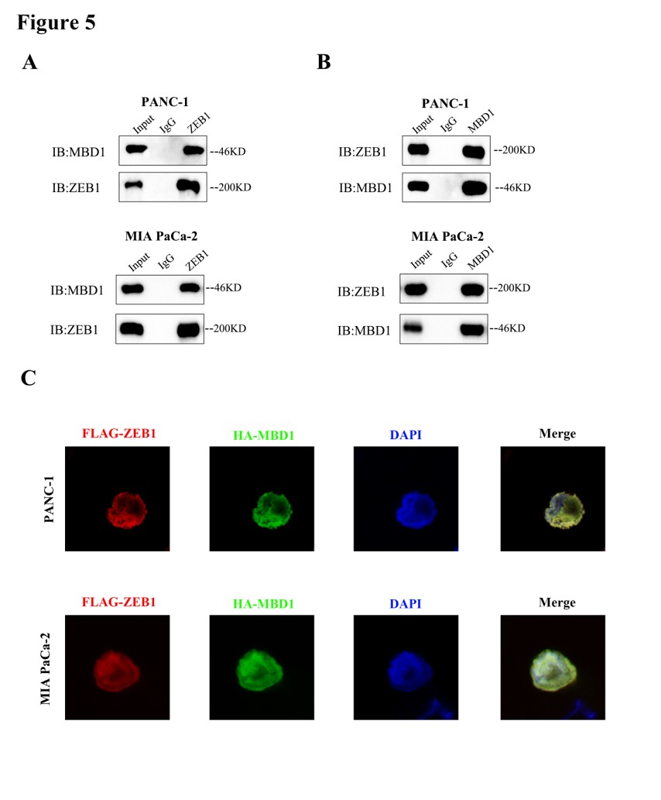
Figure 5 Epigenetic factor methyl-CpG binding domain protein 1 interacted with zinc finger E-box binding homeobox-1 in pancreatic cancer cells. A and B: Coimmunoprecipitation assay with methyl-CpG binding domain protein 1 (MBD1) or zinc finger E-box binding homeobox-1 (ZEB1) antibody demonstrated that MBD1 interacted with ZEB1 in PANC-1 and MiaPaCa-2 cells. C: Immunofluoresence assay indicated that MBD1 colocalized with ZEB1 in the nucleus in PANC-1 and MiaPaCa-2 cells. ZEB1: Zinc finger E-box binding homeobox-1; MBD1: Methyl-CpG binding domain protein 1.
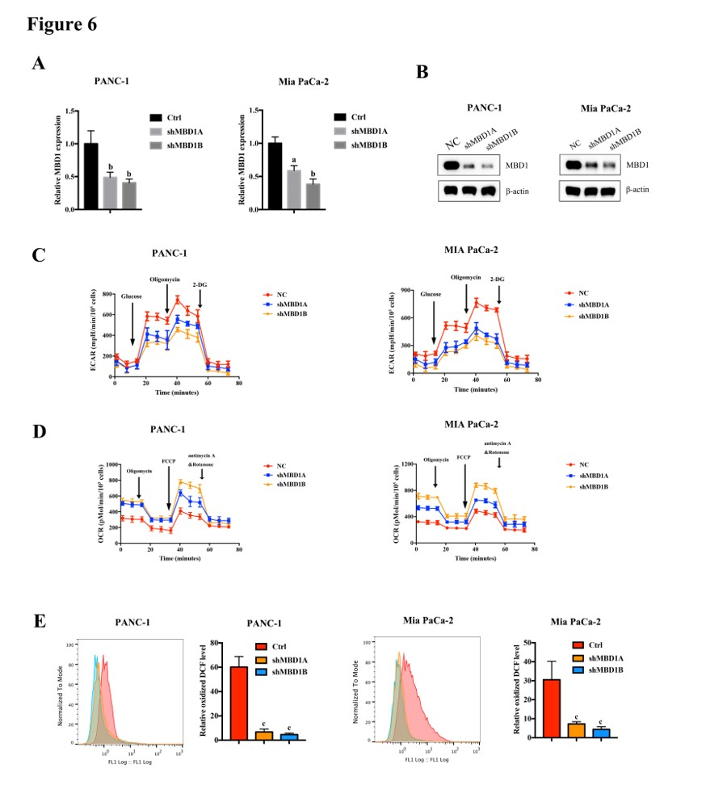
Figure 6 Methyl-CpG binding domain protein 1 positively regulated aerobic glycolysis and reactive oxygen species production in pancreatic cancer cells. A and B: Real-time PCR and western blotting demonstrated that methyl-CpG binding domain protein 1 (MBD1) was silenced in PANC-1 and MiaPaCa-2 cells. C: Knockdown of MBD1 decreased ECAR values, indicating that MBD1 was a positive regulator of glycolysis. D: Silencing MBD1 in PANC-1 and MiaPaCa-2 cells increased OCR values, suggesting that MBD1 negatively regulated mitochondrial respiration. E: Downregulation of MBD1 decreased ROS generation in PANC-1 and MiaPaCa-2 cells. MBD1: Methyl-CpG binding domain protein 1; ECAR: Extracellular acidification rate; OCR: Oxygen consumption rate. ªP < 0.05, ^{b}P < 0.01, and ^{c}P < 0.001 vs NC or mock group.

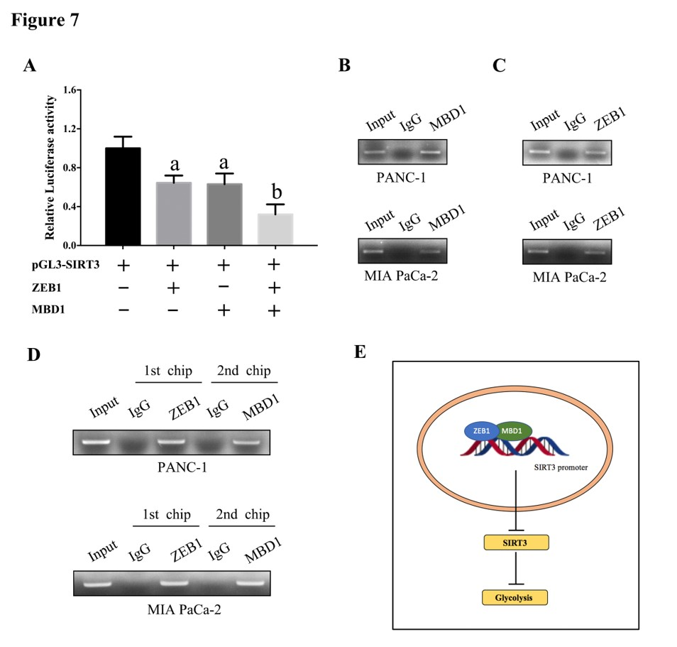
Figure 7 Zinc finger E-box binding homeobox-1 interacted with methyl-CpG binding domain protein 1 to suppress sirtuin 3 expression in pancreatic cancer cells. A: Methyl-CpG binding domain protein 1 (MBD1) and zinc finger E-box binding homeobox-1 (ZEB1) repressed Sirtuin 3 (SIRT3) promoter luciferase activity respectively, and when cotransfected into HEK-293T cells, SIRT3 decreased more dramatically than transfecting MBD1 or ZEB1 alone. B and C: Chromatin immunoprecipitation (ChIP) assay demonstrated that MBD1 and ZEB1 bound the Z-box region in SIRT3 promoter. D: ChIP and re-ChIP assays demonstrated that MBD1 and ZEB1 jointly occupied the same Z-box region in SIRT3 promoter. E: Schematic representation of the working model. ZEB1: Zinc finger E-box binding homeobox-1; MBD1: Methyl-CpG binding domain protein 1; SIRT3: Sirtuin 3. ªP < 0.05, and ^{b}P < 0.01 vs NC or mock group. Error bars indicate mean ± SD.

