Name of Journal: World Journal of Cardiology
Manuscript NO: 32526
Manuscript Type: Original Article

Retrospective Study

Title Page
Utility and Correlation of Known Anticoagulation Parameters in the Management of Pediatric Ventricular Assist Devices.

Running title: Anticoagulation Parameters In Pediatric VAD

Ajay K Bhatia, Mouhammad Yabrodi, Mallory Carroll, Silvia Bunting, Kirk Kanter, Kevin O Maher, Shriprasad R Deshpande

Ajay K Bhatia, MD, PhD¹, Mouhammad Yabrodi, MD¹, Mallory Carroll FNP², S. Bunting MD³, Kirk Kanter MD⁴ , Kevin O Maher MD¹, and Shriprasad R Deshpande MBBS,MS¹
¹Division of Pediatric Cardiology, Emory University School of Medicine, Children’s Healthcare of Atlanta, Atlanta, Georgia,USA 30322
²Mechanical Circulatory Support Program, Children’s Healthcare of Atlanta, Atlanta, Georgia, USA 30322
³Department of Pathology, Emory University School of Medicine, Atlanta, Georgia,USA 30322
⁴Department of Cardiothoracic Surgery, Emory University School of Medicine, Atlanta, Georgia, USA 30322

Keywords: VAD, anticoagulation, BERLIN-EXCOR, Pediatric, TEG

Author contributions:
Ajay K Bhatia : Data collection, writing manuscript
Mouhammad Yabrodi : Data collection, writing manuscript
Mallory Carroll : Clinical care and data, oversight
Silvia Bunting : Laboratory oversight, technical writing and oversight
Kirk Kanter :Surgical care, overnight and critical review
Kevin O Maher : Critical care, study oversight and critical review
Shriprasad R Deshpande :Study design and concept, oversight and manuscript writing and final edits.

Corresponding Author
Shriprasad R Deshpande MBBS,MS
Division of Pediatric Cardiology,
Emory University School of Medicine,
Children’s Healthcare of Atlanta,
1405, Clifton Rd NE,
Atlanta, Georgia.
FAX: 770-488-9480
Phone: 404 694 7739
Email: deshpandes@kidsheart.com
Disclaimers: None
Conflicts of Interest and Source of Funding: The authors have no conflicts of interest or financial disclosures. No funding source to disclose.

Institutional review board statement: Study was reviewed and approved by the Institutional Review Board at Children’s Healthcare of Atlanta.
Informed consent statement : Not applicable, retrospective study. Institutional review board waived need for consent for retrospective study.
Biostatistics: Basic statistical analysis performed by senior author who has a MS in Public Health with biostatistical training.
Data sharing statement : Not applicable

Utility and Correlation of Known Anticoagulation Parameters in the Management of Pediatric Ventricular Assist Devices.

Abstract:
Aim : Failure to achieve appropriate anticoagulation in patients supported with ventricular assist devices [VADs] increases the risk of serious complications such as post-operative bleeding and thrombo-embolic events. Purpose of this study was to assess utility and correlation of known anticoagulation parameters in the management of pediatric VAD.
Methods : Retrospective study of pediatric patients supported with a Berlin EXCOR VAD at a single pediatric tertiary care center during a single year.
Results : We demonstrated associations between aPTT and R-TEG values [r_{s} = 0.65, p<0.001] and between anti-Xa assay and R-TEG values [r_{s} = 0.54, p<0.001]. The strongest correlation was seen between aPTT and anti-Xa assays [r_{s} = 0.71 , p<0.001]. There was also a statistically significant correlation between platelet counts and the maximum amplitude of TEG [r_{s} = 0.71 , p<0.001 ]. Importantly, there was no association between dose of unfractionated heparin and either measure of anticoagulation [aPTT , anti-Xa or TEG R value].
Conclusion : This study suggests that while there is strong correlation between aPTT, anti-Xa assay and R-TEG values for patients requiring VAD support, there is a lack of relevant correlation between heparin dose and degree of effect. This raises concern as various guidelines continue to recommend using these parameters to titrate heparin therapy.
[Word Count ]
CORE TIP : This study suggests that while there is strong correlation between aPTT, anti-Xa assay and R-TEG values for patients requiring VAD support, there is a lack of relevant correlation between heparin dose and degree of effect. This raises concern as various guidelines continue to recommend using these parameters to titrate heparin therapy. A comprehensive strategy for appropriate anticoagulation may therefore warrant a combination of parameter monitoring and warrants further study.

Audio Core Tip : Please see audio file.

Utility and Correlation of Known Anticoagulation Parameters in the Management of Pediatric Ventricular Assist Devices.

Introduction :
Appropriate anticoagulation continues to be a significant challenge in pediatric patients supported with ventricular assist devices [VADs]. VAD implantation leads to dysregulation of hemostasis through contact of blood with foreign materials and introduction of shear forces that activate vascular endothelium, platelets, leukocytes and the coagulation cascade. This constellation of events increases the generation of thrombin and thus greatly increases the risk of thrombosis. Clinicians attempt to address the resultant imbalance between the pro- and anti-thrombotic states through the administration of anticoagulation and antiplatelet therapy. However, appropriate titration of these therapies in the pediatric population is challenging and result in various complications related to either a pro-thrombotic state leading to embolic complications or an overly anti-thrombotic state presenting as post-operative bleeding, gastrointestinal bleeding or hemorrhagic stroke.
Despite technological advances in VAD design and development of new methods of anticoagulation, complication rates remain significant. Adults on VAD support have bleeding rate of 15-50% while the risk of stroke has been reported at 5%[1, 2] Unfortunately the overall incidence of these complications in children with VAD appears to be higher.[3-5] While the VAD technology and anticoagulation agents are the same as those for adult patients, there are marked differences in dosing of medications, device performance characteristics in children and intrinsic differences in the maturity of the hemostatic system in children as they develop.[6-9] One retrospective study of 28 pediatric patients with various types of VAD demonstrated major bleeding in 29% and stroke in 25%. Given that there are several types of VAD that can be used in the pediatric population, and technology is constantly evolving, interpretation of older studies is challenging. The Berlin Heart EXCOR Pediatric VAD, a pulsatile extracorporeal device, is currently the most commonly used in pediatrics as it can accommodate a wide range of patient sizes and can support both the right and left heart as necessary. A prospective study comparing the Berlin Heart Pediatric EXCOR device to extracorporeal membrane oxygenation [ECMO] as bridge-to –transplantation demonstrated bleeding in 50% of patients and stroke in 29%[3] in the setting of a prescribed anticoagulation protocol with high degree of adherence.
The major obstacle to achieving adequate anticoagulation while minimizing the risk of hemorrhagic complications revolves around ineffective monitoring strategies and the lack of evidence-based pediatric guidelines to assist clinicians in modifying therapy. Various laboratory tests exist that measure specific components of the hemostatic system, including anti-Xa, aPTT, PT, and INR, but none of these gives a complete picture of hemostasis.[7, 10-12] Thromboelastography [TEG] has been proposed to more accurately demonstrate the in vivo state of hemostasis.[13, 14] Specifically the R-value is thought to reflect the anticoagulant effect of heparin. Current VAD anticoagulation guidelines, including those adopted for clinical trials, lack standardization to guide heparin therapy.[15] In addition, there is very limited data on coagulation parameters in pediatric patients supported on VADs. This disconnect may explain why, in many cases, using target lab values to indicate degree of anticoagulation does not prevent poor clinical outcomes. This study attempts to assess the utility and correlation between various measures of anti-coagulation, including the value of TEG, in a cohort of patients who received the Berlin Heart Pediatric EXCOR VAD.

Methods :
Anticoagulation parameters from four patients supported with a Berlin Heart EXCOR VAD at a single center during 2013 were studied retrospectively. The study was approved by the institutional review board. Standard anticoagulation therapy was initiated for all of these patients after the implantation of the Berlin EXCOR VAD in accordance with the published guidelines.[15] All management decisions for anticoagulation and anti-platelet therapy were made by the VAD team, again with target levels for various parameters consistent with the published protocol. Briefly, our standard regimen included unfractionated heparin initiated typically about 12 hours post-operative, followed by initiation of anti-platelet therapy with aspirin and dipyridamole typically, 48 hours post-operative in the setting of good surgical hemostasis. This was followed by dose adjustments as needed based on monitoring parameters. Patients were monitored closely by assessing various anticoagulation parameters such as PT, aPTT, anti-Xa assay, complete blood count, fibrinogen level daily. Thromboelastography [TEG] was performed using a TEG® 5000 Thrombelastograph® Hemostasis Analyzer system [Haemonetics Corporation, MA,USA]. Kaolin TEG as well as heparinase TEG were both performed as part of a standard approach to assess whole blood anticoagulation related to heparin as well as the health of coagulation system without the heparin effect. Additionally, TEG was also used to perform platelet-mapping studies using the platelet agonists Arachidonic acid [AA] and Adenosine diphosphate [ADP] to study platelet inhibition achieved by aspirin and dipyridamole. We tabulated all laboratory tests that were ordered to both assess their coagulation system and to direct their anticoagulation therapy. Additionally, we tabulated incidental heparin dose at time of laboratory collection, as well as clinical data reflecting outcomes, adverse events, morbidities and mortality. Statistical analysis was performed using SPSS 21 software [SPSS Inc., Chicago, IL, USA]. Continuous data are reported as mean ± standard deviation, categorical data are reported as frequency [%]. Continuous data was compared using student t-test while chi-square test was used for categorical variables. Spearman ’s Correlation was used to assess correlation between various tests. Statistical significance was defined as p<0.05.
Results :
Chart review of anticoagulation parameters from a total of four patients who were supported with the Berlin EXCOR Pediatric VAD during a single year yielded nearly 100 data points for every test. Three of the four patients had the primary diagnosis of dilated cardiomyopathy while the fourth patient carried a diagnosis of congenital heart block and developed pacemaker induced cardiomyopathy [Table 1]. No other significant comorbidities, genetic syndrome or coagulation disorders noted prior to the implants. Indications for VAD placement were heart failure non-responsive to standard inotropic therapy with milrinone and need for a second agent [dobutamine], along with evidence of end-organ injury. The later was extremely poor tolerance of enteral feeds in 3 patients while it was increased need for respiratory support [including intubation] in one patient. Berlin EXCOR VAD implantation was performed in the standard fashion per manufacturer’s detailed instructions. There were no intraoperative complications.
Measures of anticoagulation and correlations:
The results for the various tests are shown in Table 2. As noted, there was wide variation in the degree of anticoagulation achieved. We performed Spearman correlation testing to assess the relationship between individual tests measuring degree of anticoagulation, namely, aPTT, anti –Xa assay and R value on TEG. There was a strong and statistically significant correlation between all of these three parameters, with the strongest correlation existing between the aPTT value and anti-Xa assays [R² = 0.55, Spearman correlation coefficient of 0.71 , p<0.001]. R-TEG had correlation coefficients of 0.54 and 0.65 with anti-Xa and aPTT, respectively. These correlations are summarized in Table 3 and demonstrated in Figure 1a-c.
Role of platelets:
We also assessed the correlation between platelet count [PLT] and the maximum amplitude [MA] on TEG with heparinase added to nullify the heparin effect. We demonstrated that there was a strong and statistically significant correlation between the two values [Spearman correlation coefficient of 0.71, p<0.001 ] [Figure 2].
Heparin dose and effect:
Similar to previous studies, we found no clinically relevant association between heparin dose and the degree of anticoagulation measured by the tests. There was no relationship between aPTT and Heparin dose [Figure 3a] giving a Spearman’s rho correlation coefficient of 0.152 and a p value of 0.168. Similarly, there was no correlation between the heparin dose and anti-Xa levels [Spearman’s rho of -0.004, p =0.971]. There was weak correlation between heparin dose and TEG –R values [Spearman’s rho of 0.24, p = 0.015]. To account for patient variation in response to heparin as well as inherent differences in the coagulation system in pediatric patients, we also performed a correlation analyses by patient. In this case, there was a large variation in correlation between heparin dosing and aPTT or anti-Xa levels for a given patient. The R² value ranged from 0.0318 to 0.108 with a p value between 0.01 to 0.18 giving a statistically unstable model.
VAD associated coagulopathy:
It has been widely hypothesized that the circulatory support devices themselves induce a coagulopathic state beyond that induced by anti-coagulant therapy.[7, 16] The degree and nature of coagulopathy was assessed using heparinase –TEG to neutralize the heparin effect. Figure 4 shows dot-density plots of the distribution of individual values for individual parameters such as R, K, Angle, Maximum Amplitude value obtained on heparinase TEG. As demonstrated in the panel, we found a wide variation in the health of the underlying coagulation system with variable demonstration of factor deficiencies as well as clot strength. 4.9 % to 13.72% of all values for individual parameters were out of the normal range [represented by solid grey circles in the plots] suggesting significant coagulopathy or factor deficiencies. These findings were used to guide therapy for correcting the coagulopathy by administering appropriate factors in the form of cryoprecipitate or fresh frozen plasma.
Outcomes:
The mean duration of VAD support was 69.25 days [range 13 to 141 days]. Two patients suffered stroke. One patient suffered an ischemic stroke with hemorrhagic conversion, a second patient suffered an ischemic stroke diagnosed by computed tomography [CT]. Although the exact timing of the strokes could not be ascertained, the degree of anticoagulation was within prescribed ranges for the 12 hours before the CT scan and or clinical detection of the event. Both these patients made complete clinical recovery. A secondary endpoint was need for VAD pump change-out. A total of 8 pump exchanges were performed. The indications for pump change were made by the VAD team based on rate of clot growth, visualization of a dark clot measuring greater than 4 mm and subjective mobility of the clots. White clots and fibrin deposits in the blood chamber did not initiate pump exchanges, per manufacturer guidelines. Pump exchanges were well tolerated and did not result in any procedural complication. We were unable to identify predictors, such as degree of anticoagulation, fibrinogen levels, heparin dosing and the occurrence of either stroke or need for pump change. There were no mortalities in the cohort. All four patients underwent successful heart transplantation and at follow-up are alive and well.
Discussion:
Managing anticoagulation in the pediatric VAD patient remains a challenging task. Failure to provide adequate anticoagulation results in thromboembolic events. Unfortunately, if the balance is tipped too far, devastating hemorrhagic complications may ensue. Clinicians are further stymied by the lack of evidence-based guidelines to direct therapy based on available laboratory data. The current study provides a direct comparison of these laboratory tests to determine their degree of correlation with one another as well as with anticoagulant effect. In a robust comparison sample of greater than 100 individual data points from four patients, our study showed very strong correlations between aPTT, anti -Xa assay and R-TEG [figure 1]. This is not unexpected, but demonstrates that these tests segregate together and may be substituted for one another, especially in the clinically relevant ranges.
The role of thromboelastography in routine monitoring remains controversial.[17] While TEG has limitations, including difficulty with reproducibility, the utilization of TEG may be beneficial when employed routinely by experienced practitioners within a single center. Interestingly, we found a significant and clinically important correlation between platelet count and MA-TEG [figure 2]. This supports the importance of maintaining a normal platelet count and need for increased anti-platelet agents in the setting of thrombocytosis to manage the strength of clot formation. Additionally, TEG with- and without heparinase is important for diagnosing coagulopathy on VAD and guiding therapy. Furthermore, the presence of a wide range of values suggest a significant underlying coagulopathy that would otherwise be under-appreciated. This may be secondary to multiple factor deficiencies, prothrombotic microparticles or activation of coagulation factors. TEG may enable clinicians to monitor underlying VAD-induced coagulopathy and thereby explain how complications of anticoagulation therapy arise despite achievement of target levels for other coagulation parameters. We are currently validating this hypothesis using a larger cohort of patients that includes those dependent upon mechanical circulatory support devices as well as those requiring extracorporeal membrane oxygenation support.
One important observation from our investigation is the lack of relevant correlation between unfractionated heparin [UNFH] dose and degree of effect as measured by aPTT, anti-Xa or R value [figure 3]. This potentially reflects a significant variation in response to heparin by patient as well as by the coagulation milieu at any given time. These results differ somewhat from data that suggests good correlation between aPTT and UNFH levels in adults on extracorporeal life support [ECLS][18] as well as a recent study in a small cohort of pediatric patients on ECLS.[19] These discrepancies may reflect variations in heparin response amongst patients due to developmental differences in hemostasis and genetic variability.[20, 21] Lastly, none of these tests are specific in their assessment of the effect of unfractionated heparin in vivo. A lack of correlation between heparin dose and PTT or anti-Xa assay has also been noted in other settings, including a cohort of critically ill children.[10] This is extremely relevant as various guidelines continue to recommend use of these monitoring parameters to titrate heparin therapy.
We also noted timing and significance of thrombotic or hemorrhagic events in our patient cohort. Three patients experienced significant morbidities. Two had an ischemic stroke and one had a hemorrhagic stroke. The older patient had an uneventful course. All patients eventually underwent successful bridge to transplantation and were discharged to home. At follow-up, all of them are alive. The patients with ischemic strokes have made a complete functional recovery, albeit after extensive rehabilitation. The patient who had hemorrhagic stroke still has speech delay and motor delay, but no deficits. Unfortunately, due to a small number of events, predictive modeling could not be performed to analyze further risk factors. Correlation of TEG and anticoagulation values with thromboembolic or hemorrhagic events in a larger patient cohort will provide valuable data as to the predictive ability of these tests. This study was also limited only to a single type of VAD. Future studies will include non-pulsatile and implantable devices such as Heartmate II or HeartWare HVAD in an effort to not only provide device-specific information, but also to determine if standards can be applied across all devices.

Conclusion :
This study provides valuable data regarding the utility of common laboratories to monitor the state of hemostasis in VAD patients, as suggested by existing guidelines. It also highlights the imprecise nature of current means of monitoring and demonstrates that multiple targets in the hemostatic pathway need to be targeted in order to achieve the desired balance between prevention of device thrombosis and hemorrhagic consequences.

COMMENTS

REFERENCES
1. Slaughter MS. Hematologic effects of continuous flow left ventricular assist devices. Journal of cardiovascular translational research. 2010;3[6]:618-24. Epub 2010/09/14. doi: 10.1007/s12265-010-9222-6. PubMed PMID: 20835786.
2. Adzic A, Patel SR, Maybaum S. Impact of adverse events on ventricular assist device outcomes. Current heart failure reports. 2013;10[1]:89-100. Epub 2013/01/15. doi: 10.1007/s11897-012-0127-3. PubMed PMID: 23314865.
3. Fraser CD, Jr., Jaquiss RD, Rosenthal DN, Humpl T, Canter CE, Blackstone EH, Naftel DC, Ichord RN, Bomgaars L, Tweddell JS, Massicotte MP, Turrentine MW, Cohen GA, Devaney EJ, Pearce FB, Carberry KE, Kroslowitz R, Almond CS. Prospective trial of a pediatric ventricular assist device. The New England journal of medicine. 2012;367[6]:532-41. Epub 2012/08/10. doi: 10.1056/NEJMoa1014164. PubMed PMID: 22873533.
4. Almond CS, Morales DL, Blackstone EH, Turrentine MW, Imamura M, Massicotte MP, Jordan LC, Devaney EJ, Ravishankar C, Kanter KR, Holman W, Kroslowitz R, Tjossem C, Thuita L, Cohen GA, Buchholz H, St Louis JD, Nguyen K, Niebler RA, Walters HL, 3rd, Reemtsen B, Wearden PD, Reinhartz O, Guleserian KJ, Mitchell MB, Bleiweis MS, Canter CE, Humpl T. Berlin Heart EXCOR pediatric ventricular assist device for bridge to heart transplantation in US children. Circulation. 2013;127[16]:1702-11. Epub 2013/03/30. doi: 10.1161/circulationaha.112.000685. PubMed PMID: 23538380.
5. Adachi I, Fraser CD, Jr. Berlin Heart EXCOR Food and Drug Administration Investigational Device Exemption Trial. Seminars in thoracic and cardiovascular surgery. 2013;25[2]:100-6. Epub 2013/11/13. doi: 10.1053/j.semtcvs.2013.07.008. PubMed PMID: 24216526.
6. Monagle P. Anticoagulation in the young. Heart [British Cardiac Society]. 2004;90[7]:808-12. Epub 2004/06/18. doi: 10.1136/hrt.2003.024299. PubMed PMID: 15201260; PMCID: PMC1768335.
7. Annich G, Adachi I. Anticoagulation for pediatric mechanical circulatory support. Pediatric critical care medicine : a journal of the Society of Critical Care Medicine and the World Federation of Pediatric Intensive and Critical Care Societies. 2013;14[5 Suppl 1]:S37-42. Epub 2013/06/14. doi: 10.1097/PCC.0b013e318292dfa7. PubMed PMID: 23735984.
8. Bembea MM, Annich G, Rycus P, Oldenburg G, Berkowitz I, Pronovost P. Variability in anticoagulation management of patients on extracorporeal membrane oxygenation: an international survey. Pediatric critical care medicine : a journal of the Society of Critical Care Medicine and the World Federation of Pediatric Intensive and Critical Care Societies. 2013;14[2]:e77-84. Epub 2013/01/05. doi: 10.1097/PCC.0b013e31827127e4. PubMed PMID: 23287906; PMCID: PMC3567253.
9. Monagle P, Chan AK, Goldenberg NA, Ichord RN, Journeycake JM, Nowak-Gottl U, Vesely SK. Antithrombotic therapy in neonates and children: Antithrombotic Therapy and Prevention of Thrombosis, 9th ed: American College of Chest Physicians Evidence-Based Clinical Practice Guidelines. Chest. 2012;141[2 Suppl]:e737S-801S. Epub 2012/02/15. doi: 10.1378/chest.11-2308. PubMed PMID: 22315277; PMCID: PMC3278066.
10. Kuhle S, Eulmesekian P, Kavanagh B, Massicotte P, Vegh P, Lau A, Mitchell LG. Lack of correlation between heparin dose and standard clinical monitoring tests in treatment with unfractionated heparin in critically ill children. Haematologica. 2007;92[4]:554-7. Epub 2007/05/10. PubMed PMID: 17488668.
11. Miller BE, Bailey JM, Mancuso TJ, Weinstein MS, Holbrook GW, Silvey EM, Tosone SR, Levy JH. Functional maturity of the coagulation system in children: an evaluation using thrombelastography. Anesthesia and analgesia. 1997;84[4]:745-8. Epub 1997/04/01. PubMed PMID: 9085950.
12. Alexander DC, Butt WW, Best JD, Donath SM, Monagle PT, Shekerdemian LS. Correlation of thromboelastography with standard tests of anticoagulation in paediatric patients receiving extracorporeal life support. Thrombosis research. 2010;125[5]:387-92. Epub 2009/08/14. doi: 10.1016/j.thromres.2009.07.001. PubMed PMID: 19674773.
13. Spiess BD, Tuman KJ, McCarthy RJ, DeLaria GA, Schillo R, Ivankovich AD. Thromboelastography as an indicator of post-cardiopulmonary bypass coagulopathies. Journal of clinical monitoring. 1987;3[1]:25-30. Epub 1987/01/01. PubMed PMID: 3819793.
14. Miller BE, Guzzetta NA, Tosone SR, Levy JH. Rapid evaluation of coagulopathies after cardiopulmonary bypass in children using modified thromboelastography. Anesthesia and analgesia. 2000;90[6]:1324-30. Epub 2000/05/29. PubMed PMID: 10825314.
15. Almond CS, Buchholz H, Massicotte P, Ichord R, Rosenthal DN, Uzark K, Jaquiss RD, Kroslowitz R, Kepler MB, Lobbestael A, Bellinger D, Blume ED, Fraser CD, Jr., Bartlett RH, Thiagarajan R, Jenkins K. Berlin Heart EXCOR Pediatric ventricular assist device Investigational Device Exemption study: study design and rationale. American heart journal. 2011;162[3]:425-35.e6. Epub 2011/09/03. doi: 10.1016/j.ahj.2011.05.026. PubMed PMID: 21884857.
16. Achneck HE, Sileshi B, Parikh A, Milano CA, Welsby IJ, Lawson JH. Pathophysiology of bleeding and clotting in the cardiac surgery patient: from vascular endothelium to circulatory assist device surface. Circulation. 2010;122[20]:2068-77. Epub 2010/11/26. doi: 10.1161/circulationaha.110.936773. PubMed PMID: 21098468.
17. Chitlur M, Lusher J. Standardization of thromboelastography: values and challenges. Seminars in thrombosis and hemostasis. 2010;36[7]:707-11. Epub 2010/10/28. doi: 10.1055/s-0030-1265287. PubMed PMID: 20978991.
18. Brill-Edwards P, Ginsberg JS, Johnston M, Hirsh J. Establishing a therapeutic range for heparin therapy. Annals of internal medicine. 1993;119[2]:104-9. Epub 1993/07/15. PubMed PMID: 8512158.
19. Liveris A, Bello RA, Friedmann P, Duffy MA, Manwani D, Killinger JS, Rodriquez D, Weinstein S. Anti-factor Xa assay is a superior correlate of heparin dose than activated partial thromboplastin time or activated clotting time in pediatric extracorporeal membrane oxygenation*. Pediatric critical care medicine : a journal of the Society of Critical Care Medicine and the World Federation of Pediatric Intensive and Critical Care Societies. 2014;15[2]:e72-9. Epub 2013/12/18. doi: 10.1097/pcc.0000000000000028. PubMed PMID: 24335992.
20. Chan KL, Summerhayes RG, Ignjatovic V, Horton SB, Monagle PT. Reference values for kaolin-activated thromboelastography in healthy children. Anesthesia and analgesia. 2007;105[6]:1610-3, table of contents. Epub 2007/11/29. doi: 10.1213/01.ane.0000287645.26763.be. PubMed PMID: 18042858.
21. Newall F, Johnston L, Ignjatovic V, Monagle P. Unfractionated heparin therapy in infants and children. Pediatrics. 2009;123[3]:e510-8. Epub 2009/02/18. doi: 10.1542/peds.2008-2052. PubMed PMID: 19221154.

Table 1 :
 | Patient 1 K | Patient 2 S | Patient 3 P | Patient 4 N
Diagnosis | DCM | DCM | CHB; DCM | DCM
Age | 13 months | 5 months | 8 months | 10 years
Weight | 8.4kg | 7.2kg | 8.1kg | 24.5kg
Gender | F | M | M | F
Type of VAD | LVAD | LVAD | LVAD | LVAD
Days on VAD | 141 | 69 | 13 | 54
Outcome | OHT | OHT | OHT | OHT

Table 1: Patient Demographics. Relevant clinical data from the four patients studied including diagnosis prior to receiving VAD, type of ventricular support [LVAD = left ventricular assist device], absolute number of days on VAD support and eventual patient outcome. All patients received Berlin EXCOR devices as bridge to successful transplantation. DCM = dilated cardiomyopathy, CHB = congenital heart block, OHT= orthotopic heart transplantation

Table 2:

Test | N | Minimum | Maximum | Mean | Std. Deviation
Prothrombin time | 97 | 12.5 | 30.8 | 14.542 | 2.34
Activated partial thromboplastin time (seconds) | 98 | 26.1 | 200.0 | 79.779 | 44.62
INR | 98 | 0.9 | 3.0 | 1.132 | 0.25
Anti-Xa levels (U/ml) | 97 | 0.05 | 1.20 | .4381 | 0.24
TEG – R (minutes) | 102 | 5.2 | 82.8 | 32.464 | 19.77
TEG – alpha angle | 99 | 5.9 | 71.8 | 28.83 | 18.00
TEG - MA | 98 | 10 | 75.0 | 46.002 | 18.08
TEG R (heparinase) (minutes) | 102 | 5.1 | 34.5 | 8.455 | 3.20
TEG – K (heparinase) | 102 | 0.8 | 12.0 | 2.029 | 1.12
TEG – alpha angle (heparinase) | 102 | 17.8 | 74.4 | 63.306 | 7.30
TEG – MA (heparinase) | 102 | 45.1 | 73.0 | 59.696 | 6.03
TEG – G (heparinase) | 100 | 4.1 | 13.5 | 7.712 | 2.01
Platelet Inhibition – ADP (%) | 90 | 0.0 | 100.0 | 41.113 | 33.73
Platelet inhibition – AA (%) | 91 | 0.0 | 100.0 | 43.690 | 37.05
Platelet count (k/uL) | 131 | 77 | 451 | 267.05 | 89.6
Platelet volume | 121 | 6.8 | 10.1 | 8.460 | 0.69
Heparin dose (units/kg/hour) | 131 | 15 | 46 | 33.66 | 7.15

Table 2 : Distribution of values for various measures of coagulation status. Summary of data are presented as number of individual data points (N) with value ranges, mean value and standard deviation given. PT = prothrombin time, aPTT = activated thromboplastin time, INR = international normalized ratio. TEG values without heparinase are represented by R (reaction time), ANGLE (alpha-angle), MA (mean amplitude). TEG values with heparinase are noted as RHEP, KHEP (K = coagulation time) ,ANGLEHEP, MAHEP and GAHEP (GA = overall clot strength) . Percent of platelet inhibition via the arachidonic acid (AA) and adenosine phosphate (ADP) pathways are shown. The range of administered heparin dose at the time of laboratory value collection is also presented.

Table 3:

 | aPTT  Correlation  Coefficient p | Anti Xa  Correlation  Coefficient p | R-TEG  Correlation  Coefficient p
aPTT | 1.0 | 0.71 <0.001 | 0.65 <0.001
Anti Xa | 0.71 <0.001 | 1.0 | 0.54 <0.001
R-TEG | 0.65 <0.001 | 0.54 <0.001 | 1.0
Table 3: Correlation matrix between tests. Spearman correlation analyses were used to determine the degree of correlation between aPTT, Anti-Xa and R values (R-TEG)

Legends :
Figure 1 : Scatterplots demonstrating correlation between standard measures of anticoagulation for patients on LVAD support. The estimated linear regression line (line of best fit) is shown along with 95% confidence interval for individual value predictions for (a) anti-Xa and TEG-R levels, (b) aPTT and TEG –R levels, and (c) aPTT and anti-Xa levels. The R2 values are shown alongside each panel (all p < 0.001).

Figure 2 : Correlation between platelet count and maximum amplitude after treatment with heparinase. The estimated linear regression line (line of best fit along with 95% confidence interval) is shown for platelet counts and TEG-MA (heparinase). Correlation coefficient of 0.541( p<0.001)

Figure 3 : Scatterplots demonstrating correlation between unfractionated heparin dose and (a) aPTT (b) Anti-Xa levels and (c) TEG-R value. The estimated linear regression line (line of best fit) is shown along with 95% confidence interval for individual value predictions.

Figure 4 : Dot-density plots of TEG (heparinase) parameters R (panel A), K (panel B), Angle (panel C) and Maximum Amplitude (panel D) showing distribution of individual values. Abnormal values are represented by solid grey circles.

Figure 1 :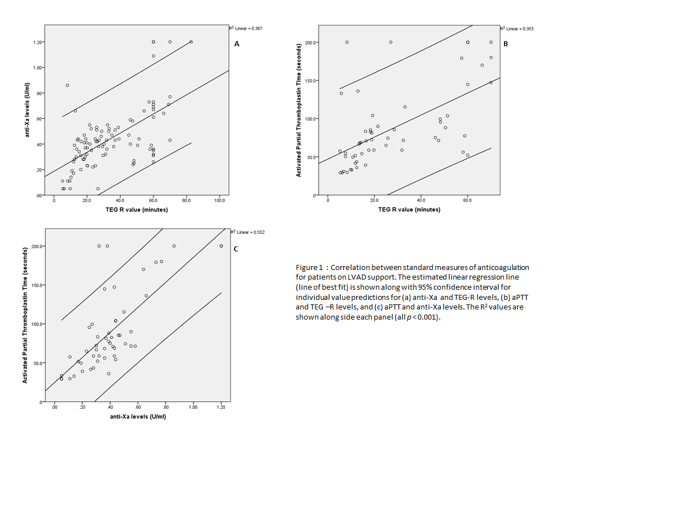Figure 2 : F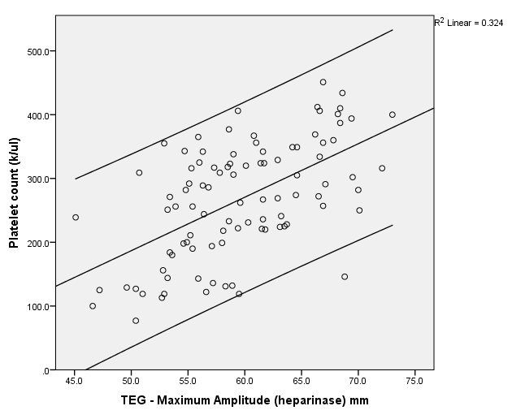

Figure 3 :
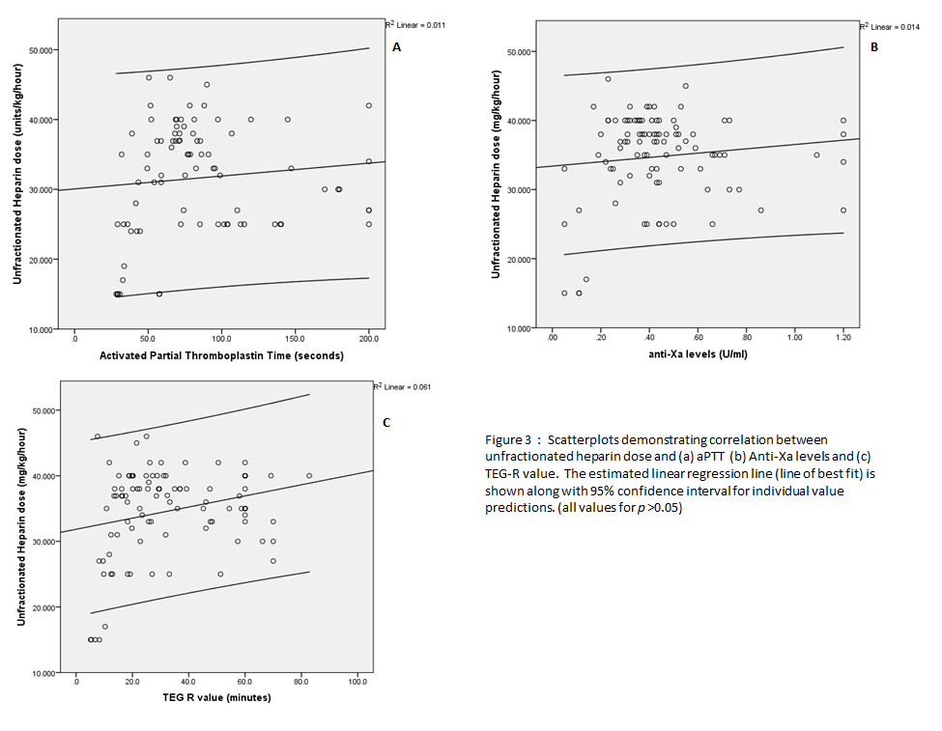

Figure 4 :
