Name of Journal: World Journal of Clinical Cases
Manuscript NO: 61536
Manuscript Type: CASE REPORT

Clinical characteristics of intrahepatic biliary papilloma: A case report

Yi D et al. Clinical characteristics of intrahepatic biliary papilloma

Dan Yi, Li-Jing Zhao, Xiao-Bo Ding, Tai-Wei Wang, Song-Yang Liu

Dan Yi, Song-Yang Liu, Department of Hepatobiliary and Pancreatic Surgery, First Hospital of Jilin University, Changchun 130012, Jilin Province, China

Li-Jing Zhao, Tai-Wei Wang, Department of Rehabilitation, School of Nursing, Jilin University, Changchun 130012, Jilin Province, China

Xiao-Bo Ding, Department of Radiology, First Hospital of Jilin University, Changchun 130012, Jilin Province, China

Author contributions: Yi D was a major contributor to data acquisition, literature retrieval and manuscript writing; Ding XB contributed to the acquisition of screening and imaging data; Wang TW contributed to the analysis of materials and the modification of the manuscript; Zhao LJ and Liu SY made important modifications to the manuscript; All authors read and approved the final manuscript.

Corresponding author: Song-Yang Liu, MD, PhD, Chief Physician, Professor, Department of Hepatobiliary and Pancreatic Surgery, First Hospital of Jilin University, No. 71 Xinmin Street, Changchun 130021, China. liusongyang@126.com

Received: December 10, 2020
Revised: January 30, 2021
Accepted: February 25, 2021
Published online: May 6, 2021

Abstract
BACKGROUND
Intrahepatic bile duct papilloma (IPNB) is a rare benign tumour from the bile duct epithelium and has a high malignant transformation rate. Early radical resection can obviously improve the prognosis of patients, but it is difficult to be sure of the diagnosis of IPNB before operating.

CASE SUMMARY
This study included 28 patients with intraductal papilloma admitted to the First Hospital of Jilin University from January 2010 to November 2020 and recorded their clinical manifestations, imaging features, complications and prognosis. There were 12 males and 16 females with an average age of 61.36 ± 8.03 years. Most patients had symptoms of biliary obstruction. Biliary dilatation and cystic mass could be seen on imaging. After surgery, IPNB was diagnosed by pathology.

CONCLUSION
IPNB is a rare benign tumour in the bile duct. Early diagnosis and timely R0 resection can improve the prognosis of IPNB.

Key Words: Intrahepatic bile duct; Papillary tumour; Biliary obstruction; Mural nodules; Case report

©The Author(s) 2021. Published by Baishideng Publishing Group Inc. All rights reserved.

Yi D, Zhao LJ, Ding XB, Wang TW, Liu S. Clinical characteristics of intrahepatic biliary papilloma: A case report. World J Clin Cases 2021; 9(13): 3185-3193 URL: https://www.wjgnet.com/2307-8960/full/v9/i13/3185.htm DOI: https://dx.doi.org/10.12998/wjcc.v9.i13.3185

Core Tip: Intrahepatic bile duct papilloma (IPNB) is a rare benign tumour in the bile duct. An early radical operation can improve the prognosis. This study analysed the clinical manifestations, imaging features, complications and prognosis of IPNB. IPNB should be considered in patients with bile duct recurrent infection, cholestasis and biliary obstruction, if imaging examination shows cystic dilatation of the bile duct, if there are mural nodules or papillary tumours with delayed enhancement, if the cystic-solid tumours communicate with the bile duct and if the upstream and downstream bile ducts dilate.

INTRODUCTION
Intrabiliary papilloma is a rare benign tumour from the bile duct epithelium that has been gradually recognized by surgeons in recent years. In 2019, the World Health Organization defined it as “a grossly visible premalignant neoplasm with intraductal papillary or villous growth of biliary-type epithelium”^{[1]}. Therefore, intrahepatic bile duct papilloma (IPNB) is a precancerous lesion or early tumour lesion that is characterized by an intraluminal papillary tumour with a fibrovascular core in the dilated bile duct^{[2]}. However, it has been reported that the malignant transformation rate of IPNB can be as high as 41%-83%^{[3]}. Because it takes 1-2 years for precancerous lesions to transform into invasive carcinoma, there is sufficient time for surgical treatment.
Kim et al^{[4]} showed that the 3-year overall survival rate of patients with IPNB who underwent R0 surgery was 91.3%, and the 5-year overall survival rate was as high as 68.8%. Therefore, early diagnosis, active R0 resection and avoidance of positive biliary tract margins are the primary ways to ensure long-term survival in patients with IPNB^{[1]}. However, it is difficult to diagnose IPNB before surgery, and it is often misdiagnosed as cholangiocarcinoma before surgery, which leads to increased fear of patients and their families, poor willingness to actively treat and even the opportunity for surgical treatment. Therefore, patients with IPNB lose the best treatment time, and at the same time, their quality of life and survival time are reduced.
This study summarized and analysed the clinical data of 28 patients diagnosed with IPNB for the first time at the First Hospital of Jilin University from January 2010 to November 2020 to improve doctors’ understanding of IPNB and improve the preoperative diagnosis rate.

CASE PRESENTATION
Chief complaints
Eighteen patients (64.29%) showed epigastric pain, and three of them had yellow staining of the skin and sclera. Another 4 patients (14.29%) only showed yellow staining of the skin and sclera. Five patients (17.86%) had no obvious clinical manifestations.

History of present illness
Five patients (17.86%) came to see a doctor because of abdominal diseases found in physical examination.
Seven patients (25%) were referred to our hospital for jaundice reduction due to obstructive jaundice. Among them, 5 patients (17.86%) underwent ultrasound-guided intrahepatic bile duct puncture and drainage in local hospitals, and 2 patients (7.14%) underwent endoscopic retrograde cholangiopancreatography nasobiliary drainage in local hospitals. The other 16 patients (57.14%) did not receive other treatment, and they visited our hospital for the first time.

History of past illness
Four patients (14.29%) had undergone cholecystectomy for gallstones. One patient had undergone laparoscopic cholecystectomy for choledocholithiasis. One patient (3.57%) had undergone a radical operation for colon cancer.

Personal and family history
All patients had no personal family history.

Physical examination
Eighteen patients (28.57%) had upper abdominal tenderness. Seven patients (25%) had yellow staining of the skin and sclera.

Laboratory examinations
The CA19-9 of 13 patients was higher than normal, among which 12 patients (92.3%) were diagnosed as IPNB invasive carcinoma and 1 patient (7.7%) was IPNB high-grade intraepithelial neoplasia. The total bilirubin level of 11 patients (39.29%) increased.

Imaging examinations
Twenty-six patients underwent abdominal enhanced computed tomography (CT) examination. Ten patients (35.71%) were examined by cholangiography. According to the results of the imaging examination, 12 cases (42.86%) showed cystic and solid tumours communicating with the bile duct, 8 cases (28.57%) showed soft tissue nodules, and 23 cases (82.14%) showed obvious dilatation of the bile duct. However, only 4 patients (14.29%) were diagnosed as intrahepatic bile duct papilloma by imaging doctor before operation. Seventeen cases (60.71%) were considered cholangiocarcinoma or liver cancer, 4 cases (14.29%) as bile duct dilatation, 1 case (3.57%) as bile duct cystadenocarcinoma, and 1 case (3.57%) as intrahepatic bile duct stones.

Accompanying related diseases
Thirteen patients (46.43%) had bile duct stones, 7 patients (25%) had hepatitis, 3 patients (10.71%) had gallstones, 2 patients (7.14%) had sclerosing cholangitis, and 1 patient (3.57%) had bile duct cysts.

FINAL DIAGNOSIS
All cases were confirmed as papillary tumours of the intrahepatic bile duct by postoperative pathology. Among them, 11 cases (39.29%) were high-grade intraepithelial neoplasia, and 17 cases (60.71%) were IPNB invasive carcinoma (Figure 1).

TREATMENT
All patients underwent radical surgical resection. Rapid pathological examination was performed during operation to realize R0 resection. Choledochoscopy was performed in some patients during operation (Table 1 and Figure 2).

OUTCOME AND FOLLOW-UP
Patients were followed up for 3 years after discharge. Three patients died of multifunctional organ failure. The other patients had no recurrence and a good quality of life. The 3-year survival rate was 89.3%.

DISCUSSION
IPNB is a rare benign tumour in the bile duct that can secrete mucin in different proportions. It is considered the counterpart in the biliary system of the pancreas intraductal papilloma^{[5]}, which can affect any part of the biliary system, but it has been reported that it occurs in the hilar region^{[6]}. In this study, 11 patients’ lesions occurred in the intrahepatic bile duct combined with the hilar region, and 16 patients’ lesions were only located in the left intrahepatic bile duct but did not invade the hilar region, which may be due to the fluidity of mucus secreted by IPNB and the dynamic evolution of the disease. According to the covered epithelial cells, IPNB can be divided into gastric type, intestinal type, pancreaticobiliary type and eosinophilic type^{[1]}. According to pathological results, it can be divided into low-grade intraepithelial neoplasia, high-grade intraepithelial neoplasia and invasive tumour, and the former two are precancerous lesions. Wan-Joon Kim et al^{[4]} others believe that this is a dynamic transition process from benign to malignant. According to the location, size and mucin secretion degree of IPNB, some patients have biliary obstruction symptoms to different degrees, such as abdominal pain, yellow skin and sclera, fever, etc.^{[7]}, and some patients have no obvious symptoms. The patients collected in this study are consistent with the above literature reports.
The pathogenesis of IPNB is not clear, but it may be related to repeated infection of the biliary tract and cholestasis^{[3]}. It is worth mentioning that bile duct stones, Clonorchis sinensis infection, primary sclerosing cholangitis and biliary malformation are risk factors for IPNB^{[8]}. Among the cases included in this study, 13 patients suffered from bile duct stones, 2 patients suffered from sclerosing cholangitis and 1 patient suffered from bile duct cysts. Long-term stimulation of the above factors can lead to hyperplasia of bile duct epithelial columnar cells and heterotopic tissues and further lead to papillary hyperplasia and the formation of papilloma.
The preoperative diagnosis of IPNB is mainly based on magnetic resonance imaging, CT and magnetic resonance cholangiopancreatography. Because of the different locations, sizes, shapes and mucin secretions of intrahepatic bile duct tumours, they present different imaging manifestations^{[6]}, such as: (1) A tumour that is cystic in appearance, in which polypoid, lobulated or coral-like wall nodules can be seen, while in some patients, lump-like or papillary lesions can be seen; (2) The downstream bile duct is obviously dilated; and (3) Slight dilatation of the upstream bile duct is observed, which is also the characteristic manifestation of IPNB in CT examination^{[4,9]}. However, in a few patients, nodule-like lesions are not obvious and are difficult to find by preoperative CT examination, which is also why preoperative diagnosis is difficult at present^{[6,10]}. Siripongsakun et al^{[11]} and other studies show that magnetic resonance imaging, as the most sensitive preoperative examination method of IPNB, has the following imaging features: (1) Cystic dilatation of the bile duct and small nodules in the catheter is observed; and (2) The lesion communicates with the bile duct, and the nodule grows into the bile duct cavity and is connected with the bile duct wall through the fibrovascular stalk^{[2,12]}, showing a floating sign^{[13]} (Figure 3).
The imaging characteristics of the patients included in this study are consistent with the above report. CT showed that the cystic solid tumour had a smooth cystic wall in which the wall nodules distributed along the bile duct wall projected into the lumen but not out of the bile duct wall. The enhancement of parietal nodules was delayed, the enhancement of papilla was not obvious in the arterial phase, and the enhancement was delayed in the portal phase. Cystic components were not enhanced. Enlargement of the proximal and distal bile ducts was apparent. Magnetic resonance cholangiopancreatography and CT three-dimensional reconstruction characteristically showed that the tumour communicated with the bile duct (Figures 4 and 5). The mucus of the tumour can be distributed in any part of the bile duct, which leads to poor circulation of bile and dilatation of the bile duct, but the mucus cannot completely block all bile ducts, so there is communication with the bile duct. However, because cholangiocarcinoma can cause bile duct dilatation, the bile in the dilated bile duct is difficult to distinguish from IPNB mucus, so preoperative diagnosis is often misdiagnosed as space-occupying lesions of the bile duct.
To improve the accuracy of preoperative diagnosis, IPNB should be differentiated from cholangiocarcinoma and mucinous cystic tumours of the liver. Cholangiocarcinoma is characterized by an ill-defined mass invading into the liver, the distal bile duct showing dead tree-like changes and the tumour showing delayed enhancement^{[14]} (Figure 5). Mucinous cystic tumours of the liver (MCN) tend to occur in women^{[15]}, and most of these MCN do not communicate with the bile duct and have ovarian stroma^{[3]} (Figure 6). In contrast, IPNB communicates with the bile duct and lacks ovarian stroma.
The level of serum carbohydrate antigen 19-9 (CA19-9) is increased in malignant tumours of the bile duct^{[16,17]}. In this study, 70.59% of patients with IPNB invasive carcinoma had higher CA19-9 than normal. The CA19-9 of 9.09% patients with IPNB high-grade intraepithelial neoplasia was higher than the normal level (Chi-square test, P < 0.05); therefore CA19-9 level in patients with IPNB invasive cancer is usually higher than normal level.

CONCLUSION
In summary, when patients have the following characteristics, doctors should be aware of the possibility of IPNB: (1) Symptoms of biliary obstruction; (2) Other diseases related to repeated infection of the biliary tract and cholestasis; and (3) Cystic dilatation of the bile duct in which wall nodules or papillary masses with delayed enhancement can be seen, cystic solid masses communicate with the bile duct and the upstream and downstream bile ducts are dilated. R0 surgery should be performed actively for patients with IPNB to obtain a good prognosis.

ACKNOWLEDGEMENTS
The authors thank all the patients who participated in the survey.

REFERENCES
1 Uemura S, Higuchi R, Yazawa T, Izumo W, Matsunaga Y, Shiihara M, Ota T, Furukawa T, Yamamoto M. Prognostic Factors for Surgically Resected Intraductal Papillary Neoplasm of the Bile Duct: A Retrospective Cohort Study. Ann Surg Oncol 2021; 28: 826-834 [PMID: 32651697 DOI: 10.1245/s10434-020-08835-6]
2 Matono R, Ninomiya M, Morita K, Tomino T, Oshiro Y, Yokota T, Nishizaki T. Branch-type intraductal papillary neoplasm of the bile duct treated with laparoscopic anatomical resection: a case report. Surg Case Rep 2020; 6: 103 [PMID: 32415464 DOI: 10.1186/s40792-020-00864-3]
3 Pattarapuntakul T, Ovartlarnporn B, Sottisuporn J. Mucinous cystic neoplasm of the liver with extrahepatic growth presenting with ascending cholangitis diagnosed by endoscopic ultrasound features: a case report. J Med Case Rep 2018; 12: 33 [PMID: 29444709 DOI: 10.1186/s13256-017-1560-4]
4 Kim WJ, Hwang S, Lee YJ, Kim KH, Park KM, Ahn CS, Moon DB, Ha TY, Song GW, Jung DH, Park GC, Kim MH, Lee SK, Seo DW, Park DH, Lee SS, Lee SG. Clinicopathological Features and Long-Term Outcomes of Intraductal Papillary Neoplasms of the Intrahepatic Bile Duct. J Gastrointest Surg 2016; 20: 1368-1375 [PMID: 26873016 DOI: 10.1007/s11605-016-3103-5]
5 Matsumoto T, Kubota K, Hachiya H, Sakuraoka Y, Shiraki T, Shimizu T, Mori S, Iso Y, Kato M, Yamagishi H, Imai Y, Aoki T. Impact of Tumor Location on Postoperative Outcome of Intraductal Papillary Neoplasm of the Bile Duct. World J Surg 2019; 43: 1313-1322 [PMID: 30659344 DOI: 10.1007/s00268-019-04913-3]
6 Park HJ, Kim SY, Kim HJ, Lee SS, Hong GS, Byun JH, Hong SM, Lee MG. Intraductal Papillary Neoplasm of the Bile Duct: Clinical, Imaging, and Pathologic Features. AJR Am J Roentgenol 2018; 211: 67-75 [PMID: 29629808 DOI: 10.2214/AJR.17.19261]
7 Jabbour E, Garcia-Manero G, Ravandi F, Faderl S, O'Brien S, Fullmer A, Cortes JE, Wierda W, Kantarjian H. Prognostic factors associated with disease progression and overall survival in patients with myelodysplastic syndromes treated with decitabine. Clin Lymphoma Myeloma Leuk 2013; 13: 131-138 [PMID: 23260600 DOI: 10.1016/j.clml.2012.11.001]
8 Aslam A, Wasnik AP, Shi J, Sahai V, Mendiratta-Lala M. Intraductal papillary neoplasm of the bile duct (IPNB): CT and MRI appearance with radiology-pathology correlation. Clin Imaging 2020; 66: 10-17 [PMID: 32438236 DOI: 10.1016/j.clinimag.2020.04.036]
9 Komori T, Inoue D, Zen Y, Yoneda N, Kitao A, Kozaka K, Yokka A, Toshima F, Matsubara T, Kobayashi S, Gabata T. CT imaging comparison between intraductal papillary neoplasms of the bile duct and papillary cholangiocarcinomas. Eur Radiol 2019; 29: 3132-3140 [PMID: 30519930 DOI: 10.1007/s00330-018-5841-0]
10 Zaccari P, Cardinale V, Severi C, Pedica F, Carpino G, Gaudio E, Doglioni C, Petrone MC, Alvaro D, Arcidiacono PG, Capurso G. Common features between neoplastic and preneoplastic lesions of the biliary tract and the pancreas. World J Gastroenterol 2019; 25: 4343-4359 [PMID: 31496617 DOI: 10.3748/wjg.v25.i31.4343]
11 Siripongsakun S, Sapthanakorn W, Mekraksakit P, Vichitpunt S, Chonyuen S, Seetasarn J, Bhumiwat S, Sricharunrat T, Srittanapong S. Premalignant lesions of cholangiocarcinoma: characteristics on ultrasonography and MRI. Abdom Radiol (NY) 2019; 44: 2133-2146 [PMID: 30820627 DOI: 10.1007/s00261-019-01951-2]
12 Kim JR, Jang KT, Jang JY, Lee K, Kim JH, Kim H, Kim SW, Kwon W, Choi DW, Heo J, Han IW, Hwang S, Kim WJ, Hong SM, Kim DS, Yu YD, Kim JY, Nah YW, Park HW, Choi HJ, Han HS, Yoon YS, Park SJ, Hong EK, Seo HI, Park DY, Kang KJ, Kang YN, Yu HC, Moon WS, Lim CS, Bae JM, Jo S, Lee W, Roh YH, Jeong JS, Jeong CY, Lee JS, Song IS, Kim KH, Kim HG, Cho CH, Joo SH, Won KY, Kim HJ, Choi JH, Chu CW, Lee JH, Park IY, Lee H, Lee SE, Kim HS, Lee HK, Cho MS, Kim H, Han KM. Clinicopathologic analysis of intraductal papillary neoplasm of bile duct: Korean multicenter cohort study. HPB (Oxford) 2020; 22: 1139-1148 [PMID: 31837945 DOI: 10.1016/j.hpb.2019.11.007]
13 Zhang H, Zhong Z, Kong G, Khan J, Zou L, Jiang Y, Liu X, Tang Y, Jiang B, Peng C, Song Y, Liu S. Clinicopathological findings and imaging features of intraductal papillary neoplasms in bile ducts. PeerJ 2020; 8: e10040 [PMID: 33062441 DOI: 10.7717/peerj.10040]
14 Joo I, Lee JM, Yoon JH. Imaging Diagnosis of Intrahepatic and Perihilar Cholangiocarcinoma: Recent Advances and Challenges. Radiology 2018; 288: 7-13 [PMID: 29869969 DOI: 10.1148/radiol.2018171187]
15 Frezin J, Komuta M, Zech F, Annet L, Horsmans Y, Gigot JF, Jouret-Mourin A, Hubert C. Mucin-producing hepatic cystic neoplasms: an uncommon but challenging disease often misdiagnosed and mismanaged. Acta Chir Belg 2020; 120: 6-15 [PMID: 30388391 DOI: 10.1080/00015458.2018.1532706]
16 Fang T, Wang H, Wang Y, Lin X, Cui Y, Wang Z. Clinical Significance of Preoperative Serum CEA, CA125, and CA19-9 Levels in Predicting the Resectability of Cholangiocarcinoma. Dis Markers 2019; 2019: 6016931 [PMID: 30863466 DOI: 10.1155/2019/6016931]
17 Zheng BH, Yang LX, Sun QM, Fan HK, Duan M, Shi JY, Wang XY, Zhou J, Fan J, Ma ZY, Gao Q. A New Preoperative Prognostic System Combining CRP and CA199 For Patients with Intrahepatic Cholangiocarcinoma. Clin Transl Gastroenterol 2017; 8: e118 [PMID: 28981082 DOI: 10.1038/ctg.2017.45]

Footnotes
Informed consent statement: All included patients gave written and oral informed consent for publication.

Conflict-of-interest statement: The authors declare no conflicts of interest.

CARE Checklist (2016) statement: The authors have read the CARE Checklist (2016), and the manuscript was prepared and revised according to the CARE Checklist (2016).

Open-Access: This article is an open-access article that was selected by an in-house editor and fully peer-reviewed by external reviewers. It is distributed in accordance with the Creative Commons Attribution NonCommercial (CC BY-NC 4.0) license, which permits others to distribute, remix, adapt, build upon this work non-commercially, and license their derivative works on different terms, provided the original work is properly cited and the use is non-commercial. See: http://creativecommons.org/Licenses/by-nc/4.0/

Manuscript source: Unsolicited manuscript

Peer-review started: December 10, 2020
First decision: January 27, 2021
Article in press: February 25, 2021

Specialty type: Gastroenterology and hepatology
Country/Territory of origin: China
Peer-review report’s scientific quality classification
Grade A (Excellent): 0
Grade B (Very good): 0
Grade C (Good): C, C
Grade D (Fair): D
Grade E (Poor): 0

P-Reviewer: Hokuto D, Jabi R, Minaga K S-Editor: Zhang H L-Editor: Filipodia P-Editor: Li JH

Figure Legends
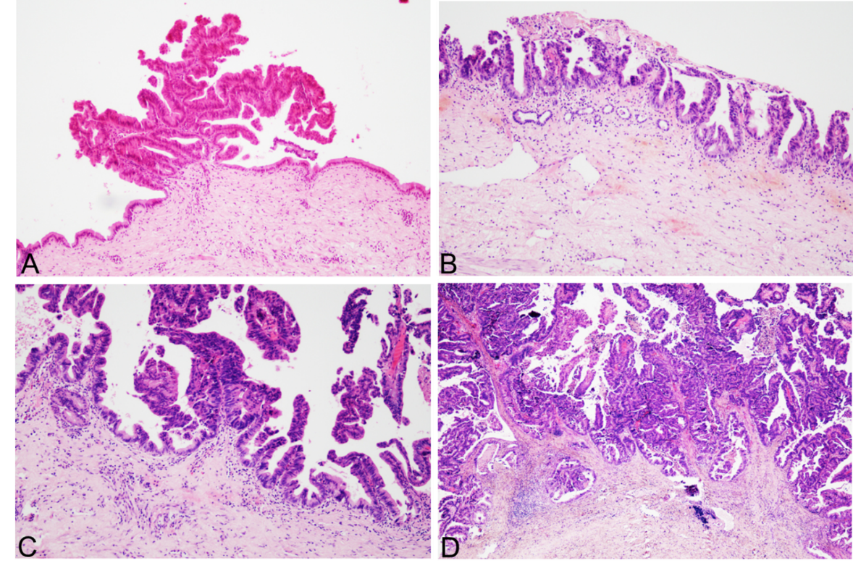
Figure 1 Pathological images. A: Intrahepatic bile duct papilloma (IPNB)’s atypical hyperplasia; B: IPNB’s intraepithelial neoplasia; C: IPNB’s focal carcinomatosis; D: IPNB’s correlation with invasive cancer.
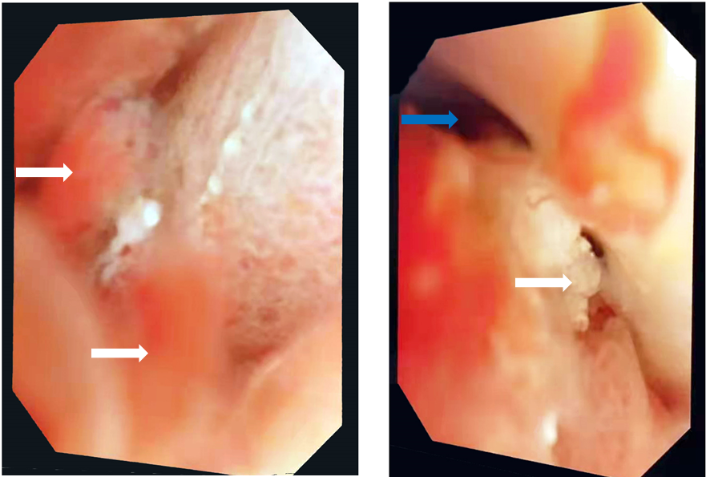
Figure 2 Choledochoscope images. White arrows indicate papillary nodules or bulges. The blue arrow indicates that myxoid bile is attached to the bile duct wall in a strip shape.
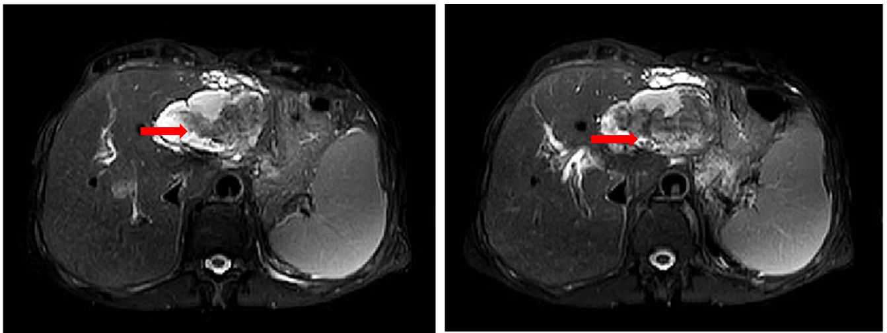
Figure 3 Magnetic resonance imaging of patients with intrahepatic bile duct papilloma. Red arrows indicate solid components floating in cystic lesions.
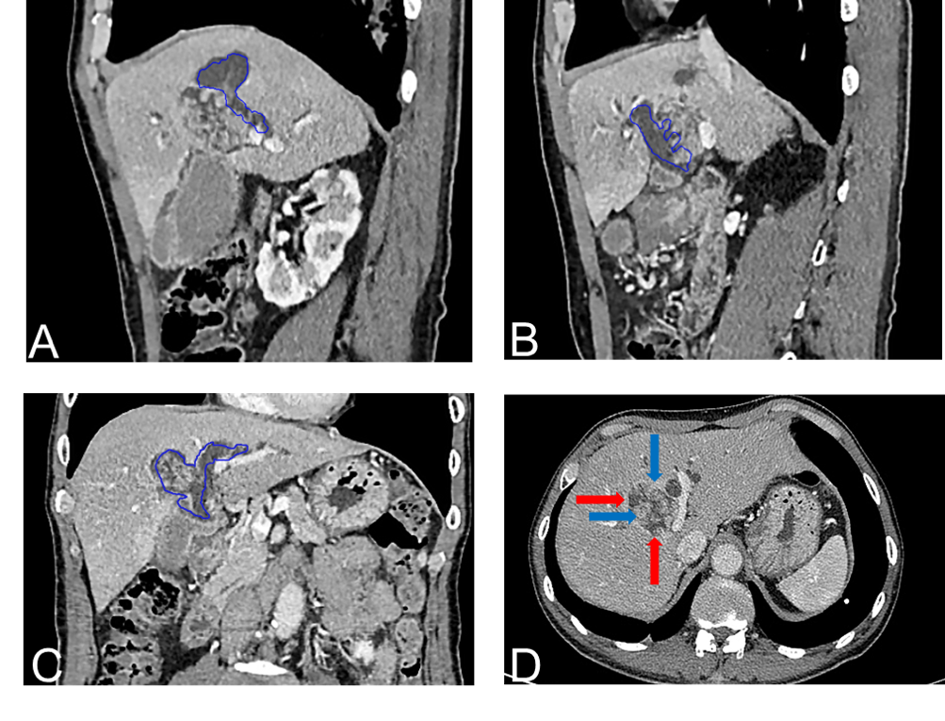
Figure 4 Intrahepatic bile duct papilloma whole abdominal plain scan and enhanced computed tomography scan. A-C: Blue depicts that the tumour communicates with the bile duct, and bile duct dilatation can be seen; D: The red arrow indicates a mucinous tumour, and the blue arrow indicates a mural nodule.
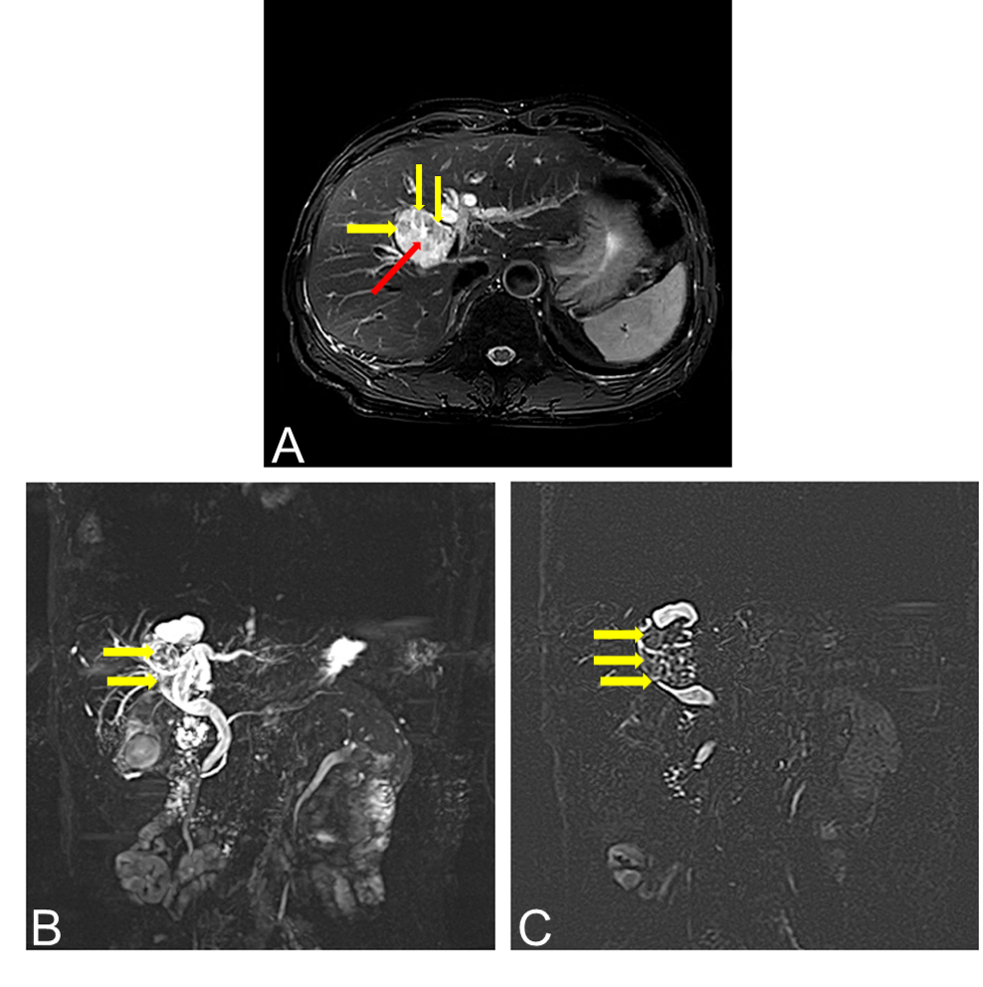
Figure 5 Magnetic resonance cholangiopancreatography images of patients with intrahepatic bile duct papilloma. A: The tumour is cystic and solid, with a smooth wall, yellow arrow indicating a wall nodule and red arrow indicating a mucinous tumour; B and C: The yellow arrow indicates that the tumour communicates with the bile duct.
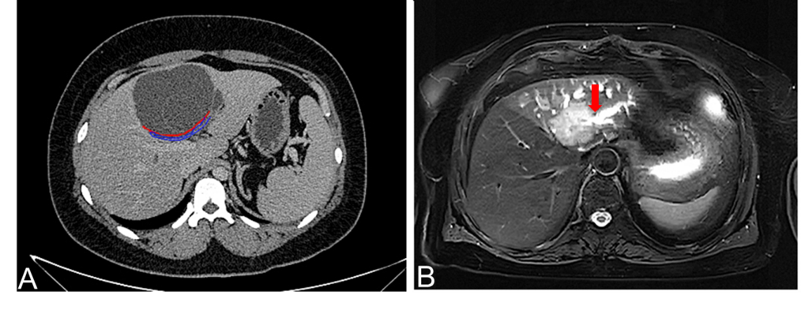
Figure 6 Differential diagnosis instructions. A: Computed tomography image of mucinous cystic tumour of liver. It can be seen that the tumour does not communicate with bile duct. The red arrow indicates the boundary of the tumour, and the blue arrow shows the bile duct compressed by the tumour; B: Magnetic resonance imaging image of cholangiocarcinoma. It can be seen that the boundary is not clear and smooth, and it invades into the liver, and the distal bile duct expands like a twig. The red arrow indicates that the bile duct is out of shape and cut off at the lesion

Table 1 General information
Number | Gender | Age | CA19-9 | CEA | Chief complaint |  |  | Accompanying diseases | Pathological classification | Operation mode
 |  |  |  |  | Abdominal pain | Jaundice | No symptoms
1 | Female | 71 | Normal | Normal | + | + |  |  | Ⅰ | 1234
2 | Female | 65 | Normal | Normal | + |  |  | a | Ⅱ | 1
3 | Female | 74 | ↑ | ↑ | + |  |  | ab | Ⅱ | 1234
4 | Male | 45 | ↑ | Normal |  |  | + | b | Ⅱ | 1234
5 | Male | 71 | ↑ | Normal |  |  | + |  | Ⅱ | 1235
6 | Female | 66 | Normal | Normal | + |  |  | a | Ⅱ | 1235
7 | Female | 62 | Normal | Normal | + |  |  | b | Ⅰ | 1246
8 | Male | 63 | ↑ | Normal |  | + |  |  | Ⅱ | 1246
9 | Male | 57 | Normal | Normal |  | + |  | e | Ⅰ | 135
10 | Female | 58 | Normal | Normal | + |  |  |  | Ⅰ | 1246
11 | Female | 82 | ↑ | Normal | + |  |  | b | Ⅱ | 1235
12 | Female | 67 | Normal | Normal |  | + |  | ab | Ⅰ | 1246
13 | Female | 65 | Normal | Normal | + |  |  |  | Ⅰ | 1
14 | Male | 52 | ↑ | Normal | + | + |  | abe | Ⅱ | 1246
15 | Female | 60 | Normal | Normal | + |  |  | b | Ⅱ | 1235
16 | Male | 59 | Normal | Normal | + | + |  | b | Ⅱ | 1235
17 | Female | 70 | Normal | Normal |  |  | + |  | Ⅰ | 12
18 | Female | 60 | ↑ | Normal | + |  |  | b | Ⅱ | 124
19 | Male | 60 | Normal | Normal |  |  | + | c | Ⅱ | 12
20 | Female | 58 | ↑ | Normal | + |  |  | ab | Ⅱ | 14
21 | Male | 52 | Normal | Normal |  |  | + |  | Ⅰ | 1246
22 | Male | 57 | ↑ | Normal | + |  |  | b | Ⅱ | 123
23 | Female | 61 | ↑ | Normal | + |  |  | b | Ⅱ | 135
24 | Male | 57 | ↑ | Normal | + |  |  |  | Ⅱ | 1
25 | Female | 50 | ↑ | Normal |  | + |  | c | Ⅱ | 1246
26 | Male | 51 | Normal | Normal | + |  |  | ab | Ⅰ | 135
27 | Female | 58 | Normal | Normal |  |  |  | d | Ⅰ | 1246
28 | Male | 67 | ↑ | ↑ | + |  |  | c | Ⅰ | 1246
1: Partial hepatectomy; 2: Cholecystectomy; 3: Exploration of biliary tract; 4: Biliary-intestinal anastomosis; 5: T tube drainage; 6: Excision of upper segment of common bile duct; Ⅰ: Intrahepatic bile duct papilloma (IPNB)’s high-grade intraepithelial neoplasia; Ⅱ: IPN-B’s invasive cancer; a: Hepatitis; b: Calculus of bile duct; c: Gallbladder stone; d: Biliary cyst; e: Sclerosing cholangitis. CA 19-9: Carbohydrate antigen 19-9; CEA: Carcinoembryonic antigen.

Published by Baishideng Publishing Group Inc
7041 Koll Center Parkway, Suite 160, Pleasanton, CA 94566, USA
Telephone: +1-925-3991568
E-mail: bpgoffice@wjgnet.com
Help Desk: https://www.f6publishing.com/helpdesk
https://www.wjgnet.com

© 2021 Baishideng Publishing Group Inc. All rights reserved.

