Name of Journal: World Journal of Gastroenterology
Manuscript NO: 41039
Manuscript Type: ORIGINAL ARTICLE

Basic Study
Recovery of natural killer cells is mainly on post-treatment period in chronic hepatitis C patients treated with sofosbuvir plus ledipasvir

Wang XX et al. NK cells recovered after EOT of DAAs

Xiao-Xiao Wang, Bi-Fen Luo, Han-Ji Jiang, Xu-Cong, Qian Jin, Dan-Li Ma, Lai Wei, Bo Feng

Xiao-Xiao Wang, Bi-Fen Luo, Han-Ji Jiang, Xu-Cong, Qian Jin, Dan-Li Ma, Lai Wei, Bo Feng, Peking University Hepatology Institute, Beijing Key Laboratory of Hepatitis C and Immunotherapy for Liver Diseases, Peking University People’s Hospital, Beijing 100044, China

ORCID number: Xiao-Xiao Wang (0000-0003-1654-7302); Bi-Fen Luo (0000-0001-7166-278X); Han-Ji Jiang (0000-0003-2118-0584); Xu-Cong (0000-0001-8922-7321); Qian Jin (0000-0002-5213-8680); Dan-Li Ma (0000-0002-0936-6792); Lai Wei (0000-0003-2326-1257); Bo Feng (0000-0001-5084-6715).

Author contributions: Wang XX, Luo BF, Feng B and Wei L designed the study, performed data analysis, and wrote and edited the manuscript; Luo BF, Jiang HJ, Jin Q and Ma DL enrolled the patients; Wang XX, Jiang HJ, and Cong X performed samples testing; all authors reviewed and approved the manuscript.

Supported by the National S&T Major Projects for Infectious Diseases Control, No. 2017ZX10302201-004-001.

Institutional review board statement: This study was reviewed and approved by the Ethics Committee of Peking University People’s Hospital.

Conflict-of-interest statement: To the best of our knowledge, no conflict of interest exists.

Data sharing statement: No additional data are available.

Open-Access: This article is an open-access article which was selected by an in-house editor and fully peer-reviewed by external reviewers. It is distributed in accordance with the Creative Commons Attribution Non Commercial (CC BY-NC 4.0) license, which permits others to distribute, remix, adapt, build upon this work non-commercially, and license their derivative works on different terms, provided the original work is properly cited and the use is non-commercial. See: http://creativecommons.org/licenses/by-nc/4.0/

Manuscript source: Invited manuscript

Correspondence to: Bo Feng, PhD, Chief Doctor, Professor, Research Fellow, Peking University Hepatology Institute, Beijing Key Laboratory of Hepatitis C and Immunotherapy for Liver Diseases, Peking University People’s Hospital, No.11 Xizhimen South Street, Beijing 100044, China. fengbo@pkuph.edu.cn
Telephone: +86-10-88325980
Fax: +86-10-66515490

Received: July 27, 2018
Peer-review started: July 27, 2018
First decision: August 27, 2018
Revised: September 2, 2018
Accepted: October 5, 2018
Article in press:
Published online:

Abstract
AIM
Highly effective direct-acting antivirals (DAAs) make chronic hepatitis C (CHC) a curable disease. Impact of various DAAs on innate immunity was unclear. To investigate how natural killer (NK) cells were affected in the elimination of hepatitis C virus (HCV) by sofosbuvir/ledipasvir.

METHODS
13 naïve-treated and experienced-treated CHC patients were treated with sofosbuvir/ledipasvir, and NK cells were detected at baseline, week 2, 4, 8 and 12 during therapy, and week post of treatment (Pt) -12 and 24 after the end of therapy by multicolor flow cytometry and compared with 13 healthy controls.

RESULTS
All patients achieved sustained virological response. There was a significant decline in CD56^{bright} NK cells frequency at week 8 (P = 0.002) and week 12 (P = 0.003), which altered to the level comparable to healthy controls at week Pt-12, but no difference in the frequency of CD56^{dim} NK cells. Compared with healthy controls, the expression levels of NKG2A, NKp30, CD94 on NK cells from CHC patients at baseline were higher. NKG2A, NKp30 and CD94 started to recover at week 12 and reached to the level of similar to healthy controls at week Pt-12 or Pt-24. Before treatment, patients have higher interferon (IFN)-γ and perforin levels than healthy controls, and IFN-γ started to recover at week 8 and reached to the normalized level at week Pt-12.

CONCLUSION
NK cells of CHC patients can be affected by DAAs, and phenotypes and function of NK cells recovered not at early stage but mainly after the end of sofosbuvir/ledipasvir treatment.

Key words: Direct-acting antivirals therapy; Hepatitis C virus; Natural killer cells; Natural killer subsets

© The Author(s) 2018. Published by Baishideng Publishing Group Inc. All rights reserved.

Core tip: In our study, we observed the dynamic changes of natural killer (NK) cell subsets, phenotypes and functional parameters during and after direct-acting antivirals (DAAs) treatment and investigated the effect of sofosbuvir/ledipasvir therapy on innate immunity in genotype 1b hepatitis C virus (HCV)-infected patients. We illustrated that NK cells of chronic hepatitis C patients can be affected by DAAs and phenotypes and function of NK cells recovered not at early stage but mainly after the end of sofosbuvir/ledipasvir treatment, which may provide an explanation for HCV reinfection or liver carcinogenesis after HCV elimination.

Wang XX, Luo BF, Jiang HJ, Cong X, Jin Q, Ma DL, Wei L, Feng B. Recovery of natural killer cells is mainly on post-treatment period in chronic hepatitis C patients treated with sofosbuvir plus ledipasvir. World J Gastroenterol 2018; In press

INTRODUCTION
Chronic hepatitis C virus (HCV) infection is a disease that affects about 71 million people worldwide^{[1]}. It can lead to mortality from hepatic as well as extra-hepatic causes^{[2]}. In the era of HCV treatment by pegylated-interferon (PEG-IFN)/ribavirin (RBV), the sustained virological response (SVR) rate is different according to HCV genotypes: Approximately 40% to 50% in patients with genotype 1 and 80% in patients with genotype 2 or 3^{[3-5]}. However, because of their higher SVR rate (> 95%) and less toxicity^{[6]}, IFN-free direct antiviral agents (DAAs) have replaced PEG-IFN/RBV as a first-line treatment option recommended by international guidelines^{[7,8]}.
IFN-α can induce immunomodulatory effects by acting the innate and adaptive immune system of various cells^{[9,10]}. Since IFN-free DAAs take the virus life cycle as a target, they can inhibit NS3 protease, NS5A replication complex or NS5B polymerase activity specifically^{[11]}. These regiments can help us clarify the interaction between HCV clearance and the innate immune response, regardless of the IFNα induced immune modulation^{[12]}. This provides a unique opportunity to analyze whether DAAs can change natural killer (NK) cell activation when HCV replication is inhibited. Previous studies had explored the eﬀect of IFN therapy on the NK cells. It has been shown that chronic hepatitis C (CHC) patients with SVR by IFN therapy exhibited greater levels of NK cell degranulation and enhanced NK cytotoxicity^{[13,14]}. Combination therapy of PEG-IFN-α/RBV reversed NK subtype distribution and function in HCV-eliminated patients^{[15]}. Until now, only few studies have reported the effect of DAAs on NK cells^{[16-18]}, in which the results and conclusions were controversial.
NK cells are enriched among lymphocytes in the blood (5%-20%), and their percentage increases further in viral hepatitis^{[19]}. NK cells play an important role in the antiviral immune defense and undergo great changes in subsets, phenotypes and function during persistent viral infection^{[20]}. NK cells can be divided into three subgroups according to the expression levels of CD56 and CD16, including CD56^{bright} NK cells, CD56^{dim} NK cells and CD56^{neg} (CD16^{positive}) NK cells^{[21]}. CD56^{bright} NK cells, which can produce IFN-γ mainly and inhibit viral replication, are the less-mature subset that can differentiate into CD56^{dim} NK cells^{[22]}. CD56^{dim} NK cells are cytotoxic NK cell subset expressing higher levels of killer immunoglobulin-like receptors (KIR), CD16 and perforin^{[21]}. CD56^{neg} NK cells express lower perforin and exhibit lower cytotoxicity^{[23]}.
The function of NK cells is regulated by interaction of NK cell receptors (NKRs), which can be divided into activating and inhibitory NKRs, and their respective ligands^{[24]}. Activating NKRs include NKG2C, NKG2D, and the “natural cytotoxicity receptors”, for example, NKp30, NKp44 and NKp46. Inhibitory receptors comprise NKG2A and the KIR family members^{[25]}. During viral infection, the balance shifts from inhibition to activation because the threshold value of activation receptors exceeds those of inhibition^{[26]}. For example, the integration of all signals results in activation of blood and liver NK cells in HCV infection^{[27]} and altered functional phenotypes with increased cytotoxicity and decreased antiviral cytokines production^{[27,28]}.
Up to now, more and more DAAs have been approved for clinical practice. In China, sofosbuvir/ledipasvir have been increasingly used among CHC patients, especially those with genotype 1 HCV infection. Sofosbuvir is an NS5B polymerase inhibitor and ledipasvir is an NS5A replication complex inhibitor. In current study, we aimed to observe the dynamic changes of NK cell subsets, phenotypes and functional parameters during and after DAAs treatment, and to investigate the effect of DAAs (sofosbuvir/ledipasvir) treatment on innate immunity in genotype 1b HCV-infected patients.

MATERIALS AND METHODS
Study cohort
NK cells were studied in 13 genotype 1b HCV infected patients at baseline, week 2, 4, 8, 12 in a 12 wk treatment course with DAAs (90 mg ledipasvir once daily and 400 mg sofosbuvir once daily), and then at week post of treatment (Pt) -12 and 24 after the end of therapy. There are 6 experienced-treated patients who relapsed to PEG-IFN/RBV and 7 naïve-treated patients in our study. 13 age- and sex-matched uninfected subjects were enrolled for comparison. Informed consents were obtained from all participants. The study conformed to the ethical guidelines of 1975 Declaration of Helsinki and had been approved by the Ethics Committee of Peking University People’s Hospital. Patients had no signs and evidences of coinfection with hepatitis A virus, hepatitis B virus, hepatitis D virus, hepatitis E virus and human immunodeficiency virus. Patients with evidence of hepatocellular carcinoma or cirrhosis will be excluded. Besides, pregnant patients or patients with psychiatric disorder were also excluded.

Serologic analyses
Serum HCV RNA level was quantitated using the Cobas TaqMan automated real-time PCR platform reaction (Roche Molecular System, Pleasanton, CA, United States) with a lowest limit of detection of 15 IU/mL and a lower limit of quantification of 43 IU/mL.

Lymphocyte isolation
Peripheral blood mononuclear cells (PBMCs) were separated from EDTA- anticoagulated blood on Ficoll Histopaque (GE Healthcare Bio-Science AB, Germany) density gradients, washed 3 times with phosphate-buffered saline (BD, Bioscience, Franklin Lakes, NJ, United States)^{[17]} and was cryopreserved at -80 ℃ and were transferred to the liquid nitrogen after 24 h.

NK cells frequency and phenotypes
For each patient, cryopreserved PBMCs from week 0 to week Pt-24 were thawed and tested. PBMCs of healthy donors were included in this experiment. Thawed PBMCs were stained with anti-CD45-APC-H7, anti-CD3-PerCP-Cy5.5, anti-CD56-APC, anti-CD16-BV510, anti-CD94-PE, anti-CD335 (NKp46) -PE-Cy7, anti-CD336 (NKp44) -BB515, anti-CD337 (NKp30) - BV421 (BD Bioscience), anti-CD314 (NKG2D) -PE-Cy7 (Biolegend), anti-CD159a (NKG2A) -PE (R and D Systems) and anti-CD159C (NKG2C) - VioBrightTMFITC (Miltenyi Biotech, Bergisch Gladbach, Germany) for 15 min and with 7-AAD (BD Bioscience) for 10 min before detected by flow cytometry (BD FACSAria II, BD Bioscience). Data was analyzed by BD FACSDiva Software v7.0.

NK cells cytokine production
Thawed PBMCs were incubated with Leukocyte Activation Cocktail with BD GolgiPlug (BD Bioscience) 2 µL/1 × 10⁶ cells for 4 h. Cells were washed, fixed, and permeabilized with the BD IntraSureTM Kit and stained with anti-IFN-γ–FITC, anti–Perforin-BV421 and anti-Granzyme B-PE-CF594 (all from BD Biosciences) for 30 min before detected by flow cytometry (BD FACSAria II, BD Bioscience). Data was analyzed by BD FACSDiva Software v7.0.

Statistical analysis
Statistical analysis was performed using Graphpad Prism Version 5.0a (Graphpad Software Inc., San Diego, CA, United States) and SPSS 16.0 (SPSS, Chicago, IL, United States). Normal distribution was tested with the Kolmogorov-Smirnov test. Values in our study were not normally distributed, comparison of expression levels among different time points the of CHC patients were analyzed by the Wilcoxon matched pairs. Comparison of expression levels between the CHC patients and healthy controls were analyzed by the Mann-Whitney test. Two-sided P values less than 0.05 were considered significant.

RESULTS
Baseline characteristics of the study population and effect of sofosbuvir/ledipasvir therapy on HCV viremia and liver inflammation
Table 1 describes the main demographical and clinical characteristics of the CHC patients at baseline. The median log HCV RNA level was 6.39 (range 4.60-6.98). The median alanine aminotransferase (ALT) level was 34 U/L (range 11-55 U/L). All 13 patients were treated with sofosbuvir/ledipasvir within 12 wk and reached SVR24. Treatment with DAAs induced a rapid and early clearance of serum HCV RNA within the first 2 wk that was accompanied by a significant reduction in liver inflammation as demonstrated by a decrease in ALT (P = 0.007) and AST levels (P = 0.015) (Figure 1).

Effects of sofosbuvir/ledipasvir therapy on NK cell subsets
NK cells were identified as CD3⁻CD56⁺ cells in the PBMC population, and CD56^{bright} NK cells and CD56^{dim} NK cells were determined by sequential gating on CD3⁻CD56⁺ NK cells (Figure 2A).
Our study showed that during the 12 wk of IFN-free DAAs therapy, there was a significant decline in CD56^{bright} NK cell frequencies at week 8 (P = 0.002) and week 12 (P = 0.003), and lower than that of healthy controls at week 12. The frequency of CD56^{bright} NK cells altered to the level comparable to healthy controls at week Pt-12 (Figure 3B). There was no difference in the frequencies of CD56⁺ NK cells and CD56^{dim} NK cells between chronically HCV-infected patients and healthy controls at baseline. No differences were found in the frequencies of CD56⁺ NK cells and CD56^{dim} NK cells among different time points during and after DAAs therapy (Figure 3A and C).

Effects of sofosbuvir/ledipasvir therapy on NK cell phenotypes
To illustrate the effect of the rapid DAA-mediated decrease in HCV RNA levels on NK cells phenotypes, we detected activating and inhibitory receptors on the surface of NK cells by multicolor flow cytometry (Figure 2B).
Compared with uninfected healthy controls, the frequencies of the inhibitory NKG2A and activating NKp30 on NK cells from CHC patients were higher at baseline (P < 0.001) (Figures 4A and 5A). The frequency and MFI of NKG2A and the frequency of NKp30 started to decline at week 12 of treatment and reaching to levels similar to those of NK cells from healthy controls at week Pt-12 (Figure 4A and B, Figure 5A). However, MFI of NKp30 did not differ on NK cells from CHC patients and healthy controls and did not change during and after the end of sofosbuvir/ledipasvir therapy (Figure 5B).
There were no differences in frequency of CD94⁺ NK cells between CHC patients at baseline and healthy controls, and frequency of CD94⁺NK cells from CHC patients did not change significantly during and after sofosbuvir/ledipasvir therapy (Figure 4C). The MFI of CD94 started to decline in CHC patients at week 12 of treatment normalized at week Pt-24 on NK cells (Figure 4D).
There were no differences in the frequency and MFI of NKp46 on NK cells between healthy controls and CHC patients at baseline. During DAAs treatment, there was a significant decline in frequency of NKp46 on NK cells at week 8 and week 12, but NKp46 expression level increased to those of uninfected controls at week Pt-12 and week Pt-24 (Figure 5C and D).
Frequencies and MFI of NKp44, NKG2C and NKG2D on NK cells from CHC patients at baseline did not differ from those from healthy controls and did not change during and after sofosbuvir/ledipasvir therapy.

Effects of sofosbuvir/ledipasvir therapy on NK cells function
The frequency and MFI of IFN-γ⁺ NK cells from CHC patients at baseline were significantly higher than that from uninfected subjects (P < 0.001). Frequency of IFN-r⁺ NK cells started to decline in CHC patients at week 8 of treatment and reached to levels similar to those of healthy controls at week Pt-12 (Figure 6A). However, no difference was shown in MFI of IFN-γ⁺ NK cells from CHC patients during and after DAAs therapy (Figure 6B). There was no difference in the frequency of perforin⁺ NK cells between healthy controls and CHC patients at every time points (Figure 6C). MFI of perforin⁺ NK cells from CHC patients was significantly higher than that from uninfected subjects from 0 week to week Pt-24W persistently (Figure 6D). However, there were no differences in frequency (Figure 6E) and MFI (Figure 6F) of Granzyme B of NK cells groups between CHC patients at baseline and healthy controls, and the expression of NKp46 did not change during and after sofosbuvir/ledipasvir therapy.

Effects of sofosbuvir/ledipasvir therapy on NK cells between naïve-treated and experienced CHC patients
There were no differences in the frequency of CD56⁺ NK cells and the expression of NKG2A, NKG2D, NKG2C, CD94, NKp30, NKp46, IFN-γ, perforin and Granzyme B between naïve-treated and experienced CHC patients during and after DAAs treatment. The changing trend of these phenotypes and cytokines of NK cells between these two groups were similar. (Figure 7A-J)

DISCUSSION
In our study, we evaluated the innate immune effects in 13 CHC patients successfully treated with sofosbuvir/ledipasvir, and all patients have achieved SVR12 and SVR24, no patients have virologic breakthrough.
The development of DAAs has opened a new era of HCV treatment^{[29]}. IFN-free regimens for HCV infection provide a unique opportunity to study the interaction between HCV and the immune system because DAAs rapidly decrease viremia to undetectable levels regardless of the IFNα induced immune modulation^{[12]}. Due to the direct effect of IFN-α on NK cells, the consequences of viral load decline on NK cells could not be examined precisely. Our study examined the innate immune effects of sofosbuvir/ledipasvir therapy induced HCV RNA level decline. There was no difference in the frequency of total NK cells from CHC patients at baseline and healthy controls, which is inconsistent with other two studies assumed that NK cells frequency decreases in the blood in chronic HCV infection^{[28,30]}. We found that only CD56^{bright} NK cells showed a slightly decline at week 8 and week 12 during DAAs treatment and normalized at week Pt-12. There were no changes in total NK cells and CD56^{dim} NK cells. However, another study reported that DAA therapy enhances the frequency of CD56^{dim} and decreases CD56^{bright} cells in chronic HCV patients^{[30]}.
As for NK cell phenotypes and function of CHC patients, we showed that reduced HCV RNA load altered NK cell phenotype and function, including NKG2A, CD94, NKp30, NKp46, IFN-γ and perforin. Most of these phenotypes and cytokines became to change at week 12 approximately and normalized to the level of healthy controls at week Pt-12 or Pt-24, which were different from previous studies^{[17,30]}. Serti et al^{[17]} demonstrated that the expression level of NKp46 and NKG2A normalized in patients with undetectable viremia by week 8 in daclatasvir (DCV) and asunaprevir (ASV) therapy and they assumed that the percentage of IFN-γ producing NK cells and the IFN-γ expression level were significantly lower in chronic HCV patients compared with healthy controls and increased within the first 8 wk. Spaan et al^{[30]} illustrated that NK cell phenotype is already normalized at week 12 during DCV/ASV therapy and they assumed that DAAs treatment did not alter the frequency of NK cells producing perforin. But we found that the MFI of perforin⁺ NK cells was higher than that of healthy controls before, during and after DAAs therapy persistently, which has not been found in previous studies. Importantly, researchers in these two studies haven’t demonstrated the changes of NK cells after the end of DAAs therapy.
Patients in other two studies were treated with DCV/ASV and all patients were HCV-infected non-responders to previous PEG-IFN/RBV therapy^{[17,30]}. However, patients in our study were naive-treated CHC patients and experienced-treated CHC patients who relapsed to PEG-IFN/RBV therapy. NK cells might be affected by PEG-IFN/RBV therapy^{[13,14]}. Combination therapy of PEG-IFN-α/RBV reversed NK subtype distribution and functions in HCV-eliminated patients^{[15]}. But, we found that there was no difference in the changes of the NK cells during and after DAAs treatment between patients who are naive-treated and relapsed to PEG-IFN/RBV therapy. And the effect of non-response to PEG-IFN/RBV treatment on the changes of NK cells during and after DAA treatment should not be excluded. Because it is unclear whether the response pattern of PEG-IFN/RBV treatment can affect the subsequent changes of NK cells induced by DAAs in experienced-treated patients. Secondly, HCV genotype may affect dynamic changes of NK cells during DAAs therapy. In the study of Ning et al^{[31]}, patients with different genotypes were included in this research, they assumed that different HCV genotypes may have an impact on their results that after treatment with sofosbuvir/ledipasvir or sofosbuvir/daclatasvir, the frequency of CD16⁺CD56⁺ NK cells gradually increased to normal levels of healthy controls at week 12. Thirdly, different DAAs may have different impact on NK cells. Sofosbuvir is an NS5B polymerase inhibitor, ledipasvir and DCV are NS5A replication complex inhibitor and ASV is an NS3 protease inhibitor. As Ning et al^{[31]} described, we can’t exclude the effect that different DAA regiments induce different dynamic changes of NK cells. Fourthly, the race of CHC patients maybe an important factor. Whether in era of PEG-IFN/RBV or DAAs treatment, race is one of the most important factors which can affect SVR^{[32,33]}. Therefore, we can’t rule out the distinction induced by different races between our studies and others. Additionally, we assumed that it may take a long-term for NK cells recovery and NK cells can’t recover immediately after the influence from DAAs was relieved.
We confirm earlier studies on increased inhibitory NKG2A expression on NK cells when HCV infection^{[18,27]}. NKG2A is a major and prominent inhibitory NK cell receptor and is known as lectin superfamily group A^{[34]}. DAA-induced NKG2A levels reduction might be the consequence of compensatory mechanisms exerted upon declining activating signals. Besides, CD94 is mainly expressed as a heterodimer with NKG2A, NKG2B or NKG2C protein^{[35]}. The inhibitory signals of NK cells are mainly mediated by HLA class I-binding receptors, including KIRs and CD94/NKG2A^{[36]}. Accordingly, there are something in common of the changing trend between NKG2A and CD94 MFI in our study.
Frequency of NKp30⁺ NK cells at baseline in our cohort was higher than those of healthy controls. During DAAs treatment, the percentage of NKp30⁺ NK cells reduced to the level of healthy control consistent with the study of Serti et al^{[17]} and Spaan et al^{[30]}, but there was no difference in the MFI of NKp30.
In all changed phenotypes, NKp46 is a special one. The changing trend of NKp46 is completely different from that of other receptors during sofosbuvir/ledipasvir treatment. There was a significant decline only at week 8 and week 12. As we all know, NKp46, a member of the natural cytotoxicity receptor family, is a main activating NK-cell receptor^{[37]}. NK cells that high expression of NKp46 were characterized by a high functional capacity (eg, high cytotoxicity and IFN-γ production) and a high antiviral activity in vitro^{[38,39]}. But the percentage of IFN-γ⁺ NK cells was similar to the level of healthy controls at week Pt-12, and this level was maintained until week Pt-24.
Effects of HCV infection on NKG2D was controversy. Oliviero et al^{[28]} reported that CHC patients have increased NKG2D expression, while Dessouki et al^{[15]} demonstrated that the frequency of NKG2D⁺ NK cells decreased in HCV infection. In our study, the expression of NKp44, NKG2C, NKG2D and Granzyme B did not differ between NK cells from CHC patients at baseline and healthy donors in our study, and there was no change in the expression during and after the end of treatment (EOT) of DAAs, which is consistent with the published articles^{[19,40]}.
Our results showed that NK cells phenotypes and function started to change at the later period of sofosbuvir/ledipasvir treatment and reversed to the normalized level of healthy individuals mainly after EOT. What we found in our research is different from previous studies which assumed that HCV clearance induced by DAAs can mediated NK recovery rapidly. Whether dynamic changes of NK cells in DAA-treated patients are related to HCV reinfection or liver carcinogenesis after HCV elimination is a great topic in the future.

ARTICLE HIGHLIGHTS
Research background
Chronic hepatitis C virus (HCV) infection lead to mortality from hepatic as well as extra-hepatic causes. Until now, direct-acting antivirals (DAAs) have replaced pegylated-interferon (PEG-IFN)/ribavirin as a first-line treatment option. IFN-free DAAs take the virus life cycle as a target, it can help us clarify the interaction between HCV clearance and the innate immune response, regardless of the IFN-α induced immune modulation. Previous studies showed that PEG-IFN-α can change natural killer (NK) subtype distribution and function in HCV-eliminated patients. But it is controversial whether DAAs can change phenotypes and function of NK cells.

Research motivation
More and more DAAs have been approved for clinical practice. In China, sofosbuvir/ledipasvir been increasingly used among chronic hepatitis C (CHC) patients, especially those with genotype 1 HCV infection. Previous illustrated that NK cells play an important role in the antiviral immune defense and undergo great changes in subsets, phenotype and function during persistent viral infections. So it is meaningful to investigate how NK cells were affected in the elimination of HCV by sofosbuvir/ledipasvir.

Research objectives
Objectives of this study is observing the dynamic changes of NK cell subsets, phenotypes and functional parameters during and after DAAs treatment, and investigating the effect of DAAs (sofosbuvir/ledipasvir) treatment on innate immunity in genotype 1b HCV-infected patients.

Research methods
13 naïve-treated and experienced-treated CHC patients were treated with sofosbuvir/ledipasvir, and NK cells were detected at baseline, week 2 to 12 during therapy, and week post of treatment (Pt)-12 and 24 after the end of therapy by multicolor flow cytometry and compared with 13 healthy controls.

Research results
There was a significant decline in CD56^{bright} NK cells frequency at week 8 (P = 0.002) and week 12 (P = 0.003), which altered to the level comparable to healthy controls at week Pt-12, but no difference in the frequency of CD56^{dim} NK cells. Compared with healthy controls, the expression levels of NKG2A, NKp30, CD94 on NK cells from CHC patients at baseline were higher. NKG2A, NKp30 and CD94 started to recover at week 12 and reached to the level of similar to healthy controls at week Pt-12 or Pt-24. Before treatment, patients have higher IFN-γ and perforin levels than healthy controls, and IFN-γ started to recover at week 8 and reached to the normalized level at week Pt-12.

Research conclusions
NK cells of CHC patients can be affected by DAAs, NK cells phenotypes and function started to change at the later period of sofosbuvir/ledipasvir treatment and reversed to the normalized level of healthy individuals mainly after end of treatment. What we found in our research is different from previous studies which assumed that HCV clearance induced by DAAs can mediated NK recovery rapidly.

Research perspectives
In hepatitis B virus (HBV)/HCV coinfected patients, HBV reactivation often occurred at the later period or even after the end of DAAs treatment. Our study may provide an explanation. Whether dynamic changes of NK cells in DAA-treated patients are related to HCV reinfection or liver carcinogenesis after HCV elimination is a great topic in the future.

REFERENCES
1 World Health Organization. Hepatitis C. Available on October 13, 2017. Updated July 2017. Available from: URL: http://www.who.int/mediacentre/factsheets/fs164/en/
2 Lee MH, Yang HI, Lu SN, Jen CL, You SL, Wang LY, Wang CH, Chen WJ, Chen CJ; R.E.V.E.A.L.-HCV Study Group. Chronic hepatitis C virus infection increases mortality from hepatic and extrahepatic diseases: a community-based long-term prospective study. J Infect Dis 2012; 206: 469-477 [PMID: 22811301 DOI: 10.1093/infdis/jis385]
3 Hadziyannis SJ, Sette H Jr, Morgan TR, Balan V, Diago M, Marcellin P, Ramadori G, Bodenheimer H Jr, Bernstein D, Rizzetto M, Zeuzem S, Pockros PJ, Lin A, Ackrill AM; PEGASYS International Study Group. Peginterferon-alpha2a and ribavirin combination therapy in chronic hepatitis C: a randomized study of treatment duration and ribavirin dose. Ann Intern Med 2004; 140: 346-355 [PMID: 14996676]
4 Fried MW, Shiffman ML, Reddy KR, Smith C, Marinos G, Gonçales FL Jr, Häussinger D, Diago M, Carosi G, Dhumeaux D, Craxi A, Lin A, Hoffman J, Yu J. Peginterferon alfa-2a plus ribavirin for chronic hepatitis C virus infection. N Engl J Med 2002; 347: 975-982 [PMID: 12324553 DOI: 10.1056/NEJMoa020047]
5 Manns MP, McHutchison JG, Gordon SC, Rustgi VK, Shiffman M, Reindollar R, Goodman ZD, Koury K, Ling M, Albrecht JK. Peginterferon alfa-2b plus ribavirin compared with interferon alfa-2b plus ribavirin for initial treatment of chronic hepatitis C: a randomised trial. Lancet 2001; 358: 958-965 [PMID: 11583749]
6 Chu PS, Nakamoto N, Taniki N, Ojiro K, Amiya T, Makita Y, Murata H, Yamaguchi A, Shiba S, Miyake R, Katayama T, Ugamura A, Ikura A, Takeda K, Ebinuma H, Saito H, Kanai T. On-treatment decrease of NKG2D correlates to early emergence of clinically evident hepatocellular carcinoma after interferon-free therapy for chronic hepatitis C. PLoS One 2017; 12: e0179096 [PMID: 28617830 DOI: 10.1371/journal.pone.0179096]
7 European Association for Study of Liver. EASL Recommendations on Treatment of Hepatitis C 2015. J Hepatol 2015; 63: 199-236 [PMID: 25911336 DOI: 10.1016/j.jhep.2015.03.025]
8 Omata M, Kanda T, Wei L, Yu ML, Chuang WL, Ibrahim A, Lesmana CR, Sollano J, Kumar M, Jindal A, Sharma BC, Hamid SS, Dokmeci AK, Mamun-Al-Mahtab, McCaughan GW, Wasim J, Crawford DH, Kao JH, Yokosuka O, Lau GK, Sarin SK. APASL consensus statements and recommendation on treatment of hepatitis C. Hepatol Int 2016; 10: 702-726 [PMID: 27130427 DOI: 10.1007/s12072-016-9717-6]
9 García-Sastre A, Biron CA. Type 1 interferons and the virus-host relationship: a lesson in détente . Science 2006; 312: 879-882 [PMID: 16690858 DOI: 10.1126/science.1125676]
10 Markova AA, Mihm U, Schlaphoff V, Lunemann S, Filmann N, Bremer B, Berg T, Sarrazin C, Zeuzem S, Manns MP, Cornberg M, Herrmann E, Wedemeyer H. PEG-IFN alpha but not ribavirin alters NK cell phenotype and function in patients with chronic hepatitis C. PLoS One 2014; 9: e94512 [PMID: 24751903 DOI: 10.1371/journal.pone.0094512]
11 Pawlotsky JM. New hepatitis C therapies: the toolbox, strategies, and challenges. Gastroenterology 2014; 146: 1176-1192 [PMID: 24631495 DOI: 10.1053/j.gastro.2014.03.003]
12 Lin JC, Habersetzer F, Rodriguez-Torres M, Afdhal N, Lawitz EJ, Paulson MS, Zhu Y, Subramanian GM, McHutchison JG, Sulkowski M, Wyles DL, Schooley RT. Interferon γ-induced protein 10 kinetics in treatment-naive versus treatment-experienced patients receiving interferon-free therapy for hepatitis C virus infection: implications for the innate immune response. J Infect Dis 2014; 210: 1881-1885 [PMID: 24907384 DOI: 10.1093/infdis/jiu325]
13 Edlich B, Ahlenstiel G, Zabaleta Azpiroz A, Stoltzfus J, Noureddin M, Serti E, Feld JJ, Liang TJ, Rotman Y, Rehermann B. Early changes in interferon signaling define natural killer cell response and refractoriness to interferon-based therapy of hepatitis C patients. Hepatology 2012; 55: 39-48 [PMID: 21898483 DOI: 10.1002/hep.24628]
14 Ahlenstiel G, Edlich B, Hogdal LJ, Rotman Y, Noureddin M, Feld JJ, Holz LE, Titerence RH, Liang TJ, Rehermann B. Early changes in natural killer cell function indicate virologic response to interferon therapy for hepatitis C. Gastroenterology 2011; 141: 1231-1239, 1239.e1-1239.e2 [PMID: 21741920 DOI: 10.1053/j.gastro.2011.06.069]
15 Dessouki O, Kamiya Y, Nagahama H, Tanaka M, Suzu S, Sasaki Y, Okada S. Chronic hepatitis C viral infection reduces NK cell frequency and suppresses cytokine secretion: Reversion by anti-viral treatment. Biochem Biophys Res Commun 2010; 393: 331-337 [PMID: 20138830 DOI: 10.1016/j.bbrc.2010.02.008]
16 Meissner EG, Kohli A, Virtaneva K, Sturdevant D, Martens C, Porcella SF, McHutchison JG, Masur H, Kottilil S. Achieving sustained virologic response after interferon-free hepatitis C virus treatment correlates with hepatic interferon gene expression changes independent of cirrhosis. J Viral Hepat 2016; 23: 496-505 [PMID: 26840694 DOI: 10.1111/jvh.12510]
17 Serti E, Chepa-Lotrea X, Kim YJ, Keane M, Fryzek N, Liang TJ, Ghany M, Rehermann B. Successful Interferon-Free Therapy of Chronic Hepatitis C Virus Infection Normalizes Natural Killer Cell Function. Gastroenterology 2015; 149: 190-200.e2 [PMID: 25754160 DOI: 10.1053/j.gastro.2015.03.004]
18 Serti E, Park H, Keane M, O'Keefe AC, Rivera E, Liang TJ, Ghany M, Rehermann B. Rapid decrease in hepatitis C viremia by direct acting antivirals improves the natural killer cell response to IFNα. Gut 2017; 66: 724-735 [PMID: 26733671 DOI: 10.1136/gutjnl-2015-310033]
19 Doherty DG, O'Farrelly C. Innate and adaptive lymphoid cells in the human liver. Immunol Rev 2000; 174: 5-20 [PMID: 10807503]
20 Pollmann J, Rölle A, Hofmann M, Cerwenka A. Hepatitis C Virus and Human Cytomegalovirus-Natural Killer Cell Subsets in Persistent Viral Infections. Front Immunol 2017; 8: 566 [PMID: 28567042 DOI: 10.3389/fimmu.2017.00566]
21 Lunemann S, Schlaphoff V, Cornberg M, Wedemeyer H. NK cells in hepatitis C: role in disease susceptibility and therapy. Dig Dis 2012; 30 Suppl 1: 48-54 [PMID: 23075868 DOI: 10.1159/000341680]
22 Saha B, Szabo G. Innate immune cell networking in hepatitis C virus infection. J Leukoc Biol 2014; 96: 757-766 [PMID: 25001860 DOI: 10.1189/jlb.4MR0314-141R]
23 Tatsumi T, Takehara T. Impact of natural killer cells on chronic hepatitis C and hepatocellular carcinoma. Hepatol Res 2016; 46: 416-422 [PMID: 26574168 DOI: 10.1111/hepr.12619]
24 Cooper MA, Fehniger TA, Caligiuri MA. The biology of human natural killer-cell subsets. Trends Immunol 2001; 22: 633-640 [PMID: 11698225]
25 Kokordelis P, Krämer B, Körner C, Boesecke C, Voigt E, Ingiliz P, Glässner A, Eisenhardt M, Wolter F, Kaczmarek D, Nischalke HD, Rockstroh JK, Spengler U, Nattermann J. An effective interferon-gamma-mediated inhibition of hepatitis C virus replication by natural killer cells is associated with spontaneous clearance of acute hepatitis C in human immunodeficiency virus-positive patients. Hepatology 2014; 59: 814-827 [PMID: 24382664 DOI: 10.1002/hep.26782]
26 Mondelli MU, Varchetta S, Oliviero B. Natural killer cells in viral hepatitis: facts and controversies. Eur J Clin Invest 2010; 40: 851-863 [PMID: 20597961 DOI: 10.1111/j.1365-2362.2010.02332.x]
27 Ahlenstiel G, Titerence RH, Koh C, Edlich B, Feld JJ, Rotman Y, Ghany MG, Hoofnagle JH, Liang TJ, Heller T, Rehermann B. Natural killer cells are polarized toward cytotoxicity in chronic hepatitis C in an interferon-alfa-dependent manner. Gastroenterology 2010; 138: 325-35.e1-2 [PMID: 19747917 DOI: 10.1053/j.gastro.2009.08.066]
28 Oliviero B, Varchetta S, Paudice E, Michelone G, Zaramella M, Mavilio D, De Filippi F, Bruno S, Mondelli MU. Natural killer cell functional dichotomy in chronic hepatitis B and chronic hepatitis C virus infections. Gastroenterology 2009; 137: 1151-1160, 1160.e1-1160.e7 [PMID: 19470388 DOI: 10.1053/j.gastro.2009.05.047]
29 Liang TJ, Ghany MG. Current and future therapies for hepatitis C virus infection. N Engl J Med 2013; 368: 1907-1917 [PMID: 23675659 DOI: 10.1056/NEJMra1213651]
30 Spaan M, van Oord G, Kreefft K, Hou J, Hansen BE, Janssen HL, de Knegt RJ, Boonstra A. Immunological Analysis During Interferon-Free Therapy for Chronic Hepatitis C Virus Infection Reveals Modulation of the Natural Killer Cell Compartment. J Infect Dis 2016; 213: 216-223 [PMID: 26223768 DOI: 10.1093/infdis/jiv391]
31 Ning G, Li YT, Chen YM, Zhang Y, Zeng YF, Lin CS. Dynamic Changes of the Frequency of Classic and Inflammatory Monocytes Subsets and Natural Killer Cells in Chronic Hepatitis C Patients Treated by Direct-Acting Antiviral Agents. Can J Gastroenterol Hepatol 2017; 2017: 3612403 [PMID: 28567369 DOI: 10.1155/2017/3612403]
32 Yan KK, Guirgis M, Dinh T, George J, Dev A, Lee A, Zekry A. Treatment responses in Asians and Caucasians with chronic hepatitis C infection. World J Gastroenterol 2008; 14: 3416-3420 [PMID: 18528940]
33 Su F, Green PK, Berry K, Ioannou GN. The association between race/ethnicity and the effectiveness of direct antiviral agents for hepatitis C virus infection. Hepatology 2017; 65: 426-438 [PMID: 27775854 DOI: 10.1002/hep.28901]
34 Borrego F, Ulbrecht M, Weiss EH, Coligan JE, Brooks AG. Recognition of human histocompatibility leukocyte antigen (HLA)-E complexed with HLA class I signal sequence-derived peptides by CD94/NKG2 confers protection from natural killer cell-mediated lysis. J Exp Med 1998; 187: 813-818 [PMID: 9480992]
35 Borrego F, Masilamani M, Marusina AI, Tang X, Coligan JE. The CD94/NKG2 family of receptors: from molecules and cells to clinical relevance. Immunol Res 2006; 35: 263-278 [PMID: 17172651 DOI: 10.1385/IR:35:3:263]
36 Enqvist M, Nilsonne G, Hammarfjord O, Wallin RP, Björkström NK, Björnstedt M, Hjerpe A, Ljunggren HG, Dobra K, Malmberg KJ, Carlsten M. Selenite induces posttranscriptional blockade of HLA-E expression and sensitizes tumor cells to CD94/NKG2A-positive NK cells. J Immunol 2011; 187: 3546-3554 [PMID: 21890659 DOI: 10.4049/jimmunol.1100610]
37 Moretta A, Biassoni R, Bottino C, Mingari MC, Moretta L. Natural cytotoxicity receptors that trigger human NK-cell-mediated cytolysis. Immunol Today 2000; 21: 228-234 [PMID: 10782054]
38 Krämer B, Körner C, Kebschull M, Glässner A, Eisenhardt M, Nischalke HD, Alexander M, Sauerbruch T, Spengler U, Nattermann J. Natural killer p46High expression defines a natural killer cell subset that is potentially involved in control of hepatitis C virus replication and modulation of liver fibrosis. Hepatology 2012; 56: 1201-1213 [PMID: 22532190 DOI: 10.1002/hep.25804]
39 Golden-Mason L, Stone AE, Bambha KM, Cheng L, Rosen HR. Race- and gender-related variation in natural killer p46 expression associated with differential anti-hepatitis C virus immunity. Hepatology 2012; 56: 1214-1222 [PMID: 22505144 DOI: 10.1002/hep.25771]
40 Nattermann J, Feldmann G, Ahlenstiel G, Langhans B, Sauerbruch T, Spengler U. Surface expression and cytolytic function of natural killer cell receptors is altered in chronic hepatitis C. Gut 2006; 55: 869-877 [PMID: 16322112 DOI: 10.1136/gut.2005.076463]
P-Reviewer: Pellicano R, Rezaee-Zavareh MS, Said ZN S-Editor: Wang XJ L-Editor: E-Editor:
Specialty type: Gastroenterology and hepatology
Country of origin: China
Peer-review report classification
Grade A (Excellent): 0
Grade B (Very good): B, B
Grade C (Good): C
Grade D (Fair): 0
Grade E (Poor): 0

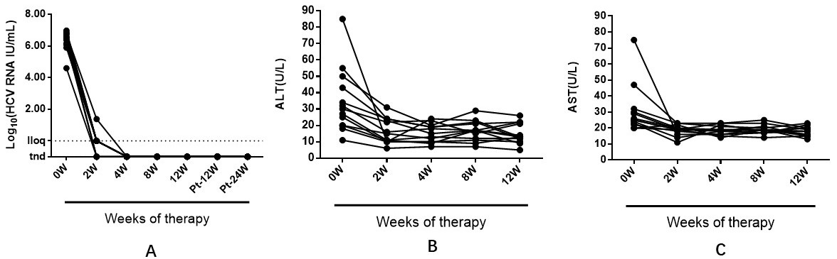
Figure 1 Serum hepatitis C virus RNA level and liver inflammation decrease rapidly with sofosbuvir and ledipasvir therapy. A: Serum HCV RNA levels of patients who all responded to therapy (n = 13). A response to sofosbuvir and ledipasvir therapy was defined as undetectable viremia at EOT (week 24); (B) Serum alanine aminotransferase (ALT). (C) Serum aspartate aminotransferase (AST). EOT: End of treatment; lloq: Lower limit of quantitation; tnd: Target not detected.

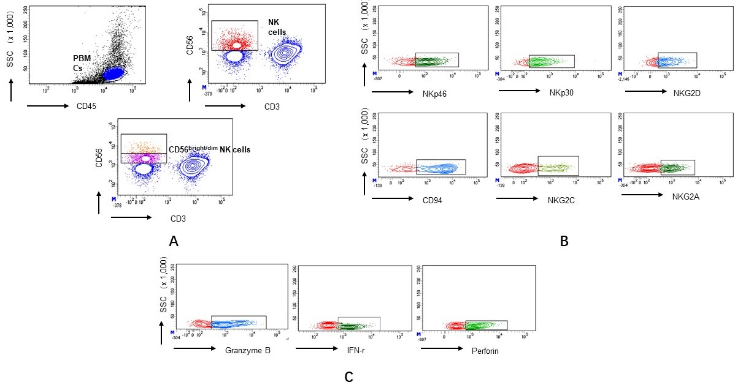
Figure 2 Flow cytometry. A: Dissection of human peripheral blood NK cells and subset; B: The expression of NKp46, NKp30, NKG2D, CD94, NKG2C and NKG2A during and after the end of DAAs treatment; C: The expression of Granzyme B, IFN-γ and perforin during and after the end of DAAs treatment. NK: Natural killer; IFN: Interferon; DAAs: Direct-acting antivirals.

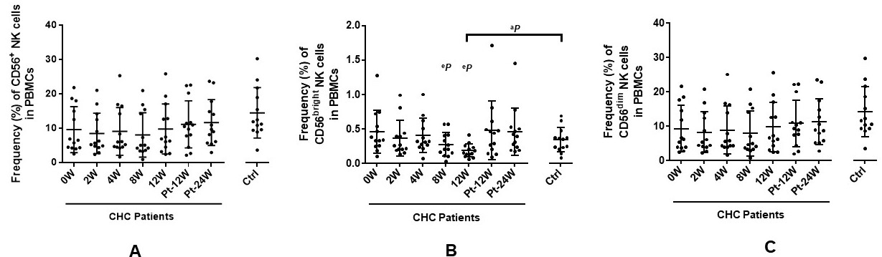
Figure 3 Effects of sofosbuvir and ledipasvir therapy on the frequencies of natural killer subsets from chronic hepatitis C patients. A: Frequencies of CD56⁺ NK cells in PBMCs; B: Frequencies of CD56^{bright} NK cells in PBMCs; C: Frequencies of CD56^{dim} NK cells in PBMCs. ªP < 0.05 and ^{b}P ≤ 0.01 and ^{c}P ≤ 0.001 different time points of CHC patients vs healthy controls; ^{d}P < 0.05 and ^{e}P ≤ 0.01 and ^{f}P ≤ 0.001 different time points of CHC patients (2 wk, 4 wk, 8 wk, 12 wk, Pt-12 wk, Pt-24 wk vs 0 wk). CHC: Chronic hepatitis C; Ctrl: Healthy control; Pt: Post of treatment; PBMCs: Peripheral blood mononuclear cells.

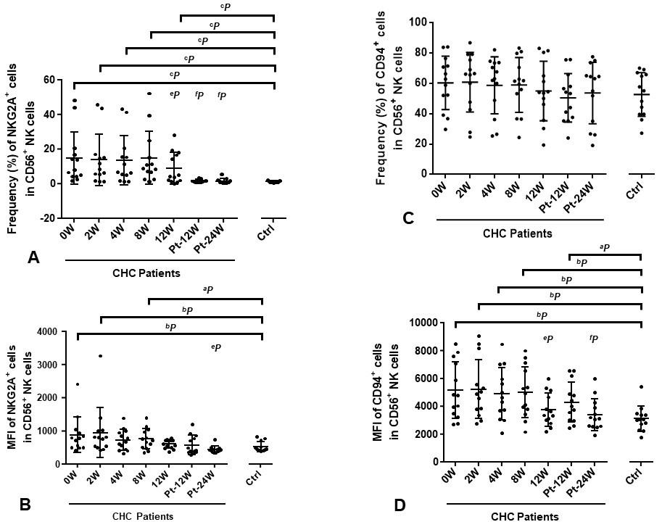
Figure 4 Sofosbuvir and ledipasvir therapy modulate the expression of NKG2A and CD94 on natural killer cells. Flow cytometric analyses of inhibitory receptor NKG2A and CD94 on NK cells. The graphs display the frequencies and MFI of NKG2A (A-B) and CD94 (C-D) on NK cells from CHC patients during and after DAAs therapy and healthy controls (n = 13). ªP < 0.05 and ^{b}P ≤ 0.01 and ^{c}P ≤ 0.001 different time points of CHC patients vs healthy controls; ^{d}P <0.05 and ^{e}P ≤0.01 and ^{f}P ≤0.001 different time points of CHC patients (2 wk, 4 wk, 8 wk, 12 wk, Pt-12 wk, Pt-24 wk vs 0 wk) CHC: Chronic hepatitis C; Ctrl: Healthy control; Pt: Post of treatment.

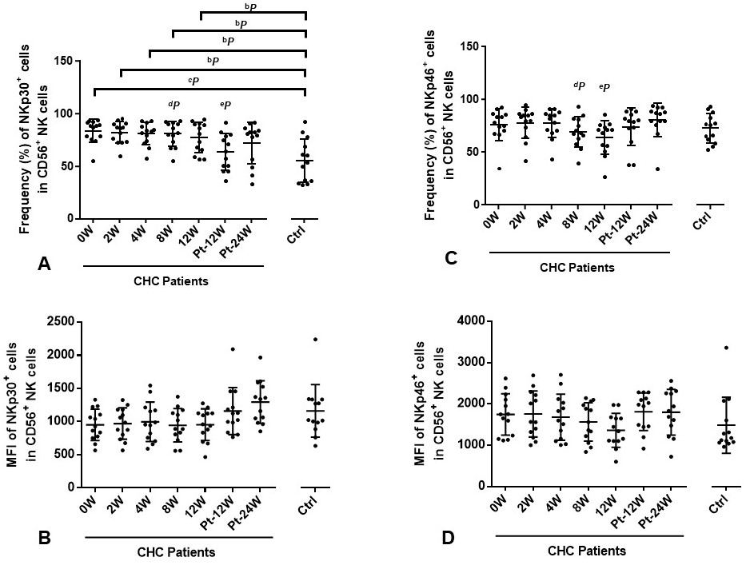
Figure 5 Sofosbuvir and ledipasvir therapy modulate the expression of NKp30 and NKp46 on natural killer cells. Flow cytometric analyses of activating receptors NKp30 and NKp46 on NK cells. The graphs display the frequencies and MFI of NKp30 (A-B) and NKp46 (C-D) on NK cells from CHC patients during and after DAAs therapy and healthy controls (n = 13). ªP < 0.05 and ^{b}P ≤ 0.01 and ^{c}P ≤ 0.001 different time points of CHC patients vs healthy controls; ^{d}P < 0.05 and ^{e}P ≤ 0.01 and ^{f}P ≤ 0.001 different time points of CHC patients (2 wk, 4 wk, 8 wk, 12 wk, Pt-12 wk, Pt-24 wk vs 0 wk). CHC: Chronic hepatitis C; Ctrl: Healthy control; Pt: Post of treatment.
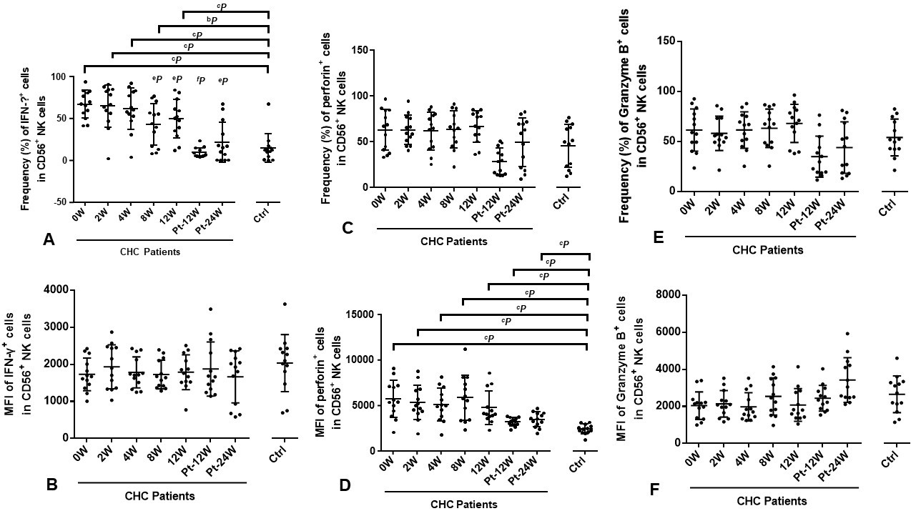
Figure 6 Sofosbuvir and ledipasvir therapy modulate the expression of natural killer cell–related cytokine interferon-γ, perforin and granzyme B. Flow cytometric analyses of IFN-γ, perforin and Granzyme B expression in NK cells. The graphs display the frequencies and MFI of IFN-γ (A-B), perforin (C-D) and Granzyme B (E-F) in NK cells from CHC patients during and after DAAs therapy and healthy controls (n = 13). ªP < 0.05 and ^{b}P ≤ 0.01 and ^{c}P ≤ 0.001 different time points of CHC patients vs healthy controls; ^{d}P < 0.05 and ^{e}P ≤ 0.01 and ^{f}P ≤ 0.001 different time points of CHC patients (2 wk, 4 wk, 8 wk, 12 wk, Pt-12 wk, Pt-24 wk vs 0 wk). IFN: Interferon; CHC: chronic hepatitis C; Ctrl: Healthy Control; Pt: Post of treatment.

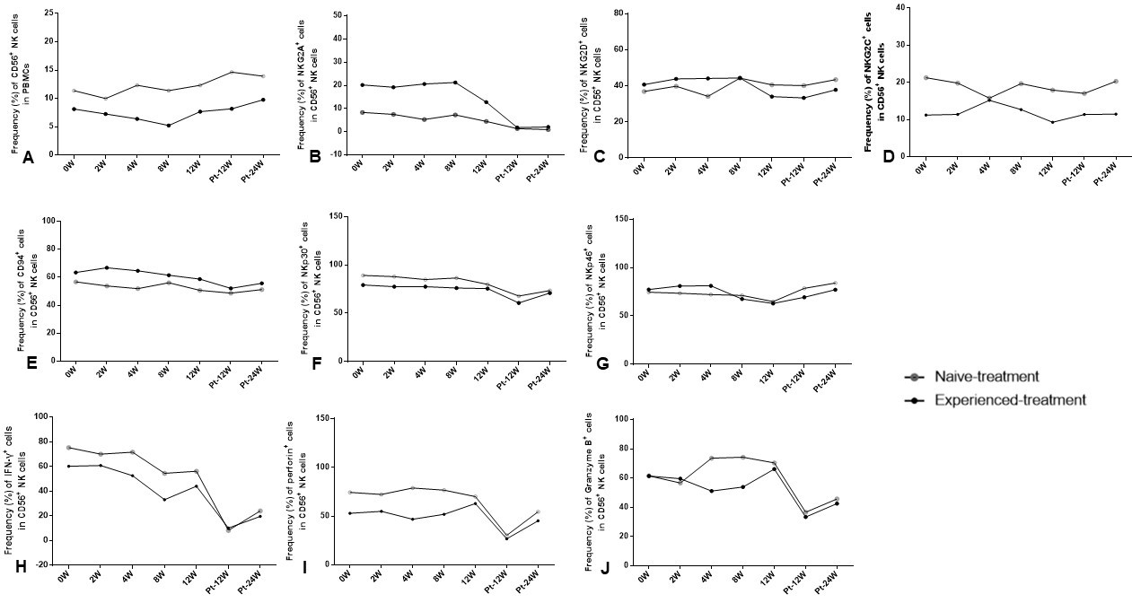
Figure 7 Frequency of CD56⁺ natural killer cells, phenotypes and cytokines expression of natural killer cells between naïve-treated and experienced-treated chronic hepatitis C patients. Flow cytometric analyses of the frequency of CD56⁺ NK cells (A), the expression of NKG2A (B), NKG2D (C), NKG2C (D), CD94 (E), NKp30 (F), NKp46 (G), IFN-γ (H), perforin (I) and granzyme B (J) expression of NK cells and the changing trend between naïve-treated (n = 7) and experienced-treated (n = 6) CHC patients during and after DAAs therapy. Pt: Post of treatment; IFN: Interferon; NK: Natural killer; CHC: Chronic hepatitis C.

Table 1 Demographical and clinical characteristics of chronic hepatitis C patients
Sex  (F/M) | Age  (yr) | BMI  (kg/m²) | Fibroscan index | Naive/experienced treatment | ALT/AST  (U/L)-baseline | ALT/AST  (U/L)-week 2 | Log HCV RNA | Response to sofosbuvir/ledipasvir
F | 27 | 18.71 | 3.8 | N | 25/25 | 10/19 | 6.16 | SVR24
M | 62 | 15.85 | 6.5 | N | 55/47 | 24/23 | 6.09 | SVR24
F | 30 | 20.07 | 5.9 | N | 18/20 | 10/19 | 6.38 | SVR24
F | 53 | 20.10 | 3.9 | N | 11/25 | 6/19 | 6.98 | SVR24
M | 25 | 24.39 | 6.1 | N | 43/22 | 23/18 | 4.60 | SVR24
F | 27 | 19.38 | 7.9 | N | 20/20 | 11/22 | 6.87 | SVR24
F | 29 | 26.67 | 6.4 | N | 32/24 | 16/14 | 5.90 | SVR24
M | 24 | 29.33 | 7.6 | E | 85/75 | 10/16 | 6.45 | SVR24
M | 63 | 25.10 | 4.8 | E | 50/32 | 31/23 | 6.51 | SVR24
M | 55 | 23.62 | 4.5 | E | 34/30 | 24/20 | 6.56 | SVR24
F | 57 | 22.31 | 4.7 | E | 20/26 | 15/20 | 6.76 | SVR24
F | 63 | 26.75 | 4.3 | E | 27/29 | 11/19 | 6.76 | SVR24
M | 25 | 26.53 | 6 | E | 30/23 | 22/11 | 6.60 | SVR24
F: Female; M: Male; N: Naive treatment; E: Experienced treatment; ALT: Alanine aminotransferase; AST: Aspartate aminotransferase; HCV: Hepatitis C virus; SVR: Sustained virological response.

