Name of Journal: World Journal of Clinical Cases
Manuscript NO: 45061
Manuscript Type: CASE REPORT

Min-invasive surgical treatment for multiple axis fractures: A case report

Zhu XC et al. Min-invasive treatment for multiple axis fractures

Xuan-Chen Zhu, Yi-Jie Liu, Xue-Feng Li, Han Yan, Ge Zhang, Wei-Min Jiang, Hou-Yi Sun, Hui-Lin Yang

Xuan-Chen Zhu, Yi-Jie Liu, Xue-Feng Li, Han Yan, Ge Zhang, Wei-Min Jiang, Hou-Yi Sun, Hui-Lin Yang, Department of Orthopedics, First Affiliated Hospital of Suzhou University, Suzhou 215008, Jiangsu Province, China

ORCID number: Xuan-Chen Zhu (0000-0003-4170-8980); Yi-Jie Liu (0000-0001-9976-856X); Xue-Feng Li (0000-0002-7291-5096); Han Yan (0000-0003-3928-1324); Ge Zhang (0000-0002-1050-2421); Wei-Min Jiang (0000-0001-8650-9403); Hou-Yi Sun (0000-0003-0376-368X); Hui-Lin Yang (0000-0003-1125-8456).

Author contributions: Zhu XC and Liu YJ joined the surgery and wrote the paper; Li XF, Yan H, Zhang G and Sun HY collect the information and follow up of the patient; Jiang WM and Yang HL revised the paper; Zhu XC and Liu YJ contribute equally to the work.

Informed consent statement: All study participants or their legal guardian provided informed written consent about personal and medical data collection prior to study enrolment.

Conflict-of-interest statement: All the Authors have no conflict of interest related to the manuscript.

CARE Checklist (2016) statement: The guidelines of the CARE Checklist (2016) was adopted during preparation of this manuscript.

Open-Access: This article is an open-access article which was selected byan in-house editor and fully peer-reviewed by external reviewers. It is distributed in accordance with the Creative Commons Attribution Non Commercial (CC BY-NC 4.0) license, which permits others to distribute, remix, adapt, build upon this work non-commercially, and license their derivative works on different terms, provided the original work is properly cited and the use is non-commercial. See: http://creativecommons.org/licenses/by-nc/4.0/

Manuscript source: Unsolicited manuscript

Corresponding author: Wei-Min Jian, MD, Chief Doctor, Professor, Department of Orthopedics, First Affiliated Hospital of Suzhou University, 188 Shizi Street, Suzhou 215008, Jiangsu Province, China. jwm610829@vip.sina.com
Telephone: +86-15051586694

Received: December 17, 2018
Peer-review started: December 17, 2018
First decision: January 30, 2019
Revised: February 16, 2019
Accepted: February 18, 2019
Article in press: February 18, 2019
Published online: April 6, 2019

Abstract
BACKGROUND
Fractures of the axis are commonly seen in spinal injuries. Upper cervical fractures are usually managed conservatively. However, the complications due to long-term external immobilization cannot be ignored. The traditional open surgery has the disadvantages of too much blood loss and soft tissue injury. The aim of our paper is to introduce a minimally invasive surgical treatment for multiple axis fractures.

CASE SUMMARY
We report a 40-year-old Chinese male who had severe neck pain and difficult neck movement after falling from 3 meters. X-ray and computed tomography (CT) scan revealed an axis injury consisting of an odontoid Type Ⅲ fracture associated with a Hangman fracture categorized as a Levine-Edwards Type I fracture. The patient underwent anterior odontoid screw fixation and posterior percutaneous screw fixation using intraoperative O-arm navigation. Neck pain was markedly improved after surgery. X-rays and CT scan reconstructions of 3-mo follow-up showed good stability and fusion. The range of cervical motion was well preserved.

CONCLUSION
Anterior odontoid screw fixation and posterior direct C2 percutaneous pedicle screw fixation with the aid of O-arm navigation and neurophysiological monitoring can be an interesting alternative option for complicated multiple axis fractures.

Key words: Axis injury; Odontoid fracture; Hangman fracture; Minimally invasive treatment; Intraoperative O-arm navigation; Percutaneous screw fixation; Case report

© The Author(s) 2019. Published by Baishideng Publishing Group Inc. All rights reserved.

Core tip: Multiple axis fracture is one kind of severe upper cervical injuries. Our team tries to find a min-invasive treatment for this kind of patients. We present a case about the surgical outcome of a patient with an odontoid Type Ⅲ fracture associated with a Hangman fracture categorized as a Levine-Edwards Type I fracture. The patient underwent anterior odontoid screw fixation and posterior percutaneous C2 pedicle screw fixation using intraoperative O-arm navigation. The patient recovered quickly and went back to normal life. Follow-up X-ray and computed tomography scan showed satisfactory bone union of C2. The range of cervical motion was well preserved.

Citation: Zhu XC, Liu YJ, Li XF, Yan H, Zhang G, Jiang W, Sun HY, Yang HL. Min-invasive surgical treatment for multiple axis fractures: A case report. World J Clin Cases 2019; 7(7): 898-902
URL: https://www.wjgnet.com/2307-8960/full/v7/i7/898.htm
DOI: https://dx.doi.org/10.12998/wjcc.v7.i7.898

INTRODUCTION
Fractures of the axis are commonly seen in spinal injuries, and account for approximately 20% of acute cervical spinal fractures^{[1]}. The Hangman fracture and the odontoid fracture are common upper cervical injuries. However, an odontoid fracture and Hangman fracture occurring at the same time is relatively rare. The management of these complicated upper cervical spinal injuries is usually difficult. Conservative management such as the Halo vest is an effective and safe treatment for upper cervical spine fractures; however, long-term external immobilization is necessary and may lead to many complications^{[2,3]}. The traditional surgery, such as posterior C1-2 internal fixation with a C1 lateral mass and a C2 pedicle screw and rod, which may be feasible for this type of complex upper cervical fracture^{[4,5]}. With the development of technology, 3D navigation and mobile intraoperative computed tomography (CT) can provide a min-invasive and safe surgical opportunity for the management of this type of injury^{[6-8]}.
We here report a patient with an axis fracture consisting of an odontoid fracture and Hangman fracture who underwent anterior odontoid screw fixation and posterior direct C2 percutaneous pedicle screw fixation using intraoperative O-arm navigation.

CASE PRSENTATION
A 40-year-old Chinese male was transferred to our hospital with the chief complaints of severe neck pain and difficult neck movement after falling from 3 meters eight days previously. Neurologic examination was normal. The patient was temporarily immobilized with a Philadelphia collar. Plain radiographs and a CT scan showed a C2 fracture consisting of an odontoid Type III fracture associated with a Hangman fracture categorized as a Levine-Edwards Type I fracture (no translation and angular deformity) (Figure 1). Magnetic resonance imaging (MRI) of the cervical spine indicated no spinal cord injury, edema or hemorrhage. There was no obvious damage to the transverse ligament of the atlas and the C2-3 intervertebral disc.
The imaging findings were shared with the patient and his family, and a Halo vest and skull traction were initially recommended. However, the patient refused these conservative options and hoped to undergo surgical treatment for going back to daily life quickly. Because it is an odontoid Type III fracture associated with a Hangman fracture (Levine-Edwards Type I), our team decided to treat the patient with simultaneous anterior and posterior screw fixations with the aid of intraoperative O-arm navigation, which was accepted by the patient.

Preoperative skull traction
In order to achieve appropriate posterior extension of the neck, the traction force was started at 2-3 kg to maintain fracture reduction.

Surgical procedures
Following general anesthesia via nasotracheal intubation, the patient was carefully placed in the supine position on a carbon table. Electrophysiological monitoring was performed during surgery for safety reasons. The patient’s head was fixed with a skull clamp which was connected to the carbon table. His neck was extended to provide a larger surgical space for odontoid screw placement. A reference arm was fixed to the head clamp. The O-arm (Medtronic, Minneapolis, MN, United States) was used to scan the patient’s cervical spine to obtain the corresponding 3D images, which were then transmitted to the navigation system (Medtronic). A 5-cm incision was made on the right side of the anterior neck which corresponded to the level of the C5-6 disc space. Gradual dissection was performed. The C2-3 disc space was identified by a spine needle. The planned entry point and the trajectory of the odontoid screw were displayed on the screen of the navigation system. The registered drill guide helped to place the spine needle and drill through the C2 vertebral body toward the tip of the odontoid process. This was confirmed using the O-arm to ensure that the position of the drill matched the planned trajectory. The guide needle helped the odontoid screw (half-thread screw 4.0 mm × 30 mm; Medtronic) find the path. Real-time confirmation using the O-arm was repeated to avoid the screw deviating from the planned trajectory. The incision was closed after accurate placement of the odontoid screw.
The patient was then carefully moved to the prone position. A 3-cm incision was made at the level of the C5 spinous process. The reference arc of the navigation system was mounted onto the C5 spinous process. The patient was scanned with the O-arm and the new data were transmitted to the navigation system. With the aid of the O-arm and the navigation instrument, the entry points were defined and two 1.5-cm paramedian incisions were made. Bilateral pedicle screws (double-threaded cannulated lag screw 4.0 mm × 28 mm Hua Sen, Changzhou, China) were placed in the precise position and angulation under the guidance of the navigation system. Following placement of the screws, the patient was scanned with the O-arm again to confirm the position of the screws and that reduction of the fracture was satisfactory. The operating time was 2 h and blood loss was 100 mL.
The patient’s neck pain was markedly improved after surgery and he was allowed to walk with a cervical collar. The collar was used for 4 wk. Three months later, imaging examinations showed good bone union of C2 (Figure 2). The patient experienced no neck pain and had little limitation in the range of cervical motion.

FINAL DIAGNOSIS
Odontoid Type Ⅲ fracture associated with a Hangman fracture categorized as a Levine-Edwards Type I fracture

TREATMENT
Anterior odontoid screw fixation and posterior percutaneous C2 pedicle screw fixation using intraoperative O-arm navigation.

OUTCOME AND FOLLOW-UP
Follow-up X-ray and CT scan showed satisfactory bone union of C2. The range of cervical motion was well preserved.

DISCUSSION
The probability of an odontoid fracture combined with a Hangman fracture is relatively rare, which can lead to severe instability of the upper cervical spine. The current treatment methods for odontoid type Ⅲ fracture and Hangman type Ⅰ fracture are usually conservative. Common conservative treatments include Halo vest and skull traction. There is evidence suggesting that the management of upper cervical spine fractures with Halo fixation is safe and effective in some patients^{[2,3]}. However, the complications of the Halo vest, such as discomfort, pin-track problems, nerve injury, cerebrospinal fluid leakage, intracranial abscesses, dysphagia, pin-site scar formation, restriction of respiratory function, loss of reduction, and late instability, cannot be ignored^{[2,9]}. These complications are more frequent in elderly patients and in those with other comorbidities. Surgery can be a good treatment choice in some circumstances. For example, posterior route, C1-2 internal fixation with a C1 lateral mass and a C2 pedicle screw and rod may be used for this type of complex upper cervical fracture^{[4]}. However, soft tissue injury and blood loss can be increased during this type of operation. Patients may lose almost 50% of their cervical rotational mobility. Besides, the anterior approach is also a feasible and safe way for traumatic spondylolisthesis of the axis, which consists of C2-C3 discectomy with interbody fusion and plating^{[10]}. Benjamin et al^{[11]} used to report a case of multiple axis fracture, which was treated with an odontoid screw fixation and a C2–C3 fusion. However, the ACDF may make it more difficult to place the anterior odontoid screw. It will sacrifice the motion of the C2-3 disc. What’s more, the anterior approach can’t solve the separation of C2 pedicle directly. Percutaneous C2 pedicle screw placement appears to be a safe and effective treatment option, which can achieve sufficient reduction and stabilization. The range of cervical motion is also preserved to a large extent^{[12,13]}. Frederick et al^{[14]} reported that O-arm navigation can significantly reduce intraoperative blood loss during C1-C2 posterior cervical fixation. In our case, according to the MRI examination, there was no obvious rupture of the transverse ligament of the atlas. Atlantoaxial instability can be reduced by internal fixation of the axis (anterior odontoid screw fixation and direct percutaneous C2 pedicle screw fixation using intraoperative o-arm navigation). The navigation system makes minimal exposure feasible with less soft tissue injury compared with traditional posterior open surgery. This may reduce the need for blood transfusion and the risk of infection. The operating time can be shortened to within 2 h. Placement of the screws using intraoperative navigation and neurophysiological monitoring is safe and reliable^{[8,15-18]}. In addition, the fracture site on the axis is stable enough for early motion. At the last follow-up visit, our patient had good bone union and no significant loss of cervical motion. Compared with the cases reported by Jun Shinbo et al^{[19]}, our surgical procedure resulted in more precise screw placement with less blood loss and soft tissue injury.

CONCLUSION
Based on this surgical outcome, we think anterior odontoid screw fixation and posterior direct C2 percutaneous pedicle screw fixation using O-arm navigation and neurophysiological monitoring can be an interesting alternative treatment for multiple axis fracture.

REFERENCES
1 Pryputniewicz DM, Hadley MN. Axis fractures. Neurosurgery 2010; 66: 68-82 [PMID: 20173530 DOI: 10.1227/01.NEU.0000366118.21964.A8]
2 Longo UG, Denaro L, Campi S, Maffulli N, Denaro V. Upper cervical spine injuries: Indications and limits of the conservative management in Halo vest. A systematic review of efficacy and safety. Injury 2010; 41: 1127-1135 [PMID: 20889154 DOI: 10.1016/j.injury.2010.09.025]
3 Levine AM, Edwards CC. The management of traumatic spondylolisthesis of the axis. J Bone Joint Surg Am 1985; 67: 217-226 [PMID: 3968113 DOI: 10.2106/00004623-198567020-00007]
4 Harms J, Melcher RP. Posterior C1-C2 fusion with polyaxial screw and rod fixation. Spine (Phila Pa 1976) 2001; 26: 2467-2471 [PMID: 11707712 DOI: 10.1097/00007632-200111150-00014]
5 Payer M, Luzi M, Tessitore E. Posterior atlanto-axial fixation with polyaxial C1 lateral mass screws and C2 pars screws. Acta Neurochir (Wien) 2009; 151: 223-9; discussion 229 [PMID: 19229471 DOI: 10.1007/s00701-009-0198-4]
6 Czabanka M, Haemmerli J, Hecht N, Foehre B, Arden K, Liebig T, Woitzik J, Vajkoczy P. Spinal navigation for posterior instrumentation of C1-2 instability using a mobile intraoperative CT scanner. J Neurosurg Spine 2017; 27: 268-275 [PMID: 28598291 DOI: 10.3171/2017.1.SPINE16859]
7 Yoshida G, Kanemura T, Ishikawa Y. Percutaneous Pedicle Screw Fixation of a Hangman's Fracture Using Intraoperative, Full Rotation, Three-dimensional Image (O-arm)-based Navigation: A Technical Case Report. Asian Spine J 2012; 6: 194-198 [PMID: 22977699 DOI: 10.4184/asj.2012.6.3.194]
8 Pisapia JM, Nayak NR, Salinas RD, Macyszyn L, Lee JY, Lucas TH, Malhotra NR, Isaac Chen H, Schuster JM. Navigated odontoid screw placement using the O-arm: Technical note and case series. J Neurosurg Spine 2017; 26: 10-18 [PMID: 27517526 DOI: 10.3171/2016.5.SPINE151412]
9 Glaser JA, Whitehill R, Stamp WG, Jane JA. Complications associated with the halo-vest. A review of 245 cases. J Neurosurg 1986; 65: 762-769 [PMID: 3772473 DOI: 10.3171/jns.1986.65.6.0762]
10 Ying Z, Wen Y, Xinwei W, Yong T, Hongyu L, Zhu H, Qinggang Z, Weihong Z, Yonggeng C. Anterior cervical discectomy and fusion for unstable traumatic spondylolisthesis of the axis. Spine (Phila Pa 1976) 2008; 33: 255-258 [PMID: 18303456 DOI: 10.1097/BRS.0b013e31816233d0]
11 Blondel B, Metellus P, Fuentes S, Dutertre G, Dufour H. Single anterior procedure for stabilization of a three-part fracture of the axis (odontoid dens and hangman fracture): Case report. Spine (Phila Pa 1976) 2009; 34: E255-E257 [PMID: 19333089 DOI: 10.1097/BRS.0b013e318195ab2d]
12 ElMiligui Y, Koptan W, Emran I. Transpedicular screw fixation for type II Hangman's fracture: A motion preserving procedure. Eur Spine J 2010; 19: 1299-1305 [PMID: 20401619 DOI: 10.1007/s00586-010-1401-2]
13 Ebraheim N, Rollins JR Jr, Xu R, Jackson WT. Anatomic consideration of C2 pedicle screw placement. Spine (Phila Pa 1976) 1996; 21: 691-695 [PMID: 8882690 DOI: 10.1097/00007632-199603150-00005]
14 Hitti FL, Hudgins ED, Chen HI, Malhotra NR, Zager EL, Schuster JM. Intraoperative Navigation Is Associated with Reduced Blood Loss During C1-C2 Posterior Cervical Fixation. World Neurosurg 2017; 107: 574-578 [PMID: 28842229 DOI: 10.1016/j.wneu.2017.08.051]
15 Deletis V, Sala F. Intraoperative neurophysiological monitoring of the spinal cord during spinal cord and spine surgery: A review focus on the corticospinal tracts. Clin Neurophysiol 2008; 119: 248-264 [PMID: 18053764 DOI: 10.1016/j.clinph.2007.09.135]
16 Holly LT, Foley KT. Percutaneous placement of posterior cervical screws using three-dimensional fluoroscopy. Spine (Phila Pa 1976) 2006; 31: 536-40; discussion 541 [PMID: 16508547 DOI: 10.1097/01.brs.0000201297.83920.a1]
17 Singh PK, Garg K, Sawarkar D, Agarwal D, Satyarthee GD, Gupta D, Sinha S, Kale SS, Sharma BS. Computed tomography-guided C2 pedicle screw placement for treatment of unstable hangman fractures. Spine (Phila Pa 1976) 2014; 39: E1058-E1065 [PMID: 25122548 DOI: 10.1097/BRS.0000000000000451]
18 Guppy KH, Chakrabarti I, Banerjee A. The use of intraoperative navigation for complex upper cervical spine surgery. Neurosurg Focus 2014; 36: E5 [PMID: 24580006 DOI: 10.3171/2014.1.FOCUS13514]
19 Shinbo J, Sameda H, Ikenoue S, Takase K, Yamaguchi T, Hashimoto E, Enomoto T, Kanazuka A, Mimura M. Simultaneous anterior and posterior screw fixations confined to the axis for stabilization of a 3-part fracture of the axis (odontoid, dens, and hangman fractures): Report of 2 cases. J Neurosurg Spine 2014; 20: 265-269 [PMID: 24409982 DOI: 10.3171/2013.12.SPINE12448]

P-Reviewer: Elgafy H, El Ghoch M, Liu JY S-Editor: Yan JP
L-Editor: A E-Editor: Wu YXJ

Specialty type: Medicine, research and experimental
Country of origin: China
Peer-review report classification
Grade A (Excellent): 0
Grade B (Very good): 0
Grade C (Good): C, C
Grade D (Fair): D
Grade E (Poor): 0

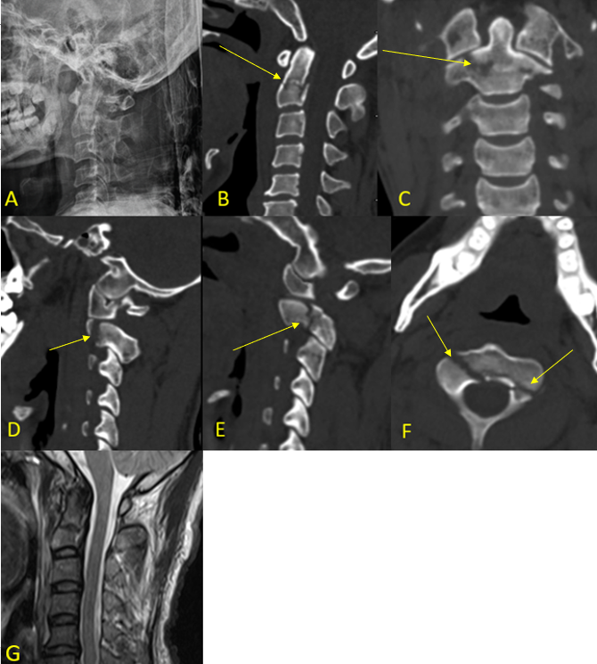
Figure 1 Imaging examinations were performed before surgery. A-F: Plain radiographs and computed tomography scan showed a C2 fracture consisting of an odontoid Type III fracture associated with a Hangman fracture categorized as a Levine-Edwards Type I fracture (no translation and angular deformity); G: Magnetic resonance imaging indicated no spinal cord injury, edema or hemorrhage. There was no obvious damage to the transverse ligament of the atlas and the C2-3 intervertebral disc.

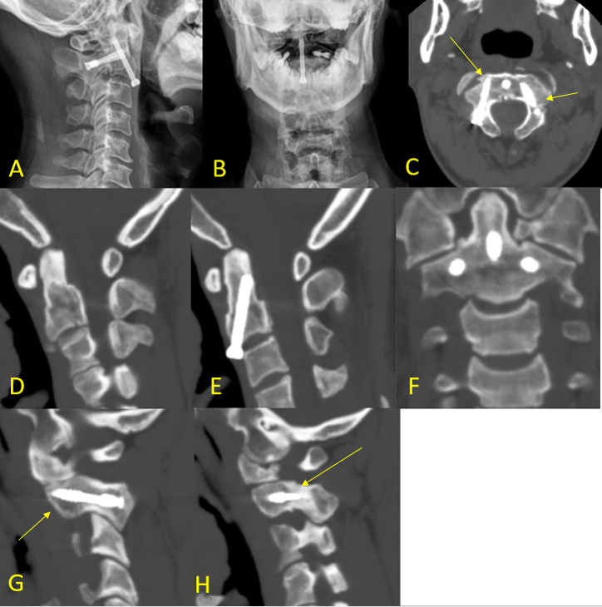

Figure 2 Imaging examinations 3 mo after surgery. A-H: The pictures showed good bone union of C2.

