Name of Journal: World Journal of Dermatology
ESPS Manuscript NO: 27611
Manuscript Type: Case Report

Papular mycosis fungoides: Six new cases and association with chronic lymphocytic leukemia

Vonderheid EC et al. Papular mycosis fungoides

Eric C Vonderheid, Marshall E Kadin, Gladys H Telang

Eric C Vonderheid, Sidney Kimmel Cancer Center, Johns Hopkins Medical Institutes, Baltimore, MD 21205, United States

Marshall E Kadin, Department of Dermatology, Boston University and Roger Williams Medical Center, Providence, RI 02908, United States

Gladys H Telang, Department of Dermatology, the Warren Alpert Medical School of Brown University, Providence, RI 02903, United States

Author contributions: Vonderheid EC and Kadin ME designed the report; Telang GH performed the histologic and immunopathologic studies; Vonderheid EC collected the patients’ clinical data; Vonderheid EC, Kadin ME and Telang GH analyzed the data and wrote the paper.

Institutional review board statement: The study was approved by the Johns Hopkins Institutional Review Board.

Informed consent statement: Information about patients was obtained from an approved Cutaneous Lymphoma Registry and informed consent for clinical photography was obtained from all patients.

Conflict-of-interest statement: The authors have no conflicts of interest to declare.

Data sharing statement: No data were created no data are available.

Open-Access: This article is an open-access article which was selected by an in-house editor and fully peer-reviewed by external reviewers. It is distributed in accordance with the Creative Commons Attribution Non Commercial (CC BY-NC 4.0) license, which permits others to distribute, remix, adapt, build upon this work non-commercially, and license their derivative works on different terms, provided the original work is properly cited and the use is non-commercial. See: http://creativecommons.org/licenses/by-nc/4.0/

Manuscript source: Invited manuscript

Correspondence to: Eric C Vonderheid, MD, Adjunct Professor of Oncology, Sidney Kimmel Cancer Center, Johns Hopkins Medical Institutes, 37580 S. Desert Sun Drive, Baltimore, MD 21205, United States. evonder1@jhmi.edu
Telephone: +1-520-8252699

Received: June 7, 2016
Peer-review started: June 13, 2016
First decision: July 11, 2016
Revised: August 25, 2016
Accepted: October 1, 2016
Article in press:
Published online:

Abstract
Papular mycosis fungoides (MF) is a rare presentation of MF. Six illustrative cases of papular MF were retrospectively reviewed. Five of the cases studied by immunohistochemistry had variable numbers (range: 1%-20%) of CD30+ cells in the dermal infiltrate, a finding that is characteristic of lymphomatoid papulosis but may occasionally occur in typical early MF. Although none of our papular MF patients had progressive disease, lesions with relatively high numbers of CD30+ cells in 3 patients did not respond well to skin-directed treatments used for MF. Interestingly, these patients had evidence of co-existing clonal B cell populations in the blood (one with clonal B cell lymphocytosis and two with B-cell chronic lymphocytic leukemia). We conclude that: (1) papular MF may contain CD30+ cells, thereby causing confusion with lymphomatoid papulosis, and (2) papular MF, like more typical MF, may be associated with clonal B-cell proliferations including chronic lymphocytic leukemia.

Key words: Mycosis fungoides; Lymphocytosis; Chronic lymphocytic leukemia; Papule; Cutaneous lymphoma

© The Author(s) 2016. Published by Baishideng Publishing Group Inc. All rights reserved.

Core tip: Mycosis fungoides presenting with papules as the only clinical manifestation is a rare variant of the disease. To date only 16 cases of papular mycosis fungoides have been described in the literature and none had CD30+ cells. We report 6 additional cases, 5 with 1%-20% CD30+ cells. Three cases had co-existing clonal B cell lymphoproliferation (2 with chronic lymphocytic leukemia). The possible pathogenic relationship between mycosis fungoides and chronic lymphocytic leukemia is discussed.

Vonderheid EC, Kadin ME, Telang GH. Papular mycosis fungoides: Six new cases and association with chronic lymphocytic leukemia. World J Dermatol 2016; In press

INTRODUCTION
Mycosis fungoides (MF), a great masquerader of other skin diseases, can present with varied types of lesions that are confused with infectious and drug related eruptions among others^{[1,2]}. Recently, Kodama reported 6 cases of “papular MF" that presented with persistent papules that had the histopathologic features of MF but without typical patch/plaque MF lesions nor evidence of a lymphomatoid drug reaction^{[3]}. Lymphomatoid papulosis (LyP) was excluded by the absence of spontaneous regression of lesions and lack of CD30+ cells in the dermal infiltrate. With follow up, 2 cases subsequently developed typical skin manifestations of MF (one developed MF patches only 2 mo after the diagnosis of papular MF).
At the time of this report, 10 additional cases of papular MF have been published (Table 1)^{[4-11]}. Collectively, these papular MF cases (8 men, 8 women, ages, 27 to 83 years) are characterized by the following: (1) persistent papules, sometimes only a few millimeters in diameter, that did not enlarge into nodules, plaques or tumors; (2) Pautrier microabscesses in 8 of 14 cases; (3) a CD4+ immunophenotype in 8 cases and a CD8+ phenotype in 2 cases; (4) negative staining for CD30 in all 16 cases; (5) clonal T cells demonstrated in 7 of 8 cases, (6) subsequent appearance of typical patch or plaque lesions of MF in 3 cases including Kodama’s 2 cases; and (7) an overall non-progressive clinical course.
Herein we report our experience with 6 additional cases of papular MF. Unlike reported cases, variable numbers of CD30+ cells were observed in the dermal infiltrate in 5 cases and 3 cases had evidence of co-existing clonal B-cell proliferations in the blood. The significance of these findings is discussed.

CASE REPORT
The registry of patients with cutaneous T cell lymphoma (1481 patients diagnosed with MF excluding its erythrodermic variant) that is maintained by one of us with approval of the Institutional Review Board at Johns Hopkins University was reviewed for cases that fulfilled the clinical-pathological criteria for papular MF as defined by Kodama^{[3]}. Information obtained at the time of initial presentation, subsequent staging and follow up provide the basis of this report. This includes the results of histopathology, immunohistochemistry on corresponding frozen sections, and PCR amplification of T cell receptor gamma (TCR-γ) chain gene for T cell clonality on representative lesions.
The Surveillance, Epidemiology, and End Results (SEER)-9 registry, which captures data from 9.4% of the total United States population, was analyzed using SEER*Stat 8.2.1 software to determine the relative risk of developing chronic B-cell leukemia (ICD-O-3 Site C42.0, C42.1, C42.4 and ICD-O-3 code 9823/3) in patients initially diagnosed with MF (ICD-O-3 code 9700/3) and vice versa between 1973 and 2012. The statistical significance of the standardized incidence ratio (observed/expected) was determined using a Poisson distribution to calculate 95% confidence intervals.
Our retrospective review identified 6 patients who presented with persistent papules and/or small nodules with histopathologic features interpreted as diagnostic or consistent with MF (Table 2 and Figures 1-7). With follow-up, none of these papular MF patients developed typical lesions of MF nor had disease progression. Pautrier microabscesses were described in skin specimens from 3 patients, and the immunophenotype of the neoplastic cells of 5 studied cases was CD4+CD8-. A dominant T cell clone was demonstrated by PCR in 3 cases.
Notably, all 5 patients evaluated for CD30 expression had variable numbers of scattered atypical CD30+ cells in the dermal infiltrate (estimated range: 1%-20%), a finding that suggested the possibility of type A LyP with epidermotropic T cells or possibly type B LyP. This was particularly true for the specimen from patient 2 (Figure 7). However, his skin lesions did not spontaneously regress as expected in LyP. In addition, CD30 also was expressed by 30% of the epidermotropic CD4+T cells of patient 3 (discussed below). Therefore, other than persistence of lesions, the histo-immunopathologic findings of papular MF overlap with those of LyP^{[12,13]}.
A second observation is that 3 of the papular MF patients had evidence of an associated clonal B-cell lymphoproliferation. Patient 1 had a T cell clone in skin and blood plus 6% of blood lymphocytes with a CD5+CD19+CD23+ phenotype and B cell clone demonstrated by PCR of the IgH gene in the blood, but not the skin. The small B cell population remained unchanged with follow-up and is therefore classified as clonal B cell lymphocytosis. Patient 2 had a T cell clone in skin and blood plus 65% of his blood lymphocytes were CD19+CD20+ B cells (absolute lymphocyte count: 770 cells/mm³) and evidence of a B cell clone by PCR in the blood but not the skin. A subsequent bone marrow analysis revealed 20% B cells co-expressing CD5 and CD23 characteristic of chronic lymphocytic leukemia (B-CLL). Patient 6 also had a B cell clone in the blood by flow cytometry (21% of lymphocytes with a CD5+CD19+CD20+ phenotype; absolute lymphocyte count: 2490 cells/mm³) but a negative PCR study when initially evaluated. However, a diagnosis of B-CLL was confirmed 6 mo later. These patients with clonal B cells tended to have higher percentages of CD30+ cells in their skin lesions and their response to treatment was partial or transitory compared to the other papular MF cases.

DISCUSSION
Papular MF is a very rare presentation of the disease, occurring in 0.4% of non-erythrodermic MF cases referred to our center. However, our patients differed from published cases with regard to the presence of atypical CD30+ cells in the dermal infiltrate in 5 studied specimens. Specimens from 3 patients had estimated numbers of dermal CD30+ cells that ranged from 5% to 20% such that LyP would be an alternative diagnosis. However, unlike LyP as currently defined, these lesions did not undergo spontaneous regression. Atypical CD30+ cells may also be encountered in clinically early lesions of MF so this finding does not exclude papular MF from the differential diagnosis^{[14]}. The clinical significance of CD30+ cells in this context is unclear. It has been reported that CD30 expression in non-transformed patch or plaque phase MF has an adverse prognostic significance^{[14]}. Although none of the patients in our small series developed more typical lesions of MF nor had disease progression, the 3 cases with 5% or more CD30+ cells in the dermal infiltrate did not respond adequately to various skin-directed therapies used to treat early MF.
An unexpected and previously unreported observation was that 3 patients with papular MF had an associated B-cell lymphoproliferative disorder (one with monoclonal B cell lymphocytosis and two with B-CLL). This raises the possibility that some of our papular MF cases might be examples of pseudo-MF reactions associated with B-CLL as described by Ingen-Housz-Oro^{[15]}. In that paper, the authors reported 4 patients that presented with localized papules in concert with B-CLL. Three patients were diagnosed to have a pseudo-MF reaction and one had papular MF. All cases had evidence of folliculotropism by lymphocytes and 3 had follicular mucinosis including the papular MF case. Of note, a T cell clone could not be demonstrated by PCR of the TCR-γ chain gene in all cases, whereas clusters of neoplastic B cells were observed in 3 cases including the papular MF case. CD30 staining was not performed. Therefore our papular MF cases differ from Ingen-Housz-Oro’s cases in several ways: (1) in our patients, lesions were more widespread; (2) folliculotropic T cells and a B cell component in the infiltrate were not present; and (3) T cell clonality was demonstrated in two cases. Of interest, mature appearing plasma cells were observed in the dermal infiltrate of skin specimens obtained from patients 1 and 2 who had evidence of clonal B cells in the blood but not the skin (Figure 7). In addition, a prior skin specimen from patient 6 and studied elsewhere also showed numerous plasma cells. This phenomenon may be the result of a homing process as suggested by Ingen-Housz-Oro^{[15]}.
The association of MF and B-CLL may not be a fortuitous event. A review of the literature uncovered 23 cases of classic patch, plaque or tumor phase MF (erythrodermic MF excluded) co-existing with B-CLL^{[15-26]}. Of interest CD30 staining was performed on skin specimens from only 2 cases and both were reported to be negative. Nevertheless, it has not been established that the risk of developing secondary B-CLL in MF patients is significantly higher than for the general population (Table 3)^{[27-34]}.
In the SEER-9 database, 1973 to 2012, there are 3,977 cases coded as MF as the primary cancer for analysis. Of these, B-CLL was subsequently diagnosed in 10 cases compared to an expected frequency of 6.77 cases. Therefore, the relative risk (observed/expected) is 1.48 (95%CI: 0.71-2.71). Conversely, of 34160 cases with B-CLL as the primary cancer, 7 developed MF as a second cancer for a relative O/E of 7/4.02 or 1.74 (95%CI: 0.7-3.59). Although these relative risks are increased, they are not statistically significant. However, the possibility that the number of MF cases in the SEER registry might be under reported must be considered for several reasons: (1) some MF cases may be diagnosed as cutaneous T cell lymphoma and therefore coded by registrars as such (ICD-0-3 code 9709/3); (2) cases of MF and B-CLL that are diagnosed concurrently are coded separately as primary cancers; and (3) perhaps not all cases of MF are reported to the SEER registry by private dermatologists or dermatopathology laboratories^{[35]}.
With regard to the first point, of 1304 patients coded initially as having cutaneous T cell lymphoma, 18 patients were subsequently coded as MF compared to an expected number of 0.15. The observed/expected ratio was 121.58 (95%CI: 72.06-192.15) was significantly high (P < 0.05). It is therefore conceivable but not proven that some patients with MF might be coded initially in the broader diagnostic category of cutaneous T cell lymphoma.
Incidentally our review also uncovered a case reported in 1983 that was characterized by disseminated therapeutically resistant papules with histopathologic features of MF in a patient with B-CLL^{[36]}. We propose this case could represent the first example of papular MF associated with B-CLL.
The underlying basis for the uncommon but well documented association of MF and other forms of cutaneous T cell lymphoma with various B cell lymphoproliferations is unclear. Our hypothesis, which also has been suggested by others^{[18,19]}, is that an inherited genetic attribute that predisposes a patient to lymphoma (such as a nucleotide polymorphism)^{[37]} or an acquired mutation is present at the level of the common lymphoid progenitor cell. If additional genetic alterations that promote lymphoma occur later in both the B and T cell developmental pathway, this would account for the observed associations of various T and B cell lymphoproliferations. It would also explain why B-CLL may precede, follow or present concurrently with cutaneous T cell lymphoma and the increased familial risk of lymphomas in family members of patients with cutaneous T cell lymphoma^{[38]}. The increased risk of non-hematologic cancers in patients with cutaneous T cell lymphoma could be explained by the immunosuppression related to the disease and/or use of oncogenic treatments^{[27-30,33,34,39]}.
Alternatively, the interaction between stimulatory ligands such as CD30-CD30L and CD40-CD40L expressed by T and B cells may provide an explanation for the co-existence of T and B cell lymphoproliferative diseases in susceptible patients. For example, the interaction between CD40L, which is expressed by neoplastic T cells of MF^{[40]}, and CD40, which is constitutively expressed by B cells, could result in up-regulation of genes involved in B cell survival and proliferation^{[41,42]}. The frequent expression of CD30 in some of our papular MF cases (and most LyP variants) with possible increased levels of soluble CD30 in the blood that we have observed in typical early MF patients could in theory contribute to the risk of developing B-CLL^{[43-45]}.
We conclude that MF may rarely present with persistent papules, but that there is considerable clinical and histo-immunopathologic overlap with LyP including a favorable prognosis^{[12,13]}. Indeed the main difference is the persistence of lesions in papular MF and spontaneous regression of lesions in LyP. Considering that typical MF lesions may undergo partial or even complete regression^{[46]}, we wonder if the differences between papular MF and LyP may be related to differences in factors that mediate lesion regression such as the host immune response. In addition, in this small series, there appears to be an association of papular MF with B-cell CLL that requires confirmation and further investigation.

ACKNOWLEDGMENTS
The authors thank Steve of the SEER*Stat Technical Support team, for his assistance in calculating the relative risk of secondary B-CLL in patients with MF.

COMMENTS
Case characteristics
Mycosis fungoides (MF), a great masquerader of other skin diseases, can present with varied types of lesions that are confused with infectious and drug related eruptions among others.

Clinical diagnosis
Lymphomatoid papulosis (LyP) was excluded by the absence of spontaneous regression of lesions and lack of CD30+ cells in the dermal infiltrate.

Differential diagnosis
The registry of patients with cutaneous T cell lymphoma (1481 patients diagnosed with MF excluding its erythrodermic variant) that is maintained by one of us with approval of the Institutional Review Board at Johns Hopkins University was reviewed for cases that fulfilled the clinical-pathological criteria for papular MF as defined by Kodama.

Imaging diagnosis
This retrospective review identified 6 patients who presented with persistent papules and/or small nodules with histopathologic features interpreted as diagnostic or consistent with MF

Experiences and lessons
Papular MF is a very rare presentation of the disease, occurring in 0.4% of non-erythrodermic MF cases referred to our center.

Peer-review
This is an interesting case series of papular mycosis fungoides. The authors described the clinical and histological features of this clinical entity, and its association with chronic lymphocytic leukemia. In general, the manuscript is well-written, and the content is clinically relevant and scientifically informative.
REFERENCES
1 Zackheim HS, McCalmont TH. Mycosis fungoides: the great imitator. J Am Acad Dermatol 2002; 47: 914-918 [PMID: 12451378 DOI: 10.1067/mjd.2002.124696]
2 Nashan D, Faulhaber D, Ständer S, Luger TA, Stadler R. Mycosis fungoides: a dermatological masquerader. Br J Dermatol 2007; 156: 1-10 [PMID: 17199560 DOI: 10.1111/j.1365-2133.2006.07526.x]
3 Kodama K, Fink-Puches R, Massone C, Kerl H, Cerroni L. Papular mycosis fungoides: a new clinical variant of early mycosis fungoides. J Am Acad Dermatol 2005; 52: 694-698 [PMID: 15793526 DOI: 10.1016/j.jaad.2004.12.018]
4 Uddin A, Bennett M, Nayeem K, Marren P, Abushaira H. A case of papular mycosis fungoides: new clinical variant of early mycosis fungoides. J Eur Acad Dermatol Venereol 2007; 21: 685-687 [PMID: 17447987 DOI: 10.1111/j.1468-3083.2006.01983.x]
5 Martorell-Calatayud A, Botella-Estrada R, Sanmartín-Jimenez O, Requena C, Guillén-Barona C, Sangüeza OP. Papular mycosis fungoides: two new cases of a recently described clinicopathological variant of early mycosis fungoides. J Cutan Pathol 2010; 37: 330-335 [PMID: 19737334 DOI: 10.1111/j.1600-0560.2009.01417.x]
6 Liu ZH, Wang YL, Chen SY, Zheng JH, Qiao G, Shen H, Xu AE. Papular mycosis fungoides: a new clinic variant of early and benign mycosis fungoides? J Clin Oncol 2011; 29: e381-e383 [PMID: 21343551 DOI: 10.1200/JCO.2010.32.8369]
7 Neri I, D'Acunto C, Pileri A, Reggiani C, Patrizi A. Papular mycosis fungoides: a new case expanding the spectrum of phenotypic and clinical findings. G Ital Dermatol Venereol 2011; 146: 505-507 [PMID: 22095185]
8 Noe MH, Drake A, Link BK, Liu V. Papular mycosis fungoides: report of two patients, literature review, and conceptual re-appraisal. J Cutan Pathol 2013; 40: 714-719 [PMID: 23651057 DOI: 10.1111/cup.12161]
9 Brajon D, Bonnet N, Dales JP, Berbis P. [Papular mycosis fungoides]. Ann Dermatol Venereol 2013; 140: 455-458 [PMID: 23773745 DOI: 10.1016/j.annder.2013.04.072]
10 Santamarina-Albertos A, Muñoz-Martínez R, Alvarez-Gago T, Miranda-Romero A. Papular mycosis fungoides on the legs: a case report. Actas Dermosifiliogr 2014; 105: 87-89 [PMID: 23339994 DOI: 10.1016/j.ad.2012.11.007]
11 Balta I, Akbay G, Eksioglu M, Astarcı M, Ekiz O. Papular mycosis fungoides: a case report and review in the literature. Indian J Dermatol 2015; 60: 107 [PMID: 25657444 DOI: 10.4103/0019-5154.147890]
12 Vonderheid EC, Kadin ME. Papular mycosis fungoides: a variant of mycosis fungoides or lymphomatoid papulosis? J Am Acad Dermatol 2006; 55: 177-180 [PMID: 16781328 DOI: 10.1016/j.jaad.2006.01.030]
13 Vonderheid EC, Kadin ME, Telang GH. Commentary about papular mycosis fungoides, lymphomatoid papulosis and lymphomatoid pityriasis lichenoides: more similarities than differences. J Cutan Pathol 2016; 43: 303-312 [PMID: 26566599 DOI: 10.1111/cup.12653]
14 Edinger JT, Clark BZ, Pucevich BE, Geskin LJ, Swerdlow SH. CD30 expression and proliferative fraction in nontransformed mycosis fungoides. Am J Surg Pathol 2009; 33: 1860-1868 [PMID: 19898220 DOI: 10.1097/PAS.0b013e3181bf677d]
15 Ingen-Housz-Oro S, Franck N, Beneton N, Fauconneau A, Do-Pham G, Carlotti A, Petit T, Liolios I, Bara C, Carpentier H, Storelli D, Prophette B, Garderet L, Haioun C, Petit E, Delfau-Larue MH, Vergier B, Chosidow O, Beylot-Barry M, Ortonne N. Folliculotropic T-cell infiltrates associated with B-cell chronic lymphocytic leukaemia or MALT lymphoma may reveal either true mycosis fungoides or pseudolymphomatous reaction: seven cases and review of the literature. J Eur Acad Dermatol Venereol 2015; 29: 77-85 [PMID: 24646004 DOI: 10.1111/dv.12454]
16 Aberer W, Groh V, Bettelheim P, Radaszkiewicz T, Wolff K. [T- and B-cell double lymphoma: immunologic characterization using monoclonal antibodies]. Hautarzt 1988; 39: 388-392 [PMID: 3261289]
17 Allué L, Domingo A, Moreno A, Crespo N, Marcoval J, Peyrí J. Simultaneous occurrence of cutaneous T cell lymphoma and low-grade B cell lymphoproliferative diseases. A report of two cases. J Am Acad Dermatol 1990; 23: 677-681 [PMID: 2121804 DOI: 10.1016/0190-9622(90)70272-J]
18 Harland CC, Whittaker SJ, Ng YL, Holden CA, Wong E, Smith NP. Coexistent cutaneous T-cell lymphoma and B-cell chronic lymphocytic leukaemia. Br J Dermatol 1992; 127: 519-523 [PMID: 1467293 DOI: 10.1111/j.1365-2133.1992.tb14852.x]
19 Grange F, Avril MF, Esteve E, Joly P, Bosq J, de Murets A, Thomine E, Ortoli JC, Duvillard P, Vaillant L. Coexistent cutaneous T-cell lymphoma and B-cell malignancy. French Study Group on Cutaneous Lymphomas. J Am Acad Dermatol 1994; 31: 724-731 [PMID: 7929916 DOI: 10.1016/S0190-9622(94)70232-2]
20 Metzman MS, Stevens SR, Griffiths CE, Ross CW, Barnett JM, Cooper KD. A clinical and histologic mycosis fungoides simulant occurring as a T-cell infiltrate coexisting with B-cell leukemia cutis. J Am Acad Dermatol 1995; 33: 341-345 [PMID: 7615882 DOI: 10.1016/0190-9622(95)91430-7]
21 Bateman AC, Hodges E, Quin CT, McCormick D, Barrett D, Smith JL. Cutaneous T-lymphocyte infiltrate associated with B-cell chronic lymphocytic leukaemia. Histopathology 1999; 34: 183-184 [PMID: 10064404]
22 Konstantopoulos K, Kapsimalis V, Vaiopoulos G, Kokkinis C, Papadaki T, Psarra K, Ekonomidou J. Simultaneous appearance of mycosis fungoides and chronic lymphocytic leukemia in the same patient. Haematologia (Budap) 2000; 30: 41-43 [PMID: 10841324 DOI: 10.1163/15685590051129878]
23 Hull PR, Saxena A. Mycosis fungoides and chronic lymphocytic leukaemia--composite T-cell and B-cell lymphomas presenting in the skin. Br J Dermatol 2000; 143: 439-444 [PMID: 10951162 DOI: 10.1046/j.1365-2133.2000.03679.x]
24 Barzilai A, Trau H, David M, Feinmesser M, Bergman R, Shpiro D, Schiby G, Rosenblatt K, Or R, Hodak E. Mycosis fungoides associated with B-cell malignancies. Br J Dermatol 2006; 155: 379-386 [PMID: 16882178 DOI: 10.1111/j.1365-2133.2006.07346.x]
25 Marschalkó M, Csomor J, Eros N, Szigeti A, Hársing J, Szakonyi J, Désaknai M, Matolcsy A, Demeter J, Kárpáti S. Coexistence of primary cutaneous anaplastic large cell lymphoma and mycosis fungoides in a patient with B-cell chronic lymphocytic leukaemia. Br J Dermatol 2007; 157: 1291-1293 [PMID: 17927791 DOI: 10.1111/j.1365-2133.2007.08226.x]
26 Chang MB, Weaver AL, Brewer JD. Cutaneous T-cell lymphoma in patients with chronic lymphocytic leukemia: clinical characteristics, temporal relationships, and survival data in a series of 14 patients at Mayo Clinic. Int J Dermatol 2014; 53: 966-970 [PMID: 24134412 DOI: 10.1111/ijd.12063]
27 Olsen EA, Delzell E, Jegasothy BV. Second malignancies in cutaneous T cell lymphoma. J Am Acad Dermatol 1984; 10: 197-204 [PMID: 6609176 DOI: 10.1016/S0190-9622(84)70023-5]
28 Kantor AF, Curtis RE, Vonderheid EC, van Scott EJ, Fraumeni JF. Risk of second malignancy after cutaneous T-cell lymphoma. Cancer 1989; 63: 1612-1615 [PMID: 2924268 DOI: 10.1002/1097-0142(19890415)63: 8<1612: : AID-CNCR2820630828>3.0.CO; 2-C]
29 Väkevä L, Pukkala E, Ranki A. Increased risk of secondary cancers in patients with primary cutaneous T cell lymphoma. J Invest Dermatol 2000; 115: 62-65 [PMID: 10886509 DOI: 10.1046/j.1523-1747.2000.00011.x]
30 Huang KP, Weinstock MA, Clarke CA, McMillan A, Hoppe RT, Kim YH. Second lymphomas and other malignant neoplasms in patients with mycosis fungoides and Sezary syndrome: evidence from population-based and clinical cohorts. Arch Dermatol 2007; 143: 45-50 [PMID: 17224541 DOI: 10.1001/archderm.143.1.45]
31 Hallermann C, Kaune KM, Tiemann M, Kunze E, Griesinger F, Mitteldorf C, Bertsch HP, Neumann C. High frequency of primary cutaneous lymphomas associated with lymphoproliferative disorders of different lineage. Ann Hematol 2007; 86: 509-515 [PMID: 17340135]
32 Brownell I, Etzel CJ, Yang DJ, Taylor SH, Duvic M. Increased malignancy risk in the cutaneous T-cell lymphoma patient population. Clin Lymphoma Myeloma 2008; 8: 100-105 [PMID: 18501103 DOI: 10.3816/CLM.2008.n.011]
33 Hodak E, Lessin S, Friedland R, Freud T, David M, Pavlovsky L, Shapiro J, Cohen AD. New insights into associated co-morbidities in patients with cutaneous T-cell lymphoma (mycosis fungoides). Acta Derm Venereol 2013; 93: 451-455 [PMID: 23303582 DOI: 10.2340/00015555-1496]
34 Lindahl LM, Fenger-Grøn M, Iversen L. Subsequent cancers, mortality, and causes of death in patients with mycosis fungoides and parapsoriasis: a Danish nationwide, population-based cohort study. J Am Acad Dermatol 2014; 71: 529-535 [PMID: 24836079 DOI: 10.1016/j.jaad.2014.03.044]
35 Criscione VD, Weinstock MA. Incidence of cutaneous T-cell lymphoma in the United States, 1973-2002. Arch Dermatol 2007; 143: 854-859 [PMID: 17638728 DOI: 10.1001/archderm.143.7.854]
36 Sheibani K, Forman SJ, Winberg CD, Rappaport H. Coincidence of B-cell chronic lymphocytic leukemia and cutaneous T-cell lymphoma (mycosis fungoides): immunologic characterization by monoclonal antibodies. Blood 1983; 62: 1176-1181 [PMID: 6416333]
37 Cerhan JR, Slager SL. Familial predisposition and genetic risk factors for lymphoma. Blood 2015; 126: 2265-2273 [PMID: 26405224 DOI: 10.1182/blood-2015-04-537498]
38 Greene MH, Pinto HA, Kant JA, Siler K, Vonderheid EC, Lamberg SI, Dalager NA. Lymphomas and leukemias in the relatives of patients with mycosis fungoides. Cancer 1982; 49: 737-741 [PMID: 7055783 DOI: 10.1002/1097-0142(19820215)49: 4<737: : AID-CNCR2820490423>3.0.CO; 2-R]
39 Amber KT, Bloom R, Nouri K. Second Primary Malignancies in CTCL Patients from 1992 to 2011: A SEER-Based, Population-Based Study Evaluating Time from CTCL Diagnosis, Age, Sex, Stage, and CD30+ Subtype. Am J Clin Dermatol 2016; 17: 71-77 [PMID: 26386881 DOI: 10.1007/s40257-015-0155-3]
40 Storz M, Zepter K, Kamarashev J, Dummer R, Burg G, Häffner AC. Coexpression of CD40 and CD40 ligand in cutaneous T-cell lymphoma (mycosis fungoides). Cancer Res 2001; 61: 452-454 [PMID: 11212229]
41 Granziero L, Ghia P, Circosta P, Gottardi D, Strola G, Geuna M, Montagna L, Piccoli P, Chilosi M, Caligaris-Cappio F. Survivin is expressed on CD40 stimulation and interfaces proliferation and apoptosis in B-cell chronic lymphocytic leukemia. Blood 2001; 97: 2777-2783 [PMID: 11313271 DOI: 10.1182/blood.V97.9.2777]
42 Garcia-Marquez MA, Shimabukuro-Vornhagen A, Theurich S, Kochanek M, Weber T, Wennhold K, Dauben A, Dzionek A, Reinhard C, von Bergwelt-Baildon M. A multimerized form of recombinant human CD40 ligand supports long-term activation and proliferation of B cells. Cytotherapy 2014; 16: 1537-1544 [PMID: 25287602 DOI: 10.1016/j.jcyt.2014.05.011]
43 Kadin ME, Pavlov IY, Delgado JC, Vonderheid EC. High soluble CD30, CD25, and IL-6 may identify patients with worse survival in CD30+ cutaneous lymphomas and early mycosis fungoides. J Invest Dermatol 2012; 132: 703-710 [PMID: 22071475 DOI: 10.1038/jid.2011]
44 Vermeulen R, Hosnijeh FS, Portengen L, Krogh V, Palli D, Panico S, Tumino R, Sacredote C, Purdue M, Lan Q, Rothman N, Vineis P. Circulating soluble CD30 and future risk of lymphoma; evidence from two prospective studies in the general population. Cancer Epidemiol Biomarkers Prev 2011; 20: 1925-1927 [PMID: 21784955 DOI: 10.1158/1055-9965.EPI-11-0396]
45 Bassig BA, Shu XO, Koh WP, Gao YT, Purdue MP, Butler LM, Adams-Haduch J, Xiang YB, Kemp TJ, Wang R, Pinto LA, Zheng T, Ji BT, Hosgood HD, Hu W, Yang G, Zhang H, Chow WH, Kim C, Seow WJ, Zheng W, Yuan JM, Lan Q, Rothman N. Soluble levels of CD27 and CD30 are associated with risk of non-Hodgkin lymphoma in three Chinese prospective cohorts. Int J Cancer 2015; 137: 2688-2695 [PMID: 26095604 DOI: 10.1002/ijc.29637]
46 Prince HM, Duvic M, Martin A, Sterry W, Assaf C, Straus DJ. Incidence of spontaneous remission in patients with CD25-positive mycosis fungoides/Sézary syndrome receiving placebo. J Am Acad Dermatol 2012; 67: 867-875 [PMID: 22285675 DOI: 10.1016/j.jaad.2011.12.027]

P-Reviewer: Chen GS, Chu-Sung Hu S, Firooz A, Hay RA, Palmirotta R, Tekin B, Vasconcellos C S-Editor: Qiu S L-Editor: E-Editor:
Table 1 Mycosis fungoides presenting as persistent papules in the literature

Case¹ | ARG;  Dur | Distribution | Dermal Infiltrate | Epidermal  Lymphocytes | Immunophenotype | PCR | Progression  (time)²
Kodama1 | 57WM;  NS | T | PV, F | Sm;  PMAs | CD30- | ND | No
Kodama2 | 58WF;  2 yr | T, UE | Li, PV | Pleo Sm-med;  No PMAs | CD4+30- | Pos | No
Kodama3 | 57F;  Few mo | T, UE, LE | Li, PV | NS;  No PMAs | CD30- | ND | Yes (3 yr)
Kodama4 | 41M;  NS | LE | Li, PV | NS;  No PMAs | CD30- | ND | Yes (2 mo)
Kodama5 | 59WM;  30 yr | T, UE, LE³ | Li | NS;  PMAs | CD30- | ND | No
Kodama6 | 61M;  NS | T | PV | NS;  PMAs | CD4+8-30- | ND | No
Uddin | 31WF;  2 yr | T, UE, LE | Li, PV, SC, VA | NS;  No PMAs | Mostly CD30- | ND | No
Martorell-Calatayud1 | 50WF;  2 yr | T³ | A, P, Li, PV, F | Pleo Med-lg;  PMAs | CD4+30- | Pos | No
Martorell- Calatayud2 | 55WF;  1.5 yr | T, LE³ | NS | Sm-med;  No PMAs | CD4+30- | Neg | No
Liu | 27AM;  NS | T³ | Li | NS;  PMAs | CD4+8-30- | ND | No
Neri | 47WF;  1 yr | UE, LE | PV | Sm-med CL;  PMAs | CD4-8+7+30- | Pos | No
Noe1 | 83WF;  3 yr | T, UE, LE | PV | NS;  PMAs | CD4+30- | Pos | No
Noe2 | 65WF; 1mo | T | Li, PV | NS | CD30- | ND | Yes (NS)
Brajon | 63WM; 10 mo | T, UE, LE | Li, PV | CL;  NS | CD4+8-30- | Pos | No
Santamarina– Albertos | 55WM;  1 yr | LE | Li | Sm-med CL;  NS | CD4+30- | Pos | No
Balta | 35WM;  2 yr | T, UE, LE | A, PV | NS;  PMAs | CD4-8+30- | Pos | No (10 mo)
ARG: Age, race, gender; Dur: Duration to disease; PCR: Polymerase chain reaction for rearrangement of T cell receptor gamma chain; NS: Not stated; T: Trunk; UE: Upper extremities; LE: Lower extremities; Li: Lichenoid; PV: Perivascular; A: Acanthosis; P: Parakeratosis; F: Fibrosis; VA: Vacuolar alteration; SC: Subcutaneous; Sm: Small sized; Med: Medium sized; Lg: Large sized; Pleo: Pleomorphic; PMA: Pautrier microabscess; CL: Lymphocyte with cerebriform or infolded nuclei. ¹References: ^{[39,41-48]}; ²Time to progression of disease; ³Some grouping or clustering of lesions.
Table 2 Six additional patients with papular mycosis fungoides
Pt | ARG; Dur¹ | Lesions and  Size (mm) | Distribution | Dermal  Infiltrate | Epidermal  Lymphocytes | Immunophenotype² | TCR-γ  (method) | Course and Status (Duration FU )
1 | 68WM;  15 mo | Pa (1-2) | T, UE, UE | PA, VA, F, PC, Eos, LVC | Focal basilar Ep, Med CLs;  No PMAs | ED: NS  D: CD4 > CD8,  CD30 10% | Pos Sk + Bd (SSCP)³ | Controlled on prednisone; Developed pancytopenia;  DwD (99 mo)
2 | 47 WM;  19 yr | Pa (3-5) | H/N, T | A, PV, F, Eos, PC, MtF, LVC | Focal basilar Ep, Med-lg CLs;  PMAs | ED: CD4+8-7-62L-30-  D: CD4 90%, CD8< 10%, CD7< 10%, CD62L< 1%,  CD30 5-10% | Pos Sk + Bd (DGGE)³ | Poor or partial response to PUVA, MTX, isotretinoin, XRT, IFNα;  DwD (171 mo)
3 | 57 WF;  5 yr | Pa (2-5) | LE, UE | P, A, Li, PV, CLs | Basilar Ep,  CLs;  No PMAs | ED: CD4+8-7+62L+30+/- ⁴  D: CD4 80%, CD8 20-30%, CD7 40%, CD62L 50%,  CD30 1-2% | Neg  (DGGE) | PUVA/NBUVB: CR; Breast CA; RA, HT; A, NED (156 mo)
4 | 68 WM;  6 mo | Pa (2-8) | T, LE | A, Li, F, EE,  Neu (v), CLs | Diffuse Ep,  Med CLs;  No PMAs | ED: CD4+/-8-7+62L-30-  D: CD4 60-70%, CD8 20%, CD7 70%, CD62L 70%,  CD30 1-2% | Pos  (DGGE) | PUVA: CR ;  No progression;  AwD (210 mo)
5 | 58 WM;  2 mo | PaNd  (2-14) | T, LE | Sp, Li, F, FM, CLs | Basilar Ep,  Med-lg CLs;  PMAs | Not available | Neg  (SSCP)⁵ | TopHN2: CR;  No progression;  A, NED (171 mo)
6 | 81 WM;  15 mo | PaNd  (5-15) | T, LE | Li, F, CLs, MtF | Diffuse Ep,  Med-lg CLs;  PMAs | ED: CD4+8-7-62L-30-  D: CD4 99%, CD8 1%,  CD7 10%, CD62L 99%,  CD30 20% | Neg (DGGE)^{3,5} | PUVA: PR;  DwD/MI (12 mo)
Pt: Patient; ARG: Age, race, gender; TCR-γ: T-cell receptor gamma chain rearrangement; FU: Follow up; Pa: Papule; Nd: Nodule; T: Trunk; UE: Upper extremity; LE: Lower extremity; A: Acanthosis; Sp: Spongiosis; P: Parakeratosis; VA: Vacuolar alteration; Ep: Epidermotropism; Li: Lichenoid (band-like); PV: Perivascular; PA: Periadnexal; PDE: Papillary dermal edema; F: Fibrosis; FM: Follicular mucinosis; Neu (v): Neutrophils in vessels; PC: Plasma cells; Eos: Eosinophils; EE: Extravasated erythrocytes; CL: Lymphocytes with cerebriform or infolded nuclei (mycosis cells); MtF: Mitotic figures; LVC: Lymphocytes with vesiculated nuclei and prominent nucleoli; PMA: Pautrier microabscess; Sm-med: CLs with small-medium sized nuclei (5 to 7 µm in diameter); Med-lg: CLs with medium-large sized nuclei (7 to 9 µm in diameter); ED: Epidermis; D: Dermis; >: Greater than; <: Less than; NS: Not stated; Sk: Skin; Bd: Blood; DGGE: Denaturing gradient gel electrophoresis; SSCP: Single-stranded conformation polymorphism; MTX: Methotrexate; XRT: Local field radiation therapy, IFNα: Interferon alfa; PUVA: Methoxsalen-ultraviolet A photochemotherapy; NBUVB: Narrow band ultraviolet B phototherapy; TopHN2: Topical mechlorethamine; CA: Carcinoma; RA: Rheumatoid arthritis; HT: Hashimoto’s thyroiditis; MI: Mycocardial infarction; AwD: Alive with active disease; DwD: Dead with active disease; A: NED, alive, no evidence disease; LTF: Lost to follow up. ¹Duration: time from onset of disease to evaluation; ²Estimated percentage of positively labeled cells in dermal infiltrate (frozen sections). CD2, CD3, and CD5 expressed by all cases (data not shown); ³Clonal B-cell population detected by flow cytometry for patients 1, 2 and 6 and confirmed by PCR for patients 1 and 2. (see text for details); ⁴30% of epidermotropic T cells expressed CD30; ⁵Blood sample also negative for T cell clone.
Table 3 Frequency of B-cell chronic lymphocytic leukemia occurring after a diagnosis of cutaneous T cell lymphoma
Ref. | Cohort | No. Patients (Dx) | No. Secondary B-CLL (%)
Olsen et al^{[27]} | One Institution | 63 (CTCL) | 0 (0)
Kantor et al^{[28]} | One Institution | 519 (MF) | 2 (0.39)
Väkevä et al^{[29]} | Finnish cancer registry | 319 (MF/SS) | 1 (0.3)
Barzilai et al^{[24]} | Two Institutions | 398 (MF) | 2 (0.50)¹
Huang et al^{[30]} | One Institution | 429 (MF/SS) | 1 (0.23)
Huang et al^{[30]} | SEER-9 registry | 1798 (MF/SS) | 0 or 4 (0 or 0.22)²
Hallerman et al^{[31]} | One Institution | 62 (CTCL) | 0 (0)
Brownell et al^{[32]} | One Institution | 672 (CTCL) | 0 (0)
Hodak et al^{[33]} | One Institution | 343 (MF) | 2 (0.59)
Hodak et al^{[33]} | Israeli population registry | 683 (MF) | 1 (0.15)
Lindahl et al^{[34]} | Population-based | 386 (MF) | 0 (0)³
Current study | SEER-9 registry | 3,977 (MF) | 10 (0.25)
MF: Mycosis fungoides; SS: Sézary syndrome; CTCL: Cutaneous T cell lymphoma; B-CLL: B cell chronic lymphocytic leukemia; Dx: Diagnostic groups in cohort. ¹One case with B-CLL preceding MF was excluded; ²Surveillance, Epidemiology, and End Results (SEER)-9 Cohort between 1984 through 2001 included 4 cases of leukemia, not defined; ³The 2 cases of hematologic cancer exclusive of non-Hodgkin lymphoma in this cohort were not B-CLL (Lindahl, personal communication, 2016).

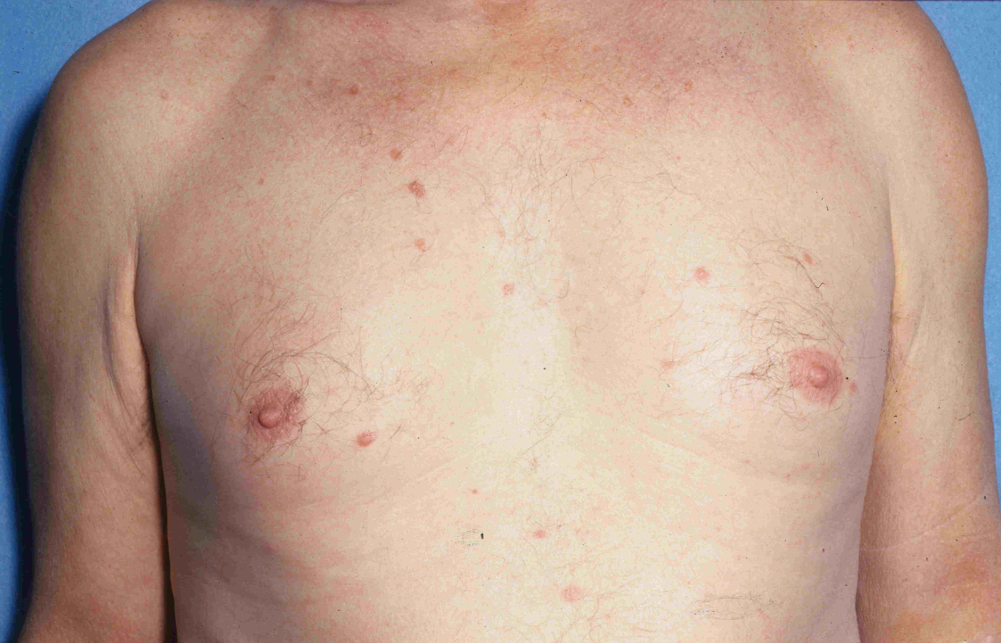
Figure 1 Patient 4 presented with a 6 mo history of persistent 2 to 8 mm papules of mycosis fungoides on the trunk and legs.

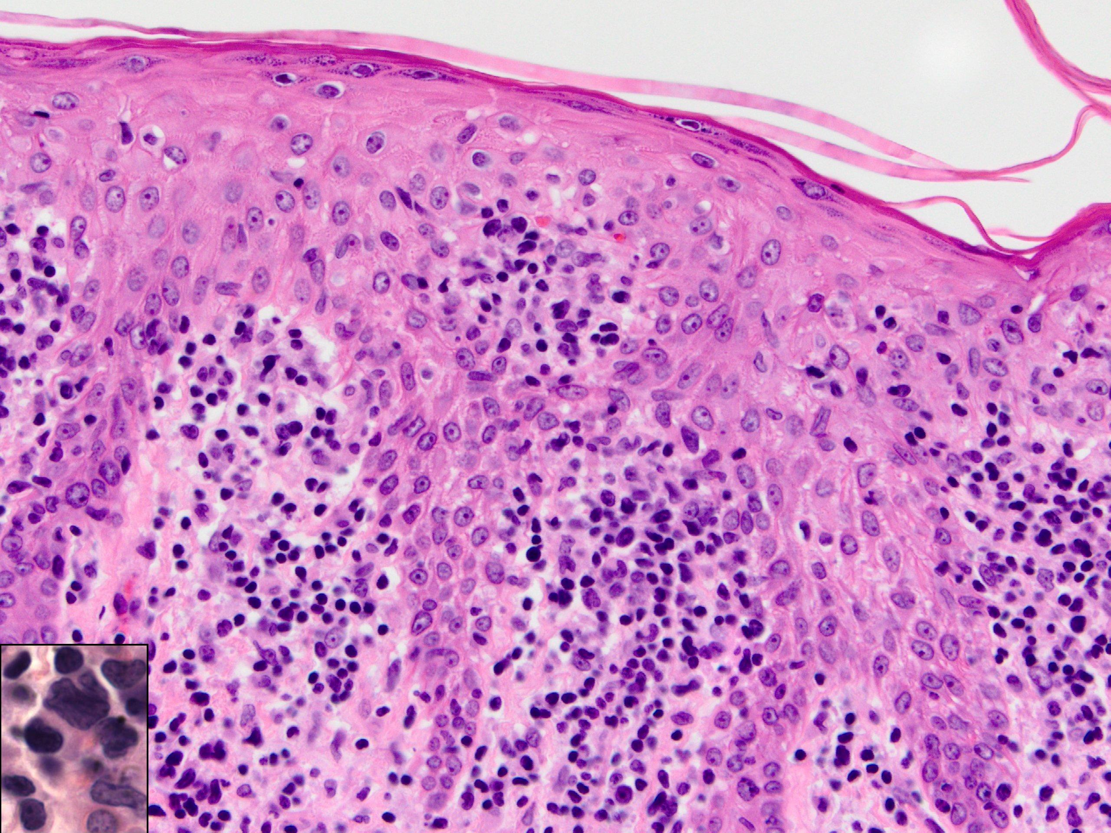
Figure 2 Skin specimen from patient 4 shows an acanthotic epidermis that contains atypical lymphocytes with hyperchromatic irregular nuclei (insert). The dermis has a superficial infiltrate composed of normal and atypical lymphocytes (H and E, × 400).

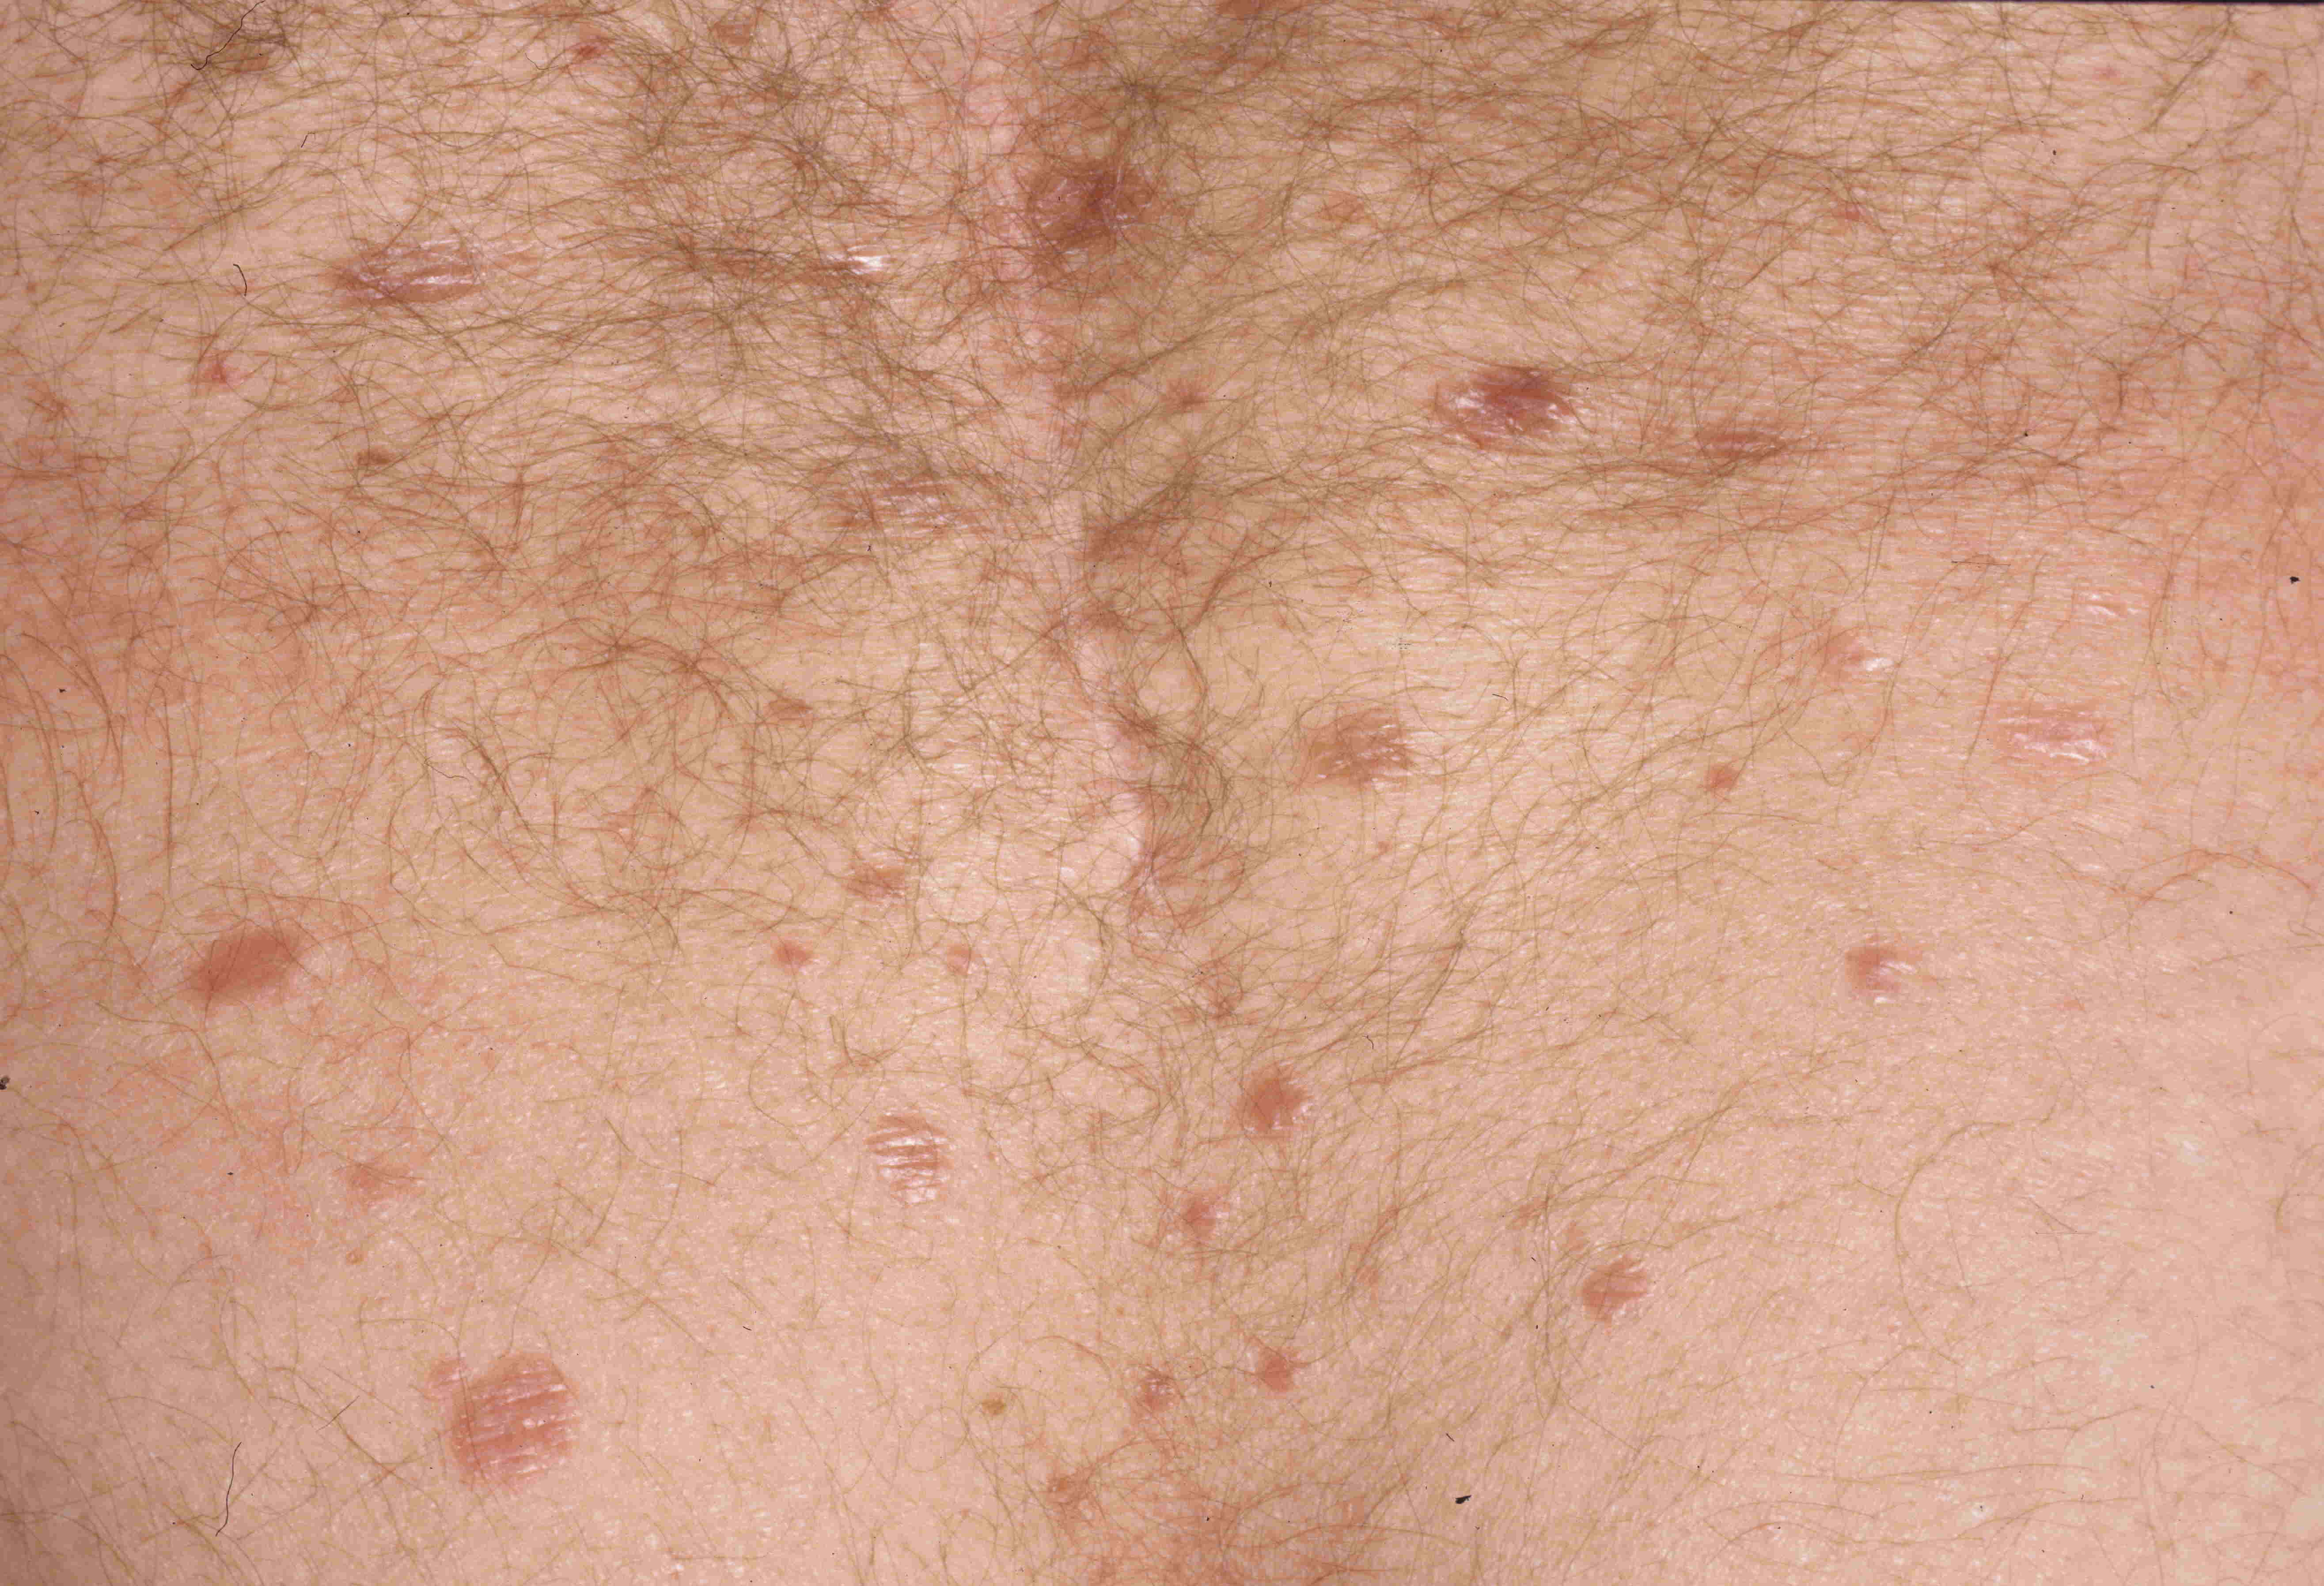
Figure 3 Persistent 2 to 14 mm papules of mycosis fungoides scattered on trunk and legs of patient 5.

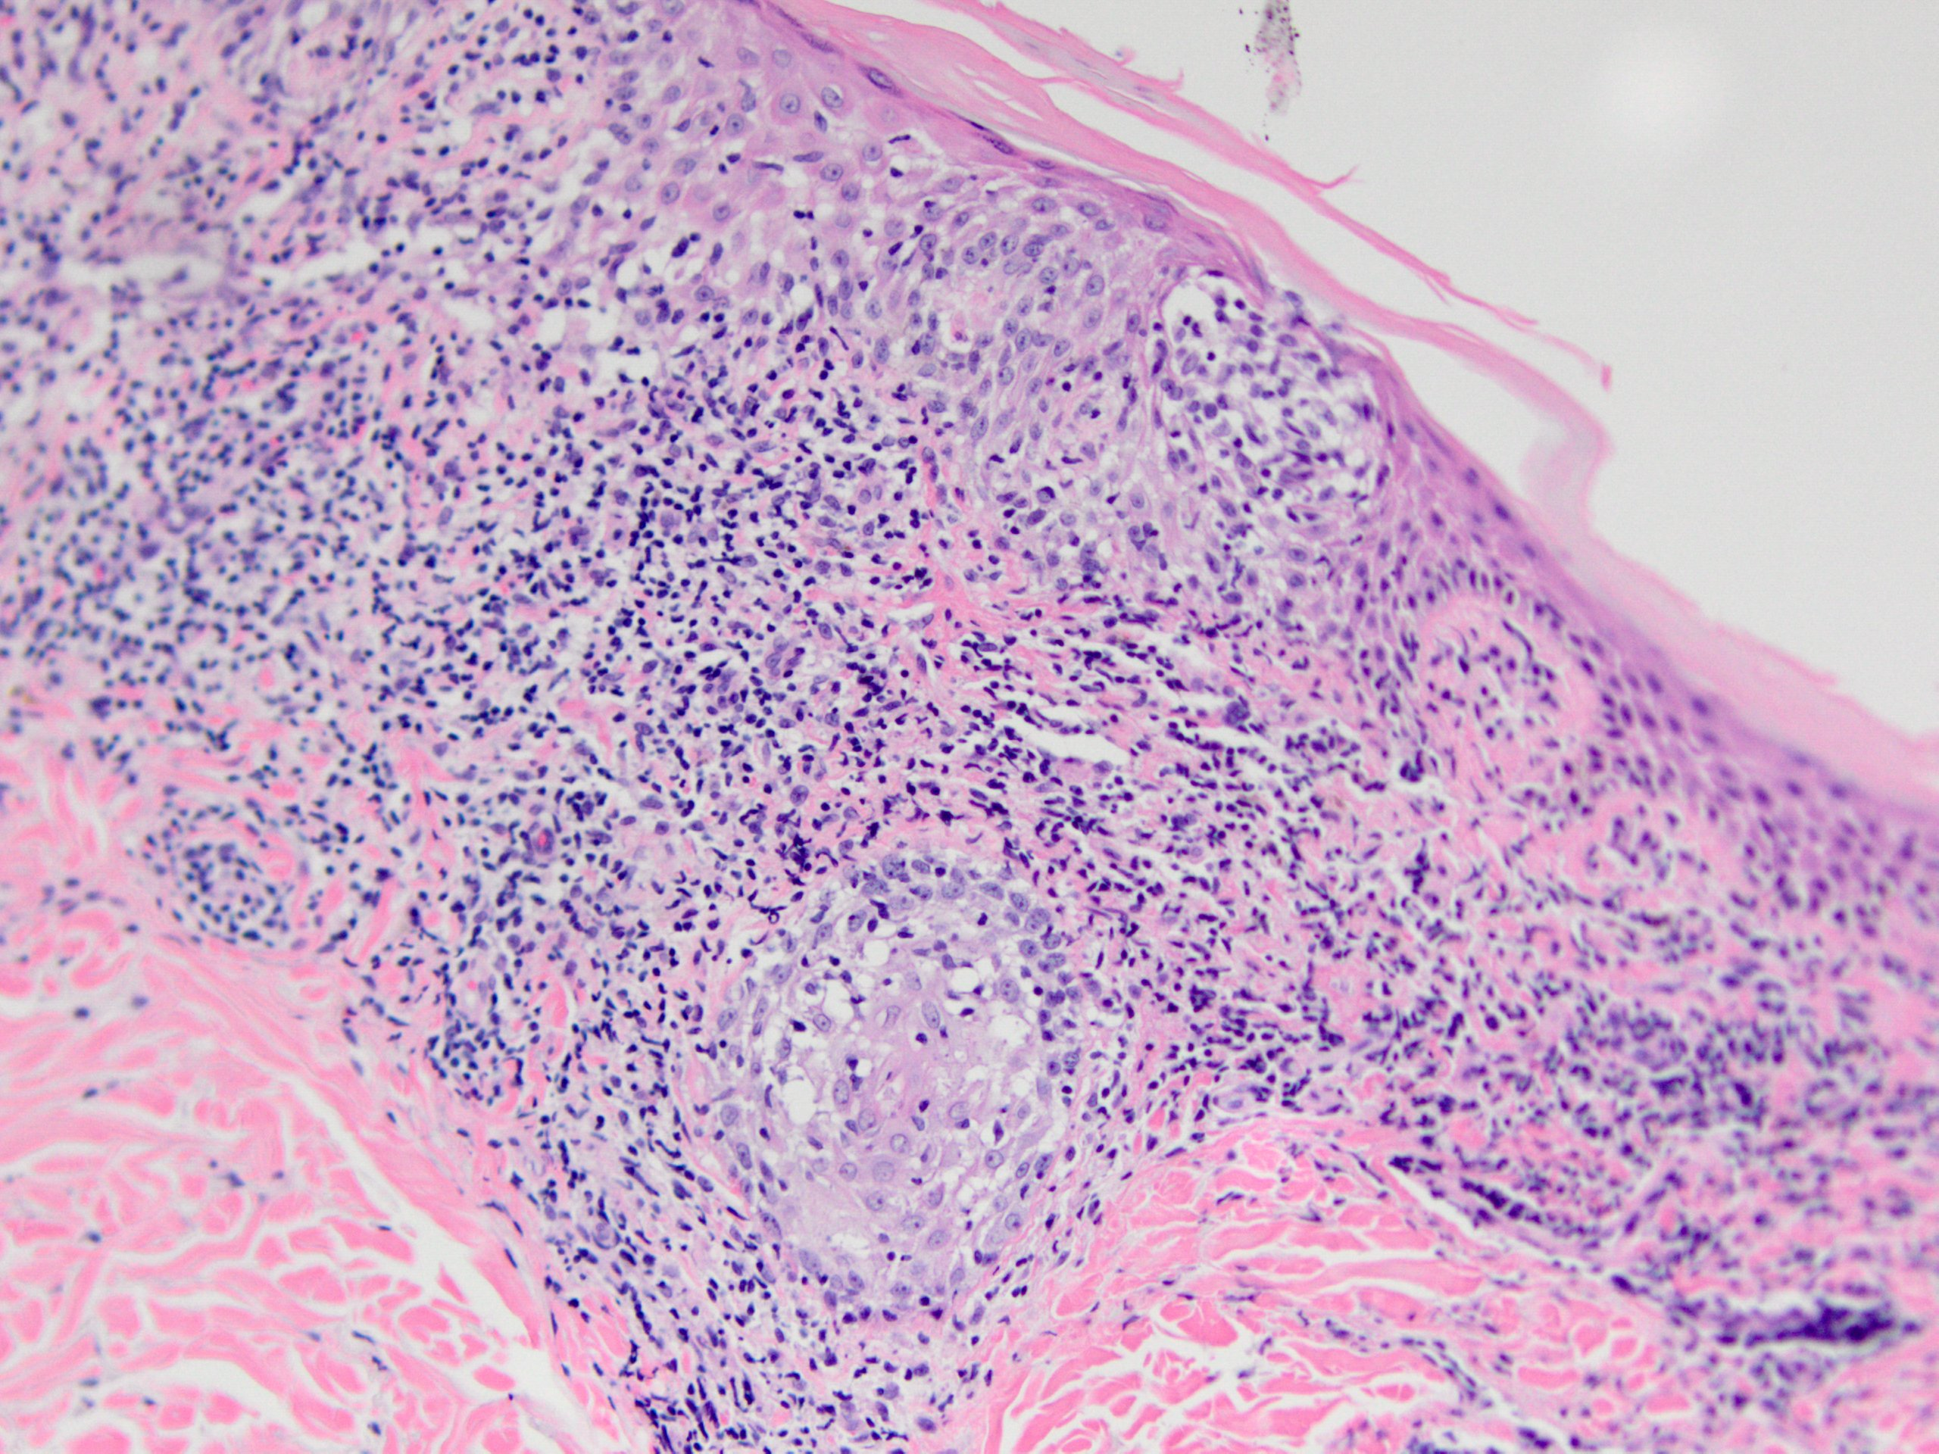
Figure 4 Skin specimen from patient 5 shows a moderately dense lichenoid infiltrate, wiry bundles of collagen in a thickened papillary dermis, and follicular mucinosis. Numerous atypical lymphocytes, some with large irregular nuclei, are located within the epidermis, both as solitary units and in aggregates, and dermal infiltrate (H and E, × 400).

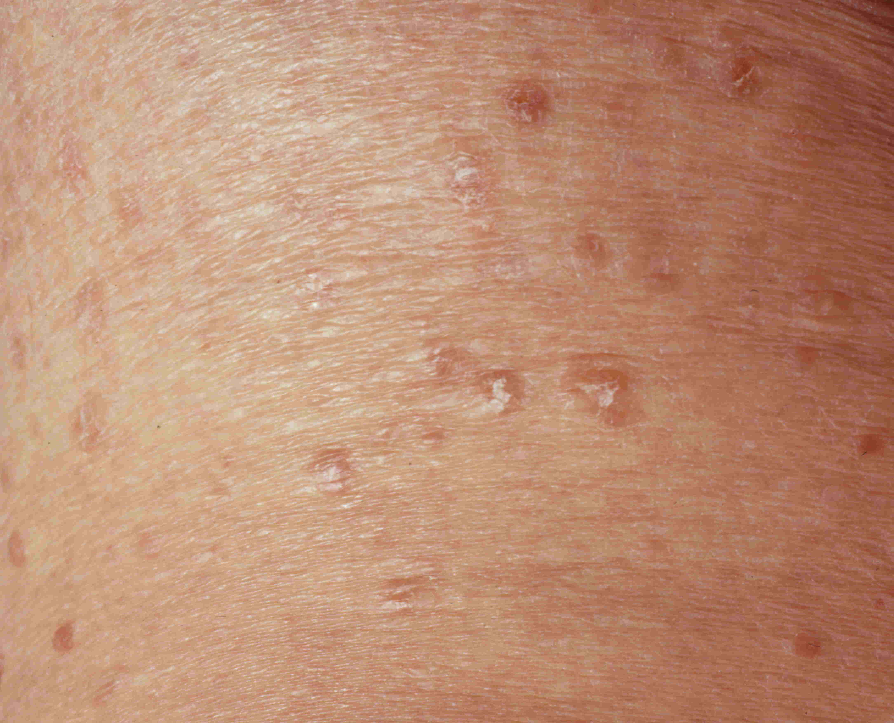
Figure 5 Patient 6 presented with a 15 mo history of persistent papules and small nodules, some with scaling, disseminated on the trunk and legs.

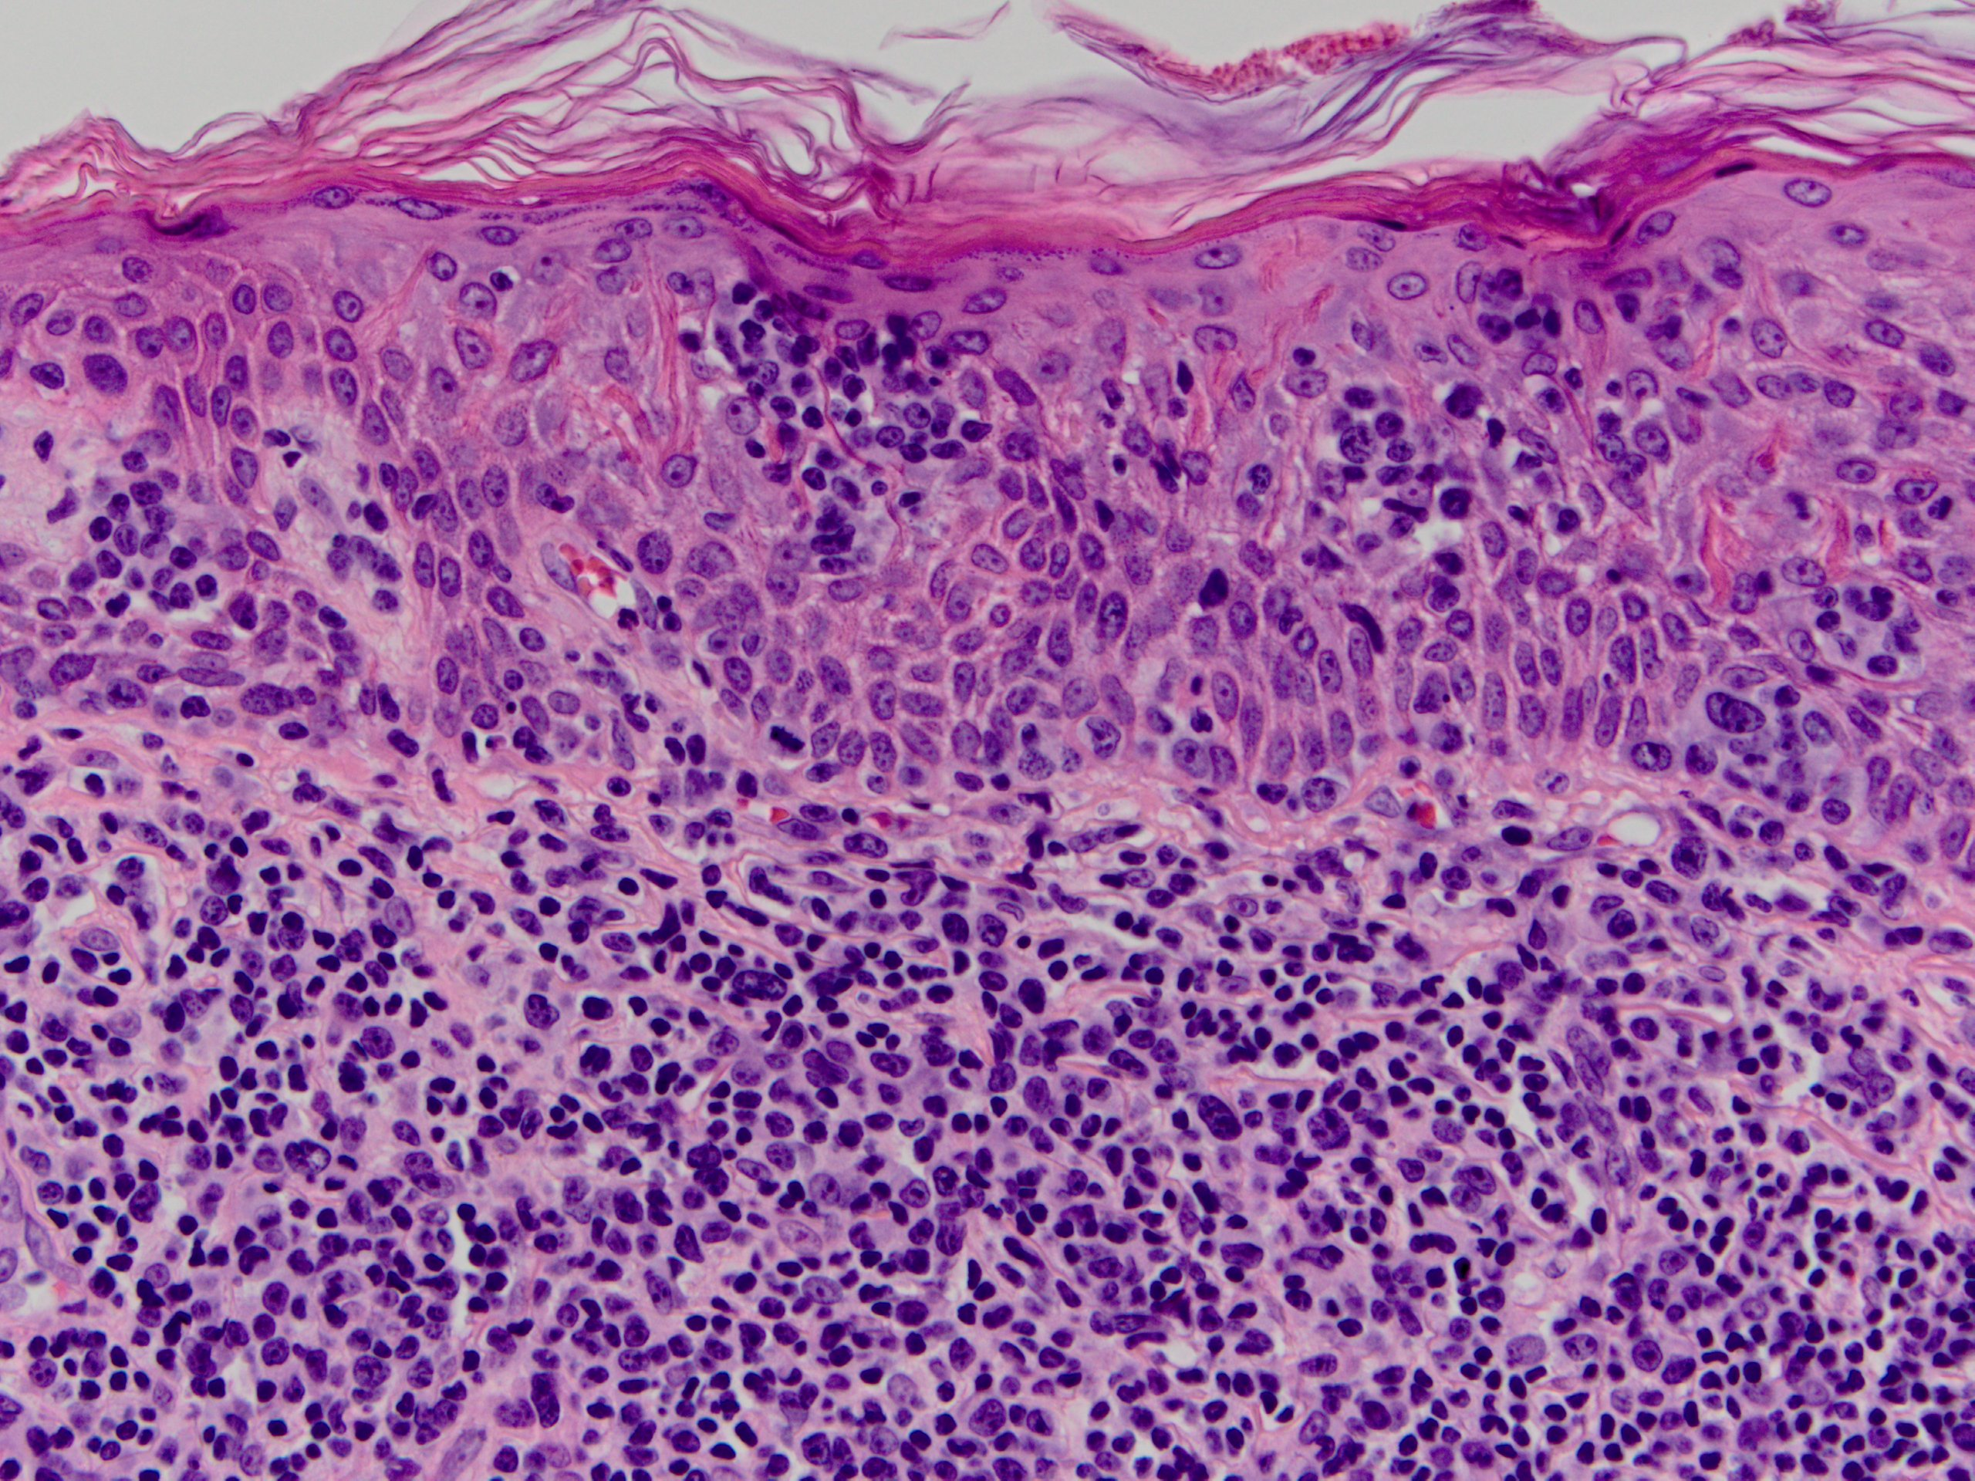
Figure 6 Skin specimen from patient 6 shows typical histopathologic features of mycosis fungoides. Nests of medium to large sized neoplastic lymphocytes with pleomorphic and cerebriform nuclei are observed within the epidermis (Pautrier microabscesses) and adjacent superficial dermis (H and E, × 400).

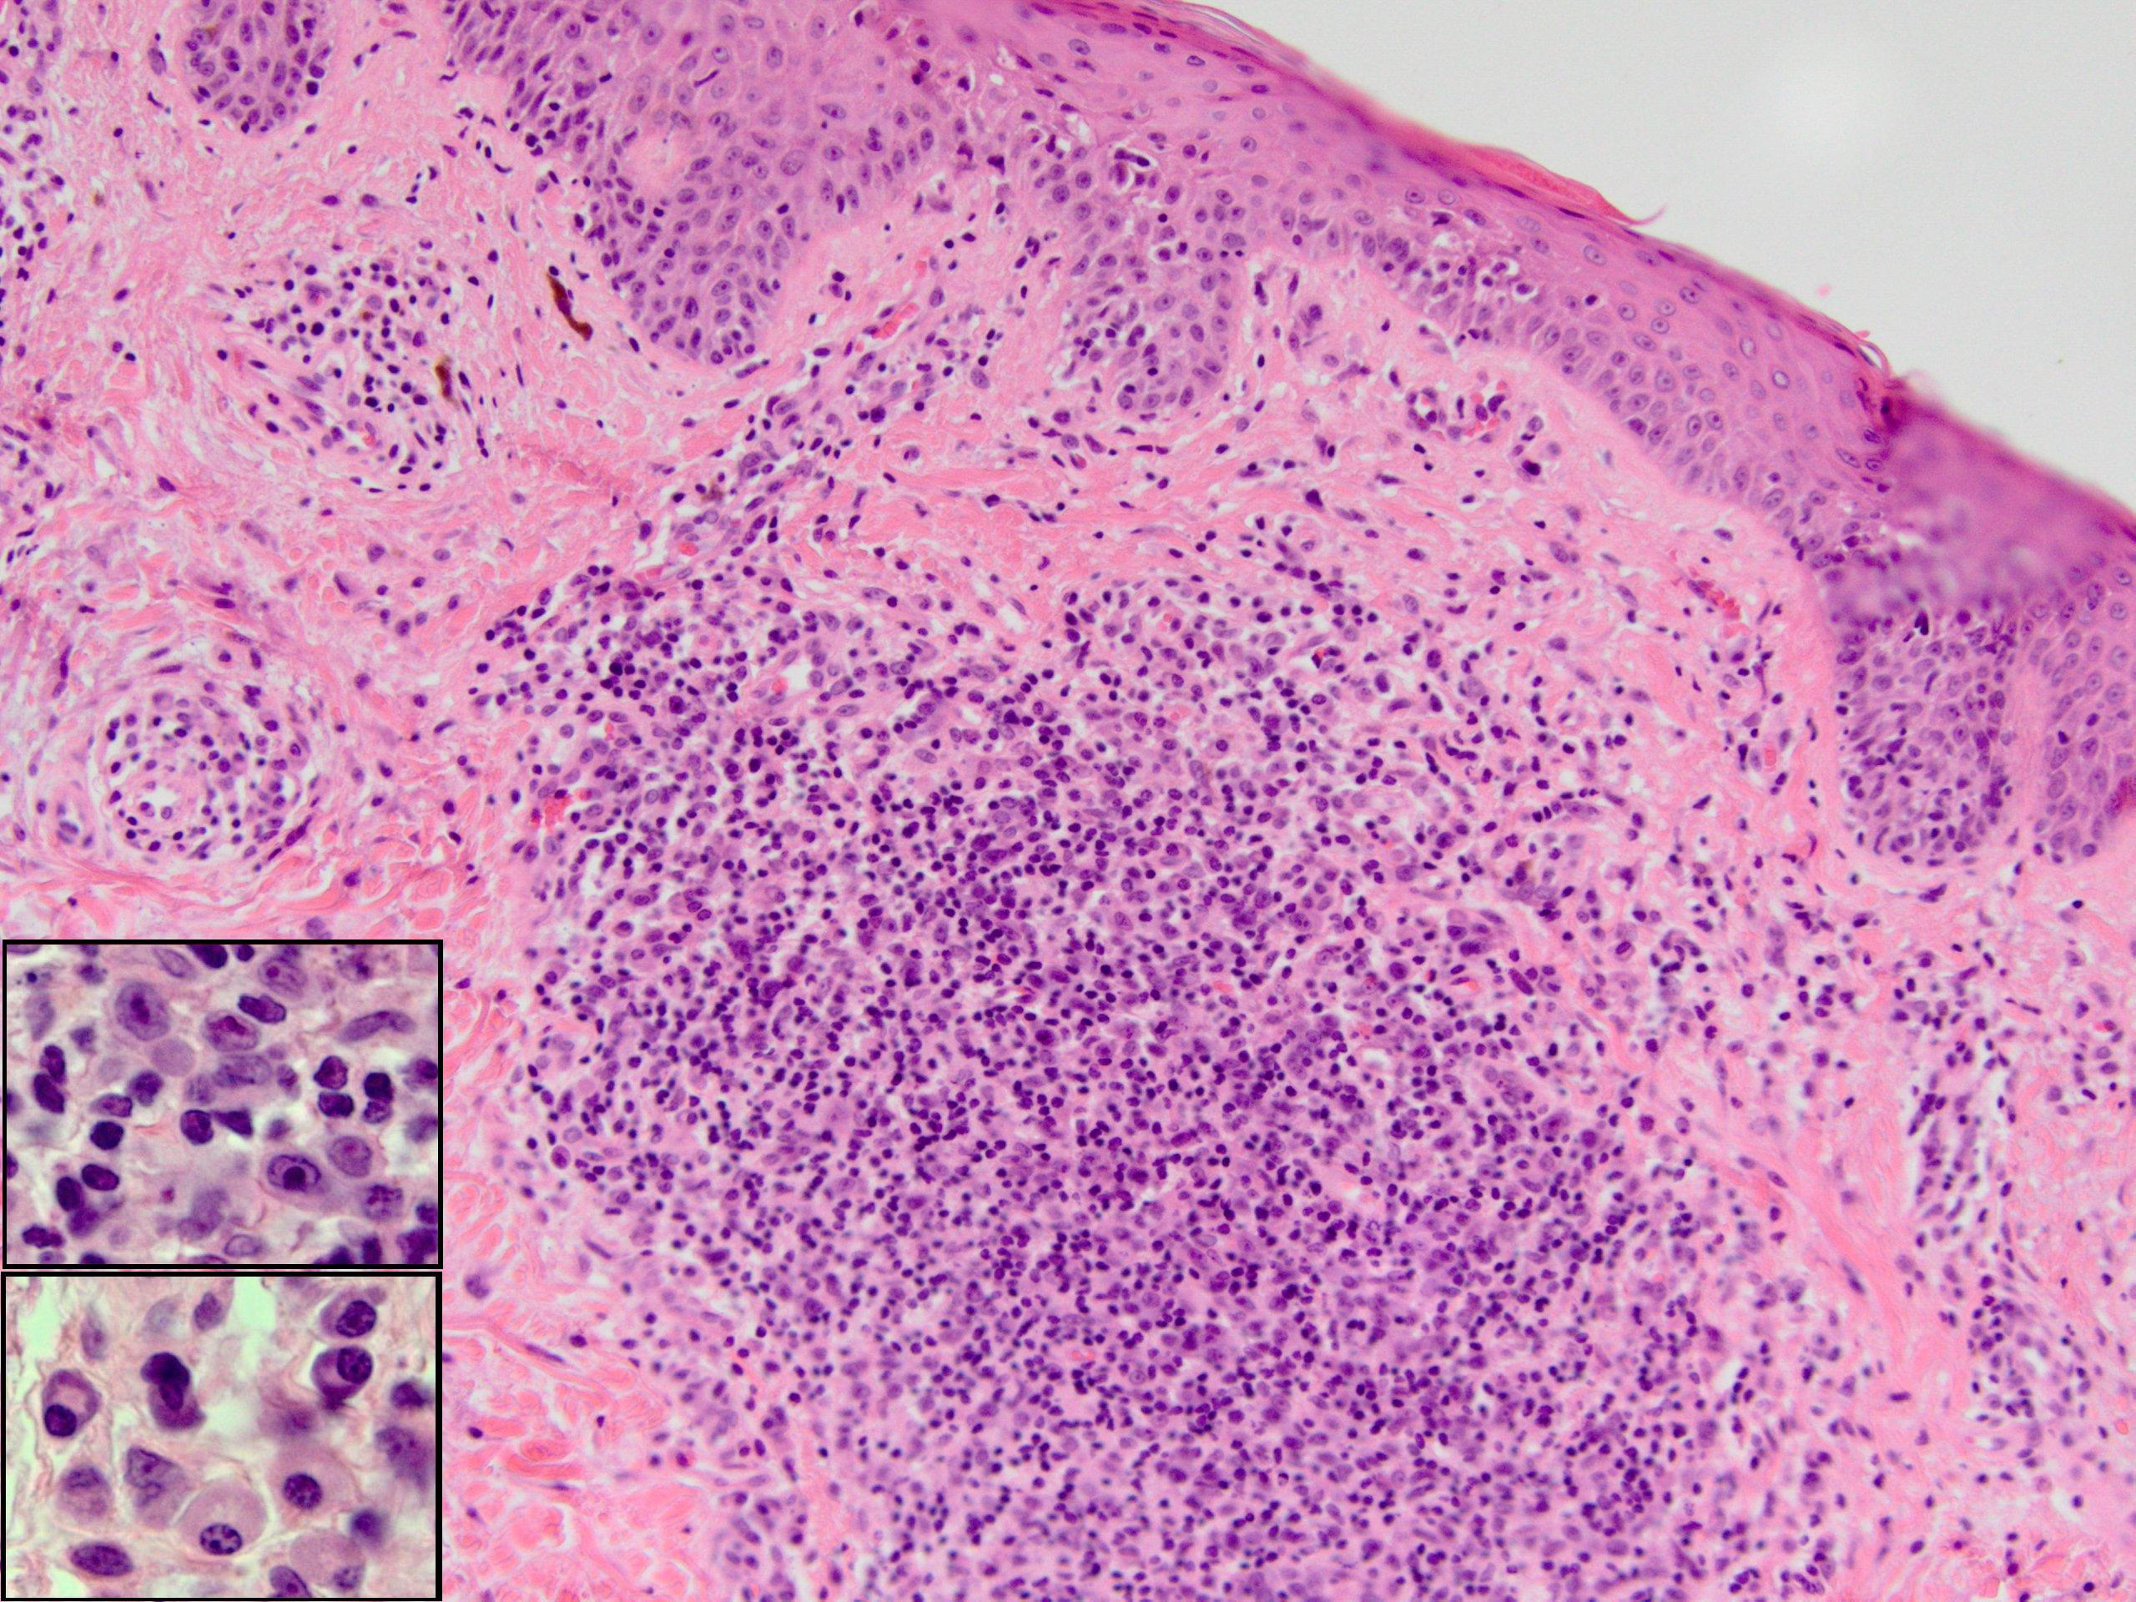
Figure 7 Skin specimen from patient 2 shows a perivascular and dense nodular infiltrate in the superficial and mid-dermis. A fibrotic papillary dermis and scattered epidermotropic lymphocytes aligned along the basal layer in the absence of spongiosis (H and E, × 400). The dermal infiltrate is composed of lymphocytes, some with large hyperchromatic cerebriform nuclei, large immunoblast-like cells (Top insert), small clusters of plasma cells (Bottom insert), and occasional eosinophils.

