Name of Journal: World Journal of Clinical Cases
Manuscript NO: 86545
Manuscript Type: CASE REPORT

Myeloid sarcoma as the only manifestation in a rare mixed lineage leukemia-fusion-driven acute myeloid leukemia: A case report

Tang SJ et al. MLL-ELL-positive MS

Sheng-Jie Tang, Qi-Guo Zhang

Sheng-Jie Tang, The First Clinical Medical College of Xuzhou Medical University, Xuzhou 221004, Jiangsu Province, China

Qi-Guo Zhang, Department of Hematology, Chuzhou Hospital affiliated to Anhui Medical University, Chuzhou 239001, Anhui Province, China

Author contributions: Tang SJ performed the study, collected the data, analyzed/interpreted the data, and drafted the article; Zhang QG supervised the study, contributed to the experimental design, and revised the paper.

Supported by Scientific Research Project of Anhui Provincial Health Commission, No. AHWJ2021b005.

Corresponding author: Qi-Guo Zhang, MD, Chief physician, Department of Hematology, Chuzhou Hospital affiliated to Anhui Medical University, No.369 Zuiwen Road, Chuzhou 239001, Anhui Province, China. qgzhang8@sina.com

Received: June 26, 2023
Revised: July 7, 2023
Accepted: August 8, 2023
Published online: September 6, 2023

Abstract
BACKGROUND
The mixed lineage leukemia (MLL)-eleven-nineteen lysine-rich leukemia (ELL) fusion gene is a rare occurrence among the various MLL fusion genes. We present the first case in which myeloid sarcoma (MS) was the only manifestation of adult MLL-ELL-positive acute myeloid leukemia (AML).

CASE SUMMARY
We report a case of a 33-year-old male patient who was admitted in June 2022 with a right occipital area mass measuring approximately 7 cm × 8 cm. Blood work was normal. The patient underwent right occipital giant subscalp mass excision and incisional flap grafting. Immunohistochemistry was positive for myeloperoxidase, CD43 and CD45 and negative for CD3, CD20, CD34, and CD56. The bone marrow aspirate showed hypercellularity with 20% myeloblasts. Flow cytometry showed that myeloblasts accounted for 27.21% of the nucleated cells, which expressed CD33, CD38, and CD117. The karyotype was 46, XY, t (11, 19) (q23; p13.1), -12, + mar/46, XY. Next-generation sequencing showed a fusion of MLL exon 7 to exon 2 of ELL. A diagnosis of MLL-ELL-positive AML (M2 subtype) with subcutaneous MS was made.

CONCLUSION
MLL-ELL-positive AML with MS is a rare clinical entity. Additional research is needed to elucidate the molecular mechanisms of the pathogenesis of MS.

Key Words: Myeloid sarcoma; Acute myeloid leukemia; Mixed lineage leukemia-eleven-nineteen lysine-rich leukemia; Transplantation; Case report

©The Author(s) 2023. Published by Baishideng Publishing Group Inc. All rights reserved.

Citation: Tang SJ, Zhang QG. Myeloid sarcoma as the only manifestation in a rare mixed lineage leukemia-fusion-driven acute myeloid leukemia: A case report. World J Clin Cases 2023; 11(25): 6000-6004
URL: https://www.wjgnet.com/2307-8960/full/v11/i25/6000.htm
DOI: https://dx.doi.org/10.12998/wjcc.v11.i25.6000

Core Tip: This study described myeloid sarcoma as the first and only manifestation in an adult patient with mixed lineage leukemia-eleven-nineteen lysine-rich leukemia-positive acute myeloid leukemia. Based on our findings and information from a few previous reports, we speculate that our patient had (1): Transformation of preleukemia cells in the marrow followed by spread to extramedullary sites; or (2) homing of preleukemia cells to extramedullary sites, followed by spreading back to bone marrow. The current study helps increase the awareness of this particular disease and reduce the clinical underdiagnosis rate.

INTRODUCTION
Myeloid sarcoma (MS) is a rare disease characterized by an extramedullary tumor composed of immature myeloid cells. When differentiating any extramedullary lesion infiltrated by heterogeneous cells, clinicians should consider the possibility of MS^{[1]}. Mixed lineage leukemia (MLL) gene rearrangements define a unique leukemia with distinctive pathophysiology and phenotype. The MLL gene encodes a large histone methyltransferase that directly binds and actively regulates gene transcription. In MLL rearrangement leukemia, menin acts as an oncogenic cofactor leading to leukemogenesis by mediating aberrant gene expression through the HOX gene and cofactor meis homeobox 1^{[2]}. A chromosomal translocation t (11; 19) (q23; P13), with breakpoints mainly located within the 19p13.1 subband, generates the MLL-eleven-nineteen lysine-rich leukemia (ELL) fusion gene and is predominantly found in acute myeloid leukemia (AML)^{[3]}. We present a rare case in which MS was the only manifestation of adult MLL-ELL-positive AML.

CASE PRESENTATION
Chief complaints
A 33-year-old male patient was admitted in June 2022 with a right occipital area mass measuring approximately 7 cm × 8 cm.

History of present illness
The patient had scalp swelling for 4 mo prior to this presentation.

History of past illness
The patient had no history of chronic conditions.

Personal and family history
The patients’ personal and family histories were not significant.

Physical examination
A hard, immobile mass measuring approximately 7 cm × 8 cm was observed in the right occipital region of the skull. The local scalp color appeared dark brown with no abnormalities in the surrounding area.

Laboratory examinations
Blood work was normal. No malignant cells were seen in the cerebrospinal fluid.

Imaging examinations
No bone erosion or abnormalities were detected in the brain parenchyma by computed tomography scan (Figure 1). The cranial magnetic resonance imaging also showed no significant abnormalities.

Further diagnostic work-up
The patient underwent right occipital giant subscalp mass excision and incisional flap grafting (Figure 2). Resection tissue staining showed a small round-cell tumor, which was suspected to be lymphoma. Immunohistochemistry was positive for myeloperoxidase, CD43 and CD45 and negative for CD3, CD20, CD34, and CD56. The bone marrow (BM) aspirate showed hypercellularity with 20% myeloblasts. Flow cytometry showed that myeloblasts accounted for 27.21% of the nucleated cells, which expressed CD33, CD38, and CD117 (Figure 3). The karyotype was 46, XY, t (11, 19) (q23; p13.1), -12, + mar^{[4]}/46, XY^{[5]}. Next-generation sequencing showed a fusion of MLL exon 12 to exon 1 of ELL.

FINAL DIAGNOSIS
A diagnosis of MLL-ELL-positive AML (M2 subtype) with subcutaneous MS was made.

TREATMENT
Complete remission (CR) was achieved after the first course of standard 7 + 3 (idarubicin and cytarabine) induction chemotherapy. He then received 2 cycles of high-dose cytarabine-based consolidation therapy followed by a myeloablative, allogeneic, matched, unrelated-donor hematopoietic stem cell transplant.

OUTCOME AND FOLLOW-UP
When last seen in May 2023, he was still in CR.

DISCUSSION
To our knowledge, we present the first case in which MS was the only manifestation of adult MLL-ELL-positive AML. The molecular mechanisms underlying extramedullary involvement remain unknown, but 70% of MS cases have concurrent AML. “extramedullary AML tumor” may be a more accurate term for MS^{[6]}.
The MLL-ELL fusion gene is a rare occurrence among the various MLL fusion genes. It is associated with the genesis of AML in a mouse model^{[7]}. MLL-ELL fusions are present in 12% of adult AML patients, 7% of pediatric AML patients and 15% of infant AML patients^{[8]}. No concurrent MLL-ELL-positive MS cases have been mentioned in the literature, although two cases of MLL-ELL-positive MS with no evidence of AML have been reported^{[9,10]}. Based on our findings and information from a few previous reports, we speculate that our patient had (1): Transformation of preleukemia cells in the marrow followed by spread to extramedullary sites; or and (2) homing of preleukemia cells to extramedullary sites, followed by spreading back to BM. This hypothesis has been proven in the development of blastic plasmacytoid dendritic cell neoplasm^{[4]}.
MLL-ELL-positive AML is associated with high response rates to conventional chemotherapy, but relapse is common, and some patients may benefit from allogeneic hematopoietic stem cell transplantation (allo-HSCT)^{[11]}. Our patient achieved BM minimal residual disease-negative CR, and concurrently, 10% hematogones^{[5]} existed in his BM, which may imply longer overall survival and a lower rate of acute graft-versus-host disease after HSCT.

CONCLUSION
In conclusion, MLL-ELL-positive AML with MS is a rare clinical entity. Additional research is needed to elucidate the molecular mechanisms of the pathogenesis of MS.

REFERENCES
1 Almond LM, Charalampakis M, Ford SJ, Gourevitch D, Desai A. Myeloid Sarcoma: Presentation, Diagnosis, and Treatment. Clin Lymphoma Myeloma Leuk 2017; 17: 263-267 [PMID: 28342811 DOI: 10.1016/j.clml.2017.02.027]
2 Krivtsov AV, Evans K, Gadrey JY, Eschle BK, Hatton C, Uckelmann HJ, Ross KN, Perner F, Olsen SN, Pritchard T, McDermott L, Jones CD, Jing D, Braytee A, Chacon D, Earley E, McKeever BM, Claremon D, Gifford AJ, Lee HJ, Teicher BA, Pimanda JE, Beck D, Perry JA, Smith MA, McGeehan GM, Lock RB, Armstrong SA. A Menin-MLL Inhibitor Induces Specific Chromatin Changes and Eradicates Disease in Models of MLL-Rearranged Leukemia. Cancer Cell 2019; 36: 660-673.e11 [PMID: 31821784 DOI: 10.1016/j.ccell.2019.11.001]
3 Panagopoulos I, Gorunova L, Kerndrup G, Spetalen S, Tierens A, Osnes LT, Andersen K, Müller LS, Hellebostad M, Zeller B, Heim S. Rare MLL-ELL fusion transcripts in childhood acute myeloid leukemia-association with young age and myeloid sarcomas? Exp Hematol Oncol 2015; 5: 8 [PMID: 26949571 DOI: 10.1186/s40164-016-0037-2]
4 Griffin GK, Booth CAG, Togami K, Chung SS, Ssozi D, Verga JA, Bouyssou JM, Lee YS, Shanmugam V, Hornick JL, LeBoeuf NR, Morgan EA, Bernstein BE, Hovestadt V, van Galen P, Lane AA. Ultraviolet radiation shapes dendritic cell leukaemia transformation in the skin. Nature 2023; 618: 834-841 [PMID: 37286599 DOI: 10.1038/s41586-023-06156-8]
5 Chantepie SP, Cornet E, Salaün V, Reman O. Hematogones: an overview. Leuk Res 2013; 37: 1404-1411 [PMID: 23932356 DOI: 10.1016/j.leukres.2013.07.024]
6 Shallis RM, Gale RP, Lazarus HM, Roberts KB, Xu ML, Seropian SE, Gore SD, Podoltsev NA. Myeloid sarcoma, chloroma, or extramedullary acute myeloid leukemia tumor: A tale of misnomers, controversy and the unresolved. Blood Rev 2021; 47: 100773 [PMID: 33213985 DOI: 10.1016/j.blre.2020.100773]
7 Lavau C, Luo RT, Du C, Thirman MJ. Retrovirus-mediated gene transfer of MLL-ELL transforms primary myeloid progenitors and causes acute myeloid leukemias in mice. Proc Natl Acad Sci U S A 2000; 97: 10984-10989 [PMID: 10995463 DOI: 10.1073/pnas.190167297]
8 Meyer C, Burmeister T, Gröger D, Tsaur G, Fechina L, Renneville A, Sutton R, Venn NC, Emerenciano M, Pombo-de-Oliveira MS, Barbieri Blunck C, Almeida Lopes B, Zuna J, Trka J, Ballerini P, Lapillonne H, De Braekeleer M, Cazzaniga G, Corral Abascal L, van der Velden VHJ, Delabesse E, Park TS, Oh SH, Silva MLM, Lund-Aho T, Juvonen V, Moore AS, Heidenreich O, Vormoor J, Zerkalenkova E, Olshanskaya Y, Bueno C, Menendez P, Teigler-Schlegel A, Zur Stadt U, Lentes J, Göhring G, Kustanovich A, Aleinikova O, Schäfer BW, Kubetzko S, Madsen HO, Gruhn B, Duarte X, Gameiro P, Lippert E, Bidet A, Cayuela JM, Clappier E, Alonso CN, Zwaan CM, van den Heuvel-Eibrink MM, Izraeli S, Trakhtenbrot L, Archer P, Hancock J, Möricke A, Alten J, Schrappe M, Stanulla M, Strehl S, Attarbaschi A, Dworzak M, Haas OA, Panzer-Grümayer R, Sedék L, Szczepański T, Caye A, Suarez L, Cavé H, Marschalek R. The MLL recombinome of acute leukemias in 2017. Leukemia 2018; 32: 273-284 [PMID: 28701730 DOI: 10.1038/leu.2017.213]
9 Ouansafi I, Arabadjief M, Mathew S, Srivastara S, Orazi A. Myeloid sarcoma with t(11;19)(q23;p13.3) (MLL-ELL) in the uterine cervix. Br J Haematol 2011; 153: 679 [PMID: 21501132 DOI: 10.1111/j.1365-2141.2010.08411.x]
10 Bao H, Gao J, Chen YH, Altman JK, Frankfurt O, Wilson AL, Sukhanova M, Chen Q, Lu X. Rare myeloid sarcoma with KMT2A (MLL)-ELL fusion presenting as a vaginal wall mass. Diagn Pathol 2019; 14: 26 [PMID: 30922345 DOI: 10.1186/s13000-019-0804-6]
11 Muto T, Takeuchi M, Yamazaki A, Sugita Y, Tsukamoto S, Sakai S, Takeda Y, Mimura N, Ohwada C, Sakaida E, Aotsuka N, Iseki T, Nakaseko C. Efficacy of myeloablative allogeneic hematopoietic stem cell transplantation in adult patients with MLL-ELL-positive acute myeloid leukemia. Int J Hematol 2015; 102: 86-92 [PMID: 25758097 DOI: 10.1007/s12185-015-1779-z]

Footnotes
Informed consent statement: Informed written consent was obtained from the patient and her parents for the publication of this report and any accompanying images.

Conflict-of-interest statement: All the authors report no relevant conflicts of interest for this article.

CARE Checklist (2016) statement: The authors have read the CARE Checklist (2016), and the manuscript was prepared and revised according to the CARE Checklist (2016).

Open-Access: This article is an open-access article that was selected by an in-house editor and fully peer-reviewed by external reviewers. It is distributed in accordance with the Creative Commons Attribution NonCommercial (CC BY-NC 4.0) license, which permits others to distribute, remix, adapt, build upon this work non-commercially, and license their derivative works on different terms, provided the original work is properly cited and the use is non-commercial. See: https://creativecommons.org/Licenses/by-nc/4.0/

Provenance and peer review: Unsolicited article; Externally peer reviewed.

Peer-review model: Single blind

Peer-review started: June 26, 2023
First decision: July 4, 2023
Article in press: August 8, 2023

Specialty type: Medicine, research and experimental
Country/Territory of origin: China
Peer-review report’s scientific quality classification
Grade A (Excellent): 0
Grade B (Very good): 0
Grade C (Good): C, C, C
Grade D (Fair): 0
Grade E (Poor): 0

P-Reviewer: Akbulut S, Turkey; Salvadori M, Italy S-Editor: Qu XL L-Editor: A P-Editor: Zhao S

Figure Legends
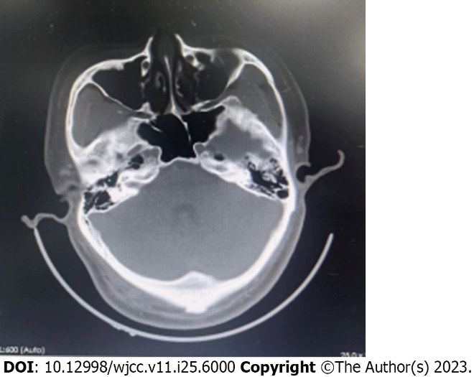
Figure 1 Head computed tomography. Anomalous density shadow of the right occipital subcutaneous region.
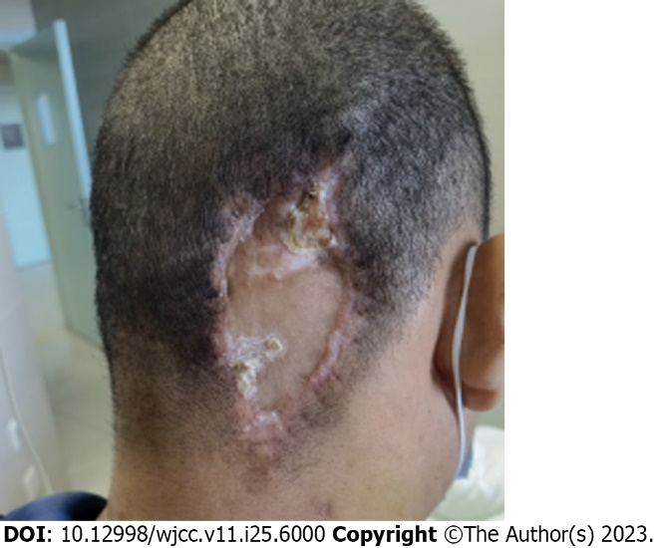
Figure 2 Skin grafting after myeloid sarcoma resection.
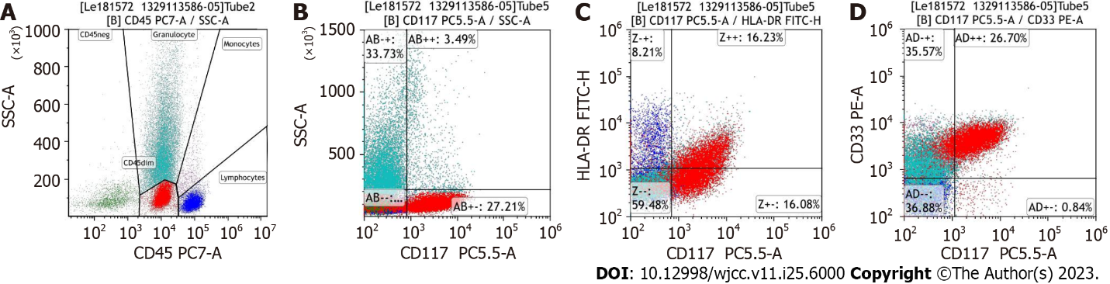
Figure 3 Flow cytometric analysis of the bone marrow aspirate. A: Expression of CD45 of all cell populations; B: Increase of CD117 positive cells was demonstrated; C: Increase of CD117/HLA-DR positive cells was demonstrated; D: Increase of CD117/CD33 positive cells was demonstrated.

Published by Baishideng Publishing Group Inc
7041 Koll Center Parkway, Suite 160, Pleasanton, CA 94566, USA
Telephone: +1-925-3991568
E-mail: bpgoffice@wjgnet.com
Help Desk: https://www.f6publishing.com/helpdesk
https://www.wjgnet.com

© 2023 Baishideng Publishing Group Inc. All rights reserved.

