Name of Journal: World Journal of Clinical Cases
Manuscript NO: 61573
Manuscript Type: CASE REPORT

Roxadustat as treatment for a blood transfusion-dependent maintenance hemodialysis patient: A case report and review of literature

Fei M et al. Renal anemia

Min Fei, Xiang-Qiong Wen, Zhao-Lan Yu, Ting Kang, Wei-Hua Wu, San-Tao Ou

Min Fei, Xiang-Qiong Wen, Zhao-Lan Yu, Ting Kang, Wei-Hua Wu, San-Tao Ou, Department of Nephrology, The Affiliated Hospital of Southwest Medical University, Luzhou 646000, Sichuan Province, China

Min Fei, Xiang-Qiong Wen, Zhao-Lan Yu, Ting Kang, Wei-Hua Wu, San-Tao Ou, Sichuan Clinical Research Center for Nephropathy, Luzhou 646000, Sichuan Province, China

Author contributions: Ou ST and Wen XQ treated the patient; Yu ZL followed up with the patient and collected the clinical data; Wu WH analyzed and interpreted the clinical data; Fei M wrote the first draft; Kang T and Fei M wrote the final draft; All authors read and approved the final manuscript.

Supported by Sichuan Clinical Research Center for Nephropathy, No. 2019YFS0537-3.

Corresponding author: San-Tao Ou, MD, PhD, Chief Doctor, Professor, Department of Nephrology, The Affiliated Hospital of Southwest Medical University, No. 25 Taiping Street, Luzhou 646000, Sichuan Province, China. ousantao@163.com

Received: December 21, 2020
Revised: January 25, 2021
Accepted: March 15, 2021
Published online:

Abstract
BACKGROUND
Erythropoiesis-stimulating agents (ESAs) have revolutionized the therapeutic strategy for anemia in chronic kidney disease. However, some cases are resistant or hyporesponsive to ESAs. Roxadustat is an oral hypoxia-inducible factor-prolyl hydroxylase inhibitor that stimulates erythropoiesis and regulates iron metabolism. Here, we describe a hemodialysis patient with refractory anemia who did not respond to traditional treatments and depended on blood transfusion for more than 1 year. After applying Roxadustat, the patient’s anemia improved significantly.

CASE SUMMARY
A 44-year-old man was diagnosed with uremia accompanied by severe anemia with a hemoglobin (Hb) level ranging from 30-40 g/L. His anemia did not improve after sufficient dialysis or high doses of active ESAs; other causes of anemia were excluded. The patient required approximately 600-1000 mL of red blood cell suspension every 15-30 d for more than 1 year. After accepting Roxadustat therapy, the patient’s anemia symptoms improved significantly; his Hb level gradually increased to 50 g/L, and no further blood transfusions were administered. His Hb level reached 69 g/L by the 34th week. Although a Hb level of 60-70 g/L cannot be considered satisfactory, he no longer required blood transfusions and his quality of life was substantially improved. Roxadustat showed good efficacy and safety in this case.

CONCLUSION
Roxadustat represents an innovative and effective agent for the clinical treatment of renal anemia caused by multiple complex factors.

Key Words: Chronic kidney disease; Renal anemia; Erythropoiesis-stimulating agents; Erythropoiesis-stimulating agent resistance; Roxadustat; Case report

Fei M, Wen XQ, Yu ZL, Kang T, Wu WH, Ou ST. Roxadustat as treatment for a blood transfusion-dependent maintenance hemodialysis patient: A case report and review of literature. World J Clin Cases 2021; In press

Core Tip: Anemia is a common complication of chronic kidney disease, often in combination with increased morbidity and mortality. Treatment of anemia in advanced chronic kidney disease includes iron replacement and administration of erythropoiesis-stimulating agents (ESAs). However, anemia remains undertreated because of concerns of the safety of ESAs. Roxadustat is an oral hypoxia-inducible factor-prolyl hydroxylase inhibitor (HIF-PHI) that stimulates erythropoiesis and regulates iron metabolism. We present a case in which Roxadustat was used for the treatment of a blood transfusion-dependent maintenance hemodialysis patient. This case highlights that increasing HIF activity with small-molecule HIF-PHIs such as Roxadustat is an innovative therapeutic approach for anemia.
INTRODUCTION
Anemia is a common complication of chronic kidney disease (CKD) that is associated with increased rates of hospitalization, transfusion^{[1]}, death and other complications in CKD^{[2,3]}. Currently, the cornerstone treatment of renal anemia is the use of erythropoiesis-stimulating agents (ESAs) and iron supplementation. Indeed, the administration of ESAs and iron supplementation are well-established and effective therapeutic approaches for treating renal anemia. However, the use of high-dose ESAs increases the risks of cardiovascular events and death, and some cases are resistant or hyporesponsive to ESAs, partly because of inflammation or iron depletion^{[4,5]}. Roxadustat is a new oral anti-renal anemia medication that stabilizes hypoxia-inducible factor (HIF) subunits, promotes HIF activity, and induces the transcription of early-response target genes. It enhances the expression of endogenous erythropoietin (EPO), EPO receptor (EPOR), and proteins that promote iron absorption and transport^{[6,7]}, ultimately increasing hemoglobin levels, and improving iron homeostasis^{[8-12]}. HIF prolyl hydroxylase inhibitors (HIF-PHIs) effectively improve anemia in CKD populations and constitute a new therapeutic approach for anemia in CKD. Here, we describe a case of a maintenance hemodialysis (MHD) patient with refractory renal anemia who required blood transfusions for more than 1 year and then received Roxadustat therapy. Ultimately, the patient’s anemia improved significantly and he no longer needed to receive blood transfusions.

CASE PRESENTATION
Chief complaints
Tiredness and shortness of breath.

History of present illness
The patient was 44 years of age when admitted to our hospital in May 2018 complaining of feeling tired and of being short of breath. More than 1 year earlier, laboratory evaluation revealed elevated serum creatinine (SCr) (unspecified details), but there was no formal diagnosis or treatment. Four months before admission, the patient started to feel tired and short of breath after activity, accompanied by foamy urine and fatigue. There was no further diagnosis or treatment. The patient was later admitted to the hospital for worsened symptoms.

History of past illness
Past medical history included hypertension that was controlled by irbesartan and abdominal surgery because of trauma more than 10 years previously.

Personal and family history
His personal and family history were unremarkable.

Physical examination
Body temperature, blood pressure, heart rate, respiratory rate, oxygen saturation, chest examination, and abdominal examination were normal.

Laboratory evaluation
His renal function results included an SCr of 1006.1 μmol/L (reference range: 57-97 μmol/L) and a glomerular filtration rate of 5 mL/min (reference range: 90-110 mL/min). Routine blood tests showed a white blood cell count of 3.30 × 10⁹/L [reference range: (3.5-9.5) × 10⁹/L] and a hemoglobin (Hb) level of 33 g/L (reference range: 130-175 g/L). Iron metabolism indices revealed a serum ferritin (SF) level of 396.14 ng/mL (reference range: 25.00-280.00 ng/mL), a serum iron level of 12.4 μmol/L (reference range: 10.6-36.7 μmol/L), a total iron-binding capacity of 52.1 µmol/L (reference range: 50-77 µmol/L), transferrin saturation (TSAT) of 23.8%, and an intact parathyroid hormone level of 385 pg/mL (reference range: 8.70-79.60 pg/mL). The autoantibody profile, antineutrophil cytoplasmic antibody, viral hepatitis, bilirubin, Coombs’ test, and fecal occult bleeding test results were all negative.

Imaging evaluation
A color Doppler ultrasound scan detected shrinkage of both kidneys. Other imaging, including computed tomography scans of the chest and cardiac ultrasound, were normal.

FINAL DIAGNOSIS
Based on the patient’s medical history and laboratory examinations, the patient was diagnosed with stage 5 chronic kidney disease (CKD-5D) complicated by severe anemia and hypertension.

TREATMENT
After making a definitive diagnosis, approximately 2200 mL of a red blood cell suspension was administered to correct his anemia during his first admission to the hospital. At the same time, therapy consisting of subcutaneous injections of ESAs was started at an initial dose of 6000 U/time (twice a week, BIW). Regular hemodialysis was also begun (three times a week, TIW). The ESW dose was adjusted based on body weight and Hb level. The maximum dose of more than 300 U/kg per week was administered for more than 3 mo, but the patient’s anemia did not improve, with an Hb level always fluctuating between 30 and 40 g/L. No iron deficiency, obvious microinflammation, serious secondary hyperparathyroidism, or blood loss were observed. The patient received multiple blood transfusions and required approximately 600-1000 mL of red blood cell suspension every 15-30 d. At the same time, the patient received intravenous deferoxamine to reduce his iron load; the SF level fluctuated between 600 and 900 ng/mL and TSAT between 30% and 50% (Table 1). After MHD and massive blood transfusion for more than 1 year, on September 6, 2019, Roxadustat was given orally at an initial dose of 100 mg/dose (TIW); ESA therapy was simultaneously discontinued. After taking Roxadustat, the patient’s anemia improved significantly, and no further blood transfusion was performed. We adjusted the dose of Roxadustat during the course of treatment according to his Hb level, and we are currently administering the recommended maximum dose (150 mg TIW); his Hb level has increased to 69 g/L.

OUTCOME AND FOLLOW-UP
Before Roxadustat administration, his Hb level was 49 g/L (Table 1), which dropped to 46 g/L in the 2nd week after starting Roxadustat. A total of 400 mL of red blood cell suspension was infused, the Hb level increased to 62 g/L, and the patient was discharged. From the 3rd week after starting Roxadustat, the patient felt that his symptoms of weakness, fatigue, and shortness of breath were significantly relieved. His Hb level gradually increased to 50 g/L, and no more blood transfusions were performed. At the 5th week of Roxadustat treatment, the dosage was adjusted to 120 mg/time (TIW), and the patient’s anemia symptoms continued to improve. At week 12, the Hb level increased further and fluctuated between 50 and 60 g/L. His Hb level had reached 69 g/L by the 30th week, and his reticulocyte (RET) count also increased (Figure 1). The dosage was then adjusted to the maximum dose (150 mg/time, TIW). In addition, iron metabolism (Table 2) and blood lipid levels improved significantly (Figure 2), total triglycerides (TGs) gradually decreased to normal, total cholesterol (TC) and low-density lipoprotein cholesterol (LDL-C) were lower than before Roxadustat treatment, and C-reactive protein (CRP), a marker of inflammation, was also reduced. At week 16, his CRP level was significantly elevated because of concurrent respiratory infections (Figure 3). However, this coinfection did not affect the response to Roxadustat. No adverse events, such as elevated blood pressure, nausea, vomiting, peripheral edema, myalgia, rash, elevated alanine aminotransferase, or metabolic acidosis, were observed during follow-up, but hyperkalemia was occasionally observed. The patient no longer required blood transfusions, and his quality of life (QoL) was substantially improved. Currently, his Roxadustat treatment is ongoing, and although his Hb is rising slowly, the level is expected to eventually reach the target value.

DISCUSSION
Anemia is one of the hallmarks of CKD and it progresses with CKD stage, greatly influencing patient prognosis and QoL. The mechanism of anemia in patients with CKD is complicated. EPO deficiency and iron metabolism disorder play vital roles in renal anemia^{[13-15]}. In addition, chronic inflammation, infection, uremic toxins, occult blood loss, oxidative stress, hyperparathyroidism, malnutrition, and other factors may further aggravate anemia^{[16-19]}. Traditional treatment strategies for anemia in CKD include the use of ESAs, intravenous administration of iron, and blood transfusion^{[20,21]}. ESAs effectively correct renal anemia and significantly reduce the need for blood transfusion^{[22,23]}. However, approximately 5%-10% of patients have a low response or show resistance to ESAs. Iron deficiency, inadequate dialysis, inflammation, malnutrition, chronic blood loss, secondary hyperparathyroidism, aluminum toxicity, and hypersplenism may be important reasons for resistance to ESAs^{[24]}. Despite the efficacy of ESAs for treating anemia, high doses may increase the risk of vascular thrombosis, myocardial infarction, heart failure, tumor progression or recurrence, and mortality^{[25]}. Therefore, the current treatments of renal anemia have some limitations.
The patient in this case was diagnosed with CKD-5D accompanied by severe anemia. However, his anemia did not improve with sufficient dialysis and high doses of active ESAs. After excluding autoimmune diseases such as systemic lupus erythematosus, vasculitis, cancer, and hemolytic anemia, ESA resistance was considered to be responsible for his refractory anemia; bone marrow diseases could not be completely excluded. The patient needed massive blood transfusions, yet there is evidence that long-term, massive blood transfusion therapy may lead to secondary iron overload, liver cirrhosis, cardiomyopathy, eventual damage to multiple organs, and even death^{[26]}.
Roxadustat (FG-4592) is an HIF-PHI that stabilizes HIF-α subunits, resulting in increased HIF transcriptional activity. This leads to functional activation of early-response target genes encoding proteins such as EPO, EPOR, enzymes of heme biosynthesis, and proteins that promote iron absorption and transport, resulting in coordinated erythropoiesis^{[12,27-30]}. Clinical trials have demonstrated that successful anemia management can be achieved with Roxadustat in both dialysis-dependent and nondialysis-dependent-CKD patients^{[29,30]}. In addition, a phase 3, randomized, double-blind study in Japan reported that Roxadustat maintained target hemoglobin in patients undergoing hemodialysis and that it was noninferior to darbepoetin alfa^{[31]}. Compared with traditional ESAs, Roxadustat is well tolerated, with fewer adverse events^{[8-11]}. In this case, the patient’s Hb level and RET count simultaneously increased after Roxadustat therapy, and although his Hb level did not reach the target value, his anemia symptoms were significantly improved. Moreover, he no longer required blood transfusions, thus avoiding iron overload as well as the economic burden of the procedure; his iron metabolism improved as well. A poor response to ESAs has been associated with inflammation^{[32,33]}, and inflammation is known to increase levels of hepcidin, resulting in functional iron deficiency. HIF promotes expression of adenosine receptor genes, with anti-inflammatory effects^{[34-36]}. In this case, the patient’s inflammation improved significantly, and coinfection did not affect his Hb response to Roxadustat, which is consistent with previous clinical research^{[29,30]}. Moreover, Roxadustat reduced nonfasting TC levels compared with rhEPO^{[12,29,30]}, which might be partly mediated by HIF-dependent effects on acetyl coenzyme A, with a vital role in the first step of cholesterol synthesis^{[37]}. Downregulation of 3-hydroxy-3-methyl glutaryl coenzyme A reductase, which is required for cholesterol synthesis, may also be involved^{[38,39]}. Chen et al^{[30]} found that TC levels decreased by 23% with Roxadustat therapy, with levels of TGs, LDL-C and high-density lipoprotein cholesterol (HDL-C) decreasing. In our case, the patient’s TG level decreased to normal, and his TC, HDL-C, and LDL-C levels were lower than before treatment, which is consistent with previous studies. In other studies, hypertension, acute pancreatitis, hyperkalemia, metabolic acidosis and diarrhea were found to be possibly related to Roxadustat treatment. Nevertheless, a phase III trial in Chinese dialysis patients previously treated with ESAs did not raise significant safety concerns^{[29,30]}. In our case, no obvious adverse events were observed. Del Vecchio and Locatelli^{[40]} reported dose-dependent effects of Roxadustat on erythropoiesis and iron metabolism in American dialysis patients. We adjusted the dose of Roxadustat according to the patient’s Hb level, and we are currently administering the recommended maximum dose of 2.5 mg/kg (150 mg TIW); his Hb level has increased to 69 g/L. The patient is being followed to assess further effects, but eliminating the need for blood transfusion represents the first step to successful treatment.

CONCLUSION
Roxadustat is a new drug that can effectively improve renal anemia through a new mechanism involving multiple pathways, and more than 80% of patients treated with Roxadustat achieve normal levels of blood indices^{[29,30]}. Therefore, Roxadustat constitutes a new, effective method for the clinical treatment of renal anemia in CKD.

REFERENCES
1 Seliger S, Fox KM, Gandra SR, Bradbury B, Hsu VD, Walker L, Chiou CF, Fink JC. Timing of erythropoiesis-stimulating agent initiation and adverse outcomes in nondialysis CKD: a propensity-matched observational study. Clin J Am Soc Nephrol 2010; 5: 882-888 [PMID: 20299377 DOI: 10.2215/CJN.07171009]
2 Levin A. The treatment of anemia in chronic kidney disease: understandings in 2006. Curr Opin Nephrol Hypertens 2007; 16: 267-271 [PMID: 17420672 DOI: 10.1097/MNH.0b013e32805b7257]
3 Hörl WH. Anaemia management and mortality risk in chronic kidney disease. Nat Rev Nephrol 2013; 9: 291-301 [PMID: 23438972 DOI: 10.1038/nrneph.2013.21]
4 Vlagopoulos PT, Tighiouart H, Weiner DE, Griffith J, Pettitt D, Salem DN, Levey AS, Sarnak MJ. Anemia as a risk factor for cardiovascular disease and all-cause mortality in diabetes: the impact of chronic kidney disease. J Am Soc Nephrol 2005; 16: 3403-3410 [PMID: 16162813 DOI: 10.1681/ASN.2005030226]
5 KDOQI.; National Kidney Foundation. KDOQI Clinical Practice Guidelines and Clinical Practice Recommendations for Anemia in Chronic Kidney Disease. Am J Kidney Dis 2006; 47: S11-145 [PMID: 16678659 DOI: 10.1053/j.ajkd.2006.03.010]
6 Fan C, Iacobas DA, Zhou D, Chen Q, Lai JK, Gavrialov O, Haddad GG. Gene expression and phenotypic characterization of mouse heart after chronic constant or intermittent hypoxia. Physiol Genomics 2005; 22: 292-307 [PMID: 15928208 DOI: 10.1152/physiolgenomics.00217.2004]
7 Peyssonnaux C, Nizet V, Johnson RS. Role of the hypoxia inducible factors HIF in iron metabolism. Cell Cycle 2008; 7: 28-32 [PMID: 18212530 DOI: 10.4161/cc.7.1.5145]
8 Besarab A, Provenzano R, Hertel J, Zabaneh R, Klaus SJ, Lee T, Leong R, Hemmerich S, Yu KH, Neff TB. Randomized placebo-controlled dose-ranging and pharmacodynamics study of roxadustat (FG-4592) to treat anemia in nondialysis-dependent chronic kidney disease (NDD-CKD) patients. Nephrol Dial Transplant 2015; 30: 1665-1673 [PMID: 26238121 DOI: 10.1093/ndt/gfv302]
9 Besarab A, Chernyavskaya E, Motylev I, Shutov E, Kumbar LM, Gurevich K, Chan DT, Leong R, Poole L, Zhong M, Saikali KG, Franco M, Hemmerich S, Yu KH, Neff TB. Roxadustat (FG-4592): Correction of Anemia in Incident Dialysis Patients. J Am Soc Nephrol 2016; 27: 1225-1233 [PMID: 26494833 DOI: 10.1681/ASN.2015030241]
10 Provenzano R, Besarab A, Sun CH, Diamond SA, Durham JH, Cangiano JL, Aiello JR, Novak JE, Lee T, Leong R, Roberts BK, Saikali KG, Hemmerich S, Szczech LA, Yu KH, Neff TB. Oral Hypoxia-Inducible Factor Prolyl Hydroxylase Inhibitor Roxadustat (FG-4592) for the Treatment of Anemia in Patients with CKD. Clin J Am Soc Nephrol 2016; 11: 982-991 [PMID: 27094610 DOI: 10.2215/CJN.06890615]
11 Provenzano R, Besarab A, Wright S, Dua S, Zeig S, Nguyen P, Poole L, Saikali KG, Saha G, Hemmerich S, Szczech L, Yu KH, Neff TB. Roxadustat (FG-4592) Versus Epoetin Alfa for Anemia in Patients Receiving Maintenance Hemodialysis: A Phase 2, Randomized, 6- to 19-Week, Open-Label, Active-Comparator, Dose-Ranging, Safety and Exploratory Efficacy Study. Am J Kidney Dis 2016; 67: 912-924 [PMID: 26846333 DOI: 10.1053/j.ajkd.2015.12.020]
12 Chen N, Qian J, Chen J, Yu X, Mei C, Hao C, Jiang G, Lin H, Zhang X, Zuo L, He Q, Fu P, Li X, Ni D, Hemmerich S, Liu C, Szczech L, Besarab A, Neff TB, Peony Yu KH, Valone FH. Phase 2 studies of oral hypoxia-inducible factor prolyl hydroxylase inhibitor FG-4592 for treatment of anemia in China. Nephrol Dial Transplant 2017; 32: 1373-1386 [PMID: 28371815 DOI: 10.1093/ndt/gfx011]
13 van Nooten FE, Green J, Brown R, Finkelstein FO, Wish J. Burden of illness for patients with non-dialysis chronic kidney disease and anemia in the United States: review of the literature. J Med Econ 2010; 13: 241-256 [PMID: 20438399 DOI: 10.3111/13696998.2010.484307]
14 Babitt JL, Lin HY. Mechanisms of anemia in CKD. J Am Soc Nephrol 2012; 23: 1631-1634 [PMID: 22935483 DOI: 10.1681/ASN.2011111078]
15 Kali A, Charles MV, Seetharam RS. Hepcidin - A novel biomarker with changing trends. Pharmacogn Rev 2015; 9: 35-40 [PMID: 26009691 DOI: 10.4103/0973-7847.156333]
16 Verdalles U, Abad S, Vega A, Ruiz Caro C, Ampuero J, Jofre R, Lopez-Gomez JM. Factors related to the absence of anemia in hemodialysis patients. Blood Purif 2011; 32: 69-74 [PMID: 21346339 DOI: 10.1159/000323095]
17 Macdougall IC. Role of uremic toxins in exacerbating anemia in renal failure. Kidney Int Suppl 2001; 78: S67-S72 [PMID: 11168986 DOI: 10.1046/j.1523-1755.2001.59780067.x]
18 Wu CJ, Chen CY, Lai TS, Wu PC, Chuang CK, Sun FJ, Liu HL, Chen HH, Yeh HI, Lin CS, Lin CJ. The role of indoxyl sulfate in renal anemia in patients with chronic kidney disease. Oncotarget 2017; 8: 83030-83037 [PMID: 29137321 DOI: 10.18632/oncotarget.18789]
19 Tanaka M, Komaba H, Fukagawa M. Emerging Association Between Parathyroid Hormone and Anemia in Hemodialysis Patients. Ther Apher Dial 2018; 22: 242-245 [PMID: 29767854 DOI: 10.1111/1744-9987.12685]
20 Fuller DS, Robinson BM, Locatelli F, Pisoni RL. Patterns of Erythropoiesis-Stimulating Agent Use in European Hemodialysis Patients: The Dialysis Outcomes and Practice Patterns Study. Nephron 2018; 140: 24-30 [PMID: 29945128 DOI: 10.1159/000490202]
21 Azmandian J, Abbasi MR, Pourfarziani V, Nasiri AA, Ossareh S, Ezzatzadegan Jahromi S, Sanadgol H, Amini S, Shahvaroughi Farahani A. Comparing Therapeutic Efficacy and Safety of Epoetin Beta and Epoetin Alfa in the Treatment of Anemia in End-Stage Renal Disease Hemodialysis Patients. Am J Nephrol 2018; 48: 251-259 [PMID: 30253403 DOI: 10.1159/000493097]
22 Eschbach JW, Abdulhadi MH, Browne JK, Delano BG, Downing MR, Egrie JC, Evans RW, Friedman EA, Graber SE, Haley NR. Recombinant human erythropoietin in anemic patients with end-stage renal disease. Results of a phase III multicenter clinical trial. Ann Intern Med 1989; 111: 992-1000 [PMID: 2688507 DOI: 10.7326/0003-4819-111-12-992]
23 Möcks J. Cardiovascular mortality in haemodialysis patients treated with epoetin beta - a retrospective study. Nephron 2000; 86: 455-462 [PMID: 11124594 DOI: 10.1159/000045834]
24 Kubasch AS, Platzbecker U. Setting Fire to ESA and EMA Resistance: New Targeted Treatment Options in Lower Risk Myelodysplastic Syndromes. Int J Mol Sci 2019; 20 [PMID: 31394818 DOI: 10.3390/ijms20163853]
25 Bennett CL, Becker PS, Kraut EH, Samaras AT, West DP. Intersecting guidelines: administering erythropoiesis-stimulating agents to chronic kidney disease patients with cancer. Semin Dial 2009; 22: 1-4 [PMID: 19175532 DOI: 10.1111/j.1525-139X.2008.00524.x]
26 Adler M, Herrera-Gómez F, Martín-García D, Gavid M, Álvarez FJ, Ochoa-Sangrador C. The Impact of Iron Supplementation for Treating Anemia in Patients with Chronic Kidney Disease: Results from Pairwise and Network Meta-Analyses of Randomized Controlled Trials. Pharmaceuticals (Basel) 2020; 13 [PMID: 32365757 DOI: 10.3390/ph13050085]
27 Becker K, Saad M. A New Approach to the Management of Anemia in CKD Patients: A Review on Roxadustat. Adv Ther 2017; 34: 848-853 [PMID: 28290095 DOI: 10.1007/s12325-017-0508-9]
28 Gupta N, Wish JB. Hypoxia-Inducible Factor Prolyl Hydroxylase Inhibitors: A Potential New Treatment for Anemia in Patients With CKD. Am J Kidney Dis 2017; 69: 815-826 [PMID: 28242135 DOI: 10.1053/j.ajkd.2016.12.011]
29 Chen N, Hao C, Liu BC, Lin H, Wang C, Xing C, Liang X, Jiang G, Liu Z, Li X, Zuo L, Luo L, Wang J, Zhao MH, Liu Z, Cai GY, Hao L, Leong R, Wang C, Liu C, Neff T, Szczech L, Yu KP. Roxadustat Treatment for Anemia in Patients Undergoing Long-Term Dialysis. N Engl J Med 2019; 381: 1011-1022 [PMID: 31340116 DOI: 10.1056/NEJMoa1901713]
30 Chen N, Hao C, Peng X, Lin H, Yin A, Hao L, Tao Y, Liang X, Liu Z, Xing C, Chen J, Luo L, Zuo L, Liao Y, Liu BC, Leong R, Wang C, Liu C, Neff T, Szczech L, Yu KP. Roxadustat for Anemia in Patients with Kidney Disease Not Receiving Dialysis. N Engl J Med 2019; 381: 1001-1010 [PMID: 31340089 DOI: 10.1056/NEJMoa1813599]
31 Akizawa T, Iwasaki M, Yamaguchi Y, Majikawa Y, Reusch M. Phase 3, Randomized, Double-Blind, Active-Comparator (Darbepoetin Alfa) Study of Oral Roxadustat in CKD Patients with Anemia on Hemodialysis in Japan. J Am Soc Nephrol 2020; 31: 1628-1639 [PMID: 32493693 DOI: 10.1681/ASN.2019060623]
32 Gomes AC, Gomes MS. Hematopoietic niches, erythropoiesis and anemia of chronic infection. Exp Hematol 2016; 44: 85-91 [PMID: 26615156 DOI: 10.1016/j.exphem.2015.11.007]
33 Bradbury BD, Critchlow CW, Weir MR, Stewart R, Krishnan M, Hakim RH. Impact of elevated C-reactive protein levels on erythropoiesis- stimulating agent (ESA) dose and responsiveness in hemodialysis patients. Nephrol Dial Transplant 2009; 24: 919-925 [PMID: 18840893 DOI: 10.1093/ndt/gfn543]
34 Bartels K, Grenz A, Eltzschig HK. Hypoxia and inflammation are two sides of the same coin. Proc Natl Acad Sci U S A 2013; 110: 18351-18352 [PMID: 24187149 DOI: 10.1073/pnas.1318345110]
35 Bowser JL, Lee JW, Yuan X, Eltzschig HK. The hypoxia-adenosine link during inflammation. J Appl Physiol (1985) 2017; 123: 1303-1320 [PMID: 28798196 DOI: 10.1152/japplphysiol.00101.2017]
36 Eltzschig HK, Carmeliet P. Hypoxia and inflammation. N Engl J Med 2011; 364: 656-665 [PMID: 21323543 DOI: 10.1056/NEJMra0910283]
37 Kim JW, Tchernyshyov I, Semenza GL, Dang CV. HIF-1-mediated expression of pyruvate dehydrogenase kinase: a metabolic switch required for cellular adaptation to hypoxia. Cell Metab 2006; 3: 177-185 [PMID: 16517405 DOI: 10.1016/j.cmet.2006.02.002]
38 Nguyen AD, McDonald JG, Bruick RK, DeBose-Boyd RA. Hypoxia stimulates degradation of 3-hydroxy-3-methylglutaryl-coenzyme A reductase through accumulation of lanosterol and hypoxia-inducible factor-mediated induction of insigs. J Biol Chem 2007; 282: 27436-27446 [PMID: 17635920 DOI: 10.1074/jbc.M704976200]
39 Hwang S, Nguyen AD, Jo Y, Engelking LJ, Brugarolas J, DeBose-Boyd RA. Hypoxia-inducible factor 1α activates insulin-induced gene 2 (Insig-2) transcription for degradation of 3-hydroxy-3-methylglutaryl (HMG)-CoA reductase in the liver. J Biol Chem 2017; 292: 9382-9393 [PMID: 28416613 DOI: 10.1074/jbc.M117.788562]
40 Del Vecchio L, Locatelli F. Roxadustat in the treatment of anaemia in chronic kidney disease. Expert Opin Investig Drugs 2018; 27: 125-133 [PMID: 29254377 DOI: 10.1080/13543784.2018.1417386]

Footnotes
Informed consent statement: Informed written consent was obtained from the patient for publication of this report and any accompanying images.

Conflict-of-interest statement: The authors declare that they have no conflicts of interest.

CARE Checklist (2016) statement: The authors have read the CARE Checklist (2016), and the manuscript was prepared and revised according to the CARE Checklist (2016).

Open-Access: This article is an open-access article that was selected by an in-house editor and fully peer-reviewed by external reviewers. It is distributed in accordance with the Creative Commons Attribution NonCommercial (CC BY-NC 4.0) license, which permits others to distribute, remix, adapt, build upon this work non-commercially, and license their derivative works on different terms, provided the original work is properly cited and the use is non-commercial. See: http://creativecommons.org/Licenses/by-nc/4.0/

Manuscript source: Unsolicited manuscript

Peer-review started: December 21, 2020
First decision: January 17, 2021
Article in press:

Specialty type: Medicine, research and experimental
Country/Territory of origin: China
Peer-review report’s scientific quality classification
Grade A (Excellent): 0
Grade B (Very good): B
Grade C (Good): 0
Grade D (Fair): 0
Grade E (Poor): 0

P-Reviewer: Ohashi N S-Editor: Gao CC L-Editor: Filipodia P-Editor:
Figure Legends
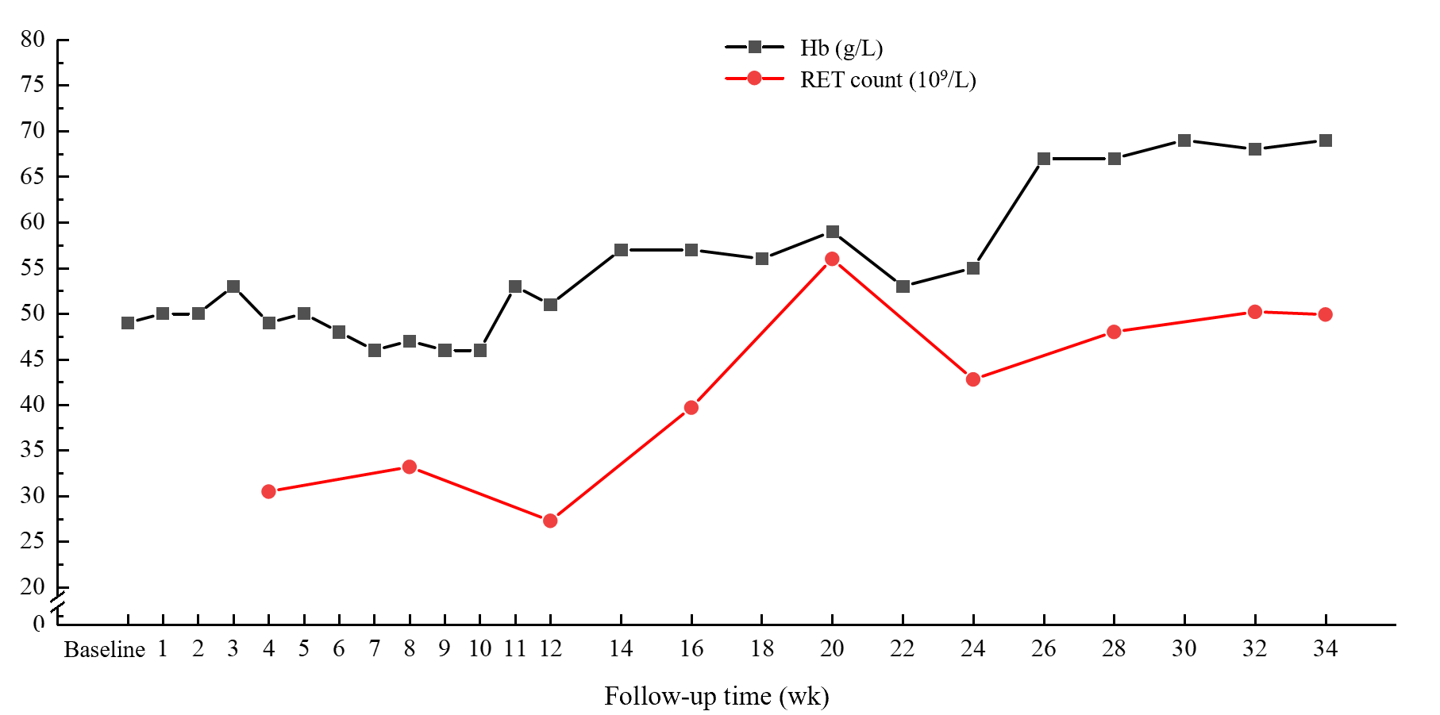
Figure 1 Changes in hemoglobin and reticulocyte count after oral administration of Roxadustat. Hb: Hemoglobin; RET: Reticulocyte.
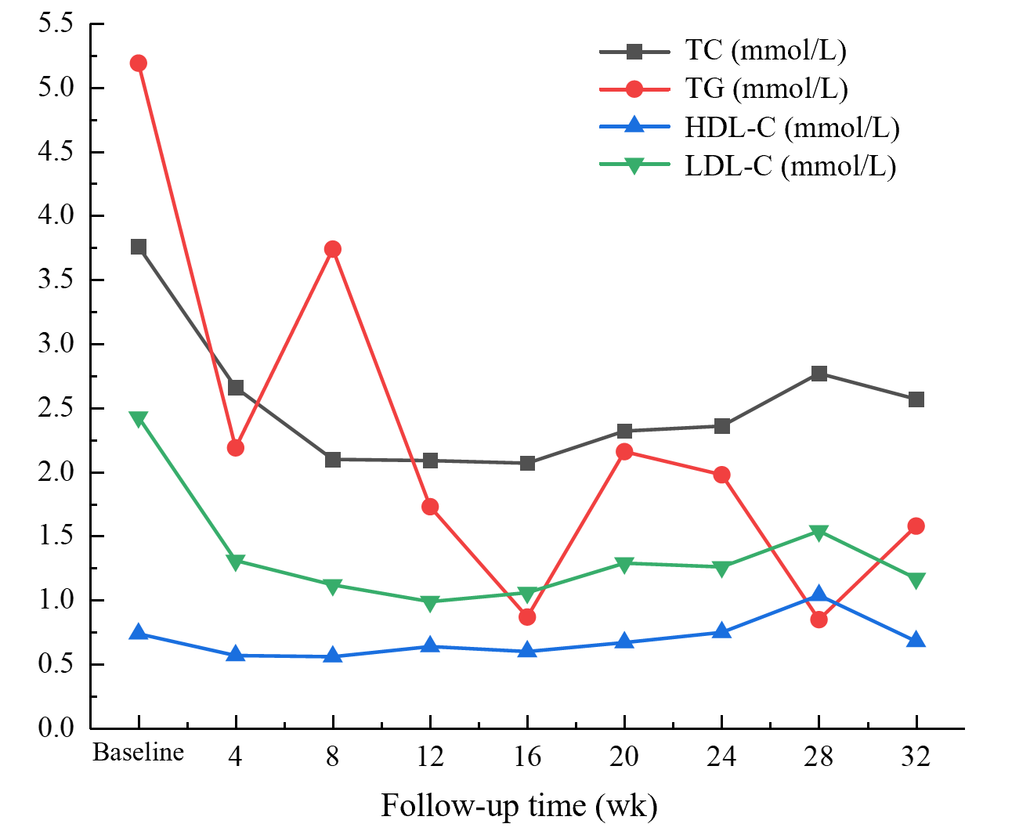
Figure 2 Changes in blood lipids after oral administration of Roxadustat. HDL-C: High-density lipoprotein cholesterol; LDL-C: Low-density lipoprotein cholesterol; TC: Total cholesterol; TG: Triglyceride.
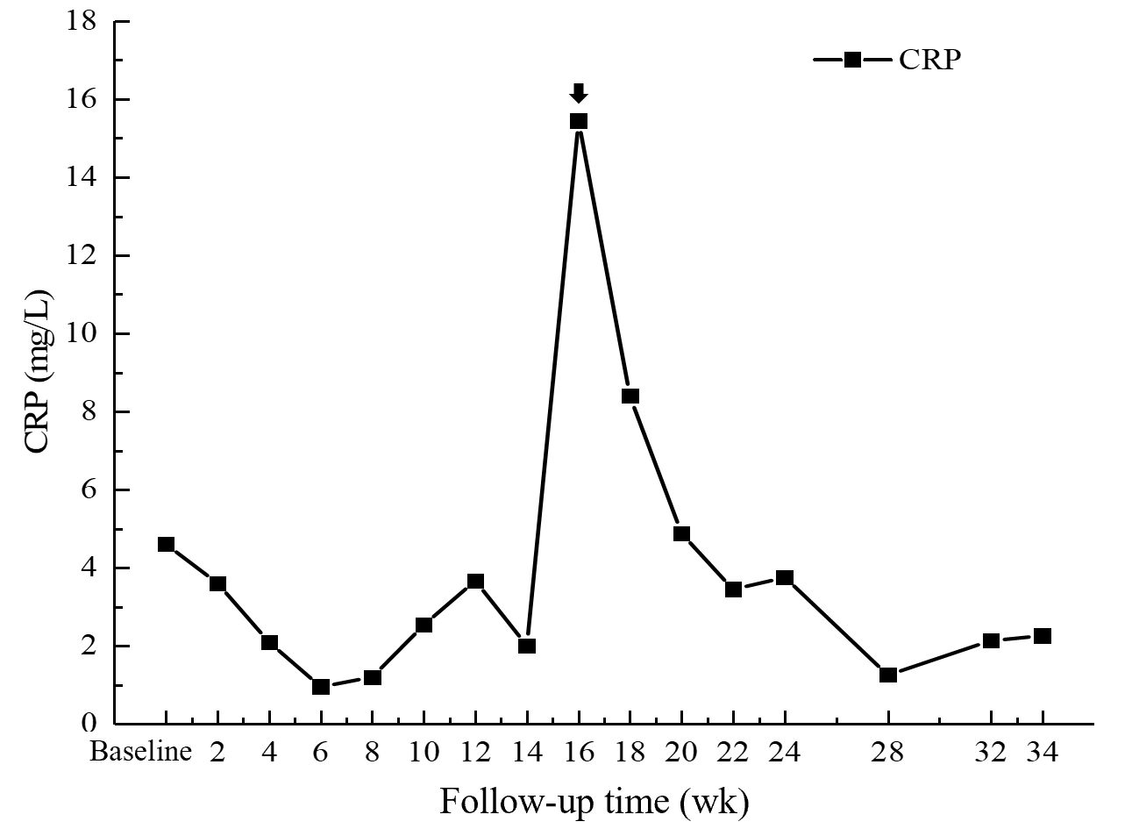
Figure 3 Changes in C-reactive protein after oral administration of Roxadustat. Arrow at week 16, C-reactive protein was significantly elevated in the patient because of concurrent respiratory infections. CRP: C-reactive protein.
Table 1 Baseline general information and clinical and laboratory characteristics
Characteristics
Age in yr | 44
Sex | Male
Body weight in kg | 60
Hb in g/L | 49
SI in μmol/L | 24.0
TIBC in μmol/L | 51.6
TSAT, % | 46.51
SF in ng/mL | 656.03
iPTH in pg/mL | 385
Dialysis method: hemodialysis/peritoneal dialysis | Hemodialysis
Duration of dialysis in yr | 1.33
Dose of rhEPO injection in IU | 6000
Frequency of rhEPO injection as times/wk | 3
Blood pressure
Systolic in mmHg | 157
Diastolic in mmHg | 96
CRP in mg/L | 4.61
Blood lipids
TC in mmol/L | 3.76
TGs in mmol/L | 5.19
LDL-C in mmol/L | 0.74
HDL-C in mmol/L | 2.43
CRP: C-reactive protein; EPO: Endogenous erythropoietin; Hb: Hemoglobin; HDL-C: High-density lipoprotein cholesterol; iPTH: Intact parathyroid hormone; LDL-C: Low-density lipoprotein cholesterol; rhEPO: recombinant human erythropoietin; SF: Serum ferritin; SI: Serum iron; TC: Total cholesterol; TG: Triglyceride; TIBC: Total iron-binding capacity; TSAT: Transferrin saturation.
Table 2 Changes in iron metabolism indices after oral administration of Roxadustat
 |  | Date
Index | Baseline | 2019-10 | 2019-11 | 2019-12 | 2020-01 | 2020-02 | 2020-03 | 2020-04 | 2020-05
SI in μmol/L | 24.00 | 47.00 | 40.90 | 24.70 | 51.40 | 18.60 | 43.5 | 24.4 | 36.5
TIBC in μmol/L | 51.6 | 50.7 | 55.2 | 54.3 | 54.9 | 63.9 | 63.5 | 69.9 | 55.2
TAST, % | 46.51 | 92.70 | 74.09 | 45.49 | 93.62 | 29.11 | 68.5 | 34.91 | 66.12
SF in ng/mL | 656.03 | 724.84 | 798.02 | 574.53 | 432.47 | 420.11 | 337.21 | 570.57 | 320.16
SF: Serum ferritin; SI: Serum iron; TIBC: Total iron-binding capacity; TSAT: Transferrin saturation.

