Name of Journal: World Journal of Gastrointestinal Endoscopy
Manuscript NO: 82570
Manuscript Type: CASE REPORT

Colonic ductal adenocarcinoma case report: New entity or rare ectopic degeneration?

Conti CB et al. Rare finding of colonic ductal adenocarcinoma

Clara Benedetta Conti, Giacomo Mulinacci, Nicolò Tamini, Marta Jaconi, Nicola Zucchini

Clara Benedetta Conti, Giacomo Mulinacci, Interventional Endoscopy, ASST Monza, Ospedale San Gerardo, Monza 20900, Italy

Nicolò Tamini, Department of Surgery, ASST Monza, Ospedale San Gerardo, Monza 20900, Italy

Marta Jaconi, Nicola Zucchini, Department of Pathology, ASST Monza, Ospedale San Gerardo, Monza 20900, Italy

Author contributions: Conti CB, Tamini N and Zucchini N designed and directed the project; Conti CB and Mulinacci G wrote the first draft of the manuscript with support of Tamini N and Jaconi M; Tamini N and Jaconi M performed the histological analysis; Zucchini N. supervised the study and reviewed for important intellectual contents. All authors approved the final manuscript.

Corresponding author: Clara Benedetta Conti, Doctor, Interventional Endoscopy, ASST Monza, Ospedale San Gerardo, 33 Via G.B. Pergolesi, Monza 20900, Italy. benedetta.conti1@gmail.com

Received: December 22, 2022
Revised: January 9, 2023
Accepted: February 8, 2023
Published online:

Abstract
BACKGROUND
Ectopic pancreatic tissue is a congenital anomaly where a part of pancreatic tissue is located outside of the pancreas and lacks vascular or anatomical communication with it but shows the same histological features. Currently, the literature reports only two anecdotal cases of malignant transformation of colonic ectopic pancreas.

CASE SUMMARY
We present a case of an 81-year-old patient presenting with anemia, with right colonic neoplasia and carbohydrate antigen 19-9 above the normal values. She underwent laparoscopic right hemicolectomy. The final histology was consistent with a primitive adenocarcinoma with ductal morphology and solid-predominant growth pattern. Benign ectopic pancreatic tissue was absent in the surgical specimen.

CONCLUSION
The case describes a very rare complete degeneration of a colonic ectopic pancreatic tissue. However, the absence of benign ectopic pancreatic tissue in the surgical specimen is suggestive of the first description of a primitive ductal adenocarcinoma of the colon.

Key Words: Pancreatic cancer; Colorectal cancer; Colonic ductal adenocarcinoma; Ectopic pancreas; Case report

Conti CB, Mulinacci G, Tamini N, Jaconi M, Zucchini N. Colonic ductal adenocarcinoma case report: New entity or rare ectopic degeneration? World J Gastrointest Endosc 2023; In press

Core Tip: Ectopic pancreatic tissue is a congenital anomaly. Currently, only two anecdotal cases of malignant transformation of colonic ectopic pancreatic tissue have been described. We present a case of an 81-year-old patient with a primitive adenocarcinoma of the right colon, with ductal morphology and solid-predominant growth pattern. Carbohydrate antigen 19-9 value was above the normal values, and both pancreas and biliary tree were healthy. Benign ectopic pancreatic tissue was missing in the surgical specimen. This observation is suggestive of a complete degeneration of a rare colonic ectopic pancreatic tissue or, even more interesting, the first description of a primitive ductal adenocarcinoma of the colon.

INTRODUCTION
Ectopic pancreatic tissue is a congenital anomaly where a part of pancreatic tissue is located outside of the pancreas and lacks vascular or anatomical communication with it while showing the same histological features: pancreatic acinar formation, duct development and islets of Langerhans. Ectopic pancreatic tissue is found in 0.2% of laparotomies and 0.5%-14.0% of autopsies. The most common locations are the stomach (25%-40%), duodenum (9%-36%) and proximal jejunum (0.5%-35.0%). The ileum, including ectopic pancreas within Meckel diverticulum, accounts for 2.8% to 7.5% of cases, being the fourth most common site. The colon, appendix, mesentery, esophagus, liver, gallbladder, bile duct, spleen, umbilical cord, retroperitoneal cavity, lung and mediastinum are extremely rare sites^{[1]}. Usually ectopic pancreas is an asymptomatic condition. However, the complications described in the literature are pancreatitis, bleeding, intussusception and malignant degeneration^{[2,3]}.
According to the Guillou description, carcinoma arising from ectopic pancreatic tissue is surely diagnosed when tumor cells are found within or close to the ectopic pancreas. A transitional area between pancreatic structures and carcinoma is clearly detected and the benign ectopic pancreatic tissue shows acini and ductal structures^{[4]}.
Currently, the literature reports only two anecdotal cases of malignant transformation of colonic ectopic pancreatic tissue: One occurred in the splenic flexure and one in the sigmoid colon^{[5]}.

CASE PRESENTATION
Chief complaints
A 81-year-old woman underwent colonoscopy for severe anemia (hemoglobin 6 g/dL) in the absence of overt gastrointestinal bleeding.

History of present illness
She had ongoing anticoagulant therapy due to atrial fibrillation. The liver enzyme test, cholestasis test and two previous abdominal sonography exams were normal. However, of note, blood tests showed carbohydrate antigen 19-9 (CA 19-9) value repeatedly above normal values (2 × upper limit of normal) since 2016.

History of past illness
The medical history of the patient reported a loss of 4 kg in the previous 6 mo, and an invasive lobular carcinoma of the breast occurred 10 years prior to admission.

Personal and family history
Family history was unremarkable. The patient did not smoke and did not drink alcohol. She was normal weight before the weight loss occurred due to the neoplasia.

Physical examination
The patient’s vital signs were normal. She was pale due to the anemia and reported fatigue. No abnormal findings were present at the physical examination, apart from the atrial fibrillation.

Laboratory examinations
Liver enzyme and cholestasis tests were normal.

Imaging examinations
Two previous abdominal sonography exams were normal. Computed tomography scan, performed after the diagnosis of the colonic neoplasia showed local peritoneal infiltration and local lymphadenopathies, in the absence of distant organ metastasis. Colonoscopy revealed a large lesion of 40 mm in size extending from the ileocecal valve fold to the ascending colon. The superficial pattern, the spontaneous bleeding and the ulcerated surface suggested the diagnosis of primitive colonic neoplasia. Biopsies were taken. The terminal ileum results were normal. Surprisingly, the histological diagnosis was consistent with a primitive ductal adenocarcinoma of the colon (Figure 1A). A total body computed tomography scan showed local peritoneal infiltration and local lymphadenopathies, in the absence of distant organ metastasis. Notably, both the pancreas and biliary tree did not report abnormalities. CEA was normal, whereas CA 19-9 value was 3 × upper limit of normal. Cholestasis and liver enzyme tests were again normal.

FINAL DIAGNOSIS
The final histology of the surgical specimen confirmed the diagnosis of adenocarcinoma with ductal morphology and solid-predominant growth pattern.

TREATMENT
After a multidisciplinary discussion, the patient underwent surgical treatment, with laparoscopic right hemicolectomy and ileocolic anastomosis. The final histology of the surgical specimen confirmed the diagnosis of adenocarcinoma with ductal morphology and solid-predominant growth pattern. The immunohistochemistry documented the diffuse positive staining for cytokeratin 7 and the absence of CDX2 immunoreactivity (Figure 1B and C). CK20, GATA3, PAX8, and ER were also negative. The final lymph node involvement occurred in three pericolic lymph nodes out of thirteen.

OUTCOME AND FOLLOW-UP
The outcome was very good, with no complications. The follow-up imaging performed six months after surgery was negative. The patient was very satisfied with the outcome and the curative surgery.

DISCUSSION
We described a rare case of primitive ductal adenocarcinoma of the right colon. The neoplasia was located in the right colon and included part of the ileocecal valve. Thus, it was mandatory to rule out an ileal origin^{[1]}. The ileum was both macroscopically and microscopically intact. Interestingly, the pathologist did not recognize a benign ectopic pancreatic tissue in the surgical specimen. This observation suggests the complete degeneration of a rare colonic ectopic pancreas or, even more interesting, the first description of a primitive ductal adenocarcinoma of the colon.

CONCLUSION
In our opinion, it is useful to consider the existence of this entity, although very rare, in the diagnostic workup of patients with clinical suspicion of organic disease and elevated CA 19-9 value.

REFERENCES
1 Cazacu IM, Luzuriaga Chavez AA, Nogueras Gonzalez GM, Saftoiu A, Bhutani MS. Malignant Transformation of Ectopic Pancreas. Dig Dis Sci 2019; 64: 655-668 [PMID: 30415408 DOI: 10.1007/s10620-018-5366-z]
2 Rezvani M, Menias C, Sandrasegaran K, Olpin JD, Elsayes KM, Shaaban AM. Heterotopic Pancreas: Histopathologic Features, Imaging Findings, and Complications. Radiographics 2017; 37: 484-499 [PMID: 28287935 DOI: 10.1148/rg.2017160091]
3 Xiang S, Zhang F, Xu G. Ectopic pancreas in the ileum: An unusual condition and our experience. Medicine (Baltimore) 2019; 98: e17691 [PMID: 31689793 DOI: 10.1097/MD.0000000000017691]
4 Guillou L, Nordback P, Gerber C, Schneider RP. Ductal adenocarcinoma arising in a heterotopic pancreas situated in a hiatal hernia. Arch Pathol Lab Med 1994; 118: 568-571 [PMID: 8192567]
5 Gallo G, Mangogna A, Manco G, Caramaschi S, Salviato T. Pancreatic ductal adenocarcinoma in colonic wall: metastatic disease or cancerized pancreatic ectopic tissue? Surg Case Rep 2020; 6: 80 [PMID: 32323034 DOI: 10.1186/s40792-020-00846-5]

Footnotes
Informed consent statement: Informed written consent was obtained from the patient for the publication of this report and any accompanying images.

Conflict-of-interest statement: The authors declare that they have no conflicts of interest.

CARE Checklist (2016) statement: The authors have read the CARE Checklist (2016), and the manuscript was prepared and revised according to the CARE Checklist (2016).

Open-Access: This article is an open-access article that was selected by an in-house editor and fully peer-reviewed by external reviewers. It is distributed in accordance with the Creative Commons Attribution NonCommercial (CC BY-NC 4.0) license, which permits others to distribute, remix, adapt, build upon this work non-commercially, and license their derivative works on different terms, provided the original work is properly cited and the use is non-commercial. See: https://creativecommons.org/Licenses/by-nc/4.0/

Provenance and peer review: Unsolicited article; Externally peer reviewed.
Peer-review model: Single blind

Peer-review started: December 22, 2022
First decision: January 3, 2023
Article in press:

Specialty type: Gastroenterology and hepatology
Country/Territory of origin: Italy
Peer-review report’s scientific quality classification
Grade A (Excellent): 0
Grade B (Very good): 0
Grade C (Good): C, C
Grade D (Fair): 0
Grade E (Poor): 0

P-Reviewer: Bal’afif F, Indonesia; Samizadeh B, Iran S-Editor: Chen YL L-Editor: Filipodia P-Editor: Chen YL

Figure Legends
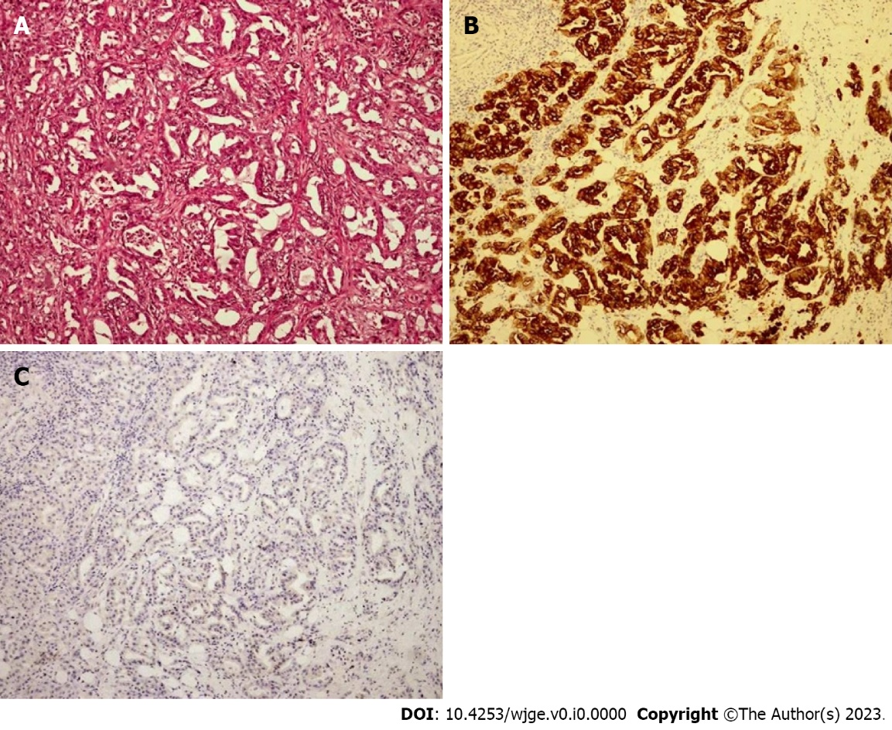
Figure 1 Right colon adenocarcinoma with ductal morphology. A: Hematoxylin and eosin, × 10; B: With diffuse positive staining for cytokeratin 7 (× 10); C: Complete absence of CDX-2 immunoreactivity (× 10).

