Name of Journal: World Journal of Gastroenterology
Manuscript NO: 88371
Manuscript Type: CASE REPORT

Dynamic ultrasonography for optimizing treatment position in superior mesenteric artery syndrome: Two case reports and review of literature

Hasegawa N et al. Dynamic US for SMA syndrome

Nobuaki Hasegawa, Akihiko Oka, Muyiwa Awoniyi, Yuri Yoshida, Hiroshi Tobita, Norihisa Ishimura, Shunji Ishihara

Nobuaki Hasegawa, Akihiko Oka, Norihisa Ishimura, Shunji Ishihara, Department of Internal Medicine II, Shimane University Faculty of Medicine, Izumo 693-8501, Shimane, Japan

Muyiwa Awoniyi, Department of Gastroenterology, Hepatology and Nutrition, Digestive Disease and Surgery Institute, Hepatology Section, Cleveland Clinic, Cleveland, OH 44195, United States

Yuri Yoshida, Clinical Laboratory Division, Shimane University Hospital, Izumo 693-8501, Shimane, Japan

Hiroshi Tobita, Division of Hepatology, Shimane University Hospital, Izumo 693-8501, Japan

Author contributions: Hasegawa N, Oka A, and Awoniyi M contributed to drafting of manuscript; Hasegawa N, Oka A, and Yoshida Y contributed to assessment of ultrasonography; Tobita H, Ishimura N, and Ishihara S contributed to supervisor of study; All the authors solely contributed to this paper.

Corresponding author: Akihiko Oka, MD, PhD, Assistant Professor, Department of Internal Medicine II, Shimane University Faculty of Medicine, 89-1, Izumo 693-8501, Shimane, Japan. aoka@med.shimane-u.ac.jp

Received: October 2, 2023
Revised: December 11, 2023
Accepted: January 12, 2024
Published online: February 7, 2024

Abstract
BACKGROUND
Superior mesenteric artery (SMA) syndrome is a rare cause of duodenal obstruction by extrinsic compression between the SMA and the aorta (SMA-Ao). Although the left lateral recumbent position is considered effective in the treatment of SMA syndrome, individual variations in the optimal patient position have been noted. In this report, we present two elderly cases of SMA syndrome that exhibited rapid recovery due to ultrasonographic dynamic evaluation of the optimal position for each patient.

CASE SUMMARY
Case 1: A 90-year-old man with nausea and vomiting. Following diagnosis of SMA syndrome by computed tomography (CT), ultrasonography (US) revealed the SMA-Ao distance in the supine position (4 mm), which slightly improved in the lateral position (5.7–7.0 mm) without the passage of duodenal contents. However, in the sitting position, the SMA-Ao distance was increased to 15 mm accompanied by improved content passage. Additionally, US indicated enhanced passage upon abdominal massage on the right side. By day 2, the patient could eat comfortably with the optimal position and massage. Case 2: An 87-year-old woman with vomiting. After the diagnosis of SMA syndrome and aspiration pneumonia by CT, dynamic US confirmed the optimal position (SMA-Ao distance was improved to 7 mm in forward-bent position, whereas it remained at 5 mm in the supine position). By day 7 when her pneumonia recovered, she could eat with the optimal position.

CONCLUSION
The optimal position for SMA syndrome varies among individuals. Dynamic US appears to be a valuable tool in improving patient outcomes.

Key Words: Superior mesenteric artery syndrome; Wilkie’s syndrome; Cast syndrome; Aorto-mesenteric compass syndrome; Ultrasonography; Case report

©The Author(s) 2024. Published by Baishideng Publishing Group Inc. All rights reserved.

Citation: Hasegawa N, Oka A, Awoniyi M, Yoshida Y, Tobita H, Ishimura N, Ishihara S. Dynamic ultrasonography for optimizing treatment position in superior mesenteric artery syndrome: Two case reports and review of literature. World J Gastroenterol 2024; 30(5): 499-508
URL: https://www.wjgnet.com/1007-9327/full/v30/i5/499.htm
DOI: https://dx.doi.org/10.3748/wjg.v30.i5.499

Core tip: Superior mesenteric artery (SMA) syndrome is a rare cause of duodenal obstruction by extrinsic compression between the SMA and aorta. While the left lateral recumbent position has traditionally been recommended as conservative therapy for facilitating duodenal passage, recent studies have highlighted variations in the optimal position among patients. Here, we present two cases of SMA syndrome where rapid recovery was achieved through ultrasonographic dynamic evaluation of the individualized optimal positions. This pioneering report includes valuable images and a video of dynamic ultrasonography, contributing to improved prognosis by averting potentially life-threatening complications such as shock, pancreatitis, perforation, and hypokalemia.

INTRODUCTION
Superior mesenteric artery (SMA) syndrome is a rare cause of duodenal obstruction by extrinsic compression between the SMA and the aorta (SMA-Ao)^{[1–4]}. Left untreated, it can lead to potentially lethal complications, including sudden death, shock, pancreatitis, gastric perforation, malnutrition and hypokalemia^{[5–9]}. Hence, early diagnosis and treatments are imperative^{[10,11]}. However, its nonspecific symptoms, such as nausea, appetite loss, and abdominal discomfort often lead to underdiagnosis in clinical practice^{[10–12]}. Additionally, due to its rarity, therapeutic guidelines have not been established. While the left lateral recumbent position is generally considered to be effective in the treatment of SMA syndrome, literature on the optimal patient position is scarce^{[4,13–18]}. Some reports suggest that the optimal position may not be limited to the lateral position but could include right recumbent and sitting positions, depending on the course of the SMA in relation to the aorta^{[14,15,17,18]}. Therefore, the optimal position might differ for each patient, and we hypothesize that dynamic observation of the SMA-Ao distance by ultrasonography (US) is ideal to determine the optimal therapeutic position. Dynamic US has recently emerged as a valuable technique offering real-time and dynamic evaluation, as well as safe and quick access^{[19,20]}. In this report, we present two cases of SMA syndrome that exhibited prompt recovery through ultrasonographic dynamic evaluation of the optimal position.

CASE PRESENTATION
Chief complaints
Case 1: A 90-year-old man arrived in the emergency department in our hospital with complaints of nausea, vomiting, and abdominal distention for several hours.

Case 2: An 87-year-old woman arrived in the emergency department in our hospital with complaints of nausea and recurrent vomiting.

History of present illness
Case 1: The patient had been treated with continuous positive airway pressure (CPAP) for sleep apnea syndrome since 2019. After CPAP therapy had started, he sometimes woke up with nausea and vomiting. During sleep, he remained mainly in the supine position because of CPAP. Several hours before his visit to our hospital in 2022, he received dental treatment in the supine position for 2 h, after which nausea and abdominal distension occurred.

Case 2: The patient had infectious diarrhea several months before coming to our hospital and lost 5 kg of body weight. The diarrhea recovered with conservative therapy. On the day coming to our hospital, she vomited frequently after dinner for several hours, then visited the emergency department in our hospital.

History of past illness
Case 1: The patient had undergone a right hemicolectomy for ascending colon cancer in 2009, with no recurrence. In the same year, he also underwent right ureteral reconstruction for right ureteral injury. Since 2019, he had been receiving CPAP therapy for mild sleep apnea syndrome. He had been on medications for hypertension, Alzheimer's disease, and paroxysmal atrial fibrillation since 2016.

Case 2: The patient had taken medication for hypertension.

Personal and family history
Case 1: There was no significant personal and family history.

Case 2: There was no significant personal and family history.

Physical examination
Case 1: The patient was 166 cm in height and 52.0 kg in weight [body mass index (BMI), 18.9, there had been no body weight loss for several recent years]. The vital signs were normal: consciousness, clear; blood pressure, 146/66 mmHg; heart rate, 53 beats/min; body temperature, 36.4 °C; respiratory rate, 16 breaths/min. The saturation of percutaneous oxygen (SpO₂) was 96% at room air. His abdomen was slightly distended with mild epigastric tenderness. There was no rebound tenderness. The abdominal sound was almost normal peristalsis. Surgical scars from right hemicolectomy were visible in the midline abdominal incision site for ascending colon cancer, located at the center and right of the abdomen.

Case 2: The patient was 161 cm in height and 42.4 kg in weight (BMI, 16.4). The vital signs were as follows: Consciousness, clear; blood pressure, 130/80 mmHg; heart rate, 100 beats/min; body temperature, 36.8 °C; respiratory rate, 24 breaths/min. SpO₂ was 94% at room air. Her abdomen was moderately distended with mild epigastric tenderness. There was no rebound tenderness. The abdominal sound was almost normal peristalsis.

Laboratory examinations
Case 1: Routine blood analyses showed no significant abnormalities: white blood cell (WBC) count, 5170 cells/µL; total bilirubin (TBil), 0.6 mg/dL; aspartate aminotransferase (AST), 20 IU/L; alanine aminotransferase (ALT), 13 IU/L; alkaline phosphatase (ALP), 66 IU/L; γ-glutamyl transpeptidase, 12 IU/L; serum amylase, 141 IU/L; blood urea nitrogen (BUN), 22.0 mg/dL; creatinine (Cr), 0.88 mg/dL; Na⁺/K⁺/Cl⁺ levels, 138/3.8/101 mmol/L; and C-reactive protein (CRP), 0.04 mg/dL. Blood pH was within the normal range (7.394).

Case 2: Elevated WBC count (8680 cells/µL) and CRP (3.59 mg/dL) indicated systemic inflammation. Elevated BUN (29.0 mg/dL) and Cr (1.29 mg/dL) indicated dehydration. Except for the elevated serum amylase (255 IU/L), other routine blood analyses were in normal range: TBil, 1.3 mg/dL; AST, 24 IU/L; ALT, 11 IU/L; ALP, 262 IU/L; Na⁺/K⁺/Cl⁺, 138/4.4/105 mmol/L. The blood pH was normal (7.366).

Imaging examinations
Case 1: Computed tomography (CT) demonstrated compression of the third portion of the duodenum between the SMA-Ao, as well as markedly dilated duodenum and stomach (Figure 1). Arteriosclerosis of the abdominal aorta and SMA was also observed. Abdominal US revealed that, in the supine position, the distance between SMA-Ao was shortened to 4 mm and the angle of SMA-Ao decreased to 15° (Figure 2). Additionally, real-time US observation showed no passage of contents through the SMA-Ao site, along with the to-and-fro sign at the oral side of this location (Video).

Case 2: CT showed a frosted shadow in the lower lobe of the right lung and compression of the third portion of the duodenum between SMA-Ao, as well as a markedly dilated duodenum and stomach (Figure 3). Arteriosclerosis of the abdominal aorta and SMA was also observed. US demonstrated the SMA-Ao distance was narrowed to 5 mm in the supine position without the passage of duodenal contents (Figure 4A). The angle of SMA-Ao decreased to 18° (Figure 4B).

Further diagnostic work-up
Case 1: We performed a position change with dynamic observation using US (Figure 5). In the left lateral position, which is traditionally recommended for the patients with SMA syndrome, the SMA-Ao distance was 4 mm (no change compared to that in the supine position). In the right lateral position, US showed that the SMA-Ao distance increased to 7 mm and intestinal gas passed through the compression site of the duodenum. In the sitting position, SMA-Ao distance increased to 15 mm and gas and fluid content passed through the site. Real-time US revealed that pushing by hand on his right upper abdomen enhanced the passage of duodenal contents through the site (Video).

Case 2: Dynamic US with a change in body position revealed dynamic changes in the SMA-Ao distance, measuring 5.3 mm in the supine position, 5.3 mm in the left lateral position, 6.6 mm in the right lateral position, and 7.0 mm in the sitting position (Figure 6).

FINAL DIAGNOSIS
Case 1
The final diagnosis was SMA syndrome based on the CT and US findings.

Case 2
The final diagnosis was SMA syndrome with aspiration pneumonia as an SMA syndrome-related complication based on her medical history and CT and US findings.

TREATMENT
Case 1
On day 1 of hospitalization, fasting and peripheral venous nutrition started. Based on the findings of dynamic US, the patient kept his postprandial position in the right lateral or sitting as much as possible.

Case 2
On the day 1 of hospitalization, fasting and peripheral venous nutrition started. Based on the findings of dynamic US, she was instructed to keep the optimal body position after a meal. Aspiration pneumonia was treated with intravenous antibiotics for 10 d.

OUTCOME AND FOLLOW-UP
Case 1
By day 2, all of the patient’s symptoms had vanished, and US confirmed significant improvements in stomach and duodenal dilatation. Consequently, he could eat without recurrence. Upon discharge from the hospital on day 3, he was advised to maintain positions such as sitting or the right lateral position after meals, and also to assume the right-side supine position when using CPAP during sleep. He was also instructed to apply manual pressure (massage) to his right upper abdomen if he experienced any symptoms related to SMA syndrome. There have been no recurrences in the two years since the incident.

Case 2
On day 7, the patients could start eating without recurrence. On day 32, she was discharged and there was no recurrence in the 12 years since the incident.

DISCUSSION
SMA syndrome (also known as Wilkie’s syndrome, cast syndrome, mesenteric duodenal obstruction, or aorto-mesenteric compass syndrome) is a rare duodenal obstruction caused by compression between the SMA-Ao^{[1,21]}. Recent reviews indicate a wide age range of patients affected by SMA syndrome, with a notable increase in elderly patients^{[1,21]}. Indeed, the present two patients were very old and required more prompt and careful management to avoid age-related complications, including aspiration pneumonia, functional decline, and malnutrition^{[22]}. Fortunately, dynamic US could determine the optimal position for individualized duodenal passage, thus obviating the need for nasogastric tube placement, a common intervention for decompression and nutritional support in SMA syndrome^{[1–4]}. However, nasogastric tubes can introduce additional complications, such as aspiration pneumonia and intestinal injuries^{[23,24]}.
The etiology of SMA syndrome might be different between younger and older patients^{[21]}. In older patients (> 40 years), post-abdominal surgery emerges as the most common etiology, followed by weight loss. In contrast, younger patients (< 40 years) predominantly experience scoliosis-related cases, such as those following spinal fusion surgery and body casting, also accompanied by weight loss. Case 1 had multiple histories of abdominal surgery, suggesting surgical adhesion pulled on the mesentery or restricted the SMA mobility^{[1]}. Furthermore, the presence of atherosclerosis affecting both the SMA and the Ao, as observed in both cases, might further impede SMA mobility^{[25,26]}. Given these restrictions of the SMA mobility, confirming the SMA mobility by dynamic US should be helpful; or, the absence of SMA mobility could suggest early surgical intervention. CT is considered the gold standard for diagnosing SMA syndrome by visualizing duodenal compression by the SMA, along with dilation of the proximal duodenum and stomach^{[1,27]}. Three-dimensional CT has emerged as a valuable tool for visualizing the anatomy of the SMA, Ao, and duodenum^{[28]}. Under normal circumstances, the SMA-Ao angle and distance measure 38–65° and 10–33 mm, respectively^{[29–31]}. The cutoff value was reported as 22° on the SMA-Ao angle and 8 mm distance with 42.8% sensitivity and 100% specificity^{[30]}. While CT undoubtedly offers valuable and objective diagnostic information, it is typically performed in a single body position, usually supine. In contrast, US can potentially be conducted in various postures and provides dynamic assessments of luminal content and vascular movement. As demonstrated in this report, dynamic US is instrumental in identifying the most suitable position for facilitating luminal content passage. Historically, barium X-ray series were used for diagnosis and evaluation of luminal content passage in SMA syndrome^{[1,32]}. However, due to the associated radiation exposure risks, US assessments offer a safer and more effective alternative for managing SMA syndrome. The diagnostic sensitivity of US for SMA syndrome has been validated in comparative studies with CT findings^{[30]}. In addition, because it can be performed at the bedside, it can easily evaluate gastroduodenal dilatation and the distance between the SMA-Ao during follow-up. In light of these advantages, we believe dynamic US represents the most valuable tool for determining the optimal position for each patient with SMA syndrome. The absence of SMA movement, possibly due to calcification at the SMA root or post-abdominal surgery, could be indicative of the need for early surgical intervention^{[1]}. While US findings may potentially be influenced by operator bias and interobserver variation, dynamic observation places greater emphasis on subjective focus compared to static images. To the best of our knowledge, this report constitutes the first documentation of dynamic US in SMA syndrome, complete with detailed images and a video. We anticipate that this report will be valuable for US practitioners aiming to enhance their understanding of SMA syndrome diagnosis.
The treatment for SMA syndrome is initiated by conservative methods, such as gastric and duodenal decompression by postural change and/or nasogastric tube suction^{[22,33]}. If the conservative treatment fails, surgery may be necessary^{[1,34]}. Although it is believed that positioning the patient in the left lateral position is effective in the treatment of SMA syndrome, there is little evidence^{[13,16]}. The optimal body position for each patient may vary because recent studies found a variation in the SMA position and movement^{[14,15,17]}. Case 1 in our report demonstrated better content passage in the right lateral position than the left, corroborating the findings of Khan et al^{[15]}. Miyata et al^{[17]} reported a variation in position of SMA demonstrating that major position was the right side along with the aorta^{[17]}. No study has reported the optimal position in SMA syndrome^{[1]}. As such, we conducted an evaluation of the optimal body position in 14 individuals, including our two SMA syndrome cases and nine healthy controls, using abdominal US (Figure 7). In cases where duodenal detection proved challenging, subjects ingested 200 mL of water, modifying the drinking US test^{[35]}. While the left lateral position, which is generally thought to be an optimal position, was significantly effective (long distance of SMA-Ao) as expected, the right lateral position was also significantly effective (Figure 7A). The best position varies from case to case: the left lateral position was effective in some cases while the right lateral recumbent position and the sitting position were more effective in other cases (Figure 7B). Further prospective cohort studies are warranted to explore the effectiveness of dynamic US in identifying ideal positions for SMA syndrome patients. Although recent surgical interventions for SMA syndrome have demonstrated safety and efficacy^{[1,36]}, surgery and anesthesia inherently pose risks to elderly patients, particularly those with pulmonary risk factors, as demonstrated by our cases^{[37]}. Dynamic US offers a promising avenue to enhance the effectiveness of non-surgical treatments and prevent unnecessary surgical procedures.

CONCLUSION
We presented two cases of SMA syndrome in elderly patients in which US proved invaluable for determining optimal positioning. Given the variability of optimal body positions in SMA syndrome among patients, dynamic assessment of the optimal body position via bedside positioning using dynamic US emerged as a minimally invasive and effective option.

ACKNOWLEDGMENTS
We thank Keiko Masuzaki and Yuriko Adachi for collecting references and Maki Watanabe for collaborating with the ethics committee.

REFERENCES
1 Oka A, Awoniyi M, Hasegawa N, Yoshida Y, Tobita H, Ishimura N, Ishihara S. Superior mesenteric artery syndrome: Diagnosis and management. World J Clin Cases 2023; 11: 3369-3384 [PMID: 37383896 DOI: 10.12998/wjcc.v11.i15.3369]
2 Wilkie DPD. Chronic duodenal ileus. Am J Med Sci 1927; 173: 643-648 [DOI: 10.1097/00000441-192705000-00006]
3 Hines JR, Gore RM, Ballantyne GH. Superior mesenteric artery syndrome. Diagnostic criteria and therapeutic approaches. Am J Surg 1984; 148: 630-632 [PMID: 6496852 DOI: 10.1016/0002-9610(84)90339-8]
4 Evarts CM. The cast syndrome. Report of a case after spinal fusion for scoliosis. Clin Orthop Relat Res 1971; 75: 164-166 [PMID: 5554620 DOI: 10.1097/00003086-197103000-00022]
5 Murakami C, Irie W, Sasaki C, Nakamaru N, Sakamoto M, Nagato J, Satoh F. Extensive gastric necrosis secondary to acute gastric dilatation: A case report. Leg Med (Tokyo) 2019; 36: 85-88 [PMID: 30448603 DOI: 10.1016/j.legalmed.2018.11.007]
6 Mohammad Kazmin NE, Kamaruzaman L, Wong Z, Fong VK, Mohd R, Mustafar R. Acute Kidney Injury Caused by Superior Mesenteric Artery Syndrome. Case Rep Nephrol 2020; 2020: 8364176 [PMID: 32328326 DOI: 10.1155/2020/8364176]
7 Petrosyan M, Estrada JJ, Giuliani S, Williams M, Rosen H, Mason RJ. Gastric perforation and pancreatitis manifesting after an inadvertent nissen fundoplication in a patient with superior mesenteric artery syndrome. Case Rep Med 2009; 2009: 426162 [PMID: 19730743 DOI: 10.1155/2009/426162]
8 Thieme ET, Postmus R. Superior mesenteric artery syndrome. Ann Surg 1961; 154: 139-143 [PMID: 13920640 DOI: 10.1097/00000658-196112000-00017]
9 Shajani-Yi Z, Lee HK, Cervinski MA. Hyponatremia, Hypokalemia, Hypochloremia, and Other Abnormalities. Clin Chem 2016; 62: 898 [PMID: 27235468 DOI: 10.1373/clinchem.2015.249292]
10 Elbadaway MH. Chronic superior mesenteric artery syndrome in anorexia nervosa. Br J Psychiatry 1992; 160: 552-554 [PMID: 1571759 DOI: 10.1192/bjp.160.4.552]
11 Mandarry MT, Zhao L, Zhang C, Wei ZQ. A comprehensive review of superior mesenteric artery syndrome. Eur Surg 2010; 42: 229-236 [DOI: 10.1007/s10353-010-0561-y]
12 Kawanishi K, Shojima K, Nishimoto M, Abe H, Kakimoto T, Yasuda Y, Hara T, Kato J. Superior Mesenteric Artery Syndrome May Be Overlooked in Women with Functional Dyspepsia. Intern Med 2017; 56: 2549-2554 [PMID: 28883239 DOI: 10.2169/internalmedicine.8647-16]
13 Evarts CM, Winter RB, Hall JE. Vascular compression of the duodenum associated with the treatment of scoliosis. Review of the literature and report of eighteen cases. J Bone Joint Surg Am 1971; 53: 431-44 passim [PMID: 5580004 DOI: 10.2106/00004623-197153030-00002]
14 Dounas GD, Cundy TP, Smith ML, Gent R, Antoniou G, Sutherland LM, Cundy PJ. The coronal aorto-mesenteric orientation theory for post-operative nausea and vomiting following scoliosis surgery in children: a pilot study. ANZ J Surg 2021; 91: 174-178 [PMID: 33244810 DOI: 10.1111/ans.16438]
15 Khan H, Al-Jabbari E, Shroff N, Barghash M, Shestopalov A, Bhargava P. Coexistence of superior mesenteric artery syndrome and nutcracker phenomenon. Radiol Case Rep 2022; 17: 1927-1930 [PMID: 35401899 DOI: 10.1016/j.radcr.2022.03.063]
16 Neri S, Signorelli SS, Mondati E, Pulvirenti D, Campanile E, Di Pino L, Scuderi M, Giustolisi N, Di Prima P, Mauceri B, Abate G, Cilio D, Misseri M, Scuderi R. Ultrasound imaging in diagnosis of superior mesenteric artery syndrome. J Intern Med 2005; 257: 346-351 [PMID: 15788004 DOI: 10.1111/j.1365-2796.2005.01456.x]
17 Miyata J, Eshak ES, Yoshioka T, Iso H. Movement of the superior mesenteric artery in patients with superior mesenteric artery syndrome: A case-reference study. Clin Anat 2022; 35: 891-898 [PMID: 35417615 DOI: 10.1002/ca.23885]
18 Choi SH, Pfalzer FA Jr. Superior mesenteric artery syndrome. N Y State J Med 1976; 76: 986-988 [PMID: 1064781]
19 Wu WT, Lin CY, Shu YC, Chen LR, Özçakar L, Chang KV. Subacromial Motion Metrics in Painful Shoulder Impingement: A Dynamic Quantitative Ultrasonography Analysis. Arch Phys Med Rehabil 2023; 104: 260-269 [PMID: 36055380 DOI: 10.1016/j.apmr.2022.08.010]
20 Shu YC, Lo YC, Chiu HC, Chen LR, Lin CY, Wu WT, Özçakar L, Chang KV. Deep learning algorithm for predicting subacromial motion trajectory: Dynamic shoulder ultrasound analysis. Ultrasonics 2023; 134: 107057 [PMID: 37290256 DOI: 10.1016/j.ultras.2023.107057]
21 Oka A, Hasegawa N, Yoshida Y, Tobita H, Awoniyi M, Ishimura N, Ishihara S. Ep129 superior mesenteric artery syndrome -a systematic review of 2,453 cases in the literature. Gastroenterology 2023; 164: S-1215 [DOI: 10.1016/S0016-5085(23)03812-X]
22 Merrett ND, Wilson RB, Cosman P, Biankin AV. Superior mesenteric artery syndrome: diagnosis and treatment strategies. J Gastrointest Surg 2009; 13: 287-292 [PMID: 18810558 DOI: 10.1007/s11605-008-0695-4]
23 McCann C, Cullis PS, McCabe AJ, Munro FD. Major complications of jejunal feeding in children. J Pediatr Surg 2019; 54: 258-262 [PMID: 30528177 DOI: 10.1016/j.jpedsurg.2018.10.078]
24 Miura T, Nakamura J, Yamada S, Miura T, Yanagi M, Tani Y, Nishihara M, Takahashi T. A Fatal Aortoesophageal Fistula Caused by Critical Combination of Double Aortic Arch and Nasogastric Tube Insertion for Superior Mesenteric Artery Syndrome. Case Rep Gastroenterol 2010; 4: 198-203 [PMID: 20805944 DOI: 10.1159/000316633]
25 Beita AKV, Whayne TF. The Superior Mesenteric Artery: From Syndrome in the Young to Vascular Atherosclerosis in the Old. Cardiovasc Hematol Agents Med Chem 2019; 17: 74-81 [PMID: 31538906 DOI: 10.2174/1871525717666190920100518]
26 Kitaura K, Harima K. Superior mesenteric artery syndrome with vascular calcification in a maintenance hemodialysis patient. Clin Nephrol 2009; 71: 228-230 [PMID: 19203523 DOI: 10.5414/CNP71228]
27 Lamba R, Tanner DT, Sekhon S, McGahan JP, Corwin MT, Lall CG. Multidetector CT of vascular compression syndromes in the abdomen and pelvis. Radiographics 2014; 34: 93-115 [PMID: 24428284 DOI: 10.1148/rg.341125010]
28 Raman SP, Neyman EG, Horton KM, Eckhauser FE, Fishman EK. Superior mesenteric artery syndrome: spectrum of CT findings with multiplanar reconstructions and 3-D imaging. Abdom Imaging 2012; 37: 1079-1088 [PMID: 22327421 DOI: 10.1007/s00261-012-9852-z]
29 Hearn JB. Duodenal ileus; with reference to superior mesenteric artery compression. Md State Med J 1965; 14: 65-68 [PMID: 14267372 DOI: 10.1148/86.2.305]
30 Unal B, Aktaş A, Kemal G, Bilgili Y, Güliter S, Daphan C, Aydinuraz K. Superior mesenteric artery syndrome: CT and ultrasonography findings. Diagn Interv Radiol 2005; 11: 90-95 [PMID: 15957095]
31 Le D, Stirparo JJ, Magdaleno TF, Paulson CL, Roth KR. Point-of-care ultrasound findings in the diagnosis and management of Superior Mesenteric Artery (SMA) syndrome. Am J Emerg Med 2022; 55: 233.e1-233.e4 [PMID: 35241297 DOI: 10.1016/j.ajem.2022.02.018]
32 Hutchinson DT, Bassett GS. Superior mesenteric artery syndrome in pediatric orthopedic patients. Clin Orthop Relat Res 1990: 250-257 [PMID: 2293937]
33 Lee TH, Lee JS, Jo Y, Park KS, Cheon JH, Kim YS, Jang JY, Kang YW. Superior mesenteric artery syndrome: where do we stand today? J Gastrointest Surg 2012; 16: 2203-2211 [PMID: 23076975 DOI: 10.1007/s11605-012-2049-5]
34 Shin MS, Kim JY. Optimal duration of medical treatment in superior mesenteric artery syndrome in children. J Korean Med Sci 2013; 28: 1220-1225 [PMID: 23960451 DOI: 10.3346/jkms.2013.28.8.1220]
35 Kato M, Nishida U, Nishida M, Hata T, Asaka R, Haneda M, Yamamoto K, Imai A, Yoshida T, Ono S, Shimizu Y, Asaka M. Pathophysiological classification of functional dyspepsia using a novel drinking-ultrasonography test. Digestion 2010; 82: 162-166 [PMID: 20588028 DOI: 10.1159/000308363]
36 Pottorf BJ, Husain FA, Hollis HW Jr, Lin E. Laparoscopic management of duodenal obstruction resulting from superior mesenteric artery syndrome. JAMA Surg 2014; 149: 1319-1322 [PMID: 25353279 DOI: 10.1001/jamasurg.2014.1409]
37 Turrentine FE, Wang H, Simpson VB, Jones RS. Surgical risk factors, morbidity, and mortality in elderly patients. J Am Coll Surg 2006; 203: 865-877 [PMID: 17116555 DOI: 10.1016/j.jamcollsurg.2006.08.026]

Footnotes
Informed consent statement: This publication of case reports was approved by the Shimane University Hospital review board (approval No. 6612) in adherence to the Helsinki Declaration. Each patient provided informed consent for publication.

Conflict-of-interest statement: All the authors report no relevant conflicts of interest for this article.

CARE Checklist (2016) statement: The authors have read CARE Checklist (2016), and the manuscript was prepared and revised according to CARE Checklist (2016).

Open-Access: This article is an open-access article that was selected by an in-house editor and fully peer-reviewed by external reviewers. It is distributed in accordance with the Creative Commons Attribution NonCommercial (CC BY-NC 4.0) license, which permits others to distribute, remix, adapt, build upon this work non-commercially, and license their derivative works on different terms, provided the original work is properly cited and the use is non-commercial. See: https://creativecommons.org/Licenses/by-nc/4.0/

Provenance and peer review: Unsolicited article; Externally peer reviewed.

Peer-review model: Single blind

Corresponding Author's Membership in Professional Societies: The Japanese Society of Gastroenterology.

Peer-review started: October 2, 2023
First decision: November 24, 2023
Article in press: January 12, 2024

Specialty type: Gastroenterology and hepatology
Country/Territory of origin: Japan
Peer-review report’s scientific quality classification
Grade A (Excellent): 0
Grade B (Very good): B
Grade C (Good): 0
Grade D (Fair): 0
Grade E (Poor): 0

P-Reviewer: Govindarajan KK, India S-Editor: Li L L-Editor: Kerr C P-Editor: Cai YX

Figure Legends
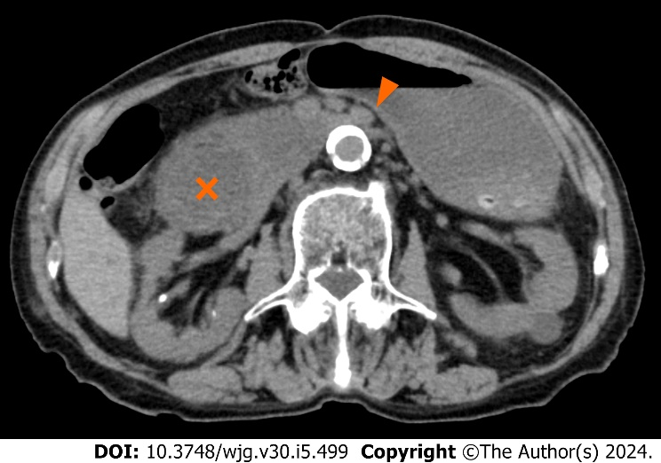
Figure 1 Computed tomography images of case 1. The axial view of computed tomography showed the compression of the third portion of the duodenum between the superior mesenteric artery and the aorta (arrowhead) as well as markedly dilated duodenum (cross) and stomach.

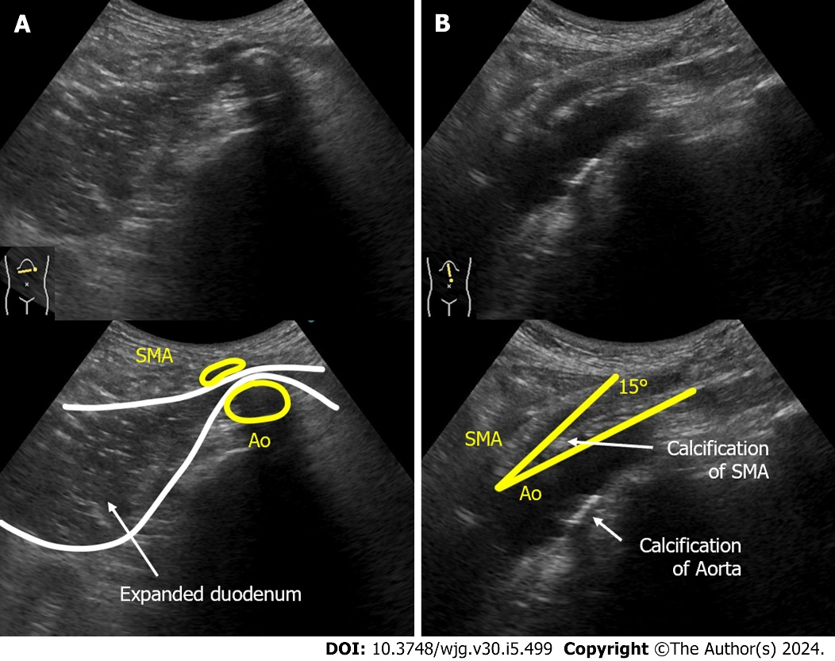
Figure 2 Abdominal ultrasonography images of case 1. A: The supine position of ultrasonography epigastric transverse scan confirmed expansion of the third part of the duodenal lumen and extrinsic compression of the duodenum by the superior mesenteric artery (SMA). The distance between the SMA and the aorta (Ao) was narrowed to 4 mm; B: Epigastric longitudinal scan showed that the angle of SMA-Ao decreased to 15°. Calcifications (arteriosclerosis) of the aorta and the root of SMA was also observed. SMA: Superior mesenteric artery; Ao: Aorta.

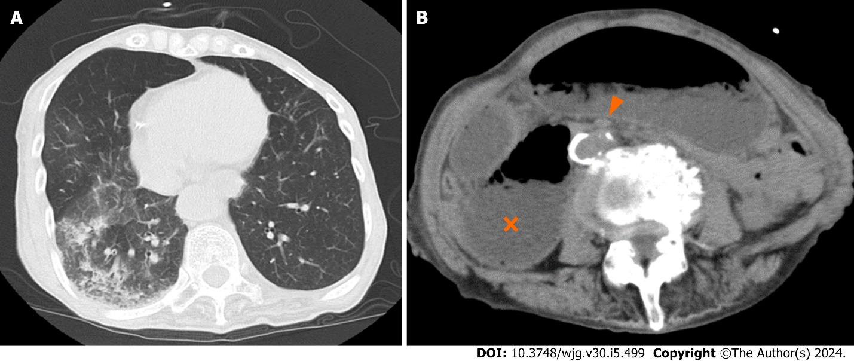
Figure 3 Computed tomography images of case 2. A: The axial view of thoracic computed tomography (CT) indicated aspiration pneumonia; B: The axial view of abdominal CT demonstrates extensive dilatation of stomach and proximal duodenum (cross), between the superior mesenteric artery (arrow head) and the aorta.

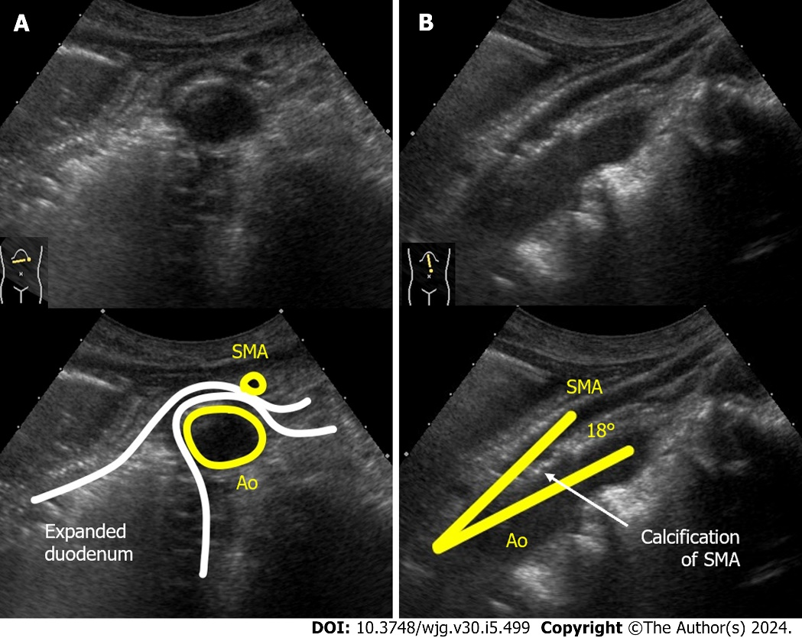
Figure 4 Dynamic ultrasonography images of case 2. A: The supine position of ultrasonography confirmed expansion of the third part of the duodenal lumen and extrinsic compression of the duodenum by the superior mesenteric artery (SMA). The distance between the SMA and the aorta (Ao) was narrowed to 5 mm; B: Epigastric longitudinal scan showed that the angle of SMA-Ao decreased to 18°. Calcifications (arteriosclerosis) of the aorta and the root of SMA was also observed. SMA: Superior mesenteric artery; Ao: Aorta.

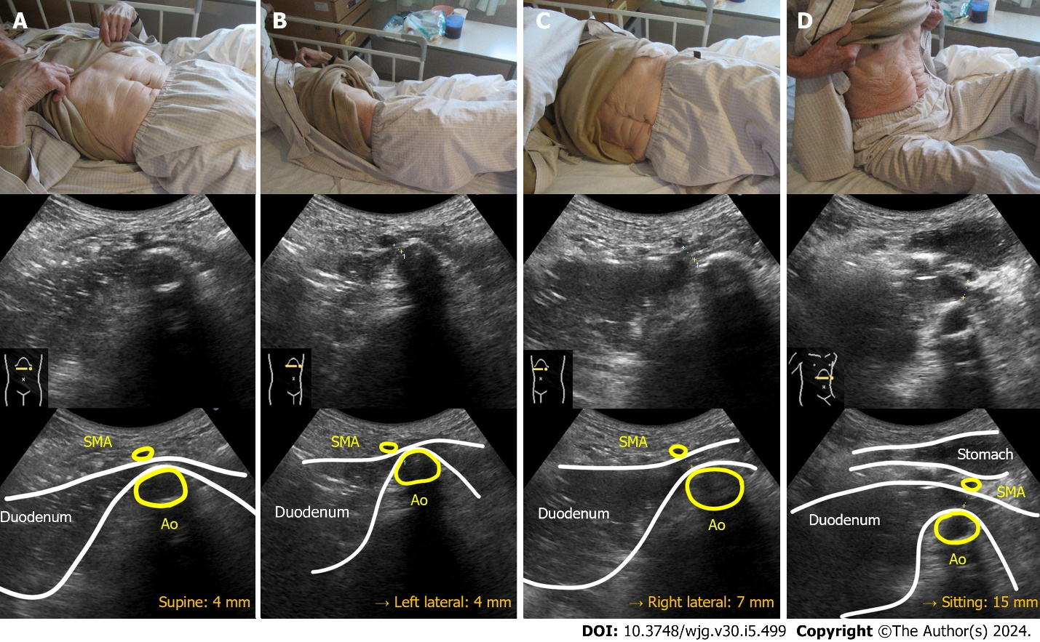
Figure 5 Dynamic ultrasonography images of case 1. A: Narrowed superior mesenteric artery-aorta (SMA-Ao) distance (4 mm); B: Left lateral position did not improve the SMA-Ao distance (4 mm); C: Right lateral position increased the SMA-Ao distance to 7 mm and the duodenal gas could pass through; D: Sitting position (Fowler’s position) dramatically improved the SMA-Ao distance to 15 mm and the passage of duodenal contents. SMA: Superior mesenteric artery; Ao: Aorta.

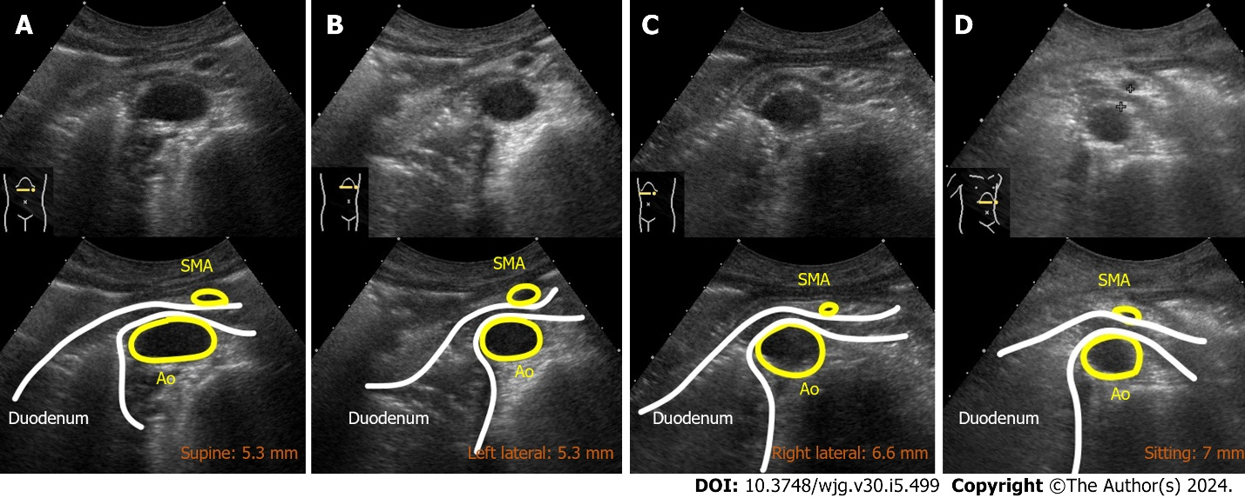
Figure 6 Dynamic ultrasonography images of case 2. A: Supine position showed the narrowed superior mesenteric artery-aorta (SMA-Ao) distance (5.3 mm); B: Left lateral position did not improve the SMA-Ao distance (5.3 mm); C and D: Right lateral position and sitting position increased the SMA-Ao distance to 6.6 and 7.0 mm, respectively. SMA: Superior mesenteric artery; Ao: Aorta.

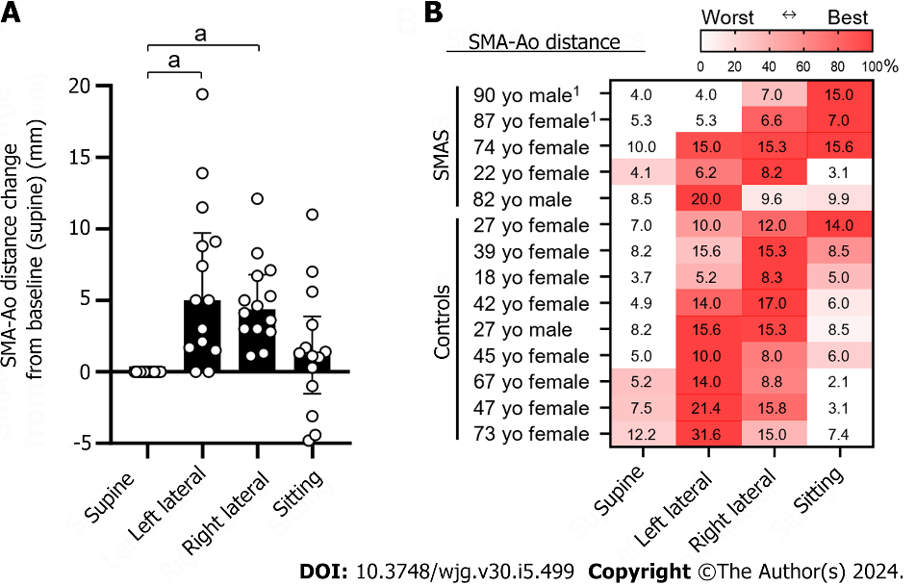
Figure 7 Superior mesenteric artery-aorta distance in four body positions in eight individuals. A: Distance change of superior mesenteric artery-aorta (SMA-Ao) from the baseline position (supine position). Dots indicate individual results. Bars indicate median with interquartile range; B: Fourteen individuals included five cases of superior mesenteric artery syndrome and nine healthy controls (age, sex, and absolute distance of SMA-Ao mm). The absolute distance of SMA-Ao (mm) in thirteen individuals were shown in each position. The SMA-Ao distances were measured by ultrasonography. If it was difficult to detect the duodenum, the subjects ingested 200 mL of water which is a modified method of drinking-ultrasonography test. Statistical analysis was performed by GraphPad Prism version 10.0.2 with Dunn’s multiple comparisons tests with ANOVA. ¹Indicates the present case. ªP < 0.01. The heat map indicates the best and worst positions of the SMA-Ao distance in each individual. SMA: Superior mesenteric artery; Ao: Aorta; SMAS: Superior mesenteric artery syndrome.

Published by Baishideng Publishing Group Inc
7041 Koll Center Parkway, Suite 160, Pleasanton, CA 94566, USA
Telephone: +1-925-3991568
E-mail: office@baishideng.com
Help Desk: https://www.f6publishing.com/helpdesk
https://www.wjgnet.com

© 2024 Baishideng Publishing Group Inc. All rights reserved.

