Name of Journal: World Journal of Radiology
ESPS Manuscript NO: 18639
Manuscript Type: ORIGINAL ARTICLE

Prospective Study

Incremental value of magnetic resonance neurography of Lumbosacral plexus over non-contributory lumbar spine magnetic resonance imaging in radiculopathy: A prospective study

Chhabra A et al. Incremental Value of MRN over MRI

Avneesh Chhabra, Sahar J Farahani, Gaurav K Thawait, Vibhor Wadhwa, Allan J Belzberg, John A Carrino

Avneesh Chhabra, Musculoskeletal Radiology, University of Texas Southwestern Medical Center, Dallas, TX 75390-9178, United States

Avneesh Chhabra, Sahar J Farahani, Gaurav K Thawait, Vibhor Wadhwa, John A Carrino, The Russell H. Morgan Department of Radiology and Radiological Science, Johns Hopkins University School of Medicine, Baltimore, MD 21205, United States

Vibhor Wadhwa, Department of Radiology, University of Arkansas for Medical Sciences, Little Rock, AR 72205, United States

Allan J Belzberg, Department of Neurosurgery, Johns Hopkins University School of Medicine, Baltimore, MD 21205, United States

John A Carrino, Department of Radiology and Imaging, Hospital for Special Surgery, New York, NY 10021, United States

Author contributions: Chhabra A guarantor of integrity of the entire study, study concepts and design, manuscript editing; Farahani SJ data collection, manuscript editing; Thawait GK data collection, manuscript preparation; Wadhwa V literature search, manuscript preparation; Belzberg AJ manuscript editing; Carrino JA study concepts and design, manuscript editing.

Institutional review board statement: Approval was taken from Institutional Review Board, Johns Hopkins University, No. IRB# JHM IRB NA_00050163.

Clinical trial registration statement: There is no Clinical trial registration statement.

Informed consent statement: All study participants, or their legal guardian, provided informed written consent prior to study enrollment.

Conflict-of-interest statement: Dr. Avneesh Chhabra received research grants from GE-AUR (GERRAF), Siemens Medical Solutions and Integra Life Sciences. He also serves as a research consultant with Siemens CAD group. Dr. John A Carrino received patient research grants from Siemens and serves as a speaker for Siemens lectures.

Data sharing statement: There is no additional data available.

Open-Access: This article is an open-access article which was selected by an in-house editor and fully peer-reviewed by external reviewers. It is distributed in accordance with the Creative Commons Attribution Non Commercial (CC BY-NC 4.0) license, which permits others to distribute, remix, adapt, build upon this work non-commercially, and license their derivative works on different terms, provided the original work is properly cited and the use is non-commercial. See: http://creativecommons.org/licenses/by-nc/4.0/

Correspondence to: Avneesh Chhabra, MD, Associate Professor, Section Chief, Radiology and Orthopedic Surgery, Musculoskeletal Radiology, UT Southwestern Medical Center, 5323 Harry Hines Blvd, Dallas, TX 75390-9178, United States. avneesh.chhabra@utsouthwestern.edu
Telephone: +1-214-6482122

Received: April 25, 2015
Peer-review started: May 4, 2015
First decision: October 27, 2015
Revised: November 12, 2015
Accepted: December 3, 2015
Article in press:
Published online:

Abstract
AIM: To test the incremental value of 3T magnetic resonance neurography (MRN) in a series of unilateral radiculopathy patients with non-contributory magnetic resonance imaging (MRI).

METHODS: Ten subjects (3 men, 7 women; mean age 54 yr and range 22-74 yr) with unilateral lumbar radiculopathy and with previous non-contributory lumbar spine MRI underwent lumbosacral (LS) plexus MRN over a period of one year. Lumbar spine MRI performed as part of the MRN LS protocol as well as bilateral L4-S1 nerves, sciatic, femoral and lateral femoral cutaneous nerves were evaluated in each subject for neuropathy findings on both anatomic (nerve signal, course and caliber alterations) and DTI tensor maps (nerve signal and caliber alterations). Minimum FA and mean ADC of L4-S2 nerve roots, sciatic and femoral nerves were recorded.

RESULTS: All anatomic studies and 80% of DTI imaging received a good-excellent imaging quality grading. In a blinded evaluation, all 10 examinations demonstrated neural and/or neuromuscular abnormality corresponding to the site of radiculopathy. A number of contributory neuropathy findings including double crush syndrome were observed. On DTI tensor maps, nerve signal and caliber alterations were more conspicuous. Although individual differences were observed among neuropathic appearing nerve (lower FA and increased ADC) as compared to its contralateral counterpart, there were no significant mean differences on statistical comparison of LS plexus nerves, femoral and sciatic nerves (P > 0.05).

CONCLUSION: MRN of LS plexus is useful modality for the evaluation of patients with non-contributory MRI of lumbar spine as it can incrementally delineate the etiology and provide direct objective and non-invasive evidence of neuromuscular pathology.

Key words: Radiculopathy; Magnetic resonance imaging; Neurography; Lumbosacral plexus

© The Author(s) 2015. Published by Baishideng Publishing Group Inc. All rights reserved.

Core tip: Magnetic resonance neurography of the lumbosacral plexus is a useful modality for the evaluation of patients with non-contributory magnetic resonance imaging of the lumbar spine. It can incrementally delineate the etiology and provides direct objective and non-invasive evidence of neuromuscular pathology.

Chhabra A, Farahani SJ, Thawait GK, Wadhwa V, Belzberg AJ, Carrino JA. Incremental value of magnetic resonance neurography of Lumbosacral plexus over non-contributory lumbar spine magnetic resonance imaging in radiculopathy: A prospective study. World J Radiol 2015; In press

INTRODUCTION
Radiculopathy refers to pain, weakness, numbness or tingling along the nerve distribution, due to inflammation or compression of the nerve roots. Electro-diagnostic (ED) testing, including electromyography and nerve conduction velocity are commonly used to confirm the presence of radiculopathy with high specificity, but with limited sensitivity^{[1]}. Magnetic Resonance imaging is the preferred non-invasive imaging technique in the evaluation of patients with radiculopathy, and serves as a valuable adjunct to ED testing. Magnetic resonance imaging (MRI) also shows excellent interobserver agreement for detection of nerve root compression in patients with radiculopathy^{[2]}. It helps in delineation of the site and cause of radiculopathy, and has been shown to have a greater sensitivity than ED testing, though with limited specificity^{[3]}. Management dilemma, however, frequently occurs when a patient with clinical features of radiculopathy has normal or non-contributory MRI findings. MR Neurography (MRN) is an imaging technique optimized for evaluation of the peripheral nerves and their associated pathologies. It uses high resolution imaging with combined 2-Dimensional (2D) and 3D inversion recovery (IR) TSE sequences for multiplanar depiction of small and large peripheral nerves emanating from the LS plexus and its tributaries. Currently available 3.0 Tesla (T) scanners provide increased SNR and superior spatial resolution over 1.5T scanners, with improved fluid conspicuity. This translates into better anatomic and pathological characterization of the nerves. The utility of MRN has been shown in evaluating patients with cervical and lumbar radiculopathy^{[4-7]}. However, its incremental value over conventional MR imaging has not yet been demonstrated. In this study, we tested the role of 3T MRN in a prospective series of patients with unilateral radiculopathy and a prior non-contributory MR imaging of the lumbar spine.

METHODS AND MATERIALS
Institutional review board approval was taken for this Health Insurance Portability and Accountability Act (HIPAA) compliant prospective study. Informed consent was obtained from all subjects. The subjects presented with unilateral radiculopathy symptoms, positive straight leg raising test, and had prior normal or non-contributory MR imaging of the lumbar spine. No patient had known tumor, neurofibromatosis, hereditary neuropathy or prior nerve surgery.

Imaging parameters
All patients were studied on 3.0 T, 60 cm bore research MR Scanner (Trio, Siemens, Erlangen, Germany) recruited over one year period (Table 1). The technique employed 2D axial T1W, Axial T2 SPAIR and isotropic 3D STIR SPACE (focused on whole abdomen and pelvis from T12-L1 level to lesser trochanters for the imaging for nerves); isotropic 3D T2 TSE focused on LS spine; and DTI technique from L3-lesser trochanters (single shot EPI, 12 encoding directions; b−values 0, 800 and 1000 s/mm², TR/TE/SL- 6000/68/4). The total acquisition time was 45 minutes.

Subjects
Ten subjects were recruited over the course of the year (3 men, 7 women; mean age 54 yr, range 22-74 yr). The symptoms and signs included pain (10/10), sensory alterations (2/10), motor symptoms (5/10), Tinel sign (0/10), prior trauma (3/10) and prior bony surgery in the field of view (2/10).

Image analysis
Two readers, experienced in musculoskeletal research imaging (Author 1, Author 3) assessed the image quality in consensus on a scale of 1-3 (1 - poor; 2 - good; 3 - excellent) on a PACS workstation (UV, Emageon). The readers were blinded to the clinical information from the patients and final reports of the prior imaging studies. Lumbar spine MR imaging performed as part of the MRN LS protocol as well as bilateral L4-S1 nerves, sciatic, femoral and lateral femoral cutaneous nerves were evaluated in each subject for neuropathy findings indicated by qualitative signal intensity and size alterations on anatomic and DTI tensor maps. Lowest FA (fractional anisotropy) and mean ADC values of L4-S2 nerve roots, sciatic and femoral nerves on tensor calculated images were recorded in consensus.

Statistical analysis
Descriptive analysis for qualitative imaging findings performed. All data were stored on a spreadsheet (Excel 2010, Microsoft, Seattle, WA). Paired t test was performed for the analysis of side to side differences among FA and mean ADC values of L4-S2 nerve roots, sciatic and femoral nerves. P value of < 0.05 was considered statistically significant.

RESULTS
All anatomic studies (10/10) received a quality grading of excellent quality and DTI studies received different quality grading (excellent 5/10, good 3/10 and poor 2/10). All DTI studies were included in analysis. In a blinded evaluation, all 10 examinations demonstrated neural and/or neuromuscular abnormality corresponding to the site of radiculopathy. The spectrum of abnormalities included imaging findings of contributory femoral neuropathy (2/10) (Figure 1), lateral femoral cutaneous neuropathy (2/10), lumbosacral nerve root abnormality (3/10), sciatic neuropathy (9/10) (Figure 2 and 3), obturator neuropathy (1/10), iliohypogastric neuropathy (1/10) (Figure 4), and double crush syndrome with ipsilateral S2 and sciatic neuropathy (1/10). The variants included split femoral nerve (1/10) and split sciatic nerves (3/10). Contributory lumbar disc herniation was seen in 2/10 cases. Other incidental abnormalities included hip labral tear (1/10), low grade hamstring tear (1/10), prostate hypertrophy (1/10), sacral insufficiency fractures (1/10), renal cysts (1/10), transitional lumbosacral vertebra (1/10), trochanteric bursitis (2/10), ischiofemoral impingement (1/10) and colonic diverticulosis (1/10). On DTI, the nerve signal alterations were more conspicuous. Although individual differences were observed between the abnormally hyperintense nerve as compared to its contralateral counterpart (Figure 1 and 4), there were no significant mean differences in FA and ADC on statistical comparison of LS plexus nerves, femoral and sciatic nerves (P > 0.05).

DISCUSSION
The LS plexus pathology can be a significant source of neuropathic pain (radiculopathy) which poses a great diagnostic challenge to the clinician and the radiologist, due to the deep location of the nerves and their variable regional innervation. LS spine related abnormalities also frequently mimic or contribute to the clinical features of radiculopathy^{[8]}. Traditionally, the diagnosis of LS radiculopathy is investigated using ED tests and MR lumbar spine findings. The high sensitivity of MRI combined with high specificity of ED tests often provide very good complementary information^{[1]}. However, ED tests are operator dependent and the results depend on the technical expertise of the examiner. Such studies are also invasive and not recommended in patients on anticoagulation therapy^{[9]}. MR imaging of LS spine is a reproducible and non-invasive diagnostic modality, but its value may be limited by a number of factors, such as the presence of multiple disc herniations or multilevel nerve impingements findings in middle aged-older age groups, commonly performed low resolution imaging with lack of thin slice 3D evaluation, absence of sacroiliac joint or pelvis inclusion in the field of view, and finally, reader focus on evaluation of the cause (disc herniation) versus effect (nerve inflammation or entrapment).
This preliminary prospective study has supports the incremental value of MRN LS plexus over lumbar spine MR imaging and ED studies. Since the protocol includes 3D imaging of lumbar spine, disc herniations and transitional bony anatomy can be easily assessed on multiplanar reconstructions. Although, the transitional segment could have been overlooked by the inexperienced outside reader in Figure 4, 3D imaging has the potential to make its identification more apparent and easier.
MRN of LS plexus is a different way of looking at the spine, with the conventional MR spine sagittal T1W and STIR imaging replaced by axial T1W, axial T2 SPAIR and coronal 3D IR TSE imaging. This allows comprehensive coverage of the whole lower abdomen and pelvis. Thereby, high resolution multi-planar depiction of normal and abnormal peripheral nerves is enabled^{[10-11]}. For side to side comparison, uniform fat suppression is essential. Therefore, authors use inversion recovery type fat suppression. Chemical selective fat suppression does not work well in the large field of view. On the other hand, STIR SPACE and axial SPAIR provide more uniform fat suppression in such a large field of view for optimal comparison. With 3D imaging, there is an additional advantage of vascular signal suppression with superior delineation of the nerves.
3D imaging clearly brings out subtle differences in the nerve signal intensity as shown in Figures 3 and 4, which are otherwise inconspicuous on the axial 2D images. DTI images further enhance the endoneurial fluid signal intensity alterations and confirm the side to side differences with effective vascular signal suppression on higher b values or tensor calculated images. This study shows that MRN produces high quality anatomic images of the LS plexus in all cases and in about 80% cases of DTI, and confirms the clinical diagnosis. It can be potentially an important for patient satisfaction, since MRN objectively demonstrates the findings corresponding to the side of symptoms when other tests do not reveal the cause or confirm the clinical suspicion of radiculopathy. Additionally, it provides additional anatomic and lesion assessment which is not possible with other modalities^{[6,12]}.
Due to the high resolution (1.5mm isotropic voxel for 3D imaging and 0.5-0.6mm in plane resolution of 2D imaging), MRN affords comprehensive assessment of lumbar spine, pelvis, sacroiliac joints, hips and regional muscles as a one-stop shop. It is reflected in the number of incidental findings observed in this small study.
MRN showed pathology in the LS plexus nerves on the side of symptoms. Additionally, it also showed nerve variants in bilateral femoral and sciatic nerves. Similar to pathologic findings of disc herniations not impinging the nerves, mere presence of developmental variants does not mean that the latter is the cause of symptoms. Direct visualization of neuromuscular abnormality is an indispensable finding.
The MRN with DTI imaging protocol takes approximately 45 minutes on 3T scanner using front XL torso coil linked to spine coils in the back. We didn’t administer intravenous contrast, since we didn’t include any cases of known tumor. Normal spine MR imaging takes about 30 minutes on 3T scanner. We do not advocate replacing conventional LS MR imaging with MRN of LS plexus on a routine basis, since it takes longer to read MRN examinations and acquisition time is also longer. However, the incremental value over the conventional spine MRI examinations is important to appreciate and MRN exams should be considered in the setting of non-contributory MRI in radiculopathy patients.
Our study has several limitations. First, being a small pilot study, we did not obtain inter- or intra-observer performance assessment. It should be kept in mind that prospective studies are difficult and expensive to accomplish and we could perform only 10 examinations over one year period from the neurosurgery clinic. Second, although there was good correlation of imaging findings, it is not an accuracy study and we do not yet have outcomes data, which remains a topic for further research. Third, there is a spectrum and selection bias, but it could not be avoided, since we wanted to study incremental value of MRN over MR spine studies. Finally, we did not test cervical radiculopathy cases, we cannot comment on whether it provides any incremental value over MRI in those cases.

In conclusion, MRN of LS plexus is useful modality for the evaluation of patients with non-contributory MR imaging of lumbar spine as it can delineate the etiology and provide direct objective and non-invasive evidence of neuromuscular pathology.

COMMENTS
Background
Magnetic resonance imaging (MRI) is the preferred non-invasive imaging technique in the evaluation of patients with radiculopathy, and serves as a valuable adjunct to electro-diagnostic testing. However, a diagnostic dilemma may occur when a patient with clinical features of radiculopathy has normal or non-contributory MRI findings.

Research frontiers
Magnetic resonance neurography (MRN) is an imaging technique optimized for evaluation of the peripheral nerves and their associated pathologies. The purpose of this study was to test the role of 3T MRN in a prospective series of patients with unilateral radiculopathy and a prior non-contributory MR imaging of the lumbar spine.

Innovations and breakthroughs
All examinations in the present study demonstrated neural and/or neuromuscular abnormality corresponding to the site of radiculopathy, thus proving that MRN is a useful modality for the evaluation of patients with non-contributory MR imaging of lumbar spine.

Applications
This study serves as evidence that MRN can be used to delineate the cause of radiculopathy in patients with non-contributory MRI findings.

Peer-review
In this preliminary study, the authors had investigated the role of MRN in the LS plexus neuropathy and found that MRN is useful modality for the evaluation of patients with non-contributory MRI of lumbar spine as it can incrementally delineate the etiology and provide direct objective and non-invasive evidence of neuromuscular pathology.
REFERENCES
1 Barr K. Electrodiagnosis of lumbar radiculopathy. Phys Med Rehabil Clin N Am 2013; 24: 79-91 [PMID: 23177032 DOI: 10.1016/j.pmr.2012.08.011]
2 Kuijper B, Beelen A, van der Kallen BF, Nollet F, Lycklama A Nijeholt GJ, de Visser M, Tans JT. Interobserver agreement on MRI evaluation of patients with cervical radiculopathy. Clin Radiol 2011; 66: 25-29 [PMID: 21147295 DOI: 10.1016/j.crad.2010.07.010]
3 Reza Soltani Z, Sajadi S, Tavana B. A comparison of magnetic resonance imaging with electrodiagnostic findings in the evaluation of clinical radiculopathy: a cross-sectional study. Eur Spine J 2014; 23: 916-921 [PMID: 24413775 DOI: 10.1007/s00586-013-3164-z]
4 Erdem CZ, Erdem LO, Cağavi F, Kalayci M, Gündoğdu S. High resolution MR neurography in patients with cervical radiculopathy. Tani Girisim Radyol 2004; 10: 14-19 [PMID: 15054696]
5 Dailey AT, Tsuruda JS, Goodkin R, Haynor DR, Filler AG, Hayes CE, Maravilla KR, Kliot M. Magnetic resonance neurography for cervical radiculopathy: a preliminary report. Neurosurgery 1996; 38: 488-492, discussion 492 [PMID: 8837800]
6 Soldatos T, Andreisek G, Thawait GK, Guggenberger R, Williams EH, Carrino JA, Chhabra A. High-resolution 3-T MR neurography of the lumbosacral plexus. Radiographics 2013; 33: 967-987 [PMID: 23842967 DOI: 10.1148/rg.334115761]
7 Chen YY, Lin XF, Zhang F, Zhang X, Hu HJ, Wang DY, Lu LJ, Shen J. Diffusion tensor imaging of symptomatic nerve roots in patients with cervical disc herniation. Acad Radiol 2014; 21: 338-344 [PMID: 24361075 DOI: 10.1016/j.acra.2013.11.005]
8 Nardo L, Alizai H, Virayavanich W, Liu F, Hernandez A, Lynch JA, Nevitt MC, McCulloch CE, Lane NE, Link TM. Lumbosacral transitional vertebrae: association with low back pain. Radiology 2012; 265: 497-503 [PMID: 22952380 DOI: 10.1148/radiol.12112747]
9 Chémali KR, Tsao B. Electrodiagnostic testing of nerves and muscles: when, why, and how to order. Cleve Clin J Med 2005; 72: 37-48 [PMID: 15691056]
10 Chhabra A. Peripheral MR neurography: approach to interpretation. Neuroimaging Clin N Am 2014; 24: 79-89 [PMID: 24210314 DOI: 10.1016/j.nic.2013.03.033]
11 Chhabra A, Lee PP, Bizzell C, Soldatos T. 3 Tesla MR neurography--technique, interpretation, and pitfalls. Skeletal Radiol 2011; 40: 1249-1260 [PMID: 21547613 DOI: 10.1007/s00256-011-1183-6]
12 Moore KR, Tsuruda JS, Dailey AT. The value of MR neurography for evaluating extraspinal neuropathic leg pain: a pictorial essay. AJNR Am J Neuroradiol 2001; 22: 786-794 [PMID: 11290501]
P-Reviewer: Shen J S-Editor: Qi Y L-Editor: E-Editor:

Table 1 Magnetic resonance neurography protocol on 3 Tesla scanner

Pulse sequence | 2D/3D | TR (ms) | TE (ms) | Slice thickness (mm) | Coverage
Axial T1W | 2D | 700 | 8 | 4 | T12-L1 to lesser trochanters
Axial T2 SPAIR | 2D | 4800 | 65 | 4 | T12-L1 to lesser trochanters
Coronal STIR SPACE | 3D | 2000 | 78 | 1.5 isotropic | T12-L1 to lesser trochanters
Sagittal T2 SPACE | 3D | 2000 | 120 | 0.9 isotropic | T12-L1 to sacrum
Axial DTI | 2D | 6000 | 65 | 4 | T12-L1 to lesser trochanters
2D/3D: 2 dimensional/3 dimensional; DTI: Diffusion tensor imaging; SPACE: Sampling perfection with application optimized contrasts using variable flip angle evolutions; SPAIR: Spectral adiabatic inversion recovery; STIR: Short tau inversion recovery; TR: Repetition time; TE: Echo time.

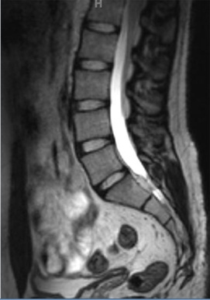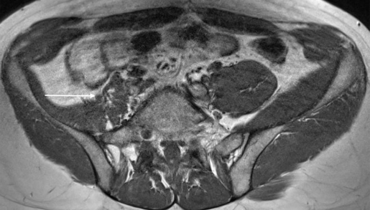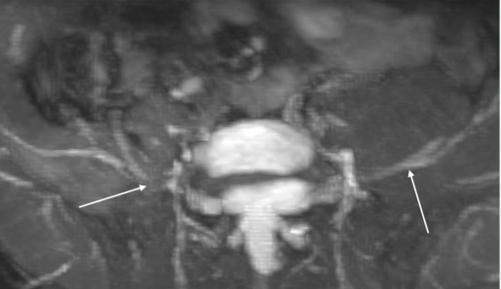
A B C
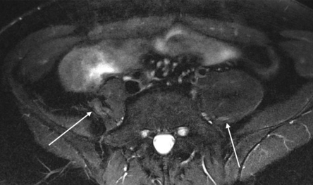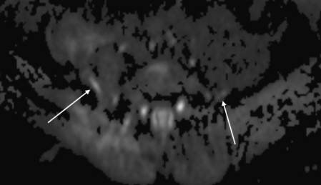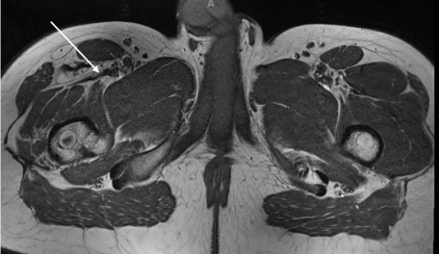
D E F
Figue 1 Right femoral neuropathy. A 22-year-old man with prior motor vehicle accident and right iliac bone surgery presented with severe right anterior leg pain and partial limb weakness, ongoing for more than 1 year. Outside MR imaging of LS spine was normal and EMG was negative. Outside right hip MRI was also reported normal. Sagittal LS spine T2 TSE (A) as part of the plexus protocol shows normal imaging appearance. Axial T1W (B) image shows irregular fibrosis along the expected course of the right femoral nerve with ipsilateral iliopsoas atrophy (arrow). Axial MIP reconstructed 3D IR TSE (C) image shows focal loss of signal along the right femoral nerve due to fibrous entrapment (arrows). Axial T2 SPAIR (D) and DTI tensor images (E) show the abnormal signal size alteration of the right femoral nerve (arrows). Axial T1W image of the lower pelvis (F) shows right quadriceps atrophy (arrow). Right Femoral Nerve- Mean FA = 0.45 Mean ADC = 1320mm2/s; Left Femoral Nerve- Mean FA = 0.77
Mean ADC = 1136.8 mm²/s.

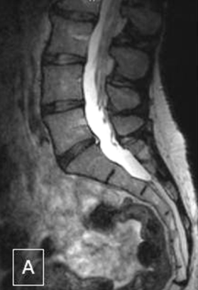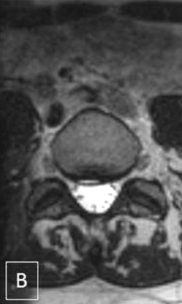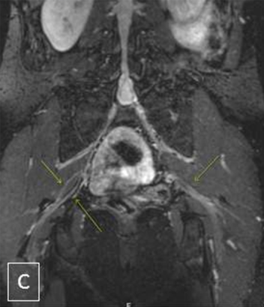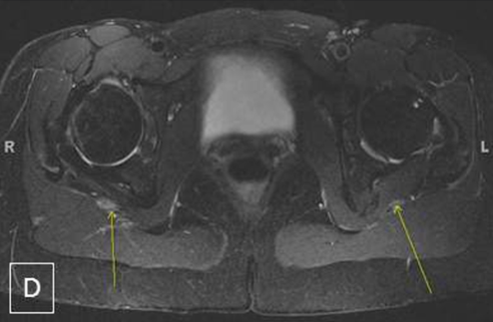
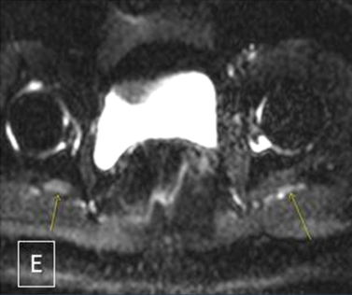
Figue 2 Right piriformis syndrome. A 42-year-old woman with 2 year history of intermittent partial foot drops and right gluteal pain. EMG was negative. Outside MR imaging of LS spine was reported normal, except small disc herniation at L5-S1 level. MRN LS plexus (A-E) shows small annular fissure and right paracentral disc herniation at L5-S1 level (A, B) on 3D TSE imaging of lumbar spine. Coronal 3D IR TSE (C) shows bilateral split sciatic nerves (right > left, arrows). Axial T2 SPAIR (D) image shows mildly enlarged and hyperintense right sciatic nerve (arrows), immediately outside the greater sciatic notch. Axial DTI (E) confirms more conspicuity of the right sciatic nerve abnormality (arrows).

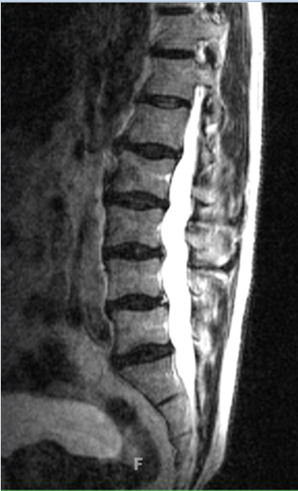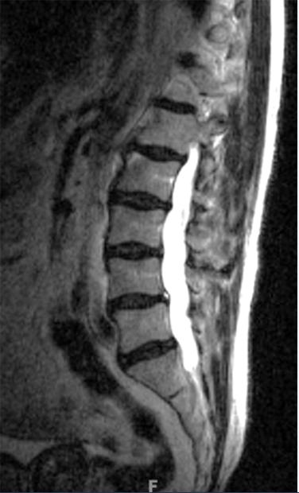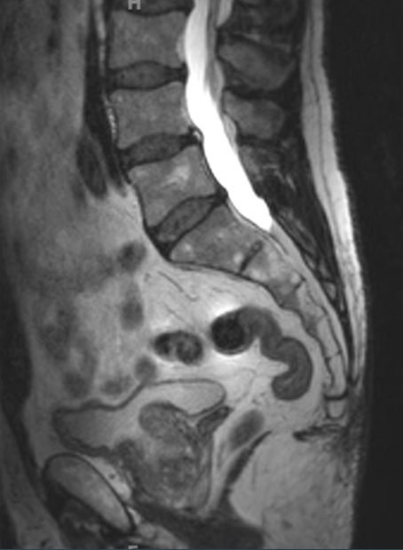
A B C
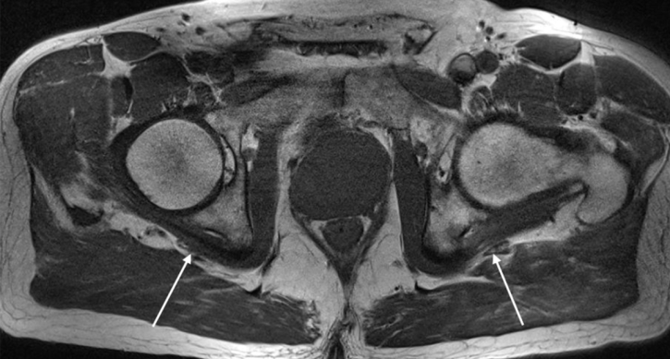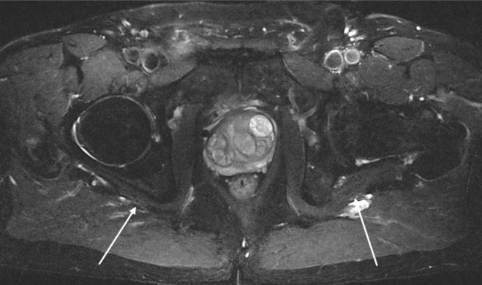
D E
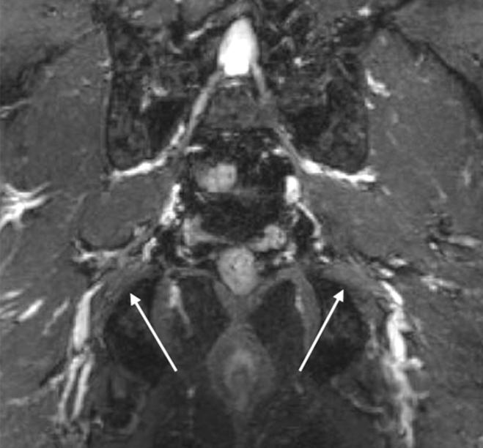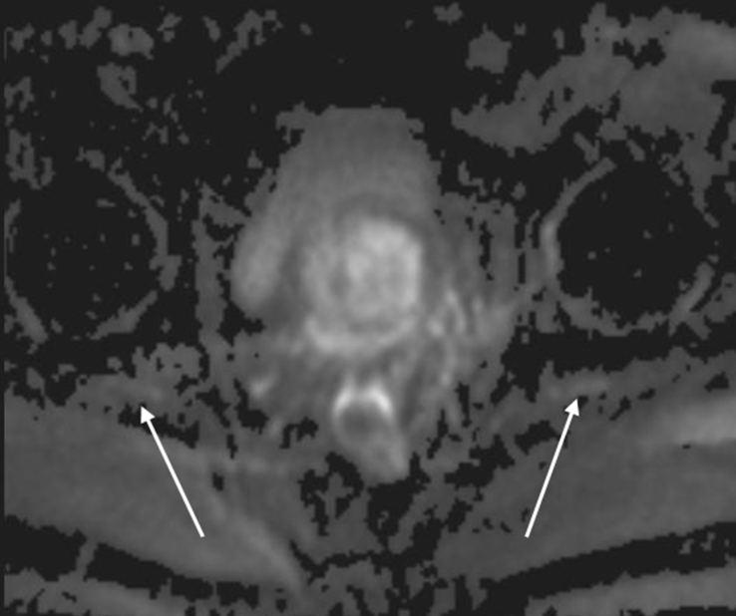
F G
Figue 3 Left sciatic chronic neuropathy. A 65-year-old man with prior left pelvic bone fracture and persistent left radicular pain. EMG was negative. MR imaging of LS spine obtained 12 mo (A) and 6 mo (B) before the MRN LS plexus examination (C-F) shows multilevel mild degenerative changes. Axial T1W (D), corresponding T2 SPAIR (E), 3D IR TSE (F) and axial DTI tensor (G) images show asymmetric mild increased signal of the left sciatic nerve with mild fatty infiltration (arrows).
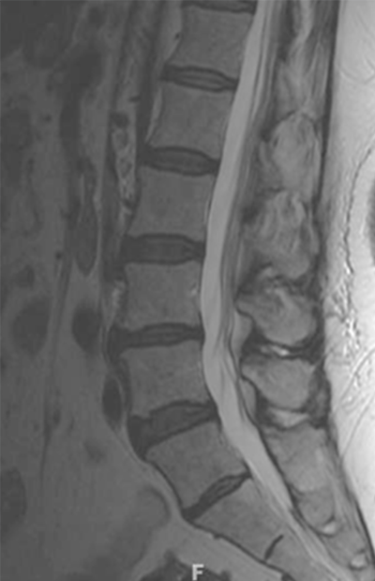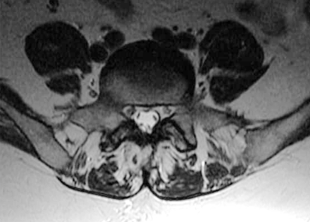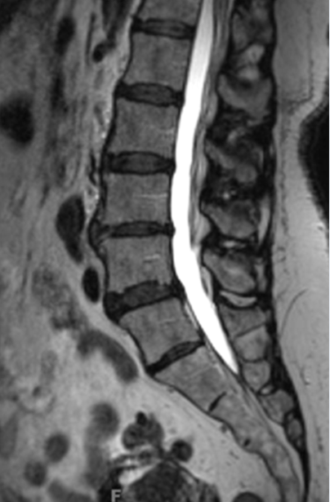
A B C
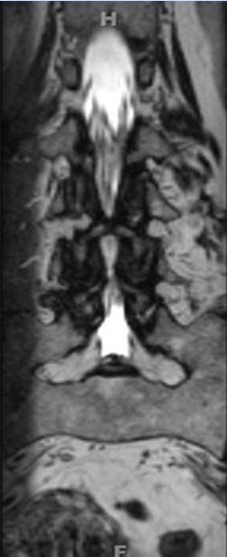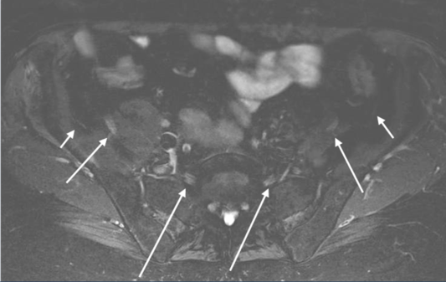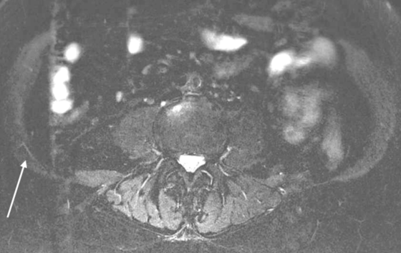
D E F
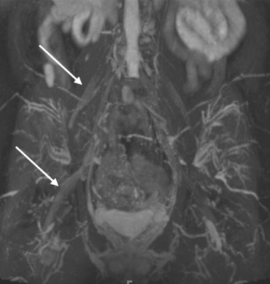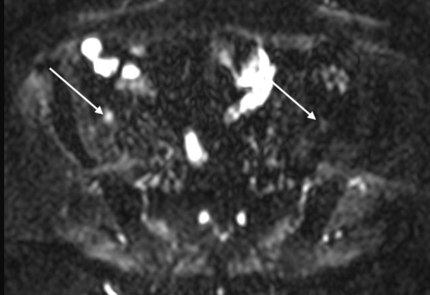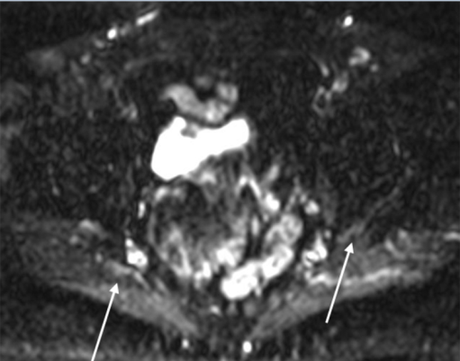
G H I
Figue 4 Right LS plexopathy. A 74-year-old woman with right leg and pelvic pain and mild right leg weakness. Outside LS spine MR (A, B) was reported negative. MRN LS plexus shows the transitional, partially sacralized L5 vertebra (C,D) and abnormally hyperintense right sided nerves (E), namely, lateral femoral cutaneous nerve (small arrow); femoral nerve (medium arrow), and L5 nerve (large arrow). Axial T2 SPAIR image shows hyperintense iliohypogastric nerve (arrow in F) and 3D MIP IR TSE image (G) confirms the right sided neural abnormalities. Axial DTI (H,I) images show the conspicuous abnormality of the right femoral (arrow in H) and sciatic (arrow in I) nerves. Right L4 Nerve- Mean FA = 0.46 Mean ADC = 1231 mm²/s; Left L4 Nerve- Mean FA = 0.5 Mean ADC = 1304. Right L5 Nerve-Mean FA = 0.26 Mean ADC = 1193.7 mm²/s; Left L5 Nerve-Mean FA = 0.36 Mean ADC = 1141 mm²/s.

