We declare that for the present manuscript no grant or fund has been given and used
Maurizio Salvadori MD
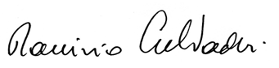
March 30th, 2018

