Name of Journal: World Journal of Gastrointestinal Surgery
ESPS Manuscript NO: 18500
Manuscript Type: CASE REPORT

Laparoscopic surgery for small-bowel obstruction caused by Meckel’s diverticulum

Matsumoto T et al. Small-bowel obstruction and Meckel’s diverticulum

Takatsugu Matsumoto, Motoki Nagai, Daisuke Koike, Yukihiro Nomura, Nobutaka Tanaka

Takatsugu Matsumoto, Second Department of Surgery, Dokkyo Medical University, Tochigi 371-0014, Japan

Motoki Nagai, Daisuke Koike, Yukihiro Nomura, Nobutaka Tanaka, Department of General Surgery, Asahi General Hospital, Chiba 371-0073, Japan

Author contributions: All authors contributed to the acquisition of data, writing, and revision of this manuscript.

Supported by Department of General Surgery, Asahi General Hospital, I-1326, Asahi-shi, Chiba, Japan.

Institutional review board statement: This case report was exempt from the Institutional Review Board standards at Asahi General Hospital in Chiba, Japan.

Informed consent statement: The patient involved in this study gave her written informed consent authorizing use and disclosure of her protected health information.

Conflict-of-interest statement: All the authors have no conflicts of interests to declare.

Open-Access: This article is an open-access article which was selected by an in-house editor and fully peer-reviewed by external reviewers. It is distributed in accordance with the Creative Commons Attribution Non Commercial (CC BY-NC 4.0) license, which permits others to distribute, remix, adapt, build upon this work non-commercially, and license their derivative works on different terms, provided the original work is properly cited and the use is non-commercial. See: http://creativecommons.org/licenses/by-nc/4.0/

Correspondence to: Takatsugu Matsumoto, MD, Assistant Professor, Second Department of Surgery, Dokkyo Medical University, 880, Kitakobayashi, Mibu, Tochigi 371-0014, Japan. takatsugu_m_475@yahoo.co.jp
Telephone: +81-282-872158
Fax: +81-282-866317

Received: April 22, 2015
Peer-review started: April 30, 2015
First decision: June 24, 2015
Revised: October 8, 2015
Accepted: November 3, 2015
Article in press:
Published online:

Abstract
A 26-year-old woman was referred to our hospital because of abdominal distention and vomiting. Contrast-enhanced computed tomography showed a blind loop of the bowel extending to near the uterus and a fibrotic band connecting the mesentery to the top of the bowel, suggestive of Meckel’s diverticulum (MD) and a mesodiverticular band (MDB). After intestinal decompression, elective laparoscopic surgery was carried out. Using three 5-mm ports, MD was dissected from the surrounding adhesion and MDB was divided intracorporeally. And subsequent Meckel’s diverticulectomy was performed. The presence of heterotopic gastric mucosa was confirmed histologically. The patient had an uneventful postoperative course and was discharged 5 d after the operation. She has remained healthy and symptom-free during 4 years of follow-up. This was considered to be an unusual case of preoperatively diagnosed and laparoscopically treated small-bowel obstruction due to MD in a young adult woman.

Key words: Surgery; Human; Meckel’s diverticulum; Small-bowel obstruction; Laparoscopic surgery

© The Author(s) 2015. Published by Baishideng Publishing Group Inc. All rights reserved.

Core tip: Meckel’s diverticulum (MD) is a rare innate anomaly of the gastrointestinal tract caused by incomplete obliteration of the omphalomesenteric duct. It sometimes causes small bowel obstruction. However, as it symptoms are so non-specific, it may be difficult to make a correct diagnosis without exploratory laparotomy. This is a successful case of small-bowel obstruction caused by MD that was diagnosed preoperatively using multi-dimensional contrast-enhanced computed tomography and treated by elective laparoscopic surgery.

Matsumoto T, Nagai M, Koike D, Nomura Y, Tanaka N. Laparoscopic surgery for small-bowel obstruction caused by Meckel’s diverticulum. World J Gastrointest Surg 2015; In press

INTRODUCTION
Meckel’s diverticulum (MD) is one of the most common congenital anomaly of the gastrointestinal tract that results from an incomplete obliteration of the omphalomesenteric duct^{[1,2]}. It has an incidence of 1%-2% among the general population, and most cases remain asymptomatic^{[2]}. The rate of developing complicated MD is reported to be about 4% throughout lifetime^{[3]}, which comprises bleeding, inflammation or obstruction.
Intestinal obstruction may occur in cases where there is a volvulus or an internal hernia around a diverticulum, intussusception, or incarceration of the diverticulum in an inguinal (Littré) hernia^{[1]}. However, as its symptoms, such as abdominal pain, distention, vomiting or constipation, are so non-specific, it may be difficult to make a correct diagnosis, and exploratory laparotomy is often required.
Here we report a case of small-bowel obstruction caused by MD that was diagnosed preoperatively using multi-dimensional contrast-enhanced computed tomography (CECT) and treated by elective laparoscopic surgery.

CASE REPORT
A 26-year-old woman was admitted to our hospital complaining of abdominal pain and recurrent vomiting. She had been hospitalized because of ovarian hyperstimulation syndrome 2 years previously, and had also suffered an episode of small-bowel obstruction 1 year prior to admission, which had been diagnosed as food impaction. She had no episode of hematochezia.
Physical examination demonstrated abdominal distention, with a soft abdomen and no tenderness or rebound pain. Her bowel sounds were hyperactive. Results of a hematologic examination were normal, and a urine pregnancy test gave a negative result.
Abdominal plain X-ray examination demonstrated a ladder-like series of distended small-bowel loops (Figure 1). Multi-dimensional CECT showed a blind-ending U-shaped loop of bowel in the pelvis and a fibrotic band connecting the mesentery to the blind end of the bowel, suggesting MD and a mesodiverticular band (MDB) (Figure 2). A change in the caliber of the ileum was evident adjacent to the band.
We diagnosed the patient as having small-bowel obstruction, probably caused by adhesion to the MDB of MD, without any sign of vascular compromise.
A long tube was placed and her small intestine was successfully decompressed. After the tube had been removed, scintigraphy with 99mTc-Na-pertechnetate was performed, and this revealed uptake in the lower abdomen (Figure 3).
Although surgical treatment was proposed, the patient expressed a wish to temporarily leave hospital because of pressing business matters. She was therefore discharged after 1 wk of hospitalization.
Two months after discharge, we performed elective laparoscopic surgery using three 5-mm ports. MD was dissected from the surrounding adhesion and MDB was divided intracorporeally. Then subsequent Meckel’s diverticulectomy was performed extracorporeally via a 2 cm mini-laparotomy. The postoperative course was uneventful and the patient was discharged on postoperative day 5, and she has since remained healthy and symptom-free during 4 years of follow-up.
Histological examination confirmed the presence of a MDB (Figure 3) and heterotopic gastric mucosa in the mucosa of the diverticulum (Figures 4 and 5).

DISCUSSION
MD is an innate anomaly of the gastrointestinal system caused by incomplete closure of the omphalomesenteric duct^{[1]}. MD was so named in 1809 after its discoverer, the German anatomist Johann Friedrich Meckel. The presence of MD can be explained in terms of intrauterine evolution of the bowel. The omphalomesenteric duct is the embryonic communication between the yolk sac and the developing midgut. By the 10th week of embryogenesis, the omphalomesenteric duct becomes a thin fibrous band. However, incomplete atrophy of the omphalomesenteric duct may result in a variety of anomalies, they are, umbilicoileal fistula, omphalomesenteric duct cyst or MD^{[4]}.
The diverticulum originates from the antimesenteric border of the small bowel, within 40-100 cm of the ileocecal valve^{[4,5]}. Blood is supplied via the vitelline artery, which is a branch of the ileocecal artery. The diverticulum is ordinarily lined by intestinal mucosa, but the heterotopic gastric mucosa or pancreatic tissue was frequently observed by the histological examination^{[4,5]}.
Reportedly, 25% of MD become symptomatic throughout the lifetime^{[4]}. Bleeding, inflammation or obstruction are the main cause of complication^{[2]}. Statistically, hemorrhage is the most common presentation in children aged 2 years or younger^{[6]}, whereas intestinal obstruction is the commonest presentation among adults^{[7]}. Intestinal obstruction due to MD is the most common presentation in adults and the second most common in children^{[6,7]}.
The clinical symptoms are non-specific; patients may have abdominal pain and distension, vomiting or constipation. MD-related small-bowel obstruction occurs so infrequently that most articles have reported only small series or isolated cases. Moreover, many patients with MD have non-specific abdominal symptoms, often making a correct preoperative diagnosis difficult, especially in an emergency setting^{[8,9]}.
The present case illustrates that abdominal CECT has the potential to identify the MDB and MD as the cause of small-bowel obstruction. Multi-dimensional CECT, especially in the coronal view, may yield more information about the cause of the small-bowel obstruction and the presence of a MDB. CECT is less invasive and speedier than other examinations such as Tc scintigraphy, interventional radiology or a gastrointestinal series, and therefore is more preferable in an emergency setting, yielding information about the cause of the small-bowel obstruction, such as internal hernia or other intestinal mass. CECT can also reveal the presence of strangulation. In the present case, we were able to confirm by CECT that there was no sign of vascular compromise, enabling us to start intestinal decompression in preparation for elective laparoscopic surgery.
Laparoscopic surgery for MD has been widely used recently. However, as it is not clear whether laparoscopic surgery is preferable to laparotomy in the setting of small-bowel obstruction^{[10]}, we performed intestinal decompression first. MD can be resected either extracorporeally or intracorporeally^{[9,11]}. Although some reports have indicated intracorporeral laparoscopic diverticulectomy, we selected laparoscopy-assisted diverticulectomy via a small incision in the lower abdomen to allow palpation of the MD, thus helping to rule out any mass or thickening of the base, and allowing a more complete assessment for the presence of any ectopic gastric mucosa^{[12]}.
In conclusion, we successfully treated MD causing small bowel obstruction by laparoscopic surgery. Multi-dimensional CECT may yield to detect both the etiology of small-bowel obstruction and the presence of strangulation in such unusual settings.

COMMENTS
Case characteristics
A 26-year-old woman with past history of small bowel obstruction presented with abdominal pain and recurrent vomiting.

Clinical diagnosis
Physical examination demonstrated abdominal distention, with a soft abdomen and no tenderness or rebound pain. Her bowel sounds were hyperactive.

Differential diagnosis
Small bowel obstruction due to food impaction, sue to internal hernia, or due to intestinal tumor.

Laboratory diagnosis
All labs were within normal limits.

Imaging diagnosis
Multi-dimensional contrast enhanced computed tomography showed a blind-ending U-shaped loop of bowel in the pelvis and a fibrotic band connecting the mesentery to the blind end of the bowel, suggesting Meckel’s diverticulum (MD) and a mesodiverticular band (MDB).

Pathological diagnosis
MDB and heterotopic gastric mucosa in the mucosa of the MD.

Treatment
Long tube decompression and subsequent laparoscopic diverticulectomy.

Related reports
MD occurs with an incidence of 1%-2% among the general population, and most cases remain asymptomatic. Complications result most commonly from bleeding, inflammation, or obstruction.

Term expression
The MDB is an embryologic remnant of the vitelline circulation which carries the arterial supply to the Meckel's diverticulum. In the event of an error of involution, a patent or nonpatent arterial band persists and extends from the mesentery to the apex of the anti-mesenteric diverticulum.

Experiences and lessons
This is a successful case of small-bowel obstruction caused by MD that was diagnosed preoperatively using multi-dimensional contrast-enhanced computed tomography and treated by elective laparoscopic surgery.

Peer-review
This is an interesting report on a rare etiologic factor of bowel obstruction in young adults.

REFERENCES
1 Platon A, Gervaz P, Becker CD, Morel P, Poletti PA. Computed tomography of complicated Meckel's diverticulum in adults: a pictorial review. Insights Imaging 2010; 1: 53-61 [PMID: 22347905 DOI: 10.1007/s13244-010-0017-8]
2 Park JJ, Wolff BG, Tollefson MK, Walsh EE, Larson DR. Meckel diverticulum: the Mayo Clinic experience with 1476 patients (1950-2002). Ann Surg 2005; 241: 529-533 [PMID: 15729078]
3 Dumper J, Mackenzie S, Mitchell P, Sutherland F, Quan ML, Mew D. Complications of Meckel's diverticula in adults. Can J Surg 2006; 49: 353-357 [PMID: 17152574]
4 Levy AD, Hobbs CM. From the archives of the AFIP. Meckel diverticulum: radiologic features with pathologic Correlation. Radiographics 2004; 24: 565-587 [PMID: 15026601 DOI: 10.1148/rg.242035187]
5 Rossi P, Gourtsoyiannis N, Bezzi M, Raptopoulos V, Massa R, Capanna G, Pedicini V, Coe M. Meckel's diverticulum: imaging diagnosis. AJR Am J Roentgenol 1996; 166: 567-573 [PMID: 8623629]
6 Rutherford RB, Akers DR. Meckel's diverticulum: a review of 148 pediatric patients, with special reference to the pattern of bleeding and to mesodiverticular vascular bands. Surgery 1966; 59: 618-626 [PMID: 5295737]
7 Alvite Canosa M, Couselo Villanueva JM, Iglesias Porto E, González López R, Montoto Santomé P, Arija Val F. [Intestinal obstruction due to axial torsion and gangrene of a giant Meckel diverticulum]. Gastroenterol Hepatol 2012; 35: 452-453 [PMID: 22425353 DOI: 10.1016/j.gastrohep.2012.01.007]
8 Sharma RK, Jain VK. Emergency surgery for Meckel's diverticulum. World J Emerg Surg 2008; 3: 27 [PMID: 18700974 DOI: 10.1186/1749-7922-3-27]
9 Sai Prasad TR, Chui CH, Singaporewalla FR, Ong CP, Low Y, Yap TL, Jacobsen AS. Meckel's diverticular complications in children: is laparoscopy the order of the day? Pediatr Surg Int 2007; 23: 141-147 [PMID: 17171378 DOI: 10.1007/s00383-006-1844-z]
10 Sauerland S, Agresta F, Bergamaschi R, Borzellino G, Budzynski A, Champault G, Fingerhut A, Isla A, Johansson M, Lundorff P, Navez B, Saad S, Neugebauer EA. Laparoscopy for abdominal emergencies: evidence-based guidelines of the European Association for Endoscopic Surgery. Surg Endosc 2006; 20: 14-29 [PMID: 16247571 DOI: 10.1007/s00464-005-0564-0]
11 Saggar VR, Krishna A. Laparoscopy in suspected Meckels diverticulum: negative nuclear scan notwithstanding. Indian Pediatr 2004; 41: 747-748 [PMID: 15297698]
12 Cobellis G, Cruccetti A, Mastroianni L, Amici G, Martino A. One-trocar transumbilical laparoscopic-assisted management of Meckel's diverticulum in children. J Laparoendosc Adv Surg Tech A 2007; 17: 238-241 [PMID: 17484657 DOI: 10.1089/lap.2006.0036]

P-Reviewer: Ciaccio EJ, Gheita TA, Lakatos PL, Vegh Z S-Editor: Ji FF L-Editor: E-Editor:

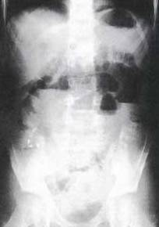
Figure 1 Abdominal plain X-ray examination demonstrated a ladder-like series of distended small-bowel loops.

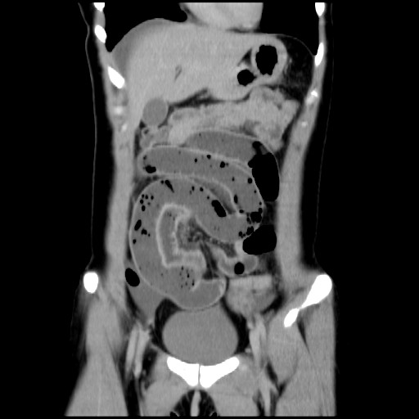
Figure 2 Contrast-enhanced computed tomography (coronal section image) showing a blind loop of the bowel extending near the uterus (arrowhead) and a fibrotic band connecting the mesentery to the top of the bowel (arrow) suggesting Meckel’s diverticulum and a mesodiverticular band. The terminal ileum appeared to be conglutinated to the band and a change in caliber was ascertained.

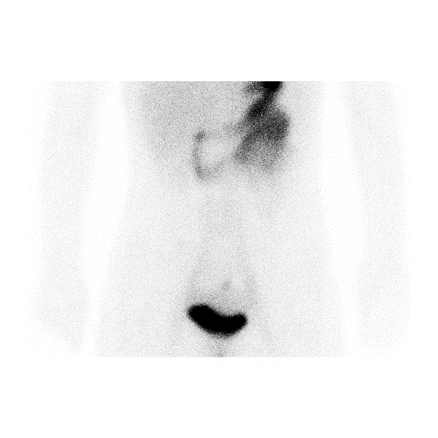
Figure 3 99mTc-Na-pertechnetate revealed uptake in the lower abdomen (arrowhead).

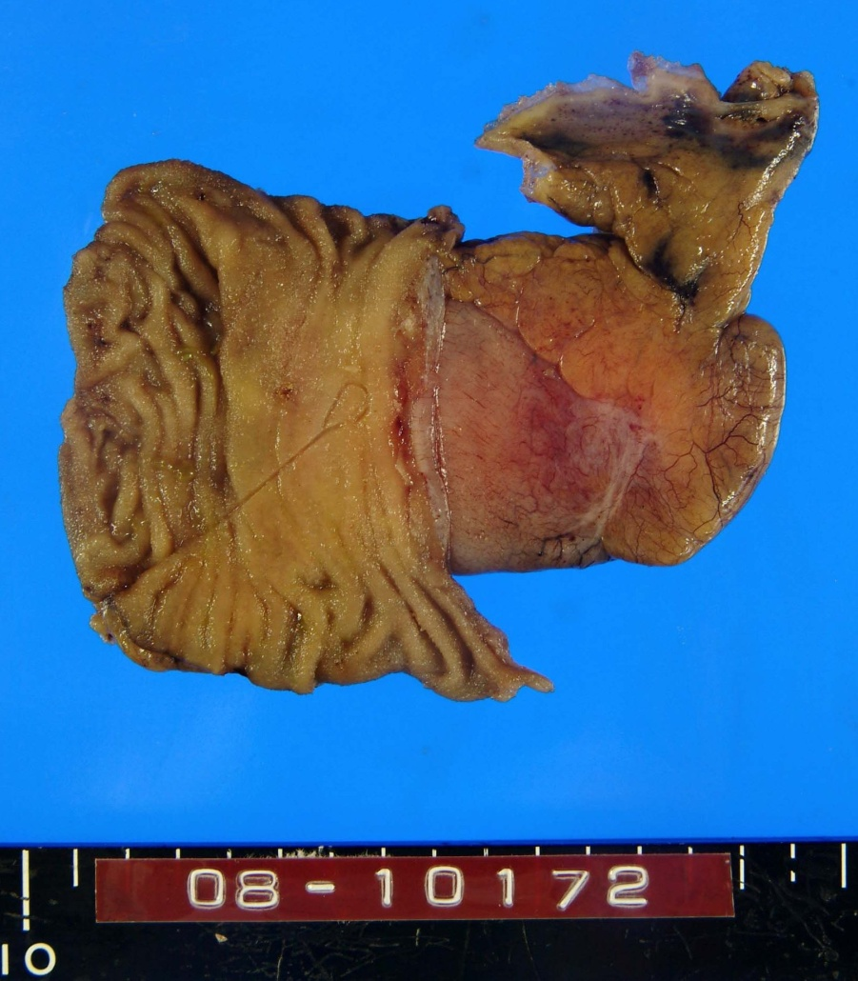
Figure 4 The resected Meckel’s diverticulum and adjunctive small intestine. The cut mesodiverticular band is seen at the blind end of the diverticulum (arrowhead).

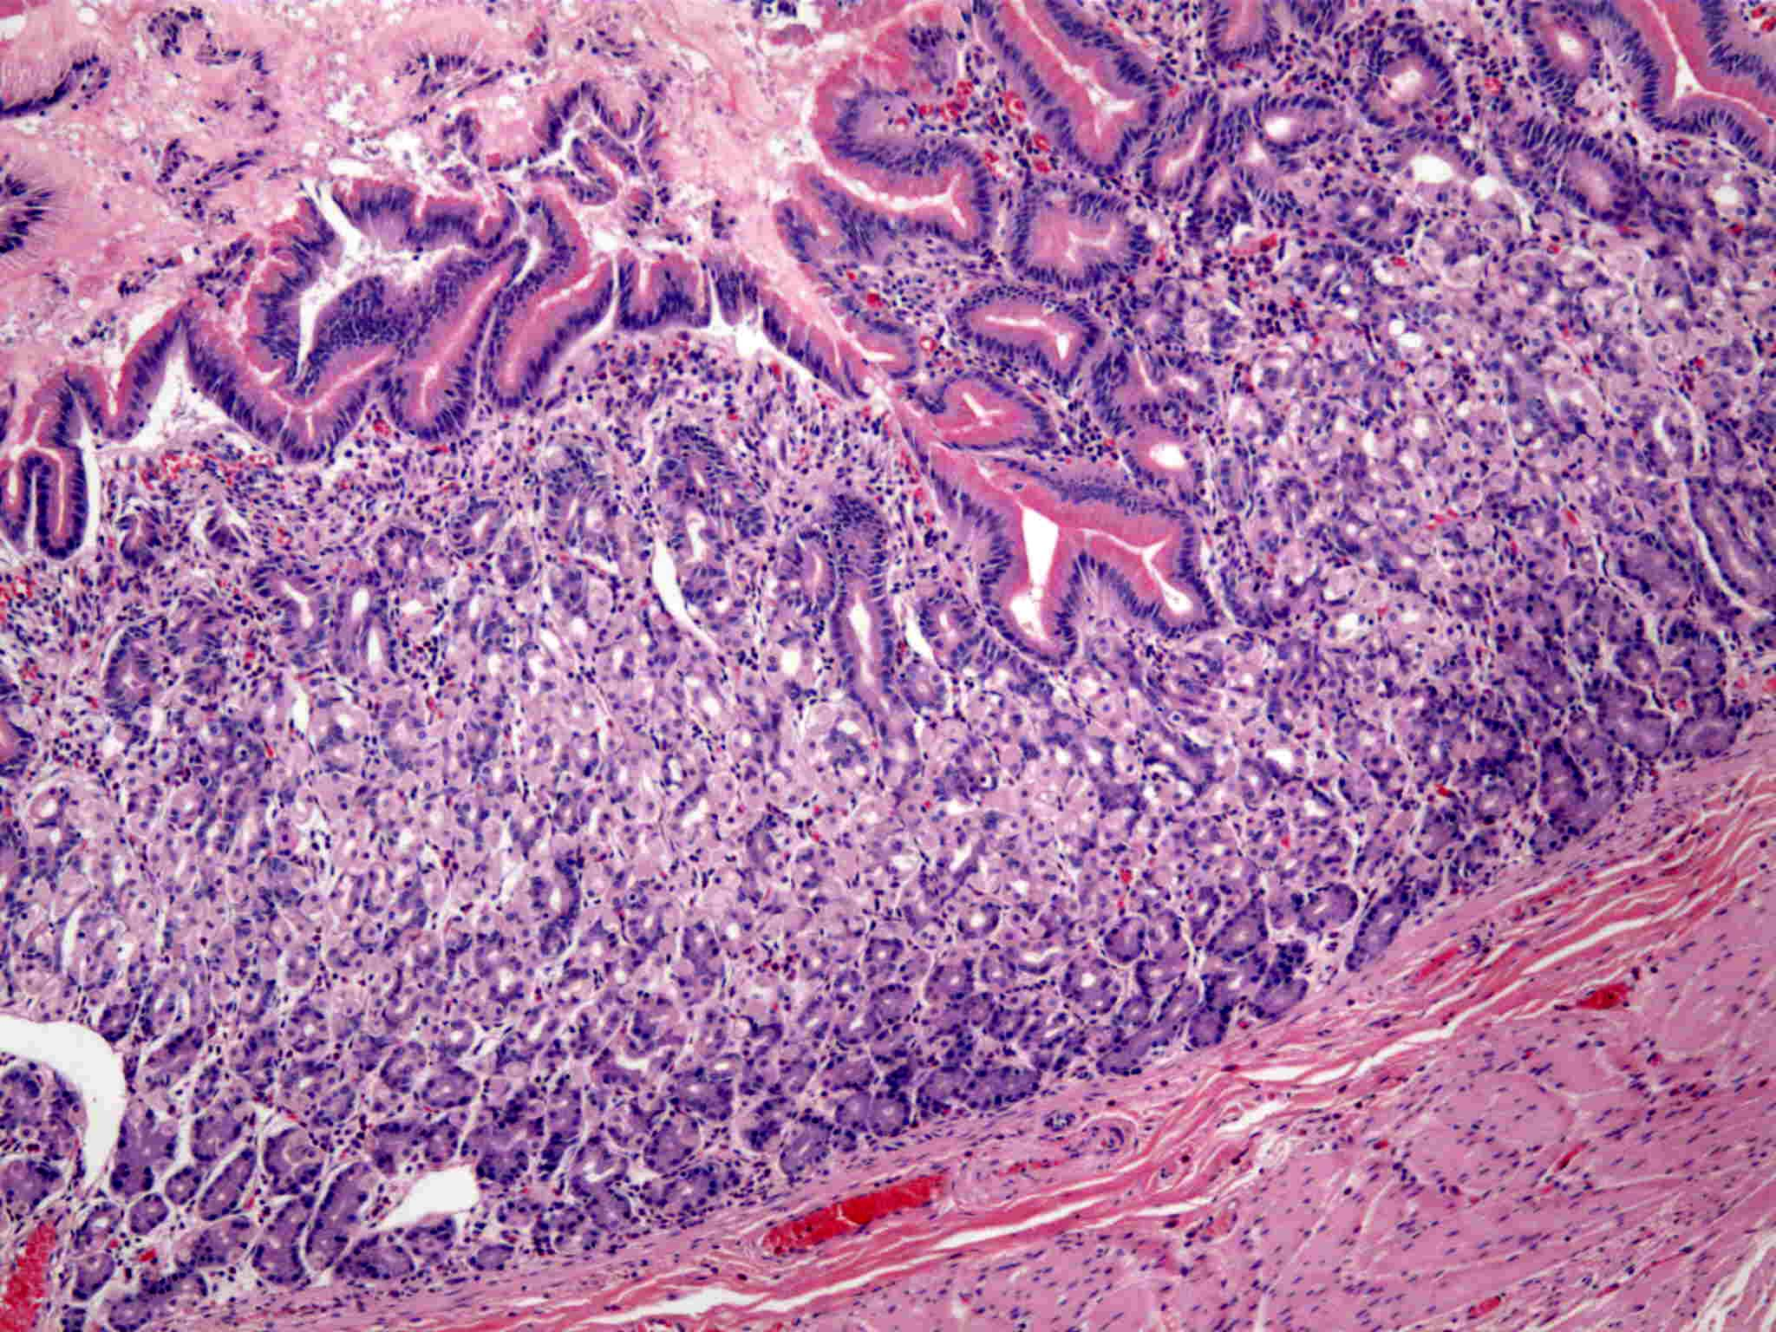
Figure 5 Histological features of the diverticulum. Heterotopic gastric mucosa was seen in the mucosa of the diverticulum (hematoxylin-eosin staining, × 100).

