Name of Journal: World Journal of Clinical Cases
Manuscript NO: 70331
Manuscript Type: CASE REPORT

Mixed porokeratosis with a novel mevalonate kinase gene mutation: A case report

Xu HJ et al. Six-year follow-up of mixed porokeratosis

Hong-Jun Xu, Guang-Dong Wen

Hong-Jun Xu, Department of Dermatology, Beijing Friendship Hospital, Capital Medical University, Beijing 100050, China

Guang-Dong Wen, Department of Dermatology, Peking University People's Hospital, Peking University, Beijing 100044, China

Author contributions: Xu HJ collected all the clinical data and wrote the draft manuscript. Wen GD completed the gene analysis; all authors read and approved the final manuscript.

Corresponding author: Hong-Jun Xu, MD, Chief Doctor, Department of Dermatology, Beijing Friendship Hospital, Capital Medical University, No. 95 Yong'an Road, Xicheng District, Beijing 100050, China. ink-008@163.com

Received: July 30, 2021
Revised: December 11, 2021
Accepted: March 25, 2022
Published online: May 16, 2022

Abstract
BACKGROUND
Porokeratosis is a rare, acquired, or inherited disorder of keratinization. There are numerous clinical types of porokeratosis and they can coexist in one patient and multiple members of an affected family. However, coexistence of disseminated superficial actinic porokeratosis (DSAP) and porokeratosis ptychotropica (Ppt) is rare.

CASE SUMMARY
A 45-year-old man presented with long-standing skin lesions. Physical examination identified numerous small, brown 2-mm to 4-mm patches on his face and several hyperkeratotic, verrucous plaques on his trunk and extremities. His father and one of his brothers also had similar lesions for years. Skin biopsies indicated a cornoid lamella in the epidermis. We identified c.155G>A mutation in the mevalonate kinase (MVK) gene, which converted a serine residue to asparagine (p.Ser52Asn) and was causative for porokeratosis in this family. A clinicopathologic diagnosis of DSAP and Ppt with a novel MVK gene mutation was made. The hyperkeratotic plaques on the patient’s scrotum were completely removed more than 10 times using a microwave knife.

CONCLUSION
An unusual case of DSAP coexisting with Ppt harbored a novel MVK gene mutation also present in the patient’s family.

Key Words: Disseminated superficial actinic porokeratosis; Porokeratosis ptychotropica; Mevalonate kinase gene; Gene mutation; Microwave knife; Case report

©The Author(s) 2022. Published by Baishideng Publishing Group Inc. All rights reserved.

Citation: Xu HJ, Wen GD. Mixed porokeratosis with a novel mevalonate kinase gene mutation: A case report. World J Clin Cases 2022; 10(14): 4528-4534
URL: https://www.wjgnet.com/2307-8960/full/v10/i14/4528.htm
DOI: https://dx.doi.org/10.12998/wjcc.v10.i14.4528

Core Tip: Porokeratosis is a rare, acquired, or inherited disorder of keratinization. The coexistence of disseminated superficial actinic porokeratosis (DSAP) and porokeratosis ptychotropica (Ppt) is rare. We present an unusual case of DSAP coexisting with Ppt and identified a novel mevalonate kinase (MVK) gene mutation in this patient’s family. To date, only four cases of DSAP coexisting with Ppt have been reported in the English literature. One case also had an MVK gene mutation. Thus, mutation of phosphomevalonate kinase pathway genes, especially the MVK gene, may have an important role in the pathogenesis of DSAP coexisting with Ppt.

INTRODUCTION
Porokeratosis is a rare, acquired, or inherited disorder of keratinization, which presents as a keratotic papule or plaque with an annular ridge-like border^{[1]}. Its main histological characteristic is a cornoid lamella, a thin column of parakeratosis leading to a ridge-like hyperkeratotic border. Numerous types of porokeratosis have been described and there are reports of more than one type of porokeratosis developing in the same patient and in multiple members of an affected family^{[2]}. Inherited or sporadic genetic defects have an important role in porokeratosis. Correlations between gene mutations and clinical phenotypes of porokeratosis have been reported previously^{[3]}. Porokeratosis lesions may alter a patient’s appearance or function. Furthermore, some cases develop squamous cell carcinoma within the porokeratosis lesions. Currently, no therapeutic interventions with good efficacy are available although various topical, surgical, destructive, and systemic therapies appear to be effective in some patients. Here, we report a rare case of disseminated superficial actinic porokeratosis (DSAP) and porokeratosis ptychotropica (Ppt) associated with a mevalonate kinase (MVK) gene mutation which was successfully treated by surgery.

CASE PRESENTATION
Chief complaints
A 45-year-old man complained of long-standing skin lesions.

History of present illness
The lesions started as brown patches on his face and gradually spread to the trunk and extremities with verrucous plaques 30 years ago. Involvement of the scrotum occurred 20 years ago.

History of past illness
The patient had no medical history and reported no history of ultraviolet exposure, immunosuppression, or immunodeficiency caused by human immunodeficiency virus (HIV) infection, tumors, or drugs.

Personal and family history
The patient’s father and one of his brothers had similar lesions for years.

Physical examination
Physical examination identified numerous small, brown 2-mm to 4-mm patches on his face (Figure 1A) and several hyperkeratotic, verrucous plaques on his trunk (Figure 1B) and extremities (Figure 1C). The widespread verrucous plaques with erosions and crust on his scrotum (Figure 1D) affected his normal life.

Laboratory examinations
Laboratory investigations including routine blood examination, hepatic and renal function, HIV antibody, Treponema pallidum hemagglutination test, rapid plasma reagin test, human papillomavirus, hepatitis B and C, tumor markers, and autoimmune screens were all negative.

Imaging examinations
Skin biopsies taken from the hyperkeratotic plaques of lesions on his scrotum showed irregular acanthosis and papillomatosis as well as a cornoid lamella in the epidermis and the absence of the granular layer beneath it (Figure 2).

Gene testing
After obtaining informed consent, genomic DNA was extracted from the proband and his affected and unaffected family members, and all exons of four mevalonate pathway genes including MVK, mevalonate decarboxylase (MVD), phosphomevalonate kinase (PMVK), and farnesyl diphosphate synthase (FDPS) with intronic flanking sequences were amplified by PCR. In addition, genomic DNA from 100 normal healthy Chinese individuals was extracted as controls. Bidirectional sequencing identified a heterozygous synonymous mutation c.155G>A in exon 18 of the MVK gene, which was not present in the unaffected family members and controls (Figure 3). This c.155 G>A mutation in the MVK gene converted a serine residue to asparagine (p.Ser52Asn) and was the causative mutation for porokeratosis in this family.

FINAL DIAGNOSIS
A clinicopathologic diagnosis of DSAP and Ppt with MVK gene mutation was made.

TREATMENT
The hyperkeratotic plaques on the patient’s scrotum were completely removed more than 10 times using a microwave knife (Figure 4).

OUTCOME AND FOLLOW-UP
The patient has had no recurrence during 6-years of follow-up.

DISCUSSION
Porokeratosis represents a heterogeneous group of hereditary and acquired disorders of the clonal hyperproliferation of keratinocytes^{[4]}. The characteristic ridge-like, keratotic border termed the “cornoid lamella” confirms the diagnosis of porokeratosis. Several clinical variants of porokeratosis have been described, all of which share this distinctive feature.
DSAP is the most common type of porokeratosis. It presents as keratotic papules with a well-demarcated elevated border, usually ranging from 3 mm to 10 mm in diameter. They are typically skin-colored to tan–brown to pink–red in color. DSAP usually occurs in the third or fourth decade of life, and patients frequently report a history of extensive exposure to ultraviolet radiation. For this reason, it usually occurs in body areas exposed to the sun, especially the shins and extensor forearms. Lesions on our patient’s face were typical of DSAP. Although 15% of DSAP patients have facial lesions, exclusively facial DSAP is an unusual clinical presentation^{[5]}. Ppt is an unusual psoriasiform variant of porokeratosis^{[6-8]}, which typically presents with pruritic, red to brown, keratotic, or verrucous papules and plaques on the buttocks or genital skin^{[8]}. Sometimes, these lesions can coalesce. Due to their clinical similarities, Ppt is often mistaken for psoriasis^{[9]} and chronic eczema. Therefore, a skin biopsy is a useful method for differential diagnosis. The verrucous plaques on our patient’s scrotum, buttocks, and limbs were diagnosed as Ppt according to the pathologic findings.
Previous studies have reported the coexistence of multiple types of porokeratosis in the same individual^{[10-20]}; however, the co-occurrence of DSAP with Ppt is rare. To the best of our knowledge, this is the fifth case reported in the English literature to date^{[7,21-23]} (Table 1).
The pathogenesis of porokeratosis is poorly understood. Risk factors include genetic susceptibility, exposure to ultraviolet radiation, and immunosuppression. Previous studies reported mutations in the phosphomevalonate kinase pathway genes, including MVD, MVK, PMVK, and FDPS in patients with porokeratosis^{[24,25]}. At least one mutation in a mevalonate pathway gene was found in 98% of familial cases and in > 70% of sporadic porokeratosis cases^{[3]}. Among the above five patients previously reported, two had genetic results. Peng et al^{[23]} identified a novel MVK missense mutation (c.1039G>C, p.Gly347Arg) in a family with coexisting DSAP and Ppt. In our patient’s family, another MVK missense mutation (c.155G>A, p.Ser52Asn) was found. Although this mutation was previously reported as benign, we suggest it is a novel mutation associated with porokeratosis. Functional analysis of this mutation in vitro and in vivo should be performed in future studies. The findings in these two cases suggest that the mutation of phosphomevalonate kinase pathway genes, especially the MVK gene, might have an important role in the pathogenesis of DSAP coexisting with Ppt. Genetic analysis is useful in affected families to predict the occurrence of these lesions in other individuals of the same family.
Patients with porokeratosis have a 7.5%-10% risk of malignant transformation to squamous cell carcinoma or basal cell carcinoma^{[26]}. Thus, clinical surveillance with regular skin examinations and patient education regarding the warning signs of skin cancer and sun protection are necessary aspects of the management in all patients with porokeratosis. However, some patients with functional impairments or appearance requirements want to have their porokeratosis lesions removed. There are five main types of treatment for porokeratosis: Topical or systemic drug therapy, surgical excision, cryotherapy, laser ablation, and photodynamic therapy. However, the disease commonly reoccurs. We used a microwave knife to remove the hyperkeratotic plaques on the patient’s scrotum. The patient did not show any functional impairment related to this treatment and did not develop disease aggravation or recurrence during 6-years of follow-up. This indicates that the microwave knife is an effective and safe therapy for porokeratosis.

CONCLUSION
In conclusion, we report an unusual case of DSAP coexisting with Ppt and identified a novel MVK gene mutation in this patient’s family. The microwave knife is an effective and safe therapy for porokeratosis and clinical surveillance for malignant transformation is necessary for all patients with porokeratosis.

REFERENCES
1 Kanitakis J. Porokeratoses: an update of clinical, aetiopathogenic and therapeutic features. Eur J Dermatol 2014; 24: 533-544 [PMID: 25115203 DOI: 10.1684/ejd.2014.2402]
2 Lucker GP, Steijlen PM. The coexistence of linear and giant porokeratosis associated with Bowen's disease. Dermatology 1994; 189: 78-80 [PMID: 8003795 DOI: 10.1159/000246791]
3 Zhang Z, Li C, Wu F, Ma R, Luan J, Yang F, Liu W, Wang L, Zhang S, Liu Y, Gu J, Hua W, Fan M, Peng H, Meng X, Song N, Bi X, Gu C, Zhang Z, Huang Q, Chen L, Xiang L, Xu J, Zheng Z, Jiang Z. Genomic variations of the mevalonate pathway in porokeratosis. Elife 2015; 4: e06322 [PMID: 26202976 DOI: 10.7554/eLife.06322]
4 Sertznig P, von Felbert V, Megahed M. Porokeratosis: present concepts. J Eur Acad Dermatol Venereol 2012; 26: 404-412 [PMID: 21929548 DOI: 10.1111/j.1468-3083.2011.04275.x]
5 Sawyer R, Picou KA. Facial presentation of disseminated superficial actinic porokeratosis. Ear Nose Throat J 1989; 68: 57-59 [PMID: 2721409]
6 Tallon B, Blumental G, Bhawan J. Porokeratosis ptychotropica: a lesser-known variant. Clin Exp Dermatol 2009; 34: e895-e897 [PMID: 20055860 DOI: 10.1111/j.1365-2230.2009.03664.x]
7 McGuigan K, Shurman D, Campanelli C, Lee JB. Porokeratosis ptychotropica: a clinically distinct variant of porokeratosis. J Am Acad Dermatol 2009; 60: 501-503 [PMID: 19022531 DOI: 10.1016/j.jaad.2008.06.038]
8 Yeo J, Winhoven S, Tallon B. Porokeratosis ptychotropica: a rare and evolving variant of porokeratosis. J Cutan Pathol 2013; 40: 1042-1047 [PMID: 24274427 DOI: 10.1111/cup.12233]
9 De Simone C, Paradisi A, Massi G, Proietti I, Capponi A, Amerio PL, Capizzi R. Giant verrucous porokeratosis of Mibelli mimicking psoriasis in a patient with psoriasis. J Am Acad Dermatol 2007; 57: 665-668 [PMID: 17870431 DOI: 10.1016/j.jaad.2007.03.020]
10 Moreland ME, Wyre HW Jr. Porokeratosis. Two morphologic forms within a family. Arch Dermatol 1981; 117: 245-246 [PMID: 7212751 DOI: 10.1001/archderm.117.4.245]
11 Dover JS, Phillips TJ, Burns DA, Krafchik BR. Disseminated superficial actinic porokeratosis. Coexistence with other porokeratotic variants. Arch Dermatol 1986; 122: 887-889 [PMID: 3740871]
12 Commens CA, Shumack SP. Linear porokeratosis in two families with disseminated superficial actinic porokeratosis. Pediatr Dermatol 1987; 4: 209-214 [PMID: 3321004 DOI: 10.1111/j.1525-1470.1987.tb00780.x]
13 Gautam RK, Bedi GK, Schgal VN, Singh N. Simultaneous occurrence of disseminated superficial actinic porokeratosis (DSAP), linear, and punctate porokeratosis. Int J Dermatol 1995; 34: 71-72 [PMID: 7896495 DOI: 10.1111/j.1365-4362.1995.tb04387.x]
14 Freyschmidt-Paul P, Hoffmann R, König A, Happle R. Linear porokeratosis superimposed on disseminated superficial actinic porokeratosis: report of two cases exemplifying the concept of type 2 segmental manifestation of autosomal dominant skin disorders. J Am Acad Dermatol 1999; 41: 644-647 [PMID: 10495390]
15 Suh DH, Lee HS, Kim SD, Cho KH, Kim KH, Park KC. Coexistence of disseminated superficial porokeratosis in childhood with congenital linear porokeratosis. Pediatr Dermatol 2000; 17: 466-468 [PMID: 11123781 DOI: 10.1046/j.1525-1470.2000.01823.x]
16 Kaur S, Thami GP, Mohan H, Kanwar AJ. Co-existence of variants of porokeratosis: a case report and a review of the literature. J Dermatol 2002; 29: 305-309 [PMID: 12081163 DOI: 10.1111/j.1346-8138.2002.tb00268.x]
17 Boente Mdel C, López-Baró AM, Frontini Mdel V, Asial RA. Linear porokeratosis associated with disseminated superficial actinic porokeratosis: a new example of type II segmental involvement. Pediatr Dermatol 2003; 20: 514-518 [PMID: 14651573 DOI: 10.1111/j.1525-1470.2003.20613.x]
18 Pearson IC, Cliff S. Case 6: plaques extending in a linear pattern from left ankle to hip forming over a 2-year period. Diagnosis: linear porokeratosis with disseminated superficial porokeratosis erupting in pregnancy. Clin Exp Dermatol 2003; 28: 345-346 [PMID: 12780739 DOI: 10.1046/j.1365-2230.2003.01278.x]
19 Suárez-Amor O, Pereiro-Ferreirós M, Ginarte M, Peteiro C, Toribio J. Coexistence of linear porokeratosis and disseminated superficial actinic porokeratosis: a type 2 segmental manifestation. Acta Derm Venereol 2007; 87: 363-364 [PMID: 17598043 DOI: 10.2340/00015555-0215]
20 Palleschi GM, Torchia D. Porokeratosis of Mibelli and superficial disseminated porokeratosis. J Cutan Pathol 2008; 35: 253-255 [PMID: 18190456 DOI: 10.1111/j.1600-0560.2007.00787.x]
21 Thomas C, Ogboli MI, Carr RA, Charles-Holmes R. Hypertrophic perianal porokeratosis in association with superficial actinic porokeratosis of the leg. Clin Exp Dermatol 2003; 28: 676-677 [PMID: 14616847 DOI: 10.1046/j.1365-2230.2003.01410.x]
22 Murase J, Gilliam AC. Disseminated superficial actinic porokeratosis co-existing with linear and verrucous porokeratosis in an elderly woman: Update on the genetics and clinical expression of porokeratosis. J Am Acad Dermatol 2010; 63: 886-891 [PMID: 20451293 DOI: 10.1016/j.jaad.2009.07.038]
23 Peng JM, Xiao XM, Chen JW, Chen LF, Cheng B, Ji MK, Zhang ZH. Novel mutation in MVK gene for co-occurrence of disseminated superficial actinic porokeratosis with porokeratosis ptychotropica. J Dermatol 2021; 48: e137-e139 [PMID: 33458876 DOI: 10.1111/1346-8138.15748]
24 Cui H, Li L, Wang W, Shen J, Yue Z, Zheng X, Zuo X, Liang B, Gao M, Fan X, Yin X, Shen C, Yang C, Zhang C, Zhang X, Sheng Y, Gao J, Zhu Z, Lin D, Zhang A, Wang Z, Liu S, Sun L, Yang S, Cui Y, Zhang X. Exome sequencing identifies SLC17A9 pathogenic gene in two Chinese pedigrees with disseminated superficial actinic porokeratosis. J Med Genet 2014; 51: 699-704 [PMID: 25180256 DOI: 10.1136/jmedgenet-2014-102486]
25 Leng Y, Yan L, Feng H, Chen C, Wang S, Luo Y, Cao L. Mutations in mevalonate pathway genes in patients with familial or sporadic porokeratosis. J Dermatol 2018; 45: 862-866 [PMID: 29722423 DOI: 10.1111/1346-8138.14343]
26 Le C, Bedocs PM. Disseminated Superficial Actinic Porokeratosis. StatPearls. Treasure Island (FL): StatPearls Publishing Copyright © 2021, StatPearls Publishing LLC. 2021

Footnotes
Informed consent statement: Written informed consent was obtained from the patient for publication of this case report and any accompanying images. A copy of the written consent is available for review from the Editor of this journal.

Conflict-of-interest statement: The authors declare that they have no conflict of interest to report.

CARE Checklist (2016) statement: The authors have read the CARE Checklist (2016), and the manuscript was prepared and revised according to the CARE Checklist (2016).

Open-Access: This article is an open-access article that was selected by an in-house editor and fully peer-reviewed by external reviewers. It is distributed in accordance with the Creative Commons Attribution NonCommercial (CC BY-NC 4.0) license, which permits others to distribute, remix, adapt, build upon this work non-commercially, and license their derivative works on different terms, provided the original work is properly cited and the use is non-commercial. See: https://creativecommons.org/Licenses/by-nc/4.0/

Provenance and peer review: Unsolicited article; Externally peer reviewed.
Peer-review model: Single blind

Peer-review started: July 30, 2021
First decision: December 1, 2021
Article in press: March 25, 2022

Specialty type: Dermatology
Country/Territory of origin: China
Peer-review report’s scientific quality classification
Grade A (Excellent): 0
Grade B (Very good): 0
Grade C (Good): C
Grade D (Fair): 0
Grade E (Poor): 0

P-Reviewer: Sridharan G, India S-Editor: Liu JH L-Editor: Webster JR P-Editor: Liu JH

Figure Legends

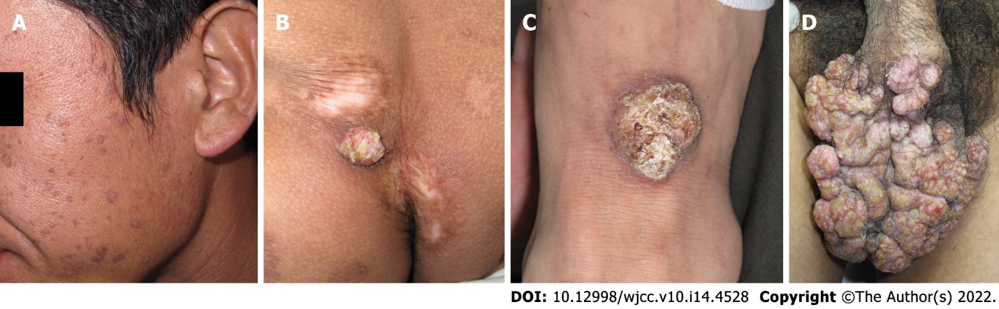

Figure 1 Skin lesions of the patient. A: Small, brown patches on the face. B-D: Hyperkeratotic, verrucous plaques on the trunk and extremities and widespread verrucous plaques with erosions and crust on the scrotum.

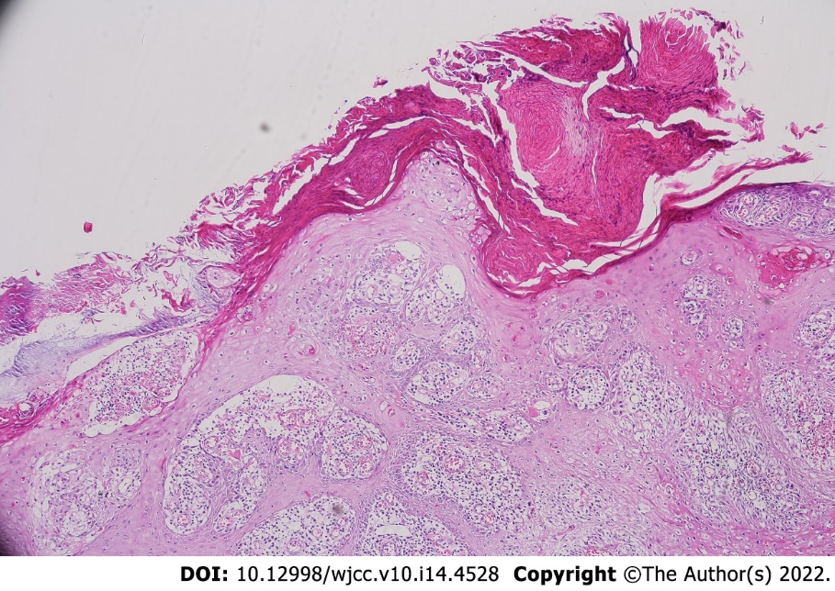

Figure 2 Histopathological examination shows a cornoid lamella in the epidermis (hematoxylin-eosin staining, original magnification: × 100).

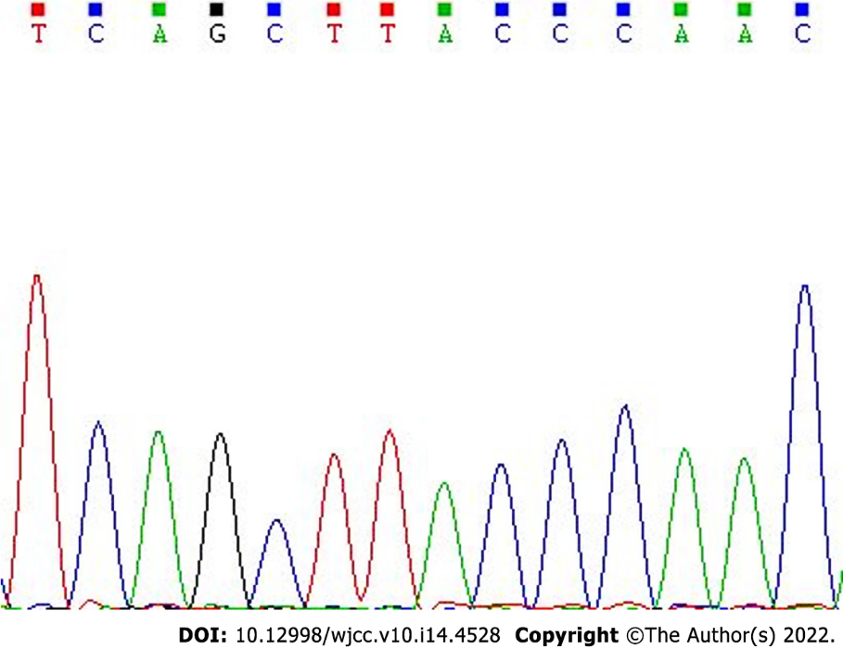
Figure 3 Analysis of the mutation in the mevalonate kinase gene. A novel mevalonate kinase missense mutation (c.155G>A) was present in the patient’s family.
Figure 4 The lesions on the patient’s scrotum were completely removed after microwave knife treatment.

Table 1 Clinical features of patients with coexisting disseminated superficial actinic porokeratosis and porokeratosis ptychotropica
Ref. | Gender | Age | Ethnicity | Nationality | Clinical variants | Genetics | Risk factors | Treatment
Thomas et al^{[21]} | Female | 78 yr | NA | United Kingdom | DSAP, Ppt | NA | None | NA
McGuigan et al^{[7]} | Male | 84 yr | NA | United States | DSAP, Ppt | NA | Sun exposure, non-melanoma skin cancer | 0.025% tretinoin cream, 0.05% tazarotene cream.
Murase et al^{[22]} | Female | 73 yr | Korean | Korea | DSAP, Ppt linear porokeratosis | NA | Family history | NA
Peng et al^{[23]} | Male | 70 yr | Chinese | China | DSAP, Ppt | MVK missense mutation (c.1039G>C, p.Gl- y347Arg) | Family history | Oral acitretin (20 mg daily)
Our patient | Male | 45 yr | Chinese | China | DSAP, Ppt | MVK missense mutation (c.155G>A, p.Ser52Asn) | Family history | Microwave knife
DSAP: Disseminated superficial actinic porokeratosis; Ppt: Porokeratosis ptychotropica; MVK: mevalonate kinase; NA: Not available.

Published by Baishideng Publishing Group Inc
7041 Koll Center Parkway, Suite 160, Pleasanton, CA 94566, USA
Telephone: +1-925-3991568
E-mail: bpgoffice@wjgnet.com
Help Desk: https://www.f6publishing.com/helpdesk
https://www.wjgnet.com

© 2022 Baishideng Publishing Group Inc. All rights reserved.

