Name of Journal: World Journal of Clinical Oncology
Manuscript NO: 89065
Manuscript Type: MINIREVIEWS

Anti-tumor effect of coix seed based on the theory of medicinal and food homology

Meng FD et al. The anti-tumor effect of coix seed

Fan-Di Meng, Ling Yuan, Dou-Dou Lu, Ya-Ting Yang, Duo-Jie Xu, Meng-Ying Che, Yi Nan

Fan-Di Meng, Dou-Dou Lu, Ya-Ting Yang, Duo-Jie Xu, Meng-Ying Che, Traditional Chinese Medicine College, Ningxia Medical University, Yinchuan 750004, Ningxia Hui Autonomous Region, China

Ling Yuan, College of Pharmacy, Ningxia Medical University, Yinchuan 750004, Ningxia Hui Autonomous Region, China

Yi Nan, Key Laboratory of Ningxia Minority Medicine Modernization Ministry of Education, Ningxia Medical University, Yinchuan 750004, Ningxia Hui Autonomous Region, China

Author contributions: Meng FD, Lu DD, Yang YT, Xu DJ, Che MY and Nan Y designed the research study; Meng FD, Yang YT, Che MY and Yuan L collected the literature, Yuan L, Meng FD and Xu DJ analyzed the data and wrote the manuscript; All authors have read and approved the final manuscript.

Supported by Ningxia Natural Science Foundation, No. 2022AAC02039; Ningxia Key Research and Development Program, No. 2023BEG02015; National Natural Science Foundation of China, No. 82260879.

Corresponding author: Yi Nan, MD, PhD, Professor, Key Laboratory of Ningxia Minority Medicine Modernization Ministry of Education, Ningxia Medical University, No. 1160 Shengli Street, Yinchuan 750004, Ningxia Hui Autonomous Region, China. 20080011@nxmu.edu.cn

Received: October 19, 2023
Revised: October 26, 2023
Accepted: November 24, 2023
Published online:

Abstract
Coix seed is a dry and mature seed of Coix lacryma-jobi L.var.ma-yuen (Roman.) Stapf in the Gramineae family. Coix seed has a sweet, light taste, and a cool nature. Coix seed enters the spleen, stomach, and lung meridians. It has the effects of promoting diuresis and dampness, strengthening the spleen to prevent diarrhea, removing arthralgia, expelling pus, and detoxifying and dispersing nodules. It is used for the treatment of edema, athlete's foot, poor urination, spleen deficiency and diarrhea, dampness and obstruction, lung carbuncle, intestinal carbuncle, verruca, and cancer. The medicinal and health value is high, and it has been included in the list of medicinal and food sources in China, which has a large development and application space. This article reviews the current research achievements in the processing methods and anti-tumor activities of Coix seed and provides examples of its clinical application in ancient and modern times, aiming to provide reference for further research on Coix seed and contribute to its clinical application and development. Through the analysis of the traditional Chinese patent medicines, and simple preparations and related health food of Coix seed queried by Yaozhi.com, the source, function, and dosage form of Coix seed were comprehensively analyzed, with a view of providing a reference for the development of Coix seed medicine and food.

Key Words: Coix seed; Cancer; Tumor; Coix lacryma-jobi L.var.ma-yuen (Roman.) Stapf; Medicinal herbs

Meng FD, Yuan L, Lu DD, Yang YT, Xu DJ, Che MY, Nan Y. The anti-tumor effect of coix seed based on the theory of medicinal and food homology. World J Clin Oncol 2023; In press

Core Tip: Cancer is a serious disease that causes a huge economic and social burden worldwide. In addition, cancer has become one of the biggest health threats globally. Numerous studies have confirmed that Coix seed has anti-tumor effects. This article will review its preparation, anti-tumor effects, and edible value.

INTRODUCTION
Cancer is a serious disease that causes a huge economic and social burden worldwide. An estimated 19.3 million new cancer cases and nearly 10 million cancer deaths were reported in 2020. It is expected that the global cancer burden will reach 28.4 million cases by 2040, an increase of 47% compared to 2020^{[1]}. In addition, cancer has become one of the biggest health threats globally. Therefore, how to effectively prevent and treat cancer has become a global focus of attention^{[1]}. So, exploring effective cancer treatment measures is crucial.
Medicinal and food-dual-use foods can be consumed as both delicious foods and medicinal herbs for treating diseases. They belong to traditional Chinese medicine and have good therapeutic effects. They are also nutritious and delicious foods that people often eat. Coix seed, which can be used as both food^{[2]}and medicine^{[3]}，is an important raw material for the development of food or health food. Coix seed is a good medicine and food for dispelling dampness and strengthening the spleen.
At present, Chinese herbal medicine^{[4]} has significant effects in inhibiting cancer proliferation, metastasis, inducing cell apoptosis^{[5]}, blocking the cell cycle, alleviating pain^{[6]}, improving quality of life^{[7]}, and has received widespread attention from researchers^{[8,9]}. Numerous studies have confirmed that Coix seed has anti-tumor effects. This article will review its preparation, anti-tumor effects, and edible value (Figure 1).

Brief Introduction
Coix seed, also known as Xie Li, Qishi, Ganmi, etc, is a dry and mature seed of Coix lacryma-jobi L. var.ma-yuen (Roman.) Stapf in the gramineae family^{[10]}. Most regions in China produce it, mainly in Fujian, Hebei, and Liaoning. It is commonly found near houses, in the wilderness, by rivers, in streams, or in damp valleys. Coix seed has a sweet and light taste and a cool nature. It enters the spleen, stomach, and lung meridians. As a drug, it has the effects of promoting diuresis and dampness, strengthening the spleen^{[11]} to stop diarrhea, removing arthralgia, expelling pus, and detoxifying and dispersing nodules. It can treat edema, athlete's foot, poor urination, spleen deficiency and diarrhea, dampness and obstruction, lung carbuncle, intestinal carbuncle, verruca, cancer^{[12,13]}, etc. As a food, its developed products have functions^{[14,15]} such as increasing bone density, improving sleep, immune regulation^{[16,17]}, weight loss^{[18]}, regulating blood lipids and blood sugar, improving gastrointestinal function, anti-fatigue, promoting growth and development, improving memory, antioxidant^{[19]}, delaying aging, and protecting liver damage^{[20]}.

Processing
Coix seed has a long history of and has various methods of processing^{[21]}. Since the Northern and Southern Dynasties, there have been records of two processing methods: Glutinous rice stir frying and salt soup boiling. Subsequently, the Song Dynasty first proposed the stir frying method. Salt frying was added in the Ming Dynasty. During the Qing Dynasty, local stir frying was added. So far, commonly used processing methods such as stir frying, earth frying, bran frying, and sand frying have been recorded in the modern Chinese Pharmacopoeia and national and provincial processing standards (Table 1).

The anti-tumor effect of Coix seed
Screening of active ingredients and targets in Coix seed
We used Coix seed as a keyword to search on the TCMSP (Traditional Chinese Medicine Systems Pharmacology Database and Analysis Platform, https://old.tcmsp-e.com/index.php)^{[22]}. The active ingredients and their related action targets were picked according to the criteria of oral bioavailability^{[23]} ≥ 30% and drug-likeness ≥ 0.18. Then, we translated the name into Gene Symbol format to obtain target genes for the main active ingredients of Coix seed via Uniprot database (https://www.uniprot.org/). We imported the active ingredients and their targets of Coix seed into Cytoscape 3.9.1 software to draw an "active ingredient-target" network. Next, we imported drug targets into the STRING database (http://string-db.org), species limited to “Homo sapiens”, to retrieve protein-protein interaction relationships, and imported them into Cytoscape 3.9.1 software to create a network diagram. Through the Metascape database (https://metascape.org/), we conducted the Kyoto Encyclopedia of Genes and Genomes (KEGG) enrichment analysis on the target. The results of KEGG signal pathways are introduced into the Bioinformatics database (http://www.bioinformatics.com.cn/) and presented in the form of a bar chart and selected pathways related to cancer (Figure 2). The KEGG results indicate that the Coix seed target is associated with multiple cancer pathways and can effectively combat cancer. So, the next main analysis is the anti-tumor effect of Coix seed.

Anti-cancer effect of Coix seed and its components
Coix seed is a commonly used clinical drug with activities such as anti-tumor (Figure 3), immune regulation^{[24,25]}, hypoglycemic^{[26,27]}, anti-inflammatory^{[28,29]}, improving intestinal microbiota^{[17,30]}, lowering blood lipids^{[31,32]}, and promoting angiogenesis^{[33]}. After KEGG enrichment analysis, we mainly discuss the pharmacological effects of Coix seed on anti-tumor effects (Table 2). Studies have confirmed that Coix seed and its extract can reduce the proliferation, invasion and migration of lung cancer^{[34]}, colon cancer, liver cancer, breast cancer, cervical cancer, gastric cancer, pancreatic cancer and other cancers, and can promote their apoptosis (Figure 4).
Lung cancer: Coix seed has a prominent inhibitory healing effect on lung cancer metastasis, and can inhibit proliferation and promote apoptosis. Research has shown that Paclitaxel combined with Kanglaite (KLT) can significantly improve patients' physical fitness, reduce bone metastasis area and tumor weight, and have significant effects in clinical treatment^{[35]}. MiRNA-21 is a therapeutic effect indicator for lung cancer. By comparing the changes in indicators before and after treatment with KLT, the expression of miRNA-21 is reduced, indicating that KLT has a significant therapeutic effect on advanced lung cancer^{[36]}. After cell experiments, Coix Polysaccharides can significantly inhibit the proliferation of lung cancer cells, and may induce apoptosis of lung cancer cells by increasing the expression of caspase-3 and caspase-9 genes^{[37]}. KLT has significant anti-tumor activity in Lewis lung cancer mice, and when combined with cisplatin, it can improve chemotherapy efficacy and immune function by reducing TAM levels and improving hypoxia status^{[38]}. Other studies have confirmed that Coix polysaccharides can demonstrably inhibit the migration and invasion of A549 cells in vitro cell experiments, and its molecular mechanism may be the down-regulation of S100A4 gene and protein expression levels^{[39]}.

Colon cancer: Research has shown that Coix seed performs well in combating colon cancer, blocking cell cycle, promoting apoptosis, and synergistic effects to achieve the effect of inhibiting colon cancer. On the HT-29 colon cancer cell model, the anticancer effect of Coix seed oil is dose-dependent and time-dependent. With the increase of drug concentration and the passage of time, the survival rate of tumor cells will also decrease^{[40]}. The synergistic effect of paclitaxel treatment after pretreatment with KLT is the best, and KLT inhibits nuclear factor NF-κΒ and upregulates the expression of connexin 43, making cancer cells sensitive to paclitaxel^{[41]}, thereby exerting an inhibitory effect on colon cancer cells.

Liver cancer: The components of Coix seed have good therapeutic effects on liver cancer, and an efficient and safe anticancer drug delivery system has been developed. There have been studies on injecting KLT into transplanted liver tumors in rats and evaluating its impact, pros and cons. Research has shown that injecting KLT into implanted hepatocellular carcinoma is more effective than ethanol, and KLT has fewer side effects on liver function than ethanol^{[42]}. In the study, Wang et al^{[43]} discovered that the combination of Norcantharidin and Coix seed oil can exert anti-tumor efficacy by regulating the immune system. Coix seed components have an inhibitory effectiveness on the progression of liver tumors in nude mice and have minimal toxicity to the liver and kidneys^{[44]}. Bitargeted microenvironments based on Coix seed receptors can effectively target tumors, enhance their inhibitory effect on tumor proliferation, and induce cancer cell apoptosis, thereby prolonging patient survival time^{[45]}.

Breast cancer: Coix seed oil has a large scale anti-cancer effect. Ting F found that Coix seed oil has a great inhibitory effect on triple negative breast cancer, which inhibited the proliferation and growth of triple negative breast cancer^{[46]}. The results of network pharmacology and in vitro experiments show that KLT has an inhibitory effect on triple negative breast cancer, which can inhibit cell proliferation and invasion, block cell cycle and induce cell apoptosis. Its mechanism of action may be to block G2/M phase cells and downregulate G2/M phase related genes^{[47]}.

Cervical cancer: Microemulsions containing Coix seed components exhibit good anti cervical cancer effects, leading to cell cycle arrest and apoptosis, and to cancer cell death. Dissolving paclitaxel in Coix seed oil, the two synergistically fight cancer, exert stronger in vitro cytotoxicity, and induce cell apoptosis, which has a stronger therapeutic effect on cervical cancer^{[48]}. Joint application of Coix Seed Oil and Tripterine can work synergistically on the proliferation of cervical cancer, as well as anti-angiogenesis and induction of cell apoptosis. In mouse models, minimal toxicity to important organs was detected^{[49,50]}.

Gastric cancer: Coix seed can reduce the vitality of gastric cancer cells, promote cell apoptosis, and upgrade the quality of life. The reason of KLT regulating chemotherapy resistance in gastric cancer cells may be through regulating expression of MDR1 and MRP1 to inhibit cell viability and promote cell apoptosis. KLT can alleviate the development of multiple drug resistance (MDR) and participate in the potential mechanism of MDR in gastric cancer^{[51]}. Comparing the indicators before and after treatment, the study found that patients with advanced gastric cancer treated with KLT combined with chemotherapy had reduced cancer, reduced chemotherapy side effects, and a further improved quality of life^{[52]}.

Pancreatic cancer: Coix seed can promote apoptosis of pancreatic cancer cells, make it sensitive to treatment, and enhance the therapeutic effect. Coix seed oil may adjust mitochondrial dysfunction and induces apoptosis in PANC-1 PC cells through PTEN, which may be related to the down-regulation of p-AKT and p-PI3K protein expression by Coix seed oil^{[53]}. Coix seed extract can synergistically reinforce the anti-pancreatic cancer effect of Gemcitabine, significantly alleviate the up regulation of ABCB1 and ABCG2 proteins caused by the use of Gemcitabine, and detect strong correlation between Bioluminescence pharmacokinetic parameters and pharmacodynamic indicators and anti-tumor efficacy^{[54]}. The anti-tumor effect of Coix seed emission combined with Gemcitabine is superior to that of any drug alone, and its mechanism is that Coix seed emission can eliminate the activation of NF-κB, making pancreatic cancer cells sensitive to gemcitabine therapy^{[55]}.

Improving cancer cachexia: Researchers have found that administering Coix seed oil can significantly prevent weight loss and improve systemic inflammation in mice, without affecting food intake and tumor size. The results indicate that Coix seed oil can cause muscle and adipose tissue loss caused by cancer cachexia^{[56]}. The results of clinical research on the injection of Coix seed oil into patients showed that Coix seed oil can effectively control the degree of pain, alleviate adverse reactions such as constipation and nausea, and raise the quality of life^{[57]}.

Application of Coix Seed
The medicinal value of coix seed
Coix seed has been widely applied since ancient times, and formulas containing Coix seed have also been widely used. Yiyi Fuzi Baijiang Powder can slow down the progression of colorectal cancer by simultaneously regulating target genes and related signaling pathways of multiple active ingredients, possibly by regulating cell apoptosis, cell proliferation, and protein and enzyme binding^{[58]}, and this has been experimentally validated^{[59]}. Yiyi Fuzi Baijiang Powder has a good effect in treating ulcerative colitis, can inhibit intestinal symptoms in mice, and improve intestinal pathology^{[60]}. According to reports, Qingyi huaji decoction can be applied as a valid method to treat pancreatic cancer, and research has confirmed that it can inhibit the growth and progression of tumor through various mechanisms such as anti-inflammatory and induction of cell apoptosis^{[61]}. Shenling Baizhu Powder inhibits colitis related colorectal cancer by inhibiting epithelial mesenchymal transformation and myelogenous inhibitor infiltration, and reduces mortality by reducing the incidence rate and diversity of colon tumors^{[62]}. Traditional Chinese patent medicines and simple preparations containing coix seed was searched on the website of Yaozhi (http://db. yaozh. com/) with the keyword "coix seed". It was recorded in the Ministry of Health drug standard Chinese prescription preparation, China Pharmacopoeia 2020 edition one, Standard for new drug conversion, National standard competition of Chinese patient medicine, New national Chinese patient medicine 2nd edition. There are 134 kinds of traditional Chinese patent medicines and simple preparations containing Coix seed (Figure 5). From the perspective of dosage forms, there are 17 types of traditional Chinese patent medicines and simple preparations containing Coix lachryma jobi seed, in which tablets are the main, followed by granules and capsules (Figure 6). We summarized the efficacy of 134 traditional Chinese patent medicines and simple preparations varieties containing coix seed, which can be roughly divided into 9 categories (Figure 7). According to the efficacy analysis, the traditional Chinese patent medicines and simple preparations that contain Coix lachryma jobi seed mainly focuses on the digestive system, musculoskeletal system, urogenital system.

Edible value of Coix seed
Coix seed is often used in dietary therapy^{[25]}. Gastrointestinal symptoms caused by chemotherapy, such as weakness, vomiting, and nausea, can be alleviated by qi-yin-reinforcing porridge^{[63]}. In recent years, there have also been many health foods mainly made of Coix seed. The keyword "Coix seed" was searched on Yaozhi.com (http://db. yaozh. com/), and a total of 126 Coix seed related health foods approved by the State Food and Drug Administration were obtained, such as mountain medicine Coix seed granules, Coix seed sea buckthorn capsules, healthy Runtong tea, bone strengthening powder, etc, which have immune regulation, weight loss, blood lipid and blood glucose regulation properties. To improve gastrointestinal function and other functions, the statistical data of the health functions involved in Coix Seed Health Products are shown in Figure 8. So far, there are mainly 18 types of Coix seed health product formulations used (Figure 9). The development forms of Coix seed health food functions are very diverse, with diverse products and dosage forms that can meet the specific needs of different populations.

Usage of Coix seed
Coix seed has the effect of promoting metabolism and reducing gastrointestinal burden, and can be used as a nourishing food for weak patients during or after illness^{[64]}. It is worth noting that people with spleen deficiency and diarrhea can stir fry Coix seed before consumption, which has a better effect. Due to its ability to remove dampness, Coix seed should be used with caution for those who suffer from body fluid depletion after fever, or for those who are usually Yin deficient or Yin deficient with excessive fire. Pregnant women and those with slippery semen or constipation should not consume it. If these people consume coix seed, it may cause a greater burden on their physical health.

DISCUSSION
We used Coix Seed; Semen coicis; Coix lacryma jobi L. var. mayen (Roman.) Stapf and cancer; neoplasm and tumor as keywords to search on PubMed. And four related reviews were found in the past 5 years. Among them, Huang et al^{[12]} discussed the chemical composition, anticancer mechanisms, marketed drugs, dosage forms, and clinical applications of fatty oils, including coix seed and other plants. Pan et al^{[65]} only discusses the treatment of malignant tumors in the female reproductive system with coix seed. This article discusses the anti-tumor effect of coix seed and is not limited to malignant tumors in the female reproductive system. Lu et al^{[66]} discussed the anticancer effect of KLT, which is an extract of Coix seed oil. This article also discusses some other components of coix seed. Kim et al^{[67]} discussed the anti-pancreatic cancer effect of various natural plants including Coix lachryma seed. In the past 5 years, there has been no specialized review on the anticancer effect of Coix seed and its components, as well as the homology between medicine and food. This article starts from the perspective of homology between medicine and food, and conducts KEGG analysis of the effective ingredient targetscoix seed and its components, as well as the homology between medicine and food. This article starts from the perspective of homology between medicine and food, and conducts KEGG analysis of the effective ingredient targets of Coix seed through bioinformatics methods, proving that Coix seed indeed has anti-tumor effects, and systematically reviews the anti-tumor effect of Coix seed. The application of Coix lachryma seed in traditional Chinese patent medicines and simple preparations and food was also summarized and sorted out, and the relevant data was displayed through charts. Methods, proving that Coix seed indeed has anti-tumor effects, and systematically reviews the anti-tumor effect of Coix seed. The application of Coix lachryma seed in traditional Chinese patent medicines and simple preparations and food was also summarized and sorted out, and the relevant data was displayed through charts.

CONCLUSION
In recent years, more and more studies have shown that Coix seed has the function of inhibiting the growth and metastasis of cancer cells, reducing the mortality rate of cancer patients. Therefore, Coix seed has become a highly anticipated health product. With the increasing emphasis on healthy diet, the idea of "treating diseases before they occur" has become increasingly popular, and Coix seed has received more and more attention in the field of medicinal and food homology. In the future, coix seed can be used to develop various new health products, such as cosmetics, and pharmaceuticals, to meet people's needs for health and beauty. At the same time, Coix seed can also be used to study new medicinal ingredients and treatment methods in order to further improve its health benefits.

REFERENCES
1 Sung H, Ferlay J, Siegel RL, Laversanne M, Soerjomataram I, Jemal A, Bray F. Global Cancer Statistics 2020: GLOBOCAN Estimates of Incidence and Mortality Worldwide for 36 Cancers in 185 Countries. CA Cancer J Clin 2021; 71: 209-249 [PMID: 33538338 DOI: 10.3322/caac.21660]
2 Igbokwe IC, Wei M, Feng Y, Duan Y, Ma H, Zhang H. Coix Seed: A Review of Its Physicochemical Composition, Bioactivity, Processing, Application, Functionality, and Safety Aspects. Food Rev Int 2022; 38 Suppl 1: 921-939 [DOI: 10.1080/87559129.2021.1892129]
3 Nurkolis F, Gunawan W, Hardinsyah H, Mayulu N, Wijayanti M. Health Benefits of Coix Seed (Coix lacryma-jobi): A Study Review. Curr Dev Nutr 2022; 6 Suppl 1: 524 [DOI: 10.1093/cdn/nzac077.027]
4 Yang M, Zhu SJ, Shen C, Zhai R, Li DD, Fang M, Xu JN, Gan YN, Yang L, Ren ZY, Zheng RX, Robinson N, Liu JP. Clinical Application of Chinese Herbal Injection for Cancer Care: Evidence-Mapping of the Systematic Reviews, Meta-analyses, and Randomized Controlled Trials. Front Pharmacol 2021; 12: 666368 [PMID: 34025425 DOI: 10.3389/fphar.2021.666368]
5 Lu Y, Li CS, Dong Q. Chinese herb related molecules of cancer-cell-apoptosis: a minireview of progress between Kanglaite injection and related genes. J Exp Clin Cancer Res 2008; 27: 31 [PMID: 18718024 DOI: 10.1186/1756-9966-27-31]
6 Su P, Leng Y, Liu J, Yu Y, Wang Z, Dang H. Comparative Analysis of the Efficacy and Safety of Different Traditional Chinese Medicine Injections in the Treatment of Cancer-Related Pain: A Bayesian Network Meta-Analysis. Front Pharmacol 2021; 12: 803676 [PMID: 35197850 DOI: 10.3389/fphar.2021.803676]
7 Wu X, Chung VCH, Lu P, Poon SK, Hui EP, Lau AYL, Balneaves LG, Wong SYS, Wu JCY. Chinese Herbal Medicine for Improving Quality of Life Among Nonsmall Cell Lung Cancer Patients: Overview of Systematic Reviews and Network Meta-Analysis. Medicine (Baltimore) 2016; 95: e2410 [PMID: 26735544 DOI: 10.1097/MD.0000000000002410]
8 Qi F, Li A, Inagaki Y, Gao J, Li J, Kokudo N, Li XK, Tang W. Chinese herbal medicines as adjuvant treatment during chemo- or radio-therapy for cancer. Biosci Trends 2010; 4: 297-307 [PMID: 21248427]
9 Ni M, Wang H, Wang M, Zhou W, Zhang J, Wu J, Zhang D, Jing Z, Liu X, Wu Z, Guo S, Jia S, Zhang X, Sheng X. Investigation on the Efficiency of Chinese Herbal Injections for Treating Non-small Cell Lung Cancer With Vinorelbine and Cisplatin Based on Multidimensional Bayesian Network Meta-Analysis. Front Pharmacol 2020; 11: 631170 [PMID: 33708126 DOI: 10.3389/fphar.2020.631170]
10 Tajalifar M. Coix Seeds: A Mini Review. J Plant Genet Breed 2018; 2
11 Du W, Zhu W, Ge W, Li C. Research on the effect of spleen-invigorating and anti-swelling active ingredients in crude and processed coix seed based on Spectrum - Effects relationship combined with chemometrics. J Pharm Biomed Anal 2021; 205: 114350 [PMID: 34507270 DOI: 10.1016/j.jpba.2021.114350]
12 Huang Y, Zhu J, Lin X, Hong Y, Feng Y, Shen L. Potential of Fatty Oils from Traditional Chinese Medicine in Cancer Therapy: A Review for Phytochemical, Pharmacological and Clinical Studies. Am J Chin Med 2019; 47: 727-750 [PMID: 31094213 DOI: 10.1142/S0192415X19500381]
13 Kuo CC, Chen HH, Chiang W. Adlay ( yì yĭ; "soft-shelled job's tears"; the seeds of Coix lachryma-jobi L. var. ma-yuen Stapf) is a Potential Cancer Chemopreventive Agent toward Multistage Carcinogenesis Processes. J Tradit Complement Med 2012; 2: 267-275 [PMID: 24716141 DOI: 10.1016/s2225-4110(16)30112-2]
14 Weng WF, Peng Y, Pan X, Yan J, Li XD, Liao ZY, Cheng JP, Gao AJ, Yao X, Ruan JJ, Zhou ML. Adlay, an ancient functional plant with nutritional quality, improves human health. Front Nutr 2022; 9: 1019375 [PMID: 36618703 DOI: 10.3389/fnut.2022.1019375]
15 Zeng Y, Yang J, Chen J, Pu X, Li X, Yang X, Yang L, Ding Y, Nong M, Zhang S, He J. Actional Mechanisms of Active Ingredients in Functional Food Adlay for Human Health. Molecules 2022; 27 [PMID: 35956759 DOI: 10.3390/molecules27154808]
16 Suzuki Y, Miyahara T, Jinnouchi M, Miura Y, Taka H, Kaga N, Ohara-Takada A. A Comprehensive Analysis of Plasma Cytokines and Metabolites Shows an Association between Galectin-9 and Changes in Peripheral Lymphocyte Subset Percentages Following Coix Seed Consumption. Nutrients 2022; 14 [PMID: 35565664 DOI: 10.3390/nu14091696]
17 Jinnouchi M, Miyahara T, Suzuki Y. Coix Seed Consumption Affects the Gut Microbiota and the Peripheral Lymphocyte Subset Profiles of Healthy Male Adults. Nutrients 2021; 13 [PMID: 34836336 DOI: 10.3390/nu13114079]
18 Jang JW, Lim DW, Chang JU, Kim JE. The Combination of Ephedrae herba and Coicis semen in Gambihwan Attenuates Obesity and Metabolic Syndrome in High-Fat Diet-Induced Obese Mice. Evid Based Complement Alternat Med 2018; 2018: 5614091 [PMID: 30210573 DOI: 10.1155/2018/5614091]
19 He C, Li Z, Liu H, Zhang H, Wang L, Chen H. Chemical compositions and antioxidant activity of adlay seed (Coixlachryma-jobi L.) oil extracted from four main producing areas in China. J Food Sci 2020; 85: 123-131 [PMID: 31872874 DOI: 10.1111/1750-3841.14982]
20 Chen LC, Zhang SY, Zi Y, Zhao HM, Wang HY, Zhang Y. Functional coix seed protein hydrolysates as a novel agent with potential hepatoprotective effect. Food Funct 2020; 11: 9495-9502 [PMID: 33078805 DOI: 10.1039/d0fo01658f]
21 Zhou Y, Wu MH, Luo SM, Huang ZH, Zhang Y, Ma ZG, Cao H, Xu CL. [Historical evolution of Coicis Semen processing methods]. Zhongguo Zhong Yao Za Zhi 2020; 45: 2694-2701 [PMID: 32627505 DOI: 10.19540/j.cnki.cjcmm.20200328.306]
22 Ru J, Li P, Wang J, Zhou W, Li B, Huang C, Li P, Guo Z, Tao W, Yang Y, Xu X, Li Y, Wang Y, Yang L. TCMSP: a database of systems pharmacology for drug discovery from herbal medicines. J Cheminform 2014; 6: 13 [PMID: 24735618 DOI: 10.1186/1758-2946-6-13]
23 Xu X, Zhang W, Huang C, Li Y, Yu H, Wang Y, Duan J, Ling Y. A novel chemometric method for the prediction of human oral bioavailability. Int J Mol Sci 2012; 13: 6964-6982 [PMID: 22837674 DOI: 10.3390/ijms13066964]
24 Suzuki Y, Konaya Y. Coix Seed May Affect Human Immune Function. Nat Prod Commun 2021; 16 [DOI: 10.1177/1934578X211048642]
25 Yin HM, Wang SN, Nie SP, Xie MY. Coix polysaccharides: Gut microbiota regulation and immunomodulatory. Bioactive Carbohydrates and Dietary Fibre 2018; 16: 53-61 [DOI: 10.1016/j.bcdf.2018.04.002]
26 Hameed A, Hafizur RM, Khan MI, Jawed A, Wang H, Zhao M, Matsunaga K, Izumi T, Siddiqui S, Khan F, Adhikari A, Sharma KR. Coixol amplifies glucose-stimulated insulin secretion via cAMP mediated signaling pathway. Eur J Pharmacol 2019; 858: 172514 [PMID: 31265841 DOI: 10.1016/j.ejphar.2019.172514]
27 Zhang W, Jia X, Xu Y, Xie Q, Zhu M, Zhang H, Zhao Z, Hao J, Li H, Du J, Liu Y, Liu WH, Ma X, Hung W, Feng H, Li H. Effects of Coix Seed Extract, Bifidobacterium BPL1, and Their Combination on the Glycolipid Metabolism in Obese Mice. Front Nutr 2022; 9: 939423 [PMID: 35923203 DOI: 10.3389/fnut.2022.939423]
28 Yuan HB, Zhu YD, Wang SS, Meng LN. Anti-Inflammatory Effect of Adlay Seed Protein in Diabetic Mice. Curr Top Nutraceut R 2018 [DOI: 10.37290/ctnr2641-452x.17:380-387]
29 Zhou Q, Yu R, Liu T, Li Y, Zhong J, Zhang T, Liu Z, Hu Y. Coix Seed Diet Ameliorates Immune Function Disorders in Experimental Colitis Mice. Nutrients 2021; 14 [PMID: 35010997 DOI: 10.3390/nu14010123]
30 Wang H, Yin H, Zhong Y, Hu J, Xia S, Wang Z, Nie S, Xie M. Polysaccharides from fermented coix seed modulates circulating nitrogen and immune function by altering gut microbiota. Curr Res Food Sci 2022; 5: 1994-2003 [PMID: 36324864 DOI: 10.1016/j.crfs.2022.10.007]
31 Chen L, Xue S, Dai B, Zhao H. Effects of Coix Seed Oil on High Fat Diet-Induced Obesity and Dyslipidemia. Foods 2022; 11 [PMID: 37431015 DOI: 10.3390/foods11203267]
32 Kim SO, Yun SJ, Lee EH. The water extract of adlay seed (Coix lachrymajobi var. mayuen) exhibits anti-obesity effects through neuroendocrine modulation. Am J Chin Med 2007; 35: 297-308 [PMID: 17436369 DOI: 10.1142/S0192415X07004825]
33 Du J, Yin G, Hu Y, Shi S, Jiang J, Song X, Zhang Z, Wei Z, Tang C, Lyu H. Coicis semen protects against focal cerebral ischemia-reperfusion injury by inhibiting oxidative stress and promoting angiogenesis via the TGFβ/ALK1/Smad1/5 signaling pathway. Aging (Albany NY) 2020; 13: 877-893 [PMID: 33290255 DOI: 10.18632/aging.202194]
34 Lu T, Yu J, Gao R, Wang J, Wang H, Wang X, Xu B, Cao L, Wu J, Ni B, Li S, Li J. Chinese patent medicine Kanglaite injection for non-small-cell lung cancer: An overview of systematic reviews. J Ethnopharmacol 2023; 302: 115814 [PMID: 36240975 DOI: 10.1016/j.jep.2022.115814]
35 Cao L, Long L, Hu C. Efficacy of Paclitaxel Combined with Kanglaite Injection in Treatment of Bone Metastases of Lung Cancer. Iran J Public Health 2019; 48: 1445-1451 [PMID: 32292727]
36 Wu Y, Zhang J, Hong Y, Wang X. Effects of Kanglaite Injection on Serum miRNA-21 in Patients with Advanced Lung Cancer. Med Sci Monit 2018; 24: 2901-2906 [PMID: 29735968 DOI: 10.12659/MSM.909719]
37 Lu X, Liu W, Luo C. Apoptotic effect of coix polysaccharides on A549 lung cancer cells in vitro. Zhongguo Fei Ai Za Zhi 2012; 15: 624-629 [PMID: 23164347 DOI: 10.3779/j.issn.1009-3419.2012.11.04]
38 Duan GC. The Effects of Combination of Coix Seed Extract and Cisplatin on TAM and Expression of HIF-1α in Vivo in Lewis Lung Carcinoma. Iran J Public Health 2018; 47: 838-843 [PMID: 30087869]
39 Luo C, Wang X, An C, Hwang CF, Miao W, Yang L, Xu M, Bai A, Deng S. Molecular inhibition mechanisms of cell migration and invasion by coix polysaccharides in A549 NSCLC cells via targeting S100A4. Mol Med Rep 2017; 15: 309-316 [PMID: 27922683 DOI: 10.3892/mmr.2016.5985]
40 Ni C, Li B, Ding Y, Wu Y, Wang Q, Wang J, Cheng J. Anti-Cancer Properties of Coix Seed Oil against HT-29 Colon Cells through Regulation of the PI3K/AKT Signaling Pathway. Foods 2021; 10 [PMID: 34829119 DOI: 10.3390/foods10112833]
41 Wang Y, Zhang C, Zhang S, Zhao Z, Wang J, Song J, Wang Y, Liu J, Hou S. Kanglaite sensitizes colorectal cancer cells to Taxol via NF-κΒ inhibition and connexin 43 upregulation. Sci Rep 2017; 7: 1280 [PMID: 28455529 DOI: 10.1038/s41598-017-01480-2]
42 Wu LQ, Lu Y, Lu HJ, Zhao ZG, Yang M. Efficacy of intra-tumor injection of Kang-Lai-Te in treating transplanted hepatoma in rats. Hepatobiliary Pancreat Dis Int 2004; 3: 580-584 [PMID: 15567749]
43 Wang D, Yang C, Wang Z, Yang Y, Li D, Ding X, Xu W, Zheng Q. Norcantharidin combined with Coix seed oil synergistically induces apoptosis and inhibits hepatocellular carcinoma growth by downregulating regulatory T cells accumulation. Sci Rep 2017; 7: 9373 [PMID: 28839202 DOI: 10.1038/s41598-017-09668-2]
44 Qu D, Liu M, Huang M, Wang L, Chen Y, Liu C, Liu Y. Octanoyl galactose ester-modified microemulsion system self-assembled by coix seed components to enhance tumor targeting and hepatoma therapy. Int J Nanomedicine 2017; 12: 2045-2059 [PMID: 28352174 DOI: 10.2147/IJN.S125293]
45 Qu D, Sun W, Liu M, Liu Y, Zhou J, Chen Y. Bitargeted microemulsions based on coix seed ingredients for enhanced hepatic tumor delivery and synergistic therapy. Int J Pharm 2016; 503: 90-101 [PMID: 26947738 DOI: 10.1016/j.ijpharm.2016.03.001]
46 Fang T, Jiang YX, Chen L, Huang L, Tian XH, Zhou YD, Nagle DG, Zhang DD. Coix Seed Oil Exerts an Anti-Triple-Negative Breast Cancer Effect by Disrupting miR-205/S1PR1 Axis. Front Pharmacol 2020; 11: 529962 [PMID: 33101013 DOI: 10.3389/fphar.2020.529962]
47 Zhao M, Fu L, Xu P, Wang T, Li P. Network Pharmacology and Experimental Validation to Explore the Effect and Mechanism of Kanglaite Injection Against Triple-Negative Breast Cancer. Drug Des Devel Ther 2023; 17: 901-917 [PMID: 36998242 DOI: 10.2147/DDDT.S397969]
48 Chen Y, Wang S, Hu Q, Zhou L. Self-emulsifying System Co-loaded with Paclitaxel and Coix Seed Oil Deeply Penetrated to Enhance Efficacy in Cervical Cancer. Curr Drug Deliv 2023; 20: 919-926 [PMID: 35762559 DOI: 10.2174/1567201819666220628094239]
49 Guo M, Qu D, Qin Y, Chen Y, Liu Y, Huang M, Chen Y. Transferrin-Functionalized Microemulsions Coloaded with Coix Seed Oil and Tripterine Deeply Penetrate To Improve Cervical Cancer Therapy. Mol Pharm 2019; 16: 4826-4835 [PMID: 31663764 DOI: 10.1021/acs.molpharmaceut.9b00717]
50 Chen Y, Qu D, Fu R, Guo M, Qin Y, Guo J, Chen Y. A Tf-modified tripterine-loaded coix seed oil microemulsion enhances anti-cervical cancer treatment. Int J Nanomedicine 2018; 13: 7275-7287 [PMID: 30510417 DOI: 10.2147/IJN.S182475]
51 Zhang XW, Liu L, Zhang XZ, Bo P. Kanglaite inhibits the expression of drug resistance genes through suppressing PVT1 in cisplatin-resistant gastric cancer cells. Exp Ther Med 2017; 14: 1789-1794 [PMID: 28810651 DOI: 10.3892/etm.2017.4650]
52 Zhan YP, Huang XE, Cao J, Lu YY, Wu XY, Liu J, Xu X, Xiang J, Ye LH. Clinical safety and efficacy of Kanglaite® (Coix Seed Oil) injection combined with chemotherapy in treating patients with gastric cancer. Asian Pac J Cancer Prev 2012; 13: 5319-5321 [PMID: 23244156 DOI: 10.7314/apjcp.2012.13.10.5319]
53 Yang J, Liu Y, Lu S, Sun X, Yin Y, Wang K, Liu S. Coix seed oil regulates mitochondrial functional damage to induce apoptosis of human pancreatic cancer cells via the PTEN/PI3K/AKT signaling pathway. Mol Biol Rep 2022; 49: 5897-5909 [PMID: 35543827 DOI: 10.1007/s11033-022-07371-8]
54 Qian Y, Xiong Y, Feng D, Wu Y, Zhang X, Chen L, Gu M. Coix Seed Extract Enhances the Anti-Pancreatic Cancer Efficacy of Gemcitabine through Regulating ABCB1- and ABCG2-Mediated Drug Efflux: A Bioluminescent Pharmacokinetic and Pharmacodynamic Study. Int J Mol Sci 2019; 20 [PMID: 31652737 DOI: 10.3390/ijms20215250]
55 Qian Y, Yang B, Xiong Y, Gu M. Coix seed emulsion synergistically enhances the antitumor activity of gemcitabine in pancreatic cancer through abrogation of NF-κB signaling. Oncol Rep 2016; 36: 1517-1525 [PMID: 27459907 DOI: 10.3892/or.2016.4958]
56 Liu H, Li L, Zou J, Zhou T, Wang B, Sun H, Yu S. Coix seed oil ameliorates cancer cachexia by counteracting muscle loss and fat lipolysis. BMC Complement Altern Med 2019; 19: 267 [PMID: 31615487 DOI: 10.1186/s12906-019-2684-4]
57 Zhang P, Meng X, Tang X, Ren L, Liang J. The effect of a coix seed oil injection on cancer pain relief. Support Care Cancer 2019; 27: 461-465 [PMID: 29971522 DOI: 10.1007/s00520-018-4313-z]
58 Yan H, Li Y, Yang B, Long F, Yang Z, Tang D. Exploring the mechanism of action of Yiyi Fuzi Baijiang powder in colorectal cancer based on network pharmacology and molecular docking studies. Biotechnol Genet Eng Rev 2023: 1-21 [PMID: 36735641 DOI: 10.1080/02648725.2023.2167765]
59 Xiang B, Geng R, Zhang Z, Ji X, Zou J, Chen L, Liu J. Identification of the effect and mechanism of Yiyi Fuzi Baijiang powder against colorectal cancer using network pharmacology and experimental validation. Front Pharmacol 2022; 13: 929836 [PMID: 36353478 DOI: 10.3389/fphar.2022.929836]
60 Yang J, Miao L, Xue Y, Wang X. Yiyi Fuzi Baijiang Powder Alleviates Dextran Sulfate Sodium-Induced Ulcerative Colitis in Rats via Inhibiting the TLR4/NF-κB/NLRP3 Inflammasome Signaling Pathway to Repair the Intestinal Epithelial Barrier, and Modulating Intestinal Microbiota. Oxid Med Cell Longev 2023; 2023: 3071610 [PMID: 36691639 DOI: 10.1155/2023/3071610]
61 Yang PW, Xu PL, Cheng CS, Jiao JY, Wu Y, Dong S, Xie J, Zhu XY. Integrating network pharmacology and experimental models to investigate the efficacy of QYHJ on pancreatic cancer. J Ethnopharmacol 2022; 297: 115516 [PMID: 35817247 DOI: 10.1016/j.jep.2022.115516]
62 Lin X, Xu W, Shao M, Fan Q, Wen G, Li C, Jing L, Sun X. Shenling Baizhu San supresses colitis associated colorectal cancer through inhibition of epithelial-mesenchymal transition and myeloid-derived suppressor infiltration. BMC Complement Altern Med 2015; 15: 126 [PMID: 25897964 DOI: 10.1186/s12906-015-0649-9]
63 Zhao CH, He B, Yang YF, Liao J. Dietary therapy of qi-yin-reinforcing porridge for the alleviation of chemotherapy related symptoms of gastrointestinal tumors: a single-case randomized controlled study. Chin J Integr Med 2013; 19: 418-423 [PMID: 23784467 DOI: 10.1007/s11655-013-1329-y]
64 Li H, Peng L, Yin F, Fang J, Cai L, Zhang C, Xiang Z, Zhao Y, Zhang S, Sheng H, Wang D, Zhang X, Liang Z. Research on Coix seed as a food and medicinal resource, it's chemical components and their pharmacological activities: A review. J Ethnopharmacol 2023; 319: 117309 [PMID: 37858750 DOI: 10.1016/j.jep.2023.117309]
65 Pan X, Shen Q, Zhang C, Zhang X, Li Y, Chang Z, Pang B. Coicis Semen for the treatment of malignant tumors of the female reproductive system: A review of traditional Chinese medicinal uses, phytochemistry, pharmacokinetics, and pharmacodynamics. Front Pharmacol 2023; 14: 1129874 [PMID: 36909176 DOI: 10.3389/fphar.2023.1129874]
66 Lu C, Wu S, Ke L, Liu F, Shang W, Deng X, Huang Y, Zhang Q, Cui X, Mentis AA, Xie Y, Wang Z. Kanglaite (Coix Seed Extract) as Adjunctive Therapy in Cancer: Evidence Mapping Overview Based on Systematic Reviews With Meta-Analyses. Front Pharmacol 2022; 13: 901875 [PMID: 36034785 DOI: 10.3389/fphar.2022.901875]
67 Kim A, Ha J, Kim J, Cho Y, Ahn J, Cheon C, Kim SH, Ko SG, Kim B. Natural Products for Pancreatic Cancer Treatment: From Traditional Medicine to Modern Drug Discovery. Nutrients 2021; 13 [PMID: 34836055 DOI: 10.3390/nu13113801]

Footnotes
Conflict-of-interest statement: The authors declare having no conflict of interests for this article.

Open-Access: This article is an open-access article that was selected by an in-house editor and fully peer-reviewed by external reviewers. It is distributed in accordance with the Creative Commons Attribution NonCommercial (CC BY-NC 4.0) license, which permits others to distribute, remix, adapt, build upon this work non-commercially, and license their derivative works on different terms, provided the original work is properly cited and the use is non-commercial. See: https://creativecommons.org/Licenses/by-nc/4.0/

Provenance and peer review: Unsolicited article; Externally peer reviewed.

Peer-review model: Single blind

Peer-review started: October 19, 2023
First decision: October 24, 2023
Article in press:

Specialty type: Oncology
Country/Territory of origin: China
Peer-review report’s scientific quality classification
Grade A (Excellent): A
Grade B (Very good): 0
Grade C (Good): 0
Grade D (Fair): 0
Grade E (Poor): 0

P-Reviewer: Ogino S, United States S-Editor: Lin C L-Editor: Filipodia P-Editor:
Figure Legends
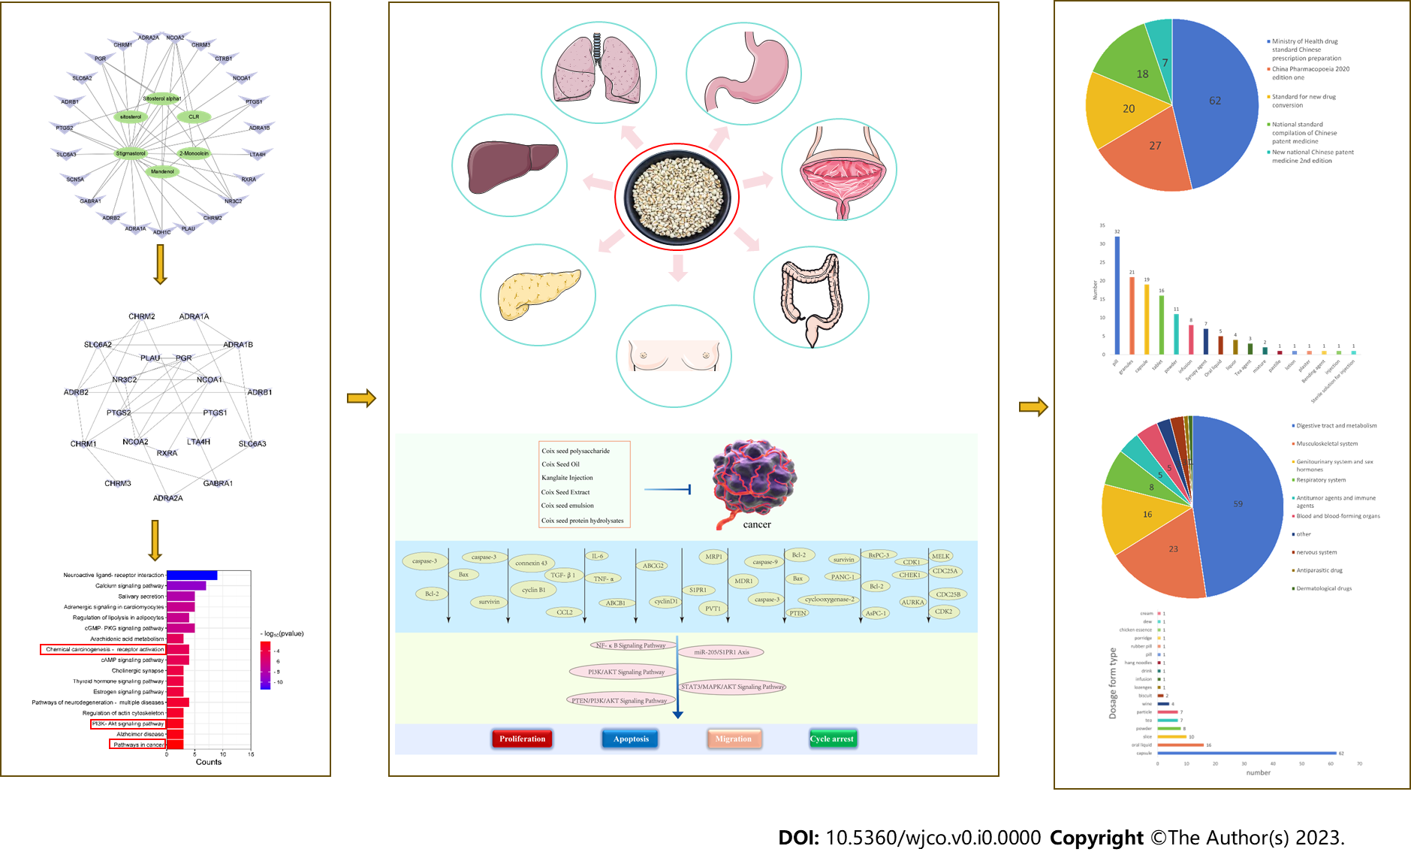
Figure 1 Flow chart.

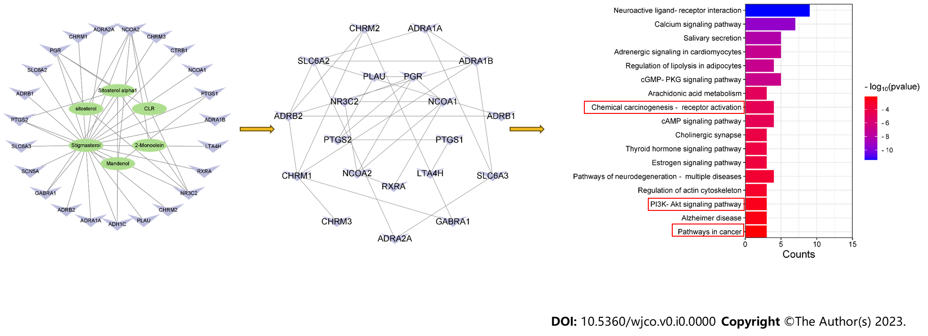
Figure 2 Relationship between active components of Coix seed and cancer.

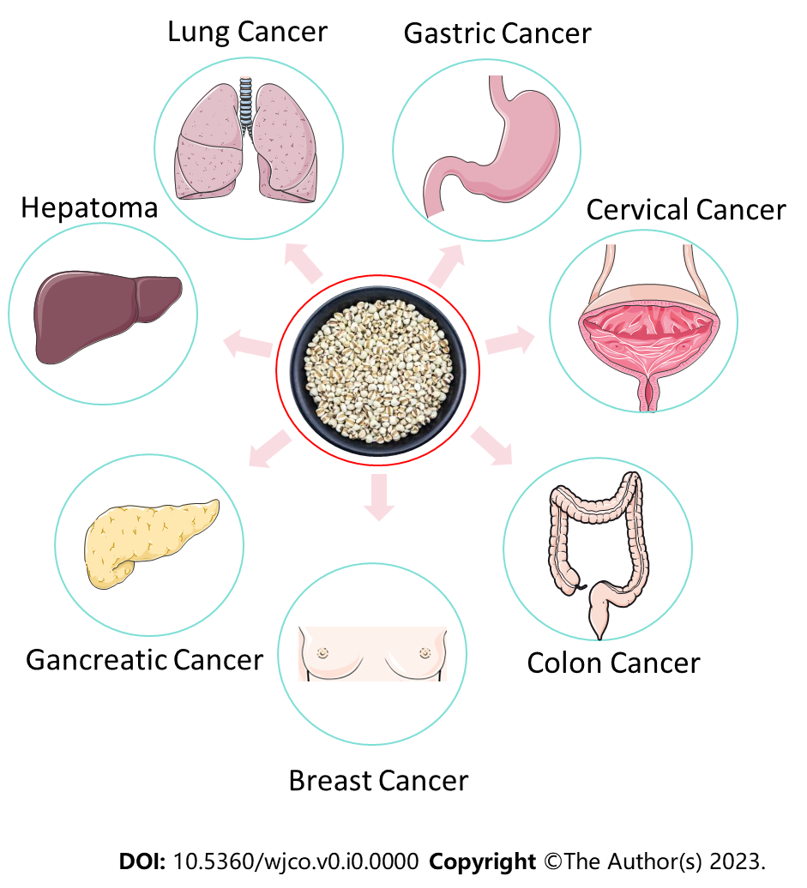
Figure 3 Relationship between Coix seed and cancer.

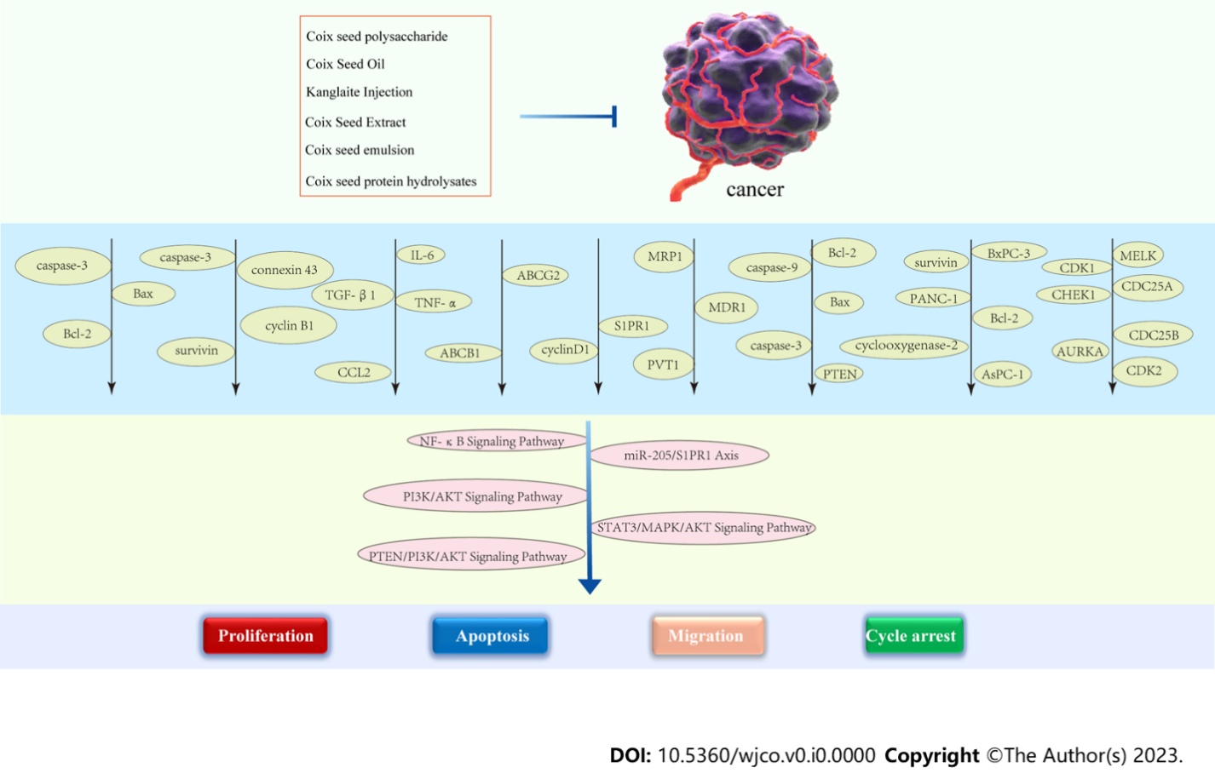
Figure 4 Mechanism of anti-tumor action of Coix seed and its components.

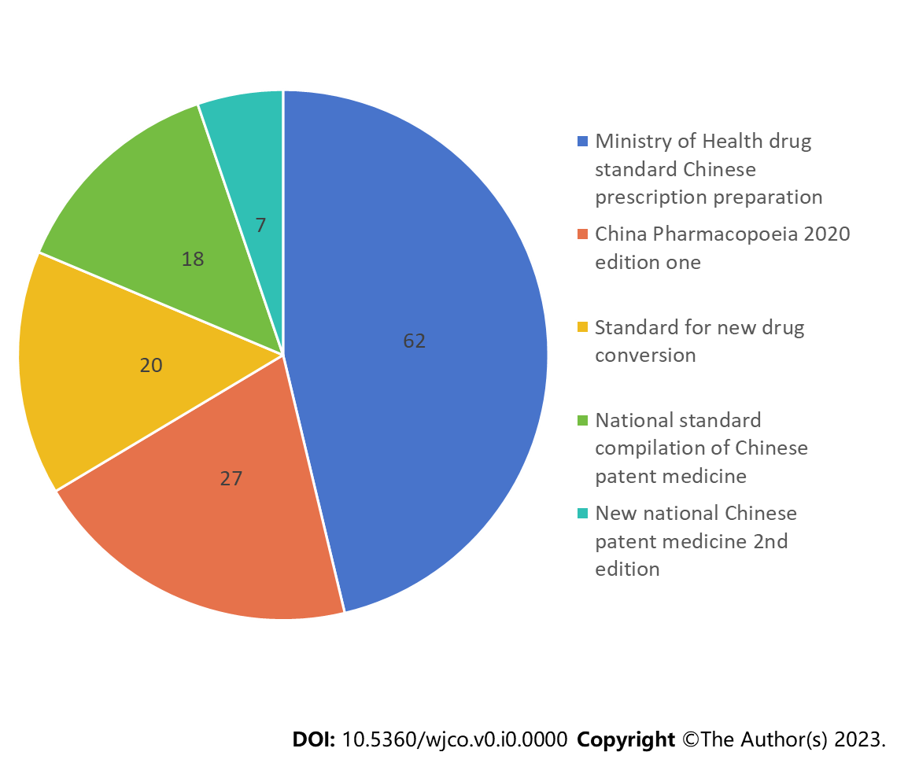
Figure 5 Source and quantity of Chinese patient medicine containing Coix seed.

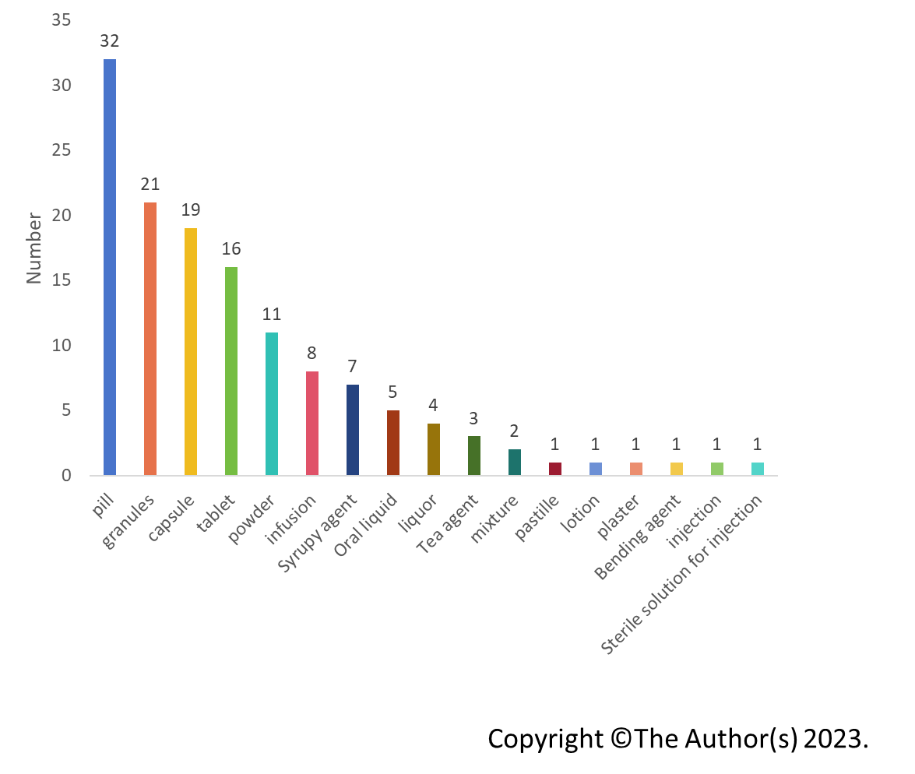
Figure 6 Chinese medicine dosage form containing Coix seed.

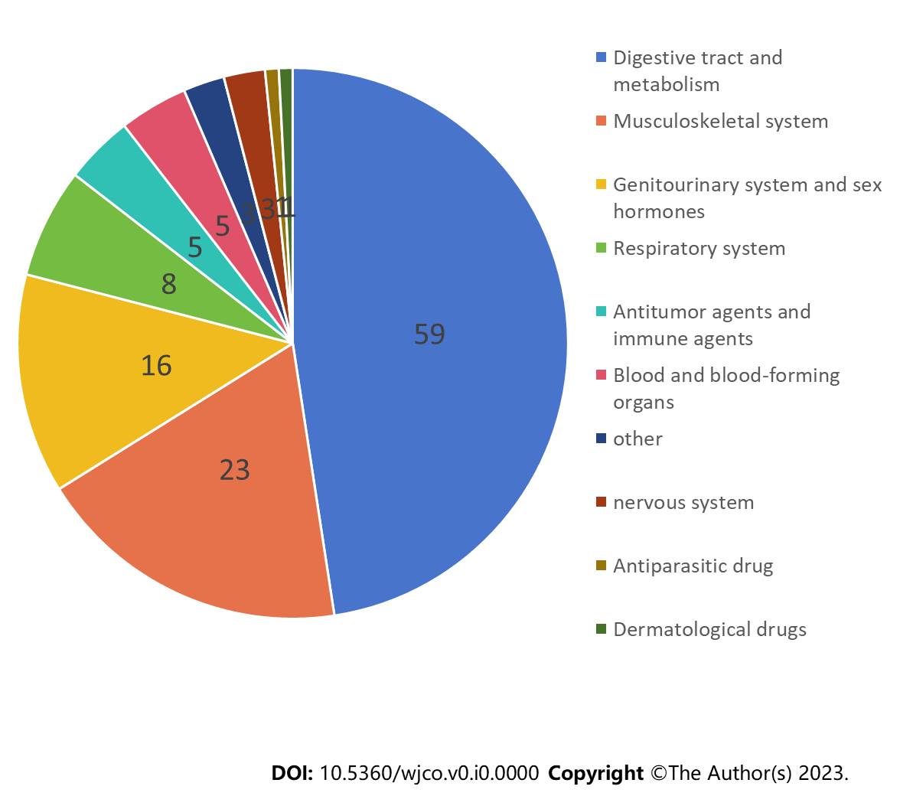
Figure 7 Anatomic Therapeutic Chemical classification of Chinese patient medicine.

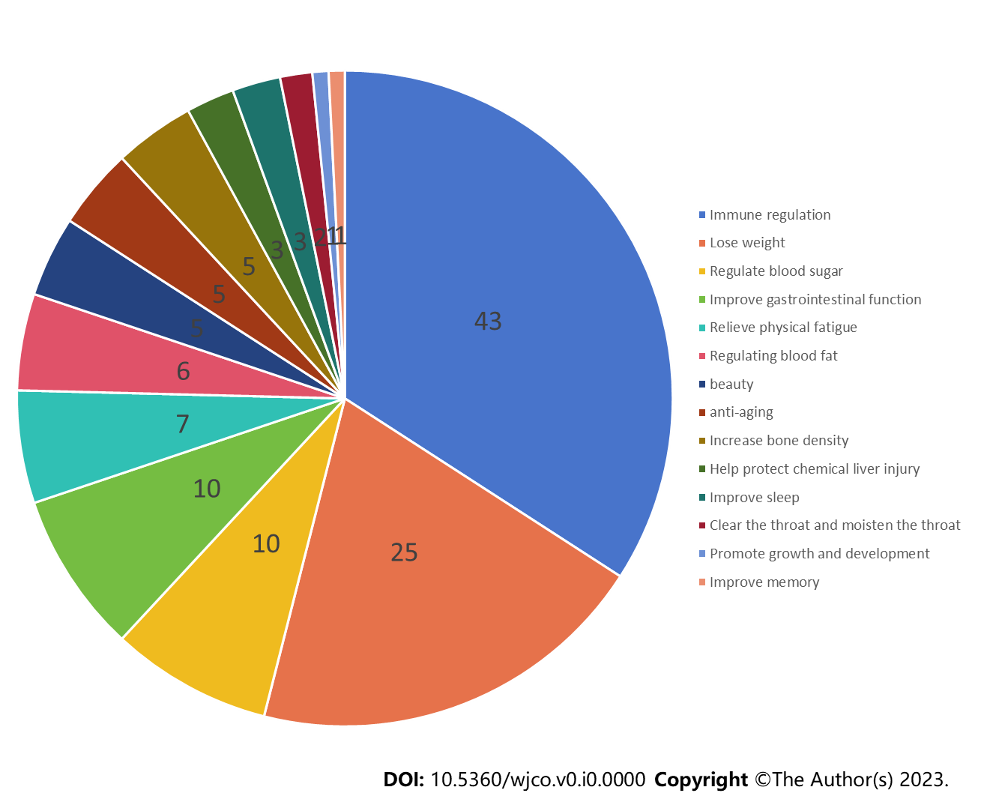
Figure 8 Function statistics of health care products containing Coix seed.

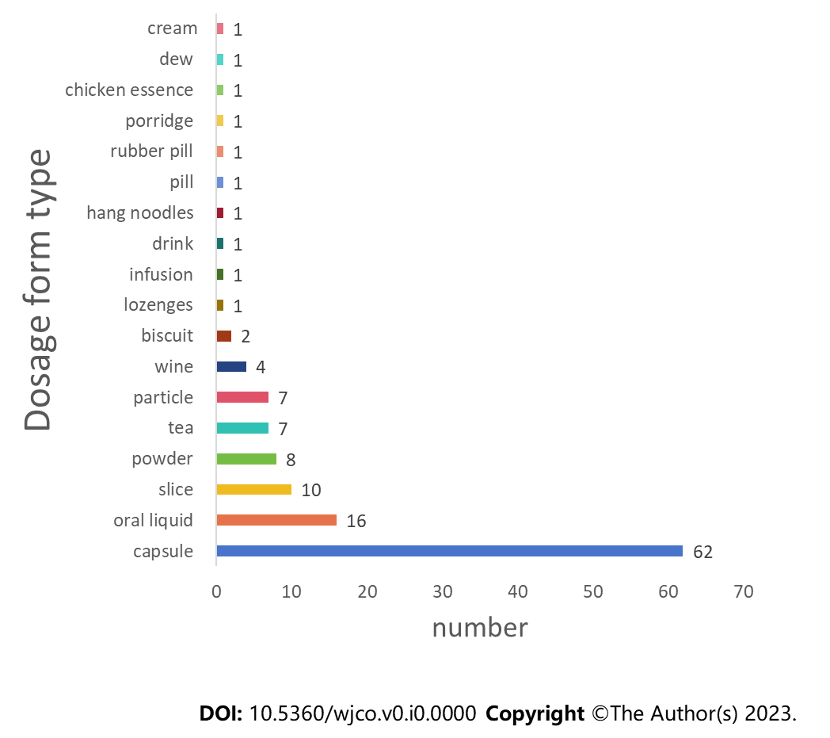
Figure 9 Dosage form containing Coix seed health care products.

Table 1 Processing method of Coix seed
Coix seed | Processing method | Source
Coix seed | Remove imports | Chinese Pharmacopoeia (2020)
Fried Coix seeds | Clean the mix seeds and fry them until they are slightly yellow | Processing Standards of TCM Decoction Pieces in Hubei Province (2018)
Fried mix seed with bran | Clean the mix seeds and fry them with bran until they are slightly yellow | Chinese Pharmacopoeia (2020)
Fried Coix seed in clay | Take the pure Coix seeds and fry them according to the method of soil frying until the surface benefits burn yellow and bulks up to the degree | Processing standard of TCM detection pieces in Henan Province  (2005)
Coix seed powder | Take coix seeds, remove impurities and crush them into fine powder | Processing Standards of TCM Decoction Pieces in Sichuan Province (2015)
Jiao Coix seed | Fry until browned | Processing Standards of TCM Decoction Pieces in Tianjin (2018)
Scald coix seed | Take the coix seed, wash it, moisten it thoroughly, steam it, dry it, and press it with the oil and method until it looks like a bubble | Fujian Province Traditional Chinese Medicine Processing Standards (1988)
TCM: Traditional Chinese medicine.

Table 2 Anti-cancer effect of Coix seed and its components
Pharmacological effect | Ingredient | Conclusion
Lung cancer | Kanglaite | Paclitaxel combined with kanglaite is effective in improving bone metastasis of lung cancer
 | Kanglaite injection | Kanglaite injection can significantly reduce the expression of miRNA-21 in patients with advanced lung cancer, and has a good thermal effect
 | Kanglaite | Kanglaite can achieve benefits by reducing TAM levels and improving hypoxia in mice with Lewis lung cancer
Colon cancer | Coix seed oil | Coix seed oil plays an anti-colon cancer role by inducing G2 rest and topology of HT-29 cells by regulating PI3K/AKT signaling pathway
Colorectal cancer | Kanglaite injection | Kanglaite pretreatment may increase the effect of Taxol on colored cancer
Hepatoma | Coix seed components | Octanoyl galactose ester modified microemulsion system self-assembled by coil seed components to enhance tumor targeting and hepatoma therapy
 | Coix seed ingredients | Bitargeted microemissions based on Coix seed ingredients have the effect of enhancing life tube transmission and synergistic therapy
Triple negative breast cancer | Kanglaite injection | Kanglaite injection was confirmed to have anti TNBC effects by arresting cell cycle and inhibiting CDK1 precipitation
 | Coix seed oil | Coix seed oil exerts an anti-triple negative breast cancer effect by interrupting miR-205/S1PR1 axis
Clinical cancer | Coix seed oil | Self-enhancing system colored with paclitaxel and Coix seed oil deeply penetrated can enhance efficiency of clinical cancer
 | Coix seed oil | Transferrin modified microemulsion carrying Coix seed oil and tripterine (Tf CT MEs) can be used to improve tube specific accumulation and connection to enhance clinical cancer treatment
 | Coix seed oil | Coix seed oil and tripterine coated microemissions with a transfer modification (Tf CT MES) could improve the treatment of cervical cancer
Gastric cancer | Kanglaite injection | Kanglaite inhibits the expression of drug resistance genes through suppressing PVT1 in cisplatin-resistant gas cancer cells
Pancreatic cancer | Coix seed oil | Coix seed oil regulations mitochondrial functional image to induce apoptosis of human pancreatic cancer cells via the PTEN/PI3K/AKT signaling pathway
 | Coix seed extract | Coix seed extract could augment the efficiency of gemcitabine therapy in pancreatic cancer cells
 | Coix seed emission | Coix seed emission synergistically enhances the antagonist activity of gemcitabine in pancreatic cancer through inhibition of NF- κ B signaling
Ameliorates cancer cachexia | Coix seed oil | Coix seed oil ameliorates cancer cachexia by counteracting muscle loss and fat lipolysis
TNBC: Triple negative breast cancer.

