Name of Journal: World Journal of Clinical Cases
Manuscript NO: 83079
Manuscript Type: CASE REPORT

Clinical review and literature analysis of hepatic epithelioid angiomyolipoma in alcoholic cirrhosis: A case report

Guo JQ et al. Hepatic epithelioid angiomyolipoma in alcoholic cirrhosis

Jing-Qiang Guo, Jia-Hui Zhou, Kun Zhang, Xin-Liang Lv, Chao-Yong Tu

Jing-Qiang Guo, Kun Zhang, Chao-Yong Tu, Department of Hepatobiliary and Pancreatic Surgery, Lishui Municipal Central Hospital, Lishui 323000, Zhejiang Province, China

Jia-Hui Zhou, Department of Pathology, Lishui Municipal Central Hospital, Lishui 323000, Zhejiang Province, China

Xin-Liang Lv, Department of General Surgery, The Fifth Affiliated Hospital of Wenzhou Medical University, Lishui 323000, Zhejiang Province, China

Co-corresponding authors: Xin-Liang Lv and Chao-Yong Tu.

Author contributions: Tu CY and Lv XL contributed equally to the manuscript; Tu CY and Lv XL designed the study; Guo JQ completed the first draft of this manuscript and performed the experiments and data collection; Zhang K was involved in data collection; Zhou JH provided pathological findings; Tu CY revised the manuscript. All authors have read and approved the final version of the manuscript.

Supported by Natural Science Foundation of Zhejiang Province, No. LY19H030004; and The Lishui City Key Research and Ddevelopment Project, No. 2022ZDYF08.

Corresponding author: Chao-Yong Tu, PhD, Occupational Physician, Department of Hepatobiliary and Pancreatic Surgery, Lishui Municipal Central Hospital, No. 289 Kuocang Road, Lishui 323000, Zhejiang Province, China. tcy7409@163.com

Received: February 3, 2024
Revised: March 7, 2024
Accepted: April 3, 2024
Published online:

Abstract
BACKGROUND
Hepatic epithelioid angiomyolipoma (HEA) has a low incidence and both clinical manifestations and imaging lack specificity. Thus, it is easy to misdiagnose HEA as other tumors of the liver, especially in the presence of liver diseases such as hepatitis cirrhosis. This article reviewed the diagnosis and treatment of a patient with HEA and alcoholic cirrhosis, and analyzed the literature, in order to improve the understanding of this disease.

CASE SUMMARY
A 67-year-old male patient with a history of alcoholic cirrhosis was admitted due to the discovery of a space-occupying lesion in the liver. Based on the patient’s history, laboratory examinations, and imaging examinations, a malignant liver tumor was considered and laparoscopic partial hepatectomy was performed. Postoperative pathology showed HEA. During outpatient follow-up, the patient showed no sign of recurrence.

CONCLUSION
HEA is difficult to make a definite diagnosis before surgery. HEA has the potential for malignant degeneration. If conditions permit, surgical treatment is recommended.

Key Words: Hepatic epithelioid angiomyolipoma; Alcoholic cirrhosis; Magnetic resonance imaging; Computed tomography; Immunohistochemistry; Misdiagnose analysis; Case report

Guo JQ, Zhou JH, Zhang K, Lv XL, Tu YC. Clinical review and literature analysis of hepatic epithelioid angiomyolipoma in alcoholic cirrhosis: A case report. World J Clin Cases 2024; In press

Core Tip: Hepatic epithelioid angiomyolipoma (HEA) is rare, with no specific clinical and imaging manifestations, has the potential of malignancy. In the presence of liver diseases such as cirrhosis, it is easily misdiagnosed as a malignant liver tumor. Characteristic imaging may help to diagnose HEA, but the diagnosis must be made by needle biopsy or histopathology. If conditions allow, active surgical treatment is recommended.

INTRODUCTION
Hepatitis cirrhosis is an obvious risk factor for the development of malignant liver tumors. The common cause of liver cirrhosis is hepatitis B virus infection and alcoholic liver disease. Hepatic epithelioid angiomyolipoma (HEA) is a special subtype of liver angiomyolipoma. Unlike hepatic angiomyolipoma, HEA contains little or no fat. Its low incidence combined with nonspecific clinical manifestations and atypical imaging findings make diagnosis difficult. Therefore, it is easily misdiagnosed as other liver tumors with a high rate of 40.34% (165/409), especially hepatocellular carcinoma which was wrongly diagnosed in 71 of 409 cases^{[1]}. HEA has the potential for malignant degeneration, and some patients have a poor prognosis^{[2]}. Epithelioid angiomyolipoma of the liver in the background of cirrhosis is a rare clinical diagnosis and easily misdiagnosed as hepatoma. We here report a case of HEA with alcoholic cirrhosis at Lishui Municipal Central Hospital, in the hope of providing a reference for future diagnosis and treatment of such cases.

CASE PRESENTATION
Chief complaints
A 67-year-old male patient was admitted to hospital with a liver mass found more than 2 months ago.

History of present illness
Three months ago, the patient underwent treatment for abnormal liver function at a nearby medical facility. No associated abdominal pain, diarrhea, or melena was observed. Ultrasound revealed a low echo mass in the left liver. A computed tomography (CT) examination indicated that liver section II was in a circular low-density lesion. Considering the possibility of hepatocellular carcinoma, magnetic resonance imaging (MRI) enhancement was recommended.

History of past illness
The patient was hospitalized 2 years ago due to trauma. During hospitalization an abdominal CT scan showed a low-density lesion in the left intrahepatic lobe. Further examinations were recommended but the patient declined due to personal reasons. A history of other infectious diseases such as viral hepatitis was denied. The patient had a history of alcohol consumption for more than 40 years.

Physical examination
The patient’s temperature was 36.8 °C, heart rate was 68 beats per minute, and blood pressure was 137/71 mmHg. There were no obvious positive signs during physical examination.

Laboratory examinations
Laboratory examinations showed that the patient’s platelet count was 87 × 10⁹/L (reference range, 125-350 × 10⁹/L), hepatitis B core antibody was positive, glutamic oxaloacetic transaminase was 42 U/L (reference range, 7-40 U/L), glutamyltransferase was 175 U/L (reference range, 7-45 U/L), alkaline phosphatase was 150 U/L (reference range, 50-135 U/L), total bile acid was 57.0 μmol/L (reference range, < 23 μmol/L), and tumor indicators were negative.

Imaging examinations
Two years previously, a CT scan suggested a low density lesion in the left intrahepatic lobe, approximately 1.2 cm × 1.0 cm in size. It was significantly enhanced in the arteriovenous phase of the enhanced scan and significantly decreased in the delayed phase, which was lower than the surrounding liver tissue (Figure 1). Two months ago, ultrasound findings at a local hospital showed a hypoechoic mass in the left liver. CT examination indicated that the liver was abnormal, the envelope was smooth, the liver fissure was widened, and liver section II showed a circular low density lesion. The boundary was clear, approximately 25.5 mm × 26.5 mm in size, and the CT value was about 35 HU. Following contrast injection, the three-level scan showed that the arterial stage was enhanced, the vein lesions were significantly enhanced, and the density of the balanced period was lower than the normal liver. Considering the possibility of hepatocellular carcinoma, MRI was recommended (Figure 2).

Further diagnostic work-up
MRI showed that the contour of the liver was not uniform, the proportion of the liver lobe was abnormal and the liver cleft was widened. The mass located near the diaphragmatic roof of the left liver lobe was approximately 2.7 cm × 2.8 cm, and showed hyperintensity on T2-weighted imaging (T2WI) and hypointensity on T1-weighted imaging (T1WI). Diffusion-weighted imaging (DWI) showed a hyperintense mass and the corresponding apparent diffusion coefficient (ADC) map showed an increased signal intensity in the mass. Enhanced MRI revealed that the mass was enhanced in the arterial phase and slightly weaker in the delayed phase with a high signal relative to the surrounding liver, suggesting a rich blood supply and cirrhotic nodules (Figure 3).

FINAL DIAGNOSIS
In middle-aged and elderly male patients with a history of alcoholic cirrhosis, who are hepatitis B core antibody positive, have a gradual increase in left liver rich blood supply to the lesion, and normal tumor serological indicators, a malignant liver tumor cannot be ruled out. Thus, the final diagnosis in this patient was a liver occupying lesion and alcoholic cirrhosis.

TREATMENT
In patients with liver lesions located in the leaf of the left liver, and no surgical contraindications, treatment is feasible. It was thought that the liver mass in this patient was malignant, therefore, laparoscopic resection of the liver tumor was performed.

OUTCOME AND FOLLOW-UP
During the operation, free ascites were found in the abdominal cavity, the liver showed nodular cirrhosis, and the tumor was successfully resected. The tumor was located in the left inner lobe of the liver, protruding from the liver surface and was approximately 2.5 cm × 3.0 cm in size, with clear boundaries. Analysis of the mass showed that the tumor envelope was complete and the boundary between the tumor and the surrounding liver tissue was clear. The surface of the liver section was reddish-brown (Figure 4). Microscopy revealed that the tumor under low-power showed a nest-like distribution, a clear boundary, interstroma rich in blood vessels, scattered lymphocyte and plasma cell infiltration, a multinucleated giant cell reaction and local nuclear red cells. Under high-power, some of the tumor cells were round or oval, with large cell bodies, an eosinophilic cytoplasm, large nuclei, and distinct nucleoli. Some tumor cells were fusiform and showed mitosis (Figure 5A and B). Immunohistochemistry revealed the following: S-100-, melanoma marker monoclonal antibody (HMB45) (locally scattered +), MelanA-, smooth muscle cell markers (SMA) locally+, Ki-67 (10%), and anti-human arginase (ARG)-1- (Figure 5B-D). When the immunohistochemistry results were combined with the other test results, the final diagnosis was HEA. The patient was discharged 11 d after surgery. At outpatient follow-up, the patient showed no signs of recurrence.

DISCUSSION
Long-term heavy drinking can lead to alcoholic cirrhosis. The cumulative annual risk of liver cancer in patients with alcoholic cirrhosis is approximately 1%-1.5%, and the 5-year cumulative risk is approximately 8%^{[3]}. Epithelioid angiomyolipoma is a member of the perivascular epithelioid cell tumors. It is common in the kidneys and rare in the liver. HEA accounts for 0.4% of primary tumors of the liver^{[4]}, and is more common in young and middle-aged women, with a male to female ratio of 1:4.84 and a median onset age of 44 years^{[1]}. There are no specific correlations with hepatitis, cirrhosis, and other underlying diseases. The clinical symptoms of HEA are not typical, most of these tumors are found during physical examination or examinations for other diseases. A few patients present with abdominal pain. Alpha-fetoprotein and other tumor indicators are usually negative^{[5]}. In this case, the patient had been drinking alcohol for a long time and had alcoholic cirrhosis without obvious clinical symptoms. He was admitted to the hospital due to a liver occupying mass. The initial examination indicated liver nodules with a rich blood supply. HEA was not considered before surgery. The patient was shown to have reduced platelets, and increased glutamic oxaloacetic transaminase, glutamyl aminotransferase, alkaline phosphatase, and total bile acid, which may have been related to alcoholic cirrhosis.
Studies have shown that the central vessel sign and the early venous drainage sign are characteristic images of HEA^{[6,7]}. In addition, the accumulation of ¹⁸F-fluorodeoxyglucose on positron emission tomography/CT can provide clues for diagnosis^{[8]}. As HEA lacks fat, it is difficult to distinguish from other liver tumors on MRI. Furthermore, when its enhanced appearance overlaps with hepatocellular carcinoma, the distinction between the two is particularly difficult^{[9]}. The imaging findings of HEA are mostly single lesions, visible in both the left and right liver. The lesions are circular or oval in shape, with clear boundaries and a false capsule. The CT scan can show a low-density shadow, enhancement of the arterial stage is obvious, and the enhanced shadow of the internal and surrounding vascular enhancement, the portal phase and the delayed phase are mostly seen on the "fast forward and slow out" mode. T1WI shows a low signal or a low hybrid signal, T2WI shows a slightly high signal or mixed signal with bleeding and an uneven signal, and DWI reveals a mostly high signal or slightly high signal. Most ADC signals are equal-signal, mixed high-low signal in some cases, and slightly low signal in rare cases. The MRI enhancement patterns are usually shown as fast wash-in and slow wash-out, and delayed enhancement^{[10]}. In our patient, HEA presented as a round low-density lesion with clear boundaries on plain CT scan, an enhanced vascular shadow was observed around the lesion, and CT enhancement demonstrated a fast wash-in and slow wash-out. MRI showed a low signal on T1WI, a slightly high signal on T2WI, a high signal on DWI, an increased ADC value, and enhancement in fast wash-in and slow wash-out.
The tumor morphology of hepatic blood vessels are often circular or oval, with reddish brown slices, no obvious leaf shape, clear boundaries, and some lesions can have a false film. Immunohistochemistry is one of the most important diagnostic methods for HEA. The tumor morphology of liver epithelioid angiomyolipoma is regular, usually circular or elliptic, with a reddish brown section, no obvious lobes, clear boundary, and a pseudocapsule in some lesions. HEA is characterized primarily by the positive expression of melanocyte markers (HMB45, Melan-A) and SMA, with negative epithelial markers (S-100, ARG-1, etc.), among which HMB45 positive expression is the most sensitive^{[11]}. Ki-67 is generally low (< 1%-15%), and Ki-67 is highly expressed in malignancy^{[12]}. The immunohistochemistry findings in this patient were HMB45 local +, SMA local +, S-100-, ARG-1-, and Ki-67 (10%), which was consistent with reports in the relevant literature. HEA has an abundant blood supply, which gradually enlarges the tumor, and has the risk of malignancy; the malignancy rate is 3.9%^{[12]}. Most clinicians advocate surgical treatment.

CONCLUSION
HEA lacks specific clinical manifestations, has variable imaging findings, and preoperative diagnosis is difficult. HEA has the potential for malignant transformation. In the presence of liver diseases such as cirrhosis, it is easily misdiagnosed as a malignant liver tumor. Surgical treatment is recommended. Characteristic imaging may help to diagnose HEA, but the diagnosis must be made by needle biopsy or histopathology.

REFERENCES
1 Mao JX, Teng F, Liu C, Yuan H, Sun KY, Zou Y, Dong JY, Ji JS, Dong JF, Fu H, Ding GS, Guo WY. Two case reports and literature review for hepatic epithelioid angiomyolipoma: Pitfall of misdiagnosis. World J Clin Cases 2019; 7: 972-983 [PMID: 31119142 DOI: 10.12998/wjcc.v7.i8.972]
2 Liu W, Meng Z, Liu H, Li W, Wu Q, Zhang X, E C. Hepatic epithelioid angiomyolipoma is a rare and potentially severe but treatable tumor: A report of three cases and review of the literature. Oncol Lett 2016; 11: 3669-3675 [PMID: 27313680 DOI: 10.3892/ol.2016.4443]
3 Tiniakos DG, Maurício J, Reeves HL. Fatty Liver Disease and Hepatocellular Carcinoma: The Pathologist's View. Adv Exp Med Biol 2018; 1032: 55-69 [PMID: 30362090 DOI: 10.1007/978-3-319-98788-0_4]
4 Jung DH, Hwang S, Hong SM, Kim KH, Ahn CS, Moon DB, Alshahrani AA, Lee SG. Clinico-pathological correlation of hepatic angiomyolipoma: a series of 23 resection cases. ANZ J Surg 2018; 88: E60-E65 [PMID: 28122404 DOI: 10.1111/ans.13880]
5 Fukuda Y, Omiya H, Takami K, Mori K, Kodama Y, Mano M, Nomura Y, Akiba J, Yano H, Nakashima O, Ogawara M, Mita E, Nakamori S, Sekimoto M. Malignant hepatic epithelioid angiomyolipoma with recurrence in the lung 7 years after hepatectomy: a case report and literature review. Surg Case Rep 2016; 2: 31 [PMID: 27037804 DOI: 10.1186/s40792-016-0158-1]
6 Jeon TY, Kim SH, Lim HK, Lee WJ. Assessment of triple-phase CT findings for the differentiation of fat-deficient hepatic angiomyolipoma from hepatocellular carcinoma in non-cirrhotic liver. Eur J Radiol 2010; 73: 601-606 [PMID: 19200676 DOI: 10.1016/j.ejrad.2009.01.010]
7 Liu W, Wang J, Huang Q, Lu Q, Liang W. Comparison of MRI Features of Epithelioid Hepatic Angiomyolipoma and Hepatocellular Carcinoma: Imaging Data From Two Centers. Front Oncol 2018; 8: 600 [PMID: 30619742 DOI: 10.3389/fonc.2018.00600]
8 Wang S, Xia H, Liu X, Liu Y, Lou C. Hepatic epithelioid angiomyolipoma mimicking hepatocellular carcinoma on MR and (18)F-FDG PET/CT imaging: A case report and literature review. Hell J Nucl Med 2022; 25: 205-209 [PMID: 35913867 DOI: 10.1967/s002449912480]
9 Xie L, Jessurun J, Manivel JC, Pambuccian SE. Hepatic epithelioid angiomyolipoma with trabecular growth pattern: a mimic of hepatocellular carcinoma on fine needle aspiration cytology. Diagn Cytopathol 2012; 40: 639-650 [PMID: 21563318 DOI: 10.1002/dc.21703]
10 O'Malley ME, Chawla TP, Lavelle LP, Cleary S, Fischer S. Primary perivascular epithelioid cell tumors of the liver: CT/MRI findings and clinical outcomes. Abdom Radiol (NY) 2017; 42: 1705-1712 [PMID: 28246920 DOI: 10.1007/s00261-017-1074-y]
11 Park HK, Zhang S, Wong MK, Kim HL. Clinical presentation of epithelioid angiomyolipoma. Int J Urol 2007; 14: 21-25 [PMID: 17199855 DOI: 10.1111/j.1442-2042.2006.01665.x]
12 Mao JX, Teng F, Yuan H, Ni ZJ, Fu H, Liu C, Sun KY, Zou Y, Dong JY, Dong JF, Ding GS, Guo WY. [409 patients with hepatic epithelioid angiomyolipoma: A pooled analysis]. Zhonghua Gandan Waike Zazhi 2018; 24: 659-663 [DOI: 10.3760/cma.j.issn.1007-8118.2018.10.003]

Footnotes
Informed consent statement: The patient and his family provided their written informed consent and agreed to the publication of this case report.

Conflict-of-interest statement: The authors declare that there is no conflict of interest.

CARE Checklist (2016) statement: The authors have read the CARE Checklist (2016), and the manuscript was prepared and revised according to the CARE Checklist (2016).

Open-Access: This article is an open-access article that was selected by an in-house editor and fully peer-reviewed by external reviewers. It is distributed in accordance with the Creative Commons Attribution NonCommercial (CC BY-NC 4.0) license, which permits others to distribute, remix, adapt, build upon this work non-commercially, and license their derivative works on different terms, provided the original work is properly cited and the use is non-commercial. See: https://creativecommons.org/Licenses/by-nc/4.0/

Provenance and peer review: Unsolicited article; Externally peer reviewed.

Peer-review model: Single blind

Specialty type: Medicine, research and experimental
Country/Territory of origin: China
Peer-review report’s scientific quality classification
Grade A (Excellent): 0
Grade B (Very good): 0
Grade C (Good): C
Grade D (Fair): 0
Grade E (Poor): 0

P-Reviewer: Puleo S, Italy S-Editor: Zheng XM L-Editor: A P-Editor:
Figure Legends
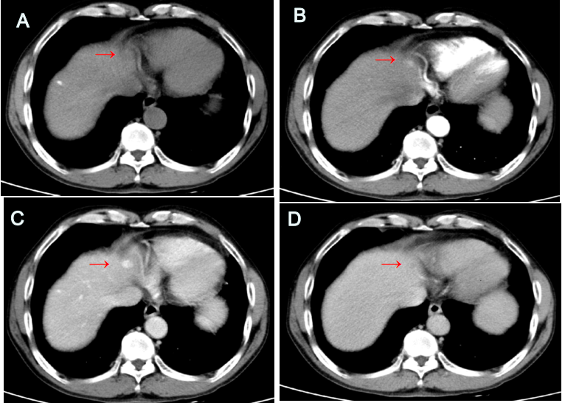
Figure 1 Abdominal computed tomography. A low-density nodular lesion near the parietal diaphragm of the left inner lobe of the liver, which was significantly enhanced in the arteriovenous phase of the enhanced scanning, and decreased in the delayed phase, lower than the surrounding liver tissue (the arrow shows the lesion). A: Plain computed tomography scan; B: The arterial phase of the enhanced scan; C: The portal vein phase; D: Delayed phase.

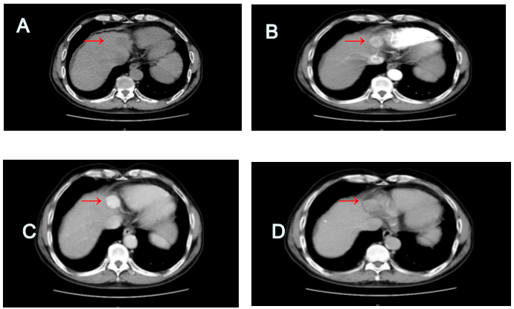
Figure 2 Computed tomography of the upper abdomen before the operation. Round low-density foci can be seen in the liver II segment with clear boundaries, enhanced foci can be seen in the arterial phase, significantly enhanced foci can be seen in the portal vein phase, and density in the equilibrium phase is lower than normal liver parenchyma (the arrow shows the lesion). A: Plain computed tomography scan; B: The arterial phase of the enhanced scan; C: The portal vein phase; D: Delayed phase.

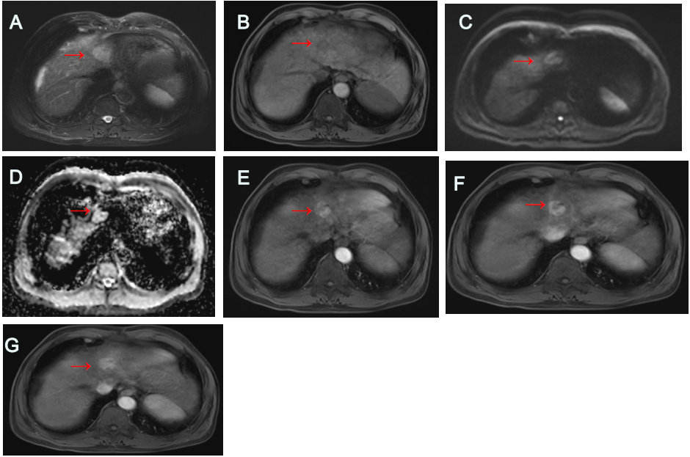
Figure 3 Magnetic resonance imaging of the upper abdomen before the operation. A sharp focus of abnormal signals was observed near the roof of the diaphragm of the left lobe of the liver, with a low signal in T1-weighted imaging (T1WI), a slightly high signal in T2-weighted imaging (T2WI), a high signal in diffusion-weighted imaging (DWI), and an increased in the apparent diffusion coefficient (ADC) value.The inproved scan showed obvious enhancement in the arterial phase, and slightly decreased local enhancement in the later period (the arrow shows the lesion). A: T1WI; B: T2WI; C: DWI; D: ADC; E: The arterial phase of the enhanced scan; F: The portal vein phase; G: Delayed phase.

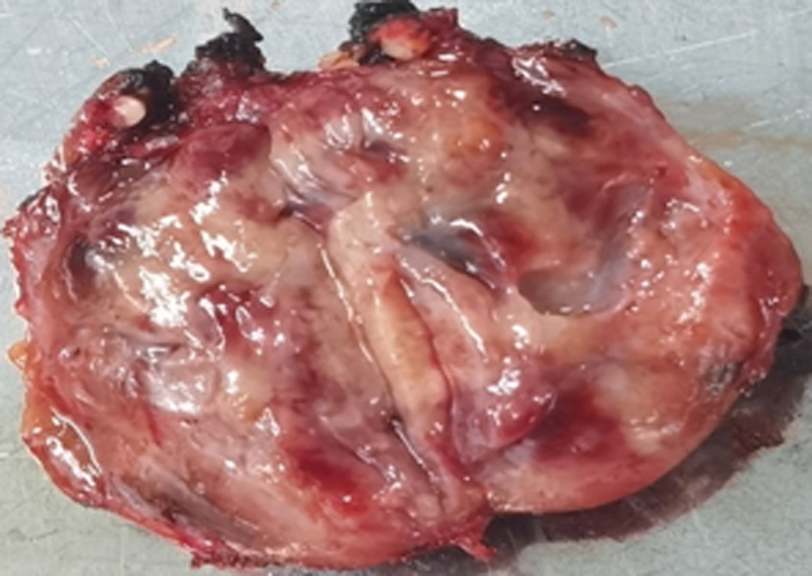
Figure 4 Gross specimen after operation. The tumor capsule was complete, the cut surface was reddish brown.

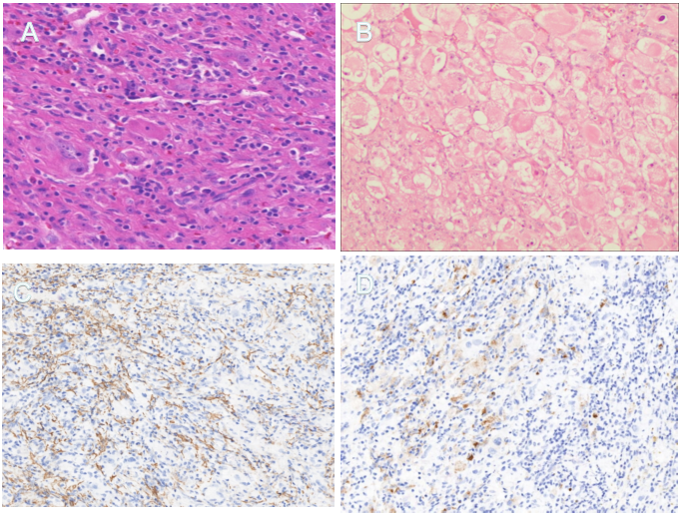
Figure 5 Postoperative pathology. A: Tumor cells showed nest-like distribution, clear boundary with liver tissue, rich blood vessels interstroma, scattered lymphocyte and plasma cell infiltration, multinucleated giant cell reaction, and local nuclear red cells (hematoxylin and eosin staining, × 20); B: The tumor cells were round or oval, with large cell bodies, eosinophilic cytoplasm, large nuclei, and distinct nucleoli. Some tumor cells are fusiform and mitotic (hematoxylin and eosin staining, × 100); C: Melanoma marker monoclonal antibody (HMB45) (+) l (immunohistochemical staining, × 100); D: Smooth muscle cell markers (+) (immunohistochemical staining, × 100).

