Name of Journal: World Journal of Gastroenterology

ESPS Manuscript NO: 21846

Manuscript Type: ORIGINAL ARTICLE

Basic Study

Ultrasound virtual endoscopy: Polyp detection and the reliability of measurements in an in vitro study with pig intestine specimens

Liu JY et al. USVE for intestinal polyp detection

Jin-Ya Liu, Li-Da Chen, Hua-Song Cai, Jin-Yu Liang, Ming Xu, Yang Huang, Wei Li, Shi-Ting Feng, Xiao-Yan Xie, Ming-De Lu, Wei Wang

Jin-Ya Liu, Li-Da Chen, Jin-Yu Liang, Ming Xu, Yang Huang, Wei Li, Xiao-Yan Xie, Wei Wang, Ming-De Lu, Department of Medical Ultrasonics, Institute of Diagnostic and Interventional Ultrasound, The First Affiliated Hospital of Sun Yat-Sen University, Guangzhou 510080, Guangdong province, China

Shi-Ting Feng, Hua-Song Cai, Department of Radiology, The First Affiliated Hospital of Sun Yat-Sen University, Guangzhou 510080, Guangdong province, China.

Author contributions: Liu JY, Chen LD, Wang W and Lu MD designed the research; Liu JY, Chen LD, Feng ST, Liang JY, Xu M, Huang Y, Li W, Cai HS, Xie XY and Wang W performed the research; Liu JY, Chen LD and Wang W analyzed the data; Liu JY and Wang W wrote the paper.

Supported by the National Natural Science Foundation of China, No. 81271576.

Institutional review board statement: The study was reviewed and approved by the The First Affiliated Hospital of Sun Yat-Sen University Institutional Review Board.

Institutional animal care and use committee statement: The animal care and use committee of The First Affiliated Hospital of Sun Yat-Sen University did not require their approval for the study. The phantoms we used in this study were commercially available at an abattoir.

Conflict-of-interest statement: None.

Data sharing statement: No additional data are available.

Open-Access: This article is an open-access article which was selected by an in-house editor and fully peer-reviewed by external reviewers. It is distributed in accordance with the Creative Commons Attribution Non Commercial (CC BY-NC 4.0) license, which permits others to distribute, remix, adapt, build upon this work non-commercially, and license their derivative works on different terms, provided the original work is properly cited and the use is non-commercial. See: http://creativecommons.org/licenses/by-nc/4.0/

Correspondence to: Wei Wang, MD, PhD, Department of Medical Ultrasonics, The First Affiliated Hospital of Sun Yat-Sen University, Institute of Diagnostic and Interventional Ultrasound, Sun Yat-Sen University, NO.58 Zhongshan Road 2, Guangzhou 510080, Guangdong province, China. wangw73@mail.sysu.edu.cn
Telephone: +86-20-87765183
Fax: +86-20-87765183

Received: July 31, 2015
Peer-review started: August 1, 2015
First decision: September 9, 2015
Revised: September 25, 2015
Accepted: December 12, 2015
Article in press:
Published online:
Abstract
AIM: To report an initial experience regarding the feasibility of ultrasound virtual endoscopy (USVE) and its measurement reliability in an in vitro study using pig intestine specimens.

Methods: Six porcine intestine specimens containing 30 synthetic polyps underwent USVE, Computer tomography colonography (CTC) and optical colonoscopy (OC) examinations for polyp detection. In USVE, the polyp measurement defined as the maximum polyp diameter on two-dimensional (2D) multiplanar reformatted (MPR) planes was obtained, and the absolute measurement error was analyzed using the direct measurement as the reference standard.

Results: In USVE, 29 (96.7%) of 30 polyps were detected, remaining a 7-mm one missed. There was one false-positive finding. Twenty-six (93.1%) of 29 reconstructed images were clearly depicted. Meanwhile, 29 (96.7%) of 30 polyps were depicted on CTC with one false-negative finding. In OC, all the polyps were detected. The intraclass correlation coefficient was 0.876 (95%CI: 0.745-0.940) for measurements obtained with USVE. The pooled absolute measurement errors ± the standard deviations of the depicted polyps with actual sizes of ≤ 5 mm, 6-9 mm, and ≥ 10 mm were 1.9 ± 0.8 mm, 0.9 ± 1.2 mm, and 1.0 ± 1.4 mm, respectively.

Conclusion: USVE was reliable for polyp detection and measurement in our in vitro phantom.

Key words: Three-dimensional ultrasound; Virtual endoscopy; In vitro; Intestinal polyps; Technical feasibility

© The Author(s) 2015. Published by Baishideng Publishing Group Inc. All rights reserved.

Core tip: We reported an initial experience regarding the feasibility of ultrasound virtual endoscopy (USVE) and its measurement reliability in an in vitro study using pig intestine specimens. USVE is a new technique that simulates views of Computer Tomography colonography (CTC). We found that USVE is an accurate screening method for simulated polyp detection and compares favorably to CTC and optical colonoscopy. As a dynamic, non-invasive, radiation-free, cost-effective method, USVE shows great promise for the screening and surveillance of colorectal cancer.

Liu JY, Chen LD, Cai HS, Liang JY, Xu M, Huang Y, Li W, Feng ST, Xie XY, Lu MD, Wang W. Ultrasound virtual endoscopy: Polyp detection and the reliability of measurements in an in vitro study with pig intestine specimens. World J Gastroenterol 2015; In press
Introduction
Colorectal cancer (CRC), which generally develops from benign adenomatous polyps, is a major cause of morbidity and mortality worldwide^{[1,2]}. Evidence-based guidelines recommend the CRC screening of individuals^{[3,4]} because the early detection and removal of polyps has been shown to reduce both the incidence and mortality of CRC^{[5,6]}. Optical colonoscopy (OC) is the primary method employed for CRC screening and the removal of polyps. As a primary imaging test, computed tomography colonography (CTC) is performed in average-risk individuals, particularly when an endoscopy is contraindicated or incomplete^{[4,7]}. It is highly sensitive for CRC screening with a sensitivity of 96.1% according to a meta-analysis^{[8]}. Unfortunately, these tests have some drawbacks, such as OC related invasiveness, procedure-related discomfort, the risk of bowel perforation, and CTC related ionizing radiation^{[9]}. Ultrasound virtual endoscopy (USVE) is a new technique that simulates views of CTC. It allows for the reconstruction of inner bowel-surface structures from the dynamic three-dimensional (3D) ultrasound data sets. Based on a surface reconstruction algorithm by interactive settings of threshold values and surface displays, endoscopic views can be obtained within seconds. Similar ultrasound virtual endoscopy imaging has been used for detection studies about carotid atherosclerosis and portal vein thrombus^{[10-12]}. But, USVE has never been used for polyp detection. It has several potential advantages for CRC screening over other modalities. It is dynamic, non-invasive, radiation-free, and cost-effective. Therefore, this new method shows great promise for the screening and surveillance of CRC.
The likelihood that a given polyp develops into malignancy or demonstrates high-grade dysplasia is directly related to its size^{[13-15]}. This risk is estimated to be much less than 1% for lesions 5-mm or smaller, whereas approximately 10%–25% for 10-mm or larger. 6-9-mm polyps are also almost invariably benign in nature. The advanced adenoma, deﬁned as a lesion 10-mm or larger, is the target of CRC screening and should be referred for polypectomy^{[16]}. However, radiologists suggested 6-mm as the minimum size for reporting polyp lesions^{[17]}. Hence, an understanding of the polyp size measurement error of USVE is very important for accurate polyp matching in the diagnostic performance.
Currently, there is no published report of the role of USVE in polyp detection, and its sensitivity and specificity for the detection of polyps are unknown. In this ideal in vitro study, we investigated the detection rate of simulated polyps at USVE compared to CTC and OC. Meanwhile, we estimated the conspicuity of the reconstructed endoscopic images. Also, we evaluated the reliability of the two-dimensional (2D) optimized polyp measurements of USVE using the direct measurement as the reference standard. In other words, the goal of this study was to report an initial experience regarding the feasibility of USVE and its measurement reliability in an in vitro study using porcine intestine specimens.

Materials and Methods
Phantom Preparation
Six porcine small intestine specimens, each about 50 cm long, were acquired from fresh pig intestines that were commercially available at an abattoir. The animal care and use committee of The First Affiliated Hospital of Sun Yat-Sen University did not require their approval for the study. Each specimen was cleansed to remove fecal matter, and no polyploid structures were found on the mucosal surface. Thirty simulated sessile polyps with maximum diameters of 4-13-mm were created from some pork wrapped by other intestinal mucosa with sutures. The maximum diameter of the polyp was confirmed by means of physical measurement with a caliper and a millimeter marked ruler. Then, the thirty polyps were secured to the mucosa of the inverted specimens and randomly placed with difference distances between adjacent polyps. Either the number or the size of the polyps was randomized in each specimen. A detailed polyp map of the specimen was recorded. Next, every specimen was re-inverted, and the distal end was double-tied with sutures. An 18-F urinary catheter was inserted into the open proximal end, which was then closed with the double-tied suture (Figure 1). A 50 ml syringe with a 3-way stopcock was attached to the urinary catheter. These procedures were performed by three individuals (Liu JY, Huang Y and Li W).

US virtual endoscopy
A 0.9% saline solution was introduced through the syringe, and the phantom was maximally distended to a diameter of approximately 3.5 cm. Then, it was placed in a plastic container containing water. The wall and the bottom of the container were covered with 2-mm-thick black sponges that helped absorb the ultrasound and reduced reﬂection.
The USVE was performed with an ultrasound scanner (Aplio 500, Toshiba, Otawa, Japan) equipped with a volume transducer (7–14 MHz) (PLT-1204MV, Toshiba Medical Systems). The imaging was performed by one radiologist (Wang W) who was unaware of the location, number and size of the polyps in each specimen. After the optimal 2D images was obtained, the 3D scan mode was initiated, and volume data were acquired with the following parameters: longitudinal scanning orientation (running along the longitudinal axis of the specimen); the 3D frequency, 8 MHz under the difference mode; the 3D gain, 70%-80%; the dynamic range, 40-50 dB; the depth (the distance between the probe and the proximal colon wall), about 30-mm; the focus, placed in the middle of the lumen; 3D Aplipure, on；3D scanning angle, 60⁰. Each specimen was scanned from the distal to the proximal end, and 3D volume data were obtained once approximately every 5-cm because of the sweeping length of the PLT-1204MV volume transducer. Therefore, one specimen was artificially separated into several approximately 5-cm-long segmentations. Then, the data from the scanning were loaded to the Fly Thru workstation (Fly Thru 3.0, Toshiba Medical Systems), which was capable of producing 2D multiplanar reformatted (MPR) images and 3D endoluminal surface renderings (Figure 2, Video 1). Virtual endoscopic images were shown by setting optimal threshold values based on a surface reconstruction algorithm. To prevent holes in the intestinal wall and the intraluminal artifact, a selection of a threshold value (0-150) was used for all reconstructions with other defined settings as follows: transparency, 20; filter, 3. All machine parameters remained unchanged between the examinations and were checked before the imaging.

Interpretation of the findings and measurements with USVE
Two independent readers (Chen LD and Xu M), who did not know the size range and number of polyps, reviewed all the ultrasound examinations and recorded wrote down the number, the position (the distance between adjacent polyps) and size of the simulated polyps. To be considered a valid match between virtual endoscopy and phantom, a polyp had to be appearing with the same segment, the same position and the similar diameters.
Lesion size is best deﬁned as the single largest diameter of the polyp head, excluding the stalk^{[17]}. With electronic calipers, the two readers independently measured the polyp size on an optimized 2D MPR plane, on which the maximum polyp diameter was viewed. The measurements were determined to the nearest millimeter. For the same polyp, mean measured size was the average of measurements from the two readers. As to the analysis of measurement accuracy, the absolute measurement error referred to difference between actual size and mean measured size. The standardized polyp size was defined as the mean measured optimized 2D diameter divided by the reference diameter and multiplied by 100%.
An overall ranking of image quality of the USVE protocol was performed. Both radiologists graded conspicuity and evaluated the images together to resolve any disagreements. The image conspicuity of each polyp was graded on a three-point scale^{[18,19]}: grade 1 = not visible or very poorly depicted; grade 2 = poorly depicted, with some artifacts that but don’t prevent diagnosis; and grade 3 = clearly depicted, without artifacts.

CTC
After the US examination, the six specimens were transferred to the CT suite. They were placed in a plastic container and then manually distended with room air using a syringe. Five liters of 93.7% soybean oil was poured into the container until the phantom was completely submerged^{[20]}. To advoid flotation, the specimen was fastened to the bottom of the container before the oil was poured by adhering strips of strap along the course of the specimen.
Being blinded to the location, size and number of polyps, two independent radiologists (Feng ST and Cai HS), performed the CT examinations with a 64-detector row CT scanner (Aquillion 64, Toshiba, Japan). The images were obtained following these parameters: 120 kV; 200-250 mA; section thickness, 0.5 mm; beam collimation, 64 mm × 0.5 mm; reconstruction interval, 0.5 mm; reconstructed section thickness, 0.5 mm; beam pitch, 0.828; gantry rotation time, 0.4 second; and ﬁeld of view, 5 cm. The scanning matrix was 512 × 512. Then, the data were loaded to a workstation (HP workstation XW8200, Vitrea 2, Version 3.7). The reconstructed virtual endoscopic images were read by these two radiologists who synchronously recorded the location, number and size of the simulated polyps.

OC
The OC of the six specimens was performed immediately after CT scanning with a colonoscope (CF-H260AI, CV-260, Olympus, Tokyo, Japan) by two independent endoscopists (Liang JY and Xie XY). The oil mixture was removed. The gastroenterologists were unaware of the location, number and size of the polyps in each specimen but were aware that polyps were present. The colonoscope was introduced through the open proximal end after the urinary catheter was removed. The examination was started and endoscopy views of the whole specimen were acquired. The same endoscopists recorded the location, number and size of the simulated polyps.

Statistical analysis
The relationship between conspicuity grades and polyp sizes was examined using Pearson’s chi-square test (SPSS 18, IBM Corporation, New York, NY, United States). A P value of less than 0.05 was considered to indicate a statistically signiﬁcant difference. The intraclass correlation coefficient (MedCalc version 10.2.0.0, Medalc Software, Mariakerke, Belgium) was applied to analyze the inter-observer agreement for polyp measurement.by applying.

Results
Simulated polyps detection
The reference polyp size and the number of the 30 simulated polyps for evaluating the detectability are shown in Figure 3. The polyps were classified into three groups according to size (≤ 5 mm, 6-9 mm, and ≥ 10 mm)^{[21,22]}. The detection rates for each group of the three modalities are shown in Table 1. With USVE, 29 (96.7%) of the 30 polyps were detected; only a 7-mm polyp was missed. There was one false-positive finding (identified as a 10-mm polyp). An initial analysis of the polyp conspicuity data revealed that no observation was assigned a grade of 1. Twenty-six (89.7%) of 29 polyps were clearly depicted (grade 3) (Figure 4), whereas the remaining 3 (10.1%) polyps were poorly depicted (grade 2). There was no significant interaction between polyp conspicuity grade and polyp size (P = 0.638) (Table 2).
Meanwhile, 29 (96.7%) of the 30 polyps were depicted on the CTC. All the polyps of 6-mm or larger were detected. One 5-mm polyp, which was located behind a fold, was not prospectively detected by the observer on any of the images but was depicted in a retrospective review. There was one false-positive finding (identified as a 6-mm lesion) as well. All the polyps were clearly detected by OC.

Polyp measurement
The intraclass correlation coefficient was 0.876 (95% confidence interval: 0.745, 0.940) for measurements obtained with USVE. The pooled absolute measurement errors ± standard deviations of the depicted polyps with actual sizes of 5-mm or smaller, 6-9-mm, and 10-mm or larger were 1.9 ± 0.8 mm, 0.9 ± 1.2 mm, and 1.0 ± 1.4 mm, respectively. The pooled standardized polyp size of the depicted polyps with actual sizes of 5-mm or smaller, 6-9-mm, and 10-mm or larger were 142.5 ± 18.7%, 111.2 ± 16.7%, and 109.2 ± 12.2%, respectively (Table 3).

Discussion
This study demonstrates that USVE is technically feasible in an in vitro intestinal specimen for the first time. We found that 96.7% (29/30) of the simulated polyps with different sizes ranging from 4 to 13 mm in diameter were depicted using USVE. Thus, it is an accurate screening method and compares favorably with CTC and OC for polyp detection. With USVE, the pooled error ± standard deviation and the pooled standardized polyp size of the optimized 2D MPR measurements were 0.9 ± 1.3 mm and 110.5% ± 14.6% for polyp ≥ 6-mm, respectively. This indicates that USVE is reliable in polyp measurement.
As we know, gastrointestinal tract ultrasonography is always challenging. Gas and fecal residue within the colonic lumen make visibility difficult. Nevertheless, the value of abdominal ultrasound in the diagnosis of CRC has already been established in various studies^{[23-26]}. Following the standard bowel preparation, including colonic cleansing and oral administration of solution for adequate luminal distention^{[19]}, transabdominal ultrasound is capable of acquiring 3D data of colon which then generate virtual endoscopic imaging. Also, transabdominal ultrasound can observe the presence of lymphadenopathy, the extracolonic extension of a mass, and the presence of distant metastases.
In 2001, a study has reported on ultrasound virtual endoscopic imaging^{[27]}, using a curved array probe or a linear array probe with a position-sensing sweeper device. A series of 2D images were manually scanned and then storied in a graphics workstation. In our study, however, we used a new 3D image processing system, called Fly Thru workstation, and the 3D volume probe. The new method is simpler, more convenient, and most important, has higher spatial resolution. In this ideal pig intestine phantom, USVE was capable of efficiently depicting polyps as small as 4-mm in diameter. In total, 89.7% of the reconstructed images were clearly depicted (Grade 3), which was approximately equal to the polyp conspicuity of CTC^{[18]}. Furthermore, the detection rate of polyps ≥ 6-mm on USVE approached 100% with only sporadic failures, which was similar to that of in vitro CTC^{[28]}. With the high resolution and high sensitivity of detecting polyp ≥ 6-mm, USVE promises to be a new colon neoplasm screening and surveillance modality.
Neither of the observers found one of the four 7-mm polyps during the retrospective reviews of USVE. In contrast, a 10-mm polyp, which was located at the division of two adjacent scan areas, was depicted twice and was regarded as a false-positive finding for both observers. These missing depiction and false-positive findings resulted from the limited sweeping range of the 3D volume transducer. When performing USVE, this transducer scanned approximately 5-cm of the intestine specimen for each acquisition. Thus, as one specimen was artificially separated into several segmentations, the polyps located at the division of adjacent scan areas could be repeatedly depicted or even missed. Based on our preliminary experience, we conclude that the limited scanning range is the major limitation of USVE.
The achievement of precise polyp matching is critical for the sensitivity of USVE. According to previous in vitro studies of CTC, the optimized 2D MPR measurement was as accurate as the 3D endoluminal measurement^{[20,29]}. In our study, we adapted the optimized 2D MPR measurement as the standard method of measurement. The mean absolute optimized 2D measurement errors and the mean standardized polyp sizes in the ≥ 6-mm group were generally consistent with that of CTC^{[20,29]}. This important indication demonstrates that the optimized 2D MPR measurement of USVE is reliable for clinical significance.
This study has some limitations. First of all, we assessed the technical accuracy of USVE performed under ideal conditions, which includes the absence of patient motion or peristaltic bowel activity, a clean, debris-free mucosal surface without folds, and maximal lumen distention. The study was not able to reflect an in vivo examination on human. The polyps, either their morphologic features or locations, may show more variability in patients. Also, polyp detection and measurement can be affected by colonic curvature, the haustral folds, and even different degrees of colonic distention. Additionally, we did not attempt to create flat adenomas in our specimens. Secondly, polyp size was not measured on the 3D view because the system is currently not able to obtain 3D measurement. Usually, 3D polyp measurements are closer to the “truth” than 2D measurement as maximum diameter of a polyp is straightforward with the former measurement. Although 2D measurements would optimize polyp diameter by comparing measurements on MPR planes, even using nonstandard oblique planes, this complex procedure would prolong the measurement^{[29]}.
In summary, USVE enables the reliable detection and measurement of small simulated mucosal polyps in our in vitro phantom. It is a good potential alternative for colorectal polyp detection. Future in vivo studies are required to determine its sensitivity and specificity for polyp detection in patients.
Acknowledgments
We are grateful to Chuan Peng, Xiao-Er Zhang, and Xiao-Wen Huang, Department of Medical Ultrasonics, Institute of Diagnostic and Interventional Ultrasound, The First Affiliated Hospital of Sun Yat-Sen University, for their valuable contributions to the phantom preparation of this study.

COMMENTS
Background
Most colorectal cancers (CRC) arose from adenomatous polyps, and the early detection and removal of polyps resulted in reducing both the incidence and mortality of CRC. Optical colonoscopy (OC) is widely accepted as the best available method for CRC screening. Computed tomography colonography (CTC) has yielded promising results. But, these tests have some drawbacks like invasiveness or ionizing radiation. Ultrasound virtual endoscopy (USVE), a novel non-invasive, radiation-free modality, shows great promise for the screening of CRC. Currently, the role of USVE in polyp detection has never been investigated, and its sensitivity and specificity are unknown.

Research frontiers
Virtue colonoscopy is an attractive alternative for CRC screening. According to some guidelines, CTC has been regarded as the leading imaging technique for CRC screening and the preferred test following an incomplete OC.

Innovations and breakthrough
This in vitro study has revealed, for the first time, an initial experience regarding the feasibility of USVE and its measurement reliability in pig intestine specimens.

Applications
USVE enables the reliable detection and measurement of small simulated mucosal polyps in our in vitro phantom. It is a good potential alternative for colorectal polyp screening.

Terminology
USVE is a novel trans-abdominal ultrasonic technique that simulates views of CTC. It allows for the reconstruction of inner bowel-surface structures from the dynamic three-dimensional ultrasound data sets.

Peer-review

This is an in vitro study that reports initial experience regarding the feasibility of a new, non-invasive, radiation-free technique (USVE) in detecting and measuring polyps. They compare it with CTC and colonoscopy, as the reference standard, with interesting results. Authors performed a well-designed study. It is detailed, easy to read and the subject (with all the important limitations of a preliminary approach) could be relevant in medicine in future. In vivo studies were encouraged to carry out.

References
1 Edwards BK, Noone AM, Mariotto AB, Simard EP, Boscoe FP, Henley SJ, Jemal A, Cho H, Anderson RN, Kohler BA, Eheman CR, Ward EM. Annual Report to the Nation on the status of cancer, 1975-2010, featuring prevalence of comorbidity and impact on survival among persons with lung, colorectal, breast, or prostate cancer. Cancer 2014; 120: 1290-1314 [PMID: 24343171 DOI: 10.1002/cncr.28509]
2 Siegel R, Desantis C, Jemal A. Colorectal cancer statistics, 2014. CA Cancer J Clin 2014; 64: 104-117 [PMID: 24639052 DOI: 10.3322/caac.21220]
3 Burt RW, Cannon JA, David DS, Early DS, Ford JM, Giardiello FM, Halverson AL, Hamilton SR, Hampel H, Ismail MK, Jasperson K, Klapman JB, Lazenby AJ, Lynch PM, Mayer RJ, Ness RM, Provenzale D, Rao MS, Shike M, Steinbach G, Terdiman JP, Weinberg D, Dwyer M, Freedman-Cass D; National comprehensive cancer network. Colorectal cancer screening. J Natl Compr Canc Netw 2013; 11: 1538-1575 [PMID: 24335688]
4 Yee J, Kim DH, Rosen MP, Lalani T, Carucci LR, Cash BD, Feig BW, Fowler KJ, Katz DS, Smith MP, Yaghmai V. ACR Appropriateness Criteria colorectal cancer screening. J Am Coll Radiol 2014; 11: 543-551 [PMID: 24793959 DOI: 10.1016/j.jacr.2014.02.006]
5 Atkin WS, Cook CF, Cuzick J, Edwards R, Northover JM, Wardle J; UK Flexible Sigmoidoscopy Screening Trial Investigators. Single flexible sigmoidoscopy screening to prevent colorectal cancer: baseline findings of a UK multicentre randomised trial. Lancet 2002; 359: 1291-1300 [PMID: 11965274 DOI: 10.1016/S0140-6736(02)08268-5]
6 Zauber AG, Winawer SJ, O'Brien MJ, Lansdorp-Vogelaar I, van Ballegooijen M, Hankey BF, Shi W, Bond JH, Schapiro M, Panish JF, Stewart ET, Waye JD. Colonoscopic polypectomy and long-term prevention of colorectal-cancer deaths. N Engl J Med 2012; 366: 687-696 [PMID: 22356322 DOI: 10.1056/NEJMoa1100370]
7 Spada C, Stoker J, Alarcon O, Barbaro F, Bellini D, Bretthauer M, De Haan MC, Dumonceau JM, Ferlitsch M, Halligan S, Helbren E, Hellstrom M, Kuipers EJ, Lefere P, Mang T, Neri E, Petruzziello L, Plumb A, Regge D, Taylor SA, Hassan C, Laghi A; European Society of Gastrointestinal Endoscopy; European Society of Gastrointestinal and Abdominal Radiology. Clinical indications for computed tomographic colonography: European Society of Gastrointestinal Endoscopy (ESGE) and European Society of Gastrointestinal and Abdominal Radiology (ESGAR) Guideline. Endoscopy 2014; 46: 897-915 [PMID: 25268304 DOI: 10.1055/s-0034-1378092]
8 Pickhardt PJ, Hassan C, Halligan S, Marmo R. Colorectal cancer: CT colonography and colonoscopy for detection--systematic review and meta-analysis. Radiology 2011; 259: 393-405 [PMID: 21415247 DOI: 10.1148/radiol.11101887]
9 Warren JL, Klabunde CN, Mariotto AB, Meekins A, Topor M, Brown ML, Ransohoff DF. Adverse events after outpatient colonoscopy in the Medicare population. Ann Intern Med 2009; 150: 849-57, W152 [PMID: 19528563]
10 He W, Zhang HQ, Shi CY, Chen J, Gao J. Fly through ultrasound imaging in assessment of carotid atherosclerosis: a pictorial essay. Clin Imaging 2013; 37: 811-820 [PMID: 23830542 DOI: 10.1016/j.clinimag.2013.03.002]
11 Kunte H, Rückert RI, Schmidt C, Harms L, Grigoryev M, Fischer T. Inverse fly-through technique in ultrasound imaging of carotid stenosis. Neurology 2013; 80: 122 [PMID: 23267033 DOI: 10.1212/WNL.0b013e31827b1b06]
12 Wang W, Liu GJ, Chen LD, Wang Z, Zhou LY, Lu MD, Xie XY, Huang Y, Li W. Preliminary experience of a new perspective view technology for the detection of portal vein thrombus in hepatocellular carcinoma patients. Abdom Imaging 2014; 39: 1145-1152 [PMID: 24760324 DOI: 10.1007/s00261-014-0145-6]
13 Shinya H, Wolff WI. Morphology, anatomic distribution and cancer potential of colonic polyps. Ann Surg 1979; 190: 679-683 [PMID: 518167 DOI: 10.1097/00000658-197912000-00001]
14 Eide TJ. Risk of colorectal cancer in adenoma-bearing individuals within a defined population. Int J Cancer 1986; 38: 173-176 [PMID: 3733258 DOI: 10.1002/ijc.2910380205]
15 Stryker SJ, Wolff BG, Culp CE, Libbe SD, Ilstrup DM, MacCarty RL. Natural history of untreated colonic polyps. Gastroenterology 1987; 93: 1009-1013 [PMID: 3653628]
16 Bond JH. Polyp guideline: diagnosis, treatment, and surveillance for patients with colorectal polyps. Practice Parameters Committee of the American College of Gastroenterology. Am J Gastroenterol 2000; 95: 3053-3063 [PMID: 11095318 DOI: 10.1111/j.1572-0241.2000.03434.x]
17 Zalis ME, Barish MA, Choi JR, Dachman AH, Fenlon HM, Ferrucci JT, Glick SN, Laghi A, Macari M, McFarland EG, Morrin MM, Pickhardt PJ, Soto J, Yee J; Working Group on Virtual Colonoscopy. CT colonography reporting and data system: a consensus proposal. Radiology 2005; 236: 3-9 [PMID: 15987959 DOI: 10.1148/radiol.2361041926]
18 Slater A, Taylor SA, Burling D, Gartner L, Scarth J, Halligan S. Colonic polyps: effect of attenuation of tagged fluid and viewing window on conspicuity and measurement--in vitro experiment with porcine colonic specimen. Radiology 2006; 240: 101-109 [PMID: 16793973 DOI: 10.1148/radiol.2401050984]
19 Bakir B, Acunas B, Bugra D, Yamaner S, Asoglu O, Salmaslioglu A, Balik E. MR colonography after oral administration of polyethylene glycol-electrolyte solution. Radiology 2009; 251: 901-909 [PMID: 19318587 DOI: 10.1148/radiol.2513081061]
20 Park SH, Choi EK, Lee SS, Byeon JS, Jo JY, Kim YH, Lee KH, Ha HK, Han JK. Polyp measurement reliability, accuracy, and discrepancy: optical colonoscopy versus CT colonography with pig colonic specimens. Radiology 2007; 244: 157-164 [PMID: 17507724 DOI: 10.1148/radiol.2441060794]
21 Pickhardt PJ, Choi JR, Hwang I, Butler JA, Puckett ML, Hildebrandt HA, Wong RK, Nugent PA, Mysliwiec PA, Schindler WR. Computed tomographic virtual colonoscopy to screen for colorectal neoplasia in asymptomatic adults. N Engl J Med 2003; 349: 2191-2200 [PMID: 14657426 DOI: 10.1056/Nejmoa031618]
22 Cotton PB, Durkalski VL, Pineau BC, Palesch YY, Mauldin PD, Hoffman B, Vining DJ, Small WC, Affronti J, Rex D, Kopecky KK, Ackerman S, Burdick JS, Brewington C, Turner MA, Zfass A, Wright AR, Iyer RB, Lynch P, Sivak MV, Butler H. Computed tomographic colonography (virtual colonoscopy): a multicenter comparison with standard colonoscopy for detection of colorectal neoplasia. JAMA 2004; 291: 1713-1719 [PMID: 15082698 DOI: 10.1001/jama.291.14.1713]
23 Rutgeerts LJ, Verbanck JJ, Crape AW, Buyse BM, Ghillebert GL. Detection of colorectal cancer by routine ultrasound. J Belge Radiol 1991; 74: 11-13 [PMID: 2022600]
24 Richardson NG, Heriot AG, Kumar D, Joseph AE. Abdominal ultrasonography in the diagnosis of colonic cancer. Br J Surg 1998; 85: 530-533 [PMID: 9607541 DOI: 10.1046/j.1365-2168.1998.00637.x]
25 Martínez-Ares D, Martín-Granizo Barrenechea I, Souto-Ruzo J, Yáñez López J, Pallarés Peral A, Vázquez-Iglesias JL. The value of abdominal ultrasound in the diagnosis of colon cancer. Rev Esp Enferm Dig 2005; 97: 877-886 [PMID: 16454607 DOI: 10.4321/S1130-01082005001200004]
26 Shirahama M, Koga T, Ishibashi H, Uchida S, Ohta Y. Sonographic features of colon carcinoma seen with high-frequency transabdominal ultrasound. J Clin Ultrasound 1994; 22: 359-365 [PMID: 8071453 DOI: 10.1002/jcu.1870220602]
27 Nakata N, Miyamoto Y, Tsujimoto F, Harada J, Tada S, Fukuda K. Ultrasound virtual endoscopic imaging. Semin Ultrasound CT MR 2001; 22: 78-84 [PMID: 11300589 DOI: 10.1016/S0887-2171(01)90020-4]
28 Taylor SA, Halligan S, Bartram CI, Morgan PR, Talbot IC, Fry N, Saunders BP, Khosraviani K, Atkin W. Multi-detector row CT colonography: effect of collimation, pitch, and orientation on polyp detection in a human colectomy specimen. Radiology 2003; 229: 109-118 [PMID: 14519872 DOI: 10.1148/radiol.2291020561]
29 Pickhardt PJ, Lee AD, McFarland EG, Taylor AJ. Linear polyp measurement at CT colonography: in vitro and in vivo comparison of two-dimensional and three-dimensional displays. Radiology 2005; 236: 872-878 [PMID: 16118167 DOI: 10.1148/radiol.2363041534]
P-Reviewer: Velayos B S-Editor: Gong ZM
L-Editor: E-Editor:

A B
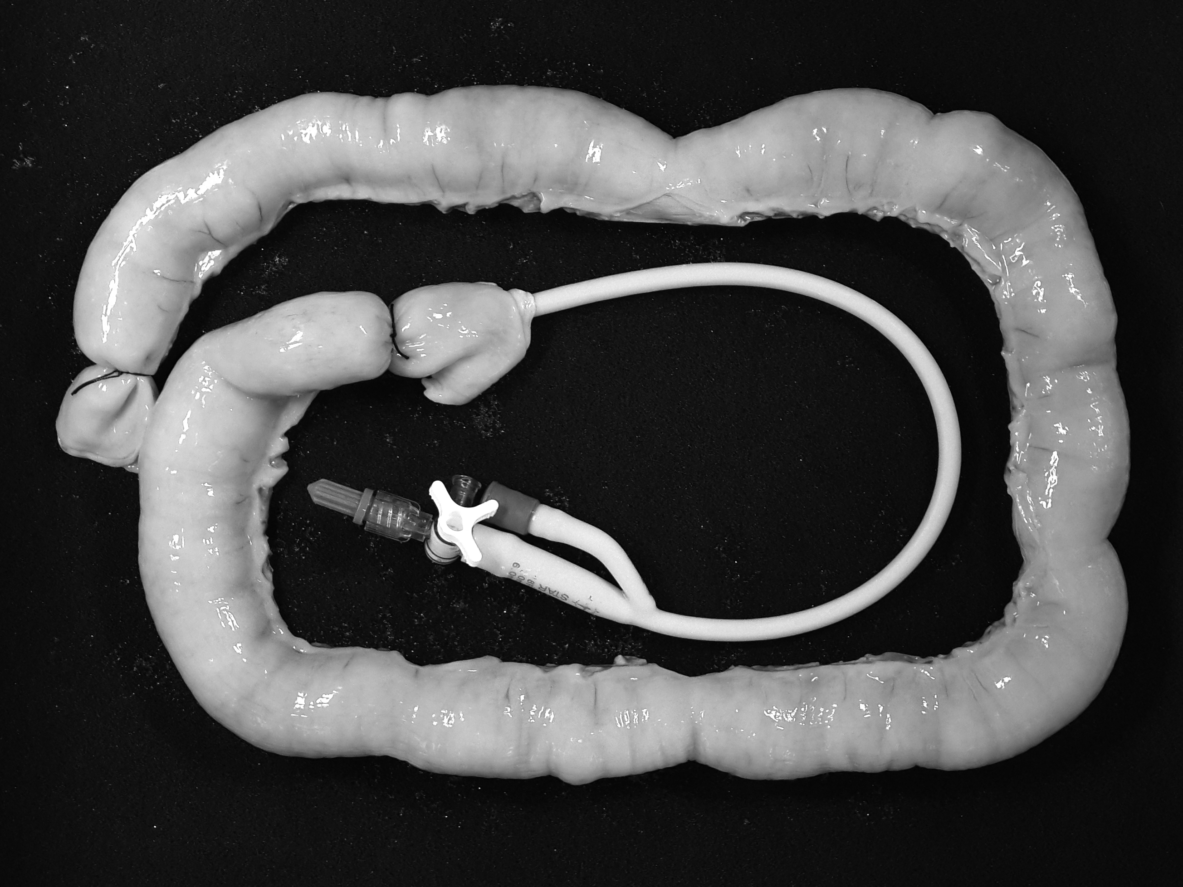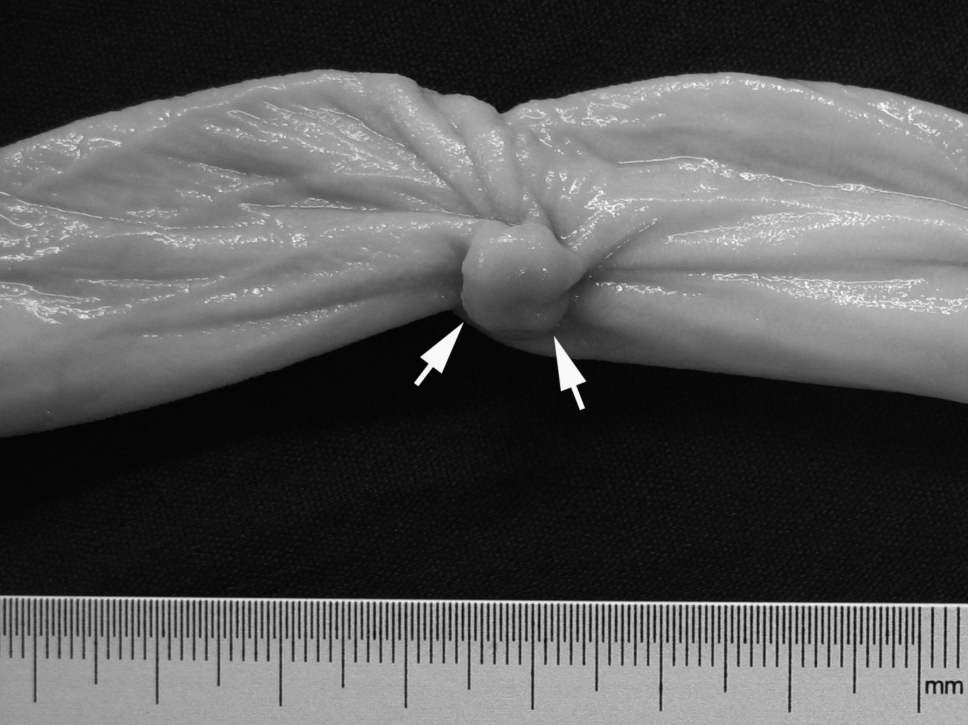
Figure 1 A pig intestine specimen and simulated polyps. A: A porcine intestine specimen with flexure configuration is placed on a black sponge. One end was double-tied with sutures. A catheter used for intestine distention, during the USVE and CTC, was placed through the other end. An optical colonoscopy was also performed through the latter end after removal of the catheter. B: A simulated polyp with a maximum diameter of 8-mm (arrow) was sutured to the inverted intestine specimen. USVE: ultrasound virtual endoscopy; CTC: Computed tomography colonography.

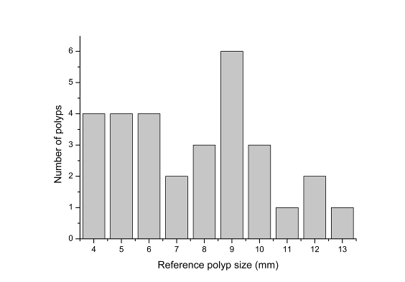
Figure 2 Polyp size and number.
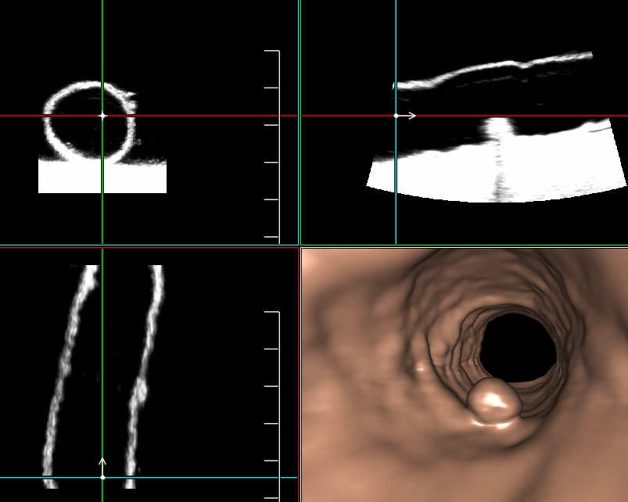
Figure 3 The 3D endoluminal reformatted image of ultrasound virtual endoscopy clearly depicting an 8-mm polyp. We can observe the polyp on the 2D transversal, sagittal and coronal ultrasonography at the same time.
A B
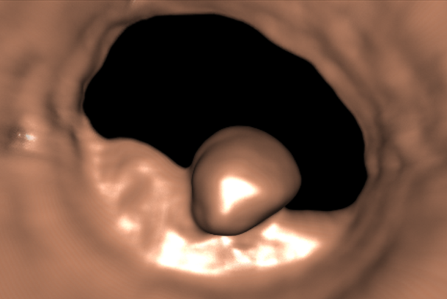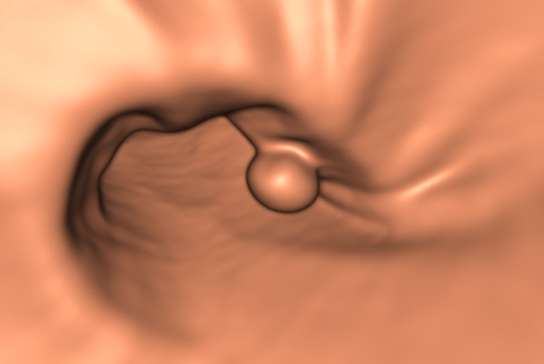
C
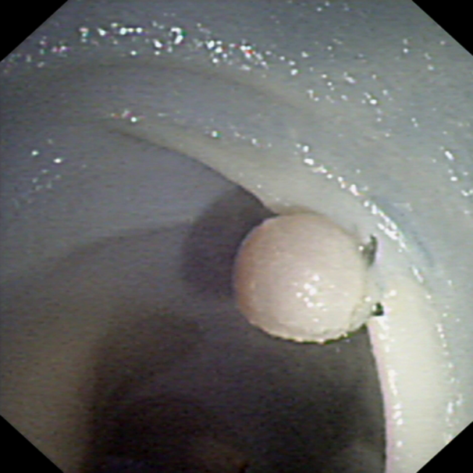
Figure 4 A 6-mm created polyp is clearly depicted on ultrasound virtual endoscopy (A), computed tomography colonography (B) and optical colonoscopy (C).

Table 1 The detection rate for the simulated polyps with ultrasound virtual endoscopy, computed tomography colonography and optical colonoscopy
Actual Polyp Size, mm | Referenced No. of polyps | OC |  |  | CTC |  |  | USVE
 |  | No. of Detected Polyps | Sensitivity (%) |  | No. of Detected Polyps | Sensitivity (%) |  | No. of Detected Polyps | Sensitivity (%)
≤ 5 | 9 | 9 | 100 |  | 8 | 88.9 |  | 9 | 100
6-9 | 15 | 15 | 100 |  | 15 | 100 |  | 14 | 93.3
≥ 10 | 6 | 6 | 100 |  | 6 | 100 |  | 6 | 100
All | 30 | 30 | 100 |  | 29 | 96.7 |  | 29 | 96.7
USVE: ultrasound virtual endoscopy; CTC: Computed tomography colonography; OC: Optical colonoscopy.
Table 2 The Relationship between the conspicuity grade and the polyp size n (%)
Actual polyp size, mm | Conspicuity grade 2¹ | Conspicuity grade 3¹ | P value
≤ 5 (n = 9) | 1 (11.1) | 8 (88.9) | 0.638
6-9 (n = 16) | 2 (12.5) | 14 (87.5)
≥ 10 ( n= 6) | 0 (0) | 6 (100)
¹Data are numbers of polyps with percentages in parentheses.
Table 3 The mean error of the optimized two-dimensional multiplanar reformatted measurement and the pooled standardized polyp size with ultrasound virtual endoscopy
Actual polyp size, mm | The mean measurement  error ± standard deviation, mm |  | The pooled standardized  polyp size ± standard deviation, %
≤ 5 (n = 9) | 1.9 ± 0.8 |  | 142.5 ± 18.7
6-9 (n = 14) | 0.9 ± 1.2 |  | 111.2 ± 16.7
≥ 10 (n = 6) | 1.0 ± 1.4 |  | 109.2 ± 12.2
≥ 6 (n = 20) | 0.9 ± 1.3 |  | 110.5 ± 14.6

Video 1 Dynamic three-dimensional endoluminal images of ultrasound virtual endoscopy with Fly Thru navigation. We can clearly see two polyps (4-mm and 6-mm) on the endoluminal wall of one segment of a specimen. Usually, the system itself will automatically navigate through the tubular structure. Sometimes, we also conduct manual Fly Thru navigation, which is useful depending on what is being imaged.

