Name of Journal: World Journal of Clinical Cases
Manuscript NO: 86613
Manuscript Type: MINIREVIEWS

Magnetic resonance imaging for acute pancreatitis in type 2 diabetes patients

Ni YH et al. MRI for AP in T2DM

Yan-Hui Ni, Ling-Ji Song, Bo Xiao

Yan-Hui Ni, Ling-Ji Song, Bo Xiao, Department of Radiology, The Affiliated Hospital of North Sichuan Medical College, Nanchong 637000, Sichuan Province, China

Bo Xiao, Department of Radiology, Bishan Hospital of Chongqing, Bishan Hospital of Chongqing Medical University, Chongqing 402760, China

Author contributions: Ni YH, Song LJ, and Xiao B designed the research study, performed the research, analyzed the data and wrote the manuscript; All authors have read and approve the final manuscript.

Corresponding author: Bo Xiao, MD, PhD, Associate Professor, Doctor, Department of Radiology, Bishan Hospital of Chongqing, Bishan Hospital of Chongqing Medical University, Chongqing 402760, China. xiaoboimaging@163.com

Received: June 27, 2023
Revised: July 13, 2023
Accepted: September 19, 2023
Published online: October 26, 2023

Abstract
Type 2 diabetes mellitus (T2DM) and its complications have significantly increased the burden of mortality and disability globally, making diabetes one of the most dangerous and prevalent chronic diseases. Acute pancreatitis (AP) is one of the most frequent gastrointestinal causes for hospital admission, which is a common exocrine pancreatic inflammatory disease that can cause severe abdominal pain and multiple organ dysfunction. There is an inseparable relationship between AP and diabetes. Diabetes is a high risk factor of AP, and patients with AP can develop pancreatogenic diabetes. In T2DM patients, the incidence rate of AP is significantly higher than that of the general population, and the clinical symptoms are more severe, with the majority of cases being moderate to severe AP. This review briefly introduces the pathogenesis and clinical features of AP in T2DM patients, focusing on the magnetic resonance imaging (MRI) manifestations of AP in T2DM patients. Our aim is to evaluate the severity of AP in patients with T2DM by MRI, so as to help clinicians assess the patient's condition and prognosis.

Key Words: Acute pancreatitis; Type 2 diabetes mellitus; Magnetic resonance imaging; Pancreatitis; Severity

©The Author(s) 2023. Published by Baishideng Publishing Group Inc. All rights reserved.

Citation: Ni YH, Song LJ, Xiao B. Magnetic resonance imaging for acute pancreatitis in type 2 diabetes patients. World J Clin Cases 2023; 11(30): 7268-7276
URL: https://www.wjgnet.com/2307-8960/full/v11/i30/7268.htm
DOI: https://dx.doi.org/10.12998/wjcc.v11.i30.7268

Core Tip: Up to the present time, a host of researchers have focused on the type 2 diabetes mellitus (T2DM) clinical manifestations. However, there are currently few investigations on the imaging features of acute pancreatitis (AP) in patients with T2DM. This paper demonstrates that the patients with T2DM have a higher prevalence of AP and more severe clinical manifestations, showing the magnetic resonance imaging findings of AP in T2DM.
INTRODUCTION
Acute pancreatitis (AP) is one of the most frequent gastrointestinal causes for hospital admission^{[1]}. AP is a common exocrine pancreatic inflammatory disease that can cause severe abdominal pain and multiple organ dysfunction, with a mortality rate of 1% to 5%^{[2]}. Overall, it has a global incidence of 30-40 cases per 100000 people per year, including children, pregnant women and the elderly. Moderate to severe AP with effusions and/or necrotizing effusions can lead to serious complications, and severe AP with persistent organ failure can lead to significant mortality^{[2,3]}.
Type 2 diabetes mellitus (T2DM) is a chronic, heterogeneous, systemic disease accompanied by varying degrees of insulin deficiency and/or insulin resistance^{[4]}. The epidemic condition of diabetes mellitus and its complications poses a major global health threat. The global prevalence of diabetes had reached pandemic proportions with reporting a prevalence of 9% (463 million adults) in 2019. This estimated number will rise to 642 million by 2040^{[5-7]}. These studies^{[8,9]} have demonstrated that patients with T2DM have a greater prevalence of AP compared with the general population, and the clinical manifestations of AP secondary to T2DM are more serious (mostly moderate to severe AP). On magnetic resonance imaging (MRI), the incidences of pancreatic or peripancreatic hemorrhage and necrosis, pancreatic duct interruption, and peripancreatic infection are higher than those of non-diabetic individuals. In the present, there has been little discussion about MRI for AP in T2DM patients. This review briefly introduces the pathogenesis and clinical features of AP in T2DM patients, focusing on the MRI manifestations of AP in T2DM patients.

Pathogenesis and clinical characteristics of AP in patients with T2DM
To our knowledge, the common causes of AP are gallstones, alcoholism, and hyperlipidemia. Previous studies show that T2DM may increase AP risk via hypertriglyceridemia^{[10]} and cholelithiasis^{[11]}. Dyslipidemia is frequently encountered in diabetic patients. The characteristics of dyslipidemia in diabetic patients are hypertriglyceridemia. T2DM increases low density lipoprotein cholesterol levels, and decreases apo-B, high-density lipoprotein cholesterol, and apo-A^{[10,12]}. Due to the hydrolysis of excess triglyceride by pancreatic lipase, a large amount of free fatty acids and free radicals are produced, resulting in acinar cell and pancreatic capillary damage and ischemia^{[13,14]}. Several other studies show that the potential mechanisms of hypertriglyceridemia pancreatitis are the insolubility of the lipid triglycerides in the aqueous environment of blood resulting in microthrombi in the pancreatic vasculature and ischemia and pancreatic infarction^{[15]}. On the other hand, a previous study has found that diabetes is consistently associated with a higher risk of gallstones^{[16]}. Obesity is common in diabetics due to insulin resistance-related metabolic syndrome, which may impact gallstone formation by multiple mechanisms^{[15]}. This clinical study investigated people with T2DM that have almost three times the risk of gallstone formation, compared with people without diabetes^{[17]}. In addition, four large epidemiological studies suggest an etiological role for diabetes in AP. Hyperglycemia and insulin resistance are major important factors leading to increased production of reactive oxygen species in acinar cells. Moreover, infectious diseases are more frequent and severe in diabetics^{[18,19]}. In clinical settings, T2DM patients with AP are often complicated with hyperlipidemia, gallstones, obesity and long average hospital stays. The prevalence of ICU admission and mortality is higher in patients with T2DM with AP^{[20]}.

Imaging evaluation of the severity of AP in patients with T2DM
Computed tomography (CT) or MRI with contrast medium is usually the first-line imaging examination for patients with AP. MRI and CT scan specifically demonstrate the overall changes of the pancreas and the degree of necrosis of the pancreas. Also, imaging can indicate the etiology and pathological findings, which has certain guiding significance for clinical guidance of medication and patient prognosis. Although contrast-enhanced CT (CECT) is considered the gold standard for evaluating AP, there are certain limitations in clinical application, such as repeated irradiation and injection of iodine contrast agents. CECT is also avoided in patients with AP-associated acute kidney injury. Moreover, scholars have found that contrast agents can exacerbate AP by damaging pancreatic microcirculation^{[21]}. However, MRI is a non-invasive and radiation free examination that can better display the morphology of the pancreatic parenchyma and pancreatic duct, evaluate the degree of pancreatic and peripancreatic exudation, necrosis, bleeding, and detect early pancreatic duct rupture^{[21]}. And it can display the morphology of bile ducts, which is also helpful for evaluating the etiology of AP, such as cholelithiasis and tumors. Gadolinium in MRI contrast agents has fewer side effects, especially less nephrotoxicity^{[22,23]}. Besides, due to better soft tissue resolution and interreader agreement for the detection of debris within the collections compared with CECT, MRI may also have a prognostic implication in terms of risk stratification when diagnosing extrapancreatic necrosis without pancreatic parenchymal necrosis^{[24]}. Moreover, MRI has better sensitivity for detection of mild parenchymal and early inflammatory changes, better detection of pancreatic glandular necrosis on unenhanced examinations, improved identification of solid components in complex necrotizing collections before drainage^{[23]}. In a prospective study, scholars investigated the correlation between CT and MRI at similar time points of particular importance, namely immediately after admission, when it is most useful for predicting outcome, and 7 d later, MRI is helpful in confirming the presence of necrosis and excluding cases with reversible hypoperfusion of the pancreatic parenchyma. Lastly, another important time point is 30 d after admission, when therapeutic decisions have to be made for the management of complications in the most severe cases^{[21]}. On MRI, AP is classified as interstitial edematous pancreatitis or necrotizing pancreatitis. Pancreatic necrosis is often defined as an area of low signal on T1-weighted images and absence of enhancement after administration of gadolinium. The severity of AP is assessed and graded according to the MR severity index (MRSI) (Table 1), which is derived from the CT severity index^{[25]}. Depending on MRSI scores, the severity of AP on MRI is subdivided into mild pancreatitis (0–3 points), moderate pancreatitis (4–6 points), and severe pancreatitis (7–10 points). In addition, MRI can evaluate for vascular injury such as pseudoaneurysm and venous thrombosis^{[26]}.

MRI manifestations of pancreatic changes in patients with AP in patients with T2DM
Pancreatic necrosis and/or hemorrhage
MRI can better display the morphology of the pancreas and signal changes in pancreatic parenchyma. Edematous pancreatitis is characterized by an enlarged pancreas and T2-weighted hyperintense changes of pancreatic parenchyma (Figure 1). AP onset of T2DM presented more frequency of moderate-to-severe AP on MRI^{[4]}. Moderate-to-severe AP manifests as pancreatic enlargement, hemorrhage and necrosis of the pancreatic parenchyma. Hemorrhage is defined as hyperintense areas within the pancreatic parenchyma or outside the pancreas on T1-weighted images. Pancreatic necrosis is determined as a low-intensity area on T1-weighted images and parenchymal nonenhancement after injection of contrast media (Figure 2, Figure 3 and Figure 4)^{[27]}. Our previous research^{[4]} has proved that the prevalence of pancreatic/peripancreatic hemorrhage was higher in AP patients with diabetes than in those without diabetes. In addition, we found that the incidence of necrotizing pancreatitis was higher in patients who presented with AP with diabetes, and there was greater parenchymal necrosis volume (greater than 30% of pancreatic necrosis) in AP patients with T2DM than in those without diabetes.

Disconnected pancreatic duct syndrome
Magnetic resonance cholangiopancreatography, a noninvasive modality, clearly demonstrates dilatation, stricture, and irregularity of the main pancreatic duct^{[28-30]}. Due to the higher incidence of acute necrotizing pancreatitis in T2DM, when a large area of pancreatic parenchyma necrosis in necrotizing pancreatitis involves the main pancreatic duct (leading to pancreatic duct necrosis), the pancreatic and peripancreatic ANC is often accompanied by rupture and interruption of the main pancreatic duct. This is so-called "disconnected pancreatic duct syndrome"^{[31]} (Figure 5).

MRI manifestations of peripancreatic changes in patients with AP in patients with T2DM
The spread of AP inflammation most often involves the retroperitoneal space, and can also spread to the subperitoneal space (omentum, mesentery, etc)^{[32]}. Peripancreatic changes of AP in patients with T2DM mainly include local complications of AP^{[33]}. According to the Revised Atlanta Classification, local complications are acute peripancreatic fluid collection (APFC), pancreatic pseudocyst, acute necrotic collection (ANC) and walled-off necrosis (WON). APFC (Figure 6) occurs in interstitial edematous pancreatitis; and pancreatic pseudocyst forms as a delayed (usually > 4 wk) complication of interstitial edematous pancreatitis. In contrast, necrosis may be an ANC (Figure 7) or WON (Figure 4). WON is a mature, encapsulated collection of pancreatic and/or peripancreatic necrosis and has a well-defined inflammatory wall. Usually, this maturation occurs ≥ 4 wk after onset of necrotizing pancreatitis^{[3]}. Patients with AP with diabetes were at higher frequency of the development of fluid collections (especially walled-off necrosis) and infected collections compared with nondiabetic AP. These recognitions among physicians are of importance for appropriate clinical treatment strategies of T2DM-associated AP^{[4]}.

MRI manifestations of adjacent or distant organ changes in T2DM with AP
Liver injury
We found that liver injury could occur in patients with AP, including local liver inflammation, apoptosis, hepatocyte necrosis, and metabolic disorders^{[34]}. It may manifest as fatty liver (FL) on MRI (Figure 8). In a prior study, we found that FL on MRI occurred in a majority of patients with AP. The severity of the FL in MRI was related to the severity of the AP and to the serum triglyceride levels. Following the patient’s recovery, the FL on MRI could subside for both mild and severe AP patients^{[35]}.

Changes of renal and perirenal space
Previous studies have found that renal dysfunction caused by AP rarely exhibits renal parenchymal abnormalities on MRI (including asymmetrical renal enhancement, abnormalities of the renal collecting system and renal vascular abnormalities). However, perirenal space involvement is much more common and includes renal fascia thickening, perirenal space stranding and patchy fluid collections in the perirenal space (Figure 9). The prevalence of perirenal space involvement in AP patients on MRI has a positive correlation with the severity of AP based on the MRSI^{[36]}.

CONCLUSION
Overall, this paper demonstrates that the patients with T2DM have a higher prevalence of AP and more severe clinical manifestations, showing the MRI findings of AP in T2DM. Up to the present time, a host of researchers focused on the clinical manifestations of AP in patients with T2DM. However, there are currently few investigations on the imaging features. Further research can be done on the imaging characteristics of AP exacerbated by diabetes, as well as whether diabetic medical histories and their blood sugar levels linked to the AP severity or not. In the future, it is expected that artificial intelligence methods, such as radiomics and deep learning, may be added to this field to detect pancreatic complications, severity prediction, and prognosis evaluation in patients with T2DM.

REFERENCES
1 Yadav D, Lowenfels AB. The epidemiology of pancreatitis and pancreatic cancer. Gastroenterology 2013; 144: 1252-1261 [PMID: 23622135 DOI: 10.1053/j.gastro.2013.01.068]
2 Petrov MS, Yadav D. Global epidemiology and holistic prevention of pancreatitis. Nat Rev Gastroenterol Hepatol 2019; 16: 175-184 [PMID: 30482911 DOI: 10.1038/s41575-018-0087-5]
3 Banks PA, Bollen TL, Dervenis C, Gooszen HG, Johnson CD, Sarr MG, Tsiotos GG, Vege SS; Acute Pancreatitis Classification Working Group. Classification of acute pancreatitis--2012: revision of the Atlanta classification and definitions by international consensus. Gut 2013; 62: 102-111 [PMID: 23100216 DOI: 10.1136/gutjnl-2012-302779]
4 Xiao B, Xu HB, Jiang ZQ, Hu JX, Yang GD. Acute Pancreatitis in Patients With a Medical History of Type 2 Diabetes Mellitus: Clinical Findings and Magnetic Resonance Imaging Characteristics. Pancreas 2020; 49: 591-597 [PMID: 32282775 DOI: 10.1097/MPA.0000000000001530]
5 Zheng Y, Ley SH, Hu FB. Global aetiology and epidemiology of type 2 diabetes mellitus and its complications. Nat Rev Endocrinol 2018; 14: 88-98 [PMID: 29219149 DOI: 10.1038/nrendo.2017.151]
6 Heald AH, Stedman M, Davies M, Livingston M, Alshames R, Lunt M, Rayman G, Gadsby R. Estimating life years lost to diabetes: outcomes from analysis of National Diabetes Audit and Office of National Statistics data. Cardiovasc Endocrinol Metab 2020; 9: 183-185 [PMID: 33225235 DOI: 10.1097/XCE.0000000000000210]
7 Sun H, Saeedi P, Karuranga S, Pinkepank M, Ogurtsova K, Duncan BB, Stein C, Basit A, Chan JCN, Mbanya JC, Pavkov ME, Ramachandaran A, Wild SH, James S, Herman WH, Zhang P, Bommer C, Kuo S, Boyko EJ, Magliano DJ. IDF Diabetes Atlas: Global, regional and country-level diabetes prevalence estimates for 2021 and projections for 2045. Diabetes Res Clin Pract 2022; 183: 109119 [PMID: 34879977 DOI: 10.1016/j.diabres.2021.109119]
8 Urushihara H, Taketsuna M, Liu Y, Oda E, Nakamura M, Nishiuma S, Maeda R. Increased risk of acute pancreatitis in patients with type 2 diabetes: an observational study using a Japanese hospital database. PLoS One 2012; 7: e53224 [PMID: 23300896 DOI: 10.1371/journal.pone.0053224]
9 Yang L, He Z, Tang X, Liu J. Type 2 diabetes mellitus and the risk of acute pancreatitis: a meta-analysis. Eur J Gastroenterol Hepatol 2013; 25: 225-231 [PMID: 23269036 DOI: 10.1097/MEG.0b013e32835af154]
10 Albai O, Roman D, Frandes M. Hypertriglyceridemia, an important and independent risk factor for acute pancreatitis in patients with type 2 diabetes mellitus. Ther Clin Risk Manag 2017; 13: 515-522 [PMID: 28450786 DOI: 10.2147/TCRM.S134560]
11 Monami M, Nreu B, Scatena A, Cresci B, Andreozzi F, Sesti G, Mannucci E. Safety issues with glucagon-like peptide-1 receptor agonists (pancreatitis, pancreatic cancer and cholelithiasis): Data from randomized controlled trials. Diabetes Obes Metab 2017; 19: 1233-1241 [PMID: 28244632 DOI: 10.1111/dom.12926]
12 Taskinen MR. Diabetic dyslipidaemia: from basic research to clinical practice. Diabetologia 2003; 46: 733-749 [PMID: 12774165 DOI: 10.1007/s00125-003-1111-y]
13 Huang DB, Raskin P. Diabetic hypertriglyceridemia-induced acute pancreatitis masquerading as biliary pancreatitis. J Diabetes Complications 2002; 16: 180-182 [PMID: 12039403 DOI: 10.1016/s1056-8727(01)00183-0]
14 Tsuang W, Navaneethan U, Ruiz L, Palascak JB, Gelrud A. Hypertriglyceridemic pancreatitis: presentation and management. Am J Gastroenterol 2009; 104: 984-991 [PMID: 19293788 DOI: 10.1038/ajg.2009.27]
15 Khatua B, El-Kurdi B, Singh VP. Obesity and pancreatitis. Curr Opin Gastroenterol 2017; 33: 374-382 [PMID: 28719397 DOI: 10.1097/MOG.0000000000000386]
16 Figueiredo JC, Haiman C, Porcel J, Buxbaum J, Stram D, Tambe N, Cozen W, Wilkens L, Le Marchand L, Setiawan VW. Sex and ethnic/racial-specific risk factors for gallbladder disease. BMC Gastroenterol 2017; 17: 153 [PMID: 29221432 DOI: 10.1186/s12876-017-0678-6]
17 Sodhi JS, Zargar SA, Khateeb S, Showkat A, Javid G, Laway BA, Parveen S, Khan BA, Yattoo GN, Shah A, Gulzar GM, Khan MA. Prevalence of gallstone disease in patients with type 2 diabetes and the risk factors in North Indian population: a case control study. Indian J Gastroenterol 2014; 33: 507-511 [PMID: 25283265 DOI: 10.1007/s12664-014-0502-y]
18 Kim YJ, Kim DB, Chung WC, Lee JM, Youn GJ, Jung YD, Choi S, Oh JH. Analysis of factors influencing survival in patients with severe acute pancreatitis. Scand J Gastroenterol 2017; 52: 904-908 [PMID: 28388866 DOI: 10.1080/00365521.2017.1310291]
19 Solanki NS, Barreto SG, Saccone GT. Acute pancreatitis due to diabetes: the role of hyperglycaemia and insulin resistance. Pancreatology 2012; 12: 234-239 [PMID: 22687379 DOI: 10.1016/j.pan.2012.01.003]
20 Huh JH, Jeon H, Park SM, Choi E, Lee GS, Kim JW, Lee KJ. Diabetes Mellitus is Associated With Mortality in Acute Pancreatitis. J Clin Gastroenterol 2018; 52: 178-183 [PMID: 28009683 DOI: 10.1097/MCG.0000000000000783]
21 Arvanitakis M, Delhaye M, De Maertelaere V, Bali M, Winant C, Coppens E, Jeanmart J, Zalcman M, Van Gansbeke D, Devière J, Matos C. Computed tomography and magnetic resonance imaging in the assessment of acute pancreatitis. Gastroenterology 2004; 126: 715-723 [PMID: 14988825 DOI: 10.1053/j.gastro.2003.12.006]
22 Haustein J, Niendorf HP, Krestin G, Louton T, Schuhmann-Giampieri G, Clauss W, Junge W. Renal tolerance of gadolinium-DTPA/dimeglumine in patients with chronic renal failure. Invest Radiol 1992; 27: 153-156 [PMID: 1601607 DOI: 10.1097/00004424-199202000-00012]
23 Sandrasegaran K, Heller MT, Panda A, Shetty A, Menias CO. MRI in acute pancreatitis. Abdom Radiol (NY) 2020; 45: 1232-1242 [PMID: 31346742 DOI: 10.1007/s00261-019-02141-w]
24 Kamal A, Singh VK, Akshintala VS, Kawamoto S, Tsai S, Haider M, Fishman EK, Kamel IR, Zaheer A. CT and MRI assessment of symptomatic organized pancreatic fluid collections and pancreatic duct disruption: an interreader variability study using the revised Atlanta classification 2012. Abdom Imaging 2015; 40: 1608-1616 [PMID: 25425489 DOI: 10.1007/s00261-014-0303-x]
25 Balthazar EJ, Robinson DL, Megibow AJ, Ranson JH. Acute pancreatitis: value of CT in establishing prognosis. Radiology 1990; 174: 331-336 [PMID: 2296641 DOI: 10.1148/radiology.174.2.2296641]
26 Xiao B, Zhang XM, Tang W, Zeng NL, Zhai ZH. Magnetic resonance imaging for local complications of acute pancreatitis: a pictorial review. World J Gastroenterol2010; 16: 2735-2742 [PMID: 20533593 DOI: 10.3748/wjg.v16.i22.2735]
27 Zhou T, Chen Y, Wu JL, Deng Y, Zhang J, Sun H, Lan C, Zhang XM. Extrapancreatic Inflammation on Magnetic Resonance Imaging for the Early Prediction of Acute Pancreatitis Severity. Pancreas 2020; 49: 46-52 [PMID: 31856079 DOI: 10.1097/MPA.0000000000001425]
28 Sugiyama M, Haradome H, Atomi Y. Magnetic resonance imaging for diagnosing chronic pancreatitis. J Gastroenterol 2007; 42 Suppl 17: 108-112 [PMID: 17238038 DOI: 10.1007/s00535-006-1923-x]
29 Bhatia H, Yadav N, Gupta P. Radiological criteria for disconnected pancreatic duct syndrome: a targeted literature review. Expert Rev Gastroenterol Hepatol2022; 16: 121-127 [PMID: 35051345 DOI: 10.1080/17474124.2022.2031978]
30 Drake LM, Anis M, Lawrence C. Accuracy of magnetic resonance cholangiopancreatography in identifying pancreatic duct disruption. J Clin Gastroenterol 2012; 46: 696-699 [PMID: 22565603 DOI: 10.1097/MCG.0b013e31825003b3]
31 Vanek P, Urban O, Trikudanathan G, Freeman ML. Disconnected pancreatic duct syndrome in patients with necrotizing pancreatitis. Surg Open Sci 2023; 11: 19-25 [PMID: 36438587 DOI: 10.1016/j.sopen.2022.10.009]
32 Xu Y, Ye C, Tan B. Evaluation of Inflammatory Infiltration in the Retroperitoneal Space of Acute Pancreatitis Using Computer Tomography and Its Correlation with Clinical Severity. Contrast Media Mol Imaging 2023; 2023: 7492293 [PMID: 37113247 DOI: 10.1155/2023/7492293]
33 Grassedonio E, Toia P, La Grutta L, Palmucci S, Smeraldi T, Cutaia G, Albano D, Midiri F, Galia M, Midiri M. Role of computed tomography and magnetic resonance imaging in local complications of acute pancreatitis. Gland Surg 2019; 8: 123-132 [PMID: 31183322 DOI: 10.21037/gs.2018.12.07]
34 Wang X, Zhao X, Shi C, Börjesson A, Chen Z, Axelsson J, Zhao H, Andersson R. Potential mechanisms and significance of acute pancreatitis-associated liver injury. Scand J Gastroenterol 2006; 41: 604-613 [PMID: 16638705 DOI: 10.1080/00365520500347105]
35 Xiao B, Zhang XM, Jiang ZQ, Tang W, Huang XH, Yang L, Feng ZS. Fatty liver in acute pancreatitis: characteristics in magnetic resonance imaging. J Comput Assist Tomogr 2012; 36: 400-405 [PMID: 22805667 DOI: 10.1097/RCT.0b013e31825977c2]
36 Li XH, Zhang XM, Ji YF, Jing ZL, Huang XH, Yang L, Zhai ZH. Renal and perirenal space involvement in acute pancreatitis: An MRI study. Eur J Radiol 2012; 81: e880-e887 [PMID: 22613509 DOI: 10.1016/j.ejrad.2012.04.032]

Footnotes
Conflict-of-interest statement: The authors declare that they have no conflicts-of-interest.

Open-Access: This article is an open-access article that was selected by an in-house editor and fully peer-reviewed by external reviewers. It is distributed in accordance with the Creative Commons Attribution NonCommercial (CC BY-NC 4.0) license, which permits others to distribute, remix, adapt, build upon this work non-commercially, and license their derivative works on different terms, provided the original work is properly cited and the use is non-commercial. See: https://creativecommons.org/Licenses/by-nc/4.0/

Provenance and peer review: Invited article; Externally peer reviewed.
Peer-review model: Single blind

Peer-review started: June 27, 2023
First decision: July 6, 2023
Article in press: September 19, 2023

Specialty type: Endocrinology and metabolism
Country/Territory of origin: China
Peer-review report’s scientific quality classification
Grade A (Excellent): 0
Grade B (Very good): 0
Grade C (Good): C
Grade D (Fair): D
Grade E (Poor): 0

P-Reviewer: Kitamura K, Japan; Sanyal D, India S-Editor: Zhang H L-Editor: Filipodia P-Editor: Cai YX
Figure Legends
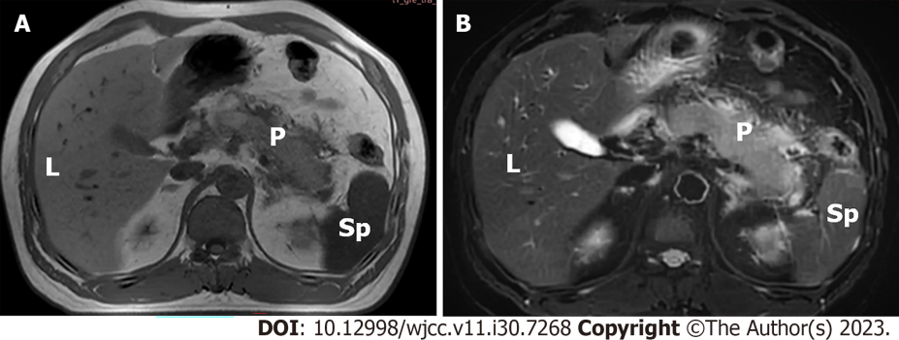
Figure 1 A 45-year-old man with type 2 diabetes mellitus with mild acute pancreatitis whose random blood glucose level was 10.1 mmol/L. A: Axial T1-weighted image shows pancreatic swelling, and the signal is reduced; B: Axial T2-weighted image with fat suppression shows diffuse hyperintensity around the pancreas. L: Liver; P: Pancreas; Sp: Spleen.
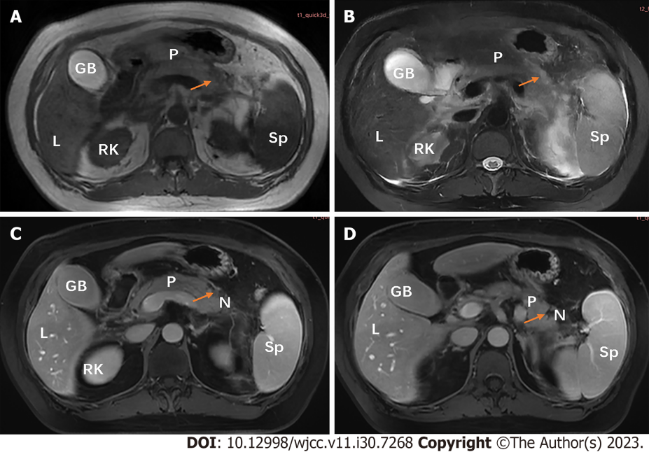
Figure 2 A 45-year-old woman diagnosed with type 2 diabetes mellitus for 6 years with severe acute pancreatitis, whose random blood glucose level was 19.19 mmol/L. A: Axial T1-weighted image shows local hypointense area (arrow); B: Axial T2-weighted magnetic resonance (MR) image with fat suppression shows pancreatic swelling and patchy hyperintense area (arrow); C and D: Postcontrast venous phase images reveal nonenhancement necrotic areas (arrow) with < 30% parenchyma involvement in the body of the pancreas (MR severity index score of 6 points). GB: Gall bladder; L: Liver; N: Necrotic areas; P: Pancreas; RK: Right kidney; Sp: Spleen.
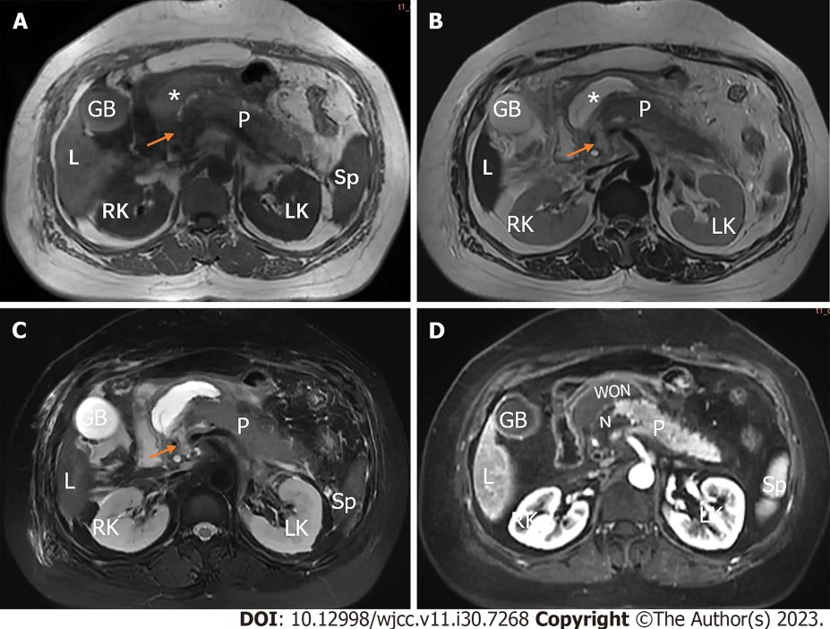
Figure 3 A 49-year-old woman with type 2 diabetes mellitus with severe acute pancreatitis whose average blood glucose level was 7.67 mmol/L. A: Axial T1-weighted image shows local hypointensity (arrow) in the head and neck of the pancreas. Peripancreatic fluid collection (asterisk) exhibit slightly hyperintensity; B: Axial T2-weighted image with fat suppression shows local hyperintensity (arrow) in the head and neck of the pancreas. Peripancreatic fluid collection (asterisk) exhibits profound hyperintensity; C: Axial T2-weighted image with fat suppression shows pancreatic swelling and hyperintense areas (arrows), concomitant with acute necrotic collection restricted to omental bursa; D: Postcontrast arterial phase axial magnetic resonance (MR) image shows nonenhanced areas (N) compatible with parenchyma necrosis (30% to 50% parenchyma involvement) in the head and body of the pancreas (MR severity index score of 6 points). GB: Gall bladder; L: Liver; LK: Left kidney; N: Necrotic areas; P: Pancreas; RK: Right kidney; Sp: Spleen; WON: Walled-off necrosis.
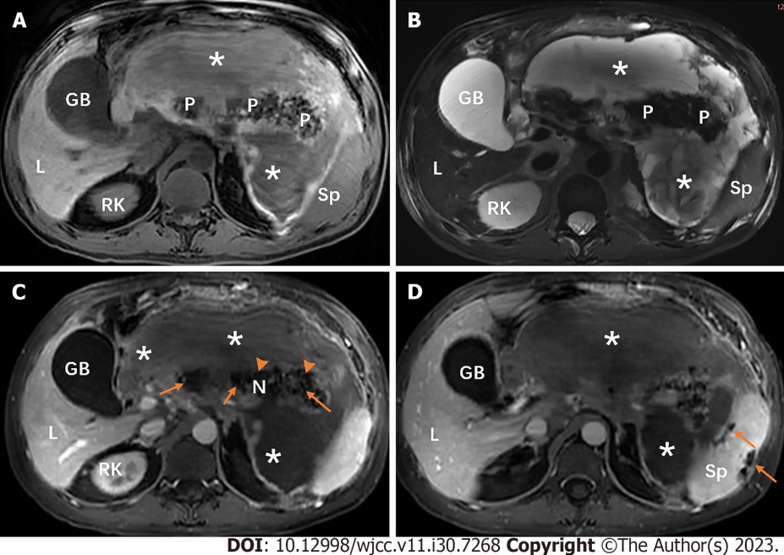
Figure 4 A 42-year-old man diagnosed with diabetes for 1 year with severe acute pancreatitis whose random blood glucose level was 19.19 mmol/L. A and B: The pancreas is poorly defined, and it shows heterogeneous hypointensity on each sequences. Peripancreatic walled-off necrosis lesions (asterisks) are both hypointensity and hyperintensity, indicating the presence of peripancreatic fat necrosis and hemorrhage; C: Postcontrast venous phase axial magnetic resonance (MR) image shows nonenhanced areas (arrows) compatible with parenchyma necrosis (> 50% parenchyma involvement) in the head, body and tail of the pancreas (MR severity index score of 10 points); D: Postcontrast venous phase axial MR image shows nonenhanced areas (arrows) of spleen (splenic infarction), which indicates splenic artery invasion. GB: Gall bladder; L: Liver; N: Necrotic areas; P: Pancreas; RK: Right kidney; Sp: Spleen.
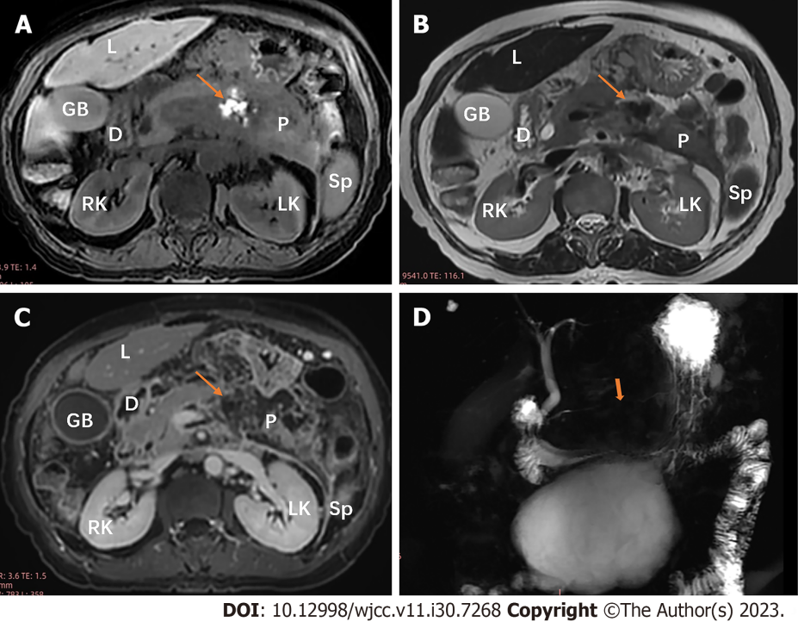
Figure 5 A 67-year-old woman with type 2 diabetes mellitus with moderately severe acute pancreatitis whose fasting blood glucose level was 7.3 mmol/L. A: Axial T1-weighted image shows local hyperintensity (arrow) in the body of the pancreas; B: Axial T2-weighted image shows local hypointensity (arrow) in the body of the pancreas, indicating pancreatic hemorrhage; C: Postcontrast venous phase axial magnetic resonance (MR) image shows nonenhanced area (arrow) compatible with parenchyma necrosis (< 30% parenchyma involvement) in the body of the pancreas (MR severity index score of 6 points); D: Magnetic resonance cholangiopancreatography shows “disconnected pancreatic duct syndrome” in the body of pancreas. D: Duodenum; GB: Gall bladder; L: Liver; LK: Left kidney; P: Pancreas; RK: Right kidney; Sp: Spleen.
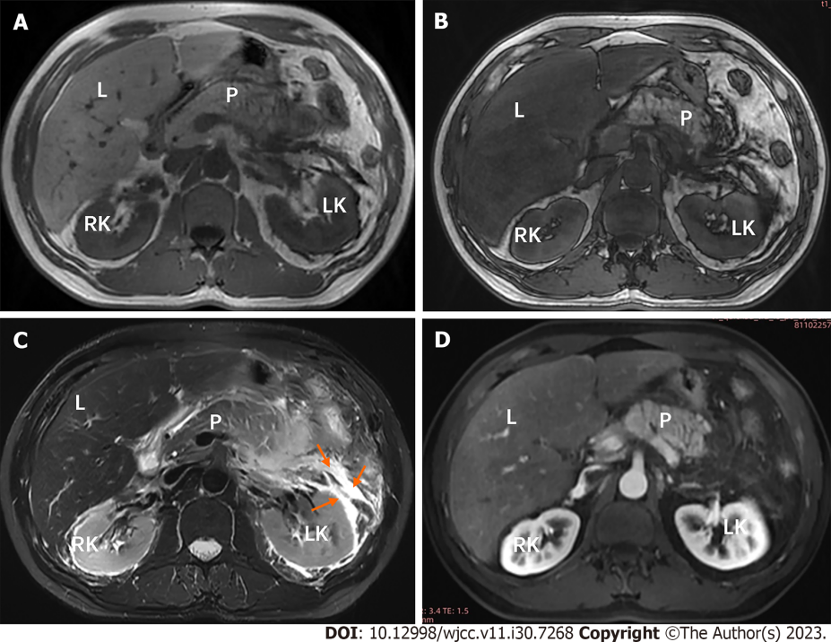
Figure 6 A 47-year-old man with type 2 diabetes mellitus with moderately severe acute pancreatitis whose average blood glucose level was 10.05 mmol/L. A and B: Compared with the in-phase T1-weighted image (A), an unequivocal signal intensity loss in liver parenchyma is demonstrated on the out of phase T1-weighted image (B). In the left perirenal space and anterior pararenal space, acute peripancreatic fluid collections (arrows) is homogeneous hypointensity on T1-weighted image (A) and hyperintensity on T2-weighted image with fat suppression (B). L: Liver; LK: Left kidney; P: Pancreas; RK: Right kidney.
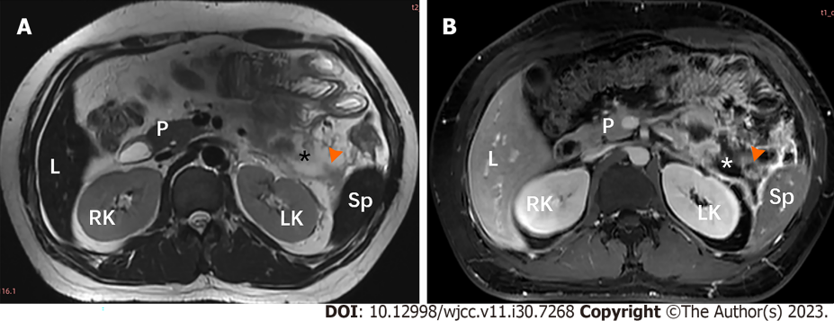
Figure 7 A 24-year-old man with type 2 diabetes mellitus with severe acute pancreatitis whose fasting blood glucose level was 23.3 mmol/L. A and B: Peripancreatic acute necrotic collection (asterisk) is demonstrated as hyperintense areas on T2-weighted images, containing hypointense solid components (arrowhead). L: Liver; LK: Left kidney; P: Pancreas; RK: Right kidney; Sp: Spleen.
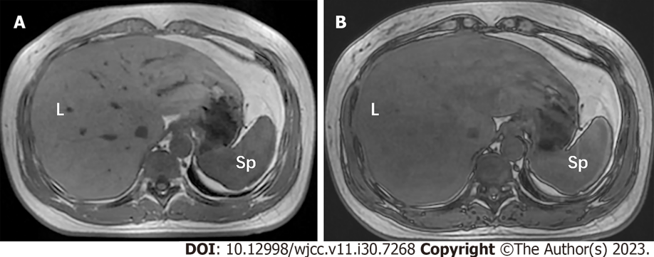
Figure 8 A 43-year-old woman with type 2 diabetes mellitus for 6 years with moderately severe acute pancreatitis whose average blood glucose level was 8.50 mmol/L. A and B: Compared with the in-phase T1-weighted image (A), an unequivocal signal intensity loss in liver parenchyma was demonstrated on the out of phase T1-weighted image (B). L: Liver; Sp: Spleen.
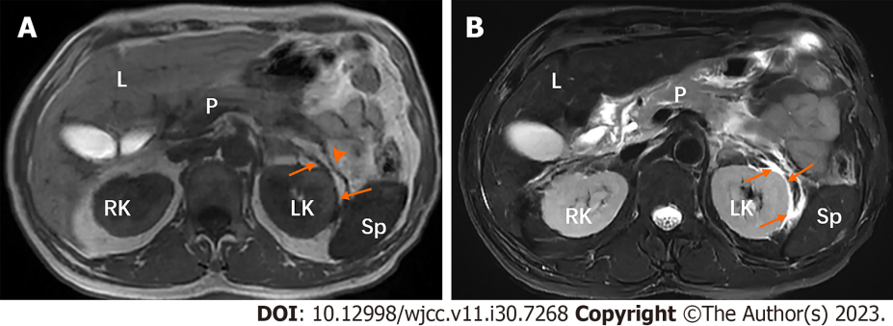
Figure 9 A 52-year-old man with type 2 diabetes mellitus over 10 years with moderately severe acute pancreatitis whose fasting blood glucose level was 15.48 mmol/L. A and B: In the left perirenal space, there are strips (arrows) of hypointensity on T1-weighted image (A) and hyperintensity on T2-weighted image with fat suppression (B). T1-weighted image (A) also shows the thickened left renal fascia (arrowhead). L: Liver; LK: Left kidney; P: Pancreas; RK: Right kidney; Sp: Spleen.
Table 1 Magnetic resonance severity index scoring system
Characteristics | Score
Pancreatic inflammation
Normal | 0
Focal or diffuse enlargement of the pancreas | 1
Peripancreatic inflammation | 2
Fluid collection in a single location | 3
Two or more fluid collections and/or the presence of gas in or adjacent to the pancreas | 4
Percent of necrosis
None | 0
< 30% | 2
30%-50% | 4
> 50% | 6

Published by Baishideng Publishing Group Inc
7041 Koll Center Parkway, Suite 160, Pleasanton, CA 94566, USA
Telephone: +1-925-3991568
E-mail: bpgoffice@wjgnet.com
Help Desk: https://www.f6publishing.com/helpdesk
https://www.wjgnet.com

© 2023 Baishideng Publishing Group Inc. All rights reserved.

