Name of Journal: World Journal of Clinical Oncology
Manuscript NO: 91648
Manuscript Type: ORIGINAL ARTICLE

Basic Study
Regulation of TMEM100 expression by epigenetic modification, effects on proliferation and invasion of esophageal squamous carcinoma

Xu YF et al. Role of TMEM100 in ESCC

Yue-Feng Xu, Yan Dang, Wei-Bo Kong, Han-Lin Wang, Xiu Chen, Long Yao, Yuan Zhao, Ren-Quan Zhang

Yue-Feng Xu, Yan Dang, Wei-Bo Kong, Han-Lin Wang, Xiu Chen, Long Yao, Yuan Zhao, Ren-Quan Zhang, Department of Thoracic Surgery, The First Affiliated Hospital of Anhui Medical University, Hefei 230000, Anhui Province, China

Author contributions: Xu YF and Dang Y are responsible for data curation and writing (original draft preparation); Kong WB is responsible for visualisation; Wang HL and Chen X are responsible for software and validation; Zhao Y is responsible for methodology; Yao L is responsible for writing (reviewing and editing); Zhang RQ is responsible for conceptualization and resources.

Corresponding author: Ren-Quan Zhang, MD, Surgeon, Department of Thoracic Surgery, The First Affiliated Hospital of Anhui Medical University, No. 218 Ji Xi Road, Hefei 230000, Anhui Province, China. zhangrenquanayfy@163.com

Received: January 2, 2024
Revised: February 1, 2024
Accepted: March 20, 2024
Published online:

Abstract
BACKGROUND
Esophageal squamous cell carcinoma (ESCC) is a prevalent malignancy with a high morbidity and mortality rate. TMEM100 has been shown to be suppressor gene in a variety of tumors, but there are no reports on the role of TMEM100 in esophageal cancer (EC).

AIM
To investigate epigenetic regulation of TMEM100 expression in ESCC and the effect of TMEM100 on ESCC proliferation and invasion.

METHODS
Firstly, we found the expression of TMEM100 in EC through The Cancer Genome Atlas database. The correlation between TMEM100 gene expression and the survival of patients with EC was further confirmed through Kaplan-Meier analysis. We then added the demethylating agent 5-AZA to ESCC cell lines to explore the regulation of TMEM100 expression by epigenetic modification. To observe the effect of TMEM100 expression on tumor proliferation and invasion by overexpressing TMEM100. Finally, we performed gene set enrichment analysis using the Kyoto Encyclopaedia of Genes and Genomes Orthology-Based Annotation System database to look for pathways that might be affected by TMEM100 and verified the effect of TMEM100 expression on the mitogen-activated protein kinases (MAPK) pathway.

RESULTS
In the present study, by bioinformatic analysis we found that TMEM100 was lowly expressed in EC patients compared to normal subjects. Kaplan-meier survival analysis showed that low expression of TMEM100 was associated with poor prognosis in patients with EC. Then, we found that the demethylating agent 5-AZA resulted in increased expression of TMEM100 in ESCC cells [quantitative real-time PCR (qRT-PCR) and western blotting]. Subsequently, we confirmed that overexpression of TMEM100 leads to its increased expression in ESCC cells (qRT-PCR and western blotting). Overexpression of TMEM100 also inhibited proliferation, invasion and migration of ESCC cells (cell counting kit-8 and clone formation assays). Next, by enrichment analysis, we found that the gene set was significantly enriched in the MAPK signaling pathway. The involvement of TMEM100 in the regulation of MAPK signaling pathway in ESCC cell was subsequently verified by western blotting.

CONCLUSION
TMEM100 is a suppressor gene in ESCC, and its low expression may lead to aberrant activation of the MAPK pathway. Promoter methylation may play a key role in regulating TMEM100 expression.

Key Words: Esophageal squamous cell carcinoma; TMEM100; Invasion; Mitogen-activated protein kinases pathway; Epigenetic

Xu YF, Dang Y, Kong WB, Wang HL, Chen X, Yao L, Zhao Y, Zhang RQ. Regulation of TMEM100 expression by epigenetic modification, effects on proliferation and invasion of esophageal squamous carcinoma. World J Clin Oncol 2024; In press

Core Tip: TMEM100 has been shown to be an oncogene in a variety of tumors, but there are no reports on the role of TMEM100 in esophageal cancer. In the present study, we found that TMEM100 was lowly expressed in esophageal squamous cell carcinoma (ESCC). Methylation may play a key role in regulating TMEM100 protein low expression. Overexpression of TMEM100 resulted in its increased expression in ESCC cells. Overexpression of TMEM100 also inhibited proliferation, invasion and migration of ESCC cells. Low expression of TMEM100 in ESCC may lead to aberrant activation of the mitogen-activated protein kinases pathway.

INTRODUCTION
Esophageal cancer (EC) is a common malignant tumour of the digestive tract and is recognised for its high incidence and mortality rate^{[1,2]}. The disease primarily manifests in two forms, namely squamous carcinoma and adenocarcinoma^{[2]}. Esophageal squamous cell carcinoma (ESCC) represents the predominant subtype of EC and is particularly prevalent in Asia, while esophageal adenocarcinoma is more commonly observed in Europe^{[3]}. China bears a significant burden, accounting for nearly 50% of ESCC cases worldwide and over 90% within Asia^{[4]}. The predominant treatment approach for ESCC primarily involves surgical procedures. While outcomes are relatively favourable for early-stage patients with EC, those with intermediate to advanced disease face a more challenging prognosis, with a 5-year overall survival rate ranging from 10%–30%^{[5]}. The emergence of immunotherapy brings a promising dimension to EC treatment^{[6]}. However, the efficacy and safety of immunotherapy for patients with tumours require further validation. Anticipated advancements in identifying more clinical targets hold the potential to improve the effectiveness of immunotherapy.
TMEM100 is a gene that encodes a 134-amino-acid protein located at locus 17q32. This gene possesses two hypothetical transmembrane structural domains (amino acids 53–75 and 85–107)^{[7]}. Initially identified as a transcription factor in the murine gene, TMEM100 is highly conserved and exhibits a structure dissimilar to any known protein family across various species^{[8]}. In the context of TMEM100’s involvement with tumours, research findings indicate its association with a variety of malignancies. A study by Han et al^{[9]} revealed a correlation between TMEM100 and the proliferation of lung cancer cells. Similarly, a study by Ou et al^{[10]} suggested that TMEM100 exhibits low expression in hepatocellular carcinoma and is closely related to both its proliferation and invasion. A study by Ye et al^{[11]} revealed that TMEM100 exhibits low expression in patients with prostate cancer and is associated with tumour stage and metastasis. In a study conducted by Li et al^{[12]}, TMEM100 demonstrated significantly low expression in colorectal cancer, and the overexpression of TMEM100 inhibited the malignant progression of tumours through the regulation of the transforming growth factor β pathway.
Epigenetic modifications are heritable alterations in gene expression that do not stem from primary DNA sequence changes, playing a pivotal role in the development of tumours such as leukaemia. These modifications primarily encompass three regulatory mechanisms: DNA methylation, non-coding RNA regulation, and histone modification^{[13]}. DNA methylation involves the transfer of a methyl to the 5' position of cytosine through the action of DNA methyltransferase. This process utilises S-adenosylmethionine as the methyl donor, resulting in the formation of 5'-methylcytosine^{[14]}. In the context of EC, multiple oncogenes, including EPB41L3/GPX3/TMEM176A, exhibit methylation in their promoter regions^{[15-17]}. Despite the critical role of epigenetics in gene regulation, the literature on the mechanisms governing the expression of TMEM100 in EC is limited. Nevertheless, the significance of epigenetic regulation cannot be overlooked. The impact of DNA methylation on TMEM100 expression in tumours remains unexplored.
In this study, our objective was to elucidate the function of TMEM100 in malignant growth and invasion in vitro within ESCC cells. We sought to investigate the expression of TMEM100 and its impact on the activation of the mitogen-activated protein kinases (MAPK) signalling pathway in ESCC cells. Additionally, we aimed to explore the epigenetic regulation of TMEM100 expression in ESCC to provide a theoretical foundation for considering TMEM100 as a potential new therapeutic target for ESCC.

MATERIALS AND METHODS
Materials and reagents
Hieff Trans Liposomal Transfection Reagent and PAGE Gel Quick Preparation Kit (12.5%) were purchased from Yeasen (Shanghai, China). Penicillin-streptomycin solution (100 ×), RIPA lysis buffer, and crystal violet were sourced from Beyotime (Shanghai, China). Fetal bovine serum (FBS) and RPMI-1640 medium were obtained from Bio-Channel (Nanjing, China). TRIzol reagent and dimethyl sulfoxide were purchased from Biosharp (Hefei, China). 5-Azacytidine was acquired from Selleck (Houston, United States of America). Paraformaldehyde was obtained from Servicebio (Wuhan, China). Cell counting kit-8 (CCK-8) was sourced from topscience (Shanghai, China). Nitrocellulose filter (NC) membranes were purchased from PALL (New York, United States of America). TMEM100 and β-actin primers were procured from Tsingke (Beijing, China). TMEM100 monoclonal antibodies were purchased from Proteintech (Wuhan, China). Human monoclonal antibodies against extracellular regulated kinase 1/2 (ERK1/2), phosphorylated (p-) ERK1/2, the c-Jun N-terminal kinase (JNK), phosphorylated (p-)JNK, p38, phosphorylated (p-) p38, goat anti-rabbit horse radish peroxidase (HRP) IgG, goat anti-mouse HRP IgG, and GAPDH were purchased from Zen Bioscience (Chengdu, China).

Cell culture
Human ESCC cell lines KYSE-450 (Cobioer Biosciences, Nanjing, China) and KYSE-150 (Typical Culture Preservation Committee Cell Bank, Chinese Academy of Sciences, Shanghai, China) were used in this study. Both cell lines were cultured in RPMI-1640 medium supplemented with 10% FBS and 1% penicillin-streptomycin solution (100 ×). The culture conditions were maintained at 37 °C with 5% CO₂.

Gene overexpression and transient transfection
The recombinant plasmid overexpressing TMEM100 was designed by General Biol (Chuzhou, China). Cells cultured at 70% density in 6-well plates were transfected with recombinant plasmids using Hieff Trans Liposomal Transfection Reagent, following the manufacturer's protocol. After 24 h, cells were collected for quantitative real-time PCR (qRT-PCR), CCK-8 assay, colony formation assay, and western blotting.

qRT-PCR
Total RNA was isolated from K-150 and K-450 cells using TRIzol reagent, following the manufacturer's instructions. Subsequently, the RNA was reverse transcribed using a cDNA synthesis kit (Promega, Fitchburg, United States of America). The resulting cDNA was amplified through 42 cycles, and the initial reaction volume was 20 µL, comprising 1 µL of reverse transcription product and 0.8 µL of primers. The housekeeping gene β-actin was used as a standardized internal control. Table 1 provides details on the gene-specific primers utilised in PCR amplification.

Western blotting
ESCC cells were lysed using RIPA lysis buffer. The resulting total cell lysates were then separated on a 12.5% sodium dodecyl sulfate polyacrylamide gel and transferred to NC membranes. After blocking in phosphate buffered saline with tween-20 containing 5% non-fat milk, membranes were incubated overnight at 4 °C with specific primary antibodies, followed by a 2 h incubation at 27 °C with HRP-conjugated specific secondary antibodies. Detection was achieved using the enhanced chemiluminescence western blotting detection system (Tanon, Shanghai, China). GAPDH was utilized to ensure equal protein loading on the gel.

Colony formation assay
For colony formation studies, ESCC cells were harvested following a 24-h treatment with transient transfection. These cells were then seeded at a density of 300 cells per 35 mm plate in RPMI-1640 medium with 10% FBS and cultured at 37 °C for two weeks. Thereafter, the cells were treated with 4% paraformaldehyde for 20 min and dyed with 1 mL of 0.1% crystal violet for 30 min. Photographs were captured after the stain was removed.

CCK-8 assay
During the exponential growth phase, three thousand cells treated with transient transfection were seeded into each well of a 96-well plate (100 μL/well). At specified time points (day 1, day 2, day 3), 10 μL of CCK-8 solution was added to each well, and the optical density (450 nm) values were measured using a microplate reader after 1 h of incubation.

Bioinformatic analysis
The efficient channel attention transcriptional data, sourced from The Cancer Genome Atlas (TCGA) database, encompasses data from 161 patients and 11 normal subjects^{[18]}. Differential expression analysis was conducted using the R package “Limma” applying the filtering criteria of |log FoldChange| ≥ 1, P-value < 0.00001, and adjusted P value < 0.0001 to identify differentially expressed genes (DEGs). Visualisation of DEG expression was accomplished through the generation of a volcano plot and heatmap using the R packages “ggplot2” and “pheatmap”. For a deeper insight into the functional implications of DEGs containing TMEM100, gene set enrichment analysis was performed using the Kyoto Encyclopaedia of Genes and Genomes (KEGG) Orthology-Based Annotation System database^{[19]}. The top 69 enriched terms or pathways were selected and visualised using the R packages “gridExtra”, “grid”, and “ggplot2”. Additionally, boxplots were constructed using the gene expression profiling interactive analysis (GEPIA) tool, and Kaplan-meier survival analysis was performed using the online analysis tool^{[20,21]}.

Statistical analysis
Statistical analysis and data visualization were performed using R software and GraphPad Prism 9.0. A P value < 0.05 was considered statistically significant unless otherwise specified. R software, comprising several packages, was employed for various analyses. When assessing differences between groups, statistical comparisons were conducted in GraphPad Prism 9.0 using the Student's t-test.

RESULTS
Low TMEM100 expression is associated with reduced overall survival in patients with EC
Analysis of TCGA data extracted from GEPIA revealed that the TMEM100 gene exhibited underexpression in EC specimens compared to adjacent normal tissue (Figure 1A). The correlation between TMEM100 gene expression and the survival of patients with EC was further confirmed through Kaplan-Meier analysis. Patients with high TMEM100 expression demonstrated a significantly higher overall survival rate compared to those with low expression of this gene (Figure 1B).

Elevated expression levels of TMEM100 in ESCC cell lines treated with 5-AZA
To validate the impact of decreased DNA methylation on TMEM100 expression, ESCC cell lines were treated with 5-AZA. Both qRT-PCR and western blotting analyses revealed upregulation of TMEM100 at both mRNA and protein levels (Figure 1C). These findings suggest that changes in DNA methylation levels affect the expression levels of TMEM100.

Overexpression effect of TMEM100 in ESCC
To ascertain the impact of TMEM100 overexpression, recombinant plasmids were transfected into K-150 and K-450 cell lines using Hieff Trans Liposomal Transfection Reagent. Examination of TMEM100 expression through qRT-PCR and western blotting analyses revealed a significant increase in both mRNA and protein levels upon transfection with the recombinant plasmid (Figure 2A and B).

Effect of TMEM100 overexpression on the proliferation and invasion ability of ESCC
In order to explore the long-term effects of TMEM100 on cancer cell growth, the colony-forming capacity was evaluated. TMEM100 overexpression was observed to significantly inhibit the colony-forming ability of both K-150 and K-450 cells (Figure 2C). Additionally, the impact of altered TMEM100 expression on the proliferation of K-150 and K-450 cells was examined using the CCK-8 assay (Figure 2D). These results indicate that the overexpression of TMEM100 exerts inhibitory effects on the proliferation and invasive ability of ESCC.

Identification and enrichment analysis of DEGs containing TMEM100
An analysis of the TCGA database resulted in the identification of a total of 50940 differential genes between EC tissue and normal tissue. Further screening narrowed down the list to 3720 differential genes containing TMEM100 (Figure 3A and B). Subsequently, the KEGG pathway enrichment analyses were conducted (Figure 3C and D), revealing a significant enrichment in the MAPK signalling pathway (P < 0.0005).

Effect of TMEM100 on the activity of the MAPK signalling pathway in ESCC
The MAPK signalling pathway plays a pivotal role in various cellular physiological activities, including cell growth, development, differentiation, and apoptosis. Given its significant involvement in tumourigenesis, we investigated whether TMEM100 mediated the cascade of the classical MAPK pathway. Western blotting results demonstrated a significant reduction in the expression of phosphorylated ERK, phosphorylated JNK, and phosphorylated p38 following transfection with the TMEM100 overexpression plasmid (Figure 4). These findings suggest that the impact of TMEM100 on ESCC cell proliferation may be regulated through the ERK/MAPK, JNK/MAPK, and p38/MAPK signalling pathways.

DISCUSSION
The prognosis for ESCC remains challenging, partially due to the absence of prognostic biomarkers capable of identifying high-risk patients and facilitating the assignment of risk-appropriate monitoring and treatment regimens. TMEM100 is well established as an oncogene, as demonstrated by its inhibitory role in colorectal cancer progression through the promotion of ubiquitin/proteasome degradation of hypoxia-inducible factor-1 alpha^{[22]}. The downregulation of TMEM100, mediated by histone deacetylase 6, expedites the development and progression of non-small cell lung cancer^{[23]}. However, the expression and function of TMEM100 in ESCC have yet to be elucidated.
In our study, we initially identified TMEM100 as a DEG between patients with EC and individuals without the condition by analysing gene expression data obtained from the TCGA database. Using online bioinformatics tools, we observed that TMEM100 exhibited low expression in patients with EC and that individuals with higher expression levels demonstrated a better prognosis. This suggests that TMEM100 may serve as a novel biomarker for EC. Given that over 70% of EC cases occur in China, with ESCC being the predominant subtype (80%)^{[24,25]}, we hypothesised that TMEM100 functions as an oncogene suppressor in ESCC. In further experiments, we observed that the overexpression of TMEM100 inhibited the proliferation and invasion of ESCC cells, supporting our conjecture. Additionally, we conducted a preliminary investigation into the mechanisms regulating TMEM100 expression in ECSS and observed that TMEM100 expression was significantly higher in ESCC cells treated with methylation inhibitors compared to that in normal ESCC cells. This suggests that DNA methylation in epigenetics may be involved in the regulation of TMEM100 expression in ESCC.
To explore the underlying mechanisms of ESCC, we performed a KEGG enrichment analysis to identify potential pathways. The analysis revealed that TMEM100 may be involved in signalling pathways, including p53, interleukin-17, and MAPK. We chose to focus on the MAPK signalling pathway in our research, as it has been extensively shown to be associated with tumour cell proliferation, differentiation, apoptosis, and stress response compared to other pathways^{[26-29]}. This choice aligns with the results of our CCK-8 and clone formation experiments. Subsequent investigations revealed that the phosphorylation levels of ERK, p38, and JNK were significantly inhibited in ESCC cells overexpressing TMEM100. These results suggest that TMEM100 exerts an inhibitory effect on ESCC proliferation and invasion by negatively regulating the ERK, p38, and JNK pathways.
This study has several limitations. First, the robustness of TMEM100 as a prognostic indicator for ESCC requires further validation in large or prospective cohort studies. Second, the in vivo effects of TMEM100 overexpression on ESCC proliferation need additional clarification. Third, the regulation of DNA methylation for TMEM100 expression in ESCC requires further investigation. Nevertheless, this study provides initial insights into the role of TMEM100 in the development of ESCC and its specific mechanism of action. These findings lay the foundation for further understanding the mechanism of action of TMEM100 in other malignant tumours, carrying important theoretical and clinical significance.

CONCLUSION
TMEM100 functions as a suppressor gene in ESCC cells, and its low expression in ESCC may contribute to aberrant activation of the MAPK pathway. Promoter methylation likely plays a crucial role in regulating the low expression of TMEM100.

ARTICLE HIGHLIGHTS
Research background
TMEM100 is associated with multiple malignancies but its role in esophageal squamous cell carcinoma (ESCC) remains unknown.

Research motivation
This study aimed to investigate the regulatory mechanism of TMEM100 expression in ESCC and its effect on ESCC cell growth and proliferation.

Research objectives
This study hopes to clarify the role of TMEM100 in ESCC as well as to preliminarily investigate the epigenetic regulation of TMEM100 expression.

Research methods
We used R software and online analysis databases to analyze the expression, prognosis and pathway of TMEM100 in esophageal cancer (EC). Utilization of real-time PCR and western blotting to probe the expression of TMEM100 and pathway proteins in ESCC. In addition, the effects of TMEM100 overexpression on the proliferation, invasion and migration of ESCC cells were assessed by CCK-8 and clone formation assays.

Research results
Kaplan-meier survival analysis revealed that low expression of TMEM100 correlated with poor prognosis in patients with EC. Further, treatment with the demethylating agent 5-AZA resulted in increased TMEM100 expression in ESCC cells. Additionally, TMEM100 overexpression exhibited inhibitory effects on the proliferation, invasion, and migration of ESCC cells. Enrichment analysis highlighted significant enrichment in the mitogen-activated protein kinases (MAPK) signalling pathway, which was validated using western blotting, confirming TMEM100’s involvement in the regulation of the MAPK signalling pathway in ESCC cells.

Research conclusions
TMEM100 is highly expressed in normal subjects and lowly expressed in EC patients, and patients with high TMEM100 expression in EC patients have a better prognosis. The expression of TMEM100 was increased in ESCC cells treated with the methylation inhibitor 5-AZA. Overexpression of TMEM100 gene inhibited the growth and proliferation of ESCC cells and negatively regulated the MAPK signaling pathway.

Research perspectives
The robustness of TMEM100 as a prognostic indicator for ESCC needs to be further validated. Further clarification of the in vivo effects of overexpression of TMEM100 on the proliferation of esophageal squamous carcinoma is needed.

ACKNOWLEDGEMENTS
We thank Xiu Zhu and Kai-Ming Wu for their contributions to the experiment preparation.

REFERENCES
1 Li Q, Dai Z, Xia C, Jin L, Chen X. Suppression of long non-coding RNA MALAT1 inhibits survival and metastasis of esophagus cancer cells by sponging miR-1-3p/CORO1C/TPM3 axis. Mol Cell Biochem 2020; 470: 165-174 [PMID: 32468237 DOI: 10.1007/s11010-020-03759-x]
2 Zhang XM, Wang J, Liu ZL, Liu H, Cheng YF, Wang T. LINC00657/miR-26a-5p/CKS2 ceRNA network promotes the growth of esophageal cancer cells via the MDM2/p53/Bcl2/Bax pathway. Biosci Rep 2020; 40 [PMID: 32426838 DOI: 10.1042/BSR20200525]
3 Wu Y, Yang X, Chen Z, Tian L, Jiang G, Chen F, Li J, An P, Lu L, Luo N, Du J, Shan H, Liu H, Wang H. m(6)A-induced lncRNA RP11 triggers the dissemination of colorectal cancer cells via upregulation of Zeb1. Mol Cancer 2019; 18: 87 [PMID: 30979372 DOI: 10.1186/s12943-019-1014-2]
4 Abnet CC, Arnold M, Wei WQ. Epidemiology of Esophageal Squamous Cell Carcinoma. Gastroenterology 2018; 154: 360-373 [PMID: 28823862 DOI: 10.1053/j.gastro.2017.08.023]
5 Paul S, Altorki N. Outcomes in the management of esophageal cancer. J Surg Oncol 2014; 110: 599-610 [PMID: 25146593 DOI: 10.1002/jso.23759]
6 Kono K, Mimura K, Yamada R, Ujiie D, Hayase S, Tada T, Hanayama H, Min AKT, Shibata M, Momma T, Saze Z, Ohki S. Current status of cancer immunotherapy for esophageal squamous cell carcinoma. Esophagus 2018; 15: 1-9 [PMID: 29892809 DOI: 10.1007/s10388-017-0596-2]
7 Kawai J, Shinagawa A, Shibata K, Yoshino M, Itoh M, Ishii Y, Arakawa T, Hara A, Fukunishi Y, Konno H, Adachi J, Fukuda S, Aizawa K, Izawa M, Nishi K, Kiyosawa H, Kondo S, Yamanaka I, Saito T, Okazaki Y, Gojobori T, Bono H, Kasukawa T, Saito R, Kadota K, Matsuda H, Ashburner M, Batalov S, Casavant T, Fleischmann W, Gaasterland T, Gissi C, King B, Kochiwa H, Kuehl P, Lewis S, Matsuo Y, Nikaido I, Pesole G, Quackenbush J, Schriml LM, Staubli F, Suzuki R, Tomita M, Wagner L, Washio T, Sakai K, Okido T, Furuno M, Aono H, Baldarelli R, Barsh G, Blake J, Boffelli D, Bojunga N, Carninci P, de Bonaldo MF, Brownstein MJ, Bult C, Fletcher C, Fujita M, Gariboldi M, Gustincich S, Hill D, Hofmann M, Hume DA, Kamiya M, Lee NH, Lyons P, Marchionni L, Mashima J, Mazzarelli J, Mombaerts P, Nordone P, Ring B, Ringwald M, Rodriguez I, Sakamoto N, Sasaki H, Sato K, Schönbach C, Seya T, Shibata Y, Storch KF, Suzuki H, Toyo-oka K, Wang KH, Weitz C, Whittaker C, Wilming L, Wynshaw-Boris A, Yoshida K, Hasegawa Y, Kawaji H, Kohtsuki S, Hayashizaki Y; RIKEN Genome Exploration Research Group Phase II Team and the FANTOM Consortium. Functional annotation of a full-length mouse cDNA collection. Nature 2001; 409: 685-690 [PMID: 11217851 DOI: 10.1038/35055500]
8 Moon EH, Kim MJ, Ko KS, Kim YS, Seo J, Oh SP, Lee YJ. Generation of mice with a conditional and reporter allele for Tmem100. Genesis 2010; 48: 673-678 [PMID: 20848592 DOI: 10.1002/dvg.20674]
9 Han Z, Wang T, Han S, Chen Y, Chen T, Jia Q, Li B, Li B, Wang J, Chen G, Liu G, Gong H, Wei H, Zhou W, Liu T, Xiao J. Low-expression of TMEM100 is associated with poor prognosis in non-small-cell lung cancer. Am J Transl Res 2017; 9: 2567-2578 [PMID: 28560005]
10 Ou D, Yang H, Hua D, Xiao S, Yang L. Novel roles of TMEM100: inhibition metastasis and proliferation of hepatocellular carcinoma. Oncotarget 2015; 6: 17379-17390 [PMID: 25978032 DOI: 10.18632/oncotarget.3954]
11 Ye Z, Xia Y, Li L, Li B, Chen W, Han S, Zhou X, Chen L, Yu W, Ruan Y, Cheng F. Effect of transmembrane protein 100 on prostate cancer progression by regulating SCNN1D through the FAK/PI3K/AKT pathway. Transl Oncol 2023; 27: 101578 [PMID: 36375375 DOI: 10.1016/j.tranon.2022.101578]
12 Li H, Cheng C, You W, Zheng J, Xu J, Gao P, Wang J. TMEM100 Modulates TGF-β Signaling Pathway to Inhibit Colorectal Cancer Progression. Gastroenterol Res Pract 2021; 2021: 5552324 [PMID: 34422038 DOI: 10.1155/2021/5552324]
13 Ntziachristos P, Abdel-Wahab O, Aifantis I. Emerging concepts of epigenetic dysregulation in hematological malignancies. Nat Immunol 2016; 17: 1016-1024 [PMID: 27478938 DOI: 10.1038/ni.3517]
14 Bird A. Perceptions of epigenetics. Nature 2007; 447: 396-398 [PMID: 17522671 DOI: 10.1038/nature05913]
15 Wang Y, Zhang Y, Herman JG, Linghu E, Guo M. Epigenetic silencing of TMEM176A promotes esophageal squamous cell cancer development. Oncotarget 2017; 8: 70035-70048 [PMID: 29050260 DOI: 10.18632/oncotarget.19550]
16 He Y, Wang Y, Li P, Zhu S, Wang J, Zhang S. Identification of GPX3 epigenetically silenced by CpG methylation in human esophageal squamous cell carcinoma. Dig Dis Sci 2011; 56: 681-688 [PMID: 20725785 DOI: 10.1007/s10620-010-1369-0]
17 Zeng R, Liu Y, Jiang ZJ, Huang JP, Wang Y, Li XF, Xiong WB, Wu XC, Zhang JR, Wang QE, Zheng YF. EPB41L3 is a potential tumor suppressor gene and prognostic indicator in esophageal squamous cell carcinoma. Int J Oncol 2018; 52: 1443-1454 [PMID: 29568917 DOI: 10.3892/ijo.2018.4316]
18 Cancer Genome Atlas Research Network; Analysis Working Group: Asan University; BC Cancer Agency; Brigham and Women’s Hospital; Broad Institute; Brown University; Case Western Reserve University; Dana-Farber Cancer Institute; Duke University; Greater Poland Cancer Centre; Harvard Medical School; Institute for Systems Biology; KU Leuven; Mayo Clinic; Memorial Sloan Kettering Cancer Center; National Cancer Institute; Nationwide Children’s Hospital; Stanford University; University of Alabama; University of Michigan; University of North Carolina; University of Pittsburgh; University of Rochester; University of Southern California; University of Texas MD Anderson Cancer Center; University of Washington; Van Andel Research Institute; Vanderbilt University; Washington University; Genome Sequencing Center: Broad Institute; Washington University in St. Louis; Genome Characterization Centers: BC Cancer Agency; Broad Institute; Harvard Medical School; Sidney Kimmel Comprehensive Cancer Center at Johns Hopkins University; University of North Carolina; University of Southern California Epigenome Center; University of Texas MD Anderson Cancer Center; Van Andel Research Institute; Genome Data Analysis Centers: Broad Institute; Brown University:; Harvard Medical School; Institute for Systems Biology; Memorial Sloan Kettering Cancer Center; University of California Santa Cruz; University of Texas MD Anderson Cancer Center; Biospecimen Core Resource: International Genomics Consortium; Research Institute at Nationwide Children’s Hospital; Tissue Source Sites: Analytic Biologic Services; Asan Medical Center; Asterand Bioscience; Barretos Cancer Hospital; BioreclamationIVT; Botkin Municipal Clinic; Chonnam National University Medical School; Christiana Care Health System; Cureline; Duke University; Emory University; Erasmus University; Indiana University School of Medicine; Institute of Oncology of Moldova; International Genomics Consortium; Invidumed; Israelitisches Krankenhaus Hamburg; Keimyung University School of Medicine; Memorial Sloan Kettering Cancer Center; National Cancer Center Goyang; Ontario Tumour Bank; Peter MacCallum Cancer Centre; Pusan National University Medical School; Ribeirão Preto Medical School; St. Joseph’s Hospital &Medical Center; St. Petersburg Academic University; Tayside Tissue Bank; University of Dundee; University of Kansas Medical Center; University of Michigan; University of North Carolina at Chapel Hill; University of Pittsburgh School of Medicine; University of Texas MD Anderson Cancer Center; Disease Working Group: Duke University; Memorial Sloan Kettering Cancer Center; National Cancer Institute; University of Texas MD Anderson Cancer Center; Yonsei University College of Medicine; Data Coordination Center: CSRA Inc; Project Team: National Institutes of Health. Integrated genomic characterization of oesophageal carcinoma. Nature 2017; 541: 169-175 [PMID: 28052061 DOI: 10.1038/nature20805]
19 Bu D, Luo H, Huo P, Wang Z, Zhang S, He Z, Wu Y, Zhao L, Liu J, Guo J, Fang S, Cao W, Yi L, Zhao Y, Kong L. KOBAS-i: intelligent prioritization and exploratory visualization of biological functions for gene enrichment analysis. Nucleic Acids Res 2021; 49: W317-W325 [PMID: 34086934 DOI: 10.1093/nar/gkab447]
20 Li L, Lei Q, Zhang S, Kong L, Qin B. Screening and identification of key biomarkers in hepatocellular carcinoma: Evidence from bioinformatic analysis. Oncol Rep 2017; 38: 2607-2618 [PMID: 28901457 DOI: 10.3892/or.2017.5946]
21 Sun C, Yuan Q, Wu D, Meng X, Wang B. Identification of core genes and outcome in gastric cancer using bioinformatics analysis. Oncotarget 2017; 8: 70271-70280 [PMID: 29050278 DOI: 10.18632/oncotarget.20082]
22 Zheng Y, Zhao Y, Jiang J, Zou B, Dong L. Transmembrane Protein 100 Inhibits the Progression of Colorectal Cancer by Promoting the Ubiquitin/Proteasome Degradation of HIF-1α. Front Oncol 2022; 12: 899385 [PMID: 35928881 DOI: 10.3389/fonc.2022.899385]
23 Wang Y, Ha M, Li M, Zhang L, Chen Y. Histone deacetylase 6-mediated downregulation of TMEM100 expedites the development and progression of non-small cell lung cancer. Hum Cell 2022; 35: 271-285 [PMID: 34687431 DOI: 10.1007/s13577-021-00635-8]
24 Xu Y, Yu X, Chen Q, Mao W. Neoadjuvant versus adjuvant treatment: which one is better for resectable esophageal squamous cell carcinoma? World J Surg Oncol 2012; 10: 173 [PMID: 22920951 DOI: 10.1186/1477-7819-10-173]
25 Liang H, Fan JH, Qiao YL. Epidemiology, etiology, and prevention of esophageal squamous cell carcinoma in China. Cancer Biol Med 2017; 14: 33-41 [PMID: 28443201 DOI: 10.20892/j.issn.2095-3941.2016.0093]
26 Cohen JV, Sullivan RJ. Developments in the Space of New MAPK Pathway Inhibitors for BRAF-Mutant Melanoma. Clin Cancer Res 2019; 25: 5735-5742 [PMID: 30992297 DOI: 10.1158/1078-0432.CCR-18-0836]
27 Ryan MB, Finn AJ, Pedone KH, Thomas NE, Der CJ, Cox AD. ERK/MAPK Signaling Drives Overexpression of the Rac-GEF, PREX1, in BRAF- and NRAS-Mutant Melanoma. Mol Cancer Res 2016; 14: 1009-1018 [PMID: 27418645 DOI: 10.1158/1541-7786.MCR-16-0184]
28 Tesio M, Tang Y, Müdder K, Saini M, von Paleske L, Macintyre E, Pasparakis M, Waisman A, Trumpp A. Hematopoietic stem cell quiescence and function are controlled by the CYLD-TRAF2-p38MAPK pathway. J Exp Med 2015; 212: 525-538 [PMID: 25824820 DOI: 10.1084/jem.20141438]
29 Vasilevskaya IA, Selvakumaran M, Hierro LC, Goldstein SR, Winkler JD, O'Dwyer PJ. Inhibition of JNK Sensitizes Hypoxic Colon Cancer Cells to DNA-Damaging Agents. Clin Cancer Res 2015; 21: 4143-4152 [PMID: 26023085 DOI: 10.1158/1078-0432.CCR-15-0352]

Footnotes
Institutional review board statement: This study does not involve human subjects.

Institutional animal care and use committee statement: This study does not involve animal subjects.

Conflict-of-interest statement: No conflicts of interest are associated with any of the senior authors or other co-authors who contributed their efforts to this manuscript.

Data sharing statement: Technical appendix, statistical code, and dataset available from the corresponding author at a1285624638@163.com

Open-Access: This article is an open-access article that was selected by an in-house editor and fully peer-reviewed by external reviewers. It is distributed in accordance with the Creative Commons Attribution NonCommercial (CC BY-NC 4.0) license, which permits others to distribute, remix, adapt, build upon this work non-commercially, and license their derivative works on different terms, provided the original work is properly cited and the use is non-commercial. See: https://creativecommons.org/Licenses/by-nc/4.0/

Provenance and peer review: Unsolicited article; Externally peer reviewed.

Peer-review model: Single blind

Peer-review started: January 2, 2024
First decision: January 20, 2024
Article in press:

Specialty type: Oncology
Country/Territory of origin: China
Peer-review report’s scientific quality classification
Grade A (Excellent): 0
Grade B (Very good): 0
Grade C (Good): C
Grade D (Fair): 0
Grade E (Poor): 0

P-Reviewer: Brown J, South Africa S-Editor: Luo ML L-Editor: A P-Editor:
Figure Legends
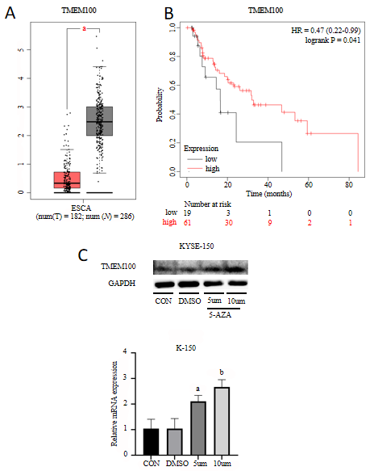
Figure 1 Relationship between low TMEM100 expression in esophageal cancer and patient survival and the effect of 5-AZA on TMEM100 expression in esophageal squamous cell carcinoma lines. A: Expression profile of TMEM100 in EC samples compared with normal samples, showing reduced expression of TMEM100 in EC tissues; B: Overall survival of patients with high vs low TMEM100 expression levels. Survival was poorer for those with low TMEM100 expression (P = 0.041); C: 5-AZA induced a dose-dependent expression of TMEM100 in K-150 cells. Real-time PCR and western blotting results showed that after 24 h of treatment, TMEM100 expression increased with increasing 5-AZA concentration. ªP < 0.05, ^{b}P < 0.01. DMSO: Dimethyl sulfoxide; EC: Esophageal cancer; ESCA: Esophageal cancer; HR: Hazard Ratio.
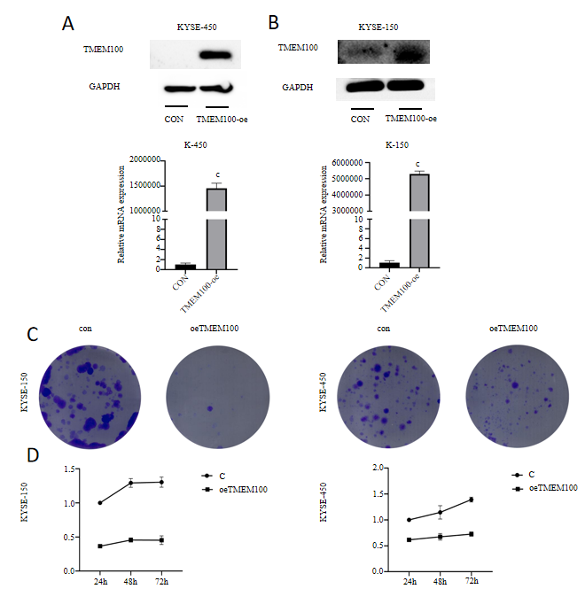
Figure 2 Overexpression effect of TMEM100 in esophageal squamous cell carcinoma lines and the inhibitory effect of TMEM100 overexpression on proliferation, migration, and invasion of esophageal squamous cell carcinoma cells in vitro. A and B: K-150/K-450 cells transfected with TMEM100-oe were assayed using real-time PCR and western blotting, and the results showed that the expression of TMEM100 was significantly upregulated in the transfected cells compared to that in the control group; C: Colony formation viability of K-150/K-450 cells after transient transfection treatment for 14 d was analysed by staining with 1% crystal violet; D: Cell counting kit-8 assay results show that overexpression of TMEM100 inhibits the proliferation of K-150/K-450 cells. ^{c}P < 0.0001.

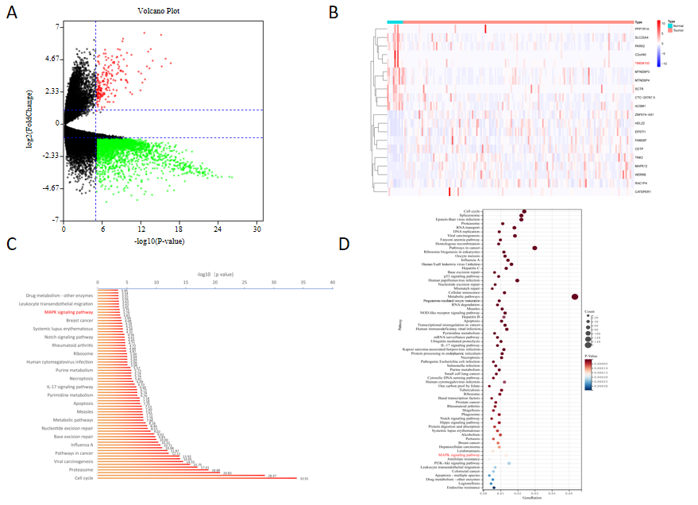
Figure 3 Identification of differentially expressed genes and functional enrichment analysis. A: In the volcano plot, upregulated genes are indicated by red dots, and downregulated genes are indicated by green dots; B: The heatmap represents the expression levels of the genes, with the blue to red spectrum indicating low to high expression; C and D: The top 69 enriched Kyoto Encyclopedia of Genes and Genomes pathways.

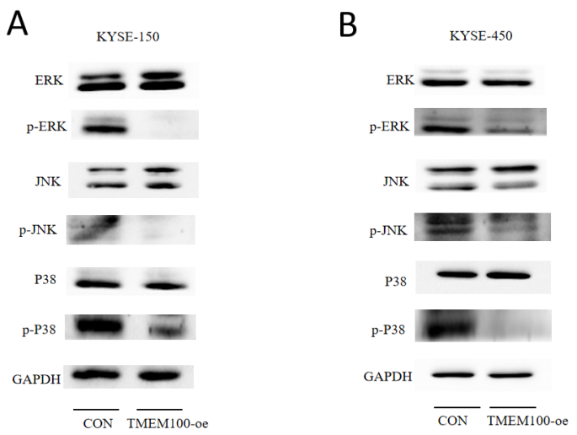
Figure 4 Effect of TMEM100 overexpression on mitogen-activated protein kinase pathway activation in KYSE-150/KYSE-450 cells. A: K-150 cells were harvested 24 h after transfection with TMEM100-oe, and total proteins were extracted for western blotting analysis. Phosphorylated-extracellular regulated kinase (p-ERK) and ERK, phosphorylated-c-Jun N-terminal kinase (p-JNK) and JNK, and p-p38 and p38 were analysed. The result demonstrated a reduction in the expression of p-ERK, p-p38, and p-JNK in K-150/K-450 cells transfected with TMEM100-oe; B: The experiment was repeated again with K-450 cells. p-ERK: Phosphorylated-extracellular regulated kinase; p-JNK: Phosphorylated-c-Jun N-terminal kinase.

Table 1 Primer sequences for quantitative real-time reverse transcription polymerase chain reaction
Gene | Primer pair
TMEM100 | F: 5-ACAGTCCCTCTGGTCAGTGAGA-3 R: 5-GGCGATGAAGACAACCACAGCA-3
β-actin | F: 5-CACCATTGGCAATGAGCGGTTC-3 R: 5-AGGTCTTTGCGGATGTCCACGT-3

