Name of Journal: World Journal of Clinical Cases
Manuscript NO: 90068
Manuscript Type: ORIGINAL ARTICLE

Clinical and Translational Research
Causal role of immune cells in obstructive sleep apnea hypopnea syndrome: Mendelian randomization study

Zhao HH et al. Mendelian randomization

Huang-Hong Zhao, Zhen Ma, Dong-Sheng Guan

Huang-Hong Zhao, Department of Encephalopathy, Henan Provincial Hospital of Traditional Chinese Medicine, Zhengzhou 450000, Henan Province, China

Zhen Ma, Department of Personnel, The First Affiliated Hospital of Henan University of Traditional Chinese Medicine, Zhengzhou 450000, Henan Province, China

Dong-Sheng Guan, Department of Neurology, Henan Provincial Hospital of Traditional Chinese Medicine, Zhengzhou 450000, Henan Province, China

Author contributions: Zhao HH assisted with planning, directing, and writing, as well as with editing and revising; Ma Z helped with the first draft of the writing, the formal analysis, and the data collection; Guan DS helped with the statistical analysis; the essay was written by all writers, who also gave their approval to the final draft.

Supported by Doctoral Research Fund Project of Henan Provincial Hospital of Traditional Chinese Medicine, No. 2022BSJJ10.

Corresponding author: Zhen Ma, Doctor, Researcher, Department of Personnel, The First Affiliated Hospital of Henan University of Traditional Chinese Medicine, No. 19 Renmin Road, Jinshui District, Zhengzhou 450000, Henan Province, China. mz15903698623@163.com

Received: November 22, 2023
Revised: February 2, 2024
Accepted: January 29, 2024
Published online:

Abstract
BACKGROUND
Despite being one of the most prevalent sleep disorders, obstructive sleep apnea hypoventilation syndrome (OSAHS) has limited information on its immunologic foundation. The immunological underpinnings of certain major psychiatric diseases have been uncovered in recent years thanks to the extensive use of genome-wide association studies (GWAS) and genotyping techniques using high-density genetic markers (e.g., SNP or CNVs). But this tactic hasn't yet been applied to OSAHS. Using a Mendelian randomization analysis, we analyzed the causal link between immune cells and the illness in order to comprehend the immunological bases of OSAHS.

AIM
To investigate the immune cells' association with OSAHS via genetic methods, guiding future clinical research.

METHODS
A comprehensive two-sample mendelian randomization study was conducted to investigate the causal relationship between immune cell characteristics and OSAHS. Summary statistics for each immune cell feature were obtained from the GWAS catalog. Information on 731 immune cell properties, such as morphologic parameters, median fluorescence intensity, absolute cellular, and relative cellular, was compiled using publicly available genetic databases. The results' robustness, heterogeneity, and horizontal pleiotropy were confirmed using extensive sensitivity examination.

RESULTS
Following false discovery rate (FDR) correction, no statistically significant effect of OSAHS on immunophenotypes was observed. However, two lymphocyte subsets were found to have a significant association with the risk of OSAHS: Basophil %CD33dim HLA DR- CD66b- (OR = 1.03, 95%CI = 1.01-1.03, P < 0.001); CD38 on IgD+ CD24- B cell (OR = 1.04, 95%CI = 1.02-1.04, P = 0.019).

CONCLUSION
This study shows a strong link between immune cells and OSAHS through a gene approach, thus offering direction for potential future medical research.

Key Words: Obstructive sleep apnea hypopnea syndrome; Immunity; Causal inference; MR analysis; Sensitivity

Zhao HH, Ma Z, Guan DS. Causal role of immune cells in obstructive sleep apnea hypopnea syndrome: Mendelian randomization study. World J Clin Cases 2024; In press

Core Tip: Our comprehensive bidirectional mendelian randomization analysis has revealed causal links between various immunophenotypes and obstructive sleep apnea-hypopnea syndrome (OSAHS), shedding light on the intricate web of relationships between OSAHS and the immune system.

INTRODUCTION
Obstructive sleep apnea-hypopnea syndrome (OSAHS) is characterized by an apnea-hypopnea index of 5 or more, accompanied by symptoms such as excessive daytime somnolence, two or more episodes of asphyxia, wheezing, frequent arousals, daily weariness, lack of attention, or memory loss^{[1,2]}. Research has illustrated that intermittent hypoxia and hypopnea can elevate the diastolic function of respiratory muscles, activate the sympathetic nervous system, induce an oxidative stress response, worsen vascular endothelial damage, and ultimately lead to atherosclerosis and recurrent apnea^{[3,4]}. Emphasizing the value of early treatment for OSAHS is crucial. Systemic inflammation, cognitive decline, cardiovascular and metabolic problems, and delayed or neglected therapy might all arise^{[5,6]}.
Current research is exploring the complicated relationships between OSAHS and the immune system, particularly focusing on how inflammatory factors impact immune cell involvement. Studies have revealed that patients with moderate-to-severe OSAHS show significantly lower natural killer cell percentages and immunoglobulin M levels, alongside notably elevated levels of interleukin (IL)-4, IL-13, C-C motif chemokine (CCL)-11, CCL-24 (a type 2 immune-associated marker), IL-17A (a type 3 immune-associated marker)^{[7]}, and serum complement C3 levels^{[8]}. These findings suggest that immune cells and inflammation may influence the development and symptoms of OSAHS. Additionally, genome-wide association studies are crucial for understanding the link between the disease and the immune system by examining genetic variations in large cohorts. Recent investigations suggest that signal variants in the COX20, PTPDC1, and TMOD4 genes may be linked to the OSAHS phenotype in affected families^{[9]}. Therefore, it is anticipated that identifying gene loci and networks using GWAS will enhance our understanding of the complex interplay among genetics, immune response, and disease, ultimately guiding personalized treatment strategies for OSAHS^{[10]}.
Mendelian randomization (MR) functions as a statistical method primarily utilized for inferring epidemiological causality by leveraging Mendelian genetic principles^{[11]}. Preserving the logical sequence of causality is crucial in the Mendelian randomization approach^{[12]}. The results of previous observers have confirmed a specific link between immune cell characteristics and OSAHS, thus reinforcing the assumption that there is a correlation between the two^{[13,14]}. This study used a two-sample magnetic resonance integrated method to investigate the causal association of immune cell characteristics with OSAHS.

MATERIALS AND METHODS
Study design
We investigated the causal relationship of the 731 immune cell profiles with OSAHS by two-sample MR analysis. MR requires the use of genetic variation as a proxy variable for risk variation to satisfy three critical hypotheses in causal inferences: That (1) the exposure is expected to be directly correlated with the genetic variance; (2) as potential confounders, no genetic link is present between the exposure and the outcome; and (3) no genetic influence on the objective is exerted by channels independent of the exposure (Figure 1). The Institutional Review Board approved our study, and informed consent was obtained from the participants.

Sources of immune cross-genomic data
Comprehensive summary statistical data (ranging from accession numbers GCST0001391 to GCST0002121) containing all immunization profiles in the GWAS catalog are readily available^{[15]}. This Genomic Study involved 3757 non-overlapping Europeans analyzed using high-density arrays based on the Sardinian Sequence Reference Panel^{[16]}. The dataset comprised approximately 22 million SNP, which underwent correlation testing while adjusting for covariates like age, age 2, and sex. Among the 731 immunophenotypes identified, these include morphologic parameters (MP) (32), relative cell count (RC) (192), absolute cell count (AC) (118), and median fluorescence intensity (MFI), indicating the level of surface antigens (389). The MP features include CDC and TBNK panels. Meanwhile, the MFI, RC, and AC features cover a variety of immune cells such as B cells, myeloid cells, T cell maturation stage, TBNK, CDC, and monocytes (B cells, T cells, and natural killer proteins).

OSAHS genome-wide association study data sources
FinnGen provided the genome-wide association study (GWAS) summary statistics for OSAHS (https://www.finngen.fi/en). 372657 European people were included in the research (Ncase = 38998, Ncontrol = 333659) for a GWAS. The GWAS identified over 16 million independent single nucleotide polymorphisms (SNPs).

Selection of instrumental variables
An instrumental variable (IV) extracted from version v1.90 was used to modify SNPs using a distance of 500 kb with a chain disequilibrium (LD) r² threshold of less than 0.1^{[17]}. Calculation of LD r² used the 1000 Genomes Project as a reference panel, and the revised OSAHS significance threshold was established at 5 × 10⁻⁸. The F statistic was calculated to evaluate the IV's strength and mitigate potential weak instrumental bias. The IV length for immunophenotyping ranged from 3 to 1641, with an average explanation of 0.021% (range 0.023% to 5.29%) for the associated immune characteristics.

Statistical analysis
All studies were analyzed using R version 4.3.1 software (http://www.Rproject.org). In particular, to explore the causal links between the 731 immunophenotypes and OSAHS, a set of analyses were performed using the "Mendelian Randomization" software (version 0.4.3)^{[18]}, including median-based weighted analysis^{[19]}, pattern-based weighted analysis^{[20]}, and inverse variance weighted (IVW) analysis^{[21]}. Instrumental heterogeneity across variables was examined based on Cochran's Q statistic and P value (IV), supported with MR-Egger test, which identifies cross-sectional multidimensionality through a significant intercept term^{[22]}. In addition, the analysis included using the MR-PRESSO software package to identify and exclude horizontal multidimensional entropy outliers that could significantly impact the estimation results^{[23]}. After eliminating these SNPs, the IVW analysis was rerun. Additionally, SNPs potentially associated with those risk variables were tracked at the Phenoscanner V2 (http://www.phenoscanner.medschl.cam.ac.uk/) Web site (P < 10-5). Finally, the analysis combines a funnel plot and a scatterplot, where the scatterplot reveals that outliers have the least significant effect on the data. In contrast, the funnel plots showed solid associations and a lack of heterogeneity.

RESULTS
Investigating the causal relationship between immunophenotypes and OSAHS

Using false discovery rate (FDR) correlation (P_{FDR} < 0.05), we identified two protective immunophenotypes against OSAHS: Basophil %CD33dim HLA DR- CD66b- and CD38 on IgD+ CD24- B cell. In particular, the ratio of basophil %CD33dim HLA DR- CD66b- to the risk of OSAHS was 1.03 (95%CI = 1.01-1.03, PFDR = 0.04, P = 0.256, Supplementary Table 1) as measured by the IVW method. Four other methods also gave similar results: the weighted median method (OR = 1.03, 95%CI = 1.01-1.03, P = 0.009), the simple mode method (OR = 1.05, 95%CI = 1.00-1.05, P = 0.053); the weighted mode method (OR = 1.03, 95%CI = 1.01-1.03, P = 0.026), and MR-Egger method (OR = 1.02, 95%CI = 0.99-1.06, P = 0.256). By applying the IVW technique, the OR of CD38 on IgD+ CD24- B cell on OSAHS risk was calculated to be 0.064 (95%CI = 0.89-0.96, P_{FDR} = 0.04, P < 0.001, Supplementary Table 1). The results were similar for weighted mode (OR = 1.03, 95%CI = 1.00-1.03, P = 0.066); weighted median (OR = 1.04, 95%CI = 1.01-1.04, P = 0.019); Simple mode (OR = 1.03, 95%CI = 0.99-1.03, P = 0.208); and MR-Egger (OR = 1.05, 95%CI = 1.01-1.05, P = 0.015). Furthermore, the MR-Egger intercept and MR-PRESSO global tests for both associations dismissed the possibility of horizontally collapsed effects. Sensitivity analyses furnished detailed information that affirmed the robustness of the identified causal relationships (Figure 2 and Supplementary Table 2). The resilience of the data was further illustrated through funnel scatterplots (Supplementary Figure 1A and Supplementary Figure 2A) and plots (Supplementary Figure 1B and Supplementary Figure 2B).

Examination of the causal relation of OSAHS onset on immunophenotypes
In exploring the causal effect of OSAHS on immunophenotypes, we used the IVW approach as the primary analytical method for the two-sample MR analysis. Although adjusted for multiplicity of tests using the FDR method, we did not identify any immunologic features at the 0.05 significance level. However, when loosely thresholding the FDR, we identified 37 cellular phenotypes with an FDR of 0.56, with the highest expression of receptor proteins in B-cell subpopulations, such as BAFF-R on IgD+ CD24 - (OR=1.13, 95%CI = 1.03-1.23, P = 0.006); BAFF-R on IgD+ CD38br (OR = 1.11, 95%CI = 1.02-1.03, P = 0.026); BAFF-R on IgD+ CD38dim (OR = 1.11, 95%CI = 1.02-1.21, P = 0.019). Other cellular subpopulations also had high CD19 expression, such as CD19 on IgD+ CD38- unsw mem (OR = 1.17, 95%CI = 1.03-1.31, P = 0.009), CD19 on IgD+ CD24+ (OR = 1.11, 95%CI = 1.02-1.21, P = 0.014), and other phenotypes, such as resting Treg AC, EM CD8br %T cells. Monocytes AC, B cells % CD3- lymphocytes, etc. (Supplementary file 3).

DISCUSSION

We explored the causal link between 731 immune cell characteristics and OSAHS by leveraging an extensive dataset of publicly available genetic information. This remains the sole MR investigation delving into the causal relationship between numerous resistant phenotypes and OSAHS. The research encompassed four categories of immune traits (MFI, RC, AC, and MP). Within these categories, two immunophenotypes demonstrated a substantial causal impact on OSAHS (P_{FDR} < 0.05) (Figure 3).
Our studies have shown that the risk of developing OSAHS increases with the percentage of CD38 in IgD+ CD24-B cells. Altered CD38 expression or increased function of the cyclic ADP ribozyme associated with CD38 in this cell subset has been directly linked to the treatment of a variety of diseases, including cancer, asthma, and neuroimmune diseases^{[24]}. It has been shown that CD38 plays a role in calcium regulation in airway smooth muscle (ASM) and that upregulation of CD38 levels improves Ca²⁺ responses when airway smooth muscle is exposed to contractile agonists^{[25,26]}. Experimental studies have also shown that CD38 increases airway inflammation and responsiveness by modulating intracellular calcium levels in mouse smooth muscle contractile (ASM) cells. Through a mechanism that is not dependent on CD38, bronchodilators are often used for clinical guidance in the medical management of chronic airway disease^{[27]}. Additionally, in CRS patients with nasal polyps, elevated IgD CSR in mucosa-associated lymphocyte B-cell populations activates mast cells and may promote IgE production and eosinophilic inflammation^{[28]}. Although the exact relationships between these variables are yet unknown, they all have an indirect impact on how OSAHS develops.
Plenty of studies have been done on the connection between basophils and airway inflammation. It has been demonstrated that basophil-associated OX40 ligand plays a key role in the onset of the Th2 response during airway inflammation^{[29]}, while basophil IL-4 is essential to the generation of NH-derived cytokines and chemokines, which in turn results in proteolytic allergen-induced airway inflammation.On the other hand, HLA-DR, or the human lymphocyte antigen D-related antigen, has been linked to immunological abnormalities and has been demonstrated to be significant in a number of autoimmune and neurological illnesses^{[30]}. HLA-DR gene variations, for instance, have been linked to an increased risk of developing certain neuropsychiatric disorders. For instance, populations with severe depressive disorders, sleep disorders, and autistic spectrum disorders have been shown to express HLA-DRB1 at the HLA-DR regional locus at greater levels^{[31]}. The results of this study also show that HLA-DR is strongly related to immunological abnormalities in patients with OSAHS^{[32]}. Of particular interest is the aberrantly elevated levels of CD3- + HLA-DR cells in the peripheral blood of patients with sleep disorders^{[33]}. These findings imply that immunological problems linked to sleep disorders and OSAHS include basophil% and HLA DR-CD66b-mediated cell subpopulations.

This study utilized a two-sample Mendelian randomization method, and the data were obtained from a sizable genomic study cohort containing 372657 individuals, ensuring robust statistical efficiency. Conclusions were based on genetic instrumental variables, and causal inferences employed diverse and powerful Mendelian randomization analysis techniques resistant to horizontal pleiotropy and other confounding variables. However, acknowledging several limitations is necessary. Firstly, despite numerous sensitivity analyses, a thorough assessment of horizontal pleiotropy remains challenging. Secondly, the lack of individual-level data could have helped stratified population analyses. Thirdly, the dependence of European databases restricts the generalization of the findings across other races. Finally, the adjustable result evaluation criteria of the study may have led to an increase in false-positive results. Still, they also helped to evaluate the close relationship between immune profiles and OSAHS thoroughly.

CONCLUSION
In conclusion, our extensive bi-directional MR analyses revealed a causal relationship between various immune phenotypes and OSAHS, elucidating the intricate relationship between OSAHS and the immune system. In addition, our study effectively minimizes the effects of reversed causality, other variables, and unavoidable confounders, providing a new perspective for researchers to explore the biological foundations of OSAHS and potentially establishment of early prevention and treatment strategies. These discoveries widen the scope of research in psychoimmunology and provide valuable insights into the prevention of OSAHS.

ARTICLE HIGHLIGHTS
Research background
Despite being one of the most prevalent sleep disorders, obstructive sleep apnea hypoventilation syndrome (OSAHS) has limited information on its immunologic foundation. The immunological underpinnings of certain major psychiatric diseases have been uncovered in recent years thanks to the extensive use of genome-wide association studies (GWAS) and genotyping techniques using high-density genetic markers (e.g., SNPs or CNVs). But this tactic hasn't yet been applied to OSAHS. Using a Mendelian randomization analysis, we analyzed the causal link between immune cells and the illness in order to comprehend the immunological bases of OSAHS.

Research motivation
In summary, our comprehensive bidirectional mendelian randomization (MR) analysis has revealed causal links between various immunophenotypes and OSAHS, shedding light on the intricate web of relationships between OSAHS and the immune system. Moreover, Reverse causality, other variables, and other unavoidable confounding factors have all been successfully reduced in impact by our study, offering a fresh perspective for researchers to delve into the biological underpinnings of OSAHS and potentially pave the way for early intervention and treatment strategies. These findings expand the realm of psychoimmunology and offer valuable insights for OSAHS prevention.

Research objectives
This study employed two-sample Mendelian randomization analysis using data from a large genomic research cohort of approximately 372657 individuals, assuring great statistical efficiency. The outcomes of the study were based on genetic instrumental variables, and causal inferences were conducted by various robust Mendelian randomization analysis techniques, which were unaffected by horizontal pleiotropy and other variables. This study does have several drawbacks, though. First, a thorough evaluation of horizontal pleiotropy is still difficult to achieve, even after several sensitivity studies. Second, stratified population analyses were not feasible due to the lack of individual-level data. Third, the study's reliance on European databases limits the generalizability of the findings to other ethnic groups. Finally, the study's flexible outcome assessment criteria may have led to more false positives, but they also made it easier to evaluate the full extent of the strong relationship between immunological traits and OSAHS.

Research methods
A comprehensive two-sample MR study was conducted to investigate the causal relationship between immune cell characteristics and OSAHS. Summary statistics for each immune cell feature were obtained from the GWAS catalog. Information on 731 immune cell properties, such as morphologic parameters, median fluorescence intensity, absolute cellular, and relative cellular, was compiled using publicly available genetic databases. The results' robustness, heterogeneity, and horizontal pleiotropy were confirmed using extensive sensitivity examination.

Research results
After false discovery rate correction, OSAHS had no statistically significant effect on immunophenotypes. However, Two lymphocyte subsets were identified to be significantly associated with OSAHS risk: (OR = 1.03, 95%CI = 1.01-1.03, P = 0.000); CD28+CD4+T cell (OR = 1.04, 95%CI = 1.02-1.04, P = 0.019).

Research conclusions
The study has shown the close association between immune cells and OSAHS through genetic methods, thereby offering direction for future clinical research.

Research perspectives
This groundbreaking study employs bidirectional MR analysis to unveil crucial immunological links in OSAHS. By establishing causal relationships between diverse immunophenotypes and OSAHS, the research offers a fresh lens for exploring the disorder's biological foundations. Successfully addressing confounding factors, the study presents opportunities for early intervention and insights into targeted preventive strategies. While limitations exist, including challenges in evaluating horizontal pleiotropy and generalizability, identifying specific lymphocyte subsets strengthens the convergence of immunology and OSAHS research, guiding future clinical investigations with promising avenues for intervention.

REFERENCES
1 Lee JJ, Sundar KM. Evaluation and Management of Adults with Obstructive Sleep Apnea Syndrome. Lung 2021; 199: 87-101 [PMID: 33713177 DOI: 10.1007/s00408-021-00426-w]
2 Akarsu FG, Algin DI, Erdinç OO. Evaluation of comorbid diseases in obstructive sleep apnea syndrome. Rev Assoc Med Bras (1992) 2023; 69: 421-425 [PMID: 36820771 DOI: 10.1590/1806-9282.20221082]
3 Lv R, Liu X, Zhang Y, Dong N, Wang X, He Y, Yue H, Yin Q. Pathophysiological mechanisms and therapeutic approaches in obstructive sleep apnea syndrome. Signal Transduct Target Ther 2023; 8: 218 [PMID: 37230968 DOI: 10.1038/s41392-023-01496-3]
4 Antonaglia C, Passuti G. Obstructive sleep apnea syndrome in non-obese patients. Sleep Breath 2022; 26: 513-518 [PMID: 34324126 DOI: 10.1007/s11325-021-02412-1]
5 Singh P, Bonitati A. Obstructive Sleep Apnea Syndrome - A Review for Primary Care Physicians and Pulmonologists. R I Med J (2013) 2021; 104: 10-13 [PMID: 34437659]
6 Challamel MJ, Beydon N, Coutier L, Launois S, Seailles T, Vecchierini MF, Franco P. [Diagnostic criteria for obstructive sleep apnea syndrome in adolescent]. Rev Mal Respir 2021; 38: 829-839 [PMID: 34565640 DOI: 10.1016/j.rmr.2021.06.006]
7 Kim DK, Lee BC, Park KJ, Son GM. Effect of Obstructive Sleep Apnea on Immunity in Cases of Chronic Rhinosinusitis With Nasal Polyps. Clin Exp Otorhinolaryngol 2021; 14: 390-398 [PMID: 33541034 DOI: 10.21053/ceo.2020.02250]
8 Wu Y, She L, Huang DH. [A review about changes of immune function in patients with obstructive sleep apnea hypopnea syndrome]. Zhonghua Er Bi Yan Hou Tou Jing Wai Ke Za Zhi 2022; 57: 649-655 [PMID: 35610692 DOI: 10.3760/cma.j.cn115330-20211206-00779]
9 de Azevedo PG, Guimarães MLR, Albuquerque ALB, Alves RB, Gomes Fernandes B, Marques de Melo F, Guimaraes Corrêa Do Carmo Lisboa Cardenas R, Friedman E, De Marco L, Bastos-Rodrigues L. Whole-exome identifies germline variants in families with obstructive sleep apnea syndrome. Front Genet 2023; 14: 1137817 [PMID: 37229194 DOI: 10.3389/fgene.2023.1137817]
10 Wang Q, Yang C, Gelernter J, Zhao H. Pervasive pleiotropy between psychiatric disorders and immune disorders revealed by integrative analysis of multiple GWAS. Hum Genet 2015; 134: 1195-1209 [PMID: 26340901 DOI: 10.1007/s00439-015-1596-8]
11 Spiga F, Gibson M, Dawson S, Tilling K, Davey Smith G, Munafò MR, Higgins JPT. Tools for assessing quality and risk of bias in Mendelian randomization studies: a systematic review. Int J Epidemiol 2023; 52: 227-249 [PMID: 35900265 DOI: 10.1093/ije/dyac149]
12 Burgess S, Mason AM, Grant AJ, Slob EAW, Gkatzionis A, Zuber V, Patel A, Tian H, Liu C, Haynes WG, Hovingh GK, Knudsen LB, Whittaker JC, Gill D. Using genetic association data to guide drug discovery and development: Review of methods and applications. Am J Hum Genet 2023; 110: 195-214 [PMID: 36736292 DOI: 10.1016/j.ajhg.2022.12.017]
13 Hou R, Ye G, Liu Y, Chen X, Pan M, Zhu F, Fu J, Fu T, Liu Q, Gao Z, Baldwin DS, Tang Z. Effects of SSRIs on peripheral inflammatory cytokines in patients with Generalized Anxiety Disorder. Brain Behav Immun 2019; 81: 105-110 [PMID: 31163212 DOI: 10.1016/j.bbi.2019.06.001]
14 Wingo AP, Gibson G. Blood gene expression profiles suggest altered immune function associated with symptoms of generalized anxiety disorder. Brain Behav Immun 2015; 43: 184-191 [PMID: 25300922 DOI: 10.1016/j.bbi.2014.09.016]
15 Orrù V, Steri M, Sidore C, Marongiu M, Serra V, Olla S, Sole G, Lai S, Dei M, Mulas A, Virdis F, Piras MG, Lobina M, Marongiu M, Pitzalis M, Deidda F, Loizedda A, Onano S, Zoledziewska M, Sawcer S, Devoto M, Gorospe M, Abecasis GR, Floris M, Pala M, Schlessinger D, Fiorillo E, Cucca F. Complex genetic signatures in immune cells underlie autoimmunity and inform therapy. Nat Genet 2020; 52: 1036-1045 [PMID: 32929287 DOI: 10.1038/s41588-020-0684-4]
16 Sidore C, Busonero F, Maschio A, Porcu E, Naitza S, Zoledziewska M, Mulas A, Pistis G, Steri M, Danjou F, Kwong A, Ortega Del Vecchyo VD, Chiang CWK, Bragg-Gresham J, Pitzalis M, Nagaraja R, Tarrier B, Brennan C, Uzzau S, Fuchsberger C, Atzeni R, Reinier F, Berutti R, Huang J, Timpson NJ, Toniolo D, Gasparini P, Malerba G, Dedoussis G, Zeggini E, Soranzo N, Jones C, Lyons R, Angius A, Kang HM, Novembre J, Sanna S, Schlessinger D, Cucca F, Abecasis GR. Genome sequencing elucidates Sardinian genetic architecture and augments association analyses for lipid and blood inflammatory markers. Nat Genet 2015; 47: 1272-1281 [PMID: 26366554 DOI: 10.1038/ng.3368]
17 Vierstra J, Lazar J, Sandstrom R, Halow J, Lee K, Bates D, Diegel M, Dunn D, Neri F, Haugen E, Rynes E, Reynolds A, Nelson J, Johnson A, Frerker M, Buckley M, Kaul R, Meuleman W, Stamatoyannopoulos JA. Global reference mapping of human transcription factor footprints. Nature 2020; 583: 729-736 [PMID: 32728250 DOI: 10.1038/s41586-020-2528-x]
18 Wang B, Gao L, Zhang J, Meng X, Xu X, Hou H, Xing W, Wang W, Wang Y. Unravelling the genetic causality of immunoglobulin G N-glycans in ischemic stroke. Glycoconj J 2023; 40: 413-420 [PMID: 37341803 DOI: 10.1007/s10719-023-10127-6]
19 Bowden J, Davey Smith G, Haycock PC, Burgess S. Consistent Estimation in Mendelian Randomization with Some Invalid Instruments Using a Weighted Median Estimator. Genet Epidemiol 2016; 40: 304-314 [PMID: 27061298 DOI: 10.1002/gepi.21965]
20 Hartwig FP, Davey Smith G, Bowden J. Robust inference in summary data Mendelian randomization via the zero modal pleiotropy assumption. Int J Epidemiol 2017; 46: 1985-1998 [PMID: 29040600 DOI: 10.1093/ije/dyx102]
21 Patel A, Ye T, Xue H, Lin Z, Xu S, Woolf B, Mason AM, Burgess S. MendelianRandomization v0.9.0: updates to an R package for performing Mendelian randomization analyses using summarized data. Wellcome Open Res 2023; 8: 449 [PMID: 37915953 DOI: 10.12688/wellcomeopenres.19995.1]
22 Cho Y, Haycock PC, Sanderson E, Gaunt TR, Zheng J, Morris AP, Davey Smith G, Hemani G. Exploiting horizontal pleiotropy to search for causal pathways within a Mendelian randomization framework. Nat Commun 2020; 11: 1010 [PMID: 32081875 DOI: 10.1038/s41467-020-14452-4]
23 Verbanck M, Chen CY, Neale B, Do R. Publisher Correction: Detection of widespread horizontal pleiotropy in causal relationships inferred from Mendelian randomization between complex traits and diseases. Nat Genet 2018; 50: 1196 [PMID: 29967445 DOI: 10.1038/s41588-018-0164-2]
24 Deshpande DA, Guedes AGP, Graeff R, Dogan S, Subramanian S, Walseth TF, Kannan MS. CD38/cADPR Signaling Pathway in Airway Disease: Regulatory Mechanisms. Mediators Inflamm 2018; 2018: 8942042 [PMID: 29576747 DOI: 10.1155/2018/8942042]
25 Deshpande DA, Guedes AGP, Lund FE, Subramanian S, Walseth TF, Kannan MS. CD38 in the pathogenesis of allergic airway disease: Potential therapeutic targets. Pharmacol Ther 2017; 172: 116-126 [PMID: 27939939 DOI: 10.1016/j.pharmthera.2016.12.002]
26 Boslett J, Hemann C, Christofi FL, Zweier JL. Characterization of CD38 in the major cell types of the heart: endothelial cells highly express CD38 with activation by hypoxia-reoxygenation triggering NAD(P)H depletion. Am J Physiol Cell Physiol 2018; 314: C297-C309 [PMID: 29187364 DOI: 10.1152/ajpcell.00139.2017]
27 Guedes AG, Dileepan M, Jude JA, Deshpande DA, Walseth TF, Kannan MS. Role of CD38/cADPR signaling in obstructive pulmonary diseases. Curr Opin Pharmacol 2020; 51: 29-33 [PMID: 32480246 DOI: 10.1016/j.coph.2020.04.007]
28 Choi JH, Wang KW, Zhang D, Zhan X, Wang T, Bu CH, Behrendt CL, Zeng M, Wang Y, Misawa T, Li X, Tang M, Zhan X, Scott L, Hildebrand S, Murray AR, Moresco EM, Hooper LV, Beutler B. IgD class switching is initiated by microbiota and limited to mucosa-associated lymphoid tissue in mice. Proc Natl Acad Sci U S A 2017; 114: E1196-E1204 [PMID: 28137874 DOI: 10.1073/pnas.1621258114]
29 Motomura Y, Morita H, Moro K, Nakae S, Artis D, Endo TA, Kuroki Y, Ohara O, Koyasu S, Kubo M. Basophil-derived interleukin-4 controls the function of natural helper cells, a member of ILC2s, in lung inflammation. Immunity 2014; 40: 758-771 [PMID: 24837103 DOI: 10.1016/j.immuni.2014.04.013]
30 Rohn H, Lang C, Schramm S, Heinemann FM, Trilling M, Gäckler A, Witzke O, Horn PA, Rebmann V. Effect of HLA-G5 Immune Checkpoint Molecule on the Expression of ILT-2, CD27, and CD38 in Splenic B cells. J Immunol Res 2022; 2022: 4829227 [PMID: 35600048 DOI: 10.1155/2022/4829227]
31 Ahmad SF, Ansari MA, Nadeem A, Bakheet SA, Al-Ayadhi LY, Alotaibi MR, Alhoshani AR, Al-Hosaini KA, Attia SM. Dysregulation of the expression of HLA-DR, costimulatory molecule, and chemokine receptors on immune cells in children with autism. Int Immunopharmacol 2018; 65: 360-365 [PMID: 30380510 DOI: 10.1016/j.intimp.2018.10.027]
32 Chang KH, Wu YR, Chen YC, Fung HC, Chen CM. Association of genetic variants within HLA-DR region with Parkinson's disease in Taiwan. Neurobiol Aging 2020; 87: 140.e13-140.e18 [PMID: 31818508 DOI: 10.1016/j.neurobiolaging.2019.11.002]
33 Enz LS, Zeis T, Schmid D, Geier F, van der Meer F, Steiner G, Certa U, Binder TMC, Stadelmann C, Martin R, Schaeren-Wiemers N. Increased HLA-DR expression and cortical demyelination in MS links with HLA-DR15. Neurol Neuroimmunol Neuroinflamm 2020; 7 [PMID: 31882398 DOI: 10.1212/NXI.0000000000000656]

Footnotes
Institutional review board statement: The selected GWAS data is obtained from open-source databases, specifically the NHGRI-EBI Catalog (https://www.ebi.ac.uk/gwas/). As it originates from such sources, there is no "Institutional Review Board statement" associated with it.

Informed consent statement: Consent was not needed as the study was retrospective without exposure to the patients’ data.

Conflict-of-interest statement: All the authors declare that they have no conflict of interest.

Data sharing statement: Participants gave informed consent for data sharing

Open-Access: This article is an open-access article that was selected by an in-house editor and fully peer-reviewed by external reviewers. It is distributed in accordance with the Creative Commons Attribution NonCommercial (CC BY-NC 4.0) license, which permits others to distribute, remix, adapt, build upon this work non-commercially, and license their derivative works on different terms, provided the original work is properly cited and the use is non-commercial. See: https://creativecommons.org/Licenses/by-nc/4.0/

Provenance and peer review: Unsolicited article; Externally peer reviewed.
Peer-review model: Single blind

Peer-review started: November 22, 2023
First decision: December 23, 2023
Article in press:

Specialty type: Immunology
Country/Territory of origin: China
Peer-review report’s scientific quality classification
Grade A (Excellent): A
Grade B (Very good): 0
Grade C (Good): 0
Grade D (Fair): 0
Grade E (Poor): 0

P-Reviewer: Verma V, United States S-Editor: Liu JH L-Editor: A P-Editor:
Figure Legends
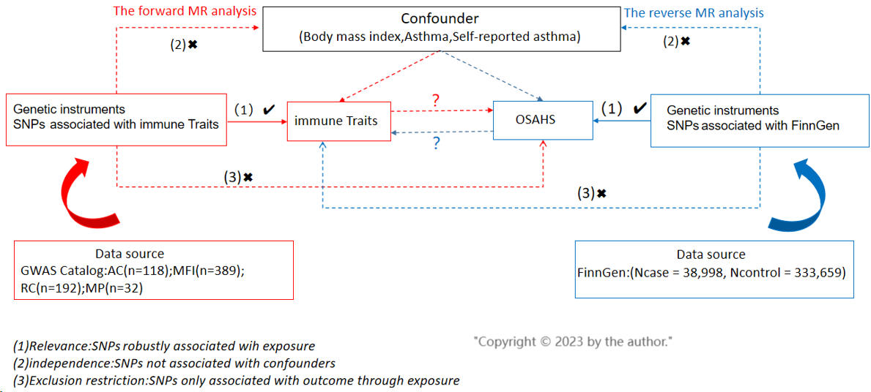
Figure 1 Overview of this bidirectional mendelian randomization study design. AC: Absolute cell count; MR: Mendelian randomization; SNPs: Single nucleotide polymorphisms; OSAHS: Obstructive sleep apnea hypoventilation syndrome; GWAS: Genome-wide association studies; RC: Relative cell count; MP: Morphologic parameters.

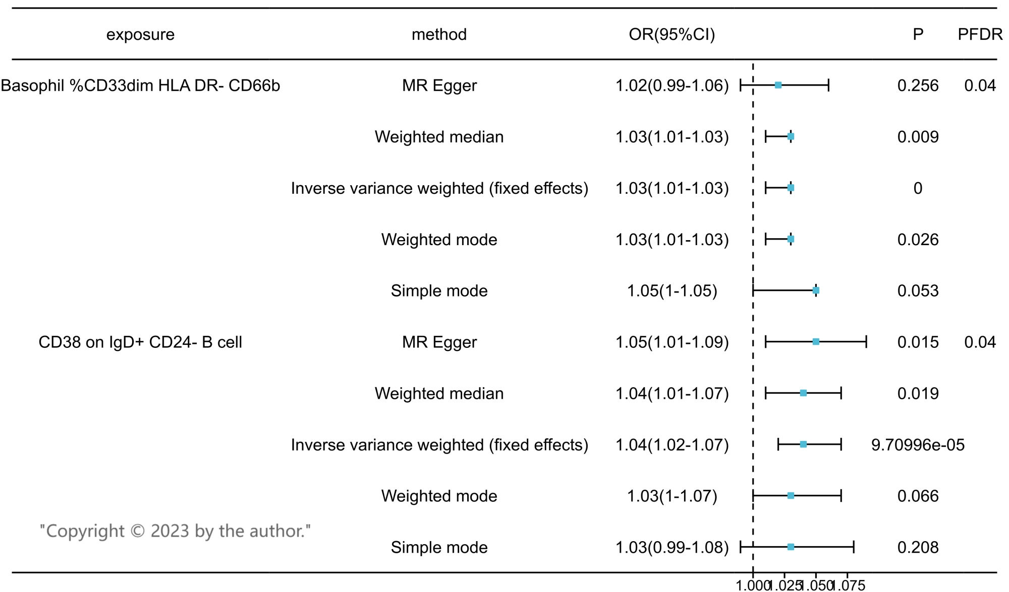
Figure 2 Forest plots showed the causal associations between immune cell traits and obstructive sleep apnea hypoventilation syndrome by using different methods.

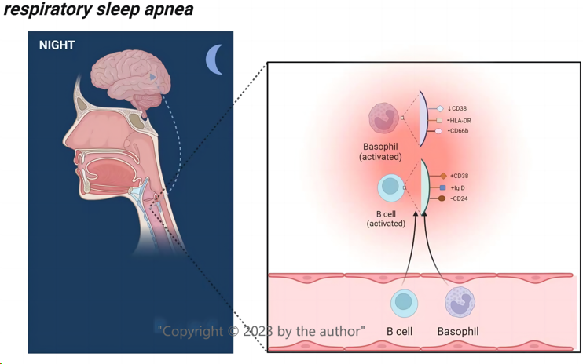
Figure 3 A diagram illustrates both cell subpopulations in the airways of patients with obstructive sleep apnea-hypopnea syndrome that are involved in inflammation.

