Name of Journal: World Journal of Clinical Cases
Manuscript NO: 89595
Manuscript Type: CASE REPORT

Adenocarcinoma of sigmoid colon with metastasis to an ovarian mature teratoma: A case report

Wang W et al. Tumor-to-tumor metastasis

Wei Wang, Chun-Chi Lin, Wen-Yi Liang, Shih-Ching Chang, Jeng-Kai Jiang

Wei Wang, Chun-Chi Lin, Shih-Ching Chang, Jeng-Kai Jiang, Division of Colorectal Surgery, Department of Surgery, Taipei Veterans General Hospital, Taipei 11217, Taiwan

Chun-Chi Lin, Wen-Yi Liang, Shih-Ching Chang, Jeng-Kai Jiang, Faculty of Medicine, School of Medicine, National Yang Ming Chiao Tung University, Taipei 112304, Taiwan

Wen-Yi Liang, Department of Pathology, Taipei Veteran General Hospital, Taipei 11217, Taiwan

Author contributions: Jiang JK, Lin CC and Chang SC contributed to the treatment of case and data collection; Liang WY reported the pathology and made the picture of the pathology slide; Wang W reviewed the literature and wrote the paper.

Corresponding author: Jeng-Kai Jiang, MD, PhD, Professor, Surgeon, Surgical Oncologist, Division of Colorectal Surgery, Department of Surgery, Taipei Veterans General Hospital, No. 201 Shipai Road, Section 2, Beitou District, Taipei 11217, Taiwan. jkjiang@vghtpe.gov.tw

Received: November 6, 2023
Revised: November 22, 2023
Accepted: January 8, 2024
Published online: February 6, 2024

Abstract
BACKGROUND
Colorectal cancer ranks third in global cancer-related mortality, often due to metastases to liver and lungs. Ovarian metastases are less common, accounting for 3.6% to 7.4% of cases. In contrast, mature ovarian teratomas are frequently benign. Tumor-to-tumor metastasis is a rare phenomenon, with a limited number of documented cases. Three cases of mature ovarian teratomas metastasizing from different cancers have been reported. This report focuses on a case of tumor-to-tumor metastasis from sigmoid colon adenocarcinoma to a mature ovarian teratoma.

CASE SUMMARY
A 41-year-old Taiwanese woman with no known systemic diseases presented with lower back pain, which led to imaging revealing malignant lesions in the spine, pelvis, liver, and multiple lung metastases. She was diagnosed with sigmoid colon adenocarcinoma with metastases to the liver, lung, bone, and a left ovarian teratoma. Treatment involved radiotherapy and chemotherapy, resulting in regression of the primary tumor and stable lung and liver lesions. Due to abdominal symptoms, she underwent exploratory surgery, unveiling a mature teratoma in the left ovary with signs of metastatic adenocarcinoma.

CONCLUSION
Consider resecting mature ovarian teratomas with concurrent colorectal adenocarcinoma to prevent tumor-to-tumor metastasis.

Key Words: Tumor-to-tumor metastasis; Colorectal cancer; Ovarian teratoma; Adenocarcinoma; Case report

©The Author(s) 2024. Published by Baishideng Publishing Group Inc. All rights reserved.

Citation: Wang W, Lin CC, Liang WY, Chang SC, Jiang JK. Adenocarcinoma of sigmoid colon with metastasis to an ovarian mature teratoma: A case report. World J Clin Cases 2024; 12(4): 853-858
URL: https://www.wjgnet.com/2307-8960/full/v12/i4/853.htm
DOI: https://dx.doi.org/10.12998/wjcc.v12.i4.853

Core Tip: Tumor-to-tumor metastasis is an unusual occurrence. We present a case in which tumor metastasis has been observed, stemming from colorectal adenocarcinoma to a mature ovarian teratoma. This serves as a reminder for clinicians to remain vigilant. While mature ovarian teratomas are typically benign, it is essential to contemplate resection when a patient presents with concurrent colorectal adenocarcinoma. This is due to the potential risk of tumor-to-tumor metastasis.

INTRODUCTION
Colorectal cancer is the third leading cause of cancer-related deaths in the world^{[1-3]}. Most deaths are due to tumor metastases; liver and lung metastases are the most common^{[4]}, followed by ovarian metastases, which account for only 3.6%-7.4% of cases^{[5]}. Mature ovarian teratomas account for up to 70% of benign ovarian masses during the reproductive years and 20% in postmenopausal women. Metastasis between tumors is a rare phenomenon; only 200 cases have been reported^{[6]}. Three cases of mature ovarian teratomas have been reported, metastasizing from appendiceal adenocarcinoma, endocervical adenocarcinoma, and breast cancer^{[7-9]}. Here, we report a case of tumor-to-tumor metastasis from adenocarcinoma of the sigmoid colon to a mature ovarian teratoma.

CASE PRESENTATION
Chief complaints
A 41-year-old Taiwanese woman visited our hospital due to lower back pain for several months.

History of present illness
The patient had no previously diagnosed illness, and low back pain, abdominal fullness developed in recent months.

History of past illness
The patient denied past illness and was not taking any medication at the time of visiting.

Personal and family history
The patient denied family history of colorectal or other cancers.

Physical examination
The patient presented to our hospital with abdominal fullness and tenderness.

Laboratory examinations
Her alpha-fetoprotein, carcinoembryonic antigen, and carbohydrate cell surface antigens 125, 19-9, and 153 Levels were 2.59 ng/mL, 2362.0 ng/mL, 49.4 U/mL, 21651 U/mL, and 6.5 U/mL, respectively.

Imaging examinations
An L-spine magnetic resonance image showed an expansile and enhanced lesion of the S1-3 vertebral bodies with left iliac bone involvement, including bony destruction. The lesion appeared to be malignant. In addition, a huge and lobulated cystic mass at the pelvis and a huge liver mass were detected. Abdominal computed tomography (CT) revealed a 16.1 cm × 10.4 cm hyperdense lesion with mixed content arising from the left adnexa. An ovarian tumor or teratoma was suspected (Figure 1A). Variable-sized lesions in the liver were also detected. The biggest lesion was in the right lobe and was 13.1 cm × 12.7 cm. Metastasis of hepatocellular carcinoma was suspected (Figure 1B). Chest CT showed multiple lung metastases. Based on a liver biopsy, metastatic adenocarcinoma of colorectal origin was diagnosed. Colonoscopy showed a 5-cm annular ulcerative tumor 30 cm above the anal verge (Figure 1C). Adenocarcinoma was confirmed by pathology. Trans-abdominal sonography of the left adnexal lesion revealed a huge cystic lesion (15 cm × 11 cm × 15 cm) with septum formation but no obvious blood flow within the tumor (Figure 1D). A follow-up abdominal CT 3 mo after radiotherapy and chemotherapy showed regression of the primary tumor and stable lesions of the lung and liver. The left adnexal tumor was stable, but bilateral hydroureteronephrosis due to compression from the pelvic tumor was detected.

FINAL DIAGNOSIS
Sigmoid colon adenocarcinoma with liver, lung and bone metastases, and metastasizing to left ovarian teratoma.

TREATMENT
The patient received radiotherapy for the bone metastases and 6 courses of FOLFOX plus bevacizumab. An exploratory laparotomy with left salpingo-oophorectomy and anterior resection of the sigmoid colon were performed due to worsened abdominal fullness and pain.

OUTCOME AND FOLLOW-UP
Gross pathology examination revealed a 4 cm × 2 cm Bormann type IV ulcerative tumor in the middle sigmoid colon, with peritoneum and mesocolon invasion (Figure 2A and B). Microscopically, a moderately differentiated adenocarcinoma in the sigmoid colon with invasion of the subserosal soft tissue was observed (Figure 2C). Lymphovascular and perineural invasion were also noted. Metastasis to one of the 16 harvested lymph nodes was detected. A mature teratoma was detected in the left ovary (Figure 2D); metastatic adenocarcinoma was present in some foci of the teratoma tissue (Figure 2D and E). The combined pathological stage was ypT3N1aM1, stage IVC. The symptoms improved after the operation and the patient resumed chemotherapy 2 wk later.

DISCUSSION
Tumor-to-tumor metastasis was first reported in 1902^{[10]}. In 1968, diagnostic criteria of metastasis between tumors were established by Campbell et al^{[11]}, including the following four criteria: (1) More than one distinct primary tumor must be present; (2) the recipient tumor must be a true neoplasm; (3) the metastatic neoplasm must be a true metastasis with established growth in the recipient tumor and not the result of embolization or contiguous growth; and (4) metastasis to lymphatic tissue already involved by lymphoreticular tumors must be excluded^{[9,10]}. In our case, two distinct tumors were present (colon adenocarcinoma and ovarian mature teratoma), and no contiguous growth or adhesions between the two tumors was detected. Moreover, the metastatic adenocarcinoma contained foci within the teratoma tissue. Based on the criteria for metastasis between tumors, a tumor-to-tumor metastasis was confirmed in our patient.
Metastasis from other tumors to normal ovarian tissue is not uncommon and accounts for 10%-25% of ovarian malignancies^{[12]}. Most ovarian metastatic tumors are Krukenberg tumors, and the primary site of metastasis is the gastrointestinal tract, although metastases can arise from other tissues such as the breast^{[13]}. Gastric and colorectal adenocarcinoma are the most common sources of tumor-to-tumor metastases^{[14]}. In contrast, metastatic lesions to ovarian tumors are extremely rare. Only 15 cases have been reported, including three patients with mature ovarian teratomas^{[7,9]}. Here, we describe the case of sigmoid colon adenocarcinoma that metastasized to a mature ovarian teratoma. Due to compression symptoms, left salpingo-oophorectomy and anterior resection of the sigmoid colon were performed at the same time.
Mature teratomas are resectable benign tumors of the ovary^{[15]}. If the patient has no clinical manifestation, the tumor can go untreated. In this case, the patient underwent synchronous resection due to clinical compression symptoms, and the tumor-to-tumor metastasis from the colon adenocarcinoma to the mature ovarian teratoma was found incidentally. The discovery of tumor-to-tumor metastasis in different types of tumors is increasing, likely due to more aggressive surgical treatment of metastatic lesions. This phenomenon is important because it might affect disease staging and treatment approaches.

CONCLUSION
While mature ovarian teratomas are typically benign, it's advisable to contemplate resection in cases of simultaneous colorectal adenocarcinoma. This is due to the potential risk associated with tumor-to-tumor metastasis.

REFERENCES
1 Xie Y, Shi L, He X, Luo Y. Gastrointestinal cancers in China, the USA, and Europe. Gastroenterol Rep (Oxf) 2021; 9: 91-104 [PMID: 34026216 DOI: 10.1093/gastro/goab010]
2 Kuo CN, Liao YM, Kuo LN, Tsai HJ, Chang WC, Yen Y. Cancers in Taiwan: Practical insight from epidemiology, treatments, biomarkers, and cost. J Formos Med Assoc 2020; 119: 1731-1741 [PMID: 31522970 DOI: 10.1016/j.jfma.2019.08.023]
3 Rawla P, Sunkara T, Barsouk A. Epidemiology of colorectal cancer: incidence, mortality, survival, and risk factors. Prz Gastroenterol 2019; 14: 89-103 [PMID: 31616522 DOI: 10.5114/pg.2018.81072]
4 Haraldsdottir S, Einarsdottir HM, Smaradottir A, Gunnlaugsson A, Halfdanarson TR. [Colorectal cancer - review]. Laeknabladid 2014; 100: 75-82 [PMID: 24639430 DOI: 10.17992/lbl.2014.02.531]
5 Dasappa L, Lakshmaiah KC, Babu G, Abraham LJ, Babu S, Kumar RV, Lokesh KN, Rajeev LK, Rudresha AH, Rao SA, Garg S. Colorectal cancer presenting as ovarian metastasis. Clin Cancer Investig J 2017; 6: 92-96
6 Shi L, Guo Z, Wei X, Jia Y, Bao L, Lu J. Gastric signet-ring cell carcinoma metastasis to bilateral ovarian granulosa cell tumors. Int J Gynecol Pathol 2015; 34: 126-131 [PMID: 25675180 DOI: 10.1097/PGP.0000000000000126]
7 Yano M, Katoh T, Hamaguchi T, Kozawa E, Hamada M, Nagata K, Yasuda M. Tumor-to-tumor metastasis from appendiceal adenocarcinoma to an ovarian mature teratoma, mimicking malignant transformation of a teratoma: a case report. Diagn Pathol 2019; 14: 88 [PMID: 31409389 DOI: 10.1186/s13000-019-0865-6]
8 Santos F, Oliveira C, Caldeira JP, Coelho A, Félix A. Metastatic Endocervical Adenocarcinoma in a Mature Cystic Teratoma: A Case of a Tumor-to-Tumor Metastasis. Int J Gynecol Pathol 2018; 37: 559-563 [PMID: 29140879 DOI: 10.1097/PGP.0000000000000457]
9 Fahoum I, Brazowski E, Hershkovitz D, Aizic A. Tumor-to-Tumor Metastasis of Colorectal Adenocarcinoma to Ovarian Cystadenofibroma: A Case Report and Review of the Literature. Int J Gynecol Pathol 2020; 39: 270-272 [PMID: 30882401 DOI: 10.1097/PGP.0000000000000592]
10 Berent W. Seltene metastasenbildung [Rare Metastasis]. Zentralbl Allg Pathol 1902; 13: 406
11 Campbell LV Jr, Gilbert E, Chamberlain CR Jr, Watne AL. Metastases of cancer to cancer. Cancer 1968; 22: 635-643 [PMID: 5673241 DOI: 10.1002/1097-0142(196809)22:3<635::aid-cncr2820220320>3.0.co;2-o]
12 de Waal YR, Thomas CM, Oei AL, Sweep FC, Massuger LF. Secondary ovarian malignancies: frequency, origin, and characteristics. Int J Gynecol Cancer 2009; 19: 1160-1165 [PMID: 19823050 DOI: 10.1111/IGC.0b013e3181b33cce]
13 Aziz M, Killeen RB, Kasi A. Krukenberg Tumor. 2023 Feb 21. In: StatPearls [Internet]. Treasure Island (FL): StatPearls Publishing; 2023 Jan- [PMID: 29489206]
14 Al-Agha OM, Nicastri AD. An in-depth look at Krukenberg tumor: an overview. Arch Pathol Lab Med 2006; 130: 1725-1730 [PMID: 17076540 DOI: 10.5858/2006-130-1725-AILAKT]
15 Jalencas G, González Bosquet E, Guirado L, Fernandez Arias M, Ruiz de Gauna B, Fiores L, Gómez Roig MD, Callejo J. Ovarian mature teratoma: a ten year experience in our institution. Clin Exp Obstet Gynecol 2015; 42: 518-522 [PMID: 26411224]

Footnotes
Informed consent statement: Informed written consent was obtained from the patient for publication of this report.

Conflict-of-interest statement: None of the authors have any conflict of interest to declare.

CARE Checklist (2016) statement: The authors have read the CARE Checklist (2016), and the manuscript was prepared and revised according to the CARE Checklist (2016).

Open-Access: This article is an open-access article that was selected by an in-house editor and fully peer-reviewed by external reviewers. It is distributed in accordance with the Creative Commons Attribution NonCommercial (CC BY-NC 4.0) license, which permits others to distribute, remix, adapt, build upon this work non-commercially, and license their derivative works on different terms, provided the original work is properly cited and the use is non-commercial. See: https://creativecommons.org/Licenses/by-nc/4.0/

Provenance and peer review: Unsolicited article; Externally peer reviewed.
Peer-review model: Single blind

Peer-review started: November 6, 2023
First decision: November 22, 2023
Article in press: January 8, 2024

Specialty type: Gastroenterology & hepatology
Country/Territory of origin: Taiwan
Peer-review report’s scientific quality classification
Grade A (Excellent): 0
Grade B (Very good): B
Grade C (Good): 0
Grade D (Fair): 0
Grade E (Poor): 0

P-Reviewer: Zhu L, China S-Editor: Yan JP L-Editor: A P-Editor: Zheng XM

Figure Legends
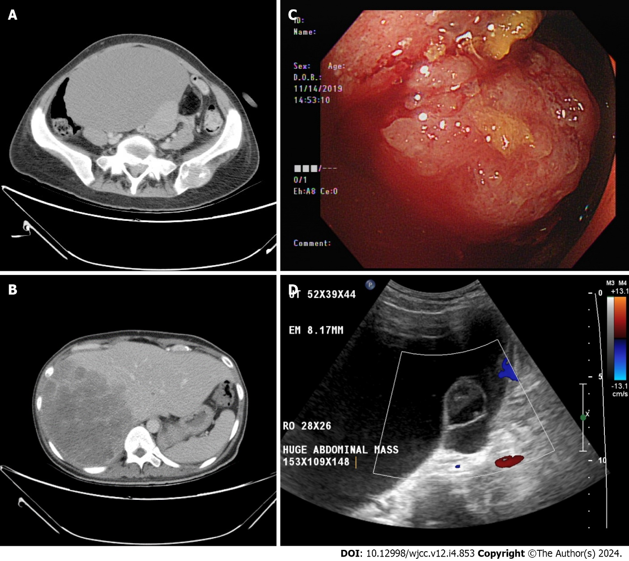
Figure 1 Imaging examinations. A: The cystic pelvic mass by computed tomography (CT) scan; B: The liver mass by CT scan; C: Colon tumor by colonoscopy; D: The pelvic mass by Doppler trans-abdominal sonography.

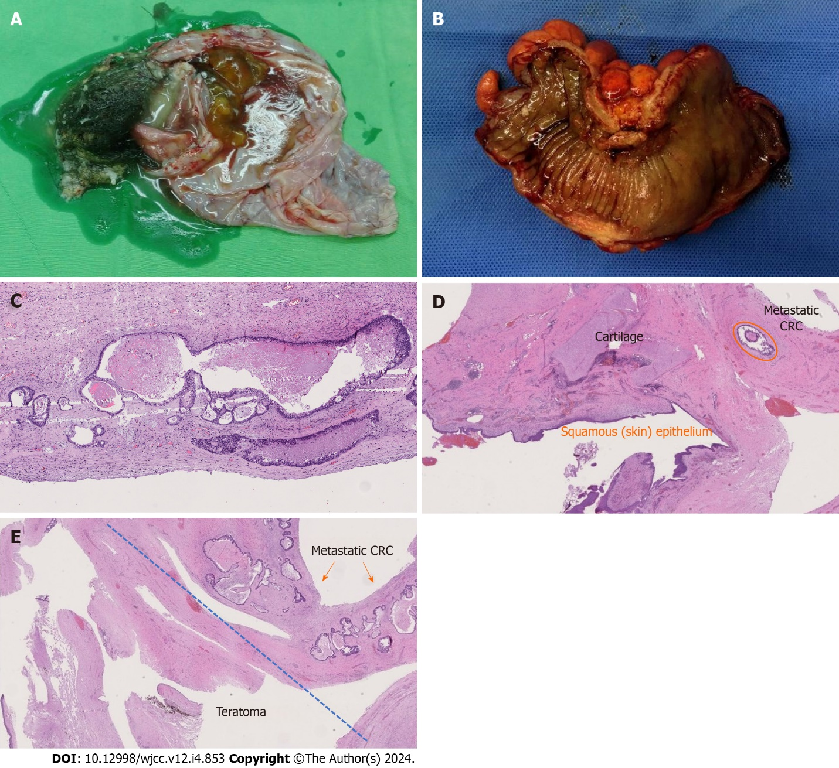
Figure 2 Macroscopic finding and immunohistochemistry test. A: Macroscopic finding of the ovarian mass; B: Gross view of the primary colon tumor; C: Microscopic view of the primary colon adenocarcinoma; D: Focus of metastatic adenocarcinoma was found in the ovarian tumor; E: Higher magnification of the metastatic colon adenocarcinoma in the mature ovarian teratoma.

Published by Baishideng Publishing Group Inc
7041 Koll Center Parkway, Suite 160, Pleasanton, CA 94566, USA
Telephone: +1-925-3991568
E-mail: office@baishideng.com
Help Desk: https://www.f6publishing.com/helpdesk
https://www.wjgnet.com

© 2024 Baishideng Publishing Group Inc. All rights reserved.

