Name of Journal: World Journal of Clinical Cases
Manuscript NO: 77386
Manuscript Type: CASE REPORT

Progressive ataxia of cerebrotendinous xanthomatosis with a rare c.255 + 1G > T splice site mutation: A case report

Chang YY et al. A case report and review of CTX

Yue-Yue Chang, Chuan-Qing Yu, Lei Zhu

Yue-Yue Chang, Chuan-Qing Yu, Lei Zhu, Department of Neurology, The First Affiliated Hospital of Anhui University of Science and Technology, First People’s Hospital of Huainan, Huainan 232007, Anhui Province, China

Author contributions: Chang YY was responsible for the conceptualization, methodology, data curation, and writing - original draft preparation; Yu CQ did the visualization and investigation; Zhu L was responsible for manuscript writing, reviewing, and editing.

Supported by the Key project of Education Department of Anhui Province, No. KJ2019A0096; Huainan science and technology planning project, No. 2016A26(3); and Project Research Fund of Anhui University of Science and Technology, No. fsyyyb2020-03.

Corresponding author: Chuan-Qing Yu, MD, Chief Doctor, Department of Neurology, The First Affiliated Hospital of Anhui University of Science and Technology, First People’s Hospital of Huainan, No. 203 Road, Huainan 232007, Anhui Province, China. yuchuanqing1969@126.com

Received: April 27, 2022
Revised: July 9, 2022
Accepted: September 8, 2022
Published online:

Abstract
BACKGROUND
Cerebrotendinous xanthomatosis is an autosomal recessive disorder of lipid metabolism caused by the mutation of the CYP27A1 gene encoding sterol 27-hydroxylase, an essential enzyme for the conversion of cholesterol to chenodeoxycholic and cholic acids. Cerebrotendinous xanthomatosis is a rare neurological disease with a wide range of clinical symptoms that are easily misdiagnosed.

CASE SUMMARY
Here we report the clinical, biochemical, and molecular characterization of a 33-year-old female patient with cerebrotendinous xanthomatosis. The patient developed ataxia and had the typical symptoms of juvenile cataracts, tendon xanthomata, and progressive nervous system dysfunction. Magnetic resonance imaging of the brain revealed bilateral dentate nucleus lesions and white matter abnormalities. This patient was misdiagnosed for 2 years resulting in severe neurological complications. After 2 years of chenodeoxycholic acid treatment, she still presented with ataxia and dysarthria. The pathogenic sites of CYP27A1 were identified as c.255 + 1G > T and c.1263 + 1G > T, which were both caused by shear denaturation.

CONCLUSION
Cerebrotendinous xanthomatosis requires a multidisciplinary diagnosis that must be made early to avoid progressive neurological degeneration. c.1263 + 1G > T is a known mutation, but c.255 + 1G >T is a rare mutation site.

Key Words: Cerebrotendinous xanthomatosis; CYP27A1 gene; Ataxia; Juvenile cataracts; Tendon xanthoma; Lipid metabolism; Case report

Chang YY, Yu CQ, Zhu L. Progressive ataxia of cerebrotendinous xanthomatosis with a rare c.255 + 1G > T splice site mutation: A case report. World J Clin Cases 2022; In press

Core Tip: This study identified a case of delayed diagnosis of cerebrotendinous xanthomatosis (CTX) that resulted in severe neurological impairment. CTX is caused by CYP27A1 gene mutations, and one rare mutation and one known mutation were identified in our patient. CTX diagnosis must be made early to avoid neurologic injury and worsening. This finding also provides new data for further revealing the pathogenesis of CTX, enriching the pathogenic mutation spectrum of the CYP27A1 gene and molecular diagnosis of the disease, which is of great significance for fertility guidance and prenatal diagnosis of this patient in the future.

INTRODUCTION
Cerebrotendinous xanthomatosis (CTX) is an autosomal recessive disorder of lipid metabolism caused by mutations of the CYP27A1 gene encoding sterol 27-hydroxylase. Sterol 27-hydroxylase is vital to the rate-limiting step in bile acid synthesis, which when deficient results in insufficient production of chenodeoxycholic acid^{[1]}. Therefore, cholesterol accumulates in plasma and precipitates into various lipophilic tissues, such as the brain (with a preference for the cerebellum), eyes, and tendons. This results in the characteristic cataracts and tendon xanthomata. CTX can occur in infants, adolescents, and adults. The clinical symptoms are diverse, with 85% of patients developing bilateral cataracts in childhood, 90% presenting with intelligence lower than other children of the same age, 80% with pyramidal tract abnormalities, 73% with the typical signs of cerebellar ataxia, and about 50% of the patients having seizures. Tendon xanthomata is the most common symptom, present in 90% of patients. Other symptoms include osteoporosis, arterial disease, and early atherosclerosis. The rarest symptoms include Parkinson’s disease and xanthoma of the spine^{[2]}. CTX is easily misdiagnosed as a treatable disease. While patients with early detection show good treatment effects^{[3]}, patients with severely impaired neurological function have poor treatment effects and are prone to sequelae. In this article, we share the clinical misdiagnosis and genotypic manifestations of a CTX patient and report a rare pathogenic mutation site for clinical reference.

CASE PRESENTATION
Chief complaints
The patient, a female with non-consanguineous parents, came to clinical attention at age 33.

History of present illness
She reported having poor stress tolerance, attention deficits, a “weird personality,” and poor learning ability during childhood. When she was 9, she was diagnosed with cataracts in both eyes and subsequently underwent cataract surgery. At the age of 27, she developed symptoms of nervous system damage such as ataxia and episodes of bilateral foot dystonia with falls with no easily observable cause. She had difficulty walking; her walking speed slowed and raising her right leg was laborious, with her right foot dragging on the floor. She needed assistance descending the stairs and easily fell when traversing slopes. She went to the hospital repeatedly but did not receive adequate treatment. Her symptoms progressively intensified, leading to multiple falls. Since the age of 31, she has reported the onset of difficulty in speech without dysphagia.

History of past illness
There was no significant history of past illnesses other than those described.

Personal and family history
There were no known consanguineous marriages in the family.

Physical examination
In a neurological examination at the age of 33, the patient presented with spastic paraparesis, progressive gait ataxia, mild dysarthria, clonic knee reflexes, bilateral Babinski sign, and abnormal proprioception, vibration, and temperature sensation in both feet.

Laboratory examinations
Her laboratory data were as follows: triglyceride, 0.83 mmol/L (normal range: 0-1.7); total cholesterol, 3.92 mmol/L (normal range: 0-5.2); high-density lipoprotein, 2.02 mmol/L (normal range: 1.04-1.90); and low-density lipoprotein, 1.77 mmol/L (normal range: 1.63-3.81).

Imaging examinations
The characteristic magnetic resonance imaging (MRI; 1.5 T) features of CTX (bilateral cerebellar lesions of dentate nuclei) were particularly prominent. On T2 weighted and FLAIR sequences, an MRI of the brain clearly revealed hyperintensity of the dentate nuclei (Figure 1). The CTX index family pedigree is shown in Figure 2. There were no known consanguineous marriages in the family.
The right Achilles tendons had a fusiform expansion with a convex anterior border, and on MRI the ankles appeared isointense to muscle. The axial image revealed low signal intensity patches across the muscle, giving it a distinctive speckled look. (Figure 3). An MRI of the right tendon showed a 56 mm × 16 mm × 21 mm mass in the middle and upper segments of the Achilles tendon. A biopsy of this mass showed mostly foam cells and a few multinucleated giant cells in the fibrous tissue (Figure 4). At the age of 33, she started the chenodeoxycholic acid (CDCA) regimen.

Genetic study
Genetic confirmation of the diagnosis was made, showing two known pathological variants in the CYP27A1 gene: c.255 + 1G > T and c.1263 + 1G > T (Figure 5). The mutation c.1263 + 1G > T has been reported previously, but the pathogenicity of c.255 + 1G > T has rarely been reported. There were clinical features of the c.255 + 1G > T mutation of CTX as reported in the literature (Table 1).

FINAL DIAGNOSIS
CTX.

TREATMENT
At the age of 33, she started the CDCA regimen.

OUTCOME AND FOLLOW-UP
She had been treated with CDCA (750 mg/d) orally for ≥ 2 years but still presented with spastic paraparesis, progressive gait ataxia, mild dysarthria, clonic knee reflexes, and tendon xanthomata.

DISCUSSION
CTX is a rare disease of lipid deposition that characteristically deposits lipids in the tendons, resulting in tendinous xanthomatosis. Typical clinical manifestations of CTX include diarrhea, bilateral cataracts in childhood, progressive neurologic dysfunction, tendon xanthomata, and atherosclerosis in adolescence and early adulthood. There are also some cases where the spinal form has a milder clinical manifestation, presenting primarily with adult-onset paraparesis similar to hereditary spastic paraparesis^{[4]}. Juvenile cataracts occur in up to 90% of patients, and signs of cerebellar dysfunction are the most common features in CTX patients, accounting for about 68%. Childhood diarrhea and juvenile cataracts are the primary non-nervous system manifestations^{[5]}. However, Abdel-Hamid et al^{[6]} reported a case of CTX with tendon xanthomatosis and neurological impairment without obvious cataracts. Brain MRI typically reveals symmetrical lesions in the cerebellar white matter, especially the cerebellum. The classic neurological dysfunction form predominantly displays with cerebellar ataxia, dementia, tendon xanthoma formation, and early-onset peripheral polyneuropathy. In the case of the present patient, juvenile cataracts were present early, followed by progressive xanthoma of the tendon, which progressed to neurological impairment (ataxia). These classic features of xanthomatosis presented without significant childhood diarrhea. A brain MRI showed the characteristic focal lesions appearing as xanthomata in the cerebellum.
The CTX median age at diagnosis is 24.5-years-old^{[7]}. The onset of symptoms for the present patient began at 9-years-old with cataracts, and by the age of 27, she reported symptoms of nervous system damage such as ataxia, with her symptoms progressively worsening. She repeatedly visited doctors but did not receive a clear diagnosis. On May 28, 2019, she was admitted to our department with ataxia and finally diagnosed with CTX at the age of 33 with serious neurological involvement. She had been treated with CDCA (750 mg/d) orally for ≥ 2 year but still presented with spastic paraparesis, progressive gait ataxia, mild dysarthria, clonic knee reflexes, and tendon xanthomata. While CTX can be treated, it is very easy to misdiagnose. Once there is severe nervous system damage, it is likely to leave serious disabilities, affecting the patient’s quality of life.
The CYP27A1 gene contains nine exons and eight introns. Of the 108 variants of CYP27A1 that have been reported, over 50 are considered pathogenic or likely pathogenic according to the Human Gene Mutation Database. Several studies have reported CYP27A1 mutations including nonsense (22%), splice site (20%), and small deletion and insertion (18%) mutations^{[8]}. According to a recent nationwide survey on CTX in Japan, the most frequent mutations in the CYP27A1 gene were c.1214G > A, c.1421G > A, and c.435G > T^{[9]}. In the Chinese population, we found that the most frequent mutations were c.410G > A, c.379C > T, and c.1435C > T. The pathogenic mutations (c.389 T > A and c.571C > T, c.379C > T, c.435G > T, c.1016C > T, c.1214G > A, c.1263 + 1G > A, c.1420C > T, and c.1435C > T) were also identified^{[10]}. The genotype of the patient included c.435 + 1G > T and c.1263 + 1G > T as well as the rare mutation site c.255 + 1G > T.
Mutation c.1263 + 1G > T has been reported previously, but the pathogenicity of c.255 + 1G > T has rarely been reported. Stelten et al^{[11]} reported 4 cases of CTX in a South African family that showed multiple xanthomata on the Achilles tendons. Despite this, their neurological examinations were all normal, their brain MR spectroscopies were unremarkable, and even their ophthalmology evaluations showed no signs of cataracts. However, the diagnosis of CTX was confirmed through genetic analysis, identifying the mutations c.2T > C and c.255 + 1G > A^{[11,12]}. The latter mutation is shared with the current case, suggesting that the same genotype but different clinical manifestations may be caused by different races.

CONCLUSION
Our paper reports a case of delayed CTX diagnosis resulting in severe neurological impairment. The CTX diagnosis was confirmed by detection of CYP27A1 gene mutations, which comprised one rare mutation (c.255 + 1G > T) and one known mutation (c.1263 + 1G > A). CTX requires a multidisciplinary diagnosis and must be made early to avoid progressive neurological impairment.

ACKNOWLEDGEMENTS
We would like to thank the patient for her cooperation.

REFERENCES
1 Cali JJ, Hsieh CL, Francke U, Russell DW. Mutations in the bile acid biosynthetic enzyme sterol 27-hydroxylase underlie cerebrotendinous xanthomatosis. J Biol Chem 1991; 266: 7779-7783 [DOI: 10.1016/s0021-9258(20)89518-0]
2 Duell PB, Salen G, Eichler FS, DeBarber AE, Connor SL, Casaday L, Jayadev S, Kisanuki Y, Lekprasert P, Malloy MJ, Ramdhani RA, Ziajka PE, Quinn JF, Su KG, Geller AS, Diffenderfer MR, Schaefer EJ. Diagnosis, treatment, and clinical outcomes in 43 cases with cerebrotendinous xanthomatosis. J Clin Lipidol 2018; 12: 1169-1178 [PMID: 30017468 DOI: 10.1016/j.jacl.2018.06.008]
3 Islam M, Hoggard N, Hadjivassiliou M. Cerebrotendinous Xanthomatosis: diversity of presentation and refining treatment with chenodeoxycholic acid. Cerebellum Ataxias 2021; 8: 5 [PMID: 33509302 DOI: 10.1186/s40673-021-00128-2]
4 Gelzo M, Di Taranto MD, Bisecco A, D'Amico A, Capuano R, Giacobbe C, Caputo M, Cirillo M, Tedeschi G, Fortunato G, Corso G. A case of Cerebrotendinous Xanthomatosis with spinal cord involvement and without tendon xanthomas: identification of a new mutation of the CYP27A1 gene. Acta Neurol Belg 2021; 121: 561-566 [PMID: 31875301 DOI: 10.1007/s13760-019-01267-4]
5 Chen C, Zhang Y, Wu H, Sun YM, Cai YH, Wu JJ, Wang J, Gong LY, Ding ZT. Clinical and molecular genetic features of cerebrotendinous xanthomatosis patients in Chinese families. Metab Brain Dis 2017; 32: 1609-1618 [PMID: 28623566 DOI: 10.1007/s11011-017-0047-8]
6 Abdel-Hamid MS, Issa MY, Otaify GA, Zaki MS. A novel frameshift mutation in the sterol 27-hydroxylase gene in an Egyptian family with cerebrotendinous xanthomatosis without cataract. Metab Brain Dis 2017; 32: 311-315 [PMID: 28229379 DOI: 10.1007/s11011-017-9971-x]
7 Degos B, Nadjar Y, Amador Mdel M, Lamari F, Sedel F, Roze E, Couvert P, Mochel F. Natural history of cerebrotendinous xanthomatosis: a paediatric disease diagnosed in adulthood. Orphanet J Rare Dis 2016; 11: 41 [PMID: 27084087 DOI: 10.1186/s13023-016-0419-x]
8 Di Taranto MD, Gelzo M, Giacobbe C, Gentile M, Marotta G, Savastano S, Dello Russo A, Fortunato G, Corso G. Cerebrotendinous xanthomatosis, a metabolic disease with different neurological signs: two case reports. Metab Brain Dis 2016; 31: 1185-1188 [PMID: 27225395 DOI: 10.1007/s11011-016-9841-y]
9 Sekijima Y, Koyama S, Yoshinaga T, Koinuma M, Inaba Y. Nationwide survey on cerebrotendinous xanthomatosis in Japan. J Hum Genet 2018; 63: 271-280 [PMID: 29321515 DOI: 10.1038/s10038-017-0389-4]
10 Tao QQ, Zhang Y, Lin HX, Dong HL, Ni W, Wu ZY. Clinical and genetic characteristics of Chinese patients with cerebrotendinous xanthomatosis. Orphanet J Rare Dis 2019; 14: 282 [PMID: 31796091 DOI: 10.1186/s13023-019-1252-9]
11 Stelten BML, Raal FJ, Marais AD, Riksen NP, Roeters van Lennep JE, Duell PB, van der Graaf M, Kluijtmans LAJ, Wevers RA, Verrips A. Cerebrotendinous xanthomatosis without neurological involvement. J Intern Med 2021; 290: 1039-1047 [PMID: 33830582 DOI: 10.1111/joim.13277]
12 Jiang J, Chen G, Wu J, Luan X, Zhou H, Liu X, Zhu Z, Song X, Wang S, Qian X, Du J, Huang X, Zhang M, Xu W, Cao L. c.1263+1G>A Is a Latent Hotspot for CYP27A1 Mutations in Chinese Patients With Cerebrotendinous Xanthomatosis. Front Genet 2020; 11: 682 [PMID: 32714376 DOI: 10.3389/fgene.2020.00682]

Footnotes
Informed consent statement: Written informed consent for publication was obtained from the patient.

Conflict-of-interest statement: All authors report no relevant conflicts of interest for this article.

CARE Checklist (2016) statement: The authors have read the CARE Checklist (2016), and the manuscript was prepared and revised according to the CARE Checklist (2016).

Open-Access: This article is an open-access article that was selected by an in-house editor and fully peer-reviewed by external reviewers. It is distributed in accordance with the Creative Commons Attribution NonCommercial (CC BY-NC 4.0) license, which permits others to distribute, remix, adapt, build upon this work non-commercially, and license their derivative works on different terms, provided the original work is properly cited and the use is non-commercial. See: https://creativecommons.org/Licenses/by-nc/4.0/

Provenance and peer review: Unsolicited article; Externally peer reviewed.
Peer-review model: Single blind

Peer-review started: April 27, 2022
First decision: June 27, 2022
Article in press:

Specialty type: Clinical neurology
Country/Territory of origin: China
Peer-review report’s scientific quality classification
Grade A (Excellent): A
Grade B (Very good): B
Grade C (Good): C, C
Grade D (Fair): 0
Grade E (Poor): 0

P-Reviewer: Alkhatib AJ, Jordan; Alkhatib AJ, Jordan; Pitton Rissardo J, Brazil; Pitton Rissardo J, Brazil S-Editor: Wu YXJ L-Editor: Filipodia P-Editor: Wu YXJ

Figure Legends
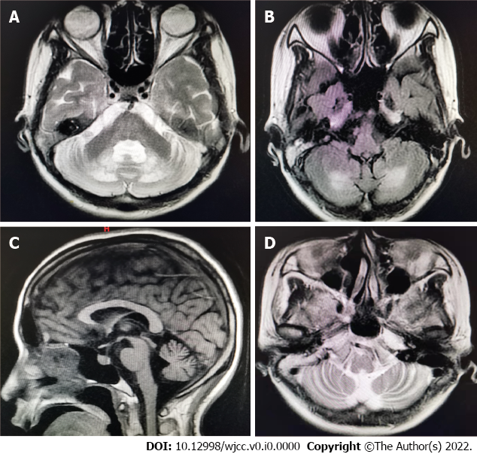
Figure 1 Magnetic resonance imaging results showed prominent bilateral cerebellar lesions of dentate nuclei. A: T2-weighted images; B: FLAIR images; Sagittal T1-weight images and axial T2-weight image sequence showed atrophy of bilateral cerebellar; C: Sagittal T1-weighted images; D: Axial T2-weighted image.

Figure 2 Cerebrotendinous xanthomatosis index family pedigree. Black symbols denote family members affected with cerebrotendinous xanthomatosis.

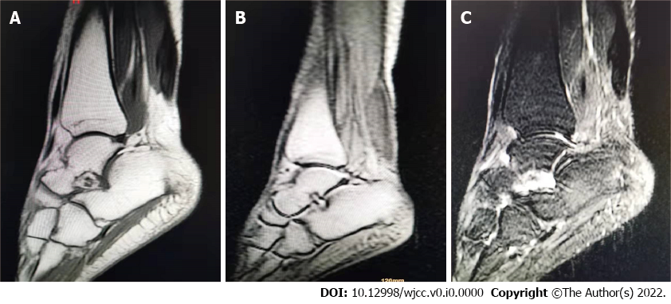
Figure 3 Magnetic resonance imaging results showed xanthoma of the right Achilles tendon. A: Sagittal proton density; B: T1-weighted image; C: T1-fat-saturated-weighted image following contrast agent injection.

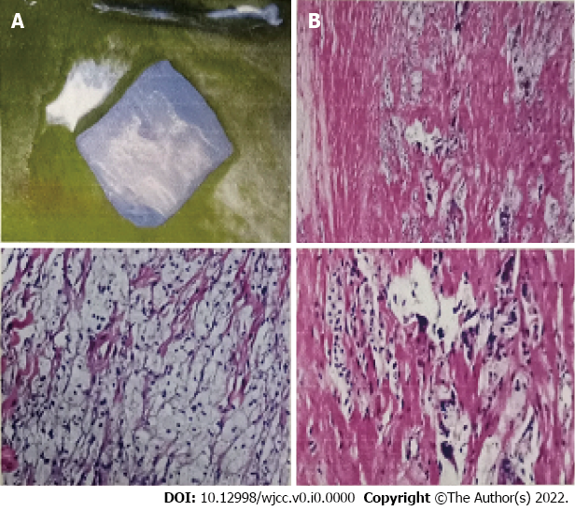
Figure 4 A biopsy of this mass showed mostly foam cells and a few multinucleated giant cells in the fibrous tissue. A: Gross-excisional biopsy specimen from right tendon xanthomas measured 56 mm × 16 mm × 21 mm; B: Histopathology of the tendon mass. Soft tissue microscopic analysis results showed foam cells and a few multinucleated giant cells in the fibrous tissue.

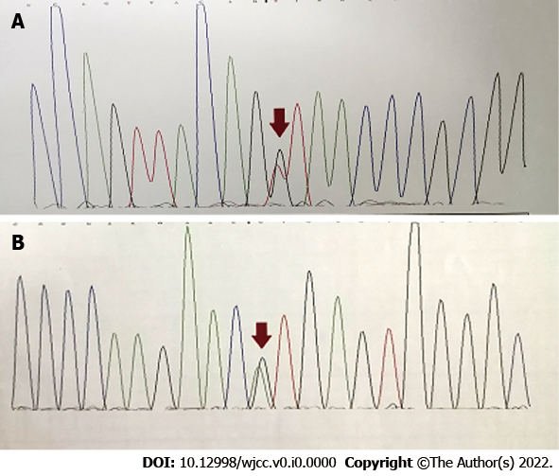
Figure 5 Two pathological variants of CYP27A1 identified in the patient with cerebrotendinous xanthomatosis. A: c.255+1G > T; B: c.1263+1G > T.

Table 1 Clinical features of the c.255 + 1G > T mutation of cerebrotendinous xanthomatosis as reported in the literature
Patients | Patient 1^{[11]} | Patient 2^{[11]} | Patient 3^{[11]} | Patient 4^{[11]} | Patient 5^{[12]} | Patient 6
Country | South Africa | South Africa | South Africa | South Africa | China | China
CYP27A1 mutations | c.2T > C, c.255+1G>A | c.2T > C, c.255+1G>A | c.2T > C, c.255+1G>A | c.2T > C, c.255+1G > A | c.1263 + 1G > A, c.255 + 1G > T | c.1263 + 1G > A, c.255 + 1G > T
Sex | M | F | F | M | F | F
Age at diagnosis in yr | 50 | 47 | 47 | 46 | 34 | 33
Diarrhea | - | - | - | - | - | -
Tendon xanthomata | + | + | + | + | + | +
Cataracts | - | - | - | - | + | +
Neurological symptoms | - | - | - | ₋ | Ataxia, dysarthria, pyramidal signs/spasticity, cognitive impairment | Ataxia, dysarthria, pyramidal signs/spasticity
Psychiatric symptoms | - | Depression + | - | - | + | -
Brain MRI | - | Cerebellar atrophy, involvement of basal ganglia, dentate nuclei | NP | NP | Cerebellar atrophy, involvement of basal ganglia, dentate nuclei | Cerebellar atrophy, involvement of basal ganglia, dentate nuclei
Patients 1-4 are members of one South African family; Patient 5 is from China; Patient 6 is from this report. +: Positive; -: Negative; F: Female; NP: Not performed; M: Male; MRI: Magnetic resonance imaging.

