Name of journal: World Journal of Gastrointestinal Surgery
ESPS Manuscript NO: 5203
Columns: BRIEF ARTICLE

Treatment of perforated giant gastric ulcer in emergency setting

Kumar P et al. Treatment of perforated giant gastric ulcer

Pradeep Kumar, Hosni Mubarak Khan, Safarulla Hasanrabba

Pradeep Kumar, Hosni Mubarak Khan, Department of General Surgery, ESI-PGIMSR and Medical College, Bangalore 560010, Karnataka, India
Safarulla Hasanrabba, Department of General Surgery, Dr.B.R.Ambedkar Medical College, Bangalore 560045, Karnataka, India

Author contributions: Kumar P contributed to concept, research, data, figures and was the operating surgeon and attending consultant; Khan HM was attending doctor and Hasanrabba S contributed to references area.

Correspondence to: Dr. Pradeep Kumar, Assistant Professor, Department of General Surgery, ESI-PGIMSR and Medical College, Rajajinagar, Bangalore 560010, Karnataka, India. dr.pradeep_k20@yahoo.com
Telephone: +91-990-2349960

Received: August 21, 2013 Revised: November 13, 2013
Accepted: November 18, 2013

Published online:
Abstract
AIM: To study and assess clinical outcomes of various modes of treatment for perforated giant gastric ulcer in emergency setting.

METHODS: From May 2010 to February 2013, 20 cases of perforated giant gastric ulcer (> 2 cm) were operated in emergency setting. All patients presented with features of peritonitis and were resuscitated aggressively before taking for surgery. In the first 4 cases, primary closure was done after taking biopsy, among these 3rd case also underwent partial distal gastrectomy and gastrojejunostomy and 4th case underwent a radical subtotal gastrectomy with D2 lymphadenectomy and gastrojejunostomy for malignancy. All remaining 16 cases underwent partial distal gastrectomy and gastrojejunostomy.

RESULTS: Among first 4 cases, 2 had uneventful recovery and discharged on 6th post-op day. The 3rd and 4th patients developed gastric fistula leading to prolonged hospitalization. For 3rd patient, conservative management was tried for 1 week followed by partial distal gastrectomy and gastro-jejunostomy and discharged on 20th day after admission while the 4th patient underwent a radical subtotal gastrectomy with D2 lymphadenectomy and gastrojejunostomy. Postoperatively, he developed ARDS, MODS and expired on 3rd post –op day of second surgery. All the remaining 16 underwent partial distal gastrectomy and gastro-jejunostomy and recovered well. Among these, 4 of them were malignant and remaining were benign ulcer. All had uneventful recovery. The percentage of malignancy in our series was 30% (6 out of 20cases). In our study 86% had uneventful recovery, complications were seen in about 10% and mortality was about 5%.

CONCLUSION: In giant gastric ulcer, the chances of malignancy and leak after primary closure are high. So we feel partial distal gastrectomy and gastro-jejunostomy is better.

© 2013 Baishideng Publishing Group Co., Limited. All rights reserved.

Key words: Giant; Gastric; Ulcer; Primary closure; Partial gastrectomy; Biopsy

Core tip: Giant gastric ulcer is considered more prone for perforation because of large size and more likely to be malignant. Delay in seeking surgical care is to be discouraged because of the poor response to medical management. We have shown that with prompt treatment for perforated gastric ulcer, nearly 86% had uneventful recovery, complications were seen in about 10% and mortality was about 5%. Furthermore the chances of malignancy and leak after primary closure of giant gastric ulcer is high, so we feel Partial distal gastrectomy and gastrojejunostomy is better option even in emergency setting if expertise is available.

Kumar P, Khan HM, Hasanrabba S. Treatment of perforated giant gastric ulcer in emergency setting.

Available from: URL:
DOI:

INTRODUCTION
Giant gastric ulcer is defined as ulcer greater than 2 cm in diameter^{[1]}. It is usually found along lesser curvature at incisura angularis. It is considered more prone for perforation because of large size^{[2]} and more likely to be malignant especially when associated with scalloped margins and loss of rugal folds around ulcer. These ulcers were traditionally treated by primary closure after taking biopsy as it was presumed that patients would not tolerate gastrectomy in emergency setting as the time taken is more and prolonged anaesthesia is contraindicated in compromised patients. In this paper, we have compared primary closure with partial gastrectomy and gastrojejunostomy for perforated giant gastric ulcer in emergency setting.

MATERIALS AND METHODS
From May 2010 to February 2013, we operated on 20 cases (Table 1) of perforated giant gastric ulcer (> 2 cm, Figure 1A) in emergency setting. All patients were > 45 years of age (Table 2), 15 males and 5 females. All patients presented with features of peritonitis with diffuse tenderness and abdominal guarding. Vitals: All patients had tachycardia and 2 had hypotension. There were no significant abnormality of respiratory system. Plain X-ray of erect abdomen revealed gas under diaphragm. All patients had past history of several episodes of pain in upper part of abdomen and were taking proton pump inhibitors. Except for leucocytosis with raised neutrophils, routine blood tests were normal. The renal parameters were slightly elevated.
All patients were resuscitated aggressively with crystalloids till the urine output was atleast 30 mL per hour before taking for surgery. In the first 4 cases we performed primary closure after taking biopsy as we thought that patients would not tolerate gastrectomy in emergency setting as the time taken is more and prolonged anaesthesia is contraindicated in compromised patients. The 3rd and 4th patients developed gastric fistula leading to prolonged hospitalization.
In the 5th patient when we opened the abdomen, we strongly suspected malignant ulcer as margins were scalloped and loss of rugal folds around ulcer and enlarged lymph nodes. Due to bad experience of previous patient, we decided to do a Partial distal gastrectomy and gastrojejunostomy (Figure 1B). The patient recovered well, the biopsy report came as adenocarcinoma and was given chemotherapy post surgery.
Postprocedural management: The 3rd and 4th patients developed gastric fistula leading to prolonged hospitalization.
For 3rd patient, conservative management was tried for 1 wk followed by partial distal gastrectomy and gastrojejunostomy when the oral feeds continued to come through drain. He was discharged on 20th day after admission.
The 4th patient underwent a radical subtotal gastrectomy with D2 lymphadenectomy and gastrojejunostomy on 4th post-op day when biopsy report came as malignant ulcer. Postoperatively, he did not come out of anaesthesia, was on ventilator, later also developed ARDS, MODS and expired on 3rd post –op day after second surgery.
After this we have done Partial distal gastrectomy and gastrojejunostomy for 15 more patients, 4 of them were malignant and remaining were benign ulcer and all had uneventful recovery. The malignant cases (6 out of 20) were also given post-op chemotherapy.
Uneventful recovery was used to assess clinical outcome in our study.

RESULTS
Among first 4 cases, 2 had uneventful recovery and discharged on 6th post-op day (Table 1). The 3rd and 4th patients developed gastric fistula leading to prolonged hospitalization. For 3rd patient, conservative management was tried for 1 wk followed by partial distal gastrectomy and gastro-jejunostomy and discharged on 20th day after admission while the 4th patient underwent a radical subtotal gastrectomy with D2 lymphadenectomy and gastrojejunostomy (Table 3). Postoperatively, he developed ARDS, MODS and expired on 3rd post –op day of second surgery.
All the remaining 16 underwent partial distal gastrectomy and gastro-jejunostomy and recovered well. Among these, 4 of them were malignant and remaining were benign ulcer. All had uneventful recovery (Table 4).
The percentage of malignancy in our series was 30% (6 out of 20 cases).
In our study 86% had uneventful recovery, complications were seen in about 10% and mortality was about 5%.

DISCUSSION
Giant gastric ulcer is defined as ulcer greater than 2 cm in diameter. It is usually found a long lesser curvature at incisura angularis^{[1,2]}. It is considered more prone for perforation because of large size and more likely to be malignant^{[3-5]} especially when associated with scalloped margins and loss of rugal folds around ulcer. Most giant ulcers occur beyond the middle span of life, (All our patients were > 45 years of age). Indeed, the long history of most of these patients requires that they no longer be in the young age group. The preponderance of males is in agreement with the usual sex distribution of gastric ulcer disease. About half the ulcers were in the antrum and half in the body. The frequency of massive bleeding and perforation indicates that giant ulcers are not immune to the usual complications of gastric ulcer disease.
The concept that giant gastric ulcers are most often benign presents the patient with an altered prognosis, and makes even more important an aggressive surgical attitude toward such a lesion. Delay in seeking surgical care is to be discouraged because of the poor response to medical management^{[6]}.
Undue delay in exploration is no longer justified in a giant ulcer simply because of fear that an inoperable carcinoma will be found. On the contrary, all such patients should be subjected to exploration as soon as possible with the expectation that beneficial results may be obtained in a large percentage of these patients^{[7,8]}.
We have shown that with prompt treatment, nearly 86% had uneventful recovery, complications were seen in about 10% and mortality was about 5%. Furthermore the chances of malignancy and leak after primary closure of giant gastric ulcer is high, so we feel Partial distal gastrectomy and gastrojejunostomy is better option even in emergency setting if expertise is available.
In a conclusion, the chances of malignancy and leak after primary closure of giant gastric ulcer is high, so we feel Partial distal gastrectomy and gastrojejunostomy is better option even in emergency setting if expertise is available.

ACKNOWLEDGMENTS
Written informed consent was obtained from the patients for publication of this case series and accompanying images. A copy of the written consent is available for review by the Editor-in-Chief of this journal on request.

COMMENTS
Background
Giant gastric ulcer is considered more prone for perforation because of large size and more likely to be malignant. Delay in seeking surgical care is to be discouraged because of the poor response to medical management. Undue delay in exploration is no longer justified in a giant ulcer simply because of fear that an inoperable carcinoma will be found. On the contrary, all such patients should be subjected to exploration as soon as possible with the expectation that beneficial results may be obtained in a large percentage of these patients.

Research frontiers
These ulcers were traditionally treated by primary closure after taking biopsy as it was presumed that patients would not tolerate gastrectomy in emergency setting as the time taken is more and prolonged anaesthesia is contraindicated in compromised patients. In this paper, authors’ have compared primary closure with partial gastrectomy and gastrojejunostomy for perforated giant gastric ulcer in emergency setting.

Innovations and breakthroughs
With modern ICU care, anesthesia and minimal access surgery, partial gastrectomy and gastrojejunostomy for perforated giant gastric ulcer in emergency setting is a viable option.

Applications
The study results suggest that the chances of malignancy and leak after primary closure of giant gastric ulcer is high, so authors’ feel Partial distal gastrectomy and gastrojejunostomy is better option even in emergency setting if expertise is available. In our study after this surgery nearly 86% had uneventful recovery, complications were seen in about 10% and mortality was about 5%.

Terminology
Giant gastric ulcer is defined as ulcer greater than 2 cm in diameter. It is usually found a long lesser curvature at incisura angularis. It is considered more prone for perforation because of large size and more likely to be malignant. Emergency closure of perforation is essential as otherwise the acidic contents of stomach will enter peritoneal cavity and cause peritonitis which is a life threatening condition. Primary Closure means simply closing the ulcer with sutures (stitches). Partial distal gastrectomy and gastrojejunostomy means removal of part of stomach along with ulcer and joining it to small intestine (jejunum) to maintain continuity of gastrointestinal tract.

Peer review
The study is interesting, the aim of this study is to assess the clinical outcomes of various treatment for perforated giant gastric ulcer in emergency setting.

REFERENCES
1 Lulu DJ. Benign giant gastric ulcer. Am Surg 1971; 37: 357-362 [PMID: 5578526]
2 COHN I, SARTIN J. Giant gastric ulcers. Ann Surg 1958; 147: 749-58; discussion 758-9 [PMID: 13521694 DOI: 10.1097/00000658-195805000-00020]
3 FERRIS DO. Gastric cancer. J La State Med Soc 1953; 105: 211-216 [PMID: 13053058]
4 Lumsden K. The problem of the giant gastric ulcer. Gastroenterologia 1950; 76: 89-93 [PMID: 14813383 DOI: 10.1159/000199136]
5 Smith FH, Boles RS, Jordan SM. Problem of the gastric ulcer reviewed: study of one thousand cases. J Am Med Assoc 1953; 153: 1505-1508 [PMID: 13108635 DOI: 10.1001/jama.1953.02940340007003]
6 Haddad W, Kestenbaum DJ, Wang HS. Effect of cimetidine on healing and surgical treatment of gastric ulcers. Am J Surg 1985; 149: 665-667 [PMID: 3993850 DOI: 10.1016/S0002-9610(85)80151-3]
7 Kukral JC. Gastric ulcer: an appraisal. Surgery 1968; 63: 1024-1036 [PMID: 4871797]
8 Zollinger RM, Watman RN, Denkewalter F. Should all gastric ulcers be treated surgically. Gastroenterology 1958; 35: 521-527 [PMID: 13598043]

P-Reviewers: Xu HM, Zhang BB S-Editor: Wen LL L-Editor: E-Editor:

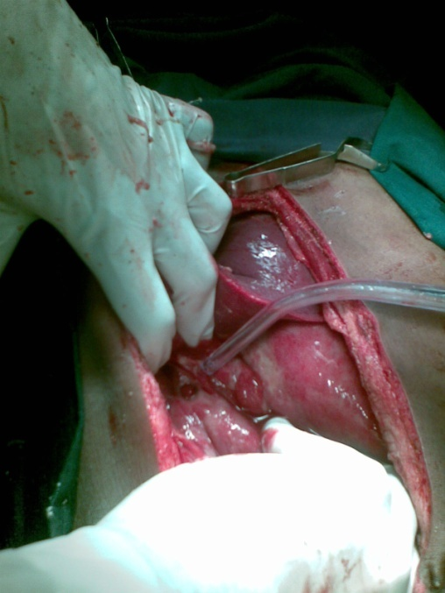
A
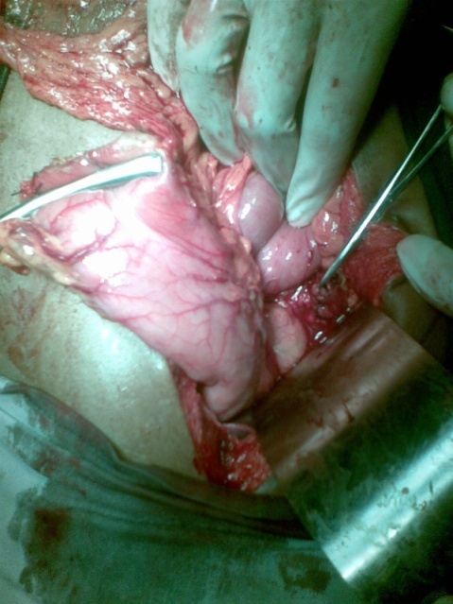
B
Figure 1 Photograph. A Perforated giant gastric ulcer; B: Stomach mobilized and divided at pyloroduodenal junction and duodenal stump closed by sutures.

Table 1 Patient characteristics
Serial No. | Age, yr | Sex | Procedure undergone | Nature of gastric ulcer | recovery | Discharge day post-operatively
1 | 47 | Male | PC | BENIGN | U | 6
2 | 54 | Male | PC | BENIGN | U | 6
3 | 52 | Male | PC+DG+GJ | BENIGN | GF | 17
4 | 77 | Male | PC+SG+GJ+D₂ | MALIGNANT | GF+ARDS+MODS+M | -
5 | 63 | Male | DG+GJ | MALIGNANT | U | 6
6 | 74 | Female | DG+GJ | BENIGN | U | 6
7 | 79 | Female | DG+GJ | BENIGN | U | 6
8 | 57 | Male | DG+GJ | BENIGN | U | 6
9 | 53 | Male | DG+GJ | MALIGNANT | U | 8
10 | 46 | Male | DG+GJ | BENIGN | U
11 | 72 | Male | DG+GJ | MALIGNANT | U | 8
12 | 49 | Female | DG+GJ | BENIGN | U | 6
13 | 67 | Male | DG+GJ | BENIGN | U | 6
14 | 56 | Male | DG+GJ | BENIGN | U | 7
15 | 68 | Female | DG+GJ | MALIGNANT | U | 8
16 | 63 | Male | DG+GJ | BENIGN | U | 9
17 | 61 | Male | DG+GJ | MALIGNANT | U | 7
18 | 56 | Female | DG+GJ | BENIGN | U | 9
19 | 49 | Male | DG+GJ | BENIGN | U | 7
20 | 66 | Male | DG+GJ | BENIGN | U | 6
PC: Primary closure; DG: Distal gastrectomy; GJ: Gastrojejunostomy; SG: Subtotal gastrectomy; D₂: D2 lymph node dissection for ca stomach; U: Uneventful recovery; GF: Gastric fistula; ARDS: Adult respiratory distress syndrome; M: Mortality; MOD: Multiorgan dysfunction syndrome.

Table 2 Distribution of patients according to age of the patients n (%)
Age group | Number of patients | Mean age = 63 yr
41-50 | 4 (20)
51-60 | 6 (30)
61-70 | 6 (30)
71-80 | 4 (20)
Total | 20

Table 3 Distribution of patients according to the type of surgery n (%)

Type of surgery | Number of patients
PC | 4 (18.2)
DG+GJ | 17 (77.3)
SG+GJ+D₂ | 1 (4.5)
Total | 22
PC: Primary closure; DG: Distal gastrectomy; GJ: Gastrojejunostomy; SG: Subtotal gastrectomy; D₂: D2 lymph node dissection for ca stomach.

Table 4 Distribution of patients according to recovery n (%)
Type of patient compliance | Number of patients
Uneventful recovery | 18 (85.72)
Complications | 2 (9.52)
Mortality | 1 (4.76)
Total | 21

