Name of Journal: World Journal of Clinical Cases
Manuscript NO: 45583
Manuscript Type: CASE REPORT

Laparoscopic appendectomy for elemental mercury sequestration in the appendix: A case report

Norčič G et al. Appendectomy due to mercury sequestration

Gregor Norčič, Žan Čebron, Primož Sever, Jan Grosek, Aleš Tomažič

Gregor Norčič, Žan Čebron, Primož Sever, Jan Grosek, Aleš Tomažič, Department of Abdominal Surgery, University Medical Centre Ljubljana, Ljubljana SI-1000, Slovenia

ORCID number: Gregor Norčič (0000-0002-8861-3412); Žan Čebron (0000-0003-1896-7167); Primož Sever (0000-0002-3449-6759); Jan Grosek (0000-0001-9832-4596); Aleš Tomažič (0000-0002-1063-8636).

Author contributions: Norčič G contributed to study conception and design; Čebron Ž contributed to collection of data, analysis and interpretation of data; Grosek J and Sever P contributed to drafting of manuscript; Tomažič A contributed to critical revision; all authors issued final approval for the version to be submitted.

Informed consent statement: Written informed consent was obtained from the patient before the surgery for publication of this case report and accompanying images.

Conflict-of-interest statement: The authors declare no conflict of interests with regard to this case report.

CARE Checklist (2016) statement: The authors have read the CARE Checklist (2016), and the manuscript was prepared and revised according to the CARE Checklist (2016).

Open-Access: This article is an open-access article which was selected by an in-house editor and fully peer-reviewed by external reviewers. It is distributed in accordance with the Creative Commons Attribution Non Commercial (CC BY-NC 4.0) license, which permits others to distribute, remix, adapt, build upon this work non-commercially, and license their derivative works on different terms, provided the original work is properly cited and the use is non-commercial. See: http://creativecommons.org/licenses/by-nc/4.0/

Manuscript source: Unsolicited manuscript

Corresponding author: Gregor Norčič, MD, PhD, Surgeon, Consultant, Department of Abdominal Surgery, University Medical Centre Ljubljana, Zaloska 7, Ljubljana SI-1000, Slovenia. gregor.norcic@kclj.si
Telephone: +386-15-224788
Fax: +386-15-224788

Received: January 8, 2019
Peer-review started: January 8, 2019
First decision: January 26, 2019
Revised: February 1, 2019
Accepted: February 18, 2019
Article in press:
Published online:

Abstract
BACKGROUND
Despite negligible absorption of elemental mercury after acute ingestion, retention in the appendix with subsequent local and systemic complications is possible. We present a case of elemental mercury sequestration in the appendix, managed by laparoscopic appendectomy.

CASE SUMMARY
A 57-year-old Caucasian female was found unconscious following application of long-lasting insulin detemir and ingestion of elemental mercury in a suicidal attempt. Diagnostic investigations revealed several radiopaque collections in the gastrointestinal (GI) tract and elevated mercury levels in the blood. Much of the ingested elemental mercury was eliminated from the GI tract with stools stimulated by several enemas. However, a significant amount of mercury remained sequestrated in the appendix despite all conservative measures. Consequently, following deliberations by an interdisciplinary team of specialists, laparoscopic appendectomy was performed 29 d after the mercury ingestion. The surgery itself and postoperative course were uneventful.

CONCLUSION
Since conservative measures are often unsuccessful in the management of mercury retention in the appendix, surgery remains a compelling option to prevent possible associated complications.

Key words: Mercury poisoning; Appendix; Mercury ingestion; Mercury retention; Appendectomy; Case report

© The Author(s) 2019. Published by Baishideng Publishing Group Inc. All rights reserved.

Core tip: Despite negligible absorption of elemental mercury after acute ingestion, retention in the appendix with subsequent local and systemic complications is possible. The question of whether or not to perform appendectomy in an asymptomatic patient remains open. We present a case of elemental mercury sequestration in the appendix, managed by laparoscopic appendectomy in order to prevent possible complications. Given the limited evidence regarding the optimal management approach for patients with retained mercury, the choice of treatment strategy should be determined on a case-by-case basis by a multidisciplinary team.

Norčič G, Čebron Ž, Sever P, Grosek J, Tomažič A. Laparoscopic appendectomy for elemental mercury sequestration in the appendix: A case report. World J Clin Cases 2019; In press

INTRODUCTION
Mercury is a heavy metal which compounds occur in different chemical dispositions including elemental, inorganic and organic forms^{[1,2]}. Its human toxicity is well-established and varies with the form of mercury, the dose and the type of exposure^{[1]}. Acute ingestion of elemental mercury is considered non-toxic due to the negligible absorption by intact gastrointestinal (GI) mucosa (oral bioavailability of 0.04%)^{[3]}. However, after ingestion of even small amounts of elemental mercury, sequestration in the appendix is possible and subsequent local complications can occur^{[3,4]}. Due to limited data in the literature the optimal management of patients is still not clear.
In the present report, we describe the clinical presentation, management, and outcome of mercury sequestration in appendix following elemental mercury ingestion in a suicidal attempt. The management approach is discussed in the context of available literature.

CASE PRESENTATION
Chief complaints
A 57-year-old Caucasian female was found unconscious near her house by her brother several hours after application of approximately 4 pens of long-lasting insulin detemir and ingestion of elemental mercury in a suicidal attempt.

History of present illness
Besides being treated for depression she had already threatened to commit suicide before.

History of past illness
Background medical history was remarkable for depression, type 2 diabetes, arterial hypertension and dyslipidemia. She had also undergone two previous abdominal surgical procedures – bariatric gastric by-pass operation and GI cyst removal.

Physical examination upon admission
The patient was noted to be unconscious (GCS 6) by the paramedics, with respiratory rate of 12/min, heart rate of 89/min, blood pressure of 162/72 mmHg and unmeasurable pO₂ saturation in peripheral blood. She was brought to hospital in severe hypothermia with body core temperature of only 28.4 °C.

Laboratory examinations
The laboratory blood tests were performed showing elevation of mercury levels in the blood (elemental blood mercury being 136.10 μg/L; normal value is up to 5 μg/L).

Imaging examinations
X-ray of abdomen was performed and showed several radiopaque foreign bodies, mostly in GI tract (Figure 1).

FINAL DIAGNOSIS
Intentional self-poisoning, elemental mercury ingestion, foreign bodies in GI tract with retention in appendix, insulin poisoning, hypoglycemia, depression, suicidal attempt.

TREATMENT
After admission to ICU in general hospital, a gastric lavage was performed and osmotic laxatives (Moviprep®) were administered. Due to discovered elemental mercury ingestion and subsequent elevation of blood mercury levels the patient was transferred to the National Center for Clinical Toxicology and Pharmacology for potential treatment with chelating agents. Treatment with metal-chelating agent dimercaprol (200 mg every 4 h) was commenced and administered for 8 d. The expected rise of mercury in urine and fall of mercury in blood occurred (elemental mercury in urine was 52.12 μg/L and in blood 81.53 μg/L).
In the meantime, the majority of the ingested elemental mercury had been already eliminated from the GI tract with stools stimulated by several enemas (Figure 2). However, a certain amount of elemental mercury was still sequestrated in the appendix despite all conservative measures.
Due to the risk of developing appendicitis and possible continuous absorption of sequestrated elemental mercury with its potential toxic effects, the decision to perform appendectomy was made by an interdisciplinary team of specialists. Laparoscopic appendectomy was subsequently performed 29 d after elemental mercury ingestion, with special care taken to avoid intraperitoneal spillage of mercury during the procedure. At the end of the surgical procedure, an intraoperative x-ray of the abdomen was performed to exclude any elemental mercury retained at the stapler line. Following removal of the appendix, dissection of the specimen was performed, revealing a copious collection of elemental mercury inside its lumen (Figure 3). Histopathology report described a 6 cm long appendix with mild chronic and focally purulent appendicitis with elemental mercury in its lumen. The surgery itself and postoperative course were uneventful. The patient was discharged home three days after the operation.

OUTCOME AND FOLLOW-UP
The surgery itself and postoperative course were uneventful. The patient was discharged home three days after the operation.

DISCUSSION
We report a case of elemental mercury ingestion in a suicidal attempt with subsequent retention of mercury in the appendix. In order to prevent complications from the retained mercury, laparoscopic appendectomy was performed. Histopathology report of the removed appendix described a mild chronic and focally purulent appendicitis approximately 1 mo after the mercury ingestion.
In a recently published paper by Michielan et al^{[3]}, a review of similar case reports was performed. Including their own case, they found only 10 described cases of elemental mercury sequestration in the appendix after oral ingestion. The clinical consequences of oral ingestion of mercury are largely unknown since the vast majority of systemic toxicity is associated with the inhalation route^{[4]}. Acute ingestion of elemental mercury is even considered non-toxic due to negligible absorption by intact GI mucosa (oral bioavailability of 0.04%)^{[3]} Furthermore, most foreign bodies that enter the GI tract are eliminated in four to six days^{[5]}. However, due to the vertical anatomy at the coecal region, foreign bodies heavier than other bowel contents are capable of entering the lumen of the appendix (elemental mercury for instance) where the peristalsis is insufficient to push it back into the GI tract^{[4–6]}.
Despite oral bioavailability of elemental mercury being close to nil, there are still several reasons to justify the measures for removal of mercury sequestrated in the appendix. The first is the possible interaction of mercury with gut bacteria which might lead to the conversion of elemental mercury into organic mercury compounds^{[7]}. Unlike elemental mercury, the bioavailability of organic mercury compounds is high via the GI route as they can be absorbed almost completely^{[8,9]} with subsequent systemic toxicity. The second reason to consider is possible local complications such as development of acute appendicitis with consequent perforation and spillage of mercury into the abdominal cavity. To date, there are only two case reports describing acute inflammation of the appendix due to elemental mercury retention, with both papers published over 50 years ago^{[10,11]}. To the best of our knowledge, the index case report is the third describing appendicitis consequent on retained elemental mercury.
Different conservative and surgical approaches of management of elemental mercury sequestrated in appendix have been reported in the literature. In general, conservatives measures such as whole bowel irrigation and endoscopic irrigation are recommended as first line of treatment^{[3]}. Besides irrigation methods, the Trendelenburg position (30°) combined with left lateral decubitus position has also been reported to be successful in one patient^{[12]}; although this approach failed to remove the mercury from the appendix in other patients^{[3]}. Moreover, one report also described a complete spontaneous elimination of appendiceal mercury within 7 mo without any associated complication^{[13]}. We believe that the effectiveness of the conservative methods may be significantly influenced by the variations in the anatomy and location of the appendix. Meanwhile, since conservative measures are often unsuccessful, surgery remains a compelling option to prevent possible associated complications of retained mercury in the appendix.
Nevertheless, the question of whether or not to perform appendectomy in an asymptomatic patient remains open^{[3]}, since surgery itself bears risks of potential complications. Remarkable in this regard is the potential perforation of the appendix during the procedure and spillage of elemental mercury into the peritoneal cavity causing life-threatening peritonitis. However, in the hands of the experienced surgeon, the rate of complications of laparoscopic appendectomy is very low.
Given the paucity of evidence regarding the optimal treatment of patients with retained ingested mercury, it is prudent to recommend that the choice of treatment strategy should be determined on a case-by-case basis by a multidisciplinary team (MDT) including toxicologists, gastroenterologists and abdominal surgeons^{[3]}. Based on the presumed amount of retained mercury and the patient’s overall clinical circumstances, the MDT should carefully weigh the potential complications of retained mercury against the potential risks and benefits of surgical intervention for each patient.

CONCLUSION
Since conservative measures are often unsuccessful for elemental mercury sequestration in appendix, surgery seems feasible and safe option. Given the limited evidence the choice of treatment should be determined on a case-by-case basis by a MDT. More case reports are needed to determine optimal treatment strategy.

ACKNOWLEDGEMENTS
The authors would like to acknowledge Dr. Ugwoke, Chiedozie Kenneth for the proofreading of the final manuscript.

REFERENCES
1 Bernhoft RA. Mercury toxicity and treatment: a review of the literature. J Environ Public Health 2012; 2012: 460508 [PMID: 22235210 DOI: 10.1155/2012/460508]
2 Rafati-Rahimzadeh M, Rafati-Rahimzadeh M, Kazemi S, Moghadamnia AA. Current approaches of the management of mercury poisoning: need of the hour. Daru 2014; 22: 46 [PMID: 24888360 DOI: 10.1186/2008-2231-22-46]
3 Michielan A, Schicchi A, Cappuccio R, Lonati D, Lamboglia F, Vitalba A, Caroli A, Crevani M, Locatelli CA, Betetto G. Intentional ingestion of elemental mercury requiring multi-step decontamination and prophylactic appendectomy: a case report and treatment proposal. Clin Toxicol (Phila) 2018; 56: 69-73 [PMID: 28650684 DOI: 10.1080/15563650.2017.1338346]
4 Caravati EM, Erdman AR, Christianson G, Nelson LS, Woolf AD, Booze LL, Cobaugh DJ, Chyka PA, Scharman EJ, Manoguerra AS, Troutman WG; American Association of Poison Control Centers. Elemental mercury exposure: an evidence-based consensus guideline for out-of-hospital management. Clin Toxicol (Phila) 2008; 46: 1-21 [PMID: 18167033 DOI: 10.1080/15563650701664731]
5 Kim JH, Lee DS, Kim KM. Acute appendicitis caused by foreign body ingestion. Ann Surg Treat Res 2015; 89: 158-161 [PMID: 26366386 DOI: 10.4174/astr.2015.89.3.158]
6 Klingler PJ, Seelig MH, DeVault KR, Wetscher GJ, Floch NR, Branton SA, Hinder RA. Ingested foreign bodies within the appendix: A 100-year review of the literature. Dig Dis 1998; 16: 308-314 [PMID: 9892790 DOI: 10.1159/000016880]
7 Poulden M. Mercury: is it elemental my dear Watson? Emerg Med J 2002; 19: 82-83 [PMID: 11777890 DOI: 10.1136/emj.19.1.82]
8 Bradley MA, Barst BD, Basu N. A Review of Mercury Bioavailability in Humans and Fish. Int J Environ Res Public Health 2017; 14: pii: E169 [PMID: 28208586 DOI: 10.3390/ijerph14020169]
9 Hong YS, Kim YM, Lee KE. Methylmercury exposure and health effects. J Prev Med Public Health 2012; 45: 353-363 [PMID: 23230465 DOI: 10.3961/jpmph.2012.45.6.353]
10 Crikelair GF, Hiratzka T. Intraperitoneal mercury granuloma. Ann Surg 1953; 137: 272-275 [PMID: 13017531 DOI: 10.1097/00000658-195302000-00022]
11 Birnbaum W. Inflammation of the vermiform appendix by metallic mercury. Am J Surg 1947; 74: 494-496 [PMID: 20266035 DOI: 10.1016/0002-9610(47)90148-7]
12 Bazoukis G, Papadatos SS, Michelongona P, Fragkou A, Yalouris A. Assessment and management of elemental mercury poisoning-a case report. Clin Case Rep 2017; 5: 126-129 [PMID: 28174636 DOI: 10.1002/ccr3.811]
13 Rusyniak DE, Nanagas KA. Conservative management of elemental mercury retained in the appendix. Clin Toxicol (Phila) 2008; 46: 831-833 [PMID: 18608269 DOI: 10.1080/15563650701846288]

P-Reviewer: Cerwenka H, Chiu KW, Contini S, Imaeda H, Thomopoulos K S-Editor: Ji FF L-Editor: E-Editor:

Specialty type: Medicine, research and experimental
Country of origin: Slovenia
Peer-review report classification
Grade A (Excellent): 0
Grade B (Very good): 0
Grade C (Good): C, C, C, C, C
Grade D (Fair): 0
Grade E (Poor): 0

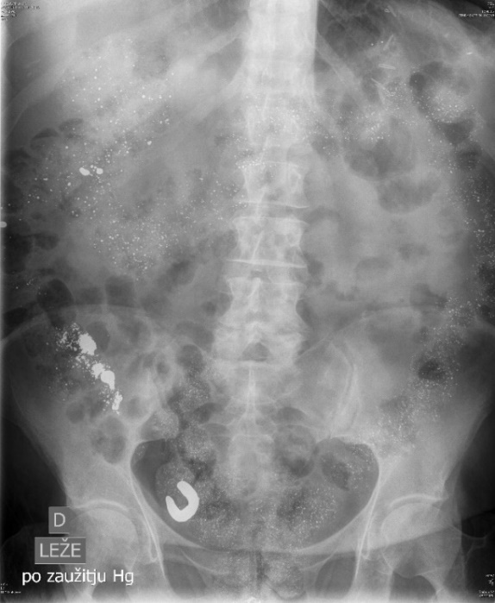
Figure 1 Abdominal X-ray 16 d after the elemental mercury ingestion showing a lot of radiopaque particles along gastrointestinal tract, mostly in colon with obvious sequestration in the appendix.

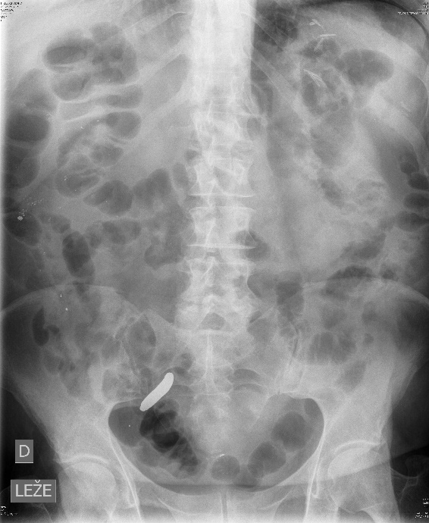
Figure 2 X-ray of the abdomen after several enemas showing almost no remnant of elemental mercury in gastrointestinal tract except sequestration of mercury in the appendix.

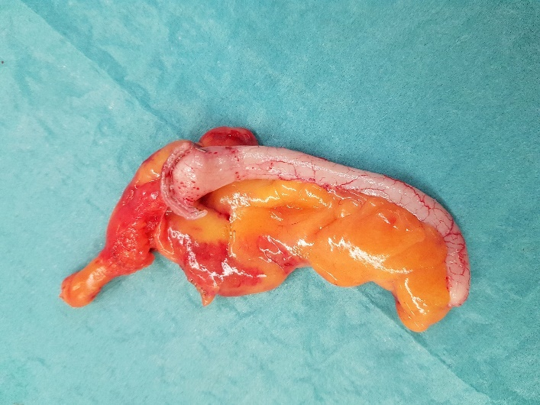  A | 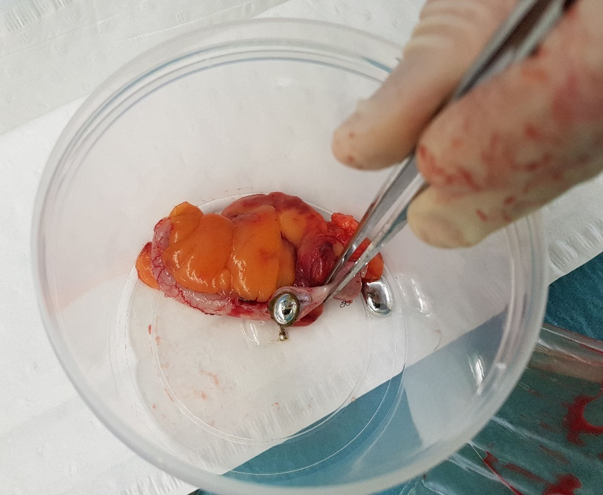  B
Figure 3 Specimen of the appendix after laparoscopic appendectomy. A: Intact specimen; B: After the incision elemental mercury showed and spilled out of the lumen of the appendix.

