Name of Journal: World Journal of Clinical Cases
Manuscript NO: 85220
Manuscript Type: CASE REPORT

Systematic review of fibroblastic rheumatism: A case report

Guo H et al. Fibroblastic rheumatism

Hua Guo, Qian Liang, Chen Dong, Qing Zhang, Zhi-Feng Gu

Hua Guo, Qian Liang, Chen Dong, Zhi-Feng Gu, Department of Rheumatology, Affiliated Hospital of Nantong University, Nantong 226001, Jiangsu Province, China

Qing Zhang, Department of Pathology, Affiliated Hospital of Nantong University, Nantong 226001, Jiangsu Province, China

Author contributions: Guo H was designed, conducted and manuscript writing; The data were collected primarily by Liang Q and Dong C; Statistical analysis and manuscript writing were partly completed by Zhang Q and Gu ZF; All authors agreed to publish the final manuscript in this journal.

Corresponding author: Zhi-Feng Gu, PhD, Chief Doctor, Department of Rheumatology, Affiliated Hospital of Nantong University, No. 20 Xisi Road, Nantong 226001, Jiangsu Province, China. guzf@ntu.edu.cn

Received: April 18, 2023
Revised: June 14, 2023
Accepted: July 6, 2023
Published online:

Abstract
BACKGROUND
Fibroblastic rheumatism (FR) is a rare fibroproliferative disease with an unknown etiology. The absence of typical symptoms makes early diagnosis challenging. This study aims to systematically review FR cases and present a case from our center to provide a comprehensive description of the clinical manifestations, diagnosis, and treatment, thereby assisting clinicians in early identification and timely management of FR, ultimately leading to improved prognosis.

CASE SUMMARY
FR is a rare fibroproliferative disease with an unknown etiology. It is characterized by rapidly progressive and destructive symmetrical inflammatory multiple arthritis. Here, we present a rare case of a 50-year-old female with symmetric inflammatory polyarthritis. We highlight the importance of a comprehensive medical history, histopathology, immunohistochemistry, and clinical manifestations of skin nodules, arthralgia, and arthritis for successful disease diagnosis. Despite employing non-steroidal anti-inflammatory drugs, corticosteroids, methotrexate, and tacrolimus, the patient's symptoms did not resolve, and joint destruction continued to progress. Early diagnosis, aggressive treatment with appropriate use of steroids and immunosuppressants, and further research to identify effective treatment strategies are crucial in preventing detrimental joint destruction and limb contractures.

CONCLUSION
A comprehensive review of the available literature emphasizes the importance of early and accurate diagnosis coupled with appropriate treatment for achieving favorable outcomes and preventing joint destruction and limb contractures.

Key Words: Fibroblastic rheumatism; Systematic review; Diagnostic; Case report

Guo H, Liang Q, Dong C, Zhang Q, Gu ZF. Systematic review of fibroblastic rheumatism: A case report. World J Clin Cases 2023; In press

Core Tip: Fibroblastic rheumatism is a rare fibroproliferative disease with unknown etiology characterized by onset of rapidly progressive and destructive symmetrical inflammatory multiple arthritis. We report a rare case of a 50-year-old female presented with symmetric inflammatory polyarthriti. We found that a complete medical history, histopathology, and immunohistochemistry combined with clinical manifestations of skin nodules, arthralgia, and arthritis are the keys to a successful diagnosis of this disease. In terms of treatment, our patient was similarly treated with non-steroidal anti-inflammatory drugs, corticosteroids, methotrexate, and tacrolimus, but the symptoms did not resolve and the joint destruction continued to develop. All in all, early diagnosis and aggressive and correct use of steroids and immunosuppressants are essential to prevent potentially harmful joint destruction and limb contracture. Meanwhile, further research is needed to determine effective treatment strategies.

INTRODUCTION
Fibroblastic rheumatism (FR) is a rare fibroproliferative disease with an unknown etiology. It was first reported by Chaouat et al^{[1]} in 1980. FR is characterized by rapidly progressive and destructive symmetrical inflammatory multiple arthritis. The key features of FR include the following: Firstly, clinical manifestations typically involve the presence of multiple flesh-colored to pink nodules on the fingers, along with multiple arthritis and finger flexion contracture^{[2]}. Histopathological evaluation of cutaneous nodules reveals diffuse dermal fibrosis with prominent spindle cells, proliferation in the dermis, and a decrease in elastic fibers^{[3]}. Immunohistochemistry demonstrates positive staining for α-smooth muscle actin (α-SMA) in spindle cells, indicating myoblast fibroblast proliferation^{[4]}. The most common presenting symptoms include cutaneous periarticular nodules on the hands^{[5]}, polyarthritis (commonly affecting distal joints)^{[6]}, arthralgias^{[7]}, and sclerodactyly^{[8]}. Diagnosis is based on histological examination, clinicopathological correlation, and a comprehensive medical history. Skin biopsy reveals localized non-enveloped spindle cell proliferation in the deep dermis and upper subcutaneous tissue, accompanied by irregular collagen deposition, significantly reduced elastic fibers (Verhoeff von Gieson staining), and mild lymphocytic infiltration around blood vessels. The intense dermal fibrosis, loss of elastic fibers, and proliferation of dermal fibroblasts, particularly myofibroblasts, distinguish FR from other fibrotic diseases. Over the years, numerous treatments have been attempted, ranging from methylprednisolone to methotrexate (MTX) and interferon-alfa (INF-α). However, none of the treatment strategies have shown significant effectiveness^{[9,10]}. Despite various treatment approaches, FR typically follows a progressive course, with many patients experiencing flexion deformities due to sclerosis or structural arthropathy. Therefore, early recognition and prompt treatment are crucial in preventing permanent disability. The term "fibroblastic rheumatism" has been present in the literature for four decades. In this article, we systematically review the latest literature on FR cases spanning the past 40 years. We focus on clinical manifestations, histopathological features, imaging findings, immunohistochemical markers, differential diagnosis, and treatment strategies for this disease.

CASE PRESENTATION
Chief complaints
A 50-year-old female, previously treated with steroid therapy, presented with symmetric inflammatory polyarthritis persisting for 17 years. The patient initially developed cutaneous nodules in 2003, which were distributed symmetrically across the joints of the hands, ankles, shoulders, and elbows. Over the following 6 mo, stiffness, joint deformities, contractures, and restricted mobility affected multiple joints, including bilateral elbows, wrists, knees, ankles, feet, MCP joints, bilateral PIP joints, and MTP and DIP joints.

History of present illness
The patient had a positive medical history of fever, decreased appetite, cough, breathlessness.

History of past illness
A previous subdiaphragmatic abscess resection and ovarian cyst removal.

Personal and family history
No special notes.

Physical examination
Physical examination revealed multiple smooth nodules, ranging in diameter from approximately 5-20 mm, on the dorsal surfaces of the patient's palms, upper arms, MCP joints, MTP joints, and PIP and DIP joints. These nodules exhibited symmetric distribution, firm texture, free mobility, and were non-tender to touch (Figure 1A-C). Furthermore, a large scar connective tissue was observed along the lateral margin of both upper arms (Figure 1D). Joint flexion contractures were prominent, particularly affecting the thumb, ring, and little fingers, resulting in a +ACI-main en griffe+ACI- (claw hand) appearance (Figure 1E). No signs of Raynaud phenomenon, calcinosis, or palmoplantar thickening were noted.

Pathological examination
Biopsy samples were obtained for pathological examination from right arch palmar aponeurosis, left foot articular cartilage and right upper arm scar tissue. The results showed dermal fibrous hyperplasia, elastic fiber disorder, excessive skin coking, irregular thickening of the spinous layer, dermal collagen fiber hyperplasia, synovial fibrous tissue hyperplasia, thickened collagen fibers, and central degeneration and necrosis of cartilage tissue with calcification (Figure 2A-F). Elastica van Gieson staining showed the reduction of elastic fibers in the dermis (Figure 2G and H). In immunohistochemical examination, the spindle cells were positive for vimentin, and α-SMA, but CD68, CD163, CD34, and S100 were negative (Figure 3A-F).

Laboratory examinations
Laboratory tests indicated positive results for both rheumatoid factor (RF) and carcinoembryonic antigen (CEA), while all other routine and immunological tests, including anti-DNA antibodies, antineutrophil cytoplasmic antibodies, C-reactive protein (CRP), erythrocyte sedimentation rate (ESR), antinuclear antibodies (ANAs), anti-extractable nuclear antigen scl-70, anti-cyclic citrullinated peptide antibodies, anti-Jo-1, anti-SSA, and anti-SSB antibodies, were negative or within normal ranges.

Imaging examinations
Imaging studies, including X-ray and computed tomography (CT), revealed worsening joint destruction in some PIP, DIP, and MCP joints, as well as bilateral joint space stenosis in MTP, MCP, and IP joints (Figure 1F-H).

FINAL DIAGNOSIS
Fibroblastic Rheumatism is a rare disease first described by Chaouat et al^{[1]} and is characterized by a combination of rheumatologic and dermatological manifestations. Rheumatologic features are symmetrical polyarthralgias with joint stiffness, associated with cutaneous nodules and sclerodactyly^{[11]}. Histology shows an increased number of fibroblasts and a marked dermal fibrosis.

TREATMENT
Upon diagnosing the patient with FR, we initially recommended surgical intervention to correct joint deformities and restore finger movement. Subsequently, we initiated immunosuppressive therapy, starting with oral methylprednisolone (32 mg/d) for a duration of 3 mo. This was followed by a course of MTX (20 mg/wk) for 8 mo until improvement of the skin lesions.

OUTCOME AND FOLLOW-UP
As of the 12-mo follow-up period, there has been no further progression of the FR condition.

SYSTEMATIC REVIEW
Using the Preferred Reporting Items for Systematic Reviews and Meta-Analysis (PRISMA) model^{[12]}, we conducted a systematic review aiming to provide a comprehensive analysis of recent publications on FR. Our search was not limited by language or region, and we utilized public data to retrieve case reports and series reports on FR. The search terms included "arthralgia, arthritis, arthropathy, cutaneous, disease, fibroblast, fibroblastic, rheumatism, rheumatology, rheumatic, and case report". The articles included in our review were sourced from PubMed, Google, and Web of Science and were published between 1980 and 2021.
During the article screening process, we adhered strictly to predefined eligibility criteria. Two authors independently evaluated the articles for inclusion, and any discrepancies were resolved by a third party. Articles that were duplicates, descriptive cases, lacked initial diagnostic test data, or focused on reviews, commentaries, or editorials were excluded. Ultimately, all included articles received unanimous agreement from the reviewers.
For each included article, we extracted the following information: author, year of publication, geographic distribution or country of cases, imaging results, histologic features, immunohistochemical findings, cutaneous manifestations, rheumatologic manifestations, other symptoms/diseases (such as upper respiratory tract infection, autoimmune disease, and trauma), and strategies of systemic treatment. We employed Microsoft Excel to calculate the simple frequency, percentage, and ratio of case reports.

Results
Our search yielded a total of 263 articles from PubMed and Web of Science. Additionally, we identified five more articles from the references of the initially searched articles. After excluding articles that did not meet the eligibility criteria, we identified 28 relevant articles for our research. The PRISMA guide was followed to present the search strategy and flow chart (Figure 4). Supplementary Table 1 provides a summary of the 28 papers, including laboratory examination results, immunohistochemistry findings, histopathology, imaging data, clinical symptoms (such as kin nodules and arthritis symptoms), complications, and treatment strategies. These papers, published between 1980 and 2020, reported on 33 patients with FR.

Demographics
Table 1 presents detailed demographic information and FR characteristics of the patients .Of the total cases, 66.67% (22/33) were males, 33.33% (11/33) were females, and the median age was 40 years (ranging from 6 to 61 years). Notably, individuals aged 0-19 years (n = 12) and 40-59 years (n = 13) accounted for 75.76% of the total patient population. The most prevalent clinical symptoms observed were cutaneous periarticular nodules on the hands (n = 28; 84.85%), polyarthritis affecting distal joints (n = 19; 57.58%), arthralgias (n = 19; 57.58%), sclerodactyly (n = 19; 57.58%), and cutaneous periarticular nodules on the feet (n = 13; 39.39%).

Imaging examination
Sixteen patients had available imaging data in the systematic review. X-ray was the most commonly employed imaging modality, accounting for 48.48% (16/33) of all cases. X-ray findings primarily included acroosteolysis in 48.48% (16/33) of cases, erosive arthropathy in 39.39% (13/33) of cases, and joint space stenosis in 36.36% (12/33) of cases. The use of MRI was relatively low, with only 15.15% (5/33) of cases reporting MRI findings.

Histology and immunohistochemistry
Histological changes were reported in 33 cases (Supplementary Table 1). Among them, 51.52% (17/33) exhibited full thickness dermal involvement with increased collagen fibers, some of which were arranged in a whirlpool pattern. Furthermore, 75.76% (25/33) of cases with reported histological changes demonstrated local spindle cell proliferation, and 45.46% (15/33) of cases exhibited significant reduction of elastic fibers in the dermis. Immunohistochemical staining (Table 2) revealed elevated levels of α-SMA in 87.5% (25/28) of cases and 100% (18/18) of cases tested positive for Vimentin. Five cases showed positive results for CD34 staining, while four cases reported positive results for S100. Notably, EMA and CD68 staining yielded mainly negative results.

Treatment
Current treatment approaches for FR encompass non-steroidal anti-inflammatory drugs, steroid anti-inflammatory drugs, immunosuppression, physical therapy, and surgical intervention. However, surgical treatment is primarily focused on relieving stiffness and restoring joint movement. In our analysis, patients received various treatment options, including methylprednisolone (20 cases), methotrexate (14 cases), interferon (3 cases), physical therapy (2 cases), and surgical treatment (1 case). Three patients did not have specific treatment details provided. Of the 33 patients included in our systematic analysis, 20 received steroid treatment, 12 were treated with a combination of steroids and immunosuppressants, and only two patients underwent physical therapy alone.

DISCUSSION
FR is a rare fibroproliferative disease that can affect individuals of all ages. The cases analyzed in this study (Table 1) demonstrated an onset age range of range of 7 to 64 years, with a higher frequency observed in individuals aged 0-19 years and 40-59 years. The average age of onset, 32.47 years, aligns with previous studies^{[13,14]}. Interestingly, a higher proportion of males (66.67%) was observed in our cases, which contrasts with recent data^{[5]}. This suggests a potential gender difference in the incidence of FR, although the underlying reason for this trend remains unclear. The etiology of FR is not well understood, although recent literature suggests a proliferative response of fibroblasts and myofibroblasts to unidentified stimuli^{[15]}. Clinically, FR often manifests with a sudden onset, and some patients may have a history of upper respiratory tract infection prior to the onset^{[5,16]}. Initially, patients experience symmetrical polyarthritis, morning stiffness, joint swelling, and pain. The disease progresses rapidly, leading to flexion contractures in bilateral PIP joints, which significantly impacts daily life and may require surgical intervention. Polyarthritis predominantly affects distal small joints such as fingers and toes, although it can also involve larger joints like the knees, hips, shoulders, and elbows. Cutaneous nodules are commonly found around the joints of the hands, appearing as smooth, firm, skin-colored, or red nodules with diameters ranging from 2 to 20 mm. Nodules may also occur on the fingers, as well as on the extension sides of the elbow and knee joints, nose, ears, neck, and back. Raynaud's phenomenon is often associated with FR, but internal organ involvement is rare, while a small number of patients may develop malignant tumors^{[17,18]}. Our patients presented with arthritis, joint pain, destructive joint changes, and multiple joint erosions, particularly affecting small joints such as fingers and toes, which is consistent with previously reported cases. Notably, even in the advanced stage of FR, joint space preservation is typically observed, distinguishing it from rheumatoid arthritis. The exact mechanism of joint destruction in FR remains unclear, but these characteristic joint symptoms and the presence of skin nodules are key factors in FR diagnosis.
Laboratory examinations, including blood tests, liver and renal function tests, ESR, and electrolyte levels, were generally within the normal range in both our case report and previous cases^{[19]}. Additionally, as shown in Table 3, tests for RF, anti-cyclic citrullinated peptide antibody, ANAs, anti-neutrophil cytoplasmic antibodies, anti-SmD1, anti-U1-snRNP, anti-SSA, anti-SSB, anti-Scl-70, anti-Jo-1, C3, CRP, and anti-DNA were negative^{[20]}. Similarly, our case report demonstrated normal laboratory test results throughout the disease progression, without any significant changes as the disease worsened. Therefore, assessing disease activity based on laboratory data may be challenging.
Early diagnosis and treatment are crucial in FR to prevent progressive joint involvement and the development of permanent joint deformities and disabilities^{[21]}. Given that several diseases can present with similar fibrosis, accurate identification of other conditions associated with skin nodules and rheumatic symptoms, such as rheumatoid arthritis, multicentric reticulohistiocytosis (MCRH), and nodular scleroderma, is essential. Experimental laboratory and histopathological examinations can be performed to rule out these differential diagnoses. Table 4 summarizes the differences between FR and other conditions like psoriatic arthritis, MCRH, rheumatoid arthritis, and nodular scleroderma. Additionally, immunostaining for CD34, CD68, EMA, α-SMA, S100, and vimentin can aid in narrowing down the differential diagnosis (Table 2).
In our case report, the clinical features primarily included multiple skin-colored nodules and polyarthritis with finger flexion contractures. Histopathological examination revealed spindle cell proliferation in the dermis, increased collagen fibers and fibrosis, and a significant decrease in elastic fibers. Immunohistochemical analysis demonstrated positive staining for α-SMA and vimentin in proliferating spindle cells, confirming the diagnosis of FR. Similarly, among the 33 cases reviewed in our systematic analysis, 56% of FR patients were diagnosed based on clinical manifestations, histopathological changes, and positive immunohistochemical results. While imaging was performed in all 23 cases, the findings were nonspecific. X-ray results indicated mostly negative findings in the early stages, with signs of joint damage becoming apparent only in the advanced stages. MRI has been extensively studied for other inflammatory arthropathies, particularly rheumatoid arthritis, exhibiting higher sensitivity for early erosions compared to standard radiography. Moreover, detailed assessment of soft tissue changes, including synovitis, has shown prognostic value, and routine imaging tests can be used to monitor disease activity and progression. However, these imaging findings are not specific to FR and are shared with other inflammatory arthropathies, such as rheumatoid arthritis. Therefore, imaging examinations serve as auxiliary diagnostic tools and aids in assessing disease progression.
Various treatment options have been attempted in FR, including aspirin, non-steroidal anti-inflammatory drugs (NSAIDs), corticosteroids, colchicine, hydroxychloroquine, MTX, alpha-interferon, and physical therapy, with varying degrees of success^{[5,22]}. However, satisfactory treatments for FR are currently lacking. Some reports suggest that corticosteroid and/or methotrexate treatment can significantly improve symptoms^{[11,23]}. Although there are no prospective studies or controlled trials, moderate to high doses of systemic steroids have been shown to be beneficial in inhibiting fibrogenic cytokine production and subsequent fibroblast activation during the early active phase of FR, thereby improving arthritis symptoms^{[6,24]}. However, complete treatment resolution is rare in FR. In our case, our patient received NSAIDs, corticosteroids, methotrexate, and tacrolimus, but symptoms persisted, and joint destruction continued to progress.
Subsequently, in our systematic review of 32 cases, four cases showed good response to MTX, with one case achieving complete remission, suggesting a potential dose-dependent effect. Additionally, 62.5% of patients initially received NSAIDs and steroid drugs (methylprednisolone) to reduce abnormal fibroblast proliferation and alleviate symptoms. However, most patients experienced disease progression and subsequently received immunosuppressants such as MTX, tacrolimus, and interferon. While the majority of patients achieved complete resolution of skin nodules and arthritis after a few years, permanent joint damage remained. Aggressive treatment with moderate to high doses of glucocorticoids in the early stages of the disease has been reported to effectively improve arthritis symptom and reduce the incidence of permanent joint damage by inhibiting cytokine-induced fibrogenesis and preventing fibroblast activation^{[5,11]}. Furthermore, the development of biologics has opened up new therapeutic possibilities. Animal experiments have shown that interferon-gamma (IFN-γ) can inhibit IL-1β-induced matrix metalloproteinase production in synovial fibroblasts and protect articular cartilage in early arthritis^{[5,19]}. Antagonists of transforming growth factor-beta inhibit fibroblast-to-myofibroblast transformation, reducing extracellular matrix deposition and scarring^{[15]}.

CONCLUSION
In summary, FR is a rare disorder affecting the skin and joints, with limited reported cases. Although the presence of skin nodules on the extremities, ears, or neck in patients with a history of rheumatism is a characteristic feature, it is not diagnostically specific. However, histological and immunohistochemical findings, such as fibroblast hyperplasia, collagen fiber thickening, dermal fibrosis, and reduced elastic fibers, strongly support the definitive diagnosis of FR. Therefore, a comprehensive evaluation, including detailed medical history, histopathology, immunohistochemistry, and consideration of clinical manifestations such as skin nodules, arthralgia, and arthritis, is crucial for successful disease diagnosis. Although current pharmacological treatments for FR remain unsatisfactory, early diagnosis and the aggressive and appropriate use of steroids and immunosuppressants are vital to prevent progressive joint destruction and limb contractures. Furthermore, further research is needed to identify effective treatment strategies.

REFERENCES
1 Chaouat Y, Binet O, Faures-Quenet B, Aubart D, Crouzet J, Amouroux J, Hamalgrand N, Todesco S, Schiavon F, Punzi L. [Fibroblastic rheumatism. A clinical and histological entity]. Rev Rhum Mal Osteoartic 1988; 55: 59-62 [PMID: 3258442]
2 Jurado SA, Alvin GK, Selim MA, Pipkin CA, Kress D, Jamora MJ, Billings SD. Fibroblastic rheumatism: a report of 4 cases with potential therapeutic implications. J Am Acad Dermatol 2012; 66: 959-965 [PMID: 21982057 DOI: 10.1016/j.jaad.2011.07.013]
3 Marconi IM, Rivitti-Machado MC, Sotto MN, Nico MM. Fibroblastic rheumatism. Clin Exp Dermatol 2009; 34: 29-32 [PMID: 19076791 DOI: 10.1111/j.1365-2230.2008.02748.x]
4 Tan J, Bardi M, Lacaille D. A Case of Fibroblastic Rheumatism. Journal of Rheumatology 2020; 47:1137-1140. [PMID: WOS:000578896800292 DOI:10.4103/0973-3698.219082]
5 Cai SCS, Tee SI, Lee JSS, Tan LS. Fibroblastic Rheumatism Versus Variant Disease of Multinucleate Cell Angiohistiocytoma. Am J Dermatopathol 2020; 42: 136-139 [PMID: 31725486 DOI: 10.1097/DAD.0000000000001550]
6 Motegi SI, Yamazaki S, Fujiwara C, Sekiguchi A, Ishikawa O. Fibroblastic rheumatism: A case of multiple nodules of fingers and hands, contractures of fingers and polyarthritis. J Dermatol 2018; 45: e142-e143 [PMID: 29314178 DOI: 10.1111/1346-8138.14203]
7 Bandino JP, Elston DM. Volar Papulonodules in a Patient With Seronegative Rheumatoid Arthritis: Challenge. Am J Dermatopathol 2018; 40: e95 [PMID: 28746056 DOI: 10.1097/DAD.0000000000000827]
8 Zou XW, Huo J, Wang JM, Yuan JY, Ma YY, Wang QY. Fibroblastic rheumatism: the first case with infiltration of multinuclear giant cells and raised blood lead level. Clin Exp Dermatol 2015; 40: 309-312 [PMID: 25545215 DOI: 10.1111/ced.12542]
9 Cabral R, Brinca A, Cardoso JC, Reis JP, Tellechea O, Figueiredo A. Fibroblastic rheumatism - case report. Acta Reumatologica Portuguesa 2013 38: 128-130 [PMID: WOS:000322099300008 DOI: 10.5070/D35TC8P38J]
10 Parida JR, Agarwal V, Krishnani N. An unusual case of polyarthritis, skin nodules and patchy skin thickening: fibroblastic rheumatism. Int J Rheum Dis 2012; 15: e12-e14 [PMID: 22324960 DOI: 10.1111/j.1756-185X.2011.01661.x]
11 Suri R, Azzam MJ, Heaphy MR Jr. Firm Cutaneous Nodule on the Dorsal Hand: A Case Report on Fibroblastic Rheumatism. Cureus 2020; 12: e10312 [PMID: 33052274 DOI: 10.7759/cureus.10312]
12 Marconi GD, Fonticoli L, Rajan TS, Lanuti P, Della Rocca Y, Pierdomenico SD, Trubiani O, Pizzicannella J, Diomede F. Transforming Growth Factor-Beta1 and Human Gingival Fibroblast-to-Myofibroblast Differentiation: Molecular and Morphological Modifications. Front Physiol 2021; 12: 676512 [PMID: 34093237 DOI: 10.3389/fphys.2021.676512]
13 Hemmati I, Wade J, Kelsall J. Risedronate-associated scleritis: a case report and review of the literature. Clin Rheumatol 2012; 31: 1403-1405 [PMID: 22864810 DOI: 10.1007/s10067-012-2035-z]
14 Courties A, Guégan S, Miquel A, Duriez P, Berenbaum F, Sellam J. Fibroblastic rheumatism: immunosuppressive therapy is not always required. Joint Bone Spine 2014; 81: 178-179 [PMID: 24112952 DOI: 10.1016/j.jbspin.2013.06.012]
15 Watanabe S, Kamada K, Imai H, Takeda H, Nose M, Murata N, Hasegawa H, Yamamoto H. An Asian case of fibroblastic rheumatism: clinical, radiological, and histological features. Mod Rheumatol 2010; 20: 423-426 [PMID: 20715301 DOI: 10.1007/s10165-010-0297-3]
16 Lacour JP, Maquart FX, Bellon G, Gillery P, Lepeytre P, Ziegler G, Ortonne JP. Fibroblastic rheumatism: clinical, histological, immunohistological, ultrastructural and biochemical study of a case. Br J Dermatol 1993; 128: 194-202 [PMID: 7681316 DOI: 10.1111/j.1365-2133.1993.tb15151.x]
17 Romas E, Finlay M, Woodruff T. The arthropathy of fibroblastic rheumatism. Arthritis Rheum 1997; 40: 183-187 [PMID: 9008615 DOI: 10.1002/art.1780400124]
18 Romiti R, Levy Neto M, Menta Simonsen Nico M. Response of fibroblastic rheumatism to infliximab. Dermatol Res Pract 2009; 2009: 715729 [PMID: 20585484 DOI: 10.1155/2009/715729]
19 Kluger N, Dumas-Tesici A, Hamel D, Brousse N, Fraitag S. Fibroblastic rheumatism: fibromatosis rather than non-Langerhans cell histiocytosis. J Cutan Pathol 2010; 37: 587-592 [PMID: 19615014 DOI: 10.1111/j.1600-0560.2009.01345.x]
20 Trotta F, Colina M. Multicentric reticulohistiocytosis and fibroblastic rheumatism. Best Pract Res Clin Rheumatol 2012; 26: 543-557 [PMID: 23040366 DOI: 10.1016/j.berh.2012.07.006]
21 Ji L, Geng Y, Hao Y, Zhang Z. Fibroblastic rheumatism: an addition to fibromatosis. Joint Bone Spine 2011; 78: 519-521 [PMID: 21549631 DOI: 10.1016/j.jbspin.2011.03.008]
22 Réty F, Tayebjee OA, Servettaz A, Godmer P, Le Van An JC, Laredo JD, Martin A, Guillevin L, Mouthon L. Radiological bone lesions in fibroblastic rheumatism; case report. Presse Med 2007; 36: 432-436 [PMID: 17321366 DOI: 10.1016/j.lpm.2006.11.010]
23 Toit R, Schneider JW, Whitelaw DA. Fibroblastic rheumatism. Jcr-Journal of Clinical Rheumatology 2006; 12: 201-203 [PMID: WOS:000239611300011 DOI: 10.1097/01.rhu.0000231383.50323.b5]
24 Pedersen JK, Poulsen T, Hørslev-Petersen K. Fibroblastic rheumatism: a Scandinavian case report. Ann Rheum Dis 2005; 64: 156-157 [PMID: 15608318 DOI: 10.1136/ard.2003.008441]

Footnotes
Informed consent statement: All study participants, or their legal guardian, provided informed written consent prior to study enrollment.

Conflict-of-interest statement: The authors declare no financial or other conflicts of interest related to this paper.

CARE Checklist (2016) statement: The authors have read the CARE Checklist (2016), and the manuscript was prepared and revised according to the CARE Checklist (2016).

Open-Access: This article is an open-access article that was selected by an in-house editor and fully peer-reviewed by external reviewers. It is distributed in accordance with the Creative Commons Attribution NonCommercial (CC BY-NC 4.0) license, which permits others to distribute, remix, adapt, build upon this work non-commercially, and license their derivative works on different terms, provided the original work is properly cited and the use is non-commercial. See: https://creativecommons.org/Licenses/by-nc/4.0/

Provenance and peer review: Unsolicited article; Externally peer reviewed.
Peer-review model: Single blind

Peer-review started: April 18, 2023
First decision: May 19, 2023
Article in press:

Specialty type: Medicine, general and internal
Country/Territory of origin: China
Peer-review report’s scientific quality classification
Grade A (Excellent): A
Grade B (Very good): 0
Grade C (Good): C, C
Grade D (Fair): D
Grade E (Poor): 0

P-Reviewer: Rezus E, Romania; Rothschild B, United States; Salimi M, Iran; Sultana N, Bangladesh S-Editor: Liu JH L-Editor: A P-Editor: Liu JH
Figure Legends
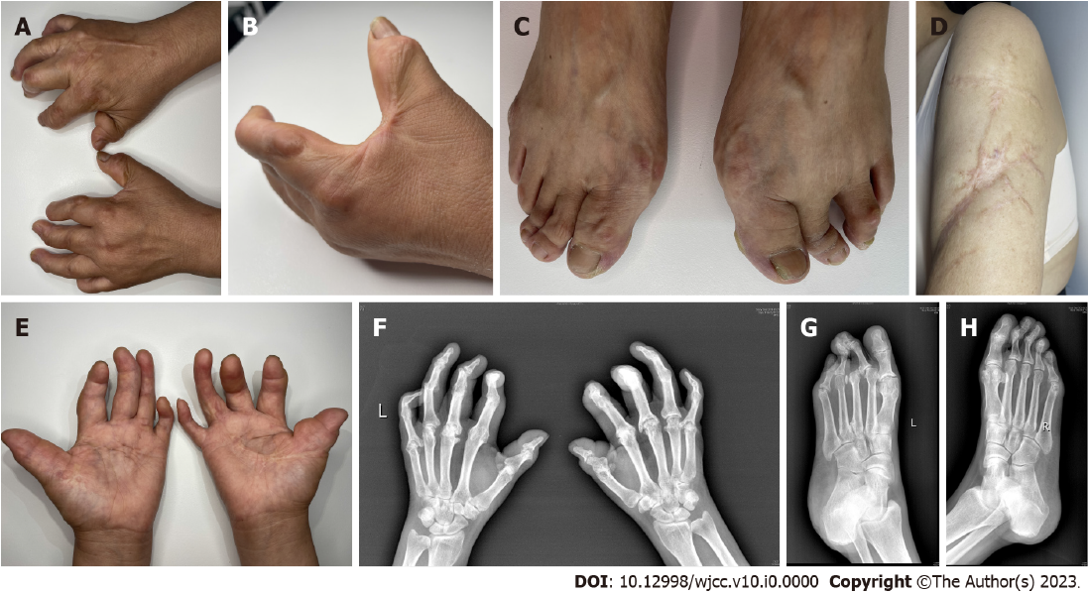
Figure 1 Pathological changes of skin and joints of limbs in patients with fibroblast rheumatism. A and B: The patient's fingers showing swelling with flexion contractures and the presence of numerous smooth, firmly, freely mobile nodules on the extensor surface of the palms, upper arms, MCP joints, and PIP joints; C: Notable contracture and multiple reddish firm nodules observed in the MTP and DIP joints; D: Scar connective tissue prominently located in the lateral margin of both upper arms; E: Joint flexion contractures evident in the patient's hands, particularly affecting all fingers, the thumb, ring, and little fingers, resulting in a 'main en griffe' (claw hand) appearance; F: Hand rand radiography revealing knuckle and interphalangeal joint flexion in in both palms, narrow joint spaces, partial fusion, and swan-neck changes in some DIP joints; G and H: Foot radiography showing a missing third toe bone in the left foot, narrow joint gaps between the two feet, flexion of the metatarsal toe joints, and semi-dislocation of the left foot's second metatarsophalangeal joint.

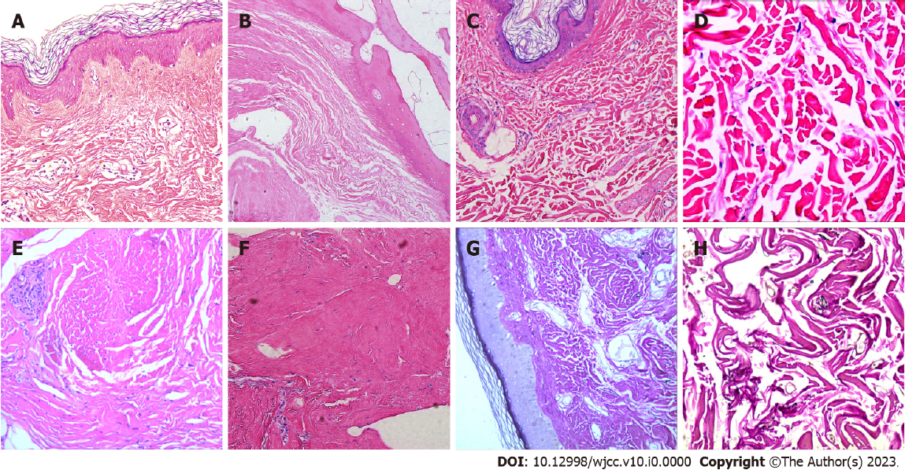
Figure 2 Typical pathological images of skin lesions in patients with fibroblast rheumatism. A: Skin biopsy from the finger revealing dermal fibrous hyperplasia, elastic fiber disorder, skin hyperkeratosis, and irregular thickening of the spinous layer; B: Haematoxylin and eosin staining of left foot articular cartilage displaying central cartilage degeneration and necrosis with calcification, along with dermal collagen fiber hyperplasia and spindle cell proliferation; C and D: Histological examination of upper arm scar tissue and synovium, showing collagen fiber hyperplasia, elastic fiber disorder, and spindle cell proliferation; E and F: Palmar aponeurosis biopsy from the right arch demonstrating fibrous hyperplasia with localized spindle cell proliferation (Haematoxylin and eosin, original magnifications: (A: ×200; B: ×200; C: ×200; D: ×400; E: ×40; F: ×200); G and H: Elastica van Gieson staining revealing reduced elastic fibers in the dermis (G: ×200; H: ×400).
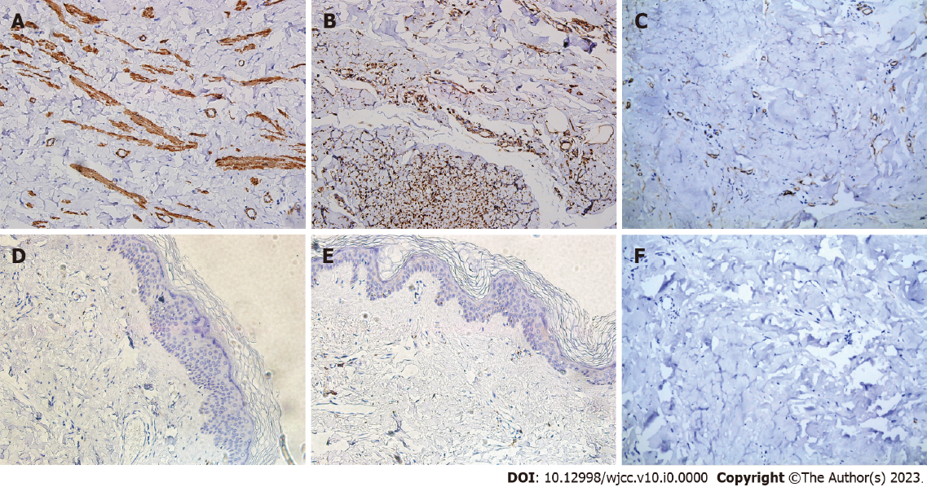
Figure 3 Immunohistochemical histopathologic images of skin lesions in patients with fibroblast rheumatism. A: Positive staining for α-smooth muscle actin (α-SMA) (×200); B: Vimentin (×200) in the spindle cells; C: As well as positive staining for CD34 (×200); D: Negative staining observed for CD68 (×200), E: CD163 (×200); F: S100 (×200).

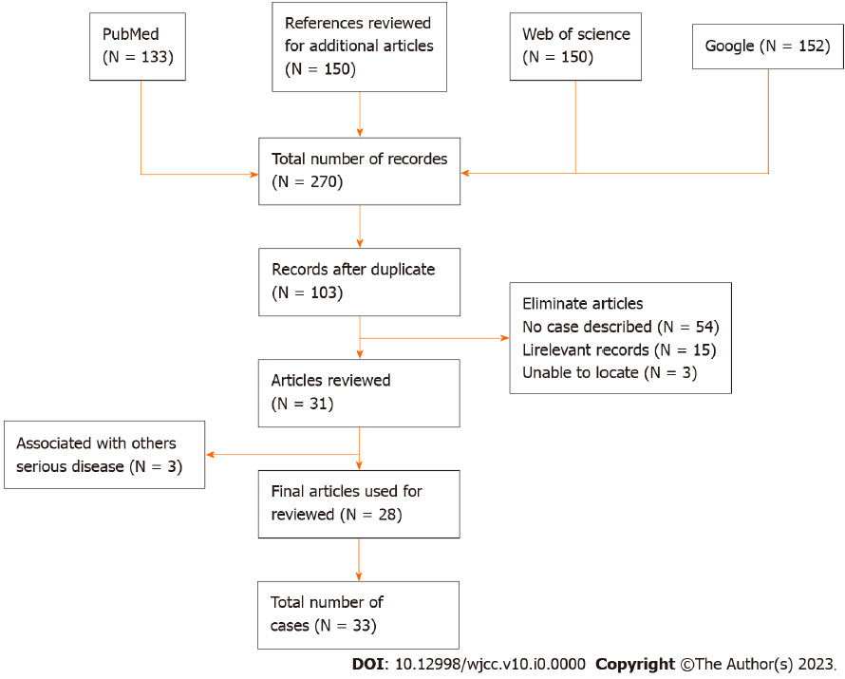
Figure 4 Preferred reporting items of Systematic Reviews and Meta-Analysis flow chart for the systematic review screening process.
Table 1 Patient characteristics included in the systematic review
Variables | Types | NO. (n = 33) | %
Gender | man | 22 | 66.67
 | female | 11 | 33.33
Age | 0-19 | 12 | 36.36
 | 20-39 | 3 | 9.09
 | 40-59 | 13 | 39.39
 | ≥ 60 | 5 | 15.16
Presenting symptoms | Cutaneous periarticular nodules on the hands | 28 | 84.85
 | Cutaneous periarticular nodules on the feet | 13 | 39.39
 | Cutaneous periarticular nodules on others parts | 9 | 27.27
 | Sclerodactyly | 19 | 57.58
 | Raynaud’s phenomenon | 9 | 27.27
 | Redness and swelling | 13 | 39.39
 | Polyarthritis (classically affecting distal joints) | 19 | 57.58
 | Arthralgias | 19 | 57.58
 | Tendonitis | 10 | 30.3
 | Thickened palmar/plantar fascia | 10 | 30.3
 | Joint contractures | 12 | 36.36
Diagnostic imaging tests | Acroosteolysis | 16 | 48.48
 | Erosive arthropathy | 13 | 39.39
 | Osteoproliferation | 3 | 9.09
 | Joint space stenosis | 12 | 36.36
Histologic features | Absence or decrease of elastic fibers | 9 | 27.27
 | Increased proliferation of dermal fibroblasts | 24 | 72.72

Table 2 Immunohistochemical findings in patients with fibroblastic rheumatism with available data
Immunohistochemical markers | Reactivity | Number of patients with available data (n/N, %)
CD34 | + | 5/20 (62.5)
 | - | 15/20 (62.5)
S100 | + | 4/23 (71.88)
 | - | 19/23 (71.88)
EMA | + | 1/10 (31.25)
 | - | 9/10 (31.25)
α-SMA | + | 25/28 (87.5)
 | - | 3/28 (87.5)
Vimentin | + | 18/18 (56.25)
 | - | 0/18 (56.25)
CD68 | + | 2/12 (37.5)
 | - | 10/12 (37.5)
α-SMA: α-smooth muscle actin; EMA: Epithelial membrane antigen.

Table 3 Laboratory findings in patients with fibroblastic rheumatism with available data
Laboratory data | Expressed levels | Number of patients with available data (n/N, %)
ANAs | + | 3/31 (96.88)
 | - | 28/31 (96.88)
ds-DNA | + | 0/18 (56.25)
 | - | 18/18 (56.25)
ANCA | + | 3/23 (71.88)
 | - | 20/23 (71.88)
Anti-SSB | + | 1/15 (46.88)
 | - | 14/15 (46.88)
Anti-Scl-70 | + | 0/17 (53.13)
 | - | 17/17 (53.13)
Anti-Jo-1 | + | 0/21 (65.63)
 | - | 21/21 (65.63)
C3 | + | 0/13 (40.63)
 | - | 13/13 (40.63)
RF | + | 0/33 (100)
 | - | 33/33 (100)
CRP | + | 4/25 (78.13)
 | - | 21/25 (78.13)
ANAs: Antinuclear antibodies; ANCA: Anti-neutrophil cytoplasmic antibodies; RF: Rheumatoid factor; CRP: C reactive protein.

Table 4 Key points of differential diagnosis between various similar diseases
 | RA | PsA | MCRH | NS | FR
Clinical features
Skin
Sclerodactyly | +/- | - | - | + | +
Subcutaneous nodules | + | - | + | - | +
Raynaud phenomenon | + | - | - | - | +
Musculoskeletal
Favorite sites
DIP | - | + | + | + | +
PIP | + | + | + | + | +
MCP | + | +/- | + | +/- | +
Histopathologic features
Proliferation of fibroblasts | - | - | - | + | +
Proliferation of collagen fibers | - | - | - | + | +
Multinucleated giant cells | - | + | + | + | +/-
Synovitis | + | + | + | +/- | +
Loss of elastin | - | - | + | - | +
Immunohistochemistry
CD34 | +/- | + | +/- | + | +/-
SMA | - | +/- | +/- | +/- | +
Vimentin | - | - | - | - | +
C3 | + | + | +/- | +/- | -
Other features
Elevation of CRP and/or ESR | + | + | +/- | + | -
Rheumatoid factor | + | - | - | +/- | -
Redness and swelling | + | +/- | - | +/- | +
RA: Rheumatoid arthritis; PsA: Psoriatic arthritis; NS: Nodular scleroderma; MCRH: Multicentric reticulohistiocytosis; FR: Fibroblastic rheumatism; DIP: Distal interphalangeal joint; PIP: Proximal interphalangeal joint; MCP: Metacarpophalangeal joints; SMA: Smooth muscle actin; CRP: C-reactive protein; ESR: Erythrocyte sediment rate.

