Name of journal: World Journal of Gastroenterology
ESPS Manuscript NO: 10695
Columns: ORIGINAL ARTICLE

Butein’s therapeutic effects in interleukin-10^{-/-} mice colitis and impacts on the interleukin-6/signal transducer and activator of transcription 3

Lee SD et al. Butein ameliorates colitis in IL-10^{-/-} mice

Sehe Dong Lee, Jung Wan Choe, Beom Jae Lee, Myoung Hee Kang, Moon Kyung Joo, Ji Hoon Kim, Jong Eun Yeon, Jong-Jae Park, Jae Sun Kim, Young-Tae Bak

Sehe Dong Lee, Jung Wan Choe, Beom Jae Lee, Myoung Hee Kang, Moon Kyung Joo, Ji Hoon Kim, Jong Eun Yeon, Jong-Jae Park, Jae Sun Kim, Young-Tae Bak, Division of Gastroenterology, Department of Internal Medicine, Korea University Medical Center, Seoul 152-703, South Korea

Author contributions: Lee SD and Choe JW contributed equally to this work; Lee BJ designed study and performed the majority of experiments; Lee SD, Choe JW, Kang MH, Joo MK, Kim JH, Yeon JE, Park JJ, Kim JS and Bak YT were involved in editing the manuscript; Choe JW wrote the paper.

Supported by National Research Foundation of Korea, No. R1102452, and Core Laboratory for Convergent Translational Research of College of Medicine, Korea University, No. K1220161

Correspondence to: Beom Jae Lee, MD, PhD, Division of Gastroenterology, Department of Internal Medicine, Korea University Medical Center, 97 Gurodong-gil, Guro-gu, Seoul 152-703, South Korea. L85210@medimail.co.kr
Telephone: +82-2-26263004 Fax: +82-2-8531943

Received: April 8, 2014 Revised: June 8, 2014
Accepted: July 11, 2014

Published online:
Abstract
AIM: To evaluate the interfering effects of butein on inflammatory cytokines and matrix metalloproteinase-9 (MMP-9) and its therapeutic effects in interleukin (IL)-10^{-/-} mice.

METHODS: To synchronize colitis, 8- to 10-wk-old IL-10^{-/-} mice were fed pellet-chow containing piroxicam for 2 wk. Then phosphate-buffered saline or butein (1 mg/kg/d, ip) was administered for 4 wk after piroxicam induction. Histologic scores, inflammatory cytokines, MMP-9 and phosphorylated signal transducer and activator of transcription 3 (pSTAT3) expressions in IL-10^{-/-} mice and Colo 205 cells were analyzed.

RESULTS: Butein reduced the colonic inflammatory score by > 50%. Genetic expressions of IL-6, IL-1β, interferons (IFN)–γ and MMP-9 decreased in the colons of mice exposed to butein, whereas other inflammatory cytokines (IL-17A, IL-21 and IL-22) were unchanged. Immunohistochemical activities for pSTAT3 and MMP-9 were significantly decreased in the butein-treated groups as compared with the controls. Butein inhibited IL-6-induced activation of STAT3 in Colo 205 cells.

CONCLUSION: Butein ameliorated colitis in IL-10^{-/-} mice by regulating IL-6/STAT3 and MMP-9 activation.

© 2014 Baishideng Publishing Group Inc. All rights reserved.

Key words: Butein; Colitis; Inflammatory bowel disease; Matrix metalloproteinase-9; Interleukin-6/signal transducer and activator of transcription 3

Core tip: This study aims to examine whether butein, a naturally derived substance, had therapeutic effects in interleukin (IL)-10^{-/-} mice, an inflammatory bowel disease model. Our results point to the possibility of applying butein to bowel inflammation-induced colon cancer since butein is observed to suppress bowel inflammation and interfere with the IL-6/signal transducer and activator of transcription 3 and matrix metalloproteinase-9 pathways in IL-10^{-/-} mice. To our knowledge, while there have been several in vitro studies on tumor cells, there has not been a similar in vivo study to show the effect of butein in colitis mice.

Lee SD, Choe JW, Lee BJ, Kang MH, Joo MK, Kim JH, Yeon JE, Park JJ, Kim JS, Bak YT. Butein’s therapeutic effects in interleukin-10^{-/-} mice colitis and impacts on the interleukin-6/signal transducer and activator of transcription 3. World J Gastroenterol 2014; In press
INTRODUCTION
Inflammatory bowel diseases (IBDs), including Crohn’s disease (CD) and ulcerative colitis (UC), are chronic diseases that are occasionally complicated by bowel perforations, strictures and fistulas^{[1,2]}. The overall risk of colorectal cancer among patients with UC is about 10 times higher than that of the general population^{[3,4]}. In Asia, including South Korea, the occurrence of colon cancer and IBD has recently increased due to environmental factors such as the influence of westernized lifestyles. This incidence pattern is expected to continue^{[2]}. 5-aminosalicylic acid and immunosuppressive agents have classically been used as treatments for IBD. Inhibition of tumor necrosis factor (TNF), an inflammatory cytokine, has been considered as a therapeutic target. Many studies have focused on diverse biologic agents to treat IBD, but a completely efficient treatment agent has not yet been discovered. Research continues for the development of new alternative drugs and in clinical trials^{[5,6]}.
IBD results from immune modulation abnormalities; helper T cells, in particular, play a critical role in the development of disease. CD is largely associated with abnormal activation of Th1-related cytokines [IL-1β, interferons (IFN)-γ, TNF-α, IL-6 and IL-22]; in addition, the importance of Th17-related cytokines in the emergence of CD has recently been highlighted^{[7]}. IL-10^{-/-} mice are known to be an appropriate animal model for CD due to the similarity of their condition to CD morbidity. In these mice, the manifestation of bowel inflammation is mediated by Th1 cytokines (IL-1β, IFN-γ, TNF-α and IL-6), and the ulcerative lesions are found in the proximal portion of the colon. In IL-10^{-/-} mice, chronic bowel inflammation can occur without any other stimuli or specific pathogens. Making use of the fact that bowel inflammation occurs after a certain period of time, it is possible to promote inflammation and inflammation-induced tumors with piroxicam, an nonsteroidal anti-inflammatory drug (NSAID). Therefore, the IL-10^{-/-} mouse can be a useful animal model for the occurrence of bowel inflammation and inflammation-induced tumors^{[8,9]}. The therapeutic effects of natural substances on inflammation and tumors are being widely studied^{[10,11]}. It has been reported that a number of chemical substances, obtained from edible plants with botanical and antioxidant characteristics interfere with tumorigenesis through suppression of the inflammatory reaction^{[12]}. However, there has been no agreement in results between actual clinical applications and a large-scale prospective study^{[13]}. In addition, numerous mechanisms have been suggested for the anti-inflammatory and anti-tumor effects of such natural substances. Cell signal transmission systems in particular have been actively studied, but it has been difficult to elucidate the mechanism of the therapeutic effects due to the structural diversity^{[11]}. Toxicodendron vernicifluum, a deciduous tree from the Anacardiaceae family, both grows natively in various places and is cultivated in South Korea. Urushiol, the major constituent, is primarily responsible for the toxicity. Other constituents, such as butein (3,4,2’,4’-tetrahydroxychalcone), have been found in in vitro studies to have antioxidant and anti-inflammatory effects and to suppress tumor cell proliferation and angiogenesis^{[14-18]}. One in vitro study demonstrated that butein inhibits the activation of nuclear factor kappa B (NF-қB) through inhibition of TNF-α, IL-6 and IL-8 in human mast cells^{[19]}. Matrix metalloproteinase (MMP), an enzyme that degrades zinc-dependent gelatin matrices, serves an important role in inflammatory cell infiltration, cytokine activation and tissue injury, reformation and recovery. MMP-9 is specifically known to be closely associated with Rheumatic arthritis, atherosclerosis, colon cancer and IBD. The suppressive effects that butein has on MMP-9 activation have been reported in an in vitro study using prostate cancer cells^{[20,21]}. However, to our knowledge, no study has yet to be conducted that examines the therapeutic effects of butein on bowel inflammation and colon cancer. This study, therefore, aims to evaluate the interfering effects of butein on inflammatory cytokines and MMP-9 in IL-10^{-/-} mice and ultimately to examine the therapeutic effects of butein.

MATERIALS AND METHODS
Experimental animals
IL-10^{-/-} mice were purchased from Jackson Laboratories (Bar Harbor, ME, USA). All mice were housed and bred in the animal care facility of Korea University Guro Hospital.

Reagents
Butein and piroxicam were purchased from Sigma-Aldrich Inc. (St. Louis, MO, USA). Butein was dissolved in dimethylsulfoxide and was diluted in phosphate-buffered saline (PBS) before use. Antibodies against phosphorylated signal transducer and activator of transcription 3 (pSTAT3)/STAT3 and β-actin were purchase from Cell Signaling Co. (Beverly, MA, USA) and the antibody against MMP-9 was purchased from Abcam Inc (Cambridge, UK).

Colitis induction
To synchronize and accelerate colitis, 8-wk-old IL-10^{-/-} mice were treated with piroxicam, as previously described^{[22,23]}. In brief, a lower dose of piroxicam (60 mg/250 g chow) was administrated for 7 d followed by a higher dose of piroxicam (80 mg/250 g chow) for 7 d. Mice were then placed on normal chow for the remainder of the experimental period. On d15 to d28, 1 mg/kg of butein or PBS was administrated daily to mice, and mice were sacrificed on d28. This experiment was performed in accordance with the guidelines of the Korea University Animal Ethics Committee.

Colitis assessment
Entire colons were dissected longitudinally and made into Swiss rolls. The tissues were fixed in 10% formalin for 14-16 h, tissue processing and paraffin blocks were made and 4-µm sections were cut and stained with hematoxylin and eosin (HE) for colitis assessment. The degree of colitis was assessed using the inflammation scoring system as described previously with slight modifications^{[24]} (Table 1).

Cell lines and cultures
The human colon cancer cell line, Colo 205, was purchased from the American Type Culture Collection (Manassas, VA). Cells were cultured in RPMI media containing 1% penicillin-streptomycin (Sigma) and 10% heat-inactivated FBS in 5% CO₂ at 37 °C. Cells were seeded at 9 × 10⁵ cells/mL in 60-mm dishes and then treated with IL-6 (25 ng/mL) at the indicated concentrations of butein.

Colic epithelial cell isolation
Colonic epithelial cells were isolated as previously described^{[25]}. Mice colonic tissues were washed using cold PBS and opened longitudinally. Mice colons were irrigated with cold Ca²⁺- and Mg⁺-free Hank’s balanced salt solution (CMF-HBSS). The tissue was then transferred to 5 mL CMF-HBSS containing 10 mmol/L dithiothreitol (1:100; Sigma, St. Louis, MO) and 50 nmol/L calyculin A (1:200; Wako, Richmond, VA) and incubated in rotator for 30 min at 4 °C. The tissue was then transferred to another 5 mL CMF-HBSS solution containing 1 mmol/L EDTA and 50 nmol/L calyculin A, and incubated at 4 °C for 1 h. Colonic tissues were removed from the tube, and epithelial cells were isolated by centrifugation at 300 rpm for 5 min. The supernatant was removed, and the remaining cells were snap-frozen in liquid nitrogen and maintained at -70 °C for future analysis.

Immunohistochemistry
For the proliferation assay, 1 mg BrdU (5-Bromo-2´-Deoxyuridine, Sigma Chemical, St. Louis, MO, USA) was injected into mice 2 h before sacrifice. Formalin-fixed, paraffin-embedded sections were processed for Immunohistochemistry (IHC). Paraffin-embedded slides were deparaffinized and hydrated. Antigen retrieval was performed using Target retrieval solution in a decloaking chamber followed by staining with antibodies against p-STAT3 (1:100 dilution, Cell Signaling), BrdU (1:200 dilution, Accurate Chemical, Westbury, NY) and MMP-9 (1:00 dilution, Abcam Inc. Cambridge, UK) followed by anti-rabbit or anti-rat mouse-HRP-labeled polymer (Dako). Sections were developed using 3,3'-diaminobenzidine tetrahydrochloride and counterstained with hematoxylin.

Western blot
Protein was extracted from isolated colonic epithelial cells and Colo 205 cells using the protein extraction buffer (Thermo Scientific, Rockford, IL, USA), as described by the manufacturer. Extracted protein concentrations were measured using the BCA method, and 30 μg of proteins were separated on a 10% SDS-polyacrylamide gel, transferred to nitrocellulose membranes and blocked with TBST (Tris-buffered saline^{[4]}, 0.05% Tween-20) with 5% nonfat milk and 5% FBS. The primary antibodies were applied overnight at 4 ℃. Antibodies against p-STAT3/STAT3 (1:1000; Cell Signaling Technology, Beverly, MA, USA) and GAPDH (Santa Cruz Biotechnology Inc. CA. USA) served as the sample loading control. After extensive washing with TBST, the membranes were incubated for 1 h in corresponding horseradish peroxidase-coupled secondary antibodies (donkey anti-rabbit 1:1000; Santa Cruz Biotechnology Inc.). The chemiluminescent reaction was developed using a West Pico (Pierce) reagent.

RNA isolation and quantitative real-time polymerase chain reaction
Quantitative real-time polymerase chain reaction (PCR) was performed to quantify the expression of mRNA for cytokines and MMP-9 with expression of GAPDH for endogenous control. Total RNA from the proximal colon of each mouse was extracted using trizol (Invitrogen, CA, USA), and cDNA was synthesized using the iScript TM cDNA synthesis Kit (Roche). Quantitative real-time PCR was performed using the LightCycler 480 SYBR Green I Master kit (Roche) according to the manufacturer’s instructions. Primers used for PCR are summarized in Table 2.

Statistical analysis
Statistical analysis was performed using Student’s t-test or the Mann-Whitney U test. Results are expressed as mean ± SEM.

RESULTS
Butein treatment ameliorates colitis in IL-10^{-/-} mice
It has been established that induction with piroxicam for 2 wk accelerates and synchronizes the onset and severity of colitis in IL-10^{-/-} mice with marked transmural inflammation and ulceration in the proximal colon^{[8,23]}. During colitis experiment, mice treated with butein exhibited the greater body weight gain and longer colonic length (Figure 2A, B). Histologic analysis with HE staining demonstrated that treatment with butein (1 mg/kg) for 2 wk after cessation of the 2-wk piroxicam administration significantly reduced the inflammatory score with no visible deep ulceration and lessened inflammatory cell infiltrates (Figure 2C, D).

Butein treatment inhibits inflammatory cytokines and MMP-9 in the colons of IL-10^{-/-} mice
Previous studies have shown that IL-10^{-/-} mice colitis was induced by dysregulation of Th1-mediated cytokines, including IL-1β, IFN-γ and IL-6. The Th1 cytokines, IFT-γ, IL-1β, IL-6, IL-21, IL-23 and IL-12β are heavily up-regulated in IL-10^{-/-} mice, together with significantly increased MMP-9, two weeks after the last administration of piroxicam. IL-10^{-/-} mice who received 2 wk of butein treatment demonstrated significantly reduced mRNA expression of IFN-γ, IL-1β, IL-6 and MMP-9 in the proximal colon, while there was no effect on the expression of IL-17a, IL-21, IL-22 and MMP-2 (Figure 3).

Butein treatment results in reduced STAT3 and MMP-9 expression in mice colons
Knowing that the STAT3 is a major intrinsic pathway for inflammation and inflammation-associated cancers that are both mediated and activated by cytokines, chemokines and other mediators including IL-6, IL-1β and macrophage colony-stimulating, we investigated STAT3 activity in mice colons. Increased STAT3 activity was noted in inflamed mice colonic epithelial cells. Butein treatment inhibited the increased STAT3 activities in colonic epithelial cells, as noted both in IHC and western blots on d28 (Figure 4A, B).
From the PCR results, we investigated the effect of butein treatment on MMP-9 activity in mice colons. MMP-9 activation was noted in inflammatory cells adjacent in colitis and ulceration in control mice. Activated MMP-9 was suppressed by butein treatment. To evaluate proliferation, a BrdU incorporation assay was performed by IHC analysis. There was no significant difference between the control and butein treatment groups (Figure 5A, B).

Butein inhibits STAT3 phosphorylation induced by IL-6 in human Colo 205 cells
We investigated the effects of butein on the modulation of IL-6/STAT3 activation in vivo using Colo 205 cells. Exposure to IL-6 for different times and at different concentrations increased phosphorylation of STAT3 in Colo 205 cells. Butein treatment suppressed the phosphorylation of STAT3 induced by IL-6 (25 ng/mL) at a concentration of 10 µmol/mL (Figure 6A-C).

DISCUSSION
The objective of this study was to examine whether butein, a naturally derived substance, had therapeutic effects in IL-10^{-/-} mice, an IBD model. The occurrence of IBD significantly decreased in mice injected with butein; butein blocked the IL-6/STAT3 signal transmission pathway and suppressed MMP-9 activation. Butein, a major constituent of Toxicodendron vernicifluum, can also be found in the stems of Semecarpus anacardium and in the heartwood of Dalbergia odorifera, as well as other plants. Previous studies have reported that butein has anti-oxidant, anti-inflammatory and antitumor effects and that it suppresses angiogenesis^{[26-29]}. Butein is known to suppress cell proliferation and promote apoptosis in both solid and hematologic tumors; it is also less toxic than urushiol, another constituent of Toxicodendron vernicifluum^{[30,31]}. Butein’s effects on tumor cells arise as a result of suppressing c-src and JAK1/JAK2 activation, thus inhibiting the IL-6/STAT3 pathway. Butein also directly inhibits the expression of Bcl-xL, Bcl-2 and cyclin D1, the target genes of STAT3^{[31]}. STAT3 plays an important role in cytokine receptor transmission; it is a signal transmission system that connects a membrane receptor to the nuclear transcription. It is principally activated by gp130-related cytokines, the most representative of which is IL-6.
STAT3, a principal mechanism of the inflammatory reaction and inflammation-related malignant tumors, is involved in the inflammatory reaction and inflammation-related malignant changes from the initial stage to tumor progression. STAT3 modulates the activity of NF-қB and is activated by the IL-6/JAK signal pathway^{[32-34]}. The IL-6/JAK/STAT3 signal system promotes tumorigenesis by inducing cellular or genetic epigenetic changes that follow intracellular inflammation reaction. IL-6/JAK/STAT3, activated by gp130-related IL-6, IL-22, cytokines, and other growth factors, is found to be active in multiple malignant tumors, such as multiple myeloma, lymphoma, hematologic malignancies, breast cancer and prostate cancer.
In this study, IL-6 mRNA expression was increased in IL-10^{-/-} mice with bowel inflammation; STAT3 activation was also observed in colonic epithelial cells with inflammation and ulcers following the inflammation.
Butein inhibited the expression of STAT3 in epithelial cells, which was demonstrated by immunohistochemical staining and western blot analysis. We also found that MMP-9 expression in the colon tissues was blocked by butein. In a study with a cell strain, IL-6-activated MMP-9 was found to be highly concentrated, and this activity is blocked by butein. Secreted with MMP-2 from tumor cells, inflammatory cells and cell matrix cells, MMP-9 is closely connected with tissue remodeling and tumor metastasis^{[35]}. In an in vitro study, butein was reported to inhibit the activation of MMP-9^{[36]}. Similarly, we found that the expression of MMP-9 that increased in inflammatory cells and infiltrated the muscle layer in bowel inflammation or inflammation-induced ulcers was also found to be blocked by butein.
Here, we examined the therapeutic effects of butein in an animal model of bowel inflammation. To our knowledge, while there have been several in vitro studies on tumor cells, there has not been a similar in vivo study. There were a few limitations to our study. First, there was no confirmatory analysis of MMP-9 with zymography for analyzing MMP-9 activation conducted after butein treatment. Second, we did not determine whether the activity of IL-6 at the protein level was identical to that at the mRNA level or not. Third, we had other limitations related to our experiment methods. These shortcomings will be further modified in future studies. Finally, no quantitative analysis of inflammatory cytokine activation was undertaken, and the analysis of signal transmission system was limited to epithelial cells. It is reasonable to state that IL-10^{-/-} mice are not an appropriate model to study the proliferation and recovery processes of epithelial cells, since IL-10^{-/-} mice are study models principally for the degree of expression of inflammatory cytokines. This limitation could be overcome by conducting additional experiments with other study models. In doing so, the therapeutic effects of butein could be evaluated more accurately.
The results of this study regarding the interfering effects of butein on the IL-6/STAT3, MMP-9 pathway, are found to be similar to those of an in vitro study that used the established malignant tumor cells. Considering that the suppression of bowel inflammation and the recovery capability of the injured mucous membrane are critical for IBD treatment, the findings obtained from BrdU analysis that the mucous membrane cell proliferation necessary for the mucous membrane recovery process is not affected by butein treatment further supports the clinical applicability of butein in treating IBD.
Chronic inflammation is a major mechanism of malignant tumors. The incidence of malignant tumors in the colon and the small intestine is significantly increased with IBD such as UC and CD. The IL-6/STAT3 pathway is an important pathway for the initiation of inflammation-mediated malignant tumors, and MMP-9 is an essential signal transmission system related to the metastasis of malignant tumors. In IBD patients, the expression of IL-6 is increased, and the expression of MMP-9 is known to serve a critical role in pathogenesis.
Our results point to the possibility of applying butein to bowel inflammation-induced colon cancer since butein is observed to suppress bowel inflammation and interfere with the IL-6/STAT3 and MMP-9 pathways in IL-10^{-/-} mice. It is therefore important to further investigate the effects of butein on the occurrence of bowel inflammation-related colon cancer.

COMMENTS
Background
The therapeutic effects of natural substances on inflammation and tumors are being widely studied. Butein have been found in in vitro studies to have antioxidant and anti-inflammatory effects and to suppress tumor cell proliferation and angiogenesis.
Research frontiers
The suppressive effects that butein has on matrix metalloproteinase-9 (MMP-9) activation have been reported in an in vitro study using several cancer cells. However, no study has yet to be conducted that examines the therapeutic effects of butein on bowel inflammation and colon cancer. This study, therefore, aims to evaluate the interfering effects of butein on inflammatory cytokines and MMP-9 in interleukin (IL)-10^{-/-} mice, an inflammatory bowel disease model and ultimately to examine the therapeutic effects of butein.
Innovations and breakthroughs
Our results point to the possibility of applying butein to bowel inflammation-induced colon cancer since butein is observed to suppress bowel inflammation and interfere with the IL-6/signal transducer and activator of transcription 3 (STAT3) and MMP-9 pathways in IL-10^{-/-} mice. To our knowledge, while there have been several in vitro studies on tumor cells, this is the first in vivo study to show the effect of butein in colitis mice.
Applications
The study results suggest that it important to represent the inhibitory effects of butein on the occurrence of bowel inflammation-related colon cancer by regulating IL-6/STAT3 and MMP-9 activation.
Peer review
The authors examined whether butein, a naturally derived substance, had therapeutic effects in IL-10^{-/-} mice, an inflammatory bowel diseases model. Butein blocked the IL-6/STAT3 signal transmission pathway and suppressed MMP-9 activation. The results are interesting and may represent the effects of butein on the occurrence of bowel inflammation-related colon cancer.

REFERENCES
1 Karlén P, Löfberg R, Broström O, Leijonmarck CE, Hellers G, Persson PG. Increased risk of cancer in ulcerative colitis: a population-based cohort study. Am J Gastroenterol 1999; 94: 1047-1052 [PMID: 10201481 DOI: 10.1111/j.1572-0241.1999.01012.x]
2 Cosnes J, Gower-Rousseau C, Seksik P, Cortot A. Epidemiology and natural history of inflammatory bowel diseases. Gastroenterology 2011; 140: 1785-1794 [PMID: 21530745 DOI: 10.1053/j.gastro.2011.01.055]
3 Ekbom A, Helmick C, Zack M, Adami HO. Ulcerative colitis and colorectal cancer. A population-based study. N Engl J Med 1990; 323: 1228-1233 [PMID: 2215606 DOI: 10.1056/NEJM199011013231802]
4 Bernstein CN, Blanchard JF, Kliewer E, Wajda A. Cancer risk in patients with inflammatory bowel disease: a population-based study. Cancer 2001; 91: 854-862 [PMID: 11241255]
5 Plevy SE, Targan SR. Future therapeutic approaches for inflammatory bowel diseases. Gastroenterology 2011; 140: 1838-1846 [PMID: 21530750 DOI: 10.1053/j.gastro.2011.02.014]
6 Rutgeerts P, Vermeire S, Van Assche G. Biological therapies for inflammatory bowel diseases. Gastroenterology 2009; 136: 1182-1197 [PMID: 19249397 DOI: 10.1053/j.gastro.2009.02.001]
7 Strober W, Fuss IJ. Proinflammatory cytokines in the pathogenesis of inflammatory bowel diseases. Gastroenterology 2011; 140: 1756-1767 [PMID: 21530742 DOI: 10.1053/j.gastro.2011.02.016]
8 Hale LP, Gottfried MR, Swidsinski A. Piroxicam treatment of IL-10-deficient mice enhances colonic epithelial apoptosis and mucosal exposure to intestinal bacteria. Inflamm Bowel Dis 2005; 11: 1060-1069 [PMID: 16306768]
9 Brown JB, Lee G, Grimm GR, Barrett TA. Therapeutic benefit of pentostatin in severe IL-10(-/-) colitis. Inflamm Bowel Dis 2008; 14: 880-887 [DOI: 10.1002/Ibd.20410]
10 Surh YJ. Cancer chemoprevention with dietary phytochemicals. Nat Rev Cancer 2003; 3: 768-780 [PMID: 14570043 DOI: 10.1038/nrc1189]
11 Tan AC, Konczak I, Sze DM, Ramzan I. Molecular pathways for cancer chemoprevention by dietary phytochemicals. Nutr Cancer 2011; 63: 495-505 [PMID: 21500099 DOI: 10.1080/01635581.2011.538953]
12 Neergheen VS, Bahorun T, Taylor EW, Jen LS, Aruoma OI. Targeting specific cell signaling transduction pathways by dietary and medicinal phytochemicals in cancer chemoprevention. Toxicology 2010; 278: 229-241 [PMID: 19850100 DOI: 10.1016/j.tox.2009.10.010]
13 Russo GL. Ins and outs of dietary phytochemicals in cancer chemoprevention. Biochem Pharmacol 2007; 74: 533-544 [PMID: 17382300 DOI: 10.1016/j.bcp.2007.02.014]
14 Ma CY, Ji WT, Chueh FS, Yang JS, Chen PY, Yu CC, Chung JG. Butein inhibits the migration and invasion of SK-HEP-1 human hepatocarcinoma cells through suppressing the ERK, JNK, p38, and uPA signaling multiple pathways. J Agric Food Chem 2011; 59: 9032-9038 [PMID: 21770460 DOI: 10.1021/jf202027n]
15 Kim N. Butein sensitizes human leukemia cells to apoptosis induced by tumor necrosis factor-related apoptosis inducing ligand (TRAIL). Arch Pharm Res 2008; 31: 1179-1186 [PMID: 18806962 DOI: 10.1007/s12272-001-1286-2]
16 Chua AW, Hay HS, Rajendran P, Shanmugam MK, Li F, Bist P, Koay ES, Lim LH, Kumar AP, Sethi G. Butein downregulates chemokine receptor CXCR4 expression and function through suppression of NF-κB activation in breast and pancreatic tumor cells. Biochem Pharmacol 2010; 80: 1553-1562 [PMID: 20699088 DOI: 10.1016/j.bcp.2010.07.045]
17 Lau GT, Huang H, Lin SM, Leung LK. Butein downregulates phorbol 12-myristate 13-acetate-induced COX-2 transcriptional activity in cancerous and non-cancerous breast cells. Eur J Pharmacol 2010; 648: 24-30 [PMID: 20826149 DOI: 10.1016/j.ejphar.2010.08.015]
18 Chen YH, Yeh CW, Lo HC, Su SL, Hseu YC, Hsu LS. Generation of reactive oxygen species mediates butein-induced apoptosis in neuroblastoma cells. Oncol Rep 2012; 27: 1233-1237 [PMID: 22245810 DOI: 10.3892/or.2012.1632]
19 Rasheed Z, Akhtar N, Khan A, Khan KA, Haqqi TM. Butrin, isobutrin, and butein from medicinal plant Butea monosperma selectively inhibit nuclear factor-kappaB in activated human mast cells: suppression of tumor necrosis factor-alpha, interleukin (IL)-6, and IL-8. J Pharmacol Exp Ther 2010; 333: 354-363 [PMID: 20164300 DOI: 10.1124/jpet.109.165209]
20 Garg P, Vijay-Kumar M, Wang L, Gewirtz AT, Merlin D, Sitaraman SV. Matrix metalloproteinase-9-mediated tissue injury overrides the protective effect of matrix metalloproteinase-2 during colitis. Am J Physiol Gastrointest Liver Physiol 2009; 296: G175-G184 [PMID: 19171847 DOI: 10.1152/ajpgi.90454.2008]
21 Lakatos G, Sipos F, Miheller P, Hritz I, Varga MZ, Juhász M, Molnár B, Tulassay Z, Herszényi L. The behavior of matrix metalloproteinase-9 in lymphocytic colitis, collagenous colitis and ulcerative colitis. Pathol Oncol Res 2012; 18: 85-91 [PMID: 21678108 DOI: 10.1007/s12253-011-9420-9]
22 Berg DJ, Zhang J, Weinstock JV, Ismail HF, Earle KA, Alila H, Pamukcu R, Moore S, Lynch RG. Rapid development of colitis in NSAID-treated IL-10-deficient mice. Gastroenterology 2002; 123: 1527-1542 [PMID: 12404228]
23 Brown JB, Lee G, Grimm GR, Barrett TA. Therapeutic benefit of pentostatin in severe IL-10-/- colitis. Inflamm Bowel Dis 2008; 14: 880-887 [PMID: 18340641 DOI: 10.1002/ibd.20410]
24 Berg DJ, Davidson N, Kühn R, Müller W, Menon S, Holland G, Thompson-Snipes L, Leach MW, Rennick D. Enterocolitis and colon cancer in interleukin-10-deficient mice are associated with aberrant cytokine production and CD4(+) TH1-like responses. J Clin Invest 1996; 98: 1010-1020 [PMID: 8770874 DOI: 10.1172/JCI118861]
25 Dirisina R, Katzman RB, Goretsky T, Managlia E, Mittal N, Williams DB, Qiu W, Yu J, Chandel NS, Zhang L, Barrett TA. p53 and PUMA independently regulate apoptosis of intestinal epithelial cells in patients and mice with colitis. Gastroenterology 2011; 141: 1036-1045 [PMID: 21699775 DOI: 10.1053/j.gastro.2011.05.032]
26 Jeong GS, Lee DS, Song MY, Park BH, Kang DG, Lee HS, Kwon KB, Kim YC. Butein from Rhus verniciflua protects pancreatic β cells against cytokine-induced toxicity mediated by inhibition of nitric oxide formation. Biol Pharm Bull 2011; 34: 97-102 [PMID: 21212525]
27 Jang JH, Yang ES, Min KJ, Kwon TK. Inhibitory effect of butein on tumor necrosis factor-α-induced expression of cell adhesion molecules in human lung epithelial cells via inhibition of reactive oxygen species generation, NF-κB activation and Akt phosphorylation. Int J Mol Med 2012; 30: 1357-1364 [PMID: 23064245 DOI: 10.3892/ijmm.2012.1158]
28 Sehrawat A, Kumar V. Butein imparts free radical scavenging, anti-oxidative and proapoptotic properties in the flower extracts of Butea monosperma. Biocell 2012; 36: 63-71 [PMID: 23185781]
29 Chung CH, Chang CH, Chen SS, Wang HH, Yen JY, Hsiao CJ, Wu NL, Chen YL, Huang TF, Wang PC, Yeh HI, Wang SW. Butein Inhibits Angiogenesis of Human Endothelial Progenitor Cells via the Translation Dependent Signaling Pathway. Evid Based Complement Alternat Med 2013; 2013: 943187 [PMID: 23840271 DOI: 10.1155/2013/943187]
30 Cui Z, Song E, Hu DN, Chen M, Rosen R, McCormick SA. Butein induces apoptosis in human uveal melanoma cells through mitochondrial apoptosis pathway. Curr Eye Res 2012; 37: 730-739 [PMID: 22578288 DOI: 10.3109/02713683.2012.671436]
31 Rajendran P, Ong TH, Chen L, Li F, Shanmugam MK, Vali S, Abbasi T, Kapoor S, Sharma A, Kumar AP, Hui KM, Sethi G. Suppression of signal transducer and activator of transcription 3 activation by butein inhibits growth of human hepatocellular carcinoma in vivo. Clin Cancer Res 2011; 17: 1425-1439 [PMID: 21131551 DOI: 10.1158/1078-0432.CCR-10-1123]
32 Yu H, Pardoll D, Jove R. STATs in cancer inflammation and immunity: a leading role for STAT3. Nat Rev Cancer 2009; 9: 798-809 [PMID: 19851315 DOI: 10.1038/nrc2734]
33 Kato T. Stat3-driven cancer-related inflammation as a key therapeutic target for cancer immunotherapy. Immunotherapy 2011; 3: 587-590 [PMID: 21554086 DOI: 10.2217/imt.11.26]
34 Hodge DR, Hurt EM, Farrar WL. The role of IL-6 and STAT3 in inflammation and cancer. Eur J Cancer 2005; 41: 2502-2512 [PMID: 16199153 DOI: 10.1016/j.ejca.2005.08.016]
35 Zheng H, Takahashi H, Murai Y, Cui Z, Nomoto K, Niwa H, Tsuneyama K, Takano Y. Expressions of MMP-2, MMP-9 and VEGF are closely linked to growth, invasion, metastasis and angiogenesis of gastric carcinoma. Anticancer Res 2006; 26: 3579-3583 [PMID: 17094486]
36 Lee SH, Seo GS, Jin XY, Ko G, Sohn DH. Butein blocks tumor necrosis factor alpha-induced interleukin 8 and matrix metalloproteinase 7 production by inhibiting p38 kinase and osteopontin mediated signaling events in HT-29 cells. Life Sci 2007; 81: 1535-1543 [PMID: 17977560 DOI: 10.1016/j.lfs.2007.09.024]

P- Reviewers: Harmanci O, Lakatos PT
S- Editor: Nan J L- Editor: E- Editor:

Figures
Figure 1 Experimental protocol for the interleukin-10^{-/-}-piroxicam colitis model. IL: Interleukin.
Figure 2 Butein treatment results in amelioration of colitis. A: Body weight; B: Colon length between the two groups revealed a significant difference; C: Hematoxylin and eosin stain of Swiss rolls showing ulcers and inflammation; D: Histologic score of mice treated with butein and PBS (n = 9, each group).
Figure 3 Expression of cytokines and metallomatrix proteinases in the colon of interleukin-10^{-/-} mice. Relative expression levels of mRNA were determined by real-time polymerase chain reaction (PCR). Data are mean ± SEM (n = 5 per each group). IL: Interleukin.
Figure 4 Butein treatment decreased mucosal expression of phosphorylated signal transducer and activator of transcription 3 and matrix metalloproteinase-9 expression in interleukin-10^{-/-} mice. A: Immunohistochemical staining for pSTAT3 and MMP-9 detected nuclei of epithelial cells or stromal cells of ^{-/-} mice mice (black arrows); B: Western blot analysis revealed reduced pSTAT3 protein expression in intestinal epithelial cells of butein-treated IL-10^{-/-} mice (n = 3). IL: Interleukin; pSTAT3: Phosphorylated signal transducer and activator of transcription 3; MMP: Matrix metalloproteinase.
Figure 5 Immunohistochemistry for BrdU incorporation. Immunohistochemisty for BrdU incorporation revealed no significant difference in proliferation of the intestinal epithelial cells between the two groups (A, B).
Figure 6 Butein inhibited the interleukin-6-induced activation of signal transducer and activator of transcription 3 in Colo 205 cells. A: Colo 205 cells were treated with IL-6 for various times; B: Colo 205 cells were treated with various concentrations of IL-6; C: Expression levels of p-STAT3, were measured by western blot analysis after pretreating Colo 205 cells with IL-6 (25 ng/mL) for 1hr prior to butein treatment for 24 h at various concentrations (n = 3). IL: Interleukin; STAT3: Signal transducer and activator of transcription 3.

Table 1 Histological score
Grade 0 | Normal tissue
Grade 1 | One or a few multifocal mononuclear cell infiltrates in the lamina propria  Minimal epithelilal hyperplasia  Slight to no depletion of mucus from goblet cells
Grade 2 | Lesions tended to involve more of the intestine than grade 1 lesions  Several multifocal, mild inflammatory cell infiltrates in the lamina propria  Mild epithelial hyperplasia and mucin depletion  Small epithelial erosions
Grade 3 | Lesions involved a large area of the mucosa or were more frequent than grade 2 lesions  Moderate inflammation with the involvement of submucosa  Mixture of mononuclear cells as well as neutrophils, and crypt abscesses  Moderate epithelial hyperplasia and mucin depletion  Ulcers were occasionally observed
Grade 4 | Lesions usually involved most of the intestinal section and were more severe than grade 3 lesions  Severe inflammation including mononuclear cells and neutrophils with transmural involvement  Marked epithelial hyperplasia  Crypt abscesses and ulcers

Table 2 Primer list
IL-6 | F | AGT TGC CTT CTT GGG ACT GA
 | R | TCC ACG ATT TCC CAG AGA AC
IL-1β | F | GCC CAT CCT CTG TGA CTC AT
 | R | AGG CCA CAG GTA TTT TGT CG
IL-22 | F | CAA CTT CCA GCA GCC ATA CA
 | R | GTT GAG CAC CTG CTT CAT CA
IL-17A | F | TCC AGA AGG CCC TCA GAC TA
 | R | AGC ATC TTC TCG ACC CTG AA
IFN-γ | F | ACT GGC AAA AGG ATG GTG AC
 | R | TGA GCT CAT TGA ATG CTT GG
MMP-2 | F | CAG ACT TGT CCC GTT TCC AT
 | R | GGT GCT GAC TGC ATC AAA GA
MMP-9 | F | CGT CGT GAT CCC CAC TTA CT
 | R | AAC ACA CAG GGT TTG CCT TC
IL-21 | F | GGC AAC ATG GAG AGG ATT GT
 | R | AAG CAG GAA AAA GCT GAC CA
IL-23R | F | CAT GAC TTG CAC CTG GAA TG
 | R | GCT TGG ACC CAA ACC AAG TA
IL-12β (P.40) | F | AGG TCA CAC TGG ACC AAA GG
 | R | TGG TTT GAT GAT GTC CCT GA
IL: Interleukin; IFN: Interferons; MMP: Matrix metalloproteinase.

Figure 1
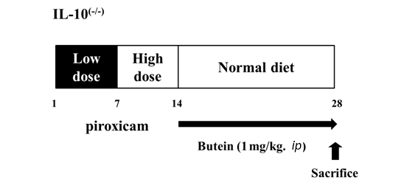

Figure 2
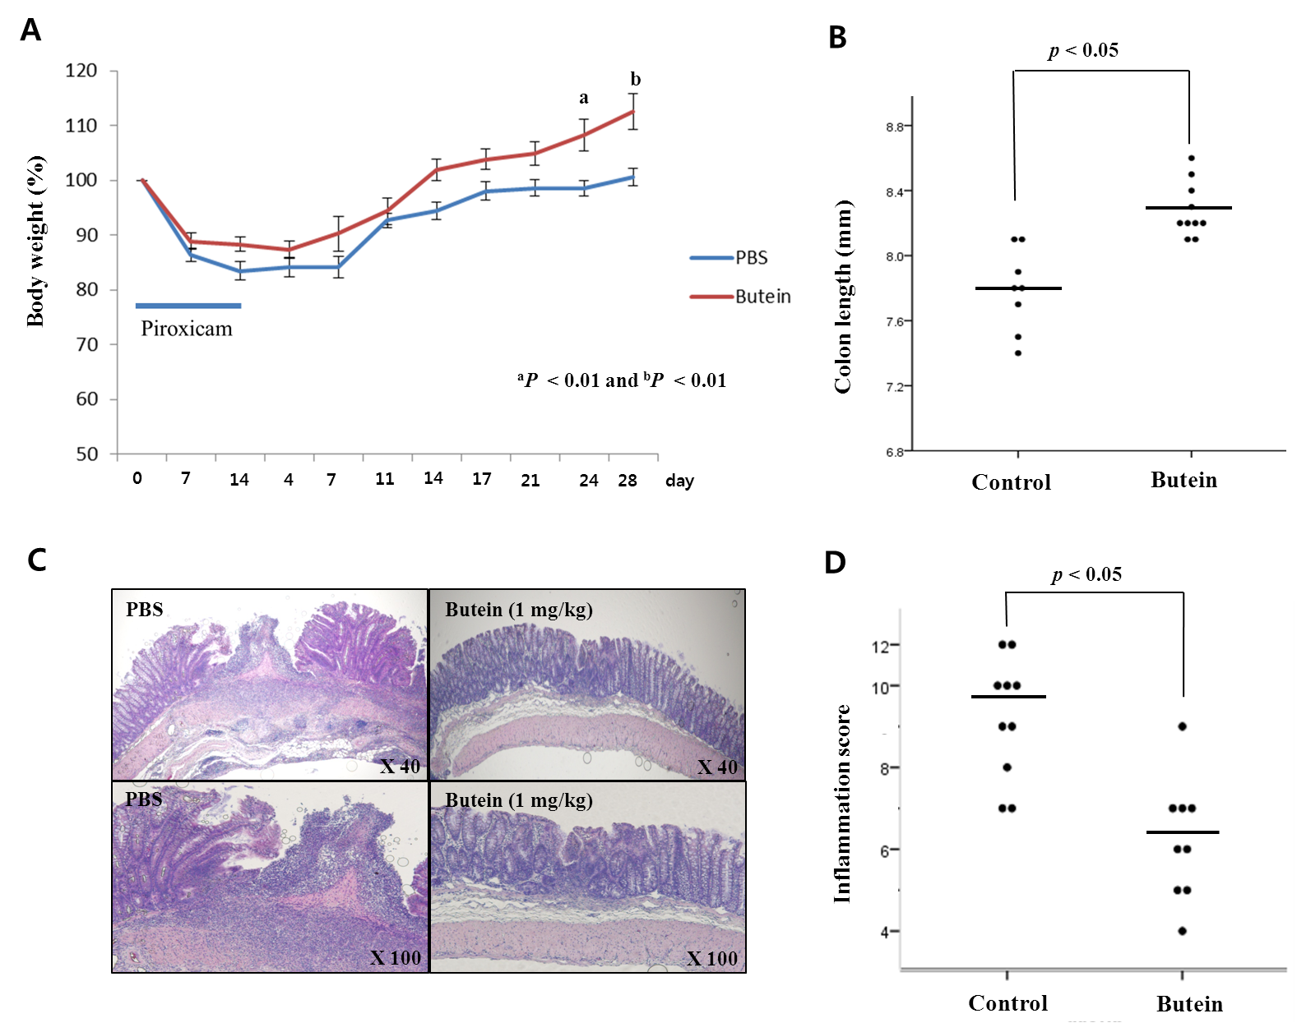

Figure 3
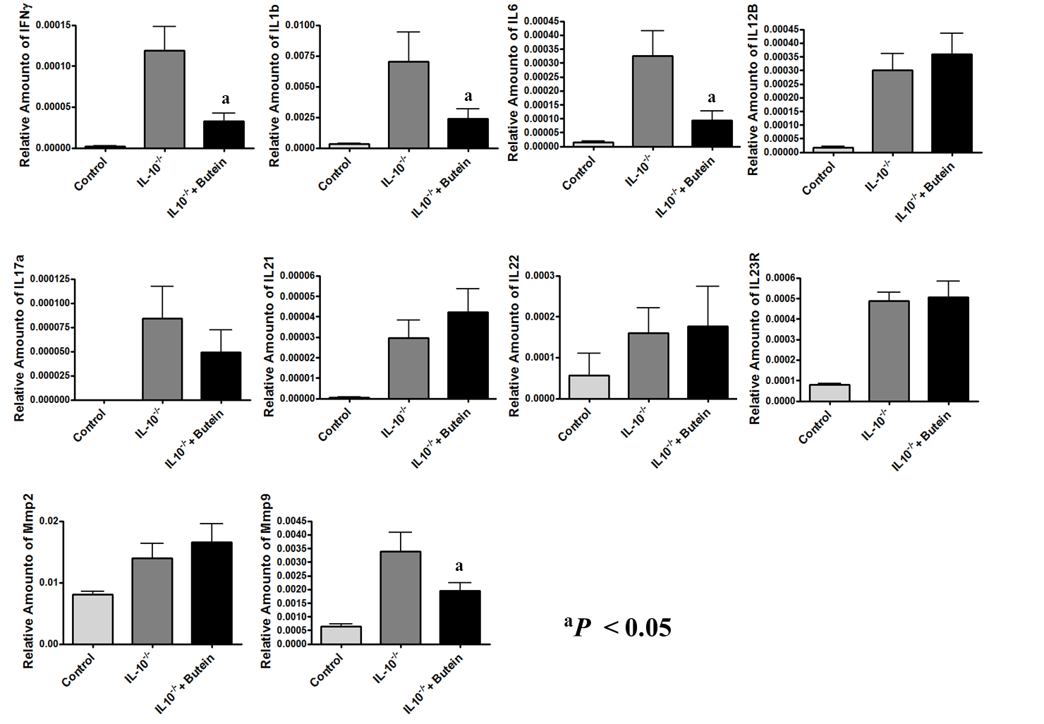
Figure 4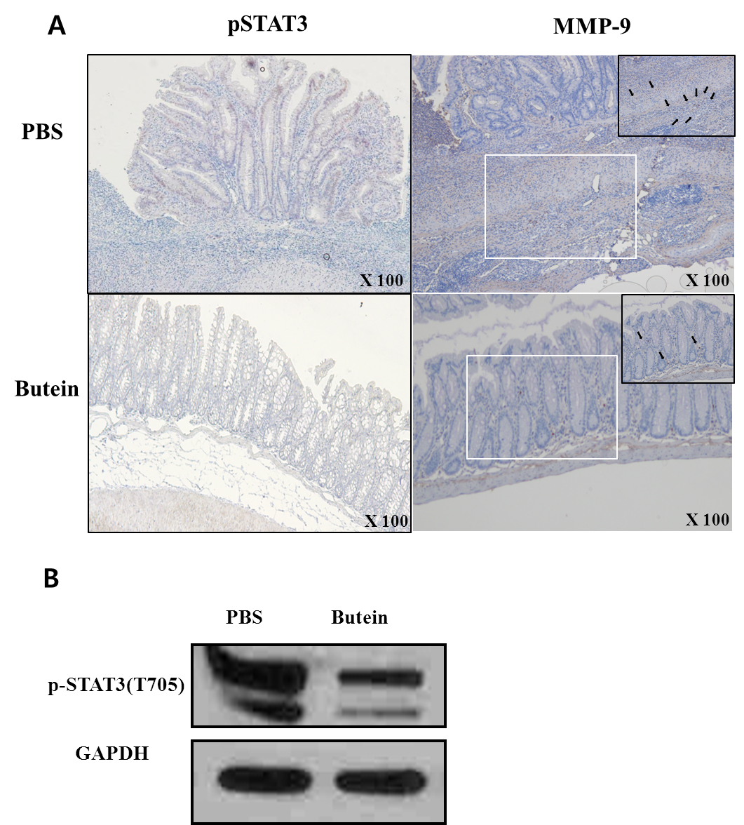

Figure 5
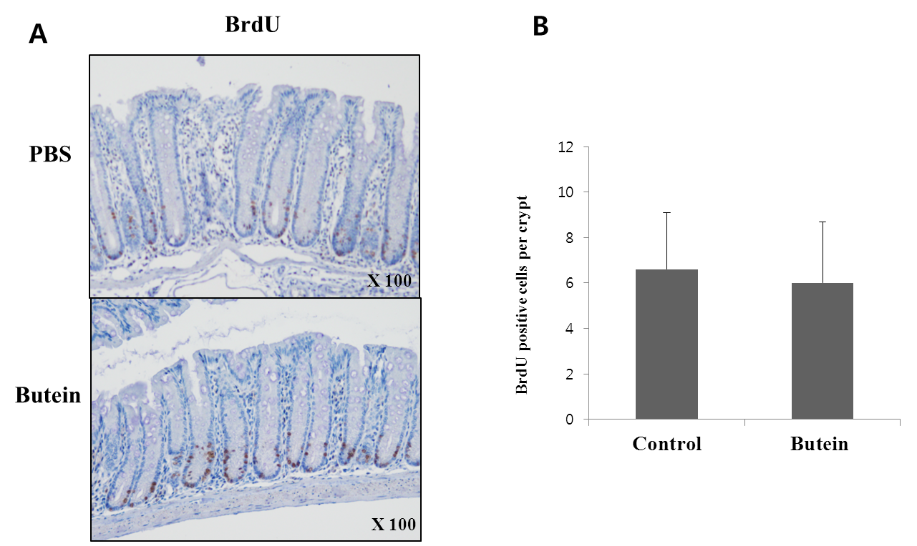

Figure 6