Name of Journal: World Journal of Gastrointestinal Oncology
Manuscript NO: 89399
Manuscript Type: ORIGINAL ARTICLE

Basic Study
CALD1 facilitates epithelial-mesenchymal transition progression in gastric cancer cells by modulating the PI3K-Akt pathway

Ma WQ et al. CALD1 facilitates EMT progression in GC

Wen-Qian Ma, Ming-Chang Miao, Ping-An Ding, Bi-Bo Tan, Wen-Bo Liu, Shuo Guo, Li-Mian Er, Zhi-Dong Zhang, Qun Zhao

Wen-Qian Ma, Shuo Guo, Li-Mian Er, Department of Endoscopy, The Fourth Hospital of Hebei Medical University, Shijiazhuang 050011, Hebei Province, China

Wen-Qian Ma, Ping-An Ding, Bi-Bo Tan, Wen-Bo Liu, Shuo Guo, Li-Mian Er, Zhi-Dong Zhang, Qun Zhao, Hebei Key Laboratory of Precision Diagnosis and Comprehensive Treatment of Gastric Cancer, Shijiazhuang 050011, Hebei Province, China

Ming-Chang Miao, Department of Radiotherapy, The Fourth Hospital of Hebei Medical University, Shijiazhuang 050011, Hebei Province, China

Ping-An Ding, Bi-Bo Tan, Wen-Bo Liu, Zhi-Dong Zhang, Qun Zhao, The Third Department of Surgery, The Fourth Hospital of Hebei Medical University, Shijiazhuang 050011, Hebei Province, China

Author contributions: Ma WQ, Tan BB, and Liu WB designed the study; Ma WQ and Liu WB wrote the manuscript; Ma WQ, Ding PA, Liu WB, and Guo S performed the experiments; Ma WQ, Miao MC, and Er LM analyzed the data; Zhang ZD and Zhao Q reviewed and edited the manuscript; all authors have read and approved the final manuscript.

Supported by The Hebei Provincial Major Science and Technology Special Project, No. 23297701Z; Beijing-Tianjin-Hebei Basic Research Cooperation Special Project, No. 22JCZXJC00140; Hebei Provincial Government-Funded Clinical Talent Project, No. ZF2023047.

Corresponding author: Qun Zhao, MD, PhD, Chief Doctor, Professor, The Third Department of Surgery, The Fourth Hospital of Hebei Medical University, No. 12 Jiankang Road, Changan District, Shijiazhuang 050011, Hebei Province, China. zhaoqun@hebmu.edu.cn

Received: November 22, 2023
Revised: December 21, 2023
Accepted: January 4, 2024
Published online:

Abstract
BACKGROUND
CALD1 has been discovered to be abnormally expressed in a variety of malignant tumors, including gastric cancer (GC), and is associated with tumor progression and immune infiltration; however, the roles and mechanisms of CALD1 in epithelial-mesenchymal transition (EMT) in GC are unknown.

AIM
To investigate the role and mechanism of CALD1 in GC progression, invasion, and migration.

METHODS
In this study, the relationship between CALD1 and GC, as well as the possible network regulatory mechanisms of CALD1, was investigated by bioinformatics and validated by experiments. CALD1-siRNA was synthesized and used to transfect GC cells. Cell activity was measured using the CCK-8 method, cell migration and invasive ability were measured using wound healing assay and Transwell assay, and the expression levels of relevant genes and proteins in each group of cells were measured using qRT-PCR and Western blot. A GC cell xenograft model was established to verify the results of in vitro experiments.

RESULTS
Bioinformatics results showed that CALD1 was highly expressed in GC tissues, and CALD1 was significantly higher in EMT-type GC tissues than in tissues of other types of GC. The prognosis of patients with high expression of CALD1 was worse than that of patients with low expression, and a prognostic model was constructed and evaluated. The experimental results were consistent with the results of the bioinformatics analysis. The expression level of CALD1 in GC cell lines was all higher than that in gastric epithelial cell line GES-1, with the strongest expression found in AGS and MKN45 cells. Cell activity was significantly reduced after CALD1-siRNA transfection of AGS and MKN45 cells. The ability of AGS and MKN45 cells to migrate and invade was reduced after CALD1-siRNA transfection, and the related mRNA and protein expression was altered. According to bioinformatics findings in GC samples, the CALD1 gene was significantly associated with the expression of members of the PI3K-AKT-mTOR signaling pathway as well as the EMT signaling pathway, and was closely related to the PI3K-Akt signaling pathway. Experimental validation revealed that upregulation of CALD1 increased the expression of PI3K, p-AKT, and p-mTOR, members of the PI3K-Akt pathway,while decreasing the expression of PTEN; PI3K-Akt inhibitor treatment decreased the expression of PI3K, p-AKT, and p-mTOR in cells overexpressing CALD1 (still higher than that in the normal group), but increased the expression of PTEN (still lower than that in the normal group). CCK-8 results revealed that the effect of CALD1 on tumor cell activity was decreased by the addition of the inhibitor. Scratch and Transwell experiments showed that the effect of CALD1 on tumor cell migration and invasion was weakened by the addition of the PI3K-Akt inhibitor. The mRNA and protein levels of EMT-related genes in AGS and MKN45 cells were greatly altered by the overexpression of CALD1, whereas the effect of overexpression of CALD1 was significantly weakened by the addition of the PI3K-Akt inhibitor. Animal experiments showed that tumour growth was slow after inhibition of CALD1, and the expression of some PI3K-Akt and EMT pathway proteins was altered.

CONCLUSION
Increased expression of CALD1 is a key factor in the progression, invasion, and metastasis of GC, which may be associated with regulating the PI3K-Akt pathway to promote EMT.

Key Words: Gastric tumor; CALD1; Epithelial-mesenchymal transition; Gene disruption; Invasion; Migration; Bioinformatics

Ma WQ, Miao MC, Ding PA, Tan BB, Liu WB, Guo S, Er LM, Zhang ZD, Zhao Q. CALD1 facilitates epithelial-mesenchymal transition in gastric cancer by modulating the PI3K-Akt pathway. World J Gastrointest Oncol 2024; In press

Core Tip: In this study, the relationship between CALD1 and gastric cancer (GC) and the possible network regulatory mechanisms of CALD1 were explored by bioinformatics methods and validated by experiments. We conducted functional analysis and verification through tissue and cell experiments, delving into possible pathways and mechanisms involved. It was showed that CALD1 may participate in the proliferation, invasion, and migration, and epithelial-mesenchymal transition (EMT)-related gene and protein expression in GC cells. Our study suggested that CALD1, through PI3K-Akt signaling pathway activation, may regulate EMT in GC cells, representing a potentially novel target for GC treatment.

INTRODUCTION
Gastric cancer (GC) is a major malignancy of the digestive tract that ranks fifth in incidence and fourth in mortality, imposing a significant societal burden^{[1,2]}. The rise in health consciousness, as well as advances in diagnostic technologies such as endoscopy and computed tomography, has improved the early detection and treatment of GC. Nonetheless, the survival rate for patients diagnosed at advanced stages is less than 40%^{[3]}, indicating a bleak prognosis. The aggressive nature of GC, which is characterized by rapid progression, increased metastatic potential, and frequent recurrence, is associated with the accelerated cell growth, robust invasiveness, and antiapoptotic properties of GC cells^{[3-6]}. It is a critical to identify precise and sensitive molecular targets, and investigate their regulatory roles in GC invasion and metastasis, in order to lay the groundwork for comprehensive, personalized treatment strategies and prognostic assessments.
The CALD1 gene encodes the Caldesmon protein, which has high and low molecular weight variants and functions as a cytoskeletal-associated protein. It is involved in cellular adhesion, cytoskeletal organization, and angiogenesis, as well as cell proliferation, apoptosis, motility, and adhesion. As a result, it may influence tumor proliferation, invasion, and metastasis^{[7-9]}. CALD1 expression is abnormal in various cancers, including GC, and it correlates with tumor stage and prognosis^{[8-13]}. In GC research, CALD1 expression has been linked with immune infiltration and prognosis, though its specific mechanisms remain unknown^{[8]}.
Tumor cells can acquire invasive mesenchymal characteristics via the epithelial-mesenchymal transition (EMT) process, resulting in increased motility and invasiveness, decreased adhesion, and altered cell polarity, all of which can lead to metastasis from the primary tumor site^{[14]}. EMT is triggered by key transcription factors such as SNAIL, and involves changes in gene expression mediated by the TGF-β, PI3K-Akt, and ERK-MAPK pathways, among others^{[15,16]}. However, the exact role and mechanism of CALD1 in GC-related EMT are unknown. Therefore, this study aimed to investigate the relationship between CALD1 and GC based on the TCGA and GEO databases. We assessed CALD1 mRNA and protein expression in GC tissues, explored the relationship between CALD1 expression and clinicopathological features, and investigated the role and mechanism of CALD1 in GC tissues and cell lines through a combination of experimental and bioinformatics approaches.

MATERIALS AND METHODS
Clinical tissue collection
This study involved 80 GC patients undergoing radical surgery from January to December 2022 at the Department of Surgery, The Fourth Hospital of Hebei Medical University. Postoperative confirmation revealed that all patients had gastric adenocarcinoma, with no preoperative treatments or concurrent secondary tumors. Uniformly sized tumors and adjacent non-tumor tissues were excised, placed in cryopreservation tubes, and stored at -80 °C in liquid nitrogen. Additionally, tissues from a previous cohort of 60 patients were included in immunohistochemical staining and follow-up studies. The Medical Ethics Committee of The Fourth Hospital of Hebei Medical University granted ethical approval, and all patients provided informed consent.

Cell culture
The human GC cell lines HGC27, NCI-N87, AGS, and MKN45, and the gastric epithelial cell line GES-1, obtained from the National Cell Resource Center of the National Biomedical Resource, were maintained in RPMI-1640 medium supplemented with 10% fetal bovine serum, 100 U/mL penicillin, and 100 μg/mL streptomycin, in a humidified 37 °C incubator with 5% CO₂. Cell growth and sterility were monitored daily, with medium changes every 1-2 d. For cell detachment for passage or subsequent experiments, 0.25% trypsin was used.

Cell transfection
Single-cell suspensions at a density of 1 × 10⁶ cells/mL were prepared, seeded into 6-well plates, and cultured. siRNA and overexpression plasmids were used to transfect cells using Lipofectamine 2000 according to the manufacturer's instructions. CALD1-shRNA obtained from a gene pharmaceutical company in Shanghai, China was used for CALD1 knockdown. For overexpression, lentiviral particles were produced by co-transfecting plasmids psPAX2, pMD2G, and pcDNA3.1/CALD1 into 293T cells and harvested 48 h post-transfection. The PI3K-Akt inhibitor from Sigma was used according to the manufacturer's instructions.

Immunohistochemical staining
Paraffin-embedded GC tumor and adjacent tissue specimens were sectioned at 4 μm, deparaffinized, and underwent antigen retrieval. Immunohistochemical staining was done according to the kit instructions, and the results were evaluated by board-certified pathologists. The scoring system considered the percentage of positive cells and staining intensity to calculate the cumulative score.

Western blot analysis for target protein expression
Cells were harvested and lysed for protein extraction, and the bicinchoninic acid method was used to quantify protein concentrations. Proteins were denatured, separated using SDS-PAGE, and transferred to PVDF membranes. Membranes were blocked and then incubated with primary and secondary antibodies before being imaged with the Odyssey dual-color infrared fluorescence scanning system. Relative protein expression was assessed by comparing grayscale values, with β-actin serving as an internal reference. This procedure was repeated three times.

RNA extraction and RT-qPCR analysis
Total RNA was extracted using Trizol, quantified, and reverse-transcribed into cDNA. qPCR amplification was performed according to the manufacturer's instructions, and mRNA expression levels were calculated using the 2^{-ΔΔCt} method.

Cell viability assessment via CCK-8 assay
Cells were seeded in 96-well plates and incubated for 48 h. CCK-8 reagent was added at different time points. After incubation, the optical density at 450 nm was measured using a microplate reader.

Cell scratch assay
After seeding single-cell suspensions in 24-well plates and allowing cells to reach confluence, cell transfection was performed. Once the cells were confluent, a scratch was made, followed by washing, serum-free medium addition, and microscopic examination at 0 and 48 h post-scratch.

Transwell invasion assay
Single-cell suspensions were seeded into Transwell chambers in a 24-well plate. After 24 h, cells on the inner surface were removed, fixed, stained, and examined under an inverted phase-contrast microscope.

GC cell xenograft model establishment
Single-cell suspensions of lentivirus-infected cells were subcutaneously injected into BALB/c nude mice. Tumor growth was tracked, and tumors were dissected for analysis at the end of the experiment.

Bioinformatics analysis
Various bioinformatics analyses were performed, including gene set enrichment analysis, protein-protein interaction (PPI) network analysis, differential gene expression enrichment analysis, Pearson correlation analysis, and Cox proportional hazards model analysis. The goal of these analyese was to determine the effect of CALD1 expression on survival and to create a predictive nomogram.

Statistical analysis
Statistical analyses were performed using IBM SPSS statistical software version 25.0. The t-test, one-way ANOVA, and Kaplan-Meier method were used for data comparisons and survival curve generation. The data are presented as the mean ± SD.

RESULTS
Analysis of CALD1 expression in GC revealed its higher levels in GC cases, particularly in the EMT subtype, according to the Asian Cancer Research Group (ACRG) classification (Figure 1A). Patients with higher levels of CALD1 expression had a worse prognosis than those with lower levels (Figure 1B). A prognostic model that included age, gender, and CALD1 expression, was developed and validated for accuracy using a calibration curve (Figure 1C). Immunohistochemical analysis revealed increased CALD1 protein expression in GC tissues compared to adjacent non-cancerous tissues in a subset of 60 cases (Figure 1D). Both CALD1 mRNA and protein levels were significantly higher in the EMT subtype of GC, as demonstrated by qPCR and Western blot in 20 cases (Figure 1E), and high expression was associated with a poor prognosis in another subset of 60 cases (Figure 1F).
Inhibition of CALD1 reduced proliferation, invasion, and migration in GC cells. Among the various cell lines tested, AGS and MKN45 had significantly higher CALD1 expression and were chosen for further investigation (Figure 2A). CALD1-siRNA had a significant inhibitory effect in these cell lines (Figure 2B). Post-transfection, there was a significant decrease in cell activity, migration, and invasion (Figure 2C). CALD1 inhibition also increased E-cadherin and Claudin-1 expression while decreasing N-cadherin, Vimentin, and Dickkop-1 (DKK-1) mRNA and protein levels, as confirmed by RT-qPCR and Western blot (Figure 2D).
Bioinformatics analysis revealed significant associations of CALD1 with the PI3K-Akt-mTOR and EMT signaling pathways in GC samples (Figure 3A). PPI network analysis revealed multiple proteins that interact with CALD1 (Figure 3B). GO and KEGG enrichment analyses revealed that CALD1 was involved in a network of various biological processes that include protein kinase B signaling and protein tyrosine kinase activity (Figure 3C). Single-cell data showed high CALD1 expression in fibroblasts, as evidenced by bulk data analysis, which revealed a positive correlation between CALD1 and fibroblast surface molecule expression (Figure 3D).
Additional studies confirmed the role of CALD1 in enhancing GC cell proliferation, invasion, and migration via the PI3K-Akt pathway. Western blot analysis revealed that CALD1 overexpression increased PI3K, p-AKT, and p-mTOR expression, while decreasing PTEN expression. However, integrating CALD1 overexpression with PI3K-Akt pathway inhibition moderated these effects (Figure 4A). The CCK-8 assay results showed that the effect of CALD1 on tumor cell activity was reduced after the addition of a PI3K-Akt inhibitor (Figure 4B). Scratch and Transwell assays revealed that CALD1 had a reduced impact on cell migration and invasion after inhibitor treatment (Figure 4C). In AGS and MKN45 cells, CALD1 overexpression altered the expression of EMT-related genes and proteins, an effect that was mitigated by the PI3K-Akt inhibitor (Figure 4D).
In an animal model, CALD1 inhibition led to reduced tumor growth in nude mice. Tumors derived from CALD1-shRNA-transfected cells were significantly lighter and smaller than those in the control group (P < 0.05), as shown by Western blot analysis, which also revealed changes in EMT-related protein expression (Figure 5A and B), thus demonstrating the suppressive effect of CALD1 inhibition on GC tumor growth.

DISCUSSION
GC is a complex, multifaceted disease that progresses through multiple steps and stages, with tumor invasion and metastasis playing important roles in the high mortality rates observed in advanced stages of GC^{[3-6]}. It is critical to comprehend the underlying mechanisms of GC development. Identifying molecules integral to its initiation and progression, as well as discovering specific and sensitive molecular targets, is critical to improve diagnosis, comprehensive treatment, and prognostic evaluation. This is especially important for patients with unresectable GC who are not candidates for surgical intervention.
The ACRG divides GC into distinct molecular subtypes: MSS/EMT, MSS/TP53+, MSI/TP53+, and MSS/TP53-. Each subtype is associated with varying prognostic outcomes, with the MSS/EMT subtype being linked to the poorest prognosis^{[17]}.
Our study employed bioinformatics analysis to establish that CALD1 is significantly overexpressed in GC compared to normal tissues. Further investigation, consistent with the ACRG molecular classification, revealed significantly higher expression of CALD1 in the EMT subtype of GC than in other subtypes. Futhermore, increased CALD1 expression was linked to a worse prognosis, implying a role for CALD1 in the progression of EMT-subtype GC. This suggests the role of CALD1 in the development of aggressive EMT-subtype GC. To substantiate these observations, we procured GC and adjacent normal tissue samples for bioinformatics analysis, which corroborated our initial findings. The correlation of high CALD1 expression with poorer patient outcomes implicates its significant role in GC progression.
Further validation using qPCR experiments showed increased CALD1 expression in GC cell lines compared to gastric epithelial cell lines. Functional assays, including CCK-8, scratch, and Transwell assays, revealed that siRNA-mediated CALD1 knockdown significantly reduced cell viability, migration, and invasion. This demonstrates a strong link between CALD1 and GC cell activity, invasion, and metastasis, emphasizing its critical role in the initiation and progression of GC.
It is well-established that the progression of GC is closely associated with the EMT process in GC cells. EMT, which is triggered by various genes and pathways, allows GC cells to switch from an epithelial to a more aggressive mesenchymal phenotype, thereby facilitating tumor progression^{[18]}. This process involves the downregulation of epithelial cell markers and the upregulation of mesenchymal cell markers, both of which are important factors promoting tumor metastasis^{[19,20]}.
In our investigation, CALD1 expression inhibition in AGS and MKN45 cells, specifically, resulted in increased expression of epithelial cell markers (E-cadherin and Claudin-1), decreased expression of mesenchymal cell markers (N-cadherin, Vimentin, and DKK-1), and decreased tumor invasion, migration, and EMT-related mRNA and protein levels. Animal experiments confirmed these findings, demonstrating delayed tumor formation, decreased tumor volume and weight, and corresponding changes in cell marker expressions in response to CALD1 inhibition, implying that CALD1 inhibition could impede GC growth and that CALD1 may contribute to GC invasion and metastasis by modulating EMT-related genes and proteins. These results also underscore the pivotal role of CALD1 in promoting GC progression and metastasis, highlighting its potential as a therapeutic target for GC.
CALD1, which is found at 7q33, encodes the Caldesmon protein, which exists in two isoforms with different molecular weights and cellular origins. Caldesmon has diverse roles in cellular processes such as migration, invasion, and proliferation by regulating actin cytoskeleton remodeling^{[8,9,21,22]}. Previous research has linked CALD1 to tumor angiogenesis^{[13]}, and its aberrant expression has been observed in various solid tumors^{[8,9,12,13,23-25]}, notably in extensive studies on bladder cancer^{[9,12]}. However, the precise mechanisms and pathways of CALD1 function remain unclear. In this study, we undertook functional analyses and validations using tissue and cell experiments to explore its pathways and mechanisms.
Using bioinformatics analysis, the PPI network of CALD1 was established and GO and KEGG data analysis was performed, revealing CALD1 enrichment in the PI3K-Akt signaling pathway, which is known for its significant influence on GC development. Previous research has shown that the PI3K-Akt signaling pathway is significantly implicated in the onset and progression of GC. This pathway contributes to the advancement of GC by inhibiting apoptosis, metastasis, EMT, and angiogenesis^{[26-31]}. To verify CALD1's involvement in this pathway, we chose HGC27 cells, which exhibit low CALD1 expression, for overexpression experiments. These experiments were conducted both independently and in combination with PI3K-Akt pathway inhibition. Our results indicated that CALD1 upregulation enhanced expression of PI3K-Akt pathway members, PI3K, p-AKT, and p-mTOR, reduced PTEN expression, and promoted cell viability, migration, and invasion. These effects were mitigated post pathway inhibitor addition, but there are still differences compared with the control group. The congruence between bioinformatics analysis and cell experiment results suggests that CALD1 may regulate the EMT process in GC cells through the activation of the PI3K-Akt signaling pathway. This activation potentially enhances the activity and invasive capabilities of these cells. Consequently, CALD1 emerges as a potential novel target for GC therapy, offering promising avenues for the development of new treatment strategies aimed at targeting this pathway to curb the aggressiveness of GC. Our bioinformatics analysis also underscored significant CALD1 expression in fibroblasts, the bulk dataset analysis showed that CALD1 was significantly positively correlated with the surface molecular expression in fibroblasts, which, alongside literature, suggests a potential interaction between CALD1 and fibroblasts in GC^{[32,33]}, necessitating further thorough investigation. The specific mechanism of action between CALD1 and fibroblasts in GC can be further studied as a subsequent research direction.
However, our study has limitations. Although the study suggests that CALD1 is involved in EMT and the PI3K-Akt pathway, the exact molecular mechanisms remain unknown, and its role in the tumor microenvironment requires further exploration. Further research needs more patients to be included to verify the conclusions obtained in this study.

CONCLUSION
In summary, our findings show that CALD1 is upregulated in GC tissues and cell lines, and that high CALD1 expression is associated with a poor prognosis in GC patients. Alterations in CALD1 expression result in changes in cell activity, invasion, migration, and the expression of EMT-related genes and proteins. The PI3K-Akt signaling pathway was discovered to be a key mediator of CALD1's effects. Our study suggests that CALD1 may regulate EMT in GC cells by activating the PI3K-Akt signaling pathway and increasing their invasive properties, representing a potential novel target for GC therapy (Figure 6).

ARTICLE HIGHLIGHTS
Research background
CALD1 is known for its abnormal expression in various malignant tumors, and this expression is linked to tumor growth and immune system infiltration. However, the specific functions and underlying mechanisms of CALD1 in the epithelial-mesenchymal transition (EMT) process in gastric cancer (GC) remain unclear.

Research motivation
The motivation behind this research is to explore and better comprehend how CALD1 functions in the context of GC.

Research objectives
This study aimed to investigate the role and mechanism of CALD1 in GC progression, invasion, and migration.

Research methods
In this study, the relationship between CALD1 and GC, as well as the possible network regulatory mechanisms of CALD1, was investigated by bioinformatics and validated by experiments. CALD1-siRNA was synthesized and used to transfect GC cells. Cell activity was measured using the CCK-8 method, cell migration and invasive ability were measured using wound healing assay and Transwell assay, and the expression levels of relevant genes and proteins in each group of cells were measured using qRT-PCR and Western blot. A GC cell xenograft model was established to verify the results of in vitro experiments..

Research results
The bioinformatics analysis revealed that CALD1 expression was significantly elevated in GC tissues, particularly in the EMT type. Additionally, the CALD1 gene was found to be associated with the PI3K-Akt signaling pathway and other EMT components. Compared to gastric epithelial cell lines, GC cell lines showed higher levels of CALD1 expression. Suppressing CALD1 and the PI3K-Akt pathway resulted in reduced viability, invasion, and migration of GC cells. These experimental findings elucidate the role of CALD1 and the PI3K-Akt pathway in GC, laying a foundation for further molecular mechanism studies of this disease.

Research conclusions
By influencing the PI3K-Akt pathway, CALD1 plays a pivotal role in advancing the EMT in GC.

Research perspectives
This study, through bioinformatics analysis, as well as in vivo and in vitro experiments, has confirmed that CALD1 promotes the EMT in GC by affecting the PI3K-Akt signaling pathways. These findings underscore its significance in tumor progression and potential as a target for future therapeutic approaches. However, the investigation into the regulatory function of these pathways in this research was not comprehensive, leaving the full mechanism of action somewhat unclear. To validate the study's conclusions more robustly, further research involving a larger patient cohort is necessary.

REFERENCES
1 Sung H, Ferlay J, Siegel RL, Laversanne M, Soerjomataram I, Jemal A, Bray F. Global Cancer Statistics 2020: GLOBOCAN Estimates of Incidence and Mortality Worldwide for 36 Cancers in 185 Countries. CA Cancer J Clin 2021; 71: 209-249 [PMID: 33538338 DOI: 10.3322/caac.21660]
2 Bray F, Ferlay J, Soerjomataram I, Siegel RL, Torre LA, Jemal A. Global cancer statistics 2018: GLOBOCAN estimates of incidence and mortality worldwide for 36 cancers in 185 countries. CA Cancer J Clin 2018; 68: 394-424 [PMID: 30207593 DOI: 10.3322/caac.21492]
3 Van Cutsem E, Sagaert X, Topal B, Haustermans K, Prenen H. Gastric cancer. Lancet 2016; 388: 2654-2664 [PMID: 27156933 DOI: 10.1016/S0140-6736(16)30354-3]
4 Allemani C, Matsuda T, Di Carlo V, Harewood R, Matz M, Nikšić M, Bonaventure A, Valkov M, Johnson CJ, Estève J, Ogunbiyi OJ, Azevedo E Silva G, Chen WQ, Eser S, Engholm G, Stiller CA, Monnereau A, Woods RR, Visser O, Lim GH, Aitken J, Weir HK, Coleman MP; CONCORD Working Group. Global surveillance of trends in cancer survival 2000-14 (CONCORD-3): analysis of individual records for 37 513 025 patients diagnosed with one of 18 cancers from 322 population-based registries in 71 countries. Lancet 2018; 391: 1023-1075 [PMID: 29395269 DOI: 10.1016/S0140-6736(17)33326-3]
5 Zhang L, Kang W, Lu X, Ma S, Dong L, Zou B. LncRNA CASC11 promoted gastric cancer cell proliferation, migration and invasion in vitro by regulating cell cycle pathway. Cell Cycle 2018; 17: 1886-1900 [PMID: 30200804 DOI: 10.1080/15384101.2018.1502574]
6 Chen W, Huang S, Fan X, Gao Y. Human Epidermal Growth Factor Receptor 2 Targeting Specific T Cells Immunotherapy for Gastric Cancer. J Mod Med Oncol, 2023; 3: 7 [DOI: 10.53964/jmmo.2023007]
7 Meola J, Hidalgo Gdos S, Silva JC, Silva LE, Paz CC, Ferriani RA. Caldesmon: new insights for diagnosing endometriosis. Biol Reprod 2013; 88: 122 [PMID: 23575144 DOI: 10.1095/biolreprod.112.103598]
8 Liu Y, Xie S, Zhu K, Guan X, Guo L, Lu R. CALD1 is a prognostic biomarker and correlated with immune infiltrates in gastric cancers. Heliyon 2021; 7: e07257 [PMID: 34189308 DOI: 10.1016/j.heliyon.2021.e07257]
9 Li C, Yang F, Wang R, Li W, Maskey N, Zhang W, Guo Y, Liu S, Wang H, Yao X. CALD1 promotes the expression of PD-L1 in bladder cancer via the JAK/STAT signaling pathway. Ann Transl Med 2021; 9: 1441 [PMID: 34733993 DOI: 10.21037/atm-21-4192]
10 Zheng H, Bai Y, Wang J, Chen S, Zhang J, Zhu J, Liu Y, Wang X. Weighted Gene Co-expression Network Analysis Identifies CALD1 as a Biomarker Related to M2 Macrophages Infiltration in Stage III and IV Mismatch Repair-Proficient Colorectal Carcinoma. Front Mol Biosci 2021; 8: 649363 [PMID: 33996905 DOI: 10.3389/fmolb.2021.649363]
11 Cheng Q, Tang A, Wang Z, Fang N, Zhang Z, Zhang L, Li C, Zeng Y. CALD1 Modulates Gliomas Progression via Facilitating Tumor Angiogenesis. Cancers (Basel) 2021; 13 [PMID: 34070840 DOI: 10.3390/cancers13112705]
12 Du Y, Jiang X, Wang B, Cao J, Wang Y, Yu J, Wang X, Liu H. The cancer-associated fibroblasts related gene CALD1 is a prognostic biomarker and correlated with immune infiltration in bladder cancer. Cancer Cell Int 2021; 21: 283 [PMID: 34051818 DOI: 10.1186/s12935-021-01896-x]
13 Alnuaimi AR, Nair VA, Malhab LJB, Abu-Gharbieh E, Ranade AV, Pintus G, Hamad M, Busch H, Kirfel J, Hamoudi R, Abdel-Rahman WM. Emerging role of caldesmon in cancer: A potential biomarker for colorectal cancer and other cancers. World J Gastrointest Oncol 2022; 14: 1637-1653 [PMID: 36187394 DOI: 10.4251/wjgo.v14.i9.1637]
14 Lan Q, Tan X, He P, Li W, Tian S, Dong W. TRIM11 Promotes Proliferation, Migration, Invasion and EMT of Gastric Cancer by Activating β-Catenin Signaling. Onco Targets Ther 2021; 14: 1429-1440 [PMID: 33658804 DOI: 10.2147/OTT.S289922]
15 Peinado H, Olmeda D, Cano A. Snail, Zeb and bHLH factors in tumour progression: an alliance against the epithelial phenotype? Nat Rev Cancer 2007; 7: 415-428 [PMID: 17508028 DOI: 10.1038/nrc2131]
16 Lamouille S, Xu J, Derynck R. Molecular mechanisms of epithelial-mesenchymal transition. Nat Rev Mol Cell Biol 2014; 15: 178-196 [PMID: 24556840 DOI: 10.1038/nrm³758]
17 Yoon JY, Sy K, Brezden-Masley C, Streutker CJ. Histo- and immunohistochemistry-based estimation of the TCGA and ACRG molecular subtypes for gastric carcinoma and their prognostic significance: A single-institution study. PLoS One 2019; 14: e0224812 [PMID: 31790410 DOI: 10.1371/journal.pone.0224812]
18 Williams ED, Gao D, Redfern A, Thompson EW. Controversies around epithelial-mesenchymal plasticity in cancer metastasis. Nat Rev Cancer 2019; 19: 716-732 [PMID: 31666716 DOI: 10.1038/s41568-019-0213-x]
19 Polyak K, Weinberg RA. Transitions between epithelial and mesenchymal states: acquisition of malignant and stem cell traits. Nat Rev Cancer 2009; 9: 265-273 [PMID: 19262571 DOI: 10.1038/nrc2620]
20 Thiery JP. Epithelial-mesenchymal transitions in tumour progression. Nat Rev Cancer 2002; 2: 442-454 [PMID: 12189386 DOI: 10.1038/nrc822]
21 Mayanagi T, Sobue K. Diversification of caldesmon-linked actin cytoskeleton in cell motility. Cell Adh Migr 2011; 5: 150-159 [PMID: 21350330 DOI: 10.4161/cam.5.2.14398]
22 Thorsen K, Sørensen KD, Brems-Eskildsen AS, Modin C, Gaustadnes M, Hein AM, Kruhøffer M, Laurberg S, Borre M, Wang K, Brunak S, Krainer AR, Tørring N, Dyrskjøt L, Andersen CL, Orntoft TF. Alternative splicing in colon, bladder, and prostate cancer identified by exon array analysis. Mol Cell Proteomics 2008; 7: 1214-1224 [PMID: 18353764 DOI: 10.1074/mcp.M700590-MCP200]
23 Al Saleh S, Al Mulla F, Luqmani YA. Estrogen receptor silencing induces epithelial to mesenchymal transition in human breast cancer cells. PLoS One 2011; 6: e20610 [PMID: 21713035 DOI: 10.1371/journal.pone.0020610]
24 Nalluri SM, O'Connor JW, Virgi GA, Stewart SE, Ye D, Gomez EW. TGFβ1-induced expression of caldesmon mediates epithelial-mesenchymal transition. Cytoskeleton (Hoboken) 2018; 75: 201-212 [PMID: 29466836 DOI: 10.1002/cm.21437]
25 Zhang L, Liu J, Wang X, Li Z, Zhang X, Cao P, She X, Dai Q, Tang J, Liu Z. Upregulation of cytoskeleton protein and extracellular matrix protein induced by stromal-derived nitric oxide promotes lung cancer invasion and metastasis. Curr Mol Med 2014; 14: 762-771 [PMID: 25056538 DOI: 10.2174/1566524014666140724103147]
26 Baghery Saghchy Khorasani A, Pourbagheri-Sigaroodi A, Pirsalehi A, Safaroghli-Azar A, Zali MR, Bashash D. The PI3K/Akt/mTOR signaling pathway in gastric cancer; from oncogenic variations to the possibilities for pharmacologic interventions. Eur J Pharmacol 2021; 898: 173983 [PMID: 33647255 DOI: 10.1016/j.ejphar.2021.173983]
27 Wang YY, Zhou YQ, Xie JX, Zhang X, Wang SC, Li Q, Hu LP, Jiang SH, Yi SQ, Xu J, Cao H, Zhao EH, Li J. MAOA suppresses the growth of gastric cancer by interacting with NDRG1 and regulating the Warburg effect through the PI3K/AKT/mTOR pathway. Cell Oncol (Dordr) 2023; 46: 1429-1444 [PMID: 37249744 DOI: 10.1007/s13402-023-00821-w]
28 Wang Z, Lv J, Li X, Lin Q. The flavonoid Astragalin shows anti-tumor activity and inhibits PI3K/AKT signaling in gastric cancer. Chem Biol Drug Des 2021; 98: 779-786 [PMID: 34396710 DOI: 10.1111/cbdd.13933]
29 Chen W, Zhang Y, Gu X, Qian P, Liu W, Shu P. Qi Ling decoction reduces gastric cancer cell metastasis by inhibiting MMP-9 through the PI3K/Akt signaling pathway. Am J Transl Res 2021; 13: 4591-4602 [PMID: 34150039]
30 Dai J, Liu D, Chen L, Sun L. Effect of Ag-1031 on apoptosis in gastric cancer AGS cells and its effects on the PI3K/AKT/mTOR signaling pathway. Biotechnol Lett 2020; 42: 2447-2452 [PMID: 32651704 DOI: 10.1007/s10529-020-02954-6]
31 Sun D, Zhang M, Wei M, Wang Z, Qiao W, Liu P, Zhong X, Liang Y, Chen Y, Huang Y, Yu W. Ox-LDL-mediated ILF3 overexpression in gastric cancer progression by activating the PI3K/AKT/mTOR signaling pathway. Aging (Albany NY) 2022; 14: 3887-3909 [PMID: 35507914 DOI: 10.18632/aging.204051]
32 Zhao Z, Zhu Y. FAP, CD10, and GPR77-labeled CAFs cause neoadjuvant chemotherapy resistance by inducing EMT and CSC in gastric cancer. BMC Cancer 2023; 23: 507 [PMID: 37277751 DOI: 10.1186/s12885-023-11011-0]
33 Zhang C, Sun D, Li C, Liu Y, Zhou Y, Zhang J. Development of cancer-associated fibroblasts subtype and prognostic model in gastric cancer and the landscape of tumor microenvironment. Int J Biochem Cell Biol 2022; 152: 106309 [PMID: 36174922 DOI: 10.1016/j.biocel.2022.106309]

Footnotes
Institutional review board statement: The study was approved by the Ethics Committee of the Fourth Hospital of Hebei Medical University.

Conflict-of-interest statement: The authors declare that they have no competing interests to disclose.

Data sharing statement: The datasets used and analyzed during the current study are available from the corresponding author on reasonable request.

Open-Access: This article is an open-access article that was selected by an in-house editor and fully peer-reviewed by external reviewers. It is distributed in accordance with the Creative Commons Attribution NonCommercial (CC BY-NC 4.0) license, which permits others to distribute, remix, adapt, build upon this work non-commercially, and license their derivative works on different terms, provided the original work is properly cited and the use is non-commercial. See: https://creativecommons.org/Licenses/by-nc/4.0/

Provenance and peer review: Unsolicited article; Externally peer reviewed.
Peer-review model: Single blind

Peer-review started: November 22, 2023
First decision: December 8, 2023
Article in press:

Specialty type: Gastroenterology & hepatology
Country/Territory of origin: China
Peer-review report’s scientific quality classification
Grade A (Excellent): 0
Grade B (Very good): B
Grade C (Good): C
Grade D (Fair): 0
Grade E (Poor): 0

P-Reviewer: de Assumpcao PP, Brazil; Petrillo A, Italy S-Editor: Gong ZM L-Editor: Wang TQ P-Editor:

Figure Legends
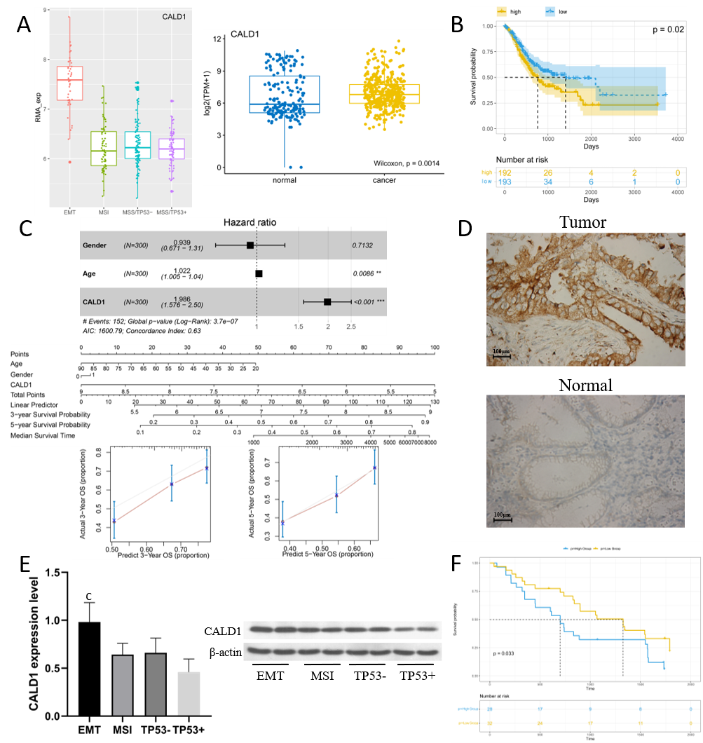
Figure 1 CALD1 overexpression in gastric cancer: Correlation with epithelial-mesenchymal transition type, prognostic implications, and enhanced protein expression in tissues. A: Bioinformatics results showed that CALD1 was highly expressed in gastric cancer (GC), and CALD1 in GC tissues of epithelial-mesenchymal transition (EMT) type was significantly higher than that in GC tissues of other types; B and C: Patients with high expression of CALD1 had a poorer prognosis than those with low expression, and a prognostic model was constructed and evaluated; D: Validation experiment showed that the protein expression of CALD1 in GC tissues was enhanced compared with that in paracancerous tissues (60 cases); E: CALD1 mRNA (qPCR) and protein (Western blot) in EMT-type GC tissues were significantly higher than those of other types (20 cases); F: Patients with high CALD1 expression had a poorer prognosis than those with low expression (60 cases). ^{c}P < 0.001.

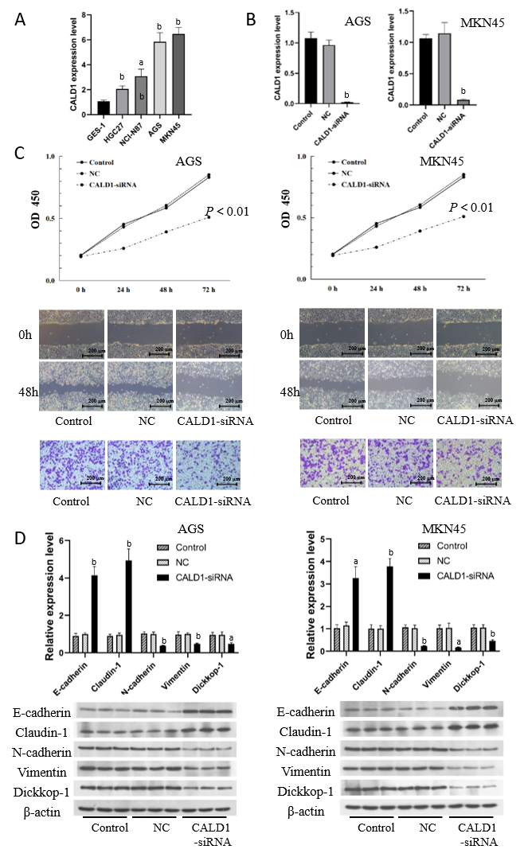
Figure 2 Inhibition of CALD1 in gastric cancer cell lines reduces cell activity, migration, and invasion, and alters epithelial-mesenchymal transition marker expression. A: CALD1 expression levels were higher in gastric cancer cell lines HGC27, NCI-N87, AGS, and MKN45 than in gastric epithelial cell line GES-1, with the strongest expression found in AGS and MKN45 cells; B: The inhibitory effect of CALD1-siRNA was verified; C: After transfection of AGS and MKN45 cells with CALD1-siRNA, cell activity was significantly reduced, and the migration and invasion ability was decreased; D: The expression of E-cadherin and Claudin-1 was increased in AGS and MKN45 cells after inhibiting the expression of CALD1, while the expression of N-cadherin, Vimentin, and Dickkop-1 mRNA and protein was decreased. ªP < 0.05, ^{b}P < 0.01.

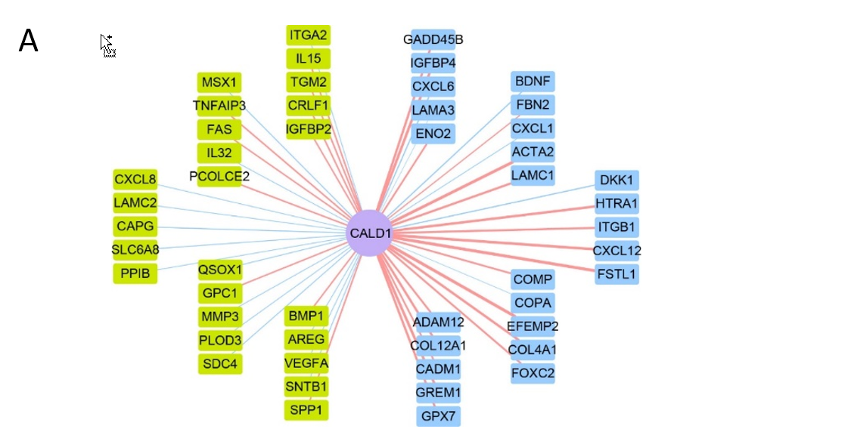
B
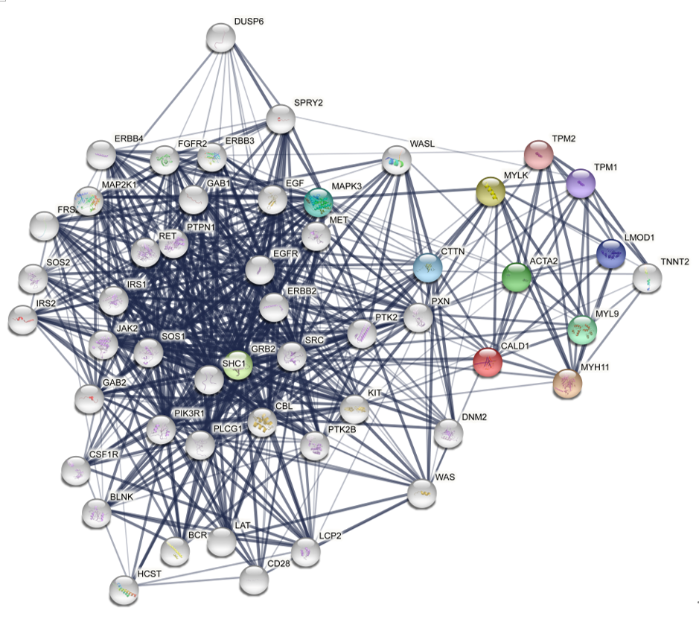
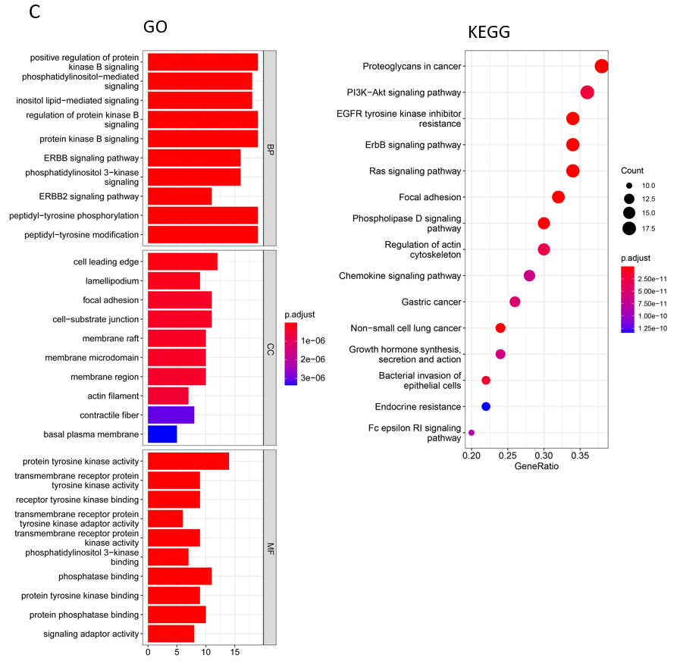
D
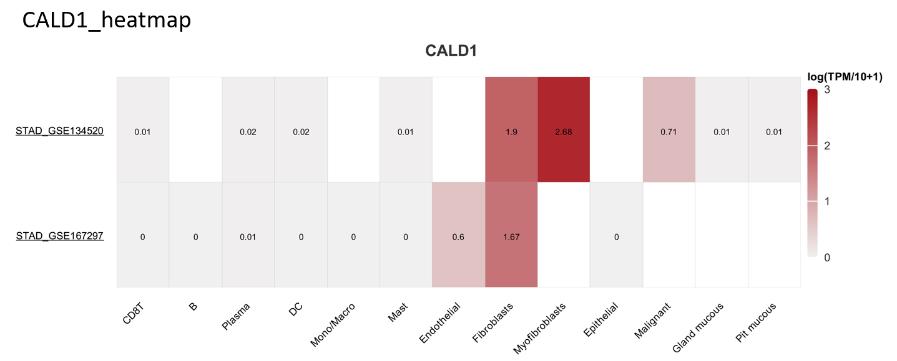
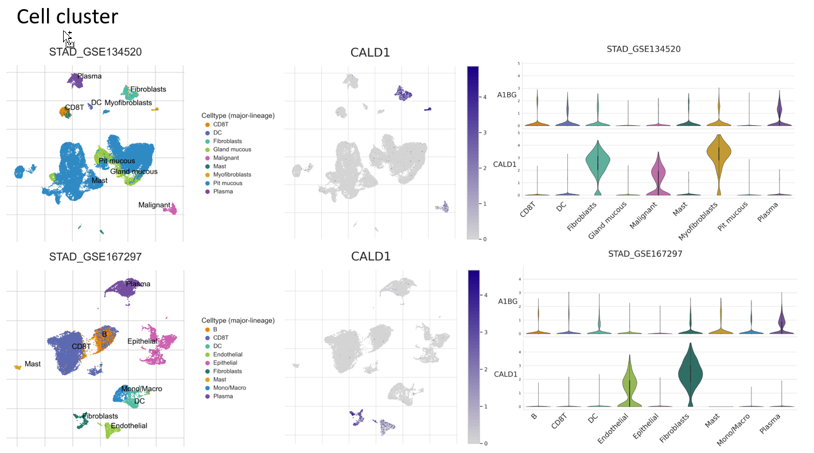
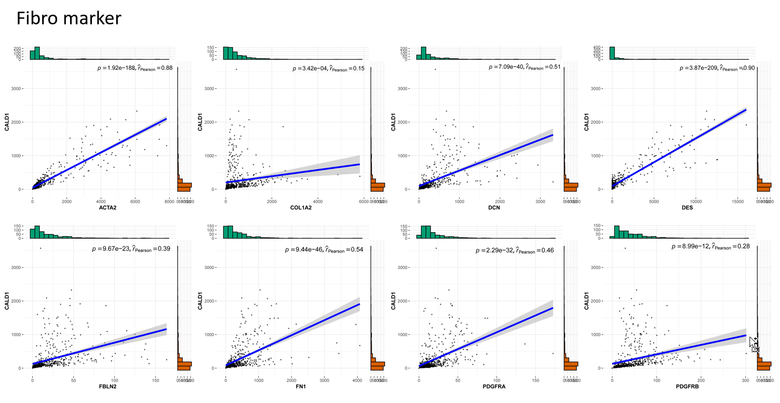
Figure 3 CALD1 gene is associated with PI3K-Akt-mTOR and epithelial-mesenchymal transition pathways in gastric cancer: Insights from bioinformatics and protein interaction studies. A: Bioinformatics results showed that the CALD1 gene was significantly associated with the expression of members in the PI3K-Akt-mTOR signaling pathway as well as the epithelial-mesenchymal transition signaling pathway in gastric cancer; B: PPI network analysis of CALD1 showed that it interacts with a variety of proteins; C: GO and KEGG enrichment analyses showed that CALD1 was closely associated with the PI3K-Akt signaling pathway; D: In-depth analysis revealed that CALD1 was highly expressed in fibroblasts and was significantly positively correlated with the expression of fibroblast surface molecules.

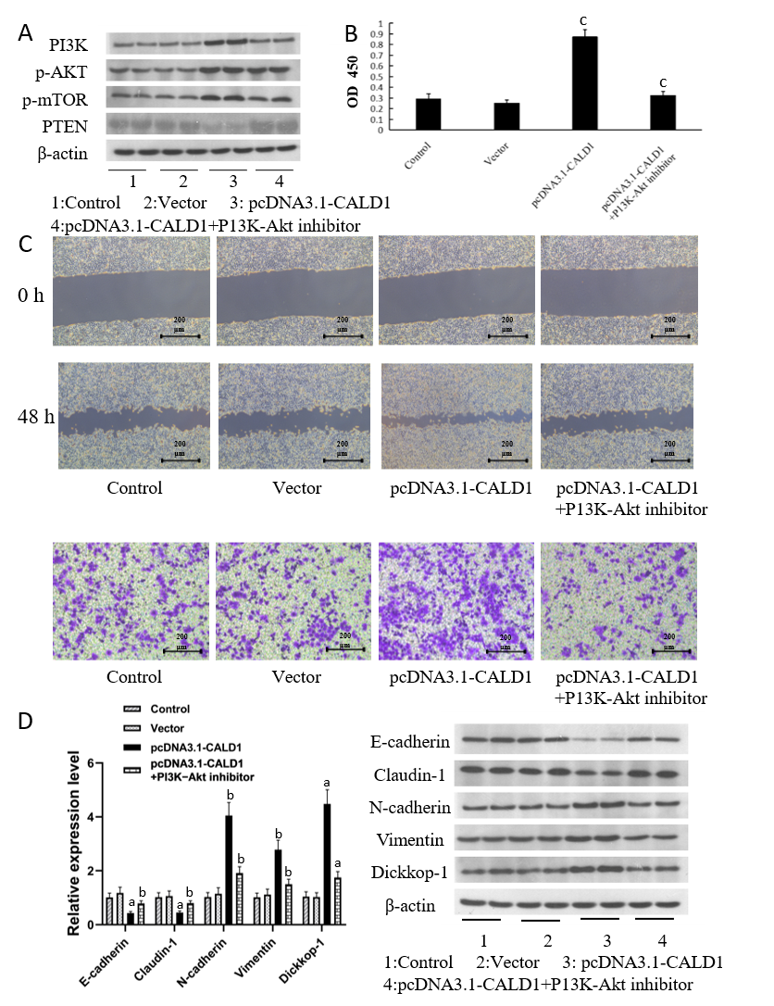
Figure 4 Effects of CALD1 modulation and PI3K-Akt inhibition on tumor cell activity, migration, and EMT-related gene expression. A: Up-regulation of CALD1 enhanced the expression of PI3K, p-AKT, and p-mTOR, members of the PI3K-Akt pathway, whereas PTEN expression was weakened; the addition of a PI3K-Akt inhibitor attenuated the expression of PI3K, p-AKT, and p-mTOR, while the expression of PTEN was enhanced; B: CCK-8 results showed that showed that the effect of CALD1 on tumour cell activity was weakened after adding a PI3K-Akt inhibitor (blank group-moderate activity, negative group-moderate activity, CALD1 overexpression group-high activity, CALD1 overexpression + inhibitor group-moderate activity or slightly high activity); C: Scratch and Transwell assay results showed that the effect of CALD1 on tumour cell migration and invasion was weakened after adding a PI3K-Akt inhibitor (blank group-moderate, negative group-moderate, CALD1 overexpression group-strong, CALD1 overexpression + inhibitor group-moderate or slightly strong); D: CALD1 overexpression, alone or in combination with PI3K-Akt inhibition, resulted in corresponding changes in EMT-related genes and proteins in AGS and MKN45 cells. ªP < 0.05, ^{b}P < 0.01, ^{c}P < 0.001.

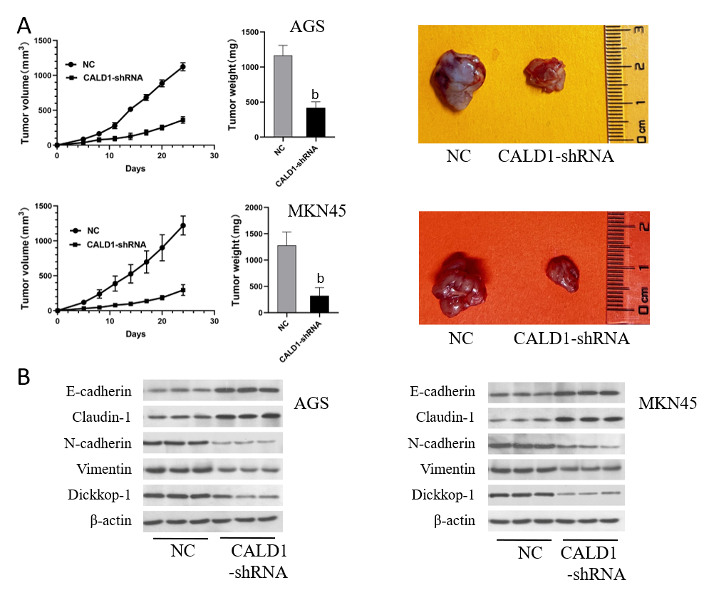
Figure 5 Impact of CALD1-shRNA on tumor growth and metastasis-related protein expression: Results from animal experiments. A: The mean weight of transplanted tumours in the CALD1-shRNA-transfected group was significantly lower than that in the empty vector-transfected group (P < 0.05), with a delayed growth curve and smaller final subcutaneous tumours; B: Compared with the empty vector-transfected group, the expression of N-cadherin, Dickkop-1, and Vimentin was reduced, whereas that of Claudin-1 and E-cadherin expression increased. ^{b}P < 0.01.

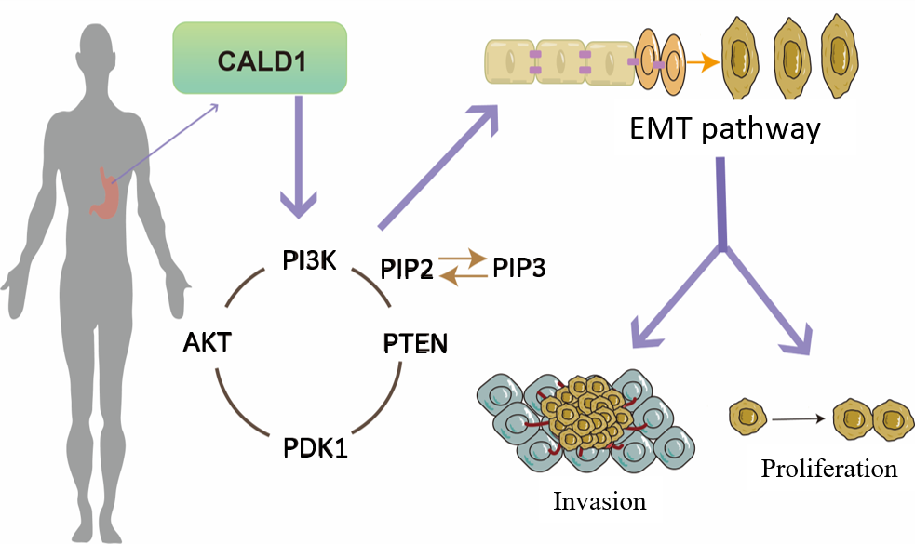
Figure 6 Pathway diagram.

