Name of Journal: World Journal of Gastrointestinal Oncology
Manuscript NO: 70902
Manuscript Type: ORIGINAL ARTICLE

Retrospective Study
Efficacy and safety of computed tomography-guided microwave ablation with fine needle-assisted puncture positioning technique for hepatocellular carcinoma

Hao MZ et al. Fine needle puncture in CT-guided MWA

Ming-Zhi Hao, Yu-Bin Hu, Qi-Zhong Chen, Zhang-Xian Chen, Hai-Lan Lin

Ming-Zhi Hao, Yu-Bin Hu, Qi-Zhong Chen, Zhang-Xian Chen, Hai-Lan Lin, Department of Tumor Interventional Radiology, Fujian Medical University Cancer Hospital, Fujian Cancer Hospital, Fuzhou 350014, Fujian Province, China

Ming-Zhi Hao, Department of Fujian Provincial Key Laboratory of Translational Cancer Medicine, Fujian Cancer Hospital, Fuzhou 350014, Fujian Province, China

Author contributions: Hao MZ, Chen QZ, Hu YB, and Lin HL participated in the microwave ablation operation; Hao MZ participated in the data analysis and interpretation, manuscript writing, and final approval of the manuscript; Chen ZX contributed to the data collection and assembly; Lin HL participated in the conception and design.

Supported by the Fujian Key Laboratory of Translational Cancer Medicine and Fujian Provincial Clinical Research Center for Cancer Radiotherapy and Immunotherapy, China, No. 2020Y2012.

Corresponding author: Ming-Zhi Hao, MM, Professor, Department of Tumor Interventional Radiology, Fujian Medical University Cancer Hospital, Fujian Cancer Hospital, No. 420 Fuma Road, Fuzhou 350014, Fujian Province, China. haomz@fjzlhospital.com

Received: March 14, 2022
Revised: April 18, 2022
Accepted: July 31, 2022
Published online: September 15, 2022

Abstract
BACKGROUND
In microwave ablation (MWA), although computed tomography (CT) scanning can overcome gas interference, it cannot achieve real-time localization. Therefore, the puncture technique is more important in CT-guided ablation.

AIM
To compare the fine needle-assisted puncture (FNP) positioning technique and the conventional puncture (CP) technique for the safety and efficacy of CT-guided MWA in treating hepatocellular carcinoma (HCC).

METHODS
This retrospective study included 124 patients with 166 tumor nodules from February 2018 and June 2021. Seventy patients received CT-guided MWA under the FNP technique (FNP group), and 54 patients received MWA under the CP technique (CP group). Intergroup comparisons were made regarding local tumor progression (LTP), recurrence-free survival (RFS), overall survival (OS), and complications. The influencing variables of LTP and RFS were analyzed through univariate and multivariate regressions.

RESULTS
The 1-, 2-, and 3-year cumulative incidences of LTP in the FNP group were significantly lower than those in the CP group (7.4%, 12.7%, 21.3% vs 13.7%, 32.9%, 36.4%; P = 0.038). The 1-, 2-, and 3-year RFS rates in the FNP group were significantly higher than those in the CP group (80.6%, 73.3%, 64.0% vs 83.3%, 39.4%, and 32.5%, respectively; P = 0.008). The FNP technique independently predicted LTP and RFS. Minor complications in the FNP group were lower than those in the CP group (P < 0.001). The difference in median OS was insignificant between the FNP and CP groups (P = 0.229).

CONCLUSION
The FNP technique used in CT-guided MWA may improve outcomes in terms of LTP, RFS, and procedure-related complications for HCC.

Key Words: Hepatocellular carcinoma; Fine needle puncture; Microwave ablation; Recurrence-free survival; Local tumor progression

©The Author(s) 2022. Published by Baishideng Publishing Group Inc. All rights reserved.

Citation: Hao MZ, Hu YB, Chen QZ, Chen ZX, Lin HL. Efficacy and safety of computed tomography-guided microwave ablation with fine needle-assisted puncture positioning technique for hepatocellular carcinoma. World J Gastrointest Oncol 2022; 14(9): 1727-1738
URL: https://www.wjgnet.com/1948-5204/full/v14/i9/1727.htm
DOI: https://dx.doi.org/10.4251/wjgo.v14.i9.1727

Core Tip: This was a retrospective study that compared the fine needle-assisted puncture positioning (FNP) technique and conventional puncture (CP) technique for the safety and efficacy of computed tomography (CT)-guided microwave ablation (MWA) in treating hepatocellular carcinoma (HCC). In total, 124 patients were divided into two groups by the puncture technique. Seventy patients received CT-guided MWA under the FNP technique (FNP group), and 54 patients received MWA under the CP technique (CP group). The FNP technique used in CT-guided MWA may improve outcomes in terms of local tumor progression, recurrence-free survival, and procedure-related complications for HCC.

INTRODUCTION
Apart from being the world’s sixth most frequently diagnosed malignancy, hepatocellular carcinoma (HCC) is also the third primary reason for cancer-associated mortality on a global scale. In 2018, about 841080 new incidences and 781631 mortalities were caused by HCC^{[1]}. For nearly 20 years since the 1990s, HCC has been managed by percutaneous radiofrequency ablation (RFA) and microwave ablation (MWA). The development of ablation technology is of extensive value in the treatment of HCC^{[2]}. It is considered the third major treatment for HCC, following surgical resection and liver transplantation^{[3]}.
Tumors located ≤ 5 mm from large vessels, gallbladder, gastrointestinal tract, diaphragm, or liver capsule have been defined as high-risk locations (HRLs), which are contraindicated for RFA treatment^{[4,5]}. The RFA of tumors lying close to large vessels with at least 3 mm in diameter is often incomplete due to the heat sink effect^{[6]}. Compared with RFA, MWA can shorten the ablation time, increase the local temperature faster, reduce the heat sink effect of adjacent vessels, and simultaneously use multiple therapeutic probes^{[7]}. Due to these advantages, MWA is more attractive in the ablation of HCC^{[8]}.
Ultrasound (US) and computed tomography (CT) are the most commonly applied image guidance methods for MWA. Due to the influence of the gas, the subphrenic area is one of the most difficult places for ultrasound guidance^{[9]}. A CT scan can compensate for this shortcoming. CT-guided puncture, in contrast, does not allow for real-time positioning. Thus, puncture skills are more important in CT-guided ablation^{[10]}.
Although a CT-guided stereotactic navigation system can provide accurate puncture path planning, the equipment is still not popularized due to economic reasons^{[11,12]}. The fine needle-assisted puncture (FNP) positioning technique is to insert a separate fine needle (21G) near the tumor nodule as the positioning and marking of the microwave antenna insertion to improve the success rate of microwave needle puncture. Although Wu et al^{[13]} recently confirmed that the FNP technique is a safe and effective puncture auxiliary technique for CT-guided biopsy or MWA of small tumor nodules near the diaphragm by a retrospective study. To date, no study has compared the efficacy of CT-guided MWA using the FNP and conventional puncture (CP) techniques in the treatment of HCC.
The current work investigated the efficacy and safety of CT-guided MWA for HCC under the FNP and CP techniques.

MATERIALS AND METHODS
Patients
We retrospectively analyzed 170 patients with consecutive primary HCC, who received CT-guided MWA or transarterial chemoembolization (TACE) combined with MWA at our hospital from February 2018 to June 2021. These patients were either inappropriate for or rejected surgery. The diagnosis of HCC was verified by imaging and serum alpha-fetoprotein (AFP) assay or hepatic needle biopsy as per the Chinese guidelines for the primary liver cancer diagnosis and treatment (2017 edition).
The inclusion criteria were: Child-Pugh class A or B, single tumor with the largest diameter ≤ 5 cm before MWA, 2-3 tumors with the largest diameter ≤ 5 cm, Eastern Cooperative Oncology Group performance status (ECOG PS) 0-1, and patients with platelet count > 50 × 10⁹/L. The exclusion criteria were: Patients with a known additional malignancy that is progressing concurrently; patients with portal vein thrombosis or extrahepatic metastases; patients with ≥ 4 HCC nodules; patients with ablation to reduce tumor burden; and recurrent HCC, except for recurrence after resection.
Figure 1 shows 4 patients with a known additional malignancy that is progressing concurrently, 6 patients with ≥ 4 HCC nodules, 15 patients with extrahepatic metastases, 3 patients with portal vein thrombosis, 6 patients with ablation to reduce tumor burden, and 12 patients with recurrent HCC after treatment other than surgery. For 17 patients who had intrahepatic distal recurrence (IDR) and 4 patients with local tumor progression (LTP) who underwent MWA twice or more, the second or subsequent MWA procedure was excluded from the study to avoid statistical bias caused by the repetition of patient data twice.
Thus, 124 patients with 166 nodules were incorporated in the current study. Patients were divided into two groups according to the microwave needle puncture methods. Seventy patients received CT-guided MWA under the FNP technique and were categorized into the FNP group, whereas 54 patients received CT-guided MWA supported with a conventional puncture and were categorized into the CP group. The operators of all TACE and MWA procedures belonged to the same attending physician team, and the chief operator in the CT-guided MWA procedures of both groups had at least 15 years of experience in RFA. The choice of puncture method was not based on the tumor size, tumor number, and tumor location. The corresponding author and the assistant performed CT-guided MWA under the FNP technique, whereas another chief operator and assistant performed CT-guided MWA under the CP technique.
Study protocol approval was obtained from the corresponding ethics committee (2018-022-02). The experimental procedures conformed to the principles of the Declaration of Helsinki. Before the retrospective study, each patient provided written informed consent.

Methods
MWA procedure: MTC-3 C MWA equipment (Yigao Microwave System Engineering Co. Ltd., Nanjing, Jiangsu Province, China) was used at 2450 MHz (± 10%) in a continuous wave mode and 5-120 W ± 30% power output. The MWA antenna was 1.8 mm in diameter with a surface coating. Before MWA, the tumor size, number, site, and relationship with important structures were evaluated by contrast-enhanced magnetic resonance imaging (MRI) and/or helical CT scan. A multidisciplinary team comprising a liver surgeon, radiologist, sonographer, oncologist, and interventional radiologist created the treatment plans for patients with HCC.
Percutaneous CT-guided MWA was conducted on an inpatient basis under local anesthesia and analgesics. The patient was awake during the MWA procedures. Before performing MWA, each tumor’s antenna layout, power output setup, and emission duration were meticulously planned. A single MWA antenna was used in the nodules ≤ 1.7 cm; if > 1.7 cm, then a double-needle was used, keeping a space of 2.0 cm between the two needles. The ablation margin was kept between 5 and 10 mm at 60 and 70 W for 5 to 10 min. After treatment, the needle was gradually withdrawn with a parallel needle tract ablation. For tumors under the liver capsule attached to the diaphragm, intestinal tube, or gallbladder, saline was injected between the target lesion and the adjacent organs, a process called hydrodissection to protect them from possible heat damage if a safe distance could not be maintained. Adjuvant hydrodissection techniques were performed on 2 patients.
A CT scan was acquired immediately after treatment and again 24 h after operation to evaluate the margin of ablation and complications, such as bleeding and pneumothorax. Nearly 2 mo post-operation, treatment response was evaluated through contrast-enhanced MRI or helical CT examination. Complete ablation was verified based on the absence of enhanced areas. In the case of incomplete ablation, a second ablation was considered. An ablation failure was indicated if complete ablation was not achieved even after two ablations, and other treatment methods were applied.

The MWA puncture technique: Before the operation, the ablation needle electrode was selected based on the size and location of the tumor, and the puncture angle and depth were set under CT guidance. The percutaneous transhepatic puncture was performed by free hands following a detailed procedure. In the CP group, the needle path had to pass through the normal liver tissue at > 1.5 cm, avoiding large blood vessels and bile ducts. CT scanning was repeated at half the depth of needle insertion to observe the relationship between the electrode needle or tumor and the surrounding tissue structure. Next, the puncture angle was adjusted, and the needle was inserted gradually inside the tumor and approximately 0.5 to 1 cm beyond the tumor margin. In the FNP group, a 21-gauge fine needle of 15 cm in length was inserted near the tumor nodule before ablation needle puncture as a marker (Figure 2A). Following that, CT scanning was used to determine the angle and direction of the MWA electrode needle puncture based on fine-needle marking. Subsequently, the microwave electrode needle was step by step gradually inserted inside the tumor and approximately 0.5 to 1 cm beyond the tumor margin, and each step was confirmed by a CT scan (Figure 2B). Afterward, the fine needle was pulled out after the electrode needle was consistent with the plan confirmed by CT scanning (Figure 2C). Figure 3 shows a sequence of images of a patient with an HCC nodule in segment 5 treated with CT-guided MWA by the FNP technique after TACE.

Assessment of the outcome: The patients were followed up 2 mo after MWA and then every 3 to 6 mo. Follow-up included general, physical, imaging, and laboratory examinations such as biochemistry and tumor marker levels. LTP was indicated when following thorough tumor ablation, any new lesions connected to ablation focus were seen at the focus rim^{[14]}. IDR was defined as the appearance of any new lesions distant from the ablation zone (excluding extrahepatic metastasis)^{[15,16]}. Recurrent-free survival (RFS) refers to the duration between the first ablation and the final follow-up or the tumor recurrence including LTP and IDR, whereas overall survival (OS) refers to the duration between the time of diagnosis and the time of death or date of the last follow-up. Under the Society of Interventional Radiology Classification System, we classified the complications into major and minor types^{[17]}. In addition, we monitored the hospital stay of patients after treatment completion. Follow-up was continued through December 25, 2021, and the median follow-up time was 22.6 mo (range: 6.0-43.4 mo).

Statistical analysis
Student’s t-test was used to assess the mean difference, whereas the χ² test was adopted for frequency distribution comparison. The LTP, RFS, and OS were tested using the Kaplan–Meier technique and log-rank tests. The multifactor influences on LTP and RFS were examined through Cox regression analysis. Differences were regarded as significant when the two-tailed P < 0.05. SPSS v24 was used for data processing and analysis.

RESULTS
Patient characteristics
The patient information and tumor characteristics are detailed in Table 1. Between the two groups, there were insignificant differences in age, sex, ECOG PS, AFP, tumor number, tumor size, tumor location, and the application rate of combined TACE therapy before MWA. At the end of the follow-up, no significant difference was observed in the detection rate of LTP between the two groups (P = 0.063). The liver function of all patients was Child-Pugh class A before MWA. A total of 91 patients were treated with TACE combined with MWA in 124 patients. MWA was conducted approximately 4 wk after TACE. No patient achieved complete remission before ablation after TACE as per the Response Evaluation Criteria in Solid Tumors criteria. There was an insignificant difference in post-MWA hospital stay between both groups (P = 0.130).

Survival and recurrence outcome
One patient in the FNP group and 2 patients in the CP group were detected to have residual tumor by MRI scan 2 mo post-MWA, which was completely ablated by MWA again. The one-stage ablation success rate was 98.6% in the FNP group and 96.3% in the CP group (P = 0.820). During the follow-up, LTP was detected in 11 (15.7%) patients in the FNP group and 16 (29.6%) patients in the CP group. In the last follow-up, 6 patients were dead, 5 were lost to the follow-up, and 113 were alive.
The 1-, 2-, and 3-year cumulative incidences of LTP in the FNP group were significantly lower than those in the CP group (7.4%, 12.7%, 21.3% vs 13.7%, 32.9%, 36.4%, respectively; P = 0.038 via log-rank test, Figure 4A).
The 1-, 2-, and 3-year RFS rates in the FNP group were significantly higher than those in the CP group (80.6%, 73.3%, 64.0% vs 83.3%, 39.4%, and 32.5%, respectively; P = 0.008 via log-rank test, Figure 4B).
The 1- and 2-year OS rates were 98.4% and 96.0% in the FNP group and 98.1% and 88.8% in the CP group, with a median OS of 45.8 mo [95% confidence interval (CI): 44.1-47.4] and 40.2 mo (95%CI: 37.6-42.8) (P = 0.229 via log-rank test, Figure 4C).

Univariate and multivariate analyses
According to univariate analysis, ECOG PS, tumor number, and puncture method were significantly related to LTP. According to multivariate analysis, tumor number (≥ 2) was independently related to a poor LTP and superior ECOG PS, and the FNP technique was independently related to a good LTP (Table 2).
Univariate analysis indicated that ECOG PS, tumor number, and puncture method were significantly related to RFS. Multivariate analysis indicated that tumor number (≥ 2) was independently associated with a poor RFS, and the FNP technique was independently associated with a good RFS (Table 3).

Subgroup analysis
In the subgroup analysis stratified by tumor number, the median time to LTP in the FNP group was significantly longer than that in the CP group for patients with a single tumor (44.9 ± 1.2 vs 33.7 ± 2.4 mo, respectively; P = 0.005 via log-rank test).
Furthermore, in the subgroup analysis stratified by tumor number, the median RFS time in the FNP group was considerably higher than that in the CP group for patients with a single tumor (37.3 ± 1.8 vs 28.5 ± 2.5 mo, respectively; P = 0.013 via log-rank test).
Complications
No deaths were directly related to the early complications of MWA. Table 4 shows the frequency of complications in all patients. The FNP group had two cases of major complications. One patient diagnosed with bacteremia recovered with anti-infective therapy, whereas another patient developed massive pneumothorax and recovered by thoracic drainage. The CP group had 4 cases of massive pneumothorax recovered by thoracic drainage. The intergroup differences were insignificant regarding major complications (P = 0.454). The CP group exhibited more minor complications, including postoperative pain and fever compared to those in the FNP group (P < 0.001).

DISCUSSION
According to the outcomes of this study, although no significant difference was observed in 1- and 2-year OS rates and median OS between the FNP and CP groups, the FNP technique may improve outcomes in terms of LTP, RFS, and procedure-related complications for HCC treated with CT-guided MWA. The FNP technique was independently associated with good LTP and RFS. In the subgroup analysis, the FNP technique may improve the median time to LTP and median RFS time for patients with a single HCC nodule. The results of this study are clinically important considering that the FNP technique has better efficacy and safety in CT-guided MWA compared to the CP technique.
Image guidance techniques play a critical role in MWA. Although no reports are available that compare the efficacies of US-guided and CT-guided MWA, several studies have demonstrated that both US-guided and CT-guided RFA are similar in terms of LTP and complete ablation^{[18,19]}. In US-guided ablation, there are blind spots and vaporization interferences^{[20]}; these disadvantages can be overcome by CT. However, it is a non–real-time image guidance technology. Repeated CT scans caused by unskilled puncture techniques can significantly increase radiation exposure. Thus, it has higher requirements for puncture technology under CT guidance.
A recent study reported that the FNP technique used in biopsy or MWA for small nodules near the diaphragm offered an improved puncture success rate and a low reduced radiation dose^{[13]}. In this method, a fine needle puncture is made, which reduces the radiation exposure because the biopsy needle or MWA electrode needle can be inserted easily in the subsequent process. Repeated puncture in ablation procedure may lead to complications of needle bleeding, tumor implantation, and pneumothorax, etc^{[4,21]}. Moreover, electrode needle placement is associated with complications such as bleeding, vascular injuries, and pneumothorax^{[22]}. We used the FNP technique in CT-guided MWA procedures to treat HCC without limiting tumors near the diaphragm. The fine needle inserted near the tumor nodule could fix the liver and thoracoabdominal wall. The fine needle, liver, thoracoabdominal wall, and diaphragm are moved as a whole unit during breathing. The fine needle inserted near the tumor nodule can be used as a sign for subsequent electrode needle insertion and also help judge the patient's respiratory movement and reduce the error of subsequent puncture and puncture times. Due to the artifact of the microwave electrode needle in CT scanning, it is difficult to judge whether the position of the end of the electrode needle is consistent with the pre-designed position. The fine needle without artifact in CT scanning as a mark is helpful for the proper placement of the MWA electrode needle. The primary reason for the better performance of the FNP than CP in CT-guided MWA may be the reduction of puncture times and the appropriate MWA electrode needle placement. Univariate and multivariate analyses showed that the FNP technique was significantly related to good RFS and LTP, which further supported the advantages of the FNP technique.
Tumor number, tumor size, and performance status are important factors affecting tumor recurrence and survival^{[23-26]}. In this study, tumor number (≥ 2) was independently associated with a poor LTP and RFS, as in previous studies. Nevertheless, tumor size was not an independent prognostic factor for LTP and RFS, and it may be attributed to the application of adjuvant TACE before MWA in 73.4% of patients. According to a meta-analysis, TACE + MWA contributed to prominently higher rates of local control and objective remission^{[27,28]}. TACE + MWA achieved better efficacy than TACE or MWA monotherapy for managing HCC of 3 to 5 cm or even > 5 cm in size^{[29,30]}. In this study, no significant difference was observed in the proportion of TACE before MWA between the two groups, which does not affect the primary results of the study.
This study had a few limitations, including the possibility of bias due to the retrospective analysis of a single-center small sample. Another limitation is the lack of comparison between FNP and CT-guided stereotactic navigation systems. Prospective multicenter studies must be conducted in the future to gain further insight.

CONCLUSION
The FNP technique used in CT-guided MWA in the current study may improve outcomes in terms of LTP, RFS, and procedure-related complications for HCC. The FNP technique was independently associated with good LTP and RFS. The results of this study have important clinical value in CT-guided MWA for HCC with the FNP technique.

ARTICLE HIGHLIGHTS
Research background
Due to the influence of the gas, the subphrenic area is one of the most difficult places for ultrasound guidance. A computed tomography (CT) scan can compensate for this shortcoming. CT-guided ablation is a commonly used ablation image-guided method in our department.

Research motivation
CT-guided puncture does not allow for real-time positioning and the microwave electrode needle will produce artifacts in CT scanning, which is different from our previous application of radiofrequency ablation.

Research objectives
To compare fine needle-assisted puncture (FNP) positioning technique and conventional puncture technique for the safety and efficacy of CT-guided microwave ablation (MWA) in treating hepatocellular carcinoma (HCC).

Research methods
The efficacy and safety were compared between the patients received CT-guided MWA under FNP technique and patients received MWA under conventional puncture technique.

Research results
The 1-, 2-, and 3-year cumulative incidences of local tumor progression (LTP) in the FNP group were significantly lower than those in the conventional puncture (CP) technique (CP group). The 1-, 2-, and 3-year RFS rates in the FNP group were significantly higher than those in the CP group. The FNP technique independently predicted LTP and recurrence-free survival (RFS). The minor complications in the FNP group were lower those in the CP group.

Research conclusions
The FNP technique used in CT-guided MWA may improve outcomes in terms of LTP, RFS, and procedure-related complications for HCC.

Research perspectives
Prospective multicenter randomized controlled studies must be conducted in the future to obtain further insights.

REFERENCES
1 Erratum: Global cancer statistics 2018: GLOBOCAN estimates of incidence and mortality worldwide for 36 cancers in 185 countries. CA Cancer J Clin 2020; 70: 313 [PMID: 32767693 DOI: 10.3322/caac.21609]
2 Zhu F, Rhim H. Thermal ablation for hepatocellular carcinoma: what's new in 2019. Chin Clin Oncol 2019; 8: 58 [PMID: 31968982 DOI: 10.21037/cco.2019.11.03]
3 Lee MW, Raman SS, Asvadi NH, Siripongsakun S, Hicks RM, Chen J, Worakitsitisatorn A, McWilliams J, Tong MJ, Finn RS, Agopian VG, Busuttil RW, Lu DSK. Radiofrequency ablation of hepatocellular carcinoma as bridge therapy to liver transplantation: A 10-year intention-to-treat analysis. Hepatology 2017; 65: 1979-1990 [PMID: 28170115 DOI: 10.1002/hep.29098]
4 Wu MC, Tang ZY, Ye SL, Fan J, Qin SK, Yang JM, Chen MS, Chen MH, Lv MD, Ma KS, Wu YL, Chen Y, Qian GJ, Lu SC, Zheng JS, Sun WB, Zou YH, Liang HM, Huang ZY, Han XW, Jing X, Pan HM, Jiang TA, Liang P, Ren ZG, Zhang YJ; Chinese Society of Liver Cancer; Chinese Society of Clinical Oncology; Liver Cancer Group; Chinese Society of Hepatology. Expert consensus on local ablation therapies for primary liver cancer. Chin Clin Oncol 2012; 1: 11 [PMID: 25842069 DOI: 10.3978/j.issn.2304-3865.2012.06.01]
5 Foltz G. Image-guided percutaneous ablation of hepatic malignancies. Semin Intervent Radiol 2014; 31: 180-186 [PMID: 25071304 DOI: 10.1055/s-0034-1373792]
6 Ahmed M, Solbiati L, Brace CL, Breen DJ, Callstrom MR, Charboneau JW, Chen MH, Choi BI, de Baère T, Dodd GD 3rd, Dupuy DE, Gervais DA, Gianfelice D, Gillams AR, Lee FT Jr, Leen E, Lencioni R, Littrup PJ, Livraghi T, Lu DS, McGahan JP, Meloni MF, Nikolic B, Pereira PL, Liang P, Rhim H, Rose SC, Salem R, Sofocleous CT, Solomon SB, Soulen MC, Tanaka M, Vogl TJ, Wood BJ, Goldberg SN; International Working Group on Image-guided Tumor Ablation; Interventional Oncology Sans Frontières Expert Panel; Technology Assessment Committee of the Society of Interventional Radiology,; Standard of Practice Committee of the Cardiovascular and Interventional Radiological Society of Europe. Image-guided tumor ablation: standardization of terminology and reporting criteria--a 10-year update. Radiology 2014; 273: 241-260 [PMID: 24927329 DOI: 10.1148/radiol.14132958]
7 Li X, Zhang L, Fan W, Zhao M, Wang L, Tang T, Jiang H, Zhang J, Liu Y. Comparison of microwave ablation and multipolar radiofrequency ablation, both using a pair of internally cooled interstitial applicators: results in ex vivo porcine livers. Int J Hyperthermia 2011; 27: 240-248 [PMID: 21501025 DOI: 10.3109/02656736.2010.536967]
8 Izzo F, Granata V, Grassi R, Fusco R, Palaia R, Delrio P, Carrafiello G, Azoulay D, Petrillo A, Curley SA. Radiofrequency Ablation and Microwave Ablation in Liver Tumors: An Update. Oncologist 2019; 24: e990-e1005 [PMID: 31217342 DOI: 10.1634/theoncologist.2018-0337]
9 Koda M, Ueki M, Maeda Y, Mimura K, Okamoto K, Matsunaga Y, Kawakami M, Hosho K, Murawaki Y. Percutaneous sonographically guided radiofrequency ablation with artificial pleural effusion for hepatocellular carcinoma located under the diaphragm. AJR Am J Roentgenol 2004; 183: 583-588 [PMID: 15333339 DOI: 10.2214/ajr.183.3.1830583]
10 Crocetti L, de Baere T, Lencioni R. Quality improvement guidelines for radiofrequency ablation of liver tumours. Cardiovasc Intervent Radiol 2010; 33: 11-17 [PMID: 19924474 DOI: 10.1007/s00270-009-9736-y]
11 Bale R, Widmann G. Navigated CT-guided interventions. Minim Invasive Ther Allied Technol 2007; 16: 196-204 [PMID: 17763092 DOI: 10.1080/13645700701520578]
12 Engstrand J, Toporek G, Harbut P, Jonas E, Nilsson H, Freedman J. Stereotactic CT-Guided Percutaneous Microwave Ablation of Liver Tumors With the Use of High-Frequency Jet Ventilation: An Accuracy and Procedural Safety Study. AJR Am J Roentgenol 2017; 208: 193-200 [PMID: 27762601 DOI: 10.2214/AJR.15.15803]
13 Wu Q, Cao B, Zheng Y, Liang B, Liu M, Wang L, Zhang J, Meng L, Luo S, He X, Zhang Z. Feasibility and safety of fine positioning needle-mediated breathing control in CT-guided percutaneous puncture of small lung/liver nodules adjacent to diaphragm. Sci Rep 2021; 11: 3411 [PMID: 33564042 DOI: 10.1038/s41598-021-83036-z]
14 Shady W, Petre EN, Do KG, Gonen M, Yarmohammadi H, Brown KT, Kemeny NE, D'Angelica M, Kingham PT, Solomon SB, Sofocleous CT. Percutaneous Microwave versus Radiofrequency Ablation of Colorectal Liver Metastases: Ablation with Clear Margins (A0) Provides the Best Local Tumor Control. J Vasc Interv Radiol 2018; 29: 268-275.e1 [PMID: 29203394 DOI: 10.1016/j.jvir.2017.08.021]
15 Ishikawa T, Higuchi K, Kubota T, Seki K, Honma T, Yoshida T, Kamimura T. Prevention of intrahepatic distant recurrence by transcatheter arterial infusion chemotherapy with platinum agents for stage I/II hepatocellular carcinoma. Cancer 2011; 117: 4018-4025 [PMID: 21365625 DOI: 10.1002/cncr.25989]
16 Chen HY, Lu SN, Hung CH, Wang JH, Chen CH, Yen YH, Kuo YH, Kee KM. Predicting outcomes for recurrent hepatocellular carcinoma within Milan criteria after complete radiofrequency ablation. PLoS One 2020; 15: e0242113 [PMID: 33170894 DOI: 10.1371/journal.pone.0242113]
17 Cardella JF, Kundu S, Miller DL, Millward SF, Sacks D; Society of Interventional Radiology. Society of Interventional Radiology clinical practice guidelines. J Vasc Interv Radiol 2009; 20: S189-S191 [PMID: 19559998 DOI: 10.1016/j.jvir.2009.04.035]
18 Yuan C, Yuan Z, Cui X, Gao W, Zhao P, He N, Cui S, Wang Y, Zhang Y, Li W, Zheng J. Efficacy of ultrasound-, computed tomography-, and magnetic resonance imaging-guided radiofrequency ablation for hepatocellular carcinoma. J Cancer Res Ther 2019; 15: 784-792 [PMID: 31436232 DOI: 10.4103/jcrt.JCRT_836_18]
19 Lee LH, Hwang JI, Cheng YC, Wu CY, Lee SW, Yang SS, Yeh HZ, Chang CS, Lee TY. Comparable Outcomes of Ultrasound versus Computed Tomography in the Guidance of Radiofrequency Ablation for Hepatocellular Carcinoma. PLoS One 2017; 12: e0169655 [PMID: 28068369 DOI: 10.1371/journal.pone.0169655]
20 Fahey BJ, Nelson RC, Hsu SJ, Bradway DP, Dumont DM, Trahey GE. In vivo guidance and assessment of liver radio-frequency ablation with acoustic radiation force elastography. Ultrasound Med Biol 2008; 34: 1590-1603 [PMID: 18471954 DOI: 10.1016/j.ultrasmedbio.2008.03.006]
21 Kim JW, Shin SS, Heo SH, Hong JH, Lim HS, Seon HJ, Hur YH, Park CH, Jeong YY, Kang HK. Ultrasound-Guided Percutaneous Radiofrequency Ablation of Liver Tumors: How We Do It Safely and Completely. Korean J Radiol 2015; 16: 1226-1239 [PMID: 26576111 DOI: 10.3348/kjr.2015.16.6.1226]
22 Mendiratta-Lala M, Brook OR, Midkiff BD, Brennan DD, Thornton E, Faintuch S, Sheiman RG, Goldberg SN. Quality initiatives: strategies for anticipating and reducing complications and treatment failures in hepatic radiofrequency ablation. Radiographics 2010; 30: 1107-1122 [PMID: 20442337 DOI: 10.1148/rg.304095202]
23 Li Z, Wang C, Si G, Zhou X, Li Y, Li J, Jiao D, Han X. Image-guided microwave ablation of hepatocellular carcinoma (≤5.0 cm): is MR guidance more effective than CT guidance? BMC Cancer 2021; 21: 366 [PMID: 33827464 DOI: 10.1186/s12885-021-08099-7]
24 Liu B, Long J, Wang W, Huang T, Xie X, Chen S, Huang G, Jiang C, Ye J, Long H, Xie X, Kuang M. Predictive factors of treatment outcomes after percutaneous ablation of hepatocellular carcinoma in the caudate lobe: a retrospective study. BMC Cancer 2019; 19: 699 [PMID: 31311502 DOI: 10.1186/s12885-019-5881-0]
25 Yang Y, Chen Y, Zhang X, Xin Y, Wang Y, Li X, Fan Q, Zhou X, Ye F. Predictors and patterns of recurrence after radiofrequency ablation for hepatocellular carcinoma within up-to-seven criteria: A multicenter retrospective study. Eur J Radiol 2021; 138: 109623 [PMID: 33711573 DOI: 10.1016/j.ejrad.2021.109623]
26 Ni JY, Sun HL, Chen YT, Luo JH, Chen D, Jiang XY, Xu LF. Prognostic factors for survival after transarterial chemoembolization combined with microwave ablation for hepatocellular carcinoma. World J Gastroenterol 2014; 20: 17483-17490 [PMID: 25516662 DOI: 10.3748/wjg.v20.i46.17483]
27 Wang L, Ke Q, Lin N, Huang Q, Zeng Y, Liu J. The efficacy of transarterial chemoembolization combined with microwave ablation for unresectable hepatocellular carcinoma: a systematic review and meta-analysis. Int J Hyperthermia 2019; 36: 1288-1296 [PMID: 31852267 DOI: 10.1080/02656736.2019.1692148]
28 Yang WZ, Jiang N, Huang N, Huang JY, Zheng QB, Shen Q. Combined therapy with transcatheter arterial chemoembolization and percutaneous microwave coagulation for small hepatocellular carcinoma. World J Gastroenterol 2009; 15: 748-752 [PMID: 19222102 DOI: 10.3748/wjg.15.748]
29 Zaitoun MMA, Elsayed SB, Zaitoun NA, Soliman RK, Elmokadem AH, Farag AA, Amer M, Hendi AM, Mahmoud NEM, Salah El Deen D, Alsowey AM, Shahin S, Basha MAA. Combined therapy with conventional trans-arterial chemoembolization (cTACE) and microwave ablation (MWA) for hepatocellular carcinoma >3-<5 cm. Int J Hyperthermia 2021; 38: 248-256 [PMID: 33615957 DOI: 10.1080/02656736.2021.1887941]
30 Si ZM, Wang GZ, Qian S, Qu XD, Yan ZP, Liu R, Wang JH. Combination Therapies in the Management of Large (≥ 5 cm) Hepatocellular Carcinoma: Microwave Ablation Immediately Followed by Transarterial Chemoembolization. J Vasc Interv Radiol 2016; 27: 1577-1583 [PMID: 27103146 DOI: 10.1016/j.jvir.2016.02.014]

Footnotes
Institutional review board statement: The protocol was approved by the ethics committee of Fujian Provincial Tumor Hospital (approval No. 2018-022-02).

Informed consent statement: Written informed consent was obtained from each patient before study initiation.

Conflict-of-interest statement: The authors have no conflicts of interest to declare.

Data sharing statement: No additional data are available.

Open-Access: This article is an open-access article that was selected by an in-house editor and fully peer-reviewed by external reviewers. It is distributed in accordance with the Creative Commons Attribution NonCommercial (CC BY-NC 4.0) license, which permits others to distribute, remix, adapt, build upon this work non-commercially, and license their derivative works on different terms, provided the original work is properly cited and the use is non-commercial. See: https://creativecommons.org/Licenses/by-nc/4.0/

Provenance and peer review: Unsolicited article; Externally peer reviewed.
Peer-review model: Single blind

Corresponding Author's Membership in Professional Societies: Anti-Cancer Association of China, No. M166300908s.

Peer-review started: March 14, 2022
First decision: April 11, 2022
Article in press: July 31, 2022

Specialty type: Gastroenterology and hepatology
Country/Territory of origin: China
Peer-review report’s scientific quality classification
Grade A (Excellent): 0
Grade B (Very good): B, B
Grade C (Good): 0
Grade D (Fair): D, D
Grade E (Poor): 0

P-Reviewer: Giacomelli L, Italy; Nakano M, Japan; Nakano M, Japan; Raissi D, United States S-Editor: Yan JP L-Editor: Filipodia P-Editor: Yan JP

Figure Legends
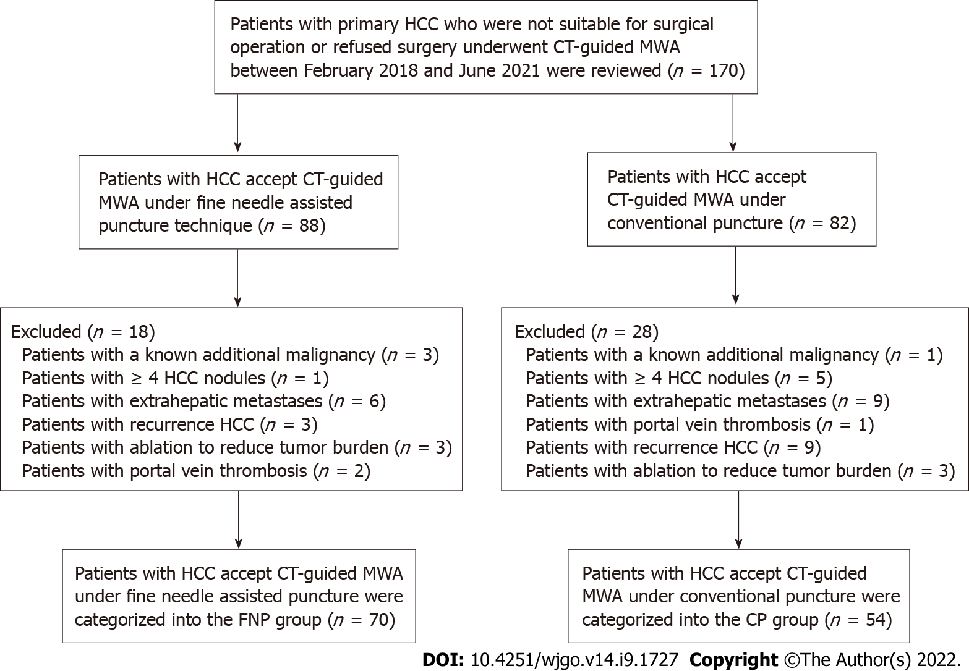
Figure 1 Flow chart showing the selection process of participants for this study. CT: Computed tomography; CP: Conventional puncture; FNP: Fine needle-assisted puncture positioning; HCC: Hepatocellular carcinoma; MWA: Microwave ablation.

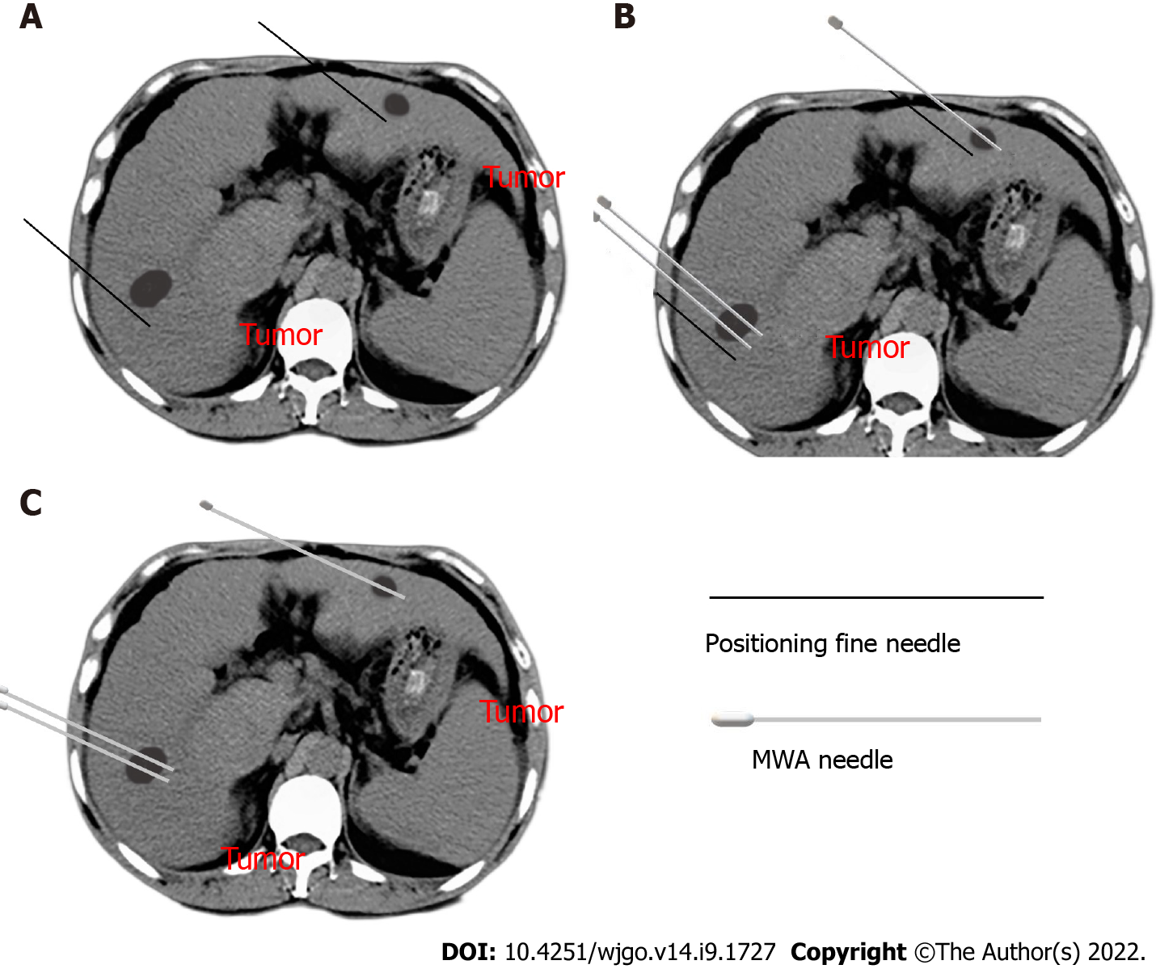
Figure 2 Fine needle-assisted puncture positioning technique in computed tomography-guided microwave ablation. A: The patient was trained to hold his breath, and then a 21-gauge fine needle was inserted near the tumor nodules; B: A microwave electrode needle was gradually inserted inside the tumor according to the mark of the fine needle while the fine needle served as a breathing indicator; C: The fine needle was pulled out after the electrode needle, consistent with the plan confirmed by computed tomography scanning.

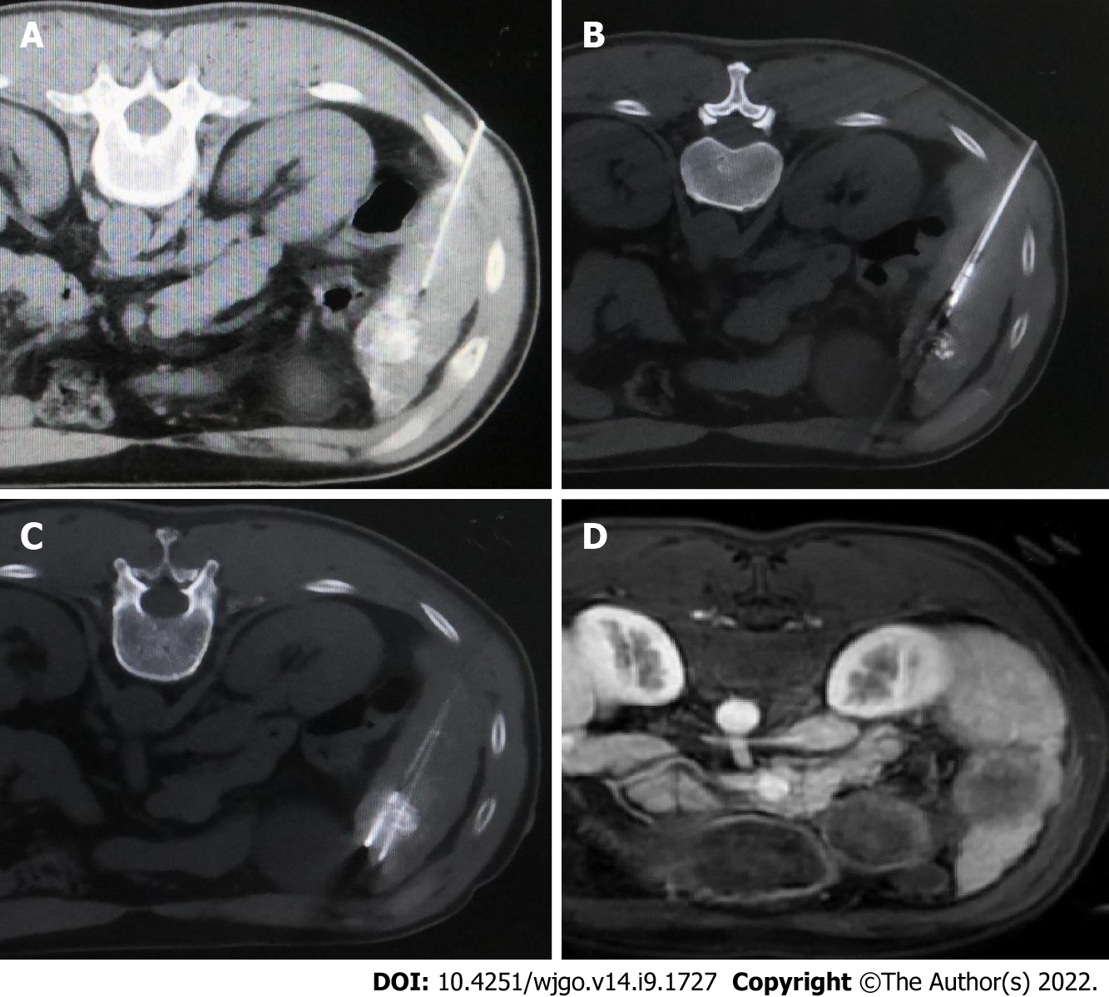
Figure 3 Computed tomography-guided microwave ablation under fine needle-assisted puncture technique for a patient with hepatocellular carcinoma nodule in segment 5 accepted transarterial chemoembolization pre-microwave ablation. A: A 21-gauge fine needle of 15 cm length was inserted near the tumor nodule after computed tomography scanning before ablation needle puncture; B: A microwave electrode needle was gradually inserted inside the tumor according to the mark of the fine needle; C: The second microwave electrode needle was gradually inserted inside the tumor needle and approximately 1 cm beyond the tumor margin according to the mark of the fine needle; D: The complete ablation was confirmed by magnetic resonance imaging 2 mo post-microwave ablation.

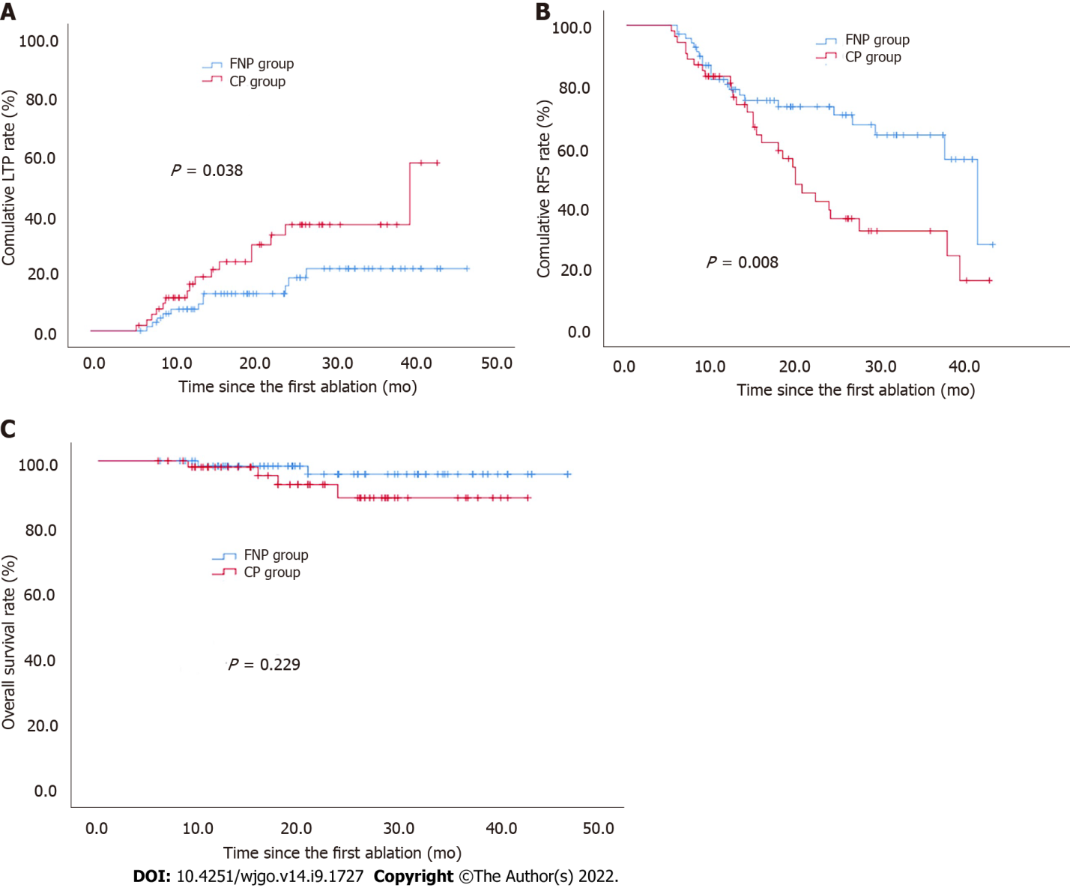
Figure 4 Comparison of cumulative incidence of local tumor progression, recurrence-free survival, and overall survival following post-computed tomography-guided microwave ablation between fine needle-assisted puncture positioning and conventional puncture groups. A: Local tumor progression (P = 0.038 based on log-rank statistics); B: Recurrence-free survival (P = 0.008 based on log-rank statistics); C: Overall survival (P = 0.229 based on log-rank statistics). CP: Conventional puncture; FNP: Fine needle-assisted puncture positioning; LTP: Local tumor progression; OS: Overall survival; RFS: Recurrence-free survival.

Table 1 Baseline characteristics of patient and tumor between the two groups
Variables | FNP group, n = 70 | CP group, n = 54 | P value
Age (yr)¹ | 58.6 ± 1.7 | 59.4 ± 1.4 | 0.728
Sex (M/F) | 60/10 | 48/6 | 0.601
ECOG PS |  |  | 0.200
0 | 22 | 23
1 | 48 | 31
AFP (ng/mL) |  |  | 0.530
< 400 | 61 | 49
≥ 400 | 9 | 5
No. of nodules in each patient |  |  | 0.871
1 | 47 | 37
2-3 | 23 | 17
Total no. of nodules | 93 | 73
Tumor size before MWA (cm) |  |  | 0.922
< 3 | 50 | 39
3-5 | 20 | 15
Mean tumor diameter (cm) pre-MWA | 2.3 ± 0.1 | 2.2 ± 0.2 | 0.711
Proportion of TACE prior to MWA | 50 (71.4%) | 41 (75.9%) | 0.574
Post-MWA hospital stay (d)¹ | 3.3 ± 0.3 | 3.9 ± 0.2 | 0.130
Tumor location
HRL | 49 | 34 | 0.409
Liver subcapsular region | 30 | 16
Diaphragmatic surface | 7 | 4
Adjacent to large vessel | 8 | 7
Adjacent to gallbladder | 3 | 4
Adjacent to gastrointestinal tract | 1 | 3
LRL | 21 | 20
LTP | 11 (15.7%) | 16 (29.6%) | 0.063
¹Values are mean ± SE. P < 0.05 is significant; P > 0.05 is non-significant.
FNP: Fine needle-assisted puncture; CP: Conventional puncture; ECOG PS: Eastern Cooperative Oncology Group performance status rating; AFP: Alpha-fetoprotein; HRL: High-risk location; LRL: Low-risk location; LTP: Local tumor progression; MWA: Microwave ablation; TACE: Transarterial chemoembolization.

Table 2 Factors associated with local tumor progression
Factors | Univariate analysis |  | Multivariate analysis
 | HR (95%CI) | P value | HR (95%CI) | P value
Sex | 0.706 (0.166, 2.966) | 0.637
Age (yr): > 60; ≤ 60 | 1.041 (0.486, 2.229) | 0.918
ECOG PS: 0; 1 | 3.169 (1.197, 8.392) | 0.020 | 2.979 (1.108, 8.014) | 0.031
Tumor number: 1; 2-3 | 3.370 (1.561, 7.277) | 0.002 | 3.008 (1.383, 6.546) | 0.005
AFP (ng/mL): < 400; ≥ 400 | 0.601 (0.142, 2.538) | 0.488
Tumor size (cm): < 3; 3-5 | 1.649 (0.754, 3.603) | 0.210
Auxiliary TACE pre-MWA: Yes; No | 1.232 (0.497, 3.055) | 0.653
Tumor location: HRL; LRL | 1.523 (0.937, 2.476) | 0.090
Puncture method: FNP technique; CP technique | 2.205 (1.021, 4.761) | 0.044 | 2.596 (1.197, 5.631) | 0.016
AFP: Alpha-fetoprotein; CP: Conventional puncture; ECOG PS: Eastern Cooperative Oncology Group performance status rating; FNP: Fine needle-assisted puncture positioning; HRL: High-risk location; LRL: Low-risk location; MWA: Microwave ablation; TACE: Transarterial chemoembolization.

Table 3 Factors associated with recurrence-free survival
Factors | Univariate analysis |  | Multivariate analysis
 | HR (95%CI) | P value | HR (95%CI) | P value
Sex | 0.547 (0.170, 1.764) | 0.313
Age (yr): > 60; ≤ 60 | 1.021 (0.590, 1.767) | 0.942
ECOG PS: 0; 1 | 1.831 (1.008, 3.325) | 0.047 | 1.609 (0.878, 2.948) | 0.124
Tumor number: 1; 2-3 | 3.692 (2.112, 6.456) | < 0.001 | 3.910 (2.195, 6.966) | < 0.001
AFP (ng/mL): < 400; ≥ 400 | 0.606 (0.218, 1.682) | 0.336
Tumor size (cm): < 3; 3-5 | 1.491 (0.841, 2.642) | 0.171
Auxiliary TACE pre-MWA: Yes; No | 0.947 (0.504, 1.780) | 0.867
Tumor location: HRL; LRL | 1.060 (0.789, 1.424) | 0.699
Puncture method: FNP technique; CP technique | 2.078 (1.196, 3.612) | 0.009 | 2.484 (1.415, 4.359) | 0.002
AFP: Alpha-fetoprotein; CP: Conventional puncture; ECOG PS: Eastern Cooperative Oncology Group performance status rating; FNP: Fine needle-assisted puncture positioning; HRL: High-risk location; LRL: Low-risk location; MWA: Microwave ablation; TACE: Transarterial chemoembolization.

Table 4 Complications of computed tomography-guided microwave ablation
Type of reactions | FNP group, n = 70 | CP group, n = 54 | χ² | P value
Major complications |  |  | 0.561 | 0.454
Bacteremia | 1 | 0
Pneumothorax | 1 | 4
Total | 2 | 4
Minor complications |  |  | 12.345 | < 0.001
Postoperative pain | 15 | 11
Postoperative fever | 2 | 7
Self-limiting pneumothorax | 2 | 1
Self-limiting pleural effusion | 3 | 0
Transient elevation of aminotransferase | 18 | 27
Bleeding at the probe-inserting point | 1 | 2
Total | 41 | 48
CP: Conventional puncture; FNP: Fine needle-assisted puncture positioning.

Published by Baishideng Publishing Group Inc
7041 Koll Center Parkway, Suite 160, Pleasanton, CA 94566, USA
Telephone: +1-925-3991568
E-mail: bpgoffice@wjgnet.com
Help Desk: https://www.f6publishing.com/helpdesk
https://www.wjgnet.com

© 2022 Baishideng Publishing Group Inc. All rights reserved.

