Name of Journal: World Journal of Clinical Cases
Manuscript NO: 77075
Manuscript Type: CASE REPORT

Acute mesenteric ischemia secondary to oral contraceptive-induced portomesenteric and splenic vein thrombosis: A case report

Zhao JW et al. Acute mesenteric ischemia

Jin-Wei Zhao, Xin-Hua Cui, Wei-Yi Zhao, Lei Wang, Lin Xing, Xue-Yuan Jiang, Xue Gong, Lu Yu

Jin-Wei Zhao, Xin-Hua Cui, Wei-Yi Zhao, Lin Xing, Xue-Yuan Jiang, Lu Yu, Department of Hepatopancreatobiliary Surgery of Second Hospital of Jilin University, State Key Laboratory for Zoonotic Diseases, Key Laboratory for Zoonosis Research of The Ministry of Education, Institute of Zoonosis, and College of Veterinary Medicine, Jilin University, Changchun 130000, Jilin Province, China

Wei-Yi Zhao, Medical College of Yanbian University, Yanbian 133002, Jilin Province, China

Lei Wang, Xue Gong, Department of Imaging Surgery of Second Hospital of Jilin University, Jilin University, Changchun 130000, Jilin Province, China

Author contributions: Zhao JW, Cui XH, Yu L, and Zhao WY contributed to the manuscript design and drafting, and reviewed the literature; Wang L and Gong X contributed to analysis and interpretation of the imaging findings, and revision of the manuscript; Zhao JW, Jiang XY, and Xing L performed exploratory surgery, managed the patient, and revised the manuscript; all authors issued final approval for the version to be submitted.

Corresponding author: Lu Yu, PhD, Doctor, Full Professor, Department of Hepatopancreatobiliary Surgery of Second Hospital of Jilin University, State Key Laboratory for Zoonotic Diseases, Key Laboratory for Zoonosis Research of The Ministry of Education, Institute of Zoonosis, and College of Veterinary Medicine, Jilin University, No. 218 Ziqiang Street, Nanguan District, Changchun 130000, Jilin Province, China. yulu225@126.com

Received: April 19, 2022
Revised: June 21, 2022
Accepted: September 1, 2022
Published online: October 16, 2022

Abstract
BACKGROUND
Mesenteric ischemia represents an uncommon complication of splanchnic vein thrombosis, and it is less infrequently seen in young women using oral contraceptives. Diagnosis is often delayed in the emergency room; thus, surgical intervention may be inevitable and the absence of thrombus regression or collateral circulation may lead to further postoperative ischemia and a fatal outcome.

CASE SUMMARY
We report a 28-year-old female patient on oral contraceptives who presented with acute abdominal pain. Her physical examination findings were not consistent with her symptoms of severe pain and abdominal distention. These findings and her abnormal blood tests raised suspicion of acute mesenteric ischemia (AMI) induced by splanchnic vein thrombosis. Contrast-enhanced abdominal computed tomography revealed ischemia of the small intestine with portomesenteric and splenic vein thrombosis (PMSVT). We treated the case promptly by anticoagulation after diagnosis. We then performed delayed segmental bowel resection after thrombus regression and established collateral circulation guided by collaboration with a multidisciplinary team. The patient had an uneventful postoperative course and was discharged 14 d after surgery and took rivaroxaban orally for 6 mo. In subsequent follow-up to date, the patient has not complained of any other discomfort.

CONCLUSION
AMI induced by PMSVT should be considered in young women who are taking oral contraceptives and have acute abdominal pain. Prompt anticoagulation followed by surgery is an effective treatment strategy.

Key Words: Oral contraceptive; Portomesenteric and splenic vein thrombosis; Acute mensenteric ischemia; Anticoagulation; Resection; Case report

©The Author(s) 2022. Published by Baishideng Publishing Group Inc. All rights reserved.

Citation: Zhao JW, Cui XH, Zhao WY, Wang L, Xing L, Jiang XY, Gong X, Yu L. Acute mesenteric ischemia secondary to oral contraceptive-induced portomesenteric and splenic vein thrombosis: A case report. World J Clin Cases 2022; 10(29): 10629-10637
URL: https://www.wjgnet.com/2307-8960/full/v10/i29/10629.htm
DOI: https://dx.doi.org/10.12998/wjcc.v10.i29.10629

Core Tip: Mesenteric ischaemia is an uncommon complication of portomesenteric and splenic vein thrombosis (PMSVT) due to oral contraceptive. We report here a case of mesenteric ischaemia secondary to PMSVT, in which contrast-enhanced abdominal computed tomography played a key role in confirming the diagnosis. This report aims to contribute more information concerning the clinical characteristics as well as demonstrate that prompt anticoagulation followed by surgical invention is an effective strategy and importance of collaboration of multi-disciplinary teamwork for management of acute mensenteric ischemia caused by PMSVT.

INTRODUCTION
Acute mesenteric venous thrombosis (AMVT) is an uncommon cause of acute abdominal disease and accounts for 1/1000 of emergency department admissions^{[1]}. Contrast-enhanced computed tomography (CECT) is a highly sensitive technique for diagnosing MV thrombus (MVT), and can accurately visualize the extent of thrombosis in the splanchnic venous system^{[2]}. Although thrombosis of the splanchnic venous system is uncommon, the disease is increasingly reported from better investigation facilities such as CECT^{[2]}. Common causes of splanchnic vein thrombosis include underlying malignancy, cirrhosis, pancreatitis, and postoperative complications^{[3,4]}. However, there are also reports that prothrombotic disease and oral contraceptives can cause portomesenteric venous thrombosis^{[5,6]}. The etiology of MVT in 75% of patients can be identified, with MVT induced by oral contraceptives accounting for 4%–5% of all MVTs and for 9%–18% in young women^{[7]}. The main treatment for MVT includes anticoagulation therapy to prevent thrombotic expansion, intestinal necrosis due to increased intestinal ischemia, and recurrent thrombosis. Multidisciplinary teamwork (MDT) is essential for the treatment of refractory acute mesenteric ischemia (AMI) secondary to portomesenteric and splenic vein thrombosis (PMSVT).
We here describe a young female patient with acute PMSVT and bowel ischemia due to oral contraceptives. She was treated with prompt anticoagulation therapy and subsequent segmental bowel resection guided by consultation with MDT.

CASE PRESENTATION
Chief complaints
A 28-year-old woman was admitted to the emergency department because of continuous abdominal pain around the umbilicus and epigastrium accompanied by abdominal distension, nausea, and vomiting for 11 d. She denied fever, diarrhea, constipation, hematochezia, and melena. She had been hospitalized in a local hospital due to these symptoms, where she underwent laboratory tests, abdominal ultrasonography, and abdominal/pelvic X-rays, and was diagnosed with ileus, and treatment included fasting and water deprivation, gastrointestinal decompression, intravenous antibiotics, and fluid replacement. None of these treatments alleviated her abdominal pain and distention but did reduce nausea and vomiting. However, the etiology of ileus could not be clearly defined and the patient’s symptoms did not improve significantly during hospitalization. She was then transferred to our hospital for further diagnosis and treatment.

History of present illness
The patient had been hospitalized for 11 d in a local hospital due to continuous abdominal pain accompanied by abdominal distension, nausea, and vomiting prior to admission to our hospital. The symptoms started 11 d ago and the patient complained of persistent abdominal pain and distention.

History of past illness
The patient had been taking oral contraceptives (ethinyl estradiol 0.03 mg and drospirenone 3 mg/d) to treat abnormal uterine bleeding, prescribed at the gynecology department of a local hospital for 13 mo prior to presentation.

Personal and family history
The patient denied smoking or alcohol consumption. She had no personal or family history of thrombosis, thrombophilia, cancer, or pregnancy loss.

Physical examination
The patient’s initial vital signs were stable, including blood pressure of 108/84 mmHg, heart rate of 90 bpm, respiratory rate of 16 breaths/min, and body temperature of 36.4 °C. Her body mass index was 20.5 kg/m², weight was 50 kg, and height was 156 cm. Physical examination revealed tenderness in the epigastrium and periumbilical region, and no significant peritoneal signs, and rectal examination was normal. These findings were not consistent with her symptoms of severe pain and distension.

Laboratory examinations
Laboratory tests performed on the day of admission showed an elevated white blood cell count of 25.5 × 10⁹/L (normal range, 3.5-9.5 × 10⁹/L), C-reactive protein (CRP) of 206 mg/mL (normal range, 0.0-6.0 mg/mL), procalcitonin (PCT) of 0.6236 ng/mL (normal range, 0.0000-0.5000 ng/mL), and D-dimer of 15.88 μg/mL (normal range, 0.00-1.00 μg/mL). Hematocrit, platelet count, and kidney and liver function tests were normal. Prothrombin time was 13.6 s (normal range, 9.4-12.5 s), activated partial thromboplastin time (aPTT) was 30.2 s (normal range, 25.4-32.4 s), and international normalized ratio (INR) was 1.16 (normal range, 0.80-1.20). Arterial blood gas analysis showed the following: pH, 7.40; partial pressure of oxygen, 89 mmHg; partial pressure of carbon dioxide, 35 mmHg; bicarbonate concentration, 23.1 mmol/L; and lactate concentration, 1.1 mg/dL. Prothrombotic testing revealed the following: Protein S, 67% (normal range 55%-145%); protein C, 81% (normal range 60%-140%); antithrombin-III, 90% (normal range 75%-125%); anticardiolipin antibody IgG, 7.5 RU/mL (normal range 0-12 RU/mL); anti-β2-glycoprotein I antibodies, 14 RU/mL (normal range 0-20 RU/mL); and lupus anticoagulant ratio, 1.0 (normal range 0.8-1.2). None of the following were detected by polymerase chain reaction assay: Factor V leiden mutation, prothrombin G20210A mutation, and JAK2V617F mutation. These results were obtained 10 d after the specimens were sent to the laboratory.
Subsequent laboratory tests on day 7 after admission showed elevated CRP of 20.4 mg/mL and D-dimer of 7.24 μg/mL; other blood tests, for example, PCT, PT, aPTT, INR, white blood cell count, and plasma lactate concentration, returned to normal. Routine blood tests performed on days 15 and 31 after admission were normal.

Imaging examinations
Imaging examinations performed on the day of admission showed that chest radiography was normal, and abdominal radiography revealed scattered air fluid levels with no free air. Abdominal ultrasound showed no fluid collection. CECT of the abdomen and pelvis revealed a large thrombus in the superior mesenteric vein (SMV), right branch of the portal vein (PV), and main vessels of the PV and splenic vein (SV). CECT showed segmented small bowel with increased fat concentration in the intestinal mesentery, intestinal wall thickening, and luminal stenosis. The segmented small bowel was dilated proximal to the intestinal stenosis, and there were no signs of intestinal pneumatosis or vein gas. There were no signs of intra-abdominal cancer or inflammatory conditions (Figure 1).
Follow-up CECT on day 7 after admission showed that the large thrombus in the right branches and main vessels of the PV and SV had slightly regressed (Figure 2).
Follow-up CECT on day 15 after admission showed that the thrombus in the right branches of the PV had significantly regressed. There were no signs of thrombus in the main PV and SV, and the MVT had slightly subsided and collateral circulation was established (Figure 3). Bowel dilation was improved, and total gastroenterography revealed intestinal segmentation and luminal stenosis (Figure 3).
Follow-up CECT on day 31 after admission revealed complete resolution of PV and SV thrombi, obliteration of the remnant thrombus in the SMV, and a well-developed collateral circulation. CECT also showed segmental stricture of the distal jejunum with proximal dilatated jejunum (Figure 4).

FINAL DIAGNOSIS
The final diagnosis was AMI secondary to PMSVT caused by oral contraceptives.

TREATMENT
After admission, we suspected that incomplete intestinal obstruction caused by AMI may be related to splanchnic vein thrombosis as CECT showed no other potential cause of bowel obstruction. It was difficult to decide whether to use anticoagulation or exploratory laparotomy as a therapeutic strategy. Hence, multidisciplinary consultations were conducted with emergency surgeons, vascular surgeons, anesthetists, anticoagulation specialists, nutrition specialists, and gynecologists, and treatment plans were: Gastrointestinal decompression; total parenteral nutrition; intravenous antibiotic cefminox 1.0 g, twice daily; and anticoagulation with low molecular weight heparin (LMWH) sodium 5000 U (100 U/kg), subcutaneous injection twice daily, which was commenced as the initial conventional therapy. Thrombolytic therapy with urokinase was added if this treatment was ineffective. If necessary, endovascular treatment by transcatheter thrombolysis was planned. The treatment endpoint was to delay the removal of diseased bowel after the thrombus had completely resolved or a collateral circulation was established. Further urgent surgical intervention should be performed when intestinal necrosis with impending perforation or peritonitis is suspected. The gynecologists recommended that oral contraceptive be discontinued immediately, and a contraceptive ring for birth control should be used when the patient recovered.
During the treatment, the patient’s vital signs, along with routine investigations and blood tests, were monitored regularly. Clinical features and plasma lactate level were used as markers of progression to extensive bowel ischemia and bowel infarction, and PT was maintained within the normal range. Her symptoms gradually improved after 1 wk of conservative management. Follow-up CECT showed that the large thrombus had slightly regressed, and blood tests showed elevated CRP of 20.4 mg/mL and D-dimer of 7.24 μg/mL, and other measures had returned to normal. With continuing parenteral nutrition and anticoagulation, her clinical condition stabilized 15 d after initiation of treatment; her routine blood tests were normal, and follow-up CECT showed that the thrombus in the right branches of the PV had regressed. There were no signs of thrombus in the main PV and SV, and the MVT had subsided and collateral circulation was established. Additionally, bowel dilatation was improved, and total gastroenterography revealed segmental intestinal luminal stenosis.
To improve her treatment, multidisciplinary consultation was conducted again. Total enteral nutrition was performed with nasointestinal tubes according to the nutrition specialist’s advice, and the anticoagulation specialists recommended that 20 mg rivaroxaban should be given orally for anticoagulation instead of LMWH injection, and the PT level was monitored according to her prothrombotic test results. However, intermittent abdominal discomfort and fullness occurred when she tried to increase nutrient intake. We were concerned about bowel stricture and discussed the necessity of surgical resection of the narrow bowel with the patient. On day 31 after admission, follow-up CECT revealed that the thrombus in the PV and SV had completely resolved, remnant thrombus in the SMV was obliterated, and collateral circulation was well developed. She underwent scheduled laparotomy, in which 25 cm of stenotic small bowel was resected and a functional end-to-end anastomosis was created using staplers. Intraoperative inspection of the stenosed jejunum showed significant narrowing of the intestinal lumen, severely fibrotic bowel wall, and swollen mesentery (Figure 5). As planned, the nutrition team advised starting total parenteral nutrition after surgery, and simultaneously, she initiated subcutaneous LMWH 5000 U/d twice a day as advised by the anticoagulation specialist. On postoperative day 5, she started enteral feeding and received rivaroxaban orally instead of subcutaneous heparin. Her postoperative course was uneventful and she was discharged on postoperative day 14. The postoperative histopathological report showed a necrotic and exfoliated epithelium and inflammatory cell infiltration of part of the intestinal mucosa, inflammatory cell infiltration, intestinal fibrosis, and widespread vascular congestion.

OUTCOME AND FOLLOW-UP
The patient was instructed to take one tablet of 20 mg rivaroxaban orally once daily for at least 6 mo. During the subsequent follow-up period, the patient has not complained of any other discomfort.

DISCUSSION
We administered successful treatment for oral contraceptive-induced PMSVT with bowel ischemia, under multidisciplinary collaboration. Our treatment was predominantly conservative with systemic anticoagulation and supportive treatment that was initiated as soon as the diagnosis was confirmed by CECT. Surgical exploration is limited to patients with persistent or worsening symptoms and the development of frank perforation or signs of peritonitis, following comprehensive examination including physical findings, laboratory data, and imaging results. Planned delayed bowel resection was performed after the thrombi were completely resolved or collateral circulation was established. Our case suggests that emergency surgeons should consider intestinal ischemia induced by MVT in young women who are taking oral contraceptives and present with severe acute abdominal pain. Although MVT only accounts for 6%–9% of cases of AMI^{[1]}, oral contraceptive-related MVT accounts for 4%–5% of all MVTs, and is a potentially life-threatening condition^{[7]}. Although splanchnic thrombosis is rare, the widespread use of CECT in patients with abdominal pain can advance diagnosis from 1 wk to 1 d^{[8]}. A filling defect in the MV is the most common finding on CT imaging in patients with MVT. Characteristic CT findings of intestinal wall ischemia include bowel wall thickening and persistent enhancement, pneumatosis intestinalis, and PV gas^{[9,10]}. However, these findings have poor diagnostic sensitivity for bowel infarction and transmural necrosis^{[10,11]}. The EASL Clinical Practice Guidelines^{[11]} and AASLD Practice Guidelines^{[12]} propose color Doppler sonography (CDUS) and CECT as the primary imaging techniques for diagnosing acute splanchnic vein thrombosis. Sturm et al^{[13]} demonstrated that CDUS and CECT are equally reliable in assessing the grade and extent of acute splanchnic vein thrombosis^{[13]}. The diagnostic sensitivity and specificity of CDUS in detecting PV thrombosis (PVT) vary from 66% to 100%^{[14]}. Angiography has historically been the reference standard for the diagnosis of AMI. However, this is an invasive procedure and infrequently performed in the acute setting^{[15]}. In AMI secondary to venous occlusion, ultrasound may reveal focal SMV or portal thrombus, and help in reducing the differential causes of abdominal pain; however, actual image quality and reproducibility of the results are operator dependent and limited by overlying bowel gas^{[16]}. Magnetic resonance angiography (MRA) has high sensitivity and specificity for evaluation of SMA occlusions. However, MRA is time consuming and not as freely available as CT, which limits its usefulness in the acute setting^{[17]}. In our patient, the use of CDUS was limited by overlying bowel gas, and MRA was unsuitable due to the patient having limited breath holding due to abdominal pain. To avoid excessive X-ray radiation, only the upper abdomen was exposed during CT scanning. To date, there have been no serum markers with high specificity and sensitivity for MVT. Laboratory testing is not usually helpful in the diagnosis of MVT; however, Yang et al^{[18]} demonstrated that D-dimer, as an early serum marker of AMVT, could assist decision-making and timely treatment of AMVT^{[12,18]}. Additionally, it has been reported that serum D-dimer level at admission has high diagnostic sensitivity for AMI^{[12,18]}; however, D-dimer may also be elevated in other conditions, such as liver disease, cardiovascular disease, or cancer, which reduces its diagnostic predictive value in splanchnic vein thrombosis^{[19]}. High serum lactate level is present in the late stage of intestinal infarction^{[1]}, but leukocytosis and hemoconcentration are common findings in MVT^{[1]}. On admission, our patient’s routine investigations showed a high white blood cell count and high hemoglobin and D-dimer levels. Additionally, she was a young woman taking oral contraceptives, who presented with acute severe abdominal pain not consistent with her physical examination findings according to the previous literature^{[13,20]}. Accordingly, we suspected the possibility of AMI induced by MVT, and she was finally diagnosed with AMI induced by PMSVT. CECT is the gold standard for the diagnosis of splanchnic venous thrombosis and AMI due to its ability to accurately depict bowel ischemia and venous thrombosis^{[14,21]}. It is increasingly possible to treat MVT conservatively by early anticoagulation in an effort to avoid or delay bowel resection. In our patient, following the second multidisciplinary consultation, the anticoagulation specialist recommended 20 mg rivaroxaban orally for anticoagulation instead of LMWH injection according to the Baveno^{[22]} recommendation, although direct oral anticoagulants (DOACs) are not recommended for the treatment of splanchnic vein thrombosis in the EASL Clinical Practice Guidelines^{[11]} and AASLD Practice Guidelines^{[12]}. In addition, Janczak et al^{[23]} indicated that DOACs (rivaroxaban and apixaban) have comparable efficacy and safety in patients with venous thrombosis as in patients with typical venous thrombosis, similar to enoxaparin^{[23]}. Hanafy et al^{[24]} indicated that rivaroxaban can improve the short-term survival rate in patients with acute HCV-related non-neoplastic PVT, and its efficacy and safety have been confirmed^{[24]}. Our patient received LMWH sodium and rivaroxaban sequentially for 31 d, and the thrombus in the PV and SV completely resolved, remnant thrombus in the SMV was obliterated, and collateral circulation was well developed as shown by CECT. An increasing number of cases of MVT are resolved by nonsurgical treatment or delayed surgical treatment^{[15-17,25-27]}. Surgical intervention may be inevitable and further ischemia may develop postoperatively, leading to a potentially fatal outcome. Early anticoagulation may promote the development of sufficient collateral circulation, ensuring venous drainage from the involved bowel in some cases. The collateral circulation may prevent hemorrhagic infarction, although it may not be adequate to prevent segmental chronic bowel ischemia and intestinal stricture^{[17,18,27,28]}. In our case, the intestinal stricture developed during anticoagulation; however, the PV and SV thrombi dissolved and the collateral circulation developed around the SMV and resulted in surgical resection of stenotic intestine.

CONCLUSION
Bowel ischemia caused by PMSVT is an uncommon complication in young women on oral contraceptives. Clinicians should consider AMI in young women on oral contraceptives who develop sudden severe abdominal pain not consistent with physical examination findings. Our case demonstrated that prompt anticoagulation followed by surgical intervention is an effective strategy for the management of AMI induced by splanchnic thrombosis, and avoidance of thrombotic expansion and excessive bowel resection. We also highlight the importance of multidisciplinary collaboration in the management of acute ischemia due to PMSVT.

REFERENCES
1 Singal AK, Kamath PS, Tefferi A. Mesenteric venous thrombosis. Mayo Clin Proc 2013; 88: 285-294 [PMID: 23489453 DOI: 10.1016/j.mayocp.2013.01.012]
2 Rajesh S, Mukund A, Arora A. Imaging Diagnosis of Splanchnic Venous Thrombosis. Gastroenterol Res Pract 2015; 2015: 101029 [PMID: 26600801 DOI: 10.1155/2015/101029]
3 Thatipelli MR, McBane RD, Hodge DO, Wysokinski WE. Survival and recurrence in patients with splanchnic vein thromboses. Clin Gastroenterol Hepatol 2010; 8: 200-205 [PMID: 19782767 DOI: 10.1016/j.cgh.2009.09.019]
4 De Stefano V, Martinelli I. Splanchnic vein thrombosis: clinical presentation, risk factors and treatment. Intern Emerg Med 2010; 5: 487-494 [PMID: 20532730 DOI: 10.1007/s11739-010-0413-6]
5 Osti NP, Sah DN, Bhandari RS. Successful medical management of acute mesenteric ischemia due to superior mesenteric and portal vein thrombosis in a 27-year-old man with protein S deficiency: a case report. J Med Case Rep 2017; 11: 315 [PMID: 29117862 DOI: 10.1186/s13256-017-1463-4]
6 Hunninghake J, Murray BP, Ferraro D, Gancayco J. Acute intestinal ischaemia from a portal vein thrombosis in a young female smoker on an oral contraceptive. BMJ Case Rep 2018; 2018 [PMID: 30077981 DOI: 10.1136/bcr-2018-225135]
7 Hmoud B, Singal AK, Kamath PS. Mesenteric venous thrombosis. J Clin Exp Hepatol 2014; 4: 257-263 [PMID: 25755568 DOI: 10.1016/j.jceh.2014.03.052]
8 Zhang J, Duan ZQ, Song QB, Luo YW, Xin SJ, Zhang Q. Acute mesenteric venous thrombosis: a better outcome achieved through improved imaging techniques and a changed policy of clinical management. Eur J Vasc Endovasc Surg 2004; 28: 329-334 [PMID: 15288639 DOI: 10.1016/j.ejvs.2004.06.001]
9 Haddad MC, Clark DC, Sharif HS, al Shahed M, Aideyan O, Sammak BM. MR, CT, and ultrasonography of splanchnic venous thrombosis. Gastrointest Radiol 1992; 17: 34-40 [PMID: 1544556 DOI: 10.1007/BF01888505]
10 Milone M, Di Minno MN, Musella M, Maietta P, Iaccarino V, Barone G, Milone F. Computed tomography findings of pneumatosis and portomesenteric venous gas in acute bowel ischemia. World J Gastroenterol 2013; 19: 6579-6584 [PMID: 24151384 DOI: 10.3748/wjg.v19.i39.6579]
11 European Association for the Study of the Liver. Electronic address: easloffice@easloffice.eu.. EASL Clinical Practice Guidelines: Vascular diseases of the liver. J Hepatol 2016; 64: 179-202 [PMID: 26516032 DOI: 10.1016/j.jhep.2015.07.040]
12 DeLeve LD, Valla DC, Garcia-Tsao G; American Association for the Study Liver Diseases. Vascular disorders of the liver. Hepatology 2009; 49: 1729-1764 [PMID: 19399912 DOI: 10.1002/hep.22772]
13 Sturm L, Bettinger D, Klinger C, Krauss T, Engel H, Huber JP, Schmidt A, Caca K, Thimme R, Schultheiss M. Validation of color Doppler ultrasound and computed tomography in the radiologic assessment of non-malignant acute splanchnic vein thrombosis. PLoS One 2021; 16: e0261499 [PMID: 34929009 DOI: 10.1371/journal.pone.0261499]
14 Tessler FN, Gehring BJ, Gomes AS, Perrella RR, Ragavendra N, Busuttil RW, Grant EG. Diagnosis of portal vein thrombosis: value of color Doppler imaging. AJR Am J Roentgenol 1991; 157: 293-296 [PMID: 1853809 DOI: 10.2214/ajr.157.2.1853809]
15 Oliva IB, Davarpanah AH, Rybicki FJ, Desjardins B, Flamm SD, Francois CJ, Gerhard-Herman MD, Kalva SP, Ashraf Mansour M, Mohler ER 3rd, Schenker MP, Weiss C, Dill KE. ACR Appropriateness Criteria ® imaging of mesenteric ischemia. Abdom Imaging 2013; 38: 714-719 [PMID: 23296712 DOI: 10.1007/s00261-012-9975-2]
16 Reginelli A, Genovese E, Cappabianca S, Iacobellis F, Berritto D, Fonio P, Coppolino F, Grassi R. Intestinal Ischemia: US-CT findings correlations. Crit Ultrasound J 2013; 5 Suppl 1: S7 [PMID: 23902826 DOI: 10.1186/2036-7902-5-S1-S7]
17 Meaney JF. Non-invasive evaluation of the visceral arteries with magnetic resonance angiography. Eur Radiol 1999; 9: 1267-1276 [PMID: 10460359 DOI: 10.1007/s003300050833]
18 Yang S, Fan X, Ding W, Liu B, Meng J, Wang K, Wu X, Li J. D-dimer as an early marker of severity in patients with acute superior mesenteric venous thrombosis. Medicine (Baltimore) 2014; 93: e270 [PMID: 25546667 DOI: 10.1097/MD.0000000000000270]
19 Johnson ED, Schell JC, Rodgers GM. The D-dimer assay. Am J Hematol 2019; 94: 833-839 [PMID: 30945756 DOI: 10.1002/ajh.25482]
20 Harnik IG, Brandt LJ. Mesenteric venous thrombosis. Vasc Med 2010; 15: 407-418 [PMID: 20926500 DOI: 10.1177/1358863X10379673]
21 Salim S, Ekberg O, Elf J, Zarrouk M, Gottsäter A, Acosta S. Clinical implications of CT findings in mesenteric venous thrombosis at admission. Emerg Radiol 2018; 25: 407-413 [PMID: 29594895 DOI: 10.1007/s10140-018-1601-3]
22 de Franchis R, Bosch J, Garcia-Tsao G, Reiberger T, Ripoll C; Baveno VII Faculty. Baveno VII - Renewing consensus in portal hypertension. J Hepatol 2022; 76: 959-974 [PMID: 35120736 DOI: 10.1016/j.jhep.2021.12.022]
23 Janczak DT, Mimier MK, McBane RD, Kamath PS, Simmons BS, Bott-Kitslaar DM, Lenz CJ, Vargas ER, Hodge DO, Wysokinski WE. Rivaroxaban and Apixaban for Initial Treatment of Acute Venous Thromboembolism of Atypical Location. Mayo Clin Proc 2018; 93: 40-47 [PMID: 29217335 DOI: 10.1016/j.mayocp.2017.10.007]
24 Hanafy AS, Abd-Elsalam S, Dawoud MM. Randomized controlled trial of rivaroxaban vs warfarin in the management of acute non-neoplastic portal vein thrombosis. Vascul Pharmacol 2019; 113: 86-91 [PMID: 29886103 DOI: 10.1016/j.vph.2018.05.002]
25 Paraskeva P, Akoh JA. Small bowel stricture as a late sequela of superior mesenteric vein thrombosis. Int J Surg Case Rep 2015; 6C: 118-121 [PMID: 25544479 DOI: 10.1016/j.ijscr.2014.11.071]
26 Kim HK, Chun JM, Huh S. Anticoagulation and delayed bowel resection in the management of mesenteric venous thrombosis. World J Gastroenterol 2013; 19: 5025-5028 [PMID: 23946612 DOI: 10.3748/wjg.v19.i30.5025]
27 Yang J, Shen L, Zheng X, Zhu Y, Liu Z. Small bowel stricture complicating superior mesenteric vein thrombosis. J Huazhong Univ Sci Technolog Med Sci 2012; 32: 146-148 [PMID: 22282262 DOI: 10.1007/s11596-012-0026-6]
28 Kim JY, Ha HK, Byun JY, Lee JM, Yong BK, Kim IC, Lee JY, Park WS, Shinn KS. Intestinal infarction secondary to mesenteric venous thrombosis: CT-pathologic correlation. J Comput Assist Tomogr 1993; 17: 382-385 [PMID: 8491898 DOI: 10.1097/00004728-199305000-00008]

Footnotes
Informed consent statement: The patient provided informed written consent prior to treatment.

Conflict-of-interest statement: All the authors report no relevant conflicts of interest for this article.

CARE Checklist (2016) statement: The authors have read the CARE Checklist (2016), and the manuscript was prepared and revised according to the CARE Checklist (2016).

Open-Access: This article is an open-access article that was selected by an in-house editor and fully peer-reviewed by external reviewers. It is distributed in accordance with the Creative Commons Attribution NonCommercial (CC BY-NC 4.0) license, which permits others to distribute, remix, adapt, build upon this work non-commercially, and license their derivative works on different terms, provided the original work is properly cited and the use is non-commercial. See: https://creativecommons.org/Licenses/by-nc/4.0/

Provenance and peer review: Unsolicited article; Externally peer reviewed.

Peer-review model: Single blind

Peer-review started: April 19, 2022
First decision: June 2, 2022
Article in press: September 1, 2022

Specialty type: Medicine, research and experimental
Country/Territory of origin: China
Peer-review report’s scientific quality classification
Grade A (Excellent): 0
Grade B (Very good): 0
Grade C (Good): C, C
Grade D (Fair): D
Grade E (Poor): 0

P-Reviewer: Dubois-Silva Á, Spain; Pappachan JM, United Kingdom; Tripathi D, United Kingdom S-Editor: Fan JR L-Editor: Wang TQ P-Editor: Fan JR

Figure Legends
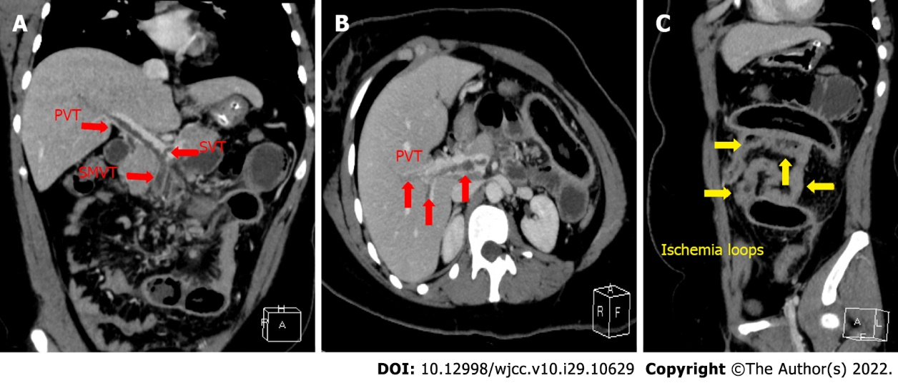
Figure 1 Computed tomography of the abdomen. A and B: Portal vein thrombosis, splenic vein thrombosis, and superior mesenteric vein thrombosis (red arrows); C: Ischemic small bowel loops (yellow arrows). PVT: Portal vein thrombosis; SVT: Splenic vein thrombosis; SMVT: Superior mesenteric vein thrombosis.
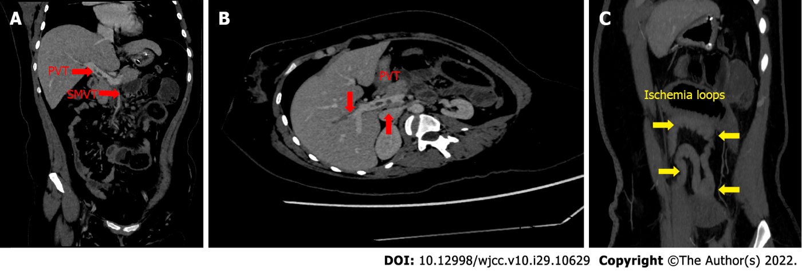
Figure 2 Follow-up computed tomography of the abdomen. A and B: Portal vein thrombosis and superior mesenteric vein thrombosis (red arrows); C: Ischemic small bowel loops (yellow arrows). PVT: Portal vein thrombosis; SMVT: Superior mesenteric vein thrombosis.
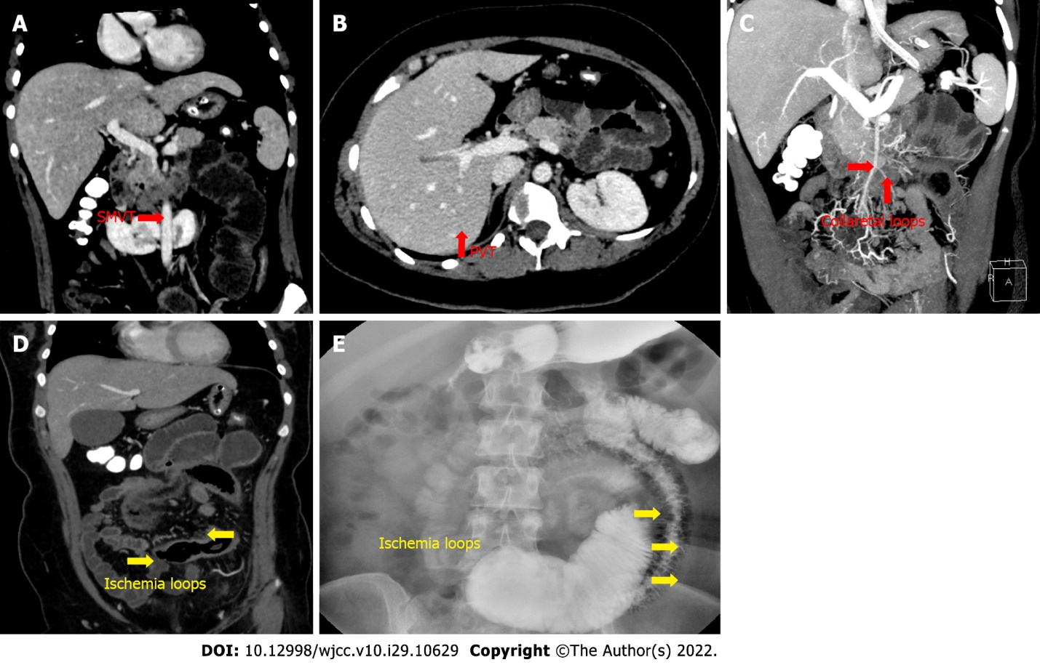
Figure 3 Follow-up contrast-enhanced computed tomography of the abdomen and total gastroenterography on day 15 after admission. A and B: Residual thrombotic material visible in the superior mesenteric vein (A) and portal vein thrombosis (B) on contrast-enhanced computed tomography (CECT); C: Collateral vessels (red arrows) on CECT; D: Ischemic intestinal loops (yellow arrows) on CECT; E: Total gastroenterography revealed ischemic intestinal loops (yellow arrows). PVT: Portal vein thrombosis; SMVT: Superior mesenteric vein thrombosis.
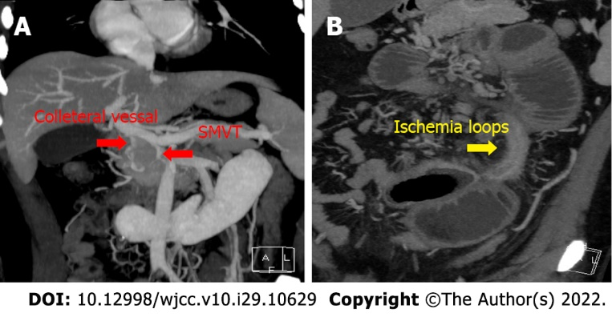
Figure 4 Follow-up contrast-enhanced computed tomography on day 31 after admission. A: No residual thrombotic material was visible in the splanchnic vein, with collateral vessels and reopened superior mesenteric vein (red arrows); B: Contrast-enhanced computed tomography revealed ischemic intestinal loops (yellow arrow) and dilated bowel segments. SMVT: Superior mesenteric vein thrombosis.

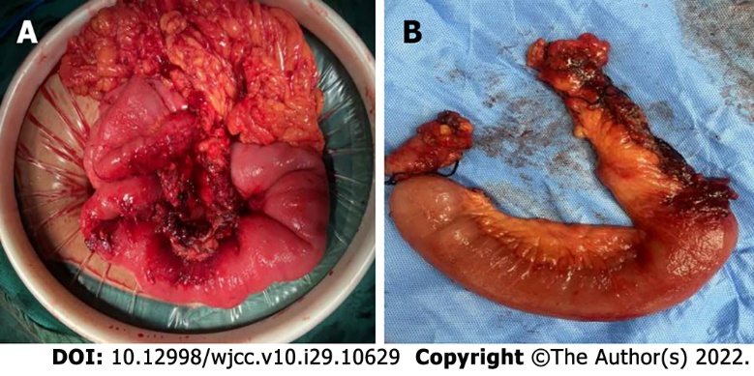
Figure 5 Inspection and resection of bowel segment with mesentery. A: Intraoperative photograph of infarcted and stenotic bowel segment with edematous mesentery; B: Intraoperative resection photograph of infarcted and stenotic bowel segment with edematous mesentery.

Published by Baishideng Publishing Group Inc
7041 Koll Center Parkway, Suite 160, Pleasanton, CA 94566, USA
Telephone: +1-925-3991568
E-mail: bpgoffice@wjgnet.com
Help Desk: https://www.f6publishing.com/helpdesk
https://www.wjgnet.com

© 2022 Baishideng Publishing Group Inc. All rights reserved.

